Integrated Geophysical Assessment of Subsurface Lithology and its potentials at Upenekang, Ibeno, Akwaibom state Nigeria.

Abstract
This study integrates Vertical Electrical Sounding (VES) and downhole geophysical logging to characterize the subsurface of Upenekang, Ibeno. The lithological sequence reveals a transition from superficial clays to prolific sand aquifers. Resistivity data at depth greater than 200m suggest a vulnerability to saltwater intrusion, while geotechnical analysis of the overburden identifies potential settlement risks in upper clay units. Also, study reveals one of the weaknesses of VES known as principle of suppression. This integrated approach validates the accuracy of surface geoelectrical models against direct borehole measurements.

1.0 INTRODUCTION:
The coastal aquifers of the Niger Delta, particularly in Akwa Ibom State, serve as the primary source of potable water. However, these systems face dual threats: anthropogenic pollution and saltwater intrusion (Etie et al., 2021). This study utilizes geoelectric sections and borehole logs from Upenekang (4° 34.473'N, 7° 58.574'E) to model the hydrogeological framework and assess the geotechnical integrity of the subsurface. Its objectives include a)To determine the depth to aquifers b)to delineate fresh water zone from salt water c) to compare both geophysical method d) to show the weaknesses that occurs from using the two.
Geophysical logging: Most borehole are sunk by rotary drilling in which the detritus produced by rotating teeth on a rock bit of drilling head flushes to the surface by a drilling fluid (mud) which holds it in suspension . The fragments of rocks flushed out is often difficult to interpret as they have been mixed and leached by the drilling fluid which provides little information on the intrinsic physical properties of formation from which they are derive hence wire line logging is used to derive further information about the sequence of rocks penetrated by a borehole. Its essence is the ability to define the depth to geological interfaces or beds that has a characteristics geophysical signature. This provides a means of correlating geological information between boreholes and to obtain information on institu properties of the borehole(wallrock) This Electric logs measure and record two quantities. The first is the variations in the borehole of electrical currents, which flow between shale beds and permeable beds whenever such beds are in contact. The second quantity is the electrical resistivity of the formations within the borehole. Conductivity in sedimentary rocks is distinguished from conductivity in metals (and certain metallic ores) by the fact that the movement of ions, whereas in metals, it is due to the movement of electrons. In the former, the conduction is electrolytic, while in the latter, it is electronic. The ions which conduct the current in sedimentary rocks are due to dissociation of salts. Such dissociation occurs when salts are dissolved in water. It is movement of these charged ions under the influence of an electrical potential which enables a solution of salts to conduct electricity. Since each ion is able to carry only a definite quantity of electrical charge, it follows that the more ions that are available in a solution to carry charge, the greater will be the charge that can be carried.Since the movement of the charge constitutes an electrical current, it follows also that a solution containing a large number of ions will conduct a larger current than a solution containing a smaller number of ions. Accordingly, the solution with the larger number of ions will have the higher conductivity and therefore a lower resistivity.
Vertical electrical sounding(VES): has been proved very effective for water content estimation, water quality assessment, evaluation of aquifer properties, geo-electric parameters and mapping of the depth to water table (Hubbard and Rubin, 2005).

Eluwole and Oladimeji (2013) did a hydrogeophysical evaluation of the groundwater potential of the Afe Babalola University,Ado Ekiti, Southwestern Nigeria using electrical resisitivity method. Teikeu etal (2012) characterized the aquifer in a hard rock environment using hydrogeophyscal parameters with a case study from Yaounde, Cameroun. Ugada et al (2013) used Geo-sounding data to delineate the shallow aquifers of Umuahia and environs. Aquifer characteristics of Ihiala and environs, Anambra state, Nigeria was estimated using vertical electrical sounding data by Obajulu et al (2016). Nwosu and Nwosu (2017) discussed the groundwater exploration for sustainable water supply development in the rural communities of Imo state in the Imo River basin, Nigeria. Ezebunanwa etal 2020 used it to delineate the suitability of utughugwu for dam construction Nwugha etal 2021used it to detect marl deposits at Ibii community, Ezebunanwa etal 2020 used it to delineate dolerite intrusive at Achara Uturu
2.0 GEOLOGY OF THE AREA
Upenakang Ibeno falls within the Benin Formation which is the youngest formation (Miocene-Recent) in the Imo River Basin. The Formation occupies the middle to lower region and directly overlies more than half of the Basin. The Benin Formation is made up of very friable sands with minor intercalations of clays. It is mostly coarse-grained, pebbly poorly sorted and contains pods and lenses of fine grained sands, sandy-clays and clays (Whiteman,1982; Uma and Egboka, 1985). The formation is in part cross-stratified and the foreset beds alternate between coarse and fine-grained sands. Petrographic study on several thin sections (Onyeagocha, 1980) show that quartz makes up more than 95% of all grains but Asseez (1976) and Avbovbo (1978) indicated a possible presence of more percentage to other skeletal materials including feldspar. The dominance of sandy horizon in the Benin Formation is also indicated by the logs of boreholes drilled through the formation. The strata logs of more than 85% of the over 400 water wells examined indicated sand horizons of more than 90% with sandy clays making up the rest. The Benin Formation and the other formations are covered (at their exposed areas) to varied depths by red acid sandy soils and mangrove soils.
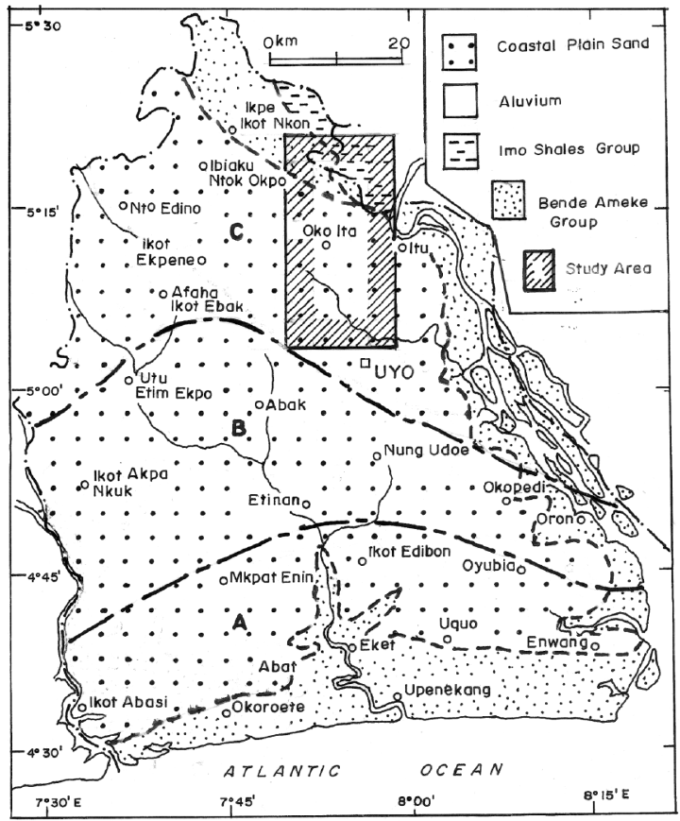

Figure 1 :Geology map of Akwaibom State
3.0 Methodology
The data was acquired using two primary geophysical methods:
- Vertical Electrical Sounding (VES): Interpreted to produce a 1D geoelectric section.
- Borehole Logging: Spontaneous Potential (SP) and Resistivity (2.5" and 10") measurements were captured to a depth of 260m
The integration of these methods allows for the "blind" interpretation of VES to be calibrated against the high-resolution "truth" of the borehole log (George et al., 2015).
The schlumberger array of the vertical electrical sounding technique was employed at maximum current electrode spacing of AB/2 of 400m for the location,Mohammed I. N., et al (2008). The theories of are well explained in standard texts such as Telford et al, (1976); Griffiths and King (1983), Dobrin M.S. and Savit (1988). Electrical resistivity data were acquired using the Vertical Electrical Sounding technique with the Schlumberger electrode configuration. The instruments employed for the data acquisition include: ABEM Terrameter SAS1000 resistivity metre, Etrex GPS, and Compass.
An ABEM Terrameter (SAS) 300B with a liquid crystal digital read-out and automatic signal averaging microprocessors was used for logging exercise. The Terrameter System consists of a basic unit called the terrameter SAS Log 200. SAS stands for Signal Averaging System – a method whereby consecutive readings are taken automatically and the results are averaged continuously.The continuously updated running average is presented automatically on the display. This continues until the operator is satisfied with stability of the result. SAS results are more reliable than those obtained using Single-Shot Systems. The SAS Log 200 has capabilities for measuring spontaneous potential (SP), Resistivity (Short Normal 16”, Long Normal 64”, long Lateral 18’). Temperature and fluid resistivity of a hole.

4.0 RESULTS AND INTERPRETATION
VES1 :4º34.473′ N, 7º58.574 ′E.(24ft )
layer | ℓ(Ω) | D(m) | LITHOLOGY
1 | 2139 | 0.319 | TOP SOIL
2 | 32 | 2.58 | clay
3 | 2.43 | 4.95
4 | 96.4 | 7.06
5 | 412 | 14.9
6 | 1645 | 34.4
7 | 7733 | 89
8 | 511 | 117
9 | 1060 | 186
10 | 5826 | >186


FIG 2 MODELLED CURVE

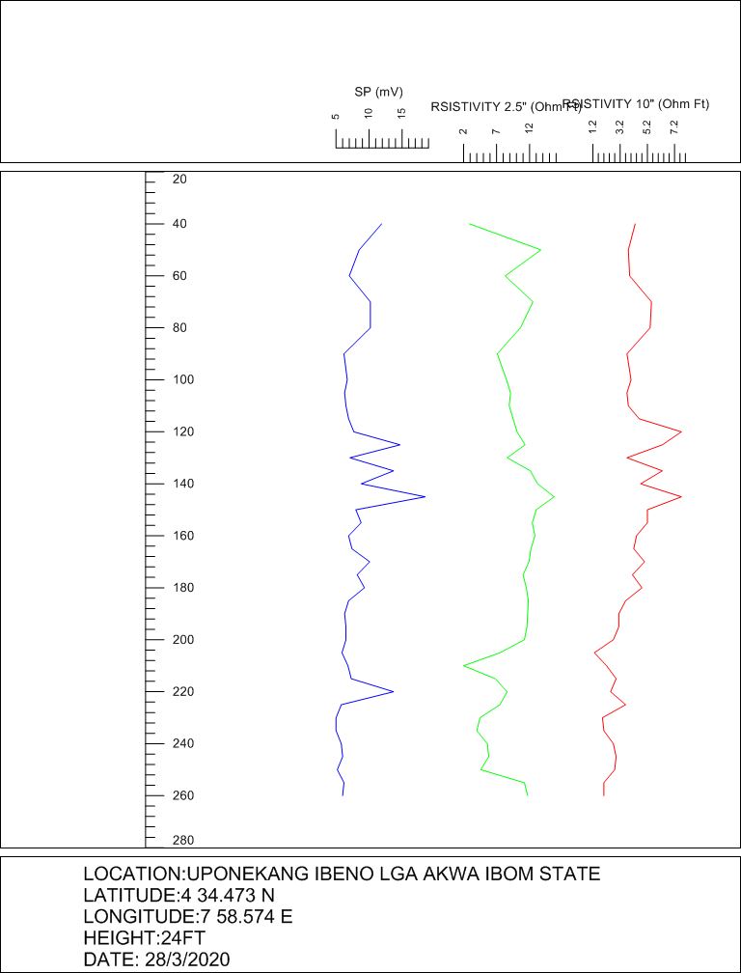
Fig 3 GEOELCTRIC SECTION fig 4 SP,RESISTIVITY LOGS
Depth (m) | Lithology | Resistivity Trend | Interpretation
0–10 | Topsoil / Clay | High () | Dry/Aerated zone
10–20 | Sandy Clay | Moderate | Aquitard (Poor yield)
40–90 | Sand | Stable High | Primary Freshwater Aquifer
120–185 | Silty Sand | Fluctuating | Secondary Aquifer (Silt risk)
200+ | Sand | Very Low () | Saline Intrusion Zone

DISCUSSION
From the results a number of facts came out
A) Topography is Low with elevation of 24ft, typical of coastal regions
B) Hydrogeological Characterization & Groundwater Potential
It is the "science of water" within the earth. with view to determine which subsurface layer provides the best yield and highest quality of water. In Ibeno, finding clean water is often a challenge due to the complex layering of sediments. . Two aquifer systems exist Primary or the upperAquifer Composed of medium-to-coarse-grained sand is the thick Sand layer between 40m and 90m. Secondary or lower Aquifer A deeper Silty Sand layer extends from 120m to roughly 185m. , the presence of "silt" might mean lower permeability compared to the upper sand. The higher silt content suggested by the SP curve fluctuations indicates lower hydraulic conductivity compared to the upper sand. The primary aquifer should be the target.Also delineating between porous sands and impermeable clays,helps in designing the borehole screen placement.
C) Saltwater Intrusion & Coastal Aquifer Vulnerability
Because Ibeno is a coastal region, the most significant threat to water is the ocean.hence"Saline Intrusion." This helps us to know if the salt-front from the Atlantic Ocean has reached the groundwater at Upenekang community.i.e to establish "fresh-saltwater interface." This is achieved from Resistivity Interpretation in the wellog. Saltwater is highly conductive, meaning it has very low resistivity. If the resistivity drops significantly as you go deeper into the sand layers, it strongly suggests saltwater or brackish water contamination and viceversa. looking at the resistivity curves (the green and red lines) there is significant increase with depth.This means fresh water without saline intrusion.In coastal regions like Ibeno, resistivity values are the primary indicators of salinity. these extremely low resistivity values at depth are indicative of brackish or saline water saturation (Uwidia et al., 2018).
Vulnerability: Aquifers of Upenekang ibeno is vulnerable due to the following factors
- Agricultural Runoff: This is rural area farming is the major occupation.The increased use of chemical fertilizers, herbicides, and pesticides in agricultural areas is a significant contributor to groundwater contamination.
- Oil Spills and Industrialization: As a major oil-producing state, numerous oil spills from production and pipelines lead to contamination of the aquifers.
- Shallow Water Table: Shallow aquifers are prevalent, especially in the coastal regions, making them highly sensitive to contaminants from surface-level activities.
- Low-Slope Terrain: Generally low-slope terrain promotes waterlogging and infiltration, which increases the speed at which contaminants move into the groundwater.
- Coastal Saltwater Intrusion: The coastal region faces high risks of salinization of shallow freshwater aquifers due to tides and sea-level rise, particularly where groundwater has been over-abstracted.
- Weak Overburden Protective Capacity: Many aquifers in the region are covered by highly permeable materials (sand, gravel) with little to no clay or lateritic layers to protect them. This allows rapid infiltration of contaminants from the surface into the groundwater.
D) Geotechnical Assessment for Coastal Engineering
The ground's stability for carrying civil structures can be establish with Objective to evaluate the load-bearing capacity and corrosivity of the soil.
Foundation Depth: The first 20m contains Clay and Sandy Clay. these layers exhibit low bearing capacity and high compressibility. Also these are "plastic" materials that can shrink or swell or contraction and expansion of clay(known as rheological property of clay) that causes cracks in the walls of buildings. The geo-technical implication of the presence of clay especially at VES results is unstable foundation of structures. Hence silt and sands are better.In the study area civil structures should be erected on more stable Silty Sand layers. For heavy coastal infrastructure, the geoelectric section suggests that pile foundations should bypass these clayey units and be seated in the denser Silty Sand layer starting at 22m.
Soil Corrosivity: Using the Resistivity 10" (red curve), how "corrosive" the soil is can be established. Soils with low resistivity are generally considered highly corrosive to buried steel pipes. This is vital for the oil and gas infrastructure which is common in Akwa Ibom.
E) Comparative Analysis
we take a look how we interpret the earth's signals by comparing "Surface Geophysics" (VES) with "Downhole Geophysics" (Borehole Logging). fig -- is an "interpretation" (what we think is there), while fig -- is "observed data" (what the tools actually felt). A comparison between the Geoelectric Section and the SP Log shows high correlation in lithological boundaries. However, the Borehole Log reveals thin clay intercalations within the 120m–180m Silty Sand unit that were "suppressed" in the VES interpretation. This highlights the Principle of Suppression one of the problems in surface geophysics (Okiongbo & Odubo, 2012). Sometimes thin layers (like the Clay at 100m) are missed by surface equipment but caught by borehole logs.
5 Conclusion
The study confirms that while prolific sand aquifers exist at 40m–90m, the deep subsurface (below 200m) shows significant signs of saline contamination. It is recommended that water abstraction be limited to the upper sand unit, and that corrosion-resistant materials be used for all subsurface installations due to low soil resistivity.

References
Etie, P., et al. (2021). Hydrogeochemical evaluation of coastal aquifers in the Niger Delta. Journal of African Earth Sciences.
George, N. J., et al. (2015). Estimation of hydraulic resistance and conductivity of alluvial aquifers. Geophysics and Engineering.
Okiongbo, K. S., & Odubo, J. (2012). Optimization of geoelectric sounding for groundwater exploration in the Niger Delta. Journal of Geology and Mining Research.
Uwidia, I. E., et al. (2018). Assessment of saltwater intrusion in coastal Akwa Ibom. International Journal of Environmental Science.
Ugada, U., Opara, A.I., Emberga, T.T., Ibim, D.F., Omenikoro, A.I., and Womuru, E.N., (2013): , Delineation of Shallow Aquifers of Umuahia and Environs, Imo River Basin, Nigeria, Using Geo-Sounding Data; Journal of Water Resource and Protection, 2013, 5, 1097-1109, http://dx.doi.org/10.4236/jwarp.2013.511115.
Uma, K.O. and Egboka B.C.E. (1985). Water Resources of Owerri and its Environs, Imo state. Nigerian Journal of Mining and Geology 22: 57-64
Uma, K.O., and Egboka, B.C.E., (1985): Groundwater Potentials of Owerri and its Environs: Nigerian Journal of Mining and Geology Vol. 22 pp57-64.
Teikeu, W.A.,Njandjock , P.N.,Bisso, D.,Atangana, Q.Y.,andNlomgan, J. S.(2012), ,Hydrogeophysical Parameters Estimation for Aquifer Characterisation in Hard Rock Environment: A Case Study from Yaounde, Cameroon. Journal of Water Resource and Protection, 2012, 4, 944-953 http://dx.doi.org/10.4236/jwarp.2012.411110 Published Online November 2012 (http://www.SciRP.org/journal/jwarp)
Obiajulu, O.O., Okpoko, E.I. and Mgbemena, C.O. (2016) Application of Vertical Electrical Sounding to estimate Aquifer Characteristics of Ihiala and its environs, Anambra State, Nigeria. ARPN Journal of Earth Science. ISSN 2305-493x vol5 No 1 June 2016.
Onyeagocha, A.C, (1980): Petrography and Depositional Environment of the Benin Formation, Journal of Mining and Geology 17(2), 147-151
Nwosu, L.I. and Nwosu, B.O. (2017). Groundwater Exploration for Sustainable Water Supply Development in the Rural Communities of Imo State in the Imo
River Basin, Nigeria. Volume - 7 , Issue - 1 January – 2017. ISSN - 2249-555X .
Nwosu , L. I., Ekine, A. S., and Nwankwo , C. N. (2013). Evaluation of Groundwater Potential from Pumping Test Analysis and Vertical
Electrical Sounding Results: Case Study of Okigwe District of Imo State Nigeria. The Pacific Journal of Science and Technology. Volume 14. Number 1. May 2013 (Spring)
Ezebunanwa A.C. Nwugha V.N., K.C. Emeghara and G.C Ibe.( 2020): Geological and Geoelectrical Investigation of a proposed dam site using vertical electrical sounding of Osuworowo stream, Utughugwu Arochukwu, Southeastern Nigeria. JGEESI
Ezebunanwa A.C., Ikoro D.O, Nwugha V.N, Eke B.O Onuoha E.C ( 2021): Geophysical investigation of intrusive Achara Nzerem Uturu southeastern Nigeria.
Nwugha V.N. Ezebunanwa A.C. Onwuegbuchulam C.O, Mbagwu E.C, Chinaka A.I, Emeghara K.C(2025):Geophysical investigation for marl exploration using VES in Akpokponke ibii southeast Nigeria.
Eluwole, B.A. and Oladimeji, L.A. (2013) .Hydrogeophysical Evaluation of the Groundwater Potential of AfeBabalola University Ado-Ekiti, Southwestern Nigeria. Journal of Emerging Trends in Engineering and Applied Sciences (JETEAS) 4(1): 77-83. Scholarlink Research Institute Journals, 2013 (ISSN: 2141-7016) jeteas.scholarlinkresearch.org
Hubbard, S.S. and Rubin, Y. ( 2005). Introduction to Hydrogeophysics, In Hydrogeophysics. Ed. (Rubin, Y and Hubbard, S.S.). Springer, The Netherlands. Pp. 3 - 21
A. M. J. Whiteman (1982)

