Investigation and Mitigation of Harmonic Distortion and Parallel Resonance in an Industrial Power System Using ETAP

ABSTRACT

Harmonics, primarily generated by non-linear loads, can lead to voltage distortion, equipment overheating, and reduced system efficiency. This project analyzes harmonic distortion in the electrical distribution network of a cement plant using ETAP software. A detailed Single Line Diagram (SLD) was modeled, and harmonic load flow analysis was conducted to evaluate Total Harmonic Distortion (THD) at key bus locations. A frequency scan was performed to identify parallel resonance conditions, which were mitigated by installing series reactors with capacitor banks. Additionally, passive filters were designed to reduce dominant harmonic components and ensure compliance with IEEE 519 standards. The study demonstrates a significant improvement in power quality and highlights ETAP as an effective tool for harmonic analysis and mitigation in industrial systems.
Keywords: Harmonics Study, Total harmonics Distortion, Capacitor bank, Resonance, ETAP
INTRODUCTION
The cement plant draws its primary power from a nearby 66 kV grid substation through a 2.8 km long, 630 sq.mm single-core underground cable, with a contracted demand of 12 MVA. Power is imported via two 66/11.5 kV, 12.5/15 MVA transformers, with a % impedance of 8.22 and a vector group of Dyn11. The star points of the transformers and the Waste Heat Recovery System (WHRS) generator are grounded through Neutral Grounding Resistors (NGR) with a current limit of 100 A. The plant operates various non-linear loads such as motors, crushers, and mills, which are common in cement production. In cement plant, operators often encounter unexplained issues related to voltage instability and overheating of electrical equipment, especially in areas with high-power-demand loads. One frequent cause of these disturbances is the interaction between the plant’s non-linear loads and capacitor banks used for power factor correction. This interaction can lead to amplified voltage fluctuations, causing equipment like motors and transformers to overheat, malfunction, or even fail prematurely. Additionally, plant operators may notice that protective devices like relays and circuit breakers sometimes trip unnecessarily or fail to operate correctly, resulting in unexpected shutdowns and increased downtime. These problems typically go unnoticed until they cause significant operational disruptions.
The underlying cause of these issues is the harmonic amplification due to the interaction between the plant’s electrical loads and the capacitor banks. Addressing these disturbances is critical to maintaining equipment reliability, improving system stability, and reducing operational disruptions in cement plant operations.

HARMONICS STUDY

Harmonic analysis was performed to assess power quality disturbances within the cement plant’s electrical network caused by non-linear loads and reactive compensation elements. The study aimed to identify the presence of harmonic distortion and resonance conditions, both of which can significantly impact equipment reliability, system losses, and protection device performance. All analyses were conducted using ETAP software, with emphasis on Harmonic Load Flow and Frequency Scan techniques in accordance with IEEE 519-2014 guidelines.

Harmonics Overview
Harmonics are voltage or current waveforms with frequencies that are integer multiples of the fundamental power frequency (typically 50 Hz in India). They arise from non-linear loads that draw non-sinusoidal currents even when supplied with a purely sinusoidal voltage. Examples include variable frequency drives (VFDs), six-pulse and twelve-pulse rectifiers, welding equipment, and similar power electronic converters.
The presence of harmonics can cause:
- Overheating and derating of transformers and motors
- False tripping or maloperation of protective devices
- Overloading of neutral conductors in three-phase systems
- Premature aging of insulation and capacitors
- Resonance amplification when capacitors are present
To quantify the harmonic content in a waveform, the IEEE 519-2014 standard defines Total Harmonic Distortion (THD) as follows:
THD_I = (√ (I₂² + I₃² + ... + Iₙ²)) / I₁ × 100%
Where:
I₁ = RMS value of the fundamental current
I₂, I₃, ..., Iₙ = RMS values of harmonic current components
THD_V = (√ (V₂² + V₃² + ... + Vₙ²)) / V₁ × 100%
Where:
V₁ = RMS value of the fundamental voltage
V₂, V₃, ..., Vₙ = RMS values of harmonic voltage components
Total Harmonic Distortion (THD)
The cement plant incorporates multiple VFD-fed loads, including those in the raw mill, crusher, and process fans. These non-linear devices are the primary sources of harmonic injection into the network. A harmonic load flow study was carried out using ETAP to identify the magnitude and propagation of harmonic currents and voltages.
Key objectives of this analysis included:
- Measuring current and voltage THD at PCCs throughout the network.
- Identifying critical buses where THD exceeds IEEE 519 limits.
- Analyzing how harmonics propagate and accumulate in different parts of the system. The results were used to determine whether passive filtering or other mitigation strategies were needed

Resonance Conditions in Industrial Networks
Resonance in an electrical network occurs when the inductive and capacitive reactance become equal in magnitude but opposite in phase, leading to a significant rise in system impedance (parallel resonance) or current (series resonance) at certain frequencies.

Parallel resonance: Occurs when a capacitor bank installed for power factor correction resonates with the inductance of the power system at or near a harmonic frequency. This results in elevated voltages and potentially dangerous amplification of harmonic currents.
The parallel resonance frequency fr is determined by:
fr = 1 / (2π√(L × C))
Where:
fr = Resonant frequency (Hz)
L = Equivalent inductance (Henrys)
C = Capacitance of the capacitor bank (Farads)
Parallel resonance is particularly critical in industrial networks with high harmonic content and capacitor banks. If the resonance frequency coincides with a dominant harmonic (e.g., 5th or 7th), it may lead to:
- Overstressed capacitors
- Voltage magnification at harmonic frequencies
- Nuisance tripping of relays and breakers
- Increased harmonic distortion throughout the system
In this study, a Frequency Scan Analysis was conducted at buses equipped with capacitor banks. ETAP's impedance versus frequency plots were used to identify resonance peaks, indicating the likelihood of parallel resonance. Locations of concern were then evaluated for potential mitigation, such as detuning or filter installation.
METHODOLOGY

The harmonic study was performed in ETAP using the following structured approach:
1. Model Development: A comprehensive Single Line Diagram (SLD) of the cement plant was created in ETAP, incorporating all major buses, power transformers, motors, VFD loads, capacitor banks, and the grid connection. Accurate modeling of impedances, load profiles, and grounding was ensured.
2. Non-linear Load Identification: All significant non-linear loads such as variable frequency drives, converters, and inverters were identified and modeled with their respective harmonic current spectra based on equipment datasheets or typical harmonic profiles as per IEEE 519.
3. Harmonic Load Flow Analysis: The Harmonic Load Flow module was used to compute the voltage and current harmonics across the network. Total Harmonic Distortion (THD) values were evaluated at multiple PCCs and critical buses to identify locations with excessive distortion.
4. Frequency Scan Analysis: For buses equipped with capacitor banks, ETAP’s Frequency Scan function was utilized to sweep the system impedance over a wide frequency range (0 Hz to several kHz). This helped identify parallel resonance frequencies by detecting peaks in bus impedance.
5. Standard Comparison: All observed harmonic distortion levels were compared against the allowable limits specified in IEEE 519-2014. This allowed the identification of non-compliant locations requiring corrective measures.
6. Result Interpretation and Mitigation Planning: Based on the analysis results, causes of observed power quality issues were correlated with field symptoms reported by plant personnel. Mitigation strategies, including detuned reactors and passive filters, were proposed and evaluated in ETAP.

RESULTS AND SUGGESTION
Suggestion-01:
At Load Centre-01 bus, located upstream near the transformer, harmonic analysis revealed that the current Total Harmonic Distortion (THD) exceeded acceptable limits. The measured THD at this location was 22.18%, significantly higher than the permissible limits defined by IEEE 519 for systems below 69 kV.
Further analysis showed that the 5th harmonic was the dominant contributor to the distortion. Additionally, the harmonic current flowing through the connected cable was beyond its thermal and insulation limits, potentially leading to overheating, increased losses, and reduced cable lifespan. at Load Centre-01.
ISC = 28000 A
IL= 1185 A
So ISC/IL=24, so the current THD should be less than 8% but it is 22.18%.
Mitigation Strategy:
To mitigate this issue, a single-tuned passive filter was designed and installed, tuned specifically to the 5th harmonic frequency (250 Hz) because 5th Harmonics is dominating in the system. The filter was connected at the affected bus to provide a low-impedance path for the 5th harmonic current, effectively absorbing it and preventing its flow into upstream components.
After installing the filter, the current THD at the bus reduced from 22.18% to 6.83%, bringing the harmonic distortion within acceptable IEEE 519 limits. This solution has improved power quality, reduced the thermal stress on cables and transformers, and ensured regulatory compliance.
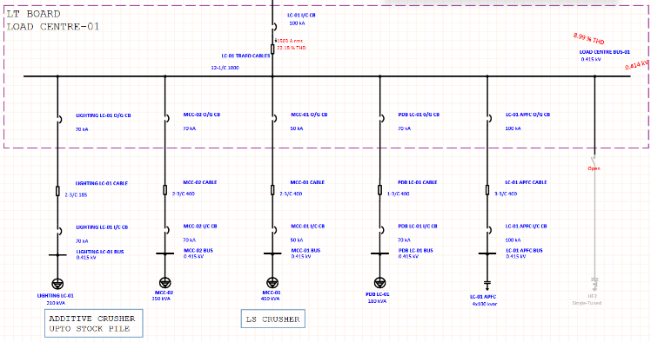
Figure 1: THD level at Load Centre-01 before mitigation
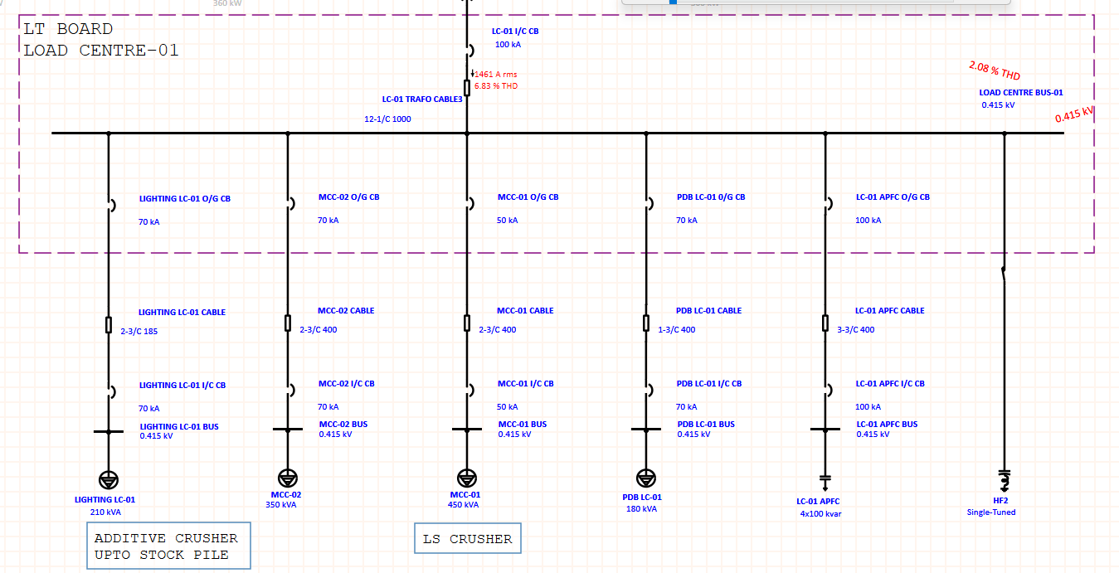
Figure 2: THD level at Load Centre-01 after mitigation
Importantly, the addition of the filter did not introduce any new parallel resonance issues. This is because the system's parallel resonance frequency was located near the 3rd harmonic (~150 Hz), and 3rd harmonic components are negligible in the system due to the absence of their sources.
Harmonic analysis was also performed at other major buses in the plant. Both current and voltage THD levels were found to be within the permissible limits specified by IEEE 519-2014. No significant harmonic distortion or resonance issues were observed at these locations, so no additional mitigation measures were required.
Bus ID | %I_THD | %V_THD
Load center-04 | 1.61 | 0.685
Load center-03 | 1.04 | 0.575
P.H, KILN & COOLER BUS | 5.95 | 0.486
Cement mill HT bus | 3.92 | 0.458
Load center-05 | 0.982 | 0.239
Load center-06 | 1.15 | 0.248
Raw mill HT bus | 8.07 | 1.78
Load center-02 | 1.73 | 1.32
Table 1: THD level at different Bus
Suggestion-02:
Parallel Resonance at Load Centre-02 Bus
During the harmonic analysis at Load Centre-02 bus, a parallel resonance condition was detected due to the connection of a 600 kVAR capacitor bank. The system’s Thevenin impedance at the bus was calculated using the following formula:
Z_{th} = V / (√3 × I_{sc})
Z_{th} = 415 / (√3 × 44,990)
Z_{th} ≈ 0.00532 ohms
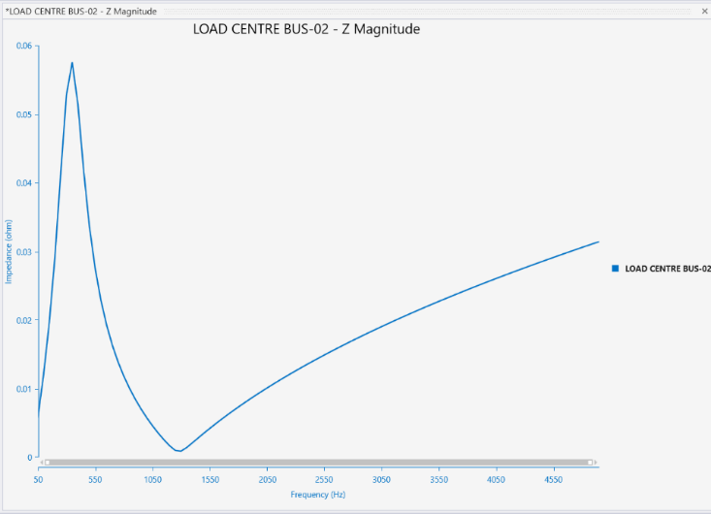
Figure 3: Parallel Resonance condition
At resonance, the impedance observed in the simulation was approximately 0.057 ohms. As per industry practice, when the resonance impedance exceeds ten times the Thevenin impedance, detuning becomes necessary to avoid harmonic amplification.
This resulted in a resonance condition near the 7th harmonic (350 Hz). Although the Total Harmonic Distortion (THD) was within acceptable IEEE 519-2014 limits, the resonance posed a risk of harmonic amplification, potentially stressing the capacitor bank and nearby equipment.
To address this, a detuned reactor was added in series with the capacitor, which shifted the resonance frequency from the 7th harmonic to the 3rd harmonic (\~150 Hz)—a frequency with negligible harmonic content in the system, thereby eliminating the risk of resonance without introducing significant filtering costs.
The original capacitive reactance was:
X_{C} = 0.28704 ohms
A 7% detuned reactor was selected to provide the required inductive reactance:
X_{L} = 0.07 × X_{C}
X_{L} = 0.07 × 0.28704
X_{L} = 0.01794 ohms
This adjustment in series impedance detuned the capacitor bank, effectively shifting the resonance away from the dominant harmonic. As a result, the risk of harmonic amplification at the 7th harmonic was eliminated while maintaining the power factor correction benefits of the capacitor.
CONCLUSION
This research addressed key power quality issues in an industrial cement plant by conducting a detailed harmonic analysis using ETAP software. The study focused on identifying and mitigating Total Harmonic Distortion (THD) and parallel resonance conditions that can adversely affect equipment performance and system stability.At one major load center, excessive current harmonics were identified and mitigated using a passive filter tuned to the dominant harmonic frequency. The filter successfully reduced distortion levels and improved overall power quality without introducing new resonance risks, as the system's resonance frequency remained in a safe range.
Another critical observation was a parallel resonance condition caused by the interaction of a capacitor bank with the system impedance. Though THD levels were within limits, the resonance risk was mitigated by detuning the capacitor bank with a series reactor, effectively shifting the resonance point to a non-problematic harmonic.
Harmonic assessments at other buses showed compliance with IEEE 519 standards, confirming that no further mitigation was necessary. The results emphasize the value of detailed harmonic studies in identifying hidden power quality challenges and implementing cost-effective solutions that enhance system reliability and longevity.

REFERENCES
- Harmonics Analysis standard IEEE 519 - IEEE Recommended Practice and Requirements for Harmonic Control in Electric Power Systems
- Arc Flash Analysis Standard IEEE 1584 - IEEE Guide for Performing Arc-Flash Hazard Calculations
- NFPA 70E, Standard for Electrical Safety in the Workplace
- IEC 60909 Short-circuit currents in three-phase A.C. systems.
- IEEE 3002.2 Recommended Practice for Conducting Load-Flow Studies and Analysis of Industrial and Commercial Power Systems
- Harmonics and Power Systems, By Francisco C. De La Rosa
- Power System Protection and Switchgear, By Bhuvanesh A. Oza, Nirmal-kumar C. Nair, Rashesh P. Mehta and Vijay H. Makwana
- ETAP Harmonic Analysis
- Short Circuit Analysis of 33/11/0.4 kV Distribution System Using ETAP, Dr. Aung Zaw Latt
Published at: International Journal of Latest Technology in Engineering, Management & Applied Science (IJLTEMAS) Volume VIII, Issue V, May 2019 | ISSN 2278-2540
- Harmonic Analysis of 132/33/11 KV Distribution Network Using EtapIkonwa, Blessing Dike, Uzoma Okogbule, Wodi Enyinda
Published at: International Journal of Advances in Engineering and Management (IJAEM) Volume 5, Issue 3 March 2023
- Power System Analysis and Relay Coordination for an Industrial Distribution System, Parth Paradva. Prof. Ajay M. Patel, Ms. Krupa Chavada
Published at: International Journal of Innovative Research in Electrical, Electronics, Instrumentation and Control Engineering, Vol. 10, Issue 4, April 2022

