Power System Analysis of Industrial Distribution Network Using ETAP: Load Flow, Short Circuit, And Protective Device Coordination Studies

ABSTRACT
This project focuses on analyzing an industrial electrical distribution network of a Cement Plant using ETAP software. A detailed Single Line Diagram (SLD) of the plant is modeled in ETAP. Load Flow studies are conducted to determine real and reactive power distribution, voltage profiles, system losses and equipment rating. Short Circuit analysis is used to evaluate fault currents for appropriate equipment rating and protection design. Protective Device Coordination ensures proper fault isolation while maintaining system stability and minimizing disruption. One of the key focuses of this project is to avoid Blackouts in the industry by enhancing system reliability and responsiveness during fault conditions. The objective is to ensure reliable, safe, and efficient power delivery through Load Flow Analysis, Short Circuit Studies, and Protective Device Coordination.
Keywords: Load Flow, Short Circuit, Protective Device Coordination, Power System Analysis, Industrial Power System, ETAP Simulation.
INTRODUCTION
The plant draws its primary power from a nearby 66 kV grid substation through a 2.8 km long, 630 sq.mm single-core underground cable, with a contracted demand of 12 MVA.
Plant shall import the power via two no of power transformer 66/11.5kV, 12.5/15 MVA having %impedance of 8.22 and vector group Dyn11. star point of transformers are ground through Neutral Grounding Resistor (NGR) with current limit of 100A. The plant has one Waste Heat Recovery System (WHRS) of 12MW at 11kV voltage level. Star point of generation is grounded through Neutral Grounding Resistor (NGR) with current limit of 100 A.
The short circuit level at the 66 kV substation is 10.92 kA, or 1248 MVA (three-phase).
To address these challenges, detailed Load Flow, Short Circuit, and Protective Device Coordination studies were conducted using ETAP software. The goal of this project is to evaluate the system’s current operating conditions, verify the adequacy of equipment ratings, and ensure proper protection coordination.
LOAD FLOW
Load flow analysis, also known as power flow analysis, is a fundamental tool used to determine the steady-state operating conditions of an electrical power system. It provides essential information such as active and reactive power flow, bus voltages, system losses, and transformer loading under normal operating conditions. In this study, load flow analysis is conducted for an industrial cement plant using ETAP software, considering two key power sources: the utility grid and the Waste Heat Recovery System (WHRS).
The load flow analysis has been carried out under different loading scenarios to evaluate voltage profiles at key buses (66 kV, 11 kV, 6.6 kV, and 415 V), power factor behavior, and transformer tap settings.
This analysis is essential for ensuring that the industrial distribution network operates efficiently, maintains voltage and thermal parameters within acceptable limits, and delivers reliable power under varying load and generation conditions, including fluctuations from both grid and WHRS sources.
Load flow analysis was carried out to evaluate the voltage profile, power factor, system losses, and equipment loading under normal operating conditions, helping to ensure balanced power distribution and identify areas requiring reactive power compensation and voltage control.
Outcomes of Load Flow Analysis
- Bus Voltage Profiles
Determines voltage magnitudes and angles at all buses to ensure they remain within acceptable limits.

- Real and Reactive Power Flow
Calculates active (kW) and reactive (kVAr) power flowing through transmission lines, transformers, and cables.
- Power Factor Evaluation
Identifies low power factor areas and helps plan capacitor placement for improvement.
- Transformer Loading
Assesses transformer loading percentage to avoid overloading and optimize tap settings.
- System Losses
Estimates active and reactive power losses (I²R losses) in the network, helping to improve overall efficiency.
- Voltage Regulation Issues
Detects undervoltage or overvoltage conditions across buses, aiding in voltage control strategies.
- Reactive Power Compensation Need
Highlights areas where capacitor banks or APFC panels are required to maintain voltage and power quality.
- Source Contribution Analysis
Shows how power is shared between multiple sources like grid and WHRS, ensuring balanced operation.
RECOMMENDATIONS IMPLEMENTED
Capacitor bank Sizing:
A 600 kVAr (150x4) capacitor bank was installed at the LOAD CENTER-02 BUS with the low power factor. This adjustment resulted in a dramatic improvement in power factor from 87.92% to 99.22%.
The capacitor bank not only improved the power factor to near unity but also reduced the overall reactive power demand from the grid.
Capacitor Size (in kVAr)
Qc=P×(tanϕ1−tanϕ2)
Qc​ = Required reactive power in kVAr (size of capacitor)
P = Active power in kW
ϕ1​ = Angle of the initial (existing) power factor
ϕ2 = Angle of the desired (corrected) power factor
You can calculate the angles using:
cosϕ1=Existing Power Factor
cosϕ2=Desired Power Factor
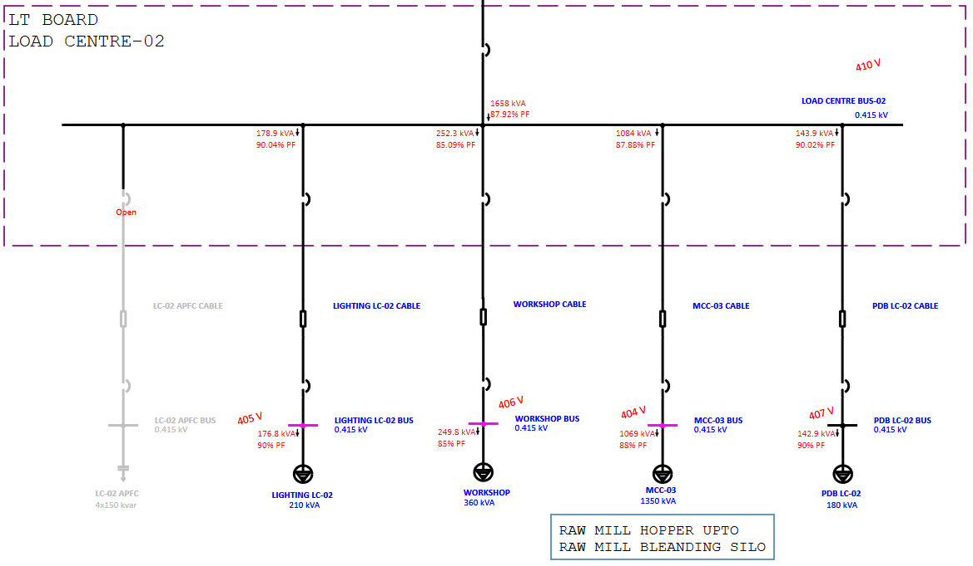
Figure 1 LOAD CENTRE-02 Without Capacitor Bank
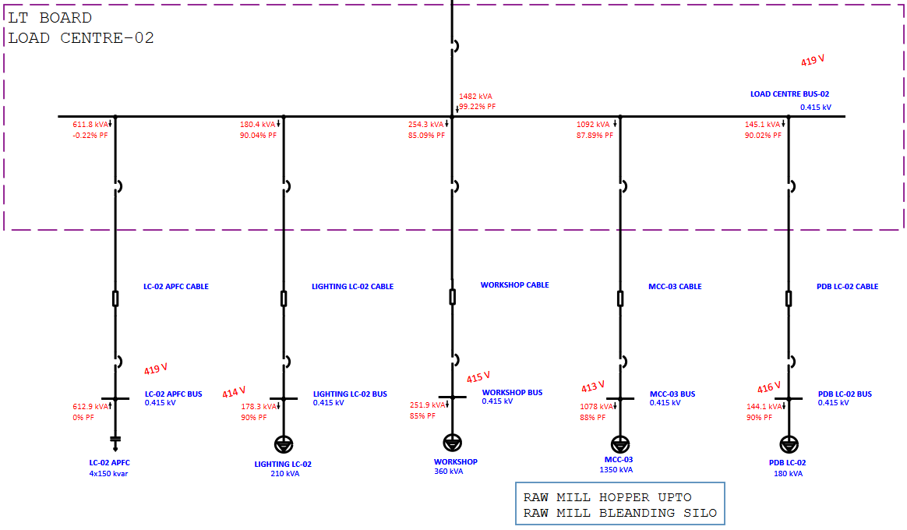
Figure 2 LOAD CENTRE-02 With Capacitor Bank
Transformer Tap Setting:
The 6.6/0.433 kV transformer with a ±5% tap range, the existing tap setting of –2.5% was found to cause overvoltage issues at the LV side at Load Centre-01, with voltage rising to 447 V; hence, a revised tap setting of +5% is recommended to bring the voltage down to 414 V, thereby restoring it within permissible limits and enhancing load-side voltage stability.
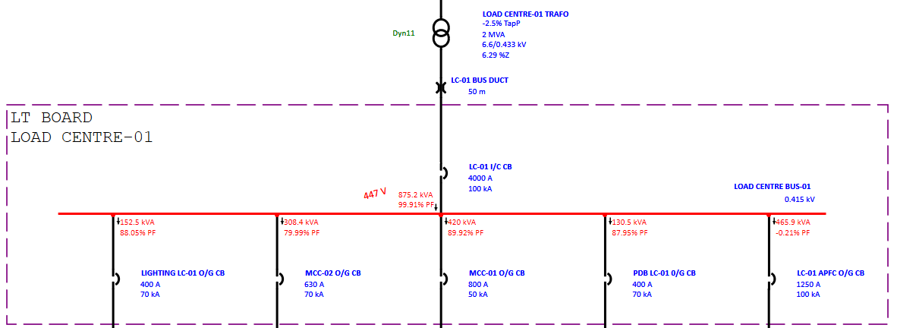
Figure 3 Load Centre Bus-01 Overvoltage
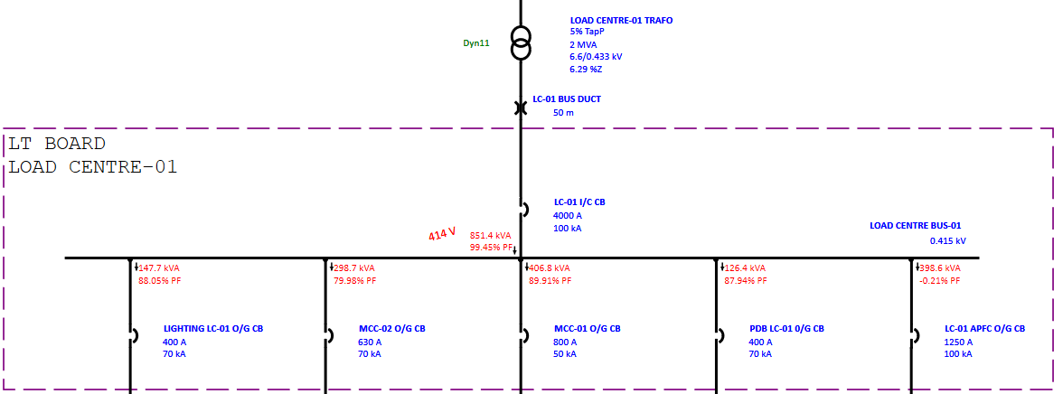
Figure 4 LOAD CENTRE BUS-01 Voltage Within Limit
Cable Sizing Review:
The current arrangement of 4 runs of 3-core 400 sq.mm cables is found to be overloaded at 102.7% due to the plant’s operational demand. To resolve the overloading issue and enhance the current-carrying capacity, it is proposed to add one additional run—bringing the total to 5 runs of 3-core 400 sq.mm cables. This upgrade will reduce the current per run, improve thermal performance, and ensure safe and reliable power distribution.
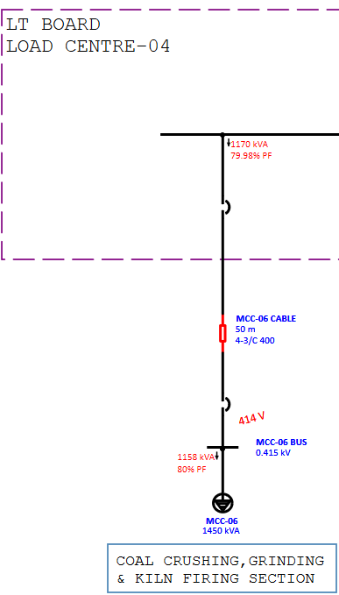
Figure 5 Cable Overload
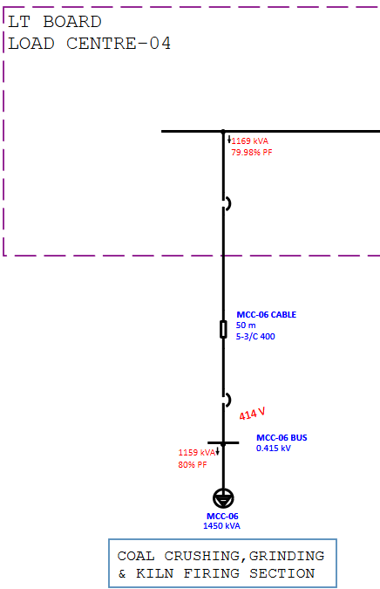
Figure 6 Cable Overload Avoid
CABLE SIZING CALCULATION CRITERIA
The minimum cross section of LV and HV voltage cables shall be calculated based on below methods:
- Short circuit current capacity
- Current carrying capacity
- Voltage drop of cable
1.Short Circuit Current Capacity:
The minimum cross-sectional area of the cable is determined based on its ability to withstand short circuit conditions. The formula is:
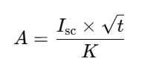
Where:
- A = Cable cross-sectional area in mm²
- Isc​ = Short circuit current in kA
- t = Duration of short circuit in seconds
- K = Constant
2.Current carrying capacity
The cable current carrying capacity under derated condition must be greater than the full load current ( I < I_{Derated} ). If it is not greater, then increase the cross section of the cable or the number of runs.
3.Voltage drop of cable
The cable has its resistance and reactance causing some voltage drop.
The voltage drop during running must be less than 3% (V_{(Running)} < 3%).
The voltage drop during starting must be less than 10 to 15% (V_{(Starting)} <10-15%).
The balanced three-phase voltage drop equation is below. For single phase voltage drop replace the √3 with 2 and V3ph with V1ph.
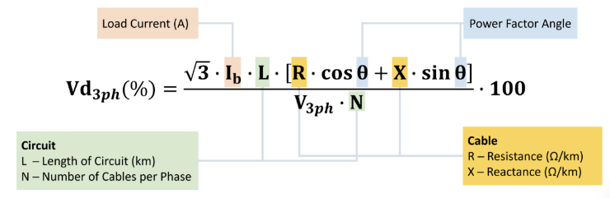
Reactive Power Compensation for Induction Motor
The load flow study was conducted for two distinct scenarios—first, without the capacitor bank, and second, with the implementation of an 885 kVAr capacitor bank at the 11kV bus. The comparative results, presented in the following figures, demonstrate significant enhancements in power factor, stabilization of the voltage profile, and effective reactive power compensation after the capacitor installation.
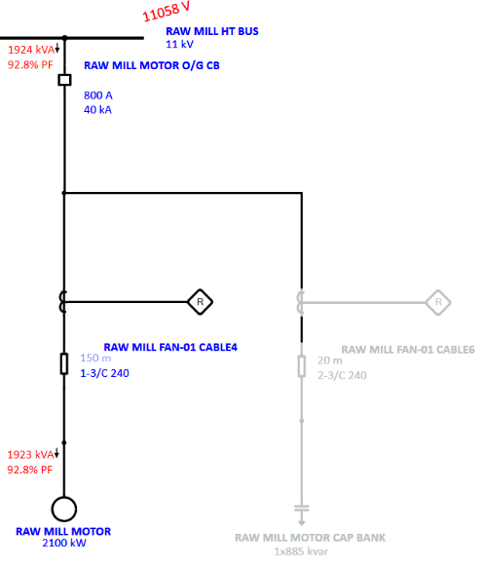
Figure 7 Motor Feeder without Capacitor Bank
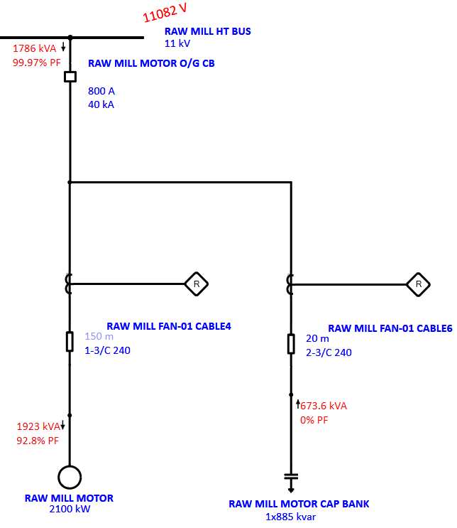
Figure 8 Motor Feeder with Capacitor Bank
SHORT CIRCUIT STUDY
Short circuit analysis is a critical component of power system studies used to determine the magnitude of fault currents under various fault conditions such as three-phase, line-to-line, and line-to-ground faults. This analysis helps in verifying the adequacy of equipment ratings, ensuring safe system operation, and designing appropriate protection schemes. The results aid in selecting circuit breakers, relays, and other protective devices capable of interrupting fault currents without damaging the system components.
Short circuit study and analysis were performed to evaluate the maximum fault current levels, referred to as Device Duty, and the minimum fault currents, which are critical for Relay Coordination. This ensures that all protective devices are correctly rated and coordinated to operate reliably under both extreme and marginal fault conditions.
DEVICE DUTY (DD) – MAX OPTION
To calculate the maximum possible fault current for verifying the interrupting capacity of protective devices like circuit breakers.
Negative tolerance applied to:
- Generator and motor sub-transient reactance (Xd″)
- Transformer, reactor, and overload heater impedances
- Cable and line lengths
- Resistance is reduced by assuming minimum ambient temperature, simulating lower conductor resistance
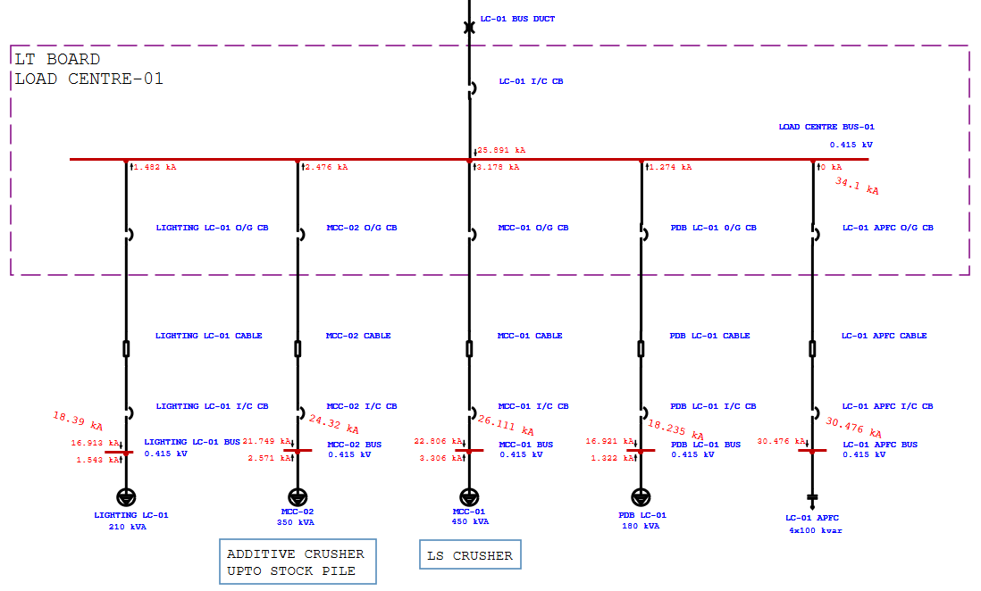
Figure 9 DD (Device Duty) Result
Maximizes fault current, ensuring that devices are capable of withstanding and interrupting the worst-case fault.
RELAY COORDINATION DUTY – MIN OPTION
To calculate the minimum fault current for ensuring that relays still operate correctly and selectively under weak fault conditions.
Positive tolerance applied to:
- Generator and motor sub-transient reactance (Xd″)
- Transformer, reactor, and overload heater impedances
- Cable and line lengths
- Resistance is increased by assuming maximum operating temperature, simulating higher conductor resistance.
Minimizes fault current, useful for relay coordination and sensitivity analysis.

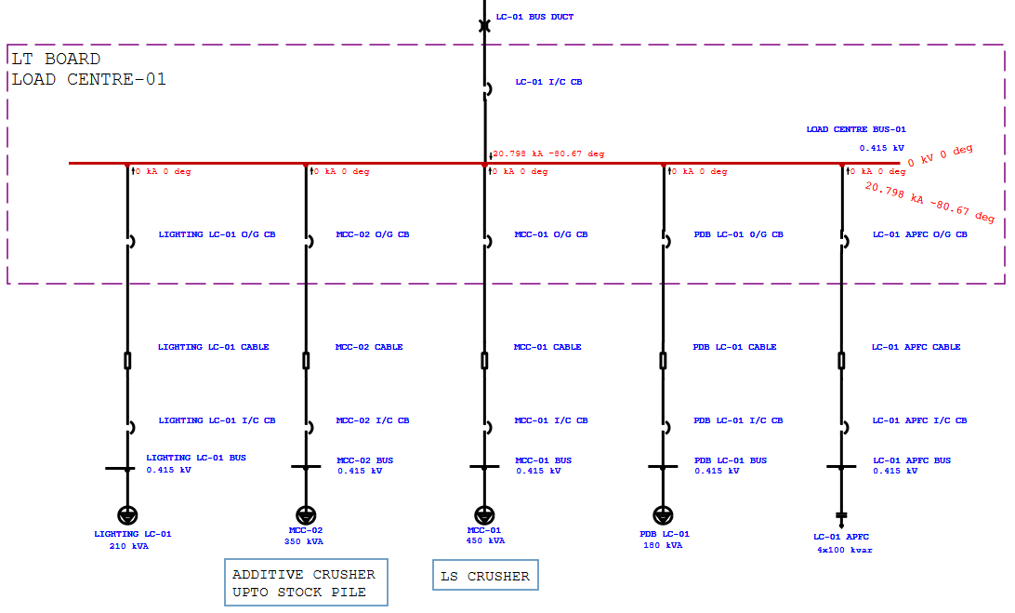
Figure 10 Relay Coordination Duty Result
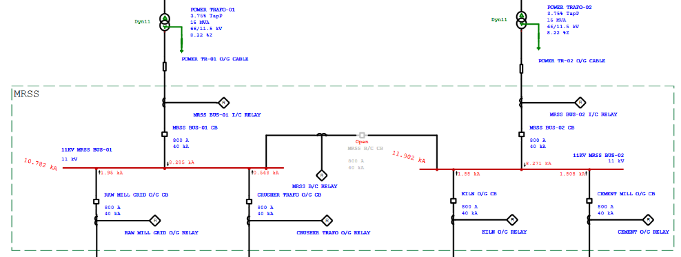
Figure 11 Bus Coupler Open (Device Duty)
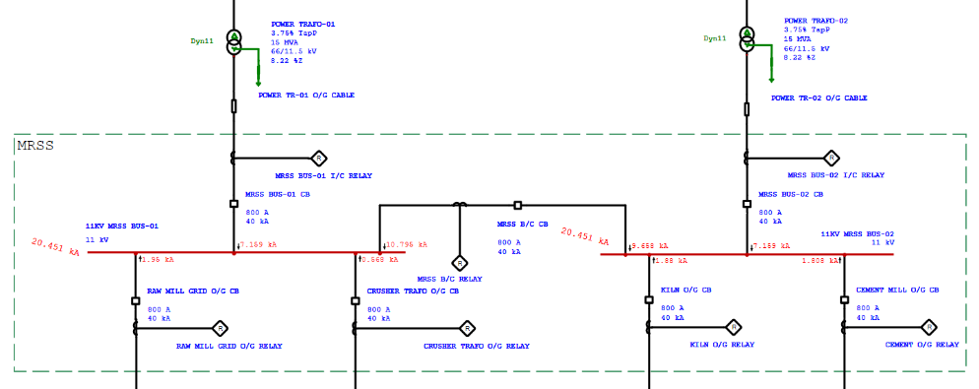
Figure 12 Bus Coupler Close (Device Duty)
When the 11 kV MRSS bus coupler is open, the fault currents at Bus-01 and Bus-02 are 10.782 kA and 11.902 kA respectively. However, closing the bus coupler results in a combined fault current of 20.415 kA. Therefore, operating the bus coupler in the open condition effectively isolates the two buses, reducing the fault current contribution from the interconnected network and serving as a practical fault current limiting strategy.
Selection of Circuit Breaker base on Device Duty
The existing circuit breaker is rated for 50 kA for 1 second, while the calculated device duty short circuit current is 59.154 kA. This means the current breaker is undersized and inadequate for safely interrupting or making the expected fault current.
To ensure safe and reliable operation under fault conditions, a new breaker rated at 70 kA is recommended. This provides adequate margin above the required 59.154 kA duty and ensures compliance with protection and safety standards.
MITIGATION TECHNIQUES TO LIMIT SHORT CIRCUIT CURRENT
- Current Limiting Reactors (CLR)
Purpose: To limit the fault current by adding impedance to the circuit.
Operation: These reactors are connected in series with the circuit and reduce the fault current by introducing additional impedance.
Benefit: Effective in limiting the fault current without the need for expensive upgrades to switchgear.
- Network Splitting
Purpose: Divide the network into smaller sections to reduce the fault current.
Operation: By isolating parts of the network (e.g., opening bus couplers), the fault current contributions from multiple sources are limited.
Benefit: Cost-efficient and simple to implement without extensive equipment changes.
- Increasing Cable Length
Purpose: Increase the impedance in the system, which in turn reduces fault current.
Operation: Longer cables have higher resistance and reactance, which limits the flow of fault currents.
Benefit: Simple and low-cost solution, though only effective for certain systems.
- Lighting Transformers
Purpose: Use 1:1 isolation transformer to limit fault current.
Operation: The transformer separates circuits while also limiting the fault current to safe levels.
Benefit: A straightforward approach for current fault reduction without significant impact on system operation.
- Unit Ratio Transformer (1:1 Transformer)
Purpose: Provides electrical isolation and reduces fault current without changing voltage.
Benefit: Limits short-circuit current, protects equipment, and improves system safety.
Operation: Power flows normally under load; during faults, transformer impedance helps reduce.
- IS Limiter (ABB)
Purpose: To instantly limit short-circuit current before it reaches dangerous levels-within 1 ms-and protect the system.
Benefit:
  - World’s fastest switching for fault control
  - Protects switchgear and transformers
  - Avoids equipment upgrade costs
  - Enables safe parallel operation of systems
Operation:
  - Under normal load, current flows through the main conductor
  - On fault detection, the main conductor opens and current is diverted to a parallel fuse, which instantly limits the current.
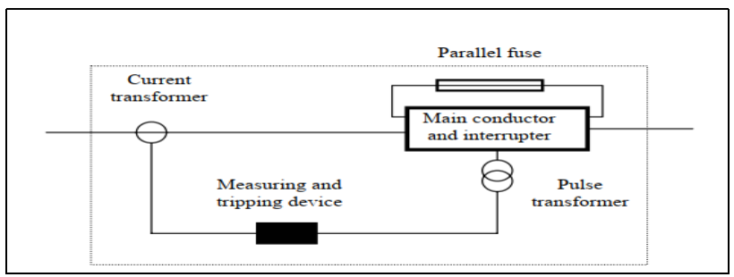
Figure 13 IS Limiter

PROTECTIVE DEVICE COORDINATION
Protective Device coordination is a critical aspect of power system protection that ensures selective, reliable, and timely isolation of faults. The goal is to coordinate multiple protective device in such a way that only the Protective Device closest to the fault operates first, while backup Protective Device are set with appropriate time delays to operate if the primary protection fails.
Protective Device coordination involves analyzing the time-current characteristics (TCC) of relays, ensuring there is a discrimination margin between primary and backup relays. This is especially important in industrial plants, substations, and transmission networks, where continuity of supply is critical.
Key Objectives of Protective Device Coordination:
- Selectivity: Only the faulty section is isolated.
- Speed: Minimize fault clearing time to avoid damage.
- Sensitivity: Detect even low-level faults.
- Backup: Ensure operation if the primary relay fails.
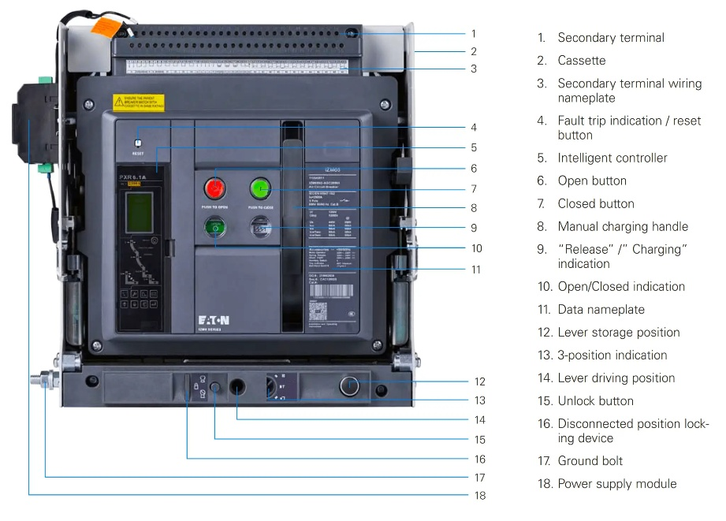
Figure 14 Air Circuit Breaker (ACB) from EATON and the electronic trip unit (ETU) is a PXR6.1A
In low-voltage power distribution systems, Air Circuit Breakers (ACBs) play a vital role in protecting equipment against overcurrent and fault conditions. A key component within an ACB is the release, also known as the trip unit or protection relay. The release is responsible for continuously monitoring the electrical parameters and initiating circuit interruption when predefined thresholds are exceeded.

KEY PROTECTION FUNCTIONS

Protection Type | Symbol | Purpose
Long-time delay | L | Overload protection
Short-time delay | S | Short-circuit with delay (coordination)
Instantaneous protection | I | Immediate trip on high fault current
Ground fault protection | G | Earth fault protection
RELEASE SETTING
1. L – Long-time (Overload Protection)
Purpose: Protects against prolonged overloads.
Setting:
- Long-time pickup (Ir):
(Load Current × Safety Margin)/CT Ratio
Typically set at 1.0 – 1.2 times full load current.
- Long-time delay (tr): Usually 1.5 to 30 seconds
2. S – Short-time (Short-Circuit with Delay)
Purpose: Allows selective tripping for short circuits.
Setting:
- Short-time pickup (Isd): Typically 2 – 10 × Ir
- Short-time delay (tsd): Typically 0.1 – 0.5 s (to coordinate with downstream)
3. Instantaneous (Short-Circuit Without Delay)
Purpose: Fast tripping for close-in faults.
Setting:
- Instantaneous pickup (Ii): Typically 8–15×Ir
No intentional time delay.
Note: To achieve proper time grading and eliminate unwanted tripping during through faults or inrush conditions, it is recommended to switch off the 'INS' setting of Release.
4. G-Ground Fault Protection
Purpose: Detects earth faults.
Setting:
- Ground pickup (Ig): Typically 0.1 – 0.5 × CT primary
- Ground delay (tg): 0-1s depending on coordination.

A relay is an electrical protection device designed to detect abnormal conditions such as overcurrent, phase faults, or earth faults in a system. It continuously monitors electrical parameters and compares them to preset thresholds. When a fault or abnormal condition is detected, the relay sends a trip signal to operate a circuit breaker, isolating the faulted section. This helps to prevent damage to equipment and maintain the stability of the system. Relay coordination ensures that only the nearest relay to the fault operates, minimizing disruption to the rest of the system. Different types of relays, like overcurrent and earth fault relays, are used based on the fault type. Proper settings and coordination of these relays are crucial for system protection.
Time Grading in relay coordination refers to the technique of setting relays in such a way that they operate sequentially, with each relay having a time delay that ensures the relay closest to the fault operates first, followed by others only if needed. This helps to prevent unnecessary trips of upstream relays and ensures that only the faulted section is isolated.
Component | Electro-mechanical Relay | Static Relay
Circuit Breaker Opening Time | 0.08 s | 0.08 s
Relay Overtravel | 0.10 s | 0.00 s
Relay Tolerance & Setting Errors | 0.12 s | 0.12 s
Total CTI Required | 0.30 s | 0.20 s
Table 1 Time Grading

RELAY SETTING CALCULATION

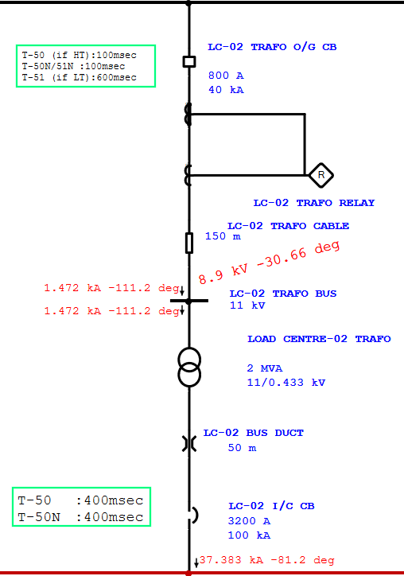
Figure 15 Time Grading and Fault Current
Transformer Details:
Rating: 2 MVA
Voltage ratio: 11/0.433 kV
FLA: 105 A
CTR: 150/1 A
Transformer Feeder 1st stage overcurrent setting (IDMT)
Pick-up(I>) :(1.2 x FLA) / CTR
:(1.2 x 105) / 150
:0.84~0.85
Operating Characteristic Curve: IEC NI
Through Fault Current (Ithr) = $\frac{Vsec}{Vpri}×LT fault current$
= 1.472 kA
Plug setting multiplier (PSM) = $\frac{Fault current in relay coil }{Pick-up current}$
PSM = 9.8133/0.85
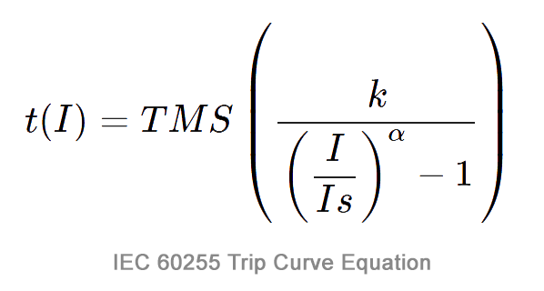
=11.54
Time of Operation =

IEC NI so, k = 0.14 and α = 0.02
t(I) = 2.79 sec (TMS=1)
Time grading is 600 msec.
TMS = (required op. time)/(op. time at TMS=1)
= 0.600/2.79
= 0.214~ 0.215
Transformer Feeder 2nd stage setting (DMT)
Pick-up(I>>)
For through-fault stability, the high-set current (I>>) is set at
1.3 times the reflected current or 8 times the Full Load Amps (FLA) for inrush withstand—whichever is higher.
Pick-up= (1.3 x Ithr )/CTR or (8 x FLA)/CTR
= (1.3 x 1472)/150
= 12.75 ~ 13
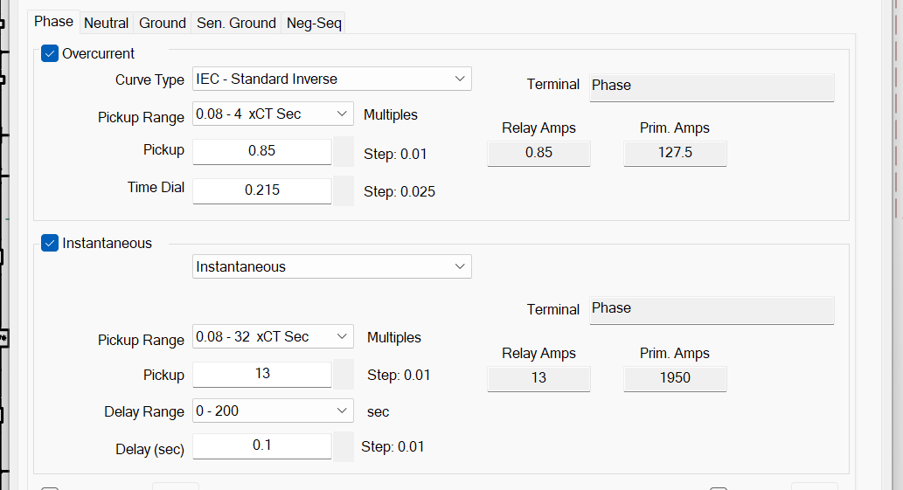
Figure 16 ETAP IDMT and DMT Stage Data Entry
Phase Fault Result:
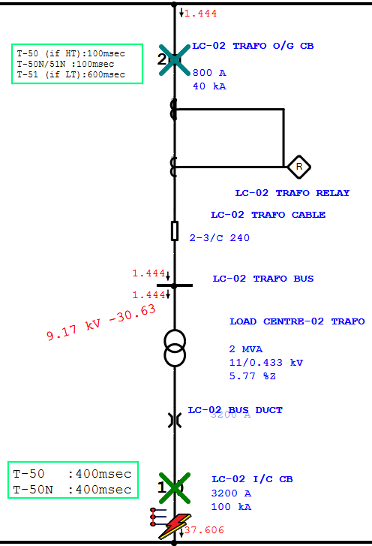
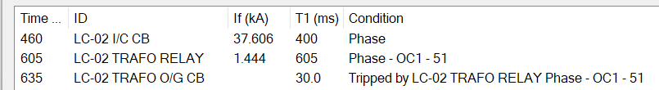

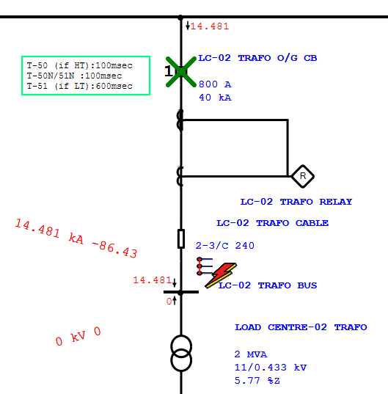

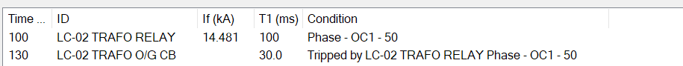

Earth Fault Relay Setting:
For NGR Earthed Systems:
- Set at 10–20% of CBCT current, or
- 10-30% of NGR current rating (whichever is appropriate)
For Solidly Earthed Systems:
- Set at 20–50% of rated current
Relay Earth fault Setting:
In an NGR-earthed system designed to limit earth fault current to 100 A, a CBCT (Core Balance Current Transformer) with a ratio of 100/1 A is used. The earth fault relay setting is typically set at 20% of the CBCT secondary current, i.e., 20 A. The time delay for the relay operation is set based on time grading to ensure coordination with upstream and downstream protection devices.
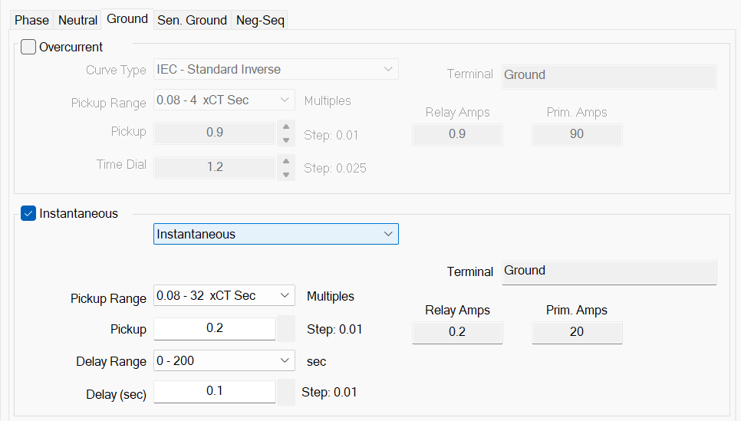
Figure 16 Earth Fault Setting Entry in ETAP
Earth Fault result:
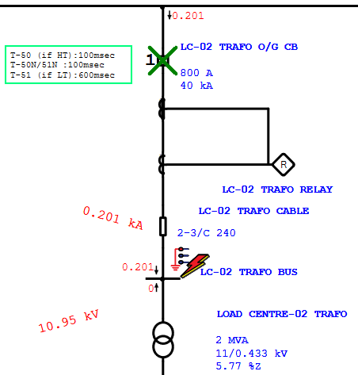

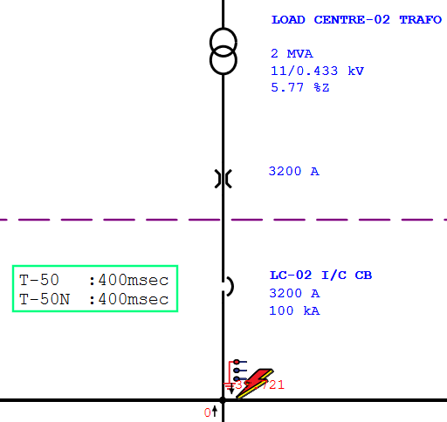

CONCLUSION
In this project, a comprehensive analysis of the industrial power distribution system was carried out using ETAP software, focusing on Load Flow Analysis, Short Circuit Study, and Relay Coordination. The Load Flow Study enabled us to evaluate the adequacy of equipment ratings under various operating scenarios. It also helped in verifying the suitability of cable sizes and the effectiveness of Automatic Power Factor Correction (APFC) units for different load conditions. Additionally, new tap settings for transformers were suggested to achieve a proper voltage profile across the network, ensuring stable and efficient operation. The Short Circuit Analysis was instrumental in assessing the capability of existing switchgear and protective devices to withstand and interrupt fault currents. Based on the results, we proposed the addition of current limiting reactors and lighting transformers at specific buses to reduce excessive fault levels and enhance system protection. Through the Relay Coordination Study, we analyzed the performance of protection relays and optimized their settings. New IDMT (Inverse Definite Minimum Time) and DMT (Definite Minimum Time) stages were suggested to improve selectivity and system reliability. In the release settings, we specifically recommended turning off the instantaneous (INS) setting where necessary to achieve proper time grading between upstream and downstream relays. Overall, the study provided critical insights into the operational robustness of the distribution system and suggested key improvements to enhance safety, reliability, and performance.

REFERENCES
- IEEE 3002.2-2018 – IEEE Recommended Practice for Conducting Load-Flow Studies and Analysis of Industrial and Commercial Power Systems
- IEC 60909 – "Short-Circuit Currents in Three-Phase AC Systems.”
- IEC 60909-0:2016, Short-circuit currents in three-phase a.c. systems – Part 0: Calculation of currents.
- IEEE Std 242-2001 (Buff Book), Recommended Practice for Protection and Coordination of Industrial and Commercial Power Systems, Institute of Electrical and Electronics Engineers, 2001.
- Parth Paradva, Prof. Ajay M. Patel, Ms. Krupa Chavada. Power System Analysis and Relay Coordination for an Industrial Distribution System. International Journal of Innovative Research in Electrical, Electronics, Instrumentation and Control Engineering, Vol. 10, Issue 4, April 2022
- Bhuvanesh. .O a, Nirmal Nair, Rashesh Mehta, Vijay Makwana “Power System Protection and Switchgear”
- https://powerprojectsindia.com/cable-sizing-calculation-low-voltage/
- https://instrumentationtools.com/types-of-relays-used-in-an-air-circuit-breaker-acb/
- https://powerprojectsindia.com/methods-of-reducing-short-circuit-current/
- https://www.se.com/in/en/product/MVS12N3NW6A/ep-mvs-cb-1250a-50ka-3p-edo-240vac-eta6-drawout-electrical-circuit-breaker/
- https://instrumentationtools.com/types-of-relays-used-in-an-air-circuit-breaker-acb/
- https://powerprojectsindia.com/transformer-protection-over-current-and-earth-fault/
- https://elek.com/resources/free-electrical-calculators/voltage-drop-as3008/

