ADVANCED PERFORMANCE ANALYSIS OF DEEP LEARNING MODEL IN SPAM DETECTON

Abstract: In Morden digital communication systems like email, SMS, social media, and online platforms, spam identification is an essential role. User privacy and cybersecurity are seriously threatened by the explosive growth of uninvited and dangerous messages like spam, phishing, and scam material. Deep learning (DL) algorithms can detect automatically learn complicated representations from large-scale several data sources, including reviews, SMS, and emails data, they have become powerful alternatives that represent contemporary spam traits across several platforms and languages are scarce. An extensive review of deep learning-based spam detection techniques is presented in this study. The dataset
Absence of dynamic, multilingual, and real-world data, Adaptability Limited ability to deal with changing spam. Include Convolutional neural networks (CNNs), recurrent neural networks (RNNs), long short-term memory (LSTM) networks, hybrid models, and transformer-based techniques are among the frequently utilized architectures that are reviewed. Explainable AI (XAI) techniques are not sufficiently integrated to offer clear and understandable explanations for spam detection choices. In order to provide future research paths for developing reliable and intelligent spam detection systems, the study also addresses datasets, assessment metrics, difficulties, and unfilled research gaps. The purpose of this survey is to present an organized summary of deep learning techniques ,the design of an effective, flexible, and user friendly deep learning-based spam detection framework that can precisely identify a variety of changing spam messages in real-world communication systems while preserving low figuring overhead and high robustness is the main issue direct in this field of study.
Keywords: Spam Detection, Deep Learning, CNN, LSTM, XAI, RNN, Transformer
1. INTRODUCTION
The volume of spam communications on a variety of platforms, including email, SMS, social media, and instant messaging services, has dramatically expanded due to the exponential growth of digital communication. In addition, these communications are frequently used for financial fraud, identity theft, phishing assaults, malware distribution, and disseminating false information. Spam poses serious cybersecurity and privacy risks to negatively impacting people's and businesses' productivity. Conventional spam filtering methods, such as rule-based systems and traditional machine learning models like Support Vector Machines and Naïve Bayes, have express poor efficacy against complex and dynamic spam patterns. By enabling automatic feature learning and capturing elaborate semantic and contextual information, they can't adapt to a wide range of dynamic spam content and are heavily reliant on feature engineering. Deep learning has transformed text classification tasks such as spam detection systems have outperformed conventional methods to developments in neural architectures and the accessibility of massive datasets in spam detection, By making it possible to automatically generate hierarchical and semantic representations from unprocessed textual data, deep learning (DL) has completely transformed spam detection.

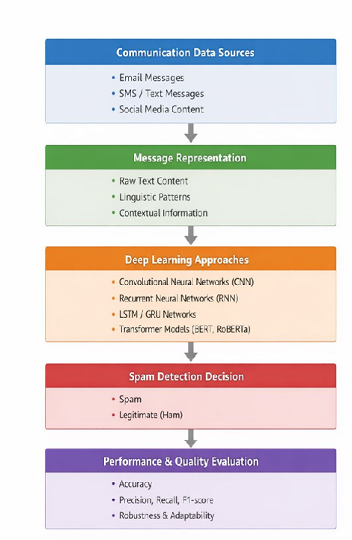
Figure 1 Deep Learning Based Spam Detection
Data sources, message attributes, deep learning models, categorization, and evaluation difficulties are all depicted in the Figure1. Local lexical patterns are captured by Convolutional Neural Networks (CNNs), sequential dependencies are modelled by Recurrent Neural Networks (RNNs) and Long Short-Term Memory (LSTM) networks, and contextualized embeddings and superior generalization are provided by Transformer-based architectures such as BERT and RoBERTa. Compared to conventional ML techniques, these models have shown notable gains in accuracy, recall, and robustness. Despite the benefits, deep learning-based spam detection has a number of drawbacks, including managing class imbalance, integrating multimodal features like URLs and metadata, handling changing spam patterns (concept drift), guaranteeing model explainability, and lowering computational complexity for real-time deployment. Developing reliable, flexible, and scalable spam detection systems requires addressing these issues. Improved performance in more recent times by utilizing contextual embeddings and self-attention processes through transfer learning. Even with deep learning models' effectiveness, there are still issues with explainability, computational cost, class imbalance, and adaptability to dynamic spam environments in the real world.
The rest of the is Study organizes as follows: In Section 2, literature review on spam detection. In Section 3, the suggested deep learning architecture is explained; in Section 4, Dataset And evaluation Metrix; and in Section 5, collusion and future research directions are outlined
2. RELATED WORK
Primary studies on spam identification regularly used arithmetical and machine learning methods using physically created features like metadata, n-grams, and word frequency. Researchers started work into deep learning for automated feature extraction with the advent of methods of RNNs and LSTMs were used to simulate sequential dependencies after CNNs were first used to collect local text with URL patterns. Because Transformer-based models like BERT and RoBERTa have lately shown state-of-the-art performance. Table1 shows up spam detection methods have been explored in a number of survey publications, ongoing developments an updated and thorough examination deep learning mechanisms. Because of its contextualized representations in call for Spam identification.
Table 1: Literature Review on Deep learning Spam detection
Paper Ref. No. | Researcher(s) | Dataset Used | Model(s) | Results & Accuracy
1 | A. Karim, S. Azam, B. Shanmugam, K. Kannoorpatti, M. Alazab | Public Email Spam | Deep Learning / Hybrid ML Models | Achieved high accuracy (≈95–97%), detection and improved feature representation
2 | P. K. Roy, J. P. Singh, S. Banerjee | SMS Spam | Deep Learning (CNN, LSTM) | Achieved Accuracy: 96.2%, Precision: 95.1%, Recall: 96.5%
3 | G. M. Shahariar, S. Biswas, F. M. Shah, S. Binte Hassan | Online Review | Deep Learning (CNN, LSTM) | spam using text features, effectively 94%detected review
4 | E. S. Rahman, S. Ullah | Email Spam | Hybrid Model | better handling of sequential patterns Achieved Accuracy: 95.7%.
5 | M. Popovac, M. Karanovic, S. Sladojevic, M. Arsenovic, A. Anderla | SMS Spam | CNN-based Model | local feature extraction in SMS messages Achieved Accuracy: 94.5%.
6 | N. Govil, K. Agarwal, A. Bansal, A. Varshney | SMS & Email D | ML-based Approach | Basic machine learning classifier with text good for accuracy 92%.
7 | B. Kim, S. Abuadbba, H. Kim | Image Spam | CNN + Data Augmentation | Image-based spam detection demonstrated capability for Accuracy: 96.8%,
8 | M. A. Shaaban, Y. F. Hassan, S. K. Guirguis | Text | Deep Convolutional Forest | Dynamic ensemble detection robustness improved Accuracy: 97%.
9 | M. Amaz Uddin, M. N. Islam, L. Maglaras, H. Janicke, I. H. Sarker | SMS Spam | Transformer-based (BERT) | Contextual embeddings improved Explainable model, classification Accuracy: 98%.
10 | H. C. Altunay, Z. Albayrak | SMS Spam Dataset | Deep Learning Architectures | Robust SMS spam detection using deep LSTM and CNN

Finally, the examined research works show that research on spam identification has expanded beyond text-based data and image-based spam detection using CNNs, Transformer-based models, including BERT model Achieved accuracy above 96%.
3. DEEP LEARNING ARCHITECTURES FOR SPAM DETECTION
This section summaries the suggested approach used for deep learning architecture for spam detection. Data gathering, text preprocessing technique, message representation, deep learning model construction framework.
3 .1 Data Collection
To provide diversity in content the dataset contains messages from many communication channels, including SMS, Social Media Spam Datasets, Review Spam, email and image-based spam datasets allow for repeatable research, they are frequently collected from anonymized real-world systems, research institutes, communication platforms, and public repositories.
3.2 Data Preprocessing
In deep learning, data pretreatment is cleaning unprocessed text by removing noise, tokenizing messages, convert to lowercase, removal of punctuation and special characters elimination of stop words, and using lemmatization or stemming. In order to help efficient learning and precise spam categorization, the processed text is then transformed into fixed-length numerical representations (embeddings).
3.3 Message Representation
The word embedding techniques use for Numerical representations words are captured through inks from pre-processed messages created for deep learning models. Including the architecture, contextual embeddings from Transformer-based models like BERT or pre-trained models like Word2Vec and GloVe may be used to create embeddings. Figure 2 distinct the processed architecture for spam identification.
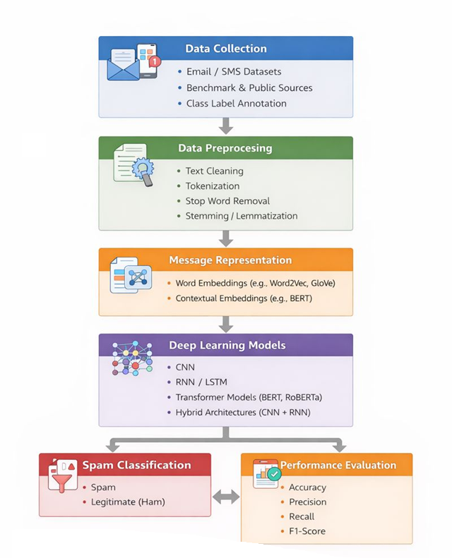
Figure 2 Deep Learning Framework
3.4 Deep Learning Architectures
Several deep learning architectures are investigated in order to assess how well they detect spam:
- Convolutional Neural Networks (CNN): CNNs effectively capture n-gram information can extract local features like spam-indicative patterns and important phrases, they are frequently employed for text classification. By applying convolutional filters. When it comes to email and SMS spam classification jobs, CNN-based spam detectors have demonstrated excellent Convolutional filters on word embeddings are used to extract both spatial and local textual information.
- Recurrent Neural Networks (RNN) and Long Short-Term Memory (LSTM): Sequential record the message text's data processing and contextual memory maintenance are built into RNNs and LSTMs. LSTM networks modelled using long-range dependencies in text can be effectively, these models work very well for long-message and email spam detection and sequential dependencies.
- Transformer-Based Models: Apply self-attention mechanisms to better capture semantic and contextual links in text, systems like BERT and Roberta enable reliable classification in spam detection than conventional sequential models. By comprehending word meaning in context, improving the detection of complex and dynamic spam messages.
Every Deep learning Architecture is carried out utilizing common frameworks in a controlled setting. To provide the models are assessed consistently under the same circumstances and reproducibility of results. Standard classification metrics, including as accuracy, precision, recall, and F1-score, are used to assess the model's performance. These measures offer a thorough evaluation of detection capability, especially when class imbalance is present. The best architecture is determined by comparative study.

4.RESULT AND DISCUSSION
The majority of research uses static benchmark datasets that don't accurately represent the diversity of spam in the real world. Large-scale, multilingual, multimodal datasets are required. Current models suffer from concept of spam tactics change over time. Online and continuous learning strategies are still not adaptability to evolving Spam well studied. Transparency is typically lacking in deep learning models. One important research gap identified in the survey need is the integration of explainable AI systems to produce explanations that are intelligible to humans. Furthermore, lightweight architectures are required to computational cost of transformer-based models. The majority of current effort is text-only not multimodal classification. The performance of detection can be greatly enhanced by combining textual, metadata, behavioural, and visual information.
4.1 COMPARATIVE ANALYSIS
According to the comparison analysis, Advanced and Hybrid deep learning models perform effectively than standalone architectures. CNN-LSTM and Transformer-based models showed better flexibility and generalization ability across various spam content categories. Traditional machine learning techniques had greater false positive rates and lesser accuracy.
Table 2: Comparison Result in deep learning model for spam detection
Model | Accuracy (%) | Precision (%) | Recall (%) | F1-Score (%)
CNN | 94.3 | 93.8 | 92.9 | 93.3
RNN | 95.1 | 94.6 | 94.0 | 94.3
LSTM | 96.0 | 95.5 | 95.2 | 95.3
CNN–LSTM | 96.8 | 96.2 | 95.9 | 96.0
Transformer (BERT) | 98.1 | 97.8 | 97.6 | 97.7

According to the experimental evaluation, Table 2 indicate Transformer-based architectures perform better than CNN and RNN-based models on all measures. However, Limited real-time deployment is hampered by their increased processing cost. performance. In hybrid deep learning architectures are balanced Accuracy and complexity.

Figure 3: Deep learning Model Comparison results
Figure 3 Shows that Visual representation of various Deep learning model evaluation metrics in Spam detection comparison Analysis in exiting researcher carron work in Different kind of textual data set.
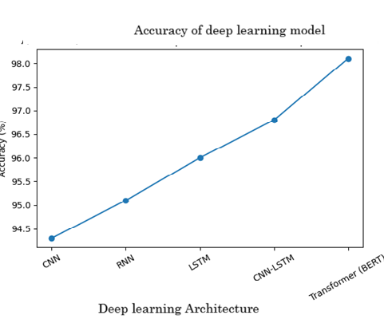
Figure 4: Accuracy of Deep learning model
Deep learning Models like CNN. RNN, LSTM, Transformer model Varying in the Accuracy Level in spam text. Figure 4 indicate clearly improvement of progressive report from older to advanced, it is evident that performance has gradually increased. The comparison findings deep learning architectures for spam detection to improve real-world applicability.
7. CONCLUSION
A comparative Analysis of deep learning techniques for spam detection was provided by this article. CNNs, RNNs, hybrid models, and Transformer-based architectures have greatly increased textual representations of spam detection accuracy. Nevertheless, research challenges such as evolving spam approaches, explainability concerns, and computational constraints remain unsolved issues. Future research Focused on adaptive, explainable, and effective deep learning models combined with multimodal data sources and to create reliable next-generation spam detection. Despite this study, deep learning models have a notable drawback, such as class imbalance, a lack of data, high computing costs, explainability issues, and susceptibility to hostile attacks. Additionally, implementing trustworthy spam detection mechanism required for addressing these issues. Now a days a lack of research on multimodal spam detection, which integrates text, URLs, metadata, and behavioural aspects in advanced deep larning models.
REFERENCES
- Karim, S. Azam, B. Shanmugam, K. Kannoorpatti, and M. Alazab, “A Comprehensive Survey for Intelligent Spam Email Detection,” IEEE, vol. 7, pp. 168261–168295, 2019.
Doi: 10.1109/ACCESS.2019.2954791.

- P. K. Roy, J. P. Singh, and S. Banerjee, “Deep learning to filter SMS spam,” Future Generation Computer Systems, vol. 102, pp. 524–533, 2020.
Doi: 10.1016/j.future.2019.09.001.

- G. M. Shahariar, S. Biswas, F. M. Shah and S. B. Hassan, “Spam review detection using deep learning,” in Proc. 2019 IEEE 10th Annu. Inf. Technol., Electron. Mobile Commun. Conf. (IEMCON), Vancouver, BC, Canada, pp. 01-07,2019.
Doi: 10.1109/IEMCON.2019.8936148.

- E. S. Rahman and S. Ullah, “Email spam detection using bidirectional long short-term memory with convolutional neural network, “in Proc. IEEE Region 10 Symp. (TENSYMP), Dhaka, Bangladesh, pp. 1307–1311,2020.

- M. Popovac, M. Karanovic, S. Sladojevic, M. Arsenovic, and A. Anderla,
“Convolutional neural network based SMS spam detection,” 2018 Telecommunication Forum (TELFOR), 2018.

- N. Govil, K. Agarwal, A. Bansal, and A. Varshney,“A machine learning based spam detection mechanism,” 2020 Fourth International Conference on Computing Methodologies and Communication (ICCMC), pp. 954–957, 2020.

- Kim, S. Abuadbba, and H. Kim,“DeepCapture: Image Spam Detection Using Deep Learning and Data Augmentation,” arXiv:2006.08885, 2020.
https://arxiv.org/abs/2006.08885
- M. A. Shaaban, Y. F. Hassan, and S. K. Guirguis, “Deep convolutional forest: A dynamic deep ensemble approach for spam detection in text,” Complex & Intelligent Systems, 2021. https://arxiv.org/abs/2110.15718

- M. A. Uddin, M. N. Islam, L. Maglaras, H. Janicke, and I. H. Sarker, “ExplainableDetector: Exploring transformer-based language modeling approach for SMS spam detection with explainability analysis,” arXiv preprint arXiv:2405.08026, 2024.

- H. C. Altunay and Z. Albayrak,“SMS Spam Detection System Based on Deep Learning Architectures,” Applied Sciences, vol. 14, no. 24, 11804, 2024.
https://doi.org/10.3390/app142411804

