Phyto-Derived Therapeutic Analogs for Neurological Disorders with Prevalence Insights into Metropolitan and Non-Metropolitan Regions of India: A Review
Ria¹ and Harsharan Singh¹*
¹Department of Plant Sciences, Central University of Himachal Pradesh, Shahpur, Kangra-176206, Himachal Pradesh, India.
Email: mriarehan@gmail.com
ORCiD ID: 0009-0004-7759-2275

¹*Corresponding Author: Dr. Harsharan Singh,
Department of Plant Sciences, Central University of Himachal Pradesh, Shahpur, Kangra-176206, Himachal Pradesh, India
Email: harsharan@hpcu.ac.in
ORCiD ID: 0009-0006-4473-8244
Contact Number: 9877212423

ABSTRACT

The field of neurological disorders is a growing public health issue, and India has shown this trend in a very uneven distribution between metropolitan and non-metropolitan areas. Air pollution, chronic stress, sedentary lifestyles, and the availability of better diagnosis have become the causes of reported increasing incidence of stroke, migraine, dementia, and Parkinson's disease among metropolitan population. In contrast, non-metropolitan regions have to experience more prevalence of epilepsy, neuroinfections, neurotrauma, and neurological impairment secondary to malnutrition due to late diagnosis and limited specialist care. The current pharmacological treatments are mostly symptomatic with common side effects and potential lack of disease-modifying effects. Neurotherapeutics derived from plants provide a potential, less expensive and culturally rooted alternative. Established medicinal species, including Withania somnifera, Bacopa monnier have multi-target effects, which are antioxidant, anti-inflammatory, neuroprotective, and neuromodulatory. Because of their extensive use in treatments, their analogs having similar activities must be found, to extend the spectrum of potential neuroprotective agents and reliance on ecologically endangered species is minimized. Further, this review summarises the metropolitan and non-metropolitan neurological disease incidence in India, where the inducers of neurological disorders might be similar but effects may vary due to availability of diagnosis, treatment and various other environmental and societal conditions. The review points out the therapeutic potential of already known plant compounds and their less-studied structural analogs. Through a combination of phytochemical research and a region-specific medical requirement, plant-based molecules may assist in filling diagnostic gaps and offer more accessible and sustainable treatment for neurological conditions in India.

Keywords: Neurological disorders, Phytochemical analogs, Neuroprotection, Medicinal plants, India

INTRODUCTION
Neurological disorders are among the most critical health problems of the 21st century (Whiteford et al., 2015). On the basis of data from Global Burden of Disease (GBD) 2021, neurological conditions collectively affect over 3.4 billion people worldwide; that is nearly 43% of the global population (Ferrari et al., 2024).
Besides being the most significant contributors to disability, these neurological disorders are among the prominent causes of premature death (GBD, 2021). In India, there has been a worrying upward trend of neurological disorders with 44% increase of burden between 1990-2013 overtaking several other countries in Asia, including China, which had seen a 20% increase (Charlson et al, 2016). According to current estimates, 20 to 30 million persons in India suffer from neurological illnesses, with incidence rates that range from 967 to 4,070 per 100,000 people (Gourie-Devi, 2014).

Figure 1: Factors Responsible for Neurological Disorders
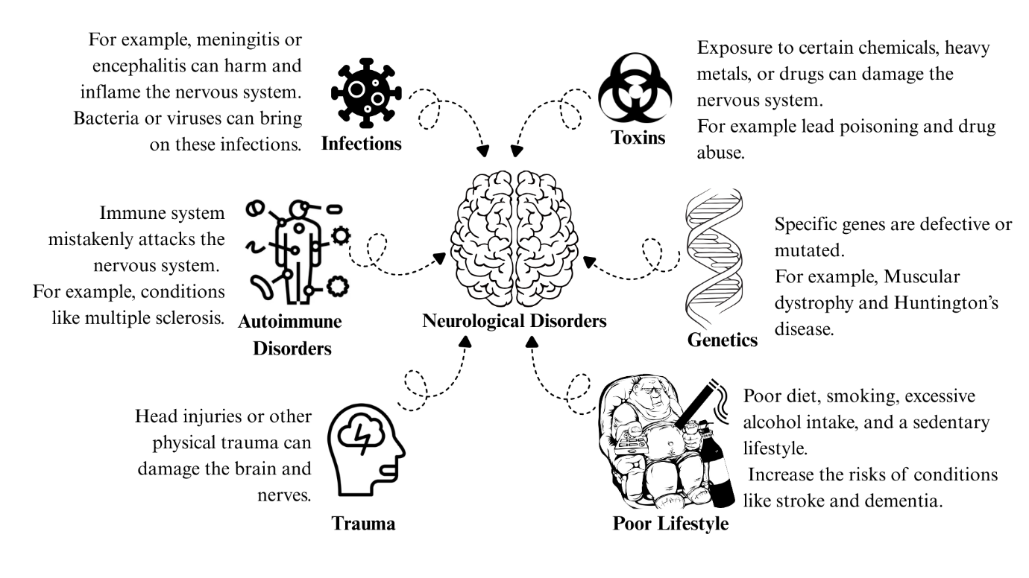
Distribution of neurological disorders in India is characterized by a significant distinction between metropolitan and non-metropolitan regions of the country. A metropolitan region represents a significantly broader spatial construct than the metropolitan area, encompassing a diverse set of urban, semi-urban, and rural territories that together form an extended functional system, including the metropolitan area itself, nearby towns, satellite cities, growth centres, peri-urban transition zones, logistics corridors, industrial clusters, and rural hinterlands economically connected to the core city.
In India, a metropolitan region is a larger geographical, economic, and functional territory that includes the metropolitan area, surrounding peri-urban/semi-urban/rural towns, industrial clusters, satellite towns, and regional corridors e.g., Delhi NCR spanning Delhi NCT and districts in Haryana, UP, and Rajasthan (Sharma, 2025). The term "non-metropolitan" is generally used for areas outside metropolitan urban agglomerations or statutory metropolitan jurisdictions that are economically not connected to the city (Balk et al., 2019).
Figure 2: Components of a metropolitan region (Sharma,2025)
Metropolitan Region

Rural hinterlands that are economically connected to the city.

The metropolitan area
Nearby towns, satellite cities, and growth centres

This distinction reflects environmental exposures, lifestyle, access to health care, correct diagnosis and the socio-economic realities of both regions. Neurodegenerative and stress-related disorders like dementia, Alzheimer's disease, Parkinson's disease, migraine, stroke are said to have more metropolitan representation. This trend is in significant part due to longer life expectancy, greater survival from other chronic diseases and the cumulative effect of conditions in the urban environment. Chronic exposure to air and noise pollution, circadian rhythm disruptions from work in different shifts and high stress levels promote oxidative damage and neuro-inflammatory pathways, leading urban residents to degenerative neurological conditions. For example, exposure to fine particulate matter (PM _{2.5}) in metropolitan regions have been strongly related to an increased frequency of stroke and cognitive impairment, emphasizing the critical influence of environmental factors on neurological health (Fu et al., 2018). According to the latest data, several non-communicable risk factors of neurological disorders are stress (44% of the population), low physical activity (67%), an unbalanced diet (55%), and obesity (24%). These risk factors are exponentially greater in metropolitan areas, where modern ways of living encourage prolonged sitting, poor food habits, disrupted sleeping and chronic psychological strain.
In contrast, the neurological disease pattern of non-metropolitan regions of India still reflects the burden of infectious, nutritional and trauma-related conditions. For instance, epilepsy is seen more commonly in non-metropolitan populations because of untreated head injuries often related to agricultural activity or road accidents, perinatal complications and parasitic infections such as neurocysticercosis. Peripheral neuropathies are also common in non-metropolitan communities, where malnutrition, micronutrient deficiencies and exposure to neurotoxic pesticides are common. Stroke is also increasingly recognised in these settings, but unlike in metropolitan areas, the burden in these settings is majorly attributed to uncontrolled hypertension and poor access to timely treatment. This divergence represents the epidemiological transition India is experiencing, where the urban centres are experiencing increasing degenerative disorders and rural parts of the country, belonging to non-metropolitan regions, are still afflicted in their fight against the preventable and infectious neurological conditions.
Another critical factor shaping this divide in India is the difference in healthcare infrastructure and diagnostic capacity. Urban populations in metropolitan areas have the advantage of access to neurologists, tertiary hospitals, and sophisticated imaging technology, which is beneficial for the early detection of disorders like early-onset Parkinson's disease. Conversely, patients from rural areas of the non-metropolitan areas usually come with late stages of diseases because of less awareness, cultural stigma, and inadequate access to specialised care. As a result, the actual amount of neurological diseases in the non-metropolitan areas is likely underestimated. It is a reflection of underdiagnosis, rather than an actual lower disease burden. There are also socioeconomic and occupational patterns that contribute to this differentiation. Urban employment, with its sedentary work, exposure to digital screens and stress in the workplace, predisposes individuals to headaches, insomnia and psychosomatic neurological conditions. In the non-metropolitan context, there are exposure risks to traumatic brain injuries, neurotoxicity from pesticides and neuropathies from repetitive stress through manual labour and agricultural practices.
Combined, these trends help underscore the fact that metropolitan India is moving more towards chronic, degenerative, and lifestyle-related neurological diseases, with a population in non-metropolitan areas still having a greater burden of infectious, nutritional and trauma-related disease. This two-sided epidemiology is the image of the accelerating but uneven health transition in India, with the increase in urban stress and the lack of health care in the countryside. Modern pharmacological therapies are offering relief in the form of the symptoms but in most cases, they fail to ensure prevention of the disease advancement which is associated with its side effects. On the one hand, antiepileptics cause cognitive dulling and L-DOPA is used for treating patients with Parkinson’s disease which causes dyskinesias, an involuntary movement.
These limitations highlight the need to investigate plant-based therapies, particularly in the Indian context, where Ayurveda and traditional medicine have long emphasised stress reduction and neurological balance. Medicinal plants with adaptogenic, antioxidant, and neuroprotective properties, such as Bacopa monnieri, Curcuma longa, Withania somnifera and Centella asiatica have shown promise in mitigating stress pathways while directly targeting neurological pathology.
The cases of the neurologic conditions are growing around the world. The combined effects of urban stressor and sedentary lifestyle and the neurological risk are peculiar to Indian metropolitan populations, which are now more vulnerable than rural populations, which are either underdiagnosed and untreated. Here, the concept of the combination of plant-based neurotherapeutics and region-specific healthcare is essential to fill the gaps in diagnosis, decrease inequities in treatment, and promote sustainable management of the neurological conditions among diverse populations. In this context, integrating plant-based neurotherapeutics with region-specific healthcare approaches becomes crucial for bridging diagnostic gaps, reducing treatment inequities, and ensuring sustainable management of neurological disorders across diverse populations. The analogs continue to preserve the core pharmacophores and in addition, have structural variations capable of making them antioxidants, increase blood-brain barrier permeability, or reduce toxicity and serve as a route to more effective and versatile therapy. Their inclusion does not only widen the list of neurotherapies but it also provides an assurance that the population of metropolitan and non-metropolitan regions will have access to affordable, accessible interventions that are scientifically-proven. Therefore, this review aims to (1) describe present condition and prevalence of the principal neurological disorders in India, (2) analyse demographic variations between metropolitan areas and other non-metropolitan areas of India, and (3) generalise evidence on medicinal plants with known or suspected neurotherapeutic potential effects.
REVIEW METHODOLOGY
This review was conducted by searching the scientific literature published between 2000 and 2025 to synthesise evidence on the prevalence, epidemiology, and plant-based management of neurological disorders. Major databases, including Scopus, ScienceDirect, PubMed, and Google Scholar, were explored, along with reports from World Health Organisation and Global Burden of Disease Study. Keywords such as “neurological disorders”, “India”, “urban stress”, “metropolitan and non-metropolitan”, “rural India” “epidemiology”, “plant-based treatment”, “Ayurveda”, “medicinal plants”, “phytochemicals”, “neuroprotection”, “Parkinson’s disease” “stroke”, “migraine”, “Alzheimer’s disease”, and “epilepsy” were used in various combinations to refine searches. Only peer-reviewed articles, systematic reviews, meta-analyses, and epidemiological reports available in English were included, while non-English publications, irrelevant studies, and inaccessible full texts were excluded. Plant names and their synonyms were validated using standard taxonomic databases, such as The Plant List and MPNS (Medicinal Plant Names Services, Kew Science). The mentioned phytochemicals were confirmed using PubChem and PubMed databases. Accurate and clear chemical structures of the chosen phytochemicals were made using PubChem Sketcher. The acquired research was critically reviewed to highlight three key points: (i) the world and Indian burden of neurological diseases, (ii) urban and rural disparities in the rate and distribution of the disease in India, and (iii) medicinal plants and bioactive substances, and their hypothetical plant-based alternatives.
Neurological Disorders
The nervous system is impacted by neurological disorders. The neurological system, which works as the body's command centre, sends impulses that govern our movements, thoughts, and physical processes. Any malfunction in this system can cause neurological diseases.
Neurological conditions cover a broad range of ailments impacting the central and peripheral nervous systems, and can generally be classified into:
- Cerebrovascular disorders (e.g., stroke, aneurysms, vascular dementia)
- Neurodegenerative disorders (e.g., Huntington’s disease, multiple sclerosis, Parkinson’s disease, Alzheimer’s disease)
- Neuroinfections and inflammatory disorders (e.g., meningitis, encephalitis, neurocysticercosis, multiple sclerosis)
- Neuromuscular and demyelinating disorders (e.g., diabetic neuropathy, amyotrophic lateral sclerosis, myasthenia gravis)
- Headache and pain-related disorders (e.g., migraine, cluster headaches, neuropathic pain)
- Neurodevelopmental disorders (e.g., autism spectrum disorders, cerebral palsy)
- Tumours and malignancies of the nervous system.
- Trauma-related conditions (e.g., traumatic brain injury, spinal cord injury)

Figure 3: Globally Leading Neurological Disorders as per Global Burden of Disease Study 2019, Expressed as Disability-Adjusted Life Years
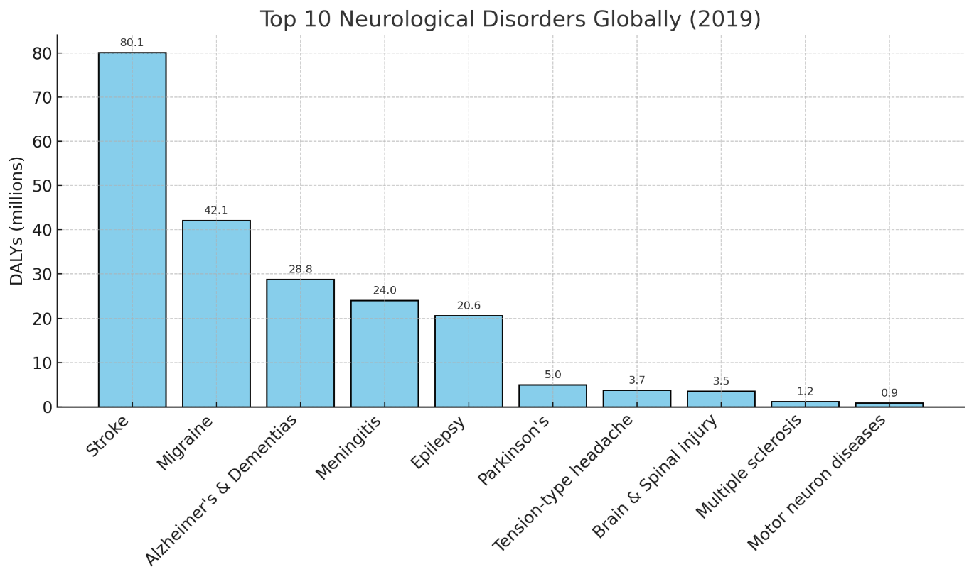

*(DALYs depict total years of life lost because of early death (YLLs) and the years lived with a disability (YLDs) resulting from existing instances of the illness or health issue within a population).

As per the data on the global burden of neurological disorders in 2019, stroke clearly emerges as the most significant contributor, accounting for approximately 80.1 million DALYs, reflecting its high prevalence and severe long-term disability outcomes. Migraine, despite being non-fatal, occupies the second position with 42.1 million DALYs, emphasising the considerable years lived with disability it generates. Alzheimer’s disease and other dementias rank third (28.8 million DALYs), underscoring the growing challenge of neurodegenerative conditions in ageing populations worldwide. Infectious causes like meningitis (24.0 million DALYs) and chronic conditions such as epilepsy (20.6 million DALYs) further highlight the diverse etiological spectrum contributing to neurological disease burden. In contrast, rarer disorders such as multiple sclerosis (1.2 million DALYs) and motor neuron diseases (0.9 million DALYs) contribute relatively less at a global scale, but remain highly debilitating at the individual level. This distribution demonstrates that both high-mortality conditions (e.g., stroke) and non-fatal disabling disorders (e.g., migraine) dominate the global neurological health landscape (Feigin et al., 2019; Huang et al., 2023).

Figure 4: Leading Neurological Disorder DALYs in India as per Global Burden of Disease Study, 2019
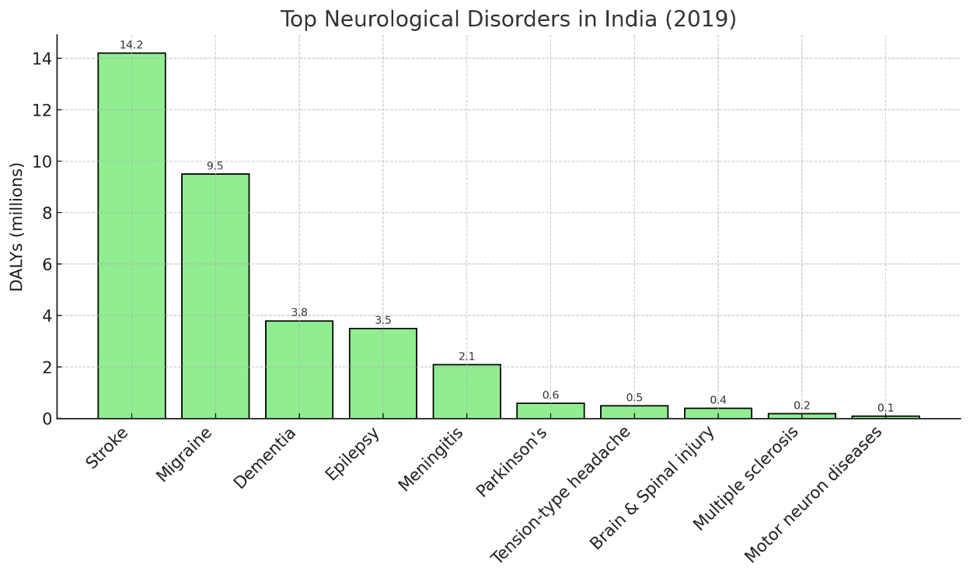
India contributes a substantial share of South Asian neurological disease burden. Stroke and migraine dominate, mirroring the global picture but at a particularly high absolute scale due to India’s large population. Dementia and epilepsy are also prominent, indicating that both ageing-related and long-standing neurological conditions contribute significantly. Meningitis remains more prominent in India compared to high-income countries, reflecting persistent challenges with infectious disease control. Parkinson’s disease and tension-type headache contribute moderately, while conditions such as multiple sclerosis and motor neuron diseases account for smaller proportions but remain clinically important (Gourie-Devi et al., 2004). This India-specific profile underscores the need for targeted strategies addressing both vascular and infectious neurological disorders, alongside preparation for the rising tide of dementia and other age-associated diseases.

Prevalence of Neurological Disorders in Metropolitan and Non-Metropolitan Areas
The epidemiological footprint of neurological disorders in India reveals a sharp urban-rural divide. In the case of stroke, there has been a concerning increase in the cases among younger adults (20-45 years) in metropolitan hospitals, which is attributed to the effect of stress, sedentary lifestyle, and poor quality of sleep. Indicatively, the number of stroke cases among IT professionals has increased many times over the last few years in Hyderabad. On the same note, urban women aged 30-45 years are significantly more susceptible to migraine with stress and hormonal fluctuations being synergistic conditions. According to the national statistics, migraine affects 15-18 percent of women and 6-8 percent of men, and it was more detected in urban healthcare systems (WHO Neurological Disorders Report, 2021). In contrast, epilepsy has increased prevalence in rural India because it is perinatally injured, neuro-infected, whereas metropolitan centres have higher rates of drug resistant cases subject to tertiary care. Both dementia and Parkinson disease are also disproportionately identified in urban populations, which is partly explained by the fact that better diagnostic facilities and longer life expectancy in cities are detected. Notably, stress in urban living conditions is a precipitating factor via vascular and metabolic risk and an exacerbating factor enhancing cognitive deterioration and motor symptoms. Although the incidence of neurological diseases in the world has shown significant disparities by region, India depicts a very intricate epidemiological picture, owing to its high rates of urbanisation and population heterogeneity. As over one-third of the population has moved into metropolitan regions and it is estimated that half of India will be urban by 2050 (WHO, 2021), the distribution of neurological disorders is a growing culture of the duality of urban stress-related disorders and rural under-diagnosis with high treatment gaps. Stroke and migraine exhibit an increase in their prevalence in metropolitan regions, especially in younger adults with the rise of exposure to sedentary jobs, lengthy commuting distances, and chronic psychosocial stress. Conversely, epilepsy and dementia tend to be more problematic in rural areas and indicates a lack of specialised care, untreated vascular and infectious risk factors and socioeconomic obstacles to prompt diagnosis. Parkinson disease exists between two worlds, as the prevalence is more detected in urban areas, yet there is an environmental exposure, pesticide use that may lead to rural prevalence (Janardhana et al., 2023). These tendencies take place against the background of alarming national prognoses: neurological diseases affect 20-30 million Indians, with the prevalence rate ranging between 967 to 4070 per hundred thousand people, and the overall burden is also projected to increase by 23 percent by 2025 (WHO, 2021). More so, comprehensive state-level analysis of Global Burden of Disease Study (1990-2019) indicates non-communicable neurological disorders share in total DALYs increased in India by 4.0% to 8.2% in 1990 and 2019, respectively, with injury-related DALYs increasing by 0.2 to 0.6. Communicable neurological diseases went down to 4.1 to 1.1. In 2019, headache disorders (17.5%), stroke (37.9%) and epilepsy (11.3%) were the leading causes with considerable state discrepancies (Singh et al., 2021). These tendencies altogether highlight the fact that the crisis of neurological health in India is not only increasing but also fragmented by the metropolitan tendency to over-diagnose stress-related illness and rural tendencies to ignore preventable and curable neurological diseases. The variations in metropolitan and non-metropolitan trends are condensed in Table 1, which identifies the prevalence, patterns, and major differences of major neurological disorders in India.
Disorder | National Prevalence | Metropolitan and Non-Metropolitan Trends | Key Causes | References
Stroke | Stroke is a significant neurological disorder in India, with prevalence rates varying widely across urban and rural settings, ranging from 44.54 to 487 per 100,000 population. | Impacts approximately 33-123/100,000 of the population. Increasing incidence among younger adults (20–45 yrs), especially IT professionals in cities like Hyderabad and Bengaluru.  Rural areas have reported around 123.57/100,000 cases of stroke.  Worse outcomes occur due to limited acute care and rehab access. | Hypertension, diabetes, obesity and sedentary lifestyle. | Hedau et al., 2024
Migraine | Migraine prevalence in India ranges between 14% and 26% nationally, with significant regional variations and a strong female predominance. | Multiple regional studies provide robust evidence of migraine’s epidemiology. The Delhi and NCR study found a 26.3% one-year migraine prevalence, whereas an Eastern India study reported a prevalence of 14.12%. Rural areas consistently show higher prevalence rates, with females experiencing significantly higher rates (35.7% vs. 15.1% in males) | Environmental exposure, education levels and oral contraceptives account for about 75% of migraine cases. | Chowdhury et al., 2024
Dementia (incl. Alzheimer’s) | Dementia affects approximately 20 per 1,000 people in India, with an estimated 4.1 million current cases expected to double by 2030. | Prevalence rates appear similar across rural and urban populations | Rapidly rising with ageing, Low education levels, Family history, and Hypertension | Kumar et al., 2019
Epilepsy | Epilepsy affects approximately 10-12 million people in India, with a national occurrence of 4.7 per 1,000 population. | Studies reveal that neurological problems are twice as common in rural as in urban settings, indicating a significantly higher incidence in rural communities. | Neuroinfections, Neurocysticercosis, Neurotrauma, Birth injuries, | Dhiman et al., 2021
Parkinson’s Disease | Shows significant regional variation, with incidence rates between 42.3 to 52.85 per 100,000 population, increasing dramatically to 308.9 per 100,000 in populations over 60 years old. | Metropolitan cities like Kolkata demonstrate slightly higher prevalence rates compared to rural areas. While specific national-level data remains limited, studies consistently show that PD prevalence increases with age for both genders | Potential genetic and environmental factors, though no definitive links have been established. | Je et al., 2021, Khurana et al., 2025.
Table 1: National Prevalence and Key Causes of Neurological Disorders
The prevalence of neurological disorders in India demonstrates a striking urban-rural divide, reflecting differences in lifestyle, healthcare access, and diagnostic capacity. Metropolitan areas, characterised by high population density, sedentary occupations, and elevated psychosocial stress, show higher rates of stress-linked disorders such as stroke, migraine, and dementia. In contrast, non-metropolitan and rural areas face a disproportionate burden of epilepsy, neuroinfections, and late-diagnosed neurodegenerative conditions, often due to inadequate healthcare infrastructure and persistent treatment gaps (Singh et al., 2021; Feigin et al., 2021).

Figure 5: Prominent Neurological Disorders in Metropolitan and Non-Metropolitan Areas

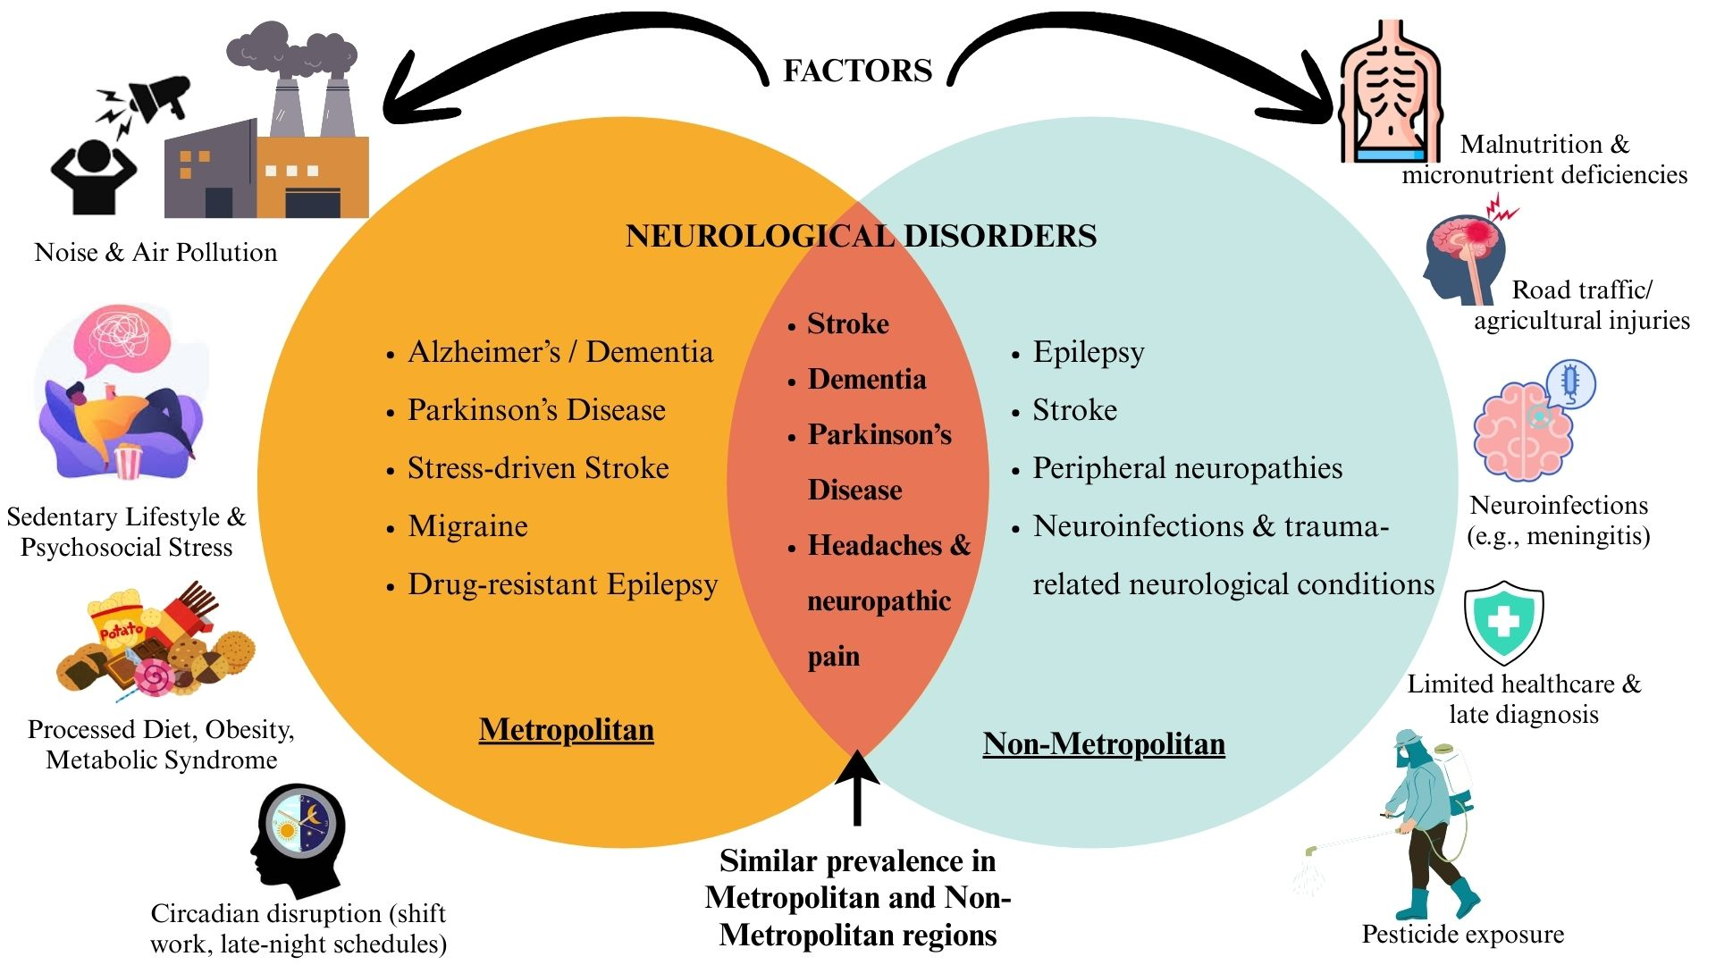
Burden of Neurological Disorders in Metropolitan and Urban regions of India
According to recent reports, the number of stroke cases is growing significantly in young adulthood in metropolitan areas like Bengaluru, Hyderabad, and Delhi, especially among IT professionals and corporate workers who work long hours, are exposed to chronic stress, and lack sleep. The incidence of migraine also varies in urban areas, with 15 to 18% of women and 6 to 8% of men experiencing it, and urban women aged 30 to 45 being the most susceptible group of people because of the combination of stress and hormonal changes and disrupted regularities (WHO, 2021). Metropolitan populations have higher rates of dementia and Parkinson disease not only due to the increased life expectancy but also to the increased number of special diagnostic facilities and care (Janardhana et al., 2023). Moreover, the prevalence of drug-resistant epilepsy is also rising in urban India in tertiary hospitals, indicating better detection and lifestyle factors including sleep deprivation and comorbid mental disorders (Dhiman et al., 2021)
Burden of Neurological Disorders in Non-Metropolitan and Rural regions of India
In non-metropolitan regions of India, the prevalence of epilepsy is higher, and surveys show a combined prevalence of 11.9 per 1,000 people in rural regions as opposed to 5.7 per 1,000 in urban regions (Dhiman et al., 2021). This gap is closely attributed to perinatal injuries, neurocysticercosis which has not been treated and increased rates of traumatic brain injuries due to road accidents and farm hazards. There is also a possibility of underdiagnosis of dementia in non-metropolitan areas because the vascular risks (hypertension and diabetes) are not well controlled, thereby increasing the true prevalence, which is higher than the reported one. Pesticide exposure and agricultural activity have been suggested as risk factors for higher prevalence in some rural groups, despite the fact that cases of Parkinson's disease are disproportionately reported in metropolitan areas (Janardhana et al., 2023). The fact that neuroinfections and malnutrition-induced neurological morbidity persist in non-metropolitan regions elucidates the contribution of the socioeconomic inequities to disease distribution.
In general, stress-related and lifestyle-related neurological conditions are more common among urban population of metropolitan regions, whereas rural population of non-metropolitan areas suffer more deaths, worse outcomes, and treatment gaps because of the lack of acute care, rehabilitation facilities, and awareness campaigns. This dichotomy highlights the importance of specific interventions: the stress management, preventive care and lifestyle modification programs are required to the urban population and enhanced infection control, maternal-child health services and primary neurological care to the rural population. There is notable inter-state variation because of urbanization, socioeconomic development, and healthcare access (Feigin et al., 2021; Singh et al., 2021).

Plant-based Treatment of Neurological Disorders
The available pharmacological therapies in the treatment of neurological disorders are symptomatic but are still insufficient in the prevention of diseases. Symptoms can be treated with drugs like antiepileptics, dopaminergic, and cholinesterase inhibitors, but they have serious side effects, including drowsiness, dyskinesias, nausea, and cardiovascular factors (Singh et al., 2021; Feigin et al., 2021). Additionally, most neurological diseases do not have disease-modifying therapies, and therefore their medical need has not been met sufficiently. Within the Indian context, the problem is aggravated by differences in accessibility to healthcare between metropolitan and non-metropolitan areas, expensive healthcare and a high number of individuals that depend on traditional healthcare systems like Ayurveda. Plant-based therapies are a cheap, culturally acceptable, and sustainable alternative. Medicinal plants are also source of a variety of bioactive phytochemicals that can directly act on the pathophysiological pathways of neurodegeneration, ischemia and synaptic dysfunction with anti-inflammatory, antioxidant, adaptogenic, neurotrophic and anti-apoptotic effects. Phytochemicals are particularly helpful in multifactorial disorders like stroke, dementia, and epilepsy because, unlike single-target synthetic medications, they often act on multiple biological pathways simultaneously (Janardhana et al., 2023). The Bacopa monnieri (brahmi), Withania somnifera (ashwagandha), Curcuma longa (turmeric) and Centella asiatica (gotu kola) are traditional Indian herbs already known to have an adaptogenic effect as well as neuroprotective properties, and have been incorporated into folk and Ayurvedic preparations. These effects are increasingly being confirmed by modern pharmacological studies, which offers a chance to reconcile conventional knowledge with the evidences of neurology. Plant-based therapies have multi-target effects (anti-inflammatory, anti-apoptotic, antioxidant, neurotrophic, modulation of synapses) and these are in line with the intricate pathobiology of major neurological disorders.
Plant-derived compounds such as polyphenols, terpenoids, curcuminoids have antioxidant and anti-inflammatory properties, blocking COX-2 production, nuclear factor kappa B signalling and proinflammatory cytokines for example IL-1β and TNF-α (Gawrysz et al., 2025; Fan & Lei, 2022). These agents also support mitochondrial integrity and anti-apoptotic pathways, evidenced by modulation of the Bcl-2/Bax ratio, suppression of caspase-3, and stabilisation of neuronal membranes (Gawrysz et al., 2025). Their influence on neurotransmission and synaptic plasticity encompasses GABAergic facilitation, cholinesterase inhibition, modulation of glutamate and NMDA, and upregulation of BDNF (Gawrysz et al., 2025; Semwal et al., 2014). Additionally, endothelial stabilisation and antiplatelet effect aid cerebrovascular protection, especially in a situation of ischemic injury (Fan & Lei, 2022).

Figure 6: Major inflammatory pathways of neurological disorders
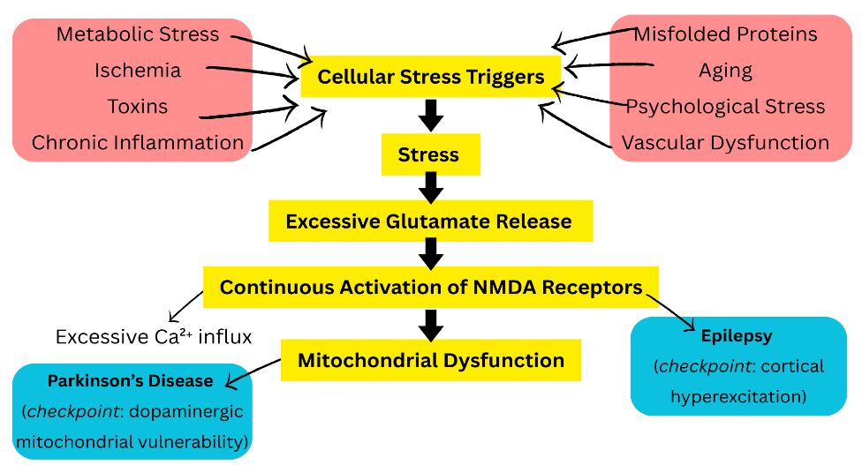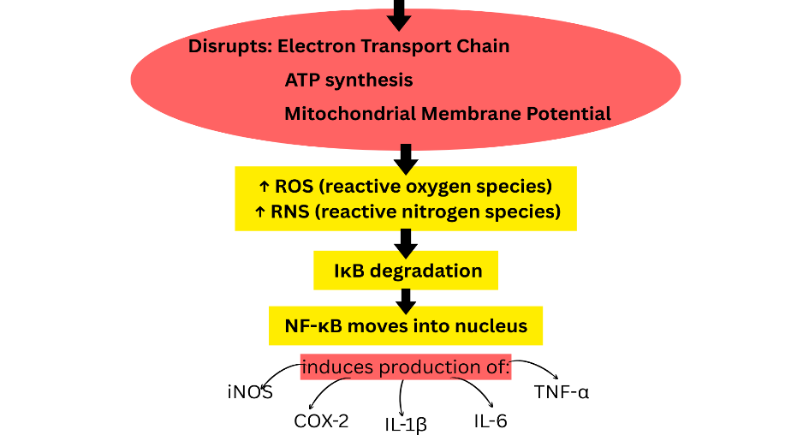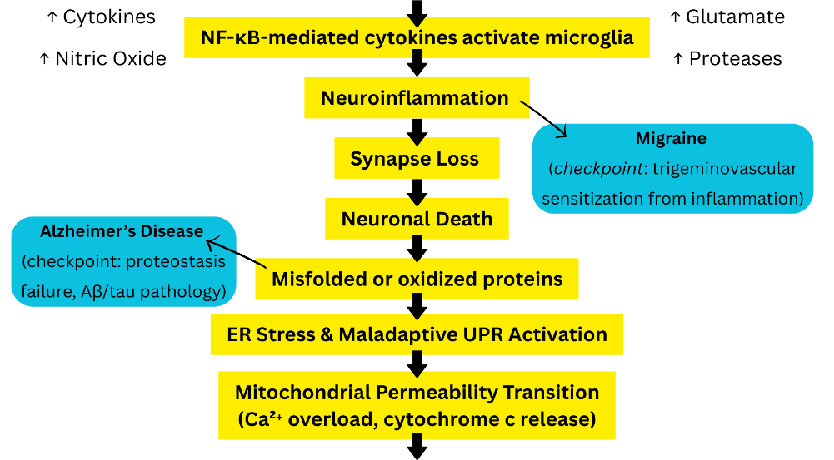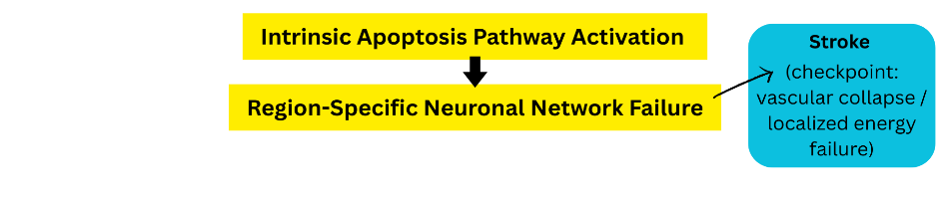
*Checkpoints mark the stages in the shared pathway where each neurological disorder emerges based on its dominant underlying mechanism.
In stroke, curcumin from Curcuma longa provides potent antioxidant, anti-inflammatory, and anti-apoptotic actions, reducing clot size and cerebral oedema, while enhancing mitochondrial and endothelial function (Gawrysz et al., 2025; Fan & Lei, 2022; W. Wang & Xu, 2020). Ginkgolides and bilobalide from Ginkgo biloba serve as an antagonist to platelet-activating factor and are used for treating inflammation, supporting microcirculation and mitochondrial health, and act as a supplement in stroke recovery. Traditional neuroprotective agents, such as Acorus calamus and Nardostachys jatamansi, exhibit antioxidative and anti-apoptotic effects. In migraine, Withania somnifera modulates the HPA axis and reduces neuroinflammation (Pandit et al., 2024), while Centella asiatica, through asiaticoside and madecassoside, supports neurotrophy and suppresses inflammation-induced neurodegenerative markers (Ansari et al., 2025). Curcuma longa also contributes to anti-inflammatory effects relevant to nerve-blood vessel system activation. For dementia and Alzheimer’s disease, bacosides and bacosaponins from Bacopa monnieri enhance synaptic plasticity and memory, while anti-amyloid and antioxidant effects ((Eraiah et al., 2024;Gościniak et al., 2025). Withanolides and sitoindosides from Withania somnifera offer anti-inflammatory, anti-amyloidogenic, and neuroprotective benefits and stress-ameliorating properties. Curcumin and demethoxycurcumin from Curcuma longa modulate neuro-inflammatory pathways making it a promising long-term therapeutic (Gawrysz et al., 2025). In Parkinson’s disease, Mucuna pruriens acts as a source of L-DOPA for dopaminergic support and reducing motor fluctuations. Withania somnifera demonstrates antioxidant, anti-apoptotic, and dopaminergic stabilisation effects including a favourable Bcl-2/Bax balance and α-synuclein aggregation attenuation (Prakash et al., 2014). Bacopa monnieri can further support anti-inflammatory and antioxidant defences. In epilepsy, Centella asiatica and Bacopa monnieri offer GABAergic facilitation and antioxidant protection, which may complement anticonvulsant therapies (Gościniak et al., 2025). Nardostachys jatamansi provides experimental anticonvulsant effects likely through GABA modulation and membrane stabilisation. For neuropathic pain and diabetic neuropathy, both Curcuma longa and Withania somnifera provide anti-inflammatory and neurotrophic support targeting sensitisation in peripheral and central pathways. In traumatic brain injury (TBI), curcumin alleviates oxidative stress, decreases inflammatory cytokines (e.g., IL-1β, IL-6, TNF-α), reduces cerebral oedema, enhances BDNF, synapsin-I, and CREB expression, and optimises apoptotic markers (Farkhondeh et al., 2019). Withania somnifera and Centella asiatica add complementary anti-inflammatory, anti-oedema, and neurotrophic support, aiding recovery and rehabilitation. Collectively, these phytochemicals offer multi-targeted neuroprotection through antioxidant, anti-apoptotic, anti-inflammatory, synaptic plasticity, neurotrophic and cerebrovascular pathways. As adjuncts, not substitutes to standard care, they hold promise when supported by clinical validation for safety, dosing, and efficacy. Table 2 compiles commonly investigated medicinal plants, their major phytochemicals, and their proposed mechanisms of neuroprotection across neurological disorders.
Table 2: Commonly used plants for the treatment of neurological disorders
Plant | Key Phytochemicals | Proposed Mechanisms | Target Neurological Disorders | References
Curcuma longa | Curcumin, demethoxycurcumin | Antioxidant (↓ ROS), anti-inflammatory (↓ NF-κB, TNF-α), anti-amyloid, neurogenesis, cerebrovascular protection | Stroke, dementia/AD, migraine, neuropathic pain, TBI | Garodia et al., 2023, Genchi et al., 2024
Withania somnifera | Withanolides, sitoindosides | Adaptogenic (HPA modulation, ↓ cortisol), neurotrophic, GABA-mimetic, antioxidant | Stress-linked migraine, dementia/AD, PD, neuropathic pain, TBI | Lerose et al., 2024,
Bacopa monnieri | Bacosides A & B | Synaptic plasticity, cholinesterase inhibition, antioxidant, anti-amyloid | Dementia/AD, epilepsy, PD | Prabhakar et al., 2020
Centella asiatica | Asiaticoside, madecassoside | Neurotrophic, anxiolytic, GABAergic, cerebrovascular protection | Migraine, epilepsy, dementia, PD | Ansari et al. 2025, Mando et al., 2024
Mucuna pruriens | Natural L-DOPA, alkaloids | Dopaminergic support, antioxidant | Parkinson’s disease | Hammoud et al., 2025
Ginkgo biloba | Ginkgolides, bilobalide | PAF antagonism, ↑ cerebral blood flow, mitochondrial protection, antioxidant | Stroke recovery, dementia/AD | Singh et al., 2019
Nardostachys jatamansi | Jatamansone (valeranone), sesquiterpenes | GABA modulation, anticonvulsant, antioxidant, anti-apoptotic | Epilepsy, stroke, anxiety | Pathak & Godela, 2024
Acorus calamus | α- and β-asarone | Neuroprotective, antioxidant, anti-apoptotic | Stroke, epilepsy, cognitive disorders | Balakrishnan et al., 2022

AD- Alzheimer’s Disease, PD- Parkinson’s Disease, ROS- Reactive Oxygen Species, GABA- Gamma-Aminobutyric Acid, L-DOPA- L-3,4-Dihydroxyphenylalanine, TNF-α- Tumor Necrosis Factor-alpha, HPA- Hypothalamic-Pituitary-Adrenal, NF-κB-Nuclear Factor Kappa-light-chain-enhancer of activated B cells, TBI- Traumatic Brain Injury, PAF-Platelet Activating Factor, ↑: increase; ↓: decrease.

Phytochemicals in Neurological Disorders
Plant-derived compounds have long played an important role in the management of neurological disorders, with many already incorporated into modern therapeutic regimens. For instance, galantamine, an Amaryllidaceae alkaloid derived from Galanthus and Narcissus species, is approved by FDA for Alzheimer’s disease due to its acetylcholinesterase inhibitory activity. Similarly, huperzine A from Huperzia serrata is a potent reversible acetylcholinesterase inhibitor that has shown promise in improving cognitive function, although its clinical application remains limited outside China. Resveratrol, a stilbene from grapes, Vitis vinifera, exerts neuroprotective effects by antioxidant and anti-inflammatory mechanisms and has been investigated for its role in Alzheimer’s, Parkinson’s, and cerebrovascular diseases. Another widely studied phytochemical is Curcumin from Curcuma longa that is known for its pleiotropic antioxidant, anti-inflammatory, and anti-amyloidogenic effects. Beyond these, withanolide A from Withania somnifera, asiaticoside from Centella asiatica, ginkgolide B from Ginkgo biloba, cannabidiol from Cannabis sativa, bacoside A from Bacopa monnieri, and lycopene from Solanum lycopersicum represent diverse structural classes including terpenoids, alkaloids, flavonoids, and carotenoids. Collectively, these phytochemicals show the therapeutic versatility of plant secondary metabolites in neurological disorders. The diverse classes of neuroactive phytochemicals and their neuroprotective roles are outlined in Table 3.

Table 3: Various Classes of Phytochemicals and Their Neuroprotective Roles
Class | Representative Compounds with Plant Sources | Neuroprotective Role | References
Alkaloids | Huperzine A (Huperzia serrata) | A reversible acetylcholinesterase inhibitor that enhances memory in Alzheimer’s disease. | Callizot et al., 2021, Suvaiv et al., 2025
 | Galantamine (Galanthus species) | FDA-approved for Alzheimer’s disease, it enhances cholinergic neurotransmission. | Varadharajan et al., 2023.
 | Morphine, Codeine (Papaver somniferum) | Pain control in neurological conditions. | Bharti et al., 2023
 | Berberine (Berberis species) | Neuroprotective, anti-inflammatory, and anti-amyloidogenic in Parkinson’s and Alzheimer’s disease models. | Cheng et al., 2022, Tian et al., 2023
Flavonoids | Quercetin (Onions, apples) | Reduces oxidative stress, prevents neuroinflammation, and improves cognition. | Chiang et al., 2023
 | Kaempferol (Green tea, Ginkgo biloba) | Neuroprotection via antioxidant mechanisms. | Nezhad Salari et al., 2024, Santos et al. 2022
 | Apigenin (Chamomilla recutita) | Anxiolytic and neuroprotective. | Olasehinde & Olaokun, 2024
 | EGCG (Epigallocatechin gallate) (Camellia sinensis (green tea)) | Modulates amyloid-beta aggregation, prevents neuronal apoptosis. | Mokra et al., 2022
Polyphenols (Non-flavonoids) | Curcumin (Curcuma longa) | Reduces amyloid-beta, inhibits alpha-synuclein aggregation and exhibits strong antioxidant properties. | Xu et al., 2022
 | Resveratrol (Grapes, red wine, Polygonum cuspidatum) | SIRT1 activation, improves mitochondrial function, and demonstrates neuroprotective properties. | Shaito et al., 2023
 | Caffeic & Ferulic acids (Various medicinal plants) | Antioxidant and anti-inflammatory neuroprotection. | Singh et al., 2022
Saponins | Bacosides (Bacopa monnieri) | Enhance memory, synaptic plasticity, extensively studied in Alzheimer’s disease; and guard against oxidative damage. | Valotto Neto et al., 2024
 | Ginsenosides (Panax ginseng) | Modulate neurotransmission, reduce oxidative stress, and improve cognition; clinical evidence supports its use in stroke and dementia recovery. | Feng et al., 2022, Lee et al.,2024
Glycosides | Salidroside (Rhodiola rosea) | Adaptogen reduces stress-induced neuronal damage. | Liang et al., 2024
 | Stevioside (Stevia rebaudiana) | Antioxidant and neuroprotective (experimental stage). | Wang et al., 2025
Essential Oils / Aromatic Compounds | Linalool (Lavandula angustifolia) | Anxiolytic, anticonvulsant (GABAergic modulation). | Bavarsad et al., 2023
 | Menthol (Mentha species) | Analgesic, anti-migraine. | Li et al.,2022, De Oliveira Koren et al., 2024
 | Thymol, Carvacrol (Thymus vulgaris, Origanum vulgare) | Neuroprotective via antioxidant/anti-inflammatory pathways. | Gago et al., 2025
Coumarins | Umbelliferone, Scopoletin (Ferula, Angelica species) | Neuroprotection through anti-inflammation and antioxidation. | Lin et al., 2023
Steroidal Compounds | Diosgenin (Dioscorea species) | Enhances memory and neurite outgrowth. | Yang and Tohda, 2023
 | β-sitosterol (Various medicinal plants) | Reduces oxidative stress, neuroprotective. | Tang et al., 2023
Lignans | Schisandrin B (Schisandra chinensis) | Improves cognition, antioxidant. | Lee et al., 2012
 | Sesamin (Sesame seeds) | Protect neurons from oxidative stress. | Ruankham et al., 2019
Cannabinoids | Δ9-Tetrahydrocannabinol (THC), Cannabidiol (CBD) (Cannabis sativa) | Modulate endocannabinoid system; neuroprotective, anticonvulsant; studied in epilepsy, multiple sclerosis, and neurodegeneration. | Yousaf et al., 2022
Terpenoids – Monoterpenoids (C10) | Linalool (Lavandula angustifolia) | Anxiolytic, anticonvulsant via GABAergic potentiation; potential in anxiety, epilepsy. | Santos et al., 2022
 | Menthol (Mentha species) | Analgesic and anti-migraine effects via TRP channel modulation. | Dillon et al., 2022
Terpenoids – Sesquiterpenoids (C15) | β-Caryophyllene (Cannabis sativa, Clove) | CB2 receptor agonist, anti-inflammatory and neuroprotective; potential in Alzheimer’s and Parkinson’s disease. | Zhang et al., 2022
 | Parthenolide (Tanacetum parthenium (feverfew)) | Historically linked to migraine prophylaxis; NF-κB pathway modulation. | Kashkooe et al., 2024
Terpenoids – Diterpenoids (C20) | Ginkgolide B, Bilobalide (Ginkgo biloba) | Protects against ischemic injury, supports cognitive function, and aids stroke recovery. | Cao et al., 2022
 | Andrographolide (Andrographis paniculata) | Anti-inflammatory, neuroprotective, and modulates mitochondrial pathways. | Shan et al., 2025
Terpenoids – Triterpenoids (C30) | Withanolides (Withania somnifera) | Enhance synaptic plasticity, reduce stress-induced cognitive deficits; potential in cognitive ageing and Alzheimer’s disease. | Vittal and Vinciguerra, 2025
 | Asiaticoside (Centella asiatica) | Promotes neurite growth, improves memory, and has antioxidant activity. | Tan et al., 2021
Terpenoids – Tetraterpenoids (C40) | Lycopene (Solanum lycopersicum (tomato)) | Potent antioxidant, protects dopaminergic neurons, adjunct in post-stroke recovery and Parkinson’s disease. | Prema et al., 2015
 | β-Carotene (Carrots, sweet potatoes) | Strong antioxidant, protective against cognitive decline. | Wang et al., 2023

Plant-Derived Structural Analogs with Untapped Potential
Structurally similar analogs of the phytochemicals mentioned in table 3 exist in related plant species and are yet to be widely explored. For example, narwedine from Narcissus pseudonarcissus and sanguinine from Galanthus woronowii share the Amaryllidaceae alkaloid structure of galantamine but display stronger acetylcholinesterase inhibition in vitro (Armengol et al., 2011). Lycodoline from Lycopodium clavatum and fawcettimine from Lycopodium fawcettii are structurally related to huperzine A and therefore have a potential to provide cholinesterase inhibitors with unique pharmacological properties (Kitajima & Takayama, 2011; Ma & Gang, 2004). Among stilbenes, oxyresveratrol from Morus alba and piceatannol from Passiflora edulis extend the neuroprotective portfolio of resveratrol through superior anti-apoptotic and antioxidative effects (Shen et al., 2009). Curcumin analogs such as yakuchinone A from Alpinia oxyphylla and dehydrozingerone from Zingiber officinale offer improved stability and distinct neuroprotective profiles (Chun et al., 2002c). Steroidal lactones beyond withanolide A, such as physalin B from Physalis angulata and withanolide E from Physalis peruviana, show early promise in modulating neuroinflammation (Kuo et al., 2006; Mirjalili et al., 2009). Likewise, triterpenoid saponins, including aescin from Aesculus hippocastanum and glycyrrhizin from Glycyrrhiza glabra, parallel asiaticoside’s neuroprotective properties (Asl & Hosseinzadeh, 2008).
In the diterpenoid class, andrographolide (Andrographis paniculata) and tanshinone IIA (Salvia miltiorrhiza) mimic the vascular and mitochondrial protective roles of ginkgolides (Islam et al., 2018b; Lee et al., 2013). Cannabinoid-related compounds, for example, perrottetinene (Radula marginata) and daurichromenic acid (Rhododendron dauricum) expand the therapeutic landscape beyond cannabidiol (Chicca et al., 2018). Similarly, ginsenoside Rg1 (Panax ginseng) and jujuboside A (Ziziphus jujuba) mirror the synaptogenic potential of bacosides (Kennedy et al., 2002; Wu et al., 2013), while carotenoid intermediates like phytofluene (Citrus paradisi) and neurosporene (Zea mays) complement lycopene’s antioxidant capacity (Fraser & Bramley, 2004; Meléndez-Martínez et al., 2015).
The significance of exploring these analogs extends beyond pharmacological novelty. Many medicinal plant species producing frontline neuroprotective compounds are globally threatened due to habitat destruction, overharvesting, and climate change, while only a few are cultivated sustainably. Even under cultivation, the phytochemical composition often differs from wild sources, limiting therapeutic consistency (Pammi, 2026). Structurally similar analogs offer a sustainable and scientifically robust solution by preserving core pharmacophores yet enhancing properties such as bioavailability, blood–brain barrier penetration, or safety profiles. For instance, oxyresveratrol demonstrates stronger antioxidative capacity than resveratrol, and narwedine surpasses galantamine in acetylcholinesterase inhibition (Shen et al., 2009). By broadening the chemical repertoire while reducing dependency on endangered species, analogs not only ensure continuity of therapeutic activity but also contribute to biodiversity conservation and equitable neurological healthcare across both metropolitan and non-metropolitan populations. Table 4 summarises the phytochemicals and their structural analogs with documented neuroprotective relevance while Table 5 highlights less-studied phytochemical analogs with potential neurotherapeutic implications.
Table 4: Plant-Derived Analogs of Already Established Phytochemicals with Their Chemical Structures
Phytochemical  (Plant Source) | Plant-Derived Analogs  (with source) | Structural Similarity
Galantamine  (Galanthus spp.)  Chemical Formula: C₁₇H₂₁NO₃  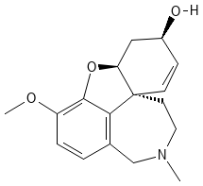 | Narwedine  (Narcissus pseudonarcissus)  Chemical Formula: C₁₇H₁₉NO₃  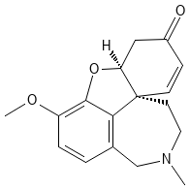 | Amaryllidaceae alkaloid sharing tetracyclic benzoazepine core; oxidation and O-methylation pattern variations (Armengol et al., 2011).
 | Sanguinine  (Galanthus woronowii)  Chemical Formula: C₁₆H₁₉NO₃  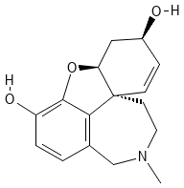 | Close Amaryllidaceae congener with the same polycyclic skeleton; substitution differences at aromatic positions (Georgiev et al., 2024).
Huperzine A  (Huperzia serrata)  Chemical Formula: C₁₅H₁₈N₂O  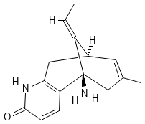 | Lycodoline  (Lycopodium clavatum)  Chemical Formula: C₁₆H₂₅NO₂  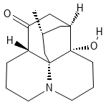 | Lycopodium alkaloid with compact polycyclic nitrogenous scaffold; potential acetylcholinesterase inhibitor (Ma & Gang, 2004).
 | Fawcettimine  (Lycopodium fawcettii)  Chemical Formula: C₁₆H₂₅NO₂  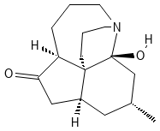 | Shares bicyclic cage-like skeleton and tertiary nitrogen; differs in ring fusion/oxidation (Kitajima & Takayama, 2011).
Resveratrol  Grapes (Vitis vinifera), Polygonum cuspidatum  Chemical Formula: C₁₄H₁₂O₃  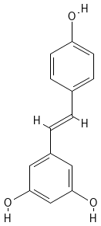 | Oxyresveratrol  Morus alba  Chemical Formula: C₁₄H₁₂O₄  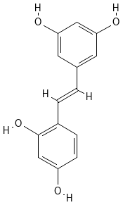 | Stilbene backbone with an additional hydroxyl group; enhances antioxidant profile (Shen et al., 2009).
 | Piceatannol  Passiflora edulis  Chemical Formula: C₁₄H₁₂O₄  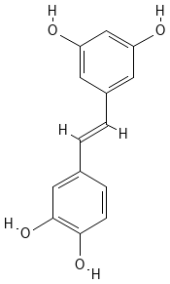 | Stilbene analog with extra hydroxylation; retains neuroprotective stilbene scaffold (Piotrowska et al., 2012).
Curcumin  (Curcuma longa)  Chemical Formula: C₂₁H₂₀O₆  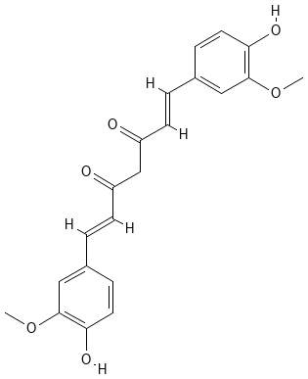 | Yakuchinone A  Alpinia oxyphylla  Chemical Formula: C₂₀H₂₄O₃  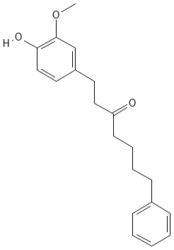 | Diarylheptanoid sharing conjugated enone linker; Michael acceptor conserved (Chun et al., 2002c).
 | Dehydrozingerone  Zingiber officinale  Chemical Formula: C₁₁H₁₂O₃  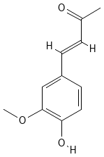 | “Half-curcumin” motif with vanillyl group and enone; common pharmacophore (Priyadarsini, 2014).
Withanolide A  Withania somnifera  Chemical Formula: C₂₈H₃₈O₆  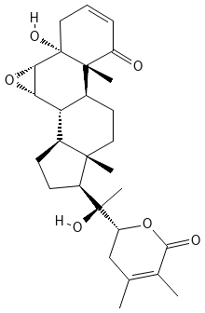 | Physalin B  Physalis angulate  Chemical Formula: C₂₈H₃₀O₉  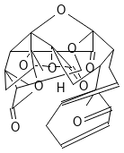 | Steroidal lactone with ergostane-derived framework and δ-lactone, akin to withanolides (Kuo et al., 2006).
 | Withanolide E  Physalis peruviana  Chemical Formula: C₂₈H₃₈O₇  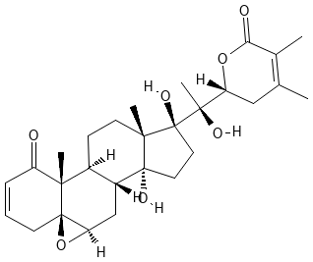 | True withanolide congener with steroidal backbone; differs in stereochemistry and oxidation (Mirjalili et al., 2009).
Asiaticoside  Centella asiatica  Chemical Formula: C₄₈H₇₈O₁₉  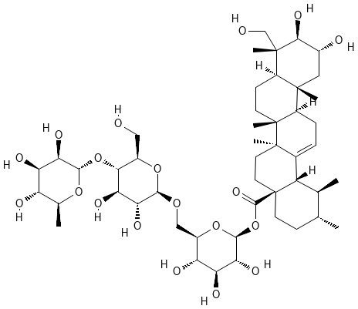 | Aescin  Aesculus hippocastanum  Chemical Formula: C₅₅H₈₆O₂₄  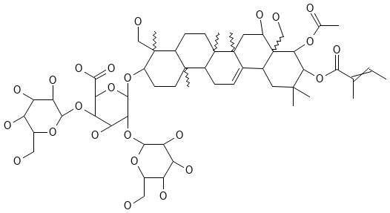 | Triterpenoid saponin with oleanane aglycone and sugars, structurally similar to asiaticoside (Chindo et al., 2012).
 | Glycyrrhizin  Glycyrrhiza glabra  Chemical Formula: C₄₂H₆₂O₁₆  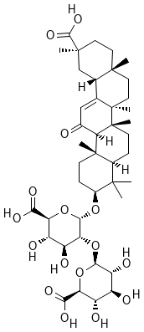 | Triterpenoid saponin with glycosylated pentacyclic triterpene, same class (Asl & Hosseinzadeh, 2008).
Ginkgolide B  Ginkgo biloba  Chemical Formula: C₂₀H₂₄O₁₀  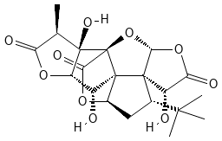 | Andrographolide  Andrographis paniculata  Chemical Formula: C₂₀H₃₀O₅  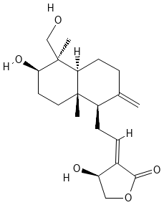 | Diterpenoid lactone, oxygen-rich with lactone rings and hydroxyl groups (Islam et al., 2018b).
 | Tanshinone IIA  Salvia miltiorrhiza  Chemical Formula: C₁₉H₁₈O₃  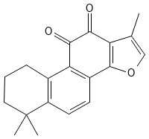 | Abietane diterpenoid with conjugated quinone core; functional-class similarity (Lee et al., 2013).
Cannabidiol (CBD)  Cannabis sativa  Chemical Formula: C₂₁H₃₀O₂  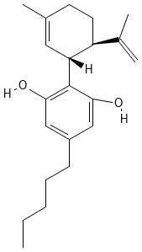 | Perrottetinene  Radula marginata  Chemical Formula: C₂₄H₂₈O₂  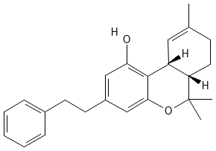 | Cannabinoid-like meroterpenoid with resorcinyl aromatic ring and terpene chain (Chicca et al., 2018).
 | Daurichromenic acid  Rhododendron dauricum  Chemical Formula: C₂₃H₃₀O₄  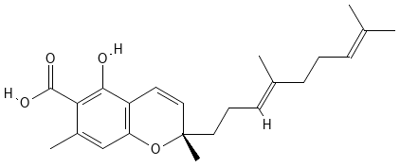 | Prenylated chromene carboxylic acid; cannabinoid-like scaffold (Iijima et al., 2017).
Bacoside A  Bacopa monnieri  Chemical Formula: C₄₁H₆₈O₁₃  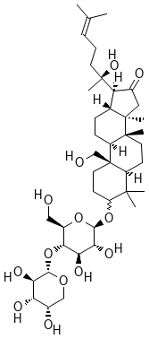 | Ginsenoside Rg1  Panax ginseng  Chemical Formula: C₄₂H₇₂O₁₄  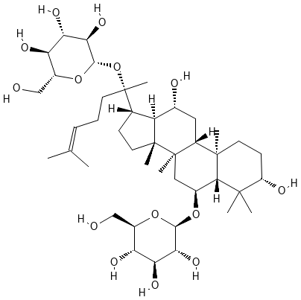 | Dammarane-type triterpenoid saponin with sugar chains; same amphiphilic scaffold (Kennedy et al., 2002).
 | Jujuboside A  Ziziphus jujube  Chemical Formula: C₅₈H₉₄O₂₆  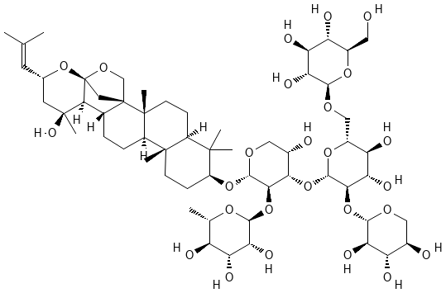 | Triterpenoid saponin with oleanane core and oligosaccharides (Wu et al., 2013).
Lycopene  Solanum lycopersicum  Chemical Formula: C₄₀H₅₆  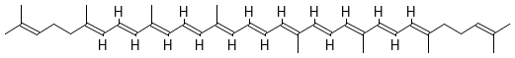 | Phytofluene  Citrus paradise  Chemical Formula: C₄₀H₆₂  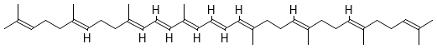 | C₄₀ carotenoid with fewer double bonds but same polyene chain (Meléndez-Martínez et al., 2015).
 | Neurosporene  Zea mays  Chemical Formula: C₄₀H₅₈  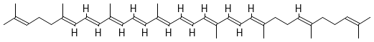 | C₄₀ carotenoid, biosynthetic precursor to lycopene, differing by one double bond (Fraser & Bramley, 2004).

Table 5: Neurological disorder-specific possible analogs for established compounds with their potential neuroprotective role
Neurological Disorder | Key Established Compound | Promising Analogs with Source Plant | Potential Neuroprotective Role
Alzheimer’s disease | Galantamine (Galanthus spp.) | Narwedine (Narcissus pseudonarcissus); Sanguinine (Galanthus woronowii) | Enhanced acetylcholinesterase inhibition, improved cholinergic neurotransmission (Bastida et al., 2019)
 | Huperzine A (Huperzia serrata) | Lycodoline (Lycopodium clavatum); Fawcettimine (Lycopodium fawcettii) | Potent cholinesterase inhibition, possible cognitive enhancement (Kitajima & Takayama, 2011; Ma & Gang, 2004)
 | Resveratrol (Vitis vinifera, Polygonum cuspidatum) | Oxyresveratrol (Morus alba); Piceatannol (Passiflora edulis) | Stronger antioxidant, anti-apoptotic and anti-amyloidogenic effects (Piotrowska et al., 2012; Shen et al., 2009)
Parkinson’s disease | Curcumin (Curcuma longa) | Yakuchinone A (Alpinia oxyphylla); Dehydrozingerone (Zingiber officinale) | Mitochondrial protection, inhibition of α-synuclein aggregation (Chun et al., 2002c)
 | Withanolide A (Withania somnifera) | Physalin B (Physalis angulata); Withanolide E (Physalis peruviana) | Neuroinflammation modulation, dopaminergic neuron protection (Kuo et al., 2006; Mirjalili et al., 2009)
Stroke & Vascular Cognitive Impairment | Ginkgolide B (Ginkgo biloba) | Andrographolide (Andrographis paniculata); Tanshinone IIA (Salvia miltiorrhiza) | Anti-ischemic effects, mitochondrial stabilization, improved vascular function (Islam et al., 2018b; Lee et al., 2013)
Epilepsy & Seizure Disorders | Cannabidiol (CBD) (Cannabis sativa) | Perrottetinene (Radula marginata); Daurichromenic acid (Rhododendron dauricum) | Anticonvulsant potential, endocannabinoid system modulation (Chicca et al., 2018).
Cognitive Decline / Memory Disorders | Bacoside A (Bacopa monnieri) | Ginsenoside Rg1 (Panax ginseng); Jujuboside A (Ziziphus jujuba) | Synaptogenic support, improved learning and memory (Wu et al., 2013).
Migraine / Oxidative Stress-Linked Disorders | Lycopene (Solanum lycopersicum) | Phytofluene (Citrus paradisi); Neurosporene (Zea mays) | Antioxidant carotenoids, neurovascular protection (Meléndez-Martínez et al., 2015)

FUTURE DIRECTIONS

The problem of neurological disorders is increasingly imposing a growing health and economic burden across the world, and the neurological drugs market is expected to grow swiftly. Although this has increased but still an enormous gap in effective therapeutics exists in terms of provision of such therapeutics. The available remedies are expensive, in many cases have side effects, and are not widely available to a majority population, especially in rural and resource-constrained areas. This disequilibrium highlights the necessity of low cost, safer, and more sustainable alternatives.

Here, phytochemical analogs have the transformational potential. Analogs serve the purpose of supplementing and not substituting current drugs as well as addressing the drawbacks of restricted bioavailability, therapeutic inconsistency, and dependency on threatened medicinal plant species through the provision of structurally similar, though functionally superior molecules. Their pharmacological retention capability coupled with stability and accessibility make them worthy alternatives in terms of filling the demand-supply gap.

The future is in identifying such analogs in a systematic manner as low-cost neurotherapeutic leads and establishing their validity. As the occurrence of neurological diseases is increasing, as well as the economic burden on healthcare systems, there is a strong demand to diversify the drug pipelines with cost-effective plant-derived analogs. Phytochemistry, computational modeling, and clinical validation can be strategically integrated to speed up the conversion of these analogs to clinically relevant drugs. The utilization of analogs would not only solve the worldwide problem of the lack of neurological therapeutics but also provide equal access to the issue, especially in such a country as India where the urban dwellers are exposed to the risks of stress and develop neurological disorders and the residents of the non-metropolitan regions are underdiagnosed and lack adequate treatment choices.

CONCLUSION
The therapeutic arena for neurological disorders is expanding beyond synthetic drugs and includes a wide range of plant-derived compounds. Well known phytochemicals like galantamine, curcumin and cannabidiol have forged the path to clinical acceptability and structurally identical though less explored analogues, like narwedine to phytofluene, are the future of neuroprotective studies. In the Indian case the miscellane of urban stress disorders versus metabolic disorders and conditions in non-metropolitan areas will leave no other way but to refine the public health strategies in terms of integrating these phytochemicals. Such an approach does not only underscore the scientific promise of ethnopharmacology but also strengthens the relevance of India’s biodiversity in neurological therapeutics at the global level.
REFERENCES

- Ansari, S., Maurya, V. K., Kumar, S., Tiwari, M., Abdel-Moneime, A. S., & Saxena, S. K. (2025). Neuroprotective effects of Centella asiatica against LPS/amyloid beta-induced neurodegeneration through inhibition of neuroinflammation. Neuroscience, 575, 19–35. https://doi.org/10.1016/j.neuroscience.2025.04.011
- Asl, M. N., & Hosseinzadeh, H. (2008). Review of pharmacological effects of Glycyrrhiza glabra. Phytotherapy Research, 22(6), 709–724.
- Balakrishnan, R., Cho, D. Y., Kim, I. S., Seol, S. H., & Choi, D. K. (2022). Molecular Mechanisms and Therapeutic Potential of α- and β-Asarone in the Treatment of Neurological Disorders. Antioxidants (Basel, Switzerland), 11(2), 281. https://doi.org/10.3390/antiox1102028
- Balk, D., Montgomery, M. R., Engin, H., Lin, N., Major, E., & Jones, B. D. (2019). Urbanization in India: Population and Urban Classification Grids for 2011. 4(1), 35. https://doi.org/10.3390/DATA4010035
- Armengol, J. B., Berkov, S., Claveria, L. T., Pigni, N. B., De Andradre, J. P., Martínez, V., Mahrer, C. C., & Meya, F. V. (2011). Chemical and biological aspects of Amaryllidaceae alkaloids. In Transworld Research Network eBooks. http://diposit.ub.edu/dspace/bitstream/2445/21374/1/259113.pdf
- Bavarsad, N. H., Bagheri, S., Kourosh-Arami, M., & Komaki, A. (2023). Aromatherapy for the brain: Lavender’s healing effect on epilepsy, depression, anxiety, migraine, and Alzheimer’s disease: A review article. Heliyon, 9(8), e18492. https://doi.org/10.1016/j.heliyon.2023.e18492
- Georgiev, B., Sidjimova, B., & Berkov, S. (2024). Phytochemical and cytotoxic aspects of Amaryllidaceae alkaloids in Galanthus species: a review. Plants, 13(24), 3577. https://doi.org/10.3390/plants13243577
- Bharti, N. P., Singh, N. M., & Singh, N. a. K. (2023). Role of Ahiphena (Papaver sominiferum) in modern and ancient treatment. Journal of Ayurveda and Integrated Medical Sciences, 8(10), 164–166. https://doi.org/10.21760/jaims.8.10.25
- Callizot, N., Campanari, M., Rouvière, L., Jacquemot, G., Henriques, A., Garayev, E., & Poindron, P. (2021). Huperzia serrata Extract ‘NSP01’ With Neuroprotective Effects-Potential Synergies of Huperzine A and Polyphenols. Frontiers in Pharmacology, 12, 681532. https://doi.org/10.3389/fphar.2021.681532
- Cao, Y., Yang, L., & Cheng, H. (2022). Ginkgolide B protects against ischemic stroke via targeting AMPK/PINK1. Frontiers in Pharmacology, 13, 941094. https://doi.org/10.3389/fphar.2022.941094
- Charlson, F. J., Baxter, A. J., Cheng, H. G., Shidhaye, R., & Whiteford, H. A. (2016). The burden of mental, neurological, and substance use disorders in China and India: a systematic analysis of community representative epidemiological studies. The Lancet, 388(10042), 376-389.
- Kuo, P., Kuo, T., Damu, A. G., Su, C., Lee, E., Wu, T., Shu, R., Chen, C., Bastow, K. F., Chen, T., & Lee, K. (2006). Physanolide A, a Novel Skeleton Steroid, and Other Cytotoxic Principles from Physalis angulata. Organic Letters, 8(14), 2953–2956. https://doi.org/10.1021/ol060801s
- Cheng, Z., Kang, C., Che, S., Su, J., Sun, Q., Ge, T., Guo, Y., Lv, J., Sun, Z., Yang, W., Li, B., Li, X., & Cui, R. (2022). Berberine: A Promising Treatment for Neurodegenerative Diseases. Frontiers in pharmacology, 13, 845591. https://doi.org/10.3389/fphar.2022.845591
- Chiang, M. C., Tsai, T. Y., & Wang, C. J. (2023). The Potential Benefits of Quercetin for Brain Health: A Review of Anti-Inflammatory and Neuroprotective Mechanisms. International journal of molecular sciences, 24(7), 6328. https://doi.org/10.3390/ijms24076328
- Chicca, A., Schafroth, M. A., Reynoso-Moreno, I., Erni, R., Petrucci, V., Carreira, E. M., & Gertsch, J. (2018). Uncovering the psychoactivity of a cannabinoid from liverworts associated with a legal high. Science Advances, 4(10), eaat2166. https://doi.org/10.1126/sciadv.aat2166
- Chowdhury, D., Krishnan, A., Duggal, A., Amarchand, R., Husøy, A., & Steiner, T. J. (2024). Headache prevalence and demographic associations in the Delhi and National Capital Region of India: estimates from a cross-sectional nationwide population-based study. The Journal of Headache and Pain, 25(1), 108. https://doi.org/10.1186/s10194-024-01814-2
- De Oliveira Koren, L., Lejeune, V. B. P., Baggio, D. F., Da Luz, F. M. R., & Chichorro, J. G. (2024). Effect of peppermint essential oil (Mentha piperita L.) in migraine-like responses in female rats. Headache Medicine/Revista Headache Medicine, 15(2), 78–85. https://doi.org/10.48208/headachemed.2024.17
- Dhiman, V., Menon, G. R., Kaur, S., Mishra, A., John, D., Vishnu, M. V. R., Tiwari, R. R., & Dhaliwal, U. S. (2021). A systematic review and meta-analysis of prevalence of epilepsy, dementia, headache, and Parkinson disease in India. Neurology India, 69(2), 294–301. https://doi.org/10.4103/0028-3886.314588
- Dhiman, V., Menon, G.R., Kaur, S., Mishra, A., John, D., Rao Vishnu, M.V., Tiwari, R.R., & Dhaliwal, R.S. (2021). A Systematic Review and Meta-analysis of Prevalence of Epilepsy, Dementia, Headache, and Parkinson Disease in India. Neurology India, 69, 294 - 301.
- Dillon, G. A., Lichter, Z. S., & Alexander, L. M. (2022). Menthol-induced activation of TRPM8 receptors increases cutaneous blood flow across the dermatome. Microvascular Research, 139, 104271. https://doi.org/10.1016/j.mvr.2021.104271
- Eraiah, M. M., Shekhar, H. C., Joshua, L., & Thomas, J. V. (2024). Effect of Bacopa monnieri Extract on Memory and Cognitive Skills in Adult Humans: A Randomized, Double-Blind, Placebo-Controlled Study. Journal of Psychiatry and Cognitive Behaviour, 8(1). https://doi.org/10.29011/2574-7762.000068
- Fan, F., & Lei, M. (2022). Mechanisms underlying Curcumin-Induced neuroprotection in cerebral ischemia. Frontiers in Pharmacology, 13, 893118. https://doi.org/10.3389/fphar.2022.893118
- Farkhondeh, T., Samarghandian, S., Roshanravan, B., & Peivasteh-Roudsari, L. (2019). Impact of curcumin on traumatic brain injury and involved molecular signaling pathways. Recent Patents on Food Nutrition & Agriculture, 11(2), 137–144. https://doi.org/10.2174/2212798410666190617161523
- Feigin, V. L., Nichols, E., Alam, T., Bannick, M. S., Beghi, E., Blake, N., Culpepper, W. J., Dorsey, E. R., Elbaz, A., Ellenbogen, R. G., Fisher, J. L., Fitzmaurice, C., Giussani, G., Glennie, L., James, S. L., Johnson, C. O., Kassebaum, N. J., Logroscino, G., Marin, B., . . . Car, M. (2019). Global, regional, and national burden of neurological disorders, 1990–2016: a systematic analysis for the Global Burden of Disease Study 2016. The Lancet Neurology, 18(5), 459–480. https://doi.org/10.1016/s1474-4422(18)30499-x
- Feigin, V. L., Stark, B. A., Johnson, C. O., Roth, G. A., Bisignano, C., Abady, G. G., ... & Hamidi, S. (2021). Global, regional, and national burden of stroke and its risk factors, 1990–2019: a systematic analysis for the Global Burden of Disease Study 2019. The Lancet Neurology, 20(10), 795-820.
- Feng, H., Xue, M., Deng, H., Cheng, S., Hu, Y., & Zhou, C. (2022). Ginsenoside and Its Therapeutic Potential for Cognitive Impairment. Biomolecules, 12(9), 1310. https://doi.org/10.3390/biom12091310
- Ferrari, A. J., Santomauro, D. F., Aali, A., Abate, Y. H., Abbafati, C., Abbastabar, H., ElHafeez, S. A., Abdelmasseh, M., Abd-Elsalam, S., Abdollahi, A., Abdullahi, A., Abegaz, K. H., Zuñiga, R. a. A., Aboagye, R. G., Abolhassani, H., Abreu, L. G., Abualruz, H., Abu-Gharbieh, E., Abu-Rmeileh, N. M., . . . Murray, C. J. L. (2024). Global incidence, prevalence, years lived with disability (YLDs), disability-adjusted life-years (DALYs), and healthy life expectancy (HALE) for 371 diseases and injuries in 204 countries and territories and 811 subnational locations, 1990–2021: a systematic analysis for the Global Burden of Disease Study 2021. The Lancet, 403(10440), 2133–2161.
- Fraser, P. D., & Bramley, P. M. (2004). The biosynthesis and nutritional uses of carotenoids. Progress in Lipid Research, 43(3), 228–265.
- Fu, P., Guo, X., Cheung, F. M. H., & Yung, K. K. L. (2018). The association between PM2.5 exposure and neurological disorders: A systematic review and meta-analysis. The Science of the Total Environment, 655, 1240–1248. https://doi.org/10.1016/j.scitotenv.2018.11.218
- Gago, C., Serralheiro, A., & Da Graça Miguel, M. (2025). Anti-Inflammatory activity of thymol and Thymol-Rich essential oils: mechanisms, applications, and recent findings. Molecules, 30(11), 2450. https://doi.org/10.3390/molecules30112450
- Garodia, P., Hegde, M., Kunnumakkara, A. B., & Aggarwal, B. B. (2023). Curcumin, inflammation, and neurological disorders: How are they linked? Integrative Medicine Research, 12(3), 100968. https://doi.org/10.1016/j.imr.2023.100968
- Gawrysz, Ż., Cholewa, Z., Derewjanko, S., Gaik, J., Woźniak, J., & Capar, K. (2025). Curcumin as a neuroprotective agent: mechanisms and therapeutic potential in neurodegenerative diseases, acute brain injuries, and neuroinflammation. A review of the literature. Medical Science, 29(163), 1–9. https://doi.org/10.54905/disssi.v29i163.e174ms3680
- Genchi, G., Lauria, G., Catalano, A., Carocci, A., & Sinicropi, M. S. (2024). Neuroprotective effects of curcumin in neurodegenerative diseases. Foods, 13(11), 1774. https://doi.org/10.3390/foods13111774
- Gościniak, A., Stasiłowicz-Krzemień, A., Szeląg, M., Pawlak, J., Skiera, I., Kwiatkowska, H., Nowak, N., Bernady, K., Trzaskoma, P., Zimak-Krótkopad, O., & Cielecka-Piontek, J. (2025). Bacopa monnieri: Preclinical and Clinical Evidence of Neuroactive Effects, Safety of Use and the Search for Improved Bioavailability. Nutrients, 17(11), 1939. https://doi.org/10.3390/nu17111939
- Gourie-Devi, M. (2014). Epidemiology of neurological disorders in India: Review of background, prevalence and incidence of epilepsy, stroke, Parkinson′s disease and tremors. Neurology India, 62(6), 588. https://doi.org/10.4103/0028-3886.149365
- Gourie-Devi, M., Gururaj, G., Satishchandra, P., & Subbakrishna, D. (2004). Prevalence of Neurological Disorders in Bangalore, India: A Community-Based Study with a Comparison between Urban and Rural Areas. Neuroepidemiology, 23(6), 261–268. https://doi.org/10.1159/000080090
- Hammoud, F., Ismail, A., Zaher, R., El Majzoub, R., & Abou-Abbas, L. (2025). Mucuna pruriens Treatment for Parkinson Disease: A Systematic Review of Clinical Trials. Parkinson's disease, 2025, 1319419. https://doi.org/10.1155/padi/1319419
- Hedau, V. N., & Patil, T. (2024). Mounting stroke crisis in India: a systematic review. Cureus, 16(3), e57058. https://doi.org/10.7759/cureus.57058
- Huang, Y., Li, Y., Pan, H., & Han, L. (2023). Global, regional, and national burden of neurological disorders in 204 countries and territories worldwide. Journal of Global Health, 13, 04160. https://doi.org/10.7189/jogh.13.04160
- Iijima, M., Munakata, R., Takahashi, H., Kenmoku, H., Nakagawa, R., Kodama, T., Asakawa, Y., Abe, I., Yazaki, K., Kurosaki, F., & Taura, F. (2017). Identification and characterization of daurichromenic acid synthase active in Anti-HIV biosynthesis. PLANT PHYSIOLOGY, 174(4), 2213–2230. https://doi.org/10.1104/pp.17.00586
- Janardhana, K., Sujatha, B., Nagaraju, K., Prasad, P. V. V., Mohan, M. R., Aruna, D., & ReddyAzizova, P. V. M. (2023). A -Comprehensive Review of Integrating Medicinal Plant Constituents into Neurological Disorder Therapeutics. Journal of Advanced Zoology, 44(S3), 1654–1661. https://doi.org/10.17762/jaz.v44is3.2171
- Chun, K., Kang, J., Kim, O. H., Kang, H., & Surh, Y. (2002c). Effects of Yakuchinone A and Yakuchinone В on the phorbol Ester-Induced expression of COX-2 and INOS and activation of NF-KB in mouse skin. Journal of Environmental Pathology Toxicology and Oncology, 21(2), 9. https://doi.org/10.1615/jenvironpatholtoxicoloncol.v21.i2.60
- Je, G., Arora, S., Raithatha, S.J., Barrette, R., Valizadeh, N., Shah, U.M., Desai, D., Deb, A., & Desai, S.D. (2021). Epidemiology of Parkinson’s Disease in Rural Gujarat, India. Neuroepidemiology, 55, 188 - 195.
- Kashkooe, A., Jalali, A., Zarshenas, M. M., & Hamedi, A. (2024). Exploring the Phytochemistry, Signaling Pathways, and Mechanisms of Action of Tanacetum parthenium (L.) Sch.Bip.: A Comprehensive Literature Review. Biomedicines, 12(10), 2297. https://doi.org/10.3390/biomedicines12102297
- Kitajima, M., & Takayama, H. (2011). Lycopodium alkaloids: isolation and asymmetric synthesis. Topics in Current Chemistry, 309, 1–31. https://doi.org/10.1007/128_2011_126
- Kennedy, D., Scholey, A., & Wesnes, K. (2002). Modulation of cognition and mood following administration of single doses of Ginkgo biloba, ginseng, and a ginkgo/ginseng combination to healthy young adults. Physiology & Behavior, 75(5), 739–751. https://doi.org/10.1016/s0031-9384(02)00665-0
- Khurana, S., & Gourie-Devi, M. (2025). A Narrative review of Community-Based Epidemiological Studies on Parkinson’s Disease in India. Cureus, 17(3), e80248. https://doi.org/10.7759/cureus.80248
- Kumar, C.T., George, S., & Kallivayalil, R.A. (2019). Towards a Dementia-Friendly India. Indian Journal of Psychological Medicine, 41, 476 - 481.
- Islam, M. T., Ali, E. S., Uddin, S. J., Islam, M. A., Shaw, S., Khan, I. N., Saravi, S. S. S., Ahmad, S., Rehman, S., Gupta, V. K., Găman, M., Găman, A. M., Yele, S., Das, A. K., De Castro E Sousa, J. M., De Moura Dantas, S. M. M., Rolim, H. M. L., De Carvalho Melo-Cavalcante, A. A., Mubarak, M. S., . . . Kamal, M. A. (2018b). Andrographolide, a diterpene lactone from Andrographis paniculata and its therapeutic promises in cancer. Cancer Letters, 420, 129–145. https://doi.org/10.1016/j.canlet.2018.01.074
- Lee, R., Kim, J. H., Kim, W. W., Hwang, S. H., Choi, S. H., Kim, J. H., Cho, I. H., Kim, M., & Nah, S. Y. (2024). Emerging evidence that ginseng components improve cognition in subjective memory impairment, mild cognitive impairment, and early Alzheimer's disease dementia. Journal of ginseng research, 48(3), 245–252. https://doi.org/10.1016/j.jgr.2024.02.002
- Lee, T. H., Jung, C. H., & Lee, D. (2012). Neuroprotective effects of Schisandrin B against transient focal cerebral ischemia in Sprague–Dawley rats. Food and Chemical Toxicology, 50(12), 4239–4245. https://doi.org/10.1016/j.fct.2012.08.047
- Lerose, V., Ponticelli, M., Benedetto, N., Carlucci, V., Lela, L., Tzvetkov, N. T., & Milella, L. (2024). Withania somnifera (L.) Dunal, a Potential Source of Phytochemicals for Treating Neurodegenerative Diseases: A Systematic Review. Plants, 13(6), 771. https://doi.org/10.3390/plants13060771
- Lee, J., Park, J. H., Park, O. K., Kim, I. H., Yan, B. C., Ahn, J. H., Kwon, S., Choi, J. H., Kim, J., & Won, M. (2013). Neuroprotective effects of tanshinone I from Danshen extract in a mouse model of hypoxia-ischemia. Anatomy & Cell Biology, 46(3), 183. https://doi.org/10.5115/acb.2013.46.3.183
- Li, X., Yuan, W., Wu, J., Zhen, J., Sun, Q., & Yu, M. (2022). Andrographolide, a natural anti-inflammatory agent: An Update. Frontiers in Pharmacology, 13, 920435. https://doi.org/10.3389/fphar.2022.920435
- Liang, K., Ma, S., Luo, K., Wang, R., Xiao, C., Zhang, X., Gao, Y., & Li, M. (2024). Salidroside: An Overview of Its Promising Potential and Diverse Applications. Pharmaceuticals, 17(12), 1703. https://doi.org/10.3390/ph17121703
- Lin, Z., Cheng, X., & Zheng, H. (2023). Umbelliferon: a review of its pharmacology, toxicity and pharmacokinetics. Inflammopharmacology, 31(4), 1731–1750. https://doi.org/10.1007/s10787-023-01256-3
- Chindo, B. A., Adzu, B., & Gamaniel, K. S. (2012). Saponins: structural diversity, properties and applications. Saponins: properties, applications and health benefits, 1-50.
- Ma, X., & Gang, D. R. (2004). The Lycopodium alkaloids. Natural Product Reports, 21(6), 752. https://doi.org/10.1039/b409720n
- Mando, Z., Mando, H., Afzan, A., Shaari, K., Hassan, Z., Mohamad Taib, M. N. A., & Zakaria, F. (2024). Biomarker triterpenoids of Centella asiatica as potential antidepressant agents: Combining in vivo and in silico studies. Behavioural brain research, 466, 114976. https://doi.org/10.1016/j.bbr.2024.114976
- Meléndez-Martínez, A. J., Mapelli-Brahm, P., Benítez-González, A., & Stinco, C. M. (2015). A comprehensive review on the colorless carotenoids phytoene and phytofluene. Archives of Biochemistry and Biophysics, 572, 188–200. https://doi.org/10.1016/j.abb.2015.01.003
- Mirjalili, M. H., Moyano, E., Bonfill, M., Cusido, R. M., & Palazón, J. (2009). Steroidal lactones from Physalis and Withania: Structural diversity and bioactivity. Phytochemistry Reviews, 8(2), 401–420.
- Mokra, D., Joskova, M., & Mokry, J. (2022). Therapeutic Effects of Green Tea Polyphenol (‒)-Epigallocatechin-3-Gallate (EGCG) in Relation to Molecular Pathways Controlling Inflammation, Oxidative Stress, and Apoptosis. International journal of molecular sciences, 24(1), 340. https://doi.org/10.3390/ijms24010340
- Nezhad Salari, A. M., Rasoulizadeh, Z., Shabgah, A. G., Vakili-Ghartavol, R., Sargazi, G., & Gholizadeh Navashenaq, J. (2024). Exploring the mechanisms of kaempferol in neuroprotection: Implications for neurological disorders. Cell biochemistry and function, 42(2), e3964. https://doi.org/10.1002/cbf.3964
- Olasehinde, T. A., & Olaokun, O. O. (2024). The Beneficial Role of Apigenin against Cognitive and Neurobehavioural Dysfunction: A Systematic Review of Preclinical Investigations. Biomedicines, 12(1), 178. https://doi.org/10.3390/biomedicines12010178
- Pammi, S. S. (2026). Comparative phytochemical analysis of wild vs. cultivated medicinal plants: Implications for bioactivity. International Journal of Agricultural Sciences and Veterinary Medicine, 3(13), 5. https://doi.org/10.25303/1303ijasvm05019
- Pandit, S., Srivastav, A. K., Sur, T. K., Chaudhuri, S., Wang, Y., & Biswas, T. K. (2024). Effects of Withania somnifera Extract in Chronically Stressed Adults: A Randomized Controlled Trial. Nutrients, 16(9), 1293. https://doi.org/10.3390/nu16091293
- Pathak, S., & Godela, R. (2024). Nardostachys jatamansi: Phytochemistry, ethnomedicinal uses, and pharmacological activities: A comprehensive review. Fitoterapia, 172, 105764. https://doi.org/10.1016/j.fitote.2023.105764
- Piotrowska, H., Kucinska, M., & Murias, M. (2012). Biological activity of piceatannol. Pharmacological Reports, 64(3), 439–450.
- Prabhakar, S., Vishnu, V. Y., Modi, M., Mohanty, M., Sharma, A., Medhi, B., Mittal, B. R., Khandelwal, N., Goyal, M. K., Lal, V., Singla, R., Kansal, A., & Avasthi, A. (2020). Efficacy of Bacopa Monnieri (Brahmi) and Donepezil in Alzheimer's Disease and Mild Cognitive Impairment: A Randomized Double-Blind Parallel Phase 2b Study. Annals of Indian Academy of Neurology, 23(6), 767–773. https://doi.org/10.4103/aian.AIAN_610_19
- Prakash, J., Chouhan, S., Yadav, S. K., Westfall, S., Rai, S. N., & Singh, S. P. (2014). Withania somnifera Alleviates Parkinsonian Phenotypes by Inhibiting Apoptotic Pathways in Dopaminergic Neurons. Neurochemical Research, 39(12), 2527–2536. https://doi.org/10.1007/s11064-014-1443-7
- Prema, A., Janakiraman, U., Manivasagam, T., & Thenmozhi, A. J. (2015). Neuroprotective effect of lycopene against MPTP induced experimental Parkinson’s disease in mice. Neuroscience Letters, 599, 12–19. https://doi.org/10.1016/j.neulet.2015.05.024
- Priyadarsini, K. I. (2014). The chemistry of curcumin: From extraction to therapeutic agent. Molecules, 19(12), 20091–20112.
- Ruankham, W., Suwanjang, W., Wongchitrat, P., Prachayasittikul, V., Prachayasittikul, S., & Phopin, K. (2019). Sesamin and sesamol attenuate H2O2-induced oxidative stress on human neuronal cells via the SIRT1-SIRT3-FOXO3a signaling pathway. Nutritional Neuroscience, 24(2), 90–101. https://doi.org/10.1080/1028415x.2019.1596613
- Santos, É. R. Q. D., Maia, J. G. S., Fontes-Júnior, E. A., & Maia, C. D. S. F. (2022). Linalool as a therapeutic and medicinal tool in depression treatment: AReview. Current Neuropharmacology, 20(6), 1073–1092. https://doi.org/10.2174/1570159x19666210920094504
- Santos, J. S. D., Cirino, J. P. G., De Oliveira Carvalho, P., & Ortega, M. M. (2022). The Pharmacological Action of Kaempferol in Central Nervous System Diseases: A Review. Frontiers in Pharmacology, 11, 565700. https://doi.org/10.3389/fphar.2020.565700
- Semwal, P., Kapoor, T., Anthwal, P., Sati, B., & Thapliyal, A. (2014). Herbal extract as potential modulator and drug for synaptic plasticity and neurodegenerative disorders. Int J Pharm Sci Rev Res, 25(1), 69-79.
- Shen, T., Wang, X., & Lou, H. (2009). Natural stilbenes: an overview. Natural Product Reports, 26(7), 916. https://doi.org/10.1039/b905960a
- Shaito, A., Al-Mansoob, M., Ahmad, S. M. S., Haider, M. Z., Eid, A. H., Posadino, A. M., Pintus, G., & Giordo, R. (2023). Resveratrol-Mediated Regulation of Mitochondria Biogenesis-associated Pathways in Neurodegenerative Diseases: Molecular Insights and Potential Therapeutic Applications. Current neuropharmacology, 21(5), 1184–1201. https://doi.org/10.2174/1570159X20666221012122855
- Shan, X., Li, S., Liu, J., Wang, C., Wei, Y., Shi, J., Zhang, X., & Gu, L. (2025). The therapeutic potential of andrographolide and its derivatives in inflammatory diseases. Pharmacology Research & Perspectives, 13(5), e70161. https://doi.org/10.1002/prp2.70161
- Sharma, S. N. (2025). Understanding Metropolitan Areas and Metropolitan Regions: A Comparative analysis. SSRN Electronic Journal. https://doi.org/10.2139/ssrn.5828564
- Singh, G., Sharma, M., Kumar, G. A., Rao, N. G., Prasad, K., Mathur, P., Pandian, J. D., Steinmetz, J. D., Dua, T., Dandona, L. (2021). The burden of neurological disorders across the states of India: The Global Burden of Disease Study 1990–2019. The Lancet Global Health, 9(8), e1129–e1144. https://doi.org/10.1016/S2214-109X(21)00164-9
- Singh, S. K., Srivastav, S., Castellani, R. J., Plascencia-Villa, G., & Perry, G. (2019). Neuroprotective and Antioxidant Effect of Ginkgo biloba Extract Against AD and Other Neurological Disorders. Neurotherapeutics : the journal of the American Society for Experimental NeuroTherapeutics, 16(3), 666–674. https://doi.org/10.1007/s13311-019-00767-8
- Singh, S., Arthur, R., Upadhayay, S., & Kumar, P. (2022). Ferulic acid ameliorates neurodegeneration via the Nrf2/ARE signalling pathway: A Review. Pharmacological Research - Modern Chinese Medicine, 5, 100190. https://doi.org/10.1016/j.prmcm.2022.100190
- Suvaiv, N., Singh, K., Hasan, S. M., Kumar, A., Khan, A., Shahanawaz, M., Zaidi, S. M. H., & Verma, K. (2025). Huperzine A: a natural acetylcholinesterase inhibitor with multifunctional neuroprotective effects. Beni-Suef University Journal of Basic and Applied Sciences, 14(1). https://doi.org/10.1186/s43088-025-00675-1
- Tan, S. C., Bhattamisra, S. K., Chellappan, D. K., & Candasamy, M. (2021). Actions and Therapeutic Potential of Madecassoside and Other Major Constituents of Centella asiatica: A Review. Applied Sciences, 11(18), 8475. https://doi.org/10.3390/app11188475
- Tang, X., Yan, T., Wang, S., Liu, Q., Yang, Q., Zhang, Y., Li, Y., Wu, Y., Liu, S., Ma, Y., & Yang, L. (2023). Treatment with β-sitosterol ameliorates the effects of cerebral ischemia/reperfusion injury by suppressing cholesterol overload, endoplasmic reticulum stress, and apoptosis. Neural Regeneration Research, 19(3), 642–649. https://doi.org/10.4103/1673-5374.380904
- Tian, E., Sharma, G., & Dai, C. (2023). Neuroprotective Properties of Berberine: Molecular Mechanisms and Clinical Implications. Antioxidants (Basel, Switzerland), 12(10), 1883. https://doi.org/10.3390/antiox12101883
- Valotto Neto, L. J., Reverete de Araujo, M., Moretti Junior, R. C., Mendes Machado, N., Joshi, R. K., dos Santos Buglio, D., Barbalho Lamas, C., Direito, R., Fornari Laurindo, L., Tanaka, M., & Barbalho, S. M. (2024). Investigating the Neuroprotective and Cognitive-Enhancing Effects of Bacopa monnieri: A Systematic Review Focused on Inflammation, Oxidative Stress, Mitochondrial Dysfunction, and Apoptosis. Antioxidants, 13(4), 393. https://doi.org/10.3390/antiox13040393
- Varadharajan, A., Davis, A. D., Ghosh, A., Jagtap, T., Xavier, A., Menon, A. J., Roy, D., Gandhi, S., & Gregor, T. (2023). Guidelines for pharmacotherapy in Alzheimer's disease - A primer on FDA-approved drugs. Journal of neurosciences in rural practice, 14(4), 566–573. https://doi.org/10.25259/JNRP_356_2023
- Vittal, M., & Vinciguerra, M. (2025). Enhancing healthspan with Ashwagandha (Withania somnifera): a comprehensive review of its multifaceted geroprotective benefits. Biogerontology, 26(5), 179. https://doi.org/10.1007/s10522-025-10320-0
- Wang, L., Chang, T., Zhu, T., Hu, W., Wang, X., Dong, C., Sun, Y., Zhang, T., Jiang, Y., Zhao, C., Cui, Y., Guo, J., & Liao, X. (2025). Stevia rebaudiana Bertoni as a Sweet Herbal Medicine: Traditional Uses, Potential Applications, and Future Development. Frontiers in Pharmacology, 16, 1638147. https://doi.org/10.3389/fphar.2025.1638147
- Wang, L., Zhao, T., Zhu, X., & Jiang, Q. (2023). Low blood carotenoid status in dementia and mild cognitive impairment: A systematic review and meta-analysis. BMC Geriatrics, 23(1), 195. https://doi.org/10.1186/s12877-023-03900-7
- Wang, W., & Xu, J. (2020). Curcumin attenuates cerebral ischemia-reperfusion injury through regulating mitophagy and preserving mitochondrial function. Current Neurovascular Research, 17(2), 113–122. https://doi.org/10.2174/1567202617666200225122620
- Whiteford, H. A., Ferrari, A. J., Degenhardt, L., Feigin, V., & Vos, T. (2015). The global burden of mental, neurological and substance use disorders: an analysis from the Global Burden of Disease Study 2010. PloS one, 10(2), e0116820. https://doi.org/10.1371/journal.pone.0116820
- Wu, Y., Zhang, J., Wang, D., Liu, J., & Hu, Y. (2013). Triterpenoid saponins from Ziziphus jujuba var. spinosa. Chemistry of Natural Compounds, 49(4), 677–681. https://doi.org/10.1007/s10600-013-0705-y
- Xu, B., Chen, J., & Liu, Y. (2022). Curcumin Interacts with α-Synuclein Condensates To Inhibit Amyloid Aggregation under Phase Separation. ACS omega, 7(34), 30281–30290. https://doi.org/10.1021/acsomega.2c03534
- Yang, X., & Tohda, C. (2023). Diosgenin restores memory function via SPARC-driven axonal growth from the hippocampus to the PFC in Alzheimer’s disease model mice. Molecular Psychiatry, 28(6), 2398–2411. https://doi.org/10.1038/s41380-023-02052-9
- Yousaf, M., Chang, D., Liu, Y., Liu, T., & Zhou, X. (2022). Neuroprotection of Cannabidiol, Its Synthetic Derivatives and Combination Preparations against Microglia-Mediated Neuroinflammation in Neurological Disorders. Molecules, 27(15), 4961. https://doi.org/10.3390/molecules27154961
- Zhang, Y., Huang, Q., Wang, S., Liao, Z., Jin, H., Huang, S., Hong, X., Liu, Y., Pang, J., Shen, Q., Wang, Q., Li, C., & Ji, L. (2022). The food additive Β-Caryophyllene exerts its neuroprotective effects through the JAK2-STAT3-BACE1 pathway. Frontiers in Aging Neuroscience, 14, 814432. https://doi.org/10.3389/fnagi.2022.814432

