Assess the Productivity of Dengue Vector Breeding Habitat Through Pupal Productivity in Kalutara District, Sri Lanka.

ABSTRACT
Dengue is a rapidly spreading mosquito-borne disease, and infected female Aedes aegypti and Aedes albopictus serve as the vectors. The study was conducted to assess the pupal productivity of dengue vector breeding habitats in the Kalutara District. All pupae from positive breeding habitats and the physicochemical parameters of water in positive breeding habitats were recorded. The recorded data were analyzed using IBM SPSS Statistics version 23 at α = 0.05. Pupae-per-House Index (PHI), Pupal per Person Index (PPI), Breeding Preference Ratio (BPR) and Pupal Productivity Percentage (PPP) were calculated. The relationship between breeding habitat variables and pupal productivity was evaluated using One-way ANOVA Water parameter differences in breeding habitats were analyzed using an independent sample t-test, and the relationship between physiochemical parameters and pupal productivity was assessed using Pearson correlations. Out of 2,400 premises surveyed, 23.92% were positive for Aedes pupae. The PHI and PPI showed no significant differences among the vectors. Among 1,480 potential breeding habitats, 21.55% contained Aedes immatures, and 23.5% of larval habitats had pupae. The highest BPR and pupal productivity of Ae. aegypti was found in tyres, with significant variation (p=0.021). For Ae. albopictus, BPR was highest in natural items, while pupal productivity was highest in temporary removed items, without significant differences. Outdoor habitats yielded highest pupal productivity for both species. Location of breeding habitats significantly affected Ae. albopictus pupal productivity (p=0.014), but not Ae. aegypti. The productivity of Ae. aegypti pupae varied significantly with breeding materials (p = 0.01), in contrast to Ae. albopictus. Rainwater was the primary water source in productive habitats. Effective Ae. aegypti management requires targeted removal of key containers. But, Ae. albopictus control demands community-wide elimination of outdoor breeding sources. Public health messaging should focus on species-specific breeding habits to reduce vector density and dengue risk.
Key words: Ae. aegypti, Ae. albopictus, Breeding habitat, Pupal productivity

INTRODUCTION
Dengue is the most rapidly spreading mosquito-borne disease (Schaffner & Mathis, 2014) and has become one of the most significant public health risks worldwide. As a South Asian country, Sri Lanka has been affected by dengue fever (DF)/dengue hemorrhagic fever (DHF) epidemics for over two decades, and DENV infections have been endemic in Sri Lanka since the mid-1960s (Sirisena & Noordeen, 2014). Currently, dengue is the most significant public health problem among infectious diseases in Sri Lanka (Liyanage et al., 2022) and is prevalent all over the country except few districts with seasonal and periodic epidemics. Approximately half of the total dengue incidences were reported in the Western Province, which comprises of Districts of Colombo, Gampaha and Kalutara (Withanage et al., 2020).
Dengue is caused by any one of four recognized serotypes of dengue virus: DENV-1, DENV-2, DENV-3 or DENV-4 and these viruses are transmitted to vertebrates, including humans, by the bite of an infected female mosquito belonging to the genus Aedes, notably Aedes aegypti (Linnaeus) and Aedes albopictus (Skuse) (Wilson-Bahun et al., 2020). Ae. aegypti is considered the main or primary vector (Edillo et al., 2012; Wilson-Bahun et al., 2020) and Ae. albopictus is considered the secondary vector (Edillo et al., 2012) in Asia. Other than Dengue, these vectors also act as vectors for Chikungunya, Zika, and Yellow fever. Both Ae. aegypti and Ae. albopictus have been recorded in Sri Lanka. Kalutara district is one of the districts severely affected by dengue, where both Ae. aegypti and Ae. albopictus are found in different proportions. Although Ae. albopictus is more prevalent in the Kalutara district, areas where Ae. aegypti is present are significantly more vulnerable to higher incidence rates of Dengue.
As there is no efficient vaccine or specific treatment against dengue, vector control remains the cornerstone to prevent outbreaks (Wilson-Bahun et al., 2020). Vector control aims to limit the transmission of pathogens by reducing or preventing human contact with the vector, and a wide range of vector control tools exists. Immature vector control by breeding habitat elimination is a more efficient, economically and environmentally friendly tool than any other adult vector control methods. To implement proper breeding habitat elimination activities, it is essential to identify the productivity of breeding habitats. Most studies about the productive breeding habitat of dengue vectors focused on traditional larval stegomyia index calculation rather than pupal densities. However, these indices are insufficient for making decisions about control actions (Nathan et al., 2006) because these indices do not consider key demographic factors, such as larval density and survival rates. As a result, predicting the abundance of adult mosquitoes, which is an epidemiologically significant stage, is challenging.
Moreover, the larval indices of Stegomyia mosquitoes fail to provide valuable insights into the productivity of various breeding habitats, making it challenging to identify which specific container types significantly contribute to the adult vector population (de Brito Arduino, 2014; Nathan et al., 2006). Since mosquito pupae are more proximal to adults than to the larval stages, and because pupal mortality is minimal, the number of pupae is highly correlated with the number of adult mosquitoes (Focks et al., 2006; Mwakutwaa et al., 2023). Also, pupal indices provide more accurate information about adult density compared to larval indices. Moreover, it was envisaged that pupal surveys, if combined with the collection of demographic data, could help elucidate the transmission dynamics of dengue, identify transmission risk, and quantify and validate target levels of vector abundance (Nathan et al., 2006)Therefore, this study was carried out to assess the productivity of dengue vector breeding habitats using pupal indices and to examine the relationships between pupal productivity and associated abiotic factors, as well as the physiochemical parameters of water in six localities within the Kalutara District of Sri Lanka.

METHODOLOGY

Study area
Kalutara District is a district in the Western Province of Sri Lanka, located in the southwestern part of the island and geographical boundaries fall within the latitudes of 6°47′ N and 6°91′ N and the longitudes of 79°570′ E and 80°18′ E (Liyanage et al., 2022). Kalutara District is located in Sri Lanka’s low country wet zone, characterized by an average annual rainfall of 2,931 mm and an average annual temperature of 27.7 °C. The study area extends over 148.3 km² from Waskaduwa to Aluthgama along the southern coastal boundary of the Kalutara district (Fig 01).

Methods
During the surveillances, premises of a house hold considered as the basic sampling unit (Aryaprema & Xue, 2019). Simple random sampling method was used to select the first premises surveyed, and every second premise on the right side was included until the required sample size was reached. About 200 premises were surveyed for each month from October 2023 to September 2024 with informed consent from the owner of the premise-hold. Premises with immature mosquito stages were identified as positive during inspections of both indoor (domestic) and outdoor (peri-domestic) areas. Additionally, the size of the area and the number of residents living in the positive premises were recorded.
All pupae and a sample of larvae (third and fourth instars) from positive breeding habitats were collected according WHO Operational Guide (Azael Che-Mendoza, Pablo Manrique-Saide, Nidia Rizzo, Daniel Pilger, Audrey Lenhart, Axel Kroeger, 2011) with the aid of pipettes and ladles (Chadee et al., 2007). Number of larvae and pupae of the positive breeding habitats were recorded. Collected larvae and pupae were placed in labeled vials and transported to the entomological laboratory at the National Institute of Health Sciences in Kalutara. Collected larvae were identified using X33RTFS2 Olympus CX33 Trinocular biological microscope and standard larval identification keys. The collected pupae were allowed to emerge into adults and identified using a Zeiss Stereo Microscope (Stemi 2000) and standard adult mosquito’s identification keys
The generic or descriptive name of each pupae positive breeding habitat were recorded with location, building material, volume of water and source of water. The physicochemical parameters of water in pupae positive breeding habitats were measured in situ using appropriate meters. Accordingly, water temperature and pH were measured with a portable HANNA pH and Temperature Meter (pHep 5 - HI98128). Conductivity and salinity were assessed using a portable APERA EC60 Cond./TDS/Sal. tester.
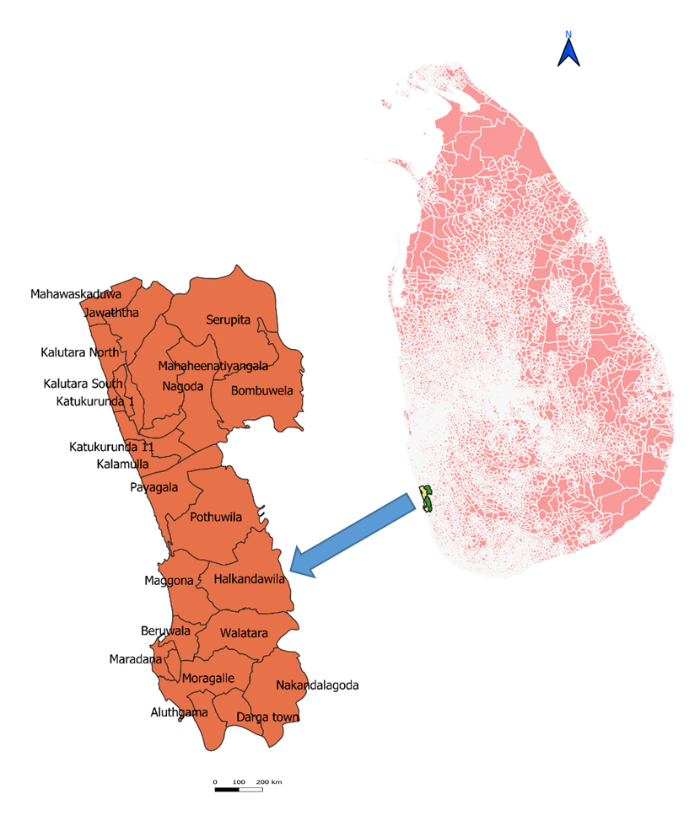
Fig 01 Map of study site

Data analysis
The recorded data was entered into MS Excel sheets and statistically analyzed using IBM SPSS Statistics version 23 at a significance level of α = 0.05. Both mixed breeding (positive for both vectors) premises and breeding habitats were not considered during the statistical analysis due to their low numbers. Pupae-per-House Index (PHI) and Pupal per Person Index (PPI) were calculated as Pupal demographic indexes. PHI was calculated as total number of pupae found, divided by the total number of households inspected (Morales-Pé Rez Id et al., n.d.) and PPI was calculated as the total number of recorded pupae, divided by the total population of the inspected households (Jiménez-Alejo et al., 2017). Comparison of demographic indexes for both species were done using Mann Whitney U test.
Index of Available Breeding Habitats (IABH) and Index of Contribution to Breeding habitats (ICBH), for each breeding habitats were calculated to determine the Breeding Preference Ratio (BPR) of both species (Kumar et al., 2002). Pupal Productivity Percentage (PPP) for different container types (the total number of pupae in the container type, divided by the total number of pupae in all breeding habitats, multiplied by 100) were calculated (Jiménez-Alejo et al., 2017). One-way ANOVA was used to evaluate the relationship between breeding habitat variables, (types, locations, building materials, and sources of water) and pupal productivity for both vectors. Difference between the measured water parameters of breeding habitats of the two species were analysed using independent sample T test and, correlation between physiochemical parameters and pupal productivity were checked using Pearson correlations.

RESULTS
Analysis of Pupal Demographic Data
A total of 2,400 premises were surveyed during the study period. Out of these, 3.29% (n=79), 6.91% (n = 166) and 0.41% (n = 10) were respectively positive with immatures of Ae. aegypti, Ae. albopictus, and both species. Among the premises positive with Aedes immatures, 23.92% (n = 61) also were positive for Aedes pupae. Ae. albopictus showed significantly higher positivity rates than Ae. aegypti in both the larval (U = 127.00, P = 0.001) and pupal (U = 178.00, P = 0.017) stages. The PHI for both species was quite similar, with Ae. aegypti at 0.16 and Ae. albopictus at 0.17, without significant difference (U = 441.5, p = 0.071). The PPI was 1.53 for Ae. aegypti and 1.63 for Ae. albopictus, also without significant difference (U = 456.0, p = 0.932).
Analysis of Breeding habitats
Among the surveyed premises, total of 1,480 potential breeding habitats were recorded. Of these, 85.54% (n = 1,266) were identified as water holding (wet), and 21.55% (n = 319) were positive for Aedes immatures. All recorded breeding habitats were categorized into 12 categories to estimate container productivity (Annex 01). Temporary removed items had the highest IABH (38.72) followed by discarded items (IABH = 17.50) and water storage items (IABH = 13.58) (Table 01). However, the highest BPR for Ae. aegypti was recorded in tyre and gutters, while for Ae. albopictus, it was recorded in natural and ornamental items (Table 01).
Among the immature positive breeding habitats, 9.09% (n = 29), 14.11% (n= 45), and 0.31% (n=1) were positive for pupae of Ae. aegypti, Ae. albopictus and both respectively. That is approximately 23.5% (n= 75) of breeding habitats with larvae were positive with pupae of both species.
As same as the highest BPR, the highest pupal productivity of Ae. aegypti was observed in tyre with a significant difference in productivity among the various breeding habitats (F = 3.265, p = 0.021, df = 6, 20). Although the highest BPR and pupal productivity of Ae. albopictus were not the same; the highest BPR was recorded in natural and ornamental items, while the highest pupal productivity was observed in temporarily removed items, without significant differences (F = 0.543, p = 0.796, df = 7, 35) (Table 01, Fig. 02).
Table 01 Calculated larval and pupal indexes according to type of breeding habitats
Breeding Habitat | Larval Indexes |  |  |  |  | Pupal Indexes
Breeding Habitat | IABH | ICBH (A) | ICBH (B) | BPR (A) | BPR (B) | PPP (A) | PPP (B)
Covering Items | 5.2 | 9.62 | 7.94 | 1.85 | 1.53 | 18.62 | 9.75
Gutters | 0.88 | 1.92 | 1.4 | 2.19 | 1.6 | 0 | 0
Discarded Items | 17.5 | 25 | 14.02 | 1.43 | 0.8 | 4.52 | 19.5
Temporary removed Items | 38.72 | 18.27 | 42.99 | 0.47 | 1.11 | 30.59 | 48
Natura Items | 1.76 | 0.96 | 3.74 | 0.55 | 2.13 | 0 | 1.25
Ornamental Items | 4.39 | 8.65 | 9.35 | 1.97 | 2.13 | 1.06 | 5.25
Pet Feeding Containers | 2.7 | 2.88 | 1.4 | 1.07 | 0.52 | 0.53 | 0
Refrigerators | 2.16 | 0 | 0.93 | 0 | 0.43 | 0 | 0
Slabs | 3.92 | 0 | 0.47 | 0 | 0.12 | 0 | 2.5
Tyre | 7.84 | 17.31 | 5.14 | 2.21 | 0.66 | 32.98 | 3
Water Storage Items | 13.58 | 12.5 | 9.81 | 0.92 | 0.72 | 9.57 | 3.25
A: Ae. aegypti, B: Ae. albopictus

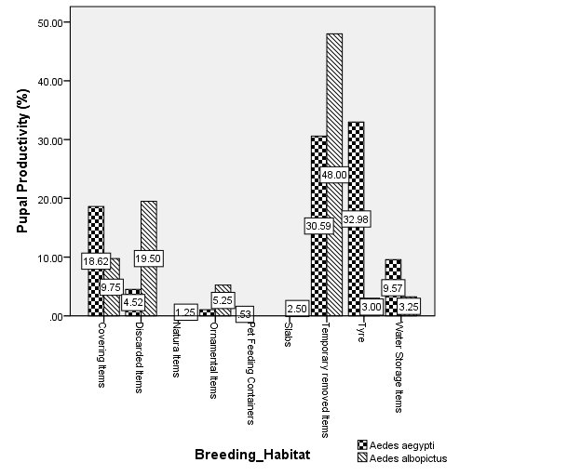
Fig 02 Productivity Variation of Ae aegypti and Ae. albopictus among different breeding habitats
Analysis of breeding habitats locations
Breeding habitat locations were categorized into indoor and outdoor; the outdoor habitats were further divided into shady and open areas. Approximately 97.12% (n = 101) of habitats were positive for Ae. aegypti larvae were found outdoors, while only 2.88% (n = 3) were found indoors. The highest pupal productivity of Ae. aegypti was observed in outdoor breeding habitats, with 64.36% (n = 242) in open areas and 31.91% (n = 120) in shady areas. In contrast, the lowest pupal productivity was recorded in indoor breeding habitats, at 3.72% (n = 14). There was no significant difference in Ae. aegypti pupal productivity among the locations of breeding habitats (F = 2.404, p = 0.112, df = 2, 24) (Fig. 03). Similarly, 98.59% (n = 211) of habitats were positive for Ae. albopictus larvae were found outdoors, and 1.41% (n = 3) were found indoors. The highest pupal productivity of Ae. albopictus were also recorded in outdoor breeding habitats, with 55.25% (n = 221) in open areas and 44.00% (n = 176) in shady areas. There was a significant difference in pupal productivity of Ae. albopictus among the locations of breeding habitats (F = 4.807, p = 0.014, df = 2, 40), and a significantly lower productivity of pupae was found in indoor habitats compared to habitats located in both open (p = 0.016) and shady (p = 0.011) areas (Fig. 03).
Analysis of building materials of breeding habitats
Most of the larvae positive breeding habitats for both species were composed of plastic, 35.58% (n = 37) of Ae. aegypti breeding habitats and 42.52% (n= 91) of Ae. albopictus breeding habitats were made from plastic. The productivity of Ae. aegypti pupae varied significantly with the building materials of breeding habitats (F = 7.008, p = 0.01, df = 4, 21), with the highest productivity found in rubber-made habitats at 34.04% (n = 128), followed by plastic-made habitats at 22.87% (n =86) Fig 04. In contrast, the productivity of Ae. albopictus pupae did not vary significantly with building materials of breeding habitats (F = 1.329, p = 0.265, df = 8, 32). However, plastic-made habitats, with 41.25% (n=165) and cement-made habitats, with16.5% (n=65), had the highest productivity (Fig. 04).
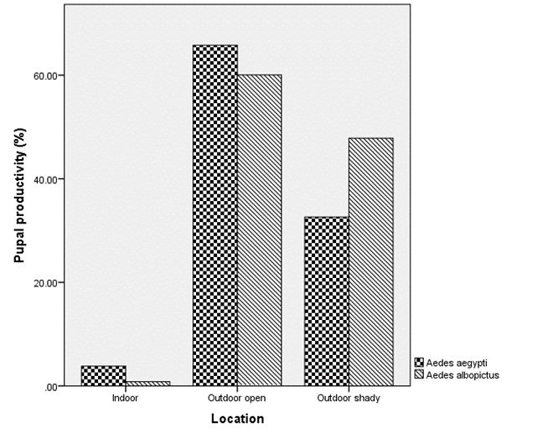

Fig 03 Variation of pupal productivity among locations of breeding habitats

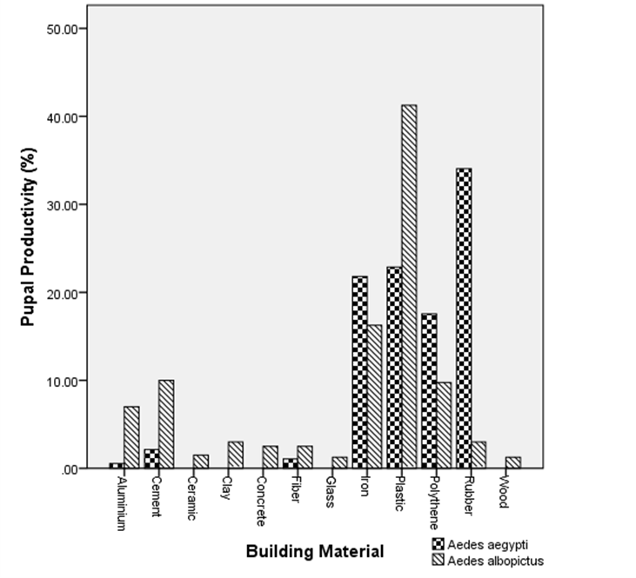

Fig 04 Variation of pupal productivity with building materials of breeding habitats

Analysis of Source of water
Rainwater was the primary water source found in both positive and pupal productive breeding habitats for both mosquito vectors. The pupal productivity of Ae. aegypti did not show a significant variation based on the water source (F = 2.962, p = 0.051, df = 3, 26), with the highest productivity recorded at 90.96% (n = 342) in breeding habitats containing rainwater (Fig 05). Similarly, the pupal productivity of Ae. albopictus also did not significantly vary with the water source (F = 0.005, p = 0.995, df = 2, 42), with the highest productivity of 90.50% (n = 362) observed in breeding habitats with rainwater (Fig 05).

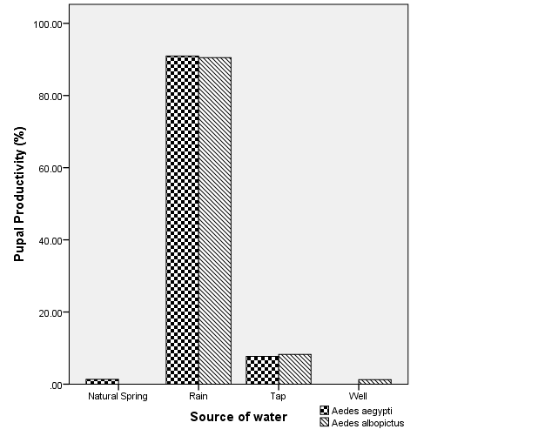
Fig 05 Variation of pupal productivity among different source of water
Analysis physiochemical parameters of Water
The mean and standard deviation of water parameters at the breeding habitat of both pupae species are summarized below. However, there were no significant differences in the measured water parameters between the two species. The results are as follows: Temperature (t =1.073, p =0.289, df =49), pH (t = 0.443, p =0.661, df =28), Conductivity (t = - 0.020, p =0.984, df =49), TDS (t =-0.226, p =0.822, df =48), Salinity (t =1.029, p =0.309, df =49).
Table 02 Physiochemical parameters of water in breeding habitats
 | Aedes aegypti |  |  | Aedes albopictus
 | Minimum | Maximum | Mean ± SD | Minimum | Maximum | Mean ± SD
Temperature (⁰C) | 28.1 | 34.3 | 31.81 ± 1.41 | 27.9 | 33.2 | 31.39 ± 1.38
PH | 5.98 | 7.24 | 6.59 ± 0.43 | 5.59 | 7.29 | 6.52 ± 0.38
Conductivity (μS) | 35.9 | 887 | 394.2 ± 274.02 | 58.2 | 873 | 395.67 ± 260.29
TDS (ppm) | 25.4 | 629 | 274.29 ± 197.24 | 72.6 | 623 | 286.5 ± 184.63
Salinity (ppt) | 0.02 | 0.52 | 0.22 ± 0.15 | 0.01 | 0.44 | 0.17 ± 0.14
Water Volume (ml) | 629 | 5000 | 906 ± 1424 | 30 | 30000 | 1660.93 ± 4923.93
The pupal productivity of Ae. aegypti showed a significant positive correlation with the volume of water in breeding habitats (r = 0.449, p = 0.019, df = 27). In contrast, the pupal productivity of Ae. albopictus did not show a correlation with the volume of water in breeding habitats (r = -0.209, p = 0.178, df = 43).
Additionally, no correlations were observed between the pupal productivity of Ae. aegypti and following physicochemical parameters of water, temperature (r = 0.071, p = 0.740, df = 24), pH (r = -0.353, p = 0.317, df = 10), conductivity (r = -0.174, p = 0.416, df = 24), total dissolved solids (r = -0.186, p = 0.395, df = 23), and salinity (r = -0.112, p = 0.603, df = 24). Similarly, there were no correlations between temperature (r = 0.100, p = 0.619, df = 27), pH (r = 0.387, p = 0.091, df = 20), conductivity (r = 0.183, p = 0.360, df = 27), total dissolved solids (r = 0.204, p = 0.308, df = 27), salinity (r = 0.097, p = 0.632, df = 27) and pupal productivity of Ae albopictus.

DISCUSSION
Even though positivity of Ae. albopictus significantly higher than Ae. aegypti, PHI was remarkably similar and statistically indistinguishable between the two species. This indicates that breeding habitats were positive for Ae. aegypti may contain more pupae on average, making them more efficient for mosquito production. Furthermore, the findings indicated that a significant proportion of infested households didn’t facilitate the development of larvae into their adult stage. This is why pupal indices area considered a more direct measure of adult vector production and transmission risk than just measuring the container (Padonou et al., 2025). This type of study provides a valuable framework for prioritizing vector-control interventions, while also highlighting the limitations of data gathered from traditional Stegomyia surveys (Banerjee et al., 2015)
The similarity in PPI indicates that the human population in this area experiences nearly equal biting pressure from both species. However, the highly anthropophilic, nervous, and discordant behavior of Ae. aegypti significantly increases the risk of disease transmission compared to Ae. albopictus. Conversely, it highlights that, Ae. albopictus could have an equal or notably important secondary role in the dynamics of disease transmission (Paul et al., 2015). This emphasizes the need for control programs to actively incorporate this species into their strategies. Otherwise the co-occurrence of Ae. aegypti and Ae. albopictus may increase arbovirus transmission (Padonou et al., 2025).
As previously well described, both Aedes species are container breeders and used various type of breeding habitats in different extend (Banerjee et al., 2015). The exploitation of certain type of breeding habitats is determined by different factors, leading to a major disparity between which habitats are commonly used (larval presence) and which are truly productive for generating adults (pupal presence).Such identification of the key container types should allow control efforts to be better focused and more cost-effective (Lenhart et al., 2006).
Pupal productivity differed in the larval habitats depending on the several factors such as size, location, building materials, sun exposure, and water volume (Mwakutwaa et al., 2023). Due to significant variation in productivity of Ae. aegypti pupae across the surveyed breeding habitats indicates that not all positive habitats types contribute equally to pupal productions. Also Ae. aegypti exhibits strong selectivity and actively prefers a few key artificial breeding habitats especially tyre, which are not only commonly infested but are also extremely productive, making them high-value targets for control.
The significant preference of Ae. aegypti for tyre is consistent with the findings from the analysis of building materials, which revealed that the highest pupal productivity occurs in habitats made of rubber. This finding strongly supports the established concept of "key containers", where a small subset of artificial habitats produces the majority of pupae in a population. Tires are a well-recognized global "key container" for Ae. aegypti, reflecting its synanthropic behavior, thriving in man-made breeding habitats that are often neglected, durable, capable of retaining stagnant water and prone to accumulate organic debris (Getachew et al., 2015; Mwakutwaa et al., 2023). The dark colour of tyre enhance their heat retention capacity which promotes rapid development of adults. Additionally, the shaded environment inside the tire protects immatures from desiccation and predators. Recycling used tyres for dengue prevention has gained popularity globally in recent years (WHO, 2009). If recycling is not feasible, storage in a dry environment and proper disposal of used tires should be encouraged.
In contrast to Ae, aegypti, the analysed results of Ae. albopictus indicates difference in the breeding preference and pupal productivity. While BPR was highest in natural and ornamental containers, pupal productivity highest in temporarily removed items. Also the lack of significant variation in Ae. albopictus pupae productivity across breeding habitats and building materials emphasizes its role as an opportunistic generalist and lays eggs in a wider variety of breeding habitats relative to their availability. This generalist strategy may reduce its vulnerability to control measures targeting specific container types.
This study finding provides more than 97% of positive larval habitats and more than 90% of pupae-positive breeding habitats for both species are located outdoors, indicating predominant exophilic breeding behavior of these vectors (Arunachalam et al., 2010; Banerjee et al., 2015; Mwakutwaa et al., 2023). This challenge the well-known endophilic behaviour of Ae. aegypti and emphasizes the exophilic behavior of Ae. albopictus. The lack of a statistically significant difference in pupal productivity among the locations of breeding habitats indicates a certain degree of flexibility of Ae. aegypti. In contrast, Ae. albopictus pupal productivity exhibited a significant aversion to indoor breeding habitats compared to both open and shady outdoor locations. According to findings, the control programme must be concentrated on outdoor focused source reduction. But, it is crucial to address specific indoor breeding habitats for Ae. aegypti, as their neglect may result in a significant increase in infestation rates.
This study confirms that rainwater is the predominant and most productive water source for the immature stages of both Ae. aegypti and Ae. albopictus, accounting for over 90% of pupal productivity for each species. This observation aligns with Forsyth's conclusion that most positive, and the most productive ones, containers, held rainwater (Banerjee et al., 2015). This overwhelming dominance of rainwater in positive breeding habitats highlights the critical role of precipitation in driving mosquito population dynamics. Furthermore, lack of significant variation in pupal productivity based on water source for either species indicates that once a container is filled with water, regardless of its origin, it becomes a potential breeding site. This underscores the importance of managing container habitats themselves, rather than the water source, through covering, disposal, or regular emptying.
The analysis of physicochemical water parameters reveals a clear and consistent pattern: the pupal production of both vectors is not determined by specific values of temperature, pH, conductivity, TDS, or salinity within the breeding habitats in this study. Also, there were no significant variation in the measured water parameters between the two species. This indicates significant ecological overlap in their fundamental niche regarding water quality, suggesting that both species can effectively use the same breeding habitats within these ranges of physicochemical conditions (Higa, 2011).
The most critical differentiating factor identified was the physical characteristic of water volume. The significant positive correlation between water volume and pupal productivity of Ae. aegypti suggests that this species preferentially develops in larger, more stable water bodies (Mwakutwaa et al., 2023). These larger volumes may offer benefits such as reduced risk of desiccation, greater resource availability, and a more stable thermal and chemical environment, supporting higher larval survival and density. Conversely, the lack of correlation for Ae. albopictus indicates its ecological flexibility as a "container generalist" and ability to exploit a wider variety of small, temporary habitats compared to Ae. aegypti.

CONCLUSION
The Pupal Demographic Indexes clearly indicate that the human population in this area faces nearly equal biting pressure from both mosquito species. However, our analysis of breeding habitats shows that a significant proportion of positive breeding sites fails to support the development of larvae into the pupal stage. Thus, it can be concluded that traditional larval indices are inadequate for accurately predicting the risk of dengue transmission.
The highest BPR and pupal productivity for Ae. aegypti are found in tyre, highlighting strong selectivity on tyre as a key container type. Furthermore, the pupal productivity of Ae. aegypti is significantly enhanced by the volume of water in breeding habitats, with larger volumes leading to greater productivity than smaller ones. Therefore, effective management of Ae. aegypti necessitates a strategic focus on removing key containers and managing larger artificial breeding habitats. In contrast, the observed variation in BPR and pupal productivity indicates that Ae. albopictus operates as an opportunistic generalist. This adaptability reduces its vulnerability to control measures targeting specific container types. Hence, a comprehensive community effort to eliminate outdoor breeding sources is crucial for effectively combating Ae. albopictus. Ultimately, public health messaging must be strategically designed to directly address the productive breeding habits of both species to effectively reduce overall vector density and mitigating the risk of dengue transmission.

REFERENCES
- Arunachalam, N., Tana, S., Espino, F., Kittayapong, P., Abeyewickreme, W., Wai, K. T., Tyagi, B. K., Kroeger, A., Sommerfeld, J., & Petzold, M. (2010). Eco-bio-social determinants of dengue vector breeding: a multicountry study in urban and periurban Asia. Bulletin of the World Health Organization, 88(3), 173. https://doi.org/10.2471/BLT.09.067892
- Aryaprema, V. S., & Xue, R. De. (2019). Breteau index as a promising early warning signal for dengue fever outbreaks in the Colombo District, Sri Lanka. Acta Tropica, 199(October), 105155. https://doi.org/10.1016/j.actatropica.2019.105155
- Azael Che-Mendoza, Pablo Manrique-Saide, Nidia Rizzo, Daniel Pilger, Audrey Lenhart, Axel Kroeger, B. A. (2011). Operational guide for assessing the productivity of Aedes aegypti breeding sites. World Health Organization, October, 1–30. http://www.who.int/tdr/publications/documents/sop-pupal-surveys.pdf
- Banerjee, S., Mohan, S., Saha, N., Mohanty, S. P., Saha, G. K., & Aditya, G. (2015). Pupal productivity &amp; nutrient reserves of Aedes mosquitoes breeding in sewage drains &amp; other habitats of Kolkata, India. Indian Journal of Medical Research, 142(Suppl 1), S87–S94. https://doi.org/10.4103/0971-5916.176632
- Chadee, D. D., Doon, R., & Severson, D. W. (2007). Surveillance of dengue fever cases using a novel Aedes aegypti population sampling method in Trinidad, West Indies: the cardinal points approach. Acta Tropica, 104(1), 1–7. https://doi.org/10.1016/J.ACTATROPICA.2007.06.006
- de Brito Arduino, M. (2014). Assessment of Aedes aegypti Pupal Productivity during the Dengue Vector Control Program in a Costal Urban Centre of São Paulo State, Brazil . Journal of Insects, 2014, 1–9. https://doi.org/10.1155/2014/301083
- Edillo, F. E., Roble, N. D., & Otero, N. D. (2012). The key breeding sites by pupal survey for dengue mosquito vectors, Aedes aegypti (Linnaeus) and Aedes albopictus (Skuse), in Guba, Cebu City, Philippines. Southeast Asian Journal of Tropical Medicine and Public Health, 43(6), 1365–1374.
- Focks, D. A., Alexander, N., Romero-Vivas, C. M., Theresa Midega, J., Bisset, J., Barbazan, P., Sinh Nam, V., & Arredondo-Jiménez, J. I. (2006). Multicountry study of Aedes aegypti pupal productivity survey methodology: findings and recommendations. www.inis.ie
- Getachew, D., Tekie, H., Gebre-Michael, T., Balkew, M., & Mesfin, A. (2015). Breeding sites of aedes aegypti: Potential dengue vectors in dire Dawa, east Ethiopia. Interdisciplinary Perspectives on Infectious Diseases, 2015. https://doi.org/10.1155/2015/706276
- Higa, Y. (2011). Dengue vectors and their spatial distribution. In Tropical Medicine and Health (Vol. 39, Issue 4 SUPPL., pp. 17–27). https://doi.org/10.2149/tmh.2011-S04
- Jiménez-Alejo, A., Morales-Pérez, A., Nava-Aguilera, E., Flores-Moreno, M., Apreza-Aguilar, S., Carranza-Alcaraz, W., Cortés-Guzmán, A. J., Fernández-Salas, I., Ledogar, R. J., Cockcroft, A., & Andersson, N. (2017). Pupal productivity in rainy and dry seasons: Findings from the impact survey of a randomised controlled trial of dengue prevention in Guerrero, Mexico. BMC Public Health, 17(1), 71–78. https://doi.org/10.1186/S12889-017-4294-8/TABLES/5
- Kumar, R. R., Kamal, S., Patnaik, S. K., & Sharma, R. C. (2002). Breeding habitats and larval indices of Aedes aegypti (L) in residential areas of Rajahmundry town, Andhra Pradesh. The Journal of Communicable Diseases, 34(1), 50–58. http://www.ncbi.nlm.nih.gov/pubmed/12718342
- Lenhart, A. E., Castillo, C. E., Oviedo, M., & Villegas, E. (2006). Use of the pupal/demographic-survey technique to identify the epidemiologically important types of containers producing Aedes aegypti (L.) in a dengue-endemic area of Venezuela. Annals of Tropical Medicine and Parasitology, 100(SUPPL. 1). https://doi.org/10.1179/136485906X105516
- Liyanage, P., Tozan, Y., Tissera, H. A., Overgaard, H. J., & Rocklöv, J. (2022). Assessing the associations between Aedes larval indices and dengue risk in Kalutara district, Sri Lanka: a hierarchical time series analysis from 2010 to 2019. Parasites and Vectors, 15(1), 1–15. https://doi.org/10.1186/s13071-022-05377-6
- Morales-Pé Rez Id, A., Nava-Aguilera, E., Herná Ndez-Alvarez, C., Alvarado-Castro, M., Arosteguí, J., Legorreta-Soberanis, J., Flores-Moreno, M., Morales-Nava, L., Harris, E., Ledogar, R. J., Andersson, N., & Cockcroft, A. (n.d.). Utility of entomological indices for predicting transmission of dengue virus: secondary analysis of data from the Camino Verde trial in Mexico and Nicaragua. https://doi.org/10.1371/journal.pntd.0008768
- Mwakutwaa, A. S., Ngugi, H. N., Ndenga, B. A., Krystosik, A., Ngari, M., Abubakar, L. U., Yonge, S., Kitron, U., LaBeaud, A. D., & Mutuku, F. M. (2023). Pupal productivity of larval habitats of Aedes aegypti in Msambweni, Kwale County, Kenya. Parasitology Research, 122(3), 801–814. https://doi.org/10.1007/s00436-022-07777-0
- Nathan, M. B., Focks, D. A., & Kroeger, A. (2006). Pupal/demographic surveys to inform dengue-vector control. Annals of Tropical Medicine and Parasitology, 100(SUPPL. 1). https://doi.org/10.1179/136485906X105462
- Padonou, G. G., Hoyochi, I., Sovi, A., Konkon, A. K., Zoungbédji, D. M., Salako, A. S., Adoha, C. J., Fassinou, A., Koukpo, C. Z., Chitou, S., Nwangwu, U., Yadouleton, A., Baba-Moussa, L., Akogbéto, M. C., Padonou, G. G., Hoyochi, I., Sovi, A., Konkon, A. K., Zoungbédji, D. M., … Akogbéto, M. C. (2025). Diversity of Aedes Mosquito Breeding Sites and the Epidemic Risk of Arboviral Diseases in Benin. Insects 2025, Vol. 16, 16(12), 1215. https://doi.org/10.3390/INSECTS16121215
- Paul, R., Valecha, N., & Telle, O. (2015). Comparison of Ae. aegypti breeding in localities of different socio-economic groups of Delhi, India. International Journal of Mosquito Research, 2(3), 83–88.
- Schaffner, F., & Mathis, A. (2014). Dengue and dengue vectors in the WHO European region: past, present, and scenarios for the future. The Lancet Infectious Diseases, 14(12), 1271–1280. https://doi.org/10.1016/S1473-3099(14)70834-5
- Sirisena, P. D. N. N., & Noordeen, F. (2014). Evolution of dengue in Sri Lanka—changes in the virus, vector, and climate. International Journal of Infectious Diseases, 19(1), 6–12. https://doi.org/10.1016/J.IJID.2013.10.012
- WHO. (2009). DENGUE GUIDELINES FOR DIAGNOSIS, TREATMENT, PREVENTION AND CONTROL. https://apps.who.int/iris/bitstream/handle/10665/44188/9789241547871_eng.pdf?sequence=1&isAllowed=y
- Wilson-Bahun, T. A., Kamgang, B., Lenga, A., & Wondji, C. S. (2020). Larval ecology and infestation indices of two major arbovirus vectors, Aedes aegypti and Aedes albopictus (Diptera: Culicidae), in Brazzaville, the capital city of the Republic of the Congo. Parasites and Vectors, 13(1). https://doi.org/10.1186/S13071-020-04374-X
- Withanage, G. P., Hapuarachchi, H. C., Viswakula, S. D., Nilmini, Y. I., Gunawardena, S., & Hapugodaid, M. (2020). Entomological surveillance with viral tracking demonstrates a migrated viral strain caused dengue epidemic in July, 2017 in Sri Lanka. https://doi.org/10.1371/journal.pone.0231408

