VALORIZATION OF PYROLYZED WASTE POLYTYRENE AND CASHEW NUT SHELL OIL (CNSO) AS A SUSTAINABLE HYBRID BINDER FOR HIGH-PERFORMANCE PAINT

Abstract
The coating industry's quest for sustainable alternatives has been sparked by the buildup of non-biodegradable expanded polystyrene (EPS) trash and the environmental harm caused by traditional petroleum-based binders. The purpose of the study was to assess how these two waste streams could work in concert to improve the final paint binder's physicochemical characteristics. Excellent performance characteristics were demonstrated by the optimized hybrid binder (PS/CNSO), which recorded a density of 1.280 g/cm³, a pH of 4.78, and a turbidity of 101.2 NTU. A refractive index of 1.556 and a melting point of 139°C were determined by thermal and optical analyses, respectively. Importantly, the binder showed good brushability with a viscosity of 16.2 mPa.s, and it showed no moisture uptake, indicating outstanding hydrophobic qualities and environmental endurance.These findings show that the combination of CNSO and PSPO improves flexibility and water resistance while successfully reducing the brittleness of recycled plastics. This study offers an economical and environmentally responsible method for producing high-quality paint by using waste materials that are produced locally, greatly lowering the environmental impact of plastic and agricultural waste. By using a batch pyrolysis process to transform solid EPS waste into a liquid intermediate and mixing it with locally sourced Cashew Nut Shell Oil (CNSO) in different concentrations, this study effectively illustrates a "waste-to-wealth" strategy.
Keywords: CNSO, Paint Binder, Physicochemical Properties, Polystyrene Pyrolysis Oil, Waste Valorization,

Introduction
A circular economy has to replace linear "take-make-dispose" paradigms due to the worldwide plastic waste management challenge. Much of this waste is made up of expanded polystyrene (EPS), a common thermoplastic that is widely used in insulation and packaging. Despite its usefulness, mechanical recycling and conventional landfilling are costly and environmentally harmful due to its low density and non-biodegradability. Pyrolysis, a recent development in thermal recycling, provides a reliable method for turning solid polystyrene waste into valuable liquid hydrocarbons. A sustainable feedstock for the production of industrial resins and binders, these pyrolytic oils are abundant in aromatic compounds (Qu, 2020). Although PSPO has great gloss and hardness, its use as a stand-alone binder in paintings is frequently restricted by its brittleness, yellowing with age, and lack of flexibility as the film forms. Researchers have resorted to bio-based modifiers in order to remedy these mechanical shortcomings. One of the best "green" options is CNSO, a non-edible agricultural waste. Anacardic acid, cardanol, and cardol are phenolic chemicals that make up CNSO. These compounds have a special chemical structure that consists of a stiff aromatic ring and a flexible, unsaturated C15 aliphatic side chain (Mohammed, 2025). Because of its structure, CNSO can function as an anti-corrosive and natural plasticizer, which could improve the toughness and water resistance of synthetic polymer matrices.
A new development in environmentally friendly surface coatings is the combination of bio-resins with recycled polymers (PSPO). The dissolving of polystyrene in solvents for emulsion paints has been studied in the past (Pietschmann, 2023), but there is still little research on using pyrolysis oil made from waste PS as the main binder component in oil-based systems. By replacing petroleum-derived monomers with renewable phenolic lipids, blending PSPO binder with CNSO not only keeps trash out of landfills but also lowers the carbon footprint of paint manufacture (Mohammed, 2025).
Systematic research is necessary to determine the precise impact of CNSO concentration on the mechanical durability, physicochemical characteristics, and film formation kinetics of a PSPO-hybrid binder. The formulation of an oil paint binder made by co-valuing waste cashew nut shells and polystyrene is assessed in this study. This study attempts to determine an ideal ratio that strikes a compromise between the structural stiffness of recycled polystyrene and the functional flexibility of CNSL by examining variables like viscosity, pH, density, turbidity, water resistance, adhesive strength, and chemical resistance.

Sample Collection
The method described by Osemeahon et al., (2025). Was used with minimal alteration. The cashew nut was bought from Jimeta Market Yola, and waste polystyrene were gathered from the trash dumps of the various electronics stores in Yola city.

Fabrication of pyrolysis plant
All the materials for the fabrication were locally sources and the construction of the pyrolysis plant carried out.
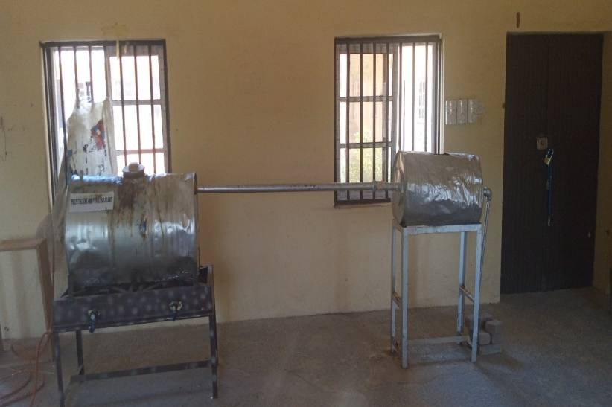
Figure 1 Picture of Locally Fabricated Pyrolysis Plant

Materials
Cashew nut was obtained from Jimeta market Yola, Adamawa State, Nigeria, while the polystyrene wastes were collected from refuse dumps in Yola metropolis.
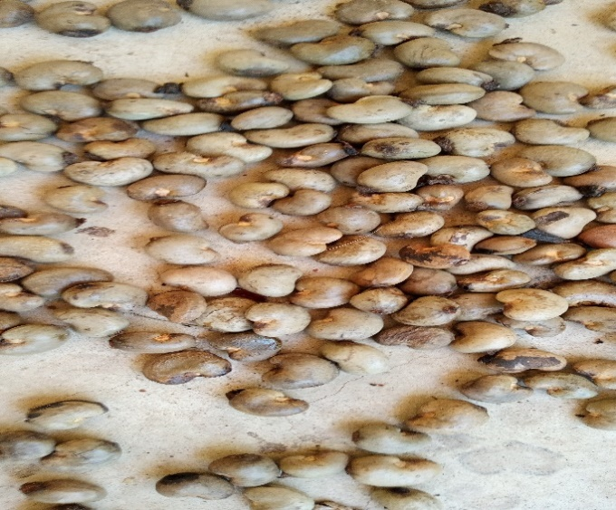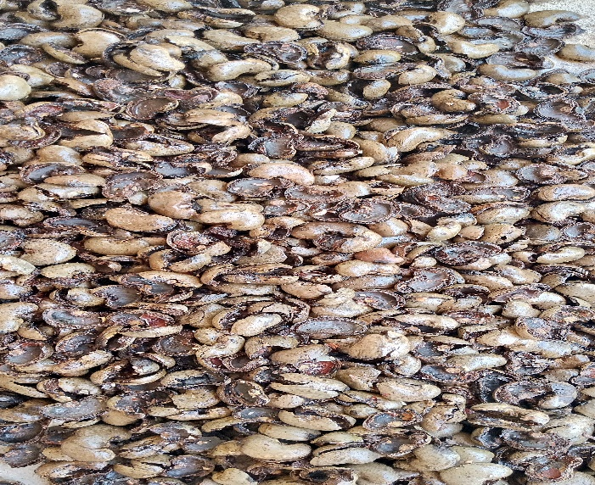
Figure 2 Picture of Cashew nut and Cashew nutshell

Method
The impurities were get rid of from the waste PS, the collected samples waste PS were processed, cleaned, size and dried. To increase the surface area during pyrolysis, the PS sample were broken up into tiny fragments. Solid PS was pyrolyzed to liquid PS pyrolysis oil (PSPO) using the pyrolysis plant built (Osemeahon et al., 2024).
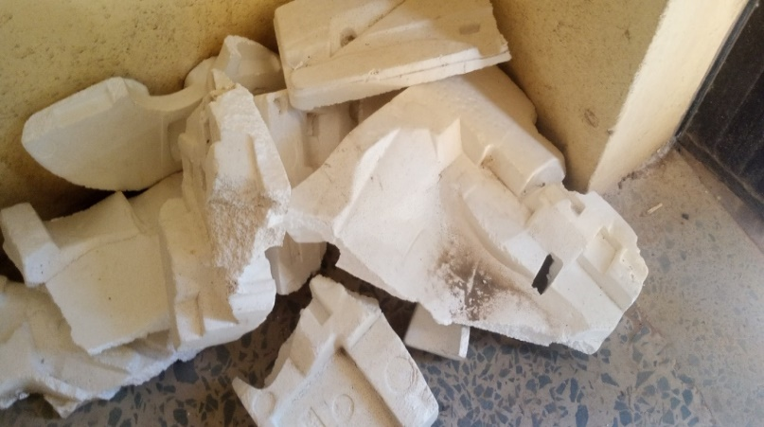
Figure 3 Picture of Polystyrene waste

Pyrolysis
The pyrolysis plant constructed, was used to convert solid waste PS into liquid PSPO using the method described by Osemeahon et al., (2025). With little modification. 2.8 kg of solid waste PS was pyrolyzed within 3 – 4 hours and pure liquid polystyrene pyrolysis oil (PSPO) of 1.7 kg was obtained at the external body temperature of between 122.4 – 130.3 ⁰C of the reactor was observed. The pyrolyzed liquid PS, pyrolysis oil (PSPO) was then further washed with clean water to get rid of any remaining impurities.

Conversion of PSPO solvent to PSPO binder
800 g solid PS was dissolved in the liquid PS pyrolysis oil (PSPO) of 3 kg to increase its viscosity and allowed to stay for 24 hours. Finally, a highly viscous liquid produced (PSPO binder) was then stored in a clean rubber container covered for use in paint formulation in the future.
Extraction of CNSO using Soxhlet extraction
The cashew nut bought from Jimeta market was washed with cleaned water and dried, the edible seed inside was carefully separated, and the shell (waste) was ground into a tiny fine powder using a pestle and mortar in order to increase the shell's surface area and make it easier to extract the CNSO. The soxhlet extractor and gasoline as the solvent were used for the extraction process. 322g of the CNS and 800 ml of gasoline were used within 8 – 9 hrs and CNSO of 70 ml was extracted or obtained after evaporation of the solvent.
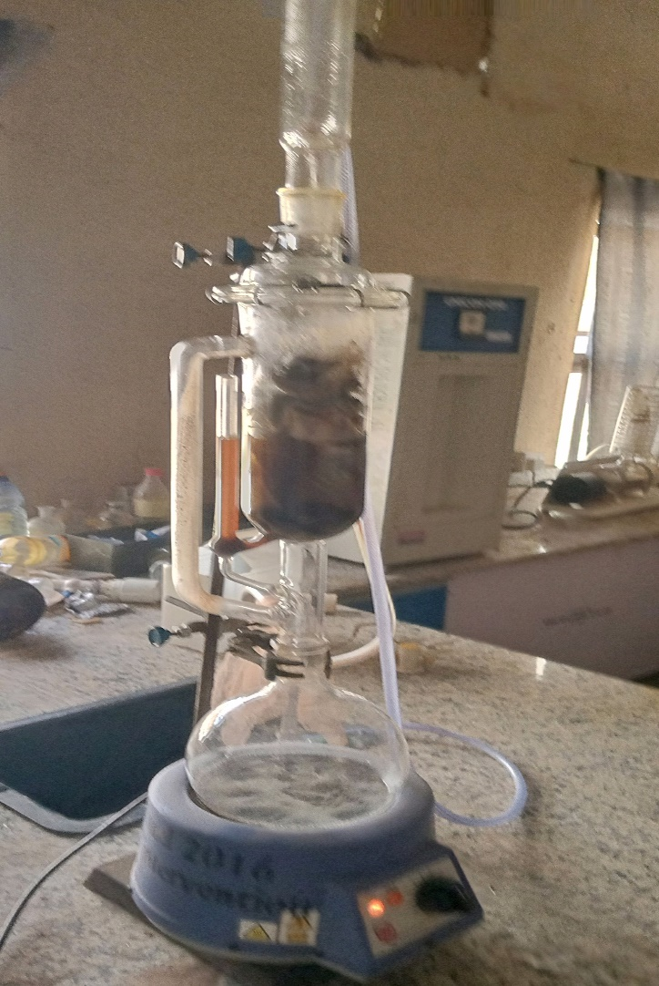
Figure 4 Picture of Soxhlet Extractor used to extract CNSO

Blending of PSPO binder with CNSO
In order to address the short comings of pure PSPO binder which includes: brittleness, yellowing with age and the little moisture observed, PSPO was blended with CNSO to remove or minimize these problems. The result from this experiment is as shown in table below

Physiochemical properties of PS/CNSO composite
Physiochemical properties Value
Density 1.280 g/cm³
pH 4.78
Turbidity 101.2 NTU
Melting point 139 ⁰C
Refractive index 1.556
Viscosity 16.2 mPa.s
Moisture uptake 0
Figure 5 Physiochemical properties of PS/CNSO Composite Resin formulated

Density of the PS/CNSO composite
The density of a binder affects characteristics like pigment stability and dispersion, which are used to calculate the paint's critical pigment volume concentration, spreading ability, and uniformity. The addition of CNSO to the PS/CNSO composite is ascribed to the morphological change, which results in the creation of a new macrostructure and the restoration of a morphology with a good packing nature, which raises the composite's high density. According to Khorssani et al. (2016), the density of a paint resin typically has a significant impact on aspects including paint flow, leveling, sagging, pigment dispersion, and brushability.

pH of the PS/CNSO composite
The PS/CNSO composite's pH value of 4.78 suggests that the paint is acidic. Since the PS/CNSO composite is in the acidic range, it is not conducive to bacterial growth and is hence impervious to bacterial assault (Surajudeen et al., 2015). The acidic character of the two ingredients (PSPO, 2.73, and CNSO, 3.00) may be the cause of the acidic level that is found. This indicates a modest decrease in pH values due to PSPO concentrations, indicating that an acidic medium will be ideal for paint formulation.

Turbidity of the PS/CNSO composite
Because it affects the resin's gloss, turbidity is a crucial characteristic in the coatings industry. The interaction between the PSPO and CNSO particles, which causes light scattering, could be the cause of the greater turbidity value displayed in the above table. Turbidity has been directly linked to light scattering. Turbidity will rise as a result of increased light scattering caused by non-homogeneity and more or many particles. This could be because the copolymer composite's randomly oriented components have different refractive indices. Once more, the haze caused by the colored PS/CNSO resin could be the cause of this. Turbidity and light scattering characteristics have been directly linked (De Fruit, 2017). Light scattering leading to good turbidity impacts opacity. Hence reflections enhance gloss and UV absorption in coating resins.

Melting point of the PS/CNSO film composite
The composite's degree of stiffness, degree of cross linking, and molecular weight all affect its melting point. A compound's melting point generally rises with its molar mass, intermolecular force, and intrinsic structures, all of which have a positive impact on stiffness.
The PS/CNSO composite has an excellent melting point, according to the results in Figure 5 above. The PS/CNSO composite's increased molecular weight, degree of cross linking, and degree of stiffness could be the cause of this. Additionally, PSPO and CNSO exhibit a strong specific interaction that forms a strong compacted structure, giving the composite some degree of hardness (Qi et al., 2022).
The PS/CNSO composite's melting point was found to be higher than that of the PSPO binder and CNSO. This could be explained by the particles' close proximity and high packing nature, which could result in a strong force of attraction between the molecules and raise the composite's melting point. In the coating industry, the paint binder's melting point is crucial since it provides information on the paint's brittleness and thermal resistance. This indicates that paints made with PS/CNSO binder won't brittlely or yellow over time (Qi et al., 2022)

Refractive Index of the PS/CNSO composite
One of the inherent characteristics of oil paint that PS/CNSO composite must operationally affect is gloss. Gloss has a significant impact on the mechanical and performance characteristics of coating materials. High refractive index coatings produce high-quality gloss.
According to the results in Figure 5 above, the PS/CNSO composite has a greater refractive index than the PSPO binder. This is explained by variations in the amount of crystalline and amorphous phases in the copolymer composites, which mainly cause light scattering. It might also result from the orientation and aggregation state that PS/CNSO creates, which results in discontinuities and light scattering boundaries in the copolymer composite's molecular structure.
Because PS/CNSO is dark brown in color, it can affect haze and raise the refractive index. Additionally, the high refractive index is caused by surface enrichment of specific chain constituents and/or surface-induced phase (Liem et al., 2017). One of the inherent characteristics of oil-based paints that the PS/CNSO has demonstrated or affected is gloss.

Viscosity of the PS/CNSO composite
Another crucial element for the coating industry is the binder's viscosity. Because the viscosity of the binder regulates numerous processing and application properties, including flow rate, leveling and sagging, thermal and mechanical properties, paint film dry time, and coating adhesion to the substrate, viscosity is traditionally considered to be one of the most significant properties (Yuri et al., 2017).
According to the results in Figure 5, the PS/CNSO composite has a higher viscosity than the PSPO binder. This could be because of the crosslinking interaction between PSPO and CNSO, which creates a new macrostructure with a higher viscosity. According to Seyfzadeh et al. (2015), PS/CNSO composites' increased viscosity is linked to changes in molecular weight and molecular characteristics, such as polydispersity.

Moisture uptake of the PS/CNSO composite
Because they encourage film deterioration and/or substrate damage, permeability and water absorption have an impact on binder performance. Additionally, water damages adhesion and thermochemical characteristics, causes the network to degrade chemically, and creates stress due to swelling.
Due to the hydrophobic property of PS/CNSO taken dominance, the result in Figure 5 above indicates 0% tolerance to water uptake, suggesting there is no worry of film deterioration (Sohel et al., 2015). Potential PSPO and CNSO contact reduces the copolymer resin's OH groups, which eliminates its affinity for water molecules. The crosslinks created by this interaction may also give the resulting product (PS/CNSO) strong resistance to alkali and water.

Analysis of FTIR on PS/CNSO
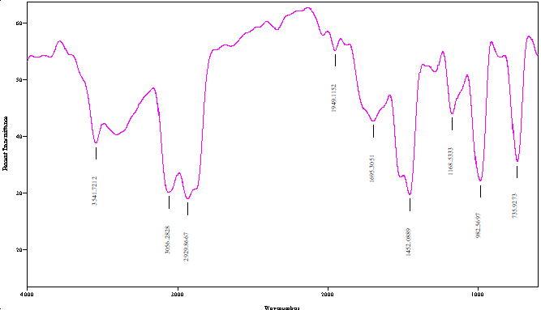
Figure 6 FTIR analysis of PS/CNSO
FTIR Interpretation of PS/CNSO
The Phenolic (O-H) Stretching is the absorption peak located at 3541.72 cm-1 in the PS/CNSO FTIR spectrum. This is the cardanol's OH group from the CNSO. According to Jaafar et al. (2023), its existence attests to the CNSO's (or its derivatives') inclusion in the component.
The PS/CNSO composite binder's FTIR spectrum shows an absorption peak at 3056.28 cm-1, which is quite typical of sp2 C-H stretching vibrations. Particularly above 3000 cm-1, this region is usually linked to C-H bonds in which the carbon atom is a component of an aromatic ring or a double bond. The chemical structures that result in a peak in this area are present in both the composite components, Polystyrene (PS) and Cardanol from Cashew Nut Shell Oil (CNSO) (Adewale et al., 2024).
The presence of saturated aliphatic C-H bonds is shown by the absorption peak at 2929.87 cm-1 in the PS/CNSO composite binder's FTIR spectra. One of the strongest and most noticeable peaks from the backbone of the polymer chain is this one. The saturated polymer structure that makes up the bulk of the binder is fundamentally present, as confirmed by the 2929.86 cm-1 peak (Milena et al., 2017).
Because of the aromatic ring of both components and the unsaturated side chain of Cardanol/CNSO, the FTIR peak seen in the PS/CNSO composite binder at 1949.1152 cm-1 represents the C=C stretching of Alkene Present (Gelzo et al., 2015).
At 1695.30 cm-1, the PS/CNSO composite's FTIR spectrum shows an absorption peak that is most likely caused by the stretching vibration of a carbonyl C=O group, which is a feature of ketone and aldehyde or a conjugated ester/carboxylic acid derivative. either by altering CNSO to produce the binder (e.g., by reacting with aldehydes, epoxidation, or esterification) or by oxidatively polymerizing the unsaturated side chain, which produces alpha, beta-unsaturated ketones, or esters, during the binder's curing, drying, or aging process (Chen-Wiegart et al., 2017).
The components' C-H vibrations are mainly responsible for the PS/CNSO composite binder's FTIR absorption band at 1452.08 cm-1. is mostly a mixed signal from cardanol, the primary component of CNSO, and polystyrene. The presence of C-H groups from the aliphatic side chains of the cardanol (CNSO) and the polystyrene backbone/ring is represented by the prominent peak at 1452.08 cm-1, which is a superimposed characteristic. It validates that these basic structural units are present in both binder components.
The C-O stretching vibration in a PS/CNSO composite binder is most likely responsible for the FTIR absorption band at 1168.53 cm-1. The cardanol (CNSO) component's C-O stretching is most consistently attributed to the peak at 1168.53 cm-1. Its presence verifies that the cardanol moiety was incorporated into the composite binder and may suggest that the PS and CNSO components are interacting chemically, such as through an etherification or cross-linking reaction (Jaafar et al., 2023).
The PS/CNSO composite binder's FTIR absorption band at 982.57 cm-1 is most likely related to the vibrations of the unsaturated double bonds seen in the CNSO cardanol component. Since these C=C bonds are the locations for oxidative cross-linking (curing), the peak at 982.57 cm-1 verifies that CNSO is present in the composite and that the C=C double bonds are intact (Adewale et al., 2024).
Lastly, the distinctive C-H peak of polystyrene (PS) is the absorption band seen at 735.93 cm-1 in the FTIR spectrum of the PS/CNSO composite binder. Aromatic C-H. In the context of composite binder, this peak's obvious presence serves two primary functions: It indicates the successful integration of the PS component into the binder matrix. Additionally, this band is associated with the PS polymer's core aromatic structure. A significant portion of the CNSO active groups are either free or hydrogen-bonded, as indicated by the phenolic (O-H) band at 3541 cm-1. This suggests that the material is either a physical blend or a grafted copolymer with a large number of unreacted CNSO hydroxyl groups still present (Milena et al., 2017).
One noteworthy characteristic is the existence of the C=O peak at 1695 cm-1. It most likely results from the {PS} or, more frequently, the CNSO component being blended, cross-linked, modified, or oxidized during processing (Milena et al., 2017). The spectral data shown that the main component of this sample (PS/CNSO) is from PS and CNSO.
Analysis of TGA of PS/CNSO
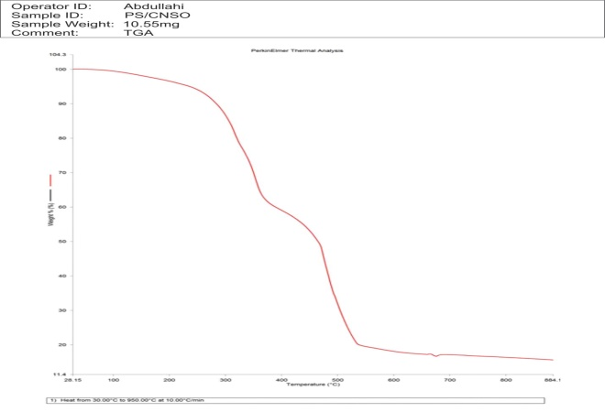
Figure 7 TGA analysis of PS/CNSO
TGA Interpretation for PS/CNSO
The PS/CNSO composite's TGA curve shows a multi-step thermal deterioration characteristic. The evaporation of surface-adsorbed moisture or volatiles is responsible for the initial slight or nonexistent weight loss below 150°C. The breakdown of polystyrene chains and the organic components of cashew nutshell oil is indicated by the most notable degradation, which takes place between 200°C and 600°C.
According to XRD studies, thermally stable inorganic oxides like SiO₂, CaO, and MgO are responsible for the final residue (~15%) that remains at 900°C. This implies that ash-forming minerals, most likely produced from CNSO, are present in the composite. According to the TGA results, the PS/CNSO composite has intermediate thermal stability, which qualifies it for use as paint additives or coating binders at moderate temperatures (Ren et al., 2022).

Analysis of XRD on PS/CNSO
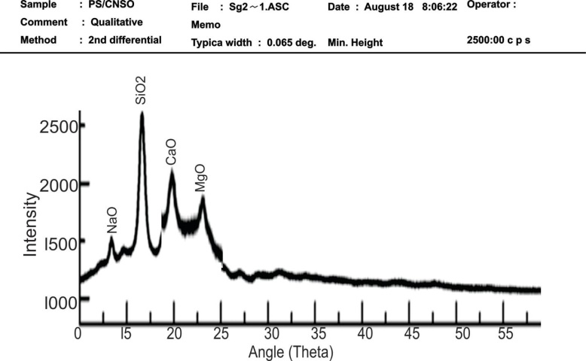
Figure 8 XRD analysis of PS/CNSO
XRD Interpretation of PS/CNSO
The PS/CNSO composite's XRD pattern shows both crystalline and amorphous phases. This amorphous polystyrene matrix is characterized by a large background hump between 15° and 25° 2θ. Sharp peaks representing SiO₂, NaO, CaO, and MgO are superimposed on this, suggesting the existence of crystalline inorganic components that most likely come from the ash content or cashew nutshell oil (CNSO).
.
These oxides are frequently found in biomass leftovers, and their presence could improve the composite material's mechanical, thermal, or barrier qualities. The XRD measurements verify that the composite is somewhat crystalline, with the polystyrene remaining mostly amorphous and the crystalline content ascribed to mineral-rich components in CNSO. Applications such as paint binders or coatings, where a balance between flexibility (amorphous) and durability (crystalline fillers) is desired, may benefit from this hybrid structure (Mark et al., 2020).

Analysis of SEM on PS/CNSO
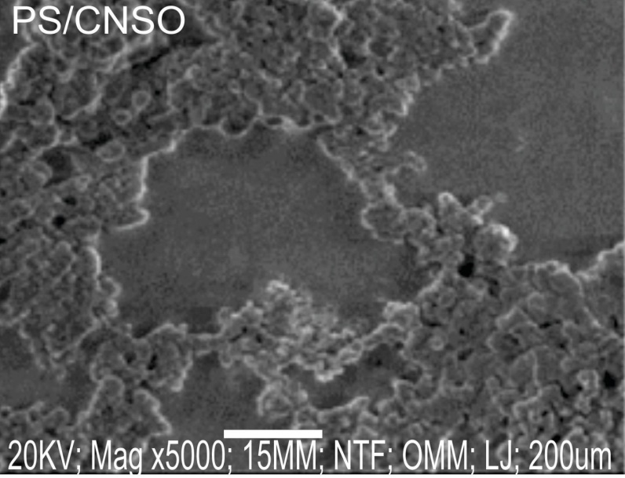
Figure 9 SEM analysis of PS/CNSO

SEM Interpretation of PS/CNSO
The polymer-modified composite's SEM micrograph, obtained at 20 kV at 5000× magnification, shows a microstructure that is densely packed and has a moderately rough surface. The NTF/OMM detector mode, which is appropriate for recording surface topography, and a 15 mm working distance, which is optimum for depth of field, were used for the imaging. A satisfactory packing density is indicated by the closely packed particles or structural elements visible in the field of view (scale bar: 200 µm). For applications needing mechanical strength, barrier qualities, or dense film formation, this indicates that the material has undergone effective processing or formulation (Adewale et al., 2024).
There are no significant flaws and the surface is non-porous and continuous, suggesting a well-formed binder matrix. While the well-packed particles or components indicate a uniform dispersion of fillers or additives inside the polymer binder, the rough morphology may favorably affect substrate adherence and improve mechanical interlocking. The mechanical and physical integrity needed for high-performance paint or coating applications is supported by this structure.
Effective film-forming behavior is also implied by the comparatively dense and homogeneous microstructure, which is necessary to provide barrier qualities, coating longevity, and environmental resistance. The polymer-modified composite's good surface and microstructural properties that support its prospective application as a functional binder in advanced paint formulations are confirmed by the SEM study (Ria et al., 2020).

REFERENCES
Adewale George Adeniyi, Sulyman A. Abdulkareem, Ebuka Chizitere Emenike, Ashraf M.M. Abdelbacki, Mubarak A. Amoloye, Kingsley O. Iwuozor, Abdelrahman O. Ezzat, Favour O. Eleregbe & Ifeoluwa Peter Oyekunle (2024). Mechanical and chemical characterization of biochar-reinforced polystyrene composites. BMC Chemistry volume 18,
Chen-Wiegart, Y. C. K., Catalano, J. and Williams, G. J. (2017). Elemental and Molecular Segregation in oil paintings due to lead soap degradation. Scientific reports 2017; 7)1): 1-9.
De Kruif C. G. (2017). The Turbidity of Renneted Skim Milk. Journal of Colloid Interface Sci. ; 156: 38-42.
Gelzo, M., Mario Grimaldi, Alessandro Vergara, Valeria Severino, Angela Chambery & Antonio Dello Russo1 (2015). Comparison of binder compositions in Pompeian wall painting styles from Insula Occidentalis. Chemistry Central Journal 8:65 http://journal.chemistrycentral.com/content/8/1/65
Jaafar, Y., Ramirez, G.C.A., Abdelouahed, L., El Samrani, A., El Hage, R. & Taouk, B. (2023). Upgrading Pyrolytic Oil via Catalytic Co-Pyrolysis of Beechwood and Polystyrene. Molecules 28, 5758. https://doi.org/10.3390/ molecules28155758
Khorassani, M., Pourmahdian, S. & Afshar Taromi, F. (2016) Estimation of Critical Pigment Volume Concentration in Latex Paint Systems Using Gas Permeation. Iran. Polymer Journal; 14 (11): 1000–7
Liem, H., Etchegoin, P. & Whitehead, K. S. (2017). Raman Scattering as a Probe of Morphology in Conjugated Polymer Thin Films. Journal of Applied Phys. 92(2): 115461
Mark R., Witkowski & Kelsey DeWitt (2020). The Use of X-Ray Powder Diffraction (XRD) and Vibrational Spectroscopic Techniques in the Analysis of Suspect Pharmaceutical Products: Spectroscopy-07-01-35 (7) : 41–48
Qu, Z. (2020). Design and performance of water resistant cementitious materials: mechanisms, evaluation and applications.
Milena N. Miljković, Dragan Đorđević, Miloš Đokić, Vojkan Miljković & Kristina Stoilkovski (2017). Qualitative Analysis of Pigments and Binders in paint colours used in “Gvozden” by Mica Popovic. Advanced technologies 6 (2) 56-59
Mohammed, A. N. (2025). Synthesis and application of modified CNSL in sustainable surface coatings. (Updated findings on cardanol-based resins for rapid-curing and UV resistance).
Osemeahon, S. A., Akinterinwa, A., Fasina, E., Andrew, F. P., Shagal, M. H., Kareem, S. A. & Aminu, A. (2025). Characterization and application of composite resin of natural rubber latex and polystyrene waste as a binder for water-resistant emulsion paint formulation. Progress in rubber, plastics and recycling technology, 41 (4), 355-372.
Osemeahon, S. A., Akinterinwa, A., Fasina, E., Andrew, F. P., Shagal, M. H., Kareem, S. A. & Esenowo, D. (2024). Reduction of polystyrene/polyurethane plastic wastes from the environment into binders for water-resistant emulsion paints. Heliyon, 10 (6).
Qi G. R., Wang, Y. H., Li, X. X., Peng, H. Y. & Yang, S. L. (2022). Viscometric study on the specific interaction between proton donating polymers and proton-accepting polymers. Journal of applied polymer science 85: 415-421.
Ren X., Huang Z., Wang X.-J. & Guo G. (2022). Isoconversional Analysis of Kinetic Pyrolysis of Virgin Polystyrene and Its Two Real-World Packaging Wastes. Journal Therm. Anal. Calorim. 147:1421–1437. doi: 10.1007/s10973-020-10411-9
Ria Afifah Almas, Anders Larsson & Ann‐Charlotte Hellgren (2020). Study of Grain Formation in Linseed Oil‐Based Paints, KTH Royal Institute of Technology Department of Fibre and Polymer Technology Stockholm, Sweden
Seyfzadeh, B., Carlson, C. D. & Harrison, G. M. (2015). Experimental Studies on the Development of a Cast Film. Polym. Eng. Sci. 45: 443-50 p443−50p.
Sohel, S., Ali, A. & Esam, H. Z. (2015). Synthesis and Solution Properties of Poly(Acrylamide-Styrene) Block Copolymers with High Hydrophobic Content. The Free library: Society of Plastic Engineers; 2015).
Surajudeen, A. & Zebulu, D. M. (2015). Production of emulsion house paint using Polyvinyl Acetate and Gum Arabic as binder. International Journal of Material Science and Applications 4(5): 350 – 353 ISSN:2327 - 2635
Pietschmann, J. (2023). Coating Defects. In Industrial powder coating: Basics, Methods, Practical Application (pp. 343-412). Wiesbaden: Springer Fachmedien Wiesbaden.
Yuri, R. M., Francisco, J. R. G., & Yurko, D. (2017). Effect of Acrylic acid Content on the Permeability and Water Uptake of Latex Films.

