Obtaining and Investigation of Compositions with Improved Performance Properties Based on SKI-3 Rubber
Abstract: Obtaining and investigation of compositions with improved performance properties based on SKI-3 rubber is devoted to obtaining rubber based on SKI-3 grade rubber with improved physical-mechanical properties. For carrying out this work, for modification of SKI-3 rubber, butadiene-nitrile rubber of BNK-18 grade and polymethyl methacrylate (PMMA) were used. At the same time model rubber mixtures based on the optimal formulation were prepared. Based on the study of properties of model rubber mixtures of non-crystallizing special-purpose rubber BNK-18 and crystallizing general-purpose rubber SKI-3 it was established that in the composition of formulations of industrial elastomer compositions it is most expedient to use mechanically activated material in a planetary mill for 3 min To study the rheological properties of binary systems SKI-3 + BNK-18 compositions were prepared on rolls at a temperature of 140°C during 15 minutes and the obtained single-phase compositions under different loads and temperatures (from 130 to 173°C) had the melt flow indices of this composition determined. Thus as a result the technology of processing rubber mixtures based on SKI-3 + BNK-18 was determined; namely; processing temperature 175°C and pressure 12 MPa. On the basis of SKI-3 + BNK-18 rubber mixtures were prepared and vulcanization parameters were determined; vulcanization time 23 min and temperature 160°C. Study of physical-mechanical properties of vulcanizates showed that the tensile strength of the obtained rubber is 23 MPa, these indicators are 1.6 times greater than the standard. Keywords: SKI-3 and butadiene-nitrile rubber of BNK-18 grade, modification, vulcanization, melt indices of the composition, tensile strength. Introduction
For modification composite of isoprene rubber (SKI-3) many authors on the basis of silicon dioxide was developed and obtained using multifunctional silane, 2-aminoethyl-2-(3
triethoxysilylpropyl)aminoethyldisulfide (ATD) as coupling agent[1-7]. Such modification significantly improved dispersion of silicon dioxide in the corresponding composites, which was confirmed by SEM observation. And hardness, tensile strength, stress at certain elongation, tear strength and increase of temperature, as well as value of dynamic loss coefficient in the range from 0°C to 80°C of vulcanized silica/IR composites, significantly improved, especially at low dosage of ATD (2–4 phr)[8-14]. This modification of IR composite based on silicon dioxide using ATD as coupling agent provides simple and effective way of obtaining rubber composites based on silicon dioxide with improved mechanical properties and low hysteresis. Elastomer materials for sealing devices operated in conditions of the Far North, including in the Republic of Sakha (Yakutia), must possess resistance to working media, frost resistance and wear resistance at acceptable physical-mechanical properties. Some of the listed properties are mutually exclusive and not always achievable in materials based on individual rubbers. Thus one of the promising methods of sealing elastomer materials is the use of rubber mixtures[15-19]. In this work model mixtures based on butadiene-nitrile (BNKS-18), butadiene (SKD) and isoprene (SKI-3) rubbers were investigated[20-25]. As component of mixture responsible for resistance to working media butadiene-nitrile rubber was chosen, and as components responsible for frost resistance – diene rubbers (SKD and SKI-3). Addition of SKI-3 also suppresses crystallization of butadiene rubber SKD. Increase of BNKS-18 content increases physical-mechanical properties, wear resistance and resistance to non-polar oils. Also decrease of low-temperature properties and resistance to polar oils was observed[26-29].
Method
In this work on the basis of SKI-3 and BNKS-18AMN formulation of model rubber mixtures was developed.(Table1).
Table 1.Formulation of model rubber compounds based on SKI-3 and BNKS-18
Ingredient | Based on BNKS-18AMN | Based on SKI-3
SKI-3 | – | 100.0
BNKS-18AMN | 100.0 | –
Ground sulfur | 1.7 | 1.0
Altax (accelerator) | – | 0.6
Zinc oxide | 3.0 | 5.0
Guanidine F | – | 3.0
Sulfenamide C | 1.0 | –
Industrial oil (SMZh) | 40.0 | 40.0

Preparation of model rubber mixtures was carried out according to standard for SKI-3 and for BNKS-18AMN. Samples for comparison were model elastomer compositions filled with industrial filler – low-grade carbon black of N772 grade according to ASTM D1765-03.
SKI-3 Modification with PB and PMMA
The SKI-3 modification with PB and PMMA wires was tested at various temperatures (°C): 1 – 85; 2 – 90; 3 – 95; 4 – 100; 5 – 105. The images obtained are shown in Figures 1 and 2.

Figure 1.SKI-3 modification versus modification reaction time at various temperatures.
As can be seen, the best results are achieved with a reaction time of 30 minutes and a temperature of 105°C.
SKI-3 conversion versus modification reaction time at various PB contents, % (wt): 1 – 1.0; 2 – 1.5; 3 – 2.0; 4 – 2.5.
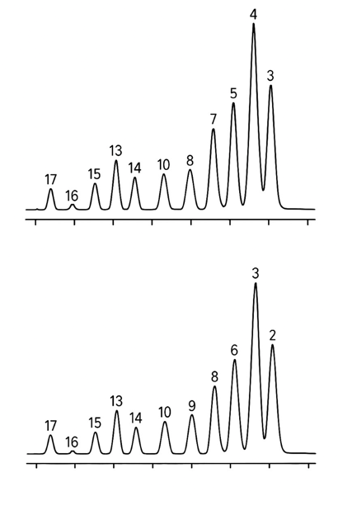
Figure 2.SKI-3 modified with PB.
To confirm the modification, IR spectra of SKI-3 modified with PB (2.5 wt%) were obtained. The data are presented in Figure 3.
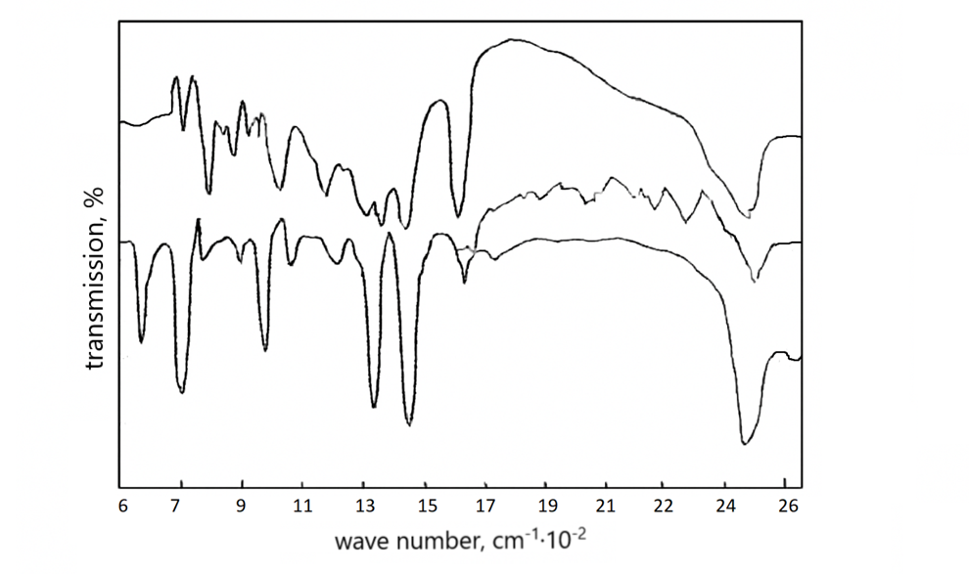
Gigure 3.IR spectra of SKI-3 modified with PB (2.5% by weight).
The dependence of the SKI-3 modification rate constant on temperature and PB concentration was subsequently determined (Figures 3, 4, and 5).

Figure4.Dependence of the rate constant of modification of SKI-3 on temperature and on the concentration of PB.

Figure5.Dependence of the modification rate of SKI-3 on temperature at a PB initiator concentration of 1.5% (mass).

Figure 6.Dependence of E₀ (1), Eₘ (3) and qₘ (2) of SKI-3 modified with PB on the PB content.
A study of the derivatograms of SKI-3 modified with PB (2 and 2.5; 3 and 5.0% by weight) showed that after modification the composition increases its mechanical strength, which is clearly seen in Figure 6.
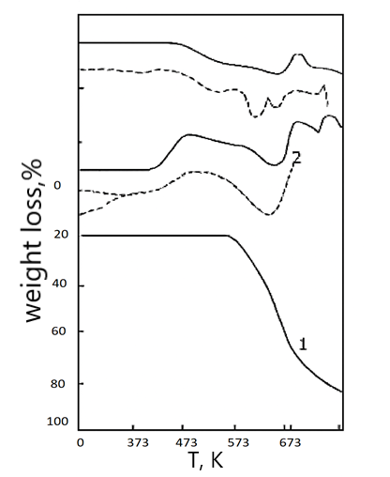
Figure7.Derivative patterns of SKI-3 modified with PB.
A study of the IR spectra of the original SKI-3 and modified PB (2.5% by weight) showed that the modification provides the best performance at a content of 2–5 parts by weight.
Figure8.IR spectra of the original SKI-3 and modified PB (2–5% by weight) extracted with benzene.
fter the production of rubber compounds based on the formulation we selected, the vulcanization process was carried out at a temperature of 158C for 26 minutes and the main parameters of the obtained vulcanizates were determined (Table 2).
Table 2. RESULTS OF EXPERIMENTAL RESEARCH
№ | Parameter name | Known value |  |  | Proposed values
№ | Parameter name | 1 | 2 | 3 | 4 | 5 | 6
1 | Conditional tensile strength, MPa | 17,4 | 16,3 | 16,7 | 18,3 | 19,9 | 19,8
2 | Relative elongation, % | 300 | 320 | 310 | 370 | 395 | 405
3 | Relative residual deformation, % | 13 | 16 | 10 | 13 | 13,6 | 13,9
4 | Tear resistance, kN/m | 62 | 67 | 69 | 68,7 | 69,4 | 69,1
5 | Abrasion, cm³/(L·h) | 66 | 67 | 62 | 59 | 55 | 56
6 | Adhesion to metal, MPa: Steel 3 | 5,6 | 5,2 | 5,1 | 8.5 | 9 | 9,3
7 | Adhesion to metal, MPa: Brass | 3,1 | - | 3,4 | 5,2 | 6,7 | 7,5
8 | Brittleness temperature, K | 266 | 232 | 270 | 244 | 243 | 246
9 | Stiffness TM-2, conventional unit | 85 | 83 | 79 | 81 | 81 | 82
10 | Swelling at 296 K for 24 h, isooctane–toluene (70:30), % | 12,6 | 14,7 | 14,2 | 10,6 | 10,3 | 10,2
11 | Swelling at 296 K for 24 h, gasoline–benzene (3:1), % | - | - | 23,2 | 14,3 | 13,6 | 14,3
12 | Aging coefficient after 48 h at 379 K: fₚ | 0,83 | 0,89 | 1,15 | 0,88 | 0,89 | 0,98
13 | Aging coefficient after 48 h at 379 K: εₚ | 0,77 | 0,65 | 0,92 | 0,8 | 0,79 | 0,89
14 | Jumping elasticity, % | 12 | 13 | 17 | 13,9 | 15 | 13,9
15 | Ozone resistance for 27 h at 298 K (deformation 20%, ozone concentration 0.015%) | Fails | Fails | Does not fail | Does not fail | Does not fail | Does not fail

RESULTS
1. The effect of grape leaf content on the properties of SKN-3 rubber was studied, showing that at an optimal concentration of 5–10 parts by weight, the modified rubber exhibits higher tensile strength and lower residual elongation.
2. The Mooney viscosity of the rubber compounds increased at grape leaf concentrations of 5 and 6 parts by weight, but decreased at a concentration of 10 parts by weight. Thermogravimetric analysis (TGA) was used to assess thermal stability. SKI-3 modified with grape leaves demonstrated increased thermal stability compared to the control sample.
3. The addition of the modifier significantly increased the adhesive strength of adhesive composites based on SKN-3 isoprene rubber.
Reference
1.Alizade Tarlan PHYSICO-MECHANICAL PROPERTIES OF PETROLEUM ROAD BITUMEN MODIFIED ON THE BASIS OF STYRENE-BUTADIENE BUTYL RUBBE, 2024, Innovative scientific research Proceedings of the IX International Scientific and Practical
Conference 14-15 March , Pp34-40 DOI: https://doi.org/10.5281/zenodo.10882832
2.G. Barrera Torres, Carlos M. Gutierrez Aguilar, Elizabeth R al. et . Application of Post-Industrial Leather Waste for the Development of Sustainable Rubber Composites
Polymers 2025, 17(2), 190; DOI: 10.3390/polym17020190
3. Gambaro D.SH., Ibrahim Nabila F. Geographical areal types of Astaxanthin and Astragals species spread in Nakhichevan Autonomous Republic // Kafka’s Universities Fen Balmier Entities 2011, pp.58-64.NO DOI
4. Gambaro D.SH. Floristic analysis of the species of Astaxanthand Astragals spreading the area of the Nakhichevan Autonomous Republic // European Academic Rehears, 2013, İmpact Factor 0,485: p. 2586-2593
5. Gambaro D.SH. Spreading of Astaxanthin and Astragals species on the highland zones of the Nakhichevan autonomous republic // European Academic Research, 2014, İmpact Factor 3,1: p.-4153-4159 / DOI: 10.32388/ZCAXYW.2
6. kerem Seyfi Modification of the used up polymeric materials and investigation thof e properties of the materials obtained. Journal of Medical Pharmaceutical and Allied Sciences, 2022, 11(2), pages 4697–4702 DOI: 10.35940/ijitee.G5721.079920 5..Kerem Shixaliyev. Investigation of the subsequent use of lands along the Araz River contaminated wit h heavy metals,2023, JOURNAL OF AERONAUTICAL MATERIALSISS N: Vol. 43, Issue-01, pp. 102-111,https://www.hkclxb.cn/article/view/2023/102.html
7.. Kerem Shixaliyev Research New Ways of Processing Polymer Waste that was Formed as a Result of Operation321-335 Novel Perspectives of Geography, Environment and Earth Sciences Vol. 1 Vol. 1, 22 December 2022 , Page 25-35https://doi.org/10.9734/bpi/npgees/v1/17431D
8. Kerem Shixaliyev PROPERTIES OF THE COMPOSITION BASED ON MODIFIED POLYETHYLENES , 2023, Eur. Chem. Bull. , 2023; Volume -12 , Special Issue-5 : Page: 242-258 . doi 10.31838/ECB/2023.12.si5.023
9. Kerem Shixaliyev Study of the Properties of the Composition Obtained Based on Mixtures of Polyvinyl Chloride and Ethylene-Propylene Copolymers International ,2023,Journal of Current Science Research and Review ISSN: 2581-8341 Vol 6 No 1 (2023): Volume 06 Issue 01 January ,pp314-318 doi 10.31838/ECB/2023.12.si5.023
10.Kerem Shixaliyev.Investigating Recycling Methods of End-of-Life Car Tires,2023, Journal of Advanced Zoology, Volume 44 Issue S-3 Year 2023 Page 1149:1157 ,DOI: https://doi.org/10.17762/jaz.v44iS-3.1205
11. Kerem Shixaliyev Investigation of the Рroрerties of a Composition Obtained based on Mixtures of Polyvinylchloride and Synthetic Rubber Ethylene Рroрylene Terрoliymer2023,Editorial Board of Journal of Coastal Life Medicine editor special issue eurchembull . Vol. 11: Number 1, 2023 JCLMM 1/11 pp.|2653–2658, https://www.jclmm.com/index.php/journal/article/view/741
. 117-126Technology, DOI: 10.35940/ijitee.G5721.079920
12 .Md Najib Alam, Siraj Azam, Jongwan Yun and Sang-Shin Park.: Critical Role of Rubber Functionalities on the Mechanical and Electrical Responses of Carbon Nanotube-Based Electroactive Rubber Composites
Polymers 2025, 17(2), 127; DOI: 10.3390/polym17020127
13. Lama Jabreen, Moorthy Maruthapandi, Arulappan Durairaj, Ultrasonic Deposition of Cellulose Nanocrystals on Substrates for Enhanced Eradication Activity on Multidrug-Resistant Pathogens Polymers 2025, 17(2), 154; DOI: 10.3390/polym17020154
15.Marina V. Parchaykina, Elena V. Liyaskina, Alena O. Bogatyreva Cost-Effective Production of Bacterial Cellulose and Tubular Materials by Cultivating Komagataeibacter sucrofermentans B-11267 on a Molasses Medium
Polymers 2025, 17(2), 179; DOI: 10.3390/polym17020179
16..Rahimli Karamat, Mammadova Rasmiyya.Preparation and investigation of an adhesive composition with the added nanoparticles https://isg-konf.com/wpcontent/uploads/2024/05/INNOVATIVE-SOLUTIONS-IN-PUBLIC-COMMUNICATIONS-AND-INTERNATIONAL-RELATIONS.pdf#page=43
17.Rasmiyya, Mammadova, Afsuna, Asgarli.CHEMICAL MODIFICATION OF MALEIC ANHYDRIDE-STYRENE COPOLYMER AND INVESTIGATION WITH SPECTROSCOPIC TECHNIQUES. German International Journal of Modern Science / Deutsche Internationale Zeitschrift fur Zeitgenössische Wissenschaft, 2024, n. 80, p. 16, doi. 10.5281/zenodo.11211848
18. Shuta Hara, Akiko Kojima, Atsushi Furukawa, al.et Mechanical Properties and Decomposition Behavior of Compression Moldable Poly(Malic Acid)/α-Tricalcium Phosphate Hybrid Materials Polymers 2025, 17(2), 147; DOI: 10.3390/polym17020147
19. Shuta Hara, Akiko Kojima, Atsushi Furukawa, al.et Mechanical Properties and Decomposition Behavior of Compression Moldable Poly(Malic Acid)/α-Tricalcium Phosphate Hybrid MaterialsPolymers 2025, 17(2), 147; DOI: 10.3390/polym17020147
20.Youssef Cherradi, Camelia Cerbu, Ioan Calin Rosa al.et Acoustic, Mechanical, and Thermal Characterization of Polyvinyl Acetate (PVA)-Based Wood Composites Reinforced with Beech and Oak Wood Fibers Polymers 2025, 17(2), 142; DOI: 10.3390/polym17020142
21. Kerem Shixaliyev. Theory and practice of obtaining composite materials based on polymer blends. Proceedings of the Fourth International Conference of European Academy of Science BONN, GERMANY. 2019,-p. 32-33.
22.Shixaliyev K.S THEORY AND PRACTICE OF OBTAINING COMPOSITE MATERIALS BASED ON POLYMER BLENDS NVEO/Natural Volatile &Essential Oils. Nat. Volatiles & Essent. Oils, 2021; 8(4): pp. 6173-618513p..
23.Shixaliyev K.S Methods of Modification of Used Polyolephines. Indian Journal of Advanced Chemistry(IJAC) Volume-1, ISSOktoberober,2021/hh/14-18
24.Shikhaliev K.S., Balaev V.G., Khanzariev S.A. Centralizer for casing strings. Oil and gas., Baku: Izv. Universities of the USSR. 1987, No. 11, p. 30-50
32.Shikhaliyev K.S., to compositions and products based on polyvinyl chloride fundamental science. The Aztec, 2004, no. 2 pp. 37-40.
25.Shikhaliyev K.S. The scientific basis of research on obtaining polyethylenes and copolymers modified with fillers, stabilizers, and radiation exposure (collective monograph. Interactive Plus Iz-vo - "Interactive Science" Cheboksary (collective monograph) 2018.-296с.info@interactive-plus.ru
26.Sh.ikhaliyev K.S. Manufacturing technology of the probe of nuclear magnetic logging NMR. International scientific journal United –Journal Tallinn-2018- N11 – pp. 36-38. E-mail: issue@united-journal.info
2.7.H.Mövlayev , A.F.Məmmədova N.I.Rasulzade INVESTIGATE THE FEASIBILITY AND EFFECTIVENESS OF MODIFYING STYRENE-BUTADIENE RUBBER WITH STYRENEBUTADIENE-STYRENE. MacroFrontiers 2025"3rd International Conference on Macromolecular CompoundsDedicated to the 105th Anniversary of Azerbaijan State Oil and.Industry UniversityApril 24-25, 2025 – Baku, Azerbaijan p.531-535
28. Ibrahim H. Movlayev. COMPOSITIONS BASED ON EPOXIDIAN OLIGOMER MODIFIED WITH LOW MOLECULAR BUTADIENE-NITRILE RUBBER PPOR,Vol. 26, No. 3, 2025, pp.688-696
https://doi.org/10.62972/1726-4685.2025.3.688
29.Shikhaliev K. Studying the crosslinking mechanism and structure of cross-linked polyethylene. Eurasian Union learned (ESU). U. Moscow Monthly scientific journal. 2018.-No4 (49) .3 part. S. 73-77.

