Assessment of knowledge, and compliance with standard precautions for infection control among Nursing students at University of Nizwa

In Fulfillment of the Requirement for the Graduation Project

STUDENT STATEMENT OF AUTHORSHIP

I understand that I am responsible for any academic work I submitted to the University of Nizwa. I declare that this assignment/project is my original work and any references and sources I have used were properly acknowledged. I claim the sole ownership of this academic work which was not done by any other person.
If the University of Nizwa discovers that the foregoing declaration is incorrect and/or that cheating or plagiarism has occurred, the University reserves the right to impose academic sanctions against me.
The copyright of this project report belongs to the University of Nizwa. The student should adhere to the University Authorship Policy [UoN/GSRER-DOR-POL/007/V1/2021].

Course Code: NURS491
Course Title: RESEARCH PROJECT
Title of Assignment/Project: Assess knowledge, and compliance with standard precautions for infection control among Nursing students at University of Nizwa.
Name of Student: Bara’ah Saleem Salim Al Batrani
Student ID: 14458455
Student Signature: Baraah
Date: 3/10/2024


SIMILARITY CHECK REPORT

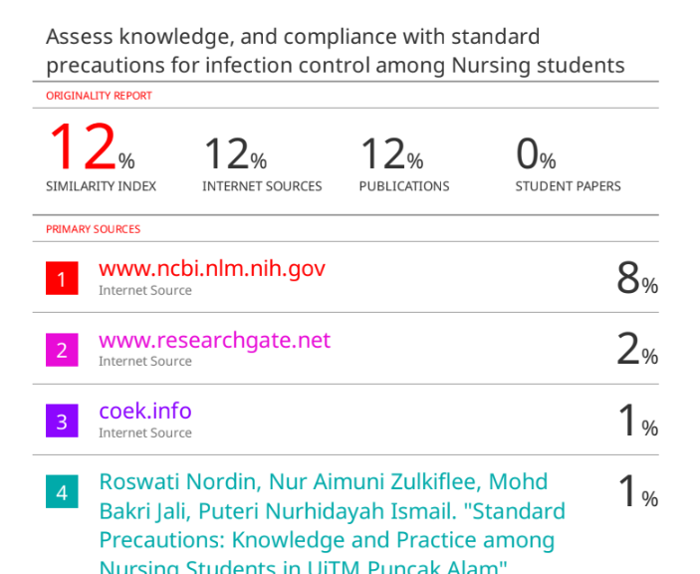

ACKNOWLEDGEMENT
The Author like to thank the students who participated in the study, and to thank the school, dean Dr. Oscar, and the supervisor Ms. Jaha Anand. Also to thank Dr. Lam from Shaqra University in Saudi Arabia for giving a permission to use their questionnaire, also the author like to thank Dr. Abdullah Khubrani from King Saud bin Abdulaziz University for Health Sciences in Saudi Arabia, Riyadh for giving the permission to use their questionnaire.

Table of Contents

SECTIONS | PAGE NO.
Title Page
Student Statement of Authorship | i
Similarity Check Report | ii
Acknowledgement | iii
Table of Contents | iv
List of Tables | v
List of Figures | vi
List of Symbols/Notations/Terminologies/Abbreviations/Acronyms | vii
List of Appendices | viii
I. Abstract | 1
II. Introduction and Statement of the Problem | 2-3
III. Aim of the Study | 3
IV. Significance of the Study | 3-4
V. Literature Review/Background of the Study | 4-8
VI. Study Design and Research Methods | 8-11
VII. Results and Discussion | 11-19
VIII. Conclusions and Recommendations | 19-20
IX. References | 21-25
X. Appendices | 26-49

List of Tables

TABLE NO. | TITLE OF TABLE | PAGE NO.
1 | Table 1: Reliability Statistics | 9
2 | Table.2 Demographic data | 12
3 | Table.3: Knowledge of Standard precautions | 14
4 | Table.4: Compliance to standard precautions | 17

List of Figures

FIGURE NO. | TITLE OF FIGURE | PAGE NO.
1 | Fegure.1 Knowledge of standard precautions | 13
2 | Fegure.2 Compliance to standard precautions | 15

List of Symbols/Notations/Terminologies/Abbreviations/Acronyms

Symbols/Notations/Terminologies/Abbreviations/Acronyms Used | Meaning
Hospital-acquired infections (HAI) | It is the infections that acquired in the hospital that is contracted from the staff themselves or from the patient himself during long time hospitalization, by contact, instrumentation or any other procedures that lead to infections. (Alberto. F, et al. 2023)
Standard precautions (SPs) | Standard precautions are simple practices of infection prevention and control that healthcare providers must follow to prevent transmission of communicable diseases, like wearing mask, hand washing, wearing PPE…etc. (United states governorate infection control. 2024).

List of Appendices

APPENDIX NO. | TITLE OF APPENDIX | PAGE NO.
1 | Ethical approval | 24
2 | Graduation project approval | 25-28
3 | Graduation project approval form | 29-31
4 | SPSS scale approval letter | 32
5 | Knowledge questionnaire approval letter | 33
6 | Questionnaire of knowledge, and compliance with standard precautions of infection control among Nursing students | 34-47

SECTIONS OF THE GRADUATION PROJECT REPORT
- Abstract
Background: Standard precautions of infection control are the most important practices that help to protect nursing students and health care providers from acquiring and transmission of communicable diseases. Communicable and infectious diseases are still existed in hospitals in Oman especially in critical areas and medical wards. Since communicable diseases are existed in hospitals around the world as well as in Oman, it becomes a challenge for infection prevention and control to control spread of infectious diseases especially in clinical settings. One of the factors that lead to transmission of communicable diseases is improper use of SPs. Methodology: This is a quantitative descriptive cross sectional study of knowledge, and compliance with SPs of infection control among Nursing students at Nizwa university. In this study a self-administered questionnaire of a single contact period distributed to 175 nursing students to obtain data about nursing student’s knowledge and compliance to standard precautions, but only 81 nursing students completed the questionnaire. Result: This study revealed that nursing students of University of Nizwa has a satisfactory level of knowledge (80.51%) on standard precautions, and have suboptimal compliance to SPs practices (51.79%) (n= 3.1). Conclusion: It is important to investigate the reasons of the suboptimal compliance of nursing students to standard precautions, the topic of nursing students’ compliance to SPs is an important topic for further and wider researches to be done.

Key words: practice, standard precautions, infection control, hospital acquired infections, compliance, communicable diseases.

- Introduction and Statement of the Problem
Standard precautions of infection control are the most important practices that help to protect nursing students and health care providers from acquiring and transmission of communicable diseases. Communicable and infectious diseases are still existed in hospitals in Oman especially in critical areas and medical wards. As a study conducted by (El-Beeli, et al. 2023) revealed that 1,246 cases of hospital acquired blood-born infectious diseases out of 139,683 of total admissions was recorded for the past 5 years, which estimated 8.9 cases per 1000 admissions. The study provides supportive evidence for a slow reduction in HA-BSI prevalence over age categories and years of follow-up.
Since communicable diseases existed in hospitals around the world as well as in Oman, it becomes a challenge for infection prevention and control to control spread of infectious diseases especially in clinical settings. One of the factors that lead to transmission of communicable diseases is improper use of SPs of infection control.
Nursing students; in term of practice they can be a factor to prevent spread of infectious diseases by compliance to SPs or they can contribute in transmission of communicable diseases by non-compliance to SPs practices, which will be investigated by conducting this study by determining the compliance with SPs of nursing students.
In a study conducted by (Stephane. L, et al. 2021) showed gaps in the standard precautions practices. As in a study done by (Kim. H, et al. 2021) showed that students has insufficient knowledge of standard precautions practices, and those who experienced needle stick injury and contact with body blood/fluid have significantly lower compliance to SPs practices.
There are no studies done on nursing student’s compliance to SPs in Oman or maybe there is but it is not published. The term of SPs is not only a simple term, but it is part of competent practice of nursing procedures, so, SPs are part of checklist of nursing procedures, so failure on applying standard precautions means connecting the infection transmission chain. As a result, more researches are required to address the issue of nurses, and nursing students’ inadequate understanding, unfavorable perceptions, and subpar practices which evidenced by the prevalence of healthcare associated blood born infections in Oman hospitals. If SPs compliance is not observed, it will lead to more increasing in healthcare associated diseases which will increase cost, care, and hospital burdens.
This cross sectional study at university of Nizwa will help to identify nursing students’ knowledge, and compliance to standard precautions of infection control. Nursing students’ practice of SPs should be investigated to make sure of their compliance and to help to protect students and future healthcare workers as well as patients, and also to reduce the prevalence of HAIs.

- Aim of the Study
The primary objectives of this study are:
- Examine nursing students’ knowledge in standard precautions of infection control.
- Identify the compliance with standard precautions of infection control among nursing students.

Research questions
Based on the objectives above, research questions are formulated to guide the study to meet its objectives.
- What is the knowledge level of standard precautions of infection control of nursing students?
- What is the level of compliance with standard precautions of infection control among nursing students?

- Significance of the Study
During the audits that is done by infection prevention and control personnel, they found some health workers, some nursing and medical students are not following the proper infection control practices, and this will contribute in HAIs transmission, and makes healthcare workers, students, and patients at high risk.
This study will help to assess nursing students’ knowledge in SPs, also to measure their compliance with standard precautions of infection control. This will identify their level of knowledge and compliance and then it will help to improve nursing students’ practices to be more competent in the clinical areas and will reduce HAIs in the hospitals and the burdens associated with.
Also, it will help to reach to the gap in term of students’ compliance to SPs and the areas of practice that students comply and which areas of practice they are not comply, so, by that it will help to address the problem.

- Literature Review/Background of the Study
There were many studies conducted on nursing students’ knowledge and compliance to SPs. According to a study conducted by (F. Brosio, et al. 2017) involving 1st, 2nd, and 3rd year nursing students at Ferrara University in Italy, they distribute a questionnaire assesses their knowledge on 3 parts which are: HAIs, standard precautions, and hand hygiene, it revealed that an adequate level of knowledge by the three groups of students was showed only in the SPs area, but the lowest score was in the area of HAIs by the all three years students.
In another study conducted by a convenience sampling in South Korea conducted by (Kim. H and Park. H, 2021). They have used self-administered survey and it has revealed that the participants have deficient knowledge of infection prevention control which was 14.82 ± 2.12 out of 25, with 59.30% correct answers, and their compliance to infection prevention and control practices at clinical training was moderate, which was 4.09 ± 0.43 out of 5.
In a cross sectional study conducted by (AL-Rawajfah. O and Tubaishat. A. 2015) showed only about part of the students has excellent in knowledge of SPs, and the mean score of the practice was 67.4 (SD = 9.9) out of 80.
A descriptive, cross sectional study done in Saudi Arabia using the CSPS scale revealed that nursing students showed only 60.1% compliance to SPs which considered suboptimal according to the CSPS scale interpretation (Colet. P, et al. 2016).
In a cross sectional study conducted by (Cheung. K, et al. 2015), were 678 questionnaire analyzed, of a sample of nursing students who have studied in a full-time undergraduate program in Hong Kong University, it showed that compliance of nursing students to standard precautions is high, and found that their practice affected by the nursing staff, wherein the second and third year students has lower compliance than first and second year, and the reason behind that the first and second year students are supervised by clinical instructors and the second, third, and fourth year students are supervised by registered nurses. This study considered a large study but the limitation is that it is conducted only for one university.
In an institutional centered cross sectional study conducted by (Getachew. D, et al. 2022), they select 423 undergraduate BSc nursing students using simple random sampling. In the study of compliance, they have used the CSPS scale and it revealed that nursing students’ compliance to SPs is suboptimal (51.4%). They found that the factors affecting the compliance were: workplace safety, knowledge, and having training.
In a qualitative study conducted by (Kim. K, et al. 2015), showed that the students showed knowledge deficit regarding standard precautions, also they expressed that they were been on a vulnerable situation where they risked exposure to pathogens due to noncompliance to SPs, and the noncompliance was due to different barriers such as noncompliant role model, and poor information about the patient.
In a cross sectional study conducted by (Nordine. I, et al. 2019), from 264 nursing students, 159 was chosen as a sample via stratified random sampling. The result showed that 94.3% of respondents has a good level of knowledge, but 5.7% of respondents showed moderate level in knowledge, and 0.00% has poor level of knowledge. For the practice of standard precautions 95.6% of respondents categorized as having good level of practice, 4.4% moderate, and 0.00% has poor level of practices.
In a cross-sectional study conducted by (Thapa.K, and Khaphle. H. 2019), 208 out of 478 nursing students of second and third year from 6 schools of nursing were chosen via simple random method. In the study CSPS scale used that is the same scale that is used also in this study, and the result showed the overall compliance to SPs was 65.0% which is considered suboptimal. In the knowledge part, 91.3% of respondents have fair knowledge, 5.8% have poor knowledge level, and 2.9% have good knowledge.
In another descriptive correlational study conducted by (Younis. M, et al. 2014), 158 nursing students of third and fourth year were selected via simple random method from College of Nursing- University of Mosul. The result showed a high knowledge and compliance of the nursing students to standard precautions.
In a cross- sectional study of conducted by (Atiqah. T, et al. 2021), 134 nursing students were requited through simple random method. The result showed that the knowledge of degree nursing students (15.4 ±2.4) is higher than diploma nursing students (14.7±2.5), and the compliance among diploma nursing students 89.8% were higher than degree nursing students 85.3%. So, the knowledge and compliance of standard precautions is very good. The strength of the study is that the participant has been chosen via simple random method with controlling selection bias, and the limitation of this study is that it was conducted on only one university, and this will affect the generalization of the results.
In a quantitative cross-sectional study conducted by (Kaushal. D, and Clement. E, 2022), 167 undergraduates nursing student of second to fourth year involved, the results showed that the majority of nursing students showed good knowledge of SPs (50.9%), and their compliance to standard precautions is high (89.8%).
In a quasi-experiment study conducted by (Hassan. Z, 2017), 256 undergraduate nursing students from 2nd, 3rd, 4th year were involved in an online education module about infection control standard precautions. The students undergo for pre-test and post-test online questionnaire about knowledge and compliance to standard precautions. The results showed that the pretest knowledge was 57% and it is scored as inadequate, and half of students showed high knowledge posttest. The results for compliance showed poor compliance pretest but moderate compliance posttest.
In a cross sectional study conducted by (Paul. B, 2014), the study revealed that nursing students showed low level of knowledge, and their compliance to universal precautions is poor.
According to a literature review conducted by (Bouget. S, and Landelle. C, 2023), the literature review done using the PRISMA method in the interval from 2010-2021. The selected articles were 81; 36 about nursing student’s knowledge of standard precautions, 43 about their practice of standard precautions, and 21 about hygiene teaching techniques in nursing training. The results revealed that the nursing student’s practice and knowledge of standard precautions was moderate.
In a cross sectional study conducted by (Sharma. M, et. al. 2023), 600 nursing and medical students showed interest in participating in the study and posted to clinical; 423 medical students, and 177 nursing students. The study revealed that both of the groups have poor knowledge of standard precautions, and to assess their practice of standard precautions, 6 hypothetical cases were given, and the students showed ideal practice of SPs. The strength of the study is that the data collected by students, this will minimise the social pressure, and will minimise biased response. The limitation is that the students respond to the hypothetical questions but their actual practice not observed.
In a cross sectional study conducted by (Bouchoucha. S, et.al, 2021), 321 undergraduate nursing students from nursing school and midwifery at an Australian university. The results showed that students’ compliance to SPs was high. The strength of the study that is very subjective to a specific social desirability. The limitations are that the study conducted only in a one university, and also the study is not based on a direct observation.
According to a cross sectional study conducted by (Topcu. S and Emlik. Z, 2023), 816 nursing students participated in the study, and CSPS questionnaire used to assess compliance to standard precautions. The study revealed that the compliance of nursing students during COVID-19 was 76.8% which is optimal.
In across sectional study conducted by (Rahiman. F, et.al, 2018), 301 nursing students from second, third, and fourth year were participated in the study, at Western Cape. The results showed that nursing students have good knowledge regarding standard precautions, and little difference in the practice of SPs.

In a cross sectional study conducted by (Gulic. N, et.al, 2021), 533 nursing students from school of nursing in Bangkok; 155 from 2nd year, 215 from 3rd year, and 163 from 4th year. CSPS tool were used in this study, and the overall compliance to SPs were 68.5%, which is considered suboptimal compliance to standard precautions. The limitation of this study is that the study conducted only at one university, and this may make the findings of the study not generalized to other universities.

- Study Design and Research Methods
This is a quantitative descriptive cross sectional study of knowledge, and compliance with SPs of infection control among Nursing students at Nizwa university. In this study a self-administered questionnaire of a single contact period helped to obtain data about nursing student’s knowledge and compliance to standard precautions.

Location of the study
The study was done at university of Nizwa in the nursing school. University of Nizwa located in Sultanate of Oman, in Al Dakhilia governorate. It contains 4 colleges (college of Health Sciences, college of Engineering and Architecture, college of Economic, Management, and Health System, and college of Arts and Sciences) and it have 14 academic departments.

Population and sampling
This study included nursing students (female, and male) of 175 participants out of 318 nursing students at University of Nizwa, which included all levels except students of 1st year, Fundamentals of nursing students, and bridging students, the students are selected by convenience sampling method according to their availability on the days of data collection using self-administered questionnaire of knowledge and compliance. A convenience sampling was used, chosen in the spring semester 2024/2025. From each group (mental nursing students, child nursing students, maternity nursing students, adult nursing students, and critical nursing students), a certain number of students have been chosen. The inclusion criteria were nursing students who are 2nd year of the program who are done with fundamentals of nursing until students of 4th year.

Research tool and pilot study
The self-administered questionnaire used in this study. It contains 3 parts:
Part 1 contain demographic data.
Part 2 contain 12 questions about knowledge of SPs (Khubrani. A, at el. 2018), it includes 4 sections (true and false questions): section I is about general concept of infection control and standard precautions, section II is about hand Hygiene, section III is about personal protective equipment, and section IV is about sharps disposal and sharp injuries.
Piloting of part 2:
The result of piloting showed that the questionnaire reliability is acceptable.
Cronbach’s alpha test
Table 1: Reliability Statistics
Cronbach's Alpha | Cronbach's Alpha Based on Standardized Items | N of Items
.719 | .745 | 12

Part 3 is CSPS scale by Lam, 2014 to assess compliance with standard precautions’ practices, that developed by Lam. S. 2022 which contains 20 items; 16 items are positively phrased items and 4 are negatively phrased items, 6 items of use of protective devices, 3 items of discarding of sharps, 3 items of decontamination of spills and used objects, 1 item of disposal of waste, and 7 items of prevention of cross infection from person to person, the response is 4-point Likert scale, such as: always, sometimes, seldom, and never, and there is 4 questions negatively phrased.

Data collection
Upon approval of the research by the Assistant Dean for Research, and the Dean of College of Health Sciences. Data collected through a self-administered questionnaire. Questionnaire administered to the participants during their classes randomly according to the participant availability through direct single contact. Data collection is completed after the participants answer the questionnaire, and it take 3 days to collect the data.

Data analysis and presentation
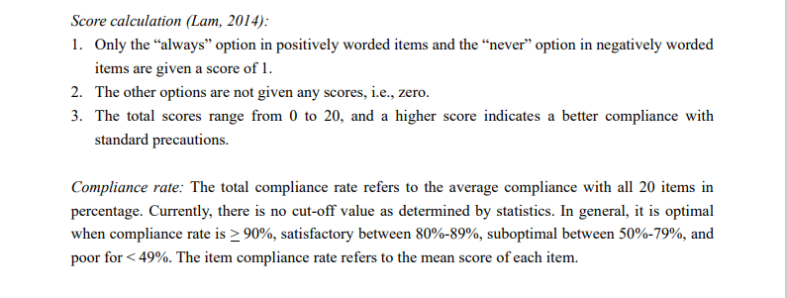
According to Burns and Grove (2011), data analysis is a method utilized for accurate data display. Data statistically assessed using a statistical program (SPSS version 20) when data collection is completed. Descriptive statistics, such as percentages and means calculated to summarize the participants' features and their responses to the survey questions, also some percentages calculated manually such as the compliance rate by getting the average of each paper in percentage of students’ answers scores (the score/20 *100%) (the sum of percentages/81= average), and the same way used on the knowledge calculation. The below picture by (Lam, 2014) show the way of scoring and calculation:
Graphs and tables utilized to visually present the analyzed data, providing a clear and concise representation of the findings. The results organized and presented in a comprehensive report, which included the research methodology, literature review, data analysis, and discussion of findings.

Additionally, a whole report prepared and submitted to the board of examiners appointed by the University of Nizwa for grading. The research paper included a thorough description of the data analysis methods used, the results obtained, and the interpretations of those results within the context of the research objectives.

Ethical consideration
Consent to join in the study gotten before conducting the study. Personal visit done to explain to the participant in the study about the study, process, and also to inform them that confidentiality of information is maintained in the study. Moreover, they informed that they have the right to withdraw at any time. The questionnaire is obtained after requesting permission and an application has been filled and the request had been accepted.

- Results
In this study, in realizing the objective, the analysis of the data was done using the Statistical Package for Social Sciences (SPSS) Version 20. The presentation of the results was divided into three parts: Part A: results related to demographic data, Part B: results related to Knowledge of Standard precautions, Part C: results related to Compliance to SPs.

Part A: Results related to demographic data:

Demographic data | Percentage %
Age:  19-22  23-25  26-28  29 or above | 78%  14.6%  7.3%  0.0%
Gender:  Male  Female | 3.7%  96.3%
Marital status:  Single  Married | 3.7%  96.3%
Stream of study:  BSN regular program  DN regular program | 92.7%  7.3%
Year in the program:  Second year  Third year  Fourth year | 34.1%  35.4%  30.5%
Clinical exposure:  Less than 1 year  1-2 years  3-4 years | 26.8%  36.6%  36.6%
Attended seminars of infection control:  Yes  No | 57.3%  42.7%

Table.1 Demographic data

Table.1 showed Out if 175 of the students received the questionnaire, 81 students completed the questionnaire, most of them are single and 96.3% are female, 3.7% are male, most of them aged from 19-22 years, 92.7% studying bachelor, and 7.3% are studying diploma. 34.1% are second year of studying, 35.3% are third year of studying, 30.5% are fourth year of studying. For the clinical exposure, 26.8% they have less than 1year exposure, 36.6% have 1-2years exposure, and 36.6% have 3-4years exposure to the clinical, and 57.3% of them attended infection control seminars.

Part B: Results related to Knowledge of Standard precautions:

Figure.1 showed that the knowledge of standard precautions participants showed higher knowledge in the domains of “general concept of standard precautions”, “personal protective equipment”, and “sharps disposal and sharps injuries” more than 80%. The results showed that nursing students’ knowledge of standard precautions is 80.51% which is considered satisfactory level of knowledge.

Table.2: Knowledge of Standard precautions:

 | Mean | Percentage
 | Mean | True | False | I don’t know
Q1. The main goal of infection control is to restrict the spread of infection. | 1.99 | 98.8 | 1.2 | 0.0
Q2. Definition of standard precautions is performing hand hygiene, use of Personal Protective Equipment (PPEs), appropriate handling of bodily fluids & patient wastes and prevention of needle stick/sharp injuries | 1.95 | 96.3 | 2.5 | 1.2
Q3. All patients are sources of infections regardless of their diagnoses. | 1.64 | 71.6 | 21.0 | 7.4
Q4. All body fluids except sweat should be viewed as sources of infection. | 1.38 | 49.4 | 39.5 | 11.1
Q5. All health providers are at risk of occupational infections. | 1.89 | 91.4 | 6.2 | 2.5
Q6. Hand washing minimizes microorganisms acquired on the hands if hands are soiled. | 1.91 | 92.6 | 6.2 | 1.2
Q7. In standard hand washing minimum duration should be 5-10 seconds. | 1.51 | 64.2 | 22.2 | 13.6
Q8. Alcohol hand rub cannot substitutes hand washing even if the hands are soiled. | 1.53 | 61.7 | 29.6 | 8.6
Q9. Use of PPEs eliminate risk of acquiring occupational infections. | 1.81 | 84.0 | 13.6 | 2.5
Q10. Gloves and masks cannot be re-used after proper cleaning. | 1.83 | 84.0 | 14.8 | 1.2
Q11. Sharps injuries should be managed with need of reporting. | 1.86 | 88.9 | 8.6 | 2.5
Q12. Immediate management of sharps injuries includes wash thoroughly with running water. | 1.80 | 86.4 | 7.4 | 6.2
Over all mean:  Over all percentage: | 1.75  80.51%

Part C: Results related to Compliance to standard precautions

Figure.2 showed that compliance of nursing students of university of Nizwa is suboptimal according to the results (51.79%) (n= 3.1). Students are more comply with throwing the sharps in sharp container after using them (70.37%), also not recapping the needle after using them (66.66%), hand washing between patient contacts (65.43%), and wearing gloves when handling body fluids and blood (65.43%). The students are less compliance on disposing sharps box (25.95%), they disposing sharps box when it is full, also the are less compliance on wearing face mask or in combination with goggles, face shield and apron whenever there is a possibility of splashes or splatters (33.33%), taking shower if there is an extensive splashing even after putting PPE (40.74%), and washing hand with water (41.97%).

Table.4: Compliance to standard precautions:
 | Mean | Percentage (%)
 | Mean | Never | Seldom | Sometimes | Always
Q1. I wash my hands between patient contacts. | 3.37 | 12.3 | 3.7 | 18.5 | 65.4
Q2. I only use water for hand washing. | 2.95 | 40.7 | 22.2 | 28.4 | 8.6
Q3. I use alcoholic hand rubs as an alternative if my hands are not visibly soiled. | 2.99 | 12.3 | 13.6 | 37 | 37
Q4. I recap used needles after giving an injection. | 3.26 | 65.4 | 9.9 | 9.9 | 14.8
Q5. I put used sharp articles into sharps boxes. | 3.38 | 13.6 | 4.9 | 11.1 | 70.4
Q6. The sharps box is disposed only when it is full. | 2.37 | 24.7 | 16 | 30.9 | 28.4
Q7. I remove Personal Protective Equipment (PPE) in a designated area. | 3.11 | 17.3 | 6.2 | 24.7 | 51.9
Q8. I take a shower in case of extensive splashing even after I have put on Personal Protective Equipment (PPE). | 2.80 | 17.3 | 25.9 | 16 | 40.7
Q9. I cover my wound(s) or lesion(s) with waterproof dressing before patient contacts. | 3.19 | 14.8 | 8.6 | 19.8 | 56.8
Q10. I wear gloves when I am exposed to body fluids, blood products, and any excretion of patients. | 3.37 | 11.1 | 7.4 | 14.8 | 66.7
Q11. I change gloves between patient contacts. | 3.19 | 11.1 | 14.8 | 18.5 | 55.6
Q12. I decontaminate my hands immediately after removal of gloves. | 3.16 | 9.9 | 14.8 | 24.7 | 50.6
Q13. I wear a surgical mask alone or in combination with goggles, face shield and apron whenever there is a possibility of a splash or splatter. | 2.85 | 13.6 | 21 | 32.1 | 33.3
Q14. My mouth and nose are covered when I wear a mask. | 3.23 | 13.6 | 9.9 | 16 | 60.5
Q15. I reuse a surgical mask or disposable Personal Protective Equipment (PPE). | 3.01 | 53.1 | 11.1 | 19.8 | 16
Q16. I wear a gown or apron when exposed to blood, body fluids or any patient excretions. | 3.14 | 9.9 | 16 | 24.7 | 49.4
Q17. Waste contaminated with blood, body fluids, secretion and excretion is placed in red plastic bags irrespective of the patient’s infection status. | 3.07 | 13.6 | 16 | 19.8 | 50.6
Q18. I decontaminate surfaces and equipment after use. | 3.16 | 11.1 | 13.6 | 23.5 | 51.9
Q19. I wear gloves to decontaminate used equipment with visible soils. | 3.25 | 9.9 | 11.1 | 23.5 | 55.6
Q20. I clean up spillage of blood or other body fluids immediately with disinfectants. | 3.21 | 9.9 | 14.8 | 19.8 | 55.6
Overall mean  Over all percentage | 3.1  51.79%

- Discussion
In the study 81 students completed the questionnaire, most of them are single and 96.3% are female, 3.7% are male, most of them aged from 19-22 years, 92.7% studying bachelor, and 7.3% are studying diploma. 34.1% are second year of studying, 35.3% are third year of studying, 30.5% are fourth year of studying. For the clinical exposure, 26.8% they have less than 1year exposure, 36.6% have 1-2years exposure, and 36.6% have 3-4years exposure to the clinical, and 57.3% of them attended infection control seminars, they have been chosen via simple random method according to their availability at the day of the data collection.
According to the results of the data analysis; the students’ level of knowledge is 80.51%, and this indicates that the students has a satisfactory level of knowledge on standard precautions, especially in “general concept of standard precautions”, “personal protective equipment”, and “sharps disposal and sharps injuries” domains. The students who has 3-4years exposure to clinical have more knowledge to standard precautions (28.39%), then students who has 1-2years exposure (27.16%), and students who has less than 1year exposure has (18.51%) knowledge. In compare to a similar study done by Khubrani. A, et, al in 2018 showed that the nursing students has satisfactory level of knowledge which is the same of this study. In another study conducted by (Sharma. M, et. al. 2023) revealed that both of the groups have poor knowledge of standard precautions, also in a literature review conducted by (Bouget. S, and Landelle. C, 2023), the results revealed that the nursing student’s knowledge and practice of SPs was moderate.
The compliance of Nursing students of university of Nizwa is suboptimal according to the results (51.79%). Students are more comply with throwing the sharps in sharp container after using them (70.37%), also hand washing between patient contacts (65.43%), and wearing gloves when handling body fluids and blood (65.43%). In comparison with a study similar to this study conducted by Colet. P, et al. 2016 revealed that nursing students showed only (60.1%) compliance to standard precautions which considered suboptimal according to the CSPS scale interpretation, in another study conducted by conducted by Getachew. D, et al. 2022, they have used the CSPS scale and it revealed that nursing students’ compliance to standard precautions is suboptimal (51.4%), also there is another study conducted by Gulic. N, et.al, 2021 in Bangkok showed that the overall compliance to standard precautions were (68.5%), which is considered suboptimal compliance to standard precautions. In a study conducted by Topcu. S and Emlik. Z, 2023, revealed that the compliance of nursing students during COVID-19 was (76.8%) which is optimal and it is the highest.
This level of compliance is suboptimal It is higher than the compliance of nursing students of Thai university of Bangkok, and the lowest comparing to other studies. The results of this study is more important to the school of nursing of University of Nizwa, it will help to investigate the gaps and how to improve knowledge and especially the compliance to SPs.

- Conclusions and Recommendations
A: Conclusions
In conclusion, Standard precautions of infection control are the most important practices that help to protect nursing students and health care providers from acquiring and transmission of communicable diseases. In this study a self-administered questionnaire of a single contact period used to collect data, and after the analysis it revealed that Nursing students of University of Nizwa has a satisfactory level of knowledge (80.51%) on standard precautions, and have suboptimal compliance to standard precautions practices (51.79%) (n= 3.1). The topic of nursing students’ compliance to SPs is an important topic for further and wider researches in other health schools to be done.

B: Recommendations
It is important to investigate the reasons and factors of the suboptimal compliance of nursing students to standard precautions, also to do more researches on the same topic in the other nursing schools in Oman and also in other health schools and hospitals, this study will be helpful to improve the students’ compliance to standard precautions. Also to follow the students’ practices of standard precautions and to stress on strict compliance to standard precautions to make the students more aware about them. It is important to remind the students in the orientation classes before every clinical about the standard precautions.

- Limitation of the study
The limitation of this study is that the participants who are willing to participate in the study are less than required, and it is only involved one university in Oman, so, the result not applicable to all nursing students in other universities in Oman.

- References
-Wu CJ, et al. 2009. Taiwanese nursing students’ knowledge, application and confidence with standard and additional precautions in infection control. Retrieved from: https://onlinelibrary.wiley.com/doi/abs/10.1111/j.1365-2702.2008.02309.x

-F Brosio, et al. 2017. Knowledge and behaviour of nursing students on the prevention of healthcare associated infections. Retrieved from: https://pubmed.ncbi.nlm.nih.gov/28900349/

-Kim. H and Park. H. 2021. Compliance with Infection Prevention and Control Practice among Prospective Graduates of Nursing School in South Korea. Retrieved from: https://www.ncbi.nlm.nih.gov/pmc/articles/PMC7967753/

-AL-Rawajfah. O and Tubaishat. A. 2015. Nursing students' knowledge and practices of standard precautions: A Jordanian web-based survey. Retrieved from: https://www.sciencedirect.com/science/article/abs/pii/S0260691715002282

- Cheung. K, et al. 2015. Predictors for compliance of standard precautions among nursing students. Retrieved from: https://www.ajicjournal.org/action/showPdf?pii=S0196-6553%2815%2900152-2

- Colet. P, et al. 2016. Compliance with standard precautions among baccalaureate nursing students in a Saudi university. Retrieved from: https://www.sciencedirect.com/science/article/pii/S1876034116300946

-Burns. N, et al. (2011). Understanding Nursing Research: Building an Evidence-Based Practice (5th ed.). St Louis, MO: Elsevier Saunders.

-Getachew. D, et al. 2022. Compliance with standard precautions and associated factors among undergraduate nursing students at governmental universities of Amhara region, Northwest Ethiopia. Retrieved from: https://bmcnurs.biomedcentral.com/articles/10.1186/s12912-022-01165-w

-Mi Kim. K, et al. 2015. Clinical Experiences as Related to Standard Precautions Compliance among Nursing Students: A Focus Group Interview Based on the Theory of Planned Behaviour. Retrieved from: https://www.asian-nursingresearch.com/action/showPdf?pii=S1976-1317%2815%2900034-1

-A&C Black Publishers Ltd. 2007. Dictionary of Nursing (second edition). Retrieved from: https://mis.kp.ac.rw/admin/admin_panel/kp_lms/files/digital/Core%20Books/Nursing/Dictionary%20of%20nursing%20-%20A.pdf

-Centers for Disease Control and Prevention. 2018. Standard Precautions. Retrieved from: https://www.cdc.gov/oralhealth/infectioncontrol/summary-infection-prevention-practices/standard-precautions.html

-Khubrani. A, et al. 2018. Knowledge and information sources on standard precautions and infection control of health sciences students at King Saud bin Abdulaziz University for Health Sciences, Saudi Arabia, Riyadh. Retrieved from: https://www.ncbi.nlm.nih.gov/pmc/articles/PMC7102774/

-Al- Ebeeli. M, et al. 2023. Estimation of Prevalence of Hospital-Acquired Blood Infections among Patients Admitted at a Tertiary Hospital in Oman over a Period of Five Years: A Cross-Sectional Study. Retrieved from: https://www.hindawi.com/journals/ipid/2023/5853779/

-Nasser. R. 2022. ICU-acquired central line-associated bloodstream infection and its associated factors in Oman. Retrieved from: https://www.sciencedirect.com/science/article/abs/pii/S0196655321008646

-Nordin. R, et al. 2019. Standard Precautions: Knowledge and Practice among Nursing Students in UiTM Puncak Alam. Retrieved from: (PDF) Standard Precautions: Knowledge and Practice among Nursing Students in UiTM Puncak Alam | ROSWATI NORDIN - Academia.edu

-Thapa. A, et al. 2021. Knowledge and Factors Associated with Compliance of Standard Precautions in Clinical Exposure among Proficiency Certificate Level Nursing Students of Pokhara, Nepal. Retrieved from: (PDF) Knowledge and Factors Associated with Compliance of Standard Precautions in Clinical Exposure among Proficiency Certificate Level Nursing Students of Pokhara, Nepal | Alisha Thapa - Academia.edu

-Nasir. M, et al. 2014. Knowledge and Compliance with Standard Precautions among Nursing Students in Mosul University. Retrieved from: (PDF) Knowledge and Compliance with Standard Precautions among Nursing Students in Mosul University | Nasir M . Younis - Academia.edu

-Nor. T, et al. 2021. Knowledge and Compliance Regarding Standard Precautions among Nursing Students at Universiti Sains Malaysia. Retrieved from: (PDF) Knowledge and Compliance Regarding Standard Precautions among Nursing Students at Universiti Sains Malaysia | Norazliah Samsudin - Academia.edu

-Nath. D and Alisca.E. 2022. Knowledge, Attitude, and Compliance to Standard Precautions Among Universiti Malaysia Sarawak Nursing Students. Retrieved from: (PDF) Knowledge, Attitude, and Compliance to Standard Precautions Among UNIMAS Nursing Students | Dev Kaushal - Academia.edu

-Zeinab. M. 2017. Improving knowledge and compliance with infection control Standard Precautions among undergraduate nursing students in Jordan. Retrieved from: Improving knowledge and compliance with infection control Standard Precautions among undergraduate nursing students in Jordan - PMC (nih.gov)

-Paul. B, et al. 2014. A Study on Knowledge, Attitude and Practice of Universal Precautions among
Medical and Nursing Students. Retrieved from: https://www.academia.edu/98367325/A_Study_on_Knowledge_Attitude_and_Practice_of_Universal_Precautions_among_Medical_and_Nursing_Students?sm=b

-Bouget. S and Landelle. C. 2023. eview of literature: Knowledge and practice of standard precautions by nursing student and teaching techniques used in training. Retrieved from: https://www.sciencedirect.com/science/article/abs/pii/S0196655322006630?via%3Dihub

-Joachim. G. 2023. Knowledge, Attitude, Practice, and Perceived Barriers for the Compliance of Standard Precautions among Medical and Nursing Students in Central India. Retrieved from: https://www.ncbi.nlm.nih.gov/pmc/articles/PMC10139079/

- Topcu. S and Emlik. Z. 2023. Turkish nursing students’ compliance to standard precautions during the COVID-19 pandemic. Rtrieved from: https://www.ncbi.nlm.nih.gov/pmc/articles/PMC10024895/

-Stephane. L, et al. 2021. An investigation into nursing students' application of infection prevention and control precautions. Retrieved from: https://www.sciencedirect.com/science/article/pii/S0260691721002446?via%3Dihub

-Rahiman. F, et al. 2018. Nursing students' knowledge, attitude and practices of infection prevention and control guidelines at a tertiary institution in the Western Cape: A cross sectional study. Retrieved from: https://www.sciencedirect.com/science/article/abs/pii/S0260691718302752?via%3Dihub

-Gulik. N, et al. 2021. Factors influencing self-reported adherence to standard precautions among Thai nursing students: A cross sectional study. Retrieved from: https://www.sciencedirect.com/science/article/pii/S1471595321002687?via%3Dihub

- Alberto. F, et al. 2023. Hospital-Acquired Infections. Retrieved from: https://www.ncbi.nlm.nih.gov/books/NBK441857/

-United states governorate infection control. 2024. Standard Precautions for All Patient Care. Retrieved from: https://www.cdc.gov/infection-control/hcp/basics/standard-precautions.html#:~:text=Standard%20Precautions%20are%20used%20for,infection%20from%20patient%20to%20patient.

- Appendices
Appendix.1: Ethical approval

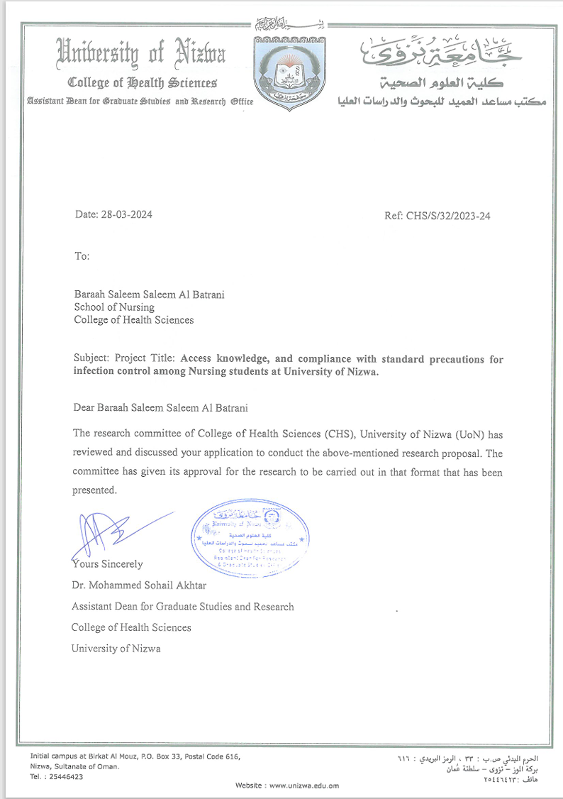

Appendix. 2: Graduation project approval

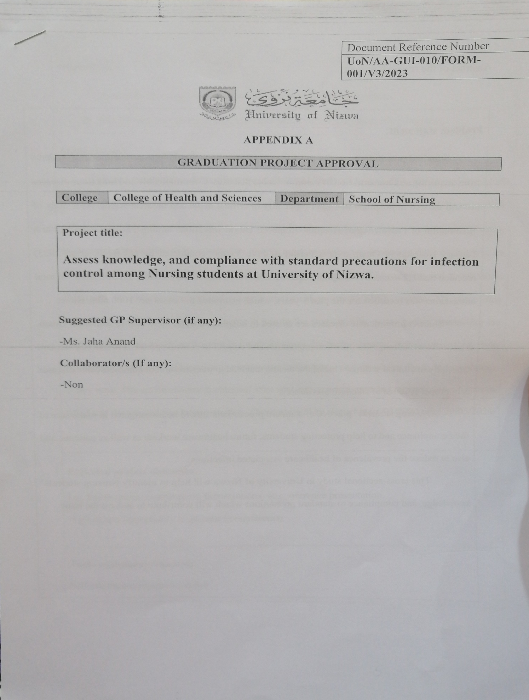

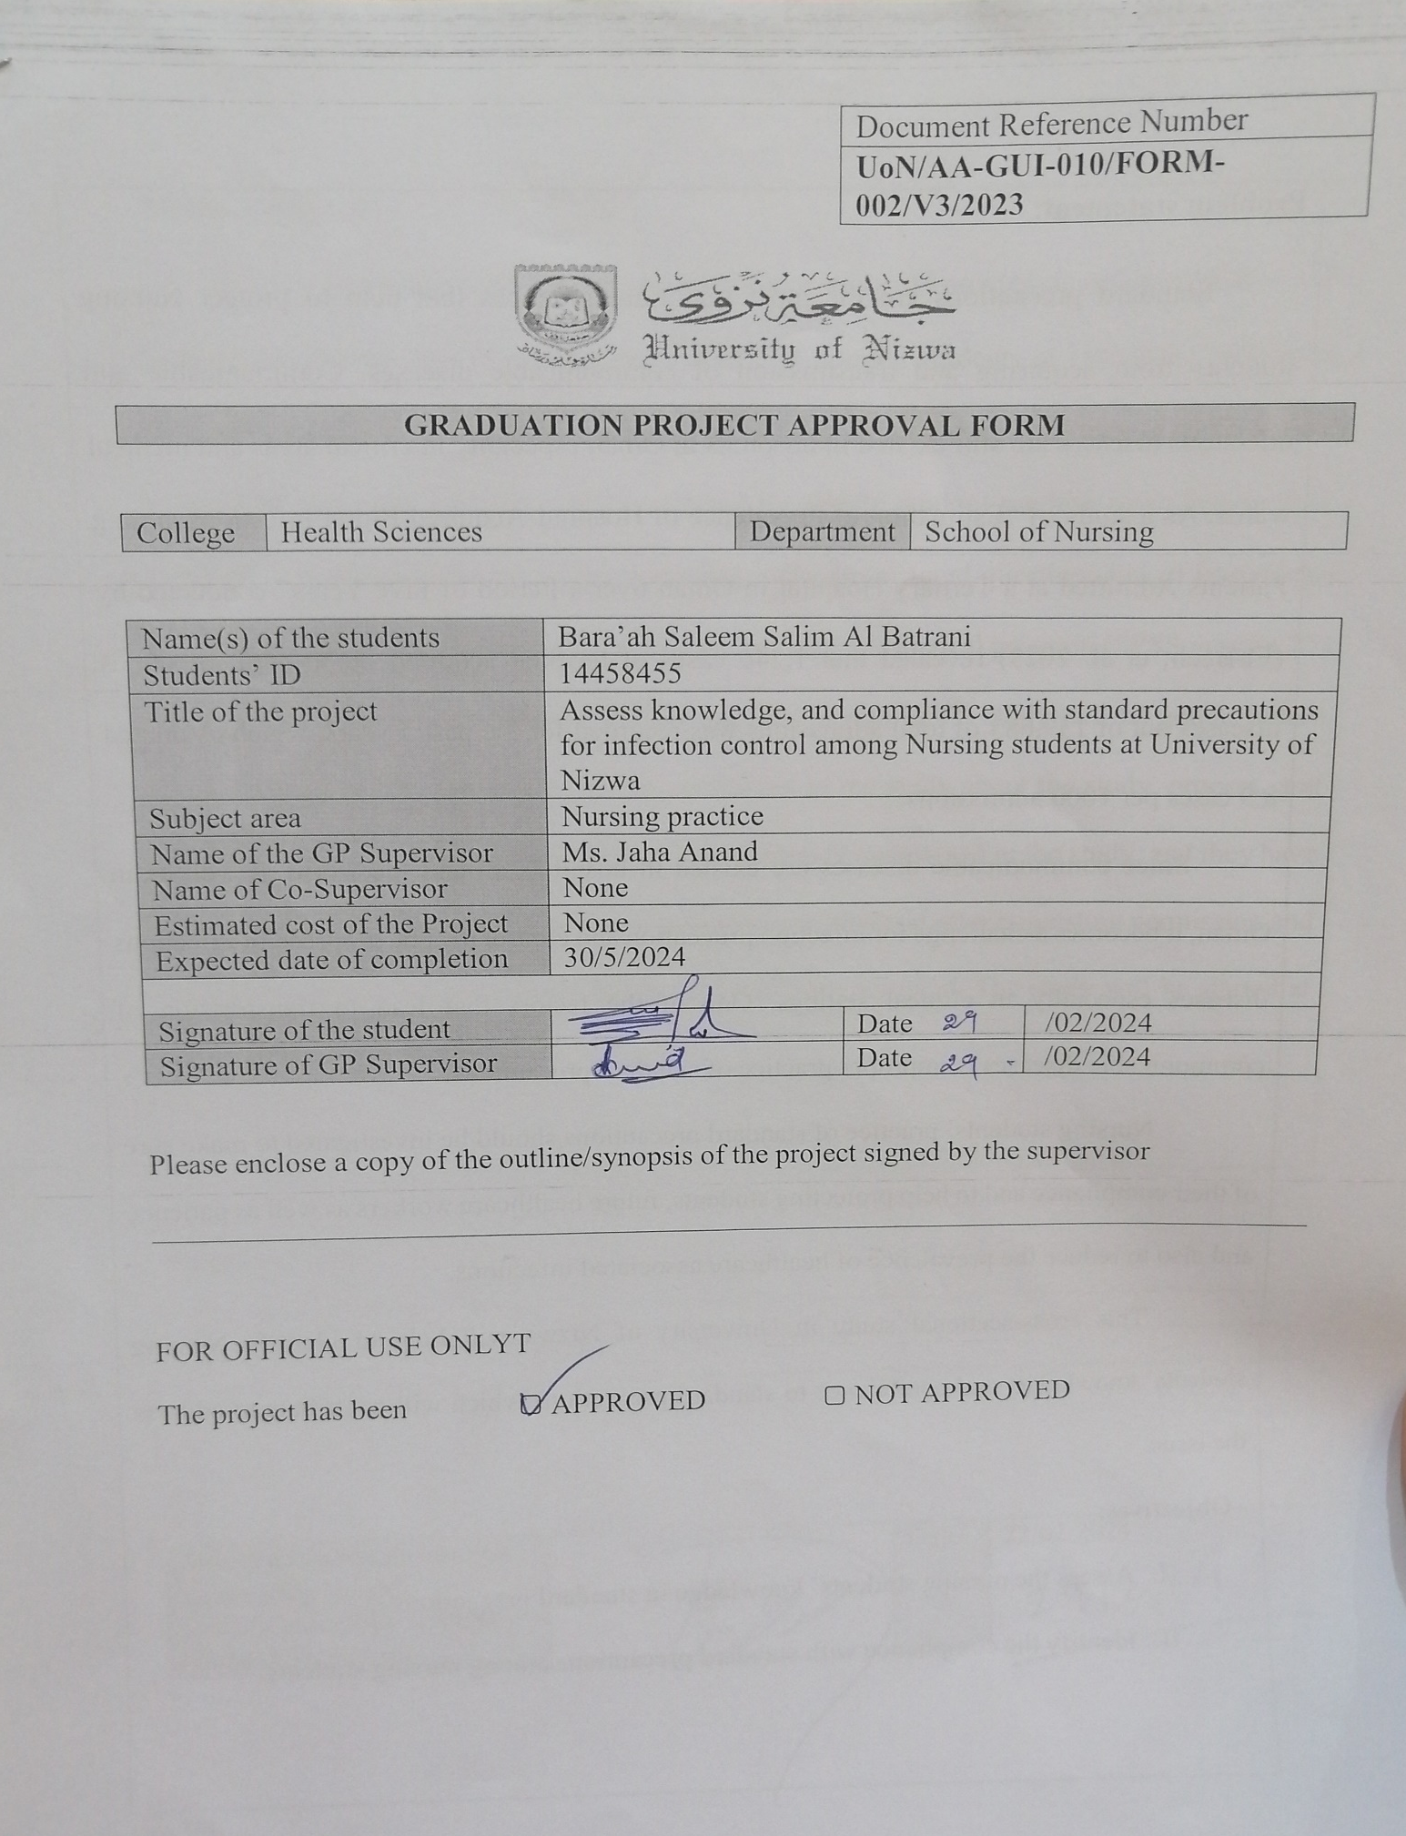
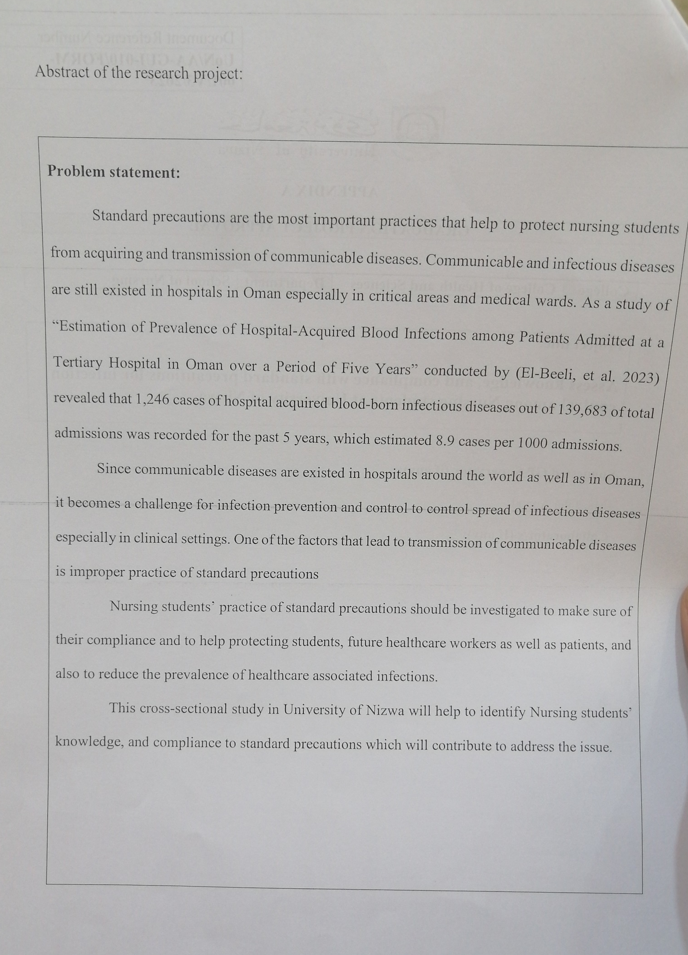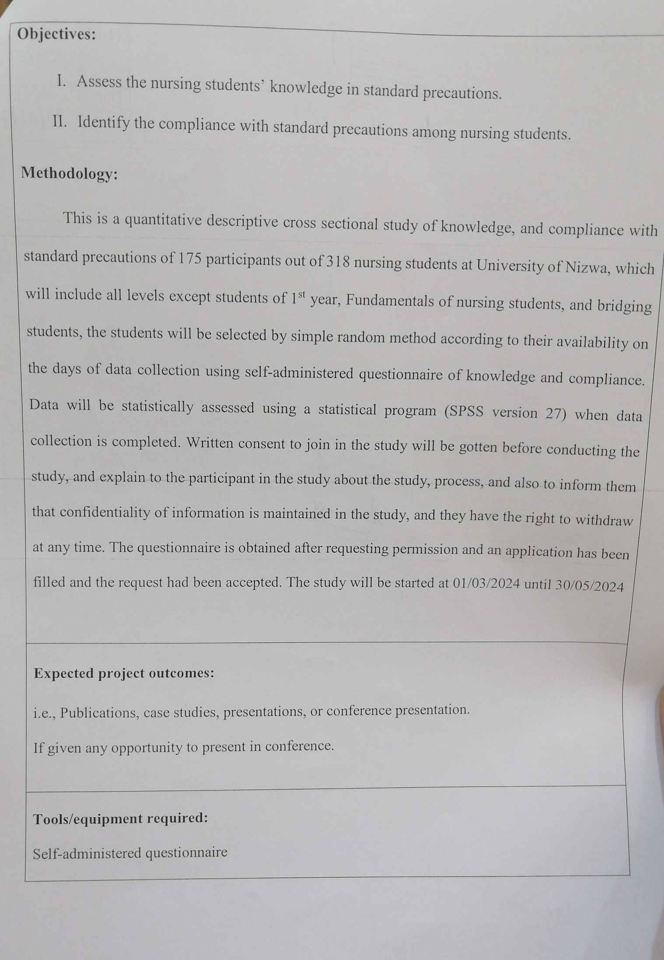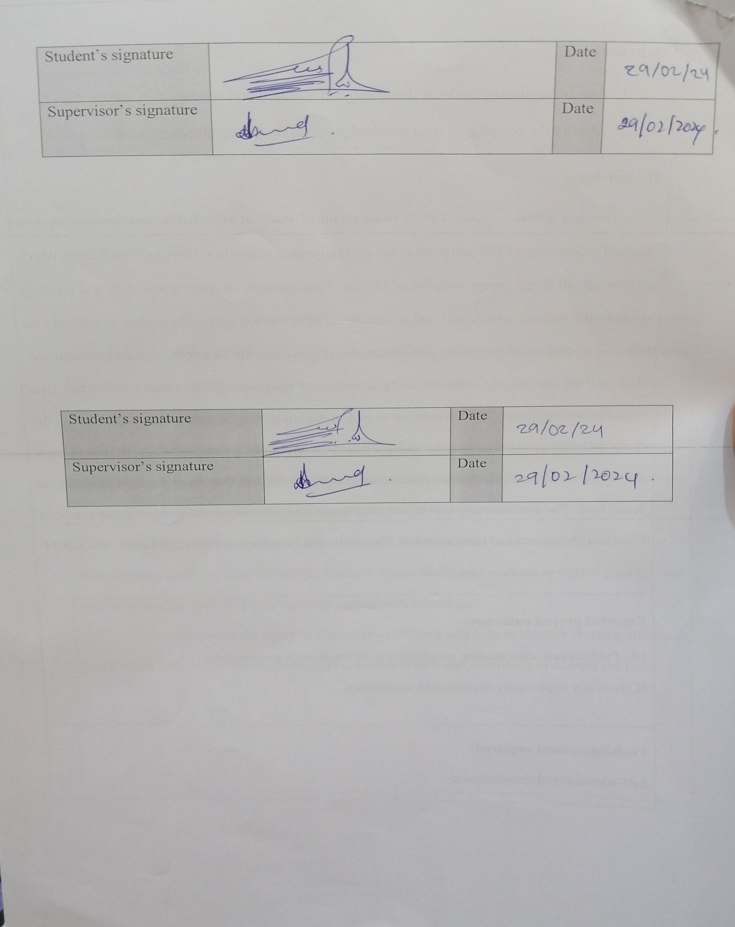Appendix. 3: Graduation project approval form
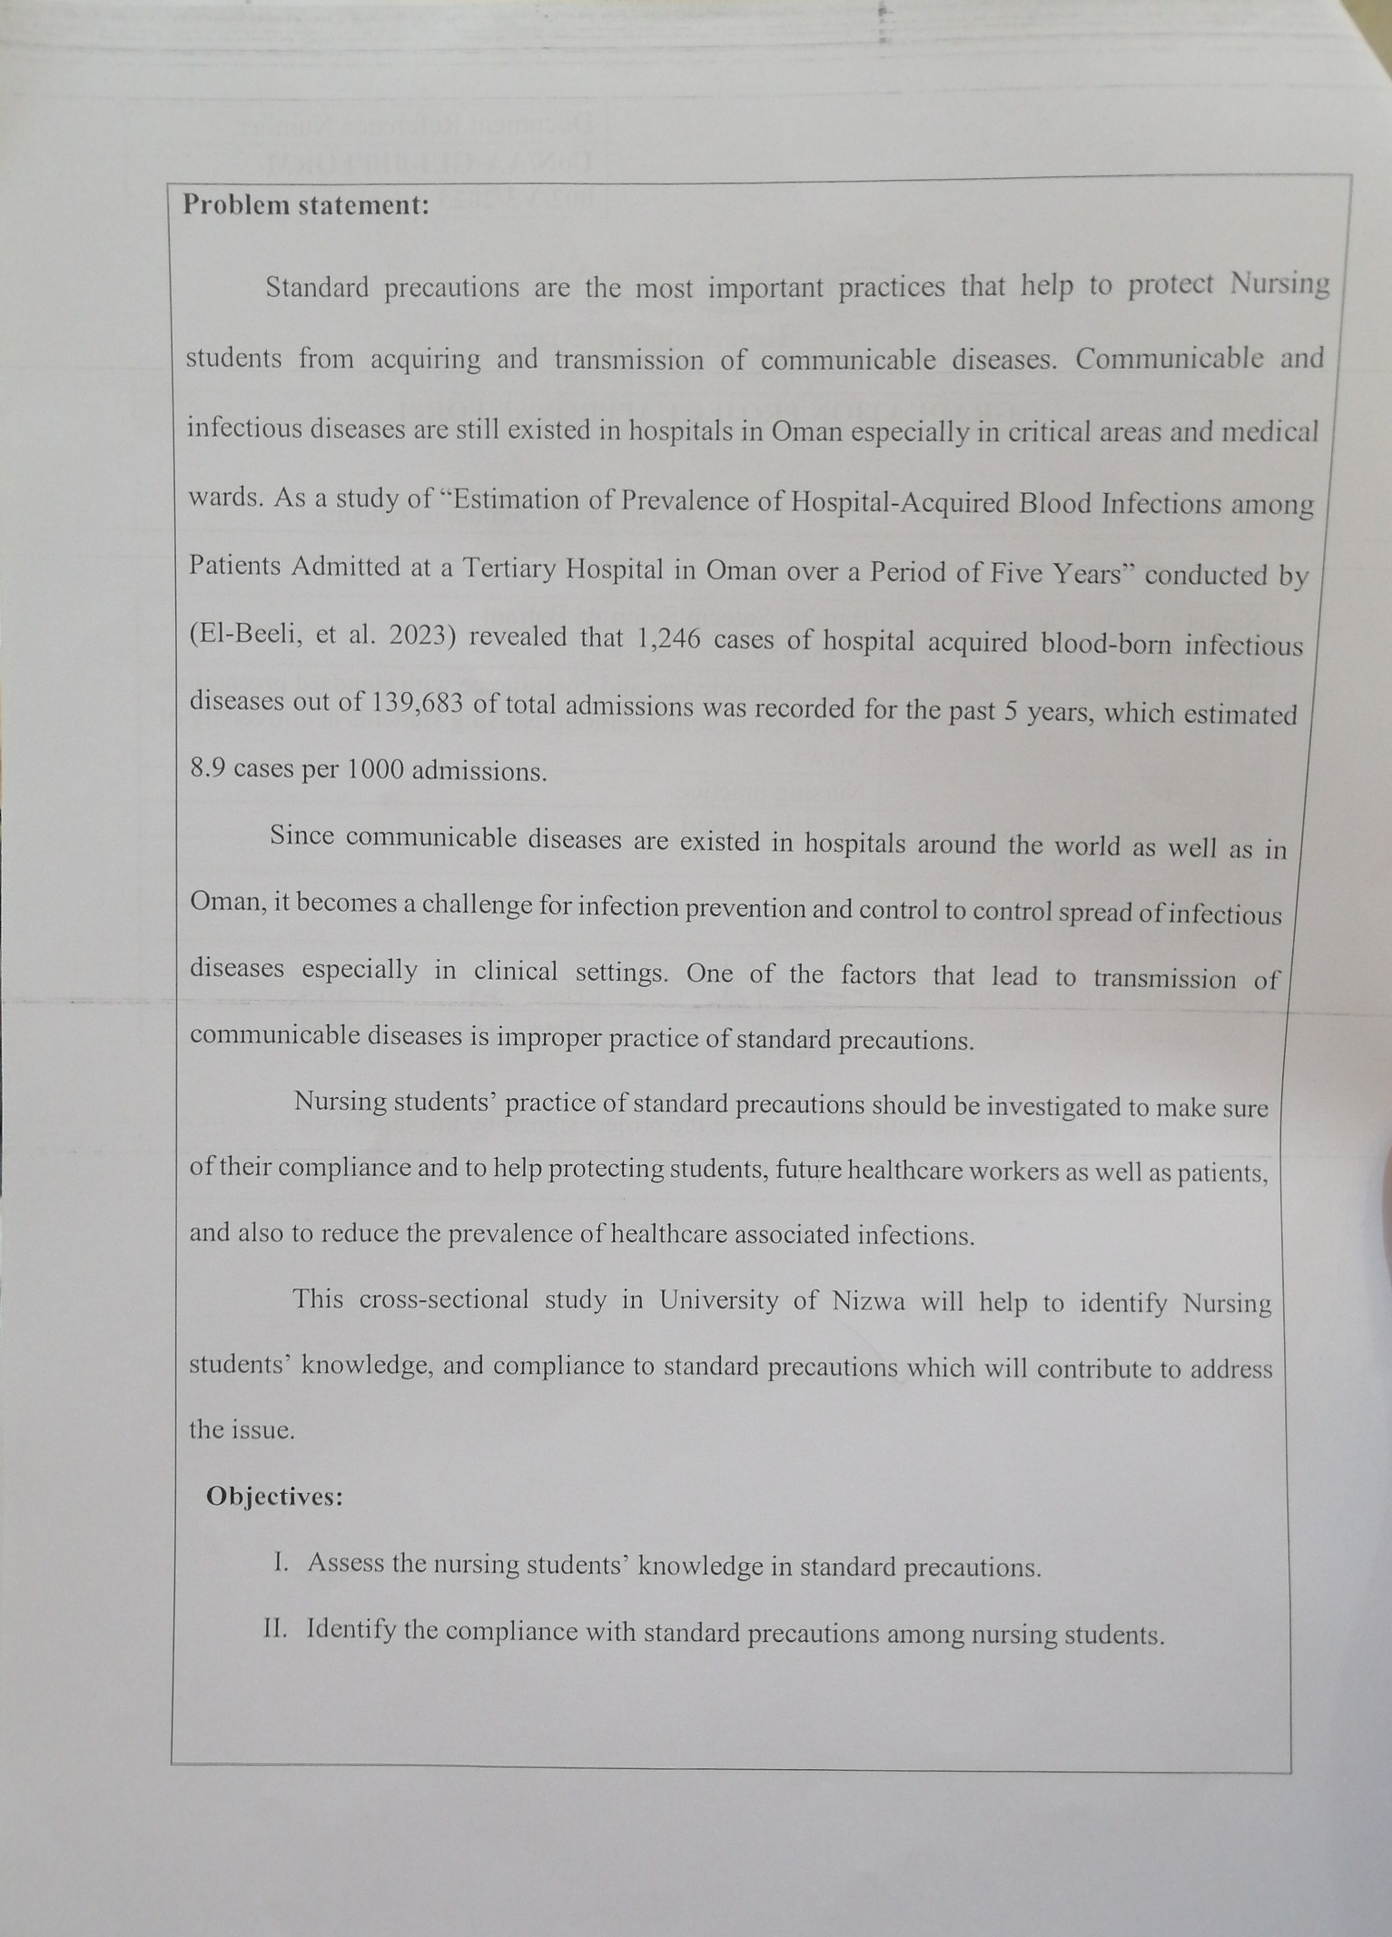
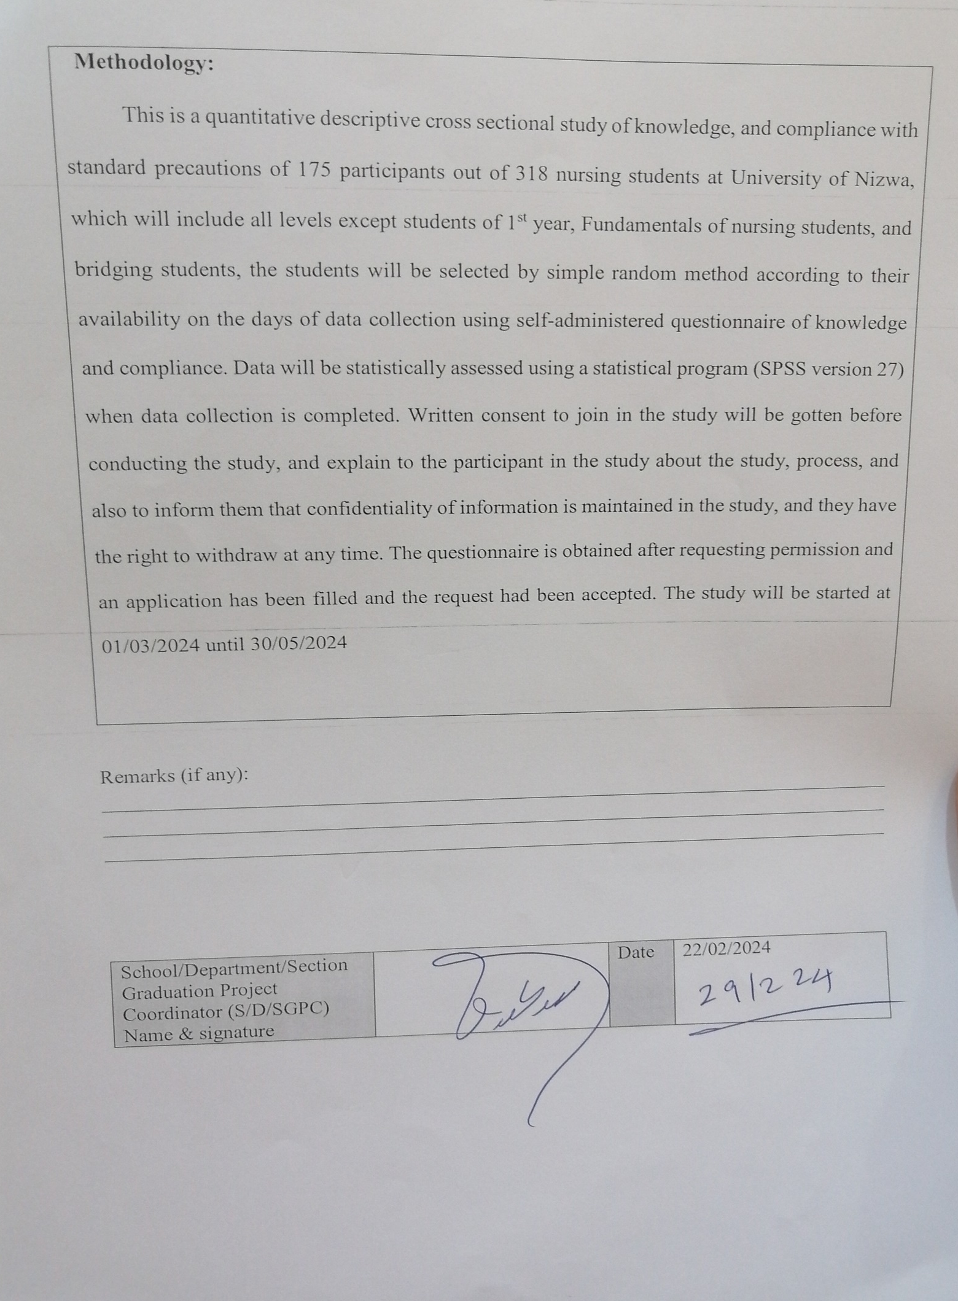

Appendix. 4: SPSS scale approval letter
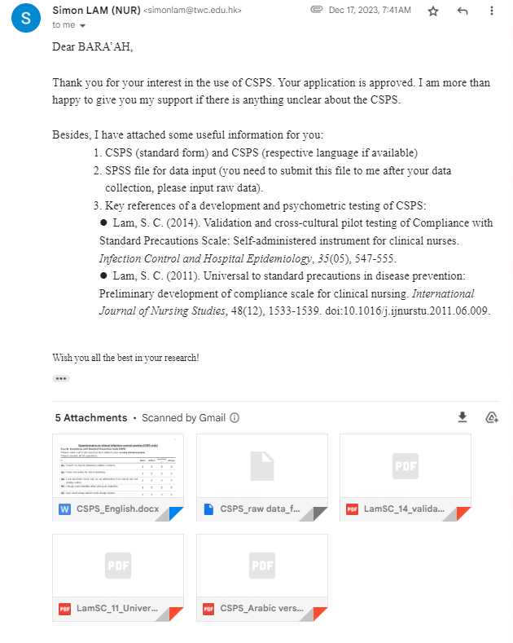

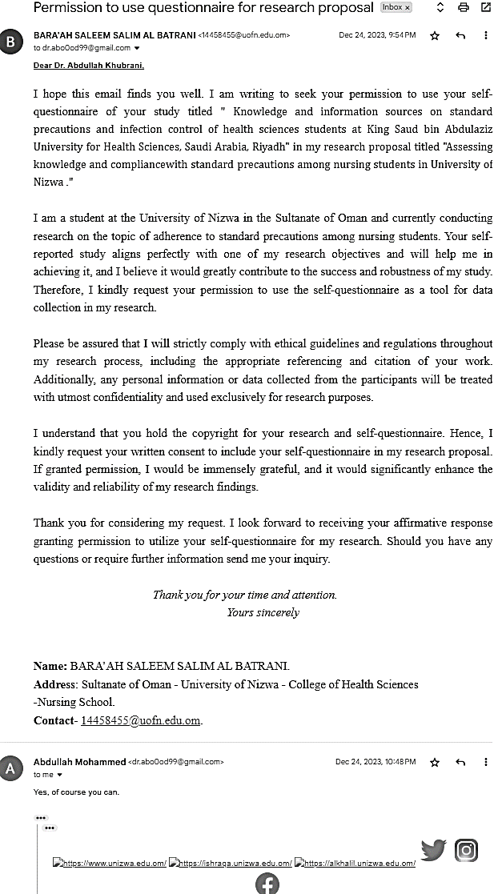
Appendix. 5: Knowledge questionnaire approval letter

Appendix. 6: Questionnaire of knowledge, and compliance with standard precautions of infection control among Nursing students

Questionnaire on knowledge, and compliance with standard precautions of infection control among Nursing students

Participants’ written consent
Dear Potential Participants,
The self-administered Questionnaire categorized under three sections: It contains 3 sections: section I contains demographic data. section II contains 12 items about knowledge of the concept of standard precautions (true and false questions). section III contains CSPS scale to assess compliance with standard precautions’ practices, which it contains 20 items, the response is 4-point Likert scale, such as: always, sometimes, seldom, and never. The findings of this study are solely reliant on the input you provide. As this implies, you must answer all of these questions. Your effort in attempting all questions honestly is highly appreciated. The data collection process involved presenting an anonymous, self-reporting questionnaire, based on available studies, the international guidelines. The questionnaire was pre-tested and used for data collection. The questionnaires were administered after obtaining KH consent.
By agreeing to answer these questions you have consented to take part in this study. It is your assurance that all information generated from this study will be treated as confidential and will be used for academic purpose only.

Part I: Participants’ demographic data:
- Age
a- 19-22
b- 23-25
c- 26-28
d- 29≤

- Gender
a- Male
b- Female

- Marital status
a- Single
b- Married
c- Others
Specify …………...

- Stream of study
a- BSN regular program
b- DN program

- Year in the program
a- second year
b- third year
c- forth year
- Clinical exposure
- less than 1 year
- 1-2 years
c- 3-4 years

- Attended seminars of infection control
- yes
- No

Part II: Standard Precautions Knowledge
Please mark a ✔ in the box that best reflects your knowledge of standard precautions.
Please answer all 20 questions.
 | True | False | I don’t know
Q1. The main goal of infection control is to restrict the spread of infection. | ❏ | ❏ | ❏
Q2. Definition of standard precautions is performing hand hygiene, use of Personal Protective Equipment (PPEs), appropriate handling of bodily fluids & patient wastes and prevention of needle stick/sharp injuries | ❏ | ❏ | ❏
Q3. All patients are sources of infections regardless of their diagnoses. | ❏ | ❏ | ❏
Q4. All body fluids except sweat should be viewed as sources of infection. | ❏ | ❏ | ❏
Q5. All health providers are at risk of occupational infections. | ❏ | ❏ | ❏
Q6. Hand washing minimizes microorganisms acquired on the hands if hands are soiled. | ❏ | ❏ | ❏
Q7. In standard hand washing minimum duration should be 5-10 seconds. | ❏ | ❏ | ❏
Q8. Alcohol hand rub cannot substitutes hand washing even if the hands are soiled. | ❏ | ❏ | ❏
Q9. Use of PPEs eliminate risk of acquiring occupational infections. | ❏ | ❏ | ❏
Q10. Gloves and masks cannot be re-used after proper cleaning. | ❏ | ❏ | ❏
Q11. Sharps injuries should be managed with need of reporting. | ❏ | ❏ | ❏
Q12. Immediate management of sharps injuries includes wash thoroughly with running water. | ❏ | ❏ | ❏

Part III: Compliance with Standard Precautions Scale (CSPS)
Please mark a ✔ in the box that best reflects your current clinical practice.
Please answer all 20 questions.
 | Never | Seldom | Sometimes | Always
Q1. I wash my hands between patient contacts. | ❏ | ❏ | ❏ | ❏
Q2. I only use water for hand washing. | ❏ | ❏ | ❏ | ❏
Q3. I use alcoholic hand rubs as an alternative if my hands are not visibly soiled. | ❏ | ❏ | ❏ | ❏
Q4. I recap used needles after giving an injection. | ❏ | ❏ | ❏ | ❏
Q5. I put used sharp articles into sharps boxes. | ❏ | ❏ | ❏ | ❏
Q6. The sharps box is disposed only when it is full. | ❏ | ❏ | ❏ | ❏
Q7. I remove Personal Protective Equipment (PPE) in a designated area. | ❏ | ❏ | ❏ | ❏
Q8. I take a shower in case of extensive splashing even after I have put on Personal Protective Equipment (PPE). | ❏ | ❏ | ❏ | ❏
Q9. I cover my wound(s) or lesion(s) with waterproof dressing before patient contacts. | ❏ | ❏ | ❏ | ❏
Q10. I wear gloves when I am exposed to body fluids, blood products, and any excretion of patients. | ❏ | ❏ | ❏ | ❏
Q11. I change gloves between patient contacts. | ❏ | ❏ | ❏ | ❏
Q12. I decontaminate my hands immediately after removal of gloves. | ❏ | ❏ | ❏ | ❏
Q13. I wear a surgical mask alone or in combination with goggles, face shield and apron whenever there is a possibility of a splash or splatter. | ❏ | ❏ | ❏ | ❏
Q14. My mouth and nose are covered when I wear a mask. | ❏ | ❏ | ❏ | ❏
Q15. I reuse a surgical mask or disposable Personal Protective Equipment (PPE). | ❏ | ❏ | ❏ | ❏
Q16. I wear a gown or apron when exposed to blood, body fluids or any patient excretions. | ❏ | ❏ | ❏ | ❏
Q17. Waste contaminated with blood, body fluids, secretion and excretion is placed in red plastic bags irrespective of the patient’s infection status. | ❏ | ❏ | ❏ | ❏
Q18. I decontaminate surfaces and equipment after use. | ❏ | ❏ | ❏ | ❏
Q19. I wear gloves to decontaminate used equipment with visible soils. | ❏ | ❏ | ❏ | ❏
Q20. I clean up spillage of blood or other body fluids immediately with disinfectants. | ❏ | ❏ | ❏ | ❏
Author retains the copyright of the CSPS, and reproduction of CSPS is available with Author’s permission only.
That’s the end of the questionnaire, thank you very much!

