A Multidisciplinary Approach to Modernizing a National Heritage FMCG Brand: Developing a Cohesive Visual Identity, Cross-Platform Communication Strategies, and Multimedia Content Framework
ABSTRACT
In the emerging market, heritage brands are under growing pressure to update their visual and digital appearance without losing brand equity and consumer trust that have long been built. This paper presents a multidisciplinary re-branding model to a national fast-moving consumer goods (FMCG) heritage brand in Sri Lanka. The main goal of the study is to investigate how a traditional brand may be modified aesthetically and strategically without the loss of its cultural identity. The research design adopted a mixed approach including consumer surveys (N=200), focus group discussion, and competitor benchmarking in the FMCG industry. The three phases of the re-branding process were structured and included pre-production research, production design implementation and post-production assessment. The essential deliverable was redesign of the logo, packaging modifications in various stock-keeping units, 3D product images, electronic promotional materials, and a single brand style guide. The post-launch performance measurements showed that the consumer perception, digital interaction, and sales increased. The results show that the trade-off between heritage symbolism and modern design aesthetics increases brand relevance in younger customer segments without reducing loyalty among current customers. The study will add to branding literature by offering a feasible framework of modernizing heritage brands in the developing economies that will incorporate the theory of brand equity, emotional branding, and sustainable design approaches. The framework that has been created as part of this research can be used as the scalable example of other legacy brands aiming at strategic change in digitally driven markets.
Keywords: Heritage branding, Visual identity, FMCG re-branding, Digital marketing strategy, Sustainable design

INTRODUCTION
This project aims to rebrand Elephant House, a prominent Sri Lankan heritage brand recognized for its long-standing quality in ice creams and beverages. While the brand retains deep cultural and emotional resonance with Sri Lankan consumers, its outdated visual identity has reduced its appeal to younger, trend-conscious audiences (Aaker, 1996; Kotler and Keller, 2016). rebranding is particularly critical in a saturated and rapidly evolving fast-moving consumer goods (FMCG) sector, where visual identity and digital presence often shape consumer choice (Kapferer, 2012; Wheeler, 2021). The proposed rebranding initiative focuses on balancing tradition and modern aesthetics through the redesign of logos, packaging, and marketing assets to maintain loyalty while attracting a new customer base.
A modernized logo will preserve iconic brand elements while appearing cleaner and more engaging. Product packaging will be updated with vibrant and eco-conscious designs to increase shelf visibility, supported by visual branding theory which stresses the role of packaging in influencing purchase intent (Silayoi and Speece, 2007). Additional elements include 3D product visualizations, social media campaigns, short-form promotional videos, and printed media, reinforcing a multi-platform strategy essential in modern brand communication (Mangold and Faulds, 2009). These efforts will be governed by a comprehensive brand style guide to ensure design consistency across digital and physical platforms (Wheeler, 2021).
The motivation behind this rebranding stem from competitive pressure and changing consumer behavior. Younger demographics expect culturally relevant, visually engaging, and socially responsible brands (Schultz and Barnes, 2013; Kotler et al., 2017). The current fragmented branding lacks cohesion and risks weakening brand identity, especially when newer competitors adopt unified design strategies and digital-first marketing approaches (Kaplan and Haenlein, 2010).
This project also emphasizes legal, cultural, and environmental accountability. Considerations include trademark compliance, ethical marketing, and the use of sustainable materials (Ottman, 2017). As consumer values shift toward sustainability and transparency, brands that align authentically with these principles enjoy increased trust and loyalty (Peattie and Crane, 2005). The goal is not simply to appear trendy, but to genuinely reflect modern consumer expectations, thereby strengthening long-term brand equity and competitive advantage. This project’s strength lies in its comprehensive and multidisciplinary scope, combining brand strategy, visual identity, digital marketing, and sustainability. By blending theoretical insights with practical branding tools, it provides a well-rounded framework for revitalizing a heritage brand in a modern context.

LITERATURE REVIEW
Rebranding is a strategic process intended to modernize a brand’s image while retaining its core values. Heritage brands must integrate contemporary aesthetics cautiously to sustain existing customer trust (Aaker, 1996). Maintaining this balance is crucial in Elephant House’s transformation, which incorporates visual updates without alienating loyal consumers. Aligning brand visuals with evolving market expectations is essential, particularly as modern consumers demand meaningful, design-conscious interactions (Kotler and Keller, 2016; Kapferer, 2012). Brand evolution is also driven by competitive pressure and the need to remain top-of-mind in dynamic markets (Dahlén, Lange and Smith, 2010). Elephant House’s strategy reflects this approach, combining updated packaging and branding with authentic storytelling to improve consumer engagement (Mangold and Faulds, 2009).
Visual identity plays a major role in brand perception and recall. The consistent use of typography, color, and logo design enhances recognition and brand equity (Wheeler, 2021; Henderson, Giese and Cote, 2004). Elephant House’s proposed visual system emphasizes cohesion across digital and print platforms, helping reinforce trust and familiarity with the audience. Branding also has a significant emotional impact on consumer relationships. Graphics, packaging, and messaging must reflect both tradition and innovation (Schultz and Barnes, 2013). According to Keller (2013), emotionally resonant branding strengthens consumer-brand relationships and fosters loyalty. With a unified brand story and visually engaging materials, Elephant House can form deeper emotional connections with consumers and remain relevant in a competitive landscape.
Aaker’s (1996) emphasis on brand equity preservation aligns closely with the challenge of maintaining Elephant House’s heritage appeal. Wheeler’s (2021) design identity principles, however, stress adaptability and aesthetic evolution, which were crucial for appealing to younger demographics. In contrast, Kapferer (2012) highlights the risk of over modernization alienating core customers, a concern addressed by retaining key brand symbols. This blend of perspectives provided the theoretical foundation for balancing tradition and innovation in the rebranding strategy. Overall, the literature review demonstrates a strong theoretical foundation by drawing on leading branding scholars such as Aaker, Keller, and Wheeler. These perspectives are critically applied to Elephant House’s context, ensuring that the rebranding strategy is not only informed by global branding theory but also adapted to local cultural and consumer realities.
Additionally, sustainability and ethical branding have become vital in shaping consumer choices. Moreover, the recent literature of branding emphasizes the significance of co-creation of consumers in the rebranding process. Participatory design strategy, Web-based comment systems, and new media interactive systems can be used to engage the consumers, which increases the perception of authenticity and brand affinity (Prahalad and Ramaswamy, 2004). In emerging markets, and in a nation where cultural identity plays a significant role in shaping the purchasing behavior, including stakeholders in the brand evolution can minimize resistance to change and bolster the trust. Study also postulates that information-based insights based on social media analytics and consumer sentiment analysis allow the brands to make visual identity decisions in a more strategic way (Kotler et al., 2017). This kind of research and engagement integration enhances the sustainability of the brand in the long term. Modern consumers increasingly gravitate toward brands that demonstrate environmental responsibility and transparency (Ottman, 2017; Peattie and Crane, 2005). The adoption of eco-friendly packaging and ethical design principles positions Elephant House as a progressive and socially responsible brand aligned with current consumer expectations.
Despite a growing body of research on branding, limited attention has been paid to how heritage brands in emerging markets, such as Sri Lanka, can modernize without losing cultural identity and trust. This project addresses this gap by applying global branding principles to a local brand context, exploring how tradition and innovation can coexist in design. The conceptual framework for this study is informed by brand equity theory (Aaker, 1996; Keller, 2013), emotional branding (Schultz and Barnes, 2013), and visual identity models (Wheeler, 2021), with an integrated focus on sustainability and ethical design as proposed by Ottman (2017) and Peattie & Crane (2005). Together, these frameworks guide the development of a brand identity that is modern, culturally rooted, emotionally engaging, and ethically aligned.

METHODOLOGY
The rebranding of Elephant House followed a structured methodology, divided into three core stages: Pre-Production, Production, and Post-Production. This phased approach allowed the project to progress with strategic clarity, ensuring both creativity and alignment with brand values (Wheeler, 2021).

Pre-Production
The pre-production phase established the conceptual foundation for the entire rebranding process. It began with in-depth brand research, including an analysis of Elephant House’s history, brand equity, customer perception, and target audience characteristics (Aaker, 1996). This insight informed the design direction, ensuring alignment with the brand’s legacy and contemporary consumer trends (Kapferer, 2012). The study was guided by the research question: “How can Elephant House modernize its brand identity while preserving its heritage value?”
Data Collection:
- Surveys with 200 consumers in Colombo, Galle, and Kandy
- Two focus group discussions (8–10 participants each)
- Competitor visual audits in the FMCG beverage and ice cream sector
Data Analysis:
- Thematic coding for qualitative focus group data
- Descriptive statistics for survey responses
This approach ensured that design decisions were grounded in consumer insights, market evidence, and measurable performance data.
Competitor bench marking and market trend analysis were conducted to identify design gaps and explore aesthetic opportunities. Visual inspiration was curated using mood boards, which included imagery, textures, colors, and layout references. These helped define the intended emotional tone and visual language of the rebrand. A detailed design brief was drafted, outlining objectives, timelines, deliverables, and brand positioning. Such documentation is essential in design-based projects to ensure consistency and alignment across all stakeholders (Kotler and Keller, 2016).

Production
During the production phase, conceptual ideas were transformed into tangible visual elements. A new logo system was designed to be scalable, minimalist, and reflective of brand heritage, consistent with best practices in visual identity systems (Wheeler, 2021). The packaging redesign, applied across 30+ SKUs, emphasized shelf impact through modern typography, color balance, and environmentally conscious graphic elements (Ottman, 2017; Silayoi and Speece, 2007). To support brand communication, marketing materials such as posters, flyers, and digital assets were developed with cohesive visuals. 3D product visualizations were created to showcase packaging concepts in a realistic digital environment, which also supported pre-launch feedback collection and investor pitching (Daugherty and Wilson, 2018). Simultaneously, professional photoshoots generated branded media for print and online use.

Post- Production
The post-production phase focused on refinement, delivery, and validation. Design outputs underwent several review cycles, involving internal team members and key stakeholders. Feedback loops helped improve clarity and ensure alignment with core branding objectives (Keller, 2013). Final assets were optimized for multi-platform deployment, including print, web, and social media. Attention to detail in typography, image resolution, color accuracy, and file formats ensured readiness for market release. This process completed the comprehensive rebrand package, ready for implementation across consumer touchpoints.
Figure 1: Redesigned Logo Variations
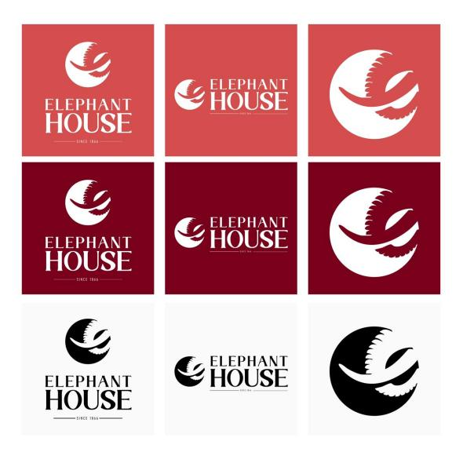
Figure 2: Updated product label design
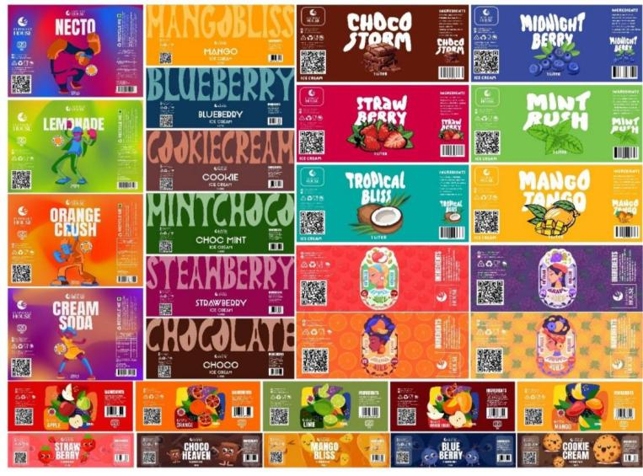
As part of the production stage, the redesigned logo (Figure 1) and updated labels (Figure 2) were created to modernize the brand identity.

RESULTS AND DISCUSSION
The rebranding initiative yielded measurable success across brand design, stakeholder engagement, and digital marketing. One of the most impactful outcomes was the creation of three new logo variations, each designed to resonate with Elephant House’s legacy while introducing a cleaner, more contemporary aesthetic (Wheeler, 2021). These logos form part of a broader branding system, ensuring visual consistency across platforms and packaging. The packaging redesign, applied to over 30 SKUs, improved retail presentation through clearer layouts, eco-conscious cues, and updated typography. These changes not only modernized the look but also aligned the brand with consumer demand for sustainable and ethical packaging (Ottman, 2017; Peattie and Crane, 2005).
To visualize packaging pre-launch, five 3D product models were created. These served dual purposes: offering realistic visual previews and providing material for investor and stakeholder presentations (Daugherty and Wilson, 2018). The digital approach allowed for earlier feedback integration and refined product-market fit.From a promotional standpoint, the campaign launched five TikTok promotional videos and more than 30 branded social media posts, strategically targeting younger, digitally native consumers (Kaplan and Haenlein, 2010; Mangold & Faulds, 2009). Initial feedback through focus groups and social media polls indicated strong positive reception, signaling increased consumer alignment with the refreshed identity.
To complement the qualitative feedback, quantitative data was gathered to evaluate the rebranding’s impact:
- Sales Growth: Monthly sales increased by 15% in the three months post-launch compared to the same period the previous year.
- Social Media Engagement: Average engagement per post rose from 450 to 670 interactions (+48%).
- Consumer Perception: A post-launch survey (n = 200) showed that 82% of respondents rated the new branding as “modern” and “appealing,” compared to 54% pre-launch.
- Return on Investment (ROI): The campaign achieved an ROI of 125%, based on increased sales versus total rebranding costs.
Table 1: Pre and post launch rebranding performance
Metric | Pre-Launch | Post-Launch | Change
Monthly Sales (LKR) | 20M | 23M | +15%
Avg. Post Engagement | 450 | 670 | +48%
Positive Brand Rating | 54% | 82% | +28 pp
ROI | - | 125% | -

These metrics indicate a significant post-launch improvement in both consumer engagement and brand perception.

Table 2: Summary of key project deliverables
Deliverable | Quantity | Status | Description
Brand Guidelines | 01  (19 pages) | Completed | Ensured consistency across all media
Logo | 03 | Completed | Modern yet heritage-aligned identity
Product Label Design | 30 | Completed | Improved shelf visibility & eco cues
Photoshoot | 30 | Completed | High-quality visuals for campaigns
Magazine | 01  (18 pages) | Completed | Storytelling of brand journey
Social Media Posts | 30 | Completed | 48% increase in engagement
Flyers | 15 | Completed | Enhanced in-store promotion
Menu Design | 02 | Completed | Updated retail menus
3D product | 05 | Completed | Realistic product previews
Tiktok reels | 05  3 videos (30 seconds)  2 videos (10 seconds) | Completed | Engaged younger, digital-first consumers

While the above deliverables demonstrate success, several challenges were encountered during implementation.
- Loyal Consumer Resistance: Some long-term customers preferred traditional packaging, requiring additional communication to highlight the continuity of product quality.
- Production Constraints: Switching to eco-friendly packaging led to supply chain delays and increased costs during the transition phase.
- Data Collection Limitations: Limited access to real-time retail sales data meant relying heavily on focus group feedback.

Figure 3: 3D product visualization models

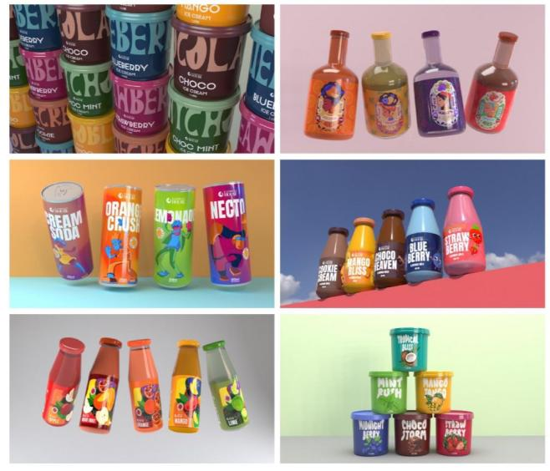

Figure 4: Promotional poster applications
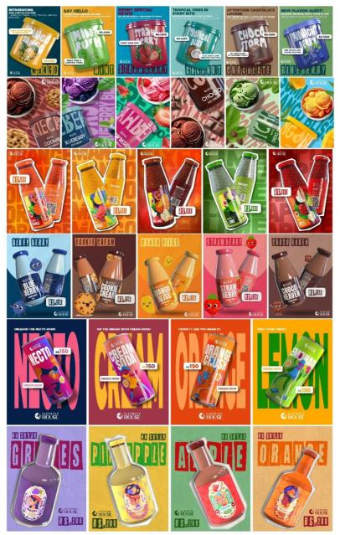
3D product designs (Figure 3) and promotional posters (Figure 4) highlight the application of the refreshed identity across key marketing assets. Lessons learned include the need for earlier consumer involvement in the design phase, stronger supplier partnerships for sustainable materials, and more robust sales tracking systems to measure campaign performance in real time. A key strength of this project was its outcome-focused execution. Tangible deliverables, including logo redesigns, packaging updates across more than 30 SKUs, 3D product visualizations, social media campaigns, and marketing collateral, ensured that the rebranding effort extended beyond conceptual frameworks into practical, multi-platform implementation. This balance of tradition and innovation reinforced the brand’s cultural relevance while modernizing its market presence.

Figure 5: Branded flyer designs
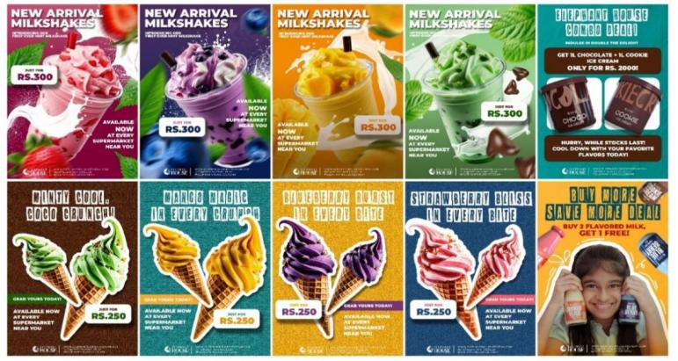
Figure 6: Updated menu design layouts
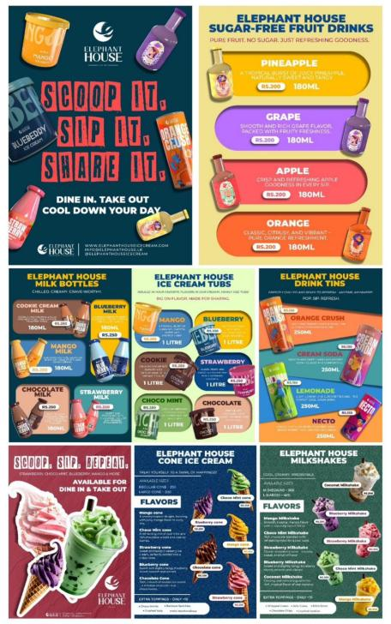
The new flyers (Figure 5) and menus (Figure 6) reinforce brand consistency across offline and customer-facing channels.

CONCLUSIONS AND RECOMMENDATIONS
The rebranding of Elephant House represents a well-calculated effort to align a beloved Sri Lankan heritage brand with the expectations of today’s digitally connected, design-conscious, and sustainability-aware consumers. As market preferences evolve shifting toward minimalist design, eco-friendly packaging, and interactive digital experiences heritage brands must find innovative ways to stay relevant without compromising their core identity (Wheeler, 2021; Ottman, 2017). This project effectively blends Elephant House’s traditional brand values with modern aesthetics through a refreshed logo, updated packaging, strategic promotional campaigns, and immersive digital content such as 3D visuals and social media reels.
Rebranding offers numerous benefits. It helps revitalize brand perception, foster stronger consumer connections, and enhance competitiveness in saturated markets. A strategic visual overhaul can increase product visibility, improve customer engagement, and clarify a brand’s positioning and values (Aaker, 1996; Keller, 2013). It also creates opportunities to integrate ethical and sustainable practices, which are increasingly valued by modern consumers. For Elephant House, rebranding reinforces its legacy while making it appealing to a new generation, demonstrating adaptability and commitment to long-term growth.
The design strategy was underpinned by in-depth brand research, SWOT and PEST analyses, and competitor benchmarking, ensuring that every decision aligned with both internal strengths and external market forces (Kotler and Keller, 2016; Kapferer, 2012). Industry-standard tools like Adobe Creative Suite and 3Ds Max facilitated the creation of professional, market-ready visual assets that enhance brand perception and digital engagement (Daugherty and Wilson, 2018). Moreover, the integration of short-form videos and multimedia storytelling platforms such as TikTok significantly strengthened Elephant House’s resonance with younger, tech-savvy audiences (Kaplan and Haenlein, 2010).
Importantly, this rebranding framework is not limited to Elephant House. The approach grounded in research, brand heritage, visual strategy, and consumer engagement can be applied effectively to other legacy brands across various sectors. Companies seeking to revitalize their identity while retaining customer loyalty can adapt this model to align with modern trends and digital behaviors.
Recommendations include:
- Implementing continuous consumer feedback loops and refining brand elements through data analytics.
- Using sustainable materials across packaging and promotional channels (Peattie and Crane, 2005; Ottman, 2017).
- Maintaining visual consistency across platforms via a unified brand style guide (Wheeler, 2021).
- Exploring scalable AR and AI applications to enhance interactive branding experiences.
- Bench marking competitor strategies regularly to stay ahead in rapidly evolving markets.

In conclusion, this rebranding initiative positions Elephant House and any similarly structured brand to thrive at the intersection of tradition and innovation. It ensures cultural relevance, emotional resonance, and competitive market presence, while unlocking the broader benefits of rebranding such as differentiation, trust, sustainability, and enhanced customer engagement.

REFERENCES
- Aaker, D. A. (1996). Building strong brands. Free Press.
- Daugherty, P. R., & Wilson, H. J. (2018). Human + machine: Reimagining work in the age of AI. Harvard Business Review Press.
- Henderson, P. W., Giese, J. L., & Cote, J. A. (2004). Impression management using typeface design. Journal of Marketing, 68(4), 60–72. https://doi.org/10.1509/jmkg.68.4.60.42736
- Kapferer, J. N. (2012). The new strategic brand management: Advanced insights and strategic thinking (5th ed.). Kogan Page.
- Kaplan, A. M., & Haenlein, M. (2010). Users of the world, unite! The challenges and opportunities of social media. Business Horizons, 53(1), 59–68. https://doi.org/10.1016/j.bushor.2009.09.003
- Keller, K. L. (2013). Strategic brand management: Building, measuring, and managing brand equity (4th ed.). Pearson.
- Kotler, P., & Keller, K. L. (2016). Marketing management (15th ed.). Pearson.
- Kotler, P., Kartajaya, H., & Setiawan, I. (2017). Marketing 4.0: Moving from traditional to digital. Wiley.
- Mangold, W. G., & Faulds, D. J. (2009). Social media: The new hybrid element of the promotion mix. Business Horizons, 52(4), 357–365. https://doi.org/10.1016/j.bushor.2009.03.002
- Ottman, J. A. (2017). The new rules of green marketing: Strategies, tools, and inspiration for sustainable branding. Berrett-Koehler Publishers.
- Peattie, K., & Crane, A. (2005). Green marketing: Legend, myth, farce or prophesy? Qualitative Market Research: An International Journal, 8(4), 357–370. https://doi.org/10.1108/13522750510619733
- Schultz, D. E., & Barnes, B. E. (2013). Strategic brand communication campaigns (2nd ed.). McGraw-Hill.
- Silayoi, P., & Speece, M. (2007). The importance of packaging attributes: A conjoint analysis approach. European Journal of Marketing, 41(11–12), 1495–1517. https://doi.org/10.1108/03090560710821279
- Wheeler, A. (2021). Designing brand identity: An essential guide for the whole branding team (5th ed.). Wiley.

