Enhancing Visitor Experience Through a Mobile App and Modernized Services at Peradeniya Botanical Garden, Kandy, Sri Lanka.
ABSTRACT
The Peradeniya Botanical Garden is one of the most famous botanical gardens in Sri Lanka, attracting both local and foreign visitors. A lack of digital infrastructure and social media participation reduce from the visiting experience at Peradeniya Garden. This project aims to enhance the visitor experience and attraction and also modernize the garden’s services, which is mainly focused on Asian and European visitors as well as local visitors. A vital part of this project is the creation of a rich mobile app that includes new technologies like GPS navigation, an AI powered virtual tour guide, VR exploration, and interactive visitor services to Enhance accessibility, offer customized experiences and modernize visitor engagement. Additionally, a rebranding method, which includes a new logo and visual identity, also strengthens the garden's brand presence, while an enhanced social media marketing campaign increases reach and popularity. This research mainly focuses on multiple topics to get a better idea about the project as well as the Royal Botanical Garden. The research includes a well-structured literature review to provide a better understanding of User Interface (UI) and User Experience (UX) Design, Digital Marketing & Promotion, Smart Tourism & Technology, Rebranding and Use of User Persona Design. I have followed Logical User-Centered Design (LUCID) methodology, ensuring a structured and research-based approach to UI/UX development while following production process methodology steps for the graphic work. In addition to reviewing the project’s strengths, issues and potential improvements, the research explains the project methods, shows how it improves engagement, branding, accessibility, satisfaction, sustainability, and marketing.

Keywords: Visitor Experience, Mobile Application, UI/UX designs, Vector graphic, Texturing and Rendering

INTRODUCTION & BACKGROUND

Introduction

This study aims to modernize and improve the Peradeniya Botanical Garden’s visitor experience through a comparative digital solution and a new look for the garden. One of the Sri Lanka's most well-known botanical gardens, the Peradeniya Botanical Garden attracts tourists both local and international, which is located near Kandy. It has stunning scenery and a high level of biodiversity. There are more than 4000 different plant kinds that can be found. The garden is managed by the Department of National Botanic Gardens (Anon., n.d.).
The main aim of this project is to enhance key services such as ticket booking, food ordering, holiday bungalow reservations, guide services, and event management to make the garden’s services more convenient and accessible for visitors at the Royal Botanic Gardens, Peradeniya. To achieve this, a mobile application with an interactive prototype will be designed, integrating new features such as an updated cafeteria menu, an event listing section, and additional facilities. The app will enable visitors to book tickets and reserve holiday bungalows anytime and from anywhere, while also allowing them to explore event packages and food options to plan their visits more efficiently, ensuring greater satisfaction. In addition to service improvement, the project emphasizes strengthening branding and promotional strategies to attract both local and international visitors. The garden’s logo will be redesigned to enhance its visual identity and marketing impact, and tickets will also be redesigned to provide a refreshed and modern appearance. Furthermore, social media posts and a promotional video highlighting the garden’s beauty and the new application will be developed to expand audience reach and improve overall visibility.
Background and Motivation
This type of research is typically called App Design and Prototyping or UI/UX Design. The purpose of a UI/UX project is to design the user interface and experience for a digital product, such as a software program, mobile app, or website. Conducting In-depth user researches and getting feedback from the users help to provide the digital product more effective and user friendly. The whole experience a user has with a digital product or service is the main focus of the field of UX design. At every point of a user's or customer's journey with an organization and its products, the UX designer seeks to develop and produce experiences that are important and relevant to clients. UX designers carry out in-depth research on users' needs, objectives, pain areas, preferences and habits in order to accomplish this goal. To guarantee usability and effectiveness, a product's navigation, structure and flow are frequently informed by the findings of this study. Meanwhile, UI design focuses on a product's visual features and interaction components. A UI designer is focused on the appearance and feel of a product or service, with particular attention to elements, buttons, layout, typography and icons. Making sure the digital interface is aesthetically beautiful, accessible, and consistent is the aim of UI designers (Allabarton, 2024).
The primary motivation for conducting this research, which focus on UI/UX designing is that the researcher’s specified area is UI/UX designing and the future ambition is to become a UI/UX designer. By working on this project based on that area, the researcher aims to gain practical experience and deeper understanding of UI/UX principles and move closer to achieving the career goal. Additionally, this project will provide researcher as a student who is studying UI/UX design, with valuable theoretical and practical knowledge in a real-world problem.

Problem in Brief

The main problem is the absence of a dedicated and integrated digital system at Royal Botanic Gardens, Peradeniya. The garden currently lacks a centralized digital platform to manage essential visitor services such as ticket booking, food ordering, holiday bungalow reservations, and guide services. As a result, visitors experience inconvenience, long waiting times, and difficulties in planning their visits efficiently.

Furthermore, the existing website is insufficient in effectively presenting services or engaging potential visitors, and the garden’s digital presence is weak due to limited and unattractive social media engagement. This lack of an integrated digital platform has led to service inefficiencies, reduced visitor satisfaction, and limited promotional reach, ultimately affecting the overall visitor experience and the attraction of prospective visitors.

Aim and Objectives.

Aim

This project aims to significantly make the visitor experience and attraction richer while boosting the garden’s charm by introducing innovative features and modernizing the garden’s services to meet present-day expectations, ensuring a more engaging, fitting and memorable visit for every single visitor.
Objectives
- To design and develop a user-friendly mobile application that enables visitors to conveniently access services such as ticket booking, holiday bungalow reservations, food ordering, and guide services from any location, thereby improving user satisfaction and service accessibility.
- To enhance operational efficiency and time management by implementing an online booking system that reduces waiting times at ticket counters and streamlines reservation processes.
- To strengthen the garden’s digital presence and promotional strategy through the development of an app landing page, engaging social media content, and promotional materials to attract a wider audience.
- To improve the garden’s brand image and reputation by redesigning visual elements such as the logo and tickets, and positioning the garden as a well-recognized attraction both locally and internationally.
Figure 1 - Comparison of Visitor Numbers to the Garden in 2011 and 2012
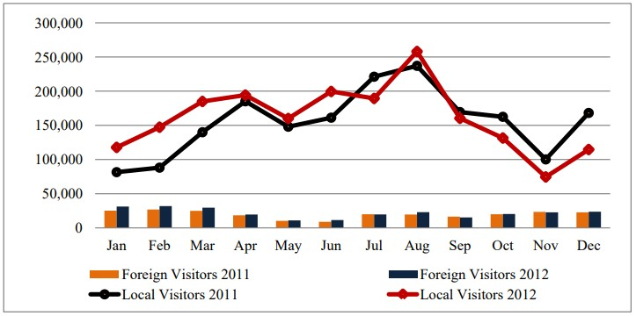
Figure 2 - Numbers of visitations
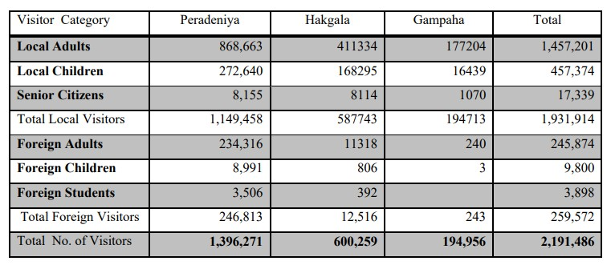
The data indicates that approximately 75% of visitors to the Royal Botanic Gardens, Peradeniya are locals, while 25% are foreign tourists, suggesting that local visitors should be the primary target audience. By modernizing services such as the booking system, holiday bungalow, cafeteria, and garden shop, the garden can become a more attractive and frequently visited destination. Additionally, offering special packages for events like birthdays, weddings, and photoshoots can further increase visitor numbers. As Sri Lanka is globally recognized for its hospitality and appeal to international travelers, and Kandy is a key tourist destination, the garden also holds strong potential to attract more foreign visitors seeking a natural experience.
Figure 3- Tourist arrivals by region and percentage share December 2024

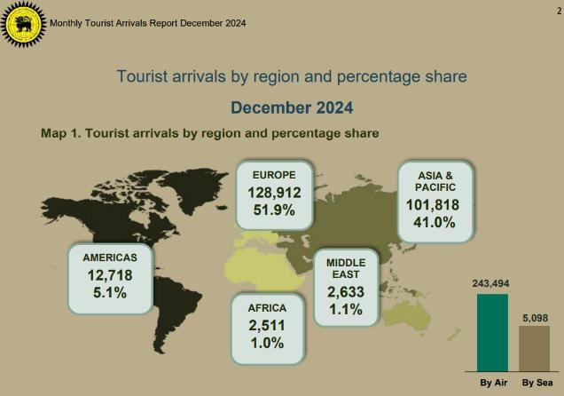
Figure 4 - Tourist arrivals by region and percentage share December 2023
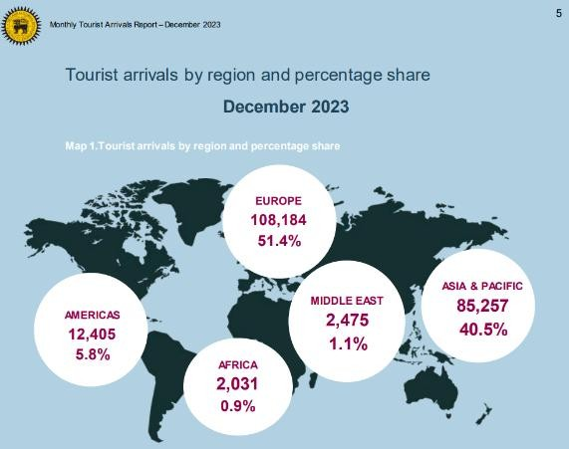
According to the monthly tourist arrival reports for month December in 2024 and 2023 provided by the Sri Lanka Tourism Development Authority it clearly shows the areas that visitors come to Sri Lanka from. The author has identified by go through these reports that this project should aims to target Asian and European visitors, as Asian tourists (especially from India, China, Japan and South Korea) are among the highest in number, while European tourists (especially from the UK, Germany, France and Russia) frequently visit Sri Lanka for its nature, culture and history. Since Sri Lanka is already an ideal tourist destination, prioritizing international visitors can further enhance the country’s tourism industry as well. (Anon., 2024)

LITERATURE REVIEW

User Interface (UI) and User Experience (UX) Design

UI (user Interface) design refers to the visual and interactive elements of an app, a web page or digital product that users engage with. The primary goal of user interface design is to capture and retain user attention by creating an esthetically pleasing and engaging interfaces. UX design boosts user experience by focusing on how users behave, making it simple to navigate and meets expectations, eventually helping organizations achieve their goals. UX (User Experience) Design is a principle in design that helps to provide a better user experience for the consumer. Its user centered design approach makes the website or digital product easy to operate, adapts according to user behavior and fits user expectations with the product to engage users and achieve the organization's goals. A great user experience is necessary for improving the customer's opinion of a business and can provide a competitive advantage by separating a product or website from its competitors (Anon., 2024).

UI (User Interface) design is the process of building interfaces in software or digital devices that prioritize the user's experience and engagement with the product. It includes designing an interface that is pleasing to the eye, convenient to use and gives a positive user experience. It involves making the design of the layout, typography, color palette, buttons, icons and other visual components that make the user interface. User experience (UX) design is the process of creating digital products or services that are tailored to the user's needs, tastes and habits. UX design aims to provide a seamless and simple user experience that satisfies the user's needs and expectations. This requires understanding the user's objectives and motivations, identifying pain spots and developing a design that addresses those difficulties. In summary, UI design concentrates on the visual elements of the product, whereas UX design focuses on the whole user experience (Hamidli, 2023).
After considering the above two, from the researcher’s point of view, UI & UX design are very important for producing user friendly and efficient digital products. An efficiently designed UI makes navigation/movement easier. It boosts branding and improves productivity. A pleasant looking interface increases engagement and encourages people to interact with the product. A strong UX secures usability, user connection and competitive advantage. By foreseeing and detecting its problems or issues, UX also minimizes the cost of development while ensuring a satisfying product for customers. UX design guarantees that digital products are usable, simple to use and satisfy users' expectations. A smooth combination of UI and UX improves consumer loyalty as well as retention rates. Well-designed UI and UX promote trust, giving users more confidence when utilizing the product. Overall, strong UI & UX, together, drive to better user satisfaction and sustained success while leading to higher conversions, which drives business growth.

Digital Marketing & Promotion

Digital marketing is the process of promoting products or services through digital technology, primarily the Internet, along with mobile devices, display advertising and any other digital channels. Organizations use digital platforms including social media, websites, search engines and email to engage with existing and potential consumers. This is also known as 'online marketing', 'internet marketing', or 'web marketing'. Digital marketing is described as the use of various digital methods and platforms to interact with customers in online environments where they spend many hours of their time. Digital marketing got more advanced in the 2000s and 2010s, as an increase of electronic devices capable of accessing digital media resulted in a rapid rise. Statistics between 2012 and 2013 revealed that digital marketing was still getting higher. With the rise of social media in the 2000s, like LinkedIn, Facebook, YouTube and Twitter, consumers became increasingly reliant on technological devices in their everyday activities. They expected a smooth user experience across multiple platforms when searching for product information. The shift in customer behavior improved the scope of marketing technology. Worldwide, digital marketing has been the most commonly used term since 2013 (Desai, 2019).
Digital marketing is currently one of the methods of advertising in which many businesses are making bigger investments. This new marketing paradigm has been primarily focused on the careful management of the customer-company connection in order to obtain information about the customers, their qualities, needs and preferences. Digital marketing is simply a collection of methods, techniques and resources for advertising products and services on the internet, including mobile devices, social media, websites, etc. The continuous process of turning leads into loyal buyers with a satisfying customer experience is the first step towards the effectiveness of digital marketing. It provides a collection of strategies, resources, methods and protocols that are coordinated online to boost a product or service's sales. In other words, digital marketing can provide real-time customer experience measurement by tracking things like conversions, what type of material works and what doesn't, how many individuals visit the company website, interact with its social networks, etc (Mohammed T. Nuseir, Ghaleb A El-Refae, Ahmad Ibrahim Aljumah,Muhammad Turki Alshurideh, 2023).
Digital Marketing is the process of promoting products or services using digital technology on a digital platform such as Websites, social media, Search engines, email, and mobile devices. Mainly electronic devices with internet access. Online Marketing, Internet Marketing or Web Marketing are some other synonyms for Digital Marketing. Basically, this turning point took place between the year 2000 to 2010 with the modernist arise of electronic digital devices. Digital Platforms like LinkedIn, Facebook, YouTube and Twitter played a major role in the expansion of Digital Marketing in the society. This has strong effects in business adoption where companies tend to increase investments digitally. Digital Marketing focuses on understanding customer needs, their Preferences, interests and behaviors, using multiple techniques and resources which creates loyal buyers by providing a satisfying user-friendly experience. Digital Marketing enhances the process of sales as well. Businesses can measure customer engagement, conversions and content effectiveness more precisely in real time. Companies can analyze user interactions on websites and social media to optimize marketing efforts. Since 2013, Digital Marketing has become very popular in the marketing arena. Nevertheless, Digital Marketing consecutively keeps on developing to evolve with technological advancement and changing consumer behaviors.

Smart Tourism & Technology

The utilization of innovative technologies for communication and information has been shown to improve both the effectiveness and the sustainability of the tourism industry, and many countries have chosen to employ smart tourism technologies as an approach to adapt to the always changing trends of tourists. The COVID-19 pandemic and lockdown periods changed not just how tourists look for information about destinations but also increased the demand for digital solutions that allow for the monitoring of customer and citizen activities. As a result, technology, as an interface between tourists and locations, has the potential to be an essential component of the tourism industry. Technology has affected the development of smart tourism, while travelers have grown into smart visitors. Furthermore, innovation in the tourism industry relates to the use of information and communication technologies. Latest research on smart tourism have suggested that technology is the secret to boosting a destination's productivity, and that the use of smart technologies is important in the entire tourist experience. As a result, transforming tourist attractions into "smarter" places has been identified as a potential improvement method. This transition is being driven by fundamental changes in the way tourism experiences are designed, delivered and used (Danny Daniel Castillo Vizuete, Alex Vinicio Gavilanes Montoya, Eduardo Antonio Muñoz Jácome, Carlos Renato Chávez Velásquez, Stelian Alexandru Borz, 2021).
According to Gretel et al. (2015), it can be difficult to define smart tourism. They emphasize that it is a multidimensional idea without a single definition. However, it is possible to state that smart tourism uses technology to enhance and optimize every stage of the visitor experience. In a world becoming increasingly ruled by technology, it's no wonder that even the way individuals travel the world is being digitally transformed. Enter smart tourism, an innovative idea that is transforming the travel scene for both travelers and attractions. Technology, sustainability, accessibility and cultural tradition are the core elements of smart tourism. Additionally, the technologies used in smart tourism are mobile applications, Internet of Things (IoT), Artificial Intelligence (AI), big data cloud computing and Augmented Reality (AR). Travelers prefer a more personalized, convenient, and engaging experience. Meanwhile, tourism destinations benefit from improved resource management, greater sustainability measures, increased competitiveness, and stronger economic growth, highlighting the value of smart tourism (Luisa, 2025).
Smart Tourism is to use modern Technology to improve the quality of the tourism industry. Information and communication technology help the tourism industry in an effective manner. In this modern technologically developing environment tourists tend to have a keen interest in digital equipment to accumulate information on destinations where it acts like bridging the gap or connector between tourists and their destinations. Smart Tourism may act like an innovative process when they start to use ICT. It may also energize the quality and the competitiveness of the destination points. Tourists will gain a great experience in every way. Usage of modern technologies like mobile applications, the Internet of Things (IoT), Artificial Intelligence (AI), big data, cloud computing, and Augmented Reality (AR) will transform the destinations into becoming smarter and much better. Smart Tourism is built on four strong pillars namely Modern Technology, accessibility, sustainability and multi-cultural traditions. Establishing the Smart Tourism concept can improve a much better perspective in personnel experience. Smart Tourism will be benefited economically, efficiently and innovatively by the destinations.

Rebranding

A company's attempt to modify or redevelop the brand identity associated with an existing brand is referred to as rebranding. The process of rebranding involves coming up with a new name, symbol, word, style, or a combination of these for an existing brand in an effort to establish a unique position in the eyes of stakeholders and competitors. A business can put itself in a better position to succeed by rebranding. The benefits of having a consistent, recognizable brand identity are being lost by many businesses and organizations with decades of experience. Consistency can be achieved by renewing the brand. Additionally, the standards it produces will save money and time in any future marketing campaigns. Rebranding is an investment in the company's future. Since rebranding can greatly affect consumer purchasing decisions, it is crucial to build a strong relationship between the company and its customers. The idea behind rebranding is to create a unique identity for a brand from its competitors in the market. It allows the company to clarify its opinions and core values and ambition for clients to continue to support a specific company for its product. Fulfilling this reveals that the company has achieved some level of glory in their rebranding efforts (Unyime Emmanuel Udonde, Nkanikpo Ibok Ibok, Clement Udowong, Clement Eke, 2023).
Rebranding is the process of changing a brand's identity without damaging the consumers' existing level of trust in it. It is a continuous process in which an organization modifies its self-identity to the dynamics of its business environment in order to succeed and survive. Rebranding can take place at three different levels inside an organization: corporate, business unit, and product levels. A minor change is called aesthetics, a medium change is called repositioning, and a complete change is called rebranding. Rebuilding the present brand to a new identity is another process that aims to make the organization stand out in a new way to competitors and customers. It is the organization's way of responding to a brand that loses its worth in the market, its reputation, its relevance, and the loyalty of its customers. Rebranding services and products are difficult, risky, and challenging for businesses. The most noticeable feature of brand management, however, is this rebranding, which is going to permanently impact the organization's image (Roslizawati Ahmad, Worlu Okechukwu, Hasnizam Shaari, 2022).
After studying about rebranding, according to the researcher’s point of view modifying or redesigning a brand’s identity is called “Rebranding”. Every company or industry has a unique brand, and from time to time there comes an urge to rebrand the identity. There are certain elements to be taken into consideration for a rebranding, namely Brand’s name, Symbol, Words and style or design. The main purpose of rebranding is to secure a unique position and to compete with others. It may extend a helping hand for future endeavors. Rebranding will positively affect the recognition and strengthening of the identity. Rebranding will function as a less time consumer. A well-defined brand identity will strengthen the customers’ trust. There are three levels of Rebranding. They are, corporate, business unit and product. Rebranding will help a company outshine its competitors and strengthen its market position. Companies decide to launch a Rebranding when their reputation values and loyalty is lost or declined in the market. Rebranding is an unpredictable and multiplex operation which should be cautiously put into action. Thus, it will create an impact on the public image and the currently secure position in the market.

Use of User Persona Design

A persona is an approach applied by professional designers in designing user interfaces. It is designed to be both effective and powerful use in interaction design. Cooper was the first person to bring the concept of 'persona' to the Human-Computer Interaction (HCI) community. A persona describes a user's qualities, needs and goals. Cooper believes that the creation of a persona should be founded on thorough field study and can be communicated through text and/or photographs. A persona is initially created to better understand user specifications and is often generated in order to help designers in understanding, describing, focusing on and enhancing users' goals, behavior patterns, and requirements. However, a persona does not always follow a single user. Some professionals develop personas by merging features from several users, extracting the characteristics from various individuals and combining them into a single complete persona (Yenning Chang, Youn-kyung Lim, Erik Stolterman, 2008).

In the field of User Experience Design, a persona does not refer to a specific individual. Designers build personas to function as fictional, particular and realistic representations of target users. Personas are fictitious people that business organizations create based on research to reflect the various user types who might interact with a service, product, site or brand in a similar manner. Personas can assist businesses understand their users' requirements, experiences, habits, and goals. Personas can help organizations look outside of their own point of view. Lene Nielsen, a Ph.D. and expert in personas, describes four major categories of personas. Goal-directed Personas focus on the processes and workflows that users prefer to use to achieve their goals. The role-based personas focus on the client's role within the organization. Engaging personas point out stories and feelings, making them more accessible to designers and building a better understanding of their audience. Lastly, fictional personas, these personas don't depend on real people, but on data, research, and insights gained from the target audience. Personas simplify the design work at hand, direct brainstorming processes, and can help achieve the aim of providing a pleasant user experience to the target user population (Rikke Friis Dam, Teo Yu Siang, 2024).
A persona is a key approach in user interface (UI) and interaction design, helping designers create effective and user-centered experiences. They can function to develop brand awareness. Initially, Alan Cooper was the person who introduced this valuable concept to the Human-Computer Interaction (HCI) community.
Personas allow designers to become aware of users’ qualities, requirements, and goals. Successful and effective personas can be created through extensive filed studies and authentic user data. User personas can be created by combining qualities from several users, collecting attributes from various individuals, and putting them into a single representation. There are multiple user personas as well. Though personas are fictional, they represent real user behaviors and needs. Personas are user centered. An expert in personas, Lene Nielsen, introduced four types of personas, namely Goal-Directed, Role-Based, Engaging and Fictional personas. These are user-friendly and provide a pleasant user experience while enhancing user satisfaction.

METHODOLOGY

The researcher utilized the methodology called Logical User-Centered Design Methodology also known as Lucid, it has five main stages.

- Develop product concept
Product concept development focuses on defining the target audience, establishing the system’s purpose, and outlining initial design ideas and usability objectives. This stage ensures that the product is clearly aligned with user needs and market expectations from the beginning (Hooda, 2023).

- Perform research and needs analysis
Research and needs analysis involve conducting user interviews, surveys, persona creation, and market analysis to gain a deep understanding of user behaviors, expectations, and challenges. It also includes analyzing competitors and industry standards to ensure the solution is innovative and relevant (karki, 2025).

- Prototyping
Prototyping allows designers to create preliminary versions of the system to visualize ideas and test functionality before full development. This stage helps identify potential usability issues early, reduce risks, and refine the user experience through practical testing (Deshpande, 2023).

- Iterative Design
Iterative design emphasizes continuous improvement by gathering user feedback, testing the prototype repeatedly, and making necessary modifications. This flexible approach ensures the system evolves based on real user interaction and enhances both usability and performance (Enginess, 2021).

- Implementation
Implementation marks the transition from design to deployment. During this stage, the system is fully developed, thoroughly tested for quality and functionality, and prepared for release, ensuring a stable, efficient, and user-friendly final product.

The researcher has followed the pre-production, production, and post-production stages of the usual production flow because the project involves a lot of graphic work.

  - Pre-production
The production pipeline's planning phase, which entails organizing and researching concepts before design starts, is essential. Research, brainstorming, scriptwriting (if applicable), idea mapping, and storyboard creation are all included in this phase. Important choices are made about color palettes, visual styles, and design directions. In order to guarantee a clear vision and an effective procedure for later phases, it also comprises organizing timeframes, choosing tools and setting up resources.

  - Production
The actual creative work is taken in the production stage while the visual elements are created based on the plans laid out previously. Various visual tools and software are used by the designers to produce materials such as videos, graphics, animations, logos, print items, etc. It is a phase of an active on-site involvement which requires creativity, technical skills, and interactions among team members to convert concepts into tangible outcomes.

  - Post-production
The focus of this last stage is on editing, proofreading, and getting the work ready for delivery. Through visual editing, sound sync, effects and transitions designers improve outputs while guaranteeing consistency with goals. The project is verified to be professional and prepared for delivery to the target audience by incorporating feedback and exporting files in the proper formats for digital or print use.

DESIGN OVERVIEW

Figure 5 - Logos

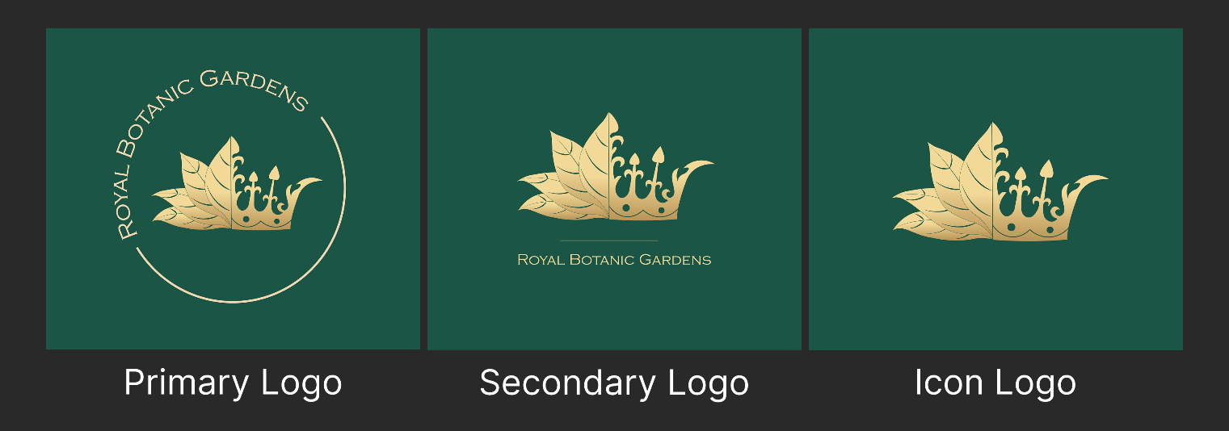

Figure 6 - Logo guidelines

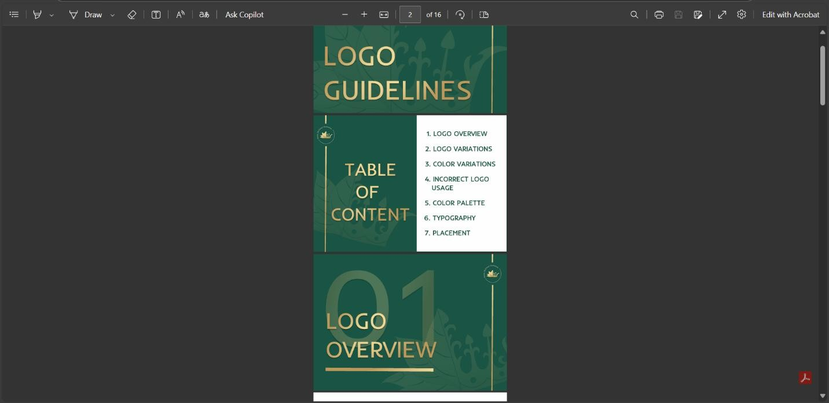
Figure 7 – Logo Animation Videos

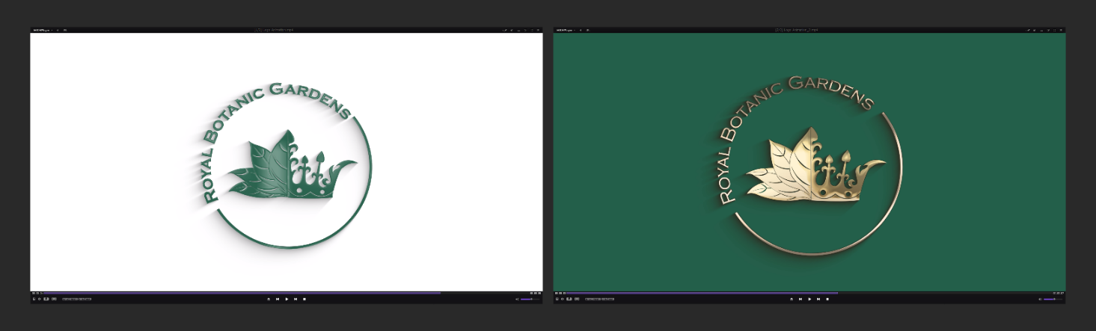

Figure 8 - Tickets

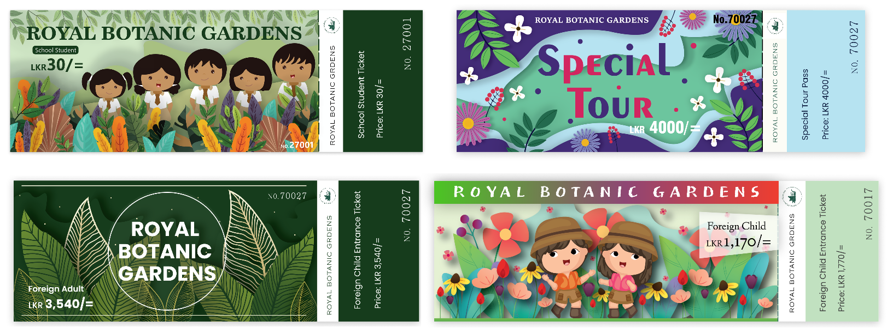

Figure 9 - Mobile App & App Landing Page

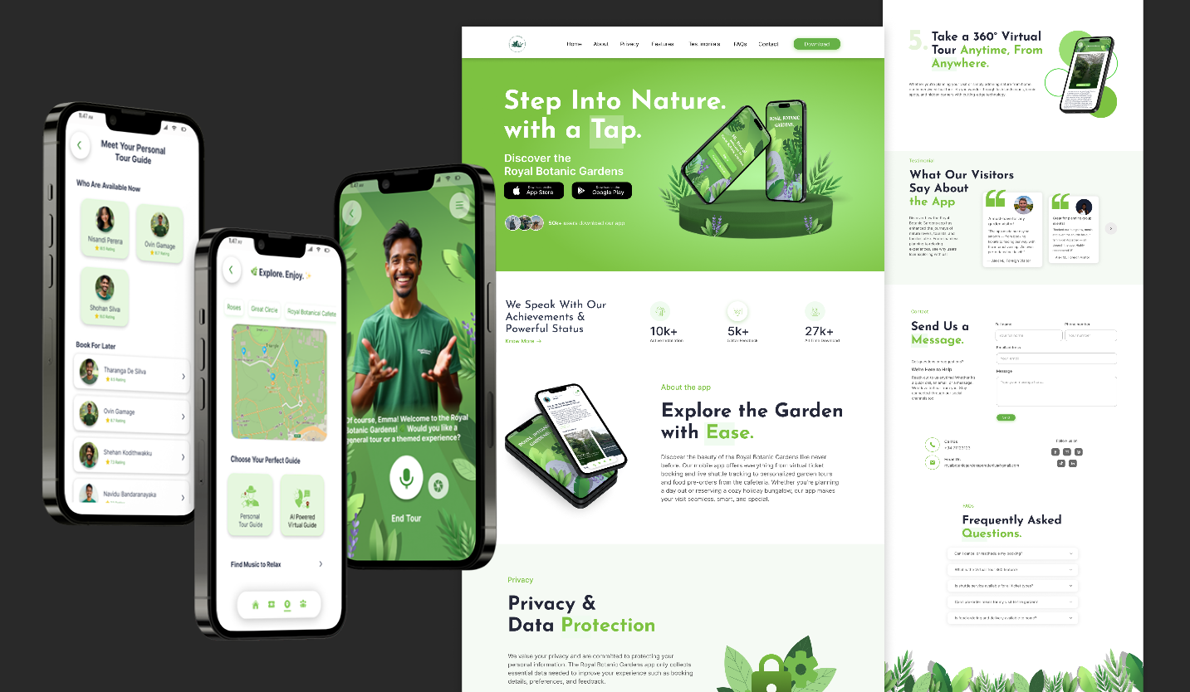

Figure 10 – Promotional Videos

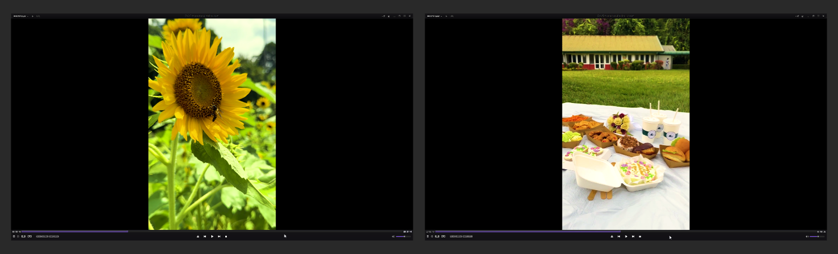

Figure 11 – User personas

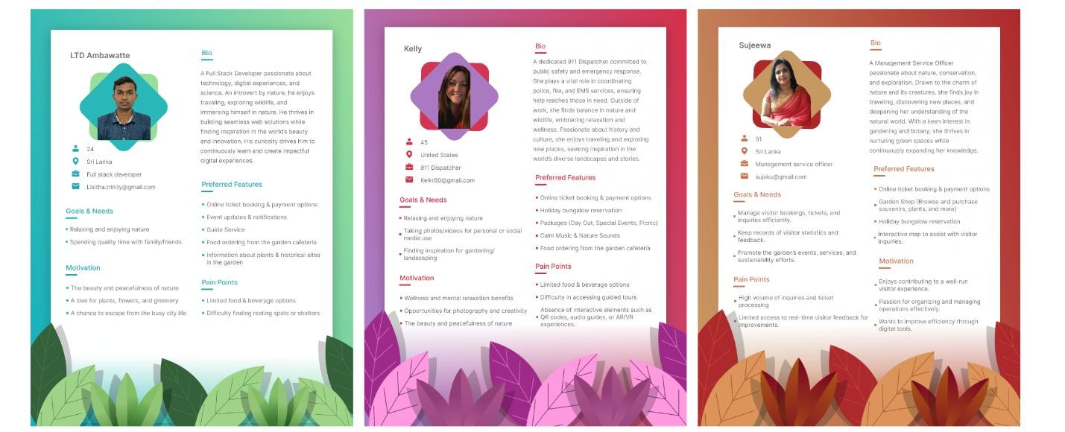

Figure 12 – Social media Posters

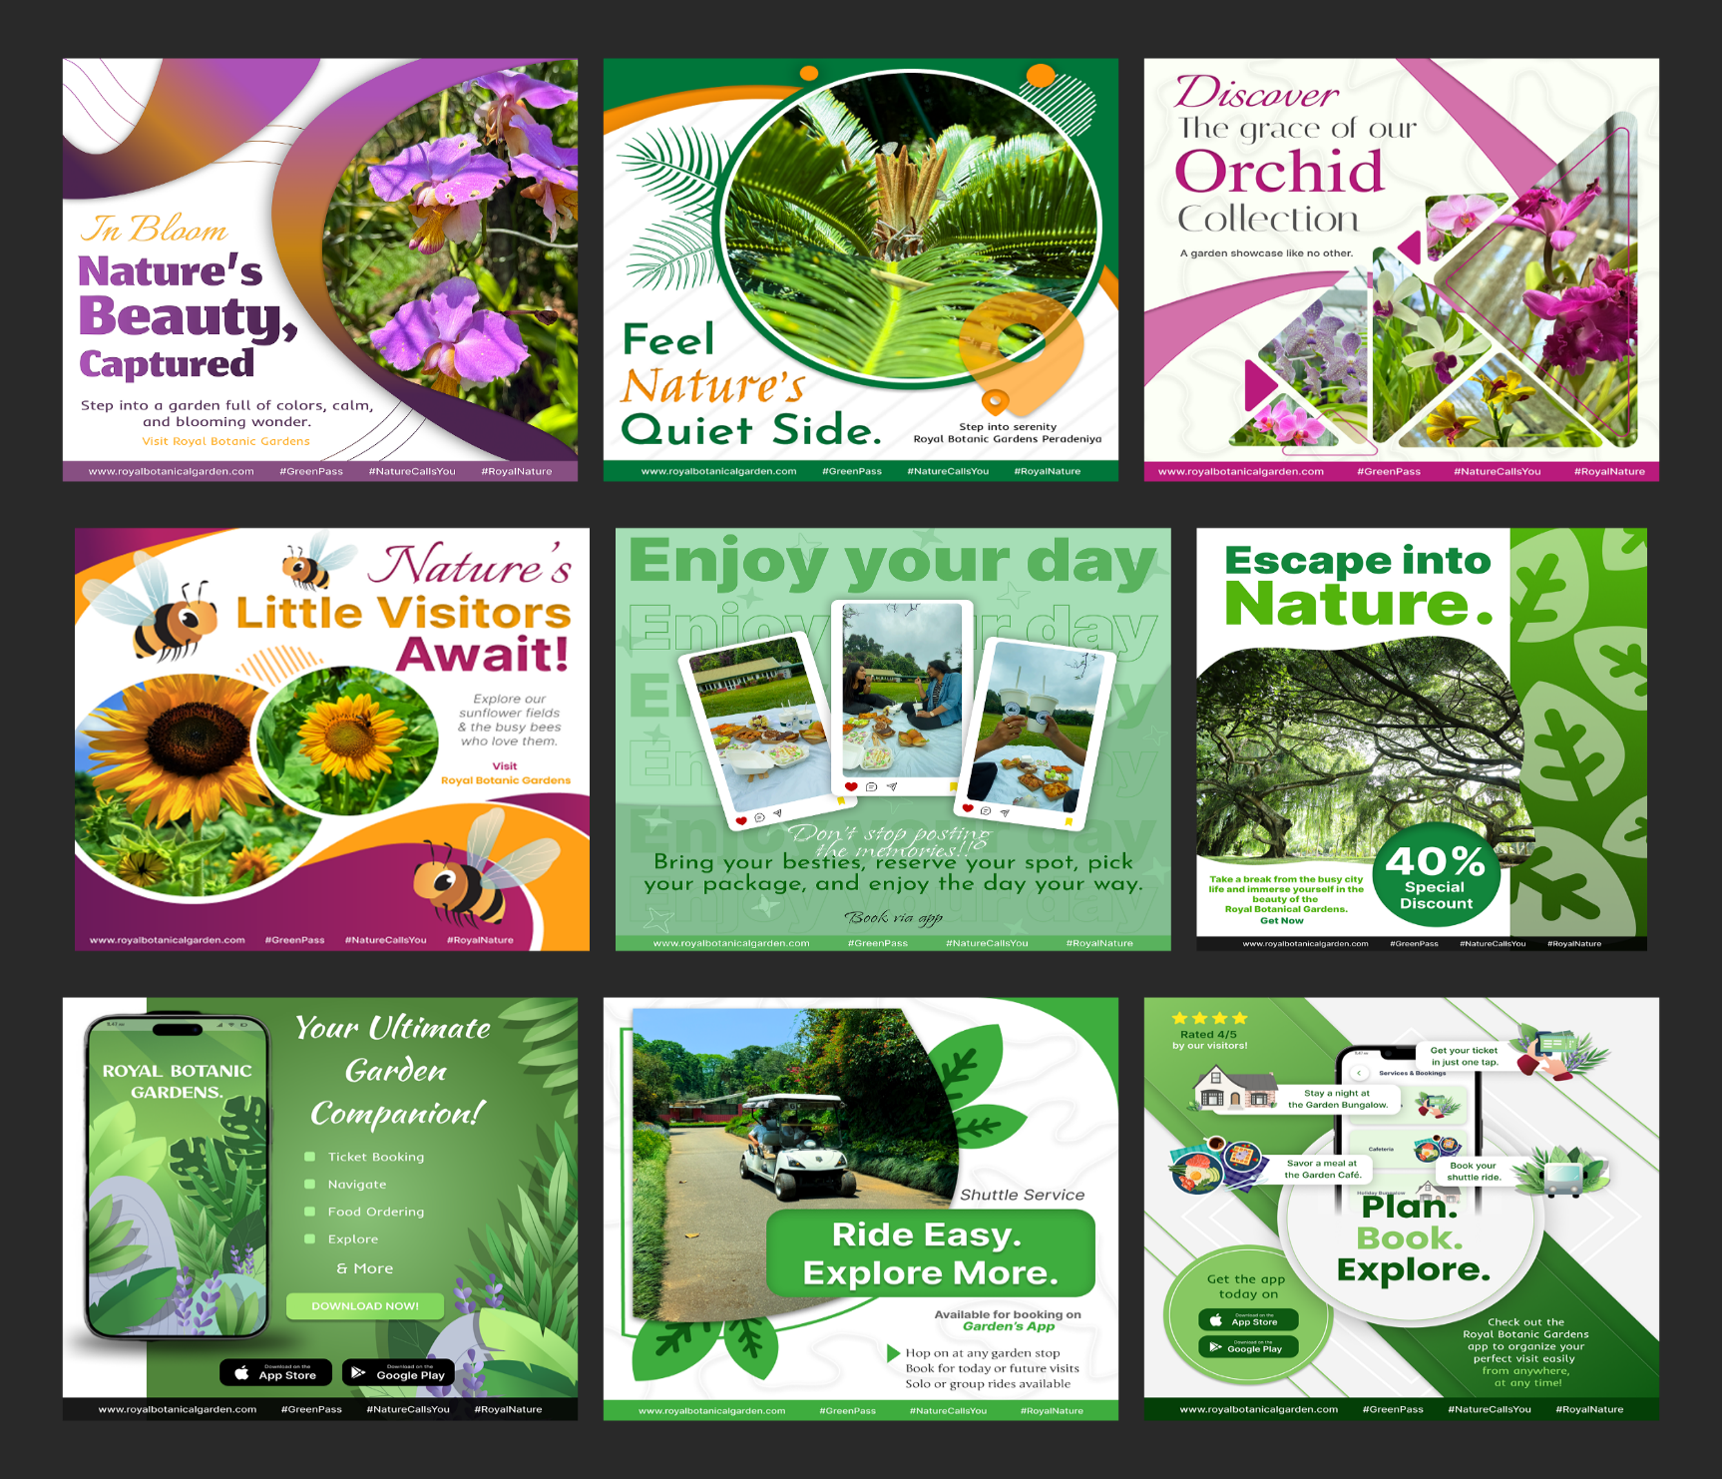
VALIDATION
Market Trends
Market Trends as the Royal Botanical Garden is a tourist’s destination, the project falls under the tourism industry. Therefore, the researcher aims on new trends for marketing products and promotional materials. As the tourist industry grows, organizations must adapt to new trends and innovations to remain effective and satisfy changing client expectations. Since its start, artificial intelligence has advanced across a wide range of organizations. The ever-changing tourist industry is also leveraging AI to change its operations. Artificial intelligence 40 systems have numerous uses in tourism. AI benefits consumers by providing relevant information, increased mobility, improved decision-making, and a better vacation experience. The app has been designed including AI technology to give users better experience throughout their visit. The AI powered tour guide helps visitors explore the garden in an effective and joyful way, making their visit easier. (Bulchand-Gidumal, 2020)
Virtual reality is another big tourist development that is changing the market, and capitalizing on it can provide a benefit over competitors who have not yet adopted it. Customers may enjoy outdoor tourism destinations and other experiences from the comfort of their own homes by utilizing online VR tours. The app introduces VR tours with the "Take Virtual Tour" feature, allowing visitors to explore locations and plan their journey before visiting the garden. Personalization can also be used to improve tourism marketing by addressing every element of the tourist experience. Consumers today want experiences that are tailored to their tastes, from destinations to housing and activities. The more accurate an experience can be personalized to a client's interests and preferences; the more likely they will return and use the same service repeatedly. The app allows visitors to personalize their tours. The feature called “Meet Your Personal Tour Guide” is an example for that. The customer experience has always been fundamental to marketing in the tourist industry. With new technology and an ever-broadening variety of tourist options, boosting the customer satisfaction has never been more important. Going with the market trends, the Royal Botanic Garden app has been designed by introducing new technologies, activities and facilities while improving visitor experience more than ever before. (Barten, 2025)
The researcher focuses on social media marketing as social media marketing is an effective approach to help companies to reach potential and customers. People discover, gain knowledge about, follow, and purchase with brands on social media, so not being present on platforms such as Facebook, Instagram and LinkedIn indicate missing out. Great social media marketing may help a business achieve extraordinary success by generating committed customers and even driving leads and profits.
Promotions

In nowadays, competition is the primary force behind business, attracting present and future customers' attention to the product and service offered. As a result, every business looks to compete with one another in order to get the attention of customers. Promotions are the main approach used by companies to attract more customers. Promotion is used to make clients aware of what an organization delivers. It is the process of building a communication relationship between a marketer and its intended audience. (Ayenew, 2023)
The researcher is using social media posters and the garden’s app to introduce promotions to garden’s visitors. The Royal Botanical Garden is a destination for various types of visitors, including foreign and local travelers, school and university students, researchers, educational institutions, families and friends, and more. Therefore, the project introduces various types of promotions tailored to different visitor groups. For university and school students, educational institutions, and researchers, an educational tour discount is offered to encourage more educational visits and increase engagement with the garden.
The project introduces a seasonal promotion, which includes special family/group ticket bundles with discounts for bookings made in April. It is promoted using Sinhala & Tamil New Year-themed campaigns targeting families, local tourists and groups to boost visitor numbers during the New Year holidays. Additionally, for the garden's membership owners, promotions are offered for special occasions such as birthdays and weddings. This encourages visitors to obtain the garden's membership and visit the garden to celebrate their special days.
Introducing these promotions, the researcher uses digital marketing like social media platforms using social media posters, as they are an effective way to reach visitors easily and convey the message in an attractive and suitable way to the customers.

Customer Feedback

Feedback from consumers is a priceless asset that provides direct insight into what customers think of products and services. Collecting customers’ feedback before planning, designing or releasing a product is an important part to confirm the product is in necessary standard and ready to release is an important part. Therefore, the researcher conducted some surveys and gathered feedback on the specific product.

The following survey is designed to collect feedback on the Royal Botanical Gardens new logo to ensure it is ready for release.

Figure 13 - Logo feedback survey_01
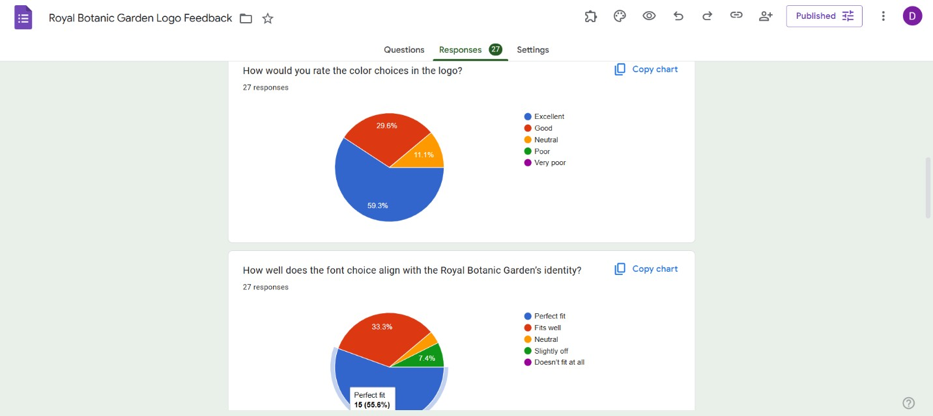
Figure 14 - Logo feedback survey_02
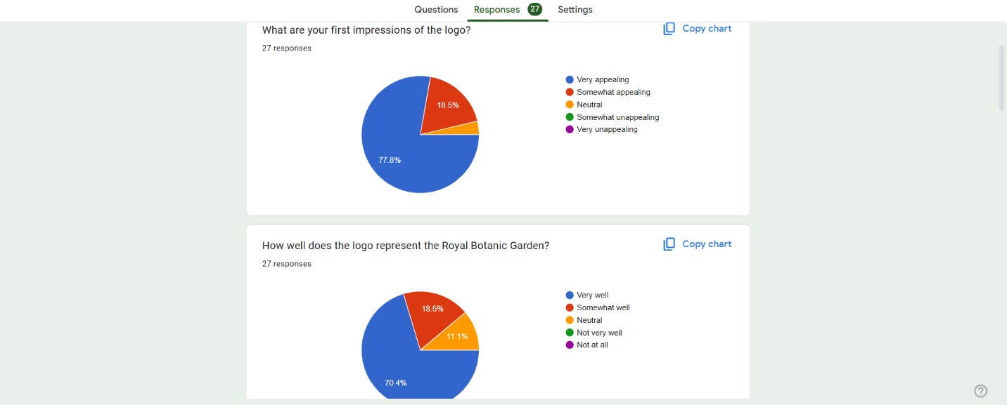
With 27 responses, most customers prefer the logo, its color and font style. The customers think this logo gives a royal and elegant vibe and is a memorable design that represents the Royal Botanical Gardens very well. According to customers feedback, the logo is ready for release.
The next survey is designed to collect users’ ideas to identify what features should be included to the app and what users need. Here are some of the important questions form the survey.
Figure 15 - App feature survey

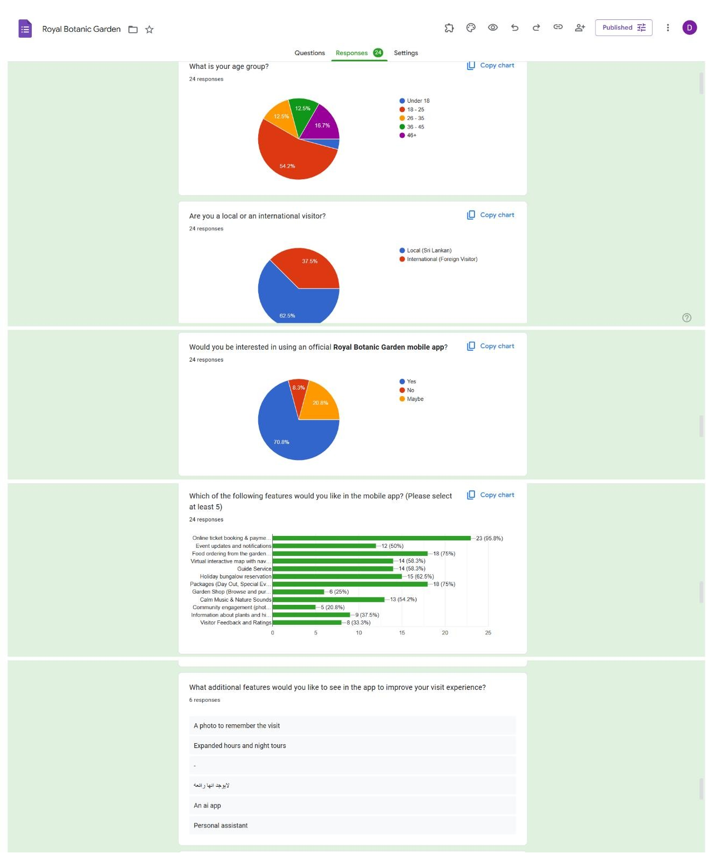
The researcher gathered feedback from both local and international users, as both groups fall into the target audience. Based on user feedback, the researcher determined the features that needed to be added to increase visitor experience and satisfaction and started working on the app.
Hashtag Strategy

In today's social media environment, hashtags have become a crucial component of almost every user's communication. As a result, several hundred hashtag-containing postings are shared on social media every day. Brand users use hashtags to publicly express their opinions, facilitate content learning, and even search for materials. Given the overwhelming popularity of hashtags, marketers have started to use this method of advertising as a hashtag campaign. A hashtag campaign is a marketing activity in which organizations use a specific hashtag in order to increase their reach and communicate with potential customers. Brands can use the hashtag in their postings to promote followers on platforms such as Instagram, Facebook and others. (Morris, 2024)

The researcher has identified a number of key words that can be utilized as hashtags to increase awareness and interaction. These keywords can be included in social media posters to make them more appealing and attract more customers. Using relevant and creative hashtags can help the Royal Botanical Garden reach a larger audience, increase brand awareness and promote social media activity. Furthermore, carefully implementing these hashtags in promotional content can boost accessibility and increase the effectiveness of the campaign. These are the key words researcher has identified to use for the hashtags,
#NatureCallsYou – A direct and appealing initiation to the gardens’ visitors for a pleasant experience in the garden
#GreenPass – Represents the Royal Botanic Gardens app as a digital pass for the botanical garden. #RoyalNature – Address the luxurious and elegant natural experience offered by the Royal Botanical Garden.

By implementing these hashtags, the project aims to attract additional visitors and make the garden even more popular than it is already, while enhancing its brand identity.

CRITICAL REVIEW

The Royal Botanical Gardens project aims to enhance visitor engagement and modernize the garden’s services through a combination of digital solutions and branding strategies. Different features of the app support many users’ needs or requirements which escalate the visitor’s experience. Some of the features are, Event calendar, reviews, ticket reservation, virtual garden tour and notifications. To be certain whether the app is properly suited for the users, three user personas provide it satisfactorily. The attractive logo design and guidelines along with an animation enhance the identity of the garden. To increase the awareness and the attraction of the users, eye-catching social media posters are used. Including a virtual tour (360°) technology in the app gives users a worthy experience. Especially for the users in the back of beyond and the users expect to pay a visit to the garden for the very first time. When it comes to the issues part of this project, one of the issues in using this app will be feature integration. That is, Users should have a smooth and continuous integration without complications. Limitation of language selection options is another issue which may restrict the accessibility for different nationalities around the world. There are some improvements that may include in the future to this project. It is better to reduce the number of steps when processing actions like ticket reservation and other processors as well. Necessary steps should be taken to increase the user satisfaction. From the user feedback, it is much better to shuffle the sequential order with reference to the priority. Using guidelines, tool tips, Pop-ups features could help new users, and they will be able to access complex features comfortably. Logo design feedback should be thoroughly put into consideration because the Logo plays a major role in an organization. Establishing interesting offers such as holiday packages, free tickets and buy one get one free option will perceive users to revisit the location multiple times. To implement this process better to have a proper analysis on feedback. User testing is another way to improve the project much better.

CONCLUSION

The study concludes by outlining the Royal Botanical Gardens project, which seeks to update the brand identity and provide a comprehensive digital solution to modernize and enhance the Peradeniya Botanical Garden's tourist experience. Through the use of technology, branding, and strategic marketing, this initiative enhances the Peradeniya Botanical Garden's visitor experience while preserving its cultural and environmental significance and ensuring its relevance in the modern digital world. When it comes to the scope of the project, the researcher has identified local visitors as the primary target users and Asian and European foreign visitors as the secondary target users as 75% of visitors are locals.

The report includes charts to prove it. Considering international visitors can enhance Sri Lanka's tourism industry as well. This report explores the Royal Botanical Garden project, including a SWOT and PEST analysis influence on the garden, literature review which gives a good knowledge about Digital Marketing & Promotion, Smart Tourism & Technology, Rebranding and Use of User Persona Design. The report also addresses the methodology called Logical User-Centered Design (LUCID) which is mainly followed by the researcher. As there are a lot of graphic works researcher had to follow the production process related to graphic works as well. These production stages are also described well in the report. The report provides a detailed proof of concept discussion about strategies for increased engagement, brand identity, accessibility, visitor satisfaction, eco-friendliness and cost-effectiveness as the points. The report also includes validation and a critical review of strengths and issues. Through the use of technology, branding, and strategic marketing, this initiative enhances the Peradeniya Botanical Garden's visitor experience while preserving its cultural and environmental significance and ensuring its relevance in the modern digital world.

ETHICAL APPROVAL
Before the project's survey was conducted, ethical permission was gained. In advance of data collection, participants were briefed on the study's objectives and their consent was secured.

DATA AVAILABILITY
The data are not publicly available due to privacy considerations of the survey participants.
REFERENCES / BIBLIOGRAPHY
- Allabarton, R. (2024). 6 UI/UX design examples to inspire your next project. AND Academy. https://www.andacademy.com/resources/blog/ui-ux-design/ui-ux-design-examples/
- American Journal of Theoretical and Applied Business. (2023). Promotional strategy and organizational performance: Source from systematic review literature.
- Anon. (2012). Annual performance report. Department of National Botanic Gardens.
- Anon. (2022). The effect of rebranding on brand loyalty: Brand reputation as mediator. International Journal of Academic Research in Business & Social Sciences.
- Anon. (2024). Monthly tourist arrivals report.
- Anon. (n.d.). 7 reasons why a logo is important. Tailor Brands. https://www.tailorbrands.com/logo-maker/why-a-logo-is-important
- Anon. (n.d.). Royal Botanic Gardens Peradeniya. https://www.botanicgardens.gov.lk/service/royal-botanic-gardens-peradeniya/
- Barten, M. (2025). Tourism trends. Revfine. https://www.revfine.com/tourism-trends/
- Bulchand-Gidumal, J. (2020). Impact of artificial intelligence in travel, tourism, and hospitality. In Handbook of e-tourism. Springer. https://doi.org/10.1007/978-3-030-05324-6
- Castillo Vizuete, D. D., Gavilanes Montoya, A. V., Muñoz Jácome, E. A., Chávez Velásquez, C. R., & Borz, S. A. (2021). An evaluation of the importance of smart tourism tools in the Riobamba Canton, Ecuador. Sustainability, 13(16). https://doi.org/10.3390/su13169027
- Chang, Y.-N., Lim, Y.-K., & Stolterman, E. (2008). Personas: From theory to practices.
- Dam, R. F., & Siang, T. Y. (2024). Personas – A simple introduction. Interaction Design Foundation.
- Desai, V. (2019). Digital marketing: A review. International Journal of Trend in Scientific Research and Development (IJTSRD), Conference Issue.
- Deshpande, N. (2023). Prototyping in UI/UX design. Medium. https://medium.com/@thenikhildeshpande/prototyping-in-ui-ux-design5f73ee8fcbf8
- Enginess. (2021). What is iterative design? (And why you should use it). https://www.enginess.io/insights/what-is-iterative-design
- flsadmin. (2019). Don’t forget the logo: 10 benefits of having a business logo. FreeLogoServices. https://www.freelogoservices.com/blog/10-business-logobenefits/
- GeeksforGeeks. (2024). Principles of UI/UX design. https://www.geeksforgeeks.org/principles-of-ui-uxdesign/
- Hamidli, N. (2023, March 1). Introduction to UI/UX design: Key concepts and principles.
- Hooda, A. (2023). Concept of product development. LinkedIn. https://www.linkedin.com/pulse/concept-product-development-ajay-hooda
- Karki, B. S. (2025). The role of research and analysis in creating exceptional UI/UX designs.
- Lockwood, C. (2020). Why is logo design so needed for a new business or website? Quora. https://www.quora.com/Why-is-logo-design-so-needed-for-a-new-business-orwebsite/answer/Chris-Lockwood-4
- Lockwood, C. (n.d.). Should you design a site first and then the logo, or the logo and then the site? Quora. https://www.quora.com/Why-is-logo-design-so-needed-for-a-new-business-orwebsite/answer/Chris-Lockwood-4
- Luisa. (2025). Exploring the impacts of smart tourism: The future of travel.
- Morris, J. (2024). Successful hashtag campaign examples. Taggbox. https://taggbox.com/blog/successful-hashtag-campaignexamples/
- Nuseir, M. T., El-Refae, G. A., Aljumah, A. I., & Alshurideh, M. T. (2023). Digital marketing strategies and the impact on customer experience: A systematic review. In The effect of information technology on business and marketing intelligence systems.
- Sudarshona. (n.d.). Peradeniya Botanical Gardens Sri Lanka. TravelTriangle. https://traveltriangle.com/blog/peradeniya-botanical-gardens-sri-lanka/
- Threedee. (2023). What is Blender used for? [Video]. YouTube. https://youtu.be/nZ2I-8h0wPQ
- Udonde, U. E., Ibok, N. I., Udowong, C., & Eke, C. (2023). Mechanics of rebranding and the need for paradigm shift.
- White, M. (2024). Why Sri Lanka is such a unique destination. Follow Alice. https://followalice.com/knowledge/why-sri-lanka-is-such-a-unique-destination
- Wijesundara, D. S. A. (2007). Botanic gardens in Sri Lanka: Past, present and future.

APPENDIX
Final deliverables link:
https://drive.google.com/drive/folders/1tf0cupnx_IeCMzMa7mMRSppGy--NOv4a?usp=sharing

