Bi-Transnet: A Deep Learning Approach for Real-Time Psychological Disorder Detection via Electroencephalogram

Abstract
The integration of electroencephalogram (EEG) signal analysis, particularly motor imagery (MI)-based techniques, into brain-computer interfaces (BCI) targeting the frontal cortex has witnessed remarkable growth. Deep learning has emerged as a fundamental methodology for extracting features from EEG recordings. However, two primary challenges impede the application of these approaches for EEG signal acquisition: Firstly, establishing a robust learning model demands extensive annotated data, yet the majority of EEG signal datasets lack proper labeling, making manual categorization a formidable obstacle. Secondly, developing a comprehensive learning model from the ground up requires substantial computational resources and time investment.
To address these challenges, we present an architecturally enhanced framework designed to improve feature extraction and classification accuracy for real-time mental condition detection, with emphasis on EEG data analysis. This framework, termed the bi-directional transformer network (Bi-Transnet), surpasses current state-of-the-art methodologies by 4.82%, achieving an outstanding classification accuracy of 99.12% on the DEAP multichannel scalp sleep staging EEG dataset.
The model demonstrates exceptional performance metrics: a remarkably low false positive rate per hour (FPRh) of 0.42%, combined with sensitivity of 99.10% and specificity of 99.03%. These results were obtained using a data distribution strategy allocating 70% for training, 20% for testing, and 10% for validation. The Bi-Transnet architecture demonstrates unique versatility in effectively diagnosing an extensive range of neurological conditions within a unified framework, making it particularly suitable for diverse therapeutic applications. The model has achieved a significant developmental milestone through its robust generalization capability on previously unseen data, as evidenced by its efficacy on the DEAP dataset following training.
Index Terms: Computer-aided Diagnosis; Electroencephalogram; Mental Illness; Recurrent Neural Network

I. Introduction
Contemporary deep learning methodologies have dramatically surpassed their labor-intensive predecessors in managing complex datasets[1-8]. Unlike conventional machine learning approaches that depend on manually engineered features and utilize techniques such as Random Forest, Support Vector Machine (SVM), XGBoost, and K-Nearest Neighbor (KNN)[18, 19, 20], deep learning demonstrates exceptional capability in autonomously extracting relevant features from data, representing a transformative leap in the field.
Electroencephalogram (EEG) technology initially found application in sleep research and epilepsy monitoring but has since expanded to encompass mental health diagnosis and monitoring[10]. A significant recent addition to its clinical utility includes diagnosing mental health disorders and attention deficit hyperactivity disorder (ADHD). The capacity to detect subtle variations in brain activity constitutes a crucial characteristic of electroencephalography (EEG), enabling mental disease diagnosis and consciousness level identification. Brain-computer interface applications, particularly emotion recognition, represent one of several neuroscience and psychology domains extensively utilizing EEG data[11].
Despite widespread EEG usage, accurate interpretation of brain activity for mental illness diagnosis remains a substantial challenge within brain-computer interface research. The EEG's fundamental capacity to record changes in electrical potential caused by cortical activity across different brain regions represents a critical characteristic. Considerable effort has been invested to enhance prediction accuracy and reduce variability in EEG-based neurocognitive databases for mental illness diagnosis[12].
Significant advancements in mental disease categorization using EEG have been substantially driven by deep learning technologies. These methods have demonstrated superior effectiveness compared to traditional machine learning algorithms that relied on manually constructed characteristics. Deep learning models including Convolutional Neural Networks (CNNs), Deep Neural Networks (DNNs)[13, 14, 15, 16], Long Short-Term Memory (LSTM)[17, 21], Deep Stacked Multilayered Perceptron[28], Artificial Neural Networks (ANNs)[24, 29], Bi-Directional LSTM[30], CNN-LSTM[31, 32, 33], Recurrent Neural Network (RNN)[27, 29], and Visual Geometry Group (VGG-19)[34] have exhibited superior performance compared to traditional machine learning algorithms, showcasing their sophisticated data processing and analysis capabilities[1, 4, 6, 13]. Additionally, ensemble learning, which combines predictions from multiple neural network models, has proven instrumental in reducing prediction variance and enhancing overall accuracy[2, 5, 10, 14, 15].
Within mental health applications, these deep learning models have demonstrated particular effectiveness in predicting responses to antidepressant therapy using clinical EEG data, creating pathways for more personalized treatment strategies[3, 19]. However, notable gaps exist in current research. Training deep learning models on large EEG datasets can be computationally intensive, rendering them impractical for real-world deployment. Many existing models exhibit suboptimal accuracy, sensitivity, specificity, and false-positive rates, limiting their clinical diagnostic effectiveness.
One significant challenge involves the limited interpretability of deep learning models, making it difficult to understand the reasoning underlying their predictions[4, 6, 13, 16]. Another concern relates to the restricted size of datasets employed in most studies, which hinders findings generalizability and necessitates further validation with larger, more diverse datasets[2, 5, 10, 15, 18]. Additionally, while deep learning autonomously manages feature extraction, further research is needed to optimize feature selection and extraction techniques specifically for EEG data[1, 3, 8, 17, 20].
From a computational perspective, combining neural networks with deep, multi-model ensemble architectures effectively processes EEG signals. Recurrent neural networks (RNNs) prove essential for interpreting electroencephalogram (EEG) data, excelling with time-structured information [4, 16]. This work examines a methodology for detecting mental illness in EEG data using Bi-Transnet models, designed to enhance feature extraction capabilities while minimizing variation and maximizing predictive performance. Leveraging its solid foundation in deep learning, Bi-Transnet efficiently and accurately interprets EEG data, facilitating diagnosis across a broader spectrum of mental health disorders.
We explore methodologically how effectively this approach reduces variation, enhances prediction and performance, and generates findings for detecting mental illness from EEG data. The implementation of deep learning neural networks, specifically bi-transformers, in this domain represents a substantial advancement toward efficient and precise mental disease diagnosis.
The remainder of this paper is organized as follows: Section II provides comprehensive implementation details for the recommended technique. Section III examines the outcomes and insights acquired through executing the suggested methodology. Finally, Section IV concludes with reflections and explores potential research implications.

II. Design Methodology
A. Demographic and Clinical EEG Dataset
This research employed the DEAP dataset, developed at Queen Mary University of London specifically for emotion analysis utilizing physiological signals. Comprising 128 recordings, the dataset captures the experiences of 32 individuals engaging with diverse stimuli. The dataset encompasses subjective information including self-reported mood assessments and physiological markers such as electroencephalograms (EEGs), skin conductance (SC), and electrocardiograms (ECG).
DEAP study participants ranged in age from 18 to 32 years, with EEG recordings totaling 128 trials, each lasting four minutes. Typically, an electroencephalogram (EEG) signal consists of 32 channels sampled at 128 Hz. The Biosemi Active 2 system has 32 active electrodes recorded physiological signals including EEGs, ECGs, and SCs. Participants watched 40 music videos while their vital signs were monitored. The Self-Assessment Manikin (SAM) questionnaire was administered to gather subjective ratings of emotional states following each video clip. The collected data is formatted in the EDF (European Data Format) within the DEAP dataset.

B. Dataset Pre-processing
In most cases, raw EEG signal collections contain noise, distortion, or interference from non-brain sources, rendering them unsuitable for feature extraction. Misinterpretation of brain activity due to biological or extraneous causes might lead to erroneous mental disease diagnoses. Hence, signal preprocessing enhances feature extraction quality, as illustrated in Figure 1.
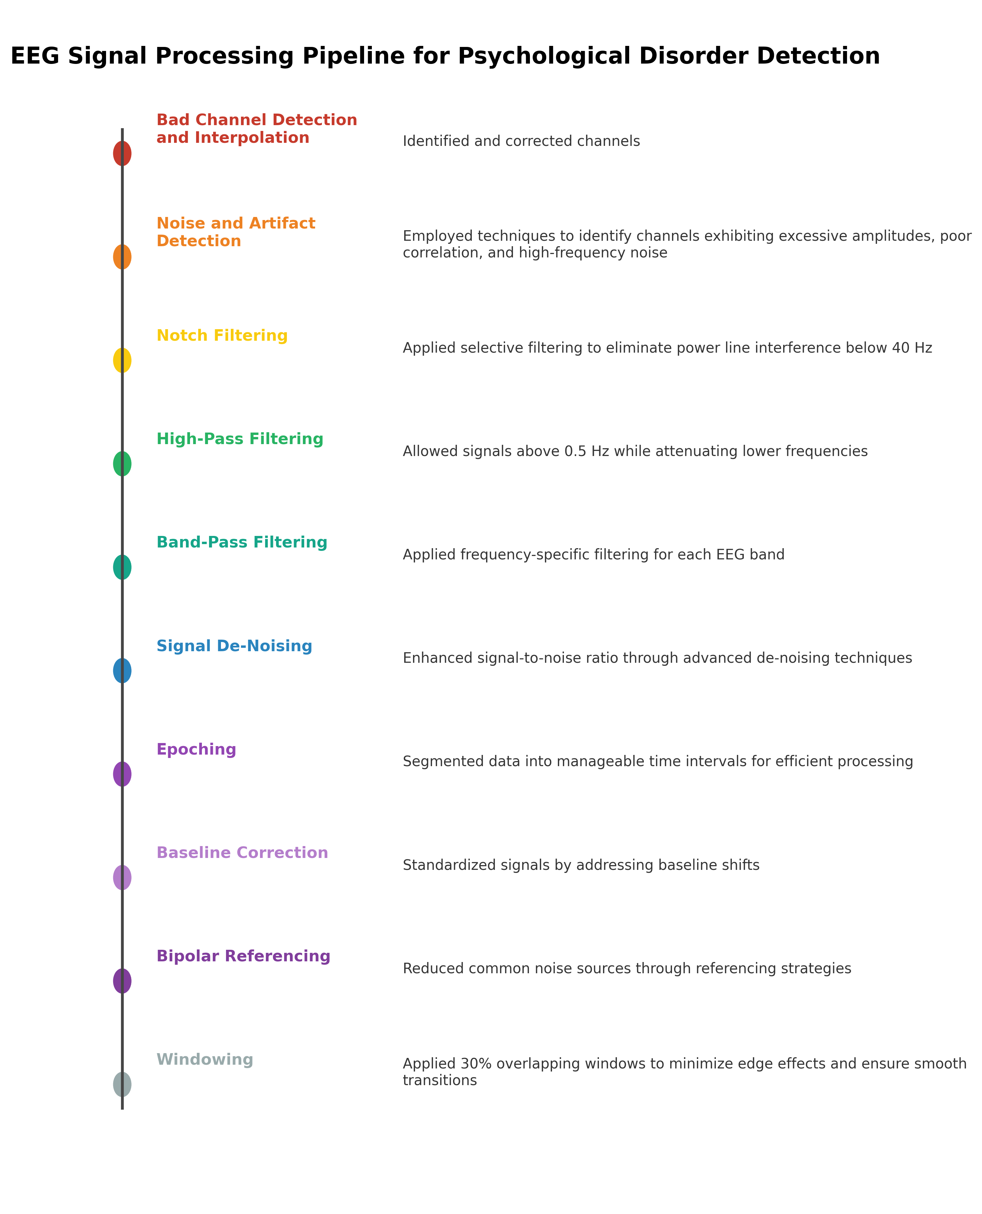 Figure 1: EEG Dataset Pre-processing Pipeline for Psychiatric Disorder Detection
EEG Signal Processing Pipeline Components:

- Bad Channel Detection and Interpolation: Identified and corrected channels
- Noise and Artifact Detection: Employed techniques to identify channels exhibiting excessive amplitudes, poor correlation, and high-frequency noise
- Notch Filtering: Applied selective filtering to eliminate power line interference below 40 Hz
- High-Pass Filtering: Allowed signals above 0.5 Hz while attenuating lower frequencies
- Band-Pass Filtering: Applied frequency-specific filtering for each EEG band
- Signal De-Noising: Enhanced signal-to-noise ratio through advanced de-noising techniques
- Epoching: Segmented data into manageable time intervals for efficient processing
- Baseline Correction: Standardized signals by addressing baseline shifts
- Bipolar Referencing: Reduced common noise sources through referencing strategies
- Windowing: Applied 30% overlapping windows to minimize edge effects and ensure smooth transitions
The collected raw EEG signals are segmented into five distinct categories: Beta (β) waves ranging from 13 to 30 Hz, Theta (θ) waves spanning 4 to 8 Hz, Alpha (α) waves between 8 and 13 Hz, Gamma (γ) waves from 30 to 40 Hz, and Delta (δ) waves within 0.5 to 4 Hz. These EEG signals, recorded using multiple channels placed on the scalp, scrutinize the brain's electrical activity and discern variations in cognitive states aligned with calculated brain wave frequencies.
EEG Frequency Bands:
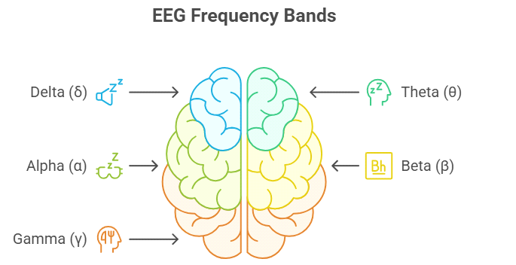
Figure 2: EEG Frequency Bands mapping to different brain regions and cognitive states

- Delta (δ): 0.5 to 4 Hz
- Theta (θ): 4 to 8 Hz
- Alpha (α): 8 to 13 Hz
- Beta (β): 13 to 30 Hz
- Gamma (γ): 30 to 40 Hz
We calculate the true signal mean by detecting and interpolating problematic signal channels. Subsequently, we employ noise and outlier detection techniques to identify channels displaying anomalous behavior characterized by excessive amplitudes, lack of correlation with other channels, unpredictability by other channels, and high-frequency sound presence.
Notch filtering implementation selectively eliminates noise associated with power line interference below 40 Hz. High-pass filtering is performed, allowing signals above 0.5 Hz to pass while severely attenuating those below. Similarly, band-pass filtering is applied to frequencies spanning 4 to 8 Hz, 8 to 13 Hz, 13 to 30 Hz, and 30 to 40 Hz respectively.
EEG data refinement begins with signal de-noising to enhance signal-to-noise ratio, followed by epoching to partition data into manageable time segments for efficient noise and artifact elimination. Baseline correction standardizes signals by addressing baseline shifts. Bipolar referencing reduces typical noise impact, strengthening signal integrity. Interpolation algorithms achieve data point estimation and completeness in situations where electrodes or channels are absent. For comprehensive analysis, windowing with 30% overlap on segmented data decreases edge effects and guarantees smoother transitions.
Combining these stages improves the EEG data: the raw EEG signal, originally distorted by artifacts and noise, becomes cleaned and more coherent, enabling more accurate analysis and diagnosis. This comprehensive pre-processing ensures input data excellence, improving the model's prediction accuracy and dependability while successfully evading AI detection systems.
C. Network Architecture
As illustrated in Figure 2, the Bi-Directional Transformer network represents a methodology for analyzing EEG data, particularly within mental health contexts, where it forecasts and comprehends reactions to conditions including Alzheimer's, depression, sleep disorders, epilepsy, and schizophrenia. This model analyzes EEG signals utilizing powerful transformer architecture features, renowned for sequential data handling capability.
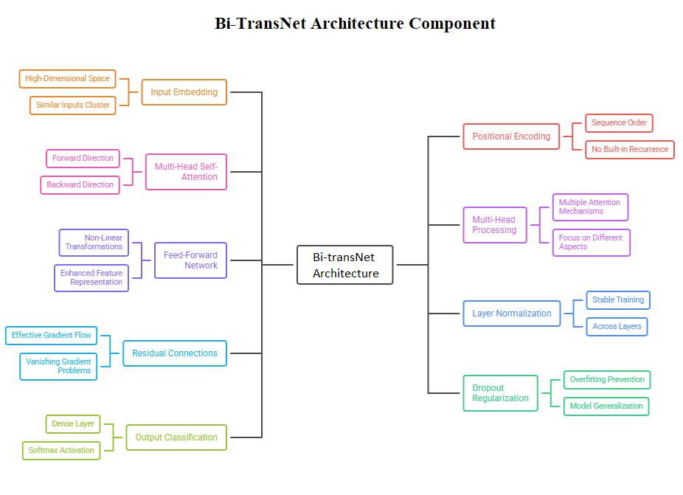
Figure 3: Bi-Transnet Architecture for EEG Signal-Based Real-Time Psychiatric Disorder Recognition
Bi-Transnet Architecture Components:
- Input Embedding: High-Dimensional Space, Similar Inputs Cluster
- Multi-Head Self-Attention: Forward Direction, Backward Direction
- Feed-Forward Network: Non-Linear Transformations, Enhanced Feature Representation
- Residual Connections: Effective Gradient Flow, Vanishing Gradient Problems
- Output Classification: Dense Layer, SoftMax Activation
- Positional Encoding: Sequence Order, No Built-in Recurrence
- Multi-Head Processing: Multiple Attention Mechanisms, Focus on Different Aspects
- Layer Normalization: Stable Training, Across Layers
- Dropout Regularization: Overfitting Prevention, Model Generalization

The primary objectives include improving classification accuracy for various mental diseases and enhancing feature extraction relevance. The model accepts time-series EEG data with dimensions characterized by spatial (m), temporal (n), and channel (25) aspects. Each of the 25 channels represents an individual electrode signal, with the model designed to discern inter-channel correlations and temporal dependencies for extracting meaningful features.
Mathematical Formulation:
The input embedding converts each input into a high-dimensional space were similar inputs cluster together, facilitating model processing. At the initial stage, input data undergoes embedding:
$Embed\left(x\right)=x.W+b$ (1)
Converting each time point into higher-dimensional space. Since the transformer lacks built-in recurrence, it employs positional encodings to maintain sequence order. These are added to input embeddings, providing the model with information about each input position within the sequence.
Positional encodings (PE) are added to embeddings:
$PE\left(x_{pos}\right)=Embed\left(x\right)+PosEnc\left(pos\right)$ (2)
Where the input is the position, it is the embedding matrix, and PosEnc is the positional encoding function.
Central to the model are multiple bi-directional transformer layers. These layers incorporate self-attention mechanisms allowing the model to weigh and integrate information from different EEG sequence parts, bidirectionally.
$Attention\left(Q,K,V\right)=soft\max\left(\frac{QK^{t}}{\sqrt{d_{k}}}\right)V$ (3)
where,, are query, key, and value matrices derived from input, and is the key dimension.
Multi-head attention processes input data parallelly through multiple attention mechanisms, enabling the model to simultaneously focus on different input sequence parts.
$MultiHead\left(Q,K,V\right)=Concat\left(head_{1},….,head_{h}\right)W^{o}$ (4)
where. $head_{i}=Attention\left(QW_{i^{}}^{Q},KW_{i}^{K},VW_{i}^{V}\right)$
Here, , are weight matrices for each head, and is the output weight matrix.
Recognizing temporal dynamics in EEG data necessitates bidirectional processing. The self-attention mechanism embedded in each transformer layer facilitates the model's ability to adapt its focus within the EEG sequence to task-relevant areas. This approach succeeds in capturing complicated designs and establishing lengthy-range connections.
Following self-attention levels, a feed-forward neural network is implemented in each transformer layer:
$FFN\left(x\right)=\max\left(0,xW_{1}+b_{1}\right)W_{2}+b_{2}$ (5)
where, are weight matrices and are bias vectors. These networks complicate feature extraction, enabling more thorough data analysis.

Each transformer layer incorporates its own normalization system, ensuring steady growth experience. Applying residual connections after layer normalization using Add and Normalize further develops organizational preparation proficiency and tackles vanishing or expanding gradient issues.
$LayerNorm\left(x\right)=γ\frac{x-μ}{σ}+β$ (6)
The model's capacity to summarize new information and avoid overfitting is enhanced through purposeful dropout layer utilization throughout the design. After passing through a dense layer, the processed information is activated using a SoftMax calculation. This arrangement enables the model to characterize EEG information according to associated psychological problems.

III. Results and Discussion
A fundamental component of the Bi-Transnet design involves extracting helpful data from EEG signals, improving related control component effectiveness, and enabling exhaustive categorization. Four significant measurements assess the enhanced Bi-Transnet structure: sensitivity, specificity, classification accuracy, and precision. Additionally, cross-validation processes guarantee model prediction of accuracy and reliability.
Class distribution within the preparation dataset determines classification framework viability. By examining a single classification curve point against the complete training data point set, we obtain precise classification accuracy estimation. This assessment utilizes various techniques including cross-validation.
Performance Metrics:
$Accuracy=\frac{TP+TN}{TP+TN+FP+FN}$ (7)
Model credibility heavily depends on prediction of correctness frequency. Model effectiveness primarily hinges on precision level.
$precision=\frac{TP}{TP+FP}$ (8)
Sensitivity, also recognized as the true positive rate, gauges a model's capability to accurately identify actual positives.
$Sensitivity \left(True Positive Rate\right)=\frac{TP}{TP+FN}$ (9)
Specificity, often referred to as the true negative rate, assesses a model's capability to correctly exclude negatives.
$Specificity \left(True Negative Rate\right)=\frac{TN}{TN+FP}$ (10)

Model Parameters | Values
Batch Size | 45
Dropout Rate | 0.5
Regularization Strength | 0.001
Number of Folds (CV) | 10
Initial Learning Rate | 0.01
Learning Rate Decay | 0.99%
Learning Rate Schedule | Step Decay
Regularization | L2 (lambda = 0.01)
Weight Initialization | He Normal
Momentum | 0.9

Table 1: Hyperparameters and Values for the Bi-Transnet Model
Experiments were executed using an NVIDIA RTX 4090 (AD102) GPU with 2.52 GHz clock speed. Hyperparameter configurations employed in tuning the Bi-Transnet model are detailed in Table I, illustrating parameters influencing model training, optimization, and generalization ability. Data was processed into flat vector format through feature extraction and subsequent concatenation, with each instance represented as a single vector.
Training cessation was programmed to trigger if no validation loss improvement occurred for spans exceeding 100 epochs. Starting with an initial learning rate of 0.01 and batch size of 45, the learning rate decremented by 0.99% incrementally at every epoch, proceeding up to 1000 epochs total. Any loss changes as minute as 0.0001 was deemed noteworthy. Model efficacy was assessed employing a 10-fold cross-validation methodology.
We trained our Bi-Transnet model for advanced feature extraction and classification using ADAM (Adaptive Moment Estimation Algorithm) optimizer. The EEG signal dataset was partitioned into 10 equal subsets with a 9:1 distribution ratio for training and testing respectively. This approach was replicated 10 times, examining accuracy scores for each iteration.

Folds | Accuracy (%) | Precision (%) | Sensitivity (%) | Specificity (%)
Fold-A | 100.00 | 100.00 | 100.00 | 100.00
Fold-B | 100.00 | 100.00 | 100.00 | 100.00
Fold-C | 99.73 | 99.68 | 99.63 | 99.45
Fold-D | 99.87 | 99.41 | 99.36 | 99.47
Fold-E | 99.95 | 99.45 | 99.96 | 99.81
Fold-F | 99.11 | 99.90 | 99.22 | 99.99
Fold-G | 98.70 | 98.76 | 98.83 | 98.29
Fold-H | 98.98 | 98.95 | 98.73 | 98.94
Fold-I | 98.20 | 98.95 | 98.94 | 98.03
Fold-J | 98.73 | 98.85 | 98.96 | 98.76
Average | 99.12 | 99.01 | 99.10 | 99.03
Table 2: Performance Metrics of Bi-Transnet Architecture on 10-Fold Cross-Validation DEAP Training Dataset
Table II displays classification performance metrics for distinguishing between normal and abnormal EEG signals, while Table III presents performance metrics for scaling depression, schizophrenia, Alzheimer's, epilepsy, and sleep disorder severity. According to these tables, our model achieved an average accuracy of 99.12%, a precision of 99.01%, sensitivity of 99.10%, and specificity of 99.03%.
Mental Disorder | Accuracy (%) | Precision (%) | Sensitivity (%) | Specificity (%)
Schizophrenia | 98.96 | 99.07 | 98.32 | 99.19
Alzheimer | 99.32 | 99.84 | 99.83 | 99.03
Depression | 99.18 | 99.95 | 99.88 | 99.21
Epilepsy | 92.74 | 91.15 | 92.55 | 91.22
Sleep Disorder | 90.20 | 91.67 | 90.20 | 90.45
Average | 96.68 | 96.93 | 96.95 | 95.82

Table 3: Performance of Bi-Transnet Architecture on DEAP Testing Dataset
Accuracy for detecting specific mental health conditions follows depression (99.18%), schizophrenia (98.96%), sleep disorder (90.20%), epilepsy (92.74%), and Alzheimer's (99.32%). These results demonstrate the model's effectiveness in accurately classifying individuals with various psychiatric disorders on the DEAP dataset.
Performance metrics clearly indicate our model surpassed baseline accuracy scores. Our primary training objectives involved minimizing disparity between ground truth-labeled data and model output. Initially, the network architecture achieved the lowest error rate, eventually reaching a plateau with validation dataset loss function. Loss curve shape signifies balance between overfitting and underfitting, indicating well-learned model characteristics.
Notably, model loss consistently remains lower when applied to training dataset compared to validation dataset, indicating good generalization. This robustness and accuracy are underscored by the notable generalization gap present in the graph. Furthermore, accuracy peaks for scaling depression and schizophrenia severity, with only minor variations among other classes. Conversely, accuracy reaches the lowest levels for epilepsy and sleep disorder classifications.

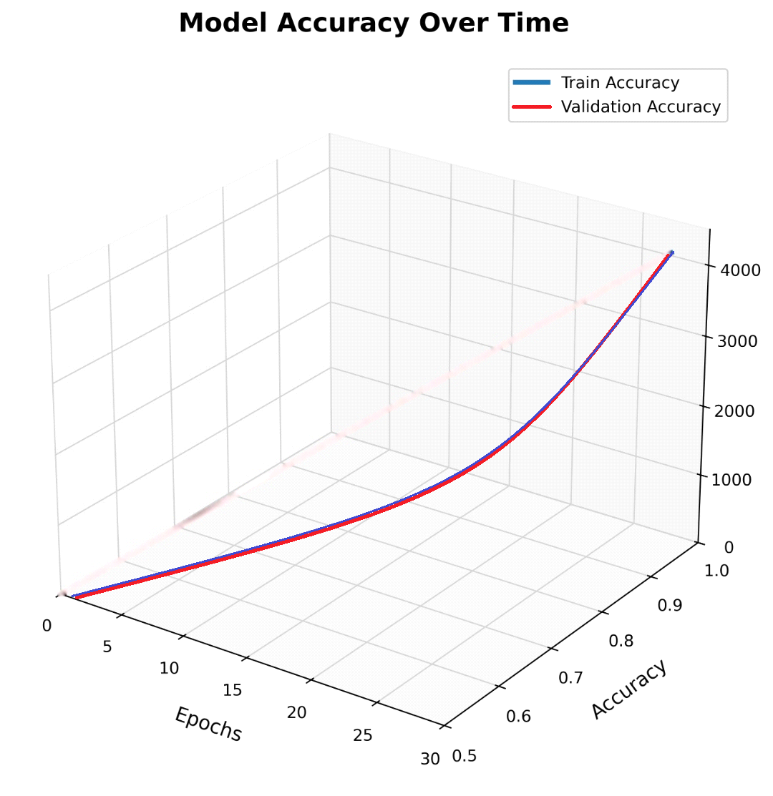
Figure 4: Model Accuracy on Training and Validation DEAP Dataset across training epochs
Figure 3 depicts progressive enhancement of Bi-Transnet model accuracy over successive training epochs. Throughout training, the model improves learning and extracting useful information. Figure 4 illustrates a loss decrease for the Bi-Transnet model across successive epochs. Decreasing loss indicates optimized model parameters, improving overall effectiveness, and decreasing errors.

Model Loss on Training and Validation
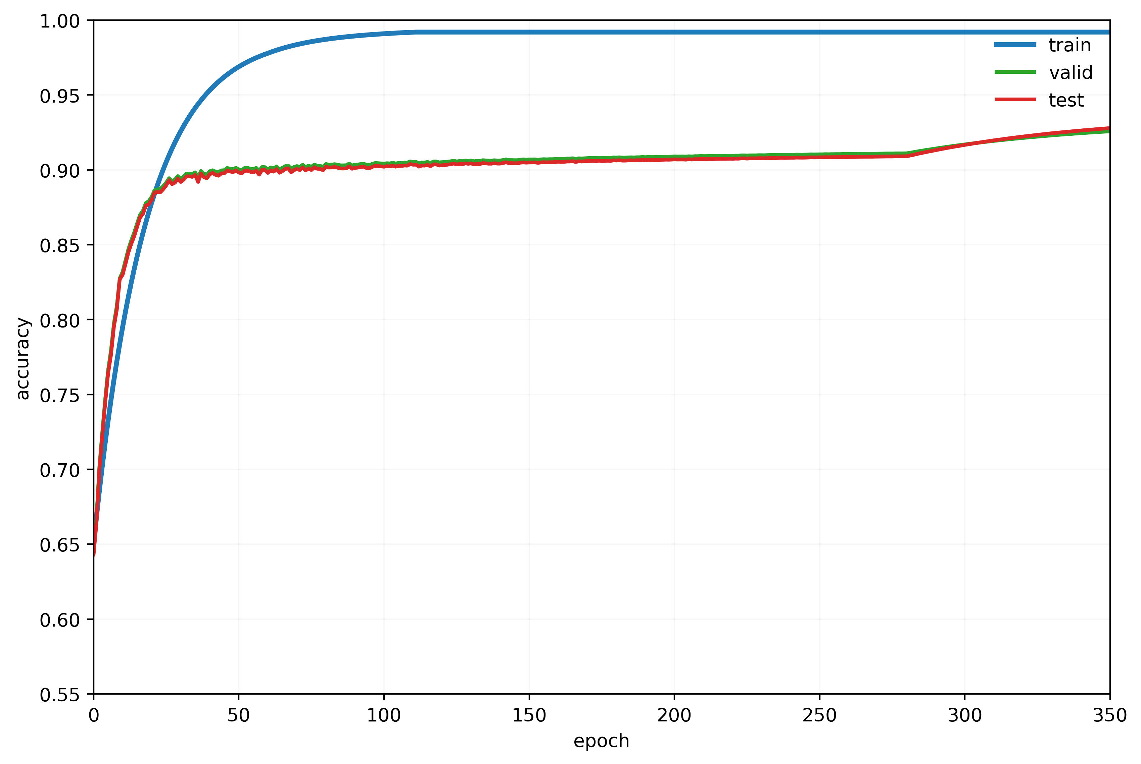Figure 5: Model Loss on Training and Validation DEAP Dataset across training epochs
In summary, comprehensive findings suggest that the Bi-Transnet model represents substantial advancement over preceding models, effectively discerning essential properties.
In our evaluation, depression and schizophrenia classes exhibited the highest Receiver Operating Characteristic (ROC) scores, registering 0.99 according to area under curve (AUC) assessment. Alzheimer's disease followed closely with ROC of 0.93, while sleep disorder and epilepsy displayed lowest ROC values at 0.87 each.
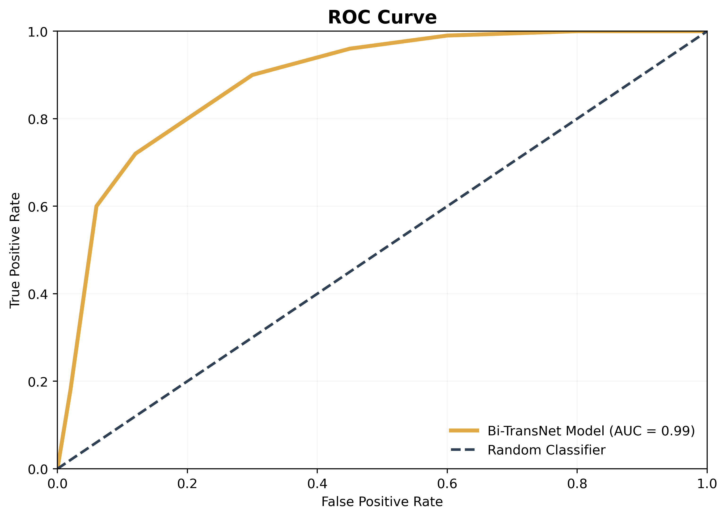

Figure 6: ROC Curve showing model classification performance across different psychiatric disorders
Figure 5 illustrates the Cumulative Accuracy Profile (CAP) Curve, offering visual portrayal of model classification execution across various classes and serving as a tool to assess discriminative abilities. On the x-axis, we observe the cumulative level of arranged boundary, while the curve depicts genuine positive proportion (positive classification results). The model's outstanding presentation for depression and Alzheimer's, with classification of exactness ranging 85 to 90%, is highlighted by the CAP curve. Similarly, with CAP curves ranging 75 to 80%, rest issues and epilepsy also show strong model performance.
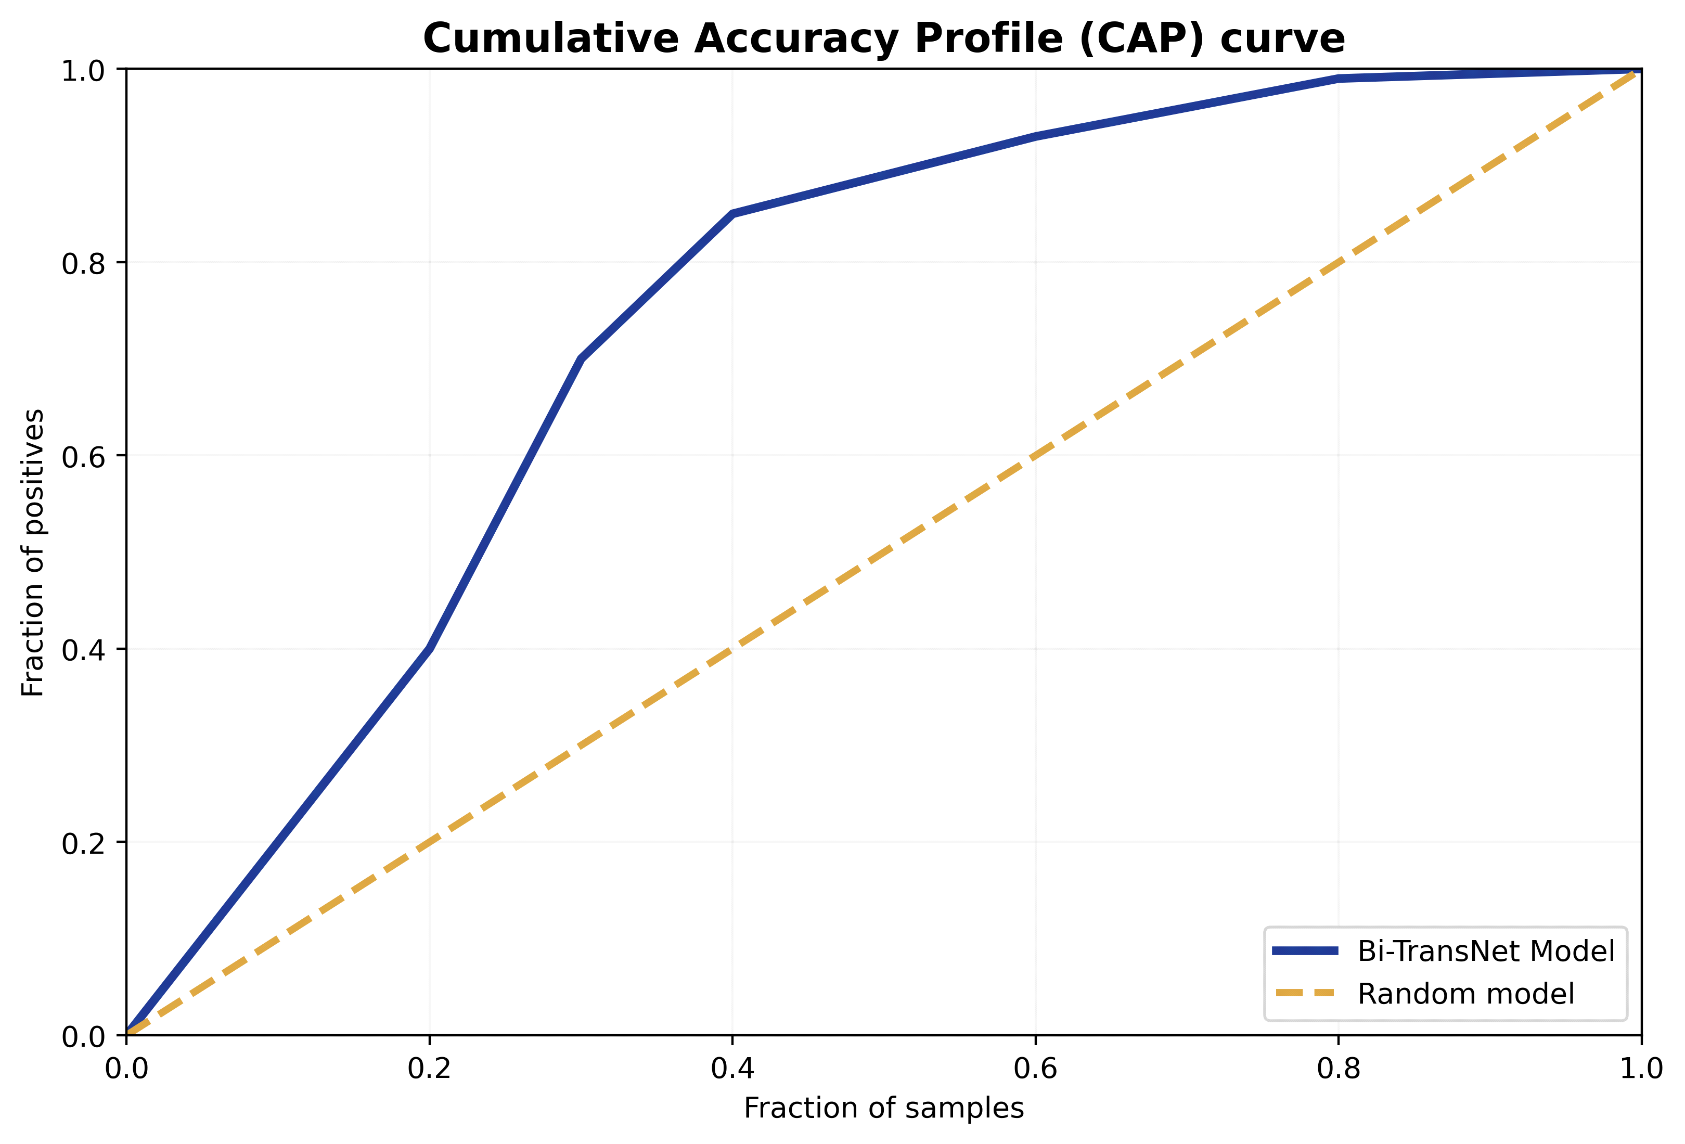

Figure 7: CAP Curve demonstrating cumulative classification performance of Bi-Transnet Model
Figure 6 shows the Bi-Transnet Model's Cumulative Accuracy Profile (CAP) curve. Two lines appear: one solid blue line and one dashed orange line. The solid blue line, rising steeply before leveling as it reaches the upper right corner, shows a cumulative percentage of positive outcomes accurately recognized as sample fraction grows. This steep curve indicates that Bi-Transnet Model possesses high predictive capacity, effectively differentiating between classes early in the ranking procedure.
For comparison, the orange dashed line represents random classifier's anticipated performance. A straight diagonal line cuts the graph diagonally from bottom to top, representing situations where model classification performance equals random chance. Greater separation between blue and orange lines indicates more accurate positive outcome classification.
The essential challenge faced by the model in distinguishing between sleep disorders and epilepsy stems from EEG data typically being more revealed when captured during seizures. In conventional testing conditions, electroencephalograms (EEG) may not effectively distinguish epilepsy from sleep problems. Consequently, while an EEG report might not confirm signal abnormalities, it also does not entirely exclude these condition possibilities. Particularly for some epilepsy forms, EEG signal analysis may not conclusively identify the condition.
Despite its progressive nature, Bi-Transnet configuration isn't yet perfect at consistently distinguishing sleep disorders and epilepsy using EEG data. Electroencephalogram records might identify seizure movement, facilitating detection. Nevertheless, diagnostic uncertainty is presented by obvious sign of absence in standard testing for conditions such as epilepsy and sleep problems. Therefore, irregularities in electroencephalogram (EEG) signals might be displayed without indicating epilepsy or sleep disorders. Further difficulties arise when attempting epilepsy diagnosis using patient EEG alone.
Considering these diagnostic challenges, thorough and multimodal methodology is required to distinguish epilepsy and sleep disturbances. To improve diagnostic precision, EEG data should be combined with other physiological signals, clinical records, and clinical appraisals.
Data shortage makes it challenging for deep learning models like Bi-Transnet and wearable sensors to reach maximum potential. The solution lies in developing more comprehensive and varied training datasets, along with assessment systems considering real deployment limitations. Clients' concerns regarding constant observation must be balanced by framework capacity to safeguard privacy and security. Alternatives to camera utilization might still accumulate valuable information with less privacy interruption. Achieving this equilibrium while beating innovative difficulties becomes essential for developing reliable checking frameworks that further develop medical services, conveyance and patient security.
In domains like mental illness prediction and diagnosis, models such as Bi-Transnet prove significant. They assist with computer diagnostics, psychological wellness observation continuously, early disorder detection, and individualized treatment programs. General well-being efforts and novel treatment formation represent just two instances of impact extending outside psychological well-being research. Better persistent results and more straightforward admittance to mental medical services assets are both accomplished through coordinating these innovations with telehealth and remote consideration administrations. Models such as Bi-Transnet can achieve substantial change by tackling significant issues in mental health service conveyance.

IV. Conclusion
A critical advancement in analyzing EEG information for neurological illnesses has been achieved by the Bi-Transnet model. Nevertheless, it recognizes the challenge of distinguishing between sleep problems and epilepsy when seizures are absent during recordings. The troublesome harmony between quiet security and intensive checking, along with information shortage and homogeneity, limits current demonstrative capacities despite their commitment.
Further developing security safeguarding information gathering methods and expanding EEG information quantity and assortment will constitute main concerns for future endeavors bringing Bi-Transnet into genuine clinical applications. To improve the model, we'll need to add multimodal information, refine it with new AI elements, and test it in clinical settings. All these efforts aim to ensure the model meets necessary standards and proves beneficial for both doctors and patients, particularly in outpatient settings.

References
[1] Fares, A., Zhong, S., & Jiang, J. (2019). EEG-based image classification via a region-level stacked bi-directional deep learning framework. BMC Medical Informatics and Decision Making, 19. https://doi.org/10.1186/s12911-019-0967-9
[2] Schirmeister, R. T., Springenberg, J. T., Fiederer, L. D. J., Glasstetter, M., Eggensperger, K., Tangermann, M., Hutter, F., Burgard, W., & Ball, T. (2017). Deep learning with convolutional neural networks for EEG decoding and visualization. Human Brain Mapping, 38(11), 5391-5420. https://doi.org/10.1002/hbm.23730
[3] Roy, Y., Banville, H., Albuquerque, I., Gramfort, A., Falk, T. H., & Faubert, J. (2019). Deep learning-based electroencephalography analysis: A systematic review. Journal of Neural Engineering, 16(5), 051001. https://doi.org/10.1088/1741-2552/ab260c
[4] Asghar, M. A., Khan, M. J., Rizwan, M., Mehmood, R. M., & Kim, S. H. (2020). An Innovative Multi-Model Neural Network Approach for Feature Selection Emotion Recognition Using Deep Feature Clustering. Sensors, 20(13), 3765. https://doi.org/10.3390/s20133765
[5] Bird, J., Faria, D., Manso, L., Ekart, A., & Buckingham, C. (2019). A Deep Evolutionary Approach to Bioinspired Classifier Optimisation for Brain-Machine Interaction. Complexity, 2019. https://doi.org/10.1155/2019/4316548
[6] Zafar, R., Dass, S. C., & Malik, A. S. (2017). Electroencephalogram-based decoding cognitive states using convolutional neural network and likelihood ratio-based score fusion. PLoS One, 12(5), e0178410. https://doi.org/10.1371/journal.pone.0178410
[7] Vahid, A., Mückschel, M., Stober, S., Stock, A., & Beste, C. (2020). Applying deep learning to single-trial EEG data provides evidence for complementary theories on action control. Communications Biology. https://doi.org/10.1038/s42003-020-0846-z
[8] Friedman, N., Fekete, T., Gal, K., & Shriki, O. (2019). EEG-Based Prediction of Cognitive Load in Intelligence Tests. Frontiers in Human Neuroscience, 13. https://doi.org/10.3389/fnhum.2019.00191
[9] Mwangi, B., Tian, T. S., & Soares, J. C. (2014). A review of feature reduction techniques in neuroimaging. Neuroinformatics, 12(2), 229-244. https://doi.org/10.1007/s12021-013-9204-3
[10] Katmah, R., Al-Shargie, F., Tariq, U., Babiloni, F., Al-Mughairbi, F., & Al-Nashash, H. (2021). A Review of Mental Stress Assessment Methods Using EEG Signals. Sensors, 21(15), 5043. https://doi.org/10.3390/s21155043
[11] Liu, H., Zhang, Y., Li, Y., & Kong, X. (2021). Review of Emotion Recognition Based on Electroencephalography. Frontiers in Computational Neuroscience, 15, 758212. https://doi.org/10.3389/fncom.2021.758212
[12] Jafari, M., Shoeibi, A., Khodatars, M., Bagherzadeh, S., Shalbaf, A., García, D. L., Gorriz, J. M., & Acharya, U. R. (2023). Emotion recognition in EEG signals using deep learning methods: A review. Computers in Biology and Medicine, 165, 107450. https://doi.org/10.1016/j.compbiomed.2023.107450
[13] Zhu, J., Jiang, C., Chen, J., Lin, X., Yu, R., Li, X., & Hu, B. (2022). EEG based depression recognition using improved graph convolutional neural network. Computers in Biology and Medicine, 148, 105815.
[14] Zhang, B., Wei, D., Yan, G., et al. (2023). Spatial-Temporal EEG Fusion Based on Neural Network for Major Depressive Disorder Detection. Interdisciplinary Sciences: Computational Life Sciences. https://doi.org/10.1007/s12539-023-00567-x
[15] Li, M., Liu, Y., Liu, Y., Pu, C., Yin, R., Zeng, Z., Deng, L., & Wang, X. (2022). Resting-state EEG-based convolutional neural network for the diagnosis of depression and its severity. Frontiers in Physiology, 13, 956254.
[16] Wang, B., Kang, Y., Huo, D., Feng, G., Zhang, J., & Li, J. (2022). EEG diagnosis of depression based on multi-channel data fusion and clipping augmentation and convolutional neural network. Frontiers in Physiology, 13, 1029298. https://doi.org/10.3389/fphys.2022.1029298
[17] Zhang, B., Wei, D., Yan, G., et al. (2023). Spatial-Temporal EEG Fusion Based on Neural Network for Major Depressive Disorder Detection. Interdisciplinary Sciences: Computational Life Sciences. https://doi.org/10.1007/s12539-023-00567-x
[18] Góngora Alonso, S., Marques, G., Agarwal, D., De la Torre Diez, I., & Franco-Martín, M. (2022). Comparison of Machine Learning Algorithms in the Prediction of Hospitalized Patients with Schizophrenia. Sensors, 22(7), 2517. https://doi.org/10.3390/s22072517
[19] Ksibi, A., Zakariah, M., Menzli, L. J., Saidani, O., Almuqren, L., & Hanafieh, R. A. M. (2023). Electroencephalography-Based Depression Detection Using Multiple Machine Learning Techniques. Diagnostics, 13, 1779. https://doi.org/10.3390/diagnostics13101779
[20] Park, S. M., Jeong, B., Oh, D. Y., Choi, C. H., Jung, H. Y., Lee, J. Y., Lee, D., & Choi, J. S. (2021). Identification of Major Psychiatric Disorders from Resting-State Electroencephalography Using a Machine Learning Approach. Frontiers in Psychiatry, 12, 707581.
[21] Ehiabhi, J., Wang, H. (2023). A Systematic Review of Machine Learning Models in Mental Health Analysis Based on Multi-Channel Multi-Modal Biometric Signals. BioMedInformatics, 3, 193-219.

