Title: Neurilemomas of the Superficial Radial Nerve: A Very Rare Case Report

Abstract
A 45-year-old right-handed female patient presented with a decade-long history of painless, progressive enlargement of a 5 cm mass on the dorsal surface of the left hand. Clinical examination revealed a well-defined, mobile lesion in the vertical axis, without Tinel’s sign, and preserved sensory-motor function in the upper extremities. Ultrasonographic imaging displayed a hypoechoic encapsulated swelling. Fine needle aspiration cytology (FNAC) yielded nondiagnostic results. Radiographic examination (anteroposterior and lateral views) excluded osseous involvement. Preoperative nerve conduction studies (NCS) demonstrated mild left median nerve sensory neuropathy, which contrasted with intraoperative observations. No systemic comorbidities were noted aside from underlying anemia. Laboratory investigations remained within normal parameters. Microsurgical excision under regional anesthesia successfully identified and isolated the radial nerve along its course. This allowed for careful enucleation of the lesion without causing any damage to the nerve. The postoperative period was uncomplicated, and there were no signs of radial nerve-related deficits. Histopathological examination confirmed benign schwannoma. Follow-up assessment at six months demonstrated satisfactory wound healing with intact sensory and motor function.

Introduction
Benign peripheral nerve tumors constitute a minority of soft tissue neoplasms, representing less than 8% of all soft tissue malignancies. Nevertheless, schwannomas (also termed neurilemomas) constitute approximately 90% of all ectodermal peripheral nerve tumors [1]. These lesions represent the most prevalent benign tumors of peripheral nerves and arise from the myelin sheath created by Schwann cells. While schwannomas exhibit a predilection for superficial cutaneous nerves and those of the extremities, their occurrence in association with the superficial radial nerve remains exceptionally uncommon in medical literature [2-4].
The superficial radial nerve, which represents the terminal sensory branch of the posterior interosseous nerve of the forearm, continues beneath the brachioradialis muscle before emerging in the subcutaneous tissue of the dorsal forearm, ultimately terminating in sensory innervation to the dorsal surface of the hand and radial three-and-a-half digits. Schwannomas originating from this specific nerve are exceptionally rare, with only sporadic case reports published in the international literature. This makes this presentation particularly noteworthy from a clinical standpoint [3,4].
Clinically, schwannomas of the peripheral nervous system usually appear as solitary, gradually enlarging, painless or mildly symptomatic masses. Diagnostic challenges often arise when these lesions occur on the dorsal side of the hand, where they can resemble more benign conditions such as lipomas, cysts, or other soft tissue tumors. [3,4,5]. This diagnostic ambiguity necessitates comprehensive clinical and radiological assessment to establish accurate preoperative diagnosis and facilitate appropriate surgical planning. This case really highlights that tricky diagnostic situation and reminds us how important it is to keep an eye out for less common things. [5-7].

Case Presentation
A 45-year-old right-handed woman visited a doctor because of a growing mass on the back of her left hand. The mass had been getting bigger over the past decade. She said the lesion wasn’t causing any pain, tingling, or trouble using her hand. She also denied any previous injuries, inflammation, or other health problems.
A well-circumscribed, indurated mass measuring approximately 5 cm in its greatest dimension was found on the dorsal aspect of the left hand. The lesion was mobile in the longitudinal plane but relatively fixed in the transverse axis, suggesting it originated from deep tissue planes. Importantly, Tinel’s sign, which indicates nerve irritation, was not elicited during the examination. A comprehensive neurological assessment of both upper extremities revealed preserved sensory sensation across all dermatomes, preserved strength in all major muscle groups, and normal reflexes [Fig.1]. No evidence of sensory loss or motor deficit attributable to peripheral nerve involvement was documented on examination.

2.1 INVESTIGATIONS
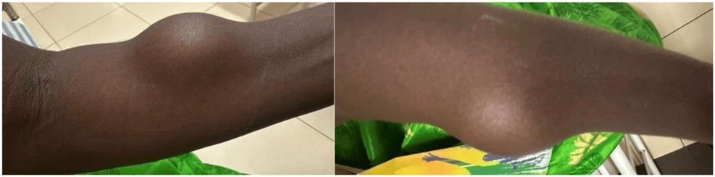

Figure 1: Preoperative Image of the swelling the patient presented
Anteroposterior View (left) and Lateral view (right)
Upon initial presentation, the patient underwent a comprehensive diagnostic evaluation. Ultrasonography of the left hand revealed a hypoechoic, well-defined, and encapsulated lesion without internal vascularity, as observed on color Doppler interrogation. These findings suggested a benign soft tissue mass. Fine needle aspiration cytology was performed to obtain tissue samples for diagnosis, but the cytological specimen was nondiagnostic, primarily consisting of hemorrhagic material without clear cellular characteristics. (However, images for ultrasound and FNAC are unavailable due to logistical reasons.) Standard radiographic imaging of the left hand, including anteroposterior and lateral projections, was obtained to assess for any osseous abnormalities. The radiological evaluation excluded any bony lesions, cortical erosion, or osseous involvement. The radiographs provided no evidence of underlying skeletal pathology or mineral abnormalities.
A complete blood count and comprehensive metabolic panel revealed normocytic anemia as an incidental finding, while all other hematological and biochemical parameters remained within the acceptable reference ranges. The coagulation profile was normal. Preoperative nerve conduction studies (NCS) were conducted to assess peripheral nerve function. These studies revealed mild sensory neuropathy involving the left median nerve, which was unexpected given the clinical presentation suggesting radial nerve involvement. This discrepancy between electrophysiological findings and the anatomical location of the lesion underscores the challenges in diagnosing this case.

2.3 TREATMENT
On the basis of the clinical presentation, imaging characteristics, and diagnostic uncertainty, surgical excision under regional anesthesia was determined to be the optimal therapeutic approach. The goal of surgical intervention was to achieve complete excision of the lesion while preserving the integrity of the radial nerve and its terminal branches. Surgery was performed with the patient under wrist block anesthesia supplemented with intravenous sedation. A modified S-shaped incision was executed over the dorsal aspect of the left hand, centered upon the palpable mass. Careful dissection through subcutaneous tissue planes permitted systematic identification of the underlying lesion. During careful surgical dissection, the superficial radial nerve was precisely identified as it emerged within the operative field, coursing along its anatomical trajectory [Fig 2].
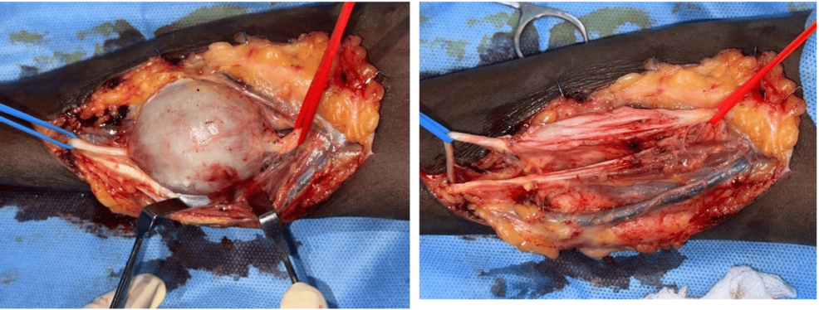

Figure 2: . Intraoperative image: showing the tumor along the course of the radial nerve (a & b)
(a) Superficial Radial nerve isolated and took control proximally and distally from the tumor; (b) After the tumor shelled out from the Nerve, you can see the individual nerve bundles. All the nerve bundles and branches were preserved.
The tumor was discovered to be a well-encapsulated, firm lesion with a grayish-tan appearance. Meticulous microsurgical technique was employed to isolate the neoplastic mass from the surrounding radial nerve fascicles without causing frank transection or traction injury [Fig.3]. The lesion was carefully enucleated and shelled out from its bed, preserving the continuity and integrity of the radial nerve and its branches throughout the procedure.
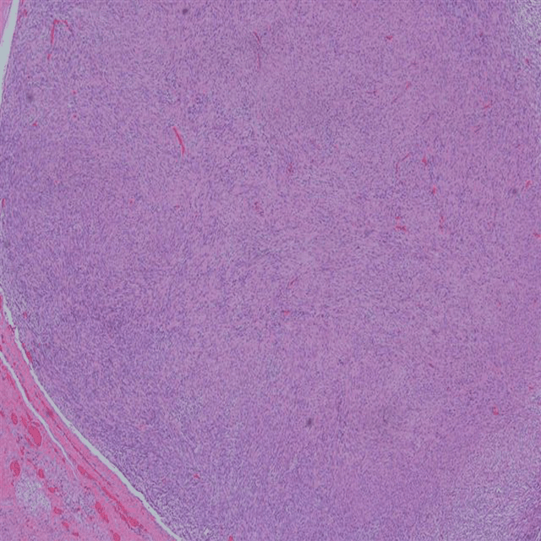

Figure 3: Histopathology Image showing Cytologically bland spindle cells with vague nuclear palisading and fibrillary background.
3. Results
• Postoperative recovery was uneventful, with minimal pain managed through oral analgesics. Upon assessment, there were no radial nerve deficits, preserved sensation, and normal strength in the forearm and hand muscles. Histopathological examination of the excised specimen revealed characteristic features consistent with schwannoma. The histological architecture demonstrated a benign peripheral nerve tumor with features suggestive of schwannoma, as depicted in Figure 3. Immunohistochemical studies could not be performed due to logistic issues. At the six-month follow-up visit, the patient demonstrated excellent clinical outcomes. Wound healing was complete with a well-healed surgical scar. Neurological examination continued to reveal intact sensation throughout the distribution of the superficial radial nerve and normal strength in all hand and forearm muscles. The patient is doing great, completely back to their usual self and without any limitations in their daily activities. There are no signs of a recurring mass or any lingering symptoms. Range of motion at the hand and wrist remained intact and painless.

Discussion
Schwannomas are benign, encapsulated tumors that originate from the neoplastic proliferation of Schwann cells, which form the myelin sheath of peripheral nerves. While schwannomas can occur in various peripheral nerves, their association with the superficial radial nerve is exceptionally rare, with only a few case reports available in the medical literature. [2]. These lesions account for approximately 90% of all ectodermal peripheral nerve tumors and comprise less than 8% of all soft tissue neoplasms [7,8].
Superficial radial nerve schwannomas present with nonspecific clinical characteristics that frequently lead to diagnostic confusion. Patients typically present with a slowly enlarging mass in the dorsal forearm or dorsal hand region. These lesions are painless and resemble more common benign soft tissue tumors, such as lipomas and ganglion cysts. This similarity often leads to delayed recognition of their true nature. Additionally, the absence of overt neurological symptoms, like paresthesia or Tinel’s sign, further contributes to the diagnostic delay [8-10].
Schwannomas exhibit varying imaging characteristics depending on the imaging modality used. Ultrasonography usually shows hypoechoic, well-defined, and encapsulated lesions with variable internal architecture. When magnetic resonance imaging is performed, it typically reveals characteristic T2-hyperintense masses, often accompanied by the split fat sign (target sign), which indicates compression of adjacent fat planes. This finding strongly suggests a peripheral nerve origin. [4]. Computed tomographic imaging may demonstrate isodose soft tissue masses without osseous involvement. Fine needle aspiration cytology, as illustrated in the present case, frequently yields inconclusive results due to the limited cellularity and benign characteristics of these lesions [4,6].
Histopathological examination remains the gold standard for definitive diagnosis. Schwannomas typically exhibit an encapsulated architecture characterized by alternating Antoni A areas (ordered spindle cells arranged in palisades or interlacing fascicles) and Antoni B areas (a loose myxoid background with stellate cells). Verocay bodies, representing tightly ordered palisades of nuclei, are frequently observed [11]. Importantly, S-100 immunostaining is also positive in neurofibromas; however not done in this case due to logistic reasons. Additional immunohistochemical markers such as NFH (neurofilament heavy chain) positivity in neurofibromas helps distinguish between these two diagnostic entities [11,12].

The differential diagnosis of superficial radial nerve schwannoma encompasses several other pathological entities [8]. That may present with similar clinical and radiological characteristics, such as neurofibromatosis-associated neurofibromas, which may exhibit infiltrative growth patterns and lack the well-defined capsule characteristic of schwannomas. Other benign lesions that may present similarly include lipomas and other benign lipomatous lesions, ganglion cysts, and other benign soft tissue tumors. Accurate differentiation requires integrating clinical presentation, imaging characteristics, and definitive histopathological examination. [13-15]

Surgical management of peripheral nerve schwannomas is the treatment of choice when diagnostic uncertainty exists or when the lesion demonstrates progressive growth. The objective of surgical intervention is to completely excise the tumor while preserving the function of the peripheral nerves. Microsurgical technique, which utilizes operative magnification, enables meticulous nerve dissection and the removal of the encapsulated tumor mass without compromising nerve continuity [9,10]. In contrast, the encapsulated nature of schwannomas, unlike infiltrative neurofibromas, generally allows for safe enucleation without sacrificing nerve fascicles.

Complications of surgical treatment may include temporary or permanent sensory loss, temporary motor weakness, and recurrence. Since schwannomas are closely associated with the peripheral nerve of origin, meticulous surgical technique is crucial to minimize morbidity [7,8]. The excellent prognosis associated with benign schwannomas, combined with their low recurrence rates following complete excision (typically less than 5%), supports the surgical approach even when symptoms are minimal [9,10].
Although recurrence rates after surgical removal are low, incomplete tumor resection or misdiagnosis of multiple tumors may cause recurrences. Artico et al. have reported recurrences in different areas of the nerves of the same extremity, not in the operated region [16].

Conclusions
In this case report, we have highlighted a rare location of schwannoma, the radial nerve, and have emphasized that the differential diagnosis should be done carefully in order to preserve the nerve during the surgical approach.

References
- Woodruff JM: Pathology of tumors of the peripheral nerve sheath in children and young adults. Am J Surg Pathol. 1999, 23:1466-1481.
- Hilton DA, Hanemann CO: Schwannomas and their pathogenesis. J Pathol. 2014, 232:242-248.
- De Vitis R, Taccardo G, Passiatore M. Re: Hems T, Parafioriti A, Thomas BP, Di Bernardo A: An algorithmic approach to the management of peripheral nerve tumours. J Hand Surg Eur. 2024, 49:552-554. 10.1177/17531934241278952
- Senol, N., & Yilmaz, O. (2015: A rare type of peripheral nerve sheath tumor: radial nerve schwannoma. Turkish Neurosurgery, 25.
- Donner TR, Voorhees RL, Kline DG: Neural sheath tumors of major nerves. J Neurosurg. 1994, 81:362-373.
- Mahajan et.al,: Schwannoma of superficial peroneal nerve presenting as leg pain. Journal of Case Reports. 2:79-82.
- Das Gupta TK, Brasfield RD, Strong EW, et al.: Benign solitary schwannomas (neurilemomas). Cancer. 1969, 24:355-366.
- Pertea M, Haba D, Veliceasa B, et al.: Schwannoma of the upper limb: retrospective study of a single institution’s experience. *Life. 2022, 12:873.
- Tripoli, Massimiliano PhD; Cordova, Adriana MD; Moschella, Francesco MD: Characteristics, Management Techniques, and Outcomes of the Most Common Soft-Tissue Hand Tumors: A Literature Review and Our Experience. Annals of Plastic Surgery 79(6): p 558-565, December. 2017, 10.1097/SAP.0000000000001148
- Hanemann CO, Bartelt-Kirbach B, Diebold R, Kämpchen K, Langmesser S, Utermark T: Differential gene expression between human schwannoma and control Schwann cells. Neuropathology and Applied Neurobiology. 2006, 32:605-14.
- Stefansson K, Wollmann R, Jerkovic M: S-100 protein in soft-tissue tumors derived from Schwann cells and melanocytes. Am J Pathol. 1982, 106:261-8.
- Schwannoma of the radial nerve: a case report. Pan Afr Med J. 2022, 43:139.
- Bhat, T. A., Alokaili, H., et.al,: A schwannoma of superficial radial nerve in hand clinically masquerading a subcutaneous lipoma: a very rare case report.
- Rodrigues, et.al,: Neurofibromatoses: part 1 - diagnosis and differential diagnosis. 20141, 72:241-50.
- Therapeutic exercise based on biobehavioral approach for the rehabilitation of a radial nerve injury after surgical removal of a schwannoma: a case report. Physiother Theory Pract. 2019, 35:677-685.
- Artico M, Cervoni L, Wierzbicki V, D’Andrea V, Nucci F: Benign neural sheath tumours of major nerves: Characteristics in 119 surgical cases. Acta Neurochir (Wien. 139:1108-1116. 10.1007/BF01410969

