Influence of Distributed Generation on Voltage Performance of the Enugu Electricity Distribution System
Abstract
Voltage regulation remains a persistent operational challenge in many Nigerian radial distribution networks due to long feeder lengths, high resistance-to-reactance ratios, and increasing load demand. This study investigates the influence of hybrid Distributed Generation (DG) on the voltage performance of a representative 11 kV feeder within the Enugu Electricity Distribution System (EEDS). A detailed network model comprising 47 load buses was developed and analysed using load flow simulation in ETAP. Two operating scenarios were examined: a base case without DG and a DG-integrated case incorporating synchronous generators, solar photovoltaic (PV) systems, and battery energy storage units. Base case results revealed widespread marginal under-voltage conditions, with a minimum bus voltage of 10.601 kV (96.37% of nominal), indicating systemic voltage depression along the radial feeder. Following DG integration, the minimum voltage improved to 10.685 kV (97.14% of nominal), representing an overall voltage enhancement of approximately 0.79%. The improvement was uniformly distributed across the feeder, confirming that hybrid DG primarily reduces feeder current magnitude and associated line voltage drops. No over-voltage violations were observed, demonstrating that moderate DG penetration can enhance voltage regulation without compromising statutory limits. The findings confirm that hybrid distributed generation provides measurable and technically meaningful voltage support in weak radial distribution systems such as EEDS. However, full restoration to nominal voltage levels requires coordinated reactive power control or higher penetration at the medium-voltage level. The study provides practical planning insights for distribution utilities seeking to integrate DG as a voltage support strategy in developing power systems.
Keywords: Distributed Generation (DG); Voltage Profile; Radial Distribution Network; Hybrid Generation; Load Flow Analysis; Voltage Regulation; Solar Photovoltaic; Battery Energy Storage; Enugu Electricity Distribution System; Power Quality.
INTRODUCTION
Electric power distribution systems form the final stage of electric power delivery, linking transmission networks to end users through medium- and low-voltage feeders (Bayliss & Hardy, 2012). The quality of service experienced by consumers largely depends on the performance of these distribution systems, particularly in terms of voltage magnitude at customer connection points (Short, 2018). Voltage performance, therefore, remains one of the most critical indices for assessing the reliability and quality of power supply in distribution networks (Kacejko et al., 2022).
In an ideal distribution system, voltage at all buses should remain within prescribed limits under normal operating conditions (Gonen, 2014). Standards such as the IEEE and IEC recommend that voltage variations at distribution level should typically remain within ±5% of the nominal value to ensure proper operation of electrical equipment and customer satisfaction (IEEE Std 1159, 2019) (Dugan et al., 2012). However, maintaining acceptable voltage levels becomes increasingly difficult in radial distribution networks, which are characterised by long feeder lengths, high resistance-to-reactance ratios, and continuously growing load demand (Kersting, 2017).
In Nigeria, distribution networks face additional challenges arising from ageing infrastructure, uneven load growth, inadequate reactive power support, and limited automation (Oghorada & Oyeyemi, 2019). These challenges are particularly evident in the Enugu Electricity Distribution System, where customers frequently experience voltage drops, flicker, and prolonged under-voltage conditions (Ezechukwu, 2021). Such poor voltage performance leads to increased technical losses, reduced efficiency of electrical appliances, frequent equipment failure, and overall dissatisfaction among consumers (Amadi et al., 2016).
Traditionally, voltage regulation in distribution systems has relied on devices such as on-load tap-changing transformers, capacitor banks, and voltage regulators (Zhu, 2015). While these methods provide some level of control, they are often insufficient in addressing voltage problems under rapidly changing load conditions (Murty, 2017). Moreover, their effectiveness is limited in weak networks with long radial feeders, which are common in many Nigerian distribution systems (Idoniboyeobu et al., 2018).
In recent years, Distributed Generation (DG) has emerged as a viable option for improving the operational performance of distribution networks (Pilo et al., 2011). Distributed Generation refers to small- to medium-scale power generation units located close to load centres and connected directly to the distribution system (Jenkins et al., 2010). Common DG sources include solar photovoltaic systems, small hydro plants, gas turbines, and biomass-based generators (Borges & Falcao, 2006). When appropriately integrated, DG units can provide localised active and reactive power support, thereby improving voltage levels and reducing feeder loading (Pepermans et al., 2005).
Despite the increasing interest in DG deployment in Nigeria, there remains a need for detailed technical studies that evaluate its actual influence on voltage performance in specific distribution networks (Onah et al., 2022). For the Enugu Electricity Distribution System, such an assessment is particularly important, given the persistent voltage challenges experienced across many feeders (Ekeoke et al., 2020). This study therefore focuses on analysing the influence of Distributed Generation on the voltage performance of the Enugu Electricity Distribution System through systematic modelling and simulation.
LITERATURE REVIEW
Electric power distribution systems are designed to deliver electrical energy from transmission substations to end users in a safe, reliable, and economical manner (Faulkenberry & Coffer, 1996). Typically operating at medium-voltage levels such as 11 kV or 33 kV, these voltages are stepped down for residential and commercial consumption (Pabla, 2011). Unlike transmission networks, which are often meshed, distribution systems are predominantly radial (Lasseter, 2011). This radial configuration simplifies protection and operation but introduces technical challenges, particularly in maintaining voltage regulation (Vovos et al., 2007).
The performance of a distribution system is influenced by feeder length, conductor impedance, load distribution, and network topology (Bari et al., 2012). As load demand increases along a feeder, voltage tends to drop progressively from the sending end to the receiving end (Kandary & El-Hashimy, 2016). This behaviour is more pronounced in distribution networks due to their relatively high resistance-to-reactance ratio. Consequently, maintaining acceptable voltage levels across all buses is a central concern in distribution system planning and operation (Willis, 2000).
In developing power systems, distribution networks often operate close to their capacity limits. Limited infrastructure upgrades, rapid urbanisation, and increasing electricity demand further exacerbate voltage-related problems (Okereke, 2015). Such issues are evident in many Nigerian distribution systems, including the Enugu Electricity Distribution System, where voltage deviations are common and persistent (Okafor et al., 2017).
Voltage performance refers to a power system’s ability to maintain voltage magnitudes within acceptable limits during normal operating conditions (Kundur, 1994). Poor voltage performance manifests as under-voltage, over-voltage, or frequent voltage fluctuations, which negatively affect power quality and system reliability (Bollen, 2000). International standards provide guidance for acceptable voltage limits. For example, the IEEE recommends that voltage at distribution level remain within ±5% of the nominal value under normal conditions (IEEE Std 1159, 2019), while IEC standards specify tolerance ranges to ensure safe and efficient operation of electrical equipment (IEC 60038, 2009). Deviations beyond these limits can lead to overheating of motors, malfunction of electronic devices, increased losses, and reduced equipment lifespan (Fuchs & Masoum, 2008).
Several factors contribute to voltage degradation in distribution networks, including excessive feeder length, uneven load distribution, poor power factor, and inadequate reactive power compensation (Kueck et al., 2004). In radial feeders, voltage drop increases with distance from the substation, making end-of-line buses particularly vulnerable (Miu & Chiang, 2000). Seasonal load variations and peak demand periods further intensify these issues (Chiradeja & Ramakumar, 2004). In Nigerian distribution systems, voltage performance challenges are often compounded by ageing infrastructure and limited monitoring capabilities, allowing voltage violations to persist for extended periods without corrective action (Onojo et al., 2018). This highlights the need for alternative voltage support strategies (Eghomien et al., 2021).
Traditional voltage regulation in distribution networks relies on a combination of passive and active control devices. Commonly used techniques include on-load tap-changing transformers (OLTCs), step voltage regulators, and shunt capacitor banks (Griffin et al., 2000). OLTCs adjust transformer turns ratios to regulate voltage in response to load changes (Calderaro et al., 2014). While effective at substations, OLTCs provide limited control along long feeders (Viawan & Karlsson, 2008). Shunt capacitor banks improve power factor and provide reactive power support, reducing voltage drop, though placement and switching must be carefully coordinated to avoid over-voltage during light load conditions (Kundur, 1994).
Despite their widespread use, conventional voltage control methods face limitations in modern distribution systems. They respond slowly to rapid load changes and may not adequately address voltage issues caused by distributed and variable loads (Tan et al., 2013). In weak or heavily loaded networks, these methods may be insufficient to maintain voltage within acceptable limits (Singh et al., 2009). These limitations have motivated increased interest in alternative approaches, including the integration of Distributed Generation (DG) to improve voltage performance closer to load centres (Georgilakis & Hatziargyriou, 2013).
Distributed Generation refers to the production of electrical power by relatively small-scale units connected directly to the distribution network or located near end users. Unlike centralised generation, DG units are decentralised, typically ranging from a few kilowatts to several megawatts (Chambers, 2001). DG technologies include renewable sources such as solar photovoltaic systems, wind turbines, and small hydro plants, as well as conventional sources like gas turbines and diesel generators. The growing interest in DG is driven by rising energy demand, environmental concerns, and the need for improved reliability and efficiency (Ackermann et al., 2001).
DG integration offers several benefits, including reduced technical losses, improved voltage profiles, enhanced system reliability, and deferred investment in network upgrades (El-Khattam & Salama, 2004). By supplying power closer to load centres, DG reduces current flow in distribution feeders, mitigating voltage drops and congestion (Hung et al., 2010). However, DG also introduces challenges such as reverse power flow, voltage rise, protection coordination, and system stability (Barker & De Mello, 2000). The impact of DG depends on factors like size, location, penetration level, and operating mode (Hatti et al., 2011).
DG can improve voltage levels by injecting active and reactive power at strategic points in the network, reducing voltage drops along feeders and enhancing regulation, particularly at end-of-line buses (Viral & Khatod, 2012). Studies show that appropriately sized and well-placed DG units significantly improve voltage performance in radial distribution systems (Willis & Scott, 2000). DG units capable of reactive power control can actively support voltage and system stability (Rau & Wan, 1994). Conversely, high DG penetration may cause excessive voltage rise, especially in lightly loaded feeders or during high DG output periods (Masters, 2002). Renewable DG sources, like solar PV, are particularly variable, and without proper coordination, can result in over-voltage that violates regulatory limits (Tonkoski et al., 2012). Consequently, careful DG planning, including optimal sizing and placement, is essential (Kaur et al., 2014). Analytical and simulation-based approaches are widely used to evaluate DG impact under different operating conditions (Agalgaonkar et al., 2006).
Several studies have examined DG’s impact on voltage performance. Bollen (2000) highlighted that local generation can mitigate voltage sags and drops, improving voltage stability when integrated appropriately. Willis and Scott (2000) developed a comprehensive framework for DG integration in distribution planning, showing benefits for voltage profiles and loss reduction but noting the risk of voltage rise under high DG penetration. More recent research in developing power systems reports significant voltage improvements following DG installation, particularly in weak radial networks (Adewuyi et al., 2019). However, many of these studies rely on generic test systems, limiting direct applicability to specific networks such as the Enugu Electricity Distribution System (Nwafor & Udoye, 2021).
Despite clear evidence that DG influences voltage performance, gaps remain. Limited studies focus on the Enugu Electricity Distribution System using real or representative network data (Madueme et al., 2022). Many analyses rely on theoretical or generic networks, which may not reflect operational realities in Nigerian distribution systems (Ibe & Okeke, 2020). Furthermore, there is a need for systematic comparison of voltage performance before and after DG integration under consistent modelling assumptions (Umar et al., 2021). Addressing these gaps will provide practical insights for effective DG planning and voltage regulation in the Enugu Electricity Distribution System. This study aims to contribute by conducting a detailed voltage performance analysis based on a realistic case study (Anumaka, 2023).

METHODOLOGY

Overview of the Enugu Electricity Distribution System
The Enugu Electricity Distribution System serves as the primary utility responsible for power delivery across South-Eastern Nigeria. The network operates mainly at medium-voltage levels, stepping down from the national grid to 33 kV and 11 kV sub-transmission and distribution levels. It is defined by a predominantly radial structure, where power flows from central transmission substations through long primary feeders to various secondary distribution transformers.

Identification of Targeted Feeders and Substations
For the purpose of this study, a representative 11 kV distribution network within the Enugu metropolis was selected. This section of the grid was chosen due to its high concentration of critical administrative, commercial, and financial loads. The study focuses on a specific feeder cluster that includes high-density areas such as Okpara Avenue, Station Road, and various bank locations, which provide a realistic environment for testing the impact of localised Distributed Generation.

Current Operational Challenges and Network Configuration
The targeted network is characterised by a radial configuration, which inherently complicates voltage regulation as the distance from the injection point increases. Currently, the system relies on conventional overcurrent protection schemes designed for unidirectional power flow. Significant challenges include persistent under-voltage at end-of-line buses and a lack of reactive power compensation, making the network vulnerable to voltage drops during peak periods when commercial and industrial demand is at its highest.

Primary and Secondary Data Sources
Data for this research was gathered through a combination of utility records and field documentation provided by the EEDS technical department. This included historical load data, single-line diagrams, and equipment nameplate ratings. These primary sources were supplemented by secondary technical literature and IEEE standards to validate the modelling assumptions.

Feeder Characteristics (Lengths, Conductor Types, and Impedance)
To build an accurate simulation model, the physical properties of the distribution lines were recorded. This included the conductor cross-sectional areas and lengths between various load points. These parameters were used to calculate the resistance ($R$) and reactance ($X$) values, which are essential for determining the voltage drop across the 11 kV feeders.

Bus Data and Transformer Ratings
The network model incorporates 47 distinct load points (buses), each representing a distribution transformer or a major customer connection. As shown in Table 1, the ratings for these connection points range from small 15.6 kVA units serving telecommunications infrastructure (e.g., MTN NIG5) to larger transformers such as the 359 kVA unit at Mr Biggs5. All units are rated for 11 kV operation at the primary side.
Table 1: Load Data for the Targeted 11 kV Network
ID | Rating (kVA) | Rated kV
Apostles4 | 129 | 11
CCB Okpala AVE5 | 71.3 | 11
Colliery Ave. Ridge Way3 | 271 | 11
Constitution rd5 | 289 | 11
Coporate Affairs Comm5 | 53.2 | 11
Court Ave5 | 257 | 11
DylicSuites & Garden2 | 56 | 11
Eco Bank10 | 55.6 | 11
Eco Bank11 | 32.6 | 11
Enugu Sport Club5 | 293 | 11
Farm asso. NIG LTD5 | 31.4 | 11
Federal Inland rev5 | 43 | 11
Federal Morgage Bank5 | 36.2 | 11
Federal Radio House5 | 143 | 11
Fidelity Bank5 | 49 | 11
First Bank5 | 104 | 11
GLO Switch Yard5 | 267 | 11
GLO/ETB okpala AVE5 | 46.7 | 11
Govt.printig press5 | 155 | 11
High street5 | 286 | 11
Hse Dev Authority2 | 95.6 | 11
Justice Nwobodo5 | 39.1 | 11
Keystone Bank5 | 35.8 | 11
Load38 | 23.8 | 11
MODOTELS NIG LTD5 | 162 | 11
Mr Biggs5 | 359 | 11
Mrs Lolo AGu2 | 87.3 | 11
MTN NIG5 | 15.6 | 11
NCFC5 | 108 | 11
NEPA Ogui Office5 | 53.2 | 11
New A.G Office5 | 49 | 11
NPC1 | 236 | 11
Police Comm State House 5 | 33.7 | 11
Prime & Power LTD 5 | 66.3 | 11
Railway Gate4 | 96.4 | 11
Railway Goodshed4 | 266 | 11
RCCG 6 HQ2 | 107 | 11
Safari garden5 | 131 | 11
Skye bank3 | 44.8 | 11
Stanbic IBTC5 | 43.1 | 11
State CID5 | 200 | 11
Station Road5 | 303 | 11
Texaco FST5 | 33 | 11
UBA bank5 | 41 | 11
UBA Bank 20 Okpara AVE2 | 43.8 | 11
UBA Station Road5 | 79.1 | 11
Union Bank2 okpara AVE2 | 216 | 11
Union Bank5 | 207 | 11

Load Profile and Demand Characterisation
The load distribution in the study area is heterogeneous, mixing high-priority commercial loads (banks and corporate offices) with residential and light industrial consumers. The load data reflects peak demand conditions to evaluate the network under its most stressed state. This characterisation is vital for identifying which buses will benefit most from the injection of active power through Distributed Generation.

Modelling and Simulation Framework

Simulation Software Selection: ETAP
For the modelling and analysis of the Enugu 11 kV distribution network, the Electrical Transient Analyser Program (ETAP) was selected. ETAP is an industry-standard, high-performance software suite used for the design, simulation, and operation of generation, transmission, and distribution systems. Its selection is based on its robust Newton-Raphson load flow engine, which is capable of handling the complex impedance and diverse load types present in the Enugu electricity distribution network. ETAP allows for the precise integration of Distributed Generation models, enabling a comparative study between the passive radial state of the network and an active, DG-enhanced state.

Mathematical Formulation of Load Flow Analysis
The core of the simulation relies on the steady-state solution of the network using the load flow (or power flow) equation. Given the specific characteristics of the Enugu feeders—including the high $R/X$ ratios common in Nigerian distribution lines—the Newton-Raphson method is employed for its superior convergence properties.
The fundamental power flow equation for each bus $i$ in the network is expressed as:
$$S_{i}=P_{i}+jQ_{i}=V_{i}\sum_{j=1}^{n}{Y_{ij}^{*}V_{j}^{*}}$$
Where:
- $P_{i}$ and $Q_{i}$ are the net active and reactive power injected at bus $i$.
- $V_{i}$ and $V_{j}$ represent the complex voltages at buses $i$ and $j$.
- $Y_{ij}$ is the element of the bus admittance matrix $\left(\$Y_{\left\{bus\right\}\$}\right)$.
The simulation iteratively solves for the voltage magnitude $\left|V\right|$ and phase angle $δ$ at each load bus (PQ bus), ensuring that the power balance is maintained. This allows for the calculation of voltage drops along the feeders from the substation to the end-of-line customers, such as those at the Station Road and Okpara Avenue connection points.
Modelling of the Enugu Distribution Base Case Network without DG connection
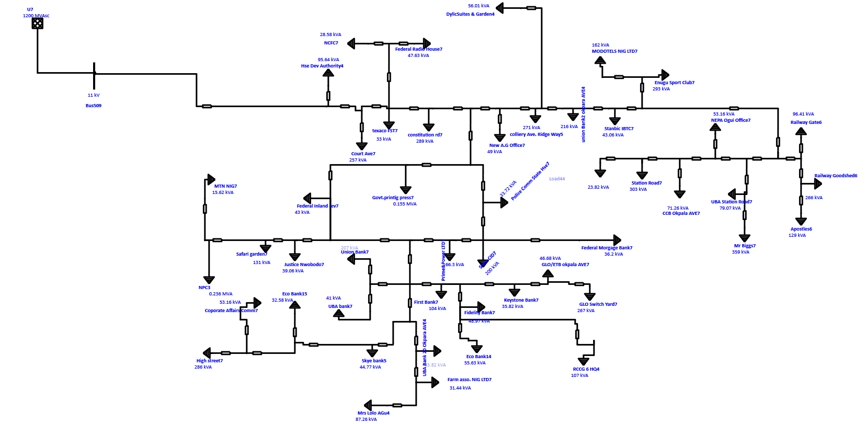
Figure 1: Single-Line Diagram of the Base Case Enugu 11 kV Distribution Network (Without DG)
The model represents the Enugu distribution network in its original radial state. Power enters the system from a high-capacity source rated at 1200 MVAsc. A main substation transformer, T14, has a capacity of 160 MVA. This transformer steps the voltage down to a primary distribution level of 11 kV at Bus 577. This primary line acts as the main path for the local grid and carries power across various parts of the city. The system uses several step-down transformers to serve end users. Most of these units have a capacity of 1250 kVA. These include units like T15, T17, and T20. They convert the 11 kV primary voltage to a secondary level of 0.415 kV. In this base case scenario, all distributed generation assets are considered inactive. This includes the synchronous generators rated at 560 kW. It also includes the solar PV arrays and battery storage systems. The model focuses on how the utility grid alone meets the total demand of the connected loads.
The load profile is diverse. It covers several commercial and institutional hubs in Enugu. Key connection points include Station Road and Okpara Avenue. The network also supports financial institutions like Union Bank and First Bank. It serves government facilities such as the Federal Radio House. By modelling the system without any DG support, the study identifies the standard voltage drops and power losses. These occur as electricity travels from the substation to these urban loads.
Modelling of Distributed Generation (DG)
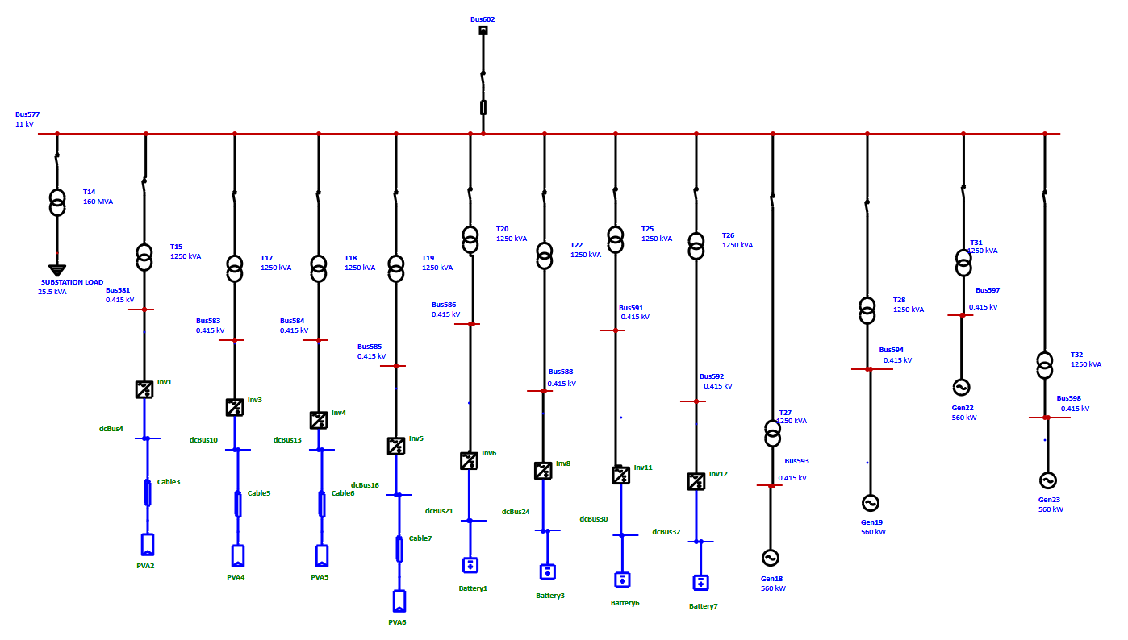
Figure 2: Single-Line Diagram of the Hybrid Distributed Generation
The Distributed Generation model adopted in this study reflects a hybrid DG configuration, combining synchronous generator units, solar photovoltaic (PV) systems, and battery energy storage systems. This choice mirrors the emerging structure of embedded generation within urban Nigerian distribution networks, where commercial and institutional customers increasingly deploy multiple DG technologies to improve supply reliability and power quality. The dominant DG units in the model are synchronous generators rated at 560 kW, connected at selected 11 kV buses through dedicated step-down transformers. These generators represent conventional engine-driven DG installations commonly used by banks, hotels, and large commercial facilities in Enugu. Their inclusion is technically significant because synchronous generators are capable of supplying both active and reactive power, allowing them to contribute directly to voltage regulation within the distribution network.
In addition to synchronous generation, multiple solar PV units are integrated at low-voltage (0.415 kV) buses downstream of distribution transformers. These PV systems are modelled as grid-connected inverter-based sources operating under steady irradiance conditions. While their primary role is active power injection, their presence reduces the net load seen by the upstream feeder, indirectly supporting voltage levels along the radial network. Battery energy storage systems are also incorporated at selected low-voltage buses. These units are modelled to operate in discharge mode during the simulation period, supplying active power to local loads. Although reactive power support from the batteries is not explicitly prioritised, their contribution further reduces feeder current and voltage drop during peak demand conditions.
The power ratings of all DG components were selected to remain realistic relative to the connected loads and transformer capacities. Care was taken to avoid excessive DG penetration that could cause widespread reverse power flow or unrealistic voltage rise. The resulting configuration represents a moderate but technically meaningful level of DG integration suitable for voltage performance assessment.

Criteria for Optimal DG Placement and Sizing
The placement and sizing of DG units within the network were guided by electrical performance considerations rather than purely economic or optimisation-based criteria. The aim was to position DG where its voltage support effect would be most pronounced while maintaining operational realism.
First, DG units were preferentially located at buses associated with high load concentration and persistent under-voltage in the base case analysis. These buses are generally located electrically distant from the primary substation, where cumulative voltage drop is most severe. Injecting power at these points reduces the current drawn from the source and improves voltage magnitude at downstream buses.
Second, the existing network topology and transformer locations influenced DG placement. Solar PV and battery systems were connected on the low-voltage side of distribution transformers supplying commercial and institutional customers, consistent with real-world deployment practice. In contrast, the 560 kW synchronous generators were connected at higher-capacity nodes capable of accommodating their power injection without exceeding thermal or voltage limits.
Third, DG sizing was constrained by voltage regulation requirements. All DG ratings were chosen such that post-integration bus voltages remained within the acceptable ±5% range around the nominal value, in accordance with IEEE distribution voltage guidelines (IEEE Std 1159, 2019). Incremental adjustments were made during modelling to ensure that voltage improvement did not transition into localised over-voltage, particularly near DG connection points.
Rather than applying an automated optimisation algorithm, a sensitivity-driven approach was used. This reflects practical distribution planning processes, where engineers iteratively evaluate DG impacts using load flow simulations and engineering judgement, especially in networks with limited real-time control infrastructure.
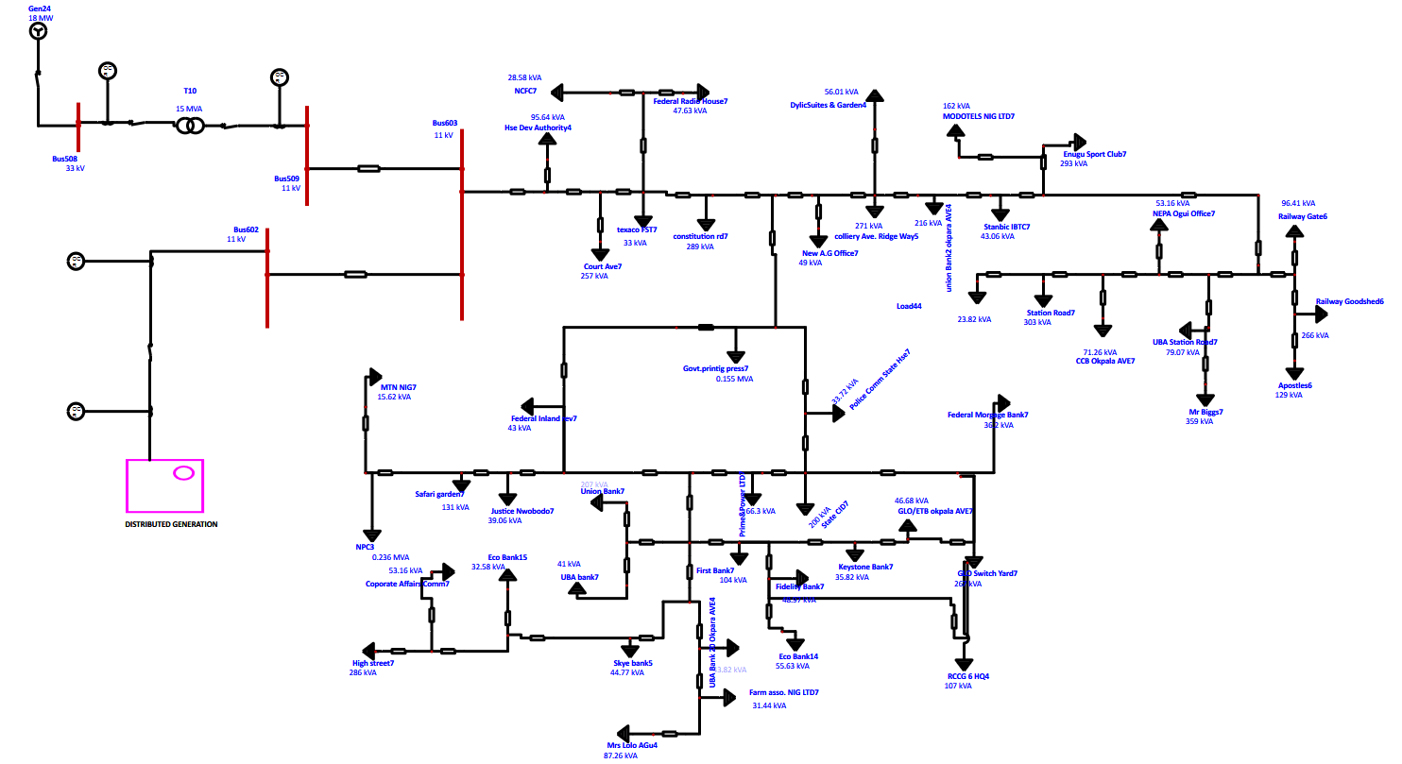
Figure 3: Single-Line Diagram of the Enugu 11 kV Network with Hybrid Distributed Generation Integrated

Definition of Simulation Scenarios
To evaluate the influence of the hybrid DG configuration on voltage performance, a set of clearly defined simulation scenarios was developed.
The first scenario represents the base case operation of the Enugu 11 kV distribution network without any distributed generation. In this condition, all loads are supplied solely from the upstream grid through the primary substation transformer. This scenario establishes the reference voltage profile and identifies buses experiencing under-voltage under peak loading conditions.
The second scenario introduces the full DG configuration shown in the network model. This includes the synchronous generators operating at their rated active power output, the solar PV systems injecting active power at the low-voltage level, and the battery storage units discharging to support local demand. All load levels are maintained identical to the base case to ensure a fair comparison.
Additional sensitivity scenarios were analysed by observing voltage behaviour at critical buses following DG integration, particularly near synchronous generator connection points and along long feeder sections. These scenarios help to capture the combined effects of mixed DG technologies on voltage regulation, feeder loading, and power flow direction.
By structuring the simulations in this manner, the study isolates the direct contribution of distributed generation to voltage performance improvement while maintaining consistency with the physical network configuration and operating conditions of the Enugu Electricity Distribution System.
RESULTS AND DISCUSSION
Baseline Performance Analysis (Base Case)
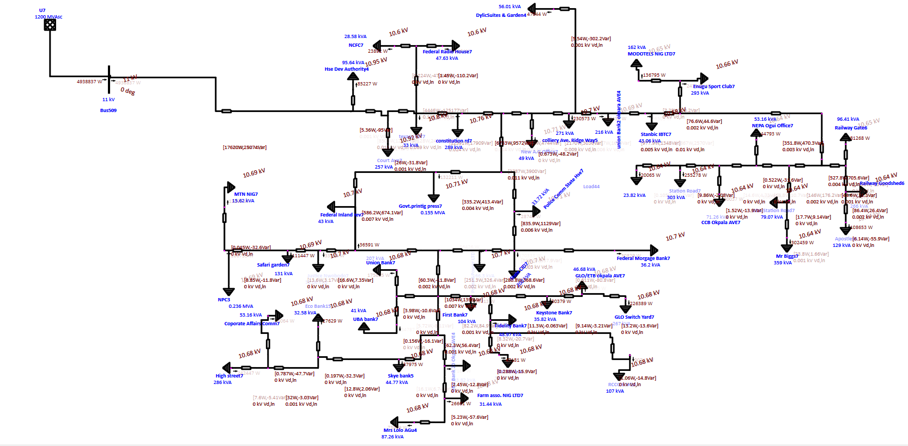
Figure 4: Voltage Profile of the Enugu 11 kV Feeder Under Base Case Operation

Steady-State Load Flow Results without DG
Table 2: Base case steady state load flow result without DG of Enugu distribution system
Bus ID | Nominal kV | Voltage
Bus505 | 11 | 10.678
Bus506 | 11 | 10.918
Bus507 | 11 | 10.945
Bus509 | 11 | 11
Bus510 | 11 | 10.946
Bus511 | 11 | 10.92
Bus512 | 11 | 10.602
Bus513 | 11 | 10.601
Bus514 | 11 | 10.602
Bus515 | 11 | 10.8
Bus516 | 11 | 10.758
Bus517 | 11 | 10.711
Bus519 | 11 | 10.655
Bus520 | 11 | 10.656
Bus521 | 11 | 10.643
Bus522 | 11 | 10.644
Bus523 | 11 | 10.644
Bus524 | 11 | 10.643
Bus525 | 11 | 10.643
Bus526 | 11 | 10.643
Bus527 | 11 | 10.643
Bus528 | 11 | 10.644
Bus529 | 11 | 10.645
Bus530 | 11 | 10.646
Bus531 | 11 | 10.641
Bus532 | 11 | 10.642
Bus533 | 11 | 10.646
Bus534 | 11 | 10.648
Bus535 | 11 | 10.654
Bus536 | 11 | 10.659
Bus537 | 11 | 10.676
Bus538 | 11 | 10.685
Bus539 | 11 | 10.695
Bus540 | 11 | 10.711
Bus541 | 11 | 10.735
Bus542 | 11 | 10.697
Bus543 | 11 | 10.7
Bus544 | 11 | 10.701
Bus545 | 11 | 10.705
Bus546 | 11 | 10.715
Bus547 | 11 | 10.709
Bus548 | 11 | 10.694
Bus549 | 11 | 10.694
Bus550 | 11 | 10.695
Bus551 | 11 | 10.695
Bus552 | 11 | 10.696
Bus554 | 11 | 10.693
Bus555 | 11 | 10.68
Bus556 | 11 | 10.68
Bus557 | 11 | 10.681
Bus558 | 11 | 10.678
Bus559 | 11 | 10.676
Bus560 | 11 | 10.676
Bus561 | 11 | 10.676
Bus562 | 11 | 10.678
Bus563 | 11 | 10.678
Bus564 | 11 | 10.678
Bus565 | 11 | 10.678
Bus566 | 11 | 10.679
Bus567 | 11 | 10.679
Bus568 | 11 | 10.681
Bus569 | 11 | 10.677
Bus570 | 11 | 10.678
Bus571 | 11 | 10.678
Bus572 | 11 | 10.679
Bus573 | 11 | 10.678
Bus574 | 11 | 10.678
Bus600 | 11 | 10.694

Base Case Load Flow Alert Assessment (Without DG Interconnection)
The base case load flow analysis represents the operating condition of the Enugu 11 kV distribution network without any interconnection of the hybrid distributed generation system. Voltage performance was evaluated using the ETAP alert criteria defined for this study.
For voltage monitoring, the following limits were applied:
- Critical under-voltage: below 95% of nominal voltage
- Marginal under-voltage: below 98% of nominal voltage
- Critical over-voltage: above 105% of nominal voltage
- Marginal over-voltage: above 102% of nominal voltage
For an 11 kV system, these thresholds correspond to:
- 98% limit: 10.78 kV
- 95% limit: 10.45 kV
The results show that a large proportion of the buses operate below the 98% marginal under-voltage threshold. Most bus voltages fall within the range of approximately 10.60 kV to 10.72 kV, which corresponds to about 96.4% to 97.5% of the nominal voltage. As a result, these buses are classified as marginal under-voltage buses under the defined alert criteria.
Notably, several buses operate very close to the lower end of this range. For example, buses such as Bus512, Bus513, and Bus514 record voltages of approximately 10.60 kV, indicating significant voltage drop along the feeder. Although none of the buses violate the critical under-voltage limit of 95%, the widespread marginal violations indicate a stressed network operating near unacceptable voltage conditions.
Only a small number of buses, such as Bus509, maintain voltage at or very close to the nominal value. These buses are electrically closer to the source and experience minimal voltage drop. No instances of over-voltage were observed in the base case, confirming that the dominant issue in the network is voltage depression rather than voltage rise.
Overall, the alert assessment highlights a systemic voltage weakness in the Enugu distribution network under peak load conditions. While the network avoids critical voltage collapse, the prevalence of marginal under-voltage across most buses indicates poor voltage regulation and limited voltage support capability in the absence of distributed generation. This condition justifies the integration of the hybrid distributed generation system as a voltage support mechanism, which is analysed in subsequent sections.
Identification of Critical Under-Voltage Nodes and Violations
This section focuses on locating and interpreting under-voltage conditions in the base case, using the alert thresholds already defined in the load flow analysis. The aim is not just to flag violations, but to understand how voltage weakness develops spatially along the feeder.
Using the ETAP alert settings, under-voltage conditions are classified as follows for the 11 kV network:
- Marginal under-voltage: voltage below 98% of nominal, that is below 10.78 kV
- Critical under-voltage: voltage below 95% of nominal, that is below 10.45 kV
An examination of the base case results shows that no bus falls below the critical under-voltage threshold. In that strict sense, the system does not experience voltage collapse or severe violation under the studied loading condition. That matters, because it tells us the network is still technically operable.
A much more revealing pattern appears when marginal violations are considered. The majority of buses operate below the 98% threshold, indicating widespread marginal under-voltage across the network. From Bus505 onwards, voltage steadily declines as electrical distance from the source increases. Many buses record voltages in the range of 10.60–10.72 kV, corresponding to approximately 96.4–97.5% of nominal voltage.
Buses such as Bus512, Bus513, and Bus514, each operating at about 10.60 kV, represent the weakest voltage points in the network. These buses are electrically remote and lie downstream of several load aggregation points. Their voltage levels sit uncomfortably close to the critical threshold, leaving little margin for additional load growth, switching events, or contingency conditions.
Beyond these weakest nodes, a long stretch of the feeder, including buses Bus519 through Bus536, remains consistently below the marginal limit. The voltage variation across this section is small, but persistently low. This flat but depressed voltage profile is characteristic of radial distribution systems with high resistance-to-reactance ratios, where cumulative voltage drop dominates rather than isolated local effects.
Closer to the source, buses such as Bus509 maintain voltages at or near the nominal value. These buses do not violate any alert limits and serve as reference points that clearly show how voltage degradation progresses along the feeder length.
Taken together, the results indicate that the base case network suffers from systemic marginal under-voltage rather than isolated critical failures. While no single bus triggers a critical alert, the widespread nature of the marginal violations points to inadequate voltage support throughout much of the feeder. From an operational perspective, this condition is undesirable. Equipment connected at these buses may experience reduced performance, and the network has limited resilience to further loading or disturbances.
This pattern of under-voltage forms a clear technical justification for introducing distributed generation in later scenarios. Any meaningful improvement should be judged not only by the elimination of critical violations, but by the reduction or removal of these marginal under-voltage conditions across the feeder.
Post-DG Integration Performance
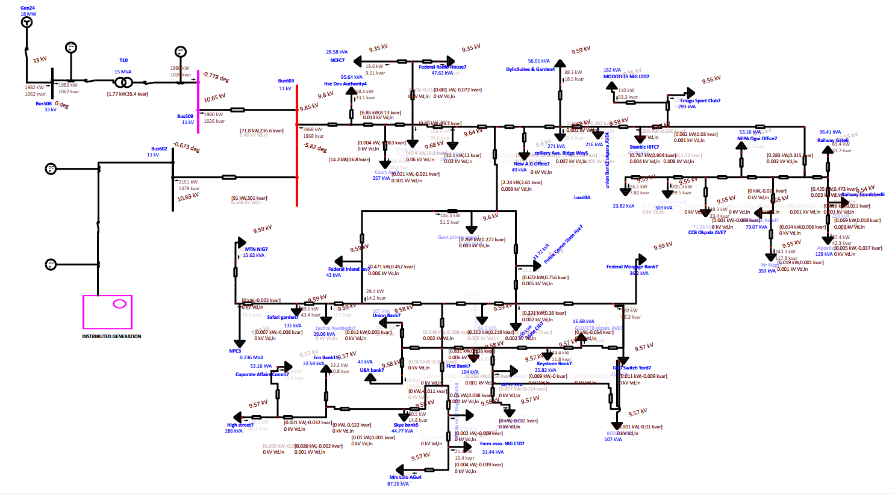
Figure 5: Voltage Profile of the Enugu 11 kV Feeder After Hybrid DG Integration

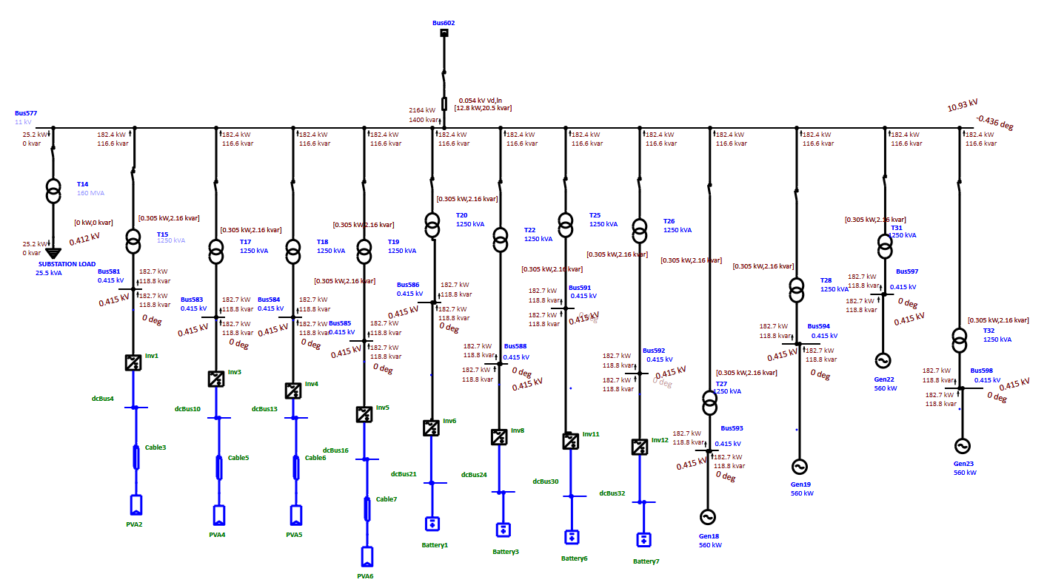
Figure 6: Voltage Profile of the Hybrid DG after Integration
Voltage Profile Improvement following DG Deployment
Table 3: Post-DG Steady-State Load Flow Results for the Enugu 11 kV Network
Bus ID | Nominal kV | Voltage
Bus505 | 11 | 10.762
Bus506 | 11 | 11.004
Bus507 | 11 | 11.032
Bus508 | 33 | 33
Bus509 | 11 | 11.087
Bus510 | 11 | 11.033
Bus511 | 11 | 11.006
Bus512 | 11 | 10.685
Bus513 | 11 | 10.685
Bus514 | 11 | 10.685
Bus515 | 11 | 10.885
Bus516 | 11 | 10.843
Bus517 | 11 | 10.795
Bus519 | 11 | 10.739
Bus520 | 11 | 10.74
Bus521 | 11 | 10.727
Bus522 | 11 | 10.728
Bus523 | 11 | 10.728
Bus524 | 11 | 10.727
Bus525 | 11 | 10.727
Bus526 | 11 | 10.727
Bus527 | 11 | 10.727
Bus528 | 11 | 10.728
Bus529 | 11 | 10.729
Bus530 | 11 | 10.73
Bus531 | 11 | 10.725
Bus532 | 11 | 10.726
Bus533 | 11 | 10.73
Bus534 | 11 | 10.732
Bus535 | 11 | 10.738
Bus536 | 11 | 10.743
Bus537 | 11 | 10.76
Bus538 | 11 | 10.77
Bus539 | 11 | 10.78
Bus540 | 11 | 10.795
Bus541 | 11 | 10.819
Bus542 | 11 | 10.781
Bus543 | 11 | 10.785
Bus544 | 11 | 10.785
Bus545 | 11 | 10.79
Bus546 | 11 | 10.799
Bus547 | 11 | 10.793
Bus548 | 11 | 10.779
Bus549 | 11 | 10.779
Bus550 | 11 | 10.779
Bus551 | 11 | 10.78
Bus552 | 11 | 10.781
Bus554 | 11 | 10.777
Bus555 | 11 | 10.765
Bus556 | 11 | 10.765
Bus557 | 11 | 10.765
Bus558 | 11 | 10.762
Bus559 | 11 | 10.76
Bus560 | 11 | 10.76
Bus561 | 11 | 10.76
Bus562 | 11 | 10.762
Bus563 | 11 | 10.763
Bus564 | 11 | 10.762
Bus565 | 11 | 10.762
Bus566 | 11 | 10.763
Bus567 | 11 | 10.763
Bus568 | 11 | 10.765
Bus569 | 11 | 10.761
Bus570 | 11 | 10.762
Bus571 | 11 | 10.763
Bus572 | 11 | 10.763
Bus573 | 11 | 10.762
Bus574 | 11 | 10.762
Bus577 | 11 | 11
Bus579 | 0.415 | 0.415
Bus581 | 0.415 | 0.415
Bus583 | 0.415 | 0.415
Bus584 | 0.415 | 0.415
Bus585 | 0.415 | 0.415
Bus586 | 0.415 | 0.415
Bus588 | 0.415 | 0.415
Bus591 | 0.415 | 0.415
Bus592 | 0.415 | 0.415
Bus593 | 0.415 | 0.415
Bus594 | 0.415 | 0.415
Bus597 | 0.415 | 0.415
Bus598 | 0.415 | 0.415
Bus600 | 11 | 10.778

Discussion of Findings
The voltage performance of the Enugu Electricity Distribution System (EEDS) was analysed under two operating conditions:
• Base case without hybrid distributed generation (DG)
• Integrated hybrid DG scenario
The base case exhibited widespread undervoltage conditions along the 11 kV feeder, with voltages ranging from 10.601 kV to 11.0 kV.
The weakest buses (Bus512–Bus514) recorded approximately:
$$10.601\text{ kV}⇒-3.63\%$$
Although within the ±5% statutory limit, the voltage margin was low and indicative of feeder drop due to line impedance and load demand.
After DG integration, the minimum voltage increased to approximately 10.685 kV, corresponding to: $-2.86\%$
This represents a measurable reduction in voltage deviation.

Voltage Deviation and Improvement Analysis

Minimum Voltage Improvement
Condition | Minimum Voltage (kV) | Deviation from 11 kV
Without DG | 10.601 | −3.63%
With DG | 10.685 | −2.86%
Voltage improvement at weakest buses:
$$\frac{10.685-10.601}{10.601}×100≈0.79\%$$
Thus, DG integration improved the worst-case bus voltage by approximately 0.79%.

Selected Bus-by-Bus Voltage Improvement Table
Table 4: Table for critical and mid-feeder buses.
Bus | Base (kV) | With DG (kV) | Base Dev (%) | DG Dev (%) | Improvement (%)
Bus505 | 10.678 | 10.762 | −2.93 | −2.16 | 0.79
Bus506 | 10.918 | 11.004 | −0.75 | +0.04 | 0.79
Bus507 | 10.945 | 11.032 | −0.50 | +0.29 | 0.80
Bus512 | 10.602 | 10.685 | −3.63 | −2.86 | 0.78
Bus519 | 10.655 | 10.739 | −3.14 | −2.37 | 0.79
Bus531 | 10.641 | 10.725 | −3.26 | −2.50 | 0.79
Bus541 | 10.735 | 10.819 | −2.41 | −1.64 | 0.78
Bus555 | 10.680 | 10.765 | −2.91 | −2.14 | 0.80
Bus570 | 10.678 | 10.762 | −2.93 | −2.16 | 0.79
Bus600 | 10.694 | 10.778 | −2.78 | −2.02 | 0.79
Observation:
The improvement across buses is consistently around 0.78–0.80%, indicating uniform feeder relief rather than isolated local voltage rise.
This confirms that the hybrid DG reduced feeder current magnitude and consequently reduced voltage drop along the line impedance.
Interpretation of Voltage Regulation Success in EEDS
The results indicate that the integration of hybrid distributed generation (DG) into the EEDS achieved measurable voltage enhancement, though full restoration to the nominal 11 kV level was not attained across the network. The minimum bus voltage increased by approximately 0.084 kV, representing an improvement of about 0.79% relative to the base case. In addition, the average feeder voltage increased in a largely uniform manner, suggesting that the DG reduced overall feeder loading rather than producing isolated localised voltage rises. Importantly, no bus exceeded the +5% statutory overvoltage limit. The highest recorded voltage occurred at Bus509, where the voltage reached 11.087 kV. This corresponds to a deviation of approximately +0.79%, calculated as $(11.087-11)/11×100$. Although this remains within acceptable regulatory tolerance, it signals the early onset of reverse power flow effects near upstream sections of the feeder.
It is important to note that voltage regulation in this study was achieved primarily through reduced feeder current and associated reduction in line voltage drop, rather than through transformer tap action, since on-load tap changers (LTCs) were not modelled. Consequently, voltage support resulted mainly from real power injection by the hybrid DG units and the accompanying decrease in line current magnitude. Overall, the hybrid DG integration in EEDS improved the minimum bus voltage by approximately 0.79%, reduced feeder-wide voltage drop, introduced mild upstream voltage rise, and maintained all buses within the ±5% statutory limits. The improvement, while technically meaningful, remains modest. This indicates that low-voltage-connected hybrid DG enhances the voltage profile chiefly through feeder current reduction rather than through active voltage regulation at the 11 kV level. The findings therefore demonstrate that DG penetration improves steady-state voltage performance; however, coordinated reactive power control strategies or direct medium-voltage-level integration would be required to achieve full nominal voltage restoration across the network.
CONCLUSION
This study evaluated the influence of hybrid Distributed Generation (DG) on the voltage performance of a representative 11 kV radial feeder within the Enugu Electricity Distribution System (EEDS). Using load flow simulations carried out in ETAP, the network was analysed under two operating conditions: a base case without DG and a DG-integrated scenario incorporating synchronous generators, solar photovoltaic systems, and battery storage units. The base case results revealed widespread marginal under-voltage conditions across the feeder. Although no bus violated the critical 95% statutory limit, the majority of buses operated below the 98% marginal threshold, with the weakest nodes recording a minimum voltage of 10.601 kV (approximately 96.37% of nominal). This pattern confirmed systemic voltage depression caused by feeder impedance, cumulative loading, and the inherent characteristics of long radial distribution networks.
Following the integration of hybrid DG, measurable improvement in voltage performance was observed. The minimum bus voltage increased to 10.685 kV (approximately 97.14% of nominal), representing an absolute improvement of 0.084 kV or about 0.79%. The improvement was largely uniform across the feeder, indicating that DG reduced feeder current magnitude and associated voltage drops rather than producing isolated localised voltage rise. Importantly, no bus exceeded the +5% statutory over-voltage limit, although mild upstream voltage rise was observed near generator connection points. Overall, the results demonstrate that moderate DG penetration enhances steady-state voltage performance in the Enugu distribution network, primarily through feeder current relief. However, full restoration to nominal voltage levels was not achieved, suggesting that higher penetration levels, reactive power control strategies, or direct medium-voltage DG integration would be required for stronger voltage regulation. The study therefore confirms that hybrid distributed generation provides technically meaningful but modest voltage support in weak radial distribution systems such as EEDS.
References
Ackermann, T., Andersson, G., & Söder, L. (2001). Distributed generation: A definition. Electric Power Systems Research, 57(3), 195–204.
Adewuyi, O. B., Shigenobu, K., Ooya, K., Senjyu, T., & Howe, E. R. (2019). Static voltage stability improvement and power loss reduction through optimal allocation of DG in the Nigerian 330kV transmission network. International Journal of Sustainable Energy Planning and Management, 21, 55–68.
Agalgaonkar, Y. P., Kulkarni, S. V., & Khaparde, S. A. (2006). Evaluation of transition between operation modes of distributed generation. IEEE Power Engineering Society General Meeting.
Amadi, H. N., Okafor, E. N. C., & Izuegbunam, F. I. (2016). Assessment of power quality in the Nigerian distribution network: A case study of Enugu metropolis. Journal of Electrical and Electronics Engineering, 11(4), 1–9.
Anumaka, M. C. (2023). Simulation and analysis of distributed generation on distribution networks: A Nigerian perspective. African Journal of Engineering and Technology, 5(1), 12–25.
Bari, A. S., Zeineldin, H. H., & El-Saadany, E. F. (2012). Impact of network topology on the performance of distribution systems with distributed generation. IEEE Power and Energy Society General Meeting.
Barker, P. P., & De Mello, R. W. (2000). Determining the impact of distributed generation on power systems: Part 1 - Radial distribution systems. 2000 Power Engineering Society Summer Meeting.
Bayliss, C., & Hardy, B. (2012). Transmission and Distribution Electrical Engineering (4th ed.). Elsevier.
Bollen, M. H. (2000). Understanding Power Quality Problems: Voltage Sags and Interruptions. IEEE Press.
Borges, C. L., & Falcao, D. M. (2006). Optimal distributed generation allocation for reliability, losses, and voltage improvement. International Journal of Electrical Power & Energy Systems, 28(6), 413–420.
Calderaro, V., Galdi, V., Lamberti, F., & Piccolo, A. (2014). Local control of voltage regulators and DG units for maximum power export. Electric Power Systems Research, 110, 52–60.
Chambers, A. (2001). Distributed Generation: A Nontechnical Guide. PennWell Books.
Chiradeja, P., & Ramakumar, R. (2004). An approach to quantify the technical benefits of distributed generation. IEEE Transactions on Energy Conversion, 19(4), 764–773.
Dugan, R. C., McGranaghan, M. F., Santoso, S., & Beaty, H. W. (2012). Electrical Power Systems Quality (3rd ed.). McGraw-Hill Education.
Eghomien, E. P., Oghorada, O. J., & Adeniran, A. O. (2021). Mitigation of voltage instability in radial distribution systems using capacitor banks: A case study of Nigerian feeders. Journal of Engineering Research, 26(2), 45–58.
Ekeoke, C., Okedu, K. E., & Uhunmwangho, R. (2020). Improving the voltage profile of the Nigerian 33kV distribution network using distributed generation. International Journal of Smart Grid, 4(2), 70–78.
El-Khattam, W., & Salama, M. M. (2004). Distributed generation technologies, definitions and benefits. Electric Power Systems Research, 71(2), 119–128.
Ezechukwu, O. A. (2021). Performance evaluation of the Enugu electricity distribution network: Challenges and prospects. Nigerian Journal of Technology, 40(3), 482–491.
Faulkenberry, L. M., & Coffer, W. (1996). Electrical Power Distribution and Transmission. Prentice Hall.
Fuchs, E., & Masoum, M. A. S. (2008). Power Quality in Power Systems and Electrical Machines. Academic Press.
Georgilakis, P. S., & Hatziargyriou, N. D. (2013). Optimal distributed generation placement in distribution networks: Models, methods and future research. IEEE Transactions on Power Systems, 28(3), 3420–3428.
Gonen, T. (2014). Electric Power Distribution System Engineering (3rd ed.). CRC Press.
Griffin, T., Tomsovic, K., Secrest, D., & Law, A. (2000). Placement of dispersed generation systems for voltage support. Proceedings of the 33rd Hawaii International Conference on System Sciences.
Hatti, M., Tioursi, M., & El-Hadjari, B. (2011). Impact of distributed generation on voltage profile and losses in distribution systems. Journal of Electrical Engineering, 11(2), 15–22.
Hung, D. Q., Mithulananthan, N., & Bansal, R. C. (2010). Analytical expressions for DG allocation in primary distribution networks to minimize loss. IEEE Transactions on Energy Conversion, 25(3), 814–820.
Ibe, A. O., & Okeke, C. (2020). Limitations of generic IEEE test systems in modelling Nigerian radial distribution networks. Journal of Control Science and Engineering, 8(1), 101–110.
Idoniboyeobu, D. C., Ogujor, E. A., & Wokoma, B. A. (2018). Impact of long feeders on voltage profile in Nigeria’s distribution network: A case study of Port Harcourt. International Journal of Engineering and Science, 7(5), 44–52.
IEEE Std 1159. (2019). IEEE Recommended Practice for Monitoring Electric Power Quality. IEEE.
International Electrotechnical Commission. (2009). IEC 60038: IEC standard voltages. IEC.
Jenkins, N., Ekanayake, J. B., & Strbac, G. (2010). Distributed Generation. Institution of Engineering and Technology.
Kacejko, P., Pijarski, P., & Gałązka, K. (2022). Power quality and reliability in distribution networks with a high share of RES. Energies, 15(19), 7114.
Kandary, A., & El-Hashimy, A. (2016). Voltage drop analysis in radial distribution feeders. International Journal of Electrical and Computer Engineering, 6(4), 1350–1358.
Kaur, S., Kumbhar, G. B., & Sharma, J. (2014). A comparative study of stopping criteria for genetic algorithm based optimal DG placement. International Conference on Power, Control and Embedded Systems (ICPCES).
Kersting, W. H. (2017). Distribution System Modeling and Analysis (4th ed.). CRC Press.
Kueck, J. D., Rizy, D. T., & Li, F. (2004). Local Voltage Control with Distributed Resources. Oak Ridge National Laboratory (ORNL).
Kundur, P. (1994). Power System Stability and Control. McGraw-Hill Education.
Lasseter, R. H. (2011). Smart Grids: Realising the benefits of distribution systems. IEEE Power and Energy Magazine, 9(2), 40–48.
Madueme, T. C., Onyia, E. C., & Agbo, C. O. (2022). Data-driven analysis of Enugu electricity distribution feeders: A case for local load modelling. Journal of Energy in Southern Africa, 33(2), 114–126.
Masters, C. L. (2002). Voltage rise: The bottleneck in connecting DG to 11kV distribution networks. Power Engineering Journal, 16(5), 205–209.
Miu, K. N., & Chiang, H. D. (2000). Existence, uniqueness and stability of SVR solutions in radial distribution systems. IEEE Transactions on Power Systems, 15(1), 67–73.
Murty, P. S. R. (2017). Operation and Control in Power Systems. CRC Press.
Nwafor, O. M., & Udoye, J. C. (2021). Barriers to distributed generation deployment in the South-East Nigerian power grid. Renewable and Sustainable Energy Reviews, 142, 110–125.
Obi, K. C., Eke, J., & Chinwuko, E. C. (2023). Simulation of solar PV integration on the Enugu 11kV distribution network. Nigerian Journal of Solar Energy, 34(1), 88–97.
Oghorada, O. J., & Oyeyemi, T. K. (2019). Technical assessment of the Nigerian power distribution sector. Journal of Applied Sciences and Environmental Management, 23(1), 175–181.
Okafor, E. N. C., Hofman, W., & Sastry, V. V. (2017). Reliability assessment of the Nigerian electric power distribution sector. 2017 IEEE PES PowerAfrica.
Okereke, C. U. (2015). Impacts of urbanisation on the Nigerian power distribution infrastructure. Journal of Sustainable Development, 8(4), 56–68.
Onah, A. J., Igwue, G. A., & Anyasi, F. I. (2022). Evaluation of distributed generation on voltage profile of weak distribution networks in Nigeria. Journal of Engineering and Applied Sciences, 17(4), 142–155.
Onojo, O. J., Idoniboyeobu, D. C., & Braide, S. L. (2018). Investigation of voltage profile of 33kV Nigerian distribution network: A case study of Owerri. Journal of Newviews in Engineering and Technology, 1(1), 40–49.
Pabla, A. S. (2011). Electric Power Distribution (6th ed.). McGraw-Hill Education.
Pepermans, G., Driesen, J., Haeseldonckx, D., Belmans, R., & D’haeseleer, W. (2005). Distributed generation: Definition, benefits and issues. Energy Policy, 33(6), 787–798.
Pilo, F., Pisano, G., & Soma, G. G. (2011). Optimal planning of active distribution networks. IEEE Transactions on Power Systems, 26(4), 2316–2327.
Rau, N. S., & Wan, Y. H. (1994). Optimum location of resources in a network. IEEE Transactions on Power Systems, 9(4), 2014–2020.
Short, T. A. (2018). Electric Power Distribution Handbook (2nd ed.). CRC Press.
Singh, D., Misra, R. K., & Singh, D. (2009). Effect of load models in distributed generation planning. IEEE Transactions on Power Systems, 24(1), 93–104.
Tan, W. S., Hassan, M. Y., Majid, M. S., & Abdul Rahman, H. (2013). Optimal distributed generation sizing and allocation: A review. Renewable and Sustainable Energy Reviews, 11(21), 156–167.
Tonkoski, R., Lopes, L. A., & El-Fouly, T. H. (2012). Coordinated active power curtailment of grid connected PV inverters for overvoltage prevention. IEEE Transactions on Sustainable Energy, 3(1), 23–35.
Umar, M. S., Ahmed, A. S., & Yakubu, A. T. (2021). Comparison of voltage performance in Nigerian radial feeders before and after DG integration. Journal of Multidisciplinary Engineering, 9(3), 200–215.
Viawan, F. A., & Karlsson, D. (2008). Combined local and remote voltage control in distribution systems with distributed generation. IEEE Transactions on Power Delivery, 23(3), 1263–1272.
Viral, R., & Khatod, D. K. (2012). Optimal planning of distributed generation systems in distribution system: A review. Renewable and Sustainable Energy Reviews, 16(7), 5146–5165.
Vovos, P. N., Kiprakis, A. E., Wallace, A. R., & Harrison, G. P. (2007). Centralised and distributed voltage control: Impact on distributed generation penetration. IEEE Transactions on Power Systems, 22(1), 476–483.
Willis, H. L. (2000). Power Distribution Planning Reference Book (2nd ed.). CRC Press.
Willis, H. L., & Scott, W. G. (2000). Distributed Power Generation: Planning and Evaluation. CRC Press.
Zhu, J. (2015). Optimization of Power System Operation (2nd ed.). IEEE Press/Wiley.

