A DESCRIPTIVE STUDY TO ASSESS THE KNOWLEDGE, ATTITUDE
AND PRACTICE REGARDING THE ILL EFFECTS OF PROLONGED
USE OF IN-EAR AUDIO DEVICES AMONG BSC NURSING
STUDENTS IN A SELECTED COLLEGE, KOZHIKODE

ABSTRACT
Hearing loss, particularly due to noise exposure is a growing public health concern, especially among young adults. The widespread use of personal audio devices at high volume levels has been linked to noise-induced hearing loss (NIHL). The present study aims to assess the knowledge, attitude, and practice (KAP) regarding the ill-effects of prolonged use of in-ear audio devices among BSc. nursing students in a selected college at Kozhikode. The objectives of the study were: to assess the knowledge of nursing students on the ill effects of prolonged usage of in- ear audio devices, to assess the attitude of nursing students towards the prolonged use of in-ear audio devices, to assess the practice of prolonged usage of in-ear audio devices, to find out the association between knowledge, attitude and practice with demographic variables. The conceptual framework was based on Health Belief Model. The tools used included socio-demographic performa, self-structured knowledge questionnaire, attitude rating scale and practice checklist. A pilot study was conducted, followed by data collection among 270 BSc nursing students. The data collected were tabulated and analysed. The findings showed, 42% (113 students) have good knowledge, 51% (139 students) have adequate knowledge, 7% (18 students) have poor knowledge. 50% (136 students) have good attitude, 50% (134 students) have average attitude. 58% (156 students) have good level of practice, 40% (107 students) have average level of practice, 2% (7 students) have poor level of practice. The study emphasizes the importance of health education and awareness programs regarding the safe use of audio devices.
Key words: Knowledge, attitude, practice, in-ear audio devices, ill- effects, prolonged earphone use.

INTRODUCTION
In recent years, the use of in-ear audio devices such as earphones and earbuds has significantly increased, especially among young adults. While these devices provide convenience and privacy, their prolonged use at high volumes raises concern about hearing impairment. Despite the growing prevalence of hearing loss among headphone users, many remain unaware of the risks of sustained exposure to loud audio levels.
This study investigates the knowledge, attitude, and practice of BSc. Nursing students regarding these risks, as future healthcare professionals must be informed and cautious in their personal and professional lives.

PROBLEM STATEMENT
“A descriptive study to assess the knowledge, attitude and practice regarding the ill-effects of prolonged use of in-ear audio devices among BSc Nursing students in a selected college, Kozhikode”.

OBJECTIVES
1. To assess the knowledge of nursing students on the ill effects of prolonged usage of in- ear audio devices.
2. To assess the attitude of nursing students towards the prolonged use of in-ear audio devices.
3. To assess the practice of prolonged usage of in-ear audio devices.
4. To find out the association between knowledge, attitude and practice with demographic variables.

HYPOTHESIS

H1: There is a significant association between the selected demographic variables and the knowledge, attitude and practice regarding the ill effects of prolonged use of in-ear audio devices among BSc Nursing students.
METHODOLOGY
Research approach: Quantitative approach
Research design: Descriptive design
Population: BSc Nursing students of a selected college in Kozhikode

Sample size: 270
Sampling technique: Convenient sampling technique.
Sampling criteria:
Inclusion criteria:
- BSc nursing students who are currently enrolled in KMCT College of Nursing.
- Students who use in-ear audio devices (e.g., earphones, earbuds)
- Students who are willing to participate in the study.
- Students who are available during the data collection period.

Exclusion criteria:
- Students with known hearing impairments or pre-existing ear disorders (e.g., chronic otitis media, congenital hearing loss).
- Students who do not use audio devices at all.
- Students who are absent or unavailable during the time of data collection.
- Students who refuse to give informed consent.
Setting of study: The study was conducted among nursing students who are studying BSc. Nursing in KMCT College of Nursing.

VARIABLES
Dependent Variable: Knowledge, attitude, practice regarding ill-effects of prolonged use of in-ear audio devices.
Independent variable: Age, gender, year of study, duration of in-ear audio device use, type of in-ear audio device used, preferred volume level, average daily listening time.

TOOL
Section A: Demographic data
It consists of 8 questions to collect age, gender, year of study, duration of in-ear audio device use, type of in-ear audio device used, preferred volume level, average daily listening time.
Section B: Knowledge questionnaire
It consists of 15 questions to assess the knowledge of students regarding ill effects of prolonged use of in-ear audio devices.
Section C: Attitude scale
It consists of 15 questions to assess the attitude of students regarding the ill-effects of prolonged use of in-ear audio devices.
Section D: Practice checklist
It consists of 15 questions to assess the practice of students regarding the ill-effects of prolonged use of in-ear audio devices.

DATA COLLECTION
Data collection was started after obtaining clearance from ethics committee and permission from ethical authorities at KMCT College of Nursing. The subjects were selected by non-probability purposive/convenient sampling.

ETHICAL CONSIDERATION
The research proposal was presented in front of research committee of KMCT College of Nursing and approval was obtained. Ethical clearance for the study was obtained from KMCT ethics committee. Informed consent was obtained from the subjects.

RESULTS
According to the study, the results showed, 42% (113 students) have good knowledge, 51% (139 students) have adequate knowledge, 7% (18 students) have poor knowledge. 50% (136 students) have good attitude, 50% (134 students) have average attitude. 58% (156 students) have good level of practice, 40% (107 students) have average level of practice, 2% (7 students) have poor level of practice. The association was found between knowledge and gender (P = 5.42941*10⁻⁶⁾, knowledge and type of device (p=0.0133), knowledge and volume level used (p=0.0124), attitude and gender (p= 0.0207), practice and gender (p=0.0105), practice and daily duration of use (p=8.1712*10⁻⁶), practice and volume level used (p= 0.0032).

Section 1
DEMOGRAPGIC VARIABLES | FREQUENCY | PERCENTAGE
AGE  18-20 years  21-23 years  24-26 years | 131  134  5 | 48.5%  49.6%  1.9%
SEX  Male  Female | 68  202 | 25.5%  74.8%
YEAR OF STUDY  2nd semester  4th semester  6th semester  7th semester | 81  80  53  56 | 30%  29.6%  19.6%  20.7%
AVERAGE DAILY DURATION OF USE PER  DAY  Less than 1 hour  1-2 hours  3-4 hours  More than 4 hours | 114  109  36 11 | 42.2%  40.4%  13.3%  4.1%
TYPE OF DEVICE USED  Wired earphones  Wireless earbuds  Headphones | 61  185  24 | 22.6%  68.5%  8.9%
VOLUME LEVEL USUALLY USED  Low  Medium  High | 39  199  32 | 14.4%  73.7%  11.9%
USING IN- EAR AUDIO DEVICES WHILE  Studying  Traveling  Sleeping  Exercising  Others | 15  158  21  7  69 | 5.6%  58.5%  7.8%  2.6%  25.6%
Table 4.1. Frequency (percentage) distribution of socio demographic characteristics of the sample

Section 2
Analysis of knowledge level of students regarding the ill-effects of prolonged use of earphones.

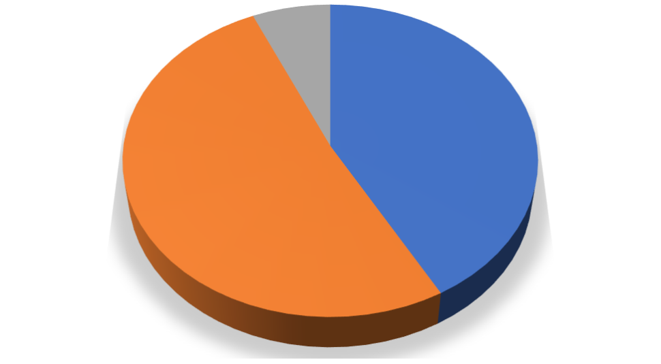 Figure 4.1 shows that 18 members have poor, 139 members have average and 113 members have good knowledge respectively.

113
,
42
%
139
,
51
%
18
,
7
%
KNOWLEDGE
Good
Average
Poor
Section 3
Analysis of attitude of students regarding the ill-effects of prolonged use of earphones.
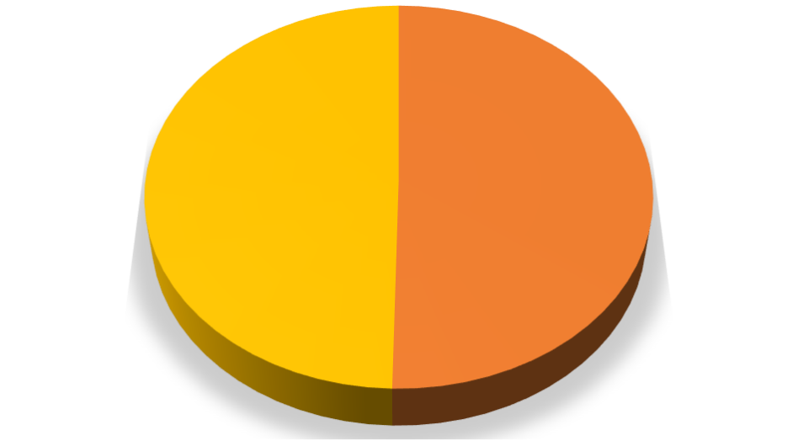
136
,
50
%
134
,
50
%
0
,
0
%
ATTITUDE
Positive
Neutral
Negative
Figure 4.2 shows that 0 had negative, 134 had neutral and 136 had positive attitude respectively.
Section 4
Analysis of level of practice of students regarding the ill-effects of prolonged use of earphones.
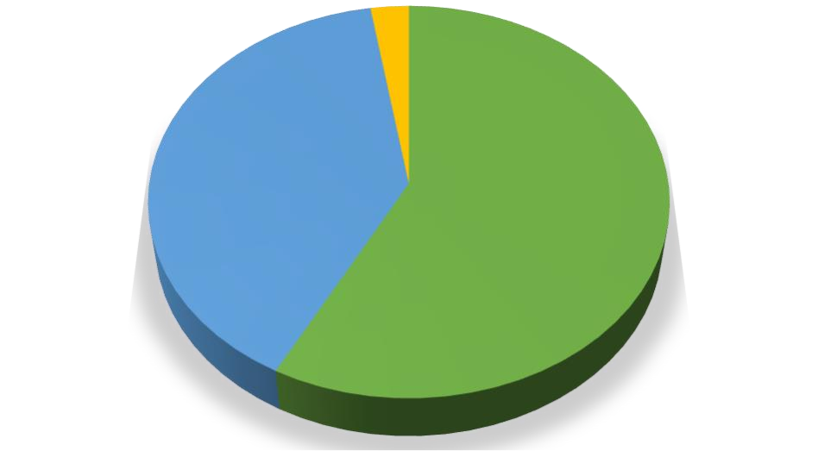

156
,
58
%
107
,
40
%
7
,
2
%
PRACTICE
Positive
Neutral
Negative
Figure 4.3 shows that 7 students have negative, 107 have neutral and 156 have positive practice respectively.
DISCUSSION
The present study was supported by similar study done by Shubhangi Borude, Vanshika Paduvil, Ganesh Jadhav, Komal Kelakar in 2024 on ‘Knowledge regarding harmful effects of continuous use of earphones among the teenagers’ residing in selected areas of Pune city, India. The research approach for the study is Quantitative approach and the research design is non - experimental, descriptive research design. 200 teenagers were selected for the study from selected areas and of Pune by using non - probability purposive sampling technique. The study revealed that among 200 samples more than half percentage of the teenagers (62%) are having average knowledge, whereas (38%) teenagers have good knowledge and (0%) have poor knowledge. That is the knowledge regarding harmful effects of continuous use of ear phones among teenagers of the study is 62%.

NURSING IMPLICATIONS

Nursing Practice
The study highlights the need for integrating preventive audiology practices into routine nursing care. Nurses, being key health educators, can take an active role in promoting safe listening habits among students through health education sessions, awareness programs, and by incorporating informational leaflets into clinical practice.

Nursing Administration
The results indicate the need for policy-level interventions within nursing institutions. Nurse administrators can use these findings to implement and support hearing health programs and awareness campaigns within the college. They can also facilitate workshops, distribute educational materials, and update institutional guidelines on safe technology use among students, in collaboration with other departments.

Nursing Education
Nurse educators should enhance their teaching strategies by incorporating modules on noise-induced hearing loss and safe listening habits. This topic can be integrated into community health nursing and ENT nursing curricula, allowing students to educate peers and the community during clinical postings and health talks.

Nursing Research
This study opens avenues for further research in the field of audiological health and behavioural practices among youth. Future research can focus on evaluating the effectiveness of interventions like educational modules, mobile apps for safe listening, and peer-led awareness programs to improve knowledge, attitude, and practice related to in-ear device usage.

LIMITATIONS
- Use of self-structured questionnaire: The study relied on self-structured questionnaire, which may have been influenced by social desirability bias or inaccurate recall.
- Limited generalizability: The sample may not represent the entire population, especially if restricted to a specific region, age group, or educational background.
- Technological variations: The study did not differentiate between types, brands, or quality of in-ear audio devices, which may influence health impacts.
- Lack of clinical correlation: No audiometric or medical examination was conducted to correlate reported usage with actual hearing health.
- Unaccounted confounders: Environmental factors, occupational noise exposure, and pre-existing hearing issues were not controlled for.

RECOMMENDATIONS
On the basis of the findings of the study, the following recommendations have been made;
- Similar study can be replicated on a large sample to validate and generalize the study findings.
- Conduct longitudinal studies to assess long-term effects of in-ear audio device usage.
- Include clinical audiological assessments to better correlate usage patterns with hearing loss.
- Expand study populations to include varied age groups and occupational backgrounds.

SUMMARY

This study assessed the knowledge, attitude, and practice regarding the ill-effects of prolonged in-ear audio device use among 270 BSc Nursing students at KMCT College of Nursing using a descriptive, non-experimental design. Findings revealed that 42% had good knowledge, 50% had a positive attitude, and 58% practiced safe usage, with significant associations between demographic factors (gender, device type, usage duration, volume levels) and outcomes. The study concluded that while many students demonstrate awareness, gaps remain, necessitating targeted interventions. Nursing implications include integrating preventive audiology into education, clinical practice, and institutional policies, while recommendations highlight the need for larger studies, longitudinal research, clinical audiological assessments, and broader population inclusion. Limitations include potential response bias, restricted generalizability, and lack of clinical hearing data. Overall, the findings emphasize the importance of promoting safe listening habits to mitigate auditory health risks among students.

REFERENCE
- Manimegalai M, Madhavi S & Kuzhanthaivel P (2025, April 30). A descriptive study to assess the impact of headphone usage on hearing acuity among students at dr. NGP Institute of Technology, Coimbatore. The Nursing Journal of India. https://www.tnaijournal-nji.com/full-text?id=qaCuhp4=
- Deafness ad hearing loss; WHO, 2 March 2021. https://www.who.int/news-room/fact-sheets/detail/deafness-and-hearingloss#:~:text=By%202050%2C%20nearly%202.5%20billion,of%20almost%20US $%201%20trillion
- Noise induced hearing loss among adults; Centre for Disease Control [CDC], 2 February 2017 https://www.cdc.gov/mmwr/volumes/66/wr/mm6605e3.htm
- Shubhangi borude et.al (2024), The Knowledge Regarding Harmful Effects Of Continuous Use Of Earphones Among The Teenagers., Educational Administration: Theory and Practice, 30(5), 8625 - 8628, Doi:
10.53555/kuey.v3015-4427 https://kuey.net/index.php/kuey/article/view/4427
- Das, J. J. (2020). Assessment of knowledge regarding the consequences of using earphones among higher secondary and non‑medical postgraduate students. International Journal of Community Medicine and Public Health, 7(10), 3924– 3930.
https://doi.org/10.18203/2394-6040.ijcmph20204355 https://www.researchgate.net/publication/345656157
- AlQahtani, Abdulaziz S; Alshammari, Ahmed N.b; Khalifah, Eyad M.c; Alnabri, Akram A.d; Aldarwish, Hadi A.d; Alshammari, Khaled F.d; Alshammari, Hamad F.d; Almudayni, Abdulkarim M.e. Awareness about the relation of noise induced hearing loss and use of headphones at Hail region. Annals of Medicine & Surgery
73():, January 2022. | DOI: 10.1016/j.amsu.2021.103113 https://doi.org/10.1016/j.amsu.2021.103113 https://www.sciencedirect.com/science/article/pii/S2049080121010633
- Herrera, S., Lacerda, A. B., Lürdes, D., Rocha, F., Alcaràs, P. A., & Ribeiro, L. H. (2016). Amplified music with headphones and its implications on hearing health in teens. The international tinnitus journal, 20(1),4247 https://pubmed.ncbi.nlm.nih.gov/27488993/

