Synchronous Squamous and Basal Cell Carcinoma in Oculocutaneous Albinism: A

Abstract
Oculocutaneous albinism (OCA) is a rare autosomal recessive disorder characterized by generalized deficiency of melanin pigment, which normally protects against ultraviolet (UV) radiation–induced DNA damage. Consequently, affected individuals are predisposed to cutaneous malignancies, most commonly squamous cell carcinoma (SCC), whereas basal cell carcinoma (BCC) occurs less frequently. The synchronous occurrence of SCC and BCC in a single patient with OCA is exceedingly uncommon.
We report a 41-year-old male with OCA who presented with ulcerated lesions over sun-exposed areas. Histopathological examination revealed two distinct tumors. One lesion showed features of SCC with nests and sheets of malignant squamous cells demonstrating nuclear pleomorphism and keratinization, and tumor cells exhibited strong nuclear positivity for p40 (ΔNp63 isoform of p63), confirming squamous differentiation. The second lesion demonstrated basaloid tumor nests with peripheral palisading and stromal retraction clefts, consistent with BCC, and showed cytoplasmic positivity for B-cell lymphoma 2 (BCL-2).
This case highlights the importance of careful clinical evaluation, histopathological examination, and immunohistochemistry in identifying synchronous malignancies in OCA. Early diagnosis and strict photoprotective measures are essential to reduce morbidity in individuals genetically susceptible to UV-induced skin cancers.
Keywords: Oculocutaneous albinism; squamous cell carcinoma; basal cell carcinoma; synchronous skin malignancy; p40; BCL-2; ultraviolet radiation; photoprotection; histopathology; immunohistochemistry.

Introduction
Oculocutaneous albinism (OCA) is an inherited disorder resulting from mutations in genes involved in melanin biosynthesis and melanosome formation, such as tyrosinase (TYR), OCA2, tyrosinase-related protein 1 (TYRP1), and solute carrier family 45 member 2 (SLC45A2)^{1,2}. Melanin mainly absorbs UVB and neutralizes reactive oxygen species ². In the absence of melanin, individuals with OCA are extremely sensitive to sunlight and have an increased risk of developing actinic keratoses and skin cancers, particularly in tropical regions with intense solar exposure ^{3,4}.
Among the cutaneous malignancies in OCA, squamous cell carcinoma (SCC) is the most prevalent, with a predilection for chronically sun-exposed areas^{3,4}. Basal cell carcinoma (BCC), although less frequent, also develops due to cumulative actinic damage and aberrations in the Hedgehog signalling pathway⁸. The simultaneous occurrence of both SCC and BCC in the same patient is extremely rare and has been reported only sporadically in the literature ⁵⁻⁷. This case report presents a rare instance of synchronous SCC and BCC in a patient with OCA and emphasizes the diagnostic role of immunohistochemical (IHC) markers p40 (ΔNp63 isoform of p63) and B-cell lymphoma 2 (BCL-2).
Case Presentation
A 41-year-old male farmer with a known history of oculocutaneous albinism presented with generalized depigmentation of the skin and hair, along with erythematous, ulcerated plaques over sun-exposed areas of the right wrist and right dorsolateral aspect of the forearm (Figure 1). The lesions bled easily on minimal trauma. The patient reported chronic occupational sun exposure without consistent use of photoprotective measures.
Two lesions were biopsied for histopathological evaluation. The right wrist lesion showed skin with an infiltrative epithelial tumor arising from the epidermis and extending into the dermis (Figure 2). The tumor was composed of nests, cords, and sheets of malignant squamous epithelial cells exhibiting nuclear pleomorphism, vesicular nuclei, prominent nucleoli, and abundant eosinophilic cytoplasm with individual cell keratinization (Figure 3). On IHC, the tumor cells showed strong nuclear positivity for p40, confirming squamous differentiation consistent with squamous cell carcinoma (SCC) (Figure 4).
The right dorsolateral forearm lesion showed a tumor arising from the basal layer of the epidermis extending into the dermis (Figure 5). The tumor was composed of nests and lobules of basaloid cells with hyperchromatic nuclei, scant cytoplasm, peripheral palisading, and retraction clefts between tumor nests and stroma (Figure 6). IHC showed cytoplasmic positivity for BCL-2, supporting the diagnosis of basal cell carcinoma (BCC) (Figure 7).
Discussion
OCA represents a spectrum of genetically heterogeneous conditions characterized by melanin deficiency in the skin, hair, and eyes ^{1,2}. The lack of melanin eliminates the natural UV-protective barrier, rendering patients vulnerable to actinic injury, DNA damage, and subsequent neoplastic transformation². Among the skin cancers, SCC is the most common in albino patients, with a reported incidence of up to 30% in equatorial regions³. In contrast, BCC is less frequent, accounting for about 5–10% of skin cancers in albinos ⁴.
SCC primarily develops due to UVB-induced mutations in the TP53 tumor suppressor gene, leading to keratinocyte dysplasia and malignant transformation². BCC arises mainly through aberrant activation of the Hedgehog signaling pathway, particularly mutations in PTCH1, which drive uncontrolled proliferation of basal keratinocytes⁸. The synchronous appearance of both tumors in an individual with OCA, as in this case, suggests cumulative UV-induced damage acting on different target cells within the epidermis^{2,8}.
Immunohistochemistry (IHC) is valuable in confirming the dual diagnosis. p40, an isoform of p63, is a highly specific nuclear marker for squamous differentiation and helps distinguish squamous cell carcinoma (SCC) from its histological mimics. B-cell lymphoma 2 (BCL-2), an anti-apoptotic cytoplasmic protein, shows strong expression in basal cell carcinoma (BCC) and assists in differentiating it from SCC and adnexal tumors⁹. Early recognition and accurate differentiation are crucial for guiding appropriate management and prognostication.
This case emphasizes the need for regular dermatological surveillance, prompt biopsy of any suspicious lesion, and rigorous photoprotection using broad-spectrum sunscreens, protective clothing, and avoidance of peak UV exposure.
Conclusions
The synchronous occurrence of SCC and BCC in oculocutaneous albinism is exceedingly rare but clinically important. This case highlights the need for a high index of suspicion and early histopathological and immunohistochemical confirmation using p40 and BCL-2. Rigorous photoprotection, patient education regarding sun avoidance, and regular clinical follow-up are essential to reduce morbidity in individuals with OCA.
References
- Montoliu L, Grønskov K, Wei AH, et al. Increasing the complexity: new genes and new types of albinism. Pigment Cell Melanoma Res. 2014;27(1):11–8. doi:10.1111/pcmr.12167
- Slominski A, Tobin DJ, Shibahara S, Wortsman J. Melanin pigmentation in mammalian skin and its hormonal regulation. Physiol Rev. 2004;84(4):1155–1228. doi:10.1152/physrev.00044.2003
- Lookingbill DP, Lookingbill GL, Leppard B. Actinic damage and skin cancer in albinos in northern Tanzania. Arch Dermatol. 1995;131(5):599–604. doi:10.1001/archderm.1995.01690170053006
- Kiprono SK, Chaula BM, Beltraminelli H. Histological review of skin cancers in African albinos. BMC Cancer. 2014;14:157. doi:10.1186/1471-2407-14-157
- Kawasaki M, Takayama Y, Okada T, Sugimoto T. Concurrent squamous cell carcinoma and basal cell carcinoma in a patient with oculocutaneous albinism. J Dermatol. 2020;47(4):e144–e146. doi:10.1111/1346-8138.15255.
- Kumar S, Saxena U. Squamous and basal cell carcinoma in an albino: report of two cases. Indian J Dermatol Venereol Leprol. 1999;65(5):238–239.
- Epstein EH. Basal cell carcinomas: attack of the hedgehog. Nat Rev Cancer. 2008;8(10):743–754. doi:10.1038/nrc2503.
- Chatterjee T, Chatterjee U, Banerjee D, Bandyopadhyay D. Basal cell carcinoma and actinic keratosis in an albino: a case report. Indian J Dermatol. 2009;54(2):181–182. doi:10.4103/0019-5154.53195.
- Rosai J. Rosai and Ackerman’s Surgical Pathology. 12th ed. Philadelphia: Elsevier; 2021.

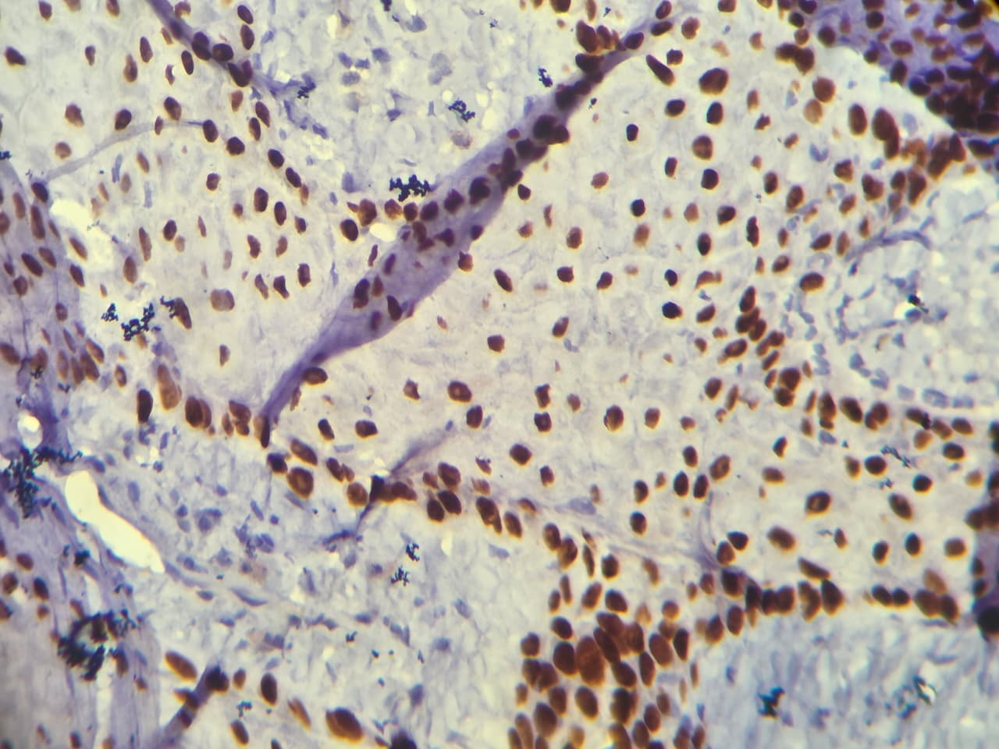
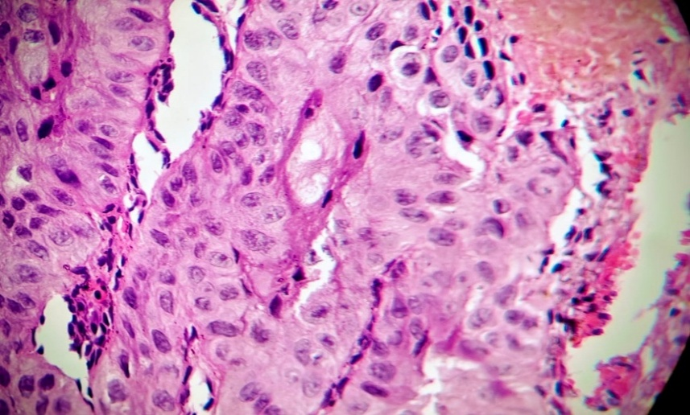
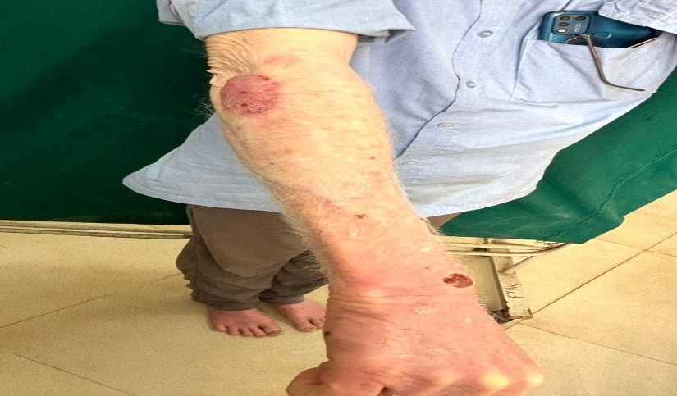
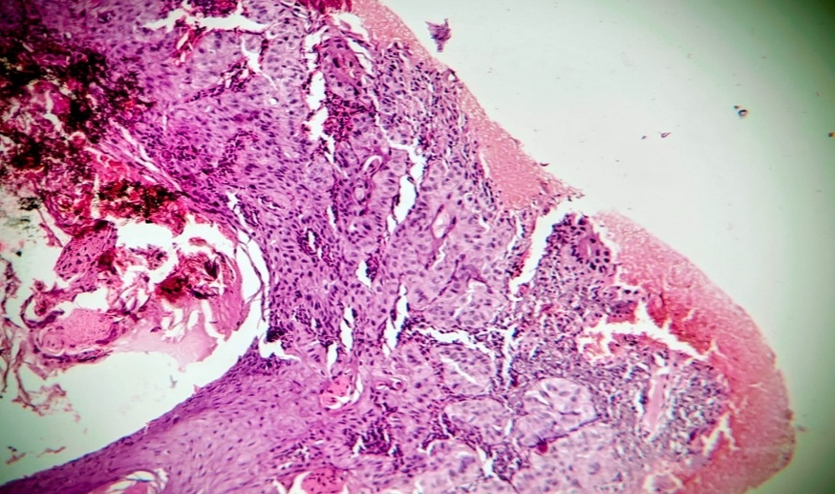
Figure 4: Immunohistochemistry showed strong nuclear positivity for p40, a specific marker for squamous differentiation, confirming the diagnosis of SCC
Figure 3:
High-power view of the squamous cell carcinoma displaying nests and sheets of malignant squamous cells with nuclear pleomorphism, vesicular nuclei, prominent nucleoli, and abundant eosinophilic cytoplasm with individual cell keratinization (H&E, 40x).
Figure 2:
Low-power photomicrograph of the right wrist lesion showing an infiltrative epithelial tumor arising from the epidermis and extending into the dermis (H&E, 10x).
Figure 1:
Clinical photograph showing generalized cutaneous and hair depigmentation consistent with oculocutaneous albinism, along with erythematous, ulcerated plaques over the right wrist and right dorsolateral forearm.
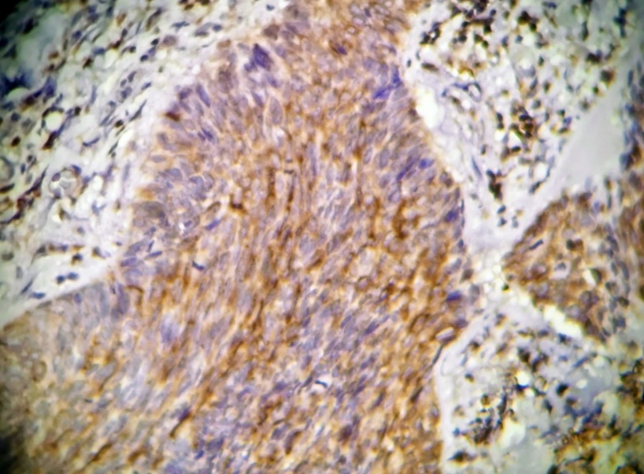
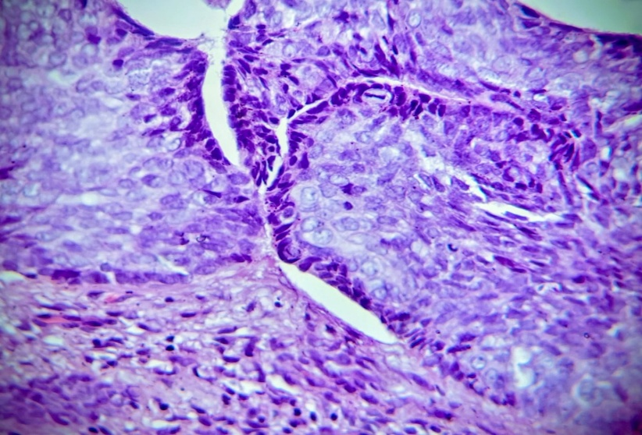
Figure 6:
High-power view of basal cell carcinoma composed of basaloid cell nests with hyperchromatic nuclei, peripheral palisading, and characteristic retraction clefts between tumor nests and surrounding stroma (H&E,40x).
Figure 5:
Low-power photomicrograph of the right dorsolateral forearm lesion showing a tumor arising from the basal layer of the epidermis and extending into the dermis (H&E, 10x).
Figure 7: Immunohistochemistry revealed cytoplasmic positivity for BCL-2, a specific marker for basal cell carcinoma, supporting the diagnosis of BCC
