A Comparative Study of Stress and Depression in Relation to Participation in Physical Education Among College Students

Abstract
Psychological well-being is an essential component of overall health and academic achievement among college students. Stress and depression are increasingly prevalent mental health concerns in higher education institutions. This study examines and compares levels of stress and depression among students actively participating in structured physical education programs and those with minimal physical activity involvement. A descriptive comparative research design was employed. Data were collected using standardized stress and depression assessment tools. Statistical techniques such as mean, standard deviation, independent t-test, and Pearson correlation were applied. The findings indicate that physically active students report significantly lower stress and depression levels compared to inactive students. The study concludes that regular participation in physical education programs plays a protective role in promoting mental health and emotional resilience.

Introduction
The modern educational environment exposes students to multiple academic, social, and personal challenges. Continuous academic evaluation, competitive examinations, career uncertainty, and peer expectations create psychological pressure. When coping resources are insufficient, students may experience stress, which can gradually lead to depressive symptoms if not managed effectively.
Stress is generally defined as the body's psychological and physiological response to demands or threats. Depression, in contrast, is a prolonged emotional disturbance characterized by persistent sadness, lack of interest, fatigue, and cognitive impairment. Physical education provides a structured platform for physical activity, which has been scientifically linked to improved mental well-being.

Review of Literature
Previous research has consistently demonstrated a relationship between physical activity and psychological health. Studies indicate that regular aerobic exercise reduces cortisol levels and enhances endorphin production, thereby improving mood states.
Students enrolled in physical education or sports science programs often report better mental wellbeing compared to other participants in different disciplines. This is attributed to high level of physical activity and greater awareness of well-being practices (Singh et al., 2022).
According to the World Health Organization (2022), regular physical activity significantly reduces the risk of depression and helps regulate mood and sleep patterns, all of which are vital for good mental health.
Biddle & Asare, (2011) Physical activity has potentially beneficial effects for reduced depression, but the evidence base is limited. Intervention designs are low in quality, and many reviews include cross-sectional studies. Physical activity interventions have been shown to have a small beneficial effect for reduced anxiety, but the evidence base is limited. Physical activity can lead to improvements in self-esteem, at least in the short term.
Gender plays a large part in both physical activity levels and mental health outcomes. Fs often report higher levels of psychological distress but lower levels of physical activity (Eisenberg et al., 2007; El Ansari et al., 2011). Cultural factors also influence activity patterns and perceptions of mental health (Penedo & Dahn, 2005).

(Goodyear et al., 2021)The objectives of this systematic review were to update the evidence base on social media interventions for physical activity and diet since 2014, analyses the characteristics of interventions that resulted in changes to physical activity and diet-related behaviors, and assess differences in outcomes across different population groups. Methods: A systematic search of the literature was conducted across 5 databases (Medline, Embase, EBSCO Education, Wiley and Scopus) using key words related to social media, physical activity, diet, and age. The inclusion criteria were: participants age 13+ years in the general population; an intervention that used commercial social media platform(s); outcomes related to changes to diet/eating or physical activity behaviors; and quantitative, qualitative and mixed methods studies. Quality appraisal tools that aligned with the study designs were used. A mixed methods approach was used to analyses and synthesize all evidence. Results: Eighteen studies were included: randomized control trials (n = 4), non-controlled trials (n = 3), mixed methods studies (n = 3), non-randomized controlled trials (n = 5) and cross-sectional studies (n = 3). The target population of most studies was young female adults (aged 18–35) attending college/university. The interventions reported on positive changes to physical activity and diet-related behaviors through increases in physical activity levels and modifications to food intake, body composition and/or body weight. The use of Facebook, Facebook groups and the accessibility of information and interaction were the main characteristics of social media interventions. Studies also reported on Instagram, Reddit, WeChat and Twitter and the use of photo sharing and editing, groups and sub-groups and gamification. Conclusions: Social media interventions can positively change physical activity and diet-related behaviours, via increases in physical activity levels, healthy modifications to food intake, and beneficial changes to body composition or body weight. New evidence is provided on the contemporary uses of social media (e.g. gamification, multi-model application, image sharing/editing, group chats) that can be used by policy makers, professionals, organisations and/or researchers to inform the design of future social media interventions. This study had some limitations that mainly relate to variation in study design, over-reliance of self-reported measures and sample characteristics, that prevented comparative analysis.
Cognitive theories suggest that depression is associated with negative thought patterns and reduced behavioral activation. Participation in sports and physical education enhances self-esteem, social connectedness, and coping ability, which act as protective factors against psychological distress.
Singh and Srivastava (2021) conducted a comparative study and discovered that students participating in group sports exhibited significantly lower anxiety levels than those involved only in individual exercises, suggesting a social benefit to team-based physical activity.
A study by Sharma et al. (2019) on Indian college students found that individuals who engaged in consistent physical activity reported lesser stress and better emotional well-being compared to their inactive peers.
However, limited comparative research has been conducted specifically examining stress and depression together in the context of structured physical education programs.

Objectives of the Study
1. To assess stress levels among physically active students.
2. To assess depression levels among physically active students.
3. To compare stress levels between physically active and inactive students.
4. To compare depression levels between physically active and inactive students.
5. To examine the relationship between stress and depression.

Hypotheses
H1: There is a significant difference in stress levels between physically active and inactive students.
H2: There is a significant difference in depression levels between physically active and inactive students.
H3: Stress and depression are positively correlated.

Methodology
Research Design: The study adopted a descriptive comparative research design.
Sample: A total of 100 college students (50 physically active and 50 physically inactive) aged between 18–25 years were selected using random sampling technique.
Tools Used: A standardized Stress Scale and the Beck Depression Inventory (BDI) were used for data collection.
Procedure: Participants were informed about the purpose of the study and confidentiality was ensured. Questionnaires were administered under supervision.
Statistical Techniques: Mean, Standard Deviation, Independent t-test, and Pearson Product Moment Correlation were applied for data analysis.

Statistical Analysis and Results
Data were analyzed using SPSS software. Descriptive statistics, Independent Samples t-test, and Pearson Product Moment Correlation were applied to test the hypotheses.

Table 1: Group Statistics – Stress
Group | N | Mean | Std. Deviation
Physically Active | 50 | 18.42 | 4.31
Physically Inactive | 50 | 24.76 | 5.12
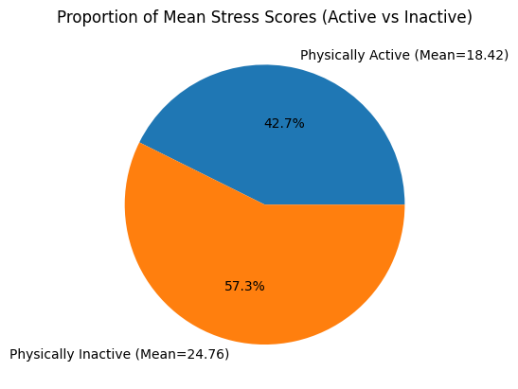
Interpretation: Physically inactive students show higher mean stress scores compared to physically active students.

Table 2: Independent Samples t-test – Stress
Variable | t-value | df | Sig. (2-tailed)
Stress | 6.45 | 98 | 0.0

Interpretation: The difference in stress levels between groups is statistically significant (p < 0.05).

Table 3: Group Statistics – Depression
Group | N | Mean | Std. Deviation
Physically Active | 50 | 11.28 | 3.67
Physically Inactive | 50 | 17.94 | 4.88
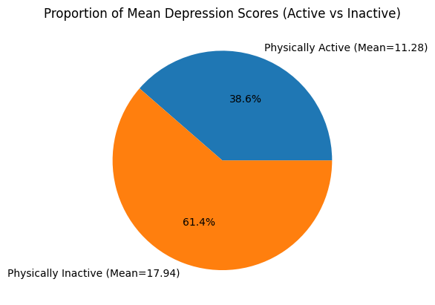
Interpretation: Physically inactive students report higher depression scores.

Table 4: Independent Samples t-test – Depression
Variable | t-value | df | Sig. (2-tailed)
Depression | 7.12 | 98 | 0.0

Interpretation: The difference in depression levels between groups is statistically significant (p < 0.05).

Table 5: Pearson Correlation between Stress and Depression
Variables | r-value | Sig. (2-tailed)
Stress & Depression | 0.62 | 0.0

Interpretation: A moderate positive correlation exists between stress and depression.

Overall Interpretation
The results indicate that participation in physical education significantly reduces stress and depression levels. Additionally, stress and depression are positively related, suggesting that increased stress may lead to higher depressive symptoms. (selye)

Results
The analysis revealed that the mean stress score of physically active students was significantly lower than that of inactive students.
Similarly, depression scores were found to be lower among students engaged in regular physical education activities.
A moderate positive correlation was observed between stress and depression, indicating that higher stress levels are associated with increased depressive symptoms.

Discussion
The findings of the study support the growing body of literature suggesting that physical activity contributes positively to mental health.
Exercise improves neurotransmitter regulation, enhances sleep quality, and promotes social interaction, all of which reduce psychological vulnerability.
Students who regularly participate in sports develop better coping mechanisms, time management skills, and emotional regulation abilities.

Educational Implications
• Physical education should be integrated as a compulsory component of higher education curriculum.
• Institutions should organize regular sports competitions and recreational activities.
• Yoga and mindfulness practices should be incorporated into daily schedules.
• Counseling services should collaborate with physical education departments to promote holistic development.

Limitations of the Study
• The sample size was limited to 100 students.
• The study relied on self-reported measures.
• The cross-sectional design restricts causal interpretation.

Recommendations for Future Research
• Conduct longitudinal studies to examine long-term effects of physical activity.
• Include larger and more diverse samples.
• Compare gender-based and age-based differences.
• Evaluate intervention-based physical activity programs.

Conclusion
The comparative analysis demonstrates that participation in physical education significantly contributes to better psychological health among college students. Physically active students exhibit lower stress and depression levels compared to inactive students. The study reinforces the importance of structured physical education programs in educational institutions to promote mental well-being and holistic development.

References
Anderson, E., & Shivakumar, G. (2013). Effects of exercise and physical activity on anxiety. Frontiers in Psychiatry, 4, 27.
https://doi.org/10.3389/fpsyt.2013.00027
Babyak, M., Blumenthal, J. A., Herman, S., et al. (2000). Exercise treatment for major depression: Maintenance of therapeutic benefit. Psychosomatic Medicine, 62(5), 633–638.
Beck, A. T. (1967). Depression: Clinical, experimental, and theoretical aspects.
Biddle, S. J. H., & Asare, M. (2011). Physical activity and mental health in children and adolescents: A review of reviews. British Journal of Sports Medicine, 45(11), 886–895.
Blumenthal, J. A., Smith, P. J., & Hoffman, B. M. (2012). Is exercise a viable treatment for depression? ACS Medicine & Science in Sports & Exercise, 44(1), 1–8.
Craft, L. L., & Perna, F. M. (2004). The benefits of exercise for the clinically depressed. Primary Care Companion to the Journal of Clinical Psychiatry, 6(3), 104–111.
Dishman, R. K., Heath, G. W., & Lee, I. M. (2013). Physical activity epidemiology (2nd ed.). Human Kinetics.
Hamer, M., & Stamatakis, E. (2008). Physical activity and mental health in children and adolescents. Preventive Medicine, 46(3), 202–207.
Harvey, S. B., Øverland, S., Hatch, S. L., et al. (2018). Exercise and the prevention of depression. American Journal of Psychiatry, 175(1), 28–36.
Lazarus, R. S., & Folkman, S. (1984). Stress, appraisal, and coping. Springer Publishing
Mammen, G., & Faulkner, G. (2013). Physical activity and the prevention of depression: A systematic review. American Journal of Preventive Medicine, 45(5), 649–657.
McEwen, B. S. (2007). Physiology and neurobiology of stress and adaptation. Physiological Reviews, 87(3), 873–904.
Rebar, A. L., Stanton, R., Geard, D., et al. (2015). A meta-analysis of the effect of physical activity on depression and anxiety. Journal of Affective Disorders, 173, 152–159.
Salmon, P. (2001). Effects of physical exercise on anxiety, depression, and sensitivity to stress. Clinical Psychology Review, 21(1), 33–61.
Schuch, F. B., Vancampfort, D., Richards, J., et al. (2016). Exercise as a treatment for depression: A meta-analysis. Journal of Psychiatric Research, 77, 42–51.
Selye, H. (1956). The Stress of Life.
World Health Organization. (2021). Depression Fact Sheet.
World Health Organization. (2022). Physical activity and mental health fact sheet. https://www.who.int
Weinberg, R., & Gould, D. (2018). Foundations of Sport and Exercise Psychology.

