Selection of Facial geometric key points using Convolution
Abstract
Face Recognition is a significant authentication procedure that is being used in bio-metrics in these days and age. Face recognition is based on various algorithmic approaches. Deep learning-based neural networks have a significant influence on the facial recognition approach. VGG (Visual Geometric Graphic) based networks are the multiple layered convNet is a 224*224 RGB channel based facial network built on various face samples. The major feature of this paper is the development of the facial key markers from facial features the procedure is conducted on samples of various data sets. The samples are then processed into the VGG19-based neural network for the facial detection of the samples processed from the data sets. Then the facial key features are extracted from the faces that are processed from the samples. The facial key features are based on the faces' eyes, forehead, and lip regions. Then the facial key markers are identified on the various faces. Then the facial geometry is calculated based on the facial key markers that are located on the individual faces the calculated facial geometry is then applied to the facial recognition of the sample of the data sets. This facial geometry is the basis of deep facial recognition on the facial samples. The face recognition that is conducted has an accuracy of 98%. Facial recognition is the basis of various authentication procedures for web-based login. The developed methodology is a low-cost computational procedure to conduct accurate facial recognition on commodity hardware.
Keywords: CNN, VGG, Facial Geometry, Facial key features.

1. Introduction
These days, regularly seeing the character of an individual is of fundamental significance. Face assertion is one of the bio-metric ways of thinking which is thoroughly utilized in home security, yet moreover continuously in business applications, by ensuring extraordinary worth in all points of view. During the past decade, the advancement of face affirmation transforming into an emerging example because of its unique applications in various fields.
Likewise, the approaching sensor progressions are also taking an interest in the progression of this field to see the face exactly. The packaging work of face affirmation is an advancement fit for perceiving or really investigating an individual from an undeniable level picture or a video outline from a video source. In any case, the face affirmation is working with different approaches, the picked facial highlights from a given picture with faces inside an information base. It is moreover portrayed as a Bio-metric Artificial Intelligence based application that can exceptionally see an individual by dismantling plans dependent upon the particular's facial surfaces and shape. As a bio-metric affirmation development, face affirmation is one of the fervently discussed issues in the fields of model affirmation, pictures dealing with, machine vision, neural association, and mental science. All the while, face affirmation as a high-constancy, high-precision, and easily recognized bio-metric development has far-reaching application prospects in the fields of character check, security noticing, and human-PC interaction. The improvement of the affirmation structure goes inseparable from the strategy for the face extraction feature. At this point, the basic part extraction procedures for face affirmation computations can be packaged into characterizations: The extraction method considers the numerical features of faces. This method does not simply concentrate the normalized between-point distance of each piece of the face and some part points of the face, for instance, the two-layered topological development made from the sides of the eyes, the edges of the mouth, and the tip of the nose, yet moreover is an early face affirmation procedure, which requires first-class face pictures. The extraction strategy considers quantifiable traits. This procedure treats the face picture as an inconsistent vector and moreover uses quantifiable systems to perceive different facial component plans, and the ordinary strategies among which join Eigen value, independent part examination, and specific worth crumbling. This procedure uses a stupendous number of neurons to store and recall face features and uses the properties of neural association self-sorting out some way to remove the fruitful components of faces. At this point, the computation considering neural network association has achieved incredible results, but neural network association techniques are astoundingly mentioning on data and equipment, which requires different data for getting ready and refined stuff to extend how much estimation. To deal with the above issues, we propose a component extraction strategy considering significant understanding that is to remove features of the face using the VGG-19 model and to diminish parts of the component vectors by using head part examination, which avoids insignificant components checking out this movement, then, the geometric estimation, is used to expect the model. We test the computation of this paper on the YALE and ORL datasets. The results show that the estimation has shown up at the state of-craftsmanship level.
2. Related Work
In [1] Fuzzy Neuro Inference based face acknowledgment framework has been presented. The framework is comprised of two-stage which are the preparing stage and the testing stage. In this paper, two arrangements of the picture are utilized to assess the presence of the framework. One of the sets is utilized in the preparation stage and which is 30 pictures. Furthermore, the second arrangement of pictures is utilized in the testing stage which is 15 pictures. The acknowledgment rate utilized in this method to assess the presentation of the framework and the worth of acknowledgment rate accomplished of the proposed framework is 92% of the pictures are gone against perceived utilized in the preparing and testing stage.
The fundamental contribution [2] proposes a continuous and low-memory multi-face identification framework carried out utilizing a Bayesian classifier. From the exploratory outcomes, the Bayes classifier has high precision to distinguish human countenances. . The skin shading channel and cross-over scratch-off are successful to dispense with misleading up-sides and unnecessary windows. The identification distance for the framework is from 0.7 to 3.2 meters.
This [3] has focused in on PCA-based face affirmation in a useful manner. There were many issues to ponder while picking a face-affirmation method. The key ones were: Accuracy, Time limitations, Process speed, and Availability. Considering one of these the PCA strategy for face affirmation was picked for this project generally clear and best to complete, extraordinarily fast estimation time. PCA can see a face with a substitute establishment is inconvenient. The face area ID program is adjusted with the objective that it just recognizes a face as well as concentrates it on another image, thusly eliminating basically all the establishment. The PCA-based strategy can see faces in a more useful way. This work has not considered any improvement in the PCA base face affirmation by consolidating it with explicit channels, contrast overhaul methodologies or neural-based arrangement, etc
Face acknowledgment in [4] VGG16 learning pipeline comprises of four phases, and the main advance is the component extraction step. One of the benefits of profound learning is profound learning needn't bother with a confounded technique to extricate the highlights. Be that as it may, the profound CNN needs more assets for the calculation while the light CNN doesn't invest an excessive amount of energy in preparing the model. Our investigation shows that shallow organization, for example, VGG16 additionally delivers high exactness which is 94.4%, and performs better in the restricted dataset and the modest number of names.

3. Methodology
Facial key features are an essential part of the facial recognition system that has been developed that will be discussed in this section. The facial key markers are the essential region of an individual face. These essential regions of the face are the forehead, eyebrow, nose, lip, and cheek regions these are the areas that distinguish one facial sample from the other. These regions are unique to each individual face. The facial key markers are extracted from the facial samples that are concerned with the YALE and ORL data sets these were also used in the fuzzy neuro system algorithm and processed for facial recognition. The sample size of the YALE dataset is 800 images of 40 individuals of which 20 samples of the individual face of different angles are taken into consideration. The ORL data set contains 2k samples of 200 individuals of which 10 facial samples of an individual face. CNN (Convolution Neural Networks) algorithm is used for locating the individual facial key marker on the individual facial sample. VGG19 which is the architecture that is considered for locating facial key markers on the individual's face.The VGG19 architecture proceeds with a 255x255 content of RGB image of which takes a (0-255) pixel value and which subtracts the mean values from the images that are considered for the facial key marker mapping. This means that all the samples processed by the algorithm convert all the images into 255*255 RGB channels of which individual faces are processed into each channel. The processed channels are represented as follows.
H(i) = k means that Fi is assigned to group k, and | Fk| is the number of points in group k. Also, let dij = d(Yi, Yj). H(i) is the datasets that are taken as input
P = $\sum_{k=1}^{K}{\frac{1}{|F_{k}|}}\sum_{F\left(i\right)=k,F\left(j\right)=k}{d_{ij}}$ 3.1
P is the channel of the VGG19 where the image is converted into micro-resolutions d is the image that is processed. The facial features from the individual face are extracted from the (0-255) pixel values that are processed into the nodes of the VGG architecture. The facial images are processed into the input layer which constitutes of the image matrix. This is divided into micro resolutions the input layer is constituted of 224x224channels of the input image data set. The images are then processed into the convolution layers with 128x128 micro resolution channels of the neural networks. The convolution layers will have 3 sub-channels. Then the images are then processed into the max-pooling layer with 128x128 which are then processed into the micro resolution channels. There are 3 sub-channels in the max-pooling layers. This process is denote as follows.
The number of possible layers that are assigned to the image data set is
L (c, K) =$\frac{1}{K!}\sum_{k=1}^{K}{{(-1)}^{K-k }}(_{k }^{K}$)k^{n} 3.2
Here L is the total number of layers that are assigned to the individually processed sample. After the above process, the patterns in an image will be detected in this current step. For the detection of the patterns in the given image data set the sample processed by the above process will be directed into the convolution layers with 64x64 micro resolutions-based channels which have 3 sub-channels. The whole process will be then directed to the max-pooling layer with 64x64 micro-resolutions with 3 sub-layers of it. From the above step, the targeted patterns that are to be discovered are identified in the sub-channels. The whole process can be denoted in as the sample processed in the max-pooling layer into 3 sub-layers is formed as a cluster of clusters C_{k} is a measure of Y(C_{k}) of the sample within a cluster differ from each other.
Mathematically the optimization process is defined as:
M=$C_{1, …,}^{ min}C_{k}\sum_{k=1}^{K}{W}$(C_{k}) 3.3
Here M is a max-pooling layer in which C_{k} is the cluster of the processed sample in the layer and its sub-layers. After the pattern recognition in the image data set, the samples are processed to the Fully Connected Layer with 64x64 micro-resolution images and with for the storage of the detected patterns in the channel. Then the stored images are redirected to the convolution layer with 128x128 micro-resolution with patterns stored in a channel for the reassembly. Then stored patterns are directed to the Fully Connected layer for the reassembly with 255x255 micro-resolution for the processing of all the patterns into the pattern matrix. The samples are then processed into Soft-Max layers with 512x512 for reassembly of the micro-patterns for the processing of these samples in a single channel. All the micro-patterns are stored in a 1024x1024 Fully Connected Layer of a single. The patterns that are detected from the data set in the previous layer were reassembled into the 2048x2048 channel of the Soft-Max layer. The Micro-patterns and all the Patterns that are detected and reassembled in the previous layers will be directed to the output layer with 4096 for the final identification of all the patterns in the image data set. The process is defined by the following formula.
L (𝑤, b, α) =$\frac{1}{2}$(𝑤. 𝑤)-$\sum_{i=1}^{n}{α}$_{i}{y_{i}[(𝑤.x_{i})+b]-1} 3.4
The Lagrange coefficient αi> 0 and the reconstructed micro-pattern 𝑤 and b are used in the Lagrange function, which seeks partial differentials of the trained patterns w and x in the VGG19 network comprising L layers. In this process, the facial key markers in the input data-set are the target patterns for detection. The algorithm follows the steps below, and the output is a matrix file that contains all the identified patterns in the network. Fig.3.1 is the facial geometry calculation flow that is processed during the training and recognition for facial key points.
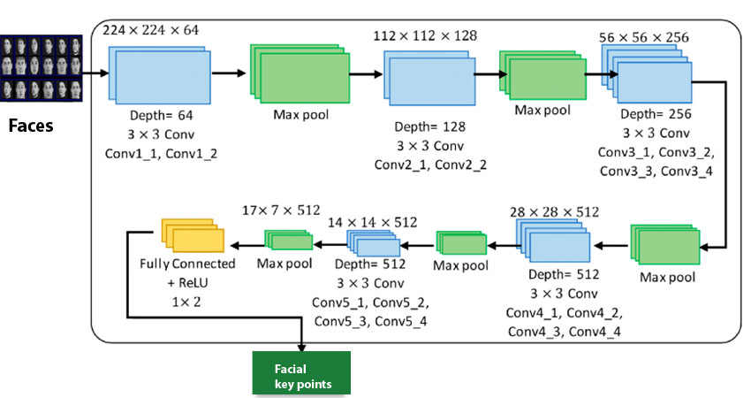
Fig.3.1Facial Geometry Calculation Flow Chart

3.1 Algorithm
The facial key markers are the initial step in calculating the facial geometry. The algorithm starts with VGG19 based approach to the samples from YALE and ORL data-set.
Step1: The samples from the YALE and ORL data sets are processed into the input layer with 255x255 micro-resolutions it is defined as follows.
I= $\frac{1}{2}\sum{µ,c,f}$ [D^{µ} _{c, f}– O^{µ} _{c, f}]² 3.1.1
Here I is the input data set that is processed in the VGG19 network and D is the image sample that is processed into the system where $µ is constant and c,f$ are multipliers.
Step2: This step will process will divide the facial samples into 128x128 micro-resolutions which are processed into convolution layers. In this layer, the image is recognized and its resolution will be re-sized and defined as follows:
Δ I^{s}_{i, j = ή} $Ʃ_{µ,p}$ ẟ^{µ}_{i, p} V^{µ} _{j, p +s} 3.1.2
Here I is the image samples that are processed and Δ I is the change in the resolution which is subdivided into micro-resolutions. V is the individual sample that is processed _{ή} $Ʃ_{µ,p}$ is the summation constant, and ẟ^{µ}_{i, p} is the divisor constant
Step3: The current step processes the re-sized image samples into 128x128 micro-resolutions into the max pooling layer and the human pattern is recognized in the current process. The whole process is defined as follows.
Δ M ^{s} _{i , j = ή} $Ʃ_{µ,p}$ ẟ^{µ}_{i, p} Δ I^{s}_{i, j} V^{µ} _{j, p +s} 3.1.3
Here M is samples that are processed into the max-pooling layer and Δ M is the change in the resolution and net human pattern detected. V^{µ} _{j, p +s} is the individual sample processed in the layer, and Δ I^{s}_{i, j -}is the detected pattern in the layer _{ή} $Ʃ_{µ,p}$ is the summation constant, and ẟ^{µ}_{i, p} is the divisor constant
Step4: The current step processes the human patterns recognized will re-configure the image resolutions into 64x64 micro-resolutions and forward into the convolution layers and human micro-patterns are stored in them.
µ=$\frac{1}{m}\sum_{j=1}^{m}{h_{j}}$ 3.1.4
h _{j} = h _{j} - µ, j= 1,2,3, …, m,
Here µ is the configuring coefficient in layer h is humans' micro-patterns in the layer and 1/m is the divisor coefficient that divides the image into micro-resolutions.
Step5: The micro-patterns are reconfigured into 32x32 micro resolutions in the max pooling layer from the previous step and facial detection from the images is processed in the current layer.
Δ F ^{s} _{i , j = ή} $Ʃ_{µ,p}$ ẟ^{µ}_{i, p} Δ I^{s}_{i, j} V^{µ} _{j, p +s} Δ M ^{s} _{i , j} 3.1.5
Here F is samples that are processed into the max-pooling layer and Δ f is the change in the resolution and net facial pattern detected. V^{µ} _{j, p +s} is the individual sample processed in the layer and Δ I^{s}_{i, j -}is the detected pattern and Δ M ^{s} _{i , is} the human patterns detected in the layer _{ή} $Ʃ_{µ,p}$ is the summation constant, and ẟ^{µ}_{i, p} is the divisor constant
Step6: Each individual face detected in the previous layers will be processed into 32x32 micro-resolutions and stored into 6 channels of convolution layers which can be defined as follows.
µ=$\frac{1}{m}\sum_{j=1}^{m}{f_{j}}$ 3.1.6
f _{j} = f_{j} - µ, j= 1,2,3, …, m,
Here µ is the configuring coefficient in layer f is the face micro-patterns in the layer and 1/m is the divisor coefficient that divides the image into micro-resolutions.
Step7: Then this step processes the faces stored in the previous stage will be divided into 16x16 micro-resolutions and facial features are calculated in the max-pooling layer and each facial feature is processed into 4 channels and stored in them.
F (n, s) =$\frac{1}{s!}\sum_{s=1}^{s}{{(-1)}^{S-s}}(_{s }^{S}$)f^{n} 3.1.7
F is the facial features that are stored in the max-pooling layer and n is the image sample entry and s is the feature of the individual face in the initial column matrix.
Step 8: The facial features which are stored are now marked with their subsequent facial key markers detected in fully connected layers and stored in 16x16 micro-resolution and stored in 4 channels for each individual feature. Each face is also labeled in the current step.
Δ K ^{s} _{i , j = ή} $Ʃ_{µ,p}$ ẟ^{µ}_{i, p} Δ I^{s}_{i, j} V^{µ} _{j, p +s} Δ M ^{s} _{i , j} Δ F ^{s} _{i , j} 3.1.8
Here K is samples that are processed into the max-pooling layer and Δ K is the change in the resolution and net facial key features detected. V^{µ} _{j, p +s} is the individual sample processed in the layer and Δ I^{s}_{i, j -}is the detected pattern and Δ M ^{s} _{i , is} the human patterns detected in the layer _{ή} $Ʃ_{µ,p}$ is the summation constant, and ẟ^{µ}_{i, p} is the divisor constant
Step9: From the current step re-assembling is done with labeled faces with key markers present in them. The facial samples will be processed into 32x32 convolution layers of 4 channels.
K (n, s) =$\frac{1}{s!}\sum_{s=1}^{s}{{(-1)}^{S-s}}(_{s }^{S}$)K^{n} 3.1.9
K is the facial key marker features that are stored in the max-pooling layer and n is the image sample entry and s is the feature of the individual face in the initial column matrix.
Step 10: The facial samples from the previous step is directed to the max-pooling layer with 64x64 resolutions for initialization of the image matrix assembling.
$∆M_{r,c}^{k,f}= \sum_{x=0}^{fh}{\sum_{y=0}^{fw}{d\left(I_{x,y}^{C,k}\right)}}O_{x+r,y+c}^{l-1,m}$ 3.1.10
Here the $∆M_{r,c}^{k,f}$ is the assembling factor of the max-pooling layer where l is the layer and O is the sub-channel of the max-pooling layer. X and y are coordinates and k is key-feature, f is the facial feature.
Step11: In the current step the second stage of the image matrix is triggered and the samples are forwarded to a fully connected layer with 128x128 resolutions.
$∆{FC}_{r,c}^{k,f}= \sum_{x=0}^{fh}{\sum_{y=0}^{fw}{d\left(I_{x,y}^{C,k}\right)}}O_{x+r,y+c}^{l-1,m}$ 3.1.11
Here the $∆{FC}_{r,c}^{k,f}$ is the assembling factor of the fully-connected layer where l is the layer and O is the sub-channel of the max-pooling layer. X and y are coordinates and k is key-feature, f is the facial feature.
Step12: The soft-max layers are triggered with 256x256 and 512x512 resolution of sample formation of the third and fourth stage of matrix assembly.
$∆{SM}_{r,c}^{k,f}= \sum_{x=0}^{fh}{\sum_{y=0}^{fw}{d\left(I_{x,y}^{C,k}\right)}}O_{x+r,y+c}^{l-1,m}$ 3.1.12
Here the $∆{SM}_{r,c}^{k,f}$ is the assembling factor of the soft-max layer where l is the layer and O is the sub-channel of the max-pooling layer. X and y are coordinates and k is key-feature, f is the facial feature.
Step13: The max-pooling layers will assemble 1024x1024 resolution images for the formation of the fifth stage of matrix assembly.
Step14: The soft-max layers will assemble 2048x2048 resolution images for the formation of the sixth stage of the matrix assembly.
Step15: This is the final step in the algorithm processing here each image is assembled into 4096x4096 resolution images. This is the output layer of the VGG19 this will comprise of all the facial samples, facial features, and facial key markers. This is the final stage of the fully trained image matrix assembly. These steps will conclude the process of training the facial key markers and the resultant will be the fully formed trained matrix.
w_{ψ}ℽ(f, k) = ‹ℽ,ψ _{a, b}› = $\int_{-ꝏ}^{+ꝏ}{ℽ(f)}\frac{1}{\sqrt{|f|}}$ψ($\frac{t-k}{f}$) dt 3.1.13
Of which, divisor $1/{\sqrt{\left|f \right|}}$ is a facial vector connected with ψ _{a, b} is ψ(f) is a facial layer coordinate which is obtained by transforming vector u(f,b) through the, as shown by the following expression:
Ψ _{a, b}(f)=[u(f, b)ψ(t)]=$\frac{1}{\sqrt{|a|}}$ψ($\frac{t-b}{f}$) 3.1.14
After the trained matrix is processed in the algorithm the sample is then tested for the validity of the network and matching will be followed. The sample is processed in the matrix for the testing process. The steps followed in the algorithm are also present in the testing process. Steps 1 to 14 will be present in the image matrix so now if the facial sample is matching with a sample of the tested image then the output is true or the process returns false all the performance factors are tested and discussed below.
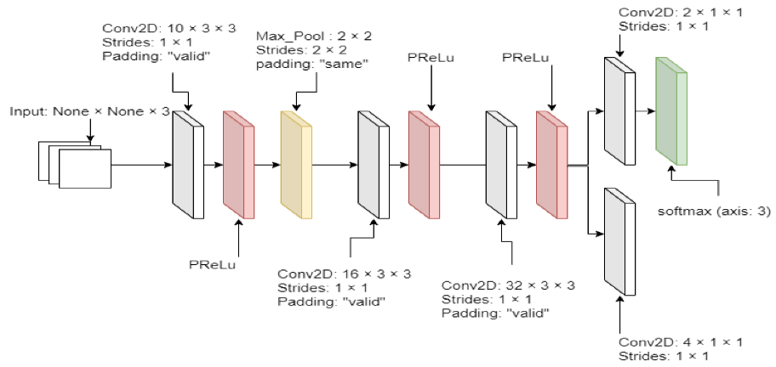
Fig.3.2 CNN VGG19 Architecture
4. Results
With 400 Images of ORL dataset and 100000 images of Image net dataset, and the trained matrix with all the samples was loaded into the system for analysis. The matrix that is formed from the training process with each layer having different image information is treated as the node in the image matrix. All the channels that store the facial information, facial key-marker, and facial features are treated as neurons in the system; these neurons are triggered accordingly as per the processed image. When the image is passed to the input layer for testing, the image will be declassified into various micro components present in the image. These micro components are the image background, objects, and the human subject present in the image. The human subject is according to the procedure used will be again declassified into different components. Each human body component is omitted except for the facial information from the image. These facial features will comprise of the facial detection in the image sample and these facial features are again declassified. The separated components from the face will be compared with the faces present in the image matrix of the system. The nodes which were trained with facial samples will be triggered and each facial feature will be compared with face nodes. If the face is present in the image matrix then the face is matched this will be the first step in the facial geometry calculation. Then the facial key-marker node is then triggered and the identified face with the corresponding facial key markers is located on the face.
These key markers will be mapped and displayed in the windowed mode. Each facial key markers are different for each face based on its respective features, some facial key markers may be less in number, and some to be more. This is based on the facial shape and the jaw structure, based on this the facial geometry point will be calculated for deep facial feature recognition.
The facial geometry features is calculated by the following calculation.
F $⊗$K = $\left[\left[\begin{matrix}F_{11}K & ⋯ & F_{1n}K \\ ⋮ & ⋱ & ⋮ \\ F_{m1}K & ⋯ & F_{mn}K\end{matrix}\right]\right]$ 4.1
The facial geometry from VGG19 is calculated by the Kronecker product:
(F⊗K)T = FT ⊗ KT 4.2
vec( F×K) = ( KT⊗F)vec(X) 4.3
for matrices F, X, and k with proper dimensions where F are the facial features that are stored in the layers and K are the key-features. With the help of ⊗, write down as
vec(G)=vec(∅(K^l )FI)=(I⊗∅(K))vec(K) 4.4
Vec(G)=vec(I∅(K^l )F) = (FT ⊗ I)vec(∅(K^l)) 4.5
Vec(G) is the geometry vector of the VGG19 and I∅ is the layer and its corresponding nodes for the processing of the layer. The deep facial features of the identified will be based on the facial key markers that are present in the trained matrix. The facial recognition completed by this process is more accurate compared to the older methodologies since the accuracy is 98.23%. The sensitivity factor is reduced significantly to 95.21% since the system is based on the deep facial features, this is also applicable for the specificity of 98.56% and precision factor of 96.53% as it is increased significantly too. Facial geometry is an essential component in the process of a facial biometric authentication system. The method developed is compared with other older methodologies and found to be efficient as discussed in the table below.

SR. No | Algorithm | Accuracy | Precision | Sensitivity  or  Recall | Specificity
1 | GABOR Filter | 58.63% | 55.26% | 51.74% | 56.75%
2 | Bayesian Classifier | 63.72% | 61.35% | 58.41% | 58.85%
3 | SVM | 73.63% | 68.72% | 68.72% | 68.32%
4 | ANFIS | 88.92% | 88.42% | 85.32% | 89.71%
5 | VGG16 | 95.37% | 92.03% | 96.47% | 96.73%
6 | VGG19 | 98.23% | 96.53% | 95.21% | 98.56%
Table4.1 Comparing Parameters of Various Algorithms

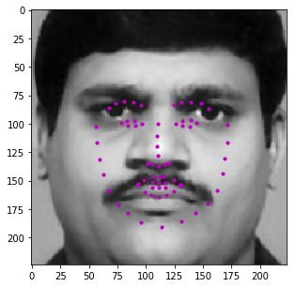
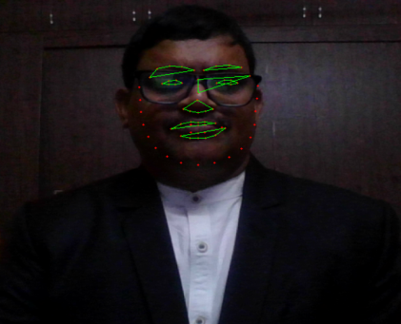
Fig.4.1 Facial Geometric Points Based On CNN
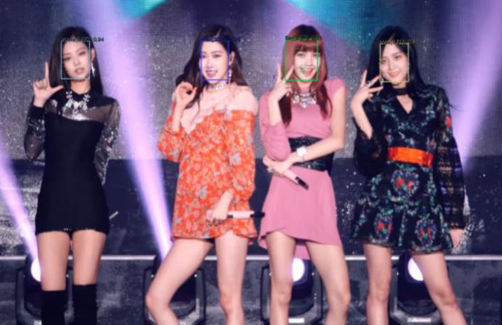
Fig.4.2 Multiple Facial Recognition Based on Facial Geometric points
5. Conclusion
The system developed which is discussed in this paper was found to be efficient as seen in the above table. The facial geometry calculation from the above method is an efficient way of deep facial recognition. The memory allocated for each node is very less compared to the previous methods. The system primary memory is also consumed very less compared to the other methodologies so this will lead to low computational cost consumption. The image matrix size is very low compared to the VGG16 so this leads to the adaptability of the system is more likely since it can be deployed with less computational cost. As discussed above the systems testing parameters which include accuracy increases significantly, by this analogy it can be said that the system can be implemented on commodity hardware which is of low cost so the authentication system developed on top of this methodology is very much economical. Facial geometry can be successfully applied to the bio-metric authentication process with more accuracy and less computational cost which makes this system more efficient.
References
- A. Bhatia, S. SriVastava and A. Agarwal., "Face Detection Using Fuzzy Logic and Skin Color Segmentation in Images",3rd International Conference on Emerging Trends in Engineering and Technology, 2010, pp. 225-228,doi: 10.1109/ICETET.2010.20.
- E. B. Putranto, P. A. Situmorang and A. S. Girsang., "Face recognition using Eigen face with naive Bayes", 11th International Conference on Knowledge, Information and Creativity Support Systems, PP. 1-4,doi: 10.1109/KICSS.2016.7951418.
- Guodong Guo, S. Z. Li, and Kapluk Chan., "Face recognition by support vector machines", Proceedings Fourth IEEE International Conference on Automatic Face and Gesture Recognition, PP.196-201, doi: 10.1109/AFGR.2000.840634.
- A. B. Perdana and A. Prahara., "Face Recognition Using Light-Convolution Neural Networks Based On Modified Vgg16 Model”, International Conference of Computer ScienceandInformationTechnology.PP.1-4,doi:10.1109/ICoSNIKOM48755.2019.9111481.
- A. Chowdhury and S. S. Tripathy., "Human skin detection and face recognition using fuzzy logic and Eigen face”, International Conference on Green Computing Communication and Electrical Engineering, PP.1-4,doi:10.1109/ICGCCEE.2014.6922222.

- D. M. M. da Costa, S. M. Peres, C. A. M. Lima, and P. Mustard., "Face recognition using Support Vector Machine and multi scale directional image representation methods: A comparative study”, International Joint Conference on Neural Networks, PP.1-8,doi: 10.1109/IJCNN.2015.7280699.
- Y. Chen, C. Liu, K. Chou, and S. Wang, "Real-time and low-memory multi-face detection system design based on naive Bayes classifier using FPGA," International Automatic Control Conference (CACS), pp. 7-12, doi: 10.1109/CACS.2016.7973875.
- H. Verma, S. Lotia and A. Singh., "Convolution Neural Network Based Criminal Detection",IEEERegion-10Conferences,PP.1124-1129,doi:10.1109/TENCON50793.2020.9293926.
- M. M. Ghazi and H. K. Ekenel., "A Comprehensive Analysis of Deep Learning Based Representation for Face Recognition", IEEE Conference on Computer Vision and Pattern Recognition Workshops, PP.102-109, doi: 10.1109/CVPRW.2016.20.
- I. K. Timotius, T. C. Linasari, I. Setyawan, and A. A. Febrianto., "Face recognition using support vector machines and generalized discriminate analysis", 6th International Conference onTelecommunicationSystems,ServicesandApplications,PP.8-10,doi:10.1109/TSSA.2011.6095397.
- M. Nakada, H. Wang, and D. Terzopoulos., "AcFR: Active Face Recognition Using Convolution Neural Networks," 2017 IEEE Conference on Computer Vision and Pattern Recognition Workshops, PP. 35-40, doi: 10.1109/CVPRW.2017.11.
- Qurat-ul-ain, N. Nida, A. Irtaza and N.Ilyas., "Forged Face Detection using ELA and Deep Learning Techniques", International Bhurban Conference on Applied Sciences and Technologies, PP.271-275, doi: 10.1109/IBCAST51254.2021.9393234.
13. B. Heisele, P. Ho and T. Poggio, "Face recognition with support vector machines: global versus component-based approach," Proceedings Eighth IEEE International Conference on Computer Vision, PP. 688-694 vol.2, doi: 10.1109/ICCV.2001.937693.

