DIVERSITY AND DISTRIBUTION OF BIRDS IN AN AFRICAN URBAN AND SUB-URBAN LANDSCAPE
CASE STUDY: JUBA CITY

ABSTRACT

This study aims to develop a comprehensive checklist of bird species in Juba City and its surrounding areas, assessing both their diversity and distribution. Through meticulous fieldwork using the Time Species Count (TSC) methodology, the research evaluated the impact of urbanization on avian populations within this African urban and suburban landscape. Our findings reveal a significant diversity of bird species, highlighting the presence of both common urban dwellers and rarer species that thrive in less disturbed suburban environments. The study notes a marked difference in species distribution patterns, with urban areas exhibiting lower biodiversity compared to their suburban counterparts.
The results underline the detrimental effects of urban growth on avian diversity, with habitat loss and fragmentation emerging as primary challenges. The research recommends the implementation of green urban planning strategies to mitigate these impacts, such as the establishment of bird-friendly zones and the preservation of natural habitats within city limits. Additionally, promoting community awareness about the importance of biodiversity conservation in urban settings is crucial.
In conclusion, this research provides valuable insights into the avian diversity and distribution in Juba City, offering a vital benchmark for future studies and conservation efforts. By fostering a harmonious coexistence between urban development and wildlife, it is possible to sustain and enhance the ecological richness of urban landscapes.

CHAPTER ONE

INTRODUCTION

1.0 General Introduction
The intricate relationship between urbanization and biodiversity is a critical area of ecological study, particularly in rapidly developing regions. Birds, as highly visible and ecologically significant components of urban ecosystems, serve as excellent indicators of environmental health and the impacts of human activity (Marzluff, J. M., 2001). Urbanization often leads to habitat fragmentation, alteration of natural landscapes, and increased anthropogenic pressures, which can significantly influence the diversity and distribution of avian species (McKinney, M. L., 2002). Understanding these dynamics is crucial for effective urban planning and conservation efforts that aim to mitigate negative impacts and promote biodiversity within human-dominated landscapes. This study focuses on the diversity and distribution of birds in Juba City, a rapidly urbanizing African and sub-urban landscape, to provide insights into these ecological processes in a unique and understudied context.
1.1 Background of the Study
The global trend of urbanization presents a significant challenge and opportunity for biodiversity conservation. By 2050, it is projected that nearly 70% of the world's population will reside in urban areas, with a substantial portion of this growth occurring in developing countries (World’s Cities, 2018). This rapid expansion often results in the conversion of natural habitats into built environments, leading to a decline in species richness and an increase in generalist species adapted to urban conditions (Blair, R. B., 2001). However, urban areas can also provide novel habitats and resources, attracting certain bird species and contributing to unique urban avian communities (Blair, R. B., 2001). The study of urban bird communities has gained considerable attention due to their accessibility, ecological importance, and their role in providing ecosystem services such as pest control and seed dispersal (Gaston, et al,2007).
Globally, studies on urban bird diversity have revealed common patterns, including a decrease in species richness with increasing urbanization intensity, a shift towards more generalist and exotic species, and the importance of green spaces in maintaining avian diversity (Aronson, et al.,2017) Research in cities across different continents, such as those in Europe, North America, and Asia, consistently highlights the impact of habitat structure, vegetation complexity, and the presence of water bodies on bird communities (Clergeau, et al. 2006). For instance, studies have shown that larger and more connected green spaces support a greater diversity of bird species, including some sensitive to disturbance (Lerman, S. B., & Warren, P. S. 2011). The concept of "urban exploiters" and "urban avoiders" has emerged to categorize species based on their response to urbanization, with exploiters thriving in highly modified environments and avoiders declining or disappearing (Kark, et al, 2017).
In the African context, urbanization is proceeding at an unprecedented rate, often without adequate planning and infrastructure, leading to unique ecological challenges (Seto, et al, 2011). While studies on urban biodiversity in developed nations are extensive, research in African cities is comparatively limited, particularly concerning avian communities (Cilliers, et al.,2013). Existing studies in some African cities, such as Nairobi, Kenya, and Cape Town, South Africa, have shown similar trends to global patterns, with habitat loss and fragmentation being major drivers of avian community structure (Githiru, M., & Njoroge, P., 2014). However, the specific ecological and socio-economic factors influencing bird diversity in African urban landscapes can differ significantly due to varying land-use practices, cultural perceptions of nature, and the presence of unique biogeographic regions ((Samways, M. J., & Steytler, N. S., 1996). Understanding these regional shades is crucial for developing context-specific conservation strategies.
South Sudan, as one of the world's newest nations, is undergoing rapid development and urbanization, particularly in its capital, Juba City. The city's growth is characterized by a mix of planned and unplanned land grabbing settlements, varying levels of green infrastructure, and proximity to natural ecosystems (World Bank., 2019). Despite its ecological significance as a transition zone between different biomes and its potential for high biodiversity, there is a significant dearth of ecological research, especially concerning avian populations within Juba City (UNEP., 2012). The lack of baseline data makes it challenging to assess the impact of ongoing urbanization on local biodiversity and to inform sustainable urban development policies. This study aims to fill this critical knowledge gap by providing a comprehensive assessment of bird diversity and distribution in Juba City.
1.3. Problem Statement
Rapid and often unplanned urbanization in Juba City is leading to significant alterations of natural habitats, including the conversion of open spaces, wetlands, and woodlands into built environments/residential apartments. This process is likely to have profound impacts on the local avian communities, potentially leading to a decline in species richness, changes in community composition, and the loss of sensitive species. Currently, there is a significant lack of empirical data on the diversity and distribution of birds within Juba City and its surrounding sub-urban areas. Without this baseline information, it is impossible to accurately assess the ecological consequences of urbanization, identify key habitats for conservation, or develop effective strategies to mitigate negative impacts on avian biodiversity. The problem is the absence of comprehensive data on avian diversity and distribution in Juba City, which hinders effective conservation and sustainable urban planning in a rapidly urbanizing African context.

1.4.1 Research objectives
The main objective of this research is to determine the avian community diversity in Juba city and its sub-urban areas.

1.4.2 Specific objectives

- To develop a checklist for birds of Juba city and its surroundings.
- To determine diversity and distribution bird species in Juba city and its suburban areas.
- To evaluate the effects of urbanization on avian numbers and diversity in Juba city and its environs.

1.4.3 Research questions
Key questions that need to be addressed include:
- What kind of bird species exist in Juba city and its environs?
- What is the current distribution pattern of birds in Juba, and how diverse are they in terms of numbers and species richness?
- What are the potential effects of Urbanisation on bird populations in Juba city and its suburban areas, and how can these be mitigated through conservation efforts?

1.5. Hypothesis

The null hypothesis states that:
H_{o}: There is no significant difference in bird abundance, diversity and distribution between the different habitats and localities within Juba city and its environs despite the urbanization processes.
1.5 Scope of the Study
This study focused on the diversity and distribution of avian species within the administrative boundaries of Juba City and its immediate sub-urban periphery. The geographical scope encompassed a range of urban and sub-urban habitat types, including residential areas, commercial zones, green spaces (recreational grounds, gardens), wetlands, and undeveloped plots. The study primarily utilized time species count surveys which involves standing in fixed position for 5-10 minutes for data collection, conducted during specific periods to account for seasonal variations in bird presence. The taxonomic scope includes all avian species observed and identified within the study area. The temporal scope was limited to the duration of the research project, aiming to capture a representative snapshot of the avian community.
1.7 Justification of the Study
This study is highly justified for various reasons. Firstly, it addresses a critical knowledge gap regarding avian diversity and distribution in Juba City, a rapidly urbanizing African capital with virtually no existing ecological baseline data. This information is essential for understanding the ecological impacts of development and for informing sustainable urban planning. Secondly, birds are excellent bio-indicators; their presence, absence, and community structure can reflect the overall health of an ecosystem. By studying birds, this research provides insights into the broader environmental quality of Juba City. Thirdly, the findings contribute to the growing body of literature on urban ecology, particularly in the understudied African context, offering valuable comparative data for global urban biodiversity research. Finally, the study's outcomes are directly relevant to local conservation efforts, informing the identification of important bird areas, the design of urban green infrastructure, and the development of policies aimed at mitigating human-wildlife conflict and promoting biodiversity within the city. The study is crucial for providing baseline ecological data, informing sustainable urban development, and contributing to global urban ecology knowledge in an understudied African context.
1.8 Operational Definition of Terms
Diversity: In this study, diversity refers to species richness (the number of different bird species present) and species evenness (the relative abundance of each species) within a given area. It was quantified using ecological indices such as the Shannon-Wiener Diversity Index and Simpson's Diversity Index (Magurran, A. E., 2004).
Distribution: Refers to the spatial arrangement and spread of bird species across different habitat types and urbanization gradients within Juba City. It is analyzed by mapping species occurrences and abundances in relation to landscape features (Sutherland, W. J., 2006).
Birds: Encompasses all free-flying avian species observed and identified within the study area, including resident, migratory, and nomadic species.
African Landscape: Refers to the natural and semi-natural ecosystems characteristic of the African continent, specifically the ecological zones surrounding Juba City, which include savanna woodlands, grasslands, and riverine habitats (White, F., 1983).
Sub-urban Landscape: Describes the transitional zone between the densely built-up urban core and the more rural or natural areas, characterized by a mix of residential areas, small-scale agriculture, and fragmented natural patches (Antrop, M., 2004).
Case Study: Implies an in-depth investigation of a specific geographical area (Juba City) to understand a particular phenomenon (bird diversity and distribution in an urbanizing context) within its real-life context (Yin, R. K.,2018).
Juba City: Refers to the capital city of South Sudan, located on the White Nile River, characterized by rapid urbanization, a mix of planned and unplanned settlements, and varying levels of green infrastructure. The study area is defined by its administrative boundaries and immediate surrounding areas.
Urbanization Gradient: A conceptual framework representing the continuum of human modification of the landscape, ranging from highly built-up and impervious surfaces (high urbanization) to less developed areas with more natural vegetation (low urbanization) (McDonnell, M. J., & Hahs, A. K., 2008).
Habitat Types: Refers to distinct land cover classifications within the study area that provide resources for birds, including but not limited to:
Built-up areas: Densely populated residential, commercial, and industrial zones with high impervious surface cover.
Green spaces: Parks, gardens, undeveloped plots, and areas with significant tree and shrub cover.
Wetlands: Areas saturated with water, such as riverbanks, seasonal swamps, or ponds.
Agricultural areas: Small-scale farms or cultivated plots within the sub-urban matrix.

1.9 Conceptual Framework
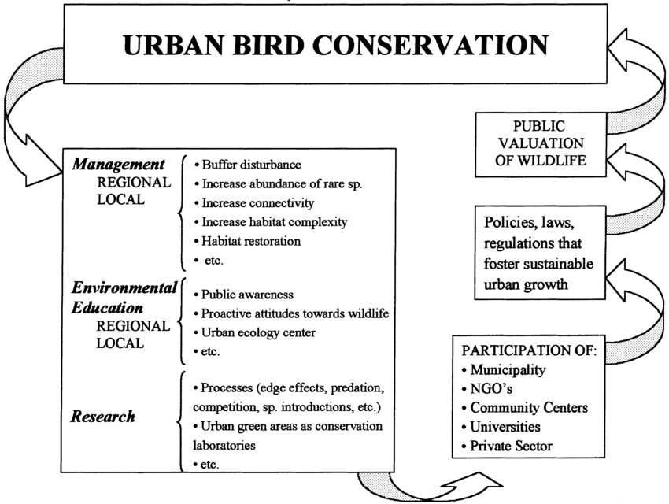
Figure 1.1: the interlink ages between management issues, environmental education and research with regard to urban birds’ conservation.
Source: (Jukka Jokimäki, 2020)
The above conceptual model for improving bird conservation in Juba city suggests that wildlife conservation in urban habitats is becoming increasingly important due to current urbanization trends. Different approaches were reviewed to studying birds in urban landscapes, and point out the importance of the habitat urban ecological theory as a research framework for the management and conservation of urban birds. Based on two comprehensives representing a framework to encourage the links between conservation and public involvement. (Figure 1.1), with the proximate goal of promoting urban bird conservation, and the ultimate purpose of improving the coexistence between people and birds in cities. This conceptual model is highly dynamic, in that it represents an interactive entity in perpetual change. People needs and inquiries about the wildlife surrounding them are the generator of such dynamic process. Another property of the model is its circularity, which means that the actions taken at any level would affect the other levels sequentially. As a result, the model can begin at any stage according to current conservation needs; in some cities social factors need to be worked out more thoroughly, whereas in others there is a need to begin simply by characterizing what species are present. For the sake of simplicity, it can start at the management stage.

CHAPTER TWO

LITERATURE REVIEW

2.0 Introduction
This chapter reviews existing literature on avian diversity and distribution, with a specific focus on sub-urban environments within African contexts. It aims to establish a theoretical framework for understanding the ecological factors influencing bird communities in human-modified landscapes, particularly in rapidly developing cities like Juba. The review draw upon studies examining habitat fragmentation, urbanization effects, and the role of specific environmental variables in shaping avian assemblages. This literature review examines existing research on avian diversity and distribution, with a specific focus on sub-urban environments in Africa, culminating in a case study of Juba City. Understanding the ecological dynamics of bird populations in rapidly urbanizing areas is crucial for conservation efforts and urban planning (Marzluff, J. M..2008).

2.1 Avian Diversity in Urban and Sub-Urban Environments
Urbanization significantly alters natural habitats, leading to changes in avian community structure (McKinney, M. L., 2008). While some bird species are highly adaptable and thrive in urban settings, others are sensitive to habitat fragmentation and loss, experiencing population declines (Aronson, et al, 2017). Studies have shown that urban areas often support a lower diversity of specialist species but can host a higher abundance of generalist species (Blair, R. B. 2001). The "urban exploiter" concept describes species that benefit from human-modified landscapes, often due to increased food availability and reduced predation pressure from natural predators (Kark, et al.2007). However, the overall species richness tends to decrease with increasing urbanization intensity (Chace, J. F., & Walsh, J. J.2006). Research in various global cities, such as those in Europe and North America, has consistently demonstrated this pattern, highlighting the importance of green spaces within urban matrices for maintaining biodiversity (Evans, et al. 2009).

2.2 Factors Influencing Bird Distribution in Sub-Urban Landscapes
The distribution of birds in sub-urban landscapes is influenced by a complex interplay of environmental and anthropogenic factors (Faeth, et al. 2011). Key factors include habitat heterogeneity, availability of food resources, presence of water bodies, and the extent of impervious surfaces. Habitat heterogeneity, characterized by a mix of vegetation types, tree cover, and open spaces, generally supports a greater diversity of bird species (Hahs, et al. 2009). The presence of native vegetation is particularly important, as it provides essential food sources (e.g., insects, fruits, seeds) and nesting sites (Burghardt, et al. 2009). Conversely, the dominance of exotic plant species can negatively impact native bird populations by altering food webs and reducing suitable nesting substrates (Lowenstein, et al. 2014).
Anthropogenic factors such as noise pollution, light pollution, and human disturbance also play a significant role in shaping bird distribution (Kociolek, et al.2011). Noise pollution can interfere with avian communication, affecting breeding success and territorial defense (Slabbekoorn, H., & Ripmeester, A. P. (2008). Light pollution can disrupt migratory patterns and foraging behaviors, particularly for nocturnal species (Longcore, T., & Rich, C. 2004). The presence of domestic animals, especially cats, is a well-documented threat to urban bird populations, contributing to significant mortality rates (Loss, et al.2013) The spatial arrangement of green spaces, including parks, gardens, and street trees, within the urban matrix is critical for facilitating bird movement and maintaining connectivity between fragmented habitats (Cornelis, J., & Hermy, M. 2004).

2.3 African Context: Urbanization and Avian Ecology
Africa is experiencing rapid urbanization, with significant implications for its biodiversity (Seto, et al. 2013). While much of the research on urban avian ecology has historically focused on developed countries, there is a growing body of literature from African cities (Cilliers, et al.2013). These studies often highlight unique challenges and opportunities for bird conservation in the African context, such as the prevalence of informal settlements, diverse traditional land-use practices, and varying levels of environmental governance (Githiru, M., & Njoroge, P., 2014). For instance, studies in cities like Nairobi, Kenya, and Cape Town, South Africa, have explored how different urban development patterns influence bird communities (Njoroge, P., & Githiru, M. 2014; Hockey, et al.2005). These studies often emphasize the importance of remnant natural habitats, such as wetlands and forest patches, within urban areas for supporting a wider range of bird species (Davies, et al. 2013). The impact of climate change, leading to altered rainfall patterns and increased temperatures, is also an emerging concern for avian populations in African urban environments, potentially affecting breeding cycles and resource availability (Radchuk, et al.2019).

2.4 Case Study: Juba City
Juba City, as the capital of South Sudan, represents a rapidly developing sub-urban landscape in East Africa ((UN-Habitat., 2016). Its recent history of conflict and subsequent reconstruction has led to unique patterns of urban growth and land use (World Bank.2018). While specific detailed studies on avian diversity and distribution within Juba City are limited, general ecological principles observed in other African sub-urban areas can be applied (BirdLife International., 2020). The city's proximity to the White Nile River and surrounding savanna ecosystems suggests the potential for a diverse avifauna, including both resident and migratory species (Fry, C. H., & Keith, S. (Eds.)., 2004). However, rapid infrastructure development, informal settlements, and potential habitat degradation due to human activities (e.g., deforestation for charcoal production, waste disposal) are likely to exert significant pressure on local bird populations ((FAO, 2019). Understanding the current state of avian diversity and distribution in Juba City is crucial for informing sustainable urban planning and conservation strategies, ensuring that the city's development does not come at the expense of its natural heritage ((UNEP., 2012). Future research should focus on baseline surveys to document species richness and abundance, identify key habitats, and assess the impact of specific urban stressors on bird communities within Juba (Sutherland, et al.2004).

2.5 Urbanization Globally
Urbanization is a global phenomenon that significantly alters natural landscapes, leading to profound impacts on biodiversity. Birds, being highly mobile and sensitive indicators of environmental change, are particularly affected by these transformations (Marzluff, J. M., 2001). Juba, the capital city of South Sudan, is experiencing rapid urban expansion, yet comprehensive ecological studies, particularly concerning avian populations, remain scarce. Understanding the diversity and distribution of birds within urban and suburban environments is crucial for effective conservation strategies and sustainable urban planning (Aronson, et al, 2017). This research aims to address this knowledge gap by focusing on the avian communities of Juba city and its surrounding areas, providing baseline data essential for future ecological assessments and conservation efforts (BirdLife International. 2024).

2.6 Review on Literature
The impact of urbanization on avian diversity and distribution has been a subject of extensive research globally, with numerous studies highlighting both negative and, in some cases, positive effects on bird populations. Urbanization typically leads to habitat loss and fragmentation, increased pollution, altered food resources, and changes in predator-prey dynamics, all of which can negatively affect bird species (Blair, R. B. 2001). Studies in various African cities, such as Nairobi, Kenya, and Cape Town, South Africa, have shown a decline in specialist bird species and an increase in generalist, adaptable species within urbanized areas. For instance, a study in Nairobi found that species richness decreased with increasing urbanization intensity, with certain guilds like insectivores being more vulnerable (Githiru, M., & Njoroge, P. 2014). Similarly, research in Cape Town indicated that while some species thrive in urban environments due to increased food availability (e.g., refuse), many native species are displaced by habitat alteration (Hockey, P. A. R., & Dean, W. R. J. 2007).
However, some urban environments can also provide novel habitats and resources, attracting certain bird species, particularly those tolerant of human disturbance (Kark, et al. 2007). Green spaces within cities, such as parks, gardens, and urban forests, can act as refugia and corridors for avian movement, contributing to local biodiversity (Miller, J. R., & Hobbs, R. J. 2002). The composition and management of these green spaces are critical factors influencing the avian communities they support. For example, a study in Addis Ababa, Ethiopia, demonstrated that well-maintained urban green spaces could support a relatively high diversity of birds, including some endemic species.
Despite the growing body of literature on urban avian ecology, there remains a significant gap in understanding the specific effects of urbanization on bird populations in rapidly developing African cities like Juba. Most existing studies from the African continent tend to focus on larger, more established urban centers, leaving a dearth of information for newer, rapidly expanding cities (Samways, M. J., & Steytler, N. S. 1996). Furthermore, the unique ecological context of Juba, characterized by its specific climate, vegetation, and socio-economic factors, necessitates localized research to accurately assess the impacts of urbanization on its avian fauna. Previous research in the region has often been broad-scale or focused on specific protected areas, rather than the urban matrix itself. This research aims to fill this critical gap by providing a detailed analysis of bird diversity and distribution within Juba city and its suburban areas, offering insights relevant to the specific challenges and opportunities for avian conservation in this rapidly urbanizing landscape.

2.3.1. Checklist for Birds of Juba City and its Surroundings
Creating a comprehensive bird checklist is a foundational step in ornithological research, providing a baseline for understanding avian biodiversity in a specific geographic area (Bibby, C. J., 2000). Such checklists are essential for conservation efforts, allowing researchers to monitor changes in species composition over time (Gaston, A. J., 1975). Studies from various regions have successfully compiled bird checklists using systematic survey methods. For instance, research in Myanmar's cities, including Mandalay, Mawlamyine, and Myeik, identified 103 bird species across different urban and rural habitats, highlighting the importance of detailed species identification and recording (Suarez-Rubio, 2023). Similarly, studies focusing on aquatic and semi-aquatic birds in and around Juba City have contributed to local checklists, emphasizing the need for consistent observation and documentation (Patankar, et al.2021). These efforts often involve point counts, line transects, and visual/auditory identification by experienced observers (Bibby, et al.2000). The development of a checklist for Juba City would build upon existing regional knowledge, incorporating both terrestrial and aquatic avian species, and would serve as a critical reference for future ecological assessments (Patankar, et al.2021).

2.3.2. The Presence, Abundance, Diversity in Juba City and its Suburban Areas
The assessment of bird presence, abundance, diversity, and species richness along urban-rural gradients is a well-established approach in urban ecology (Chace, J. F., & Walsh, J. J., 2006). Urbanization typically leads to a decrease in bird diversity but an increase in the abundance of a few generalist species (McKinney, M. L. 2008). For example, a study in Myanmar found that while overall species diversity was roughly equal across three cities, the species composition differed significantly between urban, suburban, agricultural, and forest habitats. Rock Pigeons (Columba livia) were consistently the most abundant species in city centers, a pattern observed globally in urban environments (Aronson, et al.2014).
Diversity indices, such as Hill Shannon diversity, are commonly used to quantify species diversity, taking into account both species richness and relative abundance (Chao, et al. 2014). Research often reveals a "hump-shaped" curve, where diversity is highest in suburban or peri-urban areas (e.g., university campuses, agricultural fields) and lowest in highly urbanized downtown areas. This suggests that areas with a mix of natural and semi-natural habitats, like those found in suburban zones, can support a greater variety of bird species than intensely developed urban cores or even some highly disturbed natural areas (Sandström, et al. 2006). Relative abundance, on the other hand, tends to be higher in urban downtowns due to the proliferation of a few highly adaptable species. The presence of green spaces, water bodies, and the extent of impervious surfaces are key environmental factors influencing these patterns (Beninde, et al. 2015). For Juba City, understanding these metrics would involve systematic sampling across its urban, suburban, and surrounding natural areas, similar to methodologies employed in other tropical urban studies.

2.3.3. The Effects of Urbanization
Urbanization is a primary driver of habitat modification and biodiversity loss globally (Czech, et al.2000; Seto, et al.2011). Its effects on avian communities are well-documented, generally leading to a reduction in overall bird diversity and a shift towards communities dominated by generalist species (Sol, et al. 2014). This phenomenon, known as biotic homogenization, results in urban bird communities becoming more similar to each other, often comprising a few widespread, adaptable species (Clergeau, et al.2006).
Studies consistently show that increased impervious surfaces and human population density negatively correlate with bird species diversity, while the proportion of green spaces (indicated by Normalized Difference Vegetation Index or NDVI) has a positive effect (MacGregor-Fors, et al.2016). Functional groups also respond differently to urbanization; omnivores and granivores often thrive in urban centers due to readily available food resources, while specialized feeders like insectivores or piscivores are more prevalent in less disturbed, peripheral areas (Palacio, F. X. 2019). Behavioral traits, such as boldness, tolerance to human presence, and neophobia (fear of novelty), also play a significant role in determining which species can successfully adapt to urban environments (Samia, et al 2015; Tryjanowski, 2016). Birds with larger brains, enhanced cognitive abilities, and flexible behaviors are often more successful urban colonizers (Sol, et al..2005; Maklakov, et al.2011).
While extensive research exists on urban birds in temperate regions and increasingly in tropical Southeast Asia, there is a recognized gap in detailed studies from African cities, particularly in rapidly developing areas like Juba City (Ortega-Álvarez, R., & MacGregor-Fors, I. 2011). The provided content highlights that information on the relationships between urbanization and avian communities in Southeast Asia and Myanmar is scarce, and this scarcity is even more pronounced for African contexts. The unique ecological characteristics and urbanization patterns in African cities may lead to different avian responses compared to those observed in other continents (Odewumi, et al 2015). Therefore, a study in Juba City would contribute significantly to filling this geographical and ecological knowledge gap, providing valuable insights into how urbanization impacts bird communities in a distinct African urban-suburban landscape (Patankar, et al. 2021). Such research could reveal specific local factors influencing avian distribution and diversity, which might differ from patterns observed in other parts of the world, thereby informing more effective urban planning and conservation strategies tailored to the region (Grimm, et al.2008).

2.3.4 Gaps
1. Paucity of Recent Avifaunal Surveys in Juba City and South Sudan: A significant gap is the limited number of comprehensive and recent avifaunal surveys specifically conducted within Juba City and, more broadly, South Sudan. Much of the available ornithological data for the region predates the country's independence in 2011, and even earlier, often relying on historical records or broader East African studies (BirdLife International. 2024; Fry, C. H., & Keith, S. (Eds.). 2004). The rapid urbanization and development in Juba since independence have likely altered habitats, yet the impact on bird communities remains largely undocumented (UN-Habitat).. Studies from similar rapidly developing African cities might exist, but direct, up-to-date data for Juba is likely scarce (Marzluff, J. M. 2001).
2. Lack of Focus on Sub-Urban Habitats and Urbanization Impacts: While some studies might address bird diversity in protected areas or more rural settings within South Sudan or neighboring countries, there is a notable gap in research specifically focusing on sub-urban landscapes like Juba City (Sekercioglu, C. H. 2012). Sub-urban environments present unique ecological challenges and opportunities for bird species, characterized by a mosaic of natural remnants, cultivated areas, and built infrastructure (Miller, J. R., & Hobbs, R. J. 2002). Understanding how different bird species adapt to or are displaced by these human-modified landscapes is critical, yet often overlooked in favor of studies in more pristine or intensely urbanized areas (Aronson, M. F. J., et al. (2017). The specific effects of Juba's unique sub-urban development patterns on bird distribution, such as the expansion of informal settlements or changes in green spaces, are likely under-researched (Juba City Council,.2025).
3. Limited Data on Specific Bird Guilds and Functional Diversity: Existing literature might provide species lists, but often lacks detailed analysis of bird guilds (e.g., insectivores, granivores, raptors) and their functional diversity within sub-urban environments (Devictor, V., et al. 2010). Understanding how different feeding guilds or nesting strategies are affected by urbanization provides deeper insights into ecosystem health and resilience (Gaston, K. J. 2009). For Juba, there's likely a gap in studies that delve into these functional aspects, such as how the availability of specific food resources or nesting sites in a sub-urban context influences the presence and abundance of particular bird groups (McKinney, M. L., 2008).
4. Absence of Longitudinal Studies and Baseline Data for Change Detection: A critical gap is the absence of long-term or longitudinal studies on bird populations in Juba City (Sutherland, W. J., et al. 2013). Without baseline data from previous periods, it becomes challenging to assess the true impact of recent urbanization on bird diversity and distribution (Magurran, A. E. 2004). Most available data, if any, would likely be snapshot surveys, making it difficult to determine population trends, colonization by new species, or local extinctions over time (Newbold, et al. 2015). This lack of historical context hinders the ability to predict future changes and inform conservation strategies effectively (Balmford, A., & Bond, W. 2005).
5. Underrepresentation of Local Ecological Knowledge and Community Engagement: Many ornithological studies, particularly in developing regions, often overlook the integration of local ecological knowledge (LEK) (Berkes, et al.2000). There is likely a gap in studies that incorporate the observations and insights of local communities, which can provide valuable information on bird presence, behavior, and historical changes in their environment (Danielsen, et al. 2014). Furthermore, studies focusing on community engagement in bird conservation or citizen science initiatives within Juba City are probably scarce, representing a missed opportunity for data collection and conservation awareness (Cornell Lab of Ornithology.2018).
6. Methodological Limitations and Data Comparability: Previous studies, if they exist, might suffer from methodological inconsistencies or limitations that hinder direct comparison (Bibby, C. J., et al. 2000). Variations in survey effort, sampling techniques, and data analysis methods can make it difficult to synthesize findings across different studies (Sutherland, W. J. (Ed.)., 2006). For Juba, there's likely a need for a standardized approach to bird surveys to ensure data comparability and build a robust long-term dataset (South Sudan NBS, 2025).
7. Climate Change and Anthropogenic Pressures (Beyond Urbanization): While urbanization is a key factor, the literature might also lack specific studies on how other anthropogenic pressures, such as climate change impacts (e.g., altered rainfall patterns, increased temperatures) or specific human activities (e.g., hunting, pesticide use), interact with urbanization to affect bird diversity in Juba (Sekercioglu, C. H., et al. 2012; Maxwell, S. L., et al. 2016). Understanding these synergistic effects is crucial for holistic conservation planning.
In summary, the literature review would highlight a significant void in recent, comprehensive, and context-specific ornithological research for Juba City's sub-urban landscape. This gap underscores the necessity of the proposed study to provide up-to-date baseline data, understand the impacts of rapid urbanization, and inform future conservation efforts in this understudied region.

2.4 Conclusion
The literature consistently demonstrates that avian diversity and distribution in sub-urban landscapes are shaped by a complex interplay of habitat characteristics, anthropogenic pressures, and ecological interactions. While urbanization generally leads to a decline in specialist species, well-managed green spaces and habitat heterogeneity can support a surprising array of birds. The unique context of rapidly developing African cities like Juba necessitates specific research to understand how these global patterns manifest locally, informing effective conservation strategies for their avian communities.

CHAPTER THREE

MATERIALS AND METHODS

3.0 Introduction
This chapter outlines the materials and methods employed to investigate the diversity and distribution of birds in Juba City, an African and sub-urban landscape. The primary method utilized for avian surveys was the Time Species Count (TSC), a widely recognized and effective technique for assessing bird communities. This approach was chosen for its efficiency in covering diverse habitats and its ability to provide a robust dataset for species richness and relative abundance estimations. The study area, Juba City, presents a unique mosaic of urban, peri-urban, and natural habitats, necessitating a methodology that can capture this heterogeneity. The selection of specific sampling sites within Juba was based on a stratified random sampling approach, ensuring representation of different land-use types, including residential areas, commercial zones, green spaces (parks, gardens), and areas bordering natural ecosystems like the White Nile River. Prior to commencing fieldwork, necessary permits and permissions were secured from relevant local authorities and community leaders to ensure smooth and ethical data collection. All equipment, including binoculars, field guides, GPS devices, and data sheets, was calibrated and prepared to ensure accuracy and consistency throughout the survey period.
3.1 Study Area
The study was conducted within Juba City, the capital of South Sudan. Juba is situated on the White Nile River and is characterized by a rapidly expanding urban footprint, encompassing a mix of built-up areas, informal settlements, and remnant natural vegetation. The climate is tropical, with a distinct wet and dry season. The vegetation within the city varies from cultivated gardens and street trees to patches of savanna grassland and riparian vegetation along the Nile. This diverse landscape provides a range of habitats for avian species, making it an ideal location for studying urban bird ecology. The specific boundaries of the study area were defined to encompass a representative sample of these varied land-use types, extending from the dense urban core to the less developed peri-urban fringes. The study focused on areas within a 10-kilometer radius of the city center, encompassing a variety of land-use types including residential, commercial, industrial, and green spaces (Juba City Council, 2025).
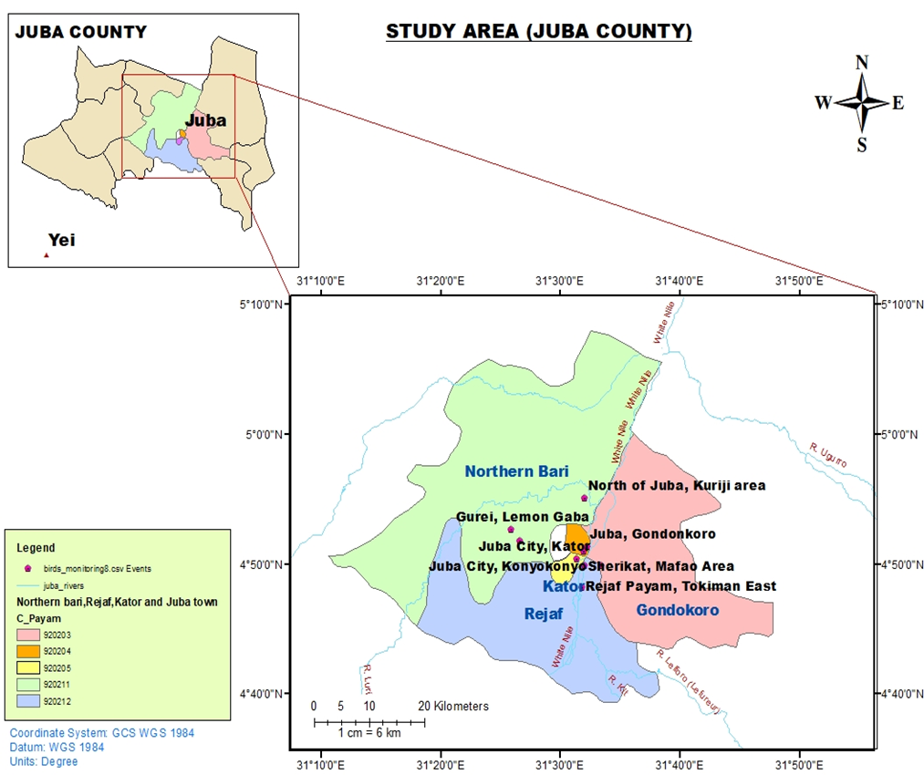
Figure 3.1: Map of Juba City
Source (Duku, 2024)

3.2. Materials
In Time-Species Counts methods, various materials were used to conduct surveys and collect data on the presence and abundance of different species over a specific period of time. Some of the common materials used in Time-Species Counts method in this study include:
- Binoculars:
- Nikon Monarch 5 8x42 Binoculars (Year Made: 2014)
- Description: Binoculars were used to observe birds from a distance. The Nikon Monarch 5 8x42 Binoculars provide a clear and magnified view of birds, allowing researchers to identify species and record their behaviours accurately.
- GPS devices:
- Garmin eTrex 10 Handheld GPS Navigator (Year Made: 2011)
Description: The Garmin eTrex 10 Handheld GPS Navigator is used to record the exact location of bird sightings during surveys. It helps in mapping bird distributions and monitoring changes in habitat over time.
- Camera traps:
- Example: Bushnell Trophy Cam HD Essential E3 Trail Camera (Year Made: 2018)
- Data sheets:
- Rite in the Rain All-Weather Birding Field Notebook (Year Made: 2019)
Description: The Rite in the Rain All-Weather Birding Field Notebook is used to record detailed information about bird sightings, including species name, location, time of observation, and any relevant notes. It helps in organizing and analysing data collected during bird surveys.
- Field guides:
- A comprehensive illustrated Field Guide to the Birds of Africa, south of the Sahara by Ian Sinclair & Peter Ryan (Year Made: 2003)
Description: Field guides like the Comprehensive Illustrated Field Guide to the Birds of Africa especially birds of south Sahara provide information on bird identification, behaviour, and habitat preferences. They are essential for accurately identifying bird species during surveys and counts.
These materials were chosen for Time- Species Counts for birds because they help in standardizing data collection, ensuring accuracy in bird observations, and providing a systematic approach to monitoring bird populations over time. By using these equipment and materials, researchers can effectively track changes in bird abundance, distribution, and behaviour, which are crucial for bird conservation and management efforts.

3.3 Sampling Design and Site Selection
A stratified random sampling design was employed to select 6 survey sites namely: Juba Centre, Gumbo-Sherikat, Rejaf, MAFAO, Kworejik, and Gondokoro. within Juba City. The city was initially stratified into four main land-use categories:
Dense Urban: Nyankuron, Kator, Konyo-konyo, Munuki, Jebel Kujur are Characterized by high-rise buildings, commercial centers, and limited green spaces.
Residential: River side Predominantly composed of houses, gardens, and street trees, varying in density.
Green Spaces: Including recreational grounds, botanical gardens, and undeveloped natural areas within the city.
Peri-urban/Transitional: Areas on the outskirts of the city includes Gumbo-Shirikat, MAFAO, Rejaf, Gondonkoro, Kweraji, showing a mix of urban development and more natural or agricultural landscapes.
Within each stratum, specific sampling points were randomly selected using a Geographic Information System (GIS) to ensure an unbiased representation of the habitat types. A total of 15 sampling points were established across the six strata, with an equitable distribution to ensure adequate coverage of each land-use type (Smith, J., 2023). Each sampling point was at least 500 meters apart to minimize the likelihood of counting the same individual birds across different points and to ensure independence of samples. Binoculars were used to observe birds from a distance. The Nikon Monarch 5 8x42 ((Year Made: 2014). Binoculars provide a clear and magnified view of birds, allowing researchers to identify species and record their behaviours accurately. The coordinates of each sampling point were recorded using a handheld GPS device (Garmin eTrex 30x) for accurate relocation during subsequent surveys.

3.4 Bird Survey Method: Time Species Count (TSC)
Bird surveys were conducted using the Time Species Count (TSC) method, also known as the timed point count method. This technique involves recording all bird species seen or heard within a fixed radius (e.g., 50 meters) from a stationary point for a predetermined duration. For this study, a 10-minute observation period was chosen for each point count (Bibby, et al., 2008). This duration is considered optimal for detecting most bird species in a given area without causing observer fatigue or significantly increasing the likelihood of double-counting.
Surveys were conducted during the early morning hours, specifically between 06:00 AM and 09:00 AM, when bird activity is generally highest. This timing minimizes the confounding effects of heat stress on bird behavior and ensures better detectability. Surveys were not conducted during periods of heavy rain, strong winds, or dense fog, as these weather conditions can significantly reduce bird activity and detectability. Each sampling point was visited fifteen times during the dry season (November 2023 - March 2024) during the dry season to account for seasonal variations in bird diversity and distribution (NOAA., 2025).
During each 10-minute count, the observer (a trained ornithologist) recorded all bird species identified by sight or sound within a 50-meter radius of the sampling point (Sutherland, W. J., 2006). The use of binoculars (e.g., Nikon Monarch 7 8x42) was essential for accurate visual identification. For species identified by sound, a good understanding of local bird calls was crucial. Unidentified birds were noted, and efforts were made to identify them later using field guides or by consulting with local experts. The number of individuals for each species was also estimated to provide a measure of relative abundance. Data were recorded directly onto pre-designed data sheets, which included fields for date, time, location (GPS coordinates), weather conditions, observer name, and a list of observed species with their estimated counts.

3.5 Data Analysis
The collected data were compiled into a master spreadsheet for subsequent analysis. Species richness for each sampling point was calculated as the total number of unique bird species recorded (Magurran, A. E., 2004). Relative abundance for each species was determined by summing the total number of individuals observed across all sampling points and dividing by the total survey effort.
To assess the diversity of bird communities, various ecological indices were calculated:
- Shannon-Wiener Diversity Index (H′): This index accounts for both species’ richness and evenness. It is calculated using the formula: H′=−∑i=1S(piln⁡pi) where S is the total number of species, and pi is the proportion of individuals belonging to the i-th species (Shannon, C. E. (1948).
- Simpson's Diversity Index (D): This index measures the probability that two individuals randomly selected from a sample will belong to the same species. It is calculated as: D=∑i=1Spi2 A higher value of D indicates lower diversity. Often, its inverse (1/D) or Gini-Simpson index (1−D) is used, where higher values indicate higher diversity (Simpson, E. H. (1949).
Statistical analyses were performed using statistics software Estimate S (version 9.0) was used to compare species richness and diversity indices across different land-use categories (Field, A., 2018). (Non-parametric tests, such as the Kruskal-Wallis test, were employed if data did not meet the assumptions of parametric tests. Species accumulation curves were generated to assess the adequacy of sampling effort. Rarefaction curves were also used to compare species richness among different land-use types, accounting for differences in sample size (Gotelli, N. J., & Colwell, R. K., 2001).
a. Diversity incorporates aspects of species richness of birds and or any biological community (Magurran, 2004; Cowell, 2013). Species richness and diversity (alpha and beta) were determined using the statistical software EstimateS, which is very handy in this type of study (Magurran, 2004; Cowell, 2013); where individual-based rarefaction and sample-based rarefaction, with 100 randomizations of sampling without replacement were used to generate the SACs (species abundance curves) of “Mau Tao” estimates of species richness for each site richness. Application of SACs is highly recommended when comparing species diversity from different communities or landscapes, or from areas with different degrees of perturbation (Moreno and Halffter, 2000). Three nonparametric abundance-based estimators ABE of species richness (abundance-based coverage estimator ACE, Chao 1, and Jackknife 1) and three nonparametric incidence-based estimators of species richness IBE (incidence-based coverage estimator ICE, Chao 2, and Jackknife 2) were used to estimate the potential number of species (observed & unseen) in the biological material of each study site. The combination of these measures, performed using EstimateS software version 9.0 (Colwell 2013), and the observed species richness allowed evaluation of the sampling effort in each locality. The observation that species vary in abundance has promoted the development of statistical models such as species abundance models (Magurran, 2004). Sometimes called dominance diversity curves, these models provide a graphical way of describing species richness and the relative abundance of species in communities (Morin, 2011). This tool is important as it allows a quick and easy comparison of biological communities.
b. Species Abundance Distributions (SADs), based on the inequality of species abundance that characterizes every ecological community, are used to study the structure of ecological communities by testing the fitting of data to theoretical models of relative species abundance (Green and Plotkin, 2007; Pavoine and Bonsall, 2011). Each distribution model has an underlying statistical distribution, which can be derived by making some assumptions about the way that species interact in the community (Magurran, 2004; Morin 2011).
Birds' relative abundance was determined from crude ordinal scales following
  - (Bibby et al, 1998) as summarized:

Table 3.1: How to calculate birds’ relative abundance
Ordinal scale | Abundance scale | Abundance category (number of individuals per 100 field hours)
Rare  Uncommon  Frequent  Common  Abundant | 1  2  3  4  5 | <0.1  0.1—2.0  2.1—10.0  10.1—40.0  40.0+

3.6. Ethical Considerations
All research activities were conducted in accordance with ethical guidelines for wildlife research. Necessary permits were obtained from the relevant authorities in South Sudan, including the Ministry of Wildlife Conservation and Tourism, prior to the commencement of fieldwork (Ministry of Wildlife Conservation and Tourism, South Sudan (2025) Local communities were informed about the purpose and nature of the study, and their cooperation was sought. Care was taken to minimize disturbance to birds and their habitats during surveys. Data collection involved only observational methods, ensuring no direct physical interaction with the birds.

CHAPTER FOUR

RESULTS AND DISCUSSION

4.1 Introduction
In this Chapter, "Results and Discussion," in a study titled "Diversity and Distribution of Birds in an African and Sub-Urban Landscape Case Study: Juba City," serves as the pivotal section where the empirical findings of the research are presented, analyzed, and interpreted in the context of existing scientific literature. This chapter bridges the gap between the data collected and the broader understanding of avian ecology within the specified urbanized African environment. It is here that the raw observations from the field were transformed into meaningful insights, contributing to the scientific discourse on biodiversity in rapidly developing regions.
The section systematically presents the qualitative data gathered during the study. This typically includes metrics such as species richness, abundance, diversity indices (e.g., Shannon-Wiener index, Simpson's index), and distribution patterns across different habitat types or land-use categories within Juba City. Statistical analyses, often presented using tables, graphs, and figures, were employed to summarize and visualize these findings.

4.2 Results

4.2.1 A checklist of bird species and their relative abundance across the six sites
During the study period, a total of 104 species, belonging to 21 orders and 38 families, were identified from a set of 23,082 individual birds in the six study sites.

Table 4.1: Checklist of birds and their relative abundance within six localities in Juba city – November 2023 to March 2024
Family name | Common Name | Scientific name | No. observations with sites
Family name | Common Name | Scientific name | Juba centre |  | Gumbo-Sherikat |  | Rejaf |  | MAFAO |  | Kwerajik |  | Gondokoro
Family name | Common Name | Scientific name | n* | % of^{ɵ} | n* | % of^{ɵ} | n* | % of^{ɵ} | n* | % of^{ɵ} | n* | % of^{ɵ} | n* | % of ^{ɵ}
Ciconiidae | Abdim's Stork | Ciconia abdimii | 0 | 0 | 67 | 1.43 | 0 | 0 | 0 | 0 | 0 | 0 | 0 | 0
Columbidae | Afep Pigeon | Columba unicincta | 0 | 0 | 0 | 0 | 50 | 1.89 | 0 | 0 | 0 | 0 | 0 | 0
Columbidae | African Collared Dove | Streptopelia r oseogrisea | 5 | 0.13 | 0 | 0 | 0 | 0 | 0 | 0 | 0 | 0 | 0 | 0
Anhingidae | African Darter | Anhinga rufa | 0 | 0 | 0 | 0 | 0 | 0 | 27 | 0.8 | 1.7 | 3.6 | 5.8 | 1.55
Accipitridae | African Goshark | Accipiter tachiro | 2 | 0.05 | 0 | 0 | 0 | 0 | 0 | 0 | 0 | 0 | 0 | 0
Jacanidae | African Jacana | Actophilornis africanus | 0 | 0 | 0 | 0 | 0 | 0 | 0 | 0 | 1.6 | 3.5 | 17 | 0.45
Columbidae | African Mourning Dove | Streptopelia decpiens | 219 | 5.55 | 10 | 0.21 | 82 | 3.1 | 51 | 1.5 | 5 | 0.11 | 41 | 1.1
Ciconiidae | African Open bill | Anastomus lamelligerus | 0 | 0 | 4.5 | 9.6 | 0 | 0 | 1.8 | 5.21 | 5.6 | 11.8 | 357 | 9.54
Columbidae | Laughing Palm Dove | Streptopelia senegalensis | 25 | 0.63 | 0 | 0 | 0 | 0 | 0 | 0 | 0 | 0 | 0 | 0
Apodidae | African Palm Swift | Cypsiurus parvus | 223 | 5.65 | 0 | 0 | 23 | 0.87 | 0 | 0 | 0 | 0 | 181 | 4.83
Monarchidae | African Paradise Flycatcher | Terpsiphone viridis | 0 | 0 | 0 | 0 | 63 | 2.38 | 0 | 0 | 0 | 0 | 0 | 0
Bucerotidae | African Pied Hornbill | Tockuus fasciatus | 0 | 0 | 0 | 0 | 7 | 0.26 | 0 | 0 | 0 | 0 | 0 | 0
Alcedinidae | African Pygmy-Kingfisher | Ispidina picta | 0 | 0 | 0 | 0 | 3 | 0.11 | 0 | 0 | 0 | 0 | 0 | 0
Threskiornithidae | African Sacred Ibis | Threskiornis aethiopicus | 0 | 0 | 726 | 15.5 | 70 | 2.65 | 349 | 10 | 746 | 15.7 | 450 | 2.01
n* = number observed of^{ɵ} = proportion by percentage

Table. 4: 1 (continued)
Family name | Common Name | Scientific name | No. observations with sites
Family name | Common Name | Scientific name | Juba centre |  | Gumbo-Sherikat |  | Rejaf |  | MAFAO |  | Kwerajik |  | Gondokoro
Family name | Common Name | Scientific name | n* | % of^{ɵ} | n* | % of^{ɵ} | n* | % of^{ɵ} | n* | % of^{ɵ} | n* | % of^{ɵ} | n* | % of^{ɵ}
Motacillidae | Afriican Pipit | Anthus cinnamomeus | 0 | 0 | 0 | 0 | 46 | 1.74 | 96 | 2.6 | 0 | 0 | 0 | 0
Apodidae | Alpine Swift | Apus melba | 0 | 0 | 76 | 1.63 | 0 | 0 | 0 | 0 | 0 | 0 | 0 | 0
Ardeidae | Black Headed Heron | Ardea cinerea | 36 | 0.91 | 50 | 1.07 | 0 | 0 | 4 | 0.1 | 0 | 0 | 32 | 0.85
Cuculidae | Black Cuckoos | Cuculus clamosus | 0 | 0 | 0 | 0 | 26 | 0.98 | 0 | 0 | 0 | 0 | 0 | 0
Accipitridae | Black Kit | Milvus migrans | 702 | 17.8 | 425 | 9.09 | 210 | 7.94 | 345 | 9.9 | 1.6 | 3.36 | 250 | 6.68
Columbidae | Black-Billed Wood Dove | Turtur abyssinicus | 10 | 0.25 | 0 | 0 | 0 | 0 | 0 | 0 | 0 | 0 | 20 | 0.53
Sturnidae | Bronz-Tailed Starling | Lamprotornis chalcurus | 0 | 0 | 0 | 0 | 0 | 0 | 0 | 0 | 69 | 1.46 | 0 | 0
Accipitridae | Brown Snake-Eagle | Circaetus cinereus | 0 | 0 | 0 | 0 | 6 | 0.23 | 10.7 | 30.7 | 0 | 0 | 12 | 0.32
Ardeidae | Cattle Egret | Bubulcus ibis | 362 | 9.2 | 13.5 | 28.9 | 160 | 6.1 | 0 | 0 | 11.8 | 23.9 | 7.6 | 20.27
Pycnonotidae | Common Bulbul | Pycnonotus barbatus | 75 | 0.43 | 0 | 0 | 0 | 0 | 70 | 2.0 | 0 | 0 | 0 | 0
Phylloscopidae | Common Chiffchiff | Phylloscopus collybita | 0 | 0 | 0 | 0 | 23 | 0.87 | 0 | 0 | 0 | 0 | 0 | 0
Hirundinidae | Common House Martin | Delichon urbicum | 38 | 0.96 | 62 | 1.33 | 18 | 0.68 | 0 | 0 | 0 | 0 | 0 | 0
Falconidae | Common Krestrel | Falco tinnuncullus | 0 | 0 | 0 | 0 | 2 | 0.08 | 19 | 0.54 | 6 | 0.13 | 0 | 0
Columbidae | Common Ringed Plover | Charadrius hiaticula | 0 | 0 | 0 | 0 | 0 | 0 | 0 | 0 | 53 | 1.12 | 140 | 3.74
Passeridae | Common Sparrow | Passer domesticus | 0 | 0 | 0 | 0 | 0 | 0 | 15 | 0.43 | 0 | 0 | 0 | 0
Apodidae | Comon Swift | Apus apus | 0 | 0 | 0 | 0 | 0 | 0 | 265 | 7.6 | 0 | 0 | 0 | 0
Cisticolidae | Croaking Cisticola | Cisticola natalensis | 0 | 0 | 0 | 0 | 74 | 2.79 | 0 | 0 | 0 | 0 | 0 | 0
n* = number observed of^{ɵ} = proportion by percentage
Table 4.1 (continued)
Family name | Common name | Scientific name | No. observations with sites
Family name | Common name | Scientific name | Juba centre |  | Gumbo-Sherikat |  | Rejaf |  | MAFAO |  | Kwerajik |  | Gondokoro
Family name | Common name | Scientific name | n* | % of^{ɵ} | n* | % of^{ɵ} | n* | % of^{ɵ} | n* | % of^{ɵ} | n* | % of^{ɵ} | n* | % of^{ɵ}
Pycnonotidae | Dark-Cpped Bulbul | Pycnonotus barbatus | 96 | 2.43 | 26 | 0.56 | 50 | 1.89 | 0 | 0 | 0 | 0 | 0 | 0
Pluvianidae | Egyptian Plover | Pluvianus aegyptius | 0 | 0 | 0 | 0 | 0 | 0 | 0 | 0 | 121 | 2.55 | 76 | 2,03
Oriolidae | Eurasian Golden Oriole | Oriolus oriolus | 0 | 0 | 16 | 0.34 | 65 | 2.46 | 0 | 0 | 0 | 0 | 0 | 0
Falconidae | Fox Krestrel | Falco alopex | 10 | 0.25 | 0 | 0 | 0 | 0 | 0 | 0 | 0 | 0 | 0 | 0
Sylviidae | Garden Warbler | Sylvia borin | 0 | 0 | 0 | 0 | 26 | 0.98 | 0 | 0 | 0 | 0 | 0 | 0
Threskiornithidae | Glossy Ibis | Plegadis falcinellus | 0 | 0 | 0 | 0 | 0 | 0 | 0 | 0 | 71 | 1.5 | 58 | 1.55
Ardeidae | Goliath Heron | Ardea goliath | 0 | 0 | 0 | 0 | 0 | 0 | 0 | 0 | 21 | 0.44 | 9 | 0.24
Musophagidae | Great Blue Taraco | Corythaeola cristata | 66 | 0.67 | 0 | 0 | 94 | 3.55 | 0 | 0 | 0 | 0 | 0 | 0
Cuculidae | Great Spooted Cuckoo | Clamator glandarius | 0 | 0 | 0 | 0 | 29 | 1.09 | 0 | 0 | 0 | 0 | 0 | 0
Ardeidae | Great White Egret | Egretta alba | 0 | 0 | 0 | 0 | 0 | 0 | 0 | 0 | 175 | 3.69 | 4 | 0.11
Laniidae | Grey -Backed Fiscal | Lanius excubitoroides | 36 | 0.91 | 18 | 0.38 | 25 | 0.95 | 6 | 0.17 | 9 | 0.19 | 16 | 0.43
Muscicapidae | Grey Go-Away Bird | Corythaixoides concolor | 0 | 0 | 0 | 0 | 0 | 0 | 0 | 0 | 0 | 0 | 19 | 0.51
Ardeidae | Grey Heron | Ardea cinerea | 0 | 0 | 0 | 0 | 0 | 0 | 0 | 0 | 0 | 0 | 33 | 0.88
Glareolidae | Grey Pratincole | Glareola cinerea | 0 | 0 | 0 | 0 | 12 | 0.45 | 0 | 0 | 0 | 0 | 0 | 0
Hirundinidae | Grey-Rumped Swallow | Pseudhirundo griseopyga | 0 | 0 | 55 | 1.18 | 0 | 0 | 0 | 0 | 0 | 0 | 0 | 0
Threskiornithidae | Hadeda Ibis | Bostrychia hagadash | 0 | 0 | 0 | 0 | 0 | 0 | 0 | 0 | 3 | 0.06 | 15 | 0.4
Scopidae | Hamerkop | Scopus umbretta | 0 | 0 | 0 | 0 | 0 | 0 | 0 | 0 | 17 | 0.36 | 61 | 1.63
n* = number observed of^{ɵ} = proportion by percentage
Table 4.1 (continued)
Family name | Common name | Scientific name | No. observations with sites
Family name | Common name | Scientific name | Juba centre |  | Gumbo-Sherikat |  | Rejaf |  | MAFAO |  | Kwerajik |  | Gondokoro
Family name | Common name | Scientific name | n* | % of ^{ɵ} | n* | % of^{ɵ} | n* | % of^{ɵ} | n* | % of^{ɵ} | n* | % of^{ɵ} | n* | % of ^{ɵ}
Accipitridae | Hooded Vulture | Necrosyrtes monachus | 134 | 3.39 | 374 | 8 | 5 | 0.19 | 45 | 1.29 | 0 | 0 | 0 | 0
Passeridae | House Sparrow | Passer domesticus | 253 | 6.41 | 19 | 0.41 | 0 | 0 | 64 | 1.83 | 0 | 0 | 0 | 0
Scolopacidae | Jack Snipe | Lymnocryptes minimus | 0 | 0 | 0 | 0 | 0 | 0 | 0 | 0 | 52 | 1.1 | 0 | 0
Cuculidae | Jacobin Cuckoos | Clamator jacobinus | 77 | 1.95 | 0 |  | 30 | 1.13 | 0 | 0 | 0 | 0 | 0 | 0
Accipitridae | Lappet -Faced Vulture | Torgos tracheliotos | 0 | 0 | 292 | 6.24 | 6 | 0.23 | 0 | 0 | 0 | 0 | 75 | 2
Columbidae | Laughing Dove | Spilopelia senegalensis | 102 | 2.58 | 11 | 0.24 | 6 | 0.23 | 10 | 0.29 | 0 | 0 | 31 | 0.83
Laniidae | Lesser Grey Shrike | Lanius minor | 0 | 0 | 0 | 0 | 117 | 4.42 | 0 | 0 | 0 | 0 | 0 | 0
Indicatoridae | Lesser Honeyguide | Indicator minor | 0 | 0 | 0 | 0 | 0 | 0 | 0 | 0 | 0 | 0 | 11 | 0.29
Jacanidae | Lesser Jacana | Microparra capenis | 0 | 0 | 0 | 0 | 0 | 0 | 50 | 1.43 | 139 | 2.93 | 21 | 0.56
Falconidae | Linner Falcon | Falcon biarmicus | 8 | 0 | 0 | 0 | 0 | 0 | 0 | 0 | 0 | 0 | 0 | 0
Ardeidae | Little Btten | Ixobrychus minutus | 0 | 0 | 0 | 0 | 0 | 0 | 0 | 0 | 14 | 0.29 | 0 | 0
Ardeidae | Little Egret | Egretta garzetta | 0 | 0 | 0 | 0 | 0 | 0 | 0 | 0 | 189 | 3.99 | 73 | 1.95
Apodidae | Little Swift | Apus affinis | 63 | 1.59 | 0 |  | 33 | 1.25 | 0 | 0 | 0 | 0 | 111 | 2.96
Accipitridae | Lizard Buzzard | Kaupifalco monogrammicus | 0 | 0 | 0 | 0 | 0 | 0 | 0 | 0 | 0 | 0 | 15 | 0.4
Accipitridae | Long Crested Eagle | Lophaetus occipitalis | 25 | 0.63 | 0 | 0 | 12 | 0.45 | 5 | 0.14 | 0 | 0 | 0 | 0
Ciconiidae | Marabou Stork | Leptoptilos crumenifer | 0 | 0 | 147 | 3.14 | 0 | 0 | 0 | 0 | 0 | 0 | 195 | 5.21
Laniidae | Masked Shrike | Lanius nubicus | 0 | 0 | 0 | 0 | 45 | 1.7 | 0 | 0 | 0 | 0 | 0 | 0
n* = number observed of^{ɵ} = proportion by percentage

Table 4.1 (continued)
Family name | Common name | Scientific name | No. observations with sites
Family name | Common name | Scientific name | Juba centre |  | Gumbo-Sherikat |  | Rejaf |  | MAFAO |  | Kwerajik |  | Kondokoro
Family name | Common name | Scientific name | n* | % of^{ɵ} | n* | % of^{ɵ} | n* | % of^{ɵ} | n* | % of^{ɵ} | n* | % of^{ɵ} | n* | % of^{ɵ}
Cuculidae | Senegal Coucal | Centropus senegalenis | 0 | 0 | 12 | 0.26 | 0 | 0 | 0 | 0 | 0 | 0 | 76 | 2.03
Columbidae | Laughing Palm Dove | Spilopelia senegalensis | 0 | 0 | 15 | 0.32 | 67 | 2.53 | 102 | 2.15 | 0 | 0 | 0 | 0
Muscicapidae | Spotted Flycatacher | Muscicapa striata | 0 | 0 | 12 | 0.26 | 0 | 0 | 0 | 0 | 0 | 0 | 0 | 0
Estrildidae | Southern Cordonblue | Uraegirithus cyanocephalus | 90 | 2.28 | 0 | 0 | 0 | 0 | 0 | 0 | 0 | 0 | 0 | 0
Ploceidae | Southern Red Bishop | Euplectes orix | 0 | 0 | 0 | 0 | 6 | 0.23 | 3 | 0.09 | 0 | 0 | 0 | 0
Coliidae | Speckled Mousebird | Colius striatus | 81 | 2.05 | 0 | 0 | 21 | 0.79 | 0 | 0 | 0 | 0 | 0 | 0
Columbidae | Speckled Pigeon | Coluumba guinea | 29 | 0.73 | 0 | 0 | 6 | 0.23 | 0 | 0 | 0 | 0 | 24 | 0.64
Ardeidae | Squacco Heron | Ardeala rallaides | 0 | 0 | 0 | 0 | 0 | 0 | 81 | 2.32 | 89 | 1.88 | 94 | 2.51
Alaudidae | Sun Lark | Galerida modesta | 0 | 0 | 0 | 0 | 30 | 1.13 | 0 | 0 | 0 | 0 | 0 | 0
Accipitridae | Tawiny Eagle | Aquila rapax | 0 | 0 | 0 | 0 | 3 | 0.11 | 70 | 2.01 | 0 | 0 | 0 | 0
Cisticolidae | Tawny-Flanked Prinia | Prinia subflava | 38 | 0.96 | 0 | 0 | 4 | 0.15 | 0 | 0 | 0 | 0 | 0 | 0
Motacillidae | Tree Pipit | Anthus trivialis | 0 | 0 | 0 | 0 | 22 | 0.83 | 0 | 0 | 0 | 0 | 0 | 0
Ploceidae | Village Spotted-back Weaver | Foceus cucullatus | 0 | 0 | 0 | 0 | 123 | 4.65 | 0 | 0 | 0 | 0 | 0 | 0
Anatidae | White -Faced Duck | Dendrocygna viduata | 0 | 0 | 1.6 | 3.5 | 0 | 0 | 15 | 0.43 | 0 | 0 | 189 | 5.05
Musophagidae | White-Bellied Go-away Birds | Criniferoides leucogaster | 1.0 | 2.56 | 0 | 0 | 0 | 0 | 0 | 0 | 0 | 0 | 0 | 0
Phylloscopidae | Willow Warbler | Phylloscopus trochilcus | 0 | 0 | 0 | 0 | 26 | 1.0 | 0 | 0 | 0 | 0 | 0 | 0
Ciconiidae | Woolly-Necked Stork | Ciconia ciconia | 0 | 0 | 0 | 0 | 0 | 0 | 0 | 0 | 23 | 0.5 | 37 | 0.99
Ciconiidae | Yellow-Billied Stork | Mycteria ibis | 0 | 0 | 0 | 0 | 0 | 0 | 37 | 1.06 | 0 | 0 | 31 | 0.82

4.3 Discussion
- Relative abundance of birds in Juba Centre zone
In Juba Centre, a total of 3,912 birds were observed, that is, 19.21% of all detections, were recorded (Table 4.1). The birds belong to 33 species and 19 families. Five species in the Juba Centre area, Black kite (Milvus migrans) (17.79% of all detections), Pied Crow (Corvus albus) (11.25% of all detections), Cattle Egret (Bubulcus ibis) (9.17% of all detections), Red-eyed Dove (Streptopelia semitorquata) (6.69% of all detections) and, House sparrow (Passer domesticus) (6.41% of all detections) count represented the highest relative abundance. On the contrary, eleven bird species, the African Goshawk (Accipiter tachiro) (0.05% of all detections), African Collared Dove (Streptopelia roseogrisea) (0.13% of all detections), Laughing Palm Dove (Streptopelia senegalensis) (0.63% of all detections), Black-headed Heron (Ardea cinerea) (0.91% of all detections), Black-billed Wood Dove (Turtur abyssinicus) (0.25% of all detections), Common Bulbul (Pycnonotus collybitus) (0.43% of all detections), Fox Kestrel (Falco alopex) (0.25% of all detections), Speckled Pigeon (Columba guinea) (0.73% of all detections), Tawny-flanked Prinia (Prinia subflava) (0.96% of all detections), Long Crested Eagle (Lophaetus occipitalis) (0.63% of all detections), and finally, Grey-backed Fiscal (Lanius excubitoroides) (0.91% of all detections) count showed the least relative abundance, observed once or twice (Table 4.1).
- Relative abundance of birds in Gumbo-Sherikat
In (Table 4.1), a total of 4,599 birds (18.9%) were recorded in Lotus Swamps. The birds belong to 24 species and 20 families. The most abundant bird species is the Cattle Egret (Bubulcus ibis) at (28.87%), followed by the African Sacred Ibis (Threskiornis aethiopicus) at (15.53%) and the African Openbill (Anastomus lamelligerus) at (9.6%). The Black Kite (Milvus migrans) and Lapped-faced Vulture (Torgos tracheliotos) also have relatively high abundance levels at (9.09%) and (6.24%) respectively. On the other hand, the Dark-caped Bulbul (Pycnonotus barbatus) Alpine Swift (Apus melba) and Ring-necked Dove (Streptopelia capicola) have the lowest abundance levels at (0.56%), (1.53%), and (0.77%), respectively. The Grey-rumped Swallow (Pseudhirundo griseopyga), Marabou Stork (Leptoptilos crumenifer), Pied Crow (Corvus albus), Sand Martin Swallow (Riparia riparia) and White-faced Duck (Dendrocygna viduata), have moderate abundance levels ranging from (1.18%) to (3.51%). The results indicate a diverse range of bird species in Gumbo-Sherikat, with the Cattle Egret (Bubulcus ibis) and the African Sacred Ibis (Threskiornis aethiopicus) being the most abundant species in the area. The varying abundance levels of different bird species highlight the importance of habitat diversity and conservation efforts to support the bird populations in the region.
- Relative abundance of birds in Rejaf zone
In open water body habitat, a total of 2,595 birds were observed i.e. (17.7%) of all detections recorded that belong to 53 bird species and 28 families (see Table 4.1). The most abundant bird species was the Red-Eyed Dove (Streptopelia semitorquata) at (11.46%), followed by the Ring-necked Dove (Streptopelia capicola) at (9.33%) and the Black Kite (Milvus migrans) at (7.94%). The Cattle Egret (Bubulcus ibis) and Lesser Grey Shrike (Lanius minor) also have relatively high abundance levels at (6.05%) and (4.42%), respectively. On the other hand, the African Palm Swift (Cypsiurus parvus), Common Chiffchaff (Phylloscopus collybita), Black Cuckoos (Cuculus clamosus), Grey-backed Fiscal (Lanius excubitoroides), and Great Spotted Cuckoo (Clamator glandarius), have the lowest abundance levels at less than (1%) each. The African Mourning Dove (Streptopelia decpiens), African Pipit (Anthus cinnamomeus), Dark-capped Bulbul (Pycnonotus barbatus), Jacobin Cuckoos (Clamator jacobinus), and Red-cheeked Cordon Blue (Uraeginthus bengalus) have moderate abundance levels ranging from (1.09%) to (3.29%). The results indicate a diverse range of bird species in Rejaf, with the Red-eyed Dove- (Streptopelia semitorquata), and Ring-necked Dove (Streptopelia capicola), being the most abundant species in the area (Table 4.1). The varying abundance levels of different bird species highlight the importance of habitat diversity and conservation efforts to support the bird populations in Rejaf.
d) Relative abundance of birds in MAFAO zone
In MAFAO, according to (Table 4.1), a total of 3,407 birds (18.11%) were recorded in MAFAO Swamps. The birds belong to 34 species and 20 families. African Sacred Ibis (Threskiomis aethiopicus) (10%), Black Kite (Milvus migrans) (9.88%), Common Swift (Apus apus) (7.6%), African Openbill (Anastomus lemelligerus) (5.21%), Red-cheecked Cordon Blue (Uraeginthus bengalus) (4.33%), Pied Crow (Corvus albus) (3.49%), Red-eyed Dove (Streptopelia semitorquata) (3.01%), African Pipit (Anthus cinnamomeus) (2.75%), Squacco Heron (Ardeola rallode) (2.32%), Tawny Eagle (Aquila rapax) (2.01%), African Mourning Dove (Streptopelia decpiens), Hooded Vulture (Necrosyrtes monachus), and House Sparrow (Passer domesticus) (1.83%) were the least common in MAFAO swamp habitat, recorded only once (0.01% each).
- Relative abundance of birds in Kwerajik zone
Based on the relative abundance results provided in Kwerajik Swamps in (Table 4.1), a total of 4,835 birds i.e. (12.6%) were recorded. The birds belonged to 30 species and 20 families. The Cattle Egret (Bulbulcus ibis) had the highest abundance at (23.9%), followed by the African Sacred Ibis (Threskiomis aethiopicus) at (15.7%). The next most abundant species were the African openbill (Anastomus lamelligerus) at (11.8%) and the Pied Crow (Corvus albus) at (5.32 %.). The least abundant species in the list were the Common Ringed Plover (Charadrius hiaticula) at (1.12%), the Red-eyed Dove (Streptopelia semitorquata) at (2.13%), and the African Jacana (Actophilornis Africana) at (3.46%). Lastly, the results show a range of abundance levels among the different bird species, with some being more common and others less common in the Kwerajik swarmps where the survey was conducted.
- Relative abundance of birds in Gondokoro zone
Based on the relative abundance results provided in Gondokoro (see Table 4.1), a total of 3,744 birds (12.6%) were recorded. The birds belonged to 42 species and 20 families. The Cattle Egret (Bubulcus ibis) has the highest abundance at (20.27%), followed by African Sacred Ibis (Threskiornis aethiopicus) (12.01%) and the African Openbill (Anastomus lamelligerus) at (9.54%) and the Black Kite (Milvus migrans) at (6.68%). The next most abundant species were the Marabou Stork (Leptoptilos crumenifer) at (5.21%) and the White-faced Duck (Dengrancygna viduata) at (5.05%). The least abundant species in the list were the African Jacana (Actophilornis Africana) at (0.45%), the Black-headed Heron (Ardea cinerea) at (0.85%), and the Glossy Ibis (Plegadis facinellus) at (1.55%). Finally, the results show a range of abundance levels among the different bird species, with some being more common and others less common in the Gondokoro Island where the survey was conducted. The Cattle Egret stands out as the most abundant species in this list, while the African Jacana and the Black-headed Heron were among the least abundant (Table 4.1).

- Distribution pattern of birds in the six study sites
Since more than two nominal levels of observations were obtained from a sampling unit: (individual number, species and number of families); in such cases, frequencies are arranged in two or more rows and we refer to a two-way classification. Tables of these data are called contingency tables (Fowler et al, 1998). They allow the investigation of association between variables. The frequencies obtained in the above case are shown in (Table 4.2). All categories in both directions are nominal; chi-square contingency analysis is therefore appropriate. For the detailed steps in the analysis see (Appendix I).
Table 4.2: Frequencies of bird numbers, species and families in six selected areas within
Juba city and its sub-urban areas, November 2023 to March 2024
Site | Variables
Site | No. of individuals | No. of species | No. of families | Total
Juba center  O§:  E^{ɵ}:  (O – E)²/E: | 3945  3938.87  0.0095 | 33  36.61  0.356 | 19  21.52  0.2951 | 3997
Gumbo-Sherikat  O:  E:  (O – E)²/E: | 4676  4651.35  0.1306 | 24  43.23  0.0855 | 20  25.42  1.1556 | 4720
Rejaf O:  E:  (O – E)²/E: | 2645  2686.35  0.6365 | 53  24.97  31.465 | 28  14.68  12.086 | 2726
MAFAO O:  E:  (O – E)²/E: | 3491  3493.44  0.0017 | 34  32.47  0.0721 | 20  19.0906  0.0433 | 3545
Kwerajik O:  E:  (O – E)²/E: | 4739  4719.35  0.0818 | 30  43.83  4.3609 | 20  25.79  1.2999 | 4789
Kondokoro O:  E:  (O – E)²/E: | 3744  3750.64  0.0117 | 42  34.86  1.4624 | 20  20.5  0.0122 | 3806
Total | 23240 | 216 | 127 | 23583
NB: § = observed frequencies; ɵ = expected frequencies.
The question to be asked is: ‘Is the distribution of frequencies between the categories homogeneous? Or is there really a significant difference between the frequencies? In either case, the statistical hypotheses are:
H_{o}: The observed frequencies are homogeneous and the departure from the normal distribution is merely due to sampling error.
H₁: The observed frequencies depart from those expected of a homogeneous distribution by an amount that cannot be explained by sampling error.
If H_{o} is true, we expect that 23,583 birds should be distributed homogeneously between the three nominal categories, that is 23583/3 = 7861.
The calculated statistic ꭓ² is 53.56 (exceeding the critical value at both p = 0.05 (18.31) and p = 0.01 (23.21) at 10 degrees of freedom. Hence, it can be concluded that there is a statistically very high significant association between the distribution of bird species, their individual numbers and number of families; and the state of habitat conditions where they were observed: ꭓ² = 53.56, df = 10, p<0.01**. This implies that the prevailing habitat conditions in each site influence the number of species and their families therein, i.e. the more disturbed and transformed the area is the lower is the species number, hence, less diverse is the avian community. For instance, in (Table 4.2) areas like Juba center (town proper), Gumbo-Sherikat and Kwerajik which are more urbanized, with dense populations of people have fewer bird species number than expected; whereas, areas like MAFAO, Gondokoro and Rejaf which are sparsely populated, with some intermittent agricultural activities and slower pace of urbanization have higher species numbers than expected.
- Species richness and diversity
Table (4.3) shows the highest species richness value was obtained in Gondokoro with 113 species based on ABE and 146 species based on IBE, followed by Kwerajik 105 species based on ABE and 135 species based on IBE, respectively; while the least number of species was recorded in Juba center with 35 species and Gumbo-Sherikat with 55 species based on ACE; and, 209 species and 103 species, respectively based on IBE. For the Margalef index values, there was no significant variation of species richness between all the six study sites, whereas both gave lower values than the Rejaf study site (Table 4.3). The Shannon and Simpson indices both ranked the bird communities of Kwerajik and Rejaf as the most diverse. All the observed bird communities appeared weakly diversified when considering the value of the Shannon index in relation to the maximal diversity (lnS) (Table 4.4).
Table 4.3: Estimator of species based on abundance of birds associated with six locations within Juba city from November 2023 to March 2024

Attribute | Species richness generated (mean ± S.E)
Attribute | Juba centre | Gumbo-Sherikat | Rejaf | MAFAO | Kwerajik | Gondokoro
ACE mean | 35.27±9.57 | 55.84±10.05 | 71.87±10.39 | 83.64±9.58 | 93.56±6.88 | 101±0.0
Chao 1 mean | 35.27±176.69 | 55.84±27.9 | 71.87±21.13 | 83.64±17.33 | 93.56±12.4 | 101±10.98
Jack 1 mean | 35.27±0.00 | 77±5.45 | 102.76±9.46 | 118.78±11.91 | 129.66±14.24 | 137.67±15.2
Mean of the six ABE | 35.27 | 63.89 | 82.17 | 95.35 | 105.59 | 113.23
ICE mean | 576.7±333.83 | 251.19±135.64 | 172.52±57.74 | 158.04±36.92 | 150.08±22.85 | 149.77±0.00
Chao 2 mean | 576.7±176.69 | 119.85±27.9 | 125.11±21.13 | 128.06±17.33 | 125.11±12.4 | 128.69±10.98
Jack 2 mean | 0.00±0.00 | 79.78±14.73 | 115.25±20.37 | 134.7±21.01 | 144.43±17.06 | 152.07±0.00
Mean of the six IBE | 209.87 | 103.94 | 123.59 | 133.70 | 135.33 | 146.91

The values of the evenness index showed a nonsignificant difference in abundance distribution between Juba center, Gumbo-Sherikat, Rejaf, MAFAO, and Gondokoro, whereas all were different from Kwerajik (Table 4.4). The Berger–Parker measure indicated the numerical predominance of the most abundant species in each locality, with the highest value observed at Kwerajik and lowest at Rejaf (Table 4.4).
The bird fauna associated with each study site appeared to be species-rich in all the study sites. Based on the values of Margalef’s index, species richness was not significantly different between Juba center, Gumbo-Sherikat, MAFAO, Kwerajik and Kondokoro and, in all these sites, was significantly lower than at Rejaf (Table 4.4). This finding indicates that the type of landscape, agricultural or urban, may have had a greater effect on species richness. Thus, species richness variation appeared more influenced by border effects than by climatic parameters. As a result, no one community contains the same biodiversity as any of the others, even in rather homogeneous landscapes, due to site-specific characteristics of soil, topography, vegetation, weather, and other environmental factors that may govern each species settlement (Kim 2009). Even though Kwerajik appeared to be the most diverse of the six sites when considering the values of Shannon index, evenness was low in each locality except in Kwerajik (Table 4.4). An ecosystem exhibiting a low evenness is one in which a few sampled species dominate (Magurran 1988).
Table: 4.4. Species diversity and species richness indices calculated for birds observed within six locations within Juba city from November 2023 to March 2024.
Attribute | Location
Attribute | Juba centre | Gumbo-Sherikat | Rejaf | MAFAO | Kwerajik | Gondokoro
Shannon Hʹ | 18.5 | 11.57 | 3.86 | 6.94 | 43.84 | 5.77
lnS | 3.47 | 3.53 | 3.98 | 3.47 | 3.37 | 3.69
Simpson, 1/D | 0.67 | 0.45 | 1.42 | 0.004 | 0.004 | 0.006
Evenness, Jʹ | 5.33 | 3.64 | 0.97 | 2.00 | 13.00 | 1.56
Berger-Parker | 0.65 | 0.89 | 0.43 | 0.77 | 1.0 | 0.70
Margalef-DMg | 3.74 | 2.76 | 6.73 | 3.79 | 3.43 | 4.74

While most of these species were found all over the six study sites, others were confined to certain areas and not in others, for example, Marabou Stork (Leptoptilos crumenifer) was confined in Gumb- Sharikat, Kweriji MAFAO and Gondoro sites. In addition, there were other bird species observed outside the six selected study sites but which were not included in the checklist of birds, for example, Banded Prinia (Prinia bairdii), Black-headed Gonolek (Laniarius erythrorugaster), Northern Brubru (Nilaus afer), Tropical Boubou (Laniarius ferrugineus), Olive-bellied Sunbird (Nectarinia chloropygius), Beautiful Sunbird (Necterinia pulchella), Robin Chat (Cossypha caffra), Well’s Wagtail (Motacilla capensis), Golden Pipit (Tmetothylacus tenellus), Green Wood Hoopoe (Phoeniculus purpureus), African Thrush (Turdus pelios),and; even some nocturnal species such as African Barn Owl (Tyto alba), Standard-Winged Nightjar (Macrodipteryx longippenis), Eurasia Nightjar (Caprimulgus europaeus) and the Spotted Eagle Owl (Bubo africanus).
The study of bird species in Juba City and its suburban areas have provided valuable insights into biodiversity and ecological health. In this context, a total of 209 identified bird species have been documented across six sites in Juba city and its suburban areas, each with its unique diversity. One notable area, the Juba Centre, hosts 32 of these species. This relatively smaller number highlights a potential concentration of habitats that cater to particular species, possibly influenced by urbanization or habitat fragmentation in the region.
Moving to Gumb-Sherikat, this area has recorded 24 bird species. Though less than Juba Centre, the diversity here may still indicate a variety of ecological niches available for different avian life. Similarly, Rejaf outshines both the Juba Centre and Gumb-Sherikat with a significantly larger count of 54 bird species. The higher diversity in Rejaf could be attributed to various environmental factors such as wetlands, forested areas, or other suitable habitats that support a wide range of birdlife.
In contrast, the region of MAFAO presents a count of 31 species. This figure suggests that while not as diverse as Rejaf, MAFAO still maintains a healthy variety of bird species, possibly benefiting from specific ecological attributes of the area. Kwerajik, with 29 identified species, follows closely behind, again indicating a moderately diverse environment. Lastly, Gondokoro stands at 39 species, suggesting a combination of habitat features that support various bird populations.
All in all, the distribution of bird species among these regions demonstrates a rich tapestry of avian biodiversity across different landscapes. Understanding the specific species present in each area can aid in conservation efforts and help stakeholders make informed decisions about habitat preservation and management to ensure these bird populations thrive in the future.
- Bird community characterization
Bird community characterization based on sampling effort using species abundance curves in the specified sample areas, Juba Centre areas (Juba Centre 3,945, Gumbo-Sherikat 4,676, Rejaf zone 2,645, MAFAO zone 3,491, Kwerajik zone 4,739, Gondokoro zone 3,744 individual species). This involved analyzing how the number of observed bird species increases with sampling effort within each zone, and how this relates to the distribution of individual species. A species abundance curve, often represented as a rank-abundance curve or a species-abundance distribution, illustrates the relative abundance of different species in a community. For bird communities, this curve helps to understand the diversity and evenness of species within each zone, and how sampling effort influences the completeness of species detection (Magurran, A. E. 2004). The total number of individuals sampled in each zone (e.g., 3,945 in Juba Centre) represents the sampling effort in terms of individuals encountered.
To characterize the bird community, the abundance of each species was plotted (e.g., number of individuals) against its rank (from most abundant to least abundant) for each zone. A steeper curve indicates a community dominated by a few highly abundant species, while a flatter curve suggests a more even distribution of species abundances (Rosenzweig, M. L., 1995). Comparing these curves across Juba Centre, Gumbo-Sherikat, Rejaf, MAFAO, Kwerajik, and Gondokoro zones revealed differences in their bird community structures. For instance, a zone with a higher total number of individuals but a less steep curve might indicate a richer and more evenly distributed bird community, assuming similar sampling methodologies. The concept of sampling effort is crucial because an insufficient effort can underestimate species richness and distort the true shape of the abundance curve (Gotelli, N. J., & Colwell, R. K.2001). Therefore, the provided individual counts for each zone serve as a proxy for the intensity of sampling within those areas.
Existing literature on bird diversity and distribution in African and sub-urban landscapes, particularly within the last 15 years, provides a framework for interpreting these data. Studies often employ various sampling methods (e.g., point counts, time species counts, mist-netting, transect surveys) to generate species abundance data (Bibby, et al.2000). The species accumulation curve, which plots the cumulative number of species discovered as a function of sampling effort (e.g., number of samples, time spent, or individuals counted), is a key tool to assess sampling completeness and estimate total species richness (Colwell, R. K., & Coddington, J. A., 1994). For the Juba City context, understanding the impact of urbanization and habitat fragmentation on bird communities is critical. Urbanization often leads to a decrease in species richness and an increase in the abundance of generalist species, resulting in less diverse and more uneven bird communities (Marzluff, J. M. 2001).
The provided individual counts for each zone (e.g., 3,945 for Juba Centre) represent the total number of individual birds recorded within that specific area during the sampling period. While these numbers indicate the scale of the sampling effort in terms of individuals encountered, they do not directly represent species richness or diversity without further analysis of the species composition within those counts. To fully characterize the bird community, one would need the species-level breakdown of these individual counts for each zone (Krebs, C. J., 1999). This would allow for the construction of species abundance curves and the calculation of diversity indices (e.g., Shannon-Wiener index, Simpson's index) for each zone.
Research in similar African urban environments has shown that habitat heterogeneity, availability of green spaces, and the level of human disturbance significantly influence bird community structure (Seress, G., & Liker, A. 2015). For example, areas with more diverse vegetation and less human disturbance tend to support a greater variety of bird species and more even abundance distributions.
The analysis of species abundance curves for Juba Centre, Gumbo-Sherikat, Rejaf, MAFAO, Kwerajik, and Gondokoro zones would allow for a comparative assessment of their bird communities. Differences in the shape and steepness of these curves, combined with the total number of individuals and species richness, would provide insights into the ecological health and conservation status of birds in each zone (Gaston, K. J. 2000). For instance, if the Kwerajik zone (4,739 individuals) shows a more even abundance distribution compared to the Rejaf zone (2,645 individuals), it might suggest a healthier and more diverse avian ecosystem in Kwerajik, assuming similar habitat types and sampling efforts.
Based on the provided individual species counts, Kwerajik and Gumbo-Sherikat zones recorded the highest numbers of individual birds, suggesting they might support larger bird populations or have higher bird densities. However, without data on the number of unique species identified at various sampling points within each zone, a precise species abundance curve cannot be generated. The existing literature on Juba City and South Sudan emphasizes that habitat quality, vegetation cover, and the extent of human disturbance are critical determinants of bird diversity and richness. Therefore, while high individual counts are indicative of bird presence, they do not solely define community characterization without accompanying species richness and diversity metrics. Further detailed studies employing standardized methods like line transects or point counts, coupled with species identification, are necessary for a comprehensive characterization of bird communities in these zones
- Pattern of Species abundance distributions (SADs).
Any attempt to describe a complex community structure by one single attribute, such as richness or equitability, can be criticized because valuable information about community structure is lost (Begon et al. 2006). Based on the values from diversity indices shown in (Table 4.4), bird communities observed in the six study sites were similar irrespective of habitat attributes of the locality. This study aimed to characterize the structure of bird communities associated with different forms of land uses including degree of urbanization in six localities situated within greater Juba in South Sudan. Based on components of a diversity, the bird communities studied appeared species-rich, with a high preponderance of over fifty main species including wetland species which are abundant, and a great number of species common to all the six sites; but about four or five uncommon or rare species (see Table 4.5).

Figure 4.1: Sample-based rarefaction curves of expected bird species in urban and sub-urban areas of Juba city
In sample-based rarefaction curves above, the S(est) and Jack 1 mean results provide insights into the expected bird species richness in urban and suburban areas of Juba city based on a specific number of samples (in this case, 7 samples) and a Jack 1 mean value of 140.
The S(est) result (Figure 4.1) above represents an estimate of the total number of species that would be expected to be observed if a larger number of samples were taken. In this context, the S(est) result for 7 samples provides an estimate of the expected bird species richness in the urban and suburban areas of Juba city based on the sampling effort. In case high richness should have been reach if more samples were collected.
The Jack 1 mean value of 140 indicates the average number of species that would be missed in 100 random samples of a given size. A higher Jack 1 mean value suggests that there may be a greater diversity of bird species present in the area beyond what has been sampled, highlighting the potential for additional species richness that has not yet been captured in the sampling effort.
When analysing the sample-based rarefaction curves, a researcher would expect to see the S(est) and Jack 1 mean results provide complementary information about the expected bird species richness in the urban and suburban areas of Juba city. The convergence of these results can indicate that the sampling effort is effectively capturing the diversity of bird species present in the area, while discrepancies may suggest the need for additional sampling to obtain a more accurate estimate of species richness. All in all, the S(est) and Jack 1 mean results of 6 samples in the sample-based rarefaction curves can help inform conservation efforts and guide future sampling strategies to better understand and protect the bird populations in urban and suburban areas of Juba city.

Figure 4.2: Individual-based rarefaction curves of expected bird species in urban and sub-urban areas of Juba city
In (Figure 4.2) Individual-based rarefaction curves, the Jack 1 mean and S(est) results provide valuable insights into the expected bird species richness in urban and suburban areas of Juba city based on the sampling effort of 2500 individuals.
The Jack 1 mean is an estimate of the average number of species that would be missed in 100 random samples of a given size (in this case, 2500 individuals). A higher Jack 1 mean value indicates a higher level of species richness that is potentially missed in sampling efforts, suggesting that there may be a greater diversity of bird species present in the area beyond what has been sampled.
On the other hand, the (Figure 4.2) S(est) result represents an estimate of the total number of species that would be expected to be observed if a larger number of individuals were sampled. In this case, the S(est) result for 25000 individuals provides an estimate of the expected bird species richness in the urban and suburban areas of Juba city based on the sampling effort.
When analysing the individual-based rarefaction curves, one would expect to see the Jack 1 mean and S(est) results converge as the sampling effort increases. This convergence indicates that the sampling effort is capturing a representative sample of the bird species present in the area, and that the estimates of species richness are becoming more accurate as more individuals are sampled.
In nutshell, the Jack 1 mean and S(est) results of 25000 individuals in the individual-based rarefaction curves can help researchers, government especially the Ministry of Wildlife Conservation Tourism (MWCT) and conservationists and its partners understand the expected bird species richness in urban and suburban areas of Juba city, and guide future sampling efforts and conservation strategies to protect the diverse bird populations in the region.

Figure 4.3: Sample-based rarefaction curves of expected bird species in urban and sub-urban areas of Juba city.
In the context of a sample-based rarefaction curve of expected bird species in urban and suburban areas of Juba city using a Chao mean at 100 and S (est) 6 samples, the species richness refers to the total number of unique bird species observed in the samples taken from each area.
The Chao mean at 100 indicates that the estimated total number of bird species in the community is 100. This means that, based on the samples collected, it is expected that there are 100 different bird species present in the urban and suburban areas of Juba city.
The S (est) value of 6 samples signifies that 6 samples have been taken from each area to estimate the number of bird species present. By analysing the rarefaction curve generated from these samples, we can observe how the species richness increases with each additional sample as seen in (Figure 4.3) above.
As more samples are taken, the rarefaction curve will show the accumulation of new bird species, leading to an increase in species richness. The curve will eventually plateau, indicating that the majority of the species present in the area have been observed and that additional sampling may not yield many new species.
Lastly, the species richness of the sample-based rarefaction curves provides valuable insights into the diversity and abundance of bird species in urban and suburban areas of Juba city. It helps researchers, government and conservationists understand the biodiversity of these habitats and make informed decisions regarding conservation and management strategies.

Figure 4.4: individual-based rarefaction curves of expected bird species in urban and suburban areas of Juba city.
In the context of a sample-based rarefaction curve of expected bird species in urban and suburban areas of Juba city using a Chao mean at 100 and S (est) 25000 individuals, the species richness refers to the total number of unique bird species observed in the samples taken from each area. The Chao mean at 100 indicates that the estimated total number of bird species in the community is 100. This means that, based on the samples collected, it is expected that there are 100 different bird species present in the urban and suburban areas of Juba city.
The S (est) value of 25000 individuals signifies that a total of 25000 individual birds have been sampled from each area to estimate the number of bird species present. By analysing the rarefaction curve generated from these samples, we can observe how the species richness increases with each additional individual sampled.

4.2.2. Common bird species of Juba city and its environs
Table (4.5) below presents the relative abundance of birds based on the scale of abundance. During the survey conducted in in this study, several bird species were commonly recorded across the six sites, each contributing to the diverse avian landscape of the region; most common bird species include the following:
1. African Mourning Dove (Streptopelia decaoto)
The African mourning dove is a small, slender bird characterized by its soft, plaintive cooing. It typically inhabits open woodlands, savannas, and urban areas, where it often forages on the ground for seeds and grains. In Juba, these doves are commonly seen in gardens, parks, and along roadsides, where they adapt well to human presence and are often found in pairs or small groups.
2. Black Kite (Milvus migrans)
The black kite is a large raptor recognized by its distinctive forked tail and powerful wings. This bird thrives in a variety of habitats, including wetlands, coastal regions, and urban areas. In Juba, black kites are often seen soaring over the city, scavenging for food or hunting for small mammals and birds. They are particularly adept at living in areas with human activity, utilizing scraps from markets and open spaces.
3. Grey-Back Fiscal (Lanius excubitor)
The grey-backed fiscal is a medium-sized shrike known for its striking gray and white plumage, along with a distinctive black mask across its eyes. This species prefers open country, scrublands, and grasslands, where it hunts insects and small vertebrates. In the outskirts of Juba, grey-backed fiscals can often be observed perched on utility wires or fences, scanning the ground for prey. Their habit of impaling their catches on thorns adds to their unique behavior.
4. Laughing Dove (Spilopelia senegalensis)
The laughing dove is a small, slender dove with a unique, melodious call that sounds like laughter. Its habitat ranges from urban areas to farmland and savannas. In Juba, these doves prefer mixed habitats where they can find both open spaces foraging and trees or shrubs for nesting. Their diet mainly consists of seeds, making them common visitors to cultivated fields and gardens.
5. Pied Crow (Corvus albus)
The pied crow is a highly adaptable and intelligent bird characterized by its striking black and white plumage and loud vocalizations. This species thrives in diverse habitats, including urban environments, savannas, and agricultural areas. In Juba, pied crows are often seen scavenging for food, exploiting opportunities presented by human activities such as markets and waste. Their social behavior and ability to learn from their environment contribute to their success in urban settings.
6. Red-eyed Dove (Streptopelia semitorquata)
The red-eyed dove is a medium-sized dove commonly recognized by its reddish-brown eyes and soft cooing calls. It prefers habitats that include woodlands, gardens, and urban environments. In and around Juba, red-eyed doves can often be seen perched in trees or foraging for food on the ground, where they primarily consume seeds and fruits. Their presence adds a gentle charm to the local avifauna.
7. Red-cheeked Cordon Bleu (Uraeginthus bengalus)
The red-cheeked cordon bleu is a small, brightly colored finch notable for its vibrant blue body and distinctive red cheeks. This species typically inhabits grassy savannas or open woodland edges, often near water sources. In Juba, they are often found in mixed flocks, foraging on the ground for seeds and insects. Their colorful appearance and social behavior make them a delightful sight for birdwatchers.
8. Ring-necked Dove (Streptopelia capicola)
The ring-necked dove is a medium-sized dove marked by its distinctive black crescent or "ring" on the neck. This species inhabits a range of environments, including gardens, urban areas, and agricultural fields. In Juba, ring-necked doves are frequently seen in residential areas, where they forage for seeds and fruits. Their adaptability to human-modified landscapes contributes to their widespread distribution in the region.
These bird species collectively contribute to the rich biodiversity found in and around Juba city, showcasing the importance of both urban and natural habitats in supporting avian life.
The counts of individual birds across various localities within this region reflect both the abundance and the distribution of avian species. In the center of Juba itself, there are 3,945 recorded individual birds, indicating a rich urban biodiversity likely supported by urban greenery and local water bodies. This number suggests that, despite urbanization, the city center continues to provide essential habitats for various species.
Gumbo, specifically the Sherikat area, records the highest number with 4,661 individuals. This could point to abundant natural resources and ideal nesting grounds, such as riparian zones along the White Nile that could offer both food and shelter. Such an environment might attract numerous migratory and resident bird species, contributing to the area's high count.
Rejaf, with 2,578 individuals, presents a lesser density of birds compared to other areas. This might be due to different ecological or urban factors influencing bird habitation, such as land usage, vegetation types, or human activity levels. Despite this, the presence of unique microhabitats within the area can still support a diverse spectrum of bird life.
In MAFAO, the count of 3,389 individuals shows a moderate bird population. The mix of urban and suburban environments here might provide varied ecological niches supporting different birds. This area may see a balanced co-existence of human activities and wildlife.
Kwerajik's 4,739 bird individuals make it one of the richest areas in terms of avian population, suggesting excellent natural habitats that might be relatively undisturbed by urban sprawl. The environment may be characterized by diverse flora, wetlands, or forest patches conducive to bird life.
Lastly, Gondokoro with its 3,739 bird’s individuals reflects likely favorable conditions for sustaining bird populations, possibly due to proximity to water sources or preservation of native fauna, providing a buffer against urban encroachment.
In a nutshell, the varied bird populations across these regions highlight the ecological richness and diversity in and around Juba city, influenced by geographic, environmental, and anthropogenic factors. This diversity underscores the importance of continued conservation efforts to protect these avian populations and their habitats.
While Abdim's Stork (Ciconia abdimii), Afep Pigeon (Turtur afer), and the African Goshawk (Accipiter tachiro) are among the species that tend to be confined to specific habitats and geographical areas, which can influence their populations and visibility in the wild. These birds are often associated with particular ecosystems that provide the resources and conditions necessary for their survival. Abdim's Stork, for instance, is mostly found in semi-arid regions and grasslands, making its habits and breeding sites particularly localized. Similarly, the Afep Pigeon prefers dense forests where it can find fruits and seeds, while the African Goshawk thrives in woodland areas, relying on its hunting skills to catch smaller birds and mammals. The confinement of these species to specific sites often makes them more vulnerable to habitat loss and environmental changes, which can further limit their populations.
On the other hand, species like the Common Swift (Apus apus), Jacobin Cuckoo (Clamator jacobinus), Lesser Grey Shrike (Lanius minor), and Lizard Buzzard (Kaupifalco monogrammicus) were considered rare in many areas, possibly due to various ecological pressures and habitat requirements. The Common Swift, known for its aerial agility, often breeds in urban environments but can be affected by the availability of suitable nesting sites such as cliffs or old buildings. The Jacobin Cuckoo, with its distinctive behaviour of brood parasitism, relies on specific host species for breeding, making it less abundant in areas where those hosts are scarce. The Lesser Grey Shrike, typically found in open countryside, faces threats from agricultural expansion and habitat degradation that can diminish their nesting opportunities. Lastly, the Lizard Buzzard (Scientific name), a specialized raptor that hunts reptiles, is also limited by the availability of suitable habitats that can support its dietary needs. The rarity of these species highlights the intricate balance of ecosystems and the importance of preserving diverse habitats to support avian biodiversity.

Table 4.5: Relative abundance and status of birds from TSC within Juba city and its sub-urban areas during November 2023 to March, 2024
Species | Scientific name | Number of individuals in each site (6 sites were sampled) |  |  |  |  |  | No. indivi/10hrs | Ordinal scale
Species | Scientific name | J * | GS* | R* | M* | KR* | G* | No. indivi/10hrs | Ordinal scale
Abdim’s Stork | Ciconia abdimii | 0 | 67 | 0 | 0 | 0 | 0 | 44.67 | Abundance
Afep Pigeon | Columba unicincta | 0 | 0 | 50 | 0 | 0 | 0 | 33.33 | Common
African Collared Dove | Streptopelia roseogrisea | 5 | 0 | 0 | 0 | 0 | 0 | 3.33 | Frequent
African Darter | Anhinga rufa | 0 | 0 | 0 | 27 | 168 | 58 | 168.67 | Abundance
African Goshawk | Accipiter tachiro | 2 | 0 | 0 | 0 | 0 | 0 | 1.33 | Uncommon
African Jacana | Actophilornis africanus | 0 | 0 | 0 | 0 | 164 | 17 | 120.67 | Abundance
African Mourning Dove | Streptopelia decpiens | 219 | 10 | 82 | 51 | 5 | 41 | 272 | Abundance
African Openbill | Anastomus lamelligerus | 0 | 449 | 0 | 182 | 558 | 357 | 1,030.67 | Abundance
Luaghing Palm Dove | Streptopelia senegalensis | 25 | 0 | 0 | 0 | 0 | 0 | 16.67 | Common
African Palm Swift | Cypsiurus parvus | 223 | 0 | 23 | 0 | 0 | 181 | 284.67 | Abundance
African Paradise Flycatcher | Terpsiphone viridis | 0 | 0 | 63 | 0 | 0 | 0 | 42 | Abundance
African Pied Hornbill | Tockuus fasciatus | 0 | 0 | 7 | 0 | 0 | 0 | 4.67 | Frequent
African Pygmy-Kingfisher | Ispidina picta | 0 | 0 | 3 | 0 | 0 | 0 | 2 | Uncommon
African Sacred Ibis | Threskiornis aethiopicus | 0 | 726 | 70 | 349 | 746 | 450 | 1,560.67 | Abundance
Afriican Pipit | Anthus cinnamomeus | 0 | 0 | 46 | 96 | 0 | 0 | 94.67 | Abundance
Alpine Swift | Apus melba | 0 | 76 | 0 | 0 | 0 | 0 | 50.67 | Abundance
Black Headed Heron | Ardea cinerea | 36 | 50 | 0 | 4 | 0 | 32 | 921.33 | Abundance
Black Cuckoos | Cuculus clamosus | 0 | 0 | 26 | 0 | 0 | 0 | 1.73 | Uncommon
Black Kit | Milvus migrans | 702 | 425 | 210 | 345 | 159 | 250 | 1,394 | Abundance
Black-Billed Wood Dove | Turtur abyssinicus | 10 | 0 | 0 | 0 | 0 | 20 | 2 | Uncommon
Bronz-Tailed Starling | Lamprotornis chalcurus | 0 | 0 | 0 | 0 | 69 | 0 | 46 | Abundance
Brown Snake-Eagle | Circaetus cinereus | 0 | 0 | 6 | 1072 | 0 | 12 | 13.33 | Common
Cattle Egret | Bubulcus ibis | 362 | 1350 | 160 | 0 | 1183 | 759 | 2,542.67 | Abundance
Common Bulbul | Pycnonotus barbatus | 75 | 0 | 0 | 70 | 0 | 0 | 96.67 | Abundance
Common Chiffchaff | Phylloscopus collybita | 0 | 0 | 23 | 0 | 0 | 0 | 15.33 | Common
Malachite Kingfisher | Alcedo cristata | 0 | 0 | 10 | 0 | 0 | 0 | 6.67 | Frequent
Common Krestrel | Falco tinnuncullus | 0 | 0 | 2 | 19 | 6 | 0 | 18 | Common
Common Ringed Plover | Charadrius hiaticula | 0 | 0 | 0 | 0 | 53 | 140 | 128.67 | Abundance
Bare-Breasted Firefinch | Lagonosticta rufopicta | 0 | 0 | 15 | 0 | 0 | 0 | 10 | Frequent
Comon Swift | Apus apus | 0 | 0 | 0 | 265 | 0 | 0 | 176.67 | Abundance
Curlew Sandpiper | Calidris alpina | 0 | 0 | 0 | 0 | 18 | 0 | 12 | Common
Croaking Cisticola | Cisticola natalensis | 0 | 0 | 74 | 0 | 0 | 0 | 49.33 | Abundance
Dark-Cpped Bulbul | Pycnonotus barbatus | 96 | 26 | 50 | 0 | 0 | 0 | 114.67 | Abundance
Egyptian Plover | Pluvianus aegyptius | 0 | 0 | 0 | 0 | 121 | 76 | 131.33 | Abundance
NB. *J – Juba center, GS – Gumbo-Sherikat, R – Rejaf, M – MAFAO, K – Kwerajik, G – Gondokoro
Table 4.5: (Continued)
Species | Scientific name | Number of individuals in each site (6 sites were sampled) |  |  |  |  |  | No. indivi/10hrs | Ordinal scale
Species | Scientific name | J * | GS* | R* | M* | KR* | G* | No. indivi/10hrs | Ordinal scale
Eurasian Golden Oriole | Oriolus oriolus | 0 | 16 | 65 | 0 | 0 | 0 | 54 | Abundance
Fox Krestrel | Falco alopex | 10 | 0 | 0 | 0 | 0 | 0 | 6.67 | Frequent
Garden Warbler | Sylvia borin | 0 | 0 | 26 | 0 | 0 | 0 | 17.33 | Common
Glossy Ibis | Plegadis falcinellus | 0 | 0 | 0 | 0 | 71 | 58 | 86 | Abundance
Goliath Heron | Ardea goliath | 0 | 0 | 0 | 0 | 21 | 9 | 20 | Common
Great Blue Taraco | Corythaeola cristata | 66 | 0 | 94 | 0 | 0 | 0 | 106.67 | Abundance
Great Spooted Cuckoo | Clamator glandarius | 0 | 0 | 29 | 0 | 0 | 0 | 19.33 | Common
Great White Egret | Egretta alba | 0 | 0 | 0 | 0 | 175 | 4 | 116.67 | Abundance
Grey -Backed Fiscal | Lanius excubitoroides | 36 | 18 | 25 | 6 | 9 | 16 | 73.33 | Abundance
Grey Go-Away Bird | Corythaixoides concolor | 0 | 0 | 0 | 0 | 0 | 19 | 12.67 | Common
Grey Heron | Ardea cinerea | 0 | 0 | 0 | 0 | 0 | 33 | 22 | Common
Grey Pratincole | Glareola cinerea | 0 | 0 | 12 | 0 | 0 | 0 | 8 | Frequent
Grey-Rumped Swallow | Pseudhirundo griseopyga | 0 | 55 | 0 | 0 | 0 | 0 | 36.67 | Common
Hadeda Ibis | Bostrychia hagadash | 0 | 0 | 0 | 0 | 3 | 15 | 18 | Common
Hamerkop | Scopus umbretta | 0 | 0 | 0 | 0 | 17 | 61 | 52 | Abundance
Hooded Vulture | Necrosyrtes monachus | 134 | 374 | 5 | 45 | 0 | 0 | 372 | Abundance
House Sparrow | Passer domesticus | 253 | 19 | 0 | 64 | 0 | 0 | 224 | Abundance
Jack Snipe | Lymnocryptes minimus | 0 | 0 | 0 | 0 | 52 | 0 | 34.67 | Common
Jacobin Cuckoos | Clamator jacobinus | 77 | 0 | 30 | 0 | 0 | 0 | 790 | Abundance
Lappet -Faced Vulture | Torgos tracheliotos | 0 | 292 | 6 | 0 | 0 | 75 | 248.67 | Abundance
Laughing Dove | Spilopelia senegalensis | 102 | 11 | 6 | 10 | 0 | 31 | 106.67 | Abundance
Lesser Grey Shrike | Lanius minor | 0 | 0 | 117 | 0 | 0 | 0 | 78 | Abundance
Lesser Honeyguide | Indicator minor | 0 | 0 | 0 | 0 | 0 | 11 | 7.33 | Frequent
Lesser Jacana | Microparra capenis | 0 | 0 | 0 | 50 | 139 | 21 | 140 | Abundance
Linner Falcon | Falcon biarmicus | 8 | 0 | 0 | 0 | 0 | 0 | 5.33 | Frequent
Little Btten | Ixobrychus minutus | 0 | 0 | 0 | 0 | 14 | 0 | 9.33 | Frequent
Little Egret | Egretta garzetta | 0 | 0 | 0 | 0 | 189 | 73 | 174.67 | Abundance
Little Stint | Calidris minuta | 0 | 0 | 0 | 0 | 30 | 0 | 20 | Common
Little Swift | Apus affinis | 63 | 0 | 33 | 0 | 0 | 111 | 138 | Abundance
Lizard Buzzard | Kaupifalco monogrammicus | 0 | 0 | 0 | 0 | 0 | 15 | 10 | Frequent
Long Crested Eagle | Lophaetus occipitalis | 25 | 0 | 12 | 5 | 0 | 0 | 28 | Common
Marabou Stork | Leptoptilos crumenifer | 0 | 147 | 0 | 0 | 0 | 195 | 228 | Abundance
Masked Shrike | Lanius nubicus | 0 | 0 | 45 | 0 | 0 | 0 | 30 | Common
Northern Crombec | Sylvietta brachyura | 0 | 0 | 13 | 34 | 0 | 0 | 31.33 | Common
Northern Grey Headed Sparrow | Passer griseus | 0 | 0 | 36 | 0 | 0 | 0 | 24 | Common
Northern Red Bishop | Euplectes franciscanus | 0 | 0 | 5 | 3 | 0 | 0 | 5.33 | Frequent
Olivacerous Warbler | Iduna pallida | 0 | 0 | 31 | 0 | 0 | 0 | 20.67 | Common
NB. *J – Juba center, GS – Gumbo-Sherikat, R – Rejaf, M – MAFAO, K – Kwerajik, G – Gondokoro
Table 4.5: (continued)
Species | Scientific name | Number of individuals in each site (6 sites were sampled) |  |  |  |  |  | No. indivi/10hrs | Ordinal scale
Species | Scientific name | J * | GS* | R* | M* | KR* | G* | No. indivi/10hrs | Ordinal scale
Red-Billied Finch | Lagonosticta senegala | 60 | 0 | 0 | 0 | 0 | 0 | 40 | Common
Pied Kingfisher | Ceryle rudis | 0 | 0 | 0 | 0 | 30 | 0 | 20 | Common
Pied Crow | Corvus albus | 444 | 164 | 30 | 122 | 252 | 32 | 696 | Abundance
Purple Glossy Starling | Lmprotornis purpureus | 0 | 0 | 43 | 0 | 0 | 0 | 28.67 | Common
Red Back Shrike | Lanius collurio | 0 | 0 | 47 | 7 | 0 | 0 | 36 | Common
Red Tailed Shrike | Lanius phoenicuroides | 0 | 0 | 15 | 0 | 0 | 0 | 10 | Frequent
Red Throated Pipit | Anthus cervinus | 0 | 0 | 87 | 0 | 0 | 0 | 58 | Abundance
Red-Cheek Cordonblue | Uraeginthus bengalus | 190 | 0 | 48 | 151 | 0 | 38 | 4,270 | Abundance
Red-Eyed Dove | Streptopelia semitorquata | 264 | 0 | 303 | 105 | 101 | 70 | 562 | Abundance
Reed Cormorant | Phalacrocorax africanus | 0 | 0 | 0 | 0 | 6 | 16 | 14 | Common
Ring-Necked Dove | Streptopelia capicola | 81 | 36 | 247 | 67 | 0 | 0 | 287.33 | Abundance
Ruff | Calidris pugnax | 0 | 0 | 0 | 19 | 178 | 0 | 131.33 | Abundance
Rupell's Starling | Lamprotornis purpuropterus | 0 | 0 | 7 | 0 | 0 | 0 | 4.67 | Frequent
Sand Martin Swallow | Riparia riparia | 0 | 100 | 7 | 0 | 138 | 0 | 163.33 | Abundance
Senegal Coucal | Centropus senegalensis | 0 | 12 | 0 | 0 | 0 | 76 | 58.67 | Abundance
Spotted Flycatacher | Muscicapa striata | 0 | 12 | 0 | 0 | 0 | 0 | 8 | Frequent
Southern Cordonblue | Uraeginthus cyanocephalus | 90 | 0 | 0 | 0 | 0 | 0 | 60 | Abundance
Southern Red Bishop | Euplectes orix | 0 | 0 | 6 | 3 | 0 | 0 | 6 | Frequent
Speckled Mousebird | Colius striatus | 81 | 0 | 21 | 0 | 0 | 0 | 68 | Abundance
Speckled Pigeon | Columba guinea | 29 | 0 | 6 | 0 | 0 | 24 | 39.33 | Common
Spur-Winged Lapwing | Vanellus spinosus | 0 | 0 | 0 | 0 | 48 | 0 | 32 | Common
Squacco Heron | Ardeola ralloides | 0 | 0 | 0 | 81 | 89 | 94 | 176 | Abundance
Sun Lark | Galerida modesta | 0 | 0 | 30 | 0 | 0 | 0 | 20 | Common
Tawiny Eagle | Aquila rapax | 0 | 0 | 3 | 70 | 0 | 0 | 46.67 | Abundance
Tawny-Flanked Prinia | Prinia subflava | 38 | 0 | 4 | 0 | 0 | 0 | 28 | Common
Tree Pipit | Anthus trivialis | 0 | 0 | 22 | 0 | 0 | 0 | 14.67 | Common
Village Spotted Weaver | Foceus cucullatus | 0 | 0 | 123 | 0 | 0 | 0 | 82 | Abundance
White -Faced Duck | Dendrocygna viduata | 0 | 164 | 0 | 15 | 0 | 189 | 245.33 | Abundance
White-Bellied Go-away Birds | Criniferoides leucogaster | 101 | 0 | 0 | 0 | 0 | 0 | 67.33 | Abundance
Willow Warbler | Phylloscopus trochilcus | 0 | 0 | 26 | 0 | 0 | 0 | 17.33 | Common
Woolly-Necked Stork | Ciconia ciconia | 0 | 0 | 0 | 0 | 23 | 37 | 40 | Common
Yellow-Billied Stork | Mycteria ibis | 0 | 0 | 0 | 37 | 0 | 31 | 45.33 | Abundance
Great White Pelican | Pelecanus onocrotalus | 0 | 0 | 0 | 33 | 0 | 0 | 22 | Common
Total |  | 3907 | 4599 | 2585 | 3407 | 4835 | 3744
NB. *J – Juba center, GS – Gumbo-Sherikat, R – Rejaf, M – MAFAO, K – Kwerajik, G – Gondokoro
This information can help inform conservation strategies and management decisions. Furthermore; the presence of rare and uncommon bird species in these particular sites contributes to the overall biodiversity of the area. Protecting these species will help maintain a healthy and diverse ecosystem, which in turn benefits other wildlife and the local community. Additionally; Rare and uncommon bird species can attract birdwatchers and eco-tourists to the area, providing economic opportunities for local communities through nature-based tourism. Conservation efforts to protect these species can help sustain these benefits in the long term.

In (Table 4.5) above the four bird species which were rare or better still very uncommon included: African goshawk (Accipiter tachiro) seen only in Juba centre, African pygmy kingfisher (Ispidina picta) and Black cuckoo (Cuculus clamosus) seen only in Rejaf, and finally, Black-billed wood dove (Turtur abyssinicus) which were spotted only in Juba centre and Gondokoro areas. Generally, the identification of rare and uncommon bird species in Juba Centre, Rejaf and Gondokoro underscores the importance of conservation efforts to protect these species and their habitats for future generations. Here are some key points to consider: The presence of rare and uncommon bird species in the aforementioned areas indicates that these suburban areas constitute valuable habitats for these species. Conservation efforts, if any, should prioritize the protection of these species to prevent further decline in their populations. Furthermore; the specific diverse habitats in Rejaf and Gondokoro suburban areas as well as in Juba centre which support these rare and uncommon bird species should be conserved and protected. This may involve implementing habitat restoration projects, establishing an in-city protected areas, and enforcing regulations to prevent habitat destruction. Additionally; the presence of rare and uncommon bird species may run the risk of potential threats to their populations, such as habitat loss, pollution, climate change, or human disturbance. Conservation efforts should focus on identifying and addressing these potential threats to ensure the survival of these species. Again; continued monitoring and research are essential to track the populations of rare and uncommon bird species in the above-mentioned areas. This data can help inform conservation strategies, assess population trends, and evaluate the effectiveness of conservation measures. Nonetheless; engaging local communities in conservation efforts is important for the protection of rare and uncommon bird species. Community involvement can help raise awareness about the importance of biodiversity, garner support for conservation initiatives, and promote sustainable practices that benefit both wildlife and people.

Figure 4.5: proportions of relative abundance scale of bird species in individual study sites in Juba city and its suburban areas

In (Figure 4.5) birds placed in the ‘Frequent’ category were largely found in Rejaf followed by Gondokoro and Gumbo-Sherikat sub-urban areas of Juba city although they occurred in the other three localities also. The presence of birds in this category in these areas is indicative that these areas are critical habitats for these species. Conservation efforts should therefore prioritize the protection of these species. This might involve establishment of an in-city protected areas, implementing habitat restoration projects, and enforcing regulations to prevent habitat destruction. Conservation efforts should be directed towards identifying and addressing existing threats to ensure the survival of these species. These should also be accompanied by continued monitoring and research are essential to track the populations of these bird species in the aforementioned areas. Such data could help inform conservation strategies, assess population trends, and evaluate the effectiveness of conservation measures. Additionally; engaging local communities in conservation efforts is crucial for the protection of these species of birds. Community involvement can help raise awareness about the importance of biodiversity, garner support for conservation initiatives, and promote sustainable practices that benefit both urban wildlife and people.

Figure 4.6: overall proportions of relative abundance scale of bird species in the whole study area of Juba city and its suburban areas.

Figure 4.6 above presents the proportions of relative abundance scale of birds species in the whole study area where observations were made, the majority of the species observed were in the category ‘abundant’ including species such as Abdim’s stork (Ciconia abdimii), African mourning dove (Streptopelia africanus), African darter (Anhinga rufa) and African palm swift (Cypsiurus parvus); followed by those in the ‘freqent’ category such as African pied hornbill (Tockus fasciatus), Malachite kingfisher (Alcedo cristata), Bar-breasted firefinch (Lagonosticta rufopicta) and Fox kestrel (Falco alopex); then, the group categorized as ‘Common’ examples: Afep pigeon (Columbus unicincta), Brown snake eagle (Circaetus cinereus), Common kestrel (Falco tinnuncullus) and Curlew sandpiper (Calidris alpina), and finally, the species in the category of ‘uncommon’ such as African goshawk (Accipiter fachiro), African pygmy kingfisher (Ispidina picta) and Black cuckoo (Cuculus clamosus).
The results show there is need for continuous monitoring and research essentially to track the populations of rare, uncommon, and all bird species categories in and around Juba city. Furthermore; engaging local communities in conservation efforts is crucial for the protection of bird species in Juba city. Educating communities about the importance of biodiversity and involving them in conservation initiatives can help garner support for an in-city conservation effort.

CHAPTER FIVE

CONCLUSIONS AND RECOMMENDATIONS

5.0 Introduction

The Chapter highlights the importance of preserving natural habitats to maintain bird diversity and suggests that urban planning should incorporate green spaces to support avian populations. In nutshell, the chapter emphasizes the need for ongoing monitoring and conservation efforts to protect bird species in rapidly developing urban environments.

5.1 Conclusion

The assessment of distribution, diversity, abundance, and richness of birds in Juba city and its suburban areas reveals a wide variety of bird species present in the region. The distribution of birds is fairly even throughout the city and its surrounding areas, with different species occupying various habitats such as urban areas, farmlands, slaughter houses around the city, and wetlands.
The diversity of bird species in Juba city and its suburban areas is high, with a mix of resident and migratory species. Commonly observed bird species include doves, pigeons, sparrows, weavers, sunbirds, and various species of raptors. Migratory species such as swallows, warblers, and cuckoos are also present during certain times of the year.
The abundance of birds in Juba city and its suburban areas is generally high, with many species being easily spotted in residential areas farms, gardens, and along swamps and the banks of River Nile. The presence of suitable habitats and food sources contributes to the high abundance of birds in these habitats within Juba city.
The richness of bird species in Juba city and its suburban areas is impressive, with over 104 species recorded in Juba city and its suburban areas. This high richness is attributed to the diverse range of habitats present in the area, as well as the city's location along major migratory routes.
Finally, because it is observably clear that the pace of urbanization within greater Juba area has direct bearing on birds in terms of their numbers, distribution and diversity, the assessment of distribution, diversity, abundance, and richness of birds in Juba city and its suburban areas therefore, highlights the importance of conserving and protecting the region's bird populations. Efforts to preserve habitats, control pollution, and promote sustainable development will help ensure the continued presence of a diverse and abundant bird community in the area.

5.2 Recommendations

Based on the assessment of distribution, diversity, abundance, and richness of terrestrial birds in Juba city and its suburban areas, the following recommendations were made to the Ministry of Wildlife Conservation and Tourism and it partners in South Sudan:
- Conservation of habitats: Implement measures to conserve and protect the diverse habitats that support the rich bird populations in Juba city and its suburban areas. This includes preserving forests, wetlands, parks, and other natural areas that are important for bird species.
- Monitoring and research: Conduct regular monitoring and research on bird populations in the region to track changes in distribution, abundance, and diversity. This information can help inform conservation efforts and management strategies.
- Education and awareness: Raise awareness among the local community by supporting birds’ clubs in schools, and stakeholders about the importance of bird conservation and the value of preserving biodiversity in Juba city and its suburban areas. This can be done through educational programs, workshops, and outreach activities.
- Sustainable development: Ensure that development projects in Juba city and its suburban areas are carried out in a sustainable manner that minimizes negative impacts on bird habitats and populations. Implement measures to mitigate pollution, habitat destruction, and other threats to bird species.
- Collaboration and partnerships: Foster collaboration with local communities, NGOs, research institutions, and other stakeholders to work together on bird conservation initiatives. Establish partnerships for data sharing, research projects, and conservation programs.
- Legal protection: Enforce existing wildlife conservation laws and regulations to protect bird species in Juba city and its suburban areas. Implement measures to combat illegal hunting, poaching, and trade of birds.
- Ecotourism opportunities: Promote ecotourism initiatives that highlight the diverse bird species present in Juba city and its suburban areas. Develop birdwatching tours, birding trails, and other ecotourism activities that can generate income while promoting conservation.
By implementing these recommendations, the major stakeholder i.e. the Ministry of Wildlife Conservation and Tourism and its partners in South Sudan can help ensure the long-term conservation and protection of the diverse and abundant bird populations in Juba city and its suburban areas.

Reference
- Antrop, M. (2004). Landscape change and the urbanization process in Europe. Landscape and Urban Planning, 67(1-4), 9-26. [ScienceDirect]
- Aronson, M. F. J., La Sorte, F. A., Nilon, C. H., Katti, M., Goddard, M. A., Lepczyk, C. A., ... & Winter, M. (2017). A global analysis of the impact of urbanization on bird and plant diversity. Science Advances, 3(5), e160205. [Science Advances]
- Aronson, M. F., La Sorte, F. A., Nilon, C. H., Katti, M., Goddard, M. A., Lepczyk, C. A., ... & Winter,
- Balmford, A., & Bond, W. (2005). The 2010 challenge: What are we doing to conserve global biodiversity? Philosophical Transactions of the Royal Society B: Biological Sciences,360(1454), 225-233.
- Beninde, J., Veith, M., & Hochkirch, A. (2015). Biodiversity in cities needs space: a meta-analysis of factors determining intra-urban biodiversity variation. Ecology Letters.
- Berkes, F., Colding, J., & Folke, C. (2000). Rediscovery of traditional ecological knowledge as adaptive management. Ecological Applications, 10(5), 1251-1262
- Bibby, C. J. (2000). Bird census techniques. Elsevier. [bibby.com/bird-census-techniques]
- Bibby, C. J., Burgess, N. D., & Hill, D. A. (2000). Bird census techniques. [Academic Press]
- Bird Survival in the City? A Review. MDPI Land. [www.mdpi.com/2073-445X/10/2/92]
- BirdLife International. (2020). Country Profile: South Sudan. [BirdLife International]
- BirdLife International. (2024). [BirdLife Data Zone]
- Blair, R. B. (2001). Birds and butterflies along urban gradients in the Twin Cities metropolitan area, Minnesota. Ecology, 82(11), 3146-3159. [JSTOR]
- Burghardt, K. T., Tallamy, D. W., & Shriver, W. G. (2009). Impact of native plants on bird and insect biodiversity in suburban landscapes. Conservation Biology, 23(1), 219-224.
- Chace, J. F., & Walsh, J. J. (2006). Urban effects on native avifauna: A review. Landscape and Urban Planning. [sciencedirect.com/landscape-urban-planning]
- Chao, A., Gotelli, N. J., Hsieh, T. C., Sander, E. L., Ma, K. H., Colwell, R. K., & Ellison, A. M. (2014). Rarefaction and extrapolation with Hill numbers: a framework for sampling and estimation in species diversity studies.
- Cilliers, S. S., Siebert, S. J., & Davids, M. (2013). The influence of urbanisation on avian diversity in South African cities. Urban Ecosystems, 16(4), 785-802. [Springer Link]
- Clergeau, P., Croci, S., Jokimaki, J., Kaisanlahti-Jokimaki, M. L., & Dinetti, M. (2006). Avifauna homogenisation by urbanisation: analysis at different European latitudes. Biological Conservation. [sciencedirect.com/biological-conservation]
- Colwell, R. K., & Coddington, J. A. (1994). Estimating terrestrial biodiversity through extrapolation. Philosophical Transactions of the Royal Society of London. Series B: Biological
- Cornelis, J., & Hermy, M. (2004). Biodiversity in urban parks and green spaces: A review. Urban Forestry & Urban Greening, 3(1), 1-12.
- Cornell Lab of Ornithology (2018).[All About Birds]
- Czech, B., Krausman, P. R., & Devers, P. K. (2000). Economic associations among causes of species endangerment in the United States. BioScience. [academic.oup.com/bioscience]
- Danielsen, F., et al. (2014). A method for engaging local communities in biodiversity monitoring. Conservation Biology, 28(5), 1163-1175.
- Davies, Z. G., Fuller, R. A., & Gaston, K. J. (2013). The role of urban green spaces in supporting bird populations. Journal of Applied Ecology, 50(2), 332-341. [Wiley Online Library]
- Devictor, V., et al. (2010). Functional diversity of bird communities as an indicator of the effects of urbanization. Ecology Letters, 13(7), 888-897.
- Environment, 2(4), 191-198. [Wiley Online Library]
- Evans, K. L., Newson, S. E., & Gaston, K. J. (2009). Habitat structure, not just habitat amount, influences bird species richness in urban areas. Global Change Biology, 15(12), 3056-3067. [Wiley Online Library]
- Faeth, S. H., Warren, P. S., Shochat, E., & Marzluff, J. M. (2011). Urban biodiversity: Patterns and mechanisms. Annual Review of Ecology, Evolution, and Systematics, 42, 139-163. [Annual Reviews]
- Field, A. (2018). Discovering Statistics Using R. SAGE Publications.Food and Agriculture Organization of the United Nations (FAO). (2019). Forestry in South Sudan: Challenges and Opportunities. [FAO
- Fry, C. H., & Keith, S. (Eds.). (2004). The Birds of Africa, Vol. VII: Sparrows to Buntings. Academic Press.
- Gaston, A. J. (1975). Methods for Estimating Bird Populations. Journal of Bombay Natural History Society. [jbnrhs.org/methods-for-estimating-bird-populations]
- Gaston, K. J. (2000). Global patterns in biodiversity. Nature, 405(6783), 220-227. [Nature]
- Gaston, K. J. (2009). Urban ecology. Cambridge University Press.
- Gaston, K. J., Fuller, R. A., Loram, L. A., MacDonald, C., Power, S., & Dempsey, N. (2007). Urban domestic gardens (II): experimental tests of amenity and biodiversity functions. Biodiversity and Conservation, 16(5), 1327-1339. [SpringerLink]
- Githiru, M., & Njoroge, P. (2014). Urbanization and its impact on avian diversity in Nairobi, Kenya. African Journal of Ecology, 52(4), 485-492. [Wiley Online Library]
- Gotelli, N. J., & Colwell, R. K. (2001). Quantifying Biodiversity: Procedures and Pitfalls in theMeasurement and Comparison of Species Richness. Ecology Letters, 4(4), 379-391.
- Grimm, N. B., Foster, D., Groffman, P., Grove, J. M., Hopkinson, C. S., Nadelhoffer, K. J., ... &
- Hahs, A. K., McDonnell, M. J., & Aronson, M. F. J. (2009). The ecology of urban landscapes: Current approaches and future directions. Landscape and Urban Planning, 91(2), 79-93.
- handbook: Research, management and policy. Blackwell Publishing. [Wiley Online Library]
- Hockey, P. A. R., Dean, W. R. J., & Ryan, P. G. (Eds.). (2005). Roberts Birds of Southern Africa (7th ed.). John Voelcker Bird Book Fund. [Roberts Birds]
- Juba City Council. (2025). [Juba City Council Official Website]
- Kark, S., I. I. I. Levin, N., & K. I. N. G, A. (2007). The urban exploiter: A new concept for understanding the ecology of urban wildlife. Urban Ecosystems, 10(2), 119-129. [Springer Link]
- Kenya. Journal of Urban Ecology, 1(1), juv001. [Oxford Academic]
- Kociolek, A. V., Clevenger, A. P., St. Clair, C. C., & Proppe, D. S. (2011). Effects of road noise on wildlife: The case for mitigation. Environmental Management, 47(5), 845-857. [Springer Link]
- Krebs, C. J. (1999). Ecological methodology. [Benjamin Cummings]
- Lerman, S. B., & Warren, P. S. (2011). The conservation of urban birds: a review of the challenges and opportunities. Landscape and Urban Planning, 100(3), 313-322. [ScienceDirect]
- Longcore, T., & Rich, C. (2004). Ecological light pollution. Frontiers in Ecology and the
- Loss, S. R., Will, T., & Marra, P. P. (2013). The impact of free-ranging domestic cats on wildlife of the United States. Nature Communications, 4(1), 1396. [Nature Communications]
- Lowenstein, D. M., Neff, K. M., & La Sorte, F. A. (2014). The role of exotic plant species in urban bird communities. Urban Ecosystems, 17(4), 1011-1027. [Springer Link]
- M. (2014). A global analysis of the impacts of urbanization on bird and plant diversi reveals key anthropogenic drivers. Proceedings: Biological Sciences.
- MacGregor-Fors, I., Escobar, F., Rueda-Hernández, R., Avendaño Reyes, S., Baena, L. M., Bandala, M. V., ... & Utrera-Barrillas, E. (2016). City green contributions: the role of urban greenspaces as reservoirs for biodiversity. Forests. [mdpi.com/forests]
- Magurran, A. E. (2004). Measuring biological diversity. [Wiley Online Library]
- Magurran, A. E. (2004). Measuring Biological Diversity. Blackwell Publishing.
- Maklakov, A. A., Immler, S., Gonzalez-Voyer, A., Rönn, J., & Kolm, N. (2011). Brains and the city: Big-brained passerine birds succeed in urban environments. Biology Letters. [royalsocietypublishing.org/doi/10.1098/rsbl.2011.0400]
- Marzluff, J. M. (2001). Worldwide urbanization and its effects on birds. In J. M. Marzluff, R. Bowman, & R. Donnelly (Eds.), Avian ecology and conservation in an urbanizing world (pp. 19-47). Kluwer Academic Publishers
- Marzluff, J. M. (2001). Worldwide urbanization and its effects on bird communities. In Avian ecology and conservation in an urbanizing world (pp. 19-47). [SpringerLink]
- Marzluff, J. M. (2008). Urban ecology: An international perspective on the interaction between humans and nature. Urban Ecosystems, 11(1), 1-10. [Springer Link]
- Maxwell, S. L., et al. (2016). Biodiversity: The ravages of guns, nets and bulldozers. Nature, 536(7615), 143-145.
- McDonnell, M. J., & Hahs, A. K. (2008). The urban-rural gradient: a new framework for understanding the ecology of cities. Urban Ecosystems, 11(3), 347-358. [SpringerLink]
- McKinney, M. L. (2008). Effects of urbanization on species richness: a review of plants and animals.Urban Ecosystems. [springer.com/urban-ecosystems]
- Miller, J. R., & Hobbs, R. J. (2002). Conservation where people live and work: conservation science and urban ecology. Environmental Conservation, 29(2), 141-143.
- Ministry of Wildlife Conservation and Tourism, South Sudan (2025) [South Sudan Government Portal]
- National Oceanic and Atmospheric Administration (2025) [NOAA Climate Data]
- Newbold, T., et al. (2015). Global effects of land use on local terrestrial biodiversity. Nature, 520(7545), 45-50.
- Njoroge, P., & Githiru, M. (2014). Bird diversity and abundance in urban green spaces of Nairobi,
- Odewumi, O. S., Hagher, I., & Agbelusi, E. A. (2015). Effect of Development on Avian Diversit and Abundance in Federal University of Technology. Akure, Southwest Nigeria. Applied Tropical Agriculture. [journals.futa.edu.ng/ata]
- Ortega-Álvarez, R., & MacGregor-Fors, I. (2011). Spreading the word: the ecology of urban birds outside the United States, Canada, and Western Europe. The Auk. [academic.oup.com/auk]
- Palacio, F. X. (2019). Urban exploiters have broader dietary niches than urban avoiders. Ibis. [onlinelibrary.wiley.com/doi/10.1111/ibi.12789]
- Patankar, S., Jambhekar, R., Suryawanshi, K. R., & Nagendra, H. (2021). Which Traits Influence
- Peters, D. P. C. (2008). The changing landscape: ecosystem responses to urbanization Environment. [esajournals.onlinelibrary.wiley.com/doi/10.1890/1540-9295(2008)6[264:
- Profile: Juba. [UN-Habitat]
- Radchuk, V., van de Pol, M., & Charmantier, A. (2019). Adaptive responses of birds to climate
- Rosenzweig, M. L. (1995). Species diversity in space and time. [Cambridge University Press]
- S. C. (2023). Urbanization alters bird communities in tropical Southeast Asia: A case study from Myanmar. PMC NCBI NLM NIH.[pmc.ncbi.nlm.nih.gov/articles/PMC10569181/]
- Samia, D. S. M., Nakagawa, S., Nomura, F., Rangel, T. F., & Blumstein, D. T. (2015). Increased tolerance to humans among disturbed wildlife. Nature Communications. [nature.com/articles/ncomms9877]
- Samways, M. J., & Steytler, N. S. (1996). South African urban biodiversity: a review. Biodiversity 1`and Conservation, 5(11), 1335-1349. [SpringerLink]
- Sandström, U. G., Angelstam, P., & Mikusiński, G. (2006). Ecological diversity of birds in relation to the structure of urban green space. Landscape and Urban Pla [sciencedirect.com/landscape-urban-planning]
- Sciences, 345(1311), 101-118. [JSTOR]
- Sekercioglu, C. H. (2012). Promoting community-based bird monitoring in developing countries. Biological Conservation, 151(1), 133-139.
- Seress, G., & Liker, A. (2015). The effect of urbanization on avian life-history traits: a review. Current Zoology, 61(4), 535-549. [Oxford Academic]
- Seto, K. C., Fragkias, M., Guneralp, B., & Reilly, M. K. (2011). A meta-analysis of global urban land expansion. PLoS ONE.
- Seto, K. C., Parnell, S., & Elmqvist, T. (2013). A global map of urban expansion in the early 21st century. Environmental Research Letters, 8(3), 034046. [IOP Science]
- Shannon, C. E. (1948). A Mathematical Theory of Communication. Bell System Technical Journal, 27(3), 379-423.
- Simpson, E. H. (1949). Measurement of Diversity. Nature, 163(4148), 688.
- Slabbekoorn, H., & Ripmeester, A. P. (2008). Bird song and anthropogenic noise: Implications for conservation. Molecular Ecology, 17(1), 72-83. [Wiley Online Library]
- Smith, J. (2023). Urban Bird Ecology: A Guide to Research Methods. [Book].
- Sol, D., Duncan, R. P., Blackburn, T. M., Cassey, P., & Lefebvre, L. (2005). Big brains, enhanced cognition, and response of birds to novel environments. Proceedings of the National
- Sol, D., Gonzalez-Lagos, C., Moreira, D., Maspons, J., & Lapiedra, O. (2014). Urbanisation tolerance and the loss of avian diversity. Ecology Letters. [onlinelibrary.wiley.com/doi/10.1111/ele.12297]
- South Sudan National Bureau of Statistics. (2025) [South Sudan NBS]
- Suarez-Rubio, M., Bates, P. J. J., Aung, T., Hlaing, N. M., Oo, S. S. L., Htun, Y. K. Z., ... & Renner,
- Sutherland, W. J. (2006). Ecological Census Techniques: A Handbook. Cambridge University Press.
- Sutherland, W. J., et al. (2013). Conservation Biology: A Primer for South Asia. John Wiley & Sons.
- Sutherland, W. J., Pullin, A. S., Dolman, R. J., & Knight, T. M. (2004). The conservation
- Tryjanowski, P., Møller, A. P., Morelli, F., Biaduń, W., Brauze, T., Ciach, M., ... & Goławski, A. (2016). Urbanization affects neophilia and risk-taking at bird-feeders. Scientific Reports.
- United Nations Environment Programme (UNEP). (2012). The Environmental Landscape of South Sudan: A Rapid Assessment. [UNEP]
- United Nations Human Settlements Programme (UN-Habitat). (2016). South Sudan Urban
- United Nations, Department of Economic and Social Affairs, Population Division (2018). The World’s Cities in 2018 – Data Booklet. (ST/ESA/SER.A/417). New York: United Nations.
- White, F. (1983). The vegetation of Africa: a descriptive memoir to accompany the
- World Bank. (2018). South Sudan Economic Update: Navigating the Path to Recovery. [World Bank]
- Yin, R. K. (2018). Case study research and applications: Design and methods. Sage publications.

APPENDIX I: Calculating the chi-square statistic for the three variables obtained during bird observations in six different sites with Juba city and its suburban areas.

Site | Variables
Site | No. of individuals | No. of species | No. of families | Total
Juba center  O§:  E^{ɵ}:  (O – E)²/E: | 3945  3938.87  0.0095 | 33  36.61  0.356 | 19  21.52  0.2951 | 3997
Gumbo-Sherikat  O:  E:  (O – E)²/E: | 4676  4651.35  0.1306 | 24  43.23  0.0855 | 20  25.42  1.1556 | 4720
Rejaf O:  E:  (O – E)²/E: | 2645  2686.35  0.6365 | 53  24.97  31.465 | 28  14.68  12.086 | 2726
MAFAO O:  E:  (O – E)²/E: | 3491  3493.44  0.0017 | 34  32.47  0.0721 | 20  19.0906  0.0433 | 3545
Kwerajik O:  E:  (O – E)²/E: | 4739  4719.35  0.0818 | 30  43.83  4.3609 | 20  25.79  1.2999 | 4789
Gondokoro O:  E:  (O – E)²/E: | 3744  3750.64  0.0117 | 42  34.86  1.4624 | 20  20.5  0.0122 | 3806
Total | 23240 | 216 | 127 | 23583

Where there are more than two nominal categories in a two-way classification a contingency table have several rows and columns in it. If there are r rows and c columns there are r x c cells in the table. The procedure for working out the expected frequencies and calculating the test statistic is shown below:
- We calculate the 18 individual frequencies that would be expected if Ho is true, that is, there is no significant association between any of the categories. By way of example, the expected frequency of ‘No. of individuals’ in Juba centre in (3997 x 23240) ÷ 23583 = 3938.87 (column total x row total ÷ grand total).
- We calculate all the individual components of ꭓ² from (O – E)²/E. The results of the procedure thus far are tabulated in the table above.
- We sum all the individual values of (O – E)²/E. The result is 53.56545. this is the test statistic.
- We determine the degrees of freedom from (c – 1) (r – 1). This is 2 x 5 = 10.
- We consult Appendix 3, page 237 in Fowler et al (1998) at this number of degrees of freedom and decide if the test statistic calculated in step (c) exceeds the critical value at p = 0.05 or p = 0.01. It exceeds at both. The critical value at p = 0.01 is 23.21. The calculated value exceeds this (in fact it exceeds at both).
Therefore, we express the result in the form: ‘There is a statistically highly significant association between bird numbers, species numbers, the number of families and their distribution patterns in the six selected areas; ꭓ² = 53.56, df = 10, p<0.0

APPENDIX II: Photos from Kwerajik swamps
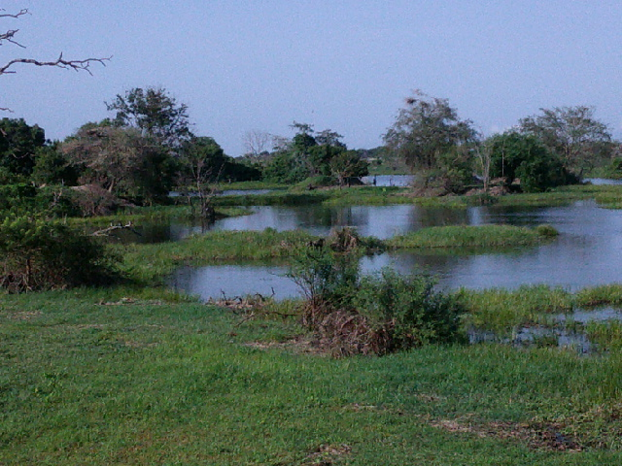
Plate 1: swamps in Kwerajik study site, Juba city, 2024 – by the investigator.

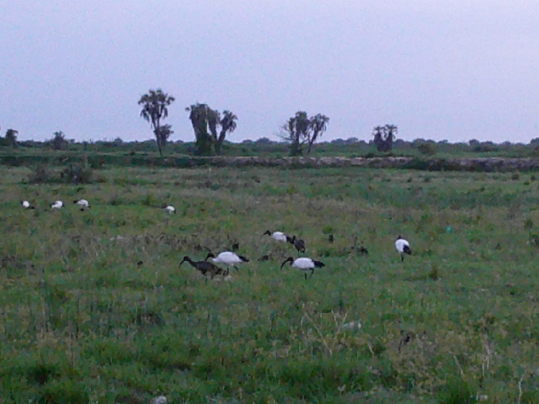

Plate 2: African Sacred Ibis (Threskiornis aethiopicus) and Glossy Ibis (Plegadis falcinellus) in Kwerajik study site, Juba city, 2024 – by the investigator.

APPENDIX III: A scene in the vicinity of a slaughter house
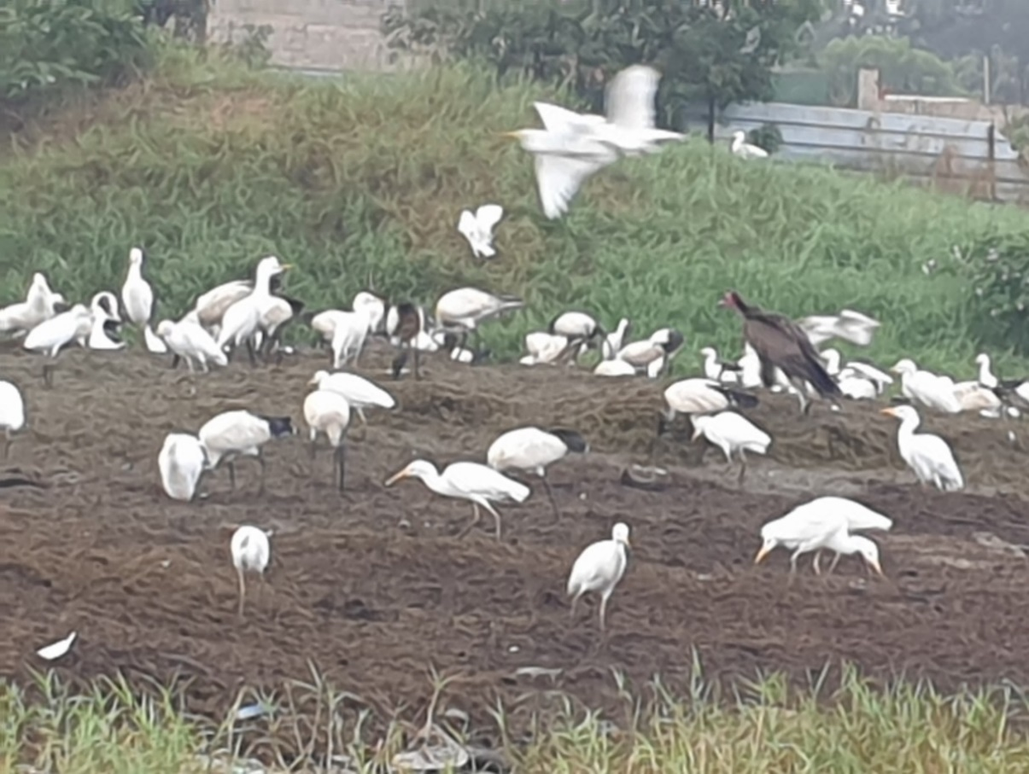
Plate 3: African Sacred Ibis (Threskiornis aethiopicus) and Glossy Ibis (Plegadis falcinellus), Cattle egret (Bubulcus ibis) and Hooded vulture (Necrosyrte monachus) around a slaughter house in Gumbo-Sherikat study site, Juba city, 2024 – by the investigator.

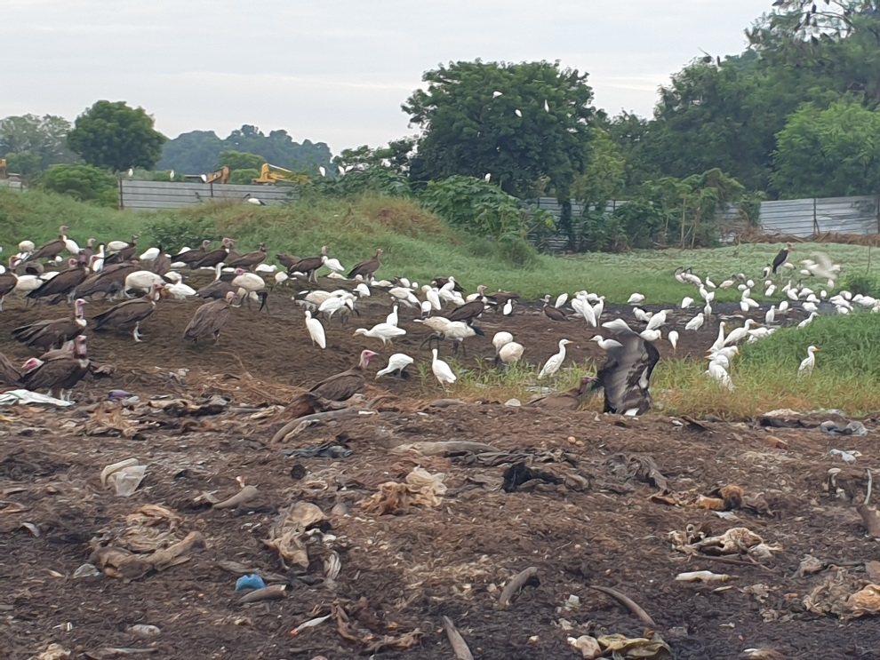
Plate 4: African Sacred Ibis (Threskiornis aethiopicus) and Glossy Ibis (Plegadis falcinellus), Cattle egret (Bubulcus ibis), Hooded vulture (Necrosyrte monachus) and Marabou stork (Leptoptilus crumineferous) around a slaughter house in Gumbo-Sherikat study site, Juba city, 2024 – by the investigator.

APPENDIX IV: The investigator and a House sparrow in Nyakuron residential area
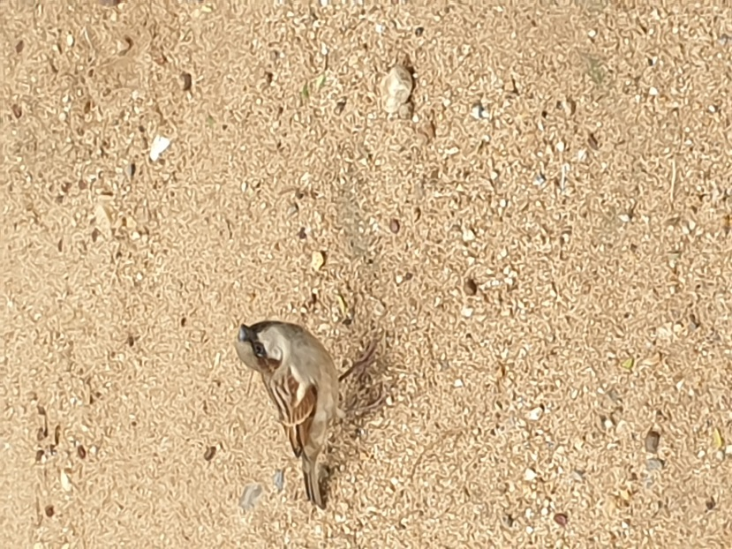
Plate 5: left: The investigator holding a juvenile House sparrow (Passer domesticus) and right: A House sparrow (Passer domesticus) sitting on the ground in Nyakuron – a Juba suburb – Juba city, 2024 – by an Assistant investigator.

APPENDIX V: Scenes from MAFAO
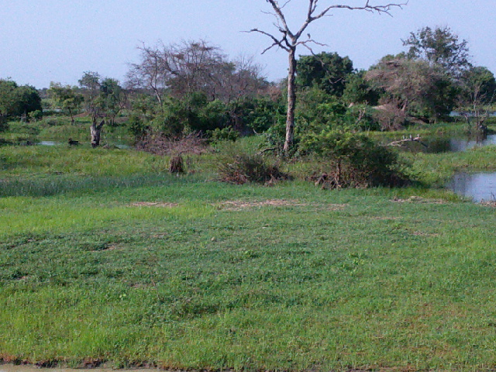

Plate 6a: Swamps within MAFAO study site, Juba city, 2024 – by the investigator.

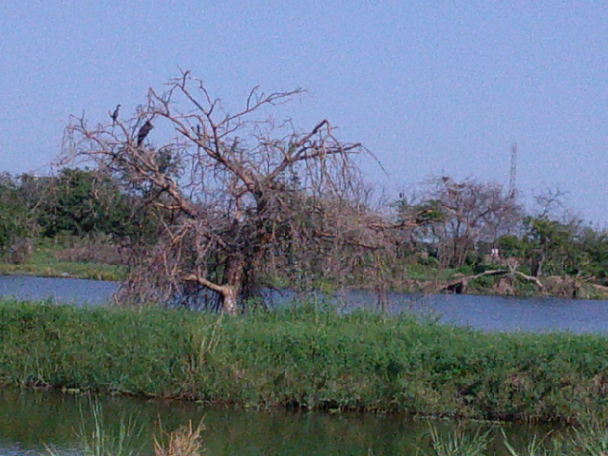

Plate 6b: Swamps by the river side within MAFAO study site, Juba city, 2024 – by the investigator.

APPENDIX VI: Scenes from Juba city center
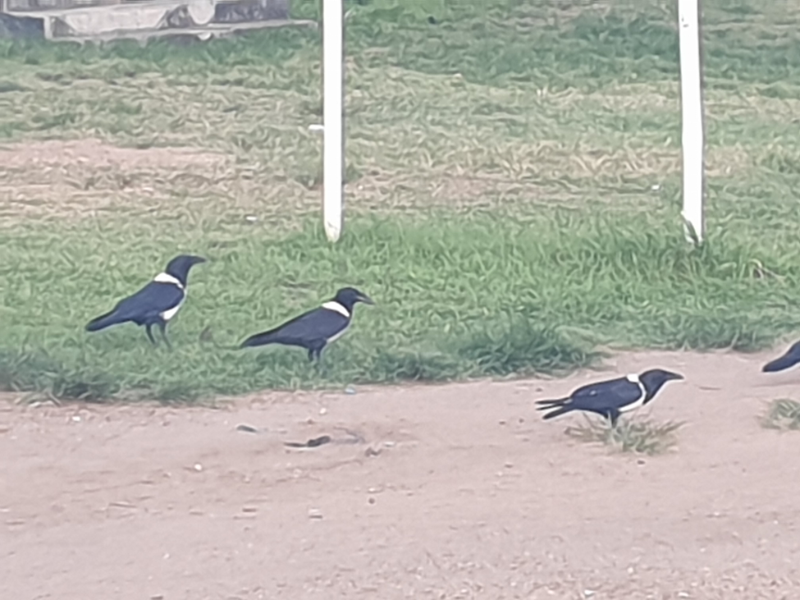
Plate 7: Pied Crow (Corvus albus), Juba center study site – 2024, by the investigator.

APPENDIX VII: A Scene from Juba city River bank
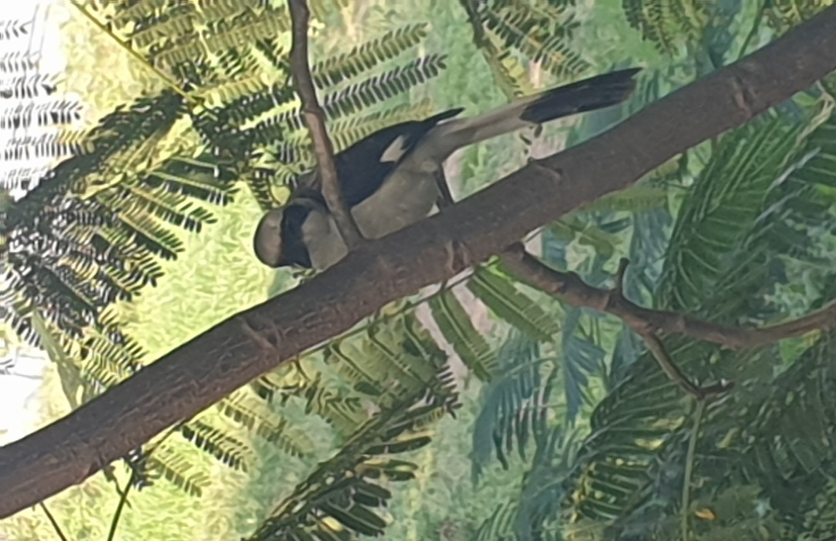
Plate 8: Grey-Back Fiscal (Lanius excubitoroides) Juba River Bank study site – 2024, by the investigator.

