MINERALOGICAL AND GEOCHEMICAL PROPERTIES OF KAZAURE IRON ORE

Abstract
This research investigates the chemical and mineralogical composition of Kazaure iron ore located in Jigawa State, Nigeria. Iron ore is a critical raw material for steel production, playing a crucial role in infrastructure development and economic growth. Despite the abundance of iron ore deposits in Nigeria, the Kazaure deposit remains largely unexplored. The study aimed to characterize the ore through chemical analysis using X-ray Fluorescence (XRF) and mineralogical analysis using X-ray Diffraction (XRD). The XRF analysis revealed the presence of 41.78% iron content, making the ore of medium-grade quality suitable for metallurgical processes. The XRD analysis identified the mineral phases of Goethite (60%), Montmorillonite (15%), and Quartz (22%). The results suggest that Kazaure iron ore possesses significant metallurgical potential but requires further beneficiation to optimize its industrial use. The findings contribute to understanding Nigeria’s underutilized mineral resources and offer insights for improving local steel production capabilities.
Keywords: Kazaure Iron Ore, X-ray Fluorescence, X-ray Diffraction, Mineralogical Composition, Chemical Composition

Introduction

Iron ore is a crucial raw material for the steel industry, which plays a significant role in infrastructure development and economic growth. With the increasing global demand for steel, the search for high-quality iron ore deposits has intensified. Nigeria is endowed with various iron ore deposits, including those in Kogi, Zamfara, and Kaduna. However, the Kazaure iron ore deposit in Jigawa State remains relatively unexplored, necessitating its detailed characterization to assess its industrial potential (Agava, 2020).
Characterizing iron ore involves evaluating its mineralogical, chemical, and physical properties to determine its suitability for various metallurgical applications. Iron ores commonly occur in forms such as hematite, magnetite, and goethite, often associated with gangue minerals like quartz and kaolinite. Understanding these mineralogical compositions is essential for designing effective beneficiation and extraction processes (Ahmad, 2017). The quality of iron ore is influenced by factors such as iron content, the presence of impurities like silica, alumina, phosphorus, and sulfur, and physical properties. High phosphorus and sulfur contents can negatively affect the steel-making process, making a detailed chemical analysis of Kazaure iron ore critical for evaluating its industrial viability and determining the best beneficiation methods (Agbalajobi, 2015).
Beneficiation methods like gravity separation, magnetic separation, and flotation are commonly employed to upgrade iron ores. The selection of an appropriate method depends on the ore's mineralogy and composition. If Kazaure iron ore contains a significant amount of magnetite, magnetic separation may be the most viable option, while gravity-based techniques might be more effective for hematite ores. A thorough understanding of these factors will enhance the efficiency of processing techniques applied to the ore. Previous studies on Nigeria’s iron ore deposits, such as those in Itakpe and Agbaja, have focused on deposits with high iron content, but the Kazaure deposit has not been extensively studied, leaving its beneficiation potential uncertain. This study aims to characterize the Kazaure iron ore, providing valuable data on its chemical composition, mineral phases, and potential for industrial application. By conducting this characterization, we aim to determine whether the ore can be processed for direct use in steel production or requires extensive treatment. Such research will contribute to the broader understanding of Nigeria’s mineral resources, promoting their efficient utilization. Properly characterized and processed iron ore deposits can support local industries, reduce reliance on imported steel, and create employment opportunities, making this study significant for Nigeria’s economic development (Aliyu, 2021).
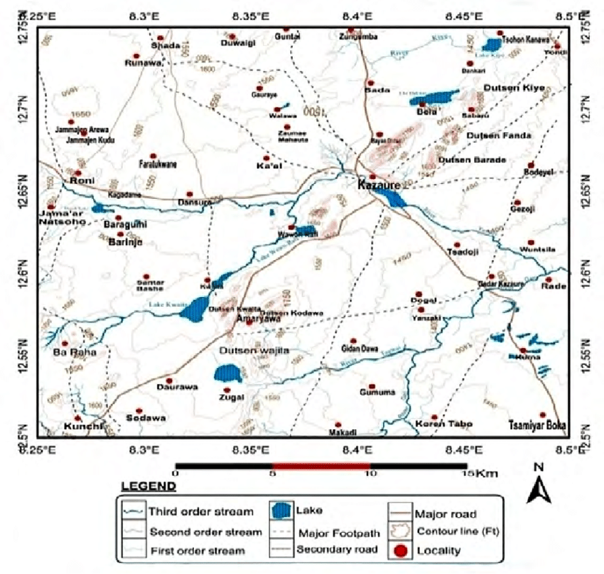

Figure 1. Map of Nigeria Showing the Study Area (MMSD, 2022)
The research involved a systematic approach to characterizing Kazaure Iron Ore from Wawara Village in the Kazaure Schist Belt, Jigawa State, Nigeria. Field sampling was conducted using a random sampling method to ensure the representativeness of the samples. The coordinates for the sampling site were E 8° 11' 38'' to 8° 12' 02'' and N 12° 37' 42'' to 12° 39' 13''. The samples were collected from the ore body or outcrops for qualitative analysis and grade assessment.
Upon collection, the samples were crushed and pulverized. A portion of these prepared samples was submitted for X-ray Diffraction (XRD) analysis, while the remainder was retained as reference material for further study. The chemical characterization of the Kazaure Iron Ore was performed using X-ray Fluorescence (XRF) with the Genius IF Xenemetrix XRF Equipment. Duplicate analyses were carried out to obtain reliable average values. The XRF technique enabled the detection and quantification of major and trace elements, including Fe, Si, Al, Ca, Mg, Ti, Mn, and P, providing valuable data for assessing the ore’s grade, beneficiation potential, and suitability for industrial use.
Additionally, mineralogical characterization was conducted through quantitative XRD analysis using the Rigaku Miniflex 600 XRD equipment. The analysis was performed with Cu-K radiation across a 2θ angle range of 2° to 70° to determine the mineral phases present in the ore samples. This multi-method approach facilitated a comprehensive understanding of the ore’s chemical and mineralogical properties.

Result of Chemical Composition of Kazaure Iron Ore
The chemical analysis of the Kazaure iron ore was conducted at the National Geosciences Research Laboratory (NGRL) in Kaduna using an X-ray Fluorescence (XRF) spectrometer. The results of the analysis revealed the chemical composition of the ore, as shown in Table 4.1. The analysis identified several major oxides, with iron (Fe₂) being the most abundant at 41.78%, indicating the ore's medium-grade quality suitable for metallurgical purposes. Silica (Si) and alumina (Al₂) were also present at 8.28% and 2.36%, respectively, representing major gangue minerals that could impact beneficiation efficiency. Phosphorus (P₂), sulfur (S), and manganese (Mn) levels were relatively low, suggesting minimal impurities in the ore. The loss on ignition (16.68%) indicates the presence of hydrated minerals like goethite and clays in the ore.
Table 1: Chemical Composition of Kazaure Iron Ore (XRF Analysis)
Oxide Component | Chemical Formula | Composition (%)
Iron (III) | Fe₂ | 41.78
Silica | Si | 8.28
Alumina | Al₂ | 2.36
Phosphorus | P₂ | 0.16
Sulphur | S | 0.02
Titanium | Ti | 0.04
Manganese | Mn | 0.09
Calcium | Ca | ND
Magnesium | Mg | ND
Potassium | K₂ | ND
Sodium | Na₂ | ND
Loss in Ignition | LOI | 16.68

Result of Mineralogical Characterization of Kazaure Iron Ore
The mineralogical analysis of the Kazaure iron ore was performed using an X-ray Diffraction (XRD) spectrometer at the National Geosciences Research Laboratory (NGRL). The analysis identified several key mineral phases present in the ore, including goethite, montmorillonite, and quartz. These minerals contribute to the ore's overall composition and influence its suitability for various beneficiation techniques.

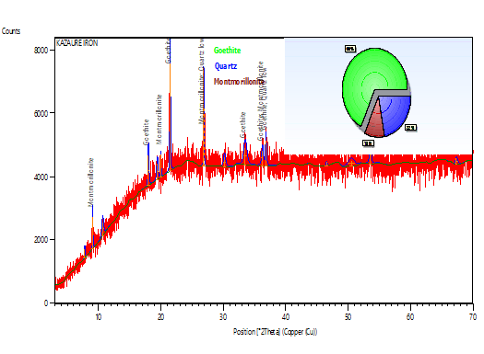

Figure 2. Result of X-Ray Diffraction of Kazaure Iron Ore

Result of Mineralogical Characterization of Kazaure Iron Ore
The mineralogical analysis of Kazaure iron ore was conducted using X-ray Diffraction (XRD) at the National Geosciences Research Laboratory (NGRL). The analysis identified three primary mineral phases in the ore: Goethite, Montmorillonite, and Quartz. The relative abundance of these minerals is as follows: Goethite comprises 60% of the ore, Montmorillonite 15%, and Quartz 22%. The XRD analysis revealed the following details for each identified mineral: Goethite (FeOOH): With the highest relative abundance, Goethite exhibits a displacement of 0.040 °2θ and a scale factor of 0.602, showing the highest match confidence. Montmorillonite (AlLiO): Present in smaller quantities, Montmorillonite has a displacement of 0.017 °2θ and a scale factor of 0.207. Quartz (SiO₂): Quartz has a displacement of 0.119 °2θ and a scale factor of 0.506, with a moderate match confidence.
These results suggest that Goethite is the dominant mineral phase in the Kazaure iron ore, followed by Quartz and Montmorillonite.
Table 2: Mineralogical Analysis of Kazaure Iron Ore (XRD Analysis)
S/N | Identified Mineral Phases | Chemical Formula | Relative Abundance (%)
1 | Goethite | FeOOH | 60%
2 | Montmorillonite | AlLiO | 15%
3 | Quartz | SiO₂ | 22%
The XRD analysis also highlighted the displacement and scale factor for each mineral phase, confirming Goethite as the most abundant and significant mineral phase in the Kazaure iron ore.
Conclusion and Recommendation
The findings from the chemical and mineralogical analysis of Kazaure iron ore indicate its potential for industrial use, with a 41.78% iron content and minimal impurities like phosphorus, sulfur, and manganese. The dominant mineral phase, Goethite, suggests that the ore is suitable for metallurgical applications, although further beneficiation is necessary to optimize its quality for steel production. To enhance the ore’s suitability for industrial use, it is recommended that additional studies on beneficiation techniques, such as gravity separation, magnetic separation, and flotation, be conducted. Moreover, further testing at a pilot scale should be undertaken to assess the economic viability of processing Kazaure iron ore. Developing local mining infrastructure in Jigawa State and collaborating with industry stakeholders can help establish a sustainable iron ore supply chain, promoting Nigeria’s steel industry and reducing reliance on imported steel.
Reference
Agava, J. I. (2006). Characterization of Agbado Okudu iron ore deposit for beneficiation. Journal of Minerals and Materials Characterization and Engineering, 5(2), 123-130.
Agava, J. I., Agba, E. H., & Sule, P. (2016). Determination of chemical, mineralogical and liberation size of Ochokochoko iron ore for beneficiation. Nigerian Journal of Technology, 35(1), 82-88.
Ahmad, I., Nasir, S., & Umar, A. (2017). Geochemical and mineralogical characterization of Jaruwa iron ore deposit, Northwestern Nigeria. Journal of African Earth Sciences, 129, 1-8.
Alexander, R. M., & Agbalajobi, S. A. (2015). Geochemical appraisal of Agbaja iron ore deposit, Kogi State, Nigeria. Journal of Applied Geology and Geophysics, 3(2), 45-50.
Bamalli, A. S., Zango, M. S., & Aliyu, A. (2011). Evaluation of Itakpe iron ore deposit for possible beneficiation. Continental Journal of Engineering Sciences, 6(3), 45-50.
Bashir, A. (2017). Characterization of Gyaza iron ore deposit, Katsina State, Nigeria. Nigerian Journal of Technology, 36(1), 1-6.
Danmola, B. A., & Abba, A. (2013). Beneficiation potential of Agbaja iron ore: A high-phosphorus iron ore. Journal of Minerals and Materials Characterization and Engineering, 1(4), 89-93.
Elijah, I. O. (2013). The challenge of domestic iron and steel production in Nigeria. Greener Journal of Business and Management Studies, 3(5), 231-240.
GNS. (1987). Geological Survey of Nigeria: Report on iron ore deposits. Bulletin of the Geological Survey of Nigeria, 26, 1-45.
Kareem, M. A., & Adebayo, T. A. (2015). Mineralogical characterization of Agbaja iron ore. Journal of Minerals and Materials Characterization and Engineering, 3(2), 55-60.
Malu, S. P., & Nwosu, E. O. (2014). Characterization and beneficiation of Koton-Karfe iron ore. International Journal of Engineering and Technology, 4(3), 123-129.
Nasir, S., & Ahmad, I. (2017). Geochemical and mineralogical characterization of Jaruwa iron ore deposit, Northwestern Nigeria. Journal of African Earth Sciences, 129, 1-8.
Obiora, D. N., & Uzoegbu, M. U. (2016). Geophysical and geochemical investigation of the Itakpe iron ore deposit. Journal of Applied Geophysics, 135, 1-10.
Okafor, C. E., & Ude, S. I. (2014). Mineralogical and chemical characterization of Agbaja iron ore. International Journal of Scientific & Engineering Research, 5(7), 1234-1240.
Olawale, J. B., & Olubambi, P. A. (2013). Characterization of Gujeni iron ore deposit, Kaduna State, Nigeria. Journal of Minerals and Materials Characterization and Engineering, 1(2), 55-59.

