In case Competitor Advertising is a plus:
Correlational study of Advertising Spillovers Effect in Competitive market

ABSTRACT

In competitive markets, advertisements tend to look like a way through which a corporation can convince the customers to abandon the rival brands. However, the effect in real life can be much wider than that. ne-company made advertisement can have effect on not only its sales but also the performance of competitors. Such promotion makes the product categories familiar at different periods and indirectly assists the rival firms. A general conceptualization of this condition terminates an advertising spillover effect. This paper discusses the time when the advertising of competitors can be more beneficial than harmful. It researches consumer attention, brand familiarity and level of competitive behavior in the market as influencing factors of such results. The advertisement of one firm may inform other buyers about a product category even when they are poorly informed enough to experiment with various types of products. On the other hand, advertising can have a more pronounced effect of moving demand to other brands in the mature market where the shoppers are already aware of their choices. In other words, the same promotional campaign may have varying reactions in various types of market structures. (It can be a debilitating factor to competitors, but in other situations strengthening them by creating a higher interest in the category in general.) To test this idea further, the study will integrate both theory and practice in the study of online and traditional advertisement landscape. It examines how variables like quantity of advertising, brand’s market position, degree of maturity and so on affect consumer responses.

Our findings suggest that smaller or lesser-known brands tend to do better when large corporations advertise as advertised to a greater extent because consumers will see that the general level of recognition grows and they will begin to investigate alternatives, which can be seen across the spectrum, and it’s possible they would find benefits with large companies advertising too. On the contrary, established brands are characterised by switching behaviour: people simply move from one brand to the other, instead of increasing the size market. The upshot of this is that advertising can expand the size of the market at the start of any competition, but in wealthier markets it mainly shifts the market share among existing players. The study contributes to marketing and competition research by demonstrating that advertising struggles don’t always turn the tide into a clear-cut win-lose situation. The impacts, however, can be spread out across, rather than within, firms, depending on the context.

Keywords: Advertising Spillover Effect, Competitive Advertising, Consumer Awareness, Market Competition, Brand Familiarity.

INTRODUCTION
The fact is that adverts are usually perceived as a competitive tool in the contemporary markets. Firms invest a lot of money on online marketing, social media advertising, and traditional media, hoping that with more intensive marketing, customers will be drawn out of rival brands and the firms themselves will increase their sales as well. The stereotype is that if one company is advertising more, then firms lose demand automatically. But actual consumer behaviour generally operates differently. Promotion by one company tends to grab attention for the whole product category and actually helps competing brands indirectly. This is known as the advertising spillover effect. Consumers have seldom relied heavily upon one marketing message when making a purchase decision. Those who see one advertisement are more inclined to look for information, look to multiple brands to compare features. A campaign that advertises a new feature, can lead buyers to cross-check with other brands for that benefit. Sahni (2016) (1) demonstrated that the search activity toward rival brands is typically higher for advertisements, thus advertising may trigger the interest for the entire category, not just the aforementioned brand.
This phenomenon is especially evidenced in competitive industries: Technology products, Beverages, Online Services, Packaged Consumer goods. To the extent possible, in these markets advertising is also an educational tool since it is meant to educate consumers to the usefulness of the category product. This means even businesses with less advertising do see more demand. Consistently supporting this observation, Liu, Lopez and Zhu (2013) (2) found that advertising by the leading beverage brands improved the total category consumption and also provided benefits to other firms along with the advertiser in their studies in that ads also increased category consumption. The development of digital media has reinforced the phenomena further. From online ads consumers will often be able to find information quickly, visiting several websites with a different option or searching for competing websites. They say rather than narrowing choice, advertising more often increases it. Goldfarb and Tucker (2011) (3) again demonstrated that online advertising promotes exploration and information search behaviour, indirectly introducing consumers to rival brands. These results are inconsistent with one of the orthodox interpretations of advertising competition being simply aggressive. If such positive indirect effects resulting from competitor promotion can be beneficial, companies may have to rethink the role of defensive marketing and resources, and where to allocate resources. Instead of always responding with more robust advertising, companies might be better off when a competitor generates awareness of their rivals. Thus, the present study looks into the scenarios in which competitor advertising emerges as a source of competitive advantage, rather than threat. The study helps to develop a more balanced picture of advertising that goes beyond rivalry and is both in essence a source of competition and a second force that strengthens the competition (in conjunction with co-operative behaviour) that drives the interaction of firms and consumers.

Role of Consumer Involvement in Advertising Spillover Effects
- The impact of advertising spillover effects on consumers. It is the extent of attention and amount of time or energy a consumer spends on determining their choice of product or service. The influence of competitor advertising on the market differs hugely based on consumer casual or careful evaluation. Low-involvement purchases (products in routine use). For everyday products like snacks, toothpaste, drinks and other items frequently purchased, purchases tend to be swift and habitual. Well, people do not spend time comparing specifications or looking for specific details as they already know the category. In this case, ad is primarily a reminder that keeps a brand fresh in memory. Familiarity grows with repetition, so the consumer tends to subconsciously pick the same brand from that list. Because the decision depends much more on habit than on evaluation for market position, advertising from rival firms rarely has any noticeable benefits for competing firms and spillover effects remain weak.
- The ad simply encourages buyers to purchase instead of encouraging exploration. High-involvement purchases (important or expensive products). Buyers have a different behaviour on products like smartphones, laptops, insurance, educational programs, or automobiles. They rarely buy just after seeing an ad. Instead, the ad prompts curiosity, so they collect information, read reviews and compare competing brands. In this latter sense also promotion is a learning mechanism, explaining features and differences among available options to the consumer. Even brands that never advertise increase their exposure because customers look to the other brands as well. Consequently, spillover is strong and positive, increasing total market demand rather than exclusively directing customers toward the advertiser. Medium-involvement purchases (consideration products). For goods and services, whether that's stuff like clothing, cosmetics or choosing a restaurant, consumers think more than they would for daily items but less than they will for expensive ones. Usually there are several options for them before they select. A particular advertisement featuring one brand usually induces comparisons with similar ones, with a moderate spillover effect. The most influential one tends to be based on the brand’s relative price, quality or style distinction.

- Consumer decision making usually takes place sequentially and not in a single step. Advertising starts by generating curiosity which can be followed by the search and comparison of information. At this point buyers are going to see many brands rather than the one product. Digital platforms magnify this behaviour, because of recommendation programmes that show similar products and alternatives, prompting people to more systematically explore the category in general. Implications for firms.
- Promotion by a well-known company can inadvertently benefit smaller and smaller competitors simply by creating interest in general across the entire category. Brand awareness when they're at a higher level allows lesser brands to make maximum benefit from advertising. In markets of people who deliberate carefully before buying, defensive advertising alone is rarely successful. In such cases, businesses now must watch over the entire category demand and not just the performance of the individual brand, because broader consumers are interested in what the market does (and doesn't) see at large, which of course shapes how well a brand's outcomes sell.

OBJECTIVES
- To know about advertising spillover effect concept during competitive markets.
- Investigating the influence of advertising of one firm on consumer’s awareness and purchase decision-making about competing brands.
- How low, medium and high levels of consumer involvement affect the extent to which advertising spillovers apply.
- To assess whether advertising creates total demand increase for the product category or whether it just pushes customers among brands.
- To discover instances in which competitor advertising is an advantage, not an impediment to the competing firms.

PURPOSE OF THE STUDY
This study primarily focuses on analysing how promotional activities of one company influence other brands in the market. Advertising has a tendency to be treated as a rivalry where one firm’s gain immediately results in another firm losing. However, that is not exactly how the real market behaviour looks like. In other cases advertising creates awareness in that category, and strengthens existing brands, unintentionally. The research is aimed at understanding how and why this is so. The study pays a lot of attention to the spill over effects of advertising and the role played by consumer involvement in leading to the spill over effects. It examines whether advertisements have the effect of merely causing people to change brands or whether the advertisements actually stimulate the market in general. The paper will examine the consumer reaction to advertising by competitors at various levels of decision making; it will help in illuminating the time when competitors are an asset and not a threat.

RESEARCH METHODOLOGY
Research Design
To understand the role played by competitor adverts in consumer behaviour, a descriptive and analytical approach was adopted in this research. The research was conducted to examine the brand reaction to advertising and whether it brings direct competition or mutual benefits in the market. The questionnaire was structured in such a way that it captured the perceptions of the consumers, their level of awareness, and their decision making behaviour after exposure to the commercials in a competitive scenario.
The online survey was used to gather primary data. The questions of the questionnaire were close-ended questions on the brand awareness, comparison behaviour, advertisement recall and intention to purchase after seeing the promotional messages. This made it easy for respondents to voice their opinions and helped to create more structure into how they responded to advertising. Sampling Methods.
the participants were chosen based on availability and readiness to respond. Following the removal of incomplete data, eighty (80) valid responses were then analysed. This sample broadly represents regular consumers who constantly see advertisements on media platforms digital and traditional.

REVIEW OF LITERATURE

Competitive Advertising and Consumer Response
Advertising and growing market demand. For a long time, the traditional reasoning is that advertising tends to shift customers from one brand to the next. But previous research indicates that promotion can also make people take notice of the product category as a whole by helping them understand why it is beneficial and useful. When consumers are more attuned to a product according to the unique needs of the person consuming it, rather than consumers switching brands, new buyers may come into the market. It means that advertising can bring something beneficial to the competing firms (Alba and Hutchinson, 1987) (4). Marketer take: That is because in developing or unknown markets, you can increase your own sales with competitors' advertising, if you do not have extra spend in a promotion.
Ads often not only persuade viewers, but provide information. If promotions are very clear about features, price, or benefits, consumers typically compare different brands before deciding. And instead of bolstering loyalty, advertising widens options available to clients. This may affect a bidirectional behavior that promotes the transfer of cross-brand demand, and indirectly supports rival firms (Brynjolfsson and Smith 2000) (5).
Implication for marketing: In-depth and clear advertising can inadvertently encourage competitors with comparable value propositions.
Consumer awareness of familiar brands can also influence spillover dynamics. When a big brand marketing is excessive, in this situation, consumers will also remember other brands that they already know, and may seek lower-cost or similar counterparts. In such situations advertising also adjusts attention rather than controlling the demand, this is supported by Bagwell (2007) (6).
Marketer implications: Smaller brands have a way to grab market share when bigger companies in the business are very active to advertise the category.
In a market where competitors advertise simultaneously, buyers, who may remember the category but cannot recall individual brands easily even for single brands, tend to have a blank label for products in mind. The exposure of advertising thus provides group attention, rather than just a single one. This joint recall generates spillover responses to rival products, as discussed by Nelson (1974) (7).
Implication for marketers: When advertising is at a certain level (whether in festive periods, sales promotions or any other time frame), category memory is more influenced over single brand memory when it comes to promotions (as compared with any other type of recall).
The degree of consumer knowledge impacts as well on ad results. People with limited knowledge utilize advertisements to learn about the category and then explore options; knowledgeable consumers compare technical variations across brands. In either case, exposure enhances exploration, not firm loyalty, according to Erdem and Sun (2002) (8).
Conclusion for marketers: Education advertising is interesting but does not provide the consumer with the trust that the final purchase will come from the advertiser.
Spillover effects because of online platforms have exacerbated spillover dynamics since they facilitate instant comparison, reviews, and price checkouts. Consumers are also put in front of competing options immediately after viewing one advertisement in search and with recommendations. As noted by Kent and Allen (1994) (9), within digital environments, ads become portals into a world of greater exploration than discrete brand messages. This means that in digital markets, all advertisements partially endorse the entire product category and promote, in part, the brand being advertised.

QUESTIONNAIRE AND REPONSES
Q1) Advertising by major brands increase my interest in the overall product category?
- Strongly agree
- Agree
- Neutral
- Disagree
- Strongly Disagree

R1)

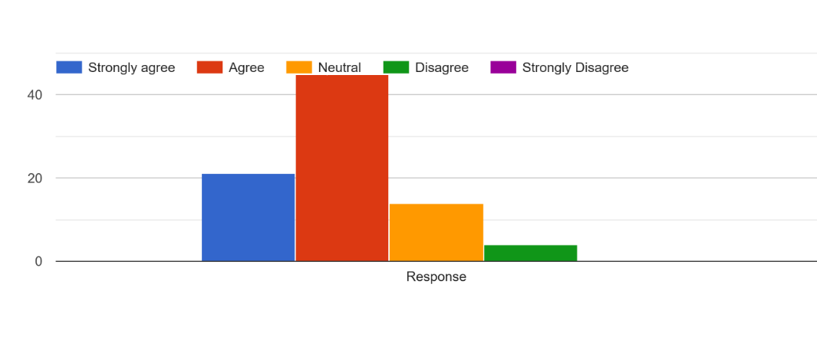

Figure 1: General Response of Advertising by major brand increases interest in the specific Product category

In Figure 1, nearly 54% of the respondents selected “agree” and about 25% chose “strongly agree.” Approximately 17% were neutral, almost 5% disagreed and almost none strongly disagreed. The answers hence are skewed towards a positive view. A lower percentage of the participants were indecisive, and there was a very minimal percentage of respondents who disagreed implying that the statement was accepted by the majority of the respondents.

Q2- I do listen to the product category as a whole even when an advertisement is specific to a particular brand?
- Strongly agree
- Agree
- Neutral
- Disagree
- Strongly Disagree

R2)

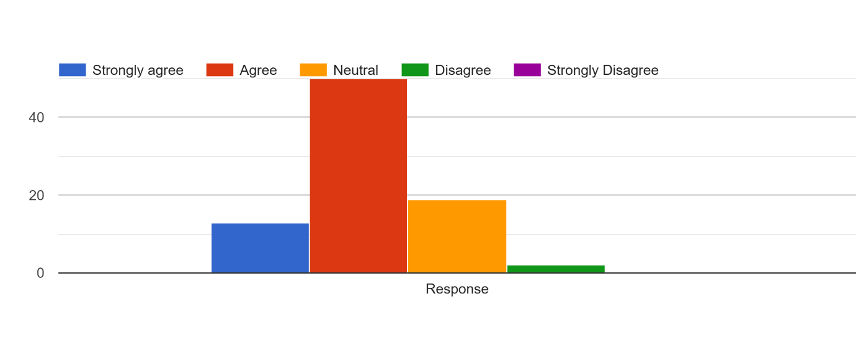

Figure 2: depicting when an advert is about a particular brand, People pay attention to the category of the product in general

Figure 2 indicates that about 51 percent of the respondents indicated either agree or strongly agree. Almost 19 per cent were neutral, about 2 per cent disagreed, and almost no one strongly disagreed. All in all, there is a lean towards agreeing. The percentage of those who were not sure was quite high, and only a small fraction of the respondents disagreed with the statement, which suggested that the overall response of respondents was rather positive.

Q3- Competitor advertisements make me know what sorts of products are being offered, in this category?
- Strongly agree
- Agree
- Neutral
- Disagree
- Strongly Disagree

R3)

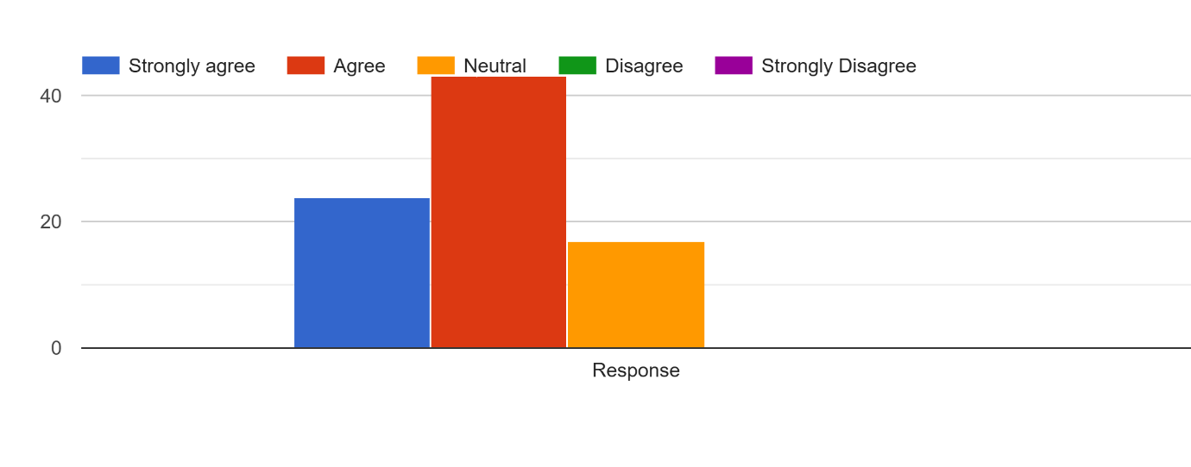

Figure 3: The display of Competitor advertisements assists individuals to realize the various kinds of products that are offered in this category.

In Figure 3, approximately 43 percent of the respondents answered agree, and approximately 24 percent strongly agree, and close to 17 percent remained neutral. None of the respondents said that he or she disagreed or strongly disagreed. This trend indicates that there was a great deal of positive opinion. A fewer number stayed unresponsive and no negative feedback was obtained indicating a definite favorable attitude of the respondents on the whole.

Q4) Advertisement Are other brands of the same category more aware of their brand by one brand?
- Strongly agree
- Agree
- Neutral
- Disagree
- Strongly Disagree

R4)

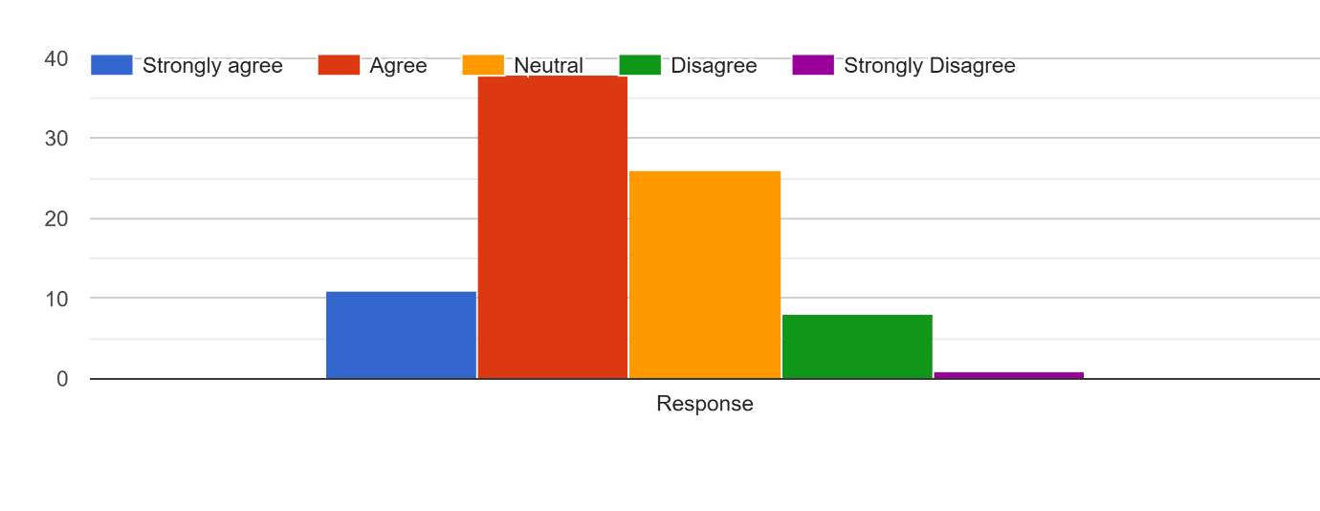

Figure 4: Displaying the degree to which Advertisement By one brand is stimulating awareness about others brand in the same category?

In Figure 4, almost 38 percent of the respondents indicated that they agree and approximately 11 percent of those who responded strongly agreed, whereas about 26 percent of the respondents indicated that they were neutral. About 8% of them disagreed and just about 1% of the respondents strongly disagreed. On the whole, the answers are more on the positive, but the proportion of those who remained undecided is relatively large. There were not many negative opinions and this indicates that the opinion was very favourable but not very strong.

Q5) Advertisement Initiate me on the product feature that cross-cuts across brands and not the brand that is advertised?
- Strongly agree
- Agree
- Neutral
- Disagree
- Strongly Disagree

R5)

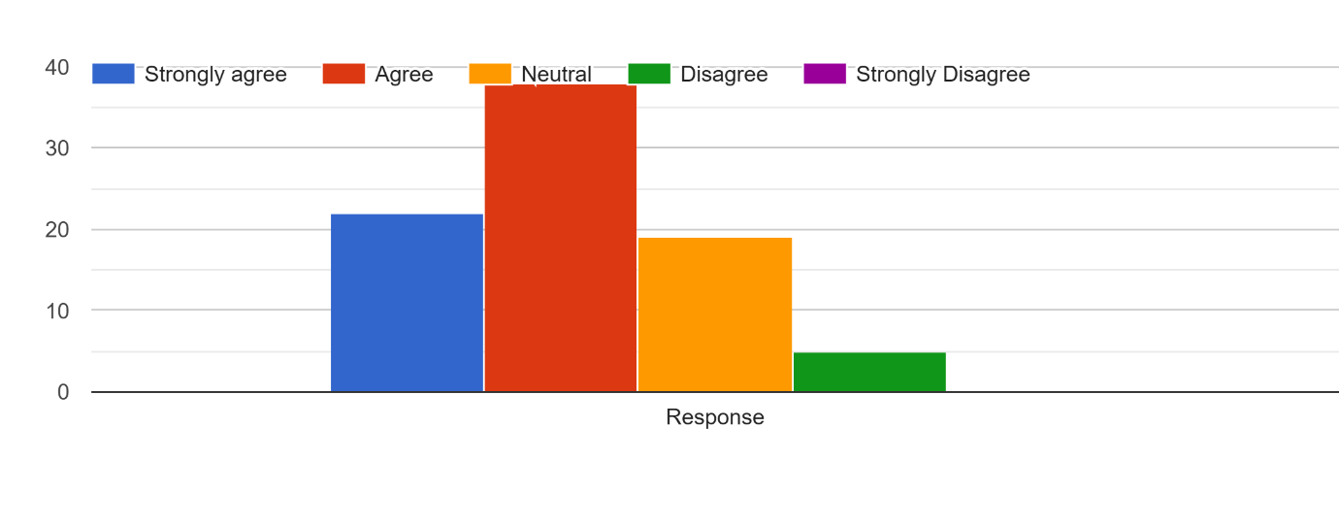

Figure 5: Responses of how Advertisement Educate people on one of the product features that pertains to several brands rather than the advertised brand alone.

In Figure 5, approximately 38 percent of the respondents answered yes and 22 percent answered strongly yes, with about 19 percent of the respondents answering no. Near 5 percent disagreed and hardly any strongly disagreed. The general trend is a favorable opinion, and most of the participants expressed unequivocal favoritism. The moderate group was unsure, a small number expressed negative opinions and this showed a generally positive attitude of the respondents.

Q6) You tend to use a non-advertised brand when making a purchase decision?
- Strongly agree
- Agree
- Neutral
- Disagree
- Strongly Disagree

R6)

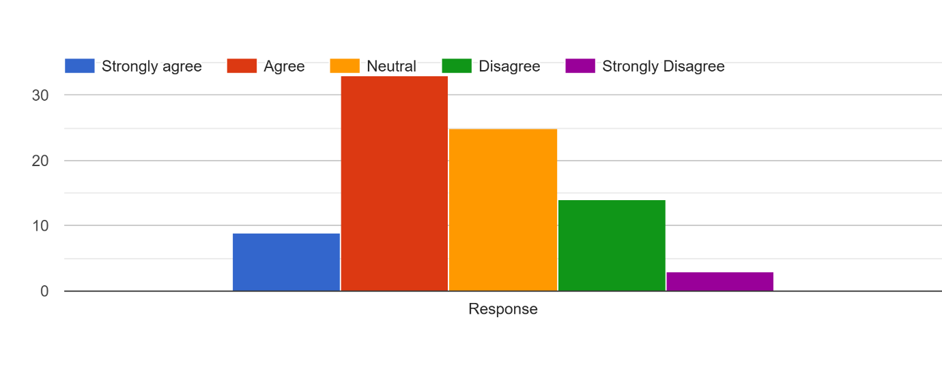

Figure 6: Reactions of how individuals tend to think about brands that are not advertised when making a buying choice.

Figure 6 shows that approximately 33 percent of participants answered affirmatively, that is, they said agree and approximately 9 percent strongly agree, and almost 25 percent said neutral. Approximately it was a disagreement of 14 per cent and strongly disagreement of 3 per cent. In spite of the fact that the majority of responses remain positive, the opinions seem to be more divided than in the previous numbers. The number of respondents who were unsure was fairly considerable, as well as the number who disagreed concurring that there is moderately acceptable level of approval instead of an apparent consensus.

Q7) Advertisement by competitors is indirectly favoring a less advertised or smaller brand to capture my attention?
- Strongly agree
- Agree
- Neutral
- Disagree
- Strongly Disagree

R7)

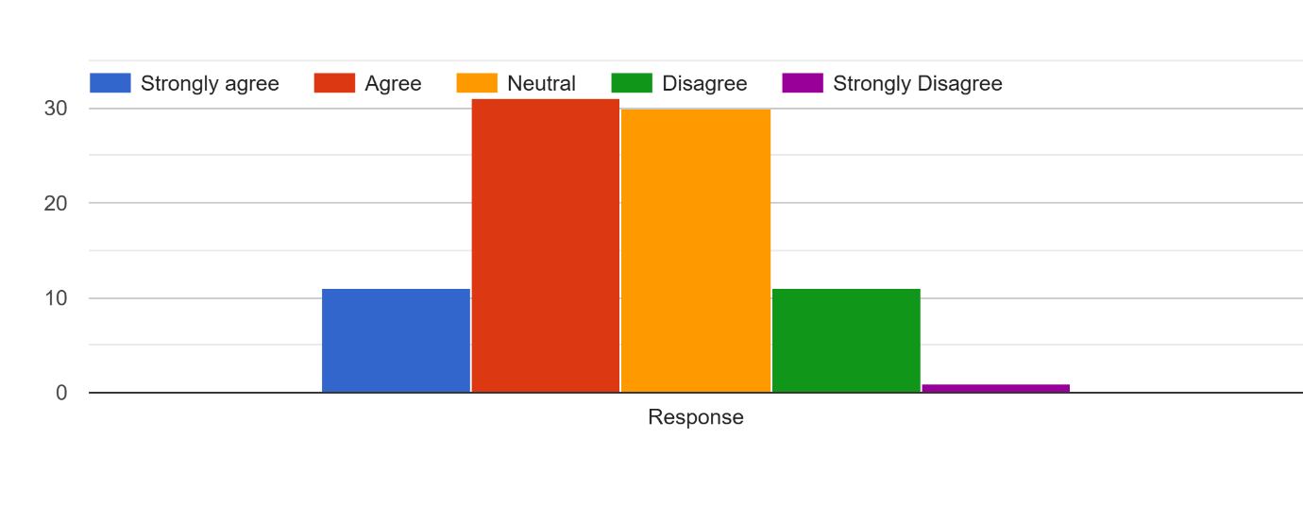

Figure 7: Denotes the Competitor advertisement Responses of how smaller or less advertised brands could gain the attention of people indirectly.

Figure 7 shows that approximately 31 percent of the respondents answered agree and only an approximate of 11 percent answered strongly agree, with almost 30 percent remaining undecided. Around 11 percent said they disagree and nearly 1 percent strongly disagree. The answers seem to be quite even with the approval being only a little above the neutrality. A large number of respondents appeared to be confused, and a relatively small number expressed the definite opposition, which suggests a not so strong but rather wary general response.

Q8) When I see advertisement of one brand, my curiosity arises into other brands in the same category?
- Strongly agree
- Agree
- Neutral
- Disagree
- Strongly Disagree

R8)

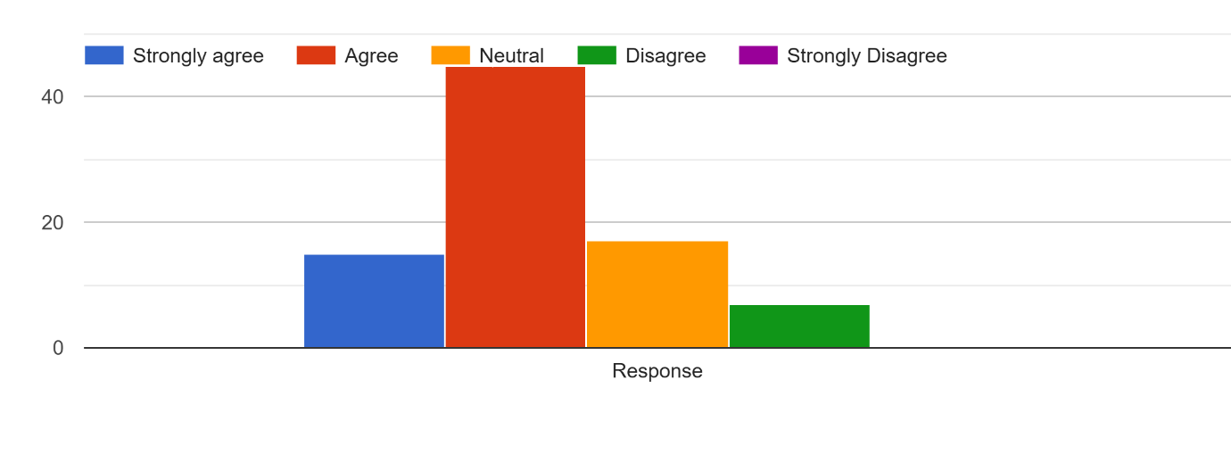

Figure 8: Representation of the response of my curiosity about the other brands in the same category by Seeing advertisement of one brand

Figure 8 shows that approximately 45 percent of the participants agreed and almost 15 percent strongly agreed, and nearly 17 percent respondents were neutral. About 7 per cent. lost their heads and nearly none strongly denied. The answers are hence biased towards the positive. The proportion of those who were undecided was moderate, and a very small proportion of those who perceived the statement negatively was found, which is an indication of a general positive attitude towards the statement.

Q9) Does that mean that even when I see high frequency adverts of a single brand I still compare the products of several brands before buying?
- Strongly agree
- Agree
- Neutral
- Disagree
- Strongly Disagree

R9)

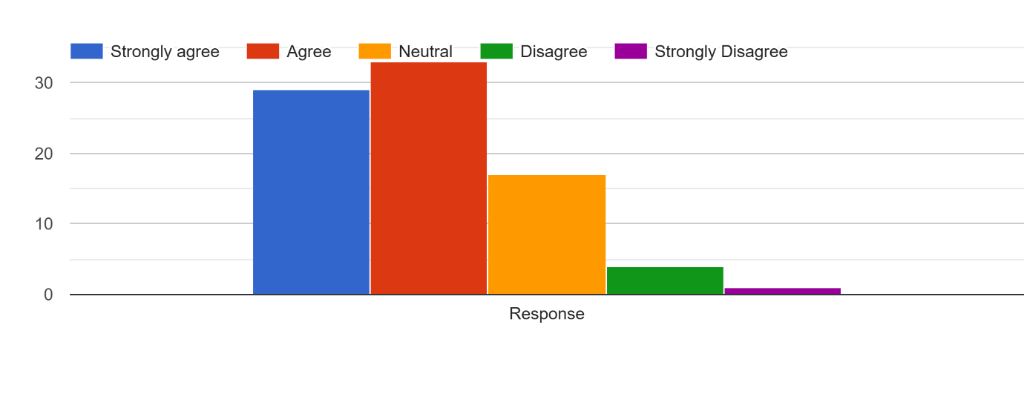

Figure 9: Indicates the reaction of individuals in the event that they observe extensive commercials of a single brand, they still consider several brands before they buy.

In Figure 9, approximately 34 percent of the respondents said that they agreed with the statement and nearly 30 percent said that they strongly agreed. Around 17% chose to stay neutral. Conversely, approximately 4% did not agree and only a small proportion of 1% of respondents strongly disagreed. Combined, the answers are skewed towards acceptance. The majority of the participants seemed to feel free about endorsing the statement and a good number of them were even strongly minded. The neutral category implies that there are individuals who were either not sure or believed that the statement was not wholly applicable to their experience.

Q10) Price and quality are other factors that affect my Final purchase decision besides advertising.
- Strongly agree
- Agree
- Neutral
- Disagree
- Strongly Disagree

R10)

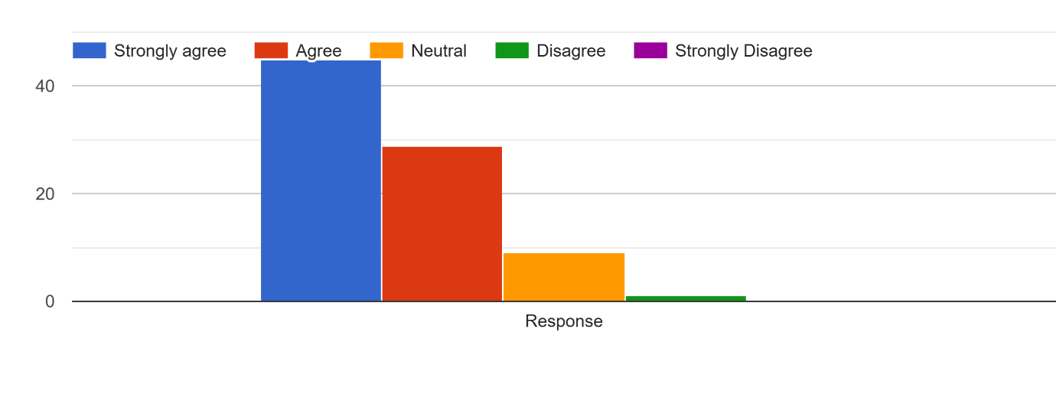

Figure 10- Indicates that price and quality are other factors that affect people Final purchase decision in relation to advertising.

As shown on Figure 10, close to 54 percentage of the respondents were in agreement with the statement with almost 34 percent strongly agreeing. Around 10% remained neutral. Only a small percentage (approximately 2) indicated that they disagreed and practically there were no respondents who said strongly disagreed. With these answers, the view is definitely leaning towards the statement. Strong agreement in itself comprises over a half of the respondents, and it indicates that a significant portion of respondents were rather confident in their opinion. The neutral reactions are seen to belong to the intervention of a few people who might have been undecided or unconcerned.

INTERPRETATION OF SURVEY FINDINGS
The responses indicate a definite behavioural pattern as shown by the responses of the respondents. Majority participants gave an Agree and Strongly Agree answer in almost every remark, only few of them claimed to be Neutral and a very small percentage gave out a disagreeing answer. The trend repetition is a sign that the participants share the same findings regarding the influence of advertising on their knowledge, comparisons behaviour and purchase choices. One of the biggest findings with advertisements is that consumers hardly ever take a moment to observe which brand it is. However, the advertisements seem to be a point of curiosity.
An advertisement is seen by people, and it is only natural that people will think of what one can do when he or she sees the advertisement. This implies that advertisement is not a fly on the wall and that it will affect the choices of consumers and not purchase of advertisement. The other major pattern is that not all the respondents are blindly believing in one brand message. It appears as though many have somehow a mental mind check that puts brands against one another when the person is not provided with anything besides a single commercial. It is due to the fact that modern-day consumers were more educated, and this implies that they are highly more wary. They do not accept claims as a given but evaluate value, quality as well as options available to them. Consequently, advertisement may more be a tool of thought rather than a final persuasive tool. There is also a reason as to the meaning of the neutral responses. They are targeting a group of consumers who are situational and in some cases and not frequent possible influenced by advertising. The choice they make is determined by the type of product, need, cost or experience. This reflects behaviour in the real world where some people do not purchase as carefully or attentively.
The very low disagreement rate is a fact. Indicating that in the majority of studies, most individuals have experienced a form of how advertising impacts awareness or comparison behaviour. Even if they do not purchase the advertised brand right then, they recognize that advertising directs their perception somehow. Indirect brand promotion is another observation to be drawn from the findings. When people witness an advertisement for one brand, they frequently also remember competing brands. As a result, advertisements add category awareness rather than just brand awareness. That makes consumers start judging the whole product category, benefiting competitors that didn't advertise.

Overall results suggest that advertising now has more general informational function rather than convincing consumers to buy one brand or another today. It prompts seeking, comparing and evaluating. Consumers seem to be “active”, and not mere recipients of marketing communications.

Key Insights of the Study
The findings suggest that advertising today functions more as a trigger than persuasion. Initially, rather than persuade consumers to instantly buy a certain brand, advertising triggers curiosity. Most consumers explore other possibilities from within the same category once they have encountered the ad. This validates that advertisement is a form of awareness raising rather than simply solidifying the endorsed brand. Another significant observation is the change in consumer behaviour. A single source of information is rarely depended on by buyers.
Before settling, they compare brands, review them, evaluate alternatives. This behaviour leads through to a branding firm advertisement unintentionally working in the favour of its competitors, by enhancing the overall product category. Findings also imply that spillover effects can vary with involvement level. Advertising for daily-use products mostly serves as a reminder and is more positive for the advertiser. However, when it comes to high-cost or high-value purchases, advertising stimulates comparison and works in the great advantage of competing brands. This means the influence of advertising varies greatly according to the product category.
Digital platforms make this effect even stronger than ever. One advertisement result in one algorithm showing consumers the same product from several brands. Thus, the consumer journey turns from brand-focused to category-focused decision making.

Limitations and Drawbacks of the Study:
- The study has limitations, which need to be taken into account while interpreting the results. For one thing, 50 respondents were included in the sample. While helpful in seeing patterns, it may not be indicative of the population as a whole.
- Second, the data is based on self-reported responses. Participants fail to remember their behaviour correctly or respond based on perception and not the actual behaviour.
- Third, the study primarily focused on aggregate consumer responses rather than measuring actual purchase activities. The variation between the consumer talk and what they do may in some cases, be very different.
- Fourth there is in fact a drawback that there was a merging of various industries. Reaction of consumers with the electronics, services and other products which we use in our day to day lives can be totally different, yet the survey has touched upon them in general terms of the levels of involvement.
- Finally, the external factors like price/discount, brand loyalty, and social influence were not deeply determined but they are likely to influence purchases in a similar manner in which advertisement can influence purchases.

CONCLUSION
The findings of this study show that advertising no more performs on its own to support one brand. Rather, this forms a first step into larger decision making. When consumers come across an advertisement, they don’t just take its message at face value and buy. Instead, it raises their awareness of the product category and compels them to find substitutes. This behaviour demonstrates that advertising is more informational than persuasive in nature. It is the thinking process, but the end of the decision is formed by comparison, an appraisal, and the perceived value of the choice. The findings also demonstrate that product involvement is critical. When it comes to everyday low-risk purchases, advertising mainly refreshes memory and helps to position the brand in the consumer’s mind as something familiar.
Yet for significant, or even costly purchases, consumers inherently become more vigilant and discerning. In these circumstances, the advertisement is profitable both for the advertiser and competing brands, as consumers actively look for alternatives and weigh alternative features. This means that the effect of advertising changes based on type of decision (one of brand-focused influence versus category-wide influence). This study confirms that contemporary consumers are not consumers of marketing messages, but rather act of active participation. This behaviour is reinforced further by digital platforms through constant access to similar brands and recommendations. Hence companies need to realize that advertising success cannot be judged purely by short-term sales. Rather, the biggest influence it has tends to be in encouraging awareness, comparing behaviour and future demand. For enterprises, those that take this wider perspective, are the most likely to not only understand but design strategies based on it and to get around it, to stay ahead of the pack in the current market.

SUGGESTIONS
• For one, companies should reassess what advertising can do. Rather than simply attempting to deliver immediate sales, companies need to implement advertising that states what makes your brand different from what the world gives its prospects. Brands must emphasize the certain benefits consumers instinctively compare once they see an advertisement, (quality, durability, support for service, etc). Transparency can help ease ambiguity and brand recall in comparison. Such an approach can stand in the way of competitors being able to extract equivalent benefits from the same recognition the ads generate.
• Second, marketers should organize themselves in terms of what kind of products you are promoting. For everyday products, repetition and recall-based advertising may still be effective, as people still rely on recognizability. However, for bulk or high-value goods, brands should give comprehensive explanations, demonstrations, product comparisons and easy access to comparison. Offering official website, comparison or comparison chart and clear specifications to consumers can help consumers to follow the brand by having them look to go to its website rather than allowing consumers only external third parties for this information. This allows the firm to remain embedded in consumers' decision-making long after they have seen the ad for the first time.
• last, companies should be watching category demand actively instead of just tracking brand sales. Advertising increases interest in the entire product category, so the competition could gain as well. Hence, companies must employ follow-up communication in the form of reminders, retargeted advertisements and informative writing to re-engage the consumer after they went through an exploration. This is even a behaviour smaller brands can leverage and promote when big brands get their name out there in your marketplace. By appreciating consumer search, and the timing of communication, big and small players are better able to target advertising to make use of advertising and not think about it as an once marketing exercise.

REFERENCES
- Sahni, N. S. (2016)
Advertising Spillovers: Evidence from Online Field Experiments
DOI: https://doi.org/10.1287/mksc.2015.0964
Website: https://pubsonline.informs.org/doi/10.1287/mksc.2015.0964
- Liu, Q., Lopez, R. A., & Zhu, C. (2013)
Spillover and Competitive Effects of Advertising in the Carbonated Soft Drink Market
DOI: https://doi.org/10.1080/00036846.2013.805400
Website: https://www.tandfonline.com/doi/abs/10.1080/00036846.2013.805400
- Goldfarb, A., & Tucker, C. (2011)
Online Advertising, Behavioral Targeting, and Privacy
DOI: https://doi.org/10.1287/mksc.1110.0610
Website: https://pubsonline.informs.org/doi/10.1287/mksc.1110.0610
- Alba, J., & Hutchinson, J. (1987)
Dimensions of Consumer Expertise
DOI: https://doi.org/10.1086/209080
Website: https://www.jstor.org/stable/2489420
- Brynjolfsson, E., & Smith, M. (2000)
Frictionless Commerce? A Comparison of Internet and Conventional Retailers
DOI: https://doi.org/10.1287/mnsc.46.4.563.12061
Website: https://pubsonline.informs.org/doi/10.1287/mnsc.46.4.563.12061
- Bagwell, K. (2007)
The Economic Analysis of Advertising
DOI: https://doi.org/10.1016/S1574-0722(07)01028-7
Website: https://www.sciencedirect.com/science/article/pii/S1574072207010287
- Nelson, P. (1974)
Advertising as Information
DOI: https://doi.org/10.1086/260419
Website: https://www.jstor.org/stable/1831094
- Erdem, T., & Sun, B. (2002)
An Empirical Investigation of the Spillover Effects of Advertising and Sales Promotions in Umbrella Branding
DOI: https://doi.org/10.1509/jmkr.39.4.408.19118
Website: https://journals.sagepub.com/doi/10.1509/jmkr.39.4.408.19118
- Kent, R. J., & Allen, C. T. (1994)
Competitive Interference Effects in Consumer Memory for Advertising
DOI: https://doi.org/10.1086/209414
Website: https://www.jstor.org/stable/2489716

