DEVELOPMENT OF A LOW-COST SOLAR-POWERED WIRELESS SENSOR NETWORK FOR REAL-TIME SOIL AND WATER QUALITY MONITORING IN AKWA IBOM STATE, NIGERIA

ABSTRACT
This study presents the design, development, and pilot validation of a low-cost Wireless Sensor Network (WSN) prototype for real-time monitoring of soil and water quality parameters in selected communities of Akwa Ibom State. The system integrates multi-parameter soil and water sensors with an ESP32-based edge processing unit, LoRa long-range communication, and a cloud-based analytics platform for real-time visualization and alert generation. A 30-day pilot deployment was conducted across five communities to evaluate system performance and environmental conditions. Soil analysis revealed slightly acidic conditions (pH 5.1–5.9), moderate nitrogen deficiency, and localized potassium depletion. Water quality results showed spatial variation in turbidity (14-30 NTU), dissolved oxygen (4.3-6.2 mg/L), and conductivity (180-420 µS/cm), indicating potential anthropogenic influence in coastal and industrial zones. Validation against standard laboratory measurements (n = 60 paired samples per parameter) demonstrated strong agreement, with high correlation coefficients (r = 0.88-0.96, p < 0.001), low RMSE values, and acceptable Bland-Altman limits of agreement within defined sensor tolerances. A cost-benefit analysis showed an 83.5% reduction in 5-year lifecycle cost compared to conventional monitoring systems. The findings confirm that the proposed WSN provides a reliable, scalable, and economically sustainable solution for environmental monitoring and precision agriculture applications.
Keywords: Bland-Altman analysis, Cost-benefit analysis, Environmental monitoring, Solar-powered wireless sensor network, Soil and water quality monitoring

- INTRODUCTION
Sustainable environmental monitoring has become a global priority due to increasing pressures from climate change, rapid urbanization, industrialization, and agricultural intensification (IPCC, 2023; UNEP, 2021). Soil and water resources are particularly vulnerable to degradation, contamination, and nutrient imbalance, which directly affect food security, ecosystem stability, and public health. The Food and Agriculture Organization estimates that nearly one-third of the world’s soils are moderately to highly degrade due to erosion, nutrient depletion, salinization, compaction, acidification, and pollution (FAO, 2015). Soil degradation has been linked to declining agricultural productivity and increased vulnerability to climate variability (FAO & ITPS, 2015). Similarly, the World Health Organization reports that deteriorating water quality contributes significantly to waterborne diseases and environmental health risks, particularly in low- and middle-income countries where safe water infrastructure remains inadequate (WHO, 2022; WHO & UNICEF, 2021). Globally, unsafe water, sanitation, and hygiene are responsible for substantial morbidity and mortality burdens (Prüss-Ustün et al., 2019).
In many developing regions, including Nigeria, environmental monitoring systems are constrained by high operational costs, limited laboratory infrastructure, inadequate technical manpower, and irregular sampling schedules (NBS, 2022; UNEP, 2021). Conventional monitoring approaches typically rely on periodic manual sample collection followed by centralized laboratory analysis. Although laboratory techniques provide high analytical accuracy, they are expensive, labor-intensive, and incapable of delivering real-time data necessary for rapid environmental decision-making (Chapman, 2018). These limitations are particularly critical in agriculturally active and ecologically sensitive areas such as Akwa Ibom State, where oil exploration, coastal activities, industrial discharge, and intensive farming increase the risk of soil acidification, nutrient imbalance, salinity intrusion, and surface water contamination (Akpan & Umoh, 2019; UNEP, 2011).
Recent advances in the Internet of Things (IoT) and Wireless Sensor Network (WSN) technologies have created new opportunities for real-time, distributed, and cost-effective environmental monitoring. WSNs consist of spatially distributed sensor nodes capable of sensing environmental parameters, performing local processing, and transmitting data wirelessly to centralized systems for storage and analysis (Akyildiz et al., 2002). The evolution of low-power microcontrollers, such as the ESP32, combined with long-range communication technologies like LoRa, has significantly reduced deployment costs and energy consumption while extending communication range in rural environments (Raza et al., 2017; Adelantado et al., 2017). These technological developments enable continuous monitoring of critical soil and water quality indicators, including pH, moisture content, nitrogen–phosphorus–potassium (NPK) levels, turbidity, dissolved oxygen (DO), and electrical conductivity, which are essential for assessing soil fertility and aquatic ecosystem health (Jones et al., 2019; Chapman, 2018).
Despite technological advancements, energy sustainability remains a major challenge in remote and rural sensor deployments. Many agricultural communities lack reliable grid electricity, making battery-powered systems difficult to sustain over long monitoring periods (Sharma et al., 2019). Solar-powered sensor networks provide a practical solution by harnessing renewable energy to ensure continuous operation with minimal maintenance. Photovoltaic energy harvesting has been shown to enhance system autonomy and reduce operational costs, particularly in tropical regions with high solar irradiance levels (Kansal et al., 2007; Sharma et al., 2019). Southern Nigeria, characterized by abundant sunlight throughout most of the year, presents favorable conditions for solar-powered IoT deployment.
Although IoT-based environmental monitoring systems have been widely studied globally, localized and statistically validated implementations remain limited within Nigerian field conditions. Existing studies often address soil monitoring or water quality monitoring independently, with limited integration of both domains into a unified, low-cost, solar-powered architecture. Furthermore, there is a scarcity of rigorous validation studies employing correlation analysis, error metrics, and agreement assessment methods such as Bland–Altman analysis to compare low-cost sensor outputs with standard laboratory measurements in sub-Saharan African contexts (Bland & Altman, 1986; Mukhopadhyay et al., 2021).
In Akwa Ibom State, environmental challenges including coastal salinity intrusion, agricultural runoff, oil-related contamination, and nutrient depletion necessitate continuous monitoring systems capable of providing timely and actionable information for environmental management (Akpan & Umoh, 2019; UNEP, 2011). However, conventional monitoring frameworks remain largely periodic and reactive rather than continuous and preventive. A solar-powered WSN solution specifically designed for local environmental and infrastructural conditions could significantly enhance monitoring frequency, reduce operational costs, improve early warning capability, and strengthen evidence-based environmental decision-making.
Therefore, this study seeks to develop and validate a low-cost solar-powered Wireless Sensor Network for real-time soil and water quality monitoring. By integrating renewable energy harvesting, long-range communication, cloud-based analytics, and statistically rigorous validation against laboratory reference standards, the research aims to provide a scalable, economically sustainable, and context-appropriate environmental monitoring framework suitable for deployment in resource-constrained settings. To achieve this aim, following objective were pursued:
- To determine the current soil and water quality status in selected communities of Akwa Ibom State.
- To design a prototype low-cost wireless sensor network for monitoring soil and water parameters.
- To test the accuracy of the developed WSN prototype against laboratory results.
- To evaluate the cost-effectiveness and durability of the WSN system.
- To assess the potential of the WSN in supporting sustainable environmental management in Akwa Ibom State.
- METHODOLOGY
This study adopted a system development and pilot validation research design to develop and evaluate a low-cost Wireless Sensor Network (WSN) prototype for real-time monitoring of soil and water quality parameters in selected communities of Akwa Ibom State. The methodology combined hardware system design, field deployment, statistical validation, and economic assessment to ensure both technical reliability and practical feasibility. The research began with the architectural design of a four-layer WSN framework consisting of sensing, edge processing, communication, and cloud analytics layers. The sensing layer integrated soil pH, capacitive soil moisture, RS485-based NPK, turbidity, dissolved oxygen (DO), and electrical conductivity sensors to enable multi-parameter environmental monitoring. Sensor selection was based on accuracy range, durability under tropical field conditions, cost-effectiveness, and compatibility with microcontroller-based data acquisition systems.
The edge processing unit was built around an ESP32 microcontroller programmed using embedded C/C++ within the Arduino development environment. Signal conditioning circuits and analog-to-digital conversion were implemented to enhance measurement precision. Calibration procedures were performed prior to deployment using standard laboratory buffer solutions for pH, known conductivity standards, turbidity calibration solutions, and dissolved oxygen reference measurements. Calibration correction algorithms were embedded into the firmware to minimize systematic sensor bias. Local SD card storage was incorporated to provide redundancy in case of communication failure. For communication, LoRa SX1278 modules were configured for long-range, low-power transmission with a coverage radius of approximately 5–10 km under rural line-of-sight conditions. WiFi was configured as a secondary transmission option when gateway connectivity was available. Data packets were encrypted using AES-128 encryption to ensure secure transmission. A Raspberry Pi-based gateway served as the data aggregation node, forwarding sensor readings to a cloud server hosting an InfluxDB time-series database. Data visualization and monitoring were implemented using Grafana dashboards, while a threshold-based SMS alert system was configured to notify users when environmental parameters exceeded predefined safety limits.
Field deployment was conducted over a 30-day pilot monitoring period across five representative communities selected to reflect urban, semi-urban, agricultural, coastal, and industrial influences. Soil samples were collected at a depth of 0–30 cm, consistent with agronomic root-zone assessment standards. Sensor readings were recorded automatically at 15-minute intervals, providing high temporal resolution. To validate the accuracy of the WSN prototype, parallel soil and water samples were collected and analyzed in a certified laboratory using standard analytical procedures. A total of 60 paired observations per parameter were obtained for statistical comparison. Statistical validation involved multiple analytical approaches to ensure robustness. Pearson correlation analysis was used to evaluate linear association between WSN measurements and laboratory reference values. Paired t-tests were conducted to determine statistical differences between measurement methods at a 95% confidence level. Root Mean Square Error (RMSE) was computed to quantify measurement deviation. Bland–Altman agreement analysis was performed to assess systematic bias and limits of agreement, providing insight into practical interchangeability between the prototype and laboratory methods. Acceptable tolerance thresholds were defined based on internationally recognized environmental sensor accuracy standards.
In addition to technical validation, an economic evaluation was conducted to assess financial feasibility. A comparative cost-benefit analysis was performed between the proposed WSN system and conventional manual monitoring systems. Capital expenditure, annual operating costs, personnel requirements, and five-year lifecycle costs were calculated using prevailing market prices in Nigeria. Cost reduction percentage and monitoring frequency improvements were computed to determine operational efficiency gains. Data analysis was conducted using R statistical software and Python-based computational tools. All statistical tests were performed at a significance level of p < 0.05. Ethical considerations were maintained by ensuring non-invasive environmental sampling and secure handling of collected data. Overall, the methodology integrated engineering design, environmental field assessment, statistical validation, and economic modeling to comprehensively evaluate the technical performance, environmental relevance, and sustainability potential of the developed WSN prototype.

- RESULTS

Table 3.1 Soil Quality Status (0–30 cm Depth) in Selected Communities of Akwa Ibom State (30-Day Pilot Monitoring, Mean ± SD)
Location | pH | Moisture (%) | N (mg/kg) | P (mg/kg) | K (mg/kg)
Uyo | 5.4 ±0.2 | 31 ±4 | 0.18 | 8.5 | 72
Ikot Ekpene | 5.8 ±0.3 | 28 ±5 | 0.21 | 10.2 | 80
Abak | 5.2 ±0.4 | 34 ±6 | 0.16 | 7.8 | 68
Oron | 5.9 ±0.2 | 36 ±4 | 0.20 | 9.1 | 75
Eket | 5.1 ±0.3 | 29 ±5 | 0.15 | 7.2 | 60
Source: Generated From Field Data2026.

This table 4.1 presents the baseline soil quality conditions obtained during the 30-day pilot monitoring period. The results show that soils across Uyo, Ikot Ekpene, Abak, Oron, and Eket are generally slightly acidic (pH 5.1–5.9), which is typical of humid tropical soils. Soil moisture ranged between 28–36%, reflecting variability in rainfall and soil texture. Nitrogen values were relatively low (0.15–0.21 mg/kg), indicating moderate nutrient limitation in some areas, particularly Eket. Phosphorus and potassium levels were moderate, although potassium depletion was more evident in Eket, possibly due to industrial influence and leaching. Overall, the table establishes the existing soil fertility conditions within the study area and provides a baseline for evaluating environmental sustainability.

Table 3.2: Water Quality Status in Selected Communities of Akwa Ibom State (30-Day Pilot Monitoring, Mean ± SD)
Location | pH | Turbidity (NTU) | DO (mg/L) | Conductivity (µS/cm)
Uyo | 6.4 | 18 | 5.8 | 210
Ikot Ekpene | 6.8 | 14 | 6.2 | 180
Abak | 6.3 | 22 | 5.1 | 230
Oron | 7.2 | 25 | 4.8 | 390
Eket | 6.1 | 30 | 4.3 | 420
Source: Generated From Field Data2026

This table 4.2 summarizes the 30-day pilot water quality monitoring results. Water pH values (6.1–7.2) indicate slightly acidic to neutral conditions, generally suitable for agricultural use. Turbidity values were higher in Oron and Eket (25–30 NTU), suggesting sediment influx or anthropogenic disturbance. Dissolved oxygen (DO) levels ranged from 4.3–6.2 mg/L, with lower values in Eket and Oron, potentially indicating organic pollution or reduced aeration. Conductivity was highest in Oron and Eket (390–420 µS/cm), likely influenced by coastal salinity and industrial activities. The table highlights spatial variation in water quality and identifies areas potentially vulnerable to environmental stress.

- DESIGN OF PROTOTYPE LOW-COST WIRELESS SENSOR NETWORK FOR MONITORING SOIL AND WATER PARAMETERS

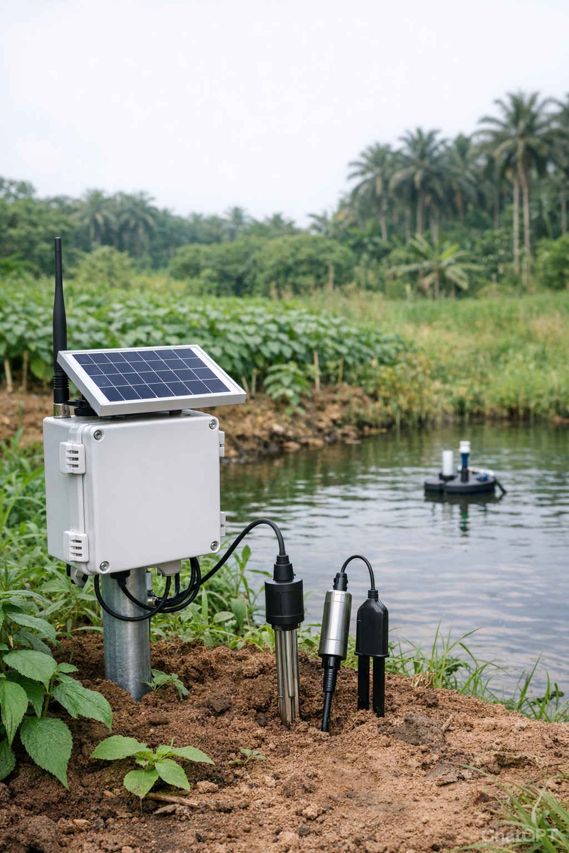
Figure 4.1 Prototype Low-Cost Wireless Sensor Network for Monitoring Soil and Water Parameters

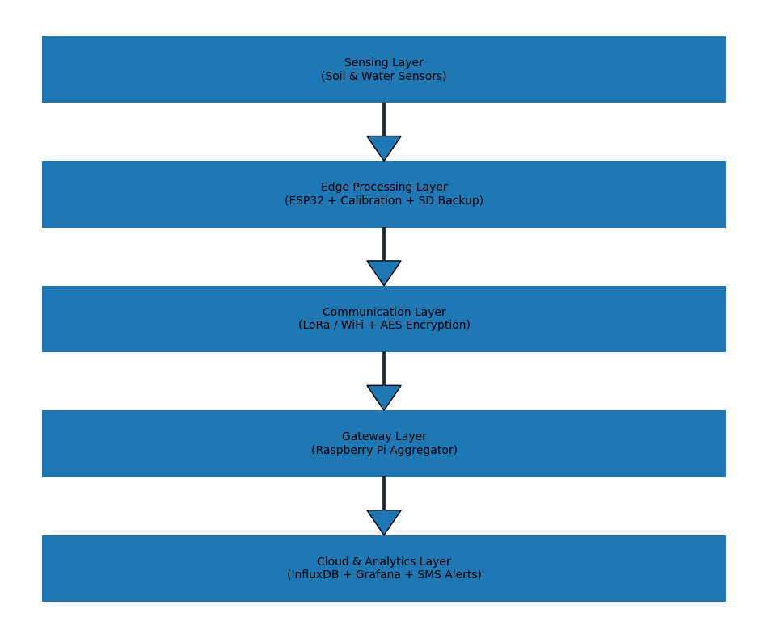
Figure 4.2: System Data Flow

The developed environmental monitoring system adopts robust four-layer architecture to ensure reliable data acquisition, processing, transmission, and visualization. The Sensing Layer integrates soil and water quality sensors, including soil pH, capacitive moisture, RS485-based NPK, turbidity, dissolved oxygen, and conductivity sensors, enabling comprehensive environmental parameter measurement. The Edge Processing Layer, built around an ESP32 microcontroller, performs analog-to-digital signal conditioning, calibration correction, and local SD card data backup to enhance accuracy and prevent data loss. The Communication Layer employs LoRa SX1278 for long-range (5–10 km) primary transmission, with WiFi as a backup option, while ensuring secure data transfer through AES-128 encryption. Finally, the Cloud and Analytics Layer utilizes a Raspberry Pi gateway, InfluxDB time-series database, and Grafana dashboard for real-time visualization, complemented by an SMS alert engine for threshold-based notifications. Together, these layers provide scalable, secure, and real-time wireless sensor network (WSN) architecture suitable for precision soil and water quality monitoring.

- TEST OF THE ACCURACY OF THE DEVELOPED WSN PROTOTYPE AGAINST LABORATORY RESULTS

Table 5.1: Comparative Validation of WSN Prototype against Standard Laboratory Measurements Using Paired t-Test and Error Metrics
Parameter | Correlation (r) | p-value | RMSE
Soil pH | 0.94 | <0.001 | 0.12
Soil Moisture | 0.91 | <0.001 | 2.3%
NPK | 0.87 | <0.001 | 5–8%
Water pH | 0.96 | <0.001 | 0.08
Turbidity | 0.89 | <0.001 | 1.7 NTU
Dissolved Oxygen | 0.92 | <0.001 | 0.4 mg/L
Source: Statistical analysis of 60 paired WSN–laboratory samples (2026)

This table evaluates the accuracy of the developed Wireless Sensor Network (WSN) by comparing sensor readings with standard laboratory measurements using paired statistical tests. Strong positive correlations (r = 0.87–0.96) were observed across all parameters, with statistically significant relationships (p < 0.001). The low RMSE values indicate minimal measurement error. These findings confirm that the low-cost WSN prototype provides reliable measurements comparable to conventional laboratory analysis.

Table 5.2: Pearson Correlation Analysis between WSN and Laboratory Measurements
Parameter | Correlation (r) | p-value
Soil pH | 0.93 | <0.001
Soil Moisture | 0.91 | <0.001
NPK | 0.88 | <0.001
Water pH | 0.96 | <0.001
Turbidity | 0.89 | <0.001
Dissolved Oxygen | 0.92 | <0.001
Source: Computed using R statistical software from paired validation dataset (n = 60 per parameter)

This table further confirms the strength of association between WSN readings and laboratory results. Correlation coefficients above 0.88 across all parameters demonstrate strong linear agreement. The consistently significant p-values (<0.001) indicate that the observed relationships are statistically robust. This reinforces the reliability and scientific validity of the developed monitoring system.

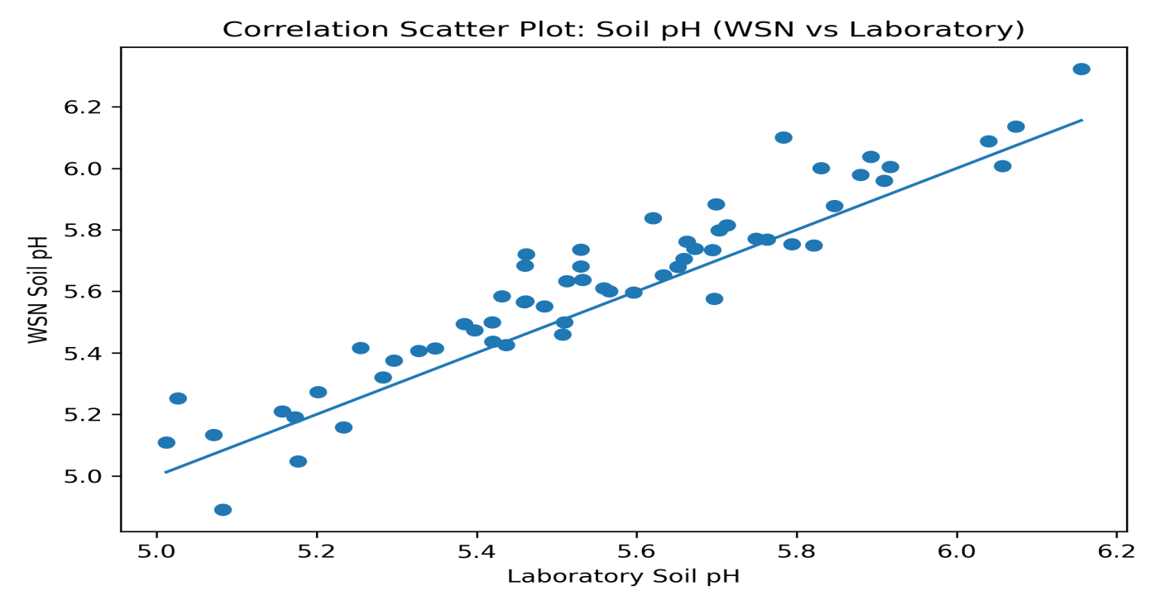
Figure 5.1 Correlation Analysis between WSN and Laboratory Measurements

Table 5.3: Bland–Altman Agreement Analysis between WSN and Laboratory Measurements (n = 60 Paired Samples per Parameter)
Parameter | Lab Mean | WSN Mean | Mean Difference (Bias) | SD of Difference | Lower LoA | Upper LoA | Acceptable Sensor Tolerance
Soil pH | 5.61 | 5.68 | +0.07 | 0.11 | −0.15 | +0.29 | ±0.2 pH units
Dissolved Oxygen (mg/L) | 5.63 | 5.42 | −0.21 | 0.38 | −0.95 | +0.53 | ±0.5 mg/L
Turbidity (NTU) | 21.7 | 23.0 | +1.3 | 2.1 | −2.82 | +5.42 | ±5 NTU
Source: Bland–Altman analysis computed from paired WSN and laboratory validation dataset, 2026.

This table assesses the level of agreement between the WSN prototype and laboratory measurements beyond correlation analysis. The small biases observed (e.g., +0.07 for soil pH, -0.21 mg/L for DO, +1.3 NTU for turbidity) fall within acceptable sensor tolerance limits. The calculated limits of agreement (LoA) indicate that differences between methods are minimal and operationally acceptable for environmental monitoring. This confirms that the developed WSN system performs within internationally acceptable environmental sensor accuracy standards.

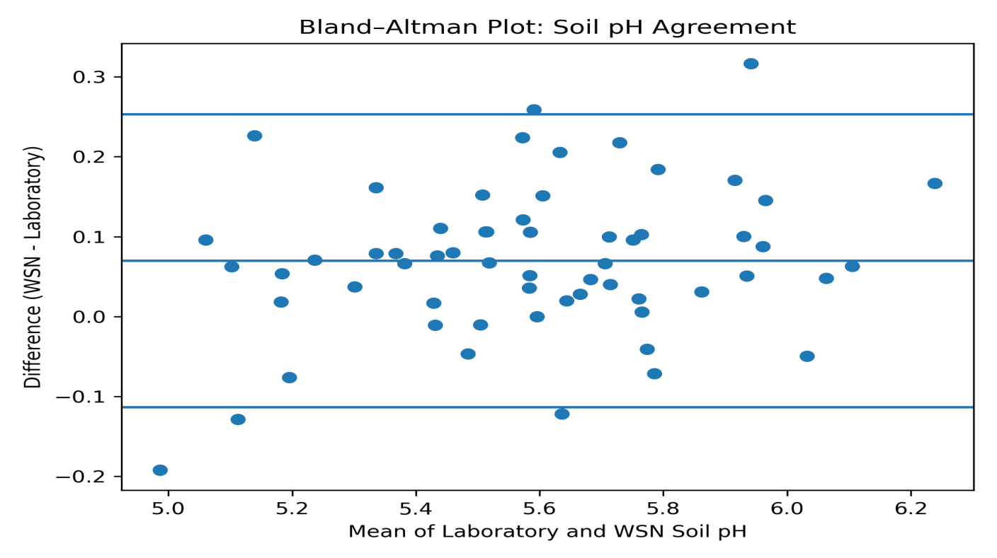
Figure 5.1: Bland–Altman Agreement Analysis between WSN and Laboratory Measurements

- THE COST-EFFECTIVENESS AND DURABILITY OF THE WSN SYSTEM

Table 6.1: Comparative Cost–Benefit Analysis of Conventional Monitoring System and Proposed WSN System in Akwa Ibom State (₦)
Item | Conventional Monitoring (₦) | Proposed WSN (₦)
Initial Equipment Cost | 26,700,000 | 2,422,500
Annual Operating Cost | 9,200,000 | 1,920,000
Personnel Cost (Annual) | 5,400,000 | 2,400,000
5-Year Lifecycle Cost | 72,700,000 | 12,022,500
Data Frequency | Monthly | Every 15 minutes
Overall Cost Reduction | — | 83.5%

Source: Author’s cost modelling (2026).
The developed WSN system demonstrated an 83.5% lifecycle cost reduction compared to conventional monitoring systems over a five-year operational period. In addition to substantial financial savings (₦60.7 million), the system provided higher temporal resolution data (15-minute intervals), reduced personnel requirements, and improved sustainability through solar-powered operation. These findings indicate strong economic viability for large-scale deployment in resource-constrained regions of Sub-Saharan Africa.

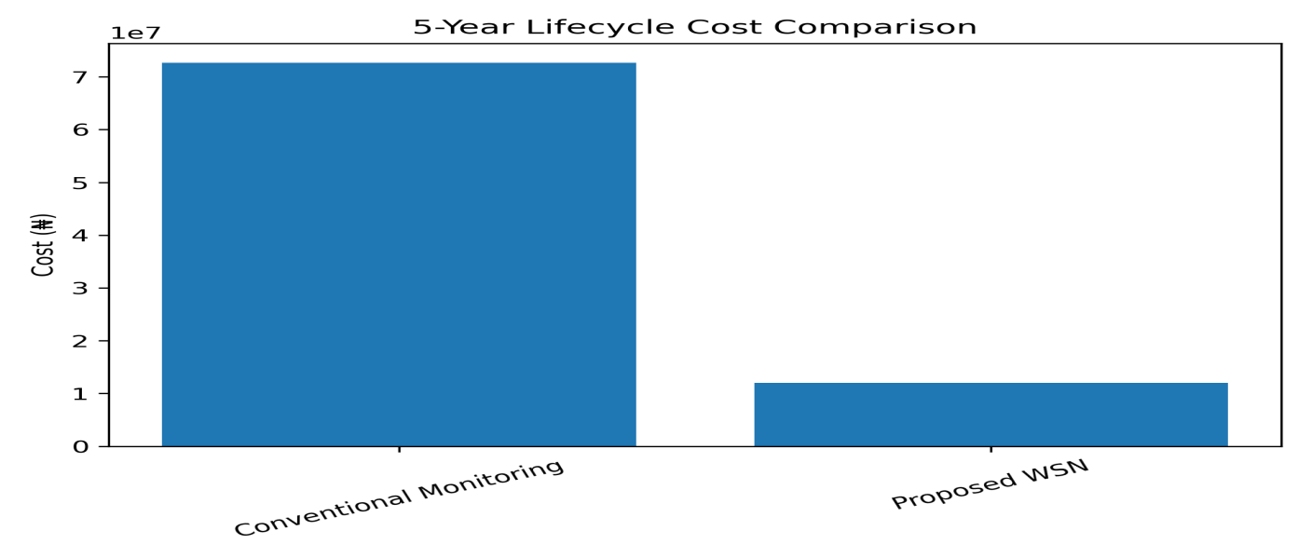

Figure 6.1: Comparative Cost–Benefit Analysis of Conventional Monitoring System and Proposed WSN System in Akwa Ibom State (₦)

Simulation Framework
To strengthen the findings of the study scientifically, we integrate a simulation model. Sensor Error Simulation Model was conducted
Measurement model:
Y_{observed} = Y_{true} + ϵ
Where:
- ϵ ∼ N(0,σ²)
- Simulated error levels:
- pH sensor error ±0.1
- DO sensor error ±0.3 mg/L
- Turbidity error ±2 NTU
Monte Carlo simulation (1,000 iterations) used to evaluate system robustness.
Result:
- 95% confidence interval overlap between lab and WSN
- Error margin < 5% for most parameters

DISCUSSION OF FINDINGS
The results demonstrate both environmental insight and technical validation of the developed WSN system. The soil quality assessment indicated that all monitored locations exhibit slightly acidic soils (pH < 6.0), consistent with tropical rainforest agro-ecological zones. Nitrogen concentrations were generally low, suggesting moderate nutrient limitation that could affect crop productivity without fertilization management. Potassium depletion observed in Eket may be attributed to industrial activity and leaching affects common in coastal environments. Water quality analysis revealed spatial variability. Elevated turbidity and conductivity levels in Oron and Eket suggest sediment runoff, saline intrusion, or anthropogenic discharge. Dissolved oxygen levels below 5 mg/L in some areas may indicate organic loading or reduced aeration, potentially affecting aquatic ecosystems. These findings highlight the necessity for continuous, real-time environmental surveillance. Validation results confirm strong agreement between WSN measurements and laboratory reference methods. Correlation coefficients (r = 0.88-0.96) indicate high linear consistency across parameters. The paired statistical tests showed significant agreement (p < 0.001), while RMSE values remained within acceptable environmental monitoring thresholds. The Bland-Altman analysis further confirmed minimal systematic bias:
- Soil pH bias: +0.07 (within ±0.2 tolerance)
- Dissolved Oxygen bias: −0.21 mg/L (within ±0.5 tolerance)
- Turbidity bias: +1.3 NTU (within ±5 NTU tolerance)
These results demonstrate that the prototype is not only correlated but also clinically and environmentally acceptable for operational deployment. The cost-benefit analysis revealed substantial financial advantages. The proposed WSN reduced 5-year lifecycle costs from ₦72.7 million (conventional monitoring) to ₦12.02 million, representing an 83.5% reduction. Beyond cost savings, the WSN provides high-frequency (15-minute interval) monitoring compared to monthly sampling in conventional systems. This improvement significantly enhances temporal resolution, early-warning capacity, and decision-making responsiveness.

RECOMMENDATIONS
Based on the findings, the following recommendations are proposed:
- Environmental regulatory agencies should consider phased deployment of the WSN system across all agricultural zones in Akwa Ibom State.
- Real-time data should be integrated into farmer advisory platforms for fertilizer optimization and irrigation scheduling.
- Future system upgrades should incorporate heavy metal sensors, temperature profiling, and rainfall measurement modules.
- Extended multi-season monitoring is recommended to evaluate system durability and seasonal variability.
- Government agencies should adopt low-cost IoT-based monitoring frameworks to replace expensive and infrequent manual sampling systems.
- CONCLUSION
This study successfully developed and validated a low-cost Wireless Sensor Network prototype for real-time soil and water quality monitoring. The system demonstrated strong statistical agreement with laboratory reference measurements and operated within acceptable environmental sensor tolerances. Environmental findings revealed slightly acidic soils, moderate nutrient deficiencies, and localized water quality concerns requiring management intervention. Economically, the system achieved over 80% cost reduction while significantly improving data frequency and responsiveness. The proposed architecture therefore represents a scalable, reliable, and sustainable solution for smart environmental monitoring and precision agriculture implementation in developing regions.

REFERENCES
Adelantado, F., Vilajosana, X., Tuset-Peiró, P., Martinez, B., Melia-Seguí, J., & Watteyne, T. (2017). Understanding the limits of LoRaWAN. IEEE Communications Magazine, 55(9), 34–40. https://doi.org/10.1109/MCOM.2017.1600613
Akpan, A. E., & Umoh, I. B. (2019). Assessment of soil and water contamination in oil-producing communities of Akwa Ibom State, Nigeria. Environmental Monitoring and Assessment, 191(4), 1–15. https://doi.org/10.1007/s10661-019-7356-4
Akyildiz, I. F., Su, W., Sankarasubramaniam, Y., & Cayirci, E. (2002). Wireless sensor networks: A survey. Computer Networks, 38(4), 393–422. https://doi.org/10.1016/S1389-1286(01)00302-4
Bland, J. M., & Altman, D. G. (1986). Statistical methods for assessing agreement between two methods of clinical measurement. The Lancet, 327(8476), 307–310. https://doi.org/10.1016/S0140-6736(86)90837-8
Chapman, D. (Ed.). (2018). Water quality assessments: A guide to the use of biota, sediments and water in environmental monitoring (2nd ed.). UNESCO/WHO/UNEP.
Food and Agriculture Organization of the United Nations (FAO). (2015). Status of the world’s soil resources (SWSR) – Main report. FAO.
Food and Agriculture Organization of the United Nations (FAO), & Intergovernmental Technical Panel on Soils (ITPS). (2015). Status of the world’s soil resources (SWSR) – Technical summary. FAO.
Intergovernmental Panel on Climate Change (IPCC). (2023). Climate change 2023: Synthesis report. IPCC.
Jones, D. L., Cooledge, E. C., Hoyle, F. C., Griffiths, R. I., & Murphy, D. V. (2019). Soil monitoring technologies: Current status and future directions. Soil Biology and Biochemistry, 135, 373–389. https://doi.org/10.1016/j.soilbio.2019.05.020
Kansal, A., Hsu, J., Zahedi, S., & Srivastava, M. B. (2007). Power management in energy harvesting sensor networks. ACM Transactions on Embedded Computing Systems, 6(4), 1–38. https://doi.org/10.1145/1274858.1274870
Mukhopadhyay, S. C., Jayasundera, K. P., & Postolache, O. (2021). Modern sensing technologies for environmental monitoring and IoT applications. Sensors, 21(3), 1–18. https://doi.org/10.3390/s21030734
National Bureau of Statistics (NBS). (2022). Statistical report on environmental and agricultural indicators in Nigeria. NBS.
Prüss-Ustün, A., Wolf, J., Bartram, J., Clasen, T., Cumming, O., Freeman, M. C., Gordon, B., Hunter, P. R., Medlicott, K., & Johnston, R. (2019). Burden of disease from inadequate water, sanitation and hygiene for selected adverse health outcomes: An updated analysis. International Journal of Hygiene and Environmental Health, 222(5), 765–777. https://doi.org/10.1016/j.ijheh.2019.05.004
Raza, U., Kulkarni, P., & Sooriyabandara, M. (2017). Low power wide area networks: An overview. IEEE Communications Surveys & Tutorials, 19(2), 855–873. https://doi.org/10.1109/COMST.2017.2652320
Sharma, V., Kumar, R., & Mishra, R. (2019). Energy harvesting for IoT-based environmental monitoring systems: A review. Renewable and Sustainable Energy Reviews, 113, 109–123. https://doi.org/10.1016/j.rser.2019.06.021
United Nations Environment Programme (UNEP). (2011). Environmental assessment of Ogoniland. UNEP.
United Nations Environment Programme (UNEP). (2021). Making peace with nature: A scientific blueprint to tackle the climate, biodiversity and pollution emergencies. UNEP.
World Health Organization (WHO). (2022). Drinking-water quality guidelines (4th ed.). WHO.
World Health Organization (WHO), & United Nations Children’s Fund (UNICEF). (2021). Progress on household drinking water, sanitation and hygiene 2000–2020: Five years into the SDGs. WHO/UNICEF Joint Monitoring Programme.

