Effectiveness of Digital Marketing Tools in Increasing Customer Engagement

ABSTRACT
The rapid growth of internet usage and smartphone adoption has transformed traditional marketing into digital marketing, leading businesses to increasingly rely on tools such as social media advertising, email marketing, online promotions, and influencer marketing to interact with customers and enhance engagement. This study examines the effectiveness of digital marketing tools in increasing customer engagement in the Indian context using a descriptive quantitative research design. Primary data were collected from 110 respondents through a structured online questionnaire, focusing on platform usage, interaction frequency, attention towards digital tools, satisfaction levels, and engagement behaviour. The findings indicate that social media platforms are the dominant digital channel, and digital advertisements significantly influence customer actions such as website visits, brand following, campaign participation, and mobile application downloads. Discounts and promotional offers emerged as the strongest motivating factors driving engagement. Overall, the study concludes that digital marketing tools are highly effective in increasing customer engagement, particularly when businesses strategically combine strong social media presence, personalized communication, and promotional incentives.
Keywords: Digital Marketing, Customer Engagement, Social Media Marketing, Online Advertising, Email Marketing, Promotional Offers, Brand Awareness

1. INTRODUCTION
The development of digital technology has significantly transformed marketing practices. Earlier, businesses relied on traditional marketing methods such as print advertisements, television commercials, and radio promotions. However, the rapid growth of internet usage and smartphone adoption has shifted marketing communication to digital platforms. Digital marketing tools such as social media advertising, email campaigns, search engine marketing, influencer marketing, and online promotions now enable businesses to communicate directly with customers in a faster and more interactive manner. Unlike traditional marketing, digital platforms allow two-way communication where customers can like, comment, share, and engage with brands instantly.
Customer engagement refers to the level of interaction and emotional connection that customers develop with a brand. Higher engagement leads to stronger brand loyalty, repeated purchases, and positive word-of-mouth promotion. As businesses increasingly invest in digital marketing strategies, it becomes important to evaluate whether these tools truly enhance customer engagement. Therefore, this study aims to examine the effectiveness of digital marketing tools in increasing customer engagement using primary data collected from 110 respondents.

2. LITERATURE REVIEW
Customer engagement is very important in modern marketing. It means how much customers interact with a brand and feel connected to it. According to Brodie et al. (2011), engagement includes how customers think about a brand, how they feel about it, and how they behave toward it. When customers are engaged, they are more likely to stay loyal and recommend the brand to others.
Earlier, marketing was mostly one-way communication through TV and newspapers. Kotler, Kartajaya, and Setiawan (2017) explain that modern marketing has changed because of digital platforms, allowing customers to talk back and interact instantly. Digital marketing includes social media, email, and online ads. Chaffey and Ellis-Chadwick (2019) note that these tools help businesses reach customers easily and track results like clicks and views.
Among these tools, social media is vital. Ashley and Tuten (2015) and De Vries et al. (2012) state that creative, interactive posts increase likes and shares, helping brands build communities. Email marketing also works well when personalized; Ryan (2016) explains that tailored messages make customers feel valued. Additionally, Tiago and Veríssimo (2014) mention that digital ads are effective for driving immediate actions like website visits at a lower cost than traditional marketing.
However, many studies talk about digital marketing in general but do not compare specific tools. There is also limited survey-based research focused on Indian customers. Therefore, this study uses primary data from 110 respondents to measure how different digital marketing tools increase customer engagement in the Indian context.
Table 1: Research Gaps in Digital Marketing Studies
Research Area | Current Understanding | Research Gap
General effectiveness of digital marketing | Many studies explain that digital marketing improves engagement | Limited studies measuring the effectiveness of specific digital marketing tools separately
Platform-specific analysis | Research discusses digital marketing broadly | Lack of focused analysis on which particular platforms create higher engagement
Measurement of engagement outcomes | Engagement is often discussed conceptually | Limited empirical data showing percentage-based engagement improvement
Regional and demographic studies | Majority of studies focus on global markets | Insufficient research focused on Indian consumers and regional behavior patterns
Comparative tool effectiveness | Some studies mention multiple tools together | Need for comparative studies showing which tool (social media, email, ads) performs better
Primary data-based research | Many studies rely on secondary sources | More survey-based primary research is required to validate results

3. STUDY AREA BACKGROUND

This study is conducted within the Indian digital marketing environment, where businesses increasingly use online platforms to promote products and interact with customers. The rapid growth of internet usage and smartphone adoption has made digital marketing a primary communication channel across industries. Companies in India actively use social media advertising, email marketing, search engine promotions, influencer collaborations, and online campaigns. Among these tools, social media platforms such as Instagram, Facebook, and YouTube serve as the main channels for customer interaction. These platforms allow businesses to share promotional content and receive measurable feedback through likes, comments, shares, and clicks. Indian consumers frequently use digital platforms for product discovery, brand comparison, and purchasing decisions. As a result, digital marketing activities directly influence customer engagement and behavioural responses. Given the expansion of India’s digital ecosystem and high online activity levels, this setting provides a relevant and practical context for examining the effectiveness of digital marketing tools in increasing customer engagement.
4. RESEARCH METHODOLOGY
4.1 Research Design
The study employs a descriptive research design to analyze the effectiveness of digital marketing tools in increasing customer engagement. This design is appropriate as it enables systematic examination of customer perceptions, interaction levels, and behavioural responses toward digital marketing activities without manipulating any variables.
4.2 Research Approach
The research follows a quantitative approach. Quantitative methodology allows the collection of structured numerical data and facilitates objective interpretation through statistical techniques. The approach ensures measurable evaluation of engagement patterns and perceived effectiveness of various digital marketing tools.
4.3 Population and Sampling
The target population for the study consists of individuals who actively use digital platforms such as social media, email services, and online websites. A sample of 110 respondents was selected using convenience sampling. The selection was based on accessibility and active digital platform usage to ensure relevant responses.
4.4 Data Collection Methods
The study is based on both primary and secondary data sources.
Primary data were collected through a structured online questionnaire comprising 12 close-ended questions. The questionnaire was designed to capture:
- Digital platform usage patterns
- Frequency of brand interaction
- Attention toward digital advertisements
- Perceived effectiveness of digital marketing tools
- Engagement behaviour (likes, shares, clicks, downloads, campaign participation)
- Purchase-related responses
A five-point Likert scale was used to measure perception-based variables such as agreement, satisfaction, and effectiveness.
Secondary data were obtained from academic journals, marketing research articles, and relevant literature to support the conceptual framework of digital marketing and customer engagement.
4.5 Data Analysis Techniques
The collected responses were analyzed using percentage analysis to determine distribution patterns. Graphical representations such as bar charts and pie charts were used for visual interpretation. Comparative analysis was conducted to evaluate the relative effectiveness of different digital marketing tools in influencing customer engagement.
5. DATA ANALYSIS
5.1 Overview of Analysis
This chapter presents the analysis of primary data collected from 110 respondents to examine the effectiveness of digital marketing tools in increasing customer engagement.
The analysis aims to evaluate digital platform usage behaviour, attention towards digital marketing tools, perceived effectiveness, engagement actions, and behavioural impact. The responses have been interpreted using percentage analysis and graphical representation.
For systematic interpretation, the questions are categorized into digital platform usage, perceived effectiveness, engagement behaviour, and promotional influence.
5.2 Analysis
Figure 1: Digital Platform Usage and Interaction Frequency (n = 110)
Questions 1 and 2 are related to digital platform usage and frequency of interaction.
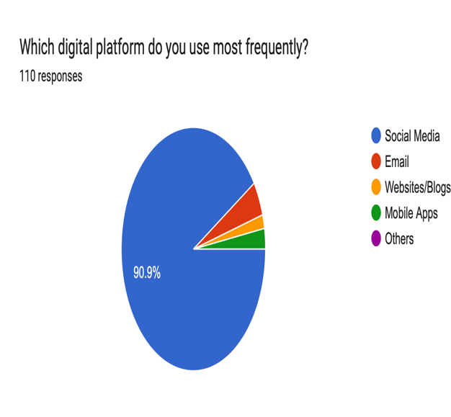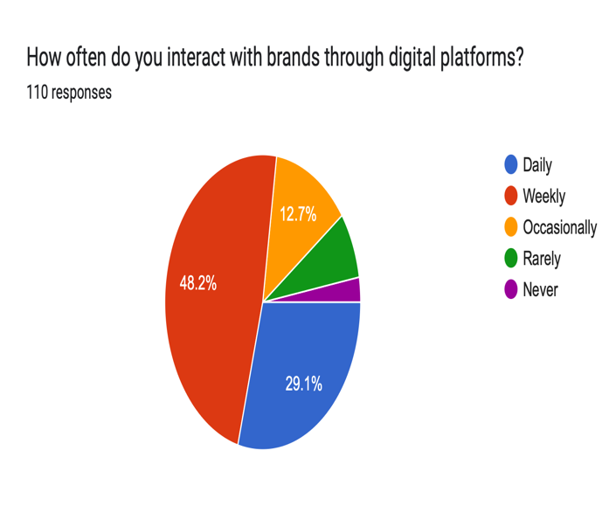
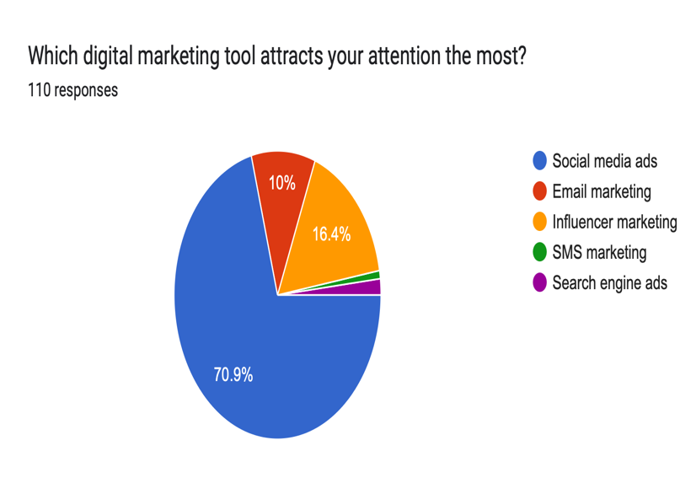
The findings show that 90.9% of respondents use social media platforms most frequently, indicating that social media is the dominant digital channel.
A majority of respondents reported interacting with brands either daily or weekly, reflecting consistent engagement behaviour.
Further, 70.9% stated that social media advertisements attract their attention the most, compared to email marketing or other tools.
This clearly indicates that social media platforms serve as the primary source of digital interaction and engagement.

Figure 2: Perceived Effectiveness of Digital Marketing Tools (n = 110)
Questions 4, 5 and 6 focus on perception and effectiveness of digital marketing tools.
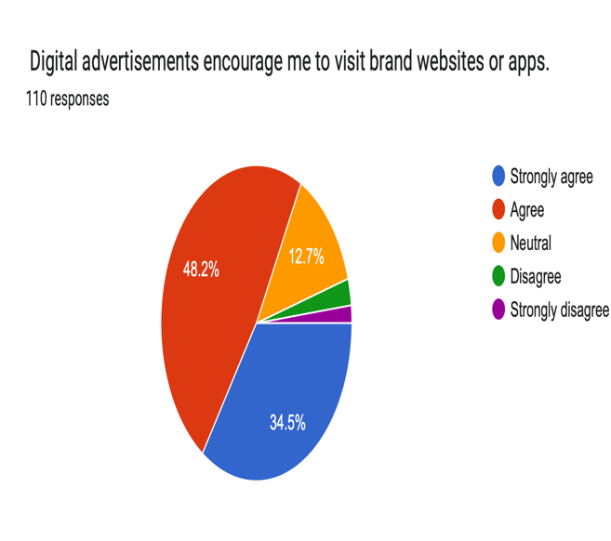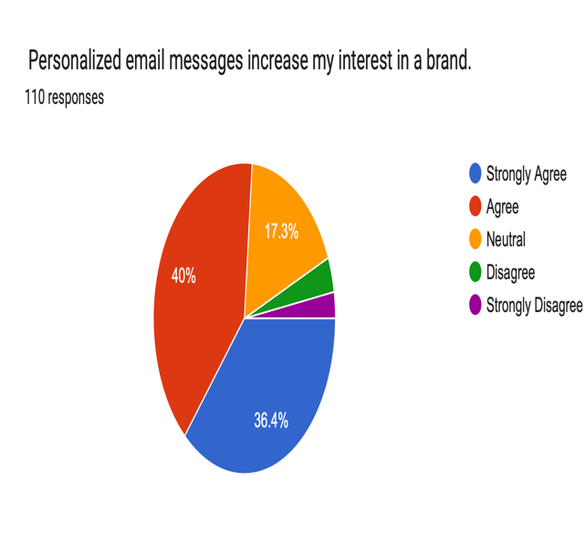

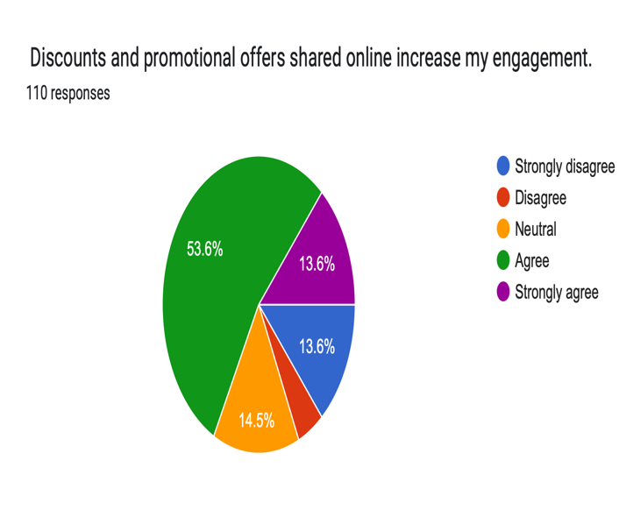
The analysis reveals that:
- Over 80% agreed that digital advertisements encourage website visits.
- Around 76% agreed that personalized emails increase interest.
- 87% rated digital marketing tools as effective or very effective in improving brand awareness.
This demonstrates that customers perceive digital marketing tools as influential and impactful.

Figure 3: Engagement Actions and Behavioural Response (n = 110)
Questions 7, 8 and 9 examine engagement behaviour and participation.
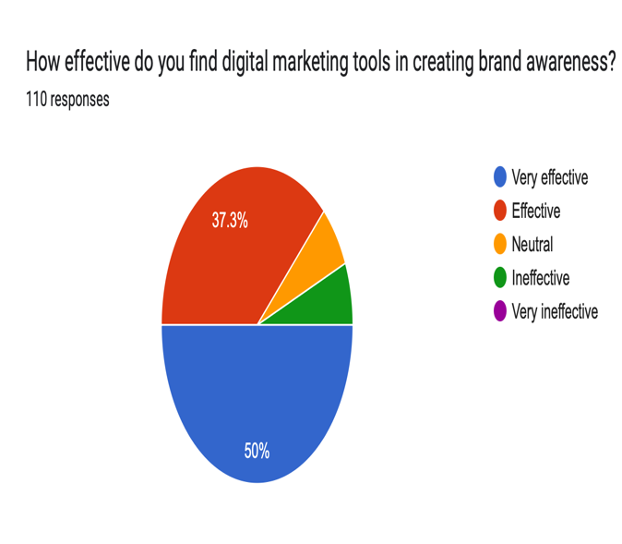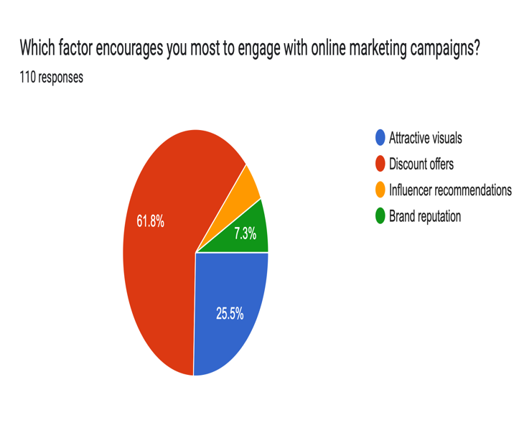
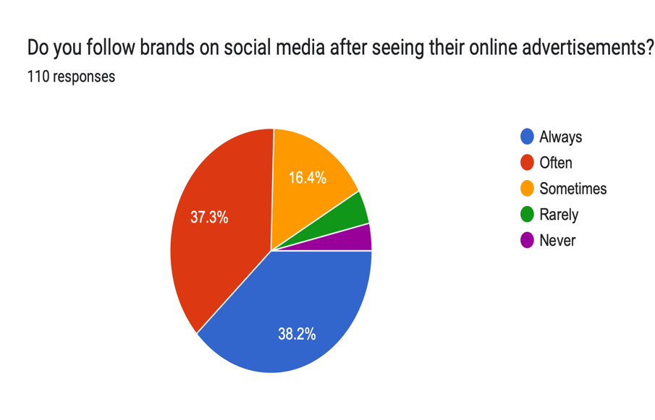
The findings indicate:
- 77.3% participated in online campaigns.
- 79.1% downloaded apps after viewing advertisements.
- A majority reported following brands after seeing promotional content.
This shows that digital marketing tools influence measurable engagement actions.
Figure 4: Impact of Discounts and Promotional Offers (n = 110)
Questions 10, 11 and 12 assess the impact of promotional incentives on engagement.
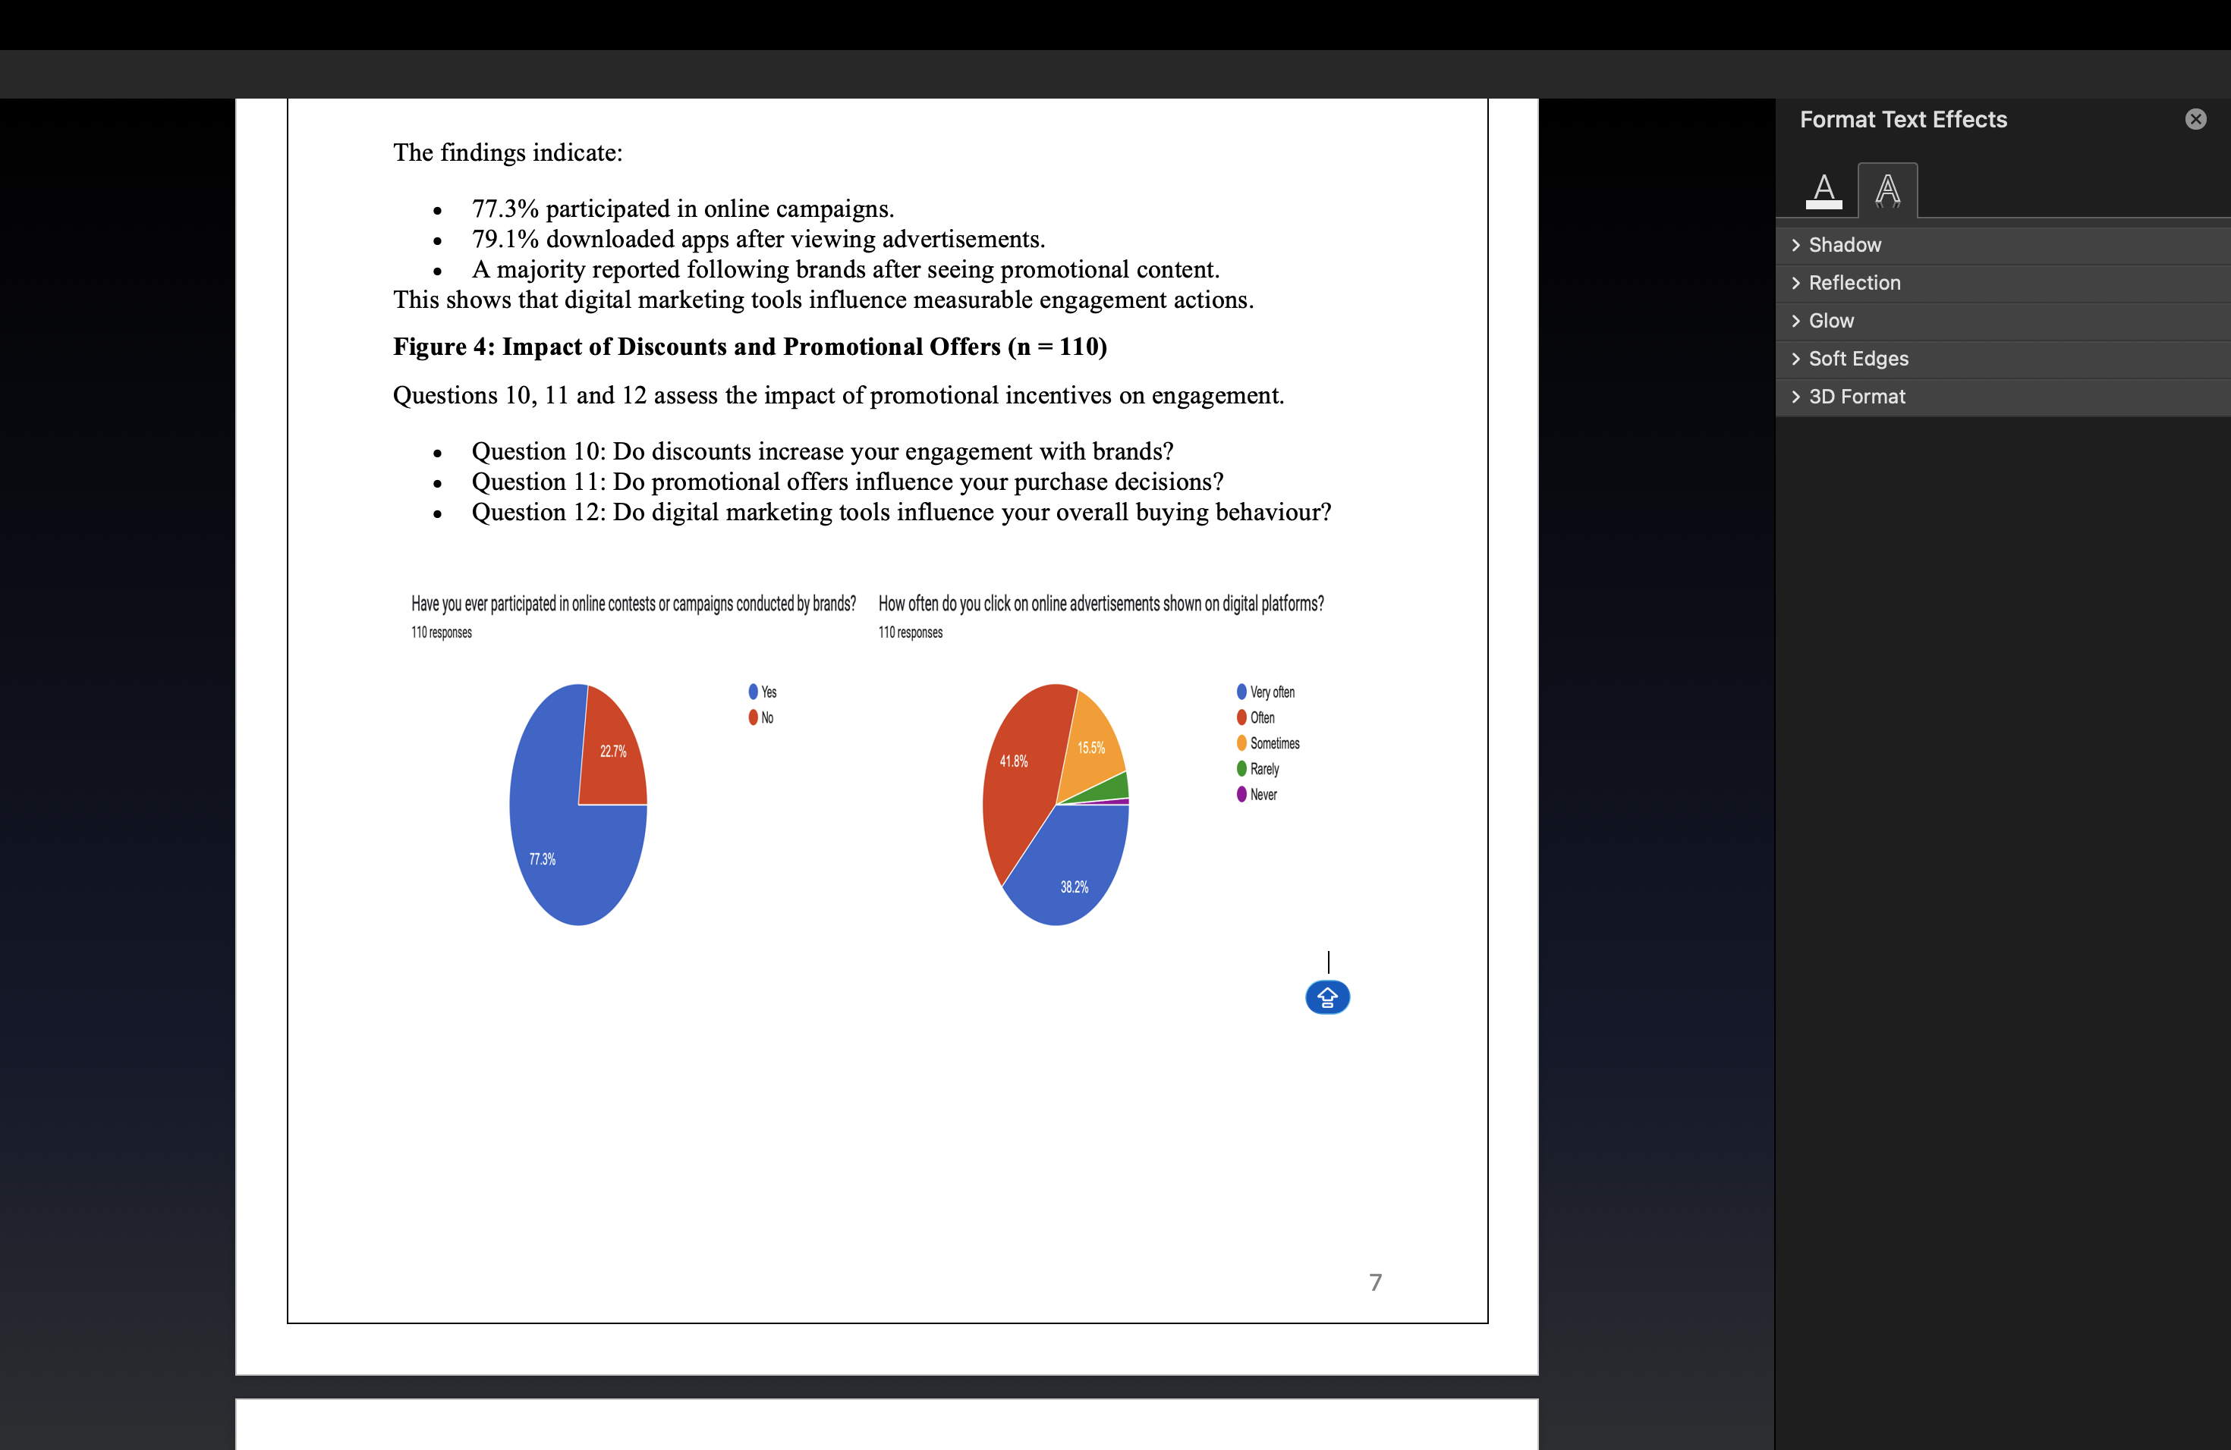
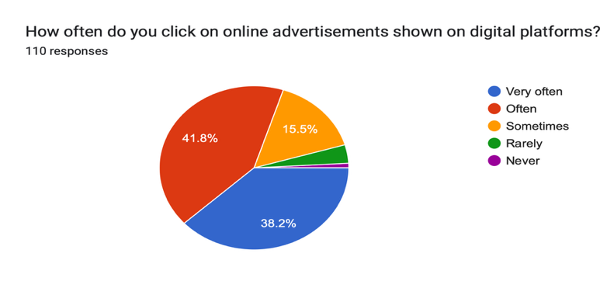

The results show that:
- 67% agreed that discounts increase engagement.
- A large proportion confirmed that promotional offers influence purchase decisions.
- Most respondents acknowledged that digital marketing tools influence their buying behaviour.
This indicates that promotional incentives are strong drivers of customer engagement and conversion behaviour.

5.3 Overall Interpretation
The overall analysis clearly confirms that digital marketing tools significantly influence customer engagement in the Indian context.
Social media platforms dominate in usage and attention levels. Digital advertisements effectively encourage website visits, campaign participation, and mobile app downloads. Personalized communication enhances interest, while discounts and promotional offers act as the strongest motivating factors.
Thus, the findings strongly support the research objective that digital marketing tools are highly effective in increasing customer engagement.
6.CONCLUSION
This study investigated the effectiveness of digital marketing tools in increasing customer engagement within the Indian context. Employing a descriptive quantitative design, data were collected from 110 respondents via a structured online questionnaire. The findings reveal that social media platforms are the most frequently used digital channel, with 90.9% of respondents favoring them above other platforms. Furthermore, digital advertisements were shown to have a substantial impact, driving customer actions such as visiting brand websites, participating in campaigns, and downloading mobile apps. Personalized communication, particularly through targeted emails, also boosted engagement by making customers feel valued. Moreover, promotional offers and discounts emerged as strong motivators, encouraging not only interaction but also purchase behavior. Overall, the study concludes that digital marketing tools are highly effective in enhancing customer engagement, particularly when businesses integrate social media presence, personalized communication, and strategic promotional tactics.
7. LIMITATIONS
• The study is based on 110 respondents, which may not fully represent the entire population.
• The use of non-probability sampling limits the generalization of results.
• The study relies on self-reported data, which may include subjective bias.
• The research is based on structured survey questions and does not include interviews for deeper understanding.
• The study focuses mainly on selected digital marketing tools and does not analyze all available marketing channels.
8.FINDINGS
• A large majority of respondents use social media most frequently, making it the most effective platform for digital marketing communication and engagement.
• Most respondents interact with brands weekly or daily, indicating strong and continuous engagement on digital platforms.
• Social media advertisements attract the highest attention compared to email, SMS, or search engine marketing.
• A significant percentage of respondents agree that digital advertisements encourage them to visit brand websites or apps, follow brands, and explore products further.
• Personalized email communication increases customer interest and strengthens brand connection.
• Promotional offers and discounts act as the strongest drivers of customer engagement and participation.
9.RECOMMENDATIONS
• Businesses should prioritize social media platforms as they provide the highest engagement potential.
• Companies should create attractive and interactive advertisements to increase customer attention and interaction.
• Brands should offer regular discounts and promotional campaigns, as they strongly influence engagement and purchase decisions.
• Marketing communication should be more personalized through targeted emails and customized advertisements to strengthen customer relationships.
• Businesses should encourage interactive campaigns such as contests and giveaways to boost customer participation.
• Organizations should regularly monitor engagement metrics like click rates, app downloads, and campaign participation to measure digital marketing effectiveness.
10. REFERENCES
Chaffey, D., & Ellis-Chadwick, F. (2019). Digital marketing: Strategy, implementation and practice (7th ed.). Pearson Education.
Kotler, P., Kartajaya, H., & Setiawan, I. (2017). Marketing 4.0: Moving from traditional to digital. John Wiley & Sons.
Ryan, D. (2016). Understanding digital marketing: Marketing strategies for engaging the digital generation. Kogan Page.
Tuten, T. L., & Solomon, M. R. (2018). Social media marketing. Sage Publications.
Ashley, C., & Tuten, T. (2015). Creative strategies in social media marketing: An exploratory study of branded social content and consumer engagement. Psychology & Marketing, 32(1), 15–27.
Lemon, K. N., & Verhoef, P. C. (2016). Understanding customer experience throughout the customer journey. Journal of Marketing, 80(6), 69–96.
Kannan, P. K., & Li, H. (2017). Digital marketing: A framework, review and research agenda. International Journal of Research in Marketing, 34(1), 22–45.
Tiago, M. T. P. M. B., & Veríssimo, J. M. C. (2014). Digital marketing and social media: Why bother? Business Horizons, 57(6), 703–708.
De Vries, L., Gensler, S., & Leeflang, P. S. H. (2012). Popularity of brand posts on brand fan pages: An investigation of the effects of social media marketing. Journal of Interactive Marketing, 26(2), 83–91.
Smith, K. T. (2018). Digital marketing strategies that Millennials find appealing, motivating, or just annoying. Journal of Strategic Marketing, 26(2), 137–157.

