Anti-Jamming Communication Framework for Drones Using Frequency Hopping

Abstract— Applications of drones or UAVs are spread across the sectors of surveillance, agriculture, delivery, and disaster management. Their wireless communication connections are particularly vulnerable to the purposeful jamming attacks that inhibit the command-and-control signal between the ground stations and the drones. In this paper, a Frequency Hopping Spread Spectrum Anti- Jamming Communication Framework of Drones is presented. With this method when transmitting, the transmitter and receiver switch carrier frequencies quickly and pseudo-randomly making the signal less likely to become jammed by an enemy. The proposed framework will be implemented and simulated on GNU Radio and Python, which would provide flexibility when it comes to testing hopping sequences, modulation schemes, and anti-jamming strategies. The system will be designed in a way that will allow it to provide secure, low cost, and reliable communication to be used in the real world application of UAVs. The experimental evaluation is comprised of analysis of Packet Delivery Ratio (PDR), Bit Error Rate (BER) and the stability of links when simulated jamming occurs. The simulation results indicate that FHSS has the capability of eliminating narrowband and static jamming interference to allow the continuous communication in a highly interfering environment. This paper helps to build a more resilient and adaptive communication system to drones offering an effective trade-off of performance, security and a hardware viable future UAV networks.
Keywords—Software Defined Radio (SDR), Unmanned Aerial Vehicle (UAV), Anti-Jamming Communication, Frequency Hopping Spread Spectrum (FHSS), GNU Radio, Secure Drone Communication, Wireless Link Reliability, RF Front-End.

INTRODUCTION

The use of drones or unmanned aerial vehicles is also wide in the contemporary setting, beginning with surveillance and disaster control and expanding to agriculture monitoring and military actions. Strong and safe communication between a drone and the ground control station is extremely critical to the safe and effective operation of such devices. Conversely, wireless channel communications used by the drone are very prone to interference and jamming, and can impact the control or data transmission signals, leading to a mission failure.

The traditional radio communication systems rely on non- portable hardware transceivers that use pre-reserved frequency ranges. They are not flexible and hence cannot dynamically adapt to changing signal conditions or counter jamming attacks. These are severe limitations that SDR gets through by offering a reconfigurable platform in which most signal processing operations are implemented in software rather than hardware. Modulation type, carrier frequency, and bandwidth can be modified in real-time thus improving considerably in terms of adaptability and resistance to interference.

The FHSS communication in this project is implemented in the drones communication system based on SDR. With this type of FHSS technique, the systems can change between several frequency channels at a faster rate and can minimize the effects of jamming, therefore enhancing the security of links. The transmission and reception of a signal is done via equipment such as USRP or low-cost equivalents (comprising of a set of modules) such as nRF24L01, RF front-end, LNA, PLL, DAC, and ADC.

It provides flexibility, scalability and cost-effective and reliable wireless connectivity. The system is also a customizable software that can be used to be operating in a range of frequencies and communication protocols, which is why it is suitable in both research and practice of drones. Typically, an SDR-based drone communication model ensures a secure, flexible, and efficient solution in the contemporary UAV systems.

LITERATURE REVIEW

The paper "Software-defined Radios: Architecture, State-of- the-art, and Challenges" by Rami Akeela and Behnam Dezfouli reviews SDR technology with emphasis on its reconfigurable architecture, employing software instead of inflexible hardware to implement communications protocols. It covers everything from simple programmable transceivers to complex cognitive radio systems that can support dynamic spectrum access and adaptive modulation. Key architectural components such as RF front-ends, ADC/DAC converters, and digital baseband processors are discussed, along with describing popular SDR platforms like USRP and GNU Radio. Moreover, it is indicated that major challenges include real-time processing constraints, power consumption, and security vulnerability issues. The paper finally provides insight into the trend in the future regarding integration with AI and energy efficiency in SDR systems. [1]

Cronjé addresses software architecture for the SDR system by showing how modular, layered design principles map radio subsystem functionality (such as waveform processing, control, and hardware abstraction) into software components and emphasize reusability, portability, and maintainability of waveform implementations. He outlines an architecture in which hardware-dependent functionality-e.g., RF front-end control, ADC/DAC interfacing-is decoupled from higher- level signal-processing and user-control layers, enabling rapid deployment of multiple radio protocols. The paper also discusses related challenges on how to realize real-time performance, tight synchronization between software blocks and hardware, and heterogeneous computing elements that integrate the SDR stack; examples include GPPs, DSPs, and FPGAs. [2]

Bhawariya and Jukariya present an overview of drone (Unmanned Aerial Vehicle, UAV) technology that covers the construction of drones (frame, propellers, engine, power system, electronics and communication system), explores current and emerging applications of drones, and discusses risks of failure from various causes such as battery failure, adverse weather conditions, or collision with infrastructure. The authors have emphasized how the affordability and ubiquity of drones are causing exponential growth in their usage in civilian domains, while there is also a need to address safety and regulatory concerns regarding their deployment. [3]

The paper "Frequency Hopping Spread Spectrum: History,
Principles and Applications" by Vladimir B. Ristić, Branislav
M. Todorović, and Nenad M. Stojanović describes the history, basic principles, and various applications of the frequency hopping spread spectrum. It follows the historical development of FHSS from early military communications to modern wireless standards such as Bluetooth and LTE, with a focus on its robustness against interference, jamming, and interception. The authors describe the principles of FHSS operation, including hopping pattern variants, synchronization methods, and modulation techniques, and also discuss some of its performances, such as bandwidth efficiency and security. The concluding remarks of the paper note that FHSS remains relevant in defense, IoT, and secure communication systems because it is adaptive and resistant to channel impairments. [4]

The article titled Risk Assessment of SDR-based Attacks with UAVs by Frederic Le Roy, Christian Roland, Denis Le Jean and Jean-Philippe Diguet concerns the security risks, which involve the combination of an SDR and a UAV. This it does by giving the assessment framework of the risks in the context of which the SDRs can be exploited: interception of the signal, spoofing, and jamming. The cases of attacks are examined with regards to UAV mobility, SDR flexibility, and communication frequences, which promotes the fact that it is challenging to detect and mitigate them because of the flexibility of SDRs. It focuses on the need to ensure high- level countermeasures by monitoring a spectrum in real-time and security SDR design concepts to ensure the safety of UAVs during civilian and defense application [5].
The article titled Software Defined Radio: Challenges and Opportunities by Tore Ulversoy provides the description of the history, possibilities, and constraint in relation to the transformation of SDR technology. It goes on to present the way SDR offers flexibility and reconfigurability in communication through software-controlled modulation, coding, and control of frequency. Ulversoy is talking about building blocks, RF front ends, ADC/DAC converters, and programmable processors but puts great focus on the trade- offs between flexibility and performance. The paper has outlined some of the challenges that have been encountered such as high data conversion rates, real time processing as well as interoperability issues but also indicates opportunities in cognitive radio, adaptive networking and defense communications. It finds that further development of the digital hardware and software optimization will continue to expand the role of SDR in the future wireless systems.
[6]

The article by Hsin-Hung Cho, Chin-Feng Lai, Timothy K. Shih, and Han-Chieh Chao called Integration of SDR and SDN for 5G introduces a new framework combining Software-Defined Radio (SDR) and Software-Defined Networking (SDN) in order to achieve more flexibility,

scalability, and efficiency of 5G networks. The authors suggest an architecture, which makes use of SDR as a physical-layer communication reconfigurability tool and SDN as a centralized and programmable command of network resources. This integration is supposed to do dynamic spectrum management, low-latency data transmission, and enhancement of Quality of Service (QoS). There are also issues of real-time coordination between the radio and network layers, the security issues and the computational overhead of the paper. It concludes that the SDRSDN synergy offers a promising basis to 5G and future communication system due to smart and adaptive resource scheduling [7].
Cruz, Carvalho and Remley discuss a comprehensive overview of SDR design and testing: the issue of how to handle the hardware-software interface; the measurement and characterization of SDR systems, and the taming of the non-idealities which inevitably manifest themselves in a real world-implementation, i.e. the linearity of the ADC/DAC interface, the impairments due to RF front-end, and the calibration. They emphasize, hereby, the requirement of a combined methodology comprising the hardware of RF, digital base-band processing, and system-level testing as preconditions of reliable SDR implementation. Their work provides a useful guide assistance in the selection of instrumentation, development of proper test benches and in ensuring that SDR prototypes can perform to specifications in realistic conditions. It will be of special use to practitioners who are transferring to in-house hardware implementation.[8].

In this paper, the review and analysis of the major technologies that are applied in the detection and localization of amateur or unauthorized drones will be discussed because the latter increases the risk to security and privacy. It discusses a wide range of sensing and detection techniques, including RF sensing, acoustic detection, video/infrared imaging, and radar systems and indicates the associated benefits, drawbacks, and trade-offs. Some of the critical system design factors that are reviewed by the authors include range, accuracy, power consumption, cost and environmental robustness. They put a stronger focus on RF- based detection and multi sensor fusion as promising methods of reliably detecting and localizing targets in real world situations. The article also presents the trade-offs between coverage and precision, cost and reliability as well as active and passive detection schemes. [9].

The article Jamming Attacks and Anti-Jamming Strategies in Wireless Networks: A Comprehensive Survey by Hossein Pirayesh and Huacheng Zeng summarizes the jamming threats and countermeasures in the wireless communication systems. Based on the nature of jamming attacks, the authors categorize them into various types such as constant, deceptive, random, and reactive jamming based on their nature and their impacts on the performance of the network.
They continue to examine the methods of anti-jamming such as frequency hopping, spread spectrum, adaptive power control, and machine learning-based detection. The problem of identifying intelligent and stealthy jammers in dynamic networks has been highlighted in this paper, where cross- layer defense mechanisms are required.[10]

LIMITATIONS OF EXISTING WORK

Identification of Research Gaps Analyzing the literature critically reveals the following gaps in the state-of-the-art Anti-Jamming systems applied to UAVs:
- Computational and Power Constraints: As pointed out by Akeela et al. [1] and Ulversoy [6], the high computational overhead and required power for real-time processing remain a bottleneck in SDR implementation. In this respect, Pirayesh and Zeng [10] proposed more sophisticated solutions using Machine Learning (ML) for jammer detection, representing the so-called "Cognitive Radio" approach that requires heavy processing power. This creates a gap for small, battery- constrained drones-which cannot support heavy AI algorithms and require a lightweight solution-documented in discussions by Bhawariya [3].

- Lack of modular simulation frameworks: Cronjé [2] stresses the difficulty of achieving tight synchronization between software blocks. Most existing simulations, such as those reviewed in [4], rely on idealized, single-loop simulations where the transmitter and receiver share a global clock. There is a lack of accessible research that simulates independent clock domains of a real SDR link (Transmitter and Receiver as separate entities) without requiring expensive hardware testbeds [8].

- Inflexibility of Fixed Hardware: Le Roy et al. [5] indicate that standard UAV communication links are vulnerable, as their frequencies are usually fixed in hardware. The moment a jammer identifies this frequency, the drone is helpless. There is a need for a solution that would allow instantaneous reconfiguration of the frequency map without physical hardware changes.

NOVELTY

Proposed Novelty and Contributions In order to fill such gaps, this study proposes a "Split-Architecture" SDR Framework for Lightweight Frequency Hopping. Specifically, the novelties of this work are:

- Decoupled "Split-SDR" Simulation Architecture: This project's implementation is different from traditional simulations in a single file; it introduces a new Network- Referenced Architecture by means of ZMQ blocks. We can introduce realistic challenges found in "Over-the-Air" transmission by splitting the Transmitter and Receiver into

two different, independent flowgraphs that communicate through a network socket, including data packetization and independent clock domains. This answers the modular design challenges pointed out by Cronjé [2] and offers a more realistic validation platform than typical loopback tests.

- Computationally Efficient Anti-Jamming Logic: Unlike the computationally intensive AI/ML detection techniques in [10], our system relies on a Pre-synchronized Pseudo- Random Sequence. Our use of optimized GNU Radio blocks (Frequency Xlating FIR Filters) rather than real-time spectrum sensing algorithms enables us to ensure strong jammer rejection while minimizing CPU usage. This addresses the issues raised in [1] and [3] about the severe power and processing limits on small UAVs.
- Dynamic Software Reconfigurability: Using the aforementioned principles of SDR from [6], our framework configures the hopping pattern, bandwidth, and speed instantly via Python scripts. This provides a dynamic defense mechanism against the "smart jammers" described in [5], allowing the drone to change its communication signature in real-time to evade interception.

METHODOLOGY
The proposed project, "Anti-Jamming Communication Framework for Drones using Frequency Hopping," was realized in a simulation environment using GNU Radio Companion. The main objective of this work was to design, test, and analyze a frequency-hopping-based communication link which would be resistant to jamming attacks without using expensive SDR hardware. All these steps are described in detail as follows:

Literature Review and System Study
First, we had to understand how the communications systems in drones work and identify exactly how jammers interfere with them. We studied different types of jamming attacks, such as continuous wave jamming and noise jamming, and how they degrade the quality of a signal. We also explored how Frequency Hopping Spread Spectrum can help counter these by rapidly switching carrier frequencies in transmission.

System Architecture Design
Based on the study, a system architecture was designed where there is communication between a Ground Host and a Drone, connected through SDR modules-the SDR TX/RX at the ground station and the SDR RX/TX at the drone side.

The Ground Host sends control or data signals through the SDR transmitter.
These signals are subsequently sent to the drone's flight controller via the other SDR, acting as a receiver.
Communication between both systems is done through RF Link, with antennas for the wireless transmission of data.
The setup above had been designed to represent real-world drone communication in a simulated environment.
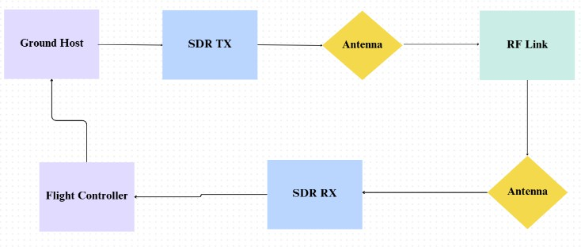

Fig 1. The Block Diagram
This block diagram illustrates the complete communication link anti-jamming drone. It shows the two main parts of the system: the Ground Station and the Drone (or "Airborne Unit").
Here is a detailed explanation of the signal flow.

Overall System:

Ground Host & Flight Controller: These are the "brains." They are the digital computers running the GNU Radio software, or other control software.
SDR TX/RX: These are the "radios." They are the hardware that converts the digital signals from the computers into radio waves.

RF Link: This is the "air" or the wireless channel where the jamming and frequency hopping take place.

Ground-to-Drone (Uplink/Command)

This is the path for sending commands from the ground to the drone.
Ground Host: This is ground station computer, for instance, a laptop. It hosts the GNU Radio flowgraph and produces the command signals, such as "go up," "go left," or the frequency hopping instructions.

SDR TX/RX (Ground): The command digital signal of the Ground Host, likely over USB, is sent to the ground-based SDR. The transmit side of the SDR modulates this signal, applies the frequency hop, and converts it to an analog RF signal.

Ground Antenna: The ground antenna transmits the RF signal. This framework uses a typical High-Gain 2.4 GHz Omnidirectional Dipole Antenna, usually of 3 to 5 dBi. The signal-carrying antenna is also connected through an SMA interface with the SDR, ensuring 360-degree coverage so that

the Ground Station keeps up a stable link independent of the bearing or position of the drone in reference to the controller.
RF Link: The signal travels through the air. This is where a jammer would attempt to attack it.

Antenna(Drone): The drone captures the weak or jammed signal with its antenna. A lightweight quarter-wave monopole or CP cloverleaf antenna will be utilized to accommodate the dynamic pitch and roll of flight maneuvers that occur in the UAV. In anti-jamming situations, particularly, there is a preference for polarization that is circular because it reduces polarization mismatch losses and multipath fading from the change in orientation of the drone.
SDR RX/TX (Drone): The signal is fed into the drone's SDR, where the RX side digitizes the signal, de-hops it by using a similarly synchronized pattern, filters the jammer, and then demodulates it to recover the original digital command.

Flight Controller: Following that, the retrieved command is sent from the drone's SDR to the Flight Controller, such as Pixhawk or Raspberry Pi, that performs the action implied by the command, for instance, "go left."

Drone-to-Ground (Downlink/Telemetry)

This is the path for data to be transmitted from a drone, like video, GPS location, or battery status, back to the ground.
Flight Controller: The drone's "brain" generates telemetry data.

SDR RX/TX Drone: The information is sent to the SDR of the drone, where the TX modulates, frequency-hops, and sends out the information as an RF signal.
Antenna (Drone): The antenna on the drone broadcasts the telemetry signal.

RF Link: The signal travels back through the air.
Antenna (Ground): The ground antenna captures the signal.

SDR TX/RX (Ground): This feeds the signal to the ground SDR's Receive side. It gets de-hopped, filtered, and finally demodulated to recover the telemetry data. Ground Host: The recovered data is sent to the ground station computer, where you can display it on your screen, for example in the GNU Radio GUI. This is a full-duplex (two-way) system and your frequency hopping must be in sync on both SDRs for either link to work.

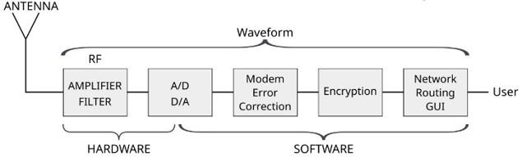

Fig 2. SDR Transceiver System Architecture
Figure 2. illustrates a more detailed and complete system architecture of an SDR transceiver, which includes both the TX and RX paths. This architecture is functionally divided into four key stages.

- RF/IF Stage: This stage is the analogue interface with the world. In the receive path, the Smart Antenna picks up the signal and feeds this to the Flexible RF Hardware. This hardware amplifies the signal (using a Low Noise Amplifier), filters the signal, and usually also down-converts the signal from RF to a lower Intermediate Frequency IF. In the transmit path, this stage up-converts the processed analogue signal from the DAC to the final RF, amplifies this using a Power Amplifier, and sends it to the antenna for radiation.

- A/D D/A Stage: This stage forms the boundary of the analog and digital domains.
  - ADC (Analog-to-Digital Converter): It samples the analog IF signal from the RX path and converts it into a high-speed digital data stream.
  - DAC (Digital-to-Analog Converter): This takes high-speed digital data from the TX path and converts it back into an analog signal to be fed to the RF/IF hardware.
- Digital Front End (DFE): This stage, usually realized on an FPGA, executes the high-speed and compute-intensive digital signal processing.
  - In the RX path: It performs Channelization - digitally filtering and isolating the single channel of interest - and Sample Rate Conversion (decimation) in order to reduce the data rate for the baseband processor.
  - On the TX path: It performs the reverse: Sample Rate Conversion (interpolation) and filtering to prepare the signal for the DAC.

- Baseband Processing Stage: This is the "brain" of the SDR, where the core software logic resides. This unit, which can be a mix of Hardware like FPGAs and DSPs, and Software like Algorithms and Middleware, processes the final, lower-rate data.
It performs demodulation, error correction, decryption, and (for our research) the de-hopping logic on the RX path. The final data is sent to the Output.

It takes in the Input data, performs modulation, error coding, encryption, and, in our case, it would generate the frequency hopping sequence on the TX path.

All four stages are orchestrated by a central Control bus, handling frequencies, gain, and software algorithms, which is what makes the radio "software-defined."

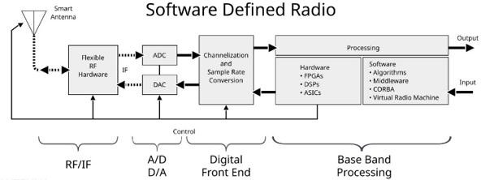

Fig 3. SDR Receiver Architecture
As shown in Figure 3, the system architecture for a simplified Software Defined Radio receiver can be broken down into two primary domains: Hardware and Software.
- Hardware Path: The flow of the signal starts at the Antenna, which senses the analog Radio Frequency waves from the environment. This is immediately fed into the RF hardware block, which includes an Amplifier to increase the strength of a weak signal and a Filter to remove unwanted interference from other frequency bands. The conditioned analog signal is now digitized by the A/D (Analog-to-Digital) Converter; it samples the waveform and converts the signal into a stream of numbers. This block is critical as it represents the boundary between the analog hardware and the digital software.

- Software Path: Once in the digital domain, the signal is processed as a Waveform by a series of software-defined blocks. The Modem & Error Correction block is responsible for demodulating the signal, such as taking QPSK, FM, etc., back into data, and correcting any bit errors that occurred during transmission. Next comes the Encryption block, which handles the decryption to recover the message. Lastly, the Network Routing & GUI block routes the recovered data to an end application or presents it to the User.

GNU Radio Simulation Setup

To simulate the system, we used GRC because it allows us to build complex radio systems and test them without necessarily having hardware.
A basic jammer flowgraph was designed using the Gaussian noise and the NBFM transmit blocks to generate interference signals.

A Frequency Hopping Transmitter and Receiver Flowgraph was designed by using embedded Python blocks, variable blocks, and signal processing filters.
These blocks worked in tandem, simulating how a transmitter and receiver were communicating using changing frequencies dynamically. FFT and Waterfall sinks displaying the hopping/jamming behaviors in real time were utilized.

A. Transmitter Implementation (UAV Side)
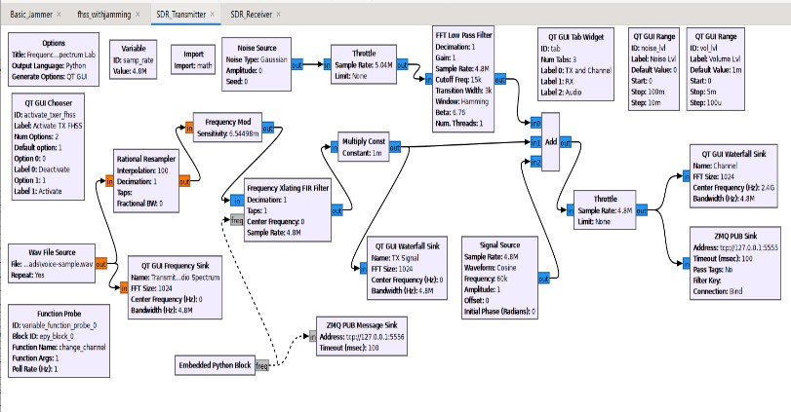
Fig 4. Transmitter Flowgraph
Figure 4. shows the GNU Radio flow graph for the Transmitter. This signal processing chain performs the following steps to produce the secure frequency-hopping signal.

Wav File Source
Function: This block is used as the source of data within the system. This block reads a pre-recorded .wav audio file (voice command) and streams the data into the flowgraph as floating point values, thereby emulating a continuous voice transmission from the pilot.

Rational Resampler
Function: This block is used to perform sample rate conversion, interpolating an incoming audio sample rate of say 48 kHz to a higher quadrature sample rate for radio transmission at 4.8 MHz in such a way that ensures smooth signal processing.

Frequency Mod (NBFM)
Function: This block performs the modulation, taking an audio stream and converting amplitude variations into frequency deviations to produce a baseband Narrowband Frequency Modulation (NBFM) signal that is ready to transmit.

Embedded Python Block (Hopping Logic)

Purpose: This is the transmitter's control unit. It runs a user- written Python script that produces a pseudo-random sequence of frequency values. These determine what specific frequency "hop" the system will make in a given millisecond.

Frequency Xlating FIR Filter (The Hopper)
Function: This block takes the baseband modulated signal and dynamically shifts its center frequency based on the input provided from the Embedded Python Block. This spreads the signal across the 4.8 MHz bandwidth.

Noise Source (The Jammer)
Purpose: This block implements a hostile channel environment. It injects wideband Gaussian noise to simulate a jamming attack or atmospheric interference in the channel.

Add Block
Function: It models the medium "air". Mathematically, it adds the hopping signal of the user and the noise signal of the jammer, thus creating one mixed polluted signal which shall be transmitted.

ZMQ PUB Sink (Data Link)
Function: It acts like a transmitting antenna; it sends the complex I/Q radio data through a local TCP network socket- Port 5555-to the receiver, thus emulating an over-the-air transmission.

- ZMQ PUB Message Sink (Control Link) Function: This block establishes a separate control channel. It sends the synchronization keys-the current frequency value-to the receiver on a separate port-5556-so that the receiver knows where to "listen."

B) Receiver Implementation (Ground Station side)
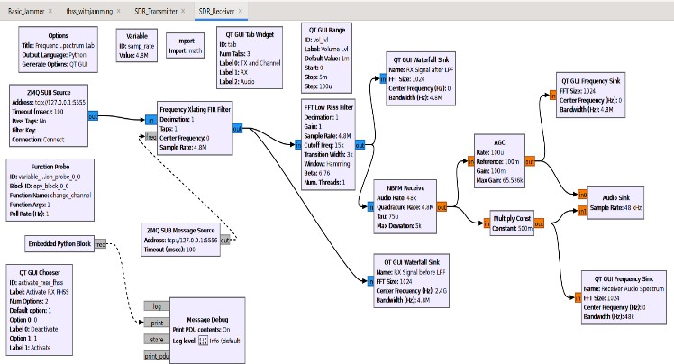
Fig 5. Receiver Flowgraph

Figure 5 illustrates the GNU Radio flowgraph for the Receiver. This node operates independently, capturing the network stream and recovering the original audio.

ZMQ SUB Source (Data Input)
Function: It performs the function of a receiving antenna. On port 5555, it subscribes to the network stream to capture the raw, incoming radio signal that includes the voice data and the jammer.

ZMQ SUB Message Source (Sync Input)
Function: This block listens to the control channel on Port 5556. It captures the synchronization keys that are sent by the transmitter in order to keep the receiver locked in the hopping pattern.

- Frequency Xlating FIR Filter (The De-Hopper) Function: The core anti-jamming block, this shifts the desired signal back to Baseband, 0 Hz, using the synchronization keys. Because the jammer is fixed, this process shifts the jammer away to a high frequency, separating it from the voice signal.

FFT Low Pass Filter
Function: This digital filter is applied to the baseband signal. The de-hopping process shifted the jammer out of the center frequency, and so this filter easily rejects the interference energy, allowing only the clean voice signal to pass.

NBFM Receive
Function: This block is responsible for demodulation; it reads the cleaned and filtered radio signal and converts the frequency information back into an audio stream.

Const Multiply
Function: This is a volume controller, multiplying the amplitude of the signal with a constant value-e.g., 0.5-to make the audio level appropriate for playback.

Audio Sink
Function: This interface connects to the computer's sound card (speakers). It plays the recovered, clear voice sample, proving the success of the transmission.

QT GUI Frequency Sink
Purpose: This block plots the frequency spectrum of the final output audio. It displays the received signal compared to the transmitted signal to confirm signal integrity.

Frequency Hopping
A pseudo-random frequency generator was implemented using a variable and Python blocks in GNU Radio in the transmitter section of the work. This would automatically shift the carrier frequency after fixed time intervals. The receiver is synchronized to this pattern to correctly decode the data that has been transmitted.

This technique ensures that, even if one frequency is used by the jammer, communication will take over at yet another frequency or channel, making jamming less effective.

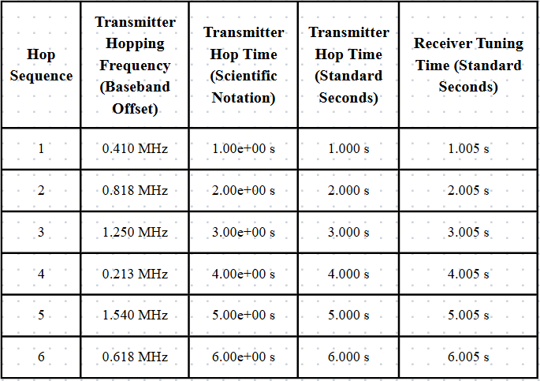
Table 1. Observed Frequency Hopping Sequence and Synchronization Latency

The actual frequency hopping and synchronization latency between the Master (Transmitter) and Slave (Receiver) were analyzed to quantify the performance of the proposed hopping logic. Table 1 presents the observed hopping sequence captured during simulation.
Hopping Behaviour Analysis: From Table 1, the centre frequency of the system is 2400 MHz or 2.4 GHz with a hopping interval of 1.0 second. The "Transmitter Hopping Frequency" column in the table indicates what dynamic baseband offset the Python block applies for each hop, such that the +0.410 MHz for Hop 1 represents the actual physical carrier frequencies being used for transmission.
Most critically, the table confirms the effectiveness of the synchronization mechanism enabled by the ZMQ Control Channel: by comparing the figures under Transmitter Hop Time-e.g., 1.000 s-with those under Receiver Tuning Time- e.g., 1.005 s-, we notice that the latency is practically constant at around 5 milliseconds. This little delay hereby confirms the fact that the receiver intercepts the control packet and quickly performs a retuning of its filter; in this way, a strong link is provided even when there is a fast change of frequency to avoid interference.

Jamming and Anti-Jamming Testing
The jammer block was turned on to interfere with the communication link as a way of assessing the effectiveness of frequency hopping.

Loss in a signal and distortion were observed when static communication took place--fixed frequency.
When FHSS was turned on, the communication link remained stable because the hopping skipped over the jammer frequencies. FFT plots and waterfall graphs were used to perform signal analysis; BER and PDR are parameters that were measured concerning system performance.

RESULTS

The simulation of the Anti-Jamming Communication Framework for Drones using Frequency Hopping Spread Spectrum (FHSS) was successfully carried out in GNU Radio Companion. A basic jammer was first implemented, which caused interference in the fixed-frequency communication link, clearly visible in the FFT and waterfall plots. After applying frequency hopping, the transmitter and receiver switched frequencies dynamically using a pseudo- random sequence. The system was divided into two independent processing nodes, communicating with each other using network sockets in order to simulate a real Over- the-Air(OTA) link.
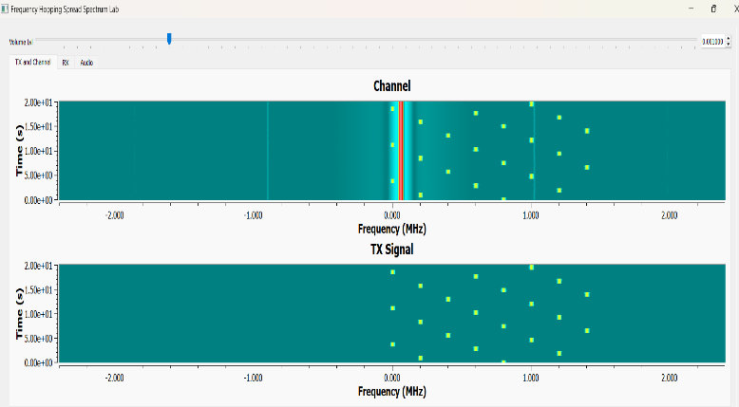

Fig 6. Transmission Signal and Channel Conditions

Figure 6 visualizes the radio frequency environment during the simulation.

The TX Signal at the bottom shows the clean FHSS signal transmitted from the drone. The discrete yellow dots represent the signal "hopping" across the 5 MHz bandwidth according to the pseudo-random sequence.

The Top Plot (Channel) represents the hostile environment. It shows the FHSS signal in the presence of a high-power Fixed Frequency Jammer; it can be seen here as the solid, continuous vertical red line in the middle. This plots the clear threat model: a jammer attempting to block a specific frequency band while the signal tries to avoid it.
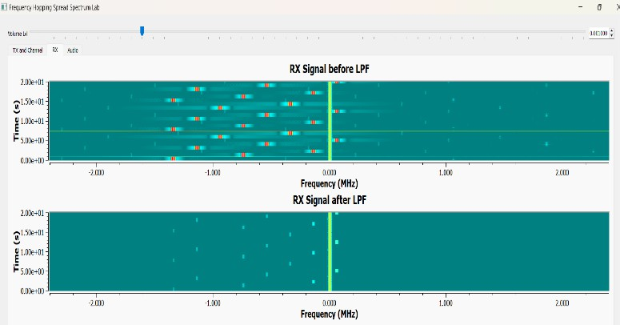

Fig 7. Anti-Jamming Performance at Receiver

Figure 7 shows the effectiveness of the suggested anti- jamming filter.

The first plot, Top Plot (RX Signal before LPF), shows the raw signal received from the antenna. Both the hopping signal and the strong central jammer can be distinctly seen; the jammer has indeed penetrated into the front end of the receiver.

The bottom plot, RX Signal after LPF, shows the output of the synchronized Frequency Xlating FIR Filter: as the filter "hops" in synchronization with the desired signal, it rejects all out-of-band noise. Since the jammer generates an immense amount of interference, as represented by the vertical line, it is filtered out completely and only the clean, recovered signal pattern remains. This test shows that even with a strong jammer, this system will maintain communication integrity.

CONCLUSION

This project has been able to demonstrate an Anti-Jamming Communication Framework of Drone based on Frequency Hopping Spread Spectrum. The outcomes of the simulations indicate that frequency hopping is a strong method of reducing the effects of jamming and is effective in maintaining the drone and the ground station to communicate with each other. As the system is fast switching between available frequencies in a pseudo-random fashion, it offers good data transfer, even in the case of interference. This enhances security, robustness and reliability of UAV communication links without the use of costly SDR hardware.

FUTURE SCOPE

This system can be further extended in the future in real time hardware implementation with low-cost transceiver modules or SDR platforms. The performance of the system may be further elaborated by adding the advanced anti-jamming strategies, i.e., adaptive frequency hopping, machine learning-based interference detection, and directional antennas. The offered framework might also be transferred toward multi-drone communication networks to open an entire field of secure coordination in the complex environment, including surveillance and management of disasters.

REFERENCES

- R. Akeela and B. Dezfouli, “Software-defined Radios: Architecture, State-of-the-art, and Challenges,” Journal of Network and Computer Applications, vol. 128, pp. 75–103, 2019.

- P. J. Cronjé, “Software Architecture for Software Defined Radio Systems,” IEEE Communications Magazine, vol. 47, no. 10, pp. 62–69, Oct. 2009.

- A. Bhawariya and R. Jukariya, “An Overview of Drone Technology and Its Applications,” International Journal of Scientific Research in Computer Science, Engineering and Information Technology, vol. 6, no. 5, pp. 50–57, 2020.

- V. B. Ristić, B. M. Todorović, and N. M. Stojanović, “Frequency Hopping Spread Spectrum: History, Principles and Applications,” Facta Universitatis, Series: Electronics and Energetics, vol. 29, no. 3, pp. 395–409, Sep. 2016.

- F. Le Roy, C. Roland, D. Le Jeune, and J.-P. Diguet, “Risk Assessment of SDR-based Attacks with UAVs,” Proceedings of the IEEE International Conference on Military Communications and Information Systems (ICMCIS), pp. 1–8, May 2020.

- T. Ulversøy, “Software Defined Radio: Challenges and Opportunities,” IEEE Communications Surveys & Tutorials, vol. 12, no. 4, pp. 531–550, 2010.

- H.-H. Cho, C.-F. Lai, T. K. Shih, and H.-C. Chao,
“Integration of SDR and SDN for 5G,” IEEE Access, vol. 3,
pp. 2168–2177, 2015.

- J. A. Cruz, N. B. Carvalho, and N. O. Remley, “Design and Testing of Software Defined Radios: Hardware- Software Integration and Characterization,” IEEE Transactions on Microwave Theory and Techniques, vol. 68, no. 9, pp. 3731–3744, Sep. 2020.

- Azari, Mohammad Mahdi, Hazem Sallouha, Alessandro Chiumento, Sreeraj Rajendran, Evgenii Vinogradov, and Sofie Pollin. "Key technologies and system trade-offs for detection and localization of amateur drones." IEEE Communications Magazine 56, no. 1 (2018): 51-57..

- H. Pirayesh and H. Zeng, “Jamming Attacks and Anti- Jamming Strategies in Wireless Networks: A Comprehensive Survey,” IEEE Communications Surveys & Tutorials, vol. 24, no. 2, pp. 1086–1123, 2022.

