A Power Efficient Multiband CMOS Ladder Mixer with Enhanced Linearity for 5G New Radio (NR) receiver system

Abstract — This paper presents a CMOS mixer employing a transconductance tuning (TCT) mechanism to achieve wideband, low power, high gain, and high linearity. The ladder CMOS mixer consists of one current source, one differential amplifier and two differential low noise switching stage. The TCT technique optimizes the optimum drain current requirement and the output voltage at the voltage control oscillator node and the RF output node, thus producing a balance linearity performance with low power consumption for 4GHz operating bandwidth. The wideband linearity performance is achieved without inductors, thus reducing the size of the chip significantly to 0.5mm². Designed in 180-nm CMOS, the TCT mixer operates from 1GHz to 5GHz with a 1.2V supply voltage, resulting in a highest measured result performances of the third-order input intercept point (IIP3) of 35.97dBm across the local oscillator (LO) input power and 27.2dBm across the RF input power. The highest measured conversion gain (CG) encapsulated around 29.17dB under RF input power whereas 22.27dB across the LO input power at center frequency of 3GHz. The TCT mixer provides full mixing operation which achieves the measured noise figure (NF) below 5dB across the IF output frequency. Moreover, the port-to-port isolation less than -30dB has also been achieved across the RF operating bandwidth. The total power consumption, P_{DC} of the TCT chip is 5mW. The operating bandwidth of the TCT mixer qualifies it to be integrated into a multiband 5G New Radio receiver system.
Key words — CMOS, linearity, mixer, ladder, transconductance, 5G New Radio, wideband, receiver, Gilbert cell.

I. Introduction
The efficient high performance of the sub-6 GHz receiver system is of superior relevance in modern devices. In submicron nodes, the most challenging task is to lower the power consumption in active mixers with higher gain and better linearity. The downscaling of the channel length in deep-submicron CMOS technology leads to voltage limitation up to 1.2V and below. However, as the power and supply voltage is reduced, the construction of the Radio Front End blocks (RFE) in optimizing stringent performance such as the conversion gain and linearity are degraded ^{[1-6]}.

CMOS technology has proven to provide high performance and high transit frequency (ft) to develop a complete system-on-chip (SoC) solution with a lower production cost^{[7]}. A significant advantage is integrating the entire system in a single chip at a smaller device size and improving the circuit functionality. Therefore, this approach towards a challenging operation in designing a wide range makes it possible for the researcher to work on unprecedented levels of architecture ^{[8]}.
Besides, it brings more interest to various applications such as multiband OFDM Alliance ultrawideband (MBOA-UWB) standard, multiband cellular, and software-defined radios. Yet, there is a growing concern to achieve better performance for higher technology demands and overcoming the performance tradeoff. Multiple methods have been used in the mixer to overcome the tradeoff between noise figure (NF), power consumption, P_{DC}, conversion gain (CG), and linearity (P1dB and IIP3). Some receivers achieve better power consumption and linearity but only cover a narrow bandwidth, making it less reliable as bandwidth demands grow higher. Similarly, work achieve a moderately higher gain and bandwidth, but the output voltage swing is limited with the penalty of higher power consumption ^{[9]}. In addition, work has performed a current bleeding technique at the mixer load stage of a transistor with a complementary feature of the transconductance stage ^{[10]}. The increased drive current via the transconductance stage results in a higher gain and linearity but consumes too high power and noise. Another approach targets to reduce the severity of the tradeoff mentioned above. This is through the implementation of securing independent bias currents for the transconductance and switching stage ^{[11]}, current bleeding ^{[12]}, injecting current, and lowering the current in the load and switching stage ^{[13,14]}.
∗Manuscript Received XXX XX, 20XX; Accepted XXX XX, 20XX.
Improving the mixer linearity is another challenge faced. S.He et al.^{[15]} impose a feed-forward technique using a derivative superposition method canceling the third-order intermodulation product using two intermodulation terms with equal amplitude and opposite phase.
However, the effect of the noise added to the mixer circuit creates an additional block complexity even though the linearity is enhanced. Another work proposed an intermodulation injection to the mixer to improve the overall performance of the mixer^{[16]}. This eventually increases the circuit complexity due to passive bulky inductors. On the other hand, techniques implied current reuse and folded–switching using a complementary pair of pMOS and nMOS, achieving better linearity and gain, with the drawbacks of a larger area and substantially increased in power consumption ^{[17,18]}.

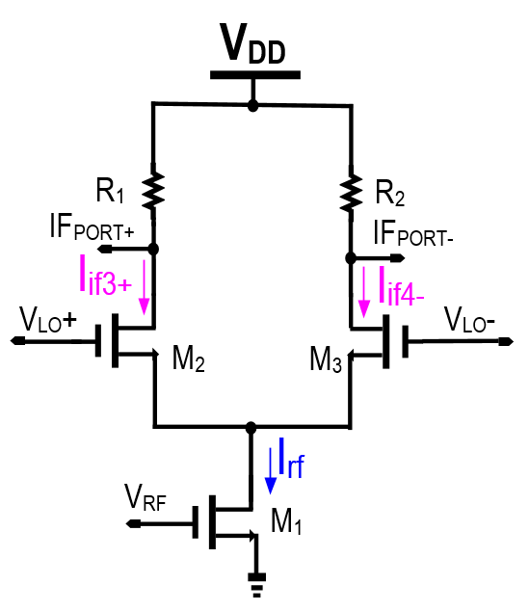
Fig. 1. Schematic of the Single Balance Mixer (SBM)
A typical mixer is shown in Fig.1. Generally, the SBM architecture is an improved version of the unbalanced mixer^{[19]}. The product of the intermediate frequency ( Iif3+ and Iif4-) are taken at both branches after a down-conversion mechanism in the mixer under the frequency translation or mixing happens between the oscillator signal (V_{LO+} and V_{LO-}) with the RF product (V_{RF}) from the Low Noise Amplifier (LNA). However, this architecture requires a higher LO drive that drains higher power and requires an additional circuit that increases the circuit level architecture, which causes the presence of LO feedthrough even though RF feedthrough has been cancelled. In addition, achieving a wider bandwidth is a big challenge and requires significant change to uphold the mixer performances.
This paper proposes low power and high linearity mixers for wide bandwidth encapsulating the 5G New Radio operating frequency. A transconductance tuning (TCT) technique has been incorporated in this mixer design to resolve the tradeoff between low power consumption and linearity. TCT technique also contributes to achieving wideband linearity without the aid of inductors, thus immensely reducing the size of the chip to be within 0.5mm².

II. TCT Mixer Principle of Operation
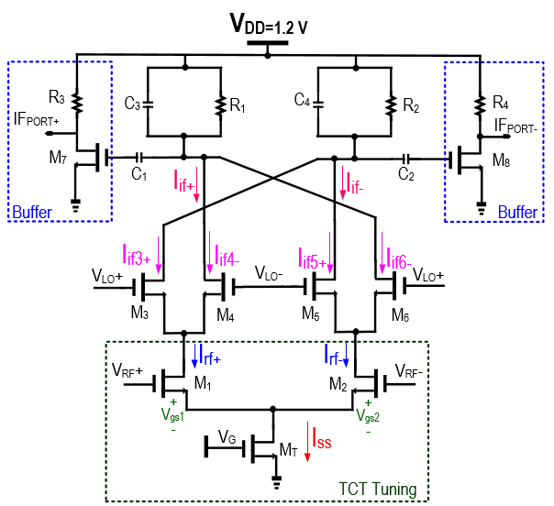
Fig. 2. Schematic diagram of the Ladder TCT mixer

Table 1. Design Parameters in the TCT mixer
Design Parameters | W/L
M _{1,2} | 7.3u/180
M _{3,4} | 29.2u/180
M _{5,6} | 29.2u/180
M _{7,8} | 60/180
M _{T} | 130u/180
C _{1,2} | 2.27pF
C _{3,4} | 1.5pF
R _{1,2} | 2kΩ
R _{3,4} | 10kΩ

VLO
Φ
1
Φ
2
V
+
V
-
t
Fig. 3. A sine wave of two phases, V_{LO} of the mixer
Fig.2 depicts the schematic of the TCT ladder mixer and its design parameters are shown in Table 1. The mixer’s transconductance and switching stages are the two source-couple pair (SCP) of M₁ and M₂ and M₃–M₆ respectively. The tail current source, M_{T} control by the supply voltage, V_{G}. M_{T} acts as a sub tail current source for the tail nodes of the M₁-M₂ performs the first V-I conversion mechanism, thus followed by the M₁ and M₂, which operate in the opposite polarity with a differential RF injection (V_{RF+} and V_{RF-}). The Irf+ and Irf- generated from M₁ and M₂ are switched through the second SCP stage of M₃ –M₆. The switching conduction depends on the LO as it determines the switch to be on when LO is high and off when the LO is low. As shown in Fig.3, the V_{LO} injection into the mixer depends on the graph phase conduction, ϕ. At time ϕ₁, when the V_{LO+} is larger than V+, M₄ and M₅ will on, the drain current of Iif4- and Iif5+ equals to the Irf+ and Irf respectively. The drain currents of Iif3+ and Iif6- from transistor M₃ and M₆ are zero which puts the transistor in the off region. Therefore, the product of Iif+ at the cross couple connection, is the current summation from M₃ and M₅, thus Iif-= Iif3+ + Iif5+ = 0+(Irf-), whereas for the Iif+ equals to the summation of Iif4- + Iif6- =Irf+ + 0=(Irf+). The cycle continues vice versa when the V_{LO} switches at the time ϕ₂.
Therefore, when the V_{LO-} hits negative, which is less than V-, M₄ and M₅ are concurrently switched off, making M₃ and M₆ switch on. In this case, the mixer’s current is diverted to the output. The negative output current of the mixer, Iif- remains as the sum of M₃ and M₅. However, the current is currently from the tail node of M₃ instead of being from the tail node of M₅, Iif-=Iif3+ + Ii5+= (Irf-) +0=Irf-. Under the same condition, the positive output current, Iif+ also remains as the sum of M₄ and M₆, representing from the tail node of M₆. This explains, Iif+= Iif4- + Iif6-=0+Irf+=Irf+. In this synchronization, the flow of the output currents depends on the conduction phase of the LO polarity during the mixing operation. Compared to the conventional mixer in Fig.1, this proposed architecture possesses the advantage that the feedthrough from the V_{LO} and V_{RF} are not propagated at the output of the mixer. The bypass capacitor of the C₁ and C₂ required careful sizing as not to weaken the Intermediate frequency, Iif signal. A typical source buffer circuit that consists of M₇ and M₈ with its respective resistive load of R₃ and R₄ acts to improve the output gain further. Furthermore, the C₃, R₁, and C₄, R₂ acts as a passive load gain booster for the mixer output. The relationship to the third-order input intercept point (IIP3), referring to the Source Coupled Pair (SCP) M₁ and M₂, can be expressed by including a gate to source voltage, V_{gs1}, and V_{gs2}, respectively. The analysis of the TCT tuning mechanism is explained below.
For the transistor M₁, the equation derived as:
where,k = µCox(W₁/L₁) (1)
The drain to source voltage of the tail transistor M_{T}, V_{DS,MT} is neglected as it only acts as a current source.
However, the Eqs.(2) is simplified as:
(2)
Equation rearrangement shown as:
(3)

(4)

As we substitute Eqs.(4) into Eqs.(1), the M₁ current, I_{rf+} expressed as:
(5)
For the transistor, M₂ , the current, I_{rf-} expression similarly derived as:
(6)
(7)
(8)

Therefore substituting the Eqs.(7) and Eqs.(8) into Eqs.(5), the Irf+ equated as:
(9)
By normalizing the respective transistor currents of M₁
and M_{T}, I_{rf+} and I_{SSX} for simplicity as:
(10)
(11)
can be expressed as: |  |  | (12)
Substituting the normalized variables into Eqs. (9), V_{RF}
(13)
(14)
(15)
Eqs. (15) represents the odd function of V_{RF} around I_{SSX}/2.
(16)
By factoring out the I_{SSX} the term, it gives Eqs.(16) V_{RF} in term of i_{rf+}. Neglecting the capacitive effect, each i_{rf+}, the term can be expanded as a power series in powers of VRF
(17)
Hence, a₁, a₂, a₃… are coefficients. To express the i_{rf+} explicitly in terms of V_{RF}, this can be overcome by doing two expansions. Firstly, two square root terms inside the bracket in Eqs.(16) were expanded around (2i_{rf+}/I_{SSX}).
(18)(19)
Secondly, each of the i_{rf+} terms in Eqs.(19) is expanded using Eqs.(17)
(20)
Finally, the coefficients a₁, a₂, a₃.. can be computed as by equating the coefficients of V_{RF},V²_{RF}… on both sides
Eqs.(20). For the V_{RF} term,
(21)

The V²_{RF} the term denoted as:
(22)
The V³_{RF} the term denoted as:
(23)
Generally, the Harmonic Distortion (HD) is expressed as:
y(t) = α₁Acosω_{o}t + α₂A² cos² ω_{o}t + α₃A³ cos³ ω_{o}t (24)
y(t) = α₂A²/2 + (α₁A + 3α₃A³/4) cosω_{o}t +
(α₂A²/2) cos2ω_{o}t + (α₃A³/4) cos3ω_{o}t (25)
where
HD₃ = (i_{rf+}(3rdorderterm))/(i_{rf+}(fundamental)) =
(1/4)(α₃/α₁)A³_{RF} (26)
Substituting Eqs.(23) into Eqs.(26), the HD₃ is expressed as:

(27)
Therefore further expanded into
HD₃ = 1/4| − (1/8) (2/I_{SSX})² |(I_{SSX}/2)(A²_{RF}) =
(1/16)1/ISSX (A²_{RF}) = (1/16)1/2 I_{SSX} (A²_{RF})
= (1/32)1/ISSX (A²_{RF}) (28)
In most real cases, the distortion at the mixer output as HD₃ and IM₃ is denoted as:
HD₃ = (1/32)k/I_{SSX}(A²_{RF}) =
(1/32)(µCoxW₁/L₁)/I_{SSX} (A²_{RF}) (29)
IM₃ = (3/32)k/I_{SSX}(A²_{RF}) =
(3/32)(µCoxW₁/L₁)/I_{SSX} (A²_{RF}) (30)
As A²RF=A²interference. Therefore the third-order intermodulation, IM₃ expressed as:
HD₃ = (3/32)k/I_{SSX}.A²interference =
(3/32)(µCoxW₁/L₁)/I_{SSX}.A²interference (31)
Hence, referring to Eqs.(31), the third-order harmonic distortion (HD₃) can be altered with the device size of M₁, hence altering the overall transconductance. This shows that the W/L ratio depends linearly on the harmonic distortion. The size of the respective transistor requires diligent sizing to produce a low distortion mixer and not to burn more power. The mixer’s overall linearity performance is highly dependent on the tail current, I_{SSX} of the M_{T}. I_{SSX} can be represented as the magnitude of the nth order drain current components, given as:
(32)
Based on Eqs.(32), the fundamental and the third order current component is plotted and is illustrated in Fig.4. It can be observed from Fig.4 that as the conduction angle increases, the fundamental current component increases due to the increment of the DC component. On the other hand, the third order current component also reduces as the conduction angle increases. An interesting observation is at the conduction angle within the range of π<α<1.8π. In this region, the fundamental component is the highest and the third order component is at the lowest. The lowest third order component of M_{1/2} on the other hand promises a linear operation. Hence device size W/L of M_{1/2} as given in Table 2 is chosen to achieve this objective. Moreover, the conduction angle is tunable through M_{T} which explains the TCT tuning operation. As the A_{RF} is low, the current through the M₁, ID1 equals the current through M₂, ID2, or half of I_{SSX}. Therefore, the overall HD₃ shows:
HD₃ = (1/32)(k/2ID1).A²_{RF} =
(1/32)(1/(V_{gs1} − V_{th}).A²_{RF} (33)
and
IM₃ = (3/32)(1/(V_{gs1} − V_{th})²).A²interference (34)
As characterising, A_{IP3} as:
A²_{IP3} = A²interference/IM₃ (35)
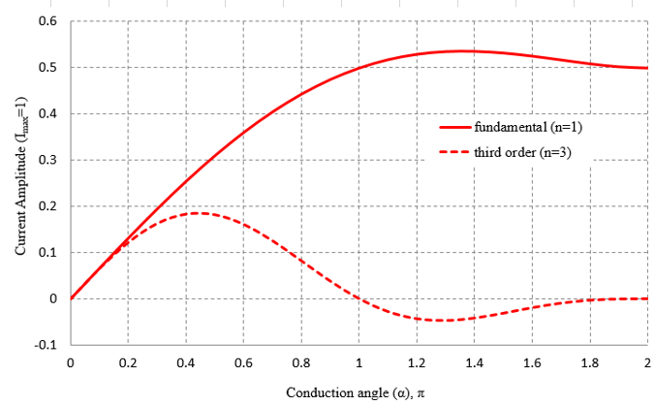
Fig. 4. Fundamental and Third order current components of M_{1/2.}
The distortion can be expressed as:
(36)
when the effect of the LO switching shifted the frequency of the fundamental and the third-order products, the amplitude of the HD₃ and IM₃ remains unchanged, and balanced isolation is formed with better linearity. The conversion gain of the proposed mixer is enhanced with the load and buffer stage. The gain of the half mixer circuit can be expressed as follows:
V_{RF} = V_{RF} cos (ω_{RF} t) (37)
Vo = VRF .VLO (t) (38)
V_{o} = g_{m}R₁(4/π)[(1/2)cos(ω_{RF} − ω_{LO})t) +
1/2)cos(ω_{RF}+ ω_{LO})t..] (39)
Vo(t) / VRF(t) ≈ g_{m7,8}R_{3,4}(2/π) (40)

III. Simulation and Measurement
The TCT ladder mixer architecture has been designed in 180nm CMOS process. Fig.5 illustrates the photomicrograph of the proposed architecture with the bondpads shown. The total layout area, including the bondpads, is 0.5mm². The IF buffer consumes around 3mW and the voltage supply is 1.2V. The measurement setup is shown in Fig. 6.
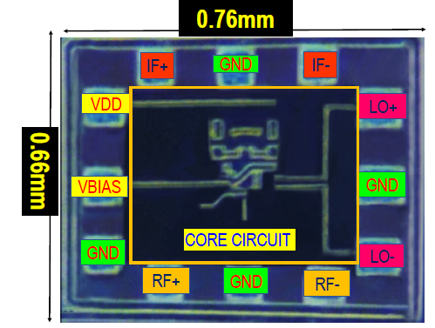
Fig. 5. The photomicrograph of the proposed TCT mixer

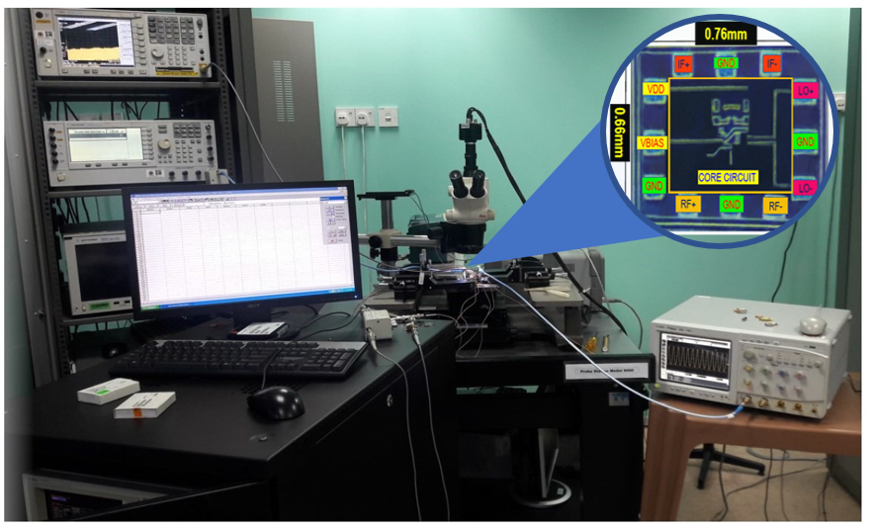

Fig. 6. Measurement setup of the TCT mixer
Fig.7 shows the transient signal swing of the IF frequency. The output peak voltage of the IF is 1.08V. Fig.8 shows the post-layout simulations (PL.Sim) and the measured results (Meas) for the TCT mixer’s IF output power performance versus the LO input power. The analysis is taken sweeping across -40dBm to 10dBm of VCO input power. The results show that the IF output power versus LO input power of 8.26dBm is achieved at 1GHz, whereas 3GHz is 7.55dBm and 5GHz is at 3.56 dBm. The measured performance looks stable and high at the VCO input power of less than 5dBm. Due to high input power from the VCO, the mixer saturates beyond 5dBm.

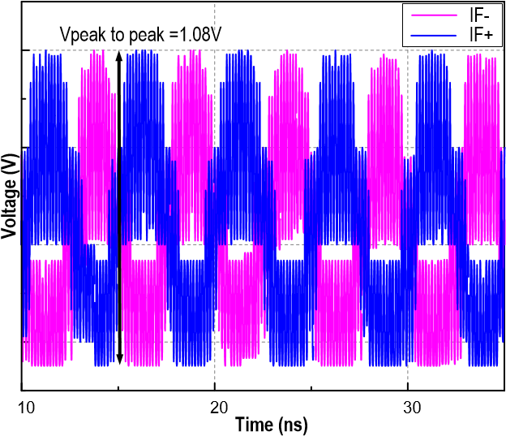
Fig. 7. IF transient at the output of the TCT ladder mixer architecture

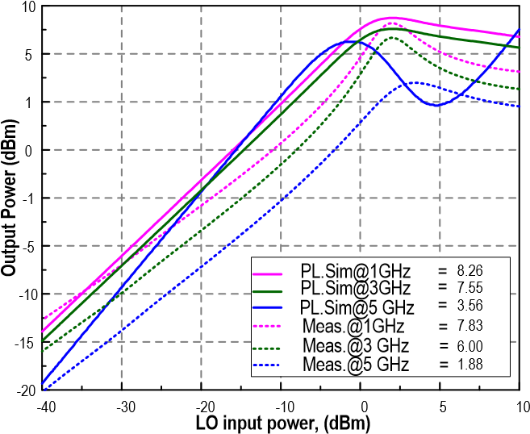
Fig. 8. IF output power versus LO oscillator input power
Fig.9 shows the IF CG across IF output frequency. The respective frequencies of the LO signal from the oscillator and RF frequency from LNA are tuned accordingly to down-convert the IF frequency from the range of 100MHz to 300MHz. The product of the IF requires to be maintained to meet the design specification. The gain of the IF frequency is higher at the lowest frequency of interest. The desired IF frequency is tuned at 100 MHz, around 24.23dB, 23.9dB, and 23.85dB when the RF LNA and VCO are tuned from 1GHz to 5GHz. The measured results in a conversion gain of 24.1dB at
1GHz RF frequency, 23.48dB at 3GHz, and 23.72dB at 5GHz.
Fig.10 illustrates the post layout simulation and measured results for the proposed mixer’s conversion gain performance in terms of voltage conversion gain versus the RF input power (prf) of the Low Noise Amplifier (LNA) at the transconductance stage. The schematic performance of the IF conversion gain at 1GHz, 3GHz, and 5GHz is 25.1dB, 22.48dB, and 19.85dB, respectively. The measured performances were also reflected at a minor less than 1dB drop for 1GHz and 3GHz. However, at 5GHz, the drop is higher due to parasitics. As per the graph shown, the RF LNA only affects the performance of the IF at a moderate level compared to the oscillator.
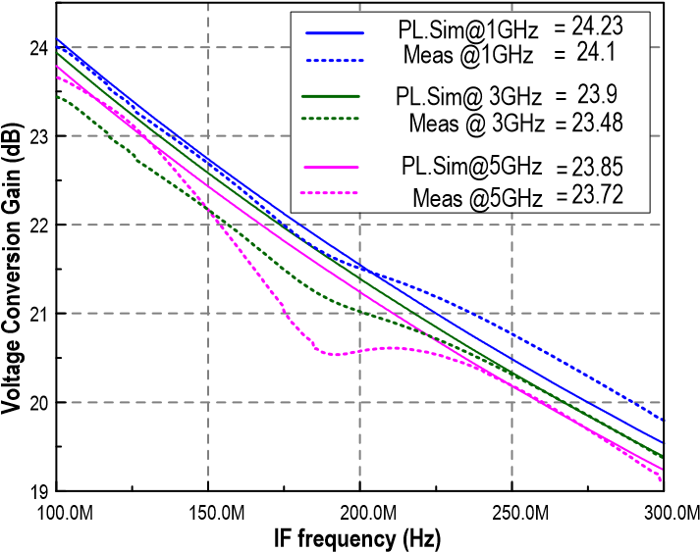
Fig. 9. IF voltage conversion gain across IF frequency

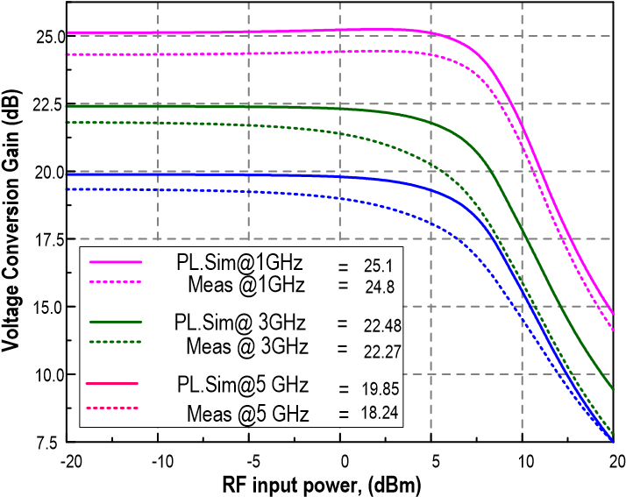
Fig. 10. IF voltage conversion gain versus RF input power
Fig.11 depicts the voltage conversion gain performance of the proposed mixer by a sweeping oscillator, LO power from -20dBm to 10dBm in the postlayout simulation results. The LO input power can be obtained for conversion gain versus LO power at its best gain. When the LO input power is 10dBm, it achieves a gain of 31.57dB, 29.17dB, and 28dB at 1GHz, 3GHz, and 5GHz, respectively. The maximum IF conversion gain was obtained when LO input power was 6dBm and achieved a conversion gain of about 32.53dB at 1GHz frequency. In addition, when the LO signal frequency is at 3GHz and 5GHz, the down-conversion results in the IF conversion gain of 29.37dB and 28.23dB, respectively. The conversion gain degrades slightly in the measured results due to the presence of the non-linear capacitance and parasitics resistance that causes the drop. However, the drop is minor, compensating for the symmetrical and compact layout design been done.
The plot in Fig.12 shows that the third-order input intercept point (IIP3) achieved 28.4dBm at -17dBm under RF power at 1GHz. At 3GHz, the IIP3 response of the mixer is at 27.5dBm, and 5GHz is of 26.3dBm at 2.5dBm RF power. The linearity at 1GHz is better than the rest due to the low influence of the parasitic capacitance compared to the higher frequency where, at that time, the parasitics tend to be a dominant factor that affects the linearity of the system. However, the challenge is maintaining the tradeoff performances by achieving an acceptable range. The mixer is tuned through the TCT technique until the sweet spot is achieved. The postlayout performance achieved a less than 1dBm drop for 1GHz, 3GHz and 5GHz, but still successfully achieved the target specification of the mixer.

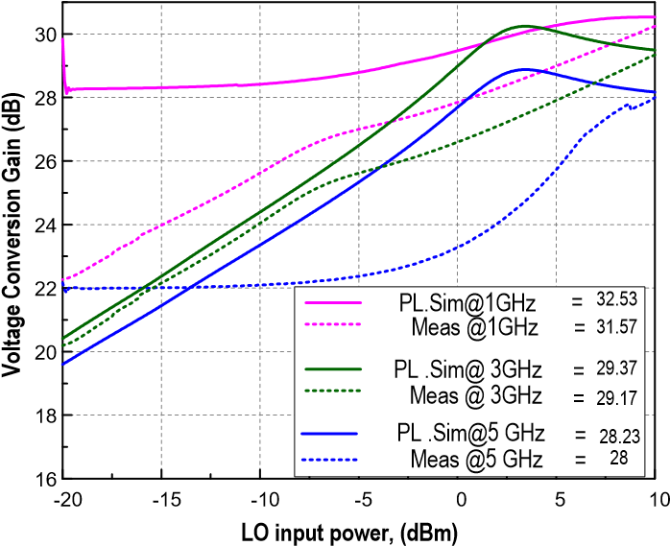
Fig. 11. IF voltage conversion gain versus LO input power

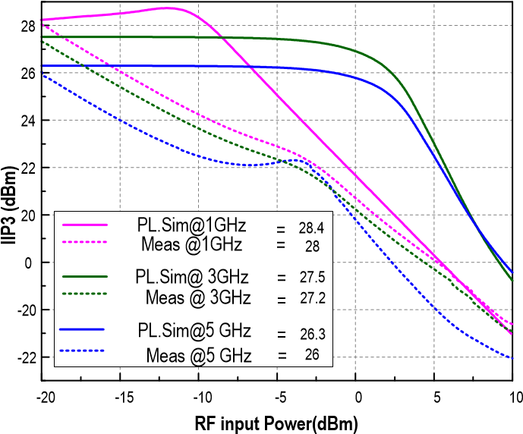
Fig. 12. IF linearity versus RF input power
Fig.13 shows the IF output linearity when the VCO input power is swept from -20dBm to 10dBm. As mentioned, the LO power brings heavy influence to the mixer linearity performance due to the LO injection at the switching transistor’s gate of the mixer M₃-M₆. As discussed, the IIP3 increases with increasing LO power up to a certain level before saturation point. The more linear is the performance, the better the system is. The highest IIP3 measured is 39.76dBm for schematic simulation under 7dBm of LO power at 5GHz frequency, followed by 1GHz at 37.72dBm, and lowest at 3GHz is 36.13 dBm. The peak linearity of the post layout is 37.65dBm, 37.15dBm, and 35.97dBm at 1GHz, 3GHz, and 5GHz under the LO input power of -1dBm, 1dBm, and -5.5dBm, respectively. The biasing of the switching stage of the mixer is biased at the threshold level to maintain linearity performance.
Fig.14 shows the S33 for the IF ports. The post simulation of the return losses is more petite than 15dB for the input frequency up to 500MHz. Therefore, overall input and output matching are tuned in the transconductance and switching stages of M₃-M₆ and M₁ and M₂ respectively, facilitating the maximum power transfer for the output signal transfer. This is the most elemental analysis in the mixer as efficient matching can only result in a good conversion gain and is crucial to safeguard the IF signal as not to cause any loss that may affect the data transfer of the whole receiver mixer system.

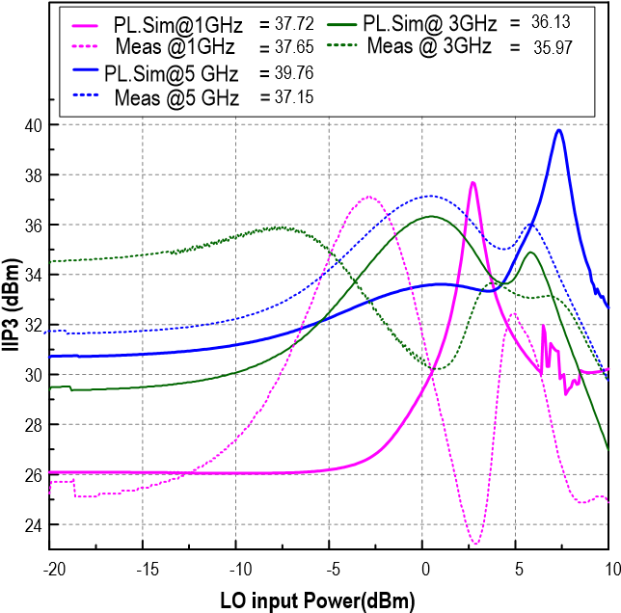
Fig. 13. IF Linearity versus LO input power
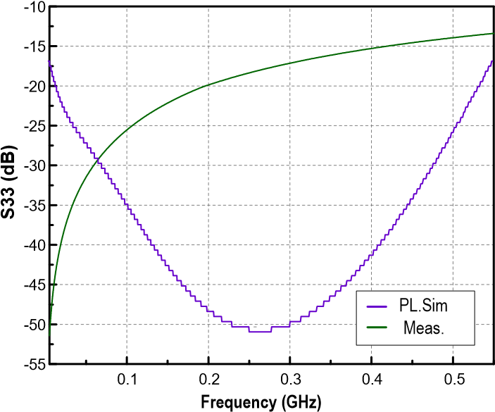
Fig. 14. S33 output of the IF path
Fig.15 shows that the input return loss is kept below -10dB throughout 1GHz to 5GHz. At shown for the post simulation, the mixer achieves the lowest input return loss of -32dB at the frequency of 3.7GHz whereas for the rest bandwidth the S11 is below -10dB. The measured result shows that the input return loss is kept below 13dB from 1GHz to 5 GHz, similar to the PL. simulation. The mixer achieves the lowest input return loss of -34 dB at the frequency of 1.7GHz and from 1.5GHz to 3.8GHz it is below -20dB. The shift of the measured simulation results falls to the lower frequency due to the existence of parasitics as well. This phenomenon happened as the metal traces in the constructed layout design hold a subsequent amount of capacitance that shifts to different operating frequency. However, as anticipating the effect of the loss and a sweet spot tuned value, the measured performances met the wideband specification.
The noise figure shown in Fig.16 of the proposed Gilbert mixer is simulated at different noise frequencies across 100MHz to 1GHz. Based on the plot above, the operating IF frequency 100MHz to 1GHz, the noise figure is kept below 5dB and thus meets the mixer’s design specification to achieve a noise figure less than 5dB across 900MHz bandwidth. The minimum NF at the schematic performances is 4.1dB at 1GHz. Measured shows a slight increase in the noise figure performance due to the metal routing parasitic effect. The noise figure increased from 4.8dB to almost 5dB. Fig.17 shows the TCT mixer’s portto-port isolation (dB). The isolation level is below -30dB across the mixer bandwidth, making a highly reliable mixer with low RF-LO leakage at the IF output of the mixer. Table 2 tabulates the performance comparison of the TCT ladder mixer with other similar reported works. The proposed TCT ladder mixer satisfies the stringent tradeoff by attaining the highest linearity and gain substantially. With minimum power and supply voltage needed, wide bandwidth is also achieved.
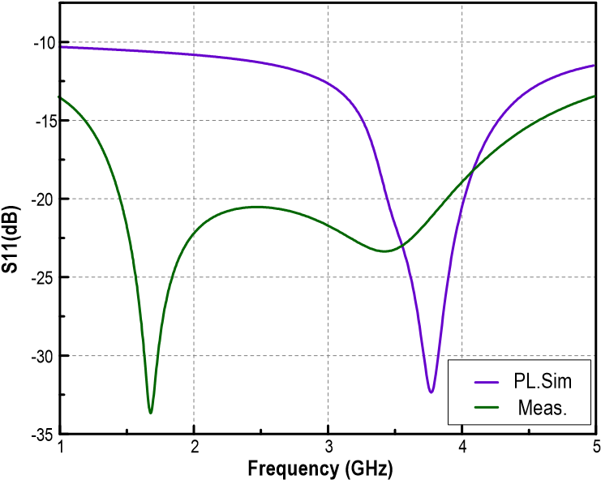
Fig. 15. S11 input of the LNA RF
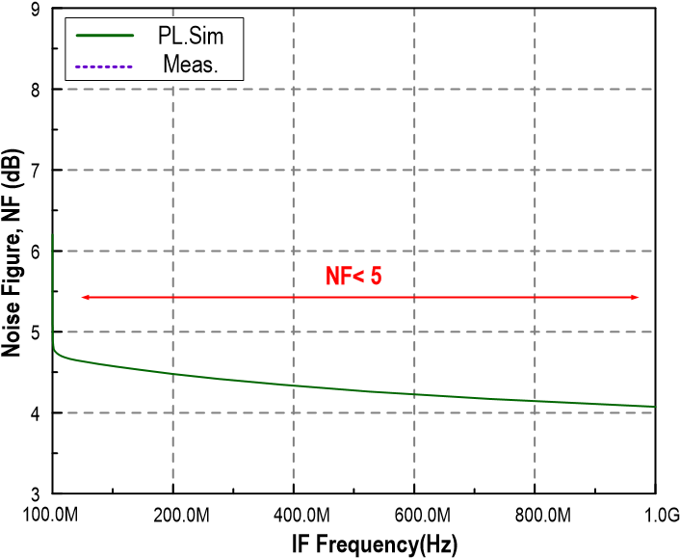
Fig. 16. Noise Figure of the output IF
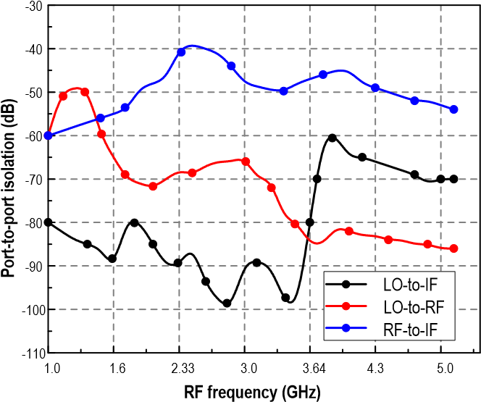
Fig. 17. Port to port isolation of the RF to LO bandwidth
Table 2. Performance comparison of the TCT mixer with other recent related works
Refs. | [20] | [21] | [22] | [23] | [24] | This  Work
Cmos  Tech(nm) | 90 | 65 | 40 | 45 | 250 | 180
RF  (GHz) | 0.5 − 2.5 | 0.3 − 3 | 3 − 2.5 | 0.2 − 8 | 0.9 − 10.6 | 1 − 5
Supply  V olt(V ) | 1.5 | 1.2 | 1.1 − 1.8 | 1.2 | 1.8 | 1.2
PDC  (mW) | 23.5 − 33.2 | 15.52 | 64.1 − 69.6 | 50 | 9.8 | 5
CG  (dB) | > 66 | 44 | 12.5 − 14.5 | 21 | 7.6 − 9.6 | 28.3 − 31.6
NF  (dB) | < 4.2 | 3 − 4.5 | 5.0 − 5.8 | 2.3 − 5.4 | 13.1 − 13.8 | < 5
IIP3  (dBm)  (Pin) | > −5  (LO) | = 0  (LO) | 15.1 − 16.7  (LO) | 390 (LO) | −4  (RF) | 26 − 28  (RF)  35.97− 37.65(LO)

V. Conclusions
This paper demonstrated a wideband, high linearity TCT mixer architecture that effectively supress the intermodulation distortion under low power consumption. The proposed design achieves an IIP3 of 37.15dBm and CG of 29.17dB under a 1.2 supply voltage. Furthermore, the structure featured a compact inductorless structure saving area, power and achieved a satisfied target performance as compared to other works which makes it well suited for 5G New Radio (NR) communication applications.

References
- R. Zheng, G. Zhang, K. Yu, S. Li, and Y. Zheng, “A 5.76.4GHz GaAs HBT power amplifier with a gain enhanced bias circuit,”, Chinese Journal of Electronics, Vol.26, No.3, pp.502–507, 2017.
- Y. Zhang, Z. Li, H. Yang, X. Geng, and Y. Zhang, “Design of a CMOS distributed power amplifier with gradual changed gain cells”, Chinese Journal of Electronics, Vol.27, No.6, pp.1158– 1162, 2018.
- A. Balankutty, S. Yu, Y. Feng and P. R. Kinget, “A 0.6V Zero-IF/Low-IF Receiver With Integrated Fractional-N Synthesizer for 2.4-GHz ISM-Band Applications”, IEEE Journal of Solid-State Circuits, Vol.45, No.3, pp.538–553, 2010.
- R. Weng, J. Wang, S. Li and H. Weil, “A Low Power Folded
Mixer Using Even Harmonic Technology”, Proc. of IEEE International Workshop on Radio-Frequency Integration Technology, Singapore, pp.247–249, 2007.
- U. Eswaran, H. Ramiah, J. Kanesan, and A. W. Rezal, “Design of wideband lte power amplifier with novel dual stage linearizer for mobile wireless communication”, Journal of Circuits, Systems, and Computers, Vol.23, No.8, 2014.
- P. Shasidharan, H. Ramiah, and J. Rajendran, “A 2.2 to 2.9 GHz Complementary Class-C VCO With PMOS Tail-Current Source Feedback Achieving – 120 dBc/Hz Phase Noise at 1 MHz Offset”,IEEE Access, Vol.7 , pp.91325–91336, 2019.
- G. Chong, et al., “Ambient RF energy harvesting system: a review on integrated circuit design”, Analog Integrated Circuits and Signal Processing, Vol.97, No.3, pp.515–531, 2018.
[8] O. E. Erdogan, et al., “A single-chip quad-band GSM/GPRS transceiver
in 0.18 µm standard CMOS”, Proc. of IEEE International Digest of
Technical Papers. Solid-State Circuits Conference , San Fransisco, CA,
USA, pp.318–601, 2005.
[9] A. Malekmohammadi, H. G. Zadeh, A. S. Nilsaz, “A LowPower and
High Gain Mixer Design for UWB Receiver”, Proc. of IEEE 2011
International Conference on Electronic and Mechanical Engineering
and Information Technology, Harbin, China, pp.2857–2860, 2011.
- D. J. Lai, Y. M. Chen, X. D. Wang, X. H. Chen, “A CMOS Single-Differential LNA and Current bleeding CMOS Mixer for GPS Receivers”, Proc. of IEEE 2011 Institute of RF and ICs, South University, Nanjing, China, pp.677–680, 2010.
- M. Wang and C. E. Saavedra, “Reconfigurable broadband mixer with variable conversion gain”, Proc. of IEEE MTT-S International Microwave Symposium, Baltimore, MD, USA, pp.1–4, 2011.
- S. S. K. Ho and C. E. Saavedra, “A CMOS Broadband LowNoise Mixer With Noise Cancellation”, IEEE Transactions on Microwave Theory and Techniques, Vol.58, No.5, pp.1126– 1132, 2010.
- H. Wei, C. Meng, H. Chien, H. Lu, J. Syu and G. Huang, “Flicker noise and power performance of CMOS Gilbert Mixers using static and dynamic current-injection techniques”, Proc. of 2010Asia-Pacific Microwave Conference, Yokohama, Japan, pp.542–545, 2010
- D. Cordova, S. Bampi and E. Fabris, “A CMOS downconversion mixer with high IIP2 and IIP3 for multiband and multiple standards”, Proc. of 2014 27th Symposium on Integrated Circuits and Systems Design (SBCCI), Aracaju, Brazil, pp.1–7, 2014
- S. He and C. E. Saavedra, “Design of a Low-Voltage and LowDistortion Mixer Through Volterra-Series Analysis”, IEEE Transactions on Microwave Theory and Techniques, Vol.61, No.1, pp.177–184, 2013.
- M. Mollaalipour and H. Miar-Naimi, “An Improved High Linearity Active CMOS Mixer: Design and Volterra Series Analysis”, IEEE Transactions on Circuits and Systems I:Regular Papers, Vol.60, No.8, pp.2092–2103, 2013.
- H. Chiou, K. Lin, W. Chen and Y. Juang, “A 1-V 5-GHz Self-Bias Folded-Switch Mixer in 90-nm CMOS for WLAN Receiver”, IEEE Transactions on Circuits and Systems I: Regular Papers, Vol.59, No.6, pp.1215–1227, 2012.
- H. Zijie and K. Mouthaan, “A 1- to 10-GHz RF and Wideband
IF Cross-Coupled Gilbert Mixer in 0.13- µm CMOS”, IEEE Transactions on Circuits and Systems II: Express Briefs, Vol.60, No.11, pp.726–730, 2013.
- M. M. Mohsenpour and C. E. Saavedra, “Method to improve the linearity of active commutating mixers using dynamic current injection”, IEEE Transactions on Microwave Theory and Techniques, Vol.64, No.12, pp.4624–4631, 2016.
- Ali Poursaadati Zinjanab, Ali Jalali, Hamed Taghipour Farshi, “A standard and harmonic blocker tolerant receiver front-end using a harmonic rejection differential N-path notch filter and blocks withstand to possible variations”, AEU - International Journal of Electronics and Communications, Vol.125, No.12, 2020.
- Vahid Moradino, Esmaeil Najafi Aghdam, “Design of a SAW-less, noise-canceling receiver using an LPTV analysis of a general system with an arbitrary number of N-path filters”, AEU - International Journal of Electronics and Communications, Vol.126, No.12, 2020.
- J. Jiang, J. Kim, A. I. Karsilayan and J. Silva-Martinez, “A 3–6-GHz Highly Linear I-Channel Receiver With Over +3.0-dBm In-Band P1dB and 200-MHz Baseband Bandwidth Suitable for 5G Wireless and Cognitive Radio Applications”, IEEE Transactions on Circuits and Systems I: Regular Papers, Vol.66, No.8, pp.3134–3147, 2019.
- Y. C. Lien, E. A. M. Klumperink, B. Tenbroek, J. Strange, and B. Nauta, “Enhanced-Selectivity High-Linearity LowNoise Mixer-First Receiver with Complex Pole Pair Due to Capacitive Positive Feedback”, IEEE J. Solid-State Circuits, Vol.53, No.5, pp.1348–1360, 2018.
- C. I. Yeh, W. S. Feng, and C. Y. Hsu, “0.9-10.6 GHz UWB mixer using current bleeding for multiband application”, IEEE Solid-State Circuits Letters, Vol.50, No.3, pp.186–187, 2014.

