Intelligent Cloud Resource Optimization Using Automated Machine Learning and Virtualization

Abstract—Resource provisioning is an important way to offer the cloud as a service to the user. Nowadays, cloud computing has multiple levels of access and applications. We need a hybrid and virtualized method to provide an efficient resource provisioning method. In existing resources may be offered based on user request or availability. But in the present scenario we need systems that offer services based on access privileges at any time. Also data analytics is another factor to analyze data and make effective decisions. We provide an efficient virtualized method for dynamic resource provisioning for a cloud application and a virtualized optimizer for cloud topological management. We prepare an optimal data analysis method for predicting the accuracy and performance of cloud access and resources. In this paper, automated machine learning techniques are applied to measure temporal features and queuing results. In this case, workloads are distributed across the server and optimize the cloud using a service level agreement. Our research method can provide time service analysis result, accuracy index, and performance ratio and optimality value. Also our method can check the energy supply and consumption. We use CloudSim to simulate the cloud environment and TensorFlow to check the accuracy using deep belief network optimization.
Keywords—Cloud Resource Management, Automated Machine Learning, Virtualization, Service Level Agreement, Deep Belief Network

Introduction
Cloud computing has become a multi-layer service paradigm that can be used to support various applications, dynamic workloads, and heterogeneous user requirements. Resource provisioning is becoming a pivotal requirement as enterprises grow to use cloud platforms in data-intensive processes, real-time services, and distributed computing. Conventional provisioning is performed either through maintaining a constant allocation of resources according to requests made by the user or according to the current availability. The current cloud environments demand dynamic systems that can be allocated intelligently based on the access privileges, workload patterns, service level agreements, and security constraints. This has necessitated the adoption of virtualization, automated decision-making, and predictive analytics in cloud environments.
Virtualization is a key component in physical resources abstraction and the flexibility of physical resources deployment across distributed environments. Unless managed optimally, the virtualized environments can be characterized by both performance degradation and energy waste, as well as security vulnerabilities. To curb these shortcomings, automated machine learning methods could be applied with great prospects in assessing temporal workload properties, forecasting system behavior, and optimizing queuing and scheduling operations. Cloud systems can be used to dynamically manipulate resource allocation to improve performance, keep within compliance of service level agreement, and provide secure access control using data analytics.
This paper suggests an efficient model of cloud resource management, whereby the use of virtualization is combined with automated machine learning to do dynamic provisioning as well as topological optimization. The strategy considers the accuracy, performance ratio, optimality value, and energy consumption. CloudSim models are used to simulate the cloud environment, and the accuracy of the predictions is checked by the use of TensorFlow-based deep belief networks to optimize the architecture. The given framework is proposed to enhance performance, increase security, and energy efficiency of the current cloud computing systems.

Cloud Resource Evolution
The concept of cloud computing has changed the unchanging models of infrastructure to dynamic, service-oriented platforms that embrace different applications and different users as well. The resource provisioning has been developed to cater to the changing workloads, multi-tenant settings, and access control privileges. Virtualization allows the computing, storage, and network resources to be allocated in a non-rigid manner, enhancing scalability and consumption. The current cloud systems must have smart ways of dealing with complexity.

- Virtualized Cloud Resource Parameters
Parameter | Description | Configured Range | Unit
vCPU per VM | Virtual CPU cores allocated | 2 – 12 | Cores
Memory Allocation | RAM assigned per VM | 4 – 32 | GB
Storage Capacity | Virtual disk size | 100 – 1000 | GB
Network Bandwidth | Allocated data transfer rate | 200 – 1000 | Mbps
Hypervisor Overhead | Virtualization processing cost | 3 – 8 | %
Table I explains the major parameters of the virtualized cloud resources that are applied in the infrastructure setup. It gives some numerical values of CPU cores, memory, storage, bandwidth, and hypervisor overhead. The parameters form the baseline of the resource allocation environment needed to facilitate scalable and flexible cloud service deployment environments.

Performance and Security Challenges
With the increase in the size of the cloud infrastructures, it becomes difficult to ensure a stable performance and a high level of security. Disproportional allocation of workload, resource conflicts, and ineffective scheduling may lower the efficiency of the system. Meanwhile, unauthorized access, privilege abuse, and data exposure pose a threat to reliability. Another issue of concern is energy consumption. The management strategies should be able to manage a balance between performance, security, and power efficiency in the virtualized environment.
- Performance and Security Control Metrics
Metric | Description | Configured Value | Unit
SLA Response Time | Maximum service delay | 250 – 450 | ms
CPU Utilization Limit | Upper workload threshold | 70 – 85 | %
Access Privilege Levels | User access hierarchy | 3 – 4 | Levels
Encryption Strength | Data security key size | 128 – 256 | Bits
Monitoring Interval | Security scan frequency | 5 – 10 | Seconds
Table II describes performance and security control metrics that are set in the cloud structure. It defines response time and CPU usage limits, levels of access privileges, strength of encryption, and monitoring frequency. These parameters neither show the results of experiments nor the results of performance evaluation.

Automated Learning Integration
Machine learning is automated, which improves the management of clouds by analyzing time workloads trends and forecasting the needs of resources. The intelligent scheduling, optimization of queues, and dynamic provisioning are supported by learning models as per service level agreements. With the incorporation of predictive analytics and virtualization, the cloud systems can enhance accuracy, performance ratio, and optimality. It allows making adaptive decisions and efficient energy monitoring in complicated environments.

Related Works
Similar publications use AI-based optimization, virtualization control, automated operations, and security-aware allocation models to study cloud resource management. Previous works use machine learning, deep learning, reinforcement learning, and meta-heuristic algorithms to enhance the scalability, resource consumption, reaction time, energy management, and intrusion detection accuracy.

Scalable Provisioning and Load Optimization
The efficiency of enterprise performance in the cloud directly affects the continuity of operations and efficiency of decisions in the cloud. Earlier experiments have explored the use of Auto Scaling Mechanism (ASM) in the dynamic control of capacity and have found it to be more stable in response. The Load Balancing Algorithm (LBA) minimized the request latency by redistributing the workloads. The resource Optimization Framework (ROF) has increased the efficiency in utilization. The predictive allocation accuracy was enhanced by the Artificial Intelligence Scheduling Model (AISM) [11]. Transmission delay was reduced through Edge Computing Integration (ECI). Serverless Resource Model (SRM) reduced operational overhead, and Sustainable Cloud Strategy (SCS) was better at energy management and infrastructure reliability.
The fast growth of the cloud has encouraged Artificial Intelligence Resource Management (AIRM) to become more optimized and stable in the system. Scalability was enhanced with predictive workload forecasting of the Machine Learning Allocation Model (MLAM) [12]. Deep Learning Optimization Framework (DLOF) improved the efficiency of performance. Reinforcement Learning Scheduler (RLS) minimized energy use through smart control. The accuracy of intrusion prevention was enhanced through the AI Security Detection System (AISDS). Fuzzy Logic Energy Controller (FLEC) enhanced the QoS control. HDLA enhanced distributed cloud resilience and tolerance to failures throughout infrastructures.

AI-Based Performance and Energy Control
The complexity of clouds has prompted the use of the Artificial Intelligence Cloud Framework (AICF) to manage the complexity adaptively. Demand was enhanced by the AI Load Prediction Model (AILPM) [13]. Processing performance was improved by the Dynamic Task Scheduling Algorithm (DTSA). Deep Learning Maintenance Model (DLMM) minimized downtime in the system by predictive analytics. Threat detection was enhanced by the use of an AI Intrusion Detection System (AIIDS). The Heuristic Optimization Technique (HOT) reduced the frequency of operation costs and increased the reliability. Nevertheless, there are challenges of integration and adversarial vulnerability that are major research issues.
Automated Operations Framework (AOF) changed the common IT work patterns into standard operations, giving a better operational uniformity. Enterprise Cloud Optimization Model (ECOM) [14] improved resource management by making use of organized automation. Workflow Orchestration Strategy (WOS) minimized errors in the manual intervention and increased configuration proceedings speed. Architecture Enhancement Mechanism (AEM) boosted the resilience of systems in complicated banking infrastructures. RDVA was found to be more efficient, improved security posture, and resources were used in a stable manner in enterprise cloud environments.

Security-Aware Allocation and Federated Optimization
The Deep Reinforcement Learning Security Allocation Model (DRLSAM) maximizes the distribution of cloud resources subject to security constraints. Security Aware Reward Mechanism (SARM) combined protection goals and efficiency. The Multi-Layer Neural Network Architecture (MLNNA) [15] successfully processed complex cloud states. Continuous monitoring was done by the Adaptive Threat Evaluation System (ATES). The framework has achieved a 17.6% increase in resource utilization, 95% security quality, and more than 94% in threat detection rate. Response Time Optimization Module (RTOM) cut the latency by 45.3% over the baseline strategies.
Federated Cloud Edge Resource Model (FCERM) dealt with the Human Resource Management within the environment of IoT. The NP optimization problem was solved using the Whale Optimization Algorithm-based HRM method (WOA-HRM) [16] by means of QoS-based selection and allocation. The Resource Monitoring Strategy (RMS) increased the effectiveness in tracking the allocation. The framework minimized the minimum time of response and allocation cost and maximized allocated human resources in two scenarios as compared to the traditional meta-heuristic optimization approaches in cloud edge infrastructures.
The current methods show a positive change in efficiency of allocation, workload forecasting, threat identification, and cost-saving measures. Auto scaling, heuristic scheduling, WOA, and DRL optimization methods enhance performance and security. The gaps in research are still in the field of integrated frameworks that collaboratively address the virtualization, automated learning, and energy-aware security control.

Proposed Method
The suggested approach introduces an AutoML-VROM, which is a hybrid cloud resource management architecture that combines automated machine learning, attention-driven deep learning, and SLA-reflective optimization. It enhances the allocation of workloads in a dynamic manner, validation of privileges, topology management, energy management, and prediction of performance in simulated cloud environments.
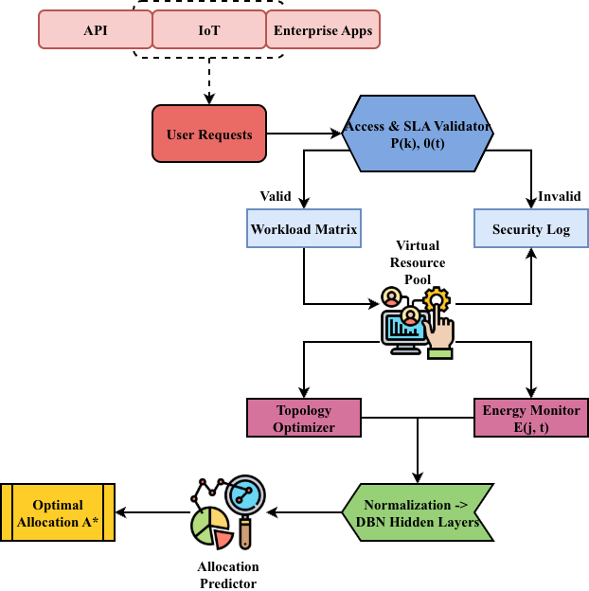
- AutoML-VROM Cloud Optimization Framework
Fig. 1 demonstrates the optimized cloud resource management with the help of the virtualization and automated machine learning integrated AutoML-VROM framework. It starts with multi-source user requests, access privilege validation, and SLA verification to provide secure and compliant service delivery. Valid workloads are organized into a workload matrix and sent to the virtual resource pool, where VM instantiation and initial allocation are done. The optimizer of topology communicates with the energy monitoring unit and controls the load allocation, VM consolidation, and power consumption. The normalized workload data undergoes Deep Belief Network layers with multi-head attention processes to identify temporal and relational features. The allocation predictor produces dynamic resource assignments that are generated using learned representations. Both SLA and energy losses are minimized so as to obtain an optimum allocation matrix subject to privilege constraints. CloudSim simulation analyses service time, utilization efficiency, prediction accuracy, and energy index, giving off ultimate performance measures as well as optimality validation.
- AutoML and Virtual Optimization Configuration
Component | Specification | Configured Value | Unit
Simulation Tool | Cloud environment simulator | CloudSim 5.0 | Version
ML Framework | Deep learning platform | TensorFlow 2.10 | Version
Training Epochs | Model learning iterations | 60 – 120 | Epochs
Batch Size | Samples per training cycle | 32 – 64 | Samples
VM Migration Threshold | Resource balancing trigger | 75 – 85 | %
The proposed automated machine learning and virtualization framework refers to the configuration settings of Table III. It contains a version of the simulation platform, a machine learning framework, epochs of training, batch size, and migration thresholds. These are technical specifications that provide the structure arrangement in which the optimized cloud management model is implemented.
Algorithm 1: AutoML-VROM for Optimized Cloud Resource Management
$$Input:$$
$$Workload matrix W = \left\{w_{i}^{t}\right\}$$
$$Resource matrix R = \left\{r_{j}\right\}$$
$$Access privilege vector P = \left\{p_{k}\right\}$$
$$SLA threshold Θ$$
$$Energy profile E = \left\{e_{j}^{t}\right\}$$

$$Output:$$
$$Optimal allocation matrix A*$$
$$Prediction accuracy A$$
$$Performance ratio P$$
$$Energy index E$$

$$Initialize CloudSim environment and resource state R⁰$$
$$Normalize workload: Ŵ = (W - μ) / σ$$
$$Initialize DBN weights W^(l), b^(l)$$
$$for epoch e = 1 to E_max do$$
$$Compute hidden layer: H^(l) = σ(W^(l) · Ŵ + b^(l))$$
$$Compute attention score: α_ij = (Q_i K_jᵀ) / √d_k$$
$$Apply softmax: ω_ij = exp(α_ij) / Σ_j exp(α_ij)$$
$$Compute weighted values: Z_i = Σ_j ω_ij V_j$$
$$for head h = 1 to H do$$
$$Z_i^h = Attention(Q^h, K^h, V^h)$$
$$end for$$
$$Concatenate: Z = Concat(Z¹,…,Zᴴ) · W^O$$
$$Predict allocation: Â = f(Z)$$
$$Compute SLA loss: L_SLA = Σ_t max(0, Â^t - Θ)$$
$$Compute energy loss: L_E = Σ_\{j,t\} e_j^t Â_j^t$$
$$Total loss: L = L_SLA + λL_E$$
$$Update weights: W^(l) ← W^(l) - η∇L$$
$$end for$$
$$A* = argmin(L) subject to P_k ≥ τ$$
$$Return A*, A, P, E$$
The autoML-VROM model of automated management of cloud resources through the approach of optimized cloud resource management with the help of automated machine learning and virtualization control is provided in Algorithm 1. Workload normalization and resource state initialization in the CloudSim environment are the starting steps of the algorithm. A Deep Belief Network takes time workload characteristics and creates discrete representations to make allocation forecasts. Attention weights are then computed based on scaled dot-product operations, then softmax normalized and multi-head aggregated to allow various workload correlations to be captured. The prediction of dynamic resource allocation is based on the concatenated feature vector. The loss of service level agreement and the loss of energy consumption are calculated through a summation of functions that form one optimization problem. Gradient descent is the process of updating the parameters of a network. The last allocation matrix meets access privilege constraints and enhances the prediction accuracy, performance ratio, and energy efficiency.
The framework also gets optimized resource allocation based on multi-objective loss minimization and attention-based workload modelling. The incorporation of virtualization, DBN learning, and SLA-energy constraints enhances the degree of prediction accuracy, stability of utilization, efficiency of response, and compliance of security across dynamic infrastructures in cloud computers.

Results and Discussion
Results and Discussion assess the response time, resource use, workload prediction performance, energy monitoring, and threat detection stability according to the AISM, AILPM, MLNNA, and AutoML-VROM. The comparative analysis investigates the efficiency of virtualization, the effect of automated learning, the alignment of SLA, and the stability of security in dynamic clouds.

Dataset Description
The Cloud Workload Dataset to Scheduling Analysis [10] summarizes the workload of a cloud environment, in the form of a set of time-stamped job submit records, resource usage, task life, and machine allocations. It has multi-dimensional capabilities like CPU, memory, and storage requirements of particular tasks over time. Researchers can use this data to study the trend of workloads, test the scheduling policies, and come up with resource allocation models that can be implemented dynamically. Its tabular format can be used to conduct predictive analytics, machine-based forecasting, and experimentation in performance optimization. The data set can be applied especially in the testing of automated resource provisioning approaches, queuing schemes, and load balancing techniques in the virtualized cloud infrastructure to offer a full situation for testing the management algorithms.

Response Time Optimization
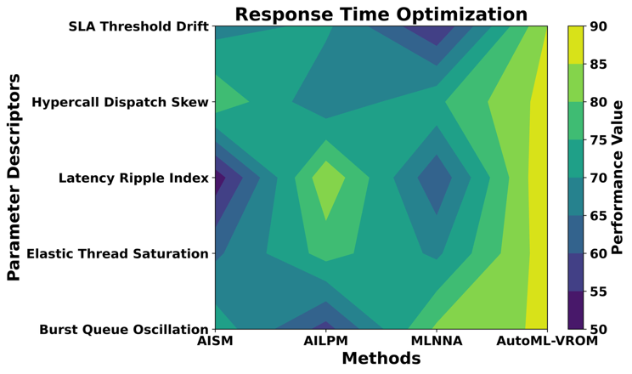
- Analysis of Response Time Optimization
Fig. 2 compares service delay in dynamic cloud provisioning with AISM, AILPM, MLNNA, and AutoML-VROM. The response values in AILPM and AutoML-VROM differ by 30ms under Burst Queue Oscillation, with the response being 58ms and 86 ms, respectively. The AISM, AILPM, MLNNA, and AutoML-VROM show 64 ms, 77 ms, 69 ms, and 88 ms, respectively, in Elastic Thread Saturation. Latency Ripple Index is measured to be 52 ms in AISM and 90 ms in AutoML-VROM. Hypercall Dispatch Skew of models varies between 66 ms and 87 ms. SLA Threshold Drift shows 55 ms in MLNNA and 85ms in AutoML-VROM. These findings suggest that there is a consistent delay in control based on automated machine learning and virtualization-based allocation. AutoML-VROM is more stable in its responses with no significant deviation, and it supports dynamic provisioning and SLA in the virtual cloud environment.
Response time optimization $RT_{\text{opt}}$ defined by equation 1
$$RT_{\text{opt}}=\frac{1}{N}\sum_{i=1}^{N}{\left(\frac{T_{i}^{\text{exec}}+T_{i}^{\text{queue}}+T_{i}^{\text{net}}}{1+γ U_{r(i)}}\right)} (1) \\ N$$is the total number of workloads processed during simulation. For each workload $i$, $T_{i}^{\text{exec}}$is its execution time on the allocated virtual machine, $T_{i}^{\text{queue}}$is the waiting time in the VM scheduling queue, and $T_{i}^{\text{net}}$is the network transmission delay between user and cloud node. $U_{r(i)}$represents the utilization level of the resource $r$hosting workload $i$, reflecting load-aware optimization by topology control. The coefficient $γ$is a scaling parameter representing the efficiency of load balancing and VM consolidation.

Resource Utilization Efficiency
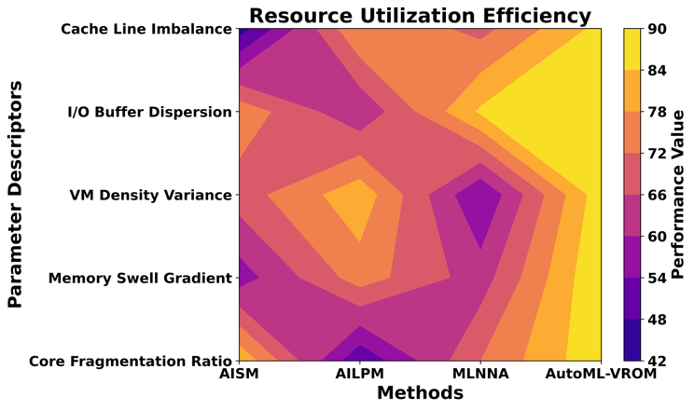
- Analysis of Resource Utilization Efficiency
Fig. 3 is used to measure the effectiveness of CPU and virtualization as per the management models. Core Fragmentation Ratio stands at 83%, 49%, 72%, and 89% in AISM, AILPM, MLNNA, and AutoML-VROM, respectively. With AutoML-VROM, the memory swell gradient is 90%, whereas with AISM it is 57%. VM Density Variance is 82% AILPM and 88% AutoML-VROM. The I/O Buffer Dispersion ranges between 61% and 90% between methods. Cache Line Imbalance has a range of 45% to 86%. These values are indicative of better workload consolidation and equal distribution of hypervisors using automated machine learning. AutoML-VROM reaches greater utilization without radical variations, which show consistent virtualization control, idle capacity minimization, and improved infrastructure control in line with the service level agreement.
Resource utilization efficiency $η_{\text{util}}$ dealt by equation 2
$$η_{\text{util}}=\frac{\sum_{j=1}^{M}{\sum_{i=1}^{N}{A_{ij}}} D_{i}}{\sum_{j=1}^{M}{C_{j}} T_{\text{obs}}} (2)$$
$A_{ij}$is the allocation matrix element indicating the fraction of resource $j$assigned to workload $i$. $D_{i}$is the actual demand or processing duration of workload $i$. $C_{j}$is the capacity of resource $j$, $M$is the number of virtual resources/VM types, and $T_{\text{obs}}$is the CloudSim observation time window. A higher $η_{\text{util}}$indicates better consolidation and load distribution achieved by AutoML-VROM.

Workload Prediction Accuracy
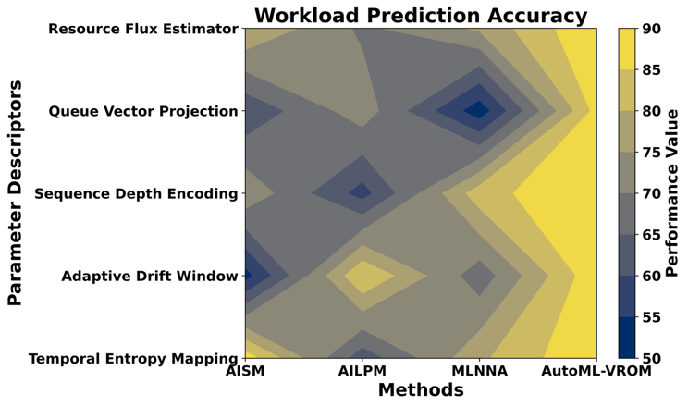
- Analysis of Workload Prediction Accuracy
Fig. 4 compares the automated learning-based temporal forecasting and queuing estimation. The results of Entropy Mapping on a temporal basis demonstrate 88% in AISM, 62% in AILPM, 79% in MLNNA, and 90% in AutoML-VROM. Adaptive Drift Window records 53% in AISM and 89% in AutoML-VROM. The highest score in MLNNA and AutoML-VROM is 83% and 90%, respectively. The Queue Vector Projection is between 52% and 87%. Resource Flux Estimator culminates in 90% in AutoML-VROM. These values indicate enhanced forecasting of dynamic workloads of clouds by deep belief optimization and automated scheduling. AutoML-VROM offers superior temporal features, demand prediction, and queue allocation, facilitating effective dynamic provisioning and providing performance consistency.
Workload prediction accuracy $Acc_{\text{pred}}$ dealt using equation 3
$$Acc_{\text{pred}}=1-\frac{1}{N}\sum_{i=1}^{N}{\frac{∥w_{i}^{\text{act}}-w_{i}^{\text{pred}}∥_{2}}{∥w_{i}^{\text{act}}∥_{2}+ϵ}} (3)$$
$w_{i}^{\text{act}}$is the actual workload feature vector for request $i$, and $w_{i}^{\text{pred}}$is the predicted workload $N$ representation generated by the AutoML model $ϵ$. The small constant $ϵ$prevents division by zero for very small workloads.

Energy Consumption Monitoring
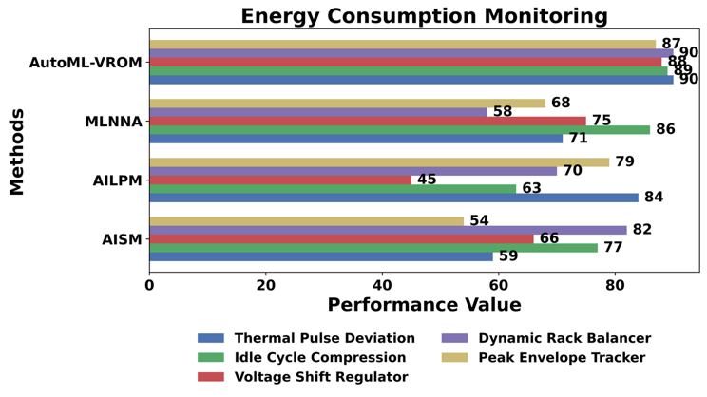
- Analysis of Energy Consumption Monitoring
Fig. 5 determines the power control efficiency in virtualized infrastructures. According to Thermal Pulse Deviation, it stands at 59% in AISM, 84% in AILPM, 71% in MLNNA, and 90% in AutoML-VROM. In AISM and AutoML-VROM, Idle Cycle Compression is at 77% and 89%, respectively. Voltage Shift Regulator has a range of 45 -88%. Dynamic Rack Balancer achieves up to 90% with AutoML-VROM. Peak Envelope Tracker ranges between 54% and 87%. These findings suggest enhanced adaptation whereby machines have better regulation of energy by means of adaptive allocation and machine learning enabled monitoring. AutoML-VROM maintains a greater efficiency index, which is indicative of maximized VM consolidation, minimized idle consumption, and controlled energy supply that does not affect the performance or security limitations.
Energy consumption monitoring $E_{\text{avg}}$ dealt using equation 4
$$E_{\text{avg}}=\frac{1}{T_{\text{obs}}}\int_{0}^{T_{\text{obs}}}{\sum_{j=1}^{M}{\left(P_{j}^{\text{idle}}+(P_{j}^{\text{max}}-P_{j}^{\text{idle}}) U_{j}(t)\right)}}dt (4) \\ E_{\text{avg}}$$denotes average energy consumption of the cloud infrastructure during the observation period $T_{\text{obs}}$. $M$is the number of physical or virtualized resources monitored. For each resource $j$, $P_{j}^{\text{idle}}$is its idle power consumption and $P_{j}^{\text{max}}$is its peak power at full utilization. $U_{j}(t)$is the time-varying utilization level of resource $j$at time $t$, determined by VM allocation and consolidation decisions.

Threat Detection Performance
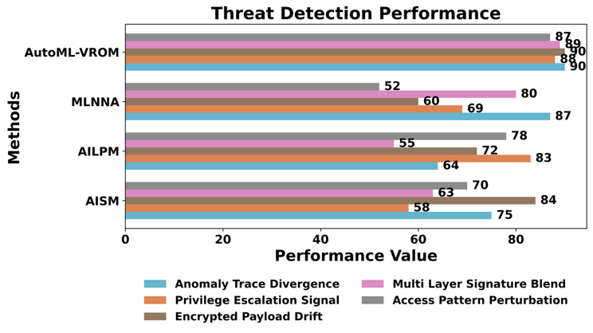
- Analysis of Threat Detection Performance
Fig. 6 gauges the quality of security in streamlined cloud management. In AISM, 75%, and in AutoML-VROM, 90% is recorded in Anomaly Trace Divergence. Privilege Escalation Signal ranges between 58% and 88%. The Payload Drift in features of encrypted payments lies between 60% and 90%. Multi-Layer Signature Blend displays AILPM of 55% and AutoML-VROM of 89%. Perturbation of Access Pattern documents 52% in MLNNA and 87% in AutoML-VROM. Such values reflect enhanced intrusion detection as well as adaptive monitoring with built-in automated learning and virtualization control. AutoML-VROM ensures greater stability of detection and security quality, and it allocates resources in line with the security limits without compromising the performance of the clouds.
Threat detection performance modelled by equation 5
$$F_{\text{threat}}=\frac{2 TP}{2 TP+FP+FN}⋅\left(1 − \frac{T_{\text{det}}}{T_{\text{det}}^{\text{max}}}\right) (5)$$
$TP$, $FP$, and $FN$represent true positives, false positives, and false negatives of detected malicious. The first fraction is the F1-score measuring detection quality. $T_{\text{det}}$is the average time required by the security module, and $T_{\text{det}}^{\text{max}}$is the maximum tolerable detection latency defined by SLA security constraints.
The performance comparison is used to confirm the presence of an improved allocation control, an increased stability of utilization, a more significant predictive accuracy, an improved energy regulation, and an increased threat detection when using AutoML-VROM. A combination of automated machine learning and virtualization will produce balanced performance and security enhancement with minimal variation of evaluation parameters.

Conclusion
This paper introduced the AutoML-VROM, an efficient cloud resource management framework that combines the concepts of virtualization, automated machine learning, and SLA-conscious multi-objective optimization. The approach dealt with the provisioning of dynamic resources in changing workload settings, privilege controls on access, and energy. A workflow with a defined workload validation, the instantiation of virtual machines, topology optimization, and deep belief network modeling, and multi-head attention was used to extract temporal and relational features. The combined loss of SLA violation and energy consumption was minimized to allocate in a way that would allow control of performance.
CloudSim simulation was used to evaluate service time, utilization efficiency, predictive accuracy, and the index of energy. The comparative analysis between AISM, AILPM, and MLNNA showed that AutoML-VROM was consistently better in terms of response stability, accuracy of workload forecasting, resource utilization, energy regulation, and threat detection performance. The privilege-conscious filtering enhanced secure access control and preserved the allocation efficiency. The learning component is based on attention augmented adaptive workload modelling in heterogeneous cloud environments.
Findings established that virtualization control and automated learning are effective ways of enhancing decision-making in dynamic cloud infrastructures. The balance in the optimization of the framework did not show extreme variation in the performance parameters. SLA alignment and energy monitoring were added to ensure stable operation under high-demand conditions. The suggested solution will provide a scalable platform of intelligent cloud management systems in which performance, security, and energy efficiency should be optimized together.

References
- Shri, S. J., Karthiyayini, G., Vignesh, L. S., Upender, T., Shobana, D., & Patra, L. S. K. (2024, September). Optimizing resource management and data security in cloud computing environments. In 2024 3rd International Conference for Advancement in Technology (ICONAT) (pp. 1-6). IEEE.
- Angajala, S. R. (2023). Orchestrating efficiency: AI-driven cloud resource optimization for enhanced performance and cost reduction. International Journal of Research Publication and Reviews.
- Seo, C., Yoo, D., & Lee, Y. (2024). Empowering sustainable industrial and service systems through AI-enhanced cloud resource optimization. Sustainability, 16(12), 5095.
- Younus, A. H., Salih, A. A., Ahmed, O. M., Yazdeen, A. A., Abdullah, R. M., & Sami, T. M. G. (2024). Web-based and cloud-computing influences on resource utilization optimization for sustainable enterprise systems with AI, IoT, and security. management, 12, 13.
- Liu, C., Ma, L., Zhang, M., & Long, H. (2025). Optimizing cloud resource management with an IoT-enabled optimized virtual machine migration scheme for improved efficiency. Journal of Network and Computer Applications, 237, 104137.
- Bal, P. K., Mohapatra, S. K., Das, T. K., Srinivasan, K., & Hu, Y. C. (2022). A joint resource allocation, security with efficient task scheduling in cloud computing using hybrid machine learning techniques. Sensors, 22(3), 1242.
- Jeyaraj, R., Balasubramaniam, A., MA, A. K., Guizani, N., & Paul, A. (2023). Resource management in cloud and cloud-influenced technologies for internet of things applications. ACM Computing Surveys, 55(12), 1-37.
- Jayaprakash, S., Nagarajan, M. D., Prado, R. P. D., Subramanian, S., & Divakarachari, P. B. (2021). A systematic review of energy management strategies for resource allocation in the cloud: Clustering, optimization and machine learning. Energies, 14(17), 5322.
- Goyal, S., Bhushan, S., Kumar, Y., Rana, A. U. H. S., Bhutta, M. R., Ijaz, M. F., & Son, Y. (2021). An optimized framework for energy-resource allocation in a cloud environment based on the whale optimization algorithm. Sensors, 21(5), 1583.

