Preparation of Physalis angulata Water Extract with High Antioxidant Efficacy and Preliminary Toxicological Assessment

ABSTRACT
Physalis angulata L. (Solanaceae) is traditionally used as a sedative, depurative, anti-rheumatic agent, and for earache relief; however, scientific validation of its antioxidant efficacy and safety remains limited. This study aimed to optimize aqueous extraction conditions to obtain a P. angulata extract with high antioxidant activity and to evaluate its preliminary toxicity profile. Dried powdered plant material was extracted with water at varying temperatures (40–100 °C) and incubation times (30 min–3 h). Antioxidant capacity was assessed using DPPH radical scavenging activity, ferric reducing antioxidant power (FRAP), total phenolic content (TPC), and malondialdehyde (MDA) inhibition assays. Phytochemical profiling was conducted using HPLC, while safety evaluation included brine shrimp lethality and acute oral toxicity testing in rats. Extraction at 80 °C for 30 min yielded the highest DPPH inhibition and TPC, whereas optimal FRAP values were observed at 60–80 °C for 1 h. The lowest MDA levels were recorded at 100 °C for 2 h. HPLC analysis identified chlorogenic acid and rutin as the major phenolic constituents. The extract demonstrated only mild toxicity in the brine shrimp assay, with significant lethality observed at 5 mg/mL. In the acute toxicity study, no mortality, significant body weight changes, or persistent behavioral abnormalities were observed. Overall, optimized aqueous extracts of P. angulata exhibit strong antioxidant activity with a favorable preliminary safety profile, supporting its potential as a natural antioxidant source for further in vivo investigations.
Keywords: Physalis angulata, temperature, duration time, antioxidant, toxicity

INTRODUCTION

Natural products derived from medicinal plants continue to attract significant scientific interest due to their long-standing traditional use and their potential as sources of bioactive compounds with health-promoting properties (El-Saadony et al., 2025). Among these, antioxidant-rich plant extracts have been extensively investigated for their ability to neutralize reactive oxygen species (ROS), which are implicated in the pathogenesis of various chronic diseases, including cardiovascular disorders, diabetes, neurodegenerative diseases, and cancer (Muscolo et al., 2024). Consequently, the identification and optimization of plant-based antioxidants, together with an evaluation of their safety, remain an important area of research.

Physalis angulata L., a member of the Solanaceae family, is an annual herb widely distributed in tropical and subtropical regions (Ramakrishna et al., 2022). In Malaysia, it is commonly known as “letup-letup” and has been traditionally used for various medicinal purposes, including as a sedative, depurative, anti-rheumatic agent, and for the relief of earache (Lem et al., 2022). Ethnomedicinal reports have also described its use in the management of inflammation, pain, and metabolic disorders (Novitasari et al., 2024). Despite its extensive traditional application, scientific studies validating its antioxidant potential and safety profile are still relatively limited.

Previous pharmacological investigations have demonstrated that P. angulata exhibits anti-inflammatory, antinociceptive, antipyretic, and antidiabetic activities, suggesting the presence of bioactive phytochemicals with significant therapeutic potential (Tuan Anh et al., 2021). Phytochemical studies have reported that P. angulata contains various secondary metabolites, including physalins, withanolides, flavonoids, and phenolic acids, which are known contributors to antioxidant activity (Pillai et al., 2024).

The antioxidant efficacy of plant extracts is strongly influenced by extraction parameters, including solvent type, temperature, and extraction duration (Xu et al., 2017). Aqueous extraction is especially relevant for traditional medicinal use and food-related applications; however, inappropriate extraction conditions may lead to suboptimal recovery of bioactive compounds or degradation of thermolabile constituents (Zhang et al., 2018). Therefore, optimizing extraction temperature and time is crucial to maximize antioxidant activity while preserving compound stability.

In addition to bioactivity, safety evaluation is a fundamental requirement in the early development of plant-based products (Najmi et al., 2022). Preliminary toxicity screening methods, such as the brine shrimp lethality test, provide a rapid and cost-effective approach for assessing potential cytotoxicity and guiding subsequent in vivo safety studies (Banti et al., 2021). Although P. angulata has been traditionally consumed, systematic toxicological data supporting its safe use remain scarce, particularly for standardized extracts prepared under controlled conditions.

In this context, the present study aimed to prepare a P. angulata water extract with high antioxidant efficacy by optimizing extraction temperature and duration. The antioxidant properties of the extracts were evaluated using DPPH radical scavenging, ferric reducing antioxidant power (FRAP), total phenolic content (TPC), and malondialdehyde (MDA) inhibition assays. Furthermore, a preliminary toxicological assessment was conducted using the brine shrimp lethality test to provide an initial indication of extract safety. The findings of this study are expected to contribute valuable baseline data supporting the potential use of P. angulata as a natural antioxidant source and to guide future in vivo safety and efficacy investigations.

METHOD

Collection of plant and authentication
The plant was collected at Forest Research Institute Malaysia (FRIM). The sample was sent to Natural Product Division for authentication.
Preparation of water extract
The plant was collected and washed. The plant was dried using an oven with a temperature of 55ºC for 48 hours. After that, the plant was ground into powder. Five milligrams of P. angulata were weighed using an electronic balance and placed in falcon tubes. One milliliter of distilled water was added. The tubes were placed in a water bath and heated at different temperatures (40ºC, 60ºC, 80ºC, and 100ºC) and at different times for each temperature (15 min, 30 min, 1h, 2hrs, and 3hrs). The extract was then centrifuged for 15 min at 2000 rpm. The suspension was kept in a freezer at -20ºC until used.
Antioxidant test
DPPH
DPPH scavenging assay was performed according to Abdullah et al., (2021) with modifications. A DPPH reagent was prepared by mixing 1.77g of DPPH powder in 10 mL methanol. Previously prepared C. gynandra extract were taken from the freezer and prepared for DPPH testing. Fifty microliters of C. gynandra extract were then mixed with 100 μL of DPPH reagent into a 96-well microplate. The microplate was incubated for 30 min in the dark. The absorbance of the solution was measured at a 540nm wavelength. Ascorbic acid with a concentration of 5 mg/mL was used as the positive control. The experiments were performed three times.
FRAP
FRAP assessment followed the procedure described by Benzie and Strain (1996). The FRAP reagent contained 2.5 mM of 10 mM TPTZ solution in 40 mM HCl, 2.5 mL of 20 mM FeCl3 • 6H2O, and 25 mM of 300 mM acetate buffer (pH = 3.6). A standard curve was prepared using a concentration of 0.1–2 mmol / l FeSO4 • 7H2O. The reaction mixture was stirred at 37oC for 30 min and the absorbance was measured at 593 nm using the spectrophotometer. For the C. gynandra sample, 30 μL of the prepared extract was placed in a 96-well plate. Then 200 μL of FRAP reagent was added to the microplate and mixed using a microplate mixer for a few minutes. Absorbance was measured spectrophotometrically. The positive control used in this study was Vitamin C (Vit C). The experiments were performed three times
TPC
The TPC of each extract was determined by the FolinCiocalteu method following Singleton and Rossi (1965) with some modifications. In short, 20 μL of the water extract was mixed with 10 μL of Folin-Ciocalteu reagent in each microplate wellcontaining sample and positive control. The mixture was kept for 5 min at 37°C. Then, 40 μL of 7.6% sodium carbonate was added. The microplate was then placed for 2 hours in a dark condition. Subsequently, 765 nm was used to measure the absorbance against the blank.
MDA
The modified thiobarbituric acid reactive species (TBARS) test was used to measure the lipid peroxide formed, using egg yolk homogeneity as the lipid-rich medium (Upadhyay et al., 2014). Two hundred and fifty microliters of 10% egg homogeneity were placed into a test tube. Then, 50 μL of C. gynandra extract was then mixed in the test tube. Distilled water was added to the test tube to make 500 μL. Finally, 25 μL “FeSO4” (0.07 M) was added to the above mixture and incubated for 30 min, for lipid peroxidation induction. Subsequently, 750 μL of 0.8% TBA, 750 μL of 20% acetic acid, and 25 μL of 20% TCA were added to the test tube. The test tube was heated in a boiling water bath for 60 minutes and cooled under tap water. Each test tube was then added with 3.0 ml of 1-butane and centrifuged at 3000 rpm for 10 min. The top layer was measured at 532 nm.
Preparation of P. angulata water extract and HPLC analysis
The plant was collected and washed and submitted to HPLC according to Ekeke et al., (2019). The plant was dried using an oven with a temperature of 55ºC for 48 hours. After that, the plant was ground into powder. 100 g of P. angulata were weighed using an electronic balance and placed into 4 L beaker. One liter of distilled water was added. The tubes were placed in a water bath and heated at 100ºC for 1h. The extract was evaporated for 55ºC. The extract was subjected to HPLC analysis. A modular Shimadzu LC-10 system composed of an LC-10AD pump, a CTO-10A column oven, an SPD-10A UV-DAD detector, a CBM-10A interface and LC-10 Workstation was utilized. A LC-18 column (250mm x 4 mm i.d. x 5 mm) from Supelco (Bellefonte, USA) was employed, at 30ºC. Separations were done in the isocratic mode, using acetonitrile: water (40:60; v/v) at a flow rate of 1 mL min-1; with an injection volume (“loop”)of 20 µL; UV detection was at 274 nm.
Toxicity: Brine Shrimp Lethality Test
For the preparation of sea water 38 g of sodium chloride was weighed, dissolved in distilled water to make 1 liter solution and then filtered off to get clear solution. This simulated sea water was used for hatching of brine shrimp (Sahgal et al., 2010). The shrimp was allowed for two days to hatch and mature as nauplii (larvae). In a small beaker, measured amount of the sample was accurately weighed and dissolved in dimethyl sulfoxide (DMSO) to give a final concentration of 10mg/ml (10 μg/μl). From the test tube containing brine shrimp nauplii, 10 test tubes were taken for the sample where each contained 5ml of seawater and 10 nauplii. These test tubes were marked from 1 to 10 for the sample. To these test tubes different concentrations (1000 μg/ml, 800 μg/ml, 500 μg/ml, 300μg/ml, 200μg/ml, 150 μg/ml, 100 μg/ml, 50 μg/ml, 20 μg/ml and 10 μg/ml) of the sample were added. Then the samples were subjected to brine shrimp lethality evaluation. 13 In this case, only 50 μl DMSO was added in 5 ml sea water containing 10 nauplii. No extract was added to prepare control solution. Measured amount of the vincristine sulphate (Techno Drugs Ltd., Bangladesh) was used dissolved in DMSO to get an initial concentration of o.512 µg/ml.9 test tubes for the standard sample were taken where each contained 5 ml of seawater and 10 nauplii.
Acute animal toxicity test
The test was performed according to Ballesteros-Ramírez et al., (2024). Wistar rats and mice of both sexes were used in the experiment to compare their histopathological changes. Totally, 90 Wistar rats weighing 168-205 g and 180 Swiss albino mice weighing 17-24 g were acclimatized for 7 days before the treatments. A standard was provided and water was available ad libitum. Ten rats (5 of each sex) and 20 mice (10 of each sex) were administrated with the aphthous powder diluted in sterile distilled water in concentrations of 2, 4, and 8 ml/kg. For the aphthous gel treatment groups the subjects were administrated with the aphthous gel in 3, 6, and 12 ml/kg and 12 ml/kg for the gel base. The animal control groups were treated with sterile distilled water. The administration was done by using the stomach tubes for introduction both diluted aphthous powder and gel directly into the animal stomachs. All animals were treated once daily for 14 days and were observed for their changing behavior. After treatments, all sacrificed animals were dissected for their livers and kidneys for histopathological examination. The experiment protocol was submitted to KU Animal care guideline committee.
Statistical Analysis
Animal toxicity results were expressed as mean ± standard error of mean (S.E.M.). The data obtained from acute toxicity studies was analyzed using Student’s t-test. P values less than 0.05 were considered significant.

RESULTS

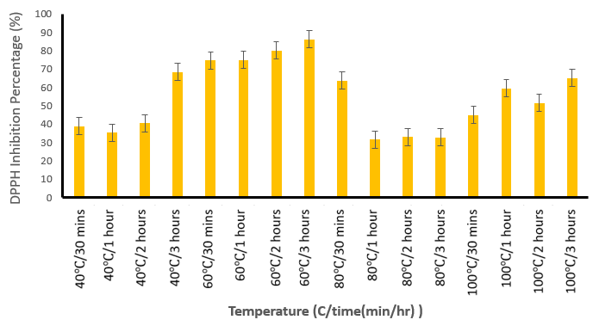
Figure 1: DPPH free radical scavenging activity of P. angulata extract with different temperatures and times. Values are mean ± standard deviation (n = 8). Different superscript letters indicate a significant difference at p < 0.05.
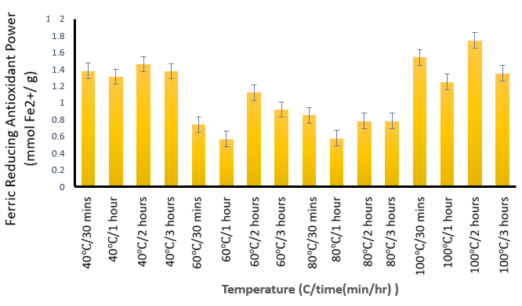

Figure 2: FRAP value of P. angulata extract with different temperatures and times. Values are mean ± standard deviation (n = 8). Different superscript letters indicate a significant difference at p < 0.05.

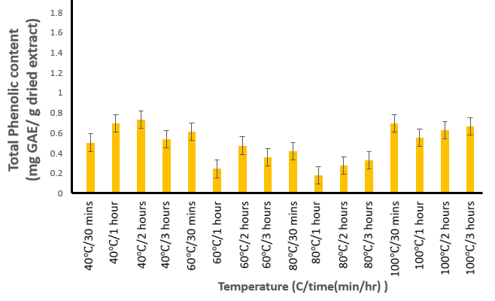
Figure 3: TPC level of P angulata extract with different temperatures and times. Values are mean ± standard deviation (n = 8). Different superscript letters indicate a significant difference at p < 0.05.
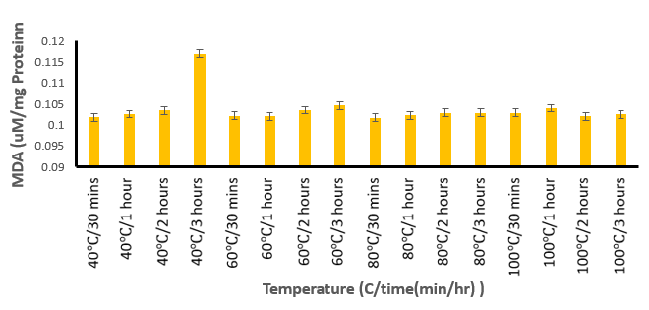

Figure 4: MDA level after treatment of P. angulata extract with different temperatures and times. Values are mean ± standard deviation (n = 8). Different superscript letters indicate a significant difference at p < 0.05.

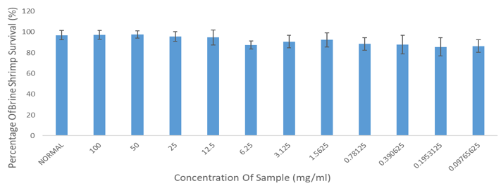
Figure 5: Percentage of Brine shrimp survival against the concentration of P. angulata. Values are mean ± standard deviation (n = 8). Different superscript letters indicate a significant difference at p < 0.05.
Table 1. Quantitative determination of chlorogenic acid and rutin in Physalis angulata water extract using HPLC analysis. Chlorogenic acid and rutin contents are expressed as concentration (ppm) and percentage of compound in the extract (w/w). Values represent individual measurements and mean ± relative standard deviation (RSD).

Sample | Chlorogenic acid concentration (ppm) | Average concentration of chlorogenicacid ± RSD (ppm) | Percentage of chlorogenic acid in the sample (w/w) | Average percentage of chlorogenic acid in the sample ±RSD (w/w)
Water extract of P. angulata | 101.09 | 103.14 ± 7.94 | 0.51 | 0.52 ± 7.94
Water extract of P. angulata | 96.43 | 103.14 ± 7.94 | 0.48 | 0.52 ± 7.94
Water extract of P. angulata | 111.91 | 103.14 ± 7.94 | 0.56 | 0.52 ± 7.94

Sample | Rutin concentration (ppm) | Average concentration of rutin ± RSD (ppm) | Percentage of rutin in the sample (w/w) | Average percentage of rutin in the sample ±RSD (w/w)
Water extract of P. angulata | 23.92 | 24.31 ± 7.60 | 0.12 | 0.12 ± 7.60
Water extract of P. angulata | 22.68 | 24.31 ± 7.60 | 0.11 | 0.12 ± 7.60
Water extract of P. angulata | 26.31 | 24.31 ± 7.60 | 0.13 | 0.12 ± 7.60

Table 2. Comparison of rat body weights at the beginning (Day 0) and end (Day 14) of the acute toxicity assessment after treatment with P. angulata water extract. No abnormal weight loss was observed during the study period.

Bodyweight of Day 0 Bodyweight of Day 14
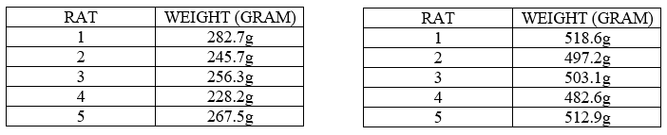

Table 3. Behavioral observations of rats following acute oral administration of P. angulata water extract. Transient behavioral changes, including mild hypoactivity, brief body shaking, and short periods of sleep, were observed within the first few hours post-administration. No mortality or persistent adverse effects were recorded, and all animals returned to normal activity during the subsequent observation period.

No. of day | Time | Notes
1 | 15 min | Start the treatment for rat 1 for first time (508.86mg)
1 | 30 min | Body shaking, active
1 | 1 hour | Active
1 | 2 hours | Sleep
1 | 3 hours | Active
1 | 4 hours | Active
2 | 15 min | Start the treatment for rat 1 for second time (3392.4mg)
2 | 30 min | Stay at one place and running
2 | 1 hour | Sleep
2 | 2 hours | Active
2 | 3 hours | Sleep
2 | 4 hours | Active
3 | 4 hours | Active
4 | 4 hours | Active
5 | 4 hours | Active and normal
6 | 4 hours | Active and normal
7 | 4 hours | Active and normal
8 | 4 hours | Active and normal
9 | 4 hours | Active and normal
10 | 4 hours | Active and normal
11 | 4 hours | Active and normal
12 | 4 hours | Active and normal
13 | 4 hours | Active and normal
14 | 4 hours | Active and normal

DISCUSSION

The present study provides a comprehensive evaluation of the antioxidant efficacy and preliminary safety of P. angulata water extract through systematic optimization of extraction parameters, phytochemical characterization, and toxicological screening. The findings clearly demonstrate that extraction temperature and duration play a pivotal role in determining the antioxidant profile and safety characteristics of the extract.

Among the extraction conditions tested, preparation at 80 °C for 30 min consistently yielded the highest DPPH radical scavenging activity and total phenolic content. This observation is in agreement with previous studies reporting that moderate thermal treatment enhances the release of phenolic compounds by disrupting plant cell walls, while excessive heating may lead to oxidation or degradation of thermolabile antioxidants (Maghsoudlou et al., 2019). Similar trends have been reported for other medicinal plants, where extraction temperatures between 60–80 °C were found to be optimal for preserving antioxidant capacity (Antony & Farid, 2022).

The FRAP assay revealed maximal reducing power at 60–80 °C for 1 h, further supporting the role of controlled heating in enhancing electron-donating antioxidant compounds. Since FRAP predominantly reflects the reducing capacity of phenolic acids and flavonoids, the observed results suggest that these extraction conditions favor the enrichment of redox-active constituents (Olszewska et al., 2012). Differences between optimal conditions for DPPH/TPC and FRAP assays are not uncommon and can be attributed to distinct reaction mechanisms and sensitivity toward different antioxidant classes (Kiss et al., 2025).

Lipid peroxidation inhibition, assessed via the MDA assay, showed the lowest malondialdehyde levels in extracts prepared at 100 °C for 2 h. This finding suggests that higher extraction temperatures may facilitate the recovery of compounds capable of suppressing lipid oxidation, potentially through enhanced solubilization of bound phenolics. However, when interpreted alongside DPPH, FRAP, and TPC results, prolonged exposure to high temperatures appears less favorable for achieving a balanced antioxidant profile, reinforcing the importance of multi-parameter evaluation rather than reliance on a single assay (Félix et al., 2020).

Quantitative HPLC analysis identified chlorogenic acid and rutin as major phenolic constituents of the P. angulata water extract. Both compounds are widely recognized for their potent antioxidant and cytoprotective properties. Chlorogenic acid has been reported to exhibit strong free radical scavenging, metal-chelating, and lipid peroxidation inhibitory activities, while rutin is known to enhance endogenous antioxidant defense systems and stabilize reactive oxygen species (Nguyen et al., 2024). The presence of these compounds provides a robust phytochemical explanation for the antioxidant effects observed in the present study and is consistent with earlier pharmacological reports on P. angulata (Al Dhabi et al., 2015; Nguyen et al., 2024).

From a safety perspective, preliminary toxicological evaluation using the brine shrimp lethality test demonstrated that P. angulata water extract exhibited only mild toxicity, with significant lethality observed exclusively at a relatively high concentration (5 mg/mL). The brine shrimp assay is widely employed as an initial screening tool and has been shown to correlate reasonably well with mammalian toxicity profiles (Banti & Hadjikakou., 2021). The low toxicity observed at lower concentrations suggests a favorable preliminary safety margin.

Importantly, the acute oral toxicity study in rats further corroborated the safety findings. No mortality or abnormal body weight changes were observed over the 14-day study period, indicating the absence of systemic toxicity or adverse metabolic effects. Only transient behavioral changes, such as mild hypoactivity and short periods of sleep, were observed shortly after administration, and these effects resolved spontaneously without progression to severe clinical signs. Similar observations have been reported in previous studies on P. angulata, where extracts administered within reasonable dose ranges did not induce significant acute toxicity (Bastos et al., 2008). According to OECD guidelines, the absence of mortality, sustained behavioral abnormalities, and significant weight loss indicates a low risk of acute toxicity (OECD, 2001).

Taken together, the present findings suggest that P. angulata water extract, when prepared under optimized aqueous extraction conditions, exhibits strong antioxidant activity with an acceptable preliminary safety profile. Based on the brine shrimp lethality test, stable body weight, and absence of persistent behavioral toxicity in rats, P. angulata cannot be classified as acutely toxic under the conditions tested. These results support its suitability as a candidate for further development as a natural antioxidant ingredient.

However, it is important to emphasize that the current study represents an early-stage safety evaluation. While the extract appears safe for preliminary use, comprehensive subacute, subchronic, and chronic toxicity studies, as well as reproductive and genotoxicity assessments, are required before definitive conclusions regarding long-term safety and product application can be made. Nevertheless, the present data provide strong scientific justification for advancing P. angulata toward further in vivo evaluation and potential incorporation into antioxidant-based formulations.

CONCLUSION

This study demonstrated that extraction temperature and duration significantly influence the antioxidant efficacy of P. angulata water extract. Extraction at 80 °C for 30 min produced the most favorable overall antioxidant profile, as reflected by high DPPH radical scavenging activity and total phenolic content, while strong reducing power was observed at 60–80 °C for 1 h. Phytochemical analysis confirmed chlorogenic acid and rutin as major phenolic constituents, supporting the antioxidant activity observed. Preliminary toxicological evaluation indicated that the extract exhibited only mild toxicity at high concentrations. Importantly, acute oral toxicity assessment in rats showed no mortality, no abnormal body weight changes, and only transient behavioral effects that resolved spontaneously. Collectively, these findings indicate that P. angulata water extract is not acutely toxic and has strong potential as a natural antioxidant source, warranting further safety and efficacy studies.

REFERENCES

Abdullah, H., Abd Rani, N.F., Ibrahim, M., Ramli, N., Ahmed, I.A., Mhd Jalil, A.M. & Anuar, M.N.N. (2021). Optimization of extraction temperature and time on phenolic compounds and antioxidant activity of Malaysian propolis Trigona spp. aqueous extract using response surface methodology. Malaysian Journal of Analytical Sciences, 25(4), pp.649–660.
Antony, A. & Farid, M. (2022). Effect of temperatures on polyphenols during extraction. Applied Sciences, 12(4), 2107. https://doi.org/10.3390/app12042107
Ballesteros-Ramírez R, Lasso P, Urueña C, Saturno J, Fiorentino S. Assessment of Acute and Chronic Toxicity in Wistar Rats (Rattus norvegicus) and New Zealand Rabbits (Oryctolagus cuniculus) of an Enriched Polyphenol Extract Obtained from Caesalpinia spinosa. J Toxicol. 2024 Apr 10;2024:3769933. doi: 10.1155/2024/3769933. PMID: 38633362; PMCID: PMC11023715.
Banti CN, Hadjikakou SK. Evaluation of Toxicity with Brine Shrimp Assay. Bio Protoc. 2021 Jan 20;11(2):e3895. doi: 10.21769/BioProtoc.3895. PMID: 33732784; PMCID: PMC7952950.
Bastos GN, Silveira AJ, Salgado CG, Picanço-Diniz DL, do Nascimento JL. Physalis angulata extract exerts anti-inflammatory effects in rats by inhibiting different pathways. J Ethnopharmacol. 2008 Jul 23;118(2):246-51.
Benzie, I.F.F., and Strain, J. J., (1996). The ferric reducing ability of plasma (FRAP) as a measure of antioxidant power: The FRAP assay. Anal. Biochern., 239, 70-76.
Ekeke, C., Obute, G.C. & Ogazie, C.A. (2019). HPLC evaluation of phenolic compounds in Physalis angulata Linn. and Physalis micrantha Linn. (Solanaceae). European Journal of Medicinal Plants, 29(2), pp.1–9. doi: 10.9734/EJMP/2019/v29i230151
El-Saadony MT, Saad AM, Mohammed DM, Korma SA, Alshahrani MY, Ahmed AE, Ibrahim EH, Salem HM, Alkafaas SS, Saif AM, Elkafas SS, Fahmy MA, Abd El-Mageed TA, Abady MM, Assal HY, El-Tarabily MK, Mathew BT, AbuQamar SF, El-Tarabily KA, Ibrahim SA. Medicinal plants: bioactive compounds, biological activities, combating multidrug-resistant microorganisms, and human health benefits - a comprehensive review. Front Immunol. 2025 Apr 28;16:1491777. doi: 10.3389/fimmu.2025.1491777. PMID: 40375989; PMCID: PMC12079674.
Félix, R., Valentão, P., Andrade, P.B., Félix, C., Novais, S.C. & Lemos, M.F.L. (2020). Evaluating the in vitro potential of natural extracts to protect lipids from oxidative damage. Antioxidants, 9(3), 231. https://doi.org/10.3390/antiox9030231
Iwansyah A.C., Luthfiyanti R., Ardiansyah R.C.E., Rahman N., Andriana Y., Abd Hamid H., Antidiabetic activity of Physalis angulata L. fruit juice on streptozotocin-induced diabetic rats, South African Journal of Botany, Volume 145, March 2022, Pages 313-319
Kiss, A., Papp, V.A., Pál, A., Prokisch, J., Mirani, S., Toth, B.E. & Alshaal, T. (2025). Comparative study on antioxidant capacity of diverse food matrices: Applicability, suitability and inter-correlation of multiple assays to assess polyphenol and antioxidant status. Antioxidants, 14(3), 317. https://doi.org/10.3390/antiox14030317
Lem FF, Yong YS, Goh S, Chin SN, Chee FT. Withanolides, the hidden gem in Physalis minima: A mini review on their anti-inflammatory, anti-neuroinflammatory and anti-cancer effects. Food Chem. 2022 May 30;377:132002. doi: 10.1016/j.foodchem.2021.132002. Epub 2022 Jan 3. PMID: 35033733.
Muscolo A, Mariateresa O, Giulio T, Mariateresa R. Oxidative Stress: The Role of Antioxidant Phytochemicals in the Prevention and Treatment of Diseases. Int J Mol Sci. 2024 Mar 13;25(6):3264. doi: 10.3390/ijms25063264. PMID: 38542238; PMCID: PMC10970659.
Najmi A, Javed SA, Al Bratty M, Alhazmi HA. Modern Approaches in the Discovery and Development of Plant-Based Natural Products and Their Analogues as Potential Therapeutic Agents. Molecules. 2022 Jan 6;27(2):349. doi: 10.3390/molecules27020349. PMID: 35056662; PMCID: PMC8779633.
Nguyen V, Taine EG, Meng D, Cui T, Tan W. Chlorogenic Acid: A Systematic Review on the Biological Functions, Mechanistic Actions, and Therapeutic Potentials. Nutrients. 2024 Mar 23;16(7):924. doi: 10.3390/nu16070924. PMID: 38612964; PMCID: PMC11013850.
Novitasari A, Rohmawaty E, Rosdianto AM. Physalis angulata Linn. as a medicinal plant (Review). Biomed Rep. 2024 Jan 24;20(3):47. doi: 10.3892/br.2024.1735. PMID: 38357237; PMCID: PMC10865294.
Pillai JR, Wali AF, Shivappa P, Talath S, Attia SM, Nadeem A, Rehman MU. Evaluating the anti-cancer potential and pharmacological in-sights of Physalis angulata Root Extract as a strong candidate for future research. J Genet Eng Biotechnol. 2024 Dec;22(4):100410. doi: 10.1016/j.jgeb.2024.100410. Epub 2024 Aug 22. PMID: 39674639; PMCID: PMC11387689.
Ramakrishna Pillai J, Wali AF, Menezes GA, Rehman MU, Wani TA, Arafah A, Zargar S, Mir TM. Chemical Composition Analysis, Cytotoxic, Antimicrobial and Antioxidant Activities of Physalis angulata L.: A Comparative Study of Leaves and Fruit. Molecules. 2022 Feb 22;27(5):1480. doi: 10.3390/molecules27051480. PMID: 35268579; PMCID: PMC8911865.
Sahgal G, Ramanathan S, Sasidharan S, Mordi MN, Ismail S, Mansor SM. Brine shrimp lethality and acute oral toxicity studies on Swietenia mahagoni (Linn.) Jacq. seed methanolic extract. Pharmacognosy Res. 2010 Jul;2(4):215-20. doi: 10.4103/0974-8490.69107. PMID: 21808570; PMCID: PMC3141130.
Singleton VL, Rossi JA (1965) Colorimetry of total phenolics with phosphomolybdic-phosphotungstic acid reagents. Am J Enol Vitic 16:144–158. https://doi.org/10.1038/nprot.2007.102
Tuan Anh HL, Le Ba V, Do TT, Phan VK, Pham Thi HY, Bach LG, Tran MH, Tran Thi PA, Kim YH. Bioactive compounds from Physalis angulata and their anti-inflammatory and cytotoxic activities. J Asian Nat Prod Res. 2021 Aug;23(8):809-817. doi: 10.1080/10286020.2020.1825390. Epub 2020 Oct 8. PMID: 33030034.
Upadhyay R, Chaurasia JK, Tiwari KN, Singh K. Antioxidant property of aerial parts and root of Phyllanthus fraternus Webster, an important medicinal plant. Scientific World Journal. 2014 Jan 23;2014:692392. doi: 10.1155/2014/692392. PMID: 24587744; PMCID: PMC3921995.
Xu DP, Li Y, Meng X, Zhou T, Zhou Y, Zheng J, Zhang JJ, Li HB. Natural Antioxidants in Foods and Medicinal Plants: Extraction, Assessment and Resources. Int J Mol Sci. 2017 Jan 5;18(1):96. doi: 10.3390/ijms18010096. PMID: 28067795; PMCID: PMC5297730.
Zhang QW, Lin LG, Ye WC. Techniques for extraction and isolation of natural products: a comprehensive review. Chin Med. 2018 Apr 17;13:20. doi: 10.1186/s13020-018-0177-x. PMID: 29692864; PMCID: PMC5905184.

