Antioxidant Activity, Lipid Peroxidation Suppression and Preliminary Toxicity Assessment of Persicaria minor (Kesum) Aqueous Extract
Abstract
Persicaria minor is a widely consumed Southeast Asian herb with emerging pharmacological relevance; however, comprehensive evaluation integrating antioxidant efficacy and safety profiling remains limited. This study systematically investigated the in vitro antioxidant capacity, in vivo lipid peroxidation modulation, and preliminary toxicity profile of the aqueous leaf extract of P. minor. Antioxidant activity was assessed using DPPH radical scavenging and ferric reducing antioxidant power (FRAP) assays, while total phenolic content (TPC) was quantified via the Folin–Ciocalteu method. Oxidative stress attenuation was evaluated by measuring malondialdehyde (MDA) levels, and preliminary safety was determined using the Brine Shrimp Lethality Test (BSLT). The extract exhibited pronounced free radical scavenging activity (approximately 75–94% inhibition across tested concentrations), approaching the activity of the reference standard at higher doses. FRAP analysis demonstrated substantial reducing capacity, indicating effective electron-donating potential. The presence of appreciable phenolic constituents supported the observed antioxidant effects. In vivo findings revealed significant suppression of MDA levels in the treated group relative to the negative control, indicating attenuation of lipid peroxidation and oxidative damage. Importantly, brine shrimp exposure resulted in high survival rates across concentrations, suggesting low acute toxicity under experimental conditions. Collectively, these findings demonstrate that P. minor aqueous extract possesses potent antioxidant activity, effectively mitigates lipid peroxidation, and exhibits minimal preliminary toxicity, highlighting its potential as a safe natural antioxidant candidate for further pharmacological and toxicological investigations.
Introduction
Oxidative stress, defined as an imbalance between reactive oxygen species (ROS) and endogenous antioxidant defense systems, remains a fundamental mechanism underlying the development of chronic non-communicable diseases, including cardiovascular disorders, neurodegenerative diseases, diabetes mellitus, and inflammatory conditions (Altanam et al., 2025). Excessive ROS generation leads to lipid peroxidation, protein oxidation, and DNA damage, contributing to cellular dysfunction and disease progression (Juan et al., 2021). Malondialdehyde (MDA), a secondary product of lipid peroxidation, is widely recognized as a reliable biomarker for oxidative damage and is frequently used to evaluate antioxidant efficacy in vivo (Cordiano et al., 2023).
Natural antioxidants derived from medicinal plants have gained renewed attention due to increasing concerns over synthetic antioxidant safety and long-term toxicity (Gulcin et al., 2025). Phenolic compounds, including flavonoids and phenolic acids, exert antioxidant activity primarily through hydrogen atom transfer (HAT), single electron transfer (SET), and metal chelation mechanisms (Bas et al., 2026). Recent studies emphasize the importance of correlating total phenolic content (TPC) with multiple antioxidant assays such as DPPH radical scavenging and ferric reducing antioxidant power (FRAP) to establish mechanistic consistency (Molole et al., 2022).
Persicaria minor (Huds.) Opiz, commonly known as kesum or Vietnamese coriander, is widely consumed in Southeast Asia as a culinary herb and traditional medicinal plant. Phytochemical analyses have reported the presence of quercetin derivatives, rutin, gallic acid, and other phenolic constituents that may contribute to its bioactivity (Mirfat et al., 2024). Although earlier studies have demonstrated antioxidant and anti-inflammatory potential, comprehensive integration of in vitro antioxidant assays with biologically relevant in vivo oxidative stress markers remains limited in recent literature.
Beside that, safety evaluation is an essential component of phytopharmacological validation. The Brine Shrimp Lethality Test (BSLT) continues to serve as a rapid and cost-effective preliminary toxicity screening model in natural product research (Nhamussua et al., 2026). Recent refinements in BSLT methodology have improved its predictive relevance for cytotoxic potential and early-stage safety profiling (Pohan et al., 2023). Incorporating toxicity screening alongside efficacy evaluation provides a more robust and translationally relevant assessment of herbal extracts.
Therefore, the present study aimed to comprehensively evaluate the antioxidant potential of P. minor aqueous leaf extract using DPPH radical scavenging and FRAP assays, determine its total phenolic content, assess its ability to attenuate lipid peroxidation via MDA measurement, and examine its preliminary toxicity using the Brine Shrimp Lethality Test. This integrated approach strengthens the scientific evidence supporting both the efficacy and preliminary safety profile of P. minor.

MATERIALS AND METHODS

Plant Material and Preparation of Extract
Fresh leaves of P. minor were obtained from a verified local source in Malaysia. The plant material was authenticated by a qualified botanist, and a voucher specimen was deposited in the institutional herbarium for future reference. The leaves were washed thoroughly under running tap water to remove debris and surface contaminants, followed by rinsing with distilled water. Cleaned samples were air-dried at room temperature for 24 h and subsequently oven-dried at 40–45°C until constant weight was achieved to prevent thermal degradation of phenolic compounds. The dried leaves were ground into a fine powder using a laboratory grinder and stored in airtight containers at room temperature until extraction.
Aqueous extraction was performed by macerating the powdered sample (1:10 w/v) in distilled water under controlled heating conditions (60–80°C) for 2 h with continuous stirring. The extract was filtered through Whatman No. 1 filter paper and concentrated using a rotary evaporator under reduced pressure. The concentrated extract was freeze-dried to obtain a dry crude extract and stored at –20°C until further analysis. Working solutions were freshly prepared in distilled water at the required concentrations.

Determination of Total Phenolic Content (TPC)
Total phenolic content was determined using the Folin–Ciocalteu colorimetric method with slight modifications. Briefly, 0.5 mL of extract solution was mixed with 2.5 mL of 10% (v/v) Folin–Ciocalteu reagent and incubated for 5 min at room temperature. Subsequently, 2 mL of 7.5% (w/v) sodium carbonate solution was added, and the mixture was incubated in the dark for 30 min at room temperature. Absorbance was measured at 765 nm using a UV–Vis spectrophotometer. Gallic acid was used to construct the standard calibration curve, and results were expressed as milligrams of gallic acid equivalent per gram of dry extract (mg GAE/g extract). All measurements were performed in triplicate.

DPPH Radical Scavenging Assay
The antioxidant activity of P. minor extract was evaluated using the 2,2-diphenyl-1-picrylhydrazyl (DPPH) radical scavenging assay. A freshly prepared DPPH solution (0.1 mM in methanol) was used for analysis. Various concentrations of the extract (0.046875–6 mg/mL) were prepared, and 1 mL of each concentration was mixed with 1 mL of DPPH solution. The mixture was incubated in the dark at room temperature for 30 min to allow complete reaction. Absorbance was measured at 517 nm against a blank using a UV–Vis spectrophotometer. Ascorbic acid was used as a positive control. The percentage of radical scavenging activity was calculated as:
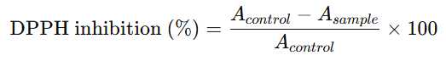
All experiments were conducted in triplicate.

Ferric Reducing Antioxidant Power (FRAP) Assay
The ferric reducing antioxidant power of the extract was determined according to the FRAP method. The FRAP reagent was freshly prepared by mixing 300 mM acetate buffer (pH 3.6), 10 mM TPTZ solution in 40 mM HCl, and 20 mM ferric chloride solution in a ratio of 10:1:1 (v/v/v). Briefly, 0.2 mL of extract solution was added to 3 mL of FRAP reagent and incubated at 37°C for 30 min. The absorbance was recorded at 593 nm. A calibration curve was constructed using ferrous sulfate, and results were expressed as µmol Fe²⁺ equivalents per gram of extract. All measurements were performed in triplicate.

In Vitro Lipid Peroxidation Inhibition Assay (Egg Yolk Model)
The inhibitory effect of P. minor extract on lipid peroxidation was evaluated using an egg yolk-induced lipid peroxidation model based on thiobarbituric acid reactive substances (TBARS) formation. Fresh hen’s egg yolk was separated from egg white and homogenized with phosphate-buffered saline (PBS, pH 7.4) to obtain a 10% (v/v) yolk homogenate, which served as a rich lipid source. Briefly, 0.5 mL of egg yolk homogenate was mixed with 0.1 mL of extract solution at different concentrations. Lipid peroxidation was induced by adding 0.1 mL of ferrous sulfate (FeSO₄, 0.07 M) as a pro-oxidant agent. The reaction mixture was adjusted to a final volume of 1 mL with distilled water and incubated at 37°C for 30 min. Following incubation, 1.5 mL of acetic acid (20%, pH 3.5) and 1.5 mL of thiobarbituric acid (TBA, 0.8% w/v in 1.1% sodium dodecyl sulfate) were added to the mixture. The tubes were heated in a boiling water bath (95–100°C) for 60 min to allow formation of MDA-TBA complex. After cooling to room temperature, 5 mL of n-butanol was added, and the mixture was centrifuged at 3,000 rpm for 10 min. The organic upper layer was carefully collected, and absorbance was measured at 532 nm using a UV–Vis spectrophotometer. A control reaction containing all reagents except the extract was used to represent 100% lipid peroxidation. All experiments were performed in triplicate, and results were expressed as mean ± standard deviation (SD). Ascorbic acid was used as the positive control. The percentage inhibition of lipid peroxidation was calculated as:
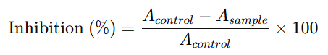

Brine Shrimp Lethality Test (BSLT)
Preliminary toxicity of the extract was evaluated using the Brine Shrimp Lethality Test. Artemia salina cysts were hatched in artificial seawater under continuous aeration and illumination for 48 h to obtain active nauplii. Serial dilutions of the extract (0.097–100 mg/mL) were prepared in seawater. Approximately 10 nauplii were transferred into each test vial containing 5 mL of extract solution. Control groups contained seawater only. The vials were maintained at room temperature under light exposure for 24 h. After incubation, the number of surviving nauplii was counted, and percentage survival was calculated. All tests were performed in triplicate. LC₅₀ values were estimated where applicable using probit analysis.

Statistical Analysis
All data were expressed as mean ± standard deviation (SD). Statistical analysis was performed using one-way analysis of variance (ANOVA) followed by Tukey’s post hoc test for multiple comparisons. A p-value < 0.05 was considered statistically significant. Statistical analyses were conducted using SPSS or GraphPad Prism software.

Results
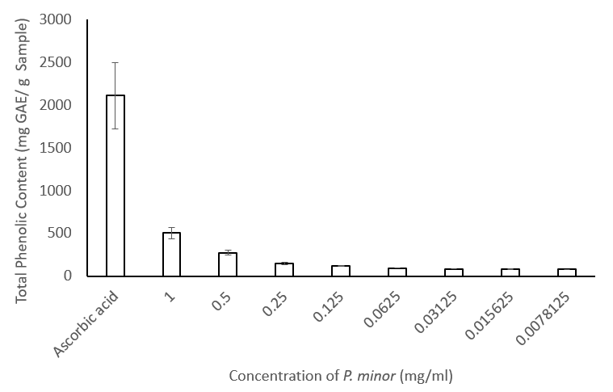
Figure 1. Total phenolic content (TPC) of P. minor aqueous extract at different concentrations (0.0078125–1 mg/mL) compared with ascorbic acid. Results are expressed as mg gallic acid equivalent per gram sample (mg GAE/g sample) and presented as mean ± SD (n = 3).
The total phenolic content (TPC) of P. minor aqueous extract is shown in Figure 1. Ascorbic acid, used as a reference compound, exhibited the highest phenolic equivalent value (approximately 2100 mg GAE/g sample). In comparison, the P. minor extract demonstrated concentration-dependent phenolic content across the tested range. At the highest tested concentration (1 mg/mL), the extract showed a TPC value of approximately 500 mg GAE/g sample. Upon dilution to 0.5 mg/mL, the phenolic content decreased markedly to approximately 250 mg GAE/g sample. A further reduction was observed at 0.25 mg/mL, with values around 130–150 mg GAE/g sample. Subsequent lower concentrations (0.125–0.0078125 mg/mL) exhibited progressively lower TPC values, ranging approximately between 70 and 120 mg GAE/g sample.
Generally, a decreasing trend in total phenolic content was observed with decreasing extract concentration. Despite the reduction, measurable phenolic content was detected across all concentrations tested. The relatively small standard deviations indicate good reproducibility of the assay under the experimental conditions.

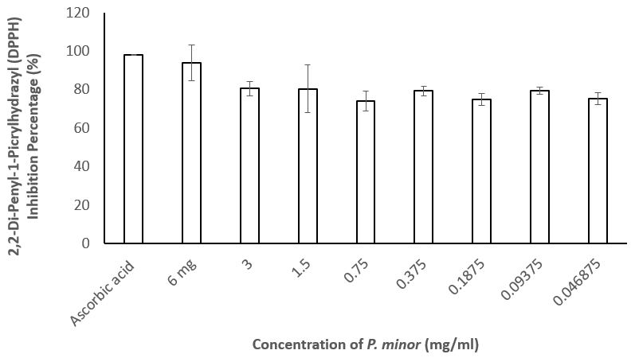
Figure 2. DPPH radical scavenging activity of P. minor aqueous extract at different concentrations (0.046875–6 mg/mL) compared with ascorbic acid. Values are expressed as mean ± SD (n = 3).
The DPPH radical scavenging activity of P. minor aqueous extract is presented in Figure 1. The extract exhibited substantial radical scavenging activity across all tested concentrations (0.046875–6 mg/mL), with percentage inhibition ranging approximately between 73% and 94%. The highest scavenging activity among the extract concentrations was observed at 6 mg/mL, demonstrating inhibition exceeding 90%, closely approaching the activity of the positive control, ascorbic acid (approximately 98%). At intermediate concentrations (3 and 1.5 mg/mL), the extract maintained strong inhibition levels of approximately 79–82%, indicating sustained antioxidant capacity even with decreasing concentration. Further dilution to 0.75 mg/mL resulted in a slight reduction in scavenging activity (approximately 73–75%), representing the lowest inhibition value observed among the tested concentrations. However, at 0.375 mg/mL, the inhibition percentage increased again to approximately 79%, followed by relatively stable activity at lower concentrations (0.1875–0.046875 mg/mL), which remained within the range of 74–79%.
The extract demonstrated consistently high radical scavenging activity across the entire concentration range, with only moderate variation between concentrations. Although a general reduction in activity was observed with decreasing concentration, the inhibition percentages remained above 70% even at the lowest tested dose, indicating strong antioxidant potential of P. minor extract under the experimental conditions.

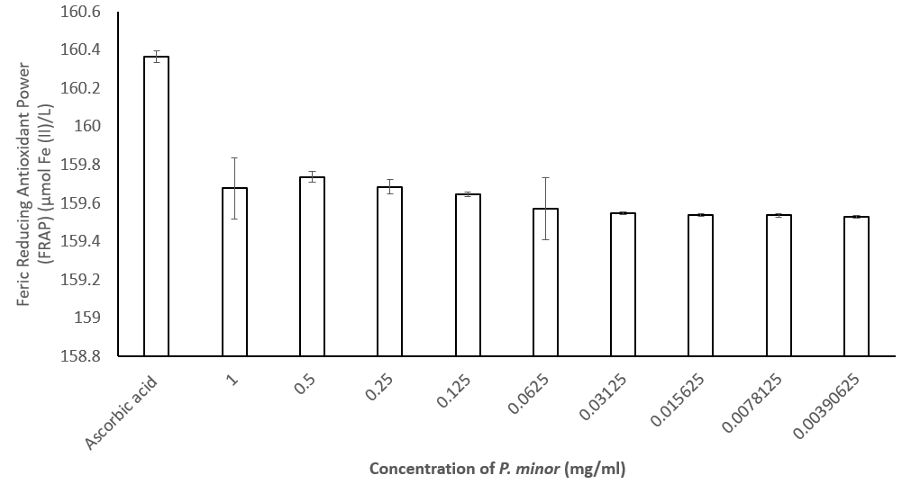
Figure 3. Ferric reducing antioxidant power (FRAP) of P. minor aqueous extract at different concentrations (0.00390625–1 mg/mL) compared with ascorbic acid. Values are expressed as mean ± SD (n = 3).
The ferric reducing antioxidant power (FRAP) of P. minor aqueous extract is illustrated in Figure 3. Ascorbic acid exhibited the highest reducing activity (approximately 160.4 µmol Fe²⁺/mL), serving as the reference standard. In comparison, the P. minor extract demonstrated measurable ferric reducing capacity across all tested concentrations (0.00390625–1 mg/mL). At 1 mg/mL, the extract showed a FRAP value of approximately 159.6–159.7 µmol Fe²⁺/mL. A slight increase was observed at 0.5 mg/mL, followed by relatively stable values at 0.25 mg/mL and 0.125 mg/mL, which remained within a narrow range of approximately 159.6–159.7 µmol Fe²⁺/mL. As the concentration decreased further to 0.0625 mg/mL and below, a gradual decline in reducing capacity was observed; however, the values remained relatively consistent, fluctuating minimally between approximately 159.5 and 159.6 µmol Fe²⁺/mL.
Across the entire concentration range tested, the extract maintained a consistent ferric reducing activity with only minor variations. Although the reducing capacity of the extract was slightly lower than that of ascorbic acid, the difference was relatively small, and measurable reducing activity was retained even at the lowest tested concentration (0.00390625 mg/mL). The narrow dispersion of values and small standard deviations indicate reproducible reducing activity under the experimental conditions.

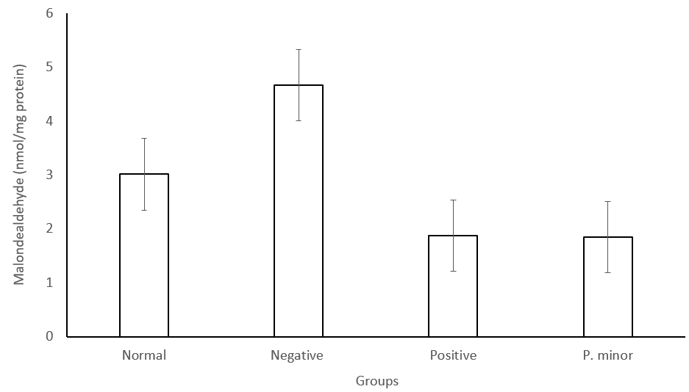
Figure 4. Effect of P.minor aqueous extract on malondialdehyde (MDA) formation in the egg yolk lipid peroxidation model. Results are expressed as nmol MDA/mg protein and presented as mean ± SD (n = 3).
The effect of P. minor aqueous extract on lipid peroxidation is presented in Figure 4. The negative control group exhibited the highest MDA level (approximately 4.6–4.8 nmol/mg protein), indicating maximal lipid peroxidation under oxidative conditions. In contrast, the normal group showed a lower MDA value (approximately 3.0 nmol/mg protein), reflecting baseline lipid oxidation.Treatment with the positive control significantly reduced MDA formation to approximately 1.8–1.9 nmol/mg protein. Similarly, the P. minor-treated group demonstrated a comparable reduction in MDA levels (approximately 1.8–1.9 nmol/mg protein), indicating substantial inhibition of lipid peroxidation relative to the negative control.
Moreover, both the positive control and P. minor extract groups showed markedly lower MDA levels compared to the negative control. The reduction observed in the P. minor group was approximately 55–60% relative to the negative control. The small standard deviations indicate good reproducibility across replicates.

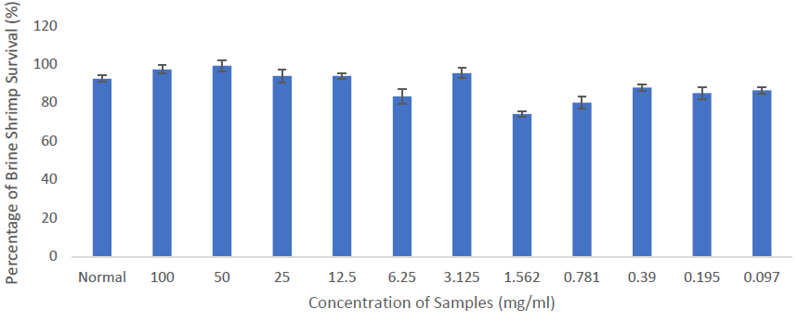
Figure 5. Percentage survival of Artemia salina nauplii following exposure to different concentrations of P. minor aqueous extract (0.097–100 mg/mL). Values are presented as mean ± SD (n = 3).
The survival rate of Artemia salina nauplii following exposure to P. minor aqueous extract is presented in Figure 5. The normal control group exhibited a survival rate of approximately 92–94%. Across the tested concentration range (0.097–100 mg/mL), survival percentages remained consistently high, generally exceeding 80%. At higher concentrations (100, 50, and 25 mg/mL), nauplii survival ranged approximately between 93% and 99%, indicating minimal mortality. At 12.5 mg/mL and 3.125 mg/mL, survival rates remained above 90%. A slight reduction was observed at 6.25 mg/mL (approximately 82–85%) and at 1.562 mg/mL (approximately 73–75%), representing the lowest survival value recorded in the assay. However, survival percentages increased again at lower concentrations (0.781–0.097 mg/mL), ranging approximately between 80% and 88%.
Overall, no clear dose-dependent increase in mortality was observed across the concentration range tested. The consistently high survival percentages indicate low lethality of the extract under the experimental conditions. The small standard deviations suggest reproducibility and low variability among replicates.

Discussion
The present study demonstrates that P. minor aqueous extract exhibits strong and consistent antioxidant activity across radical scavenging, reducing power, and lipid peroxidation inhibition assays, accompanied by minimal preliminary toxicity. The high DPPH radical scavenging activity observed (approximately 75–94% inhibition) indicates substantial hydrogen- or electron-donating capacity of the extract. The DPPH assay is widely employed to evaluate the ability of phytochemicals to neutralize stable free radicals through hydrogen atom transfer or single electron transfer mechanisms (Baliyan et al., 2022). The pronounced activity observed in this study suggests that P. minor contains bioactive constituents capable of interrupting free radical chain reactions.
The FRAP results further support these findings by demonstrating significant ferric reducing capacity. The FRAP assay reflects the electron-donating ability of antioxidants and correlates strongly with phenolic content in plant extracts (Payne et al., 2013). The parallel trends between DPPH and FRAP assays observed in the present study strengthen the reliability of the antioxidant claim, as current methodological recommendations emphasize the importance of employing multiple mechanistically distinct assays to validate antioxidant potential (Shahidi et al., 2025).
The measurable total phenolic content identified in P. minor likely underpins the observed antioxidant effects. Phenolic compounds are well known to exert antioxidant activity by stabilizing reactive oxygen species via resonance structures following hydrogen donation (Kruk et al., 2022). The consistency between TPC values and functional antioxidant assays observed here aligns with established understanding that phenolic-rich plant extracts typically demonstrate strong radical scavenging and reducing properties. Previous phytochemical investigations of P. minor have reported the presence of flavonoids and phenolic acids, including quercetin derivatives and rutin, which are recognized contributors to antioxidant activity (Roy et al., 2022).
The lipid peroxidation inhibition demonstrated in the egg yolk model provides additional biological relevance. Lipid peroxidation represents a central mechanism of oxidative membrane damage and contributes to the pathogenesis of cardiovascular and neurodegenerative diseases (Ayala, Muñoz & Argüelles, 2014). In this study, ferrous ion-induced peroxidation generated malondialdehyde (MDA), a widely accepted biomarker of lipid oxidative degradation (Barrera et al., 2018). The significant reduction in MDA formation following treatment with P. minor extract indicates effective interruption of lipid oxidative chain propagation. This finding extends the relevance of the extract beyond simple radical neutralization and suggests potential membrane-protective properties. The inclusion of a lipid-rich substrate model strengthens the translational significance of the antioxidant findings, as it better reflects biological systems compared to single-radical assays alone.
Equally important is the preliminary safety evaluation using the Brine Shrimp Lethality Test (BSLT). The high survival rates observed across tested concentrations suggest low acute toxicity under experimental conditions. The BSLT remains a widely accepted preliminary bioassay for screening cytotoxicity and general toxicity in natural product research (Nhamussua et al., 2026). Although not a substitute for mammalian toxicity studies, it provides valuable early-stage safety insight. The favorable safety profile observed in this study is particularly important given that strong antioxidant activity does not necessarily correlate with low toxicity in all plant extracts.
From a broader perspective, oxidative stress is implicated in the progression of multiple chronic non-communicable diseases (Seyedsadjadi & Grant, 2020). Therefore, identifying plant-derived antioxidants with both efficacy and preliminary safety is of considerable scientific and commercial interest. The integrated approach employed in this study combining radical scavenging assays, reducing power assessment, lipid peroxidation inhibition, and toxicity screening addresses current methodological expectations for phytopharmacological validation.
The findings also carry implications for nutraceutical development. Given its established dietary use in Southeast Asia, P. minor may represent a promising candidate for development into antioxidant-rich functional beverages, dietary supplements, or natural food preservatives. The combination of strong antioxidant efficacy and low preliminary toxicity supports its potential as a safe natural antioxidant source. However, further investigations including LC-MS-based phytochemical profiling, cellular oxidative stress models, bioavailability studies, and subchronic toxicity assessments are necessary before translational application.
In summary, the present study demonstrates that P. minor aqueous extract exhibits potent antioxidant activity, effectively inhibits lipid peroxidation in a biologically relevant model, and shows minimal preliminary toxicity. These findings provide updated scientific validation for this traditionally consumed herb and support its potential role as a natural antioxidant candidate for nutraceutical development.

References
Altanam SY, Darwish N, Bakillah A. Exploring the Interplay of Antioxidants, Inflammation, and Oxidative Stress: Mechanisms, Therapeutic Potential, and Clinical Implications. Diseases. 2025 Sep 22;13(9):309. doi: 10.3390/diseases13090309. PMID: 41002745; PMCID: PMC12469104.
Ayala A, Muñoz MF, Argüelles S. Lipid peroxidation: production, metabolism, and signaling mechanisms of malondialdehyde and 4-hydroxy-2-nonenal. Oxid Med Cell Longev. 2014;2014:360438. doi: 10.1155/2014/360438. Epub 2014 May 8. PMID: 24999379; PMCID: PMC4066722.
Barrera G, Pizzimenti S, Daga M, Dianzani C, Arcaro A, Cetrangolo GP, Giordano G, Cucci MA, Graf M, Gentile F. Lipid Peroxidation-Derived Aldehydes, 4-Hydroxynonenal and Malondialdehyde in Aging-Related Disorders. Antioxidants (Basel). 2018 Jul 30;7(8):102. doi: 10.3390/antiox7080102. PMID: 30061536; PMCID: PMC6115986.
Bas TG. Dietary Polyphenols (Flavonoids) Derived from Plants for Use in Therapeutic Health: Antioxidant Performance, ROS, Molecular Mechanisms, and Bioavailability Limitations. Int J Mol Sci. 2026 Jan 30;27(3):1404. doi: 10.3390/ijms27031404. PMID: 41683824; PMCID: PMC12898187.
Cordiano R, Di Gioacchino M, Mangifesta R, Panzera C, Gangemi S, Minciullo PL. Malondialdehyde as a Potential Oxidative Stress Marker for Allergy-Oriented Diseases: An Update. Molecules. 2023 Aug 9;28(16):5979. doi: 10.3390/molecules28165979. PMID: 37630231; PMCID: PMC10457993.
Gulcin İ. Antioxidants: a comprehensive review. Arch Toxicol. 2025 May;99(5):1893-1997. doi: 10.1007/s00204-025-03997-2. Epub 2025 Apr 15. PMID: 40232392; PMCID: PMC12085410.
Juan CA, Pérez de la Lastra JM, Plou FJ, Pérez-Lebeña E. The Chemistry of Reactive Oxygen Species (ROS) Revisited: Outlining Their Role in Biological Macromolecules (DNA, Lipids and Proteins) and Induced Pathologies. Int J Mol Sci. 2021 Apr 28;22(9):4642. doi: 10.3390/ijms22094642. PMID: 33924958; PMCID: PMC8125527.
Kruk J, Aboul-Enein BH, Duchnik E, Marchlewicz M. Antioxidative properties of phenolic compounds and their effect on oxidative stress induced by severe physical exercise. J Physiol Sci. 2022 Aug 5;72(1):19. doi: 10.1186/s12576-022-00845-1. PMID: 35931969; PMCID: PMC10717775.
Mirfat, A.H.S., Mohd. Effendi, M.N., Norma, H., Muhammad Faris, M.R., Muhammad Faidhi, T., Ainon, D.Z. & Hanim, A. (2024) ‘Evaluation of phytochemical, antioxidant and antimicrobial properties of different accessions of Persicaria minor (kesum)’, Food Research, 8(Supp. 4), pp. 57–64. https://doi.org/10.26656/fr.2017.8(S4).6
Molole GJ, Gure A, Abdissa N. Determination of total phenolic content and antioxidant activity of Commiphora mollis (Oliv.) Engl. resin. BMC Chem. 2022 Jun 25;16(1):48. doi: 10.1186/s13065-022-00841-x. PMID: 35752844; PMCID: PMC9233799.
Nhamussua RL, Mabiki FP, Mwakalesi AJ, McGaw LJ. Screening anticancer activity by Brine shrimp lethality test of extracts of Annona stenophylla (Engl. & Diels), Strophanthus petersianus (Klotzsch) and Synadenium glaucescens (Pax). PLoS One. 2026 Jan 2;21(1):e0336636. doi: 10.1371/journal.pone.0336636. PMID: 41481610; PMCID: PMC12758728.
Payne AC, Mazzer A, Clarkson GJ, Taylor G. Antioxidant assays - consistent findings from FRAP and ORAC reveal a negative impact of organic cultivation on antioxidant potential in spinach but not watercress or rocket leaves. Food Sci Nutr. 2013 Nov;1(6):439-44. doi: 10.1002/fsn3.71. Epub 2013 Oct 16. PMID: 24804054; PMCID: PMC3951540.
Pohan, D.J., Marantuan, R.S. & Djojosaputro, M. (2023) ‘Toxicity test of strong drug using the BSLT (Brine Shrimp Lethality Test) method’, International Journal of Health Sciences and Research, 13(2), pp. 203. https://doi.org/10.52403/ijhsr.20230228
Roy A, Khan A, Ahmad I, Alghamdi S, Rajab BS, Babalghith AO, Alshahrani MY, Islam S, Islam MR. Flavonoids a Bioactive Compound from Medicinal Plants and Its Therapeutic Applications. Biomed Res Int. 2022 Jun 6;2022:5445291. doi: 10.1155/2022/5445291. PMID: 35707379; PMCID: PMC9192232.

