Formulation of Eco-Crayons Using
Organic Pigments and Natural Waxes
(Soy Wax, Palm Wax and Beeswax)

INTRODUCTION
- Background of the Study
Children’s art supplies are widely used in homes, schools, and early childhood education settings. Among these materials, crayons are the most frequently used tools for drawing and coloring that help enhance children’s imagination, creativity, and fine motor skills (Formosa Publisher, 2023). However, because young children often handle, mouth, or accidentally ingest these materials, the safety chemical composition is critically important (National Library of Medicine, 2023). Since crayons are commonly used in early childhood, it is crucial to guarantee that they are safe, non-toxic, and eco-friendly. Traditional crayons, which are made from petroleum-based waxes and artificial colorants, may expose children to harmful chemicals. Therefore, creating a safer substitute that prioritizes both health and environmental protection is essential.
Based on the Consumer Council (2021) and Magramo (2021), growing concerns have emerged regarding the environmental impact and chemical safety of traditional crayons, which are primarily made from paraffin wax a petroleum byproduct and often contain harmful substances such as polycyclic aromatic hydrocarbons (PAHs). These petroleum-based compounds pose both health and ecological risks, highlighting the urgent need for safer and more sustainable alternatives in educational materials. Developing eco-friendly crayons not only addresses environmental and health concerns but also supports science learning and sustainability education by integrating real-world environmental issues into the curriculum, encouraging students to understand and practice eco-conscious decision-making.
In response, there is growing interest in natural, non-toxic, biodegradable alternatives. Natural waxes such beeswax, soy wax, and palm wax, and blends thereof, together with organic or botanical pigments derived from flowers and plants, are promising as safer substitutes. Beeswax, for instance, is biodegradable, hypoallergenic, and free from the chemical additives found in petroleum-based waxes (Smilogy Kids, 2024). Previous research has also shown that crayons made from natural waxes and organic additives can be produced safely without containing harmful heavy metals (Universiti Teknikal Malaysia Melaka, 2024). However, further research is still needed to optimize these eco-crayons in terms of durability and color vibrancy.

B. Review of Related Literatures
Neddo (2020), in The Organic Artist for Kids, advocates for the integration of natural materials in art-making to promote creativity, environmental awareness, and experiential learning among children. His work emphasizes the educational value of hands-on, eco-conscious activities such as making natural crayons which directly supports the conceptual framework of the present study. It establishes the relevance of using botanical pigments and natural waxes like soy, palm, and beeswax as sustainable materials that align with environmental and educational goals.
Similarly, Becchi (2021), discusses the Oyasai Crayons project by Naoko Kimura, which uses vegetable scraps and rice bran oil to produce non-toxic and biodegradable crayons. This study highlights the feasibility of transforming organic waste into vibrant and safe art materials, providing an applied model for integrating plant-based pigments and biodegradable waxes. The findings support the methodological approach of this study in evaluating eco-crayon performance based on sustainability, safety, and usability.
Hickey and King (2000), provide a comprehensive botanical reference that aids in identifying pigment-rich plant species suitable for use in crayon formulation. Their work supports the current study’s material selection process by offering scientific bases for classifying flowers with strong color potential and ensuring accurate pigment extraction from botanical sources.
Romero et al. (2021), present an experimental study on producing bioparaffin wax from soybean oil, demonstrating that soy-based waxes can replicate the thermal and physical properties of conventional paraffin. This directly informs the use of soy wax as a binder in eco-crayon development, ensuring appropriate texture, melting point, and durability while maintaining biodegradability and non-toxicity.
Complementing this, Alexander et al. (2023), explore the application of natural waxes such as soy, beeswax, candelilla, and carnauba wax in enhancing the durability and water resistance of biodegradable materials. Their findings provide technical insights into how wax types influence hardness, stability, and moisture resistance, which are vital parameters in optimizing eco-crayon texture and resilience under varying conditions.

C. Statement of the Problem
This study seeks to address the increasing demand for safe, eco-friendly, and sustainable art materials for young learners by developing eco-crayons made from natural pigments, botanical flower extracts, and natural waxes. Specifically, the problem of this study is expressed in the following questions:
- How do soy wax, palm wax, and beeswax affect the physical properties of eco-crayons in terms of durability?
- How does the color vibrancy of eco-crayons affect the functionality of those made from natural waxes such as palm wax, soy wax, and beeswax and botanical pigments extracted from rose for red color, butterfly pea flower for blue color, and sunflower for yellow color?

D. Objectives
To evaluate the effectiveness of eco-crayons made from botanical flowers and natural waxes as a sustainable alternative to commercial crayons in terms of:
- Resistance to wear and breakage is a measure of durability; and
- When applied to paper, color quality is determined by the color vibrancy and consistency

E. Conceptual Framework
Figure 1.1 The Conceptual Framework of the Study

Independent Variable Dependent Variable
Types of flowers to used - rose for red color, butterfly pea for blue color, sunflower for yellow color
Types of natural wax to used - soy wax, palm wax, and bees wax

Color Vibrancy - how vibrant the color would be
Durability- if the crayons are not easy to break

Figure 1.1 shows the variables of the study. It can be observed that the types of flowers such as rose for red pigment, butterfly pea for blue pigment, and sunflower for yellow pigment as well as the types of waxes, namely soy wax, palm wax, and beeswax, serve as the independent variables of the study. These variables are manipulated to determine their effects on the outcomes of the experiment. Conversely, color vibrancy and durability function as the dependent variables, as their values vary in response to changes in the independent variables. The measurements of these dependent variables depend on the concentration or amount of pigment and type of wax used in the formulation process.

F. Hypothesis
Null Hypothesis (H0):
- At 5% level of significance, there is no significant difference in the durability of eco-crayons made from soy wax, palm wax, and bees wax.
- At 5% level of significance, there is no significant difference in the color vibrancy of eco-crayons made from soy wax, palm wax, and beeswax.

Alternative Hypothesis (H1):
- There is a significant difference in the durability of eco-crayons made from soy wax, palm wax, and beeswax.
- There is a significant difference in the color vibrancy of eco-crayons made from soy wax, palm wax, and beeswax.

G. Significance of the Study
This study explores the potential for developing sustainable, non-toxic, and environmentally friendly alternatives to conventional crayons through the formulation of eco-crayons using pigments derived from botanical flowers and natural waxes such as soy wax, beeswax, and palm wax. The outcomes may offer benefits for students, parents, teachers, and the wider community. Since crayons are commonly used by early childhood and elementary students and often come into contact with the skin or, in some cases, are accidentally ingested, using crayons made from natural pigments and waxes could reduce children’s exposure to harmful substances found in some commercial products.
Beyond their material advantages, the use of eco-crayons has strong educational implications. Integrating these sustainable materials into classroom activities supports curriculum goals in science, health, and environmental education, as learners can directly engage in discussions and experiments about natural resources, chemical safety, and ecological preservation. Teachers can utilize eco-crayons as instructional tools to connect environmental concepts with hands-on creative learning, fostering early awareness of sustainability and responsible consumption. Moreover, this approach aligns with the DepEd’s advocacy for environmental literacy and sustainable practices, providing opportunities for interdisciplinary lessons that combine art, science, and social responsibility (Department of Education, 2019).
This study also seeks to explore the feasibility of producing biodegradable crayon alternatives that align with safety and environmental considerations. The use of eco-crayons might contribute to reducing reliance on petroleum-based ingredients and synthetic dyes typically present in traditional crayons. Sourcing botanical pigments and natural waxes locally could support ecological sustainability and open possibilities for community-driven initiatives or small-scale enterprises. By examining factors such as color vibrancy and durability, the research aims to identify which waxes are most suitable for eco-crayon production, offering insights that can guide future studies and inform the development of sustainable art materials that strengthen environmental values in education.
H. Scope and Delimitation
The scope and limitations of this study encompass the period from August to October 2025. The research primarily focuses on the development of eco-friendly crayons formulated using natural pigments extracted from selected botanical flowers and natural waxes, specifically soy wax, beeswax, and palm wax.
The scope of the study includes the extraction of pigments from the petals of selected botanical flowers rose (red pigment), butterfly pea (blue pigment), and sunflower (yellow pigment) which were chosen for their high pigment concentration, natural availability, and non-toxic properties. These flowers are widely accessible in local environments, making them suitable for sustainable and cost-efficient pigment extraction. The formulation process involves combining these natural pigments with soy wax, beeswax, and palm wax, chosen for their biodegradability, non-toxicity, and renewable origins. Soy wax offers smooth texture and easy blending, beeswax provides natural hardness and gloss, and palm wax contributes durability and vibrant color retention.
The physical properties of the resulting eco-crayons will be evaluated in terms of color vibrancy using colorimeter testing and durability through drop testing. A comparative analysis will then determine the most suitable wax for producing eco-crayons with optimal quality and sustainability.
This study is delimited to the use of flower petals as the sole source of pigments, excluding other plant parts such as stems, leaves, and roots to ensure consistency of color extraction and avoid impurities that may alter the pigment quality. Similarly, only soy wax, beeswax, and palm wax are employed in the formulation because they represent three distinct categories of plant-based, animal-derived, and vegetable waxes, allowing for meaningful comparison across natural wax types. The study does not include synthetic additives, stabilizers, or commercial-grade color enhancers to maintain the ecological integrity of the formulations. Furthermore, the research is confined to small-scale laboratory formulation and testing and does not extend to industrial-scale production or long-term storage assessments. Evaluation is limited to the crayons’ physical and functional characteristics, excluding factors such as market feasibility or user preference testing.

- Definition of Terms
This study encompasses the following terms:
Conceptual Terms:
- Anthocyanins - any various soluble pigments producing blue to red coloring in flowers
- Botanical - substance obtained or derived from a plant
- Carotenoids - a class of natural pigments responsible for the vibrant
- Derived - being, possessing, or marked by a character (such as the large brain in humans) not present in the ancestral form
- Immersive - providing, involving, or characterized by deep absorption or immersion in something (such as an activity or a real or artificial environment)
- Interrogative - an expression often used to test knowledge
- Perception - a result of perceiving: observation
- Scalability - scalability measures a system’s ability to handle an increasing amount of work
- Tactile - relating to, or being the sense of touch
- Vividness - of a color: very strong: very high in chroma

Operational Terms:
- Anthocyanins - In the researcher’s study, anthocyanins defined a natural, water-soluble pigment, which created red, purple, and blue hues, and are abundant in flowers like roses and lavender. Eco-crayons can utilize these pigments extracting them from floral sources to provide vibrant color
- Botanical - In the context of the study, botanical is a pigments derived from flowers are natural colorants extracted from various floral sources
- Carotenoids - In the context of the study, carotenoids defined a class of natural pigments responsible for the vibrant
- Derived - In the researcher’s study, derived defined the pigments used in natural crayons may be obtained from fruits and vegetables, therefore the color is taken from the natural dyes present in these foods
- Immersive - In the context of the study, immersive defined the number of senses engaged in an activity increases as an additional feature or element is introduced, such as touch and sights
- Interrogative - In the researcher’s study, interrogative defined to the questioning or investigate approach used to explore different formulations, test hypothesis, and gather data on the properties of the eco-crayons
- Perception - In the researcher's study, perception defined observing the formulation of making eco-crayons
- Scalability -In the context of the study, scalability is the ability to increase the production volume of the eco-crayons easily and efficiently, depending on demand while maintaining quality and cost-effectiveness
- Tactile - In the context of the study, tactile defined to create a tangible product which is crayons, “tangible” refers to something that has a physical shape that can be seen, felt, and utilized
- Vividness - In the researcher’s study, vividness defined the number of senses engaged in an activity increase as an additional feature or element is introduced, such as touch and sights.

Chapter 2
METHODOLOGY
Research Design
- Research Questions
This study is expressed in the following questions: How do soy wax, palm wax, and beeswax affect the physical properties of eco-crayons in terms of durability? How does the color vibrancy of eco-crayons affect the functionality of those made from natural waxes such as palm wax, soy wax, and beeswax and botanical pigments extracted from rose for red color, butterfly pea flower for blue color, and sunflower for yellow color?
- durability test
- color vibrancy
- red color (rose petals)
- blue color (butterfly pea)
- yellow color (sunflower petals)

B. Participants
No other respondent, aside from the researchers, were involved during the experimental process. The researchers served as the primary implementers and observers throughout the entire experimentation. They were responsible for preparing the materials, conducting the procedures, recording the data, and analyzing the results. Since the nature of the study is experimental, direct participation from external respondents or participants was not necessary.

C. Materials and Procedures
Phase I – Pigment Extraction
Materials
The following materials were used for pigment extraction: fresh botanical flower petals such as rose, butterfly pea, and sunflower, hot water, 3 heat-resistant containers, organic kaolin clay, cream of tartar, coffee filter paper and fine sieve.
Procedure
Fresh flower petals were cleaned thoroughly to remove dirt and impurities. Each type of flower was prepared separately to avoid color contamination. The cleaned petals were soaked in approximately 1.5 liters of hot water and left undisturbed for 12–24 hours to allow the release of natural pigments.
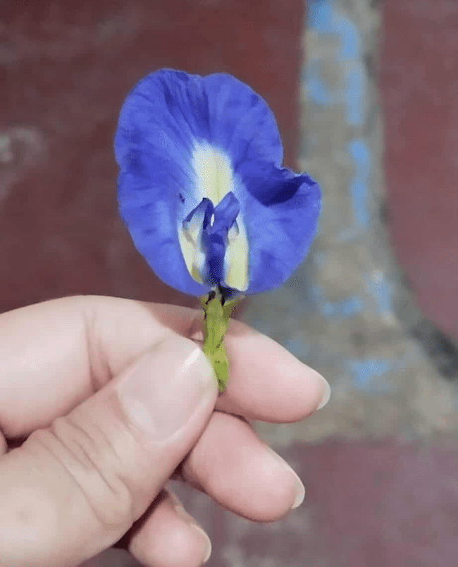
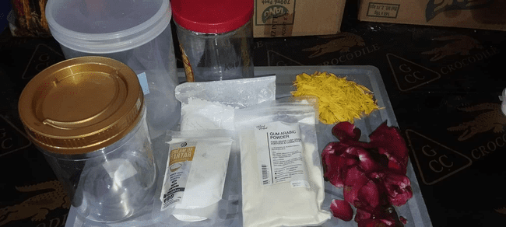

After soaking, the petals were removed and squeezed to extract the remaining colored liquid. The pigment-infused water was then divided equally into three containers. In the second container, four (4) tablespoons of organic kaolin clay were added and mixed thoroughly to serve as a natural precipitating agent. In the third container, three (3) tablespoons of cream of tartar were added and stirred to act as a mordant that fixes the pigment.

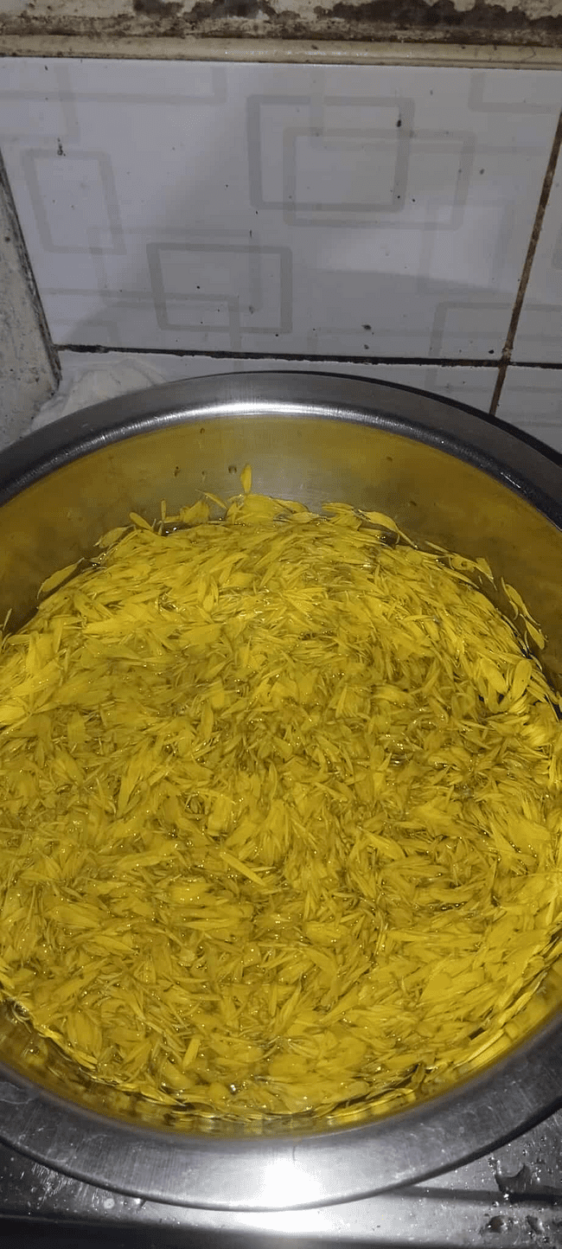 | 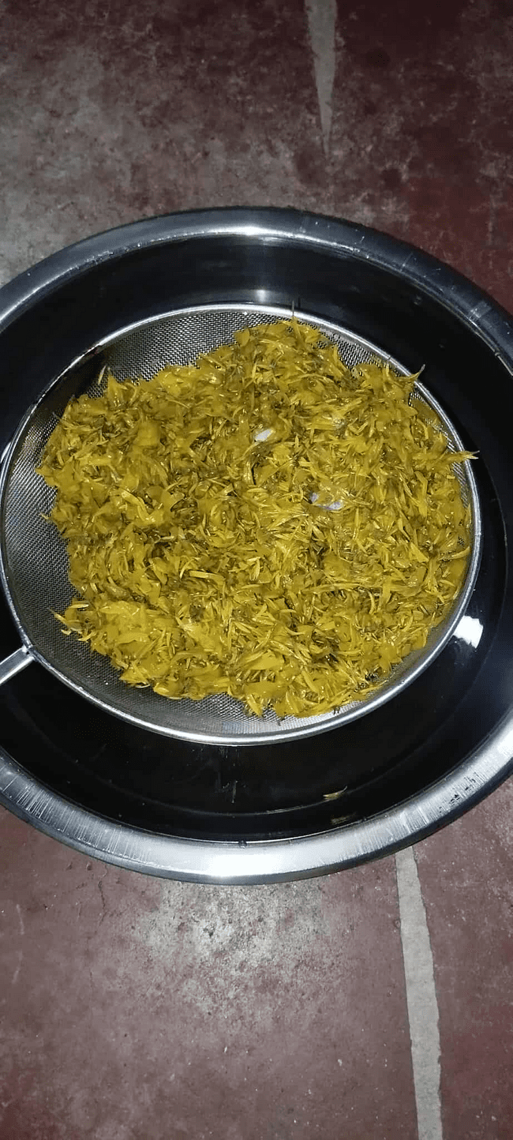 | 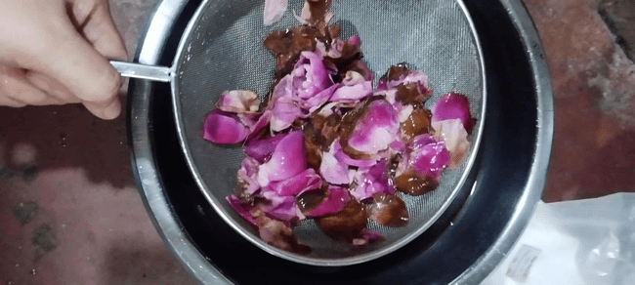
The kaolin clay mixture and cream of tartar solution were gradually poured into the first container containing the pigment solution while stirring continuously. The mixture was left undisturbed for 24 hours to allow the pigment to separate from the liquid.
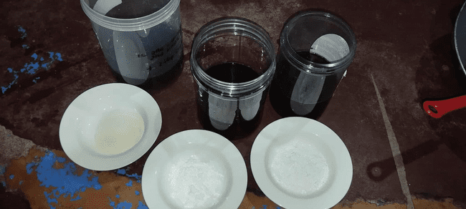
After separation, the mixture was filtered using coffee filter paper to remove excess liquid. The residue containing the pigment was allowed to drain completely for another 24 hours.
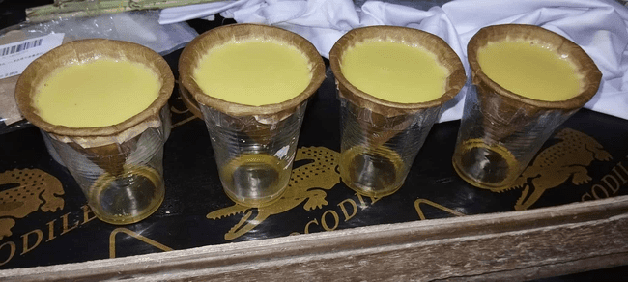 | 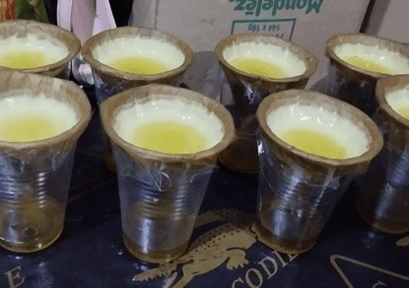 | 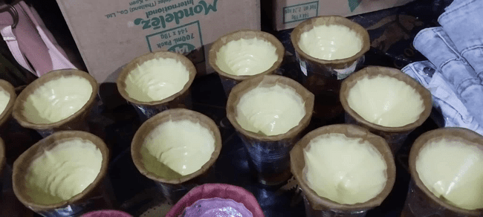
The filtered pigment residue was transferred to a pan and dried in an oven at 100°C for approximately 60 minutes or until completely dry. Once dried, the pigment was ground into a fine powder using a mortar and pestle. The powder was sieved to ensure uniform texture and then stored in airtight containers for use in crayon formulation.
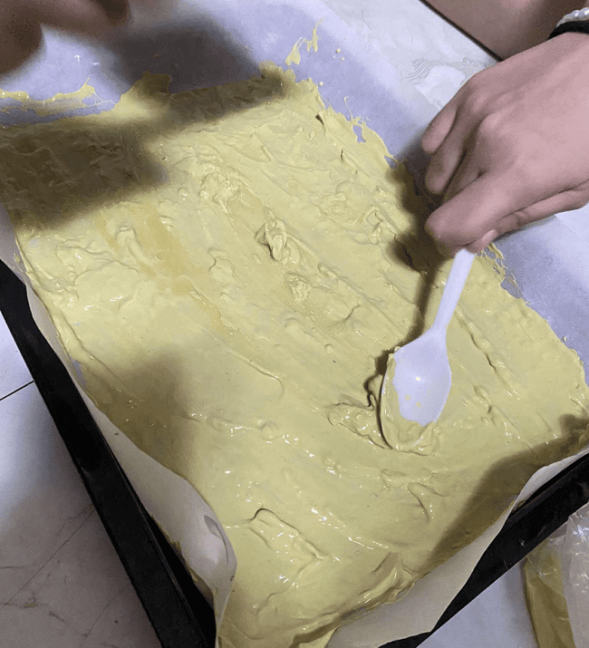 | 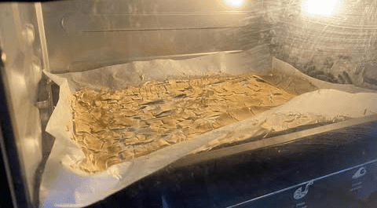
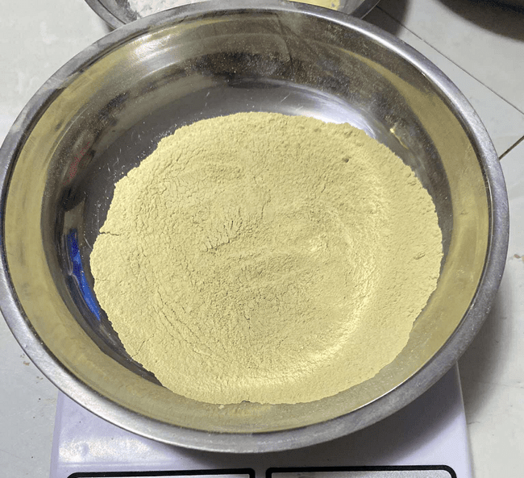

Phase II – Crayon Making
Materials
The following materials were used in the crayon-making process: powdered botanical pigments (from Phase 1), natural waxes such as soy wax, palm wax, beeswax, improvised double boiler, crayon molds, popsicle sticks or wooden spoons, refined shea butter, citrus-scented oil (lemon), dropper.
Procedures
Each crayon formulation used measured amounts of wax (5 g, 10 g, and 15 g) combined with two (2) teaspoons of powdered pigment. The formulations were prepared separately for soy wax, palm wax, and beeswax.
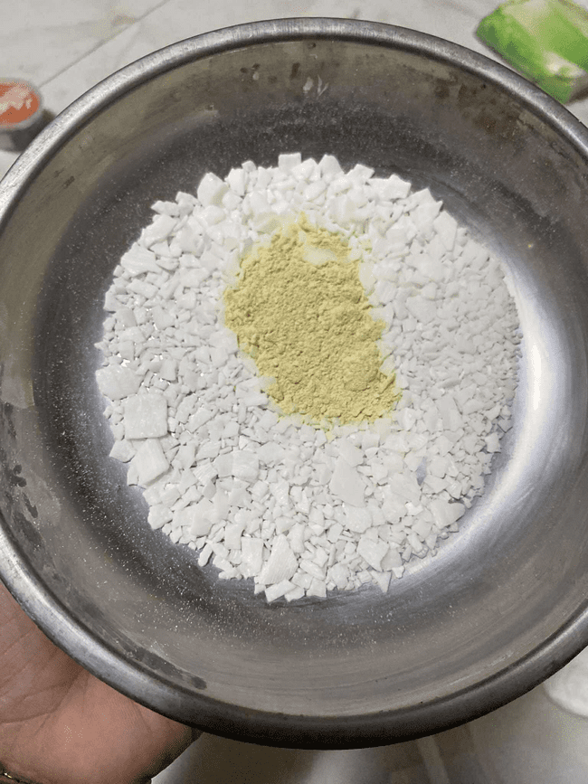 | 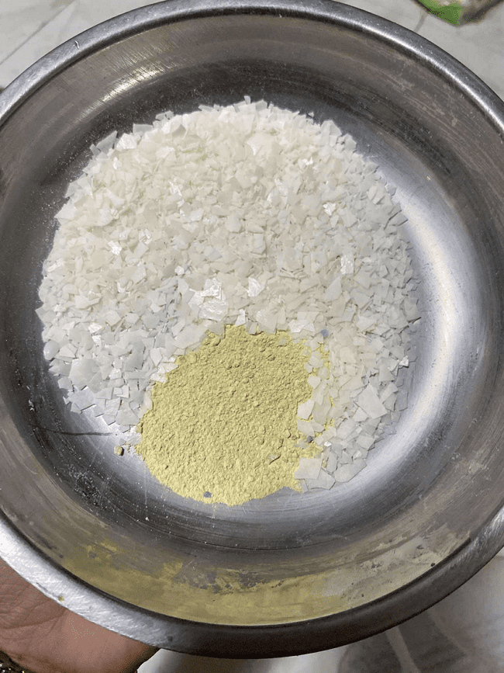 | 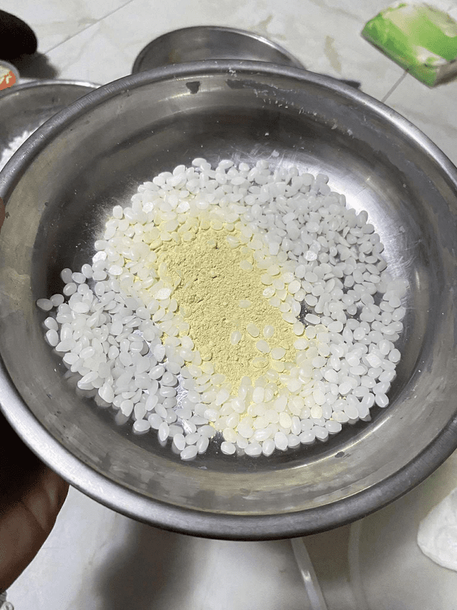
The measured wax was placed in a heat-resistant container and melted using an improvised double boiler to prevent direct heat exposure and ensure even melting. Once the wax was fully melted, the powdered pigment was gradually added while stirring continuously until a uniform mixture was achieved. A small amount of refined shea butter was added to improve smoothness, and a few drops of citrus-scented oil were incorporated for fragrance.
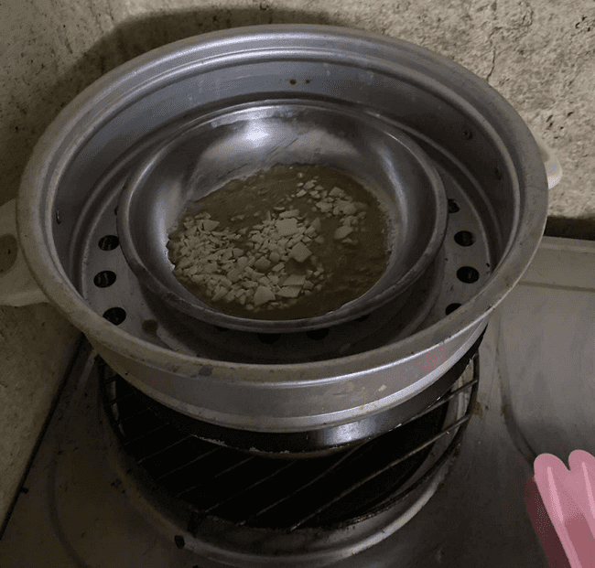
The molten wax–pigment mixture was carefully poured into crayon molds and allowed to cool at room temperature.
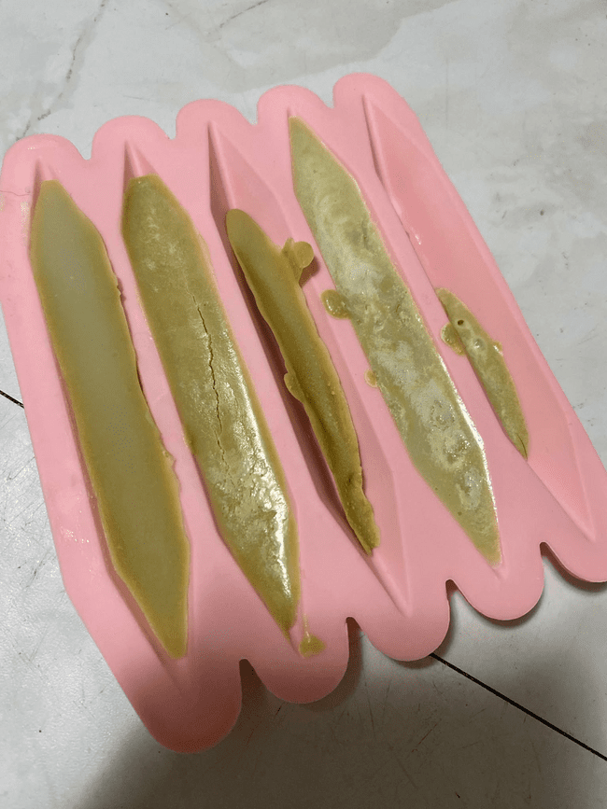
The molded crayons were air-dried for 30 minutes to one hour or until fully solidified. Once hardened, the crayons were removed from the molds and stored in labeled containers for durability and color vibrancy testing.

D. Data Gathering
The following data gathered and computed are arranged in the following table for simpler and easier process of calculation and analysis of variance:

Table 1.1: A table of data from drop test to measure the durability of soy wax, palm wax, and beeswax
Durability Test | Soy Wax |  |  | Palm Wax |  |  | Beeswax
Trials | 5g | 10g | 15g | 5g | 10g | 15g | 5g | 10g | 15g
Mass of Weight (kg)
Number of Break Resistant
Number of Drops
Drop Survival Rate (DSR)
Damage Index (DI)
The researcher utilized this table to systematically gather data from the drop test conducted to determine the durability of the crayons formulated using different types of waxes, namely soy wax, palm wax, and beeswax. Each crayon sample was subjected to three trials at varying gram weights to assess its resistance to breakage upon impact. The multiple trials ensured the reliability and consistency of the results, allowing for a comparative analysis of the durability performance of each wax type under controlled conditions.

The damage index scoring criteria used to evaluate the durability of eco-crayons made from soy wax, palm wax, and beeswax.
Table 2.1: A table of damage index for scoring criteria of durability test for the three waxes.
Damage Index Scoring Criteria for Durability Test
0 | Excellent durability
1 | Very high durability
2 | High durability
3 | Moderate durability
4 | Low durability
5 | Very poor durability
Scores range from 0 to 5, with lower values indicating greater resistance to breakage. During the drop test, each crayon was released from a fixed height, and the extent of damage after impact determined its score. A rating of 0 signifies excellent durability with no visible damage, while 1–2 denote high durability with minor surface marks. A score of 3 indicates moderate durability, and 4–5 reflect low to very poor durability, showing cracks or complete breakage. This index provided a clear, quantitative basis for comparing wax performance and for subsequent ANOVA analysis of durability differences among the samples (Alexander, Rahman, & Bakar, 2021).

Table 3.1: A table of data from colorimeter test to measure the color vibrancy of primary colors such as red, blue, and yellow
RED COLOR
Color Vibrancy Test | Soy Wax |  |  | Palm Wax |  |  | Beeswax
Trials | 5g | 10g | 15g | 5g | 10g | 15g | 5g | 10g | 15g
Perceptual Lightness (l)
Red-Green axis (a)
Yellow-Blue axis (b)
Vibrancy (C)
BLUE COLOR
Trials | 5g | 10g | 15g | 5g | 10g | 15g | 5g | 10g | 15g
Perceptual Lightness (l)
Red-Green axis (a)
Yellow-Blue axis (b)
Vibrancy (C)
YELLOW COLOR
Trials | 5g | 10g | 15g | 5g | 10g | 15g | 5g | 10g | 15g
Perceptual lightness (l)
Red-Green axis (a)
Yellow-Blue axis (b)
Vibrancy (C)
The results of the colorimeter test conducted to measure the color vibrancy of eco-crayons formulated with soy wax, palm wax, and beeswax using pigments extracted from rose (red), butterfly pea (blue), and sunflower (yellow). The colorimeter provided quantitative values for perceptual lightness (L), red-green axis (a), and yellow-blue axis (b), which together determine the overall color vibrancy (C) of each sample.

E. Data Analysis
In analyzing the data, this research will use the one-way ANOVA test. The researcher has decided to choose one-way ANOVA as a statistical tool in order to interpret whether to reject or fail to reject the null hypothesis of the study. The analysis of variance is essentially designated for research whose experimentation processes include three or more conditions (JMP n.d.). In this statistical tool, the alpha value of the analysis is predetermined , 0.05. The F critical value and the variance within and between groups will also be identified.
Table 4.1: The table shows the formula of one-way ANOVA test for the computation of durability test and color vibrancy.
FORMULA OF ONE-WAY ANOVA TEST
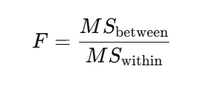
The table presents the formulas to be used in evaluating the durability of soy wax, palm wax, and beeswax through the Drop Weight Testing method. It includes the Drop Survival Rate (DSR), which measures the percentage of drops without failure, and the Damage Index (DI), which calculates the average damage sustained per drop (Habibollahi Najaf Abadi, Herrmann & Modarres, 2023). These formulas help assess the strength and resistance of the wax samples under repeated impact.
Table 5.1: The table shows the formula of the durability test of the soy wax, palm wax, and beeswax for the drop survival test and damage index of the waxes.
FORMULA FOR DURABILITY TEST
(Drop Weight Testing)
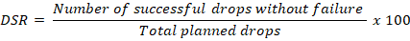
Damage Index
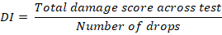
The table presents the formula to be used in the colorimeter test to determine the color vibrancy (C) of pigments extracted from flowers. It illustrates that color vibrancy is calculated using the values of a and b, which represent the chromatic components of color on the red-green and yellow-blue axis, respectively. This formula helps quantify the intensity and purity of the color produced by the natural pigments.

Table 6.1: The table shows the formula of color vibrancy test for the pigments that are extracted from the flowers
FORMULA FOR COLOR VIBRANCY TEST
(Colorimeter Test)
The data gathering procedures were systematically structured to collect accurate and reliable measurements necessary to assess the effectiveness of eco-crayons in terms of durability and color vibrancy. The chapter clearly outlines how the data were obtained using standardized experimental methods such as drop testing for durability and colorimeter testing for pigment vibrancy. Each test was carefully designed to observe how different wax types (soy wax, palm, and beeswax) and varying concentrations affected the performance of the formulated crayons.
The gathered data were organized into detailed tables to ensure clarity and comparability among the three was groups. The recorded data serve as the foundation for statistical analysis using one-way ANOVA, which helped determine whether the differences observed among the wax formulations were statistically significant. Overall, the data gathering process demonstrates a rigorous and methodical approach, ensuring that the information collected is valid, quantifiable, and aligned with the research objectives.

Chapter 3
RESULTS AND DISCUSSIONS
Figure 2.1: A graph showing the break resistant results of the 3 waxes such as soy wax, palm wax and beeswax
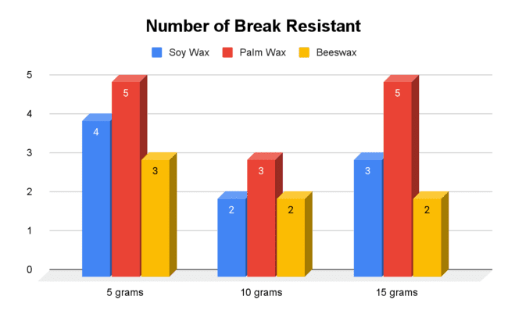
The data above present the results of the durability test on soy wax, palm wax, and beeswax using drop weight testing. Palm wax exhibited the highest break resistance, indicating it can withstand greater stress before breaking. However, beeswax demonstrated superior overall durability. Based on the Drop Survival Rate (DSR) and Damage Index (DI), beeswax achieved a 100% DSR and the lowest DI of 2, reflecting excellent impact resistance and minimal damage. In contrast, soy wax and palm wax showed higher DI values and lower DSRs, making them more susceptible to cracking or breaking. Overall, while palm wax resists breaking under stress, beeswax maintains the greatest integrity during repeated drops, making it the most durable of the three.
Figure 3.1: A graph showing the red-green axis (a) of color vibrancy results of red pigments that are extracted from roses
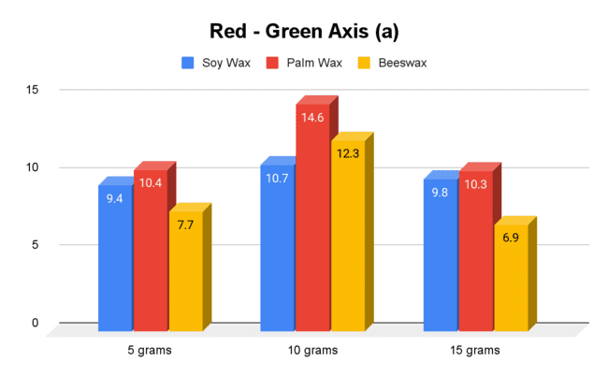
The graph illustrates the red-green axis (a) values of red pigments extracted from roses for eco-crayons made with soy wax, palm wax, and beeswax at concentrations of 5g, 10g, and 15g. The results show that palm wax consistently produced higher red intensity across all concentrations, with a peak at 10g (14.6), followed closely by soy wax (10.7) and beeswax (12.3). Medium concentrations (10g) generally yielded the highest red vibrancy, suggesting that an optimal wax-to-pigment ratio enhances color saturation. Beeswax showed lower a-values, indicating reduced pigment visibility compared to the other waxes. Overall, the data indicate that both wax type and concentration influence the red hue intensity in eco-crayons, with palm wax demonstrating the strongest enhancement of red vibrancy.
Figure 4.1: A graph showing the yellow-blue axis (b) of color vibrancy results of blue pigments that are extracted from butterfly pea
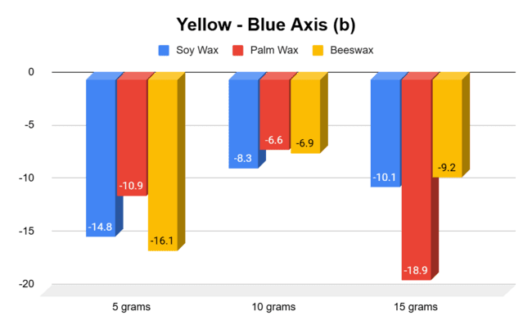
The results of the color vibrancy test for blue pigments show that the interaction between natural pigments and different wax formulations significantly affected the visibility, depth, and intensity of the blue color in eco-crayons. Data trends reveal variations in lightness, chromatic coordinates, and vibrancy, reflecting differences in each wax’s ability to retain and project the pigment. Graphs support these findings, with some waxes producing deeper, more saturated blues, while others yield lighter or less intense shades. Overall, both the type and amount of wax play a key role in color retention and brightness, emphasizing the importance of wax selection for achieving high visual quality in eco-friendly crayons.
Figure 5.1: A graph showing the yellow-blue axis (b) of color vibrancy results of yellow pigments that are extracted from sunflower
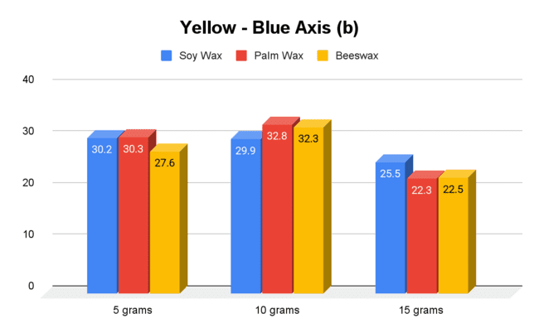
The bar graph illustrates the yellow-blue axis (b) values for yellow pigments extracted from sunflowers, formulated with three different waxes: soy wax, palm wax, and beeswax, across three concentrations (5 g, 10 g, and 15 g). At 5 grams, palm wax and soy wax exhibit similar vibrancy (30.3 and 30.2, respectively), while beeswax shows a slightly lower value (27.6). Increasing the concentration to 10 grams, all waxes show an increase in b values, with palm wax peaking at 32.8, beeswax at 32.3, and soy wax at 29.9, indicating enhanced yellow intensity. At 15 grams, the vibrancy decreases across all waxes, with soy wax at 25.5, palm wax at 22.3, and beeswax at 22.5, suggesting a potential saturation effect that reduces the yellow-blue axis values at higher pigment concentrations. Overall, the graph indicates that the wax type and pigment concentration influence the yellow vibrancy of sunflower-based eco-crayons, with palm wax generally producing the highest b values at moderate concentrations.
The results of the one-way ANOVA test for the durability of eco-crayons using soy wax, palm wax, and beeswax. It consolidates the computed values, degrees of freedom, mean squares, F-ratio, and decision on the null hypothesis.
Table 7.1: ANOVA Summary Table (Source of Variation)
Source of Variation | Sum of Squares (SS) | Degrees of Freedom (df) | Variation (MS) | Actual F Value | Tabular F Value
Between Groups | 6.22 | 2 | 3.11 | F = 3.46 | a = 0.05  Fcrit = 5.14
Within Groups | 5.34 | 6 | 0.89 | F = 3.46 | a = 0.05  Fcrit = 5.14
Total | 11.56 | 8 | 3.46 < 5.14; Hence, H0 is failed to reject the null hypothesis.
The analysis shows that the computed F-value (3.46) is less than the F-critical value (5.14) at α = 0.05, leading to the decision to not reject the null hypothesis. Therefore, the differences in durability among the three wax formulations are statistically insignificant. This confirms that all wax types of soy, palm, and beeswax exhibit comparable durability levels suitable for eco-crayon production.
The ANOVA summary for red color vibrancy among the three waxes. It collected data from the red-green axis using the colorimeter and computed the sum of squares, degree of freedom and mean of squares to get the results.
Table 8.1: Statistical Test Summary
Source of Variation | Sum of Squares (SS) | Degrees of Freedom (df) | Variation (MS) | Actual F Value | Tabular F Value
Between Groups | 12.07 | 2 | 6.035 | F = 1.21 | a = 0.05  Fcrit = 5.14
Within Groups | 29.87 | 6 | 4.978 | F = 1.21 | a = 0.05  Fcrit = 5.14
Total | 41.94 | 8 | 1.21<5.14; Hence, H0 is failed to reject the null hypothesis.
The computed F-value (1.21) is lower than the critical F-value (5.14) at a 0.05 significance level, meaning there is no statistically significant difference among waxes. Although palm wax showed slightly higher visual vibrancy, the variations are not significant enough statistically. This implies that all three waxes, soy, palm, and beeswax can produce comparable red color quality in eco-crayons.
The ANOVA results for blue color vibrancy conducted to assess differences among the three experimental groups.
Table 9.1: Statistical test summary
Source of Variation | Sum of Squares (SS) | Degrees of Freedom (df) | Variation (MS) | Actual F Value | Tabular F Value
Between Groups | 3.2 | 2 | 1.6 | F = 0.66 | a = 0.05  Fcrit = 5.14
Within Groups | 146.31 | 6 | 24.39 | F = 0.66 | a = 0.05  Fcrit = 5.14
Total | 149.51 | 8 | 0.66<5.14; Hence, H0 is failed to reject the null hypothesis.
The computed F-value (0.66) is lower than the critical F-value (5.14) at the 0.05 significance level, indicating no significant difference in blue vibrancy among the wax types. While soy wax produced the most vivid color visually, the statistical test confirms that all three waxes perform comparably in rendering blue tones. Thus, each formulation is equally suitable for eco-crayon production using butterfly pea pigment.
Table 10.1: A table showing the one-way ANOVA results for the color vibrancy of the color yellow using pigments from Sunflower
Source of Variation | Sum of Squares (SS) | Degrees of Freedom (df) | Variation (MS) | Actual F Value | Tabular F Value
Between Groups | 2.45 | 2 | 1.23 | F = 0.059 | a = 0.05  Fcrit = 5.14
Within Groups | 124.03 | 6 | 20.67 | F = 0.059 | a = 0.05  Fcrit = 5.14
Total | 126.48 | 8 | 0.059 < 5.14; Hence, H0 is failed
The computed F-value (0.059) is lower than the critical F-value (5.14) at the 0.05 significance level, indicating no significant difference among the wax types. Although soy wax displayed slightly higher brightness and consistency, the results imply that all three waxes perform similarly in producing yellow hues from sunflower pigments. Hence, each formulation can be considered equally effective for eco-crayon production.

Chapter 4
DISCUSSION
The study confirmed that eco-crayons can be successfully produced using natural pigments from rose, butterfly pea, and sunflower flowers combined with natural waxes such as soy wax, beeswax, and palm wax. The experimentation demonstrated that these natural materials can yield crayons with desirable functional properties durability, smooth application, and vibrant color while eliminating the environmental and health risks associated with petroleum-based products.
Although statistical analysis revealed no significant difference among the three wax types, the results suggest that all formulations are viable for safe and sustainable crayon production. These findings highlight the potential of natural waxes and botanical pigments as eco-friendly alternatives in educational art materials. Beyond product development, this study underscores the importance of integrating environmental sustainability and material innovation into classroom resources, promoting safer learning environments and fostering ecological awareness among young learners.

Chapter 5
RECOMMENDATIONS
Educators are encouraged to integrate eco-crayons into science and art curricula to promote hands-on learning that connects environmental awareness with creative expression. By allowing students to use eco-crayons made from natural pigments and waxes, teachers can foster an appreciation for sustainable materials, demonstrate the principles of biochemistry and environmental science, and nurture a sense of responsibility toward ecological conservation. Schools may also adopt this project as a practical activity in laboratory experiments or entrepreneurship programs, allowing learners to create their own eco-crayons as part of lessons on recycling, sustainability, or innovation in the classroom.
For parents, it is recommended to encourage the use of eco-crayons at home as a safe alternative to commercial crayons that may contain synthetic or petroleum-based chemicals. Doing so not only supports children’s creativity but also helps reduce chemical exposure and cultivates early awareness of environmentally friendly practices in everyday life.
Future researchers are advised to explore other sources of natural pigments, such as leaves, tree bark, turmeric, and onion skins, to expand the color range of eco-crayons. Further studies could also examine the use of alternative natural waxes such as candelilla wax, carnauba wax, or rice bran wax to enhance durability, texture, and color performance. It is also recommended to evaluate the biodegradability, color fastness, and storage stability of eco-crayons to better assess their long-term sustainability. Comparative studies between eco-crayons and commercial brands could provide valuable data on safety, cost-effectiveness, and performance. Additionally, future initiatives may involve community-based livelihood programs, where the production of eco-crayons can be a small-scale enterprise promoting both education and environmental protection.
Through continued research and classroom implementation, this project can serve as a model for integrating sustainability education into the basic curriculum, inspiring students, teachers, and communities to take active roles in promoting green innovation and environmental stewardship.

BIBLIOGRAPHY
Adaniel, B. A., Agustin, A.M., Berbaña, C.M. P., Biona, J. L., Daga-as, S. A.,
Fuentes, R B., Gabo, J. X. J., Gonzales, I. S. M., Maningo, S. P. O.,
Quillan, K. M. V., & Valenzuela, J. P. S. (2023). Eco-lors: Crayon crafting
through natural organic pigments \[Practical Research 2 – Quantitative
Research, Senior High School]. Balasan National High School. Studocu.
https://www.scribd.com/document/770435782/amo-nani-sa-maam-1](https
://www.scribd.com/document/770435782/amo-nani-sa-maam-1)

Alexander, I., Sodri, A., & Mizuno, K. (2023). The effect of different natural waxes
to hydrophobic properties of starch-based biodegradable foams. Journal
of Environmental Science and Sustainable Development, 6(1), 86-101.
https://scholarhub.ui.ac.id/jessd/vol6/iss1/7/?

Alexander, I., Rahman, N., & Bakar, S. (2021). The effect of different
natural waxes on the physical and mechanical properties of eco-friendly
crayons. Journal of Environmental Science and Sustainable Development,
4(2), 45–58.
https://scholarhub.ui.ac.id/cgi/viewcontent.cgi?article=1199&context=jessd

Arisgado, J. S. C., Saldia, J. B., Gabao, P. M. U., Lopez, H. K. U., Nabong, A. J.
S., Paje, A. J. N., Reyes, T. P. S., Globo, J. B., & Rivera, B. L. (2025).
Feasibility of producing crayons using paprika as natural pigment and
beeswax as binder [Unpublished practical research]. Arellano University
Juan Sumulong Campus. https://www.studocu.com/ph/document/don-honorio-ventura-technological-state-university/practical-research/paprika-beeswax-as-crayons/83151290?utm

Banias, M., & Ciudad, K. (2023). Natural red lake pigments extraction from
selected plants in Agusan Del Norte, Philippines: Characterization using
Fourier transform infrared spectroscopy. Journal of Ecosystem Science.
https://journals.carsu.edu.ph/JESEG/article/view/67?

Becchi, M. (2021). Oyasai crayons: Vegetable-based art materials for children.
Designboom.
https://www.designboom.com/design/oyasai-crayons-vegetable-based-art-
materials-for-children-05-28-2021/

Consumer Council. (2021, May 17). Over 50% children’s art supplies found to
release toxic metal substances: 7 tested crayon models contain PAHs
posing safety risks [Press release]. Consumer Council.
https://www.consumer.org.hk/en/press-release/535-children-art-material

DepEd Memorandum No. 024, s. 2019: National Search for Sustainable and
Eco-Friendly Schools. Department of Education.
https://www.deped.gov.ph/wp-content/uploads/2019/03/DM_s2019_024.pdf

Formosa Publisher. (2023). The effect of coloring activities on fine motor
development of kindergarten children. International Journal of Academic Research, 5(2), 45–52. https://journal.formosapublisher.org/index.php/ijar/article/view/6909

Habibollahi Najaf Abadi, H., Herrmann, J. W., & Modarres, M. (2023). Measuring
and indexing the durability of electrical and electronic equipment.
Sustainability, 15(19), 14386. https://doi.org/10.3390/su151914386

Hickey, M., & King, C. (2000). The Cambridge illustrated glossary of botanical
terms. Cambridge University Press.
https://books.google.com.ph/books/about/The_Cambridge_Illustrated_Glo
ssary_of_Bo.html?id=0Yja1lL_pJYC&redir_esc=y

JMP. (n.d.). One-Way ANOVA | Introduction to Statistics. Retrieved from
https://www.jmp.com/en/statistics-knowledge-portal/one-way-anova

Leung, G. (2021, May 17). Not so flying colours: Hong Kong watchdog finds half
of crayons tested contain harmful petroleum derivatives. South China
Morning Post.
https://www.scmp.com/news/hong-kong/health-environment/article/313375
1/not-so-flying-colours-hong-kong-watchdog-finds

Magramo, K. (2021, May 17). Hong Kong watchdog finds harmful petroleum
compounds in children’s crayons and paints. CNN Philippines.
https://www.cnnphilippines.com/news/2021/5/17/crayons-paints-harmful-p
Etroleum-compounds.html

National Library of Medicine. (2023, March 13). Polycyclic aromatic hydrocarbons
(PAHs) exposure and child neurodevelopment: A meta-analysis. PubMed.
https://pubmed.ncbi.nlm.nih.gov/36931089/

Neddo, N. (2020). The organic artist for kids: A hands-on guide to creativity with
natural materials. Quarry Books. https://www.quarto.com/books/9781631597671/The-Organic-Artist-for-Kids?utm

Romero, S., Minari, R. J., & Collins, S. E. (2021). Bio-paraffin from soybean oil as
an eco-friendly alternative to mineral waxes. *Industrial & Engineering
Chemistry Research, 60*(15), 5364–5373.
https://pubs.acs.org/doi/abs/10.1021/acs.iecr.1c00322

Ryu, A. (2024). Experimental research design in eco-friendly material formulation
studies. Journal of Applied Science in Education, 4(2), 45–58.

Saldia, J. B., Arisgado, J. S. C., Gabao, P. M. U., Lopez, H. K. U., Nabong, A. J.
S., Paje, A. J. N., Reyes, T. P. S., Globo, J. B., Rivera, B. L. (2024).
Effectiveness of paprika & beeswax as crayons: A study for SHS students
of Arellano University Juan Sumulong Campus \[Unpublished practical
research]. Don Honorio Ventura Technological State University.
https://www.studocu.com/ph/document/don-honorio-ventura-technological-
state-university/practical-research/paprika-beeswax-as-crayons/83151290

Smilogy Kids. (n.d.). Why we chose beeswax: The unique properties of beeswax.
Smilogy Kids.
https://www.smilogykids.com/blogs/smilogy-blog-news-updates-and-produ
ct-information/why-we-chose-beeswax-the-unique-properties-of-beeswax

Universiti Teknikal Malaysia Melaka. (2024). Production of safe and natural wax crayons using botanical extracts [Research report]. Universiti Teknikal Malaysia Melaka Repository. https://digitalcollection.utem.edu.my/32841/?utm

