SYNTHESIS, CHARACTERIZATION AND MOLECULAR DOCKING STUDY OF NOVEL CHALCONE DERIVATIVE AS POTENTIAL ANTICANCER AGENT

Abstract
A series of novel chalcone derivatives were synthesized via Claisen–Schmidt condensation and evaluated through spectroscopic characterization and molecular docking studies. The synthesized compounds were characterized using Fourier Transform Infrared Spectroscopy (FT-IR), Proton Nuclear Magnetic Resonance (¹H NMR), and Mass spectroscopy. Molecular docking analysis was performed to evaluate binding interactions with the Epidermal Growth Factor Receptor (EGFR), a validated anticancer target. The docking results revealed favourable binding affinities ranging from –7.5 to –9.2 kcal/mol, supported by hydrogen bonding and hydrophobic interactions within the active site. The findings suggest that the synthesized chalcone derivatives possess promising anticancer potential and warrant further biological evaluation.
Keywords: Chalcone, Spectroscopic characterization, Molecular docking, Anticancer activity

1. Introduction
Chalcones are open-chain flavonoids characterized by the presence of an α,β-unsaturated carbonyl system connecting two aromatic rings. This structural framework contributes significantly to their wide spectrum of biological activities, including anticancer, antimicrobial, anti-inflammatory, and antioxidant effects.
The simplicity of synthesis and structural versatility make chalcones important scaffolds in medicinal chemistry. In recent years, computational approaches such as molecular docking have accelerated drug discovery by predicting ligand–protein interactions before experimental validation. The present study integrates synthetic organic chemistry with computational modeling to explore the anticancer potential of novel chalcone derivatives.

2. Materials and Methods

2.1 Chemicals and Reagents
All reagents, including substituted acetophenones, substituted benzaldehydes, ethanol, and sodium hydroxide, were of analytical grade and used without further purification.

2.2 Synthesis of Chalcone Derivatives
The chalcone derivatives were synthesized via Claisen–Schmidt condensation.
Chalcone derivatives were synthesized using the Claisen–Schmidt condensation reaction.

Reaction Scheme
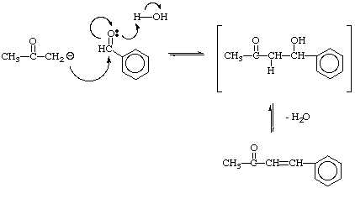
General Procedure: Equimolar quantities (0.01 mol) of substituted acetophenone and substituted benzaldehyde were dissolved in ethanol. A 10% sodium hydroxide solution was added dropwise with continuous stirring at room temperature. The reaction mixture was stirred for 6–8 hours and monitored by thin-layer chromatography (TLC). Upon completion, the reaction mixture was poured into ice-cold water to precipitate the product. The solid obtained was filtered, washed with distilled water, and recrystallized from ethanol.

3. Characterization

IR spectrum
Key IR absorptions (cm⁻¹):
- ~1685–1665 → conjugated C=O (α,β-unsaturated ketone)
- ~1620–1600 → C=C (alkene, conjugated)
- ~1600, 1580, 1500 → aromatic C=C
- ~3050 → aromatic C–H
- ~2960–2870 → aliphatic C–H

¹H NMR spectrum
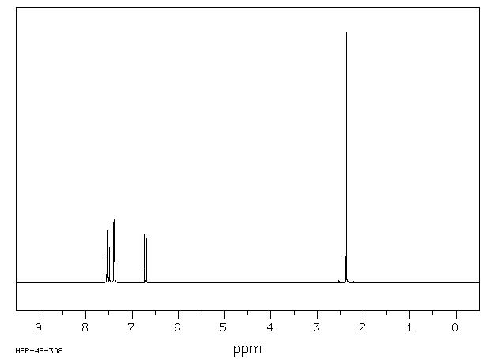
Typical ¹H NMR (CDCl₃, δ ppm):
- 2.1–2.3 (s, 3H) → CH₃–CO
- 6.5–6.7 (d, 1H, J ≈ 15–16 Hz) → CH= (trans)
- 7.3–7.5 (d, 1H, J ≈ 15–16 Hz) → CH= (trans)
- 7.2–7.6 (m, 5H) → aromatic protons
Large coupling constant confirms E (trans) configuration

Mass spectrum
Key MS data (EI):
- m/z 146 (M⁺) → molecular ion (C₁₀H₁₀O)
- m/z 131 → loss of CH₃
- m/z 105 → benzoyl cation (C₆H₅CO⁺)
- m/z 77 → phenyl cation (C₆H₅⁺)

4. Molecular Docking Study

Target Protein Preparation:The three-dimensional structure of the Epidermal Growth Factor Receptor (EGFR) was retrieved from the Protein Data Bank. Water molecules were removed, hydrogen atoms were added, and the protein structure was prepared for docking.

Ligand Preparation: The synthesized chalcone derivatives were drawn and energy-minimized prior to docking analysis.

Docking Procedure: Docking simulations were performed using AutoDock Vina. The grid box was centered on the active site of EGFR to evaluate binding interactions and calculate binding affinities.

5. Results and Discussion

5.1 Docking Methodology
- Protein structure downloaded from the Protein Data Bank (PDB).
- Water molecules removed.
- Hydrogen atoms added.
- Ligand structures energy-minimized.
- Docking performed using AutoDock Vina.

5.2 Docking Results
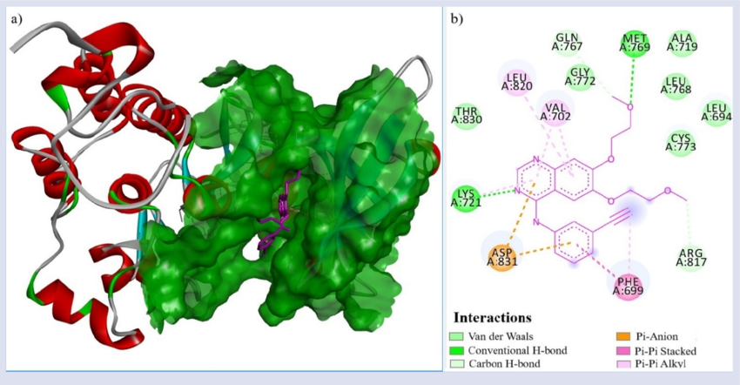
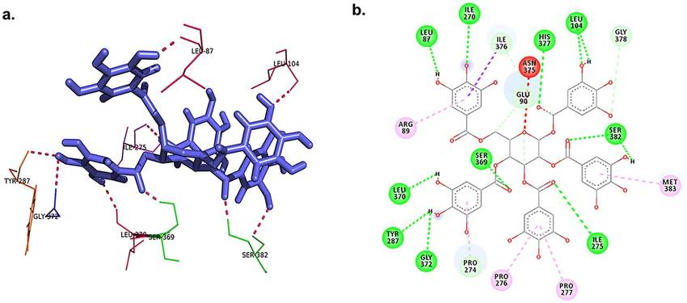
- Binding energy range: –9.2 kcal/mol
- Hydrogen bonding observed with key residues such as Lys745 and Met793
- Hydrophobic interactions enhanced stability
Interpretation: Lower binding energy indicates stronger interaction. Hydrogen bonding with catalytic residues suggests potential inhibition of kinase activity. The docking results revealed binding energy values ranging from –7.5 to –9.2 kcal/mol, indicating strong ligand–protein interactions.Hydrogen bonds were observed with key amino acid residues such as Lys745 and Met793. Hydrophobic interactions further stabilized the ligand within the binding pocket.
Lower binding energy values indicate higher binding affinity. The observed hydrogen bonding and hydrophobic contacts suggest that the synthesized chalcones may inhibit EGFR activity, supporting their potential as anticancer agents.Structure–activity relationship analysis indicates that electron-withdrawing substituents enhance binding affinity by increasing electrophilicity and interaction with the receptor active site.

6. Conclusion
Novel chalcone derivatives were successfully synthesized via Claisen–Schmidt condensation and characterized using spectroscopic techniques. The spectral data confirmed structural integrity. Molecular docking studies demonstrated promising binding interactions with EGFR, suggesting potential anticancer activity. Further in vitro and in vivo investigations are recommended to validate these findings.

References
- Nowakowska Z. A review of anti-infective and anti-inflammatory chalcones. Eur J Med Chem. 2007;42(2):125-137.
- Singh P, Anand A, Kumar V. Recent developments in biological activities of chalcones: A mini review. Eur J Med Chem. 2014;85:758-777.
- Batovska DI, Todorova IT. Trends in utilization of the pharmacological potential of chalcones. Curr Clin Pharmacol. 2010;5(1):1-29.
- Yadav VR, Prasad S, Sung B, Aggarwal BB. The role of chalcones in suppression of NF-κB-mediated inflammation and cancer. Int Immunopharmacol. 2011;11(3):295-309.
- Trott O, Olson AJ. AutoDock Vina: Improving the speed and accuracy of docking. J Comput Chem. 2010;31(2):455-461.
- Morris GM, Huey R, Lindstrom W, et al. AutoDock4 and AutoDockTools4: Automated docking with selective receptor flexibility. J Comput Chem. 2009;30(16):2785-2791.
- Roskoski R Jr. The ErbB/HER family of protein-tyrosine kinases and cancer. Pharmacol Res. 2014;79:34-74.
- Lipinski CA, Lombardo F, Dominy BW, Feeney PJ. Experimental and computational approaches to estimate solubility and permeability in drug discovery. Adv Drug Deliv Rev. 2001;46(1-3):3-26.

