Research article
BIOACTIVE POTENTIAL OF LEAF, FRUIT AND BARK EXTRACTS OF FICUS SEMICORDTA AN IN VITRO ANALYSIS
ABSTRACT
Medicinal plants are valuable sources of bioactive compounds with therapeutic potential. Ficus semicordata is commonly used in India and Nepal to treat digestive issues, infections, inflammation, and liver diseases. This study examines the phytochemical makeup, antioxidant activity, and antimicrobial potential of methanolic extracts from the fruit, leaf, and bark of Ficus semicordata. Qualitative phytochemical screening showed the presence of key secondary metabolites like alkaloids, terpenoids, phenolic compounds, and glycosides. We assessed antioxidant activity using the DPPH radical scavenging assay, where the leaf extract demonstrated strong free radical scavenging activity compared to the fruit and bark extracts. We evaluated antibacterial and antifungal activities using the agar well diffusion method against selected bacterial and fungal strains. Among the samples tested, the bark extract showed significant antibacterial activity, while all extracts exhibited measurable antifungal effects. These findings support the traditional medicinal uses of Ficus semicordata and suggest that it might be a useful natural source of antioxidant and antimicrobial agents. Further studies should aim to isolate and identify the active compounds responsible for these biological effects.
KEYWORDS: Ficus semicordata, Phytochemicals, Antioxidant activity, Antimicrobial activity, DPPH assay, Methanolic extract.
1. INTRODUCTION
Medicinal plants have been used for centuries in traditional healthcare systems such as Ayurveda and Siddha for the treatment of various diseases. Even today, a large portion of the global population depends on plant-based medicines because they are affordable, accessible, and considered to have fewer side effects. The therapeutic value of medicinal plants mainly comes from the presence of phytochemicals such as alkaloids, flavonoids, phenolic compounds, terpenoids, tannins, and glycosides. These secondary metabolites have important biological activities such as antioxidant, antimicrobial, anti-inflammatory, and anticancer properties (Cowan et al., 1999).
The genus Ficus is part of the family (Moraceae) and includes more than 750 species found in tropical and subtropical regions. Many Ficus species are known for their nutritional, ecological, and medicinal importance. Ficus semicordata is an ethnomedicinal plant commonly found in the Himalayan region and northeastern parts of India. It is locally known as drooping fig or khanayo and has been traditionally used to treat digestive problems, liver disorders, wounds, skin infections, and inflammatory conditions (Lansky et al., 2008).
Different parts of Ficus semicordata including fruit, leaves, bark, roots, and latex are used in folk medicine. The fruits are edible and considered nutritious, especially during food scarcity. The bark and leaves are used for wound healing and infections, while the latex is applied to treat some skin diseases and parasitic infections. These traditional uses suggest that the plant contains biologically active compounds with therapeutic potential (Sharma et al., 2011).
Oxidative stress caused by free radicals is associated with several chronic diseases including cancer, diabetes, and cardiovascular disorders. Natural antioxidants from plants can neutralize free radicals and protect cells from damage. The rise in antibiotic resistance among pathogenic microorganisms has increased the need for alternative antimicrobial agents from natural sources. Scientific evaluation of the antioxidant and antimicrobial properties of medicinal plants has gained great importance (Halliwell et al., 1995).
Ficus semicordata has been widely used in traditional medicine, but few scientific studies have compared the phytochemical composition and biological activities of its fruit, leaf, and bark. A comparative study is essential because different plant parts can vary in their chemical constituents and potency (Saxena et al., 2013).
2.MATERIALS AND METHODS
2.1. Collection and Processing of Plant Materials
Fresh samples of Ficus semicordata fruit, leaves, and bark were obtained from a healthy and full-grown plant. The plant materials were recognized based on their morphological features. To prevent any differences among the plant materials, the samples were thoroughly washed with distilled water to remove dust and foreign particles(Gamble et al., 1915).
The fruit, leaf, and bark samples obtained from Ficus semicordata were separately shade-dried at room temperature until a constant weight was achieved. The drying process was conducted in the shade to prevent the breakdown of heat-sensitive phytochemicals. Once the drying process was completed, the plant materials were ground separately into a fine powder using a mechanical grinder(Hooker et al., 1872). All three plant materials were processed under similar conditions to enable a comparative assessment of their phytochemical and biological properties(Matthew et al., 1983).
2.2. Preparation of Methanolic Extracts
Methanolic extraction was performed using the cold maceration technique to retain heat-sensitive compounds. A 10g quantity of each powdered plant part (fruit, leaf, and bark) was separately packed in 100ml of analytical grade methanol in sterile conical flasks at a 1:10 w/v ratio(Harborne et al., 1998).
The samples were left to shake on a rotary shaker for 24 hours at room temperature to enable efficient extraction of bioactive compounds. The resulting extracts were filtered using Whatman No.1 filter paper to separate plant debris. The filtered extracts were then concentrated by evaporation of the solvent at room temperature(Sofowora et al., 2008). The dried crude extracts of the fruit, leaf, and bark samples were quantitatively measured to determine the yield of the extracts and stored at 4°C until further analysis. The extraction process was done under the same conditions of solvent concentration and time to enable a fair comparison of the three plant parts(Azwanida et al., 2015).
2.3. Preliminary Phytochemical Screening
Qualitative phytochemical screening of the methanolic extracts of fruit, leaf, and bark samples was done to check for the presence of major secondary metabolites. Routine biochemical tests were conducted to check for the presence of alkaloids, flavonoids, tannins, phenolic compounds, terpenoids, saponins, glycosides, carbohydrates, and proteins(Trease and Evans et al., 2009). The same test conditions were applied to each extract, and the development of specific color or precipitates confirmed the presence of specific compounds. The development of color was comparatively estimated among fruit, leaf, and bark extracts to assess the relative phytochemical content. The comparative screening helped in gaining preliminary information regarding the differences in secondary metabolites among different parts of the plant(Kokate et al., 1994).
2.4. UV-Visible Spectroscopic Analysis
The methanolic extracts of fruit, leaf, and bark samples were analyzed for UV-Visible spectroscopy to characterize the bioactive compounds. The dried extracts were re-dissolved in methanol, filtered, and analyzed using a UV-Visible spectrophotometer in the wavelength range of 200-800 nm. Methanol was used as the blank sample(Silverstein et al., 2005 Skoog et al., 2018). The absorption maxima (λmax) values were determined for each sample. The presence of peaks in the UV region (200-400 nm) indicated the presence of phenolic compounds and flavonoids, whereas the presence of peaks in the visible region indicated the presence of conjugated systems and other chromophoric groups.The differences in phytochemical composition of fruit, leaf, and bark samples were analyzed by comparing the spectral patterns.
2.5.Determination of Antioxidant Activity
DPPH Radical Scavenging Assay
The antioxidant activity of the extracts was determined by the DPPH (2,2-diphenyl-1-picrylhydrazyl) radical scavenging assay. A 0.1 mM DPPH solution was prepared in methanol. Different concentrations of fruit, leaf, and bark extracts were reacted with the DPPH solution and allowed to stand in the dark at room temperature for 30 min(Brand-Williams et al., 1995). The decrease in absorbance was measured at 517 nm using a UV-Visible spectrophotometer. Ascorbic acid was used as the standard antioxidant. The percentage inhibition of DPPH radicals was calculated using the formula:
The formula: % inhibition = [(A_control – A_sample) / A_control] × 100
The IC₅₀ values were determined from dose-response curves.
The comparative antioxidant activity of the three plant parts was determined by comparing the percentage inhibition and IC₅₀ values(Blois et al., 1958).
2.6.Evaluation of antibacterial activity
The antibacterial potential of the methanolic extracts was evaluated for Gram-positive and Gram-negative bacteria such as Escherichia coli, Pseudomonas aeruginosa, Staphylococcus aureus, and Enterococcus faecalis by the agar well diffusion method.Mueller-Hinton Agar plates were uniformly inoculated with bacterial cultures. Wells of 6 mm diameter were aseptically punched, and specific concentrations of each extract were placed in the wells. Tetracycline was used as the positive control, and methanol was used as the negative control. The plates were incubated at 37°C for 24 h, and the zones of inhibition were measured in millimeters(Bauer et al., 1966).Comparative antibacterial activity was evaluated by comparing the differences in the sizes of the inhibition zones for fruit, leaf, and bark extracts.
2.7.Evaluation of Antifungal Activity
The antifungal activity was assessed by the agar well diffusion method for Candida albicans and Candida krusei. The Potato Dextrose Agar plates were inoculated with fungal cultures, and wells were made aseptically. The samples were added to the wells in varying concentrations, while fluconazole was used as the positive control for antifungal activity(CLSI et al., 2017).
The plates were incubated at 28°C for 48-72 h.
The antifungal activity was compared based on the measurement of the inhibition zone.
3.RESULTS AND DISCUSSION
The species Ficus semicordata Buch.-Ham. ex Sm. is a somewhat less well-known species of the fig family, but it has received a lot of attention due to its traditional use in the treatment of infections, inflammation, and conditions caused by oxidative stress. The plant parts, especially the fruits, leaves, and bark, contain a large number of secondary metabolites such as alkaloids, flavonoids, tannins, and terpenoids. As mentioned in pharmacognosy, these compounds have been widely acknowledged for their antimicrobial and antioxidant properties. Phytochemical screening of the plant would be helpful in identifying and characterizing these compounds. Moreover, the antioxidant activity of the plant extract could be determined by using the DPPH radical scavenging assay. The antimicrobial activity of the plant could also be determined by using methods such as agar well diffusion assay and MIC assay against pathogenic bacteria. This research is planned to explore the phytochemical constituents and biological activities of methanolic extracts of Ficus semicordata, with a focus on validating the traditional medicinal use and exploring its potential as a promising therapeutic agent.
3.1.EXTRACTION OF SAMPLE
The collection of fruits, leaves, and bark from the Ficus semicordata tree is an important first step in natural product research. This step requires careful and systematic sampling to ensure proper plant identification, integrity of the samples, and the ability to reproduce and verify the experimental results.
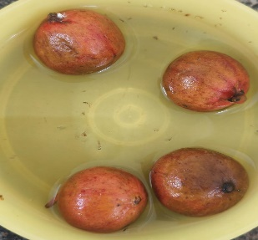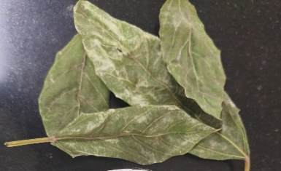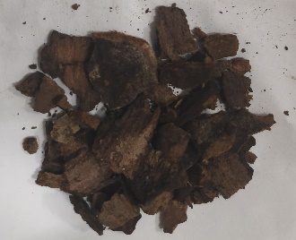
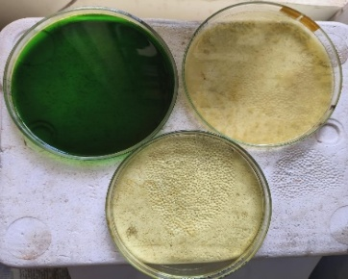
The fresh fruits, leaves, and bark of Ficus semicordata were collected and properly washed several times with distilled water to remove dirt and other impurities. The plant materials were then cut into smaller pieces to ensure efficient extraction and shade-dried at room temperature until a constant weight was attained. Weighed portions of each plant part (10 g of fruit, 10 g of leaf, and 10 g of bark) were separately placed in three 250 mL conical flasks.
Methanol was employed as the extraction solvent in a 1:10 ratio (sample to solvent; 1g per 10mL). Accordingly, 100mL of methanol was poured into each flask containing 10g of the respective plant samples. The resulting mixtures were then placed under continuous shaking for 24 hours to facilitate the extraction of bioactive compounds. The mixtures were then filtered using Whatman No. 1 filter paper to separate the solid residues. The filtrates obtained were the crude methanolic extracts of the fruit, leaf, and bark samples. The filtrates were poured into separate Petri dishes and left to dry in the shade at room temperature for 24 hours. After complete drying, the crude extracts were collected and stored in airtight containers for further phytochemical and biological studies (Mandal et al., 2023)
3.2PHYTOCHEMICAL ANALYSIS
Qualitative phytochemical screening was carried out on the methanolic extracts of the fruit, leaf, and bark to determine the presence or absence of the major classes of secondary metabolites. Standard phytochemical screening tests were conducted to detect the presence of alkaloids, flavonoids, tannins, terpenoids, and other secondary metabolites. The results of the screening tests are presented in the table below.
PHYTOCXHEMICAL ANALYSIS | LEAF | FRUIT | BARK
Alkaloids | Negative | Positive | Positive
Terpenoids | Positive | Positive | Positive
Tannins | Negative | Negative | Negative
Phenolic compounds | Positive | Positive | Positive
Flavonoids | Negative | Negative | Negative
Carbohydrates | Positive | Negative | Negative
Saponins | Negative | Negative | Negative
Glycosides | Negative | Positive | Negative
Proteins | Negative | Negative | Negative

The phytochemical analysis showed different compositions in the leaf, fruit, and bark extracts. The presence of terpenoids and phenolic compounds in all parts of the plant shows their potential use as antioxidants and biological agents. The presence of alkaloids in the bark and glycosides in the fruit shows part-specific properties. The absence of some phytochemicals such as tannins, flavonoids, and saponins in all parts of the plant may affect the overall nutritional or medicinal value of the plant. These results will help in understanding the phytochemical differences in various parts of the plant and may help in further research related to their applications in pharmacology, food science, or other disciplines (Abeysekara WP et al., 2019).
3.3ANTIOXIDANT ACTIVITY (DPPH SCAVENGING ACTIVITY)
Based on the IC50 values, the antioxidant activity of the extracts can be ranked as follows (Graph 1.1 – 1.4)
- Leaf extract (IC50 = 25.90): Shows higher antioxidant activity than the standard ascorbic acid (IC50 = 41.89).
- Standard ascorbic acid (IC50 = 41.89): Reference compound for antioxidant activity.
- Bark extract (IC50 = 45.97): Shows slightly lower antioxidant activity than the standard ascorbic acid.
- Fruit extract (IC50 = 60.08): Shows the lowest antioxidant activity among the tested extracts.
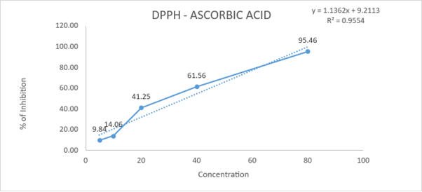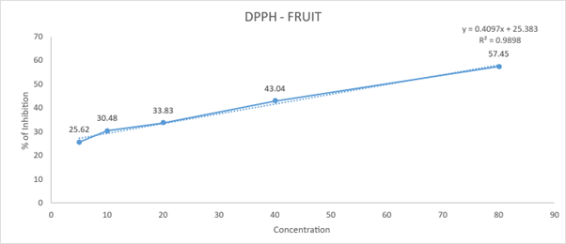
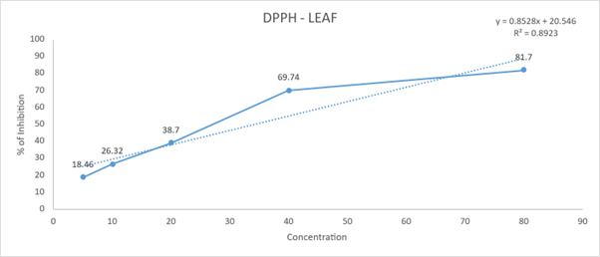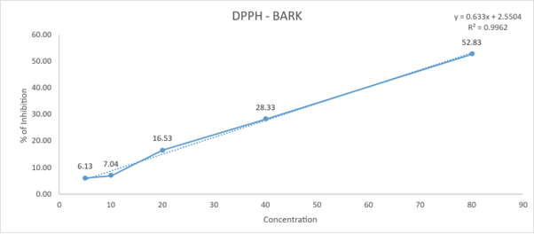

The leaf extract has a strong antioxidant property, which is greater than the standard ascorbic acid. The bark extract has moderate antioxidant property, and the fruit extract has lower antioxidant property.
3.4 ANTIBACTERIAL ACTIVITY
The antibacterial properties of the leaf, fruit, and bark extracts of the plant against Escherichia coli, Pseudomonas aeruginosa, Staphylococcus aureus, and Enterococcus faecalis were tested using the well diffusion method. The results are given in the table below, which shows the zone of inhibition (in mm) at different concentrations of 0.5 mg/mL, 1 mg/mL, and 2 mg/Ml.Escherichia coli, Pseudomonas aeruginosa, Staphylococcus aureus, and Enterococcus faecalis were all tested for antibacterial properties using the well diffusion method. The leaves, fruits, and bark extracts also demonstrated high antimicrobial properties against the microorganisms. The comparison of the concentrations (0.5 mg/mL, 1 mg/2 mg/3 ml) and the zone of inhibition (in mm) is shown below. There is no data available for 0.5 mg/mL and 1 mg/2mM in the enzymes of Escherichia coli. Inhibition in Pseudomonas aeruginosa is shown at 0.2 M/L (15 mm). Staphylococcus aureus inhibits at 2 mg/mL (9 mm). The amount of inhibition shown by Enterococcus faecalis is equal, with concentrations of 0.5 mg/mL, 1 mg/1 mg/2 mg/20 mm. Escherichia coli: No inhibition. At 2 mg/mL (11 mm), Pseudomonas is an inhibiting organism. Staphylococcus aureus inhibition occurs at molarity (2 mg/mm) in this organism. All concentrations of Enterococcus faecalis exhibit inhibition, with measurements of 13 mm at 0.5 mg/mL, 14 MM at 1 mg/1 MG/M, and 12 SM at 2 mg/3 ML.
The inhibition of Escherichia coli at 2 mg/mL (21 mm) is evident. At 2 mg/mL (14 mm), Pseudomonas is an inhibiting organism. The inhibition rate for Staphylococcus aureus is 1 mg/mL (13 mm) and 2 mg/20 mm. Enterococcus faecalis exhibits inhibition at all levels specifically 1 mg/mL and 2 moles (Gupta, S et al.,2022). The antibacterial assay showed different levels of activity based on the plant part and concentration. In general, higher concentrations (2 mg/mL) produced larger inhibition zones against the tested bacteria The bark extract had the widest and strongest activity, especially against Escherichia coli (21 mm at 2 mg/mL). Enterococcus faecalis was sensitive to all extracts at most concentrations. Escherichia coli was least sensitive to leaf and fruit extracts but strongly inhibited by the bark extract at 2 mg/mL.The data indicate that the bark may harbor more potent antibacterial compounds than leaf and fruit extracts (Shashi Gupta et al.,2022).
ANTIFUNGAL ACTIVITY
The antifungal results shows an unusual trend where the inhibition zones are larger at the lowest concentration (0.5 mg/mL) compared to higher concentrations (1 mg/mL and 2 mg/mL) for both Candida albicans and Candida krusei in all plant parts (leaf, fruit, bark). Generally, in well diffusion tests, higher concentrations of an antifungal agent would produce larger inhibition zones. The opposite observed in this study could imply a number of things:
Antagonistic effect at higher concentrations: The extract may contain compounds that at higher concentrations work against or decrease the antifungal effect. Solubility or diffusion problems at higher concentrations: The higher concentrations may cause problems with the diffusion of the extract in the agar, resulting in smaller inhibition zones. Further study needed: The test could be repeated or other tests such as broth dilution could be employed to confirm these results. Among the plant parts, the fruit extract has a slightly higher activity against Candida albicans at 0.5 mg/mL (39 mm). The bark extract has a steadily increasing inhibition zone with concentration against Candida krusei, unlike other parts (Abhay Jayprakash Gandhi et al.,2019).
CONCLUSION
The current study has made it clear that Ficus semicordata has notable phytochemical and biological properties. Phytochemical screening has confirmed the presence of major phytochemicals like terpenoids and phenolic compounds in all parts of the plant, while alkaloids were mainly present in the bark and glycosides in the fruit. The antioxidant study using the DPPH radical scavenging method has shown that the leaf extract had the highest antioxidant activity with the lowest IC₅₀ value, showing potent free radical scavenging activity. The bark had moderate antioxidant activity, while the fruit had relatively lower activity. The antibacterial study has shown concentration-dependent inhibition of growth of the tested bacterial strains, with the bark extract having the highest antibacterial activity, especially against Escherichia coli. The leaf and fruit extracts also showed moderate antibacterial activity.Likewise, antifungal testing proved that all extracts exhibited efficacy against Candida albicans and Candida krusei, indicating significant antifungal activity despite differences in concentration response. In the results indicate that various parts of Ficus semicordata have different levels of bioactive potency: the leaf has the highest antioxidant activity, the bark exhibits the strongest antibacterial properties, and the fruit has promising antifungal properties. Thus, Ficus semicordata can be regarded as a medicinal plant with significant potential in pharmaceutical and therapeutic development.
REFERENCE
- Gamble JS. Flora of the Presidency of Madras. Vol. I–III. Calcutta: Botanical Survey of India; 1915–1936.
- Hooker JD. The Flora of British India. Vol. I–VII. London: L. Reeve & Co.; 1872–1897.
- Matthew KM. The Flora of the Tamil Nadu Carnatic. Tiruchirappalli: The Rapinat Herbarium, St. Joseph’s College; 1983.
- Harborne JB. Phytochemical Methods: A Guide to Modern Techniques of Plant Analysis. 3rd ed. London: Chapman & Hall; 1998.
- Sofowora A. Medicinal Plants and Traditional Medicine in Africa. 3rd ed. Ibadan: Spectrum Books; 2008.
- Azwanida NN. A review on the extraction methods use in medicinal plants, principle, strength and limitation. Med Aromat Plants. 2015;4:196.
- Trease GE, Evans WC. Pharmacognosy. 16th ed. London: Saunders Elsevier; 2009.
- Kokate CK. Practical Pharmacognosy. 4th ed. New Delhi: Vallabh Prakashan; 1994.
- Silverstein RM, Webster FX, Kiemle DJ. Spectrometric Identification of Organic Compounds. 7th ed. New York: Wiley; 2005.
- Skoog DA, Holler FJ, Crouch SR. Principles of Instrumental Analysis. 6th ed. Boston: Cengage Learning; 2018.
- Blois MS. Antioxidant determinations by the use of a stable free radical. Nature. 1958;181:1199–1200.
- Bauer AW, Kirby WMM, Sherris JC, Turck M. Antibiotic susceptibility testing by a standardized single disk method. Am J Clin Pathol. 1966;45:493–496.
- Clinical and Laboratory Standards Institute (CLSI). Performance Standards for Antimicrobial Susceptibility Testing. CLSI supplement M100. Wayne, PA: CLSI; 2023.
- Clinical and Laboratory Standards Institute (CLSI). Reference Method for Broth Dilution Antifungal Susceptibility Testing of Yeasts; Approved Standard M27. Wayne, PA: CLSI; 2017.
- Perez C, Pauli M, Bazerque P. An antibiotic assay by the agar well diffusion method. Acta Biol Med Exp. 1990; 15:113–115.

