Integrating stepwells into urban water management systems: A case study of Ahmedabad stepwells
Abstract
Stepwells are architectural marvels unique to India. Historically, they sustained groundwater, moderated microclimates, and embedded water within cultural landscapes. Hydrological studies have shown that stepwells slow runoff and recharge aquifers; yet, today they are largely treated as heritage structures, sidelined from water policy. Given the climatic conditions of western India, restoring stepwells assumes renewed importance. Case evidence from Rajasthan’s johads (earthen check dams) and lake restoration initiatives in Bengaluru and Hyderabad demonstrates measurable aquifer gains when traditional systems are integrated at the catchment scale. The Sarkhej Roza–Makarba complex in Ahmedabad and the Adalaj Stepwell illustrate both the persistence of heritage value and the missed opportunity for hydrological reintegration, even though many stepwells have lost their functional identity as a result of urbanisation.
Recasting heritage water systems as active infrastructure offers a pathway to climate-resilient urban water planning. Drawing on comparative case evidence, governance reviews, and secondary sources, this paper examines how traditional recharge systems can be repositioned within contemporary urban water management.
Keywords: lake systems, water recharge, stepwells, governance, policies
Introduction
Stepwells were once among India’s most efficient and sustainable practices of groundwater recharge (Selvaraj et al., 2022). Their nomenclature varies regionally, including vav, vavdi, vai, kalyani, baoli, and pushkarni. Early Sanskrit scriptures and inscriptions refer to them as vapi or vapika (Sriparvathy and Salahsha, 2021). These structures were not merely functional; they were carefully designed architectural expressions that harmonised with the surrounding urban and rural landscapes. In addition to storing water, stepwells reflected the social, religious, and cultural practices of the communities that built and maintained them, often serving as gathering spaces, ceremonial sites, and markers of local identity.
Beyond their engineering significance, stepwells embodied a profound connection between groundwater and surface water, linking ecological systems with the communities that depended on them. Their stepped geometry slowed runoff, allowed water to percolate into underground aquifers, and ensured reliable access to stored water throughout the year. This design also reduced the impact of seasonal variability and helped maintain ecological balance in surrounding areas. At the same time, lake complexes functioned as extensive rainwater reservoirs, moderating local microclimates, supporting biodiversity, and reducing dependence on direct rainfall. Collectively, stepwells and lake systems formed resilient hydrological networks that were seamlessly integrated into urban life, representing an early form of sustainable water management that combined technical expertise with social and environmental awareness.
Today, however, this once self-sufficient system has been systematically sidelined. Rapid urbanisation, encroachment, unplanned construction, and the expansion of impervious surfaces have disrupted historic water linkages. Recharge nodes that were once integral to local water security have been neglected, many erased, while others survive only as architectural heritage or tourist attractions. In their place, cities have become increasingly reliant on borewells and groundwater extraction, accelerating aquifer depletion and creating long-term vulnerability. The consequences are tangible: municipal health reports indicate higher rates of waterborne illnesses linked to declining water quality, while economic surveys highlight the rising financial burden of accessing safe drinking water and maintaining irrigation systems. This neglect reflects not only ecological loss but also a governance failure in urban water planning, demonstrating that sustainable water management has been deprioritised in favour of short-term urban expansion (Niyogi, 2023).
Dependence on contemporary extraction techniques has resulted in widespread and rapid groundwater depletion across India. Groundwater tables in northwestern India declined by more than one foot annually from 2002 to 2008, despite near-normal rainfall. Agricultural pumping subsidies, originally intended to support resource-poor farmers, have inadvertently encouraged overextraction, with agricultural power subsidies increasing almost threefold between 2000/01 and 2013/14 in real terms. Combined with the absence of metering or usage monitoring, this has resulted in rates of aquifer depletion that far exceed natural recharge, contributing to long-term water insecurity and increasing the risk of conflict over scarce water resources (Banerjee and Gulati, 2016).
Assessments of groundwater status at the administrative-unit level reveal an alarming trend. Of the 6,607 assessed units, more than 1,000 are classified as overexploited, while several hundred fall under critical or semi-critical categories. Acute stress is particularly evident in the northwestern states of Punjab, Haryana, and Rajasthan, where stages of groundwater development reach 172, 133, and 137 per cent, respectively. Even states previously considered relatively secure, such as Gujarat and Karnataka, now exhibit semi-critical conditions. The cumulative impact is both economic and ecological: per capita water availability in India declined from 5,200 m³ in 1951 to 1,588 m³ in 2010, and despite decades of policy intervention, only 46 per cent of net sown area is irrigated (Banerjee and Gulati, 2016). This context situates the degradation of stepwells and lake systems not merely as a heritage loss, but as evidence of systemic deficiencies in urban water governance, planning, and sustainable resource management.
The scale of decline is striking. India is home to over 3,000 stepwells, yet only an estimated 400–500 retain any functional hydrological role (DW, 2023), while the remainder stand derelict, filled with debris, or are preserved solely as ornamental or tourist structures. Gujarat alone contains approximately 570 stepwells (Mistry, 2024; Suhane, 2024), though only a small fraction remain integrated into active water systems. Lake complexes exhibit a similar trajectory. Bengaluru, for instance, historically supported more than 1,000 lakes; by 1961, this number had declined to 262, and today only 81 remain, of which just 33 are considered ecologically active (Bothra and Gowda, 2025). The pattern of decline underscores the challenges of urbanisation, encroachment, pollution, and fragmented governance, all of which hinder the restoration and continued function of traditional water systems.
Ahmedabad, located in the semi-arid region of western India, exemplifies this trend. The city has long maintained a close relationship with water as a defining element of its urban identity. Historically, stepwells and lake complexes functioned as community focal points—spaces that transcended social boundaries and demonstrated both architectural and hydrological ingenuity. The urban fabric evolved in harmony with this water infrastructure, embedding reservoirs, stepwells, and tanks into everyday life. Today, however, these structures are largely treated as heritage relics, excluded from contemporary planning frameworks despite their proven ecological potential.
This paper examines how traditional water systems can be repositioned within contemporary urban water management through comparative case evidence and a review of secondary policies. Addressing this oversight requires more than the conservation of heritage structures; it necessitates a re-evaluation of climate resilience and water security in rapidly urbanising cities. Such an approach also demands attention to the broader social, ecological, and economic implications of water infrastructure. Historic systems such as stepwells and lake networks were inherently multifunctional, supporting communities, regulating local microclimates, and fostering biodiversity. Drawing on these principles, this study explores how traditional practices can inform sustainable water management strategies that are not only efficient but also inclusive and environmentally robust. Integrating these lessons into contemporary planning frameworks can enhance urban preparedness for future water crises, promote equitable access to water resources, and strengthen urban ecosystems. In this way, the study demonstrates that heritage-based knowledge and modern innovation can operate synergistically to address the pressing water challenges of the twenty-first century.
Literature review
Traditional water systems in India, such as stepwell systems, or baolis, johad systems, man-made ponds, and lake networks, are significant intersections between the engineering, ecology and social organisation of societies before the arrival of the British. Historical documents and past studies have shown that these types of systems were built to perform several interrelated functions: The recharge of groundwater, local climate regulation, and community activity. Recent academic work indicates that the outcomes of restoration efforts vary significantly based on the scale at which they occur and the attention given to integrating all elements (technical, ecological and social). Heritage structures located in smaller communities usually respond well to local, site-specific techniques of restoration, i.e. Structural repairs, desilting and community-led maintenance. Larger urban lakes, on the other hand, require a holistic approach involving land use planning, pollution control, catchment interventions, and coordinated governance across multiple institutions and stakeholders. Previous studies of restoration projects have indicated that technical solutions are usually not enough to guarantee sustainability over time, that social participation, ecological considerations and institutional frameworks are equally important for successful restoration of water systems. The study of the dynamics of restoration efforts across different regions will provide a comprehensive understanding of how to tailor restoration strategies to the unique environmental and socio-cultural conditions in which they exist. Tables 1 and 2 provide valuable examples of both successful projects and projects that are having difficulty due to a lack of attention to the issues outlined above. Together, these two tables demonstrate how the combined knowledge of the relationship between water infrastructure, governance systems, and community engagement can be utilised to inform current urban water management practices while ensuring ecological integrity is maintained.

Table 1 presents examples of heritage water structures and urban water bodies where restoration efforts have successfully integrated ecological, technical, and social interventions. These cases illustrate how context-sensitive approaches, community participation, and coordinated governance can restore hydrological functions, improve water quality, and enhance ecosystem services.
Table 1: Successful cases of water heritage and urban water bodies rejuvenation
Case Example | Location and Context | Area | Images | Issue | Proposed steps | Results
Hazrat Nizamuddin Dargah stepwell, Delhi | The western edge is defined by Chini ka Burj, Gogabai Tomb, and Lal Chauburji; an eastern vaulted corridor leads to the dargah; and a southern arcade features arcaded passages. The precinct includes approximately 45 listed monuments and a basti of around 15,000 residents (Aga Khan Trust for Culture). | Internal area 38 m × 16 m; depth approximately 80 ft below ground level. | 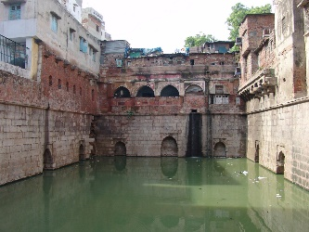  Figure 1. Baoli and the surrounding area before restoration. Image credit: Aga Khan Trust for Culture.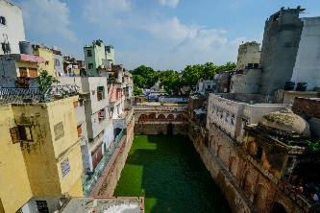  Figure 2. Baoli and the surrounding area post restoration. Image credit: Aga Khan Trust for Culture. | Severe siltation; contamination from sewage inflows; structural damage due to inappropriate conservation measures, including 3–5 cm epoxy plaster that trapped moisture and caused masonry failure.  (Baoli Conservation Works Panels, Aga Khan Trust for Culture) | Manual desilting to full depth; removal of centuries of accumulated sludge and debris; removal of twentieth-century epoxy plaster; relaying of over 100 m of sewage pipelines; structural repair of collapsed sections; repair of underground passage connecting the baoli and mosque courtyard.  (Baoli Conservation Works Panels, Aga Khan Trust for Culture) | Restored underground spring inflows; improved water quality with reduced contamination (including Escherichia coli); stabilised water levels; revival of community access from the mosque
Restoration of Johads (Tarun Bharat Sangh model), Alwar district, Rajasthan | Approximately 8,600 johads were documented across 1,086 villages in Alwar district (Hussain and Hussain, 2014). | Around 6,500 km² across villages; individual johad storage areas range from 2 to 100 ha.  (Hussain and Hussain, 2014). | 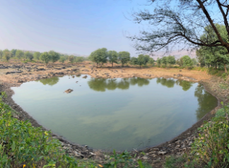  Figure 3. Johad constructed under the Tarun Bharat Sangh initiative. Image credit: Centre for Energy, Environment and Water. | Severe groundwater depletion; seasonal water scarcity; agricultural decline; limited aquifer thickness.  (Hussain and Hussain, 2014). | Community-built earthen catchment ponds, contour trenches, and percolation structures; voluntary labour by local communities for construction and maintenance.  (Hussain and Hussain, 2014). | Groundwater table rose from 100–120 m to 3–13 m depth; increase in single- and double-cropping areas from 11 and 3 per cent to 70 and 50 per cent; forest cover increased from 7 to 40 per cent.  (Hussain and Hussain, 2014).
Upper Lake (Bhojtal), Bhopal, Madhya Pradesh | Located within Bhopal city; primary drinking water source for approximately 1.2 million people. Lower Lake downstream forms a wetland complex. Declared a Ramsar site and restored under the Bhoj Wetland Project (1995–2004). | Catchment area 361 km²; submergence area 36.54 km²; total storage 117 million m³; mean depth 11.7 m. | 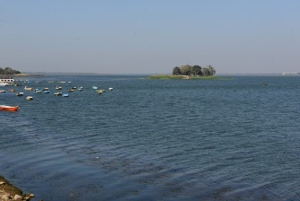  Figure 4. Upper Lake, current condition. Image credit: Madhya Pradesh Tourism. | Severe siltation and loss of storage capacity; eutrophication and algal blooms; weed infestation; pollution from washermen activities and urban runoff; declining biodiversity and dissolved oxygen levels. | Sewage interception and treatment infrastructure; large-scale desilting; weed removal; introduction of herbivorous fish species; catchment area treatment; spill channel widening; aeration units; solid waste management. | 56 MLD sewage diverted and treated; 4 per cent increase in storage capacity; major reduction in aquatic weeds; increase in fish yield; improved dissolved oxygen levels; upgraded municipal solid waste infrastructure.

Table 2 highlights examples where restoration initiatives have faced significant challenges. Issues such as fragmented governance, socio-economic pressures, insufficient stakeholder involvement, and catchment complexities have hindered the recovery of hydrological and ecological functions, demonstrating the importance of comprehensive and systemic approaches.
Table 2: Struggling or failed cases of water heritage and urban water bodies rejuvenation
Case Example | Location and Context | Area | Images | Issue | Proposed steps | Results
Bellandur and Varthur lakes, Bengaluru | South-eastern Bengaluru, part of the Koramangala–Challaghatta Valley catchment (~290.44 km²) (Ramachandra et al, 2020). | Bellandur Lake 366.9 ha; Varthur Lake 190.8 ha; combined catchment 279 km² with cascading interlinked lakes. | 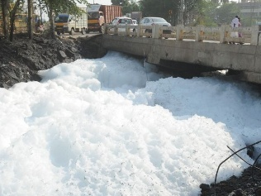  Figure 5. Frothing in Varthur Lake. Image credit: BCCL.  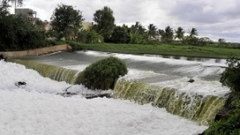  Figure 6. Bellandur Lake. Image credit: Hindustan Times. | Untreated sewage, biomedical, solid, and industrial waste; deforestation-induced siltation; wetland loss; buffer-zone encroachment; eutrophication; foam and fire incidents; groundwater decline; loss of lake interconnectivity. | Expansion of sewage treatment plants; desilting; constructed wetlands; enforcement of anti-encroachment laws; bioremediation using macrophytes; regulation of phosphorus in detergents; aeration; reconnection of lakes. | Persistent foaming; incomplete sewage treatment; delayed implementation; funding and operational constraints; desilting remains unresolved.
Najafgarh Jheel, Delhi–Haryana | Transboundary freshwater lake across southwest Delhi and Gurugram, part of the Najafgarh Drain (formerly the Sahibi River); habitat for near-threatened, vulnerable, and endangered waterfowl species (Rao and Tarannum, 2024). | Reduced from approximately 266 km² in 1883 to about 7 km² at present. | 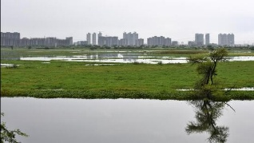  Figure 7. Najafgarh Jheel. Image credit: Hindustan Times. | Transboundary governance challenges; illegal waste dumping; untreated sewage inflows exceeding 500 MLD; recurrent flooding; siltation; eutrophication; invasive species; catchment degradation; public health impacts. | Public awareness; demarcation of lake boundaries; embankment construction; National Green Tribunal oversight; sewage treatment improvements; river and catchment rejuvenation; community participation. | Non-compliance with directives; stakeholder conflicts; delayed coordination between states; socio-economic inequities; political and financial constraints.
Anasagar Lake, Ajmer, Rajasthan | Located in Ajmer within the Aravalli range, connected to tanks and natural drains in the north-eastern valley (Bhargava, 2019). | Lake, shore, and catchment ~56 km²; lake area varies between 97 and 182 ha; depth 1.9–4.4 m. | 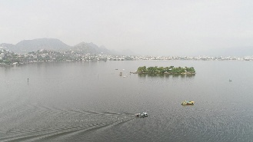  Figure 8. Anasagar Lake. Image credit: Incredible India. | Urban encroachment over ~30 per cent of the catchment; eutrophication; fluctuating water levels causing flooding; untreated sewage inflows; shoreline land-right disputes; siltation. | Manual and mechanical de-eutrophication; increased inflows to maintain perennial water levels; establishment of a lake management body; implementation of national lake restoration programmes. | Reliance on temporary de-eutrophication measures; limited community involvement; governance delays; funding constraints; unresolved shoreline and flooding issues.
Throughout various locations, from Delhi’s Nizamuddin Baoli to Bhopal’s Bhojtal, Bengaluru’s Bellandur, and Ajmer’s Anasagar Lake, the literature indicates a common trend: effective architectural or infrastructural restoration rarely aligns with sustained hydrological resilience. Initiatives spearheaded by organisations such as the Aga Khan Trust for Culture, National Lake Conservation Plan (NLCP), and Tarun Bharat Sangh illustrate that community engagement, ongoing monitoring, and catchment-scale planning are the most reliable indicators of ecological recovery. In contrast, examples like Bellandur and Najafgarh Jheel reveal how fragmented governance, inflows of untreated sewage, and interruptions in policy can threaten restoration efforts.
The comparative analysis of water heritage structures and water bodies in urban areas identifies discernible trends that distinguish successful rehabilitation initiatives from non-successful or failed ones. The successful examples in water heritage structure rehabilitation, such as the case of Hazrat Nizamuddin Baoli in Delhi, johads in Alwar District, and Upper Lake (Bhojtal) in Bhopal, indicate that successful rehabilitation in the longer term must be done integrally, encompassing water processes, ecologies, and institutional levels. The rehabilitation activities included desilting, interception of sewage, treatment of catchments, and rehabilitation of structures, resulting in improved water quality, recharged groundwater levels, stabilised water levels, enhanced biodiversity, and increased community use. The enabling factor in such successful rehabilitation has remained community engagement, as in Johads, and institutional collaboration, as in Bhoj Wetlands.
However, the struggling and failed examples of lakes, namely those of Bellandur and Varthur Lakes in Bengaluru, Najafgarh Jheel in Delhi-Haryana, and Anasagar Lake in Ajmer, bring out the deficiencies of the present approaches of lake restoration. Having been proposed numerous times through means like sewage treatment plant construction, desilting, and bioremediation, these lakes still owe their deterioration to the input of raw sewage, loss of hydrological connectivity, encroachment of buffer zones, and gaps in governance.
The analysis highlights the point that the intervention in the water bodies for technical restoration or beauty enhancements is not adequate for effective restoration. The restoration of water bodies needs to be planned on the macro-level of the water body system. The water bodies need to be treated not as isolated objects in the context of heritage status, but as living elements in the environmental system.

Ahmedabad as a case example
From 1991 to 2011, the population of Ahmedabad almost doubled, increasing from 2.9 million to 5.6 million, reflecting rapid urban growth in a semi-arid environment. This growth has intensified pressure on small and decentralised water systems, threatening their ecological stability and sustainability (Mishra, Shukla & Iyer, 2019). The city’s urban identity has long been shaped by its stepwells, tanks, and lakes, which historically provided both climatic moderation and reliable water security (Mistry, 2024).
Today, many of these systems stand neglected, reduced to heritage monuments rather than functioning elements of urban hydrology, which has increased demand for freshwater and heightened vulnerability to climate stresses. For example, during the 2016 heat wave, temperatures in Ahmedabad soared to an unprecedented 48°C, exerting severe pressure on both human health and water availability. These extreme climatic events exacerbate the existing challenges of water supply, particularly in a rapidly growing, semi-arid urban environment, highlighting the need for resilient and decentralised water management solutions (Aartsen et al., 2018).
Urban expansion continues at a yearly rate of approximately 3.3%, resulting in the widespread development of city outskirts and further limiting the availability of freshwater. As built-up areas replace open lands, natural recharge zones for groundwater are lost, increasing reliance on centralised water sources and overexploited borewells. Groundwater depletion is a particularly pressing issue, driven primarily by illegal extraction through private borewells, which lower water tables by several metres each year and, over time, increasingly lead to saline conditions. Simultaneously, river water quality deteriorates due to urban runoff and the discharge of untreated waste, further compounding water scarcity challenges. (Aartsen et al., 2018).
These environmental challenges intersect closely with social inequality. Middle-class households often have access to private borewells, but the water from these sources is becoming progressively more polluted, presenting risks to health and hygiene. Residents of informal settlements, in contrast, depend almost entirely on a limited municipal supply, which is often available for only a few hours per day. Even when households have connections, multiple families frequently share the same source, leading to unpredictable and unreliable water access. Such disparities underscore the uneven impacts of water scarcity and stress the need for inclusive urban water planning that addresses both infrastructure and equity (Aartsen et al., 2018).
The City Blueprint Framework (CBF) provides a comprehensive, quantitative representation of these challenges. Ahmedabad’s Blue City Index (BCI) score of 3.13 out of 10 reflects a low overall performance in water management, signalling the urgency of coordinated interventions to improve both supply reliability and quality. While the city demonstrates reasonably strong performance in basic services such as drinking water access, sanitation, and solid waste collection, socio-economic disparities significantly undermine these achievements. Affluent populations consume higher volumes of water and generate more waste, whereas marginalised communities face severe limitations in both quantity and quality of supply. The CBF findings further highlight systemic deficiencies in wastewater treatment, solid waste disposal, and climate change mitigation measures, illustrating the city’s inability to cope with compounded pressures arising from rapid urban growth, environmental degradation, and climate variability. These results emphasise the importance of integrating resilient, heritage-based water systems such as stepwells and decentralised storage infrastructures to reduce dependence on overexploited groundwater and enhance urban water security (Aartsen et al., 2018).
These factors indicate that the water problems of Ahmedabad are not just technical but also relate to environmental, social, and governance issues. The heritage water systems such as the stepwells, tanks and puffers were once decentralised and allowed for a resilient water supply to help mitigate these pressures. However, the lack of attention to these systems has created a greater dependency on the overexploitation of groundwater and the continued use of a centralised piped supply for an urgent need to incorporate heritage water infrastructure into modern urban water management practices.
Sarkhej Roza: heritage and hydrology in Ahmedabad
From 1991 to 2011, the population of Ahmedabad almost doubled, increasing from 2.9 million to 5.6 million, reflecting rapid urban growth in a semi-arid environment. This growth has intensified pressure on small and decentralised water systems, threatening their ecological stability and sustainability (Mishra, Shukla & Iyer, 2019). The city’s urban identity has long been shaped by its stepwells, tanks, and lakes, which historically provided both climatic
Sarkhej Roza is a royal and Sufi complex from the fifteenth century in Ahmedabad, situated on the city's periphery, featuring a mosque, mausoleum, and a constructed system of lakes and reservoirs, excavated to serve ritual, social, and water management needs.
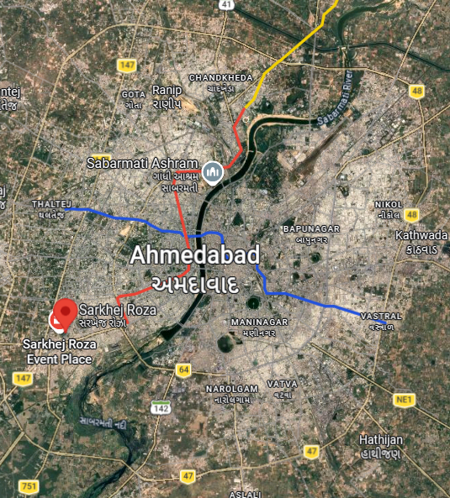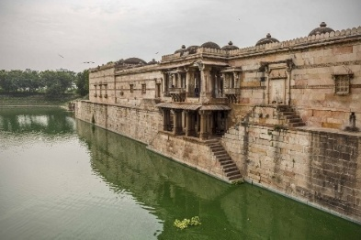
Figure 9. Location of Ahmedabad in Gujarat. Image credit: Google Maps
Figure 10. Distribution of stepwells and major water bodies in Ahmedabad. Image credit: Flickr
Figure 11. Sarkhej Roza–Makarba complex and associated water tanks. Image credit: Gujarat Tourism
Historically, the Sarkhej reservoir and associated waterworks – comprising lakes, tanks, sluices, and channels – were part of a carefully planned hydrological network rather than mere ornamental structures. The main reservoir spanned over 17 acres and was fed by the interconnected Makarba Lake, a natural water body, through three sluice gates forming a cascade. The combined catchment area of 1.74 km² ensured that overflow from Makarba Lake sustained Sarkhej Lake year-round, creating a perennial waterbody that moderated the microclimate of the adjacent complex and supported surrounding communities (Mishra et al., 2019).
Figures 4 and 5 depict the location, seasonal variation, and historical mapping of Sarkhej Lake and its surroundings, illustrating both its original hydrological design and the impact of urban encroachment. Rapid urbanisation, particularly after 2000, has led to the encroachment of roughly 50 per cent of the catchment area, significantly reducing natural inflows and disrupting hydrological connectivity (Mishra et al., 2019). The lake now functions primarily as a seasonal waterbody, relying almost entirely on monsoonal inputs, highlighting the urgent need for restoration.
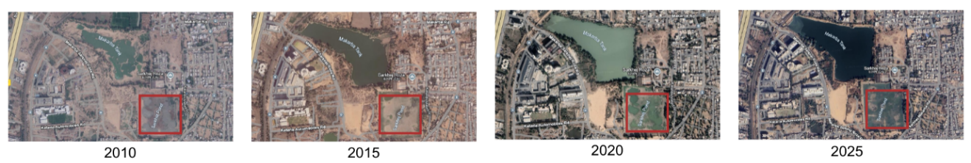
Figure 12. Hydrological relationship between Sarkhej Roza tanks and the surrounding catchment. Image credit: Google Earth
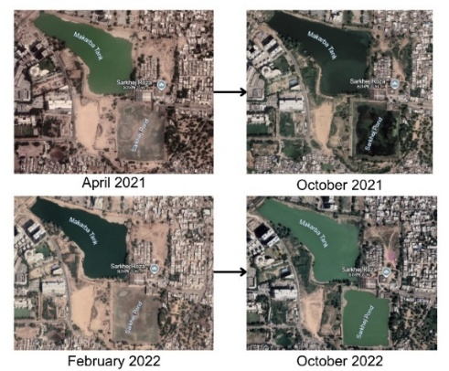
Figure 13. Seasonal Fluctuation in water patterns of Sarkhej Lake. Image credit: Google Earth
Causes of Restoration Needs
Table 3: Author’s analysis of causes necessitating restoration efforts across hydrological, social, planning, and governance dimensions (Mishra et al., 2019).
Category | Causes / Issues
Urbanisation & Planning Failures | Encroachment of ~50% of the catchment; real estate growth without hydrological planning; land-use conversion and sprawl
Hydrological / Environmental Causes | Disrupted stormwater flow; sewage inflow from Prahlad Nagar Lake; effluent contamination; high coliform and suspended solids beyond CPCB/WHO standards; groundwater depletion, borewell depth up to 76 m and quality loss
Infrastructure & Governance Failures | Lack of WSUD integration; no sewerage network until 2008–09; institutional overlap (AMC–AUDA–ASI); absence of consistent monitoring or enforcement
Social & Behavioural Causes | Open defecation and waste dumping; failed community awareness initiatives; illegal soil mining and public apathy
Restoration/conservation efforts and proposals
Table 4 Author's Analysis of Conservation and Restoration Efforts under Cultural, Hydrological, Planning and Governance Dimensions based on existing literature (Mishra et al., 2019).
Category | Restoration / Conservation Efforts
Urbanisation & Planning Measures | Enforce catchment protection buffers >30 m; integrate runoff–recharge–drainage cycles into land-use plans; position Sarkhej Roza as a World Heritage Site linking built and natural heritage.
Hydrological / Environmental Causes | Revive drainage links between Makarba and Sarkhej lakes; desilt and clean lakes; block sewage inflow; monitor groundwater and promote stormwater recharge; separate stormwater and wastewater flows.
Infrastructure & Governance Efforts | Establish ASI–AMC–AUDA–SRC coordination for joint lake–heritage management; ensure regular audits and maintenance; expand SRC’s stewardship role; clarify policy overlaps through joint bylaws.
Cultural & Heritage Integration | Restore built heritage (mosque, mausoleum, palaces); sustain cultural events like Sufi festivals and Janmashtami; rebrand Sarkhej Roza as “Ahmedabad’s Acropolis” to foster civic pride.
Gaps in the execution of restoration
- AUDA’s General Development Control Regulation (GDCR) permits only a 15–30 m buffer from the edges of lakes, which is inadequate for effective stormwater absorption and protection of hydrological systems.
- There is a lack of context-specific, water-sensitive urban planning (WSUD) in the approval of developments.
- The traditional flow of stormwater has been disrupted, as the connection from Makarba to the Sarkhej lake sluice gates has been obstructed by encroachments.
- Sewage continues to flow into the lake: around 70% of households have illegal connections discharging directly into Makarba Lake.
- The interconnected lakes spread pollution, with sewage-laden water from Prahalad Nagar lake contaminating Makarba and, subsequently, Sarkhej.
- Water quality has deteriorated, with coliform levels at approximately 1,600 MPN/100 ml (compared to CPCB's permissible limit of 0), a pH of 8.3 (alkaline), and suspended solids exceeding CPCB standards.
- Since the restoration efforts, there has been no published, peer-reviewed evidence indicating any measurable improvement in water levels or groundwater recharge; the hydrological functions remain degraded and unmonitored.
- There is an overlap of responsibilities among ASI (heritage), AMC (infrastructure and sanitation), and AUDA (planning), leading to a lack of coherent accountability.
- The Sarkhej Roza Committee (SRC) does not have authority over hydrological management.
- There is no established inter-agency mechanism to manage the coordination of heritage and water governance, resulting in a condition where “everybody’s responsibility = nobody’s responsibility.”
- There are gaps in monitoring and enforcement: there are no regular audits, water quality tests, or catchment surveillance.
- Awareness initiatives conducted by SRC and ACF in 2014–15 did not lead to sustained behavioural change, and there has been no ongoing monitoring. (Mishra et al., 2019).
The Sarkhej–Makarba system exemplifies the challenges of integrating heritage water infrastructure into contemporary urban environments. Historically, the cascading lakes not only provided potable water but also regulated local microclimates, supported agricultural activities, and maintained biodiversity in semi-arid Ahmedabad. Their design demonstrated an intrinsic understanding of catchment hydrology, using topography and controlled sluices to ensure perennial water availability. The encroachment and unregulated urban growth witnessed over the past two decades have disrupted these functions, exacerbating heat stress, water scarcity, and ecological degradation. Restoration efforts, while extensive in planning, often overlook the socio-cultural dimensions that historically sustained these systems. For instance, local festivals and religious practices linked to the lakes historically encouraged community engagement, which is now absent. A holistic approach must therefore intertwine technical rehabilitation, such as desilting and sluice repair, with active community engagement, regulatory enforcement, and cultural revival. Only by reinstating both ecological and socio-cultural functionality can the Sarkhej–Makarba system be restored as a resilient urban water node, providing lessons for integrating heritage water systems into modern water management frameworks.

Other stepwells and limits of heritage-led restoration
The Adalaj Stepwell, situated approximately 18 km north of Ahmedabad, shares a similar fate to Sarkhej Roza, preserved in terms of architecture but lacking in hydrological connection. This condition reflects a broader trend in which historic water structures are conserved as isolated monuments rather than as components of larger environmental systems. The loss of functional connectivity has gradually diminished their role within contemporary water management frameworks
.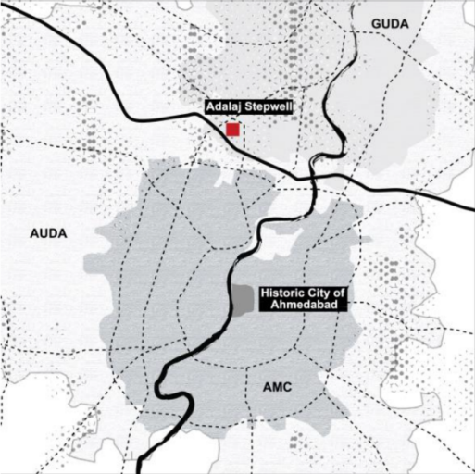
Figure 14. Adalaj Stepwell. Image credit: Peter Patel.
Figure 15. Sectional view illustrating stepwell depth and groundwater interface. Image credit: www.mdpi.com/2073-445X/12/8/1539
The Archaeological Survey of India (ASI) and the Gujarat Archaeological Department (GAD) oversee the maintenance of this historical site, with further assistance from the Jal Sampatti Vibhag (Gujarat Water Supply and Sewerage Board). Conservation efforts emphasise the protection of sculptures, limit access to delicate areas, and implement grill covers to avoid contamination. These measures prioritise material preservation and visitor safety, but they do not address the environmental processes that historically sustained the stepwell. (Sriparvathy and Salahsha, 2021).
The site’s revival in social practices, primarily driven by local women through goddess shrines, sustains its ritual significance but does not facilitate groundwater replenishment. This separation between cultural use and ecological function underscores the selective nature of current restoration approaches. Other stepwells, such as Khodiyar Mata ni Vav, have been restored under similar initiatives, revealing varying restoration techniques, where cement plastering and tiling have replaced traditional finishes. Such interventions often prioritise durability and visual clarity over material authenticity and hydrological performance.
Although the renewed cultural appreciation, exemplified by Rani ki Vav’s depiction on the ₹100 note, has raised the profile of these monuments, their environmental functions have not been reinstated. Consequently, Adalaj illustrates a restoration approach focused on aesthetics and ritual continuity without addressing hydrological restoration, while Rani ki Vav in Patan demonstrates the potential for more integrated cultural and ecological preservation (Sriparvathy and Salahsha, 2021).
This gap becomes more evident in the case of Rudabai Stepwell at Adalaj, where heritage protection operates entirely separately from landscape and water-system planning. Although the stepwell is protected as a Monument of National Importance under the AMASR Act and falls under the responsibility of the Archaeological Survey of India, the hydrological hinterland, including the catchment basin and associated agricultural landscapes, remains outside the scope of protection. This disconnect limits the effectiveness of conservation in addressing long-term water sustainability.
In the past twenty years, the area surrounding the stepwell has undergone rapid transformation driven by regional development plans, tourism promotion, and infrastructure projects, including highway expansion and visitor facilities (Rajabi, 2023). These developments have reshaped land-use patterns and altered surface runoff conditions. As a result, traditional drainage relationships that once sustained the stepwell have been progressively disrupted.
These changes have significantly altered natural drainage patterns; the historical village lake was replaced by an artificial reservoir, and the stepwell was physically cut off from its original water sources (Rajabi, 2023). While conservation efforts have preserved architectural features, they have also contributed to the spatial and functional isolation of the structure. Instead of reinforcing hydrological linkages, greater emphasis has been placed on tourist-oriented beautification, resulting in a monument that is visually restored but environmentally inactive.
This example highlights the consequences of limited institutional coordination, where heritage conservation frameworks remain confined to monument boundaries, while urban development and smart-city initiatives reshape surrounding landscapes without accounting for traditional water systems. Adalaj, therefore, demonstrates how stepwells are increasingly maintained as static cultural artefacts, rather than being reintegrated as active elements within contemporary urban water networks (Rajabi, 2023).
Discussion
The cases of stepwells, lake systems, and recent rejuvenation projects highlight a critical gap in contemporary urban water governance: the disconnect between heritage-based water infrastructure and formal planning mechanisms. Current approaches to water management in Indian cities are largely engineering-driven, relying on borewells, pipelines, and centralised supply systems, while neglecting decentralised recharge structures embedded within the historic urban fabric. This separation has resulted in the parallel existence of heritage conservation and water management, with limited interaction between the two domains.
Recent policy frameworks offer opportunities to reposition such systems. At the national level, missions such as the Atal Mission for Rejuvenation and Urban Transformation (AMRUT) and the Jal Jeevan Mission (JJM) emphasise sustainable urban water supply, recharge, and resilience. Locally, Gujarat’s Sujalam Sufalam Jal Abhiyan focuses on desilting and restoring waterbodies, while the Heritage City Development and Augmentation Yojana (HRIDAY) seek to integrate cultural conservation with infrastructure development. Despite this, stepwells and historic tanks remain largely absent from operational planning agendas, continuing to be treated primarily as architectural or tourism-oriented assets rather than as functional components of urban hydrology.
Urban planning policies rarely acknowledge the dual role of heritage structures as both cultural landmarks and hydrological assets. For instance, the Adalaj Stepwell and the Sarkhej Roza complex are managed under heritage conservation frameworks, yet their operational capacity for aquifer recharge, stormwater retention, and microclimatic regulation is overlooked in statutory planning documents. This omission reflects a broader reluctance to engage with traditional systems as active infrastructure within modern urban contexts.
A sharper integration requires embedding traditional recharge systems into statutory planning instruments. This involves:
- Recognising stepwells, tanks, and lakes as elements of urban blue–green infrastructure rather than solely heritage assets.
- Incorporating them into zoning regulations and development control norms, ensuring protection from encroachment and the designation of adequate buffer zones.
- Aligning restoration projects with state-level water security missions and municipal water supply schemes, so that heritage systems actively complement centralised infrastructure.
- Institutionalising community participation models, as demonstrated in successful lake restoration projects, to ensure long-term maintenance, monitoring, and accountability.
Transforming heritage-based water systems into practical planning tools extends beyond policy recognition alone. Stepwells and historic lakes continue to be treated in statutory plans as isolated heritage markers, detached from the larger hydrological networks that once sustained them. Infrastructure expansion, real estate development, and tourism-oriented projects are often prioritised in development plans, frequently disrupting natural drainage routes, catchment areas, and recharge zones historically connected to these systems. Consequently, monuments may remain visually intact while their ecological contexts progressively degrade.
A shift from monument-centric conservation to landscape-based planning is therefore essential. Catchment areas, feeder channels, seasonal drainage paths, and associated open spaces must be recognised as functional extensions of heritage water structures. Integrating hydro-heritage overlays into planning tools such as Development Plans, Town Planning Schemes, and Local Area Plans can help identify recharge zones and regulate incompatible land uses. In semi-arid cities such as Ahmedabad, where groundwater stress is intensifying, this approach aligns closely with climate-responsive and resilience-oriented planning frameworks.
Cross-sectoral coordination is equally critical. At present, water departments, urban development authorities, heritage agencies, and tourism bodies often operate independently, leading to fragmented and sometimes contradictory interventions. A coordinated governance framework, supported by shared datasets, collaborative assessments, and integrated funding mechanisms, can enable heritage water systems to function as part of contemporary urban resilience strategies. Through such integration, stepwells and lakes can emerge as hybrid infrastructures that are socially relevant, culturally embedded, and environmentally productive.
Conclusion and way forward
In Ahmedabad, the challenge of incorporating stepwells and water complexes into the city’s urban recharge infrastructure should not only be considered as an artefact of culture but rather as a usable part of the city's ecological and planning systems. Stepwells and lakes were created to create a sustainable socio-ecological system that provides groundwater recharge, regulates local climates and serves as a social focal point within their communities. The gradual degradation of these systems exemplifies a larger evolutionary trend throughout urban areas where increased population density, lack of collaboration between governmental agencies and excessive reliance on borewells have destroyed the vibrant place-based water practices. The case studies of Adalaj, Sarkhej, Anasagar and Varthur highlight the hidden possibility of cultural heritage-based water systems and point out the dangers of revitalising these systems without an integrated approach to hydrology and urban planning.
The way forward lies in moving beyond monument-focused conservation toward systemic integration within statutory urban planning. Stepwells, tanks, and lakes must be recognised as components of urban blue-green infrastructure that contribute actively to groundwater recharge, flood moderation, and climate adaptation. This requires embedding heritage water systems within Development Plans, Town Planning Schemes, and local water management strategies, ensuring their catchments, feeder channels, and recharge zones are protected from incompatible land uses. Without such spatial and regulatory alignment, restoration efforts risk remaining symbolic rather than functional.
Equally critical is the restructuring of governance mechanisms. Coordinated action between urban development authorities, water supply agencies, heritage bodies, and local communities is essential to prevent fragmented interventions. Heritage water systems offer an opportunity to bridge environmental resilience with cultural continuity, but only if supported by shared data frameworks, integrated funding models, and long-term maintenance strategies.
Ahmedabad, with its layered and well-documented water heritage, is uniquely positioned to demonstrate how traditional hydrological knowledge can inform contemporary urban water planning. By treating stepwells and lakes as living infrastructure rather than static artefacts, cities can reclaim adaptive, decentralised water systems that are environmentally robust, socially inclusive, and culturally grounded, setting a transferable precedent for semi-arid urban regions across India and beyond.
References
- BHANOT, C., & CHATTERJEE, S. (2023). Conservation of Urban Wetland with Potential International Significance: A Case Study on Najafgarh Jheel, Delhi, India. International Journal of Conservation Science, 14(3), 1057–1070. https://doi.org/10.36868/ijcs.2023.03.18
- Das, R., H.N., C., & Rao, L. (2023). Unravelling the reason for seasonality of foaming in sewage-fed urban lakes. Science of the Total Environment, 886, 164019. https://doi.org/10.1016/j.scitotenv.2023.164019
- Hussain, J., Husain, I., & Arif, M. (2014). Water resources management: traditional technology and communities as part of the solution. Proceedings of the International Association of Hydrological Sciences, 364, 236–242. https://doi.org/10.5194/piahs-364-236-2014
- Kumar, A., & Rana, S. (2021). Population and conservation threats to the Greater Flamingos Phoenicopterus roseus (Aves: Phoenicopteriformes: Phoenicopteridae) at Basai Wetland and Najafgarh Jheel Bird Sanctuary, Haryana, India. Journal of Threatened Taxa, 13(7), 18894–18898. https://doi.org/10.11609/jott.6258.13.7.18894-18898
- Madhab, D., Vinay, M., Sincy, S., Asulabha, V., Sudarshan, K., Bhat, P., & Aithal, B. (2017). T V Ramachandra Gautam and Vasantha Jagadisan Endowment-Lake Rejuvenation Bellandur and Varthur Lakes Rejuvenation Blueprint. https://data-opencity.sgp1.cdn.digitaloceanspaces.com/Documents/Recent/IISc_TVR-ETR116_25April2017_Full-RG.pdf
- Mishra, G., Shukla, P., & Iyer, M. (2019). The Dying Water Heritage of Sarkhej Roza. Journal of Heritage Management, 4(2), 141–159. https://doi.org/10.1177/2455929619890510
- Mistry, P., & Suhane, S. (2024). Stepwells as Living Heritage of India: Insights from Two Step-Wells in Ahmedabad. ISVS E-Journal, 11(11), 157–182. https://doi.org/10.61275/isvsej-2024-11-11-09
- Niyogi, B. (2023). Assessment of Groundwater Depletion and its Socioeconomic Impacts in Arid Regions with special reference of Ahmedabad City. International Journal of Research in Engineering and Science (IJRES) ISSN, 11, 167–173. https://www.ijres.org/papers/Volume-11/Issue-11/1111167173.pdf
- Nizamuddin Basti, H. (n.d.). Conservation of the 14 th century stepwell, HUMAYUN’S TOMB SUNDAR NURSERY urban renewal inititative A Public-Private Partnership initiative of Archaeological Survey of India Municipal Corporation of Delhi -Central Public Works Department Aga Khan Foundation-Aga Khan Trust for Culture. Retrieved October 27, 2025, from https://www.nizamuddinrenewal.org/conservation/nizamuddin-baoli/images/baoli-proposal-to-j-m-kaplan-fund.pdf
- Nizamuddin Urban Renewal Initiative. (2023). Nizamuddinrenewal.org. https://www.nizamuddinrenewal.org/conservation/nizamuddin-baoli/
- Rahul, U., & Arvind, P. (2013). Assessment of Lake Water Quality by Using Palmer and Trophic State Index-a Case Study of Upper Lake, Bhopal, India. Int. Res. J. Environment Sci. International Science Congress Association, 2(5), 1–8. https://www.isca.me/IJENS/Archive/v2/i5/1.ISCA-IRJEvS-2013-024.pdf
- Rao, R., Kansal, A., & Tarannum, F. (2024). Role of Stakeholders in Sustainable Management of an Urban Waterbody and Wetland. Environment and Urbanization ASIA, 15(1), 175–191. https://doi.org/10.1177/09754253241236850
- Rustogi, P., & Singh., S. K. (2017). REVIVAL AND REJUVENATION STRATEGY OF WATER BODIES IN A METROPOLITAN CITY: A CASE STUDY OF NAJAFGARH LAKE, DELHI, INDIA. International Journal of Advanced Research, 5(2), 189–195. https://doi.org/10.21474/ijar01/3131
- Scientific investigations Investigations. (n.d.). Retrieved October 27, 2025, from https://www.nizamuddinrenewal.org/conservation/nizamuddin-baoli/images/baoli-conservation-works-panels.pdf
- Selvaraj, T., Devadas, P., Perumal, J. L., Zabaniotou, A., & Ganesapillai, M. (2022). A Comprehensive Review of the Potential of Stepwells as Sustainable Water Management Structures. Water, 14(17), 2665. https://doi.org/10.3390/w14172665
- Sriparvathy, U., & Salahsha, T. N. (2021). Adalaj Stepwell: A Magical Resonance of Architectural Ingenuity. ATHENS JOURNAL of ARCHITECTURE, 7(2), 275–304. https://doi.org/10.30958/aja.7-2-3
- Themes: Lakes, Water and Sanitation ABSTRACT Case Title: Conservation and management of Bhoj Wetlands, India #329. (n.d.). Retrieved October 27, 2025, from https://iwrmactionhub.org/system/files/2021-11/India_Conservation_and_management_of_Bhoj_Wetlands_329.pdf
- Uday Vir Singh. (2023). An Analytic Case Study of Lentic Ecosystem and Rejuvenation of Bellandur and Varthur Lakes in Bengaluru, India. International Journal of Environment and Climate Change, 13(9), 1260–1272. https://doi.org/10.9734/ijecc/2023/v13i92354
- Bothra, M., Gowda, S., & Gowda, N. (2025). Dying Waters: An Ecological and Governance Crisis in Bengaluru’s Lakes. Journal Peer Reviewed Journal INTERNATIONAL JOURNAL of TRENDS in EMERGING RESEARCH and DEVELOPMENT, 3. https://doi.org/10.5281/zenodo.15732541

