"Smoking And Bone Fragility: An Incidence Study On Osteoporosis Among Smokers”.

\

ABSTRACT
Background: Osteoporosis is a metabolic bone condition characterized by progressive reduction in bone strength due to decreased bone mineral density (BMD). Tobacco consumption is considered a significant behavioral risk factor that interferes with bone remodeling by affecting osteoblastic activity, mineral balance, and endocrine function. While osteoporosis is often associated with aging, early bone changes related to tobacco exposure may occur in young adults. Aim: To assess the incidence of osteoporosis among adult smokers and to compare bone mineral density between smokers, smokeless tobacco users, and individuals without tobacco habits. Materials and Methods: A total of 90 subjects aged 20–45 years were included in this observational study and categorized into three equal groups: smokers, smokeless tobacco users, and non-users. Bone mineral density was evaluated at the calcaneum using a portable SONOST 2000 peripheral DEXA system. Based on T-score values, participants were classified as normal, osteopenic, or osteoporotic. Statistical analysis was carried out using SPSS version 21.0. Differences in mean T-scores were analyzed using one-way ANOVA, while associations between tobacco exposure and BMD status were examined using the Chi-square test. Correlation analysis was performed to determine the relationship between smoking intensity, duration, and T-score values. A p-value less than 0.05 was considered statistically significant. Results: Individuals with a smoking habit demonstrated lower mean T-scores compared to smokeless tobacco users and non-users. Osteoporosis was more frequently identified among smokers, whereas most non-users exhibited normal BMD values. Greater duration and frequency of smoking were associated with progressively lower T-scores. Conclusion: Tobacco use, particularly smoking, is strongly associated with reduction in bone mineral density. Preventive measures, including early screening and tobacco cessation counseling, are essential to minimize long-term skeletal complications.

Keywords: Osteoporosis; Bone Mineral Density; Smoking; Smokeless Tobacco; DEXA; T-score; Calcaneum; Tobacco Exposure; Osteopenia; Risk Factors

INTRODUCTION
Osteoporosis is a systemic skeletal disorder characterized by decreased bone mass and microarchitectural deterioration of bone tissue, leading to increased bone fragility and susceptibility to fractures.[1] Although osteoporosis is commonly regarded as a disease predominantly affecting women, a substantial proportion of osteoporotic fractures also occur in men.[2] The World Health Organization (WHO) defines osteoporosis based on Bone Mineral Density (BMD) measurement using Dual Energy X-ray Absorptiometry (DEXA), where a T-score of ≤ –2.5 standard deviations below the young adult mean confirms the diagnosis.[3] Osteopenia, a precursor stage of osteoporosis, is defined by a T-score between –1.0 and –2.5.[4]
Several environmental and lifestyle factors influence bone mineral density, among which tobacco use is considered a major modifiable risk factor.[5] Smoking has been consistently associated with reduced BMD at various skeletal sites and an increased risk of fractures.[6,7] Meta-analytic evidence suggests that cigarette smoking significantly lowers bone mineral density and increases hip fracture risk in both men and women.[6,7] The adverse skeletal effects of smoking are mediated through multiple mechanisms, including direct toxicity of nicotine on osteoblasts, inhibition of collagen synthesis, increased bone resorption, and premature osteoblast apoptosis.[9,10] Additionally, smoking indirectly impairs bone health by reducing intestinal calcium absorption, altering steroid hormone levels, and affecting estrogen metabolism.[11–14]
Epidemiological studies have demonstrated that smokers exhibit significantly lower BMD compared to non-smokers, with the risk increasing proportionally to duration and intensity of smoking.[6,15,16] Furthermore, combined tobacco exposure, including smokeless tobacco use, has also been associated with compromised bone health.[16] Given the rising prevalence of tobacco use among young and middle-aged adults, early identification of tobacco-related bone loss is crucial to prevent long-term skeletal complications.
Therefore, the present study was undertaken to determine the incidence of osteoporosis among adult smokers and to compare bone mineral density among smokers, smokeless tobacco users, and non-smokers using peripheral DEXA assessment.

AIM AND OBJECTIVES

Aim
To evaluate the incidence of osteoporosis among adult smokers and to compare bone mineral density among smokers, smokeless tobacco users, and non-smokers.

Objectives

To measure bone mineral density (BMD) in smokers, smokeless tobacco users, and non-smokers using peripheral DEXA.To compare mean T-scores among the three groups.To determine the prevalence of osteopenia and osteoporosis based on WHO diagnostic criteria.To assess the association between tobacco use and bone mineral density.

MATERIALS AND METHODS

Study Design and Setting
This observational cross-sectional study was conducted in the Department of Oral Medicine and Radiology.

Study Population
A total of 90 participants aged 20–45 years were included and divided equally into three groups: Group I – Smokers (n=30), Group II – Smokeless tobacco users (n=30), Group III – Non-smokers (n=30).

Inclusion Criteria

Inclusion criteria for the study was as follows
Individuals aged 20–45 years, history of smoking for more than 5 years (Group I), habit of smokeless tobacco use (Group II), healthy individuals without tobacco habit (Control group).

Exclusion Criteria

Exclusion criteria for the study was as follows
Pregnant or lactating women, patients with systemic diseases affecting bone metabolism, individuals on calcium, bisphosphonate, or steroid therapy, patients previously diagnosed with osteoporosis, history of heel trauma or pathology.

Method of Measurement
Bone Mineral Density was assessed using a portable SONOST 2000 peripheral Dual Energy X-ray Absorptiometry (DEXA) device. Measurements were taken at the calcaneum.
T-scores were interpreted according to WHO criteria^{3 :} Normal: ≥ –1, Osteopenia: –1 to –2.5, Osteoporosis: ≤ –2.5.
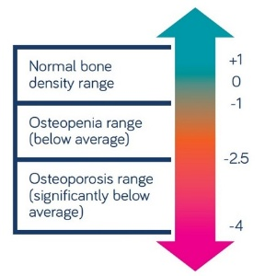

Statistical Analysis
Data were entered into Microsoft Excel and analyzed using SPSS version 21.0. Mean and standard deviation were calculated for quantitative variables. Shapiro–Wilk test assessed normality. One-way ANOVA compared mean T-scores among groups. Chi-square test evaluated association between tobacco habit and BMD category. Pearson correlation assessed the relationship between smoking duration, frequency, and T-score. A p-value < 0.05 was considered statistically significant with 95% confidence interval and 80% study power.

Results

Table 1
BMD Category | Smokers (n=30) | Smokeless Tobacco Users (n=30) | Non-Smokers (n=30) | Total (N=90)
Normal | 4 (13.3%) | 8 (26.7%) | 21 (70.0%) | 33 (36.7%)
Osteopenia | 15 (50.0%) | 16 (53.3%) | 8 (26.7%) | 39 (43.3%)
Osteoporosis | 11 (36.7%) | 6 (20.0%) | 1 (3.3%) | 18 (20.0%)
Total | 30 (100%) | 30 (100%) | 30 (100%) | 90 (100%)

Table 2
Test | Value | df | p-value | Significance
Pearson Chi-Square | 18.42 | 4 | 0.001 | Significant

Table 3 Comprehensive summery of demographic and BMD parameters across study groups

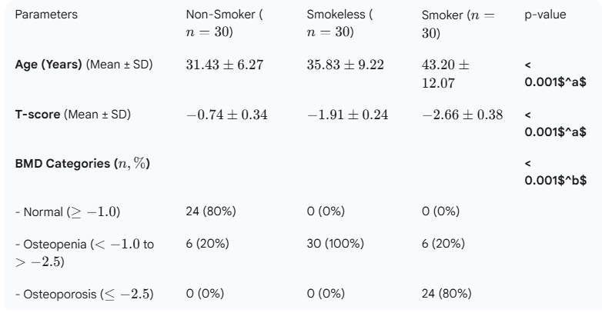
Smokers showed the highest percentage of osteoporosis (36.7%). Smokeless tobacco users demonstrated moderate prevalence (20%). Non-smokers predominantly had normal BMD (70%). The association between tobacco habit and BMD category was statistically significant (p = 0.001). Table presents the distribution of Bone Mineral Density (BMD) categories among smokers, smokeless tobacco users, and non-smokers. The findings show that smokers had the highest prevalence of osteoporosis (36.7%), followed by smokeless tobacco users (20.0%), while only 3.3% of non-smokers were osteoporotic. A majority of non-smokers (70.0%) had normal BMD compared to only 13.3% of smokers. Osteopenia was most commonly observed among smokeless tobacco users (53.3%) and smokers (50.0%). Overall, the results demonstrate a clear trend of reduced bone mineral density among tobacco users, particularly smokers. The association between tobacco habit and BMD category was found to be statistically significant (Chi-square test, p = 0.001), indicating that tobacco use is significantly related to increased risk of osteopenia and osteoporosis. These findings support the rejection of the null hypothesis and confirm that smoking is associated with decreased bone mineral density.
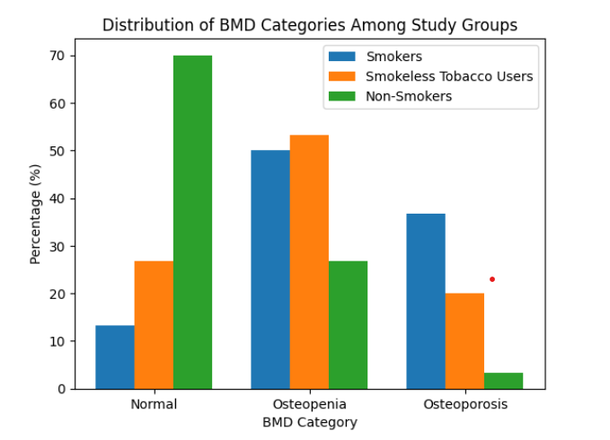

DISCUSSION
The present study demonstrated a statistically significant reduction in bone mineral density among smokers compared to smokeless tobacco users and non-smokers. Smokers exhibited the lowest mean T-scores, and the highest prevalence of osteoporosis was observed in this group.
These findings are consistent with the meta-analysis by Ward and Klesges,[6] which reported a significant negative association between cigarette smoking and bone mineral density. Similarly, Höidrup et al.[7] observed increased hip fracture risk among smokers across different age groups.
The direct toxic effect of nicotine on osteoblast function, including inhibition of collagen synthesis and increased bone resorption, has been documented in experimental studies.[9,10] Additionally, smoking interferes with calcium absorption and estrogen metabolism, further contributing to reduced bone mass.[11–14]
Krall and Dawson-Hughes[11] reported accelerated bone loss among smokers compared to non-smokers. Kim et al.[15] also demonstrated an association between secondhand smoke exposure and osteoporosis in postmenopausal women. Furthermore, Ayo-Yousaf[16] observed that combined tobacco exposure significantly increases osteoporosis risk.
The present study also revealed a significant negative correlation between duration and frequency of smoking with T-score values, indicating dose-dependent bone loss. These findings support previous evidence suggesting that prolonged tobacco exposure progressively impairs skeletal health.[6,7]
The inclusion of smokeless tobacco users in this study provides additional insight into the broader skeletal effects of tobacco exposure. Although smokeless tobacco users demonstrated reduced BMD compared to controls, the impact was less severe than that observed in smokers.
Early identification of tobacco-related bone loss through peripheral DEXA assessment may help in timely preventive interventions.

CONCLUSION
Smoking is significantly associated with decreased bone mineral density and increased prevalence of osteoporosis. The severity of bone loss correlates with duration and frequency of smoking. Preventive strategies, including tobacco cessation programs and early BMD screening, are recommended to reduce long-term skeletal complications.

CONFLICT OF INTEREST: Nil

REFERENCES
- Alldredge BK, Koda-Kimble MA, Young LY, Kradjan WA, Guglielmo BJ. Applied therapeutics: The clinical use of drugs. Philadelphia: Wolters Kluwer Health; 2009. p.101–103.
- Eastell R, Boyle IT, Compston J, et al. Management of male osteoporosis: Report of the UK Consensus Group. QJM. 1998;91:71–92.
- World Health Organization. WHO Scientific Group on the Assessment of Osteoporosis at Primary Health Care Level. Geneva: WHO Press; 2004.
- US Department of Health and Human Services. Bone Health and Osteoporosis: A Report of the Surgeon General. Rockville, MD; 2004.
- Wong PK, Christie JJ, Wark JD. The effects of smoking on bone health. Clin Sci (Lond). 2007;113:233–241.
- Ward KD, Klesges RC. A meta-analysis of the effects of cigarette smoking on bone mineral density. Calcif Tissue Int. 2001;68:259–270.
- Höidrup S, Prescott E, Sörensen TIA, et al. Tobacco smoking and risk of hip fracture in men and women. Int J Epidemiol. 2000;29:253–259.
- Walker LM, Preston MR, Magnay JL, Thomas PBM, Haj AJ. Nicotinic regulation of cfos and osteopontin expression in human-derived osteoblast-like cells. Bone. 2001;28:603–608.
- Iwaniec UT, Fung YK, Akhter MP, et al. Effect of nicotine on bone mass, turnover, and strength in adult female rats. Calcif Tissue Int. 2001;68:358–364.
- Krall EA, Dawson-Hughes B. Smoking and bone loss among postmenopausal women. J Bone Miner Res. 1991;6:331–338.
- Baron JA, La Vecchia C, Levi F. The antiestrogenic effect of cigarette smoking in women. Am J Obstet Gynecol. 1990;162:502–514.
- Kilany YF, Abou Holw SA, Abouel-Nour MF, Morsy AT. Early development of osteoporosis in male smokers with hypoandrogenism. J Egypt Soc Parasitol. 2009;39:789–802.
- Friedman AJ, Ravnikar VA, Barbieri RL. Serum steroid hormone profiles in postmenopausal smokers and nonsmokers. Fertil Steril. 1987;47:398–401.
- Kim KH, Lee CM, Park SM, et al. Secondhand smoke exposure and osteoporosis in never-smoking postmenopausal women. Osteoporos Int. 2013;24:523–532.
- Ayo-Yousaf OB. Epidemiological association between osteoporosis and combined smoking and snuff use. Niger J Clin Pract. 2014;17:174–177.

