Sharing of Safety Culture at workplace measures to reduce industrial risks & hazards
ABSTRACT:
Environment, Safety, Health, and Welfare of people are intimately related with the measures taken towards effective safety culture at workplace in industries. Adopting and proper sharing of safety culture is a crucial component of an effective occupational safety and health practices in industries for reducing risks & hazard, preventing recurrences, improving safety by taking corrective measures and others as reducing costs, complying with regulations, building a safety culture, protecting reputation, meeting insurance requirements and making information available for litigation in due course of time etc. It is important for workers, employers, governments, and the society at large. Researchers are also emphasized the needs to adopt sharing of safety culture investigate as a measures to reduce risks & hazards in industries as the cases of occupational diseases or accidents in industries are increasing now a days. The study is aimed to assess the adoption for sharing of safety culture at the workplace in Hindustan Copper Limited as a measure to reduce associated risks & hazards towards the effective occupational safety and health practices in industries. The study suggests the ways to control the occupational diseases or industrial accidents by practicing an effective safety culture as a measure at workplace and sharing of safety culture among working population at workplace ensures the preventive measures to reduce the associated risks & hazards.
KEYWORDS: Safety Culture, Preventive measures for associated risks & hazards in industries, Safety Performance, Occupational afety & health practices.

INTRODUCTION:
As per Chib S & Kanetkar (2014) Safety culture reflects the attitudes, beliefs, perceptions and values that employees’ share in relation to safety. Safety culture is often seen as a subset of organizational culture and distinction of these concepts as well as safety climate is not clear. Safety culture is a multidimensional concept. The constituent factors are management responsibility, job satisfaction, individual responsibility, leadership style and communication, risk awareness and risk taking. Safety culture refers to the set of shared beliefs, perceptions, attitudes, and behaviours that influence how workplace safety is managed and sustained. It’s emphasized in how employees think and act regarding safety hazards and risks, as well as in the decisions made at the highest levels of management – decisions that must consider the human, organizational, and technical aspects of workplace safety. It’s based on voluntary adherence, collective dynamics, and a shared sense of responsibility. Such culture marks a shift from safety that’s “imposed from above” to safety that’s “supported by all.” Leadership is in general given great importance for safety culture. Ek (2006) states that the safety culture in organization could be said to be influenced by two important components: a) the type of work that is conducted and b) the leadership and management system. Flin (2003) further concludes that management commitment is one of the major factors in managing of an organization safety where the others are open communication &reporting, continuous training &education, employee engagement and integration with daily operations. A positive safety culture transforms safety from a compliance requirement into a shared, daily responsibility. Safety culture at the workplace in industry is to be truly ensured by full & honest dedications on Commitment, Communication, Cooperation/ Collaboration, and Competence to reduce industrial risk(a situation involving exposure to hazard or danger, a relative term) and hazard (a condition prevailing at the workplace having potential to cause damage to health, life and property).

LITERATURE REVIEW:
To make the eco-friendly and healthy working environment by establishing a good safety culture, study of related literature review carried out as per the available sources of information on websites and gains the knowledge and understands the background of the topic or subject being studied. Kumar V & Bhasi (2010) explained to analyze the measures taken towards occupational and industrial safety management with influence of safety engineering and management practices in selected industry in Kerala as collected efforts and proper thoughts in the direction of controlling work related hazards and accidents as unstable as no safety culture factors across industries and lack of study & to identify the critical safety. Md Saifullah N & Ismail (2011) while studying to identify the occupational safety & health elements as the safety culture as to analyses the measures towards industrial safety as it contributes to numbers of incidents and fatality to the construction players and public. Viscusi W. Kip (1986) expressed the OSHA's impact on workplace with the magnitude of the effect is modest, and the effect is not robust with respect to different risk variables on safety culture as to analyses the measures. Nielsenin E (1994) in his study on to review the knowledge in the fields of occupational exposure and health problems related to waste collection. The aims are to highlight the knowledge to put forward hypotheses on causal links between exposures and health effects on safety culture as to analyses the measures. López-Valcárcel A (2001) while studying the hazardous occupation in construction industry, all economic sectors considered on safety culture as to analyses the measures. Smallwood J & Ehrlich (2001) while analyzing the first look at health hazards and associated OH and hygiene services for safety culture needs as the risk of traumatic injuries, Musculoskeletal strain, Regional pain syndromes, exposed to noise and Respiratory irritation from dusts, fumes and gases. Viscusi W. Kip (2006) in his study to analyze the determinants of health &safety investment and industrial injury rates and opined as conceptual analysis indicated that the effect of jab hazard hinges critically on the economic incentives created and the policy makers have to pay little attention both to the potential desirability and economic mechanisms considered on safety culture. Janocha J A & Smith (2008) while analyzing the safety culture as to analyses the measures in a workplace safety & health to develop means to reduce future injuries, illnesses, and fatal occupational injuries to workers with the assessment for larger proportion of the fatal injuries occurred. Kumar V &Bhasi (2008) on their study to determine the safety culture and the personal attributes of participants to improve any specific abnormalities after comparing with the benchmarked scores and considered on safety culture as to analyses the measures towards industrial safety. Lekka C, Webster & Corbett (2010) while studying on key health & safety risks and control measures at major sporting events towards the planning and management risks towards the potential risks to health & safety during and after major sporting events as well as HSE or other bodies/ organisations do to prevent or mitigate potential/foreseeable risks considered on safety culture as to analyses measures towards industrial safety. Feng Y,Prasad, XiaohuaJin, Saha & Hardie (2013) while ascertaining factors influencing the effective implementation of safety management system having difficulties includes the contractor and client’s attitude towards the consideration on safety culture as to analyses the measures towards industrial safety. Subramani T & Lordsonmillar (2014) recommended for a focused dedication towards safety culture to eliminate injury or loss of property. Schofield E S, Gerberich & Ryan (2015) in their study emerged as an outside perception of management commitment which is to be wholly indicative of risk of injury within a company, but may be predicative for some construction trades or potentially in combination with other measures considered on safety culture as to analyses the measures towards industrial safety. Zahoor H, Chan, Masood, Rafiq. Choudhry, Javed & Utama (2016) expressed concern towards stakeholders' perspective that in absence of a regulatory authority, lack of commitment of management towards safety and overall safety unawareness have caused slackness in employees’ safety culture as to analyses the measures towards industrial safety which should not be resulted in an exacerbated accident rate and their findings came out as “lack of compliance with OSH” resulted a relatively higher construction accident rate in developing countries. Divya P, Bhavsar & Pitroda (2017) on a critical review in construction projects on safety management to utilize descriptive analysis for benchmark safety performance of construction contractors and client as Workers, Environmental and organizational are the factors affecting safety performance. Workers Factors are Human, Historical and Psychological. Natural and workings are the environmental factor whereas Incentive & project budget, policy & procedure and incentives are the organizational factors on safety culture as to analyses the measures towards industrial safety. Martha L. Ríosa, ShareaIjazb, Ruotsalainenb, Breslinf, Gummessong & Verbeekb (2018) studied for identifying preventive occupational safety & health interventions to protect young workers from hazards at work while considering their ongoing physical and mental maturation towards safety culture as to analyses the measures towards industrial safety. Christopher A H (2020) expressed concern in a global perspective to provide insights on safety culture as to analyses the measures towards industrial safety.
RESEARCH GAP:
Reviewed the literatures in context to the measures to be taken at the workplace for reducing risks & hazards and assessed that sharing of safety culture is not fully explored and also the aligned preventive measures are not properly explained as a result sharing of Safety Culture as measures to reduce risks & hazards at workplace in industries is very much effective as per latest standard and statutory norms.

OBJECTIVE OF THE STUDY:
The aim of the study is to know the measures to be taken at the workplace for reducing industrial risks & hazards. It further aims to prevent associated risks & hazards by sharing good safety culture among the working population at workplace in industrial perspectives.

RESEARCH METHODOLOGY:
Primary and secondary data both were used for the study. Developed the questionnaires by referring past research papers. Used Five-point Likert scale in questionnaire. The survey was conducted among the working populations in copper industry Hindustan Copper Limited in Jharkhand. The secondary data was collected from the articles published in journals, companies’ manuals etc. Considered sample size of 100 for this study. Randomly selected the working employees of Hindustan Copper Limited in Jharkhand to collect the data.
DISCUSSIONS AND ANALYSIS:
The opinion of the employees was collected on occupational safety and health practices in industries. The factor suggested by Prasad K (2023) from the Title “Occupational health and safety strategies”.
(i) | I am aware of my building evacuation plan.
(ii) | The personal protective equipment is upgraded whenever required.
(iii) | There are proper fire mock drills and other safety-related drills conducted & we also know the location of my building emergency utensils (such as fire extinguishers for first aid kits, sand etc).
(iv) | The safety committee conducts formal safety audits at regular intervals, are a normal part of a business.
(v) | The organisation follows the safety health policies and practices to deal with hazards at work, which is improving safety culture.
(vi) | All incidents are investigated quickly to improve safety at workplace as soon as possible.
(vii) | Safety is a high priority for our company hence first aid treatment is given to every injury however small.
(viii) | The safety information and rules are consistently &fairly enforced.
(ix) | We always do a risk assessment when we start a new process or when a process is changed.
(x) | There is enough collaboration within and across team so that everyone collaborates to improve safety in the company.
(xi) | Workplace health and safety are considered to be at least as important as production and quality.
(xii) | The training given us to make us feel to more confident to work safely even when we are doing the job for the first time.
(xiii) | Post-accident investigations are done in a proper time frame and learned from to improve the condition later to make all feel safe at work.
The five points of Likert Scale were: Strongly Agreed (SA) as 1, Agreed (A) as 2, Neutral (N) as 3, Disagreed (D) as 4, and Strongly Disagreed (SD) as 5.The data collected has been tabulated in Table 1. The value of standard deviation and weighted average calculated. Remarks on the perception of respondents for each statement were given based on the value of weighted average.
Table1: Perceptions on accident causation & its remedial measures for effective occupational safety& Health.
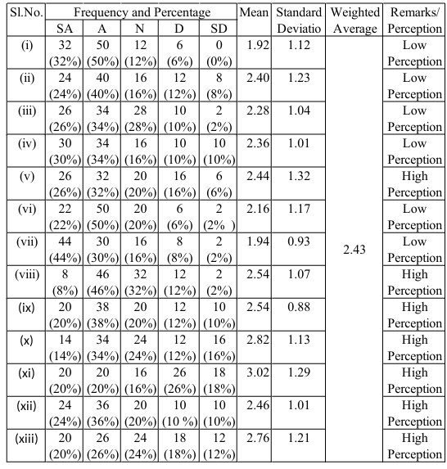
Histogram analysis for the frequency distribution and cumulative percentage option wise and question wise depicts that majority of respondents rather more than 60% responded the option strongly agree (SA) or agree (A) which supports the topic in favour. Details of charts for the frequency distribution and cumulative percentage are as under.
Chart: 1 Details of frequency distribution

Chart: 2 Details of cumulative percentage

H0: There is no impact of sharing safety culture as a measure at workplace to reduce industrial risks & hazards.
For analysing the data single test ANOVA using MS Excel was applied.
Table: 2 Outcome of analysis
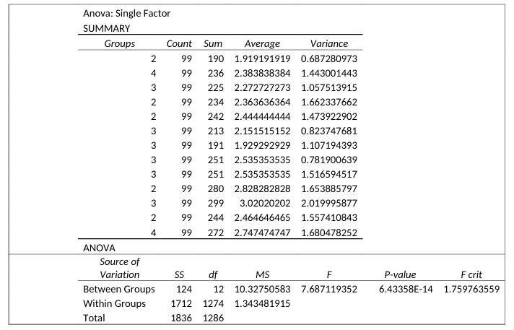
At 5% significance level, the null hypothesis rejected. Therefore, there is a significant impact of sharing safety culture as a measure at workplace to reduce industrial risks & hazards. With reference to the data collected, the respondents accepted that industrial risks & hazards are sensibly getting reduced by sharing safety culture as a measure at the workplaces. It was also accepted that the unsafe act or behaviour & physical working conditions as well as resilient management strategy on safety is the main issues responsible for dangerous occurrences and industrial risks & hazards at workplace in industries which could be controlled or rather reduced by sharing safety culture at the workplace among the employees and other stakeholders employer, employees, public living in the surrounding and society at large which could be established by strict OSH strategy by management as they are accountable towards OSH for their employees.
Majority of the respondents accepted that sharing safety culture as a very much effective tool for preventing industrial risks & hazards in industries. This may be in the form of wearing required PPE, following Lockout/ Tag out procedures, reporting hazards immediately, never bypassing safety devices, staying trained and authorized for equipment, maintaining good housekeeping, and stopping work if unsafe, safety training, safety talk, safety compaign &propaganda, safety demonstration,awareness to follow safety rules, regulations, guidelines & SOPs, use safety appliances & protective equipments etc which ignonorance will certainly invite dangerous occurrences as industrial accidents and occupational illness by the workers. Resilent motives, ignoring attitude, less attention and defer for later are the lapses by the managements towards safety culture and lack of practice for non- using safety appliances is a major concern for occuring accidents / incidents at work places.
Adopting & sharing safety culture is the pillar that upholds a culture of protection, where every individual is empowered to prioritize their well-being and that of others. Optimal safety and safe working conditions are the priorities of the management in industries as the safety & health are their responsibilities. A strong safety culture in industries integrates shared beliefs, attitudes, and behaviours that prioritize safety as a core value rather than just a set of rules. It requires top-management commitment, open communication, and employee empowerment to identify hazards and stop unsafe work, ultimately reducing accidents, improving morale, and enhancing productivity. The industry is always aiming to achieve “Zero Harm/ Damage/ Loss” and committed to continue sustainable growth and reputation by diligently adhering the ‘Sustainable Development Framework’. In a line of preventive measures towards adopting safety culture & its sharing, formal standards for behavioural changes, attitudes to act by workers and maintaining proper & safe workplace, resources to meet/exceed standards, a system of measurement, effective consequences, appropriate application and continual evaluation of the system may reduce or rather control the industrial risks & hazards. The importance of creating an effective safety culture in the workplace is a matter related to human, economic and organizational and its overall performance is to demonstrate a successful safety culture, marked by consistency, shared commitment, and proactive risk management. By building a work environment where safety performance is a shared priority through which industry may reduce unforeseen issues, streamline team collaboration and accountability, and increase production rates.
Opposite to the above towards the dangerous occurances and associated risks & hazards in industries, resilent motives, ignoring attitude, less attention and defer for later are the lapses by the managements towards safety culture or rather ignorances in safe procedure is a major concern for occuring accidents / incidents at work places. Every accident or incident is preventable by improving employees act or behaviour in their attitude to follow safety norms, guidelines as well as use of safety appliances and improving the healthy work environment or rather work place condition and taking adequate safety measures by the management. Measures have to be introduced to avoid violation of safety rules just by ignoring behavioural safety practices.
The method of research includes surveys and fact- finding enquires of different kinds through questionnaires to understand their perception about the awareness of safety culture among the working employees towards occupational health & safety in industries and the preventive measures taken by the management for controlling or rather reducing the dangerous occurrences and associated risks & hazards in industries.
CONCLUSION:
The study concludes that industries are performing or rather maintaining their image or reputations effectively at the cost on due consideration of safety and health of their workforce. However discussing best practices, asking questions, and learning from each other helps to improve safety and to prevent loss of life and this may be happened to the ground only by sharing safety culture at the workplace in industries. The purpose is to explain the necessity for developing and implementing effective and efficient safety training and education for the workers. Following five essential elements for creating a strong safety culture as per study of HSE Guide for Risk Assessment as measure to reduce associated risks & hazards in industries are most effective tool.
- Continually Updating Safety Precautions. ...
- Internal Safety Training for All Employees. ...
- External Training from Your Partner in Safety. ...
- Bringing Employees Together to Form a Safety Culture. ...
- Holding Each Other Accountable to Safety Standards.
Adopting good safety culture and its sharing among the workers towards dangerous occurrences and associated risks & hazards in industries is the key for the prevention of industrial accidents as well as occupational hazards and subsequently it is easy to protect rather to prevent the industrial injury/ harm/ loss/ damage. It is important to recognize work-related diseases in the early stages by promoting the development of occupational health services, including the training of doctors.
BIBLIOGRAPHY:
Published Reports, Acts and Rules:
- Factories Act, 1948 read with Jharkhand Factories Rules, 1950.
- Mines Act, 1952 read with its rules and regulations.
Books and Sites:
- Loss & prevention manuals fifth edition.
- Industrial Accidents (2015) chapter 13.
- HSE Study Guide for Risk Assessment.
Journals:
- Kumar V& Bhasi (2010), Influence of safety engineering and management practice in selected industry in Kerala. Shodhganga @inflibnet,CochinUniversity,Oct.2010
- Saifullah N M & Ismail (2011), Integration of occupational safety and health during preconstruction stage in Malaysia. Asia Pacific International Conference on Environment-Behaviour Studies, Salamis Bay Conti Resort Hotel, Famagusta, North Cyprus, 7-9 December 2011
- Chib S & Kanetkar (2014), safety culture to ensure occupational safety and health. The Science of the Total Environment 170 (1995) 1-19
- Kathryn M,Whitaker & Flin (2018), Safety management practices and safety performance. Tenega University IEBMC 2017/July 2018
- Viscusi W. Kip (1986), Impact of occupational safety and health regulation, 1973-1983. The Bell Journal of Economics, Vol 10, No.1 (spring, 1979), 2006
- Nielsenin E (1994), Collection of domestic waste, review of occupational health problems and their possible causes. The Science of the Total Environment 170 (1995) 1-19
- Valcárcel A L (2001), Occupational safety & health at the construction sites. AfrNewslett on Occup Health and Safety 2001;11:4−7
- Smallwood J & Ehrlich (2001), Occupational health in the South African construction industry: Management and Worker perceptions. AfrNewslett on Occup Health and Safety 2001;11:10–12
- Viscusi W. Kip (2006), Impact of occupational safety & health regulation. Rand Journal of Economics Vol. 17, No. 4, Winter 1986
- Janocha J A. & Smith (2008), Workplace safety and health in the health care and social assistance industry, 2003-07. NAICS BLS http://www.bls.gov/bls/naics.htm
- Kumar V & Bhasi (2008), Safety climate factors, its relationship with accidents and personal attributes in the chemical industry
- Lekka C, Webster & Corbett (2010), Insight on key health & safety risks and control measures at major sporting events towards the planning and management risks for the 2012 olympic and paralympic games. Health and Safety Laboratory in the year 2010
- Feng Y, Prasad, Xiaohuajin, Saha & Hardie (2013), Effective implementation of safety management system on construction site in Australia. University of Western Sydney,Locked Bug 1797 Australia, 2013
- Subramani T & Lordsonmillar (2014), Safety management in construction industry. T. Subramani Int. Journal of Engineering Research and Applications ISSN : 2248-9622, Vol. 4, Issue 6( Version 5), June 2014, pp.117-120
- Schofield E S, Gerberich & Ryan (2015), Management commitment to safety & risk of workplace injury: a workers’ compensation insurance perspective. Journal of Safety, Health & Environmental Research • VOLUME 11, NO. 1 • 2015
- Zahoor H, Chan, Masood, Rafiq . Choudhry, Javed & Utama (2016), Occupational safety and health performance in the pakistani construction industry as stakeholders' perspective. International Journal of Construction Management, 2016 Vol. 16, No. 3, 209 219, http:// dx.doi.org/ 10.1080/ 15623599.2015.1138027
- Divya P, Bhavsar & Pitroda (2017), A critical review in construction projects on safety management. International Journal of Constructive Research in Civil Engineering (IJCRCE) Volume 3, Issue 4, 2017, PP 148-154
- Martha L. Ríosa, ShareaIjazb, Ruotsalainenb, Breslinf, Gummessong & Verbeekb (2018), Protecting young worker from hazardous work towards occupational safety & health interventions. Journal homepage: www.elsevier.com/locate/safety 2018
- Christopher A H (2020), Health, Safety and wellbeing at work, A global perspectives. Safe and Healthy Work in Global Perspective 2020

