SPIDER DIVERSITY IN THE VICINITY OF “AMAKONI RESERVIOR”,
SARANGARH-BILAIGARH DISTRICT, CHHATTISGARH, INDIA
ABSTRACT
Spiders are a globally distributed group, with established populations in a wide range of habitats. The present study aimed to investigate spider faunal diversity within "Amakoni Reservoir," also called "Putka Reservoir", Sarangarh- Bilaigarh District, Chhattisgarh, India. This study was conducted from December 2024 to Nvember2025 Specimens were collected from the environs of Amakoni Reservoir (Putka Reservoir) using a variety of collection methods and subsequently identified using a taxonomic key for Indian spiders. This study was conducted to evaluate spider species richness and develop a detailed species checklist for the spider fauna of the Amakoni Reservoir area A total of 23 species, representing 8 families, were recorded from study area. The Araneidae family was the most prevalent, comprising six species. Shannon’s Index (H)=-0.83031 and Simpson’s Index (D)= 0.8425 This research yields significant and contemporary data regarding the species diversity within the "Amakoni Reservoir," Sarangarh- Bilaigarh District, Chhattisgarh. The article provides a dataset that may be useful for future research on spider fauna.
Key words- Spider, diversity, Araneidae Amakoni Reservoir, Sarangarh- Bilaigarh District, "Putka Reservoir
OBJECTIVES- Objectives: This study was undertaken with the following primary objectives:
1. To assess the overall status of spider populations in the vicinity of the Amakoni reservoir.
2. To compile a comprehensive checklist of spider species identified at Amakoni reservoir.
1. INTRODUCTION
Spiders are fascinating creatures, they represent the most diverse and abundant group of invertebrate predators within terrestrial ecosystems (Wise, 1993). The fossil record indicates their emergence in the Devonian period approximately 380 million years ago (Shear et al., 1989). The current taxonomic classification recognizes 53'325 accepted species, distributed across 4391 genera within 135 families worldwide. (WSC2025 version-25) India is home to 1,442 spider species, distributed across 59 families and 361 genera, constituting 3.6% of the world's spider diversity, The family Salticidae exhibits the highest number of species (181), followed by Thomisidae (154) in India. (Silwal et al.2005) Currently Singh et al. (2022) recorded 336 spider species, belonging to 136 genera and 30 families, based on surveys conducted in 36 of the 52 districts of Madhya Pradesh. Furthermore, Singh’s book details 2,110 species within 527 genera and 55 families found in India. (Singh et al 2023). In Chhattisgarh, 222 spider species from 96 genera of 23 families have been recorded by Choudhary et al. (2023).
Spiders are classified within the Phylum Arthropoda, Class Arachnida, order Araneae, and are exclusively predatory organisms. Their body structure is segmented into two primary divisions: the cephalothorax and the abdomen. Characteristically, spiders possess eight legs, which are attached to the cephalothorax. The two major groups of spiders are Mygalomorphs, referred to as ancient spiders, and Araneomorphs, known as present day spiders. Spiders, characterized by their eight eyes, silk secretion, and web-spinning capabilities facilitated by spinnerets, are readily differentiated from insects.
As a dominant predator of insect pests, spiders fulfill a crucial ecological role. They contribute to the dynamic equilibrium of micro-level food webs and represent an essential component of Integrated crop Pest Management strategies. Spiders serve as efficient natural regulators of numerous insect-mediated diseases, including malaria and dengue. Spiders are significant biological pest regulators and serve as a food source for birds, reptiles, and mammals, thus maintaining the food web (Riechert & Lockley, 1984). They exhibit diverse distributions across habitats, contingent upon site suitability, and in feeding behaviors, occupying nearly all types of ecosystems. Spiders are a significant predatory group in terrestrial ecosystems, especially within agricultural and forest environments (Foelix, 2011); and play a crucial role in maintaining ecological balance. They are ecologically important for regulating insect populations (Nyffeler & Birkhofer, 2017).
. Amakoni Reservoir, situated in the Amakoni village in Sarangarh–Bilaigarh district of Chhattisgarh, India. Chhattisgarh exhibits substantial forest coverage, encompassing approximately 44.21% of its total area. The dominant vegetation types are classified as Tropical Moist Deciduous and Tropical Dry Deciduous Forests (Champion & Seth, 1968). The reservoir, situated within a dry deciduous forest ecosystem, provides a distinctive interface between terrestrial and aquatic environments. The shining water body acts as a lifeline for Amakoni villagers. During the monsoon, the reservoir brims with fresh water, reflecting the dense canopy of Sal, Bhirra, Karra, Bija, Harra, Amla, Khair, Neem, Baheda, and Karanj, teak, and other deciduous trees that line its banks. This ecologically significant reservoir boasts considerable natural beauty and a calming atmosphere, with its banks supporting a wide variety of plant and animal life with spiders.
2. METHODOLOGY
2.1 STUDY AREA- The current study was conducted Putka Reservoir, situated in the Amakoni village in Sarangarh–Bilaigarh district of Chhattisgarh, India, is a tranquil waterbody encompassed by tropical dry deciduous forests. The geographical coordinates of this area are 21° 35' 15.71'' N, 83° 4' 25.37'' W, and the elevation is 217 m (712 ft).
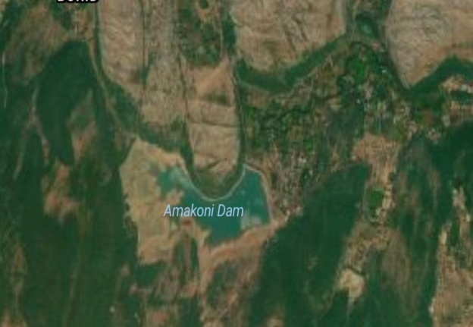
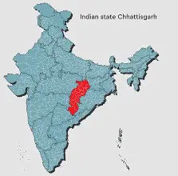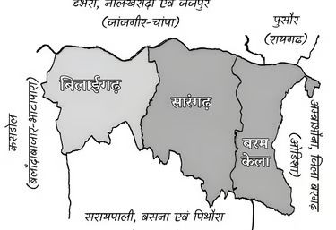
Study Area -India- Chhattisgarh-Sarangarh-Amakoni Reservoir
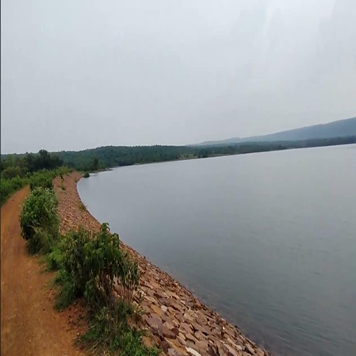  Study Area- Amakoni Reservoir | 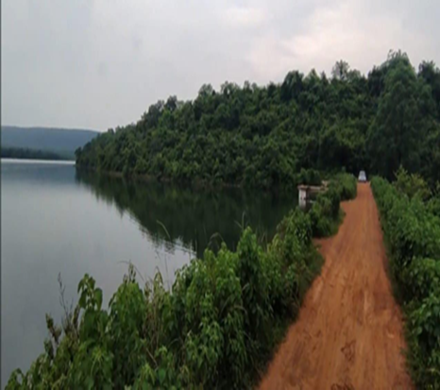
2.2 CLIMATE OF STUDY AREA- The climate of a region plays a crucial role in shaping the biodiversity of its spider population, impacting both the variety of species present and their numbers throughout the different seasons. The town of Sarangarh is located at an altitude of 231.33 meters, which is equivalent to 758.96 feet, above the average sea level. In terms of rainfall, Sarangarh experiences an average annual precipitation of approximately 46.69 millimetres, which translates to about 1.84 inches. This rainfall is distributed across the year, occurring on roughly 34.92 days annually, which means that rainfall is experienced around 9.57% of the time. The overall climate in this district is characterized by a relatively high average annual temperature, reaching about 30.28 degrees Celsius, or 86.5 degrees Fahrenheit. These climatic factors collectively influence the spider communities found in the Sarangarh area, affecting their distribution, behavior, and overall ecological balance. The interplay of temperature, rainfall, and altitude creates a specific environmental niche that supports certain spider species and influences their seasonal cycles of activity and reproduction.
2.3 SAMPLING METHOD- This study was conducted across all three sessions (summer, rainy, and winter) from December 2024 to November 2025. The following techniques were employed for specimen collection:
a. Ground-hand Collection: This method was utilized to collect spiders observed on the ground surface.
b. Aerial Hand Collection: This method was employed to collect web-building and free-living spiders from the foliage, herbaceous plants, stems of living or dead shrubs, and tree bark.
c. Active visual surveys - Active visual surveys were conducted within the habitat to locate spiders. Specimens were collected from ground-level and subterranean locations, as well as above-ground microhabitats, including folded leaves, plant branches, bark, rock surfaces, and grassland, in a collection vial.
d. Litter sampling -Litter sampling involves to the gathering arachnids specifically from the litter layer of an environment.
2.3. PHOTOGRAPHY AND IDENTIFICATION
All spiders observed were photographed using a digital single-lens reflex (DSLR) camera and a Vivo mobile application. Following photographic documentation, collected spiders were released back into their natural habitats. Deceased specimens were preserved in 70% ethanol. Data regarding collected specimens, including date and location, were recorded, and morphological features were clearly observed and documented.
Spider specimens were identified using established taxonomic keys and morphological characteristics, following the guidelines in the published literature (Pocock, 1900; Tikader, 1975, 1987; Tikader & Malhotra, 1980; Barrion & Litsinger, 1995; Majumder, 2004; Gajbe, 2008; Platnick, 2013; Peter & Sebastian, 2009).

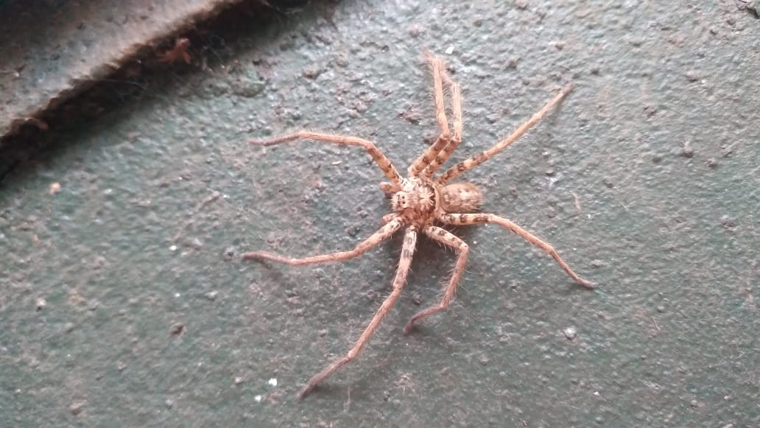  aa | 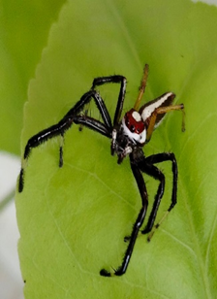  b
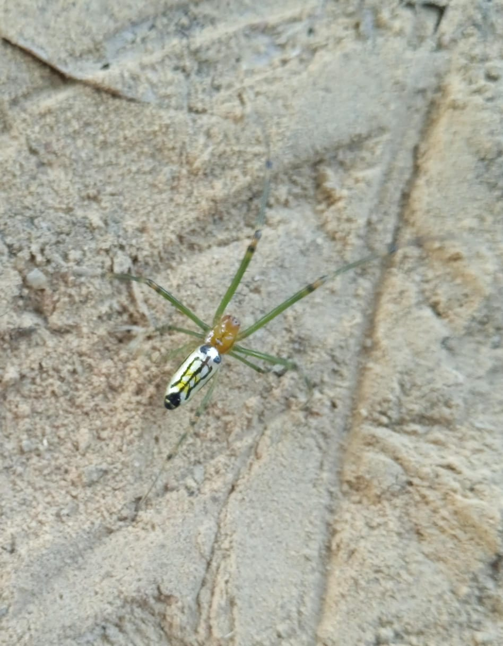  c | 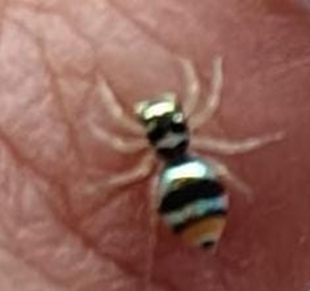  Plate-1- a Heteropoda venatoria, b - Telamonia dimidiate, c Leucauge decorata,- d- Phintella vittata  d

2.3. CALCULATION-
Table for calculations Biodiversity of following samples from the area: Amakoni reservoir
family | Number of individuals (n) | n/N | $p_{i}$=n/N | log$p_{i}$ | $$p_{i} logp_{i}$$ | n$-$1 | n(n$-1)$
Araneidae | 30 | 30/137 | 0.219 | $-$0.65956 | $-$0.14444 | 29 | 870
Hersiliidae | 14 | 14/137 | 0.1022 | $-$0.99055 | $-$0.10123 | 13 | 182
Lycosidae | 08 | 8/137 | 0.0584 | $-$1.23359 | $-$0.07204 | 07 | 56
Oxyopidae | 25 | 25/137 | 0.1825 | $-$0.73874 | $-$0.13482 | 24 | 600
Pholcidae | 05 | 5/137 | 0.0365 | $-$1.43771 | $-$0.05248 | 04 | 20
Salticidae | 28 | 28/137 | 0.2044 | $-$0.68952 | $-$0.14094 | 27 | 756
Sparassidae | 06 | 6/137 | 0.0438 | $-$1.35853 | $-$0.0595 | 05 | 30
Tetragnathidae | 21 | 21/137 | 0.1533 | $-$0.81446 | $-$0.12486 | 20 | 420
S (number of species) = n $-0.83031$ 2934
N (Total number of individuals) = 137,
Shannon’s Index (H) = $\sum_{i=1}^{s}{p_{i}}$log$p_{i}$ =$-0.83031$
Simpson’s Index (D)= 1$-\frac{\sum{n(n-1)}}{N(N-1)}$ = 1$-\frac{2934}{18632}$ = $\frac{15698}{18632}$ = 0.8425
.
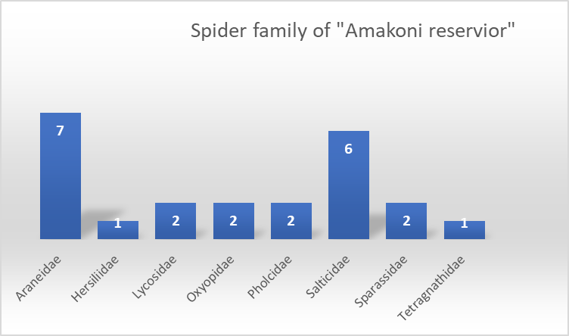
Figure 1: Abundance of Spider Families Figure 2: Percent of Spider Families in the “Amakoni reservoir

Percentage of Spider family in the “Amakoni reservoir”.
Table 1. Spider checklist of Putka Reservoir, (Amakoni Reservoir,) in Sarangarh–Bilaigarh district of Chhattisgarh. -
S.N. | Family/ Genus | Species | Common name
1, | Araneidae Clerck, 1757
 | Argiope Savigny, 1825 | Argiope aemula (Female)  (Walckenaer, 1842) | Orb- weaver spider
 |  | Argiope anasuja Thorell,  1887 | Orb- weaver spider
 |  | Argiope bruennichi (Scopoli, 1772) | Orb- weaver spider
 |  | Argiope pulchella Thorell,  1881 | Orb- weaver spider
 |  | Argiope trifasciata (Forskål,  1775) | Orb- weaver spider
 | Cyrtophora Simon, 1864 | Cyrtophora cicatrosa | Garden tent-web spider
 | Nephila Leach, 1815 | Nephila pilipes (Fabricius,  1793 | golden orb-weaver.
2. | Hersiliidae Thorell, 1869
 | Hersilia Savigny,  1825 | Hersilia savignyi Lucas, 1836 | Hersilia spider.
3. | Lycosidae Sundevall, 1833
 | Arctosa C.L. Koch,  184 | Trochosa sp. | Indian wolf
 | Pardosa C.L. Koch,  1847 | Pardosa jabalpurensis Gajbe  & Gajbe, 1999 | Pardosa wolf spider.
4. | Oxyopidae Thorell, 1869
 | Oxyopes Latreille,  1804 | Oxyopes sp.
 | Peucetia Thorell, 1869 | Peucetia viridana (Stoliczka,  1869) | green lynx spider.
5. | Pholcidae C.L. Koch, 1850
 | Holocnemus Simon, 1873 | Holocnemus pluchei (Scopoli,  1763) | marbled cellar spider
 | Pholcus Walckenaer,1805 | Pholcus phalangioides  (Fuesslin, 1775) | long-bodied cellar spider,
6. | Salticidae Blackwall, 1841
 | Carrhotus Thorell, 1891 | Carrhotus viduus (C.L. Koch,  1846) | Carrhotus jumping spider
 | Chrysilla Thorell, 1887 | Chrysilla volupe (Karsch,  1879) | Jumping spider
 | Menemerus Simon, 1868 | Menemerus bivittatus  (Dufour, 1831 | jumping spiders
 | Phintella Strand, 1906 | Phintella vittata (C.L. Koch,  1846) | Phintella jumping spiders
 | Plexippus C.L. Koch, 1846 | Plexippus paykulli (Audouin,  1825) | Pantropical jumping spider
 | Telamonia Thorell,  188 | Telamonia dimidiate (Simon,  1899) | Jumping spider
7. | Sparassidae Bertkau, 1872
 | Heteropoda Latreille, 1804 | Heteropoda venatoria  (Linnaeus, 1767 | Brown huntsman
 | Olios Walckenaer,1837 | Olios lamarcki  (Latreille, 1806) | Lamark’s huntsman spider
8. | Tetragnathidae Menge, 1866
 | Leucauge White, 1841 | Leucauge decorata  (Walckenaer, 1842) | long-jawed orb weaver
3. RESULT AND DISCUSSION-
The Amakoni reservoir supports a diverse spider population. A survey of the reservoir identified 23 spider species, representing 8 families and 19 genera. The Araneidae family was the most abundant. The study documented 7 species from the Araneidae, 6 from the Salticidae, and 2 each from the Lycosidae, Oxyopidae, Pholcidae, and Sparassidae. Single species were recorded from Hersiliidae and Tetragnathidae, (Table-1) and species richness was 0.000266 per square feet. Leucauge decorata generally found in grassland and shrub Compared to other regions of India, comprehensive data regarding the diversity and distribution of spiders in Chhattisgarh is limited. Pandey & Agrawal (2025) reported a total of 32 species, representing 28 genera and 12 families, during a survey of Madosilli Waterfall, Chhattisgarh. The Araneidae family exhibited the highest diversity, comprising 8 species. Previous research includes Ekka, and Kujur (2015), who documented 118 species representing 52 genera under 17 families, in Ram Jharna, Raigarh district Chhattisgarh, and Kujur and Ekka (2016), describes 120 species representing 49 genera under 16 families, 16 species in Gomarda Wildlife Sanctuary, Chhattisgarh, India. Subsequently, (Gupta and Chandra 2016) identified 33 species pertaining to 30 genera under 5 families in Achanakmar Wildlife Sanctuary, Bilaspur, Chhattisgarh, India and Sen (2021) reported a total of 55 species belonging to 42 Genus under 11 families in North East Gariaband Forest Regions of Chhattisgarh, India.
4.CONCLUSION- Amakoni reservoir demonstrates a notable diversity of spider species. Spiders are a key living factor in the food chain that maintains the ecosystem as predators. Based on these findings, conservation strategies should be developed to protect spider habitats and promote biodiversity.
REFERENCE-
- Caleb, J.T.D. and Sankaran, P.M. 2020. Araneae of India. Version 2020, online at http://www.indianspiders.in (accessed on 09 September 2020)
- Champion HG, Seth SK. A revised survey of the forest types of India. Government of India Press. 1968.
- Choudhury, S.R.et al. (2023) Spider fauna of Chhattisgarh: An updated checklist of spiders of Chhattisgarh, India with new additions. Serket (2024) vol. 20(3): 311-334.
- Foelix RF. Biology of Spiders (3rd ed.). Oxford University Press. 2011.
- Gajbe, P. (2003). Checklist of Spiders (Arachnida: Araneae) of Madhya Pradesh and Chhattisgarh. Zoos' Print Journal, 18(10), 1223-1226.
- Gupta and Chandra (2016) Diversity of Orthoptera (Insecta) fauna of Achanakmar Wildlife Sanctuary, Bilaspur, Chhattisgarh, India. Journal of Asia-Pacific Biodiversity 10(1)
- Kujur, R., & Ekka, A. (2015). Spider diversity of Ram Jharna, Raigarh District, Chhattisgarh, India. Research Journal of Pharmacy and Technology, 8(7), 813-819.
- Kujur, R., & Ekka, A. (2016). Exploring the spider fauna of Gomarda Wildlife Sanctuary, Chhattisgarh, India. International Research Journal of Biological Sciences, 5(6), 31-36
- Kujur, R., & Ekka, A. (2016). Incentivization of Spider fauna of Indra Vihar Park, Raigarh,
Chhattisgarh, India. IOSK-JESTFT, 1(2), 20-26.
- Kujur, R., & Ekka, A. (2016). Spatial diversity of spiders of Rose Garden, Raigarh, Chhattisgarh, India. International Journal of Advanced Research in Science and Engineering, 5(11), 139-144
- Mishra, A.K. & Shrivastava, S.K. 2002. Spiders associated with rice crop in Raipur. Agricultural Science Digest, 22(4): 261-263.
- Nyffeler M, Birkhofer K. (2017) An estimated 400-800 million tons of prey are annually killed by the global spider community. The Science of Nature.;104(3-4):30
- Pandey & Agrawal (2025) Diversity of Spiders and Seasonal Variation Surrounding “Madosilli Waterfall” Sarangarh-Bilaigarh District, Chhattisgarh, India. IJRSI Volume/Issue: 12/10 | Page No: 2156-2164
- Riechert SE, Lockley T. (1984) Spiders as biological control agents. Annual Review of Entomology. 29:299- 320. https://doi.org/10.1146/annurev.en.29.010184.001 503
- Sen, D.L. 2021. Biodiversity of spider fauna at, Gariaband, Chhattisgarh, India. International Research Journal of Modernization in Engineering Technology and Science, 3(10): 953-961.
- Sebastian, P.A. and Peter, K.V. 2009. Spiders of India, 1st Edition. Universities Press, Hyderabad, 614pp.
- Sing et al. (2023) SPIDER FAUNA OF INDIA, (Book) ISBN- 978-81-959483-4-5
Singh and Sharma (2022) An updated checklist of spider (Araneomorphae: Araneae: Arachnida) diversity of Madhya Pradesh, India. International Journal of Zoological Investigations 8(8):191- 218
- Siliwal, M., Molur, S. and Biswas, B.K. 2005. Indian spiders (Arachnida: Araneae): updated checklist 2005. Zoos’ Print Journal 20(10): 1999–2049.
- Shear, W.A., Palmer, J. M., Coddington, J. A., and Bonamo, P. M. (1989). A Devonian spinneret: early evidence of spiders and silk use. Science, 246: 479- 481.
- Tikader, 1960 (Araneae: Thomisidae) in Gariyaband, Chhattisgarh, India. International Journal of Research in Academic World, 3(12), 94-95.
- Tikader, B.K. 1987. Handbook of Indian Spiders. Zoological Survey of India, Calcutta, 251pp.
- Toppo AK., Sahu KR. & Nishad H. (2020). Diversity of Spider in Achankmar Wild Life Sanctuary district Bilaspur, Chhattisgarh. Life Sciences Bulletin 17(1&2): 117- 119.
- Toppo AK., Sahu KR. & Nishad H. (2022). Diversity of Spider Fauna of Kharun River at Khutaghat Dam, District Bilaspur, Chhattisgarh, India, International Journal Of FoodAnd Nutritional Sciences, 11(12):14170-14176
- Wise, D.H. 1993. Spiders in Ecological Webs. Cambridge University Press, Cambridge, UK.
- (WSC-2025, version-26) https://wsc.nmbe.ch/

