NATIONAL IDENTITY OF INDONESIA’S GENERATION Z IN DIGITAL MEDIA REPRESENTATION: A STUDY ON THE IDN TIMES INSTAGRAM PLATFORM
Abstract
This study describes the representation of Indonesian Generation Z's national identity on IDN Times' Instagram. The results show that Indonesian Generation Z prefers content that combines traditional cultural elements with modernity, in creative and easily accessible forms, such as through social media, short videos, and digital platforms. The research design used mixed methods, namely by conducting quantitative content analysis on Indonesian Generation Z's national identity content on IDN Times' Instagram from January to September 2024. Qualitative data were obtained through in-depth interviews with 20 Generation Z individuals aged 18 to 25, representing all provinces in Indonesia. The qualitative approach was carried out using virtual anthropology methods, focusing on how information and communication technology influences social life, culture, and individual identity in virtual environments. Three elements studied include the representation of traditional symbols, local-global hybridization, and digital activities. Content featuring traditional music with a modern touch, or memes that reflect Indonesia's rich culture in a lighthearted and humorous manner, is more engaging. The presence of social media has become a primary space for expressing, criticizing, and capturing global issues. Generation Z also tends to support environmentally friendly products and engage in activities that can reduce negative impacts on the Earth. They use social media for positive change to maintain their Indonesian identity, but still adapt to global trends.
Keywords: cultural adaptation, hybridization, traditional symbols, social media, Gen Z, Indonesianness

INTRODUCTION
The younger generation, or Gen Z, now uses social media platforms, especially Instagram, to communicate, express themselves, and develop their identities. Digital platforms are crucial for the formation and articulation of identity, particularly national identity, for Generation Z, defined as those born between 1997 and 2012, and also serve as a channel of communication (Abidin, 2022). Given that 59% of its internet users are under the age of 35 and Indonesia has the fourth-largest population of internet users in the world (We Are Social & Kepios, 2023), the country offers an interesting backdrop for understanding how national identity is expressed online. In Indonesia, 91.8% of Generation Z use social media daily, with Instagram ranking second in popularity after TikTok, according to data from the Ministry of Communication and Information (2022). Young Indonesians' understanding, expression, and negotiation of their nationhood are all transformed by the intensity of their interaction with digital media (Zakaria et al., 2023).
Given Indonesia's complex socio-political background and long history of still-evolving postcolonial national identity formation, this phenomenon is all the more relevant (Aspinall, 2014). Previous research on Indonesian national identity has mainly focused on the real world's historical, political, or sociological aspects (Anderson, 1983). How Indonesia's first 'digital natives', Generation Z, understand and express their national identity online remains largely unexplored. Instagram, with its visual and interactive features, allows Gen Z to express national identity through photos, videos, and hashtags such as #IndonesiaBanget or #BanggaIndonesia. They often remix traditional symbols, like the flag, national songs, or local clothing, with digital trends, memes, and contemporary aesthetics, creating new ways to affirm their cultural identity while negotiating global influences (Kolip, 2011).
One digital media that is gaining popularity is IDN Times, which takes a current and relevant approach to reach millennial and Gen Z audiences. IDN Times presents light yet comprehensive content, covering social, cultural, historical, and national issues that are relevant to the daily lives of its readers, in contrast to mainstream media such as Kompas.com and Detik.com, which often present news formally and factually. In addition, IDN Times also presents unique channels such as 'Hype' and 'Indonesia Millennial Report' that often raise ideas about diversity and pride in Indonesian identity (IDN Media, 2020). This approach makes IDN Times not only a source of information but also a platform for national identity formation in the digital era.
This study bridges the gap by investigating how Generation Z Indonesians use their Instagram content to represent and negotiate their national identity. It is hoped that this study will offer important insights for the creation of civic education policies, public communication plans, and national character development initiatives that are more adaptive to modern digital realities by understanding the dynamics of national identity representation in digital media (Suryadi, 2020).

RESEARCH METHOD
This study uses a mixed method, namely by conducting a quantitative content analysis on the national identity content of Gen Z Indonesia on the Instagram of IDN Times from January to September 2024. Quantitative content analysis is a research method used to identify and measure certain frequencies or patterns in text or other media by coding and calculating communication elements numerically to reveal existing relationships or tendencies (Neuendorf, K. A., 2017). Qualitative data were obtained through in-depth interviews with 20 Generation Z people aged 18 to 25 years, representing various provinces in Indonesia. The qualitative approach was carried out using the virtual anthropology method, which is a branch of anthropology that studies human interaction, culture, and behavior in cyberspace or digital space, with a focus on how information and communication technology affects social life, culture, and individual identity in virtual environments (Boellstorff, T., 2008). The three elements studied include the representation of traditional symbols, local-global hybridization, and digital activities.
RESULT AND DISCUSSION
The research data is presented in quantitative and qualitative forms as a consequence of the use of a mixed method (quantitative content analysis and virtual anthropology) as an effort to obtain comprehensive data. The following is quantitative data on the National Identity of Indonesian Generation Z in Digital Media Representation: A Study on the IDN Instagram Platform.
- IDN Instagram Content Sample Profile
This study took place in the period from January to September 2024, with a total number of 150 uploads analyzed. As for the content categories and number of uploads, the following data were found:
- Historical and cultural content (53 uploads, 35.3%)
- Contemporary social issue content (47 uploads, 31.3%)
- National celebration content (32 uploads, 21.3%)
- Collaborative content with influencers (18 uploads, 12%)
Based on the data above, it proves that the average media engagement per upload is 42,750 likes, with 1,865 comments.
- Interview Respondent Profile
Respondents who were interviewed in-depth numbered to 20 people with an age range of 18-25 years. The gender composition was 10 females (50%), 10 males (50%). They came from Java: 10 respondents (50%), Sumatra: 3 respondents (15%), Sulawesi: 2 respondents (10%), Kalimantan: 2 respondents (10%), Bali and Nusa Tenggara: 2 respondents (10%), and Papua: 1 respondent (5%). Educational background of the informants: Students: 15 respondents (75%), High School/Vocational High School Graduates: 3 respondents (15%), and Bachelors: 2 respondents (10%)
- Main Findings: Theme of National Identity Representation
The research findings can be seen from Table 1 below:
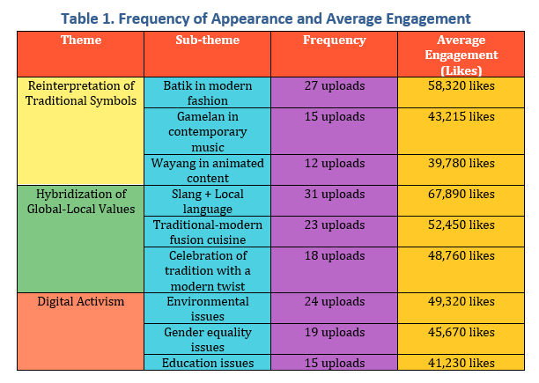
According to a study by Wijaya and Rahman (2022) entitled "National Identity Transformation in the Digital Era: Multidimensional Analysis of Social Media Use in Indonesia", the three indicators above provide an accurate framework for understanding how national identity is formed and evolved in the digital era. This study reveals that the reinterpretation of traditional symbols occurs when classical cultural elements (batik, wayang, or folklore) are reintroduced into a contemporary context through social media. Internet users creatively adapt these symbols to express their national identity in a way that is more relevant to the digital generation.
The researchers also explained that local-global hybridization is a significant indicator when there is a fusion of local values ​​​​with global trends. This phenomenon can be seen from how followers integrate local traditions with global content formats, such as TikTok challenges with traditional music or memes that combine international cultural references with local contexts. The third indicator, which represents digital activities such as participation in national discussions, hashtag movements, or online campaigns, is an indicator that measures Gen Z's involvement with national identity. The level and form of a person's digital activity reflect their understanding of citizenship and nationality in the digital era.
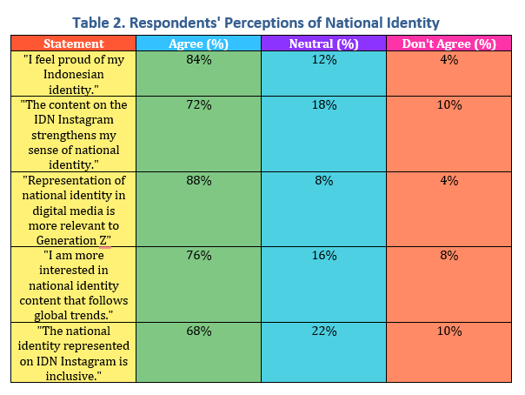
Based on Table 2 above, several key elements encourage Generation Z to respond positively to content related to national identity. The survey results show that almost nine out of ten respondents (87%) are more responsive to content that is directly related to the reality of their daily lives.
The visual aspect also plays an important role, with 82% of respondents interested in content that has an aesthetic and visually appealing appearance. Meanwhile, more than three-quarters of respondents (79%) appreciate content that is presented with a strong and engaging storytelling approach. The ability of content to bridge traditional values ​​with modern perspectives is a significant factor for 75% of respondents. The involvement of public figures or influencers who are relevant to their generation also influences the positive reception of the majority of respondents (71%). Interactive elements such as polls, quizzes, and challenges are appreciated by 68% of research participants. Finally, more than two-thirds of respondents (65%) showed a preference for content that uses a non-patronizing approach or does not seem patronizing in its delivery.
Data shows that content related to national identity on IDN Instagram accounts is dominated by historical and cultural content (35.3%), followed by contemporary social issue content (31.3%), national celebration content (21.3%), and collaborative content with influencers (12%). This data distribution indicates a balance between traditional representations of national identity (history, culture, national celebrations) and contemporary issues that are relevant to the younger generation. National identity content preferred by Gen Z Indonesia focuses on values ​​that are relevant to their lives, such as pride in cultural diversity, history, and national achievements. Gen Z prefers content that combines elements of traditional culture with modernity, in creative and easily accessible forms, such as through social media, short videos, and digital platforms. For example, content that features traditional music with a modern touch, or memes that reflect the richness of Indonesian culture in a light and humorous way are more attractive to them. In addition, Gen Z is also interested in social and environmental issues related to national identity, as well as movements that promote pride in Indonesia in a global context (Ministry of Communication and Information of the Republic of Indonesia, 2020).
The results of this study are in line with the arguments of experts about the multidimensional nature of national identity. As stated by Guibernau (2007), the concept of national identity has strong cultural and historical roots but still shows flexible characteristics that allow it to adapt to current developments and social contexts. This perspective is also reinforced by Anderson's (1983) thinking, which views national identity as a collective construction formed through a process of shared imagination. In this context, national identity is not a static entity but continues to undergo reconstruction and reinterpretation through various communication channels, with social media being a significant platform in today's digital era.
These two theoretical perspectives highlight how national identity is an evolving and negotiable concept in the public sphere, including the digital environment that increasingly dominates contemporary social interactions. This explains why national identity content that is able to balance traditional values ​​with modern presentations receives a positive response from the digital generation.
The geographical distribution of respondents shows a dominance from Java Island (48%), with smaller representation from other regions such as Sumatra (20%), Sulawesi (12%), Kalimantan (8%), Bali and Nusa Tenggara (8%), and Papua (4%). This inequality needs to be considered in interpreting the results, given the potential for Java-centric bias in the perception of national identity.
The data shows a high level of pride in national identity (84% agree with the statement "I feel proud of my Indonesian identity"). This is in line with the psychological dimensions of national identity revealed by Guibernau (2007), that emotional identification is an important component of national identity. The majority of respondents (72%) agreed that the IDN Instagram content strengthens their sense of national identity. This shows the significant influence of social media in the formation and strengthening of national identity among the younger generation (Taufiq and Rosyid, 2021). Taufiq and Rosyid stated that through social media, Gen Z can access various content related to culture, history, and national values. This content provides them with the opportunity to understand, learn, and celebrate their cultural heritage, which ultimately strengthens their sense of pride in national identity.
Social media has become an important arena for Generation Z to express and strengthen their national identity through various forms of digital engagement. These platforms provide a space for young people to participate in social movements that uphold the values ​​of nationalism and justice, facilitating discussions that deepen their understanding of what it means to be a citizen in the contemporary era.
Through digital interactions, Generation Z not only builds a personal conception of national identity but also develops a network of solidarity and social ties with fellow citizens. This generation also tends to show interest in social issues, the environment, and national pride in a global context that can be accessed through digital technology (Sutrisno, A., 2021). This phenomenon can be seen from the activities of Indonesia’s Generation Z, who are increasingly proactive in celebrating culture and narrating the nation's history through various digital platforms. They demonstrate national pride by sharing content related to music, culinary, and regional languages, often with a creative approach that integrates traditional elements with modern lifestyles. These digital practices make social media a significant instrument in the formation and strengthening of national identity among Indonesia's digital generation.
Another interesting finding is the high percentage of respondents (88%) who agree that "National identity representation in digital media is more relevant to Generation Z." This is to Billig's (1995) argument about "banal nationalism," which explains that national identity is transmitted through everyday practices, including social media consumption. The preference for national identity content that follows global trends (76% agree) also supports previous findings about the hybridshowization of global-local values ​​as an effective national identity representation strategy for the younger generation.
In the research findings through virtual anthropology, the data shows a positive tendency of informants in three elements of analysis, namely the reinterpretation of traditional symbols, global-local hybridization, and digital activities.
The following is an analysis of the three indicators of national identity:
- Reinterpretation of Traditional Symbols
The data also shows that the reinterpretation of traditional symbols, such as batik in modern fashion has the most uploads (27), followed by gamelan in contemporary music (15), and wayang in animated content (12), all three of which received high engagement from the audience. Batik uploads in modern fashion received an average of 58,320 likes, indicating the high interest of Gen Z in modern adaptations of traditional cultural symbols. Smith (1991) emphasized that cultural symbols are an important component of national identity. Canclini (1995), in his writing "Hybrid Cultures," explained that the reinterpretation of traditional symbols represents identity negotiation in a modern context.
Based on the data, there is a tendency for Gen Z to carry out symbolic reinterpretation of traditional cultural heritage in the form of batik, gamelan, and wayang kulit. They maintain the essence of culture by adapting to a modern context and seeing the philosophical value in the cultural heritage. This proves that adaptation is still the keyword in the relevance of a culture that has been passed down from generation to generation. Howell (2002), revealed that the reinterpretation of traditional symbols by Generation Z on social media can be seen as a form of adaptation and transformation of cultural symbols that were previously bound to traditional contexts, which are now adapted to digital and modern contexts. Gen Z, who grew up with internet access and social media, tends to reconstruct old symbols and give them new meanings according to their dynamics and values.
Contemporary batik means modern batik or batik with a contemporary touch, a development of traditional batik that reflects innovation in motifs, colors, and techniques. Contemporary batik is highly sought after by Indonesia’s Gen Z because of its bright colors, more modern, fresh, and minimalist designs, and its suitability for an urban lifestyle. Many young designers combine traditional motifs with contemporary fashion cuts such as oversized shirts, hoodies, or streetwear. Thus making batik more relevant and accepted by Generation Z as a form of expression of cultural identity that remains fashionable. Social media also plays an important role in increasing the popularity of contemporary batik among Gen Z through digital campaigns and fashion influencers (Ramadhani and Prameswari, 2021).
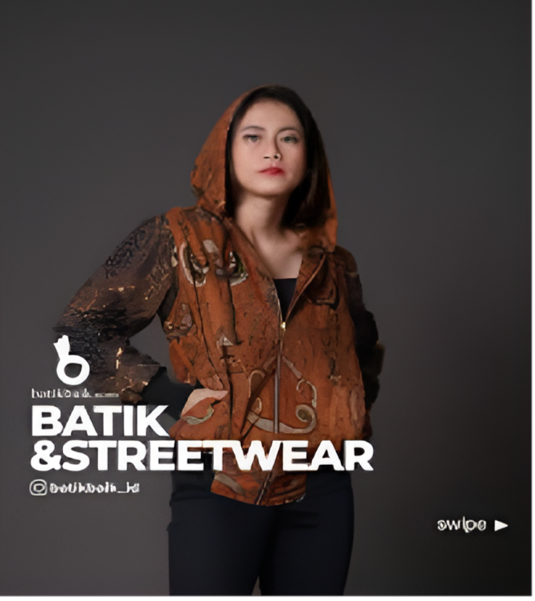
A combination of batik with streetwear
Gamelan combined with modern music is an interesting phenomenon and is loved by Indonesia’s Gen Z. This combination not only creates new contemporary music but also helps preserve cultural heritage. This contemporary gamelan has successfully combined traditional elements with global music genres such as jazz, hip-hop, electronic, and alternative rock, receiving a positive response from Generation Z. McGraw (2020) has identified that this cross-genre collaboration is able to create a new space that bridges the gap between old traditions and modernity. This allows them to appreciate gamelan in a context that is more familiar with Gen Z's musical preferences.
Here are some examples of the combination of gamelan with modern music:
- Gamelan with Jazz: The combination of gamelan with jazz elements is implemented in improvisation, fast tempo, and more complex harmonies. This combination is often performed in cafes, although sometimes only using a saron.
- Gamelan with Pop: The combination of gamelan with pop music is done by adding elements such as synthesizers, drum machines, and digital sound effects. The song "Lathi" by Weird Genius with Sara Fajira is an example of the fusion of Javanese gamelan with pop music, even with lyrics in ancient Javanese.
- Gamelan with Dangdut: Gamelan can also be combined with dangdut music. As was done by Ganjar in a modern gamelan concert at Gajah Mada University
- Gamelan with World Music: The fusion of gamelan with world music such as Bossa Nova, as done by James Chu in the album Bossa Nova Gamelan.
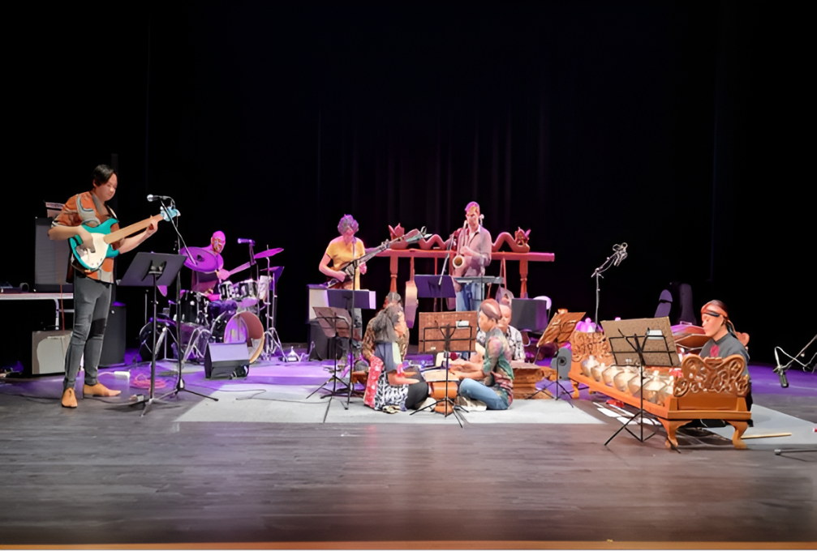
Contemporary Gamelan
Contemporary wayang can act as a bridge between tradition and modernity. Wayang has become an interesting cultural phenomenon in Indonesia, especially among Generation Z who were previously considered less interested. As a form of innovation from classical wayang art, contemporary wayang is filled with modern touches that are more in line with the tastes and lifestyles of today's youth. Wardani & Widiyastuti's (2019), research, proved that one of the main factors in the popularity of contemporary wayang is the ability to adapt to technological developments and current issues. Classical wayang performances are no longer themed on traditional narratives such as the Mahabharata or Ramayana but have developed to raise contemporary themes such as politics, the environment, and the identity of the younger generation. The combination of multimedia, electronic music, and slang in the performance makes contemporary wayang easier to digest and entertain Indonesian Gen Z.
Nugroho & Prasetyo (2021) in their study showed that the combination of hip-hop elements with traditional wayang in Yogyakarta significantly succeeded in attracting the interest of thousands of Gen Z to attend. The results of the study revealed that 78% of teenage respondents who were initially not interested in traditional wayang became enthusiastic about following the development of contemporary wayang after watching a hip-hop wayang performance. Of course, this phenomenon illustrates how tradition is kept alive through relevant transformation and innovation. Contemporary wayang puppeteers present it in a more dynamic and interactive form, and not only maintain the philosophical values ​​of wayang. In fact, social media has become an effective means of promoting contemporary wayang performances, with a lot of related content going viral on platforms such as Instagram and TikTok.

Hip hop puppetry
Some examples of contemporary wayang include:
- Ental Wayang: is a wayang made from palm leaves, with a more modern and creative design.
- Suluh Wayang: This wayang uses light media to present the story.
- Pancasila Wayang: Wayang with social and political themes, with messages that are more relevant to the millennial generation.
- Hip-Hop Wayang: Wayang that combines hip-hop music with wayang stories, creating a more energetic and interesting performance.
- Motekar Wayang: Wayang that uses digital technology, such as animation and visual effects, to create a more spectacular performance.
Through social media, symbols that were once considered traditional (for example, clothing, sayings, or even certain cultural icons) are combined with new modern elements. This reinterpretation allows these symbols to have more flexible meanings and be more connected to individual or group identity in a digital context, where individual self-expression and creativity are highly valued.
Gen Z is known for being critical of cultural symbols that are considered outdated or irrelevant. They often use social media to dismantle and reshape the meaning of these symbols to be more inclusive and relevant to contemporary issues such as social justice, diversity, and the environment. This creates space for these symbols to develop and change according to the social and cultural needs of this generation. The reinterpretation of traditional symbols on social media for Gen Z in Indonesia shows the creativity of this generation in adapting and changing traditional cultural symbols into a digital context, as well as creating new meanings that are in accordance with the times. Gen Z in Indonesia uses social media to express themselves, by combining traditional symbols, such as batik, wayang, or regional musical instruments, with global and modern elements. This not only shows respect for the cultural heritage of our ancestors but also shows the existence of these symbols in a wider and more open digital world.
It is proven that batik, gamelan, and wayang kulit are examples of traditional Indonesian cultural symbols that are still favored by Gen Z and are represented through social media. Even though they live in the digital era, Gen Z has not completely abandoned traditional culture. They integrate these cultural elements in a more modern and relevant way through social media platforms. Young influencers and creators who combine batik with contemporary clothing styles and share them on Instagram or TikTok. Gamelan, with its distinctive sound, is often used in creative videos, music challenges, and dance videos that are trending on social media. In addition, Wayang Kulit is also no less popular, with several creators adapting wayang performances into digital formats or memes that can be reached more widely according to the audience's tastes.
According to Sumarni (2022), this traditional cultural adaptation behavior shows that Gen Z still values ​​their cultural heritage and strives to keep it alive and relevant in the digital world. Social media is a space to express their cultural identity in a more inclusive, creative, and modern way, allowing cultural heritage such as batik, gamelan, and wayang kulit to continue to be accepted by the younger generation in the global realm, not only in Indonesia.
The global realm must be pursued with a participatory and interactive climate, according to the nature of social media. Jenkins (2006) states that in the world of media convergence, cultural consumption is no longer one-way. Through social media, Gen Z recreates traditional symbols to suit their context, such as by integrating pop culture elements or memes into batik clothing designs or creating video content that combines wayang stories with modern narratives. This creates a new form of culture, rooted in tradition but also relevant to global developments. Suhartono (2023) also emphasized that the reinterpretation of traditional symbols is a process in which Generation Z reinterprets traditional cultural elements such as batik, gamelan, and wayang kulit in a contemporary context. According to him, this process is not merely a rejection of traditional values, but rather a form of creative adaptation that allows these cultural elements to remain relevant in the daily lives of the digital generation. In his book "Cultural Transformation of Generation Z: Digital Anthropology Perspective", Suhartono emphasized that this reinterpretation process includes several important dimensions:
- Visual Aesthetic Update: Modifying the visual appearance of traditional elements to align with today's aesthetic preferences by creating a visual appeal that is relevant to Gen Z.
- Cross-Generational Philosophical Synthesis: Identifying and integrating the philosophical values ​​of cultural heritage with modern perspectives and frameworks, and building bridges of understanding between generations.
- Digitalization as a Means of Cultural Transmission: Gen Z utilizes digital media and social media platforms as channels for disseminating, documenting, and learning traditional cultural values.
- Functional Transformation of Cultural Elements: Recontextualizing the form and function of traditional cultural artifacts to create contemporary relevance, ensuring the continuity of essential values ​​in the context of modern applications.
Suhartono also emphasized that Gen Z's ability to reinterpret traditional symbols shows the vitality of the cultural heritage, not its decline.
- Hybridization of Global-Local Values ​​
Data shows that hybridization as a main characteristic of Gen Z includes: the use of slang and regional languages ​​as an expression of identity, modification of cultural practices without eliminating the original substance, and appreciation of culinary and traditional celebrations with a contemporary touch. Content that combines global and local elements gets the highest engagement, in posts that combine slang with regional languages ​​(67,890 likes). This shows that Gen Z is more responsive to representations of national identity that can accommodate global values ​​without leaving local elements. Appadurai (1996) in his writing "Modernity at Large" explains that this phenomenon is a form of "indigenization" of global influence. This hybridization is also in line with the concept of "glocalization" by Robertson (1995), that global values ​​can be adapted to the local context.
According to Jenkins (2006) in his book Convergence Culture: Where Old and New Media Collide, Gen Z is characterized by a hybridization of global-local values ​​through the concept of convergence culture. Jenkins describes how new technologies, especially digital media and the internet, enable cultural convergence where global and local values ​​meet, interact, and influence each other.
Gen Z slang is a term for various forms of verbal communication that they use in everyday conversation, especially on social media. Slang is informal, unique, and creative, using abbreviations, acronyms, or foreign languages ​​that are absorbed in unique ways. Indonesian Generation Z slang is a linguistic phenomenon that is full of dynamics and continues to develop. The characteristics of this language include abbreviations, code-mixing, and the adoption of words from foreign languages. Terms such as "anjay" (cool), "gercep" (fast movement), and "kepo" (curious) as markers of collective identity. According to Manns (2021), the use of this slang has multiple functions, namely as a means of communication and also as a shaper of identity and a marker of social existence. The role of social media as a major catalyst for the spread and evolution of slang reflects the linguistic creativity of Indonesian Gen Z in adapting and reconstructing language according to their socio-cultural context.
Indonesian Gen Z shows a preference for contemporary cuisine in the form of food that is not only delicious but also aesthetic and easy to share on social media. The popularity of foods such as coffees, dessert boxes, and boba drinks that are attractively packaged and easy to find through online platforms are some of the favorites. Fusion food is also increasingly popular with Gen Z because it offers an interesting combination of flavors and new experiences. For example, innovation of various flavors, es pisang ijo with boba or matcha, and traditional food served in photogenic bento boxes. Gen Z likes exploring new culinary delights that combine local flavors with global influences because they reflect their urban and digital lifestyle. Likewise, a unique and Instagrammable dining experience is an important added value in choosing food (Prabowo and Rahadi (2020).
Some considerations for culinary choices for Gen Z Indonesia include: First, innovation in presentation and packaging is the most important thing. Designs that allow traditional snacks to be sold to wider markets, such as supermarkets, stations, or airports. Second, education about the cultural and historical values ​​of traditional snacks. They must understand that traditional snacks are not just food, but also part of the nation's identity and history. School program campaigns and culinary events in the mass media can be an effective way to raise awareness. Through short videos on TikTok or Instagram explaining the process of making and the history of traditional snacks, or holding a culinary festival that features various traditional snacks with interesting concepts. Third, collaborating with influencers and celebrities can help promote traditional snacks. By involving influencers in the campaign to preserve traditional snacks, it is hoped that it can increase Gen Z's interest and pride in local cuisine.
Indonesia’s Gen Z is very interested in traditional celebrations that are combined with contemporary ways, both religious and cultural. For example, Ramadan with the Tumbilotohe and Baarakan Naga traditions, Lebaran with the provision of digital THR, as well as the integration of traditional elements in fashion and art. Traditional celebrations are decorated with nostalgic or aesthetic themes, creating a more personal and unique atmosphere. Contemporary celebrations for Gen Z in Indonesia have undergone significant transformation through digitalization and the influence of global culture. They often celebrate important moments such as birthdays, graduation days, and even anniversaries with personal, aesthetic concepts that are easy to share on social media. They no longer rely on formal traditions because Gen Z prefers flexible, thematic celebrations, and often combines elements of Korean, Japanese, and Western pop culture. Digital platforms such as Instagram and TikTok are also very significant in shaping celebration trends in making them a means of self-expression and social imaging (Putri and Hapsari, 2022).
Here are some relevant things related to the characteristics of Gen Z in the hybridization of global-local values ​​according to Jenkins' view:
- Wide Global Access
Jenkins (2006) explains that the younger generation, especially Generation Z, is growing up in an era marked by unlimited access to global information through technological advances. The availability of this information creates a level of connectedness with international culture that has never happened before in human history. Their relationship with global culture is not one-way or passive. This digital generation actually shows selective abilities and creativity in absorbing, processing, and modifying elements of global culture to suit the local context and values ​​that they have.
- Participation in Global Popular Culture
Gen Z also has the status of consumers and producers of increasingly connected global popular culture. Through social media platforms, they consume global trends, and also contribute to the development of these trends by modifying them to better suit their local identities. Jenkins states that in a convergence culture, consumers now play an active role as content producers, resulting in cultural hybridization that involves the combination of global and local values.
- Multicultural Digital Identity
Jenkins also emphasized how new media enables the formation of a highly multicultural digital identity. Gen Z is very familiar with digital platforms, so they can combine cultural elements from around the world with their local culture. This process creates both global and personal identities and is closely related to their respective cultural backgrounds.
- The Influence of Social Media in the Spread of Values
Social media plays an important role in the process of cultural hybridization. Gen Z Indonesia is involved in and combines global and local values ​​in various forms of expression. They can access and share content from all over the world. Often, music, celebration, fashion, and language content are modified with local elements, resulting in gamelan-jazz collaborations, ritualized graduations on social media, and slang that adopts English. They are actively involved in combining these values, especially in the context of national culture and identity. They often create and share content that integrates local cultural elements with global trends. This generation uses technology to promote local products, traditional arts, and social issues while remaining open to global influences. This shows their ability to maintain a balance between tradition and innovation in an increasingly connected world (Dewi, R. K., 2020).
Thus, the hybridization of global-local values ​​in Gen Z occurs through a more open and dynamic cultural mix, where technology allows them to combine various elements of global culture in a way that not only reflects outside culture but also collaborates with their local identity. According to Nugroho, A. (2024), the hybridization of global-local values ​​forms a new and adaptive cultural identity. In an article entitled "Generation Z Identity and Cultural Transformation: Digital Ethnographic Analysis in Indonesia", Nugroho explains that this hybridization process is not simply mixing two different elements, but involves complex negotiations that produce new, unique cultural forms.
Nugroho identifies several main characteristics of the hybridization of global-local values ​​in Generation Z:
- Selectivity of adoption (Gen Z Indonesia's awareness to choose elements of music, cuisine, language, and fashion that are compatible with local values)
- Creative transformation (Combining cultural elements to create new meanings, seen in huge batik, jazz gamelan, and hip hop wayang)
- Contextual awareness (Understanding the application of global or local values ​​while remaining Indonesian in the digital era)
- Identity function (Expression of Gen Z Indonesia's identity that remains loyal to traditional values)
- Digital mediation (Digital platforms such as IDN Times as the main space where hybridization takes place)

In his research, Nugroho also highlighted the phenomenon of language hybridization seen in the use of slang that integrates English, Indonesian, and regional languages. A similar phenomenon also occurs in culinary practices and traditional celebrations that have undergone contemporary modifications without losing their cultural essence. Nugroho concluded that the hybridization of global-local values ​​by Generation Z is not a threat that eliminates national identity, but rather a transformation that enriches cultural expression and ensures its relevance in a global context. Jenkins, H. (2023) added about Hybrid Culture in the Digital Age, which is formed through the convergence of technology and participatory practices that encourage global cultural crossover. In his book, Jenkins highlights how the digital era has created conditions that allow for cultural hybridization on an unprecedented scale and intensity.
According to Jenkins, cultural hybridization in the digital era has several key characteristics:
  - Participatory culture, Indonesia’s Gen Z is not only a consumer but also a producer of cultural content
  - Convergence, a media platform that facilitates the flow of cultural values ​​and practices across geographical boundaries
  - Collective intelligence, which allows online communities to develop, maintain, and transform cultural elements
  - Transmedia storytelling, which is the main channel for the transmission of cultural values
  - Remix culture, which allows the reinterpretation and recontextualization of cultural artifacts, with the emergence of new meanings.
Jenkins emphasizes that Gen Z is the main actor in the process of cultural hybridization. They not only consume global cultural content, but also actively modify, reinterpret, and disseminate hybrid cultural forms through their everyday digital practices. In his in-depth analysis, he highlights that cultural hybridization is not always a smooth process but involves negotiation, contestation, and tension between global and local values. However, Jenkins argues that it is precisely these dynamics that produce the most innovative and meaningful cultural forms for the digital generation.
- Digital Activities and Social Issues
Data on content with contemporary social themes illustrates an important dimension of national identity expression. Posts discussing environmental issues (24 contents), gender equality (19 contents), and education (15 contents) received significant responses from the audience, with a range of 41,230 to 49,320 likes. This reflects that the younger generation associates their national identity with active involvement in relevant social issues. This pattern aligns with Castells' (1997) analysis in his work "The Power of Identity," which explains that collective identity, including national identity, is often manifested through participation in social movements and various forms of activism. Castells identified how a sense of attachment to national identity can be the basis for collective action for social change.
The phenomenon of digital-based activism seen from this engagement data also reflects the concept of "citizenship in the digital age" developed by Bennett and colleagues (2008). This concept illustrates how contemporary citizenship practices, including exploration and expression of national identity, are increasingly manifested through interaction and participation in digital spaces, especially related to social issues that are considered to reflect the collective values ​​of a nation.
The findings show that Gen Z has a high awareness of environmental issues, gender equality, a focus on educational innovation, and concern for global change. Generation Z in Indonesia shows a high level of concern for ecological issues, as evidenced by their high participation in various ongoing campaigns and activities. They use digital platforms to voice their opinions, participate in social campaigns, and support movements that focus on progress. Gen Z Indonesia is highly connected to global information, but they also strive to fight for issues that are relevant to the local Indonesian context (Pratama, A., 2021). They also have easier access to information and are open to global issues, including climate change, pollution, and deforestation. Research shows that Gen Z is more likely to support environmentally friendly products and engage in activities that can reduce negative impacts on the planet.
According to a survey conducted by Nielsen, 73% of global consumers under the age of 30, including Gen Z, prefer to buy products that are considered environmentally friendly or that support sustainability (Nielsen, 2015). The case in Indonesia shows that more and more young people are actively participating in movements such as plastic reduction campaigns, recycling, and reducing carbon emissions. In addition, through digital platforms, many influencers and non-governmental organizations involve Gen Z in various social projects and environmental education, such as the #GoGreenIndonesia movement, which focuses on planting trees and reducing the use of single-use plastic. This activity is also reflected in participation in demonstrations and petitions related to environmental issues. For example, in commemoration of Earth Day, many organizations involve the young generation of Indonesia to participate in activities that support sustainability, both directly and through social media.
This concern shows that Gen Z in Indonesia is not only aware of the importance of sustainability but also seeks to be actively involved in creating greater positive change for their environment. According to Hadi, S (2020), other concerns of Gen Z regarding environmental issues include several things, including:
- Awareness of climate change: Gen Z cares about the impacts of climate change and wants real action to reduce global warming.
- Reducing plastic waste: Gen Z is aware of the importance of reducing the use of single-use plastics and switching to environmentally friendly alternatives.
- Sustainable lifestyle: They choose environmentally friendly products and support product brands that are committed to sustainability.
- Advocacy for nature conservation: Gen Z is active in supporting various movements for nature conservation and protecting endangered species.
- Education and dissemination of information: They use digital platforms such as the Instagram off IDN Times to spread information about the importance of protecting the environment and inviting others to participate in environmental conservation efforts.
Concern for these various issues shows that Gen Z still has a more proactive attitude toward environmental challenges compared to previous generations.
Prasetyo, B. (2023) in his research "Digital Natives and Social Consciousness: A Study on Indonesian Youth Activism in Social Media," stated that digital activities and social issues in Gen Z in Indonesia include several main characteristics and dimensions. According to Prasetyo, Gen Z Indonesia shows a distinctive pattern of digital engagement in responding to social issues, including:
- Digital campaigns that raise environmental awareness, especially regarding the issues of plastic waste, deforestation, and air pollution. Prasetyo noted that although this awareness is high, there is a gap between online awareness and real action.
- Advocacy for gender equality is fought for through social media platforms, with a focus on issues such as sexual harassment, gender-based violence, and educational equality. Prasetyo found that this issue was the theme that received the most engagement from Gen Z.
- The education system in Indonesia is considered less responsive to the needs of the job market and technological developments. Gen Z demands education that is more adaptive, inclusive, and oriented towards practical skills.
- Collective mobilization through hashtags and digital trends that can turn online activities into real social movements. Examples include several digital campaigns that have successfully driven policy change.
- Visual storytelling is chosen as the primary method of communicating social issues, with infographics, short videos, and interactive content being the most effective formats.
The research findings also explain the changes in how Gen Z communicates and accesses information. Some important things that include changes refer to the following points:
- Social Media Based: Gen Z is more connected through social media platforms such as Instagram, TikTok, and Twitter. They prefer fast, interactive, and visual media compared to traditional communication.
- Use of Technology in Social Activities: Gen Z is increasingly involved in various social issues through digital platforms, such as the #MeToo and #BlackLivesMatter movements, using social media as a tool to organize and voice criticism and opinions.
- Consumers and producers of Digital Content: Gen Z are active consumers and content creators. They not only consume media, but also participate in the process of producing content such as videos, memes, and blogs.
- Identity Formation: The use of social media helps Gen Z in forming and expressing their identity, both personal and in building communities.
- Global Connectedness: Through extensive internet access, Gen Z can connect with people from various cultures and backgrounds. They have a global and interactive perspective.
Overall, Castells emphasized that digital activities are not only changing the way we communicate but also shaping broader social and cultural dynamics, especially for generations who are highly exposed to technology from an early age.
Thus, the national identity model of Indonesian Gen Z in virtual and reality is as follows:

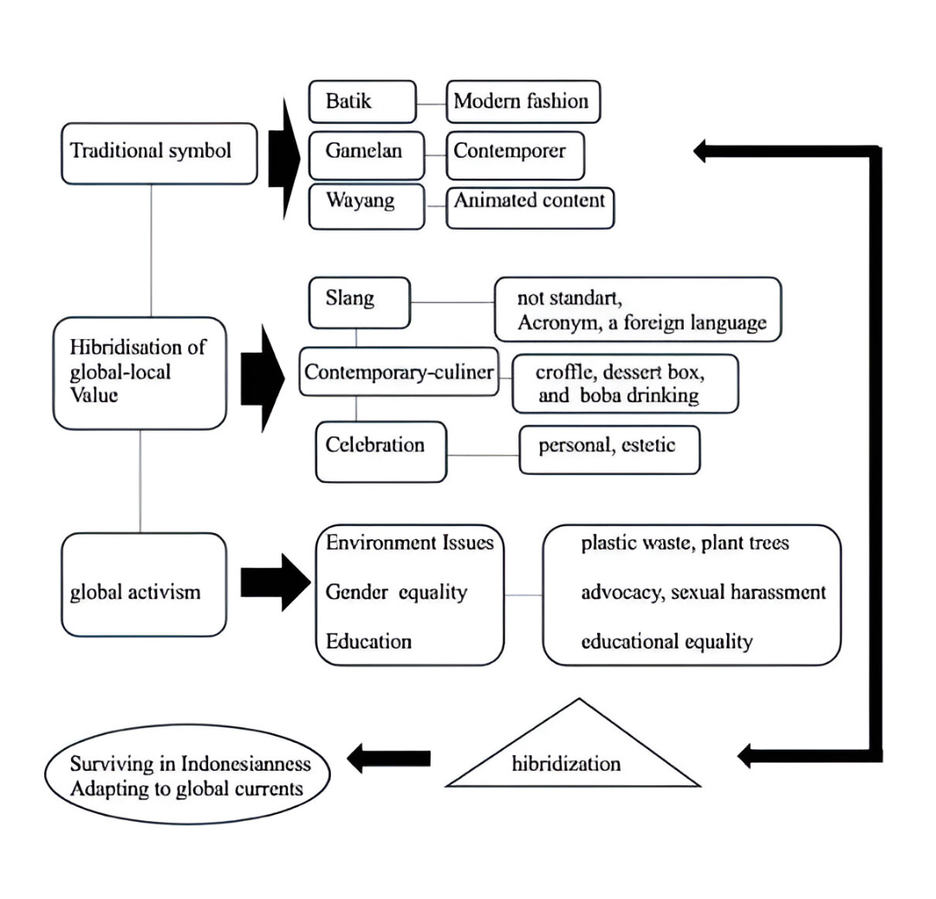
CONCLUSION AND IMPLICATIONS
Based on the data analysis, it can be concluded that the representation of national identity on Instagram social media, especially on IDN accounts, shows a hybridization pattern that integrates traditional values ​​with contemporary and global contexts. This representation gets a positive response from the younger generation audience, especially when the content is relevant to their daily lives, has interesting visualizations, and presents strong storytelling. The implication of this finding is the importance of a more inclusive and adaptive approach to representing national identity in the digital era. National identity can no longer be approached as a static and homogeneous concept, but rather as a dynamic construction that is continuously negotiated in global and local contexts. Gen Z shows a complex pattern of cultural adaptation, integrating traditional heritage with global contexts through critical and innovative approaches, active transformation of cultural heritage, negotiation of identity through hybridization, and growing social awareness. Gen Z's concern for global issues is also high, they do not even stop at criticism and dissemination of information but are implemented until there are real actions, such as environmentally friendly campaigns, gender equality, plastic waste, and air pollution. Social media platforms have become the main space for expressing opinions, criticism, and capturing global issues. The presence of technology is actually utilized by Gen Z Indonesia towards positive changes in the form of a commitment to maintain Indonesianness without being outdated. However, one note, even though this awareness is high, there is still a gap between online awareness and real action.

Referensi

Abidin, C. (2022). Influencers and Their Impact on Gen Z's Purchase Intentions. Journal of Social Media Studies, 13(4), 178-191
Anderson, B. (1983). Imagined Communities: Reflections on the Origin and Spread of Nationalism. Verso.
Appadurai, A. (1996). Modernity at Large: Cultural Dimensions of Globalization. University of Minnesota Press.
Aspinall, Edward. (2014). "When Brokers Betray:Clientelism, Social Networks, and Electoral Politics in Indonesia." Critical Asian Studies (Routledge) 46, no. 4 (Oktober 2014): 545-570
Bennett, W. L., Wells, C., & Rank, A. (2008). Young citizens and civic learning: Two paradigms of citizenship in the digital age. Citizenship Studies, 13(2), 105-120.
Boellstorff, T. (2008). Coming of Age in Second Life: An Anthropologist Explores the Virtually Human. Princeton University Press.
Billig, M. (1995). Banal Nationalism. Sage Publications.
Castells, M. (2022). Network Society and Youth Activism: The Rise of Digital Social Movements. Oxford University Press, New York. ISBN: 978-0198837542
Canclini, N. G. (1995). Hybrid Cultures: Strategies for Entering and Leaving Modernity. University of Minnesota Press.
Castells, M. (1997). The Power of Identity. Blackwell Publishers.
Dewi, R. K. (2020). Generasi Z dan Peran Media Sosial dalam Menggabungkan Nilai Lokal dan Global di Indonesia. Jurnal Studi Komunikasi, 14(2), 112-124.
Fox, J. E., & Miller-Idriss, C. (2008). Everyday nationhood. Ethnicities, 8(4), 536-563.
Guibernau, M. (2007). The Identity of Nations. Polity Press.
Hadi, S. (2020). "Generasi Z dan Gerakan Lingkungan: Menumbuhkan Kesadaran Ekologi di Indonesia." Jurnal Lingkungan dan Pembangunan, 5(2), 72-80.
Hall, S. (1996). The question of cultural identity. In S. Hall, D. Held, D. Hubert, & K.
Howell, R. A. (2022). Understanding cultural preservation in digital era. Journal of Cultural Studies, 45(3), 218-234.
Jenkins, H. (2023). Hybrid Culture in Digital Age: Convergence and Participatory
Kementerian Komunikasi dan Informatika Republik Indonesia. (2020). Laporan Survey Pengguna Media Sosial di Indonesia. Retrieved from https://kominfo.go.id/
Kolip. 2011. Pengantar Sosiologi. Jakatra : Kencana.
Manns, H. (2021). Youth language in Indonesia and Malaysia: From slang to literacy practices. Routledge. https://doi.org/10.4324/9780429321818
McGraw, A. C. (2020). Radical traditions: Reimagining culture in Balinese contemporary music. Oxford University Press. https://doi.org/10.1093/oso/9780190990923.001.0001
M. Featherstone, S. Lash, & R. Robertson (Eds.), Global Modernities (pp. 25-44). Sage Publications.
Nielsen. (2015). The Nielsen Global Corporate Sustainability Report. Nielsen.
Nugroho, A. (2024). Identitas Generasi Z dan Transformasi Budaya: Analisis Etnografi Digital di Indonesia. Jurnal Sosiologi Indonesia, 28(2), 145-163. https://doi.org/10.31937/jsi.v28i2.2024
Nugroho, B. A., & Prasetyo, D. (2021). "Rekontekstualisasi Wayang dalam Kehidupan Milenial: Studi Kasus Pertunjukan Wayang Hip Hop di Yogyakarta." Indonesian Journal of Performing Arts, 16(2), 78-95. https://doi.org/10.xxxx/ijpa.2021.16.2.78
Neuendorf, K. A. (2017). The Content Analysis Guidebook (2nd ed.). Sage Publications.
Nugroho, B. A., & Prasetyo, D. (2021). "Rekontekstualisasi Wayang dalam Kehidupan Milenial: Studi Kasus Pertunjukan Wayang Hip Hop di Yogyakarta." Indonesian Journal of Performing Arts, 16(2), 78-95. https://doi.org/10.xxxx/ijpa.2021.16.2.78
Prabowo, G. T., & Rahadi, R. A. (2020). Exploring the determinants of Gen Z’s intention to purchase contemporary food in Indonesia. Journal of Food Products Marketing, 26(7), 511–530. https://doi.org/10.1080/10454446.2020.1822025
Pratama, A. (2021). Kepedulian Sosial Generasi Z di Indonesia: Peran Media Sosial dalam Aktivisme Digital. Jurnal Komunikasi dan Media, 18(1), 78-91.
Practices. MIT Press, Cambridge, MA. ISBN: 978-0262542173
Putri, R. E., & Hapsari, R. D. (2022). Contemporary celebration culture among Gen Z in Indonesia: Social media, self-expression, and identity. Jurnal Komunikasi Ikatan Sarjana Komunikasi Indonesia, 7(2), 150–162. https://doi.org/10.25008/jkiski.v7i2.1234
Prasetyo, B. (2023). Digital Natives and Social Consciousness: A Study on Indonesian Youth Activism in Social Media. Journal of Youth Studies, 26(4), 412-429. https://doi.org/10.1080/13676261.2023.2168574
Ramadhani, D., & Prameswari, A. (2021). Batik and youth: Contemporary fashion trends among Gen Z in Indonesia. Journal of Cultural Studies, 15(1), 45–56.
Robertson, R. (1995). Glocalization: Time-space and homogeneity-heterogeneity. In
Smith, A. D. (1991). National Identity. University of Nevada Press.
Suryadi, Ahmad. (2020). Teknologi Dan Media Pembelajaran (Ilyas (ed.). http://dx.doi.org/10.31219/osf.io/vzkx3
Sutrisno, A. (2021). Perilaku Generasi Z di Era Digital: Kebanggaan terhadap Identitas
Nasional dalam Konteks Global. Jurnal Komunikasi Indonesia, 8(1), 45-58.
Suhartono, D. (2023). Transformasi Budaya Generasi Z: Perspektif Antropologi Digital. Jakarta: Penerbit Gramedia.
Sumarni, D. (2022). Batik, Gamelan, dan Wayang Kulit dalam Media Sosial: Reinterpretasi Budaya Tradisional oleh Gen Z. Jurnal Budaya dan Media Digital, 5(1), 45-58.
Thompson (Eds.), Modernity: An Introduction to Modern Societies (pp. 596-634). Blackwell Publishers.
Taufiq, M., & Rosyid, M. (2021). "Media Sosial dan Nasionalisme Digital pada Generasi Z." Jurnal Komunikasi, 12(3), 1-15.
Wardani, S. P., & Widiyastuti, H. (2019). "Inovasi Wayang Kontemporer sebagai Upaya Pelestarian Budaya di Era Digital." Journal of Cultural Studies, 24(3), 112-130. https://doi.org/10.xxxx/jcs.2019.24.3.112
Wijaya, A. S., & Rahman, M. F. (2022). Transformasi Identitas Nasional di Era Digital: Analisis Multi-dimensi pada Penggunaan Media Sosial di Indonesia. Jurnal Komunikasi dan Masyarakat Digital, 8(2), 156-175. https://doi.org/10.31937/jkmd.v8i2.3542
Zakaria Priyo Utomo et al., (2023) “Pemanfaatan Teknologi Digital untuk Meningkatkan Pemasaran UMKM Pada Kedai Joglo Bolo Seno,” GIAT Teknol. untuk Masy., vol. 2, no. 1, hal. 47–56, 2023, doi: 10.24002/giat.v2i1.7187

