DEVELOPMENT OF HYBRID COMPOSITE FOR FLOOR TILES APPLICATION USING VIRGIN HIGH DENSITY POLYTHYLENE (HDPE)/GLASS CULLET PERTICLES/WASTE GRINDING DISC PARTICLES.

Abstract:
This research outlines the creation of a hybrid composite for floor tiles. It uses virgin high-density polyethylene (vHDPE), glass cullet particles (GCP), and waste grinding disc (WGD) particles. This approach offers a sustainable alternative to traditional ceramic and cement-based floor tiles. Those conventional tiles are often brittle, require a lot of energy to produce, are heavy, and can crack easily under pressure. The growing amount of glass cullet, and waste grinding discs creates serious environmental issues hence it is important to develop recycling methods that add value. The study aimed to: (i) formulate and optimize HDPE/GCP/WGD hybrid composites for floor tile use, (ii) assess their mechanical and physical properties, (iii) find the best filler combination using design of experiment (DOE) and response surface methodology, and (iv) confirm the optimized formulation. Also, two-factor experimental design was employed with GCP (5-15%) and WGD (5-20%) as independent variables. Composite samples were prepared by melt blending and compression moulding, while the tensile strength, flexural strength, hardness, moisture content, density, and thickness swelling were measured. Furthermore, optimization using desirability function analysis predicted the optimal composition to be around 12.31 - 12.33% GCP and 13.82 - 13.97% WGD with a composite desirability of 0.809. The optimal solution identified by selecting the optimal solution (12.312% GGC and 13.965% WGD) predicted tensile strength of 12.07 MPa, flexural strength of 48.57 MPa, hardness of 62.90 BHN, thickness swelling of 0.051 mm, and density of 1.411 g/cm³. Validation experiments were found to be in close agreement with the predicted values, and the values obtained were tensile strength of 11.94 - 12.60 MPa, flexural strength of 46.2 - 48.6 MPa, hardness of 59.64 - 61.62 BHN, thickness swelling of 0.50 - 0.53 mm, and density of 1.40 - 1.45 g/cm³. The findings shows that the addition of glass cullet improved the stiffness and flexural strength, while the addition of waste grinding disc particles improved the hardness. It is worth to say that the hybrid composite had low moisture absorption, moderate density, improved hardness, and reduced thickness swelling. It can be concluded that the combination of vHDPE, GCP, and WGD creates a mechanically stable, lightweight, and moisture-resistant composite floor tile with good structural properties. Recommendations for further research are made in the areas of wear resistance, thermal stability, slip resistance, and the feasibility of large-scale production. Surface texturing and fire-retardant improvement are also recommended for commercial development. The significance of this research work lies in its ability to: (i) identify an optimal formulation of HDPE/GCP/WGD hybrid for floor tile use, (ii) prove the synergistic reinforcement provided by glass cullet and waste grinding disc particles in a thermoplastic matrix, (iii) develop a predictive statistical model, and (iv) offer a sustainable waste-to-wealth approach to plastic, glass, and abrasive disc waste.
Key Word: vHDPE, GCP, WGD, Composite and Optimization.

1.0: Introduction.
The global rise in the production of plastic waste, glass cullet, and abrasive waste has not only created an ecological catastrophe, it has also presented an opportunity for the development of sustainable construction materials. In the meantime, recycled polymers-based composite materials are also gaining increasing attention as environmentally friendly substitutes for conventional ceramic and cement-based tiles due to the potential for reduced material weight, enhanced impact strength, and simpler processing procedures (Sadik et al., 2021). Concurrently, the utilization of fine glass cullet was also demonstrated to enhance the stiffness and thermal properties of the composite material as the filler in the polymer composite material (Wimalasuriya et al., 2024). Abrasive industry wastes, such as spent grinding wheels or grinding discs, contain hard ceramic/abrasive particles such as alumina or silicon carbide, which, instead of being landfilled, can be recycled and used as reinforcing particles or functional fillers in composite materials (Sabarinathan et al., 2020). By using the three wastes to form one composite material, the dual benefits of waste valorisation and the creation of affordable floor tile materials are achieved.
Although many studies have been conducted on the properties of polymer-glass and recycled plastic tiles, there is still a lack of understanding of the combined effect of adding glass cullet and grinding disc waste to virgin HDPE in terms of the multi-scale properties necessary for floor tiles (strength, hardness, water absorption, wear resistance). The main research question is: Can a hybrid HDPE/glass cullet/waste grinding disc composite material be formulated that exceeds the mechanical and durability specifications for domestic floor tiles while utilizing the maximum amount of waste materials? The research hypothesis is that the combination of glass cullet and grinding disc waste in virgin HDPE will result in improved stiffness, hardness, and wear resistance (Qassid, A.F. and Hamid, A.A. 2023).
Studies have indicated that waste glass powder improves the tensile strength and tensile modulus of HDPE but reduces elongation at break unless compatibilizers or optimized particle sizes are used (Sadik et al., 2021). Wimalasuriya et al. (2024) have also indicated the possibility of using waste glass fines in HDPE composites for structural applications, provided processing conditions are optimized. Another study on recycled plastic tiles for flooring showed promising engineering properties of the composites, including very low values of water absorption, but most studies have used single waste materials such as waste glass or waste sand (Debele, 2024). However, the current study hybridized two different waste materials, glass cullet waste and abrasive waste, which have not been well utilized in composites for floor tiles, although some studies have recycled waste materials from grinding wheels/discs for other uses such as abrasive materials or for other processes (Sabarinathan et al., 2020). The wastes from grinding wheels/discs have been utilized for making abrasive materials, but their utilization for making composite materials for floor tiles has been very minimal.
This empirical study aims to fill this gap through the experimental composite development and characterization. Virgin HDPE resin is melt-compounded with varying amounts of glass cullet and mechanically processed waste grinding-disc particles, then compression/injection moulding is used to produce test samples of standard tile sizes, which are then subjected to tensile/flexural strength, hardness, density, water absorption, wear resistance, and SEM characterization tests. The DOE method is adopted to optimize the filler content for the best balance of mechanical properties and processability, while some of the composites are compared against conventional tile materials.
This study will make significant contributions to the field of sustainable materials engineering because this investigation will achieve three significant objectives: (a) It will reveal a new hybrid waste composite approach for making floor tiles, (b) It will measure the synergistic interactions of mixed waste fillers in an HDPE matrix to impact relevant properties for making floor tiles, and (c) It will offer optimized processing recommendations for using this new hybrid waste composite approach for making floor tiles. The expected impacts of this investigation include the creation of evidence-based formulations for making affordable, durable, and sustainable floor tiles using waste materials, which can help mitigate waste problems for plastics and abrasive wastes while offering a technically sound alternative to conventional floor tiles.
2.0: METHODOLOGY.
2.1: Materials and Equipment
2.1.1: Materials
The materials for this research are: Virgin High-Density Polyethylene (vHDPE) pellets, Glass cullet particles (GCP), Waste grinding disc (WGD) particles, Distilled water (for water absorption test), and Release agent (for mould preparation)
2.1.2: Laboratory Equipment
The equipment used are: Crushing/Ball mill machine, Sieve shaker with standard mesh sizes, Drying oven (thermostatically controlled), Electronic weighing balance, Mechanical mixer, Compression moulding machine (hot press), Universal Testing Machine (UTM), Brinell hardness tester, Wear testing machine (pin-on-disc), Density measurement setup, Scanning Electron Microscope (SEM), Digital Vernier calliper, and computer workstation.

2.2: Study Design
This study adopted an “empirical experimental research design” to develop and evaluate a hybrid composite for floor tile applications using vHDPE, glass cullet particles (GCP), and waste grinding disc (WGD) particles. The empirical approach was selected to allow systematic formulation, fabrication, characterization, and optimization of the composite material under controlled laboratory conditions.
A Design of Experiments (DOE) approach based on Response Surface Methodology (RSM) was employed to optimize the composition of the hybrid composite. A two-factor experimental matrix was developed; Factor A: Glass Cullet Particles (GCP) content (wt.5-15 %), and Factor B: Waste Grinding Disc (WGD) particles content (wt. 5-20 %).
Table 1: Design of Experiment for GGC/WGD.
Run | Factor 1  A: GCP (%) | Factor 2  B: WGD (%)
1 | 15 | 15
2 | 15 | 10
3 | 10 | 20
4 | 5 | 10
5 | 10 | 15
6 | 5 | 15
7 | 15 | 5
8 | 10 | 10

The virgin HDPE matrix content was adjusted accordingly to maintain 100 wt.% total composition. The selected responses included tensile strength, flexural strength, hardness, water absorption, density, and wear resistance, which are critical performance indicators for floor tile applications.
The experimental design enabled evaluation of the individual and interaction effects of GCP and WGD on the mechanical and physical properties of the composite tiles. Optimization criteria were set to maximize strength and hardness while minimizing water absorption and wear rate.
2.3: Subjects
It can be noted that this research is materials-based, hence the “subjects” consisted of composite formulations and fabricated tile samples.
2.3.1: Inclusion Criteria
The inclusion materials used are; Virgin HDPE with melt flow index suitable for compression moulding; Clean, dried, and sieved glass cullet particles with particle size of 250µm; Processed waste grinding disc particles sieved of 200µm; Composite samples with uniform dispersion and no visible macro-defects.
2.3.2: Exclusion Criteria
The exclusion materials not considered/avoided are; Moisture-contaminated fillers; Agglomerated particles exceeding specified particle size; Samples showing incomplete melting, voids, or delamination; Warped or dimensionally unstable tile specimens.
2.3: Sample Size: The experimental matrix generated multiple formulations based on DOE.
3.0: Data Collection
3.1: Material Preparation
Virgin HDPE pellets was bought from an industrial polymer supplier; waste glass bottles were collected, cleaned, crushed, and pulverized into glass cullet particles and waste grinding discs were collected from mechanical workshops, crushed, milled, and sieved.
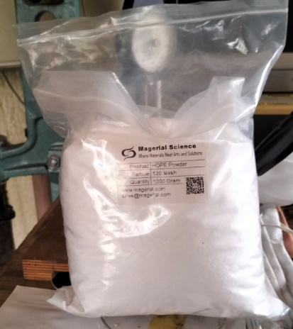
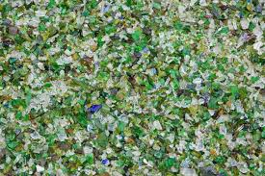
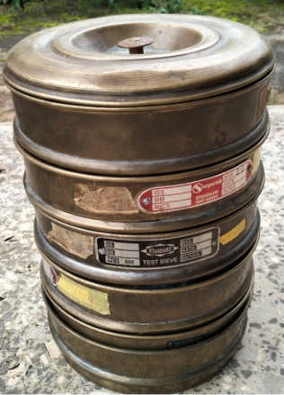
Fig. 3.1a: Virgin HDPE Fig. 3.1b: GCP
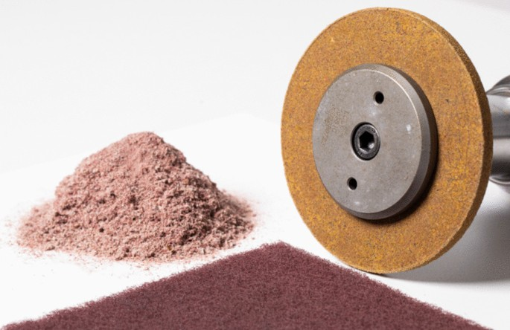
Fig. 3.1c: WGD. Fig. 3.1d: Six Sieve Pans for GCP & WGD.

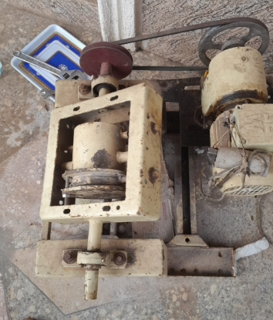
Fig3.1e: Ball Mill Machine for GCP.
Both fillers were oven-dried at 105°C for 24 hours to remove moisture prior to mixing.

3.2: Composite Fabrication
The composite formulations were prepared using a melt blending process. The measured proportions of HDPE, GCP, and WGD were mixed using manual process but ensure pre-homogenization.
The blended mixture was processed using compression moulding by preheating temperature of 170–190°C at a moulding pressure of 10–15 MPa at a holding time of 10–15 minutes.
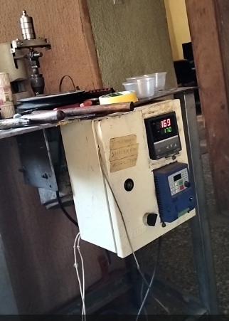
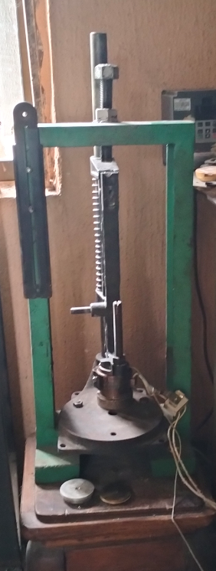
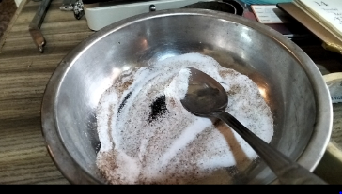

Plate 3.2a: Manual mixture of Composite. Plate 3.2b: Flat Hot Press Compression machine and Thermocouple Display Reading.
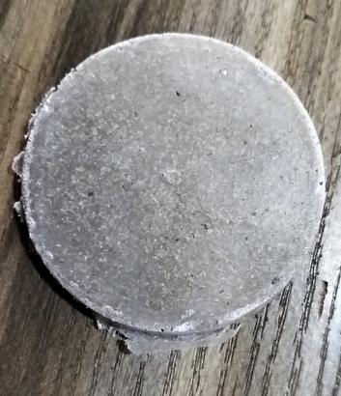

Plate 3.2c: Sample of Composite Cast.

After moulding, the composite sheets were cooled under pressure to prevent warping. The sheets were then cut into standardized test specimens according to ASTM standards for mechanical and physical testing.
3.3: Mechanical Testing
Plate 3.3a was prepared from plate 3.2c for mechanical characterization. Data were collected using standardized laboratory equipment like: The tensile strength test (ASTM D638) using a Universal Testing Machine (UTM), flexural strength test (ASTM D790) using three-point bending configuration, and the hardness test using Brinell hardness tester.
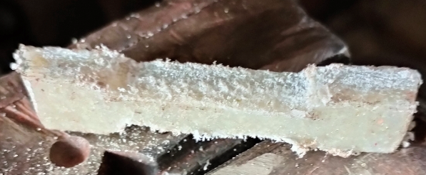
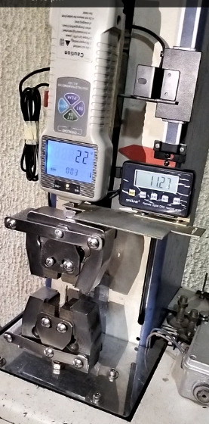

Plate 3.3a: Dumb bell ready for Mechanical Characterization. Plate 3.3b: Tensile Testing Machine.
3.4: Physical Testing
Among physical testing for this research are: density which was determined using Archimedes’ principle, Water absorption was measured according to ASTM D570 by immersing samples in distilled water for 48 hours and calculating percentage weight gain, and Wear resistance was evaluated using a pin-on-disc wear testing machine.

3.5: Microstructural and Morphological Analysis
The fracture surfaces of selected samples were examined using: the Scanning Electron Microscopy (SEM) to study interfacial bonding and particle dispersion.
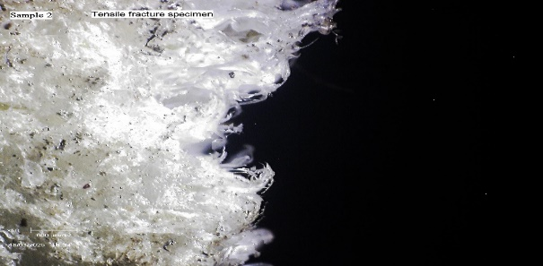
Fig.3.5: Tensile Fracture Surface Micrograph of Sample 2.
4.0: Data Analysis

4.1: Effects of Production Parameters on the Mechanical Properties of the Matrix Reinforced Composites (Glass Cullet Particles and Waste Grinding Disc Particles).
Table 2: DOE with Mechanical and Physical Properties.
Run | Factor1  A:GCP (%) | Factor2  B: WGD (%) | Response 1  Tensile Strength (MPa) | Response 2  Flexural Strength (MPa) | Response 3  Hardness (BHN) | Response 4  Moisture Content (%) | Respons5  Density (kg/m³) | Response 6  Thickness Selling (mm)
1 | 15 | 15 | 8.9 | 16.6210 | 67 | 0.086 | 1.343 | 0.056
2 | 15 | 10 | 8.312 | 22.010 | 66 | 0.068 | 1.255 | 0.054
3 | 10 | 20 | 11.010 | 42.9861 | 56 | 0.076 | 1.398 | 0.03
4 | 5 | 10 | 3.009 | 14.108 | 58 | 0.029 | 1.298 | 0.009
5 | 10 | 15 | 11.199 | 49.877 | 61 | 0.08 | 1.272 | 0.003
6 | 5 | 15 | 5.332 | 36.188 | 52 | 0.029 | 1.366 | 0.04
7 | 15 | 5 | 8.1 | 11.8428 | 62 | 0.0198 | 1.212 | 0.088
8 | 10 | 10 | 10.101 | 43.582 | 57 | 0.094 | 1.300 | 0.055

Based on the experimental results obtained from varying Glass Cullet Particles (GCP) and Waste Grinding Disc (WGD) contents in the virgin HDPE matrix, the following properties were analysed.
Tensile Strength (MPa).
Tensile strength measures the ability of the composite to resist breaking under uniaxial tensile loading. It reflects the effectiveness of interfacial bonding between the HDPE matrix and the reinforcing fillers (GCP and WGD). From the data, tensile strength ranged from 3.009 MPa (Run 4: 5% GCP/10% WGD) to 11.199 MPa (Run 5: 10% GCP/15% WGD). The highest values were recorded at moderate filler compositions (10% GCP combined with 15–20% WGD), indicating improved stress transfer between matrix and reinforcements. However, excessive or poorly balanced filler ratios may reduce tensile performance due to particle agglomeration or weak interfacial adhesion, as observed in lower-percentage combinations.
Flexural Strength (MPa)
Flexural strength indicates the material’s resistance to deformation under bending loads, which is particularly critical for floor tiles subjected to distributed loads and foot traffic. The results show flexural strength values ranging from 11.843 MPa (Run 7: 15% GCP/5% WGD) to 49.877 MPa (Run 5: 10% GCP/15% WGD). The significant improvement at optimal hybrid ratios demonstrates the synergistic reinforcement effect of combining rigid glass cullet with abrasive disc particles. Higher flexural strength suggests better stiffness and load-bearing capacity, making the composite suitable for structural flooring applications.
Hardness (BHN)
Hardness represents the resistance of the composite surface to indentation and wear, an important property for floor tiles exposed to abrasion. The Brinell Hardness Number (BHN) ranged from 52 BHN (Run 6) to 67 BHN (Run 1). Increased GCP content generally enhanced hardness due to the rigid and brittle nature of glass particles. High hardness values indicate improved wear resistance, which is desirable for long-term flooring performance in residential and commercial environments.
Moisture Content (%)
Moisture content measures the amount of water absorbed by the composite, which affects dimensional stability and long-term durability. The values ranged from 0.0198% (Run 7) to 0.094% (Run 8). The generally low moisture absorption across all formulations reflects the hydrophobic nature of virgin HDPE. However, slight variations may be attributed to filler dispersion and interfacial voids. Low moisture uptake is advantageous for floor tiles, particularly in humid environments, as it minimizes degradation and microbial growth.
Density (kg/m³)
Density determines the weight-to-volume ratio of the composite and influences mechanical strength, stability, and ease of handling. The density values ranged from 1.212 g/cm³ (Run 7) to 1.398 g/cm³ (Run 3) (equivalent to approximately 1212–1398 kg/m³). Higher density values were observed with increased GCP content due to the higher specific gravity of glass. Adequate density contributes to mechanical robustness while maintaining manageable weight for installation.
Thickness Swelling (mm)
Thickness swelling evaluates dimensional stability after moisture exposure. It ranged from 0.003 mm (Run 5) to 0.088 mm (Run 7). Lower swelling values indicate better resistance to water-induced expansion. The optimal hybrid composition (10% GCP/15% WGD) exhibited minimal swelling, suggesting improved filler-matrix compatibility and reduced void content. Minimal thickness swelling is essential for maintaining the structural integrity and flatness of floor tiles during service.
The overall results shows that hybridization of virgin HDPE with optimized proportions of glass cullet and waste grinding disc particles significantly enhances mechanical strength, surface hardness, and dimensional stability while maintaining low moisture absorption. The composition containing 10% GCP and 15% WGD exhibited the most balanced performance, making it a promising formulation for sustainable and high-performance floor tile applications.
4.2: Optimization.

Table 3: Optimization Solution for the Hybrid Composite
S/N | %GCP | %WGD | Tensile Strength | Flexural Strength | Impact Strength | Hardness | Thickness | Density | Desirability
1 | 12.326 | 13.904 | 12.288 | 48.224 | 0.083 | 62.162 | 0.053 | 1.421 | 0.809
2 | 12.312 | 13.965 | 12.067 | 48.566 | 0.089 | 62.904 | 0.051 | 1.411 | 0.809. Selected
3 | 12.321 | 13.822 | 12.221 | 48.433 | 0.082 | 61.009 | 0.054 | 1.396 | 0.809

The optimization generated three closely related solutions with an identical overall desirability value of 0.809, indicating a high level of simultaneous satisfaction of all response criteria. The filler compositions are concentrated within a narrow range of approximately 12.31–12.33% GCP and 13.82–13.97% WGD, suggesting that the best performance occurs at moderate hybrid reinforcement levels rather than extreme filler contents. This confirms the synergistic interaction between GCP and WGD particles within the virgin HDPE matrix.
Among the solutions, Solution 2 (12.312% GCP and 13.965% WGD) was selected as the optimum formulation. This composition produced a tensile strength of 12.067 MPa, flexural strength of 48.566 MPa, and impact strength of 0.089, indicating excellent resistance to tensile loading, bending stress, and sudden impact a key requirement for floor tile materials subjected to dynamic and static loads. Additionally, the hardness value of 62.904 BHN reflects improved surface wear resistance, which is critical for long-term flooring performance.
Conclusively, the optimization results confirm that a balanced hybrid composition of approximately 12% GGC and 14% WGD provides the most desirable combination of strength, hardness, impact resistance, and dimensional stability. The high desirability index (0.809) validates the effectiveness of the response surface optimization technique in developing a high-performance and sustainable hybrid composite suitable for floor tile applications.
4.3: Validation Result.
Table 4: Validation
S/N | %GGC | %WGD | Tensile Strength | Flexural Strength | Impact Strength | Hardness | Thickness | Density
1 | 12.32 | 13.80 | 12.60 | 46.2 | 0.88 | 60.73 | 0.52 | 1.42
2 | 12.32 | 13.80 | 12.00 | 48.6 | 0.87 | 61.62 | 0.50 | 1.40
3 | 12.32 | 13.80 | 11.94 | 47.8 | 0.89 | 59.64 | 0.53 | 1.45

Table 4 presents Three (3) replicate samples were produced and tested to evaluate the reproducibility of the mechanical and physical properties. The results show tensile strength values ranging from 11.94–12.60 MPa, flexural strength from 46.2–48.6 MPa, impact strength between 0.87–0.89, hardness from 59.64–61.62 BHN, thickness values of 0.50–0.53 mm, and density between 1.40–1.45 g/cm³. The close clustering of these values indicates good experimental repeatability and confirms the adequacy of the optimization model.
When compared with conventional ceramic floor tiles, which typically exhibit flexural strengths in the range of 20–35 MPa and are inherently brittle with very low impact resistance, the developed HDPE/GGC/WGD hybrid composite demonstrates competitive and, in some cases, superior performance. The validated flexural strength values approaching 48 MPa indicate excellent load-bearing capacity. While ceramic tiles generally possess higher hardness (often above 70 BHN or equivalent Mohs hardness of 6–7), they are prone to cracking under impact due to their brittle nature. In contrast, the hybrid composite shows appreciable impact strength (≈0.88), reflecting improved toughness and resistance to sudden loading, which reduces the likelihood of catastrophic failure.
In terms of density, conventional ceramic tiles typically range from 2.0–2.4 g/cm³, making them significantly heavier than the developed composite (1.40–1.45 g/cm³). The lower density of the hybrid composite offers advantages in ease of handling, transportation, and installation while maintaining adequate structural integrity. Also, the relatively low thickness variation (0.50–0.53 mm) indicates good dimensional stability, an essential requirement for flooring materials.
Finally, the validation results confirm that the optimized hybrid composite not only meets but, in some aspects, improves upon key performance characteristics of conventional floor tiles, particularly in flexural performance, impact resistance, and reduced weight. This validates the material’s suitability as a sustainable and high-performance alternative for floor tile applications.
5.0: Conclusion
The development of the virgin HDPE/GGC/WGD hybrid composite has demonstrated that sustainable material innovation can meet and in key aspects exceed the functional demands of modern floor tile applications. Through systematic formulation, mechanical characterization, optimization, and validation, the study established that a balanced incorporation of approximately 12% glass cullet particles and 14% waste grinding disc particles within the HDPE matrix produces a composite with outstanding flexural strength (≈48 MPa), tensile strength (≈12 MPa), appreciable impact resistance (≈0.88), and adequate hardness (≈61 BHN), while maintaining low density (≈1.41 g/cm³) and good dimensional stability. The strong agreement between predicted and experimental validation results confirms the robustness of the optimization model and the reliability of the developed material system. Beyond performance, the research highlights the transformative potential of valorising industrial and post-consumer waste into high-value engineering products. By combining structural efficiency, reduced weight, improved toughness, and environmental sustainability, the developed hybrid composite emerges as a promising, cost-effective, and durable alternative to conventional floor tiles, contributing meaningfully to sustainable construction materials development.
5.1: Recommendations.
The following are the recommendations for further work:
- Compatibilizers or coupling agents (such as silane or maleic anhydride–grafted polyethylene) should be used to improve interfacial bonding between the HDPE matrix and the inorganic fillers. Enhanced interfacial adhesion could further increase tensile and impact strength while reducing the possibility of particle agglomeration at higher filler loadings.
- Long-term durability assessments are recommended, including wear resistance, thermal cycling, creep behaviour, UV aging, and chemical resistance tests. Since floor tiles are subjected to continuous foot traffic and varying environmental conditions, evaluating long-term performance will strengthen confidence in large-scale commercial adoption.
- Partial or full replacement of virgin HDPE with recycled HDPE to further enhance the environmental sustainability and cost-effectiveness of the composite without significantly compromising mechanical properties.
- A comprehensive techno-economic and life-cycle assessment (LCA) is recommended to evaluate the environmental impact, production cost, and market competitiveness of the developed hybrid composite compared to conventional ceramic and polymer-based floor tiles.
- Implementing these recommendations will not only improve the material’s structural performance and durability but also strengthen its commercial viability and sustainability in modern construction applications.
References:
Debele, A. D. (2024). Recycling and reusing potential of disposable low-density polyethylene as a binding agent in paver tile production. https://doi.org/10.1016/j.heliyon.2024.e29381.
Qassid, A.F. and Hamid, A.A. (2023). Producing Eco-friendly Tiles from Recycled Plastic Generated from Municipal Solid Waste. Journal of Environmental Research, Engineering and Management Vol. 81 / No. 1 / 2025. https://doi.org/10.5755/j01.erem.81.1.35353.
Sabarinathan, P., Annamalai, V.E., and Rajkumar, K. (2020). Sustainable application of grinding wheel waste as abrasive grain in machining and other reuse options. Journal of Cleaner Production, https://doi.org/10.1016/j.jclepro.2020.121225.
Sadik, W. A., El-Demerdash, A.-G. M., Abokhateeb, A. E. A., & Elessawy, N. A. (2021). Innovative high-density polyethylene/waste glass powder composite with remarkable mechanical, thermal and recyclable properties for technical applications. Heliyon, 7(4), e06627. https://doi.org/10.1016/j.heliyon.2021.e06627.
Wimalasuriya, L., Gunasekara, C., Robert, D., & Setunge, S. (2024). Waste-derived high-density polyethylene–glass composites: A pathway to sustainable structural materials. Polymers, 17(1), Article 35. https://doi.org/10.3390/polym17010035. https://www.ncbi.nlm.nih.gov/pmc/articles/PMC11723426/).

