Effect of Thermal Extraction Conditions on Antioxidant Capacity, Phenolic Composition and Pancreatic Lipase Inhibitory Activity of Hibiscus sabdariffa Water Extract

Abstract
Thermal processing is a critical factor influencing the recovery and bioactivity of phenolic compounds in plant-based extracts. This study investigated the effect of extraction temperature (40–100°C) and duration (15 min–3 h) on the phenolic composition, antioxidant capacity, and pancreatic lipase inhibitory activity of Hibiscus sabdariffa water extract. Antioxidant activity was evaluated using DPPH radical scavenging and ferric reducing antioxidant power (FRAP) assays, while total phenolic content (TPC) and total flavonoid content (TFC) were determined using standard colorimetric methods. Pancreatic lipase inhibition was assessed spectrophotometrically. The highest DPPH radical scavenging activity was observed at 80°C for 1–5 h (51.40%), followed by extraction at 100°C for 15 min (49.93%). In contrast, prolonged extraction at 100°C for 3 h showed markedly reduced activity (1.34%). FRAP analysis revealed that extraction at 100°C for 2 h exhibited the strongest reducing power (2045 µM Fe²⁺/g sample), although all extracts showed lower values than ascorbic acid. The highest TPC was obtained at 40°C for 2 h (47.32 mg GAE/g), whereas maximum TFC was recorded at 60°C for 3 h (655.25 mg/mL CE). Notably, pancreatic lipase inhibition was most pronounced at 100°C for 30 min (92.89%), approaching the activity of Xenical (97.33%). These findings demonstrate that thermal processing significantly modulates antioxidant properties and enzyme inhibitory activity of H. sabdariffa extract. Optimal bioactivity was dependent on the targeted functional outcome, highlighting the importance of extraction parameter optimization for functional food and nutraceutical applications.

Keywords: Hibiscus sabdariffa; thermal extraction; polyphenols; antioxidant activity; DPPH; FRAP; pancreatic lipase inhibition; nutraceutical optimization

Introduction
Oxidative stress, resulting from excessive production of reactive oxygen species (ROS), is widely recognized as a major contributing factor to the development of chronic diseases such as cardiovascular disorders, diabetes mellitus, metabolic syndrome, and obesity (Reddy, 2023). Reactive oxygen species can initiate lipid peroxidation, impair cellular macromolecules, and disrupt metabolic homeostasis (Su et al., 2019). Dietary antioxidants derived from plant sources play an essential role in neutralizing free radicals and mitigating oxidative damage (Lobo et al., 2010). Among these, phenolic compounds and flavonoids have attracted considerable attention due to their strong radical-scavenging, reducing, and metal-chelating properties (Panche et al., 2016).
Hibiscus sabdariffa L., (H. sabdariffa) commonly known as roselle, is a tropical plant widely consumed as a herbal beverage and traditional remedy (Almajid et al., 2023). The calyces are particularly rich in anthocyanins, phenolic acids, and flavonoids, which contribute to its reported antioxidant, anti-inflammatory, antihypertensive, and hypolipidemic effects (Ghaly et al., 2025). Numerous studies have demonstrated that H. sabdariffa extracts exhibit substantial antioxidant activity through DPPH radical scavenging, ferric reducing antioxidant power (FRAP), and other in vitro assays (Wu et al., 2018). In addition to antioxidant properties, H. sabdariffa has been associated with lipid-lowering and anti-obesity potential, possibly through modulation of lipid metabolism and digestive enzyme inhibition (Yang et al., 2025).
Pancreatic lipase is a key enzyme responsible for the hydrolysis of dietary triglycerides into absorbable free fatty acids (Subramaniyan et al., 2025). Inhibition of pancreatic lipase reduces fat absorption and represents an established therapeutic strategy for obesity management (Tran et al., 2014). Synthetic inhibitors such as orlistat (Xenical) are clinically effective but may produce undesirable gastrointestinal side effects (Beyea et al., 2012). Therefore, identification of natural lipase inhibitors from plant sources has gained increasing research interest. Several phenolic-rich plant extracts have been shown to inhibit pancreatic lipase activity, suggesting that phenolic composition may contribute to anti-obesity potential (Yang et al., 2015).
Extraction methodology plays a critical role in determining the yield, composition, and bioactivity of phytochemicals (Fitri et al., 2025). Thermal processing, including variations in temperature and extraction duration, can significantly influence phenolic recovery and structural stability (Narra et al., 2024). While moderate heating may enhance extraction efficiency by disrupting plant cell matrices, excessive or prolonged heating may lead to degradation, oxidation, or polymerization of phenolic compounds (Sun et al., 2025). Consequently, thermal parameters may differentially affect antioxidant capacity and enzyme inhibitory activities (Frlin et al., 2025).
Although H. sabdariffa has been extensively investigated for its antioxidant properties, systematic evaluation of how thermal extraction conditions simultaneously influence phenolic profile, antioxidant capacity, and pancreatic lipase inhibitory activity remains limited. Understanding these interactions is essential for optimizing extraction strategies aimed at maximizing functional bioactivity.
Therefore, the present study aimed to investigate the influence of thermal processing (40–100°C; 15 min–3 h) on the phenolic composition, antioxidant potential (DPPH and FRAP), and pancreatic lipase inhibitory activity of H. sabdariffa water extract. By integrating antioxidant profiling with enzyme inhibition assessment, this study provides insight into the optimization of H. sabdariffa extraction for potential functional food and nutraceutical applications.

Materials and Methods

Plant Material
Dried calyces of H. sabdariffa L. were obtained from a certified local supplier in Malaysia and authenticated by a botanist at the Forest Research Institute Malaysia (FRIM), Kepong, Selangor. The plant material was cleaned to remove foreign debris and ground into a fine powder using a laboratory grinder. The powdered sample was stored in airtight containers at room temperature (25 ± 2 °C) in a dry and dark environment until further analysis.

Preparation of Water Extract under Different Thermal Conditions
The aqueous extracts were prepared by varying extraction temperature and duration to evaluate the influence of thermal processing on bioactivity. Briefly, 5 g of dried H. sabdariffa powder was mixed with 100 mL of distilled water (solid-to-solvent ratio 1:20, w/v) in a conical flask. The mixture was subjected to extraction at controlled temperatures of 40, 60, 80, and 100 °C using a thermostatically regulated water bath.
For each temperature, extraction was performed at different time intervals: 15 min, 30 min, 1 h, 2 h, and 3 h. The flasks were covered with aluminum foil to minimize evaporation and oxidation during heating. After extraction, the mixtures were cooled to room temperature and filtered through Whatman No. 1 filter paper. The filtrates were centrifuged at 4000 rpm for 10 min to remove residual particulates.
The supernatants were collected and stored at −20 °C until analysis. All extractions were performed in triplicate.

Determination of Total Phenolic Content (TPC)
Total phenolic content was determined using the Folin–Ciocalteu colorimetric method with slight modifications. Briefly, 200 µL of appropriately diluted extract was mixed with 1.0 mL of 10% (v/v) Folin–Ciocalteu reagent. After 5 min of incubation at room temperature, 800 µL of 7.5% (w/v) sodium carbonate solution was added. The reaction mixture was vortexed and incubated in the dark for 30 min at room temperature.
Absorbance was measured at 765 nm using a UV–Vis spectrophotometer. Gallic acid was used to construct a calibration curve (0–200 µg/mL), and results were expressed as milligrams of gallic acid equivalents per gram of dry sample (mg GAE/g). All measurements were performed in triplicate.

Determination of Total Flavonoid Content (TFC)
Total flavonoid content was determined using the aluminum chloride colorimetric method. Briefly, 500 µL of extract was mixed with 1.5 mL of methanol, followed by 100 µL of 10% aluminum chloride solution, 100 µL of 1 M potassium acetate, and 2.8 mL of distilled water.
The mixture was incubated at room temperature for 30 min. Absorbance was measured at 415 nm against a reagent blank. Catechin was used as the standard reference compound, and results were expressed as catechin equivalents (CE). All analyses were conducted in triplicate.

DPPH Radical Scavenging Assay
The antioxidant capacity of the extracts was evaluated using the DPPH (2,2-diphenyl-1-picrylhydrazyl) radical scavenging assay. A 0.1 mM DPPH solution was prepared in methanol.
An aliquot of 1.0 mL of extract was mixed with 2.0 mL of DPPH solution and incubated in the dark at room temperature for 30 min. Absorbance was measured at 517 nm using a UV–Vis spectrophotometer.
The percentage of radical scavenging activity was calculated using the following equation:
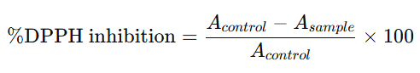
where A_{control}​ represents the absorbance of the control (DPPH solution without extract) and A_{sample}​ represents the absorbance in the presence of extract.
Ascorbic acid was used as a positive control. All assays were performed in triplicate.

Ferric Reducing Antioxidant Power (FRAP) Assay
The FRAP assay was conducted according to the method described by Benzie and Strain with minor modifications. The FRAP reagent was freshly prepared by mixing 300 mM acetate buffer (pH 3.6), 10 mM TPTZ solution in 40 mM HCl, and 20 mM FeCl₃·6H₂O in a ratio of 10:1:1 (v/v/v).
Briefly, 100 µL of extract was added to 3.0 mL of FRAP reagent and incubated at 37 °C for 4 min. Absorbance was measured at 593 nm.
A standard curve was constructed using ferrous sulfate (FeSO₄·7H₂O), and results were expressed as µM Fe²⁺ equivalents per gram of sample. All measurements were carried out in triplicate.

Pancreatic Lipase Inhibitory Assay
Pancreatic lipase inhibitory activity was determined spectrophotometrically using porcine pancreatic lipase and p-nitrophenyl palmitate (pNPP) as the substrate.
Briefly, 100 µL of extract was pre-incubated with 100 µL of pancreatic lipase solution (1 mg/mL in phosphate buffer, pH 7.4) at 37 °C for 15 min. Subsequently, 100 µL of pNPP substrate solution was added to initiate the reaction. The reaction mixture was incubated at 37 °C for 30 min.
The release of p-nitrophenol was measured at 405 nm using a microplate reader. Xenical (orlistat) was used as a positive control.
The percentage of lipase inhibition was calculated as:
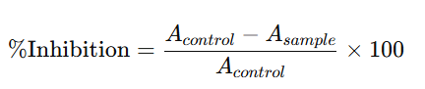
where AcontrolA_{control}Acontrol​ represents enzyme activity without inhibitor and AsampleA_{sample}Asample​ represents enzyme activity in the presence of extract.
All experiments were performed in triplicate.

Statistical Analysis
All experiments were conducted in triplicate, and results were expressed as mean ± standard deviation (SD). Statistical analysis was performed using one-way analysis of variance (ANOVA) followed by Tukey’s post hoc test to determine significant differences among extraction conditions. Differences were considered statistically significant at p < 0.05.
Results
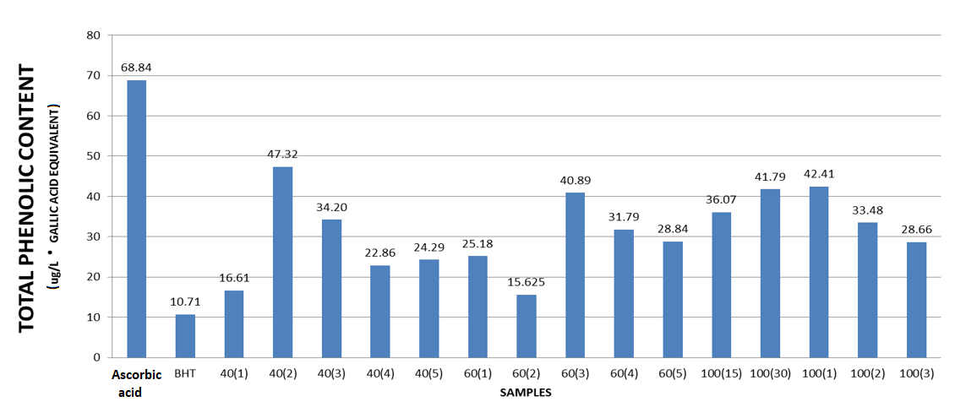
Figure 1. Total phenolic content (TPC) of H. sabdariffa water extracts prepared under different thermal extraction conditions (40–100 °C; 15 min–3 h). Results are expressed as mg gallic acid equivalent (GAE)/g sample. Ascorbic acid and BHT were included as reference standards.

The total phenolic content (TPC) of H. sabdariffa water extract varied considerably depending on extraction temperature and duration. Among the reference standards, ascorbic acid showed the highest phenolic equivalent value (68.84 mg GAE/g), followed by BHT (10.71 mg GAE/g). At 40 °C, the extract obtained after 2 h demonstrated the highest TPC (47.32 mg GAE/g), followed by 3 h (34.20 mg GAE/g). Lower values were recorded at 15 min (16.61 mg GAE/g) and 4–5 h (22.86–24.29 mg GAE/g).
For extraction at 60 °C, the highest TPC was observed at 3 h (40.89 mg GAE/g), whereas shorter extraction times yielded comparatively lower values, with 2 h recording the lowest (15.63 mg GAE/g). At 100 °C, phenolic content ranged between 28.66 and 42.41 mg GAE/g. The highest TPC at this temperature was observed at 1 h (42.41 mg GAE/g), followed closely by 30 min (41.79 mg GAE/g) and 15 min (36.07 mg GAE/g). A gradual reduction was noted at longer extraction durations (2–3 h).
The data indicate that moderate-to-high temperatures (40–100 °C) combined with intermediate extraction times (1–3 h) produced higher total phenolic content compared to shorter or prolonged heating durations.

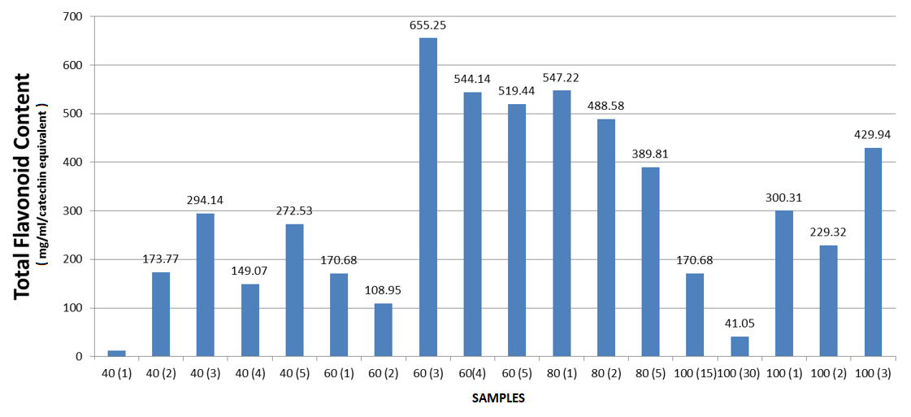
Figure 2. Total flavonoid content (TFC) of H. sabdariffa water extracts obtained under different thermal extraction conditions (40–100 °C; 15 min–3 h). Results are expressed as catechin equivalents (CE).

The total flavonoid content (TFC) of H. sabdariffa water extract showed substantial variation depending on extraction temperature and duration. At 40 °C, flavonoid content ranged from −11.42 to 294.14 CE. The highest value at this temperature was observed at 3 h (294.14 CE), followed by 5 h (272.53 CE), while lower values were recorded at shorter durations.
For extraction at 60 °C, markedly higher flavonoid levels were obtained compared to 40 °C. The highest TFC overall was recorded at 60 °C for 3 h (655.25 CE). Other high values at this temperature included 4 h (544.14 CE) and 5 h (519.44 CE), whereas 2 h yielded the lowest value (108.95 CE). At 80 °C, TFC values remained relatively high, ranging from 389.81 to 547.22 CE. The maximum at this temperature was observed at 1 h (547.22 CE), followed by 2 h (488.58 CE).
In contrast, extraction at 100 °C showed greater variability. A very low value was recorded at 30 min (41.05 CE), whereas higher values were obtained at 1 h (300.31 CE) and 3 h (429.94 CE).
Overall, the data demonstrate that extraction at 60–80 °C generally produced higher total flavonoid content compared to 40 °C and 100 °C conditions, with the highest flavonoid concentration observed at 60 °C for 3 h.
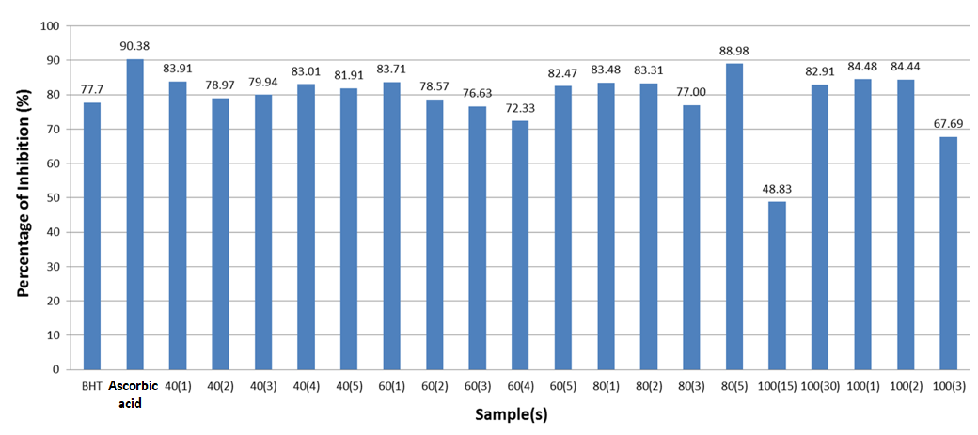
Figure 3. DPPH radical scavenging activity (%) of H. sabdariffa water extracts prepared under different thermal extraction conditions (40–100 °C; 15 min–3 h). BHT and ascorbic acid were used as reference standards.

The DPPH radical scavenging activity of H. sabdariffa water extracts ranged from 48.83% to 88.98%, depending on extraction temperature and duration. Among the reference standards, ascorbic acid showed the highest inhibition (90.38%), followed by BHT (77.70%). At 40 °C, DPPH inhibition values were relatively consistent, ranging between 78.97% and 83.91%, with the highest activity observed at 40 °C for 1 h (83.91%).
Extraction at 60 °C produced inhibition values between 72.33% and 83.71%. The highest activity at this temperature was recorded at 1 h (83.71%), while the lowest was observed at 4 h (72.33%). At 80 °C, DPPH inhibition remained high across most durations, with values between 77.00% and 88.98%. The strongest radical scavenging activity among all tested extracts was obtained at 80 °C for 5 h (88.98%). For extraction at 100 °C, inhibition values showed greater variability. High activities were observed at 30 min (82.91%), 1 h (84.48%), and 2 h (84.44%). However, a markedly lower value was recorded at 15 min (48.83%) and a reduction was also noted at 3 h (67.69%).
Moreover, most extraction conditions yielded strong DPPH radical scavenging activity exceeding 70%, with optimal activity observed at 80 °C for 5 h.

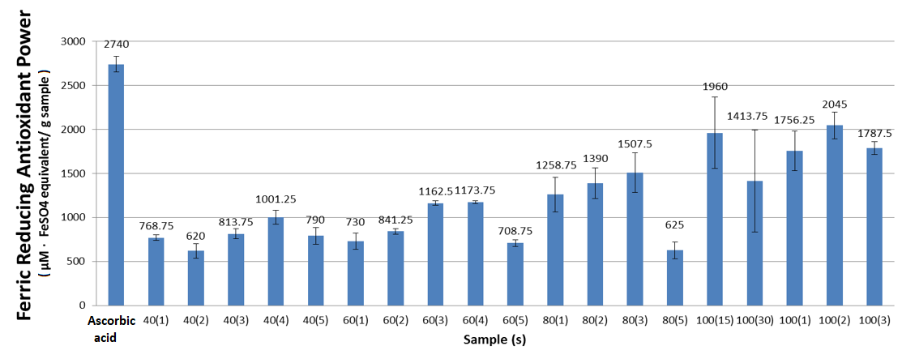
Figure 4. Ferric reducing antioxidant power (FRAP) of H. sabdariffa water extracts prepared under different thermal extraction conditions (40–100 °C; 15 min–3 h). Results are expressed as µM FeSO₄ equivalent per gram of sample. Ascorbic acid was used as a reference standard. Data are presented as mean ± SD.
The ferric reducing antioxidant power (FRAP) values of H. sabdariffa water extracts varied substantially according to extraction temperature and duration. Ascorbic acid exhibited the highest reducing power (2740 µM Fe²⁺/g), serving as the reference benchmark.
At 40 °C, FRAP values ranged from 620 to 1001.25 µM Fe²⁺/g. The highest reducing activity at this temperature was observed at 4 h (1001.25 µM Fe²⁺/g), while the lowest value was recorded at 2 h (620 µM Fe²⁺/g). For extraction at 60 °C, reducing power ranged between 708.75 and 1173.75 µM Fe²⁺/g. The highest value was observed at 4 h (1173.75 µM Fe²⁺/g), closely followed by 3 h (1162.5 µM Fe²⁺/g), whereas the lowest was noted at 5 h (708.75 µM Fe²⁺/g).
At 80 °C, FRAP values increased further, ranging from 625 to 1507.5 µM Fe²⁺/g. The highest reducing activity at this temperature was recorded at 3 h (1507.5 µM Fe²⁺/g), while a lower value was observed at 5 h (625 µM Fe²⁺/g). Extraction at 100 °C generally produced higher FRAP values compared to lower temperatures. The strongest reducing power among all H. sabdariffa extracts was obtained at 100 °C for 2 h (2045 µM Fe²⁺/g), followed by 15 min (1960 µM Fe²⁺/g) and 3 h (1787.5 µM Fe²⁺/g). However, a comparatively lower value was recorded at 30 min (1413.75 µM Fe²⁺/g).
Therefore, increasing extraction temperature from 40 °C to 100 °C was associated with a general increase in ferric reducing antioxidant power, with the highest activity observed at 100 °C for 2 h.
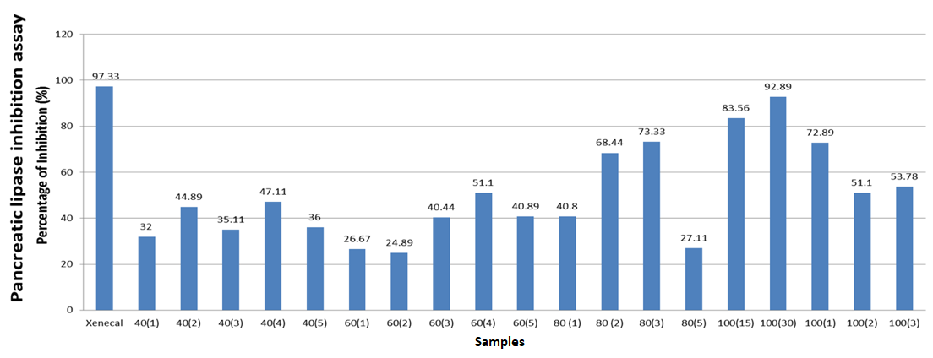
Figure 5. Pancreatic lipase inhibitory activity (%) of H. sabdariffa water extracts prepared under different thermal extraction conditions (40–100 °C; 15 min–3 h). Xenical (orlistat) was used as the positive control.
The pancreatic lipase inhibitory activity of H. sabdariffa water extracts showed marked variation depending on extraction temperature and duration. Xenical (orlistat), used as the positive control, exhibited 97.33% inhibition. At 40 °C, lipase inhibition ranged from 32.00% to 47.11%. The highest activity at this temperature was observed at 4 h (47.11%), while the lowest was recorded at 1 h (32.00%).
Extraction at 60 °C yielded inhibition values between 24.89% and 51.10%. The highest activity at this temperature was recorded at 4 h (51.10%), whereas the lowest was observed at 2 h (24.89%).
At 80 °C, inhibitory activity increased compared to 40 °C and 60 °C conditions. The highest value at this temperature was recorded at 3 h (73.33%), followed by 2 h (68.44%). Lower inhibition was observed at 5 h (27.11%). The most pronounced lipase inhibition among all tested extracts was obtained at 100 °C for 30 min (92.89%), approaching the activity of Xenical. High inhibition was also observed at 15 min (83.56%) and 1 h (72.89%). However, longer extraction times (2–3 h) resulted in reduced inhibition values (51.10–53.78%).
Generally, extraction at 100 °C for shorter durations, particularly 30 min, produced the strongest pancreatic lipase inhibitory activity among all thermal conditions tested.

Discussion
The present findings clearly demonstrate that thermal extraction parameters exert a significant modulatory effect on the phenolic composition, antioxidant potential, and pancreatic lipase inhibitory activity of H. sabdariffa water extract. Importantly, the optimal extraction condition differed according to the targeted biofunctional endpoint, highlighting the complex and multifactorial nature of thermal-induced phytochemical transformations (Sun et al., 2025).
Total phenolic content (TPC) was maximized at 40 °C for 2 h, indicating that moderate thermal conditions favor phenolic preservation. Mild heating likely enhances cell wall permeability and facilitates solvent penetration, thereby promoting diffusion of soluble phenolics without inducing substantial structural degradation (Qin et al., 2025). However, prolonged exposure or higher temperatures resulted in reduced TPC, particularly under extended heating durations. This decline may be attributed to oxidative degradation, hydrolysis, or structural instability of heat-sensitive phenolic compounds such as anthocyanins, which are known to exhibit limited thermal stability (Enaru et al., 2021). Previous studies have reported that anthocyanin degradation accelerates at elevated temperatures, leading to diminished phenolic quantification despite initial extraction enhancement (Wu et al., 2018; Narra et al., 2024). Thus, phenolic yield appears to reflect a balance between enhanced release and thermally induced degradation.
Interestingly, total flavonoid content (TFC) displayed a distinct extraction profile, with the highest level observed at 60 °C for 3 h. This suggests that flavonoids may require slightly higher thermal input to disrupt matrix-bound or conjugated forms. Thermal energy can weaken hydrogen bonding interactions and promote dissociation of flavonoid–polysaccharide complexes, thereby improving solubilization (Panche et al., 2016). Nevertheless, extraction at 100 °C generated inconsistent and occasionally reduced TFC values, implying structural instability of certain flavonoid subclasses under extreme thermal conditions. The differential responses of TPC and TFC underscore the structural diversity of phenolics and flavonoids, which differ in glycosylation patterns, hydroxyl substitutions, and thermal sensitivity (Nastasi et al., 2025). Therefore, total phenolics and flavonoids should not be considered thermally equivalent entities.
Temperature-dependent variations were further reflected in antioxidant assays. DPPH radical scavenging activity peaked at 80 °C during prolonged extraction, suggesting that certain antioxidant constituents are more efficiently liberated or activated at elevated temperatures. Thermal treatment may facilitate hydrolysis of bound phenolics into more reactive aglycone forms, thereby enhancing radical scavenging capacity (Narra et al., 2024). However, the pronounced decline observed at 100 °C for 15 min and 3 h indicates that excessive or prolonged heating may impair radical-scavenging efficiency, possibly due to anthocyanin degradation or oxidative modification (Wu et al., 2018).
Conversely, FRAP values progressively increased with temperature and reached maximum activity at 100 °C for 2 h. Unlike DPPH, which measures hydrogen-donating radical scavenging activity, FRAP evaluates electron-donating reducing power. The elevated FRAP response at higher temperatures may reflect the presence of thermally stable phenolic acids or the formation of newly generated reducing compounds. Thermal processing has been shown to induce structural rearrangements, hydrolysis of esterified phenolics, and Maillard reaction products, all of which may contribute to enhanced ferric-reducing capacity (Chaipoot et al., 2026). Such findings support the notion that antioxidant mechanisms differ in sensitivity to heat, and that reducing power may increase even when total phenolic content declines.
Notably, antioxidant capacity did not strictly correlate with TPC or TFC values. For instance, although TPC was highest at 40 °C for 2 h, the strongest DPPH activity occurred at 80 °C for 5 h, and maximum FRAP activity was recorded at 100 °C for 2 h. This lack of direct proportionality suggests that antioxidant efficacy depends not solely on quantitative phenolic abundance but also on qualitative compositional shifts, structural modifications, and synergistic interactions among phytochemicals (Lobo et al., 2010; Narra et al., 2024). Therefore, thermal processing influences not only compound yield but also biofunctional potency.
The most pronounced thermal effect was observed in pancreatic lipase inhibitory activity. Lipase inhibition was maximized at 100 °C for 30 min, approaching the efficacy of Xenical. Pancreatic lipase inhibition is a validated anti-obesity mechanism, as suppression of triglyceride hydrolysis reduces intestinal fat absorption (Subramaniyan et al., 2025). The enhanced inhibitory activity under short-term high-temperature extraction may be explained by liberation of aglycone flavonoids or phenolic acids with higher enzyme-binding affinity. Flavonoid derivatives have been reported to inhibit pancreatic lipase via competitive and non-competitive mechanisms involving hydrogen bonding and hydrophobic interactions at the catalytic site (Tran et al., 2024).
Interestingly, maximal lipase inhibition did not coincide with peak TPC or TFC values, suggesting that specific phenolic subclasses or thermally transformed metabolites, rather than total phenolic concentration, mediate enzyme inhibition. Short-duration exposure at high temperature may promote hydrolysis of glycosidic bonds, increasing availability of bioactive aglycones. However, prolonged heating at 100 °C reduced inhibitory activity, likely due to degradation or polymerization of active compounds, which may reduce enzyme-binding efficiency.
Collectively, these findings demonstrate that thermal extraction exerts a dualistic influence: moderate heating enhances phytochemical liberation, whereas excessive duration promotes degradation. Furthermore, antioxidant capacity and enzyme inhibition respond differently to thermal modulation, emphasizing that extraction optimization must be endpoint-specific. For antioxidant-focused applications, controlled extraction at 80–100 °C may enhance reducing power, whereas phenolic preservation is maximized under milder conditions (Wu et al., 2018; Narra et al., 2024). In contrast, for anti-obesity applications targeting pancreatic lipase, short-duration high-temperature extraction appears most effective (Subramaniyan et al., 2025; Tran et al., 2024).
Overall, the present study underscores that extraction temperature and time are critical determinants of both phytochemical yield and biological functionality in H. sabdariffa. These results provide a scientifically grounded framework for optimizing aqueous extraction strategies in functional food and nutraceutical development, emphasizing that bioactivity-driven optimization may not necessarily align with phenolic yield maximization.

References
Almajid A, Bazroon A, AlAhmed A, Bakhurji O. Exploring the Health Benefits and Therapeutic Potential of Roselle (Hibiscus sabdariffa) in Human Studies: A Comprehensive Review. Cureus. 2023 Nov 23;15(11):e49309. doi: 10.7759/cureus.49309. PMID: 38024072; PMCID: PMC10676230.
Beyea MM, Garg AX, Weir MA. Does orlistat cause acute kidney injury? Ther Adv Drug Saf. 2012 Apr;3(2):53-7. doi: 10.1177/2042098611429985. PMID: 25083225; PMCID: PMC4110847.
Chaipoot S, Kulprachakarn K, Wiriyacharee P, Somjai C, Chaimueng K, Jaijoi S, Khampakool A, Wongwatcharayothin W, Srinuanpan S, Pathomrungsiyounggul P, Phongphisutthinant R. Temperature-Driven Maillard Conjugation and Phenolic Changes in Dried Lychee Pulp: Implications for Antioxidative Enhancement. Foods. 2026 Jan 29;15(3):468. doi: 10.3390/foods15030468. PMID: 41683056; PMCID: PMC12896510.
Enaru B, Drețcanu G, Pop TD, Stǎnilǎ A, Diaconeasa Z. Anthocyanins: Factors Affecting Their Stability and Degradation. Antioxidants (Basel). 2021 Dec 9;10(12):1967. doi: 10.3390/antiox10121967. PMID: 34943070; PMCID: PMC8750456.
Ghaly HKF, Younis FAA, Soliman AM, El-Sabbagh SM. Phytochemical and antibacterial properties of calyces Hibiscus sabdariffa L.: an in vitro and in silico multitarget-mediated antibacterial study. BMC Complement Med Ther. 2025 Feb 18;25(1):62. doi: 10.1186/s12906-025-04794-1. PMID: 39966872; PMCID: PMC11837655.
Lobo V, Patil A, Phatak A, Chandra N. Free radicals, antioxidants and functional foods: Impact on human health. Pharmacogn Rev. 2010 Jul;4(8):118-26. doi: 10.4103/0973-7847.70902. PMID: 22228951; PMCID: PMC3249911.
Narra F, Piragine E, Benedetti G, Ceccanti C, Florio M, Spezzini J, Troisi F, Giovannoni R, Martelli A, Guidi L. Impact of thermal processing on polyphenols, carotenoids, glucosinolates, and ascorbic acid in fruit and vegetables and their cardiovascular benefits. Compr Rev Food Sci Food Saf. 2024 Nov;23(6):e13426. doi: 10.1111/1541-4337.13426. Epub 2024 Aug 21. PMID: 39169551; PMCID: PMC11605278.
Nastasi JR. Colourimetric Assays for Assessing Polyphenolic Phytonutrients with Nutraceutical Applications: History, Guidelines, Mechanisms, and Critical Evaluation. Nutraceuticals. 2025;5(4):40. doi:10.3390/nutraceuticals5040040.
Panche AN, Diwan AD, Chandra SR. Flavonoids: an overview. J Nutr Sci. 2016 Dec 29;5:e47. doi: 10.1017/jns.2016.41. Erratum in: J Nutr Sci. 2025 Jan 29;14:e11. doi: 10.1017/jns.2024.73. PMID: 28620474; PMCID: PMC5465813.
Qin X, Wang W, Zheng Y, Wang X, Chen Z, Zhao J, Li S. Effects of non-thermal processing techniques on cereal bran: Focus on changes in bran structure and polyphenol release. Food Chem X. 2025 Aug 5;29:102875. doi: 10.1016/j.fochx.2025.102875. PMID: 40823128; PMCID: PMC12355590.
Reddy VP. Oxidative Stress in Health and Disease. Biomedicines. 2023 Oct 29;11(11):2925. doi: 10.3390/biomedicines11112925. PMID: 38001926; PMCID: PMC10669448.
Su LJ, Zhang JH, Gomez H, Murugan R, Hong X, Xu D, Jiang F, Peng ZY. Reactive Oxygen Species-Induced Lipid Peroxidation in Apoptosis, Autophagy, and Ferroptosis. Oxid Med Cell Longev. 2019 Oct 13;2019:5080843. doi: 10.1155/2019/5080843. PMID: 31737171; PMCID: PMC6815535.
Subramaniyan V, Hanim YU. Role of pancreatic lipase inhibition in obesity treatment: mechanisms and challenges towards current insights and future directions. Int J Obes (Lond). 2025 Mar;49(3):492-506. doi: 10.1038/s41366-025-01729-1. Epub 2025 Feb 27. PMID: 40016558; PMCID: PMC11971044.
Sun S, Yu Y, Jo Y, Han JH, Xue Y, Cho M, Bae SJ, Ryu D, Park W, Ha KT, Zhuang S. Impact of extraction techniques on phytochemical composition and bioactivity of natural product mixtures. Front Pharmacol. 2025 Jul 30;16:1615338. doi: 10.3389/fphar.2025.1615338. PMID: 40808686; PMCID: PMC12343529.
Tran TH, Mai TT, Ho TT, Le TN, Cao TC, Thai KM, Tran TS. Inhibition of Pancreatic Lipase by Flavonoid Derivatives: In Vitro and In Silico Investigations. Adv Pharmacol Pharm Sci. 2024 Jan 24;2024:6655996. doi: 10.1155/2024/6655996. PMID: 38298460; PMCID: PMC10830309.
Wu HY, Yang KM, Chiang PY. Roselle Anthocyanins: Antioxidant Properties and Stability to Heat and pH. Molecules. 2018 Jun 5;23(6):1357. doi: 10.3390/molecules23061357. PMID: 29874816; PMCID: PMC6100195.
Yang D, Xu HX, Wang WJ, Yin ZP, Chen JG, Yuan E, Zhang QF. Roselle Extract Ameliorates Abnormal Glucolipid Metabolism and Gut Microbiota in Obese Mice Fed With High-Fat Diet. Mol Nutr Food Res. 2025 Mar;69(6):e202400756. doi: 10.1002/mnfr.202400756. Epub 2025 Feb 11. PMID: 39935166.

