"Dactylographic analysis among Interracial Populations: A Comparative Analysis of African and Indian Demographics"

ABSTRACT
Fingerprint analysis, a cornerstone of forensic science, relies on the unique patterns of ridges and valleys on the fingertips, known as dermatoglyphics or dactylography patterns. Understanding the variability of these patterns among different population groups is crucial for accurate forensic identification. This study delves into the comparative analysis of dermatoglyphic patterns among interracial population groups, specifically focusing on individuals of African and Indian descent. A diverse sample of 100 typical adolescents, under 45, was randomly selected from various schools within the National Forensic Sciences University in Gujarat, India. This sample comprised 25 males and 25 females from African countries currently residing in India, alongside Indian students. Participants willingly consented to the research, which involved a thorough cleansing process to eliminate external contaminants from their hands. Inkless pads were used to collect fingerprint impressions, and advanced digital proscope technology facilitated the analysis of the ridge characteristic- ridge thickness. The results of the study revealed significant variations in dermatoglyphic patterns between African and Indian population groups. African females exhibited greater ridge thickness relative to Indian females, with a similar trend observed among African and Indian males. These findings underscore the importance of considering demographic factors in forensic fingerprint analysis, as subtle differences in ridge characteristics can significantly impact identification accuracy. This study contributes valuable insights into forensic science by elucidating the relationship between dermatoglyphic patterns and population demographics. By recognizing and understanding these variations, forensic investigators can improve the accuracy and reliability of fingerprint identification methodologies, particularly when dealing with diverse population groups. Furthermore, the comparative analysis between African and Indian demographics sheds light on the nuanced differences in dermatoglyphic patterns, highlighting the need for inclusive and culturally sensitive approaches in forensic investigations.
Keywords: Fingerprints, Ridge Thickness, Forensic Science, Proscope, Dermatoglyphics
INTRODUCTION:
Fingerprint analysis is a fundamental pillar of forensic science, leveraging the unique dermatoglyphic patterns present on the fingertips to distinguish individuals. (Saferstein, 2013) (Wijerathne et al., 2015) These patterns, which encompass ridge configurations and valley formations, are not only distinctive to each person but also exhibit variations across different demographic groups. Understanding these nuances, particularly in terms of ridge thickness and density, is crucial for accurate forensic identification and forms the crux of this study. (Singh & Kadu, 2020) (Gibbs, 1967) Dermatoglyphics, the study of skin ridge patterns, lies at the heart of fingerprint analysis in forensic science. (Baryah & Krishan, 2020) (Basu, 1976) (Mbaka et al., 2016) (Paul et al., 2019) Formed during foetal development and remaining unchanged throughout life, these patterns serve as intrinsic identifiers for individuals. The intricate arrangement of ridges and valleys on the fingertip surface is integral to the anatomy of the skin as shown in the figure_1, providing a reliable basis for identification due to its persistence and uniqueness.
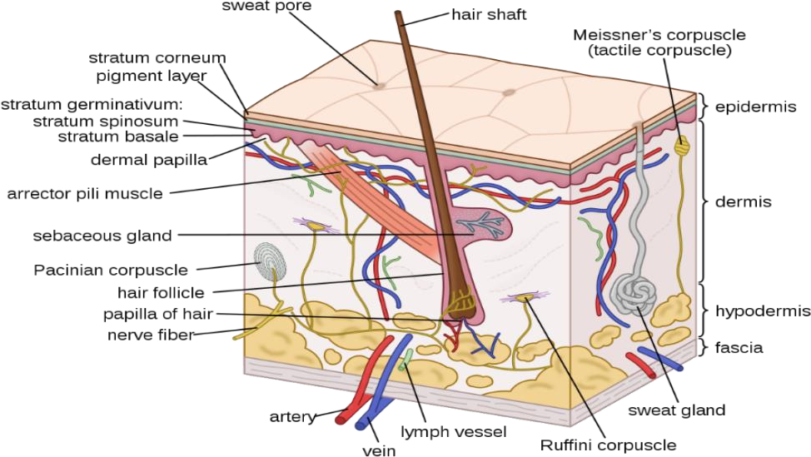
Figure 1: Anatomy of skin
Ridge thickness emerges as a pivotal parameter in dermatoglyphic analysis, offering valuable insights into individual variations within a population. (Ashbaugh, 1999) Ridge thickness refers to the width of the ridges present on the fingertip surface as shown in figure_2. (Langenburg, 2019) Ridge thickness can be as low as 100 µm for thin ridges and as high as 300µm for thick ridges.
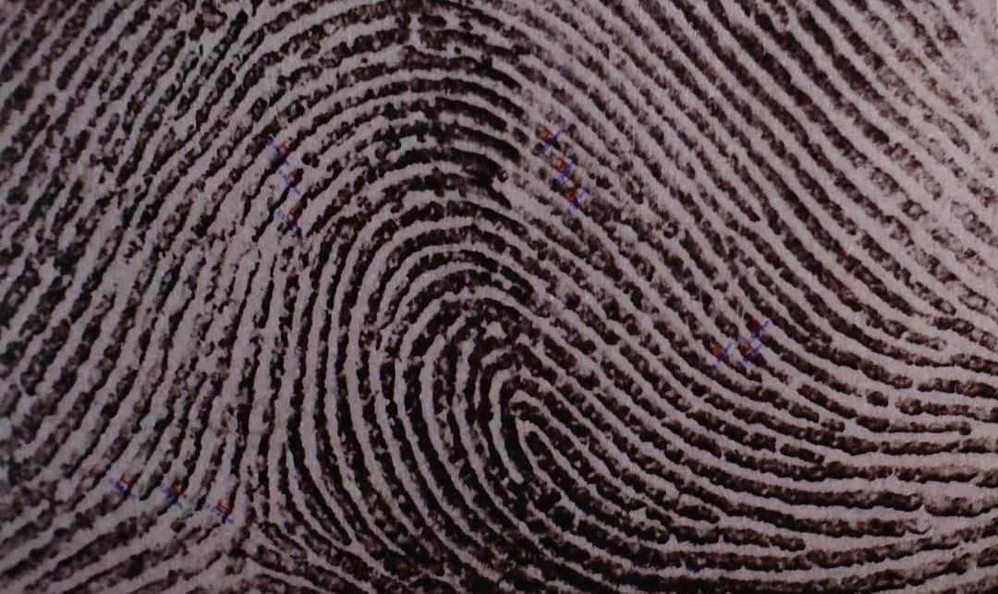
This seems to be due to a number of factors, such as genetic makeup, age, sex, and ethnic background. (Mbaka et al., 2016) (Mehdipour & Farhud, 1978) (Sangam et al., 2011) ridge thickness is one of the critical properties that are considered when one is trying to different persons in forensic examinations. For instance, it has been found out that females normally have thinner ridges as compared to males, this means that the ridge density is higher among the females. In the same way, ethnic differences have also been identified with regard to ridge thickness with the intention of using the information in the process of demographic analysis in forensic science. Digital proscope technology and high magnification digital imaging are used for precise quantitation of ridge thickness. Thus, tagging is not limited to the definition of the concept of ridge thickness alone. It also has an impact on the definitions and quality of fingerprint impressions which is essential in comparing prints obtained from the scene of crime with those in databases of fingerprints. The variations in ridge characteristics can greatly impact the performance of the fingerprint-matching algorithms, therefore it is imperative for forensics to consider such differences while making an analysis. This characteristic exhibits variability among individuals and demographic groups, reflecting both genetic predispositions and environmental influences. (Baryah & Krishan, 2020)
Figure 2: Ridge analysis
Ridge density, as the number of ridges per unit area on a fingerprint, is one of the most important factors that are used for identity recognition of persons in forensic science. (Chauhan, 2017) It varies with people and instances and depends on some features such as the sex of a person, age, and ethnicity. (Ramanjit & Garg, 2011) (Rivaldería et al., 2016) (Sucharitha et al., 2021) (Xie & Lin, 2020) In general, females were found to possess a higher ridge density compared to males, probably due to more precise ridge patterns. This characteristic is especially helpful and feasible in forensic gender assessment and demographic analysis. The significance of this study lies in its exploration of dermatoglyphic patterns and their implications for forensic investigations, particularly concerning interracial population groups. By examining the variations in ridge thickness among individuals of African and Indian descent, this research aims to elucidate the diversity of dermatoglyphic patterns and their impact on the accuracy of fingerprint identification. To facilitate precise analysis, advanced technological tools such as the Proscope are employed. The Proscope is a digital imaging device equipped with high-resolution capabilities, enabling detailed examination of dermatoglyphic features. With its ability to capture and magnify minute details of fingerprint impressions, the Proscope enhances the accuracy and reliability of forensic analyses, ensuring meticulous scrutiny of ridge characteristics.
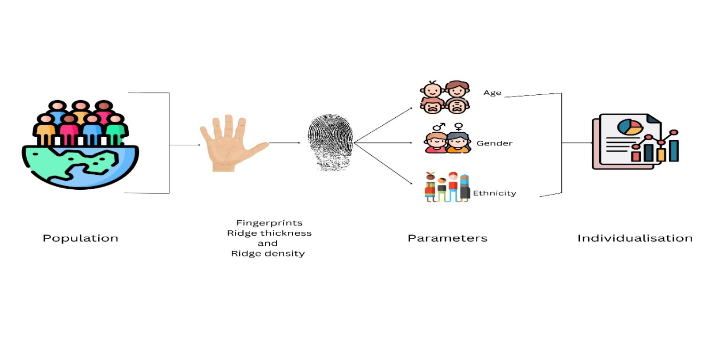
Figure 3: Dermatoglyphic analysis for Age, Gender and Ethnicity
This study endeavours to deepen our understanding of dermatoglyphic patterns and their significance in forensic investigations. By investigating variations in ridge thickness among interracial population groups and leveraging advanced technologies like the Proscope, this research aims to contribute to the advancement of forensic science and enhance the accuracy of fingerprint identification methodologies. With a comprehensive examination of these dermatoglyphic parameters, this study seeks to address several key objectives:
1. Characterizing the variability of ridge thickness among individuals of African and Indian descent.
2. Investigating the impact of demographic factors on dermatoglyphic patterns and their implications for forensic identification.
3. Assessing the efficacy of advanced imaging technologies, such as the Proscope, in enhancing the accuracy and reliability of fingerprint analysis.
4. Exploring the broader implications of these findings for forensic science and the criminal justice system.
By addressing these objectives, this study aims to provide valuable insights into the complex interplay between dermatoglyphic patterns and forensic identification, ultimately contributing to the advancement of forensic science and the pursuit of justice. One of the key challenges in forensic science is the accurate identification of individuals from complex crime scenes. Fingerprint analysis plays a vital role in this process, providing a reliable and non-invasive means of identification that can be used to link individuals to a crime. However, the accuracy of this technique depends on a deep understanding of the nuances of dermatoglyphic patterns and the ability to distinguish between individuals with similar ridge characteristics. This study focuses on the analysis of ridge thickness, one of the key parameters that can provide valuable insights into the variability of dermatoglyphic patterns across different demographic groups. The study examines individuals of African and Indian descent, two groups that exhibit significant genetic and environmental differences that can impact the formation of dermatoglyphic patterns. The results of the study reveal significant variations in ridge thickness among individuals of African and Indian descent. These variations are attributed to genetic factors, such as differences in skin pigmentation and the structure of the epidermis, as well as environmental factors, such as exposure to chemicals and other external agents. The study also highlights the impact of demographic factors on dermatoglyphic patterns and their implications for forensic identification. In particular, the study shows that the accuracy of fingerprint identification can be affected by the demographic composition of a population, with certain groups exhibiting higher levels of variability in dermatoglyphic patterns. To address these challenges, the study proposes the use of advanced imaging technologies, such as the Proscope, to enhance the accuracy and reliability of forensic analyses. The Proscope is a powerful tool that can capture and magnify minute details of fingerprint impressions, enabling a more detailed examination of dermatoglyphic features. Overall, the study provides valuable insights into the complex interplay between dermatoglyphic patterns and forensic identification. By characterizing the variability of ridge thickness and density among individuals of African and Indian descent, the study contributes to our understanding of the factors that influence the formation of these patterns and their implications for forensic identification. The study also highlights the importance of advanced imaging technologies in enhancing the accuracy and reliability of fingerprint analysis, ultimately contributing to the advancement of forensic science and the pursuit of justice.
Methodology
A study was conducted to analyze the fingerprints of 100 adolescent individuals who were under 45 years of age, comprising 25 males and 25 females from various African countries currently living in India, along with Indian students from the National Forensic Sciences University. The individuals were chosen at random from various schools within NFSU College, Gujarat (Gandhinagar). These individuals willingly participated in the research after giving their consent. The study was conducted in a controlled environment where the subjects were made to cleanse their hands by washing them with water and removing existing dust particles. After the hands were washed and dried, inkless pads were used to collect inked fingerprint impressions. The inkless pad technology provided a clean and efficient way to collect fingerprints, without the need for traditional ink and paper. The collected fingerprints were then analyzed using a digital proscope which allowed for a detailed ridge analysis. The ridge analysis included measuring the ridge thickness of the fingerprints. This information was then used to create a database of fingerprints, which could be used for future forensic investigations. The study was conducted with the utmost care for the safety and privacy of the subjects. All subjects were treated with respect and dignity, and their personal information was kept confidential. This study provides valuable insights into the analysis of fingerprints using modern technology and could help improve the accuracy and efficiency of future forensic investigations.
Results
According to a recent study, there are significant differences in the thickness of fingerprint ridges across different population groups. The study found that African females have a higher ridge thickness of 0.095mm compared to Indian females who have a lower thickness of 0.076mm. The study found that African females have a lower ridge density of 9.8/mm² compared to Indian females who have a higher density of 10.3/mm². Similarly, African males also have a higher ridge thickness of 0.080mm compared to Indian males who have a lower thickness of 0.058mm. The ridge density of African males was found to be 9.3/mm² which was lesser as compared to the ridge density of Indian males which came up to 9.5/mm². These findings highlight the significant impact that these variations can have on the accuracy and reliability of fingerprint identification, especially when dealing with low-quality or partial prints. It is important to take these differences into account while developing fingerprint identification systems and techniques to ensure that they are effective across all population groups.
Table 1 shows the mean differences in Ridge Thickness and Ridge Density between Indian and African Population
Population | Gender | Ridge Thickness (mm) | Ridge Density (per mm²)
African | Female | 0.095
  9.8
Indian | Female | 0.076 | 10.3
African | Male | 0.097 | 9.0
Indian | Male | 0.083 | 9.2

Graph 1 shows the differences in Ridge Thickness

Graph 2 shows the differences in Ridge Density
Conclusion
The importance of fingerprint identification in forensic investigations cannot be overstated. A new study has concluded that a comprehensive understanding of fingerprint ridge thickness is critical for accurate fingerprint identification. The study provides valuable insights into the relationship between fingerprint ridge thickness, and its impact on forensic investigations. It was found that the thickness of fingerprint ridges can vary greatly among individuals, and even on different parts of the same finger. This variation can pose challenges for forensic investigators, who must accurately match fingerprints to potential suspects. Overall, the study provides a better understanding of the factors that contribute to accurate fingerprint identification and provides a foundation for further research in the field of forensic science. With this knowledge, forensic investigators can improve the accuracy and reliability of their work, which can ultimately lead to more effective criminal investigations and a safer society for all.

REFERENCES
- Saferstein, R. (2013). Fingerprints. In Forensic science from the crime scene to the crime lab. Pearson Education, Inc.
- Wijerathne, B. T. B., Meier, R. J., Agampodi, T. C., & Agampodi, S. B. (2015). Dermatoglyphics in hypertension: a review. Journal of Physiological Anthropology, 34(1), 29. Https://doi.org/10.1186/s40101-015-0065-3
- Singh, M. S. U., & Kadu, S. S. (2020). Pattern of Different Types of Fingerprints amongst the Community-an Observational Cross Sectional Study. VIMS Health Science Journal, 7(2), 50–53.
- Gibbs, R. C. (1967). Fundamentals of dermatoglyphics. Archives of Dermatology, 96(6), 721–725. Https://doi.org/10.1001/archderm.1967.01610060115023
- Baryah, N., & Krishan, K. (2020). Exploration of digital dermatoglyphics of two ethnicities of North India-forensic and anthropological aspects. Forensic Science International: Reports, 2.
- Basu, A. (1976). Digital dermatoglyphics of three caste groups of Mysore. American Journal of Physical Anthropology, 45(3 PT 1), 437–441. Https://doi.org/10.1002/ajpa.1330450305
- Mbaka, G., Ejiwunmi, A., Alabi, O., & Olatayo, T. (2016). Digital dermatoglyphic variation and migratory pattern of ethnic Liberians. Egyptian Journal of Forensic Sciences, 6(4), 416–421. Https://doi.org/10.1016/j.ejfs.2016.06.005
- Paul, J. N., Oladipo, G. S., & Oghenemavwe, L. E. (2019). Investigation of ancestral relationship of ikwerres’ with binis’ and igbos’ using level 2 dermatoglyphic (minutiae) patterns. International Journal of Pharma Research and Health Sciences, 7(5), 3062–3067. Https://doi.org/10.21276/ijprhs.2019.05.04
- Ashbaugh, D. R. (1999). Quantitative-Qualitative Friction Ridge Analysis: An Introduction to Basic and Advanced Ridgeology. CRC Press.
- Langenburg, G. (2019). Ridge Thickness. In Siegel’s Forensic Science (pp. 137–150). Wiley.
- Mehdipour, M., & Farhud, D. D. (1978). A DERMATOGLYPHIC STUDY OF IRANAIAN MUSLIMS PART I: FINGER PATTERNS AND RIDGE-COUNTS. Iranian Journal of Public Health, 7(4), 196–206.
- Sangam, M. R., Krupadanam, K., & Anasuya, K. (2011). A study of finger prints: bilateral asymmetry and sex difference in the region of Andhra Pradesh. Journal of Clinical and Diagnostic Research, 5(3), 597–600.
- Chauhan, A. (2017). Feasibility of ridge density: A comparative study of fingerprint ridge densities among different Indian population. Journal of Forensic Sciences & Criminal Investigation, 5(1). Https://doi.org/10.19080/jfsci.2017.05.555654
- Ramanjit, K., & Garg, R. K. (2011). Determination of gender differences from fingerprint ridge density in two northern Indian populations. Forensic Sciences, 85, 5–10.
- Rivaldería, N., Sánchez-Andrés, Á., Alonso-Rodríguez, C., Dipierri, J. E., & Gutiérrez-Redomero, E. (2016). Fingerprint ridge density in the Argentinean population and its application to sex inference: A comparative study. Homo: Internationale Zeitschrift Für Die Vergleichende Forschung Am Menschen, 67(1), 65–84. Https://doi.org/10.1016/j.jchb.2015.09.004
- Sucharitha, T. M., Phanindra, S. V., & Shaik, A. B. (2021). A study on sexual dimorphism in fingerprint ridge density among medical students of Nellore south coastal district of Andhra Pradesh. Indian Journal of Clinical Anatomy and Physiology, 8(3), 194–197. Https://doi.org/10.18231/j.ijcap.2021.044
- Xie, H., & Lin, Z. (2020). Gender difference analysis of Chinese Han youth based on fingerprint ridge density. E3S Web of Conferences, 198, 04014. Https://doi.org/10.1051/e3sconf/202019804014

