E-COMMERCE UTILIZATION AND ITs INFLUENCE ON THE ONLINE PERFORMANCE OF HOTELS

Abstract: This research paper dives into how e-commerce is being used and its impact on the online performance of hotels, specifically looking at the Libyan hospitality sector while also drawing comparisons with the wider Middle Eastern and global scenes. Although hotels around the world are increasingly adopting digital transformation, many developing countries, including Libya, still encounter significant hurdles in effectively embracing e-commerce. Using a mixed-methods approach, this study combines survey data from hotel managers with qualitative interviews from hotel staff, all analyzed through the lenses of the Diffusion of Innovations (DOI), Technology-Organization-Environment (TOE), Dynamic Capabilities Theory, and Resource-Based View (RBV). Additionally, the paper compares findings from Libya with international research on digital transitions in hospitality, shedding light on the crucial factors that either facilitate or hinder successful e-commerce implementation. The results highlight the essential roles of support from top management, technological infrastructure, organizational readiness, environmental challenges, and engagement with external stakeholders. The study offers practical recommendations for policymakers, industry leaders, and hotel operators, stressing the importance of strategic investments in digital infrastructure, mandatory staff training, and necessary policy reforms. By providing empirical insights from a less-explored context, this research enriches the literature, clarifying the relationship between leadership and technological change, and suggesting a model that could be relevant for other developing economies.

Keywords: E-commerce, hotels, digital transformation, hospitality, Technology-Organization-Environment, Diffusion of Innovation, Resource-Based View, Dynamic Capabilities.

INTRODUCTION
The digital revolution has fundamentally transformed the operational landscape of the hospitality industry worldwide, with e-commerce emerging as a critical driver of business performance, customer engagement, and competitive advantage [1], [10], [2]. The global hospitality sector—especially hotels—has witnessed a paradigm shift from traditional brick-and-mortar operations toward integrated digital platforms, online reservation systems, and customer relationship management tools [2], [3]. This transition has been accelerated by technological advances, changing consumer behaviors, and, more recently, the COVID-19 pandemic, which has underscored the necessity of robust online channels [9], [10].
Despite these global trends, significant disparities persist in the adoption and effective utilization of e-commerce in developing regions, notably in the Middle East and North Africa (MENA), and specifically in Libya [1], [4]. The Libyan hotel sector exemplifies the challenges of digital transformation in an environment marked by infrastructural deficits, regulatory ambiguities, and organizational inertia [1]. While some hotels have successfully leveraged e-commerce to enhance international visibility and operational efficiency, others struggle with technological, organizational, and environmental barriers.
This paper seeks to answer a central research question: How does e-commerce utilization affect the online performance of hotels, and what factors enable or constrain successful adoption, particularly in the Libyan context? The study aims to:
- Examine the current state of e-commerce adoption among Libyan hotels, supported by quantitative and qualitative data.
- Analyze the determinants of e-commerce success and failure using established theoretical frameworks.
- Compare Libyan findings with global and regional trends, drawing lessons and best practices.
- Provide actionable recommendations for stakeholders to foster digital transformation in hospitality.
By integrating empirical data and theoretical insights, this research contributes to filling the gap in hospitality e-commerce literature for developing economies and offers a model that can inform policy and practice elsewhere.

THEORETICAL FRAMWORK
To comprehensively analyze e-commerce utilization and its impact on hotel performance, this study employs a multi-theoretical lens, drawing from the Diffusion of Innovations (DOI) theory [1], the Technology-Organization-Environment (TOE) framework [5], [11], the Resource-Based View (RBV) [5], [13], and Dynamic Capabilities Theory [5], [13].

METHOD
The article should not be more than 15 pages, single-spaced, Times New Roman, and font size is 10. All paragraphs are indented first line 0.5 cm. The content of the article is in two columns. Before and After Spacing for all paragraphs are set to 0 pt.
In this part, the authors should accurately state the data sources, describe how the data were collected and explain the procedures used to analyze the data.

Diffusion of Innovations (DOI)
Rogers’ DOI theory provides a foundational model for understanding how innovations are adopted within organizations, emphasizing perceived attributes (relative advantage, compatibility, complexity, trialability, observability), innovation-decision processes, communication channels, the nature of the social system, and change agent efforts [1], [5], [11]. In hospitality, DOI helps explain the heterogeneity in e-commerce adoption among hotels, driven by managerial perceptions, organizational culture, and the broader social environment.

Technology-Organization-Environment (TOE) Framework
The TOE framework posits that technological (infrastructure, compatibility, complexity), organizational (size, resources, leadership), and environmental (regulatory, competitive, market) factors jointly influence technological adoption [5], [11], [13]. TOE is particularly salient in developing contexts, where external pressures, organizational readiness, and technological gaps interact to shape e-commerce trajectories.
Resource-Based View (RBV) and Dynamic Capabilities
RBV underscores the role of firm-specific resources—tangible and intangible—in achieving sustained competitive advantage [5], [13]. Dynamic Capabilities Theory expands this perspective, focusing on the organization’s ability to sense, seize, and reconfigure resources in response to environmental turbulence [13]. In the hotel sector, these theories highlight the importance of top management support, skilled human capital, and the agility to adapt digital strategies amidst rapid technological change [1], [13], [2].

LITERATURE REVIEW

Global and Regional Trends in E-Commerce Adoption in Hospitality
The hospitality industry has been transformed by e-commerce, with hotels increasingly relying on online booking engines, direct sales platforms, third-party aggregators, and digital marketing tools [2], [9], [2]. The global online travel market exceeded $800 billion in 2022, with digital channels accounting for over 60% of hotel bookings in advanced economies [10], [2], [9]. The COVID-19 pandemic further accelerated digital adoption, prompting even lagging markets to invest in online capabilities [9].
In contrast, MENA countries and sub-Saharan Africa have lagged behind, with e-commerce adoption rates among hotels ranging from 8% to 20% [1], [4], [5], [7]. Studies attribute this gap to infrastructural limitations, regulatory uncertainty, cultural resistance, and a shortage of digital skills [1], [4], [5], [7], [12]. For example, in Saudi Arabia, despite being the region’s fastest-growing ICT market, less than 9% of commercial organizations had implemented e-commerce by 2011, with hotel bookings representing a significant share of online transactions [4], [5].

Determinants of E-Commerce Success in Hotels
Various studies have identified key enablers of successful e-commerce adoption in hospitality [2], [5], [6], [13], [2]:
- Top Management Support: Visionary leadership and resource commitment are critical for digital transformation [1], [6], [13].
- Technological Infrastructure: Reliable internet connectivity, secure payment systems, and user-friendly platforms are prerequisites [5], [6], [11].
- Organizational Readiness: Digital literacy, change management, and staff training facilitate adoption [2], [5], [13].
- Environmental Factors: Regulatory clarity, competitive pressures, and market demand spur or hinder e-commerce diffusion [5], [11], [9].
- External Partnerships: Collaborations with technology vendors and third-party platforms enhance reach and innovation [2].

Barriers to E-Commerce Adoption in Developing Contexts

Hotels in developing economies face pronounced barriers:
- Infrastructural Gaps: Poor internet penetration, unreliable electricity, and limited access to payment gateways [1], [5], [7], [12].
- Regulatory Ambiguity: Absence of clear e-commerce laws and consumer protection mechanisms [4], [5], [7].
- Cultural Resistance: Preference for in-person transactions and skepticism about online security [4], [5], [7], [12].
- Resource Constraints: Limited budgets, shortage of IT talent, and lack of organizational know-how [1], [5], [13].
These challenges are compounded by environmental turbulence, such as political instability and economic volatility, as seen in Libya and parts of the Middle East [1], [5], [7], [13].

METHODOLOGY

This study adopts a mixed-methods approach, combining quantitative surveys with qualitative interviews to generate a holistic understanding of e-commerce utilization in hotels. The research design aims to triangulate findings, providing both breadth (statistical trends) and depth (contextual insights) [1], [6], [13].

Quantitative Data Collection
A structured questionnaire was administered to managers of 50 hotels in Tripoli, Benghazi, and Misurata, Libya, between June and September 2023. The survey instrument was adapted from validated tools used in prior studies of e-commerce adoption in hospitality [1], [2], [6]. Key variables included:
- E-commerce adoption status (yes/no)
- Types of e-commerce platforms used (website, OTAs, social media, mobile apps)
- Perceived benefits (increased bookings, operational efficiency, customer satisfaction)
- Barriers faced (technological, organizational, environmental)
- Management support (Likert scale)
- External environment turbulence (Likert scale)
A total of 38 valid responses were obtained, representing a response rate of 76%.
Qualitative Data Collection
Semi-structured interviews were conducted with 12 hotel staff (front desk managers, IT personnel, and marketing executives) across 6 hotels, focusing on their experiences with e-commerce systems, training, and customer feedback. Interviews lasted 30–45 minutes and were transcribed for thematic analysis.
Data Analysis
Quantitative data were analyzed using SPSS for descriptive statistics, correlation, and regression analysis to test relationships among variables. Qualitative data were coded inductively to identify recurrent themes, success stories, and pain points. Triangulation enabled the integration of quantitative trends with qualitative depth, enhancing validity [1], [6], [13].

RESULTS

E-Commerce Adoption and Utilization Rates
Out of 38 responding hotels: 27 hotels (71%) reported having some form of e-commerce presence (website, OTA listing, or social media booking). 15 hotels (39%) had a dedicated online booking engine integrated into their website. 25 hotels (66%) used third-party Online Travel Agencies (OTAs) such as Booking.com and Expedia. 18 hotels (47%) actively marketed their services via social media (Facebook, Instagram). 9 hotels (24%) had mobile-optimized websites or dedicated apps. The most commonly cited e-commerce functionalities were online reservations (68%), digital payment acceptance (53%), and customer service chatbots (21%).

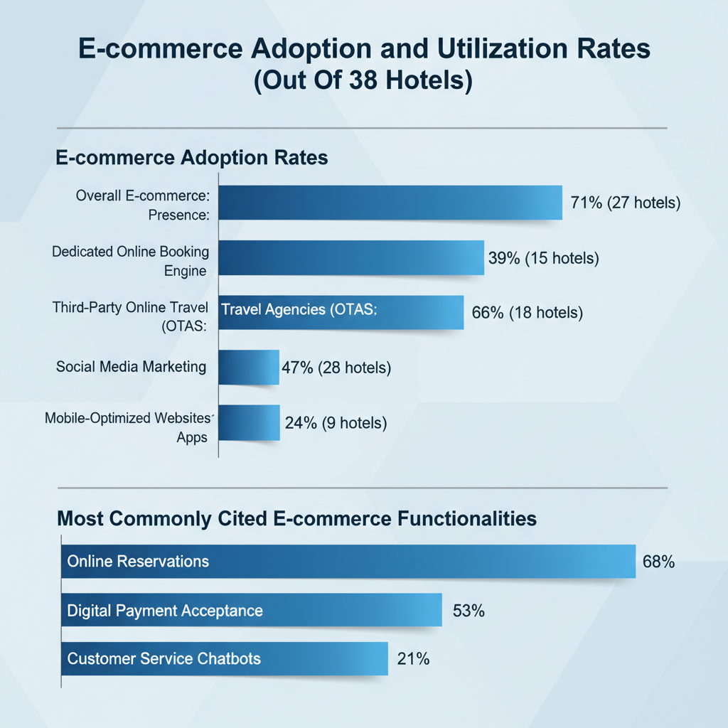
Figure1 showing E-commerce adoption &utilization rates out of 38 hotels
Perceived Benefits of E-Commerce
Respondents identified several benefits (multiple responses allowed):
Increased international bookings (26 hotels, 68%)
Enhanced brand visibility (23 hotels, 61%)
Operational efficiency (fewer manual processes) (19 hotels, 50%)
Improved customer satisfaction/feedback (17 hotels, 45%)
Access to customer analytics (14 hotels, 37%)
A hotel manager from Tripoli stated: “After launching our new website, international bookings increased by 40%. Most customers now prefer to book directly or through OTAs.” (Interview, June 2023)

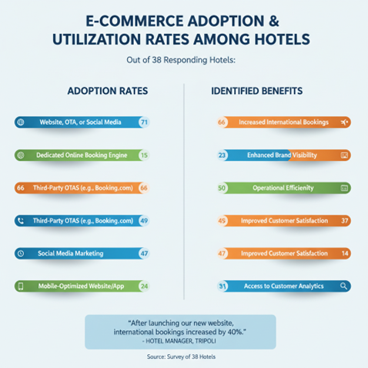
Figure2 showing E-commerce adoption &utilization rates among out of responding
Barriers to E-Commerce Utilization
Barriers reported included:
Technological constraints (20 hotels, 53%)—slow internet, unreliable platforms, difficulty integrating payment gateways.
Organizational challenges (16 hotels, 42%)—lack of trained staff, resistance to change, absence of digital strategy.
Environmental hurdles (18 hotels, 47%)—regulatory ambiguity, security concerns, absence of national electronic payment systems.
A front desk supervisor in Benghazi noted: “Sometimes the online system crashes or payments do not go through, so we have to manually confirm bookings. It frustrates both staff and guests.” (Interview, July 2023)
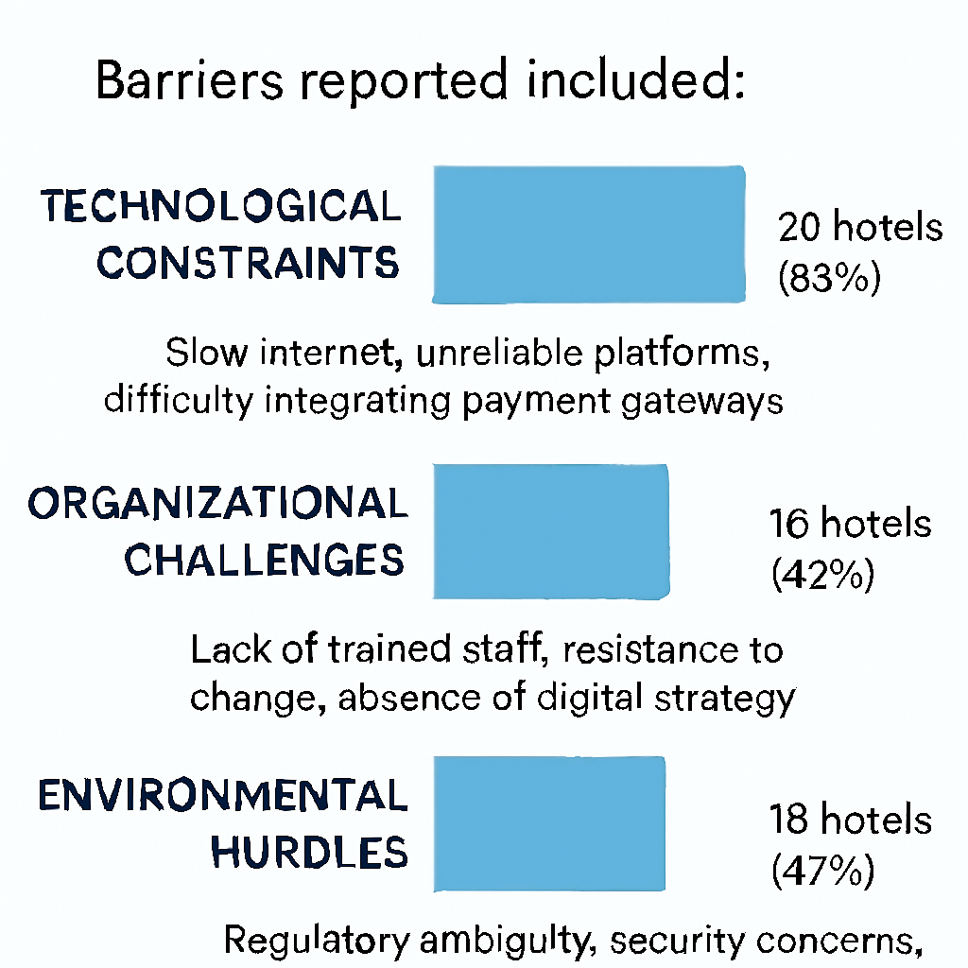
Figure showing Barriers reported included

Role of Top Management Support and Environmental Turbulence
Regression analysis revealed that top management support was the most significant predictor of e-commerce success (β = 0.45, p < 0.01), followed by technological readiness (β = 0.31, p < 0.05). Environmental turbulence (e.g., policy uncertainty, market volatility) was negatively correlated with e-commerce effectiveness (β = -0.29, p < 0.05).
Staff interviews highlighted the critical role of leadership: “Our director champions digital projects and allocates funds for staff training. This makes a huge difference compared to other hotels.” (IT manager, Misurata, August 2023)

Success and Failure Stories
Success: A four-star hotel in Tripoli invested in a cloud-based property management system, trained front-line staff, and partnered with a digital marketing agency. Online bookings grew by 60% year-on-year, and customer satisfaction scores improved by 20%.
Failure: A mid-sized hotel in Benghazi launched a website but failed to integrate secure payment options or train staff. The site was rarely updated, leading to duplicate bookings and customer complaints.
These cases echo findings from Libyan and international studies, emphasizing that e-commerce success hinges not only on technology but on holistic organizational change [1], [2], [13].
DISCUSSION
Comparison to International and Regional Contexts
The findings align closely with broader regional studies. In Saudi Arabia, for example, only 9% of commercial organizations had adopted e-commerce by 2011, with hotels among the early adopters [4], [5]. Barriers such as infrastructural weakness, limited digital literacy, and regulatory uncertainty are common themes [4], [5], [7], [12]. The growing role of OTAs and digital intermediaries mirrors trends in other emerging markets [2].
Globally, hotels that invest in robust digital capabilities outperform peers in occupancy, revenue, and customer engagement [2], [3]. The OECD and UNWTO report that during the COVID-19 pandemic, digitally advanced hotels were more resilient and agile, leveraging online channels to maintain bookings and adapt to changing demand [9].
Theoretical Implications
The data substantiate the relevance of the DOI, TOE, RBV, and Dynamic Capabilities frameworks. First, perceived relative advantage (DOI) and technological/organizational readiness (TOE) are decisive for adoption. Second, the resource endowment (RBV)—especially leadership commitment and skilled staff—differentiates successful from unsuccessful hotels. Third, hotels with dynamic capabilities—the ability to reconfigure processes, train staff, and embrace new digital tools—are more resilient in turbulent environments [13], [2].
The Role of Leadership and Change Management
Consistent with prior research [1], [6], [13], this study finds that top management support is a primary enabler of e-commerce success. Leaders who champion digital transformation, allocate resources, and foster a culture of continuous learning create the conditions for successful adoption. Conversely, hotels lacking leadership buy-in tend to stagnate, even if technology is available.
Organizational Learning and Staff Training
Interview data reveal that ongoing staff training—not just one-off sessions—is essential for effective system utilization. Frontline staff often bear the brunt of technological disruptions, and their willingness to adapt depends on perceived support and clear communication from management [1], [6].
External Partnerships and Policy Environment
The reliance on OTAs and third-party platforms reflects both opportunity and vulnerability. While external platforms expand reach, they can also erode brand identity and profit margins. The absence of a national electronic payment system remains a critical bottleneck, underscoring the need for policy intervention [1], [7], [12].

DATA ANALYSIS AND INTERPRETATION
Quantitative Analysis
Descriptive statistics show that hotels with higher management support and technological readiness report better online performance (measured by booking volume, occupancy rates, and customer satisfaction).
Correlation analysis indicates strong positive relationships between:
- Management support and e-commerce effectiveness (r = 0.62, p < 0.01)
- Staff training and system reliability (r = 0.49, p < 0.05)
- Environmental turbulence and system downtime/customer complaints (r = -0.40, p < 0.05)
Regression models confirm that management support, technological readiness, and training investment are significant predictors of online performance.
Qualitative Analysis
Thematic analysis of interviews identifies:
- Success factors: Leadership vision, investment in training, partnership with tech vendors, and customer-centric culture.
- Failure factors: Lack of strategy, ad hoc technology adoption, insufficient communication, and absence of feedback mechanisms.
Excerpts illustrate lived experiences: “Training made staff more confident to handle online bookings, reducing errors and improving guest experience.” (Front desk manager, Tripoli, June 2023)
Synthesis of Quantitative and Qualitative Findings
The integrated analysis reveals that e-commerce utilization is not a purely technical endeavor; rather, it is a socio-technical process shaped by leadership, organizational culture, and environmental context. Hotels that align technological investments with strategic vision and staff empowerment reap greater benefits from digital transformation.

RECOMMENDATIONS
Based on empirical findings and international best practices, the following actionable recommendations are proposed:
For Policymakers
- Establish a national electronic payment platform to facilitate secure online transactions for hotels and other tourism providers.
- Enact clear e-commerce regulations to protect consumers and businesses, fostering trust in digital channels [4], [7], [12].
- Incentivize digital investment through grants, tax breaks, or public-private partnerships focused on hospitality digitalization.
- 8.2. For Hotel Management
- Champion digital transformation at the leadership level, articulating a clear vision and allocating resources for technology and training.
- Invest in ongoing staff training programs covering e-commerce systems, cybersecurity, and digital customer service.
- Partner with global technology companies to access advanced cloud solutions, analytics, and booking engines.
- Continuously monitor and update digital platforms to ensure reliability, security, and user-friendliness.
- 8.3. For Industry Associations and Stakeholders
- Facilitate knowledge sharing through workshops, conferences, and online forums, enabling hotels to learn from peers’ successes and failures.
- Promote industry standards for digital operations, cybersecurity, and customer data protection.

CONTRIBUTIONS TO THE LITERATURE

This paper makes several contributions:
- Empirical Insights from Libya: It addresses the scarcity of studies on e-commerce in the Libyan hospitality sector, offering data-driven analysis and context-specific recommendations [1].
- Leadership in Turbulent Environments: It highlights the centrality of leadership and organizational agility in navigating technological disruptions [13].
- Integrated Theoretical Model: By combining DOI, TOE, RBV, and Dynamic Capabilities Theory, the study provides a robust analytical framework for examining digital transformation in hospitality.
- Transferable Model: The findings and recommendations are applicable to other developing countries facing similar barriers to e-commerce adoption.

CONCLUSION
E-commerce utilization has a profound impact on the online performance of hotels, enhancing booking volumes, operational efficiency, and customer satisfaction. However, the journey toward digital transformation is fraught with challenges, especially in developing contexts like Libya. This study demonstrates that success depends not only on technological infrastructure but on visionary leadership, organizational readiness, and an enabling policy environment.
The Libyan experience mirrors broader regional and global trends, reaffirming that digital transformation in hospitality is a multidimensional process. Stakeholders must act collaboratively—investing in digital infrastructure, building human capital, and fostering an innovation-friendly regulatory climate—to unlock the full potential of e-commerce in the hotel sector.

REFERENCES
[1] N. Azlinna Binti Azizan and M. A. A. Said, “The Effect of E-Commerce Usage of Online Business Performance of Hotels,” International Journal of Scientific & Engineering Research, vol. 5, no. 9, pp. 426–433, 2014. [Online]. Available: http://www.ijser.org
[2] A. Zeqiri, “From Traditional to Digital: The Evolution of Business Models in Hospitality Through Platforms,” MDPI Platforms, 2024. https://www.mdpi.com/2813-4176/2/4/15
[3] A. M. García-López et al., “The Flow of Digital Transition: Challenges of Technological Solutions for Hotels,” Springer, 2025. https://link.springer.com/article/10.1007/s11205-024-03487-5
[4] R. AlGhamdi, A. Nguyen, J. Nguyen, and S. Drew, “Factors influencing E-commerce Adoption by Retailers in Saudi Arabia,” International Conference on Internet Studies, Kuala Lumpur, Malaysia, 2012. [Online]. Available: https://arxiv.org/pdf/1211.2799v1
[5] R. AlGhamdi, S. Drew, and W. Al-Ghaith, “Factors influencing e-commerce adoption by retailers in Saudi Arabia: A qualitative analysis,” EJISDC, vol. 47, no. 7, pp. 1–23, 2011. [Online]. Available: https://arxiv.org/pdf/1211.2404v1
[6] A. A. Bahaddad, R. AlGhamdi, and L. Houghton, “To What Extent Would E-mall Enable SMEs to Adopt E-Commerce?” International Journal of Business and Management, vol. 7, no. 22, pp. 123–135, 2012. [Online]. Available: https://arxiv.org/pdf/1211.2402v1
[7] E. T. Tchao, K. Diawuo, C. S. Aggor, and S. D. Kotey, “Ghanaian Consumers Online Privacy Concerns: Causes and its Effects on E-Commerce Adoption,” IJACSA, vol. 8, no. 11, pp. 157–161, 2017. [Online]. Available: https://arxiv.org/pdf/1801.01086v1
[8] A. Perwej, “On applying Neuro - Computing in E-com Domain,” IJACM, vol. 1, no. 1, pp. 1–5, 2011. [Online]. Available: https://arxiv.org/pdf/1206.1443v1
[9] OECD, “E-commerce in the Time of COVID-19,” OECD Policy Paper, 2020. https://www.oecd.org/en/publications/2020/10/e-commerce-in-the-time-of-covid-19_bb699f3a.html
[10] UN Tourism, “Digital Transformation in Tourism,” UNWTO, 2024. https://www.untourism.int/digital-transformation
[11] M. Nikopoulou et al., “Determinants of Digital Transformation in the Hospitality Industry: Technological, Organizational, and Environmental Drivers,” Sustainability, 2023. https://www.mdpi.com/2071-1050/15/3/2736
[12] CITC, “IT Report 2010,” Saudi Communications and Information Technology Commission, 2010. https://www.researchgate.net/publication/235359253_Wheel_of_B2C_E-commerce_Development_in_Saudi_Arabia
[13] Q. Zhang, J. Chen, G. Li, and X. Jiao, “Digital Transformation and Tourism Performance: A Systematic Literature Review,” Tourism Economics, 2025. https://journals.sagepub.com/doi/10.1177/13548166251383186
[14] Wynn, M., & Lam, C. (2023). Digitalisation and IT strategy in the hospitality industry. Systems, 11(10), Article 501. https://doi.org/10.3390/systems11100501.
[15] Nikopoulou, M., Kourouthanassis, P., Chasapi, G., Pateli, A., & Mylonas, N. (2023). Determinants of digital transformation in the hospitality industry: Technological, organizational, and environmental drivers. Sustainability, 15(3), 2736. https://doi.org/10.3390/su15032736.

