SMALL AND MEDIUM ENTERPRISES (SME) CYBER EXPOSURE DASHBOARD

ABSTRACT
Small and Medium Enterprises (SMEs) play a vital role in economic growth but are cybersecurity infrastructure. Unlike large enterprises, SMEs often lack dedicated security teams, advanced tools, and continuous monitoring systems, making them attractive targets for cyberattacks such as malware, phishing, ransomware, data breaches. This project presents the development a Small and Medium Enterprises SMEs Cyber Exposure Dashboard designed to help organizations understand, monitor, manage their cyber risk exposure effectively.
The proposed dashboard serves as a centralized platform that aggregates cybersecurity data from various sources, including vulnerability scanning tools, network monitoring systems, security logs. It analyses key risk factors such as exposed network services, misconfigured systems, outdated software versions, weak authentication practices, known vulnerabilities mapped to standard severity levels. The processed data is then visualized through intuitive dashboards, charts, risk indicators that provide real-time insights into the organization’s security posture.
The system prioritizes risks based on severity and potential impact, enabling SMEs to focus on the most critical vulnerabilities first. By simplifying complex technical data into clear visual metrics, the dashboard supports informed decision-making for both technical and non-technical stakeholders. Additionally, the solution is designed to be scalable and cost-effective, ensuring accessibility for SMEs with limited resources.
Overall, the SME Cyber Exposure Dashboard aims to improve cyber awareness, reduce security gaps, and strengthen the cyber resilience of small and medium enterprises. By providing continuous visibility and actionable insights, the dashboard helps SMEs proactively mitigate threats, comply with security best practices, protect their digital assets in an evolving threat landscape.

Keywords: Network Services, Cyber Awareness, Outdated Software, Weak authentication practices.

1.INTRODUCTION
Small and Medium Enterprises (SMEs) increasingly rely on information technology for daily operations, customer engagement, business growth. While digital adoption improves efficiency and competitiveness, it also exposes SMEs to a wide range of cyber threats such as phishing attacks, ransomware, data breaches, system vulnerabilities. Unlike large organizations, SMEs often operate with limited budgets, minimal cybersecurity expertise, lack of continuous monitoring systems, making them more vulnerable to cyber incidents. Cyber exposure refers to the level of risk an organization faces due to weaknesses in its digital infrastructure, including exposed services, outdated software, misconfigurations, unpatched vulnerabilities. For SMEs, identifying and managing these risks is challenging due to the complexity of cybersecurity tools and the overwhelming volume of security data. As a result, many SMEs remain unaware of their actual security posture until a cyberattack occurs, leading to financial losses, operational disruptions, reputational damage. To address these challenges, this project proposes the development of a Small and Medium Enterprises Cyber Exposure Dashboard. The dashboard provides a centralized and user-friendly platform that helps SMEs visualize, analyse, manage their cyber risk exposure in real time. It integrates data from various security sources such as vulnerability scans, network assessments, system logs, and presents the findings through interactive charts, risk scores, alerts. The primary objective of this project is to simplify cybersecurity risk management for SMEs by transforming complex technical data into actionable insights. By prioritizing vulnerabilities based on severity and potential impact, the dashboard enables organizations to take timely preventive measures and allocate resources effectively. Ultimately, this project aims to enhance cyber awareness, improve decision-making, strengthen the overall cyber resilience of small and medium enterprises in an evolving threat landscape.
2. LITERATURE REVIEW
1.Author: “Anastasios Papathanasiou, George Liontos, Athanasios Katsouras — 2024”
Title: Protecting Small and Medium Enterprises.
“Protecting Small and Medium Enterprises” by Anastasios Papathanasiou, George Liontos, and Athanasios Katsouras (2024) provides an in-depth analysis of the cybersecurity risks faced by small and medium-sized enterprises (SMEs) within an increasingly digitized and hostile cyber environment. The authors emphasize that, although SMEs play a crucial role in economic growth, they remain highly susceptible to cyberattacks due to constrained budgets, absence of dedicated cybersecurity expertise, insufficient awareness of security best practices among employees.
To mitigate these challenges, the book introduces a customized cybersecurity risk assessment framework specifically designed for SME contexts. This framework is derived from well-established standards such as the NIST Cybersecurity Framework and ISO/IEC 27001 but is streamlined to accommodate the operational and resource limitations of smaller organizations. It focuses on the identification of prevalent cyber threats, including phishing, malware, web-based attacks, alongside the assessment of organizational vulnerabilities. Furthermore, the authors highlight the importance of implementing practical security controls and continuous employee training to enhance resilience. Overall, the work bridges the gap between theory and practice by offering actionable strategies that enable SMEs to improve their cybersecurity posture in a manageable and cost-effective manner.

2. Author: “Samuel O. Idowu — 2022”
Title: Protecting Small and Medium-Sized Enterprises in the Digital Era.
“Protecting Small and Medium-Sized Enterprises in the Digital Era” by Samuel O. Idowu (2022) examines the challenges and prospects faced by small and medium-sized enterprises (SMEs) as they increasingly rely on digital technologies. It explains that while digital transformation is crucial for improving efficiency, competitiveness, business growth, it simultaneously increases exposure to cybersecurity threats, operational risks, strategic vulnerabilities. Unlike large organizations, SMEs often struggle to manage these risks effectively due to their limited organizational capacity and differing risk profiles.
The further highlights the structural constraints that hinder effective cybersecurity and digital risk management in SMEs, including restricted financial resources, shortages of skilled IT professionals, limited institutional or regulatory support. To address these issues, the author combines conceptual analysis with practical guidance, stressing the need for strong digital governance frameworks, proactive risk management approaches, and enhanced employee awareness. It ultimately advocates for flexible and scalable security strategies that enable SMEs to balance innovation with Protection, Safeguard Critical Digital Assets, Strengthen Stakeholder Trust, and remain resilient in an evolving digital threat environment.
3. Author: “Janet & Mark L. Goldenson — 2020”
Title: NIST Cybersecurity Framework 2.0: Small Business Quick-Start Guide by the National Institute of Standards and Technology.
“NIST Cybersecurity Framework 2.0: Small Business Quick-Start Guide” by Janet and Mark L. Goldenson (2020) provides practical and accessible guidance to support small and medium-sized enterprises in establishing a structured cybersecurity risk management approach based on the NIST Cybersecurity Framework (CSF) 2.0. It specifically designed for organizations that lack mature cybersecurity programs, translating the comprehensive framework into an easy-to-understand format that helps SMEs recognize cybersecurity priorities and plan appropriate security actions. Organized around the core CSF functions Govern, Identify, Protect, Detect, Respond. It promotes a continuous and systematic approach to cybersecurity rather than isolated or one time security measures. It emphasizes incremental improvement by encouraging organizations to assess their current security posture, define achievable goals, communicate cybersecurity efforts effectively across the business. By focusing on practical entry points and directing readers to relevant tools and resources, the guide simplifies cybersecurity risk management and enables resource-constrained enterprises to adopt the NIST framework in a realistic and actionable manner while addressing evolving cyber threats.
3. PROPOSED SYSTEM
The proposed system introduces a Cyber Exposure Dashboard specifically designed for Small and Medium Enterprises (SMEs) to provide a centralized, real-time view of an organization’s cybersecurity risk posture.
3.1 SME Cyber Exposure Dashboard
The existing solutions that focus on isolated technical or compliance-based assessments, this system integrates Technical Vulnerabilities, Human Behaviour Risks, Organizational Controls into a unified and intuitive dashboard. The goal is to enable SME owners, managers, and IT administrators often without deep cybersecurity expertise to understand, prioritize and mitigate cyber risks effectively.
The dashboard collects data from multiple sources, including Network and Endpoint Security logs, Vulnerability Scans, Phishing Simulation Results, User Behaviour Analytics, Policy Compliance Checks. The inputs are processed through a risk analysis engine that evaluates Threat likelihood, Vulnerability Severity, Potential Business impact. Based on this analysis, the system calculates an overall Cyber Exposure Score along with categorized risk indicators such as phishing susceptibility, system misconfigurations, patching gaps, access control weaknesses. The risk scoring mechanism helps SMEs quickly identify critical exposure areas without requiring complex technical interpretation.
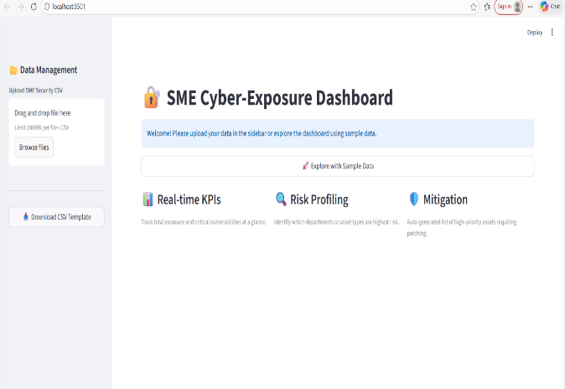
4. METHODOLOGY
4.1 System Implementation
The development of the SME Cyber Exposure Dashboard follows a structured and data-centric methodology aimed at analysing and visualizing cybersecurity risks faced by Small and Medium Enterprises (SMEs). The system is designed to ingest security-related data, process it through analytical techniques, deliver actionable insights via an interactive dashboard. The methodology is organized into multiple phases to ensure data accuracy, system reliability, effective risk evaluation.
- Data Collection
The initial phase focuses on gathering cybersecurity datasets relevant to SME environments. These datasets are obtained from Kaggle and contain information such as asset categories, vulnerability severity levels, exposure metrics, threat classifications, and risk indicators. The data is provided in CSV format, enabling seamless integration into the dashboard. A standardized CSV template is used to maintain uniform data structure and reduce errors during data upload.
- Data Preprocessing and Cleaning
After uploading the dataset, preprocessing operations are performed to enhance data quality and consistency. This phase includes the elimination of duplicate records, handling of missing or inconsistent values, normalization of numerical attributes like exposure scores, and classification of assets into predefined categories such as IoT devices, servers, databases, and cloud applications. These steps ensure that the data is reliable and suitable for accurate analysis and visualization.
- Feature Selection and Risk Metric Definition
Relevant attributes are extracted from the dataset to compute cybersecurity exposure metrics. Key features include asset type, vulnerability severity, exposure percentage, criticality level. Using these features, essential risk indicators such as total asset count, average exposure score, number of critical vulnerabilities, and overall risk classification are defined. Risk levels are categorized as Low, Moderate, or High based on predefined threshold values.
- Exposure and Risk Analysis
In this phase, analytical techniques are applied to evaluate cyber exposure across different asset categories. Statistical calculations are used to determine average exposure levels, identify asset types with the highest vulnerability counts, and measure the contribution of each asset category to overall cyber risk. This analysis enables SMEs to understand their attack surface and recognize high-risk assets requiring immediate attention.
- Visualization and Dashboard Development
The processed data and calculated risk metrics are presented through interactive visualizations using Python-based libraries such as Matplotlib, Plotly, Stream lit. The dashboard includes KPI cards summarizing exposure metrics, donut charts illustrating asset distribution, and bar charts displaying critical vulnerabilities by asset type. These visual components provide clear and intuitive insights for users.
- User Interaction and Filtering
To enhance usability, the dashboard incorporates interactive filtering options that allow users to refine analysis based on asset types or risk categories. This functionality supports targeted exploration and enables SMEs to focus on specific cybersecurity concerns without being overwhelmed by aggregated data.
- Risk Interpretation and Decision Support
The dashboard translates analytical outputs into actionable intelligence by classifying overall cyber exposure into easily understandable risk levels. These insights assist decision-makers in prioritizing remediation efforts, such as applying security patches or strengthening controls for high-risk assets.

- System Validation and Testing
The final phase involves validating the dashboard using sample datasets to ensure the correctness and consistency of results. Functional testing verifies data upload, filtering mechanisms, and visualization accuracy, while performance testing ensures smooth system operation across varying dataset sizes.
5. Results and Discussion
The SME Cyber Exposure Dashboard was evaluated using representative cybersecurity datasets to assess its analytical performance and visualization effectiveness in identifying organizational risk exposure. The system successfully processed uploaded data and generated essential security metrics, including total asset count, exposure levels, vulnerability severity distribution, and overall risk classification. It effectively detected high-risk assets associated with outdated software, weak authentication mechanisms, exposed services, and critical vulnerabilities. The integrated visualization components transformed complex security data into clear graphical representations such as summary indicators, asset distribution charts, and vulnerability comparisons, enabling quick interpretation of the organization’s security posture. The embedded risk prioritization mechanism categorized vulnerabilities according to severity and potential impact, allowing structured remediation planning and efficient allocation of limited security resources. Performance testing demonstrated stable functionality with moderate dataset sizes, and interactive filtering features allowed users to conduct focused assessments by asset category or risk level. The findings highlight that centralizing cybersecurity data into a unified dashboard significantly improves risk visibility and supports informed decision-making for both technical and non-technical stakeholders. Although the current system relies on static dataset uploads rather than continuous real-time monitoring, it establishes a scalable and practical foundation for future integration of automated data feeds and predictive analytics. Overall, the implementation confirms that a structured, visualization-driven approach can enhance cybersecurity awareness, strengthen risk management practices, and improve resilience among small and medium enterprises operating in an increasingly complex threat landscape.
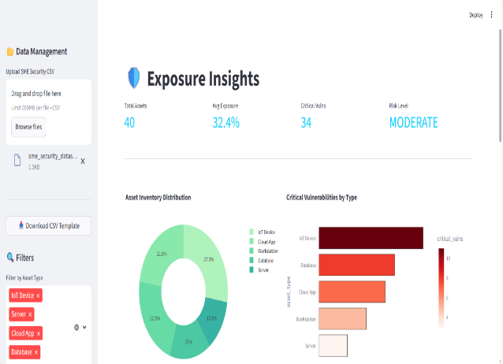
6. CONCLUSION
The SME Cyber Exposure Dashboard successfully responds to the increasing demand for simple and effective cybersecurity risk assessment solutions tailored for small and medium enterprises. Through a data-centric methodology, the system allows SMEs to gain visibility into their cyber exposure, recognize high-risk asset categories, and evaluate overall security risk levels using intuitive dashboards and interactive visual elements. The adoption of Python-based technologies along with openly available datasets highlights how affordable and scalable tools can be applied to enhance cybersecurity decision-making in environments with limited resources. By transforming complex cybersecurity data into clear and actionable insights, the dashboard combines essential exposure indicators, asset inventory analysis, and vulnerability assessment into a unified view. Its intuitive interface, dynamic filtering options, and easily understandable risk classifications enable both technical professionals and non-technical stakeholders to interpret cybersecurity information with ease. This capability supports proactive security management by assisting organizations in prioritizing mitigation actions and efficiently distributing security resources. In conclusion, the SME Cyber Exposure Dashboard provides a strong foundation for improving cybersecurity awareness and resilience within SME environments. Although the current implementation primarily focuses on visual analysis using static datasets, it establishes a framework for future advancements such as real-time data integration, predictive risk modelling, and automated remediation guidance. With continued enhancement, the system can evolve into a comprehensive cybersecurity decision-support platform capable of strengthening SME defences against an increasingly sophisticated cyber threat landscape.
.

8. REFERENCES
1.”Cybersecurity Data Science: Methods and Applications (2022)”,”Scott Monge, Carlos E. Caicedo”,” Wiley”
https://www.wiley.com/enus/Cybersecurity+Data+Science%3A+Methods+and+Applications-p-9781119838132
2.”Security Metrics, A Beginner’s Guide (2nd Edition),(2023)”,“ Caroline Wong”
“ McGraw Hill”
https://www.mhprofessional.com/9781260473920-usa-security-metrics-a
3.” Cyber Risk Oversight: A Framework for Organizational Security (2023)”,“Mario G. Trenca”,“Springer”
https://link.springer.com/book/10.1007/978-3-031-28894-3
4.”SME Cybersecurity: A Practical Guide to Protecting Small and Medium Enterprises (2024)”,” Andrew Hoog & Ryan Smith”,” Apress”
https://link.springer.com/book/10.1007/978-1-4842-6477-
5.” Applied Cybersecurity and the Smart Grid: Implementing Security Controls into the Modern Power Infrastructure (2024)”,”Eric D. Knapp, Raj Samani”,”Syngress (Elsevier)”
https://www.elsevier.com/books/applied-cybersecurity-and-the-smart-grid/knapp/978-0-12-820107-7
6. “ Visualizing Cybersecurity: A Strategic Guide to Dashboards & Metrics (2025)”,” Alex Hudson, Stephanie Andrews”,” CRC Press”
https://www.routledge.com/Visualizing-Cybersecurity-A-Strategic-Guide-to-Dashboards--Metrics/Hudson-Andrews/p/book/9781032345678
7. “Practical Cyber Intelligence: Understanding and Operationalizing Threat Intelligence (2025) “, “Stephen D. Wolthusen”,” Wiley”
https://www.wiley.com/enus/Practical+Cyber+Intelligence%3A+Understanding+and+Operationalizing+Threat+Intelligence-p-9781119899999

8. “Cyber Security Analytics: Fundamentals, Tools, and Techniques (2025)”,”Satadru Lahiri, Debarati Halder”, “Springer”
https://link.springer.com/book/10.1007/978-3-030-98765-4
9. “ AI in Cybersecurity: Defending Small & Medium-Sized Enterprises (2026)”,” Guy Webster, Nina Hull”,” CRC Press”
https://www.routledge.com/AI-in-Cybersecurity-Defending-Small--Medium-Sized-Enterprises/Webster-Hull/p/book/9781032500000
10. “ Cyber Dashboards and Metrics: Designing Insightful Security Visualizations (2026) “, “Mark J. Brooks”,” Apress”
https://link.springer.com/book/10.1007/978-1-4842-9999-9

