Modular Ticketing and Issue Resolution Framework Embedded Within Procurement Suites
Abstract
The procurement suite and external service management systems face a variety of integration problems, which means that they often create operational inefficiencies for organizations. In the article, Modulus Ticketing is explained as a brand new modular ticketing solution with a seamless integration into procurement suites and also solves problems associated with the current systems, such as the complex user setup requirements and ticketing history. There are numerous benefits attached to Modulus, including eliminating repetitive logins, the capability of linking workflows directly into Modulus, automated resolution of tickets during processing, and a significant increase in the amount of time saved per ticket resolved. The benefits of the Modulus Ticketing solution include the elimination of many of the shortcomings of previous (legacy) systems and a scalable solution that will continue to drive improvement in procurement support through a truly unified data approach and application of intelligent/automated data utilization. Other future ambitions in development, such as intake management modules, will support the modular ticketing concept. The article further states that there have been some updated words and phrases that have been revised to have a broader interpretation and can be applied to a larger audience while still remaining consistent with systems such as Ivalua and ServiceNow. The findings of this study suggest that all companies should modernize their procurement support systems and enhance their tools in order to realize the most efficiency and usability from these systems.
Keywords: Procurement Suite, External Service Management Systems, System Modulus Ticketing, Management modules
Introduction
The functions of vendor management and procurement are both important and complementary areas of the overall supplier management function within any organization. Vendor management is the overall governance of a supplier's entire lifecycle and consists primarily of a supplier's selection, on-boarding, performance monitoring, risk management, and relationship building. Procurement, on the other hand, focuses on the transactional areas of obtaining supplies, including requirements assessment for a purchase, sourcing suppliers, negotiating potential suppliers, creating and issuing purchase orders, and finalizing and signing contracts for the purchase of those supplies. While these two functions provide businesses with a means to manage costs, operational efficiency, compliance, and supplier innovation, they can also present challenges to businesses, including high levels of administrative complexity, upon-going issues within fragmented supplier management systems, and high levels of upfront costs to implement these processes in a manner that is productive. Therefore, to ensure that organizational resources are allocated effectively, there must be a strategic plan that incorporates categories of suppliers, integrated procurement suites, and the alignment of key performance indicators for both vendor management and procurement across the organization. For example, one way to meet these challenges is through the development and implementation of integrated modular ticketing and issue-resolution frameworks within integrated procurement suites, which will streamline the process for vendors, automate a large number of tasks, and synchronize actions across multiple contexts within the vendor management and procurement functions [1].
Procurement is the structured process of acquiring goods and/or services for an organization's operations and is designed to optimize value; therefore, procurement is based on the principles of efficient procurement. This process starts with an organization assessing what is needed in light of their budget plan and strategic goals. Once this is completed, the next step in the procurement process is sourcing the appropriate suppliers and requesting competitive bids from those suppliers by sending out requests for proposals (RFPs) or requests for quotation (RFQs). After a negotiation with all the suppliers who submitted bids or submitted RFPs, the optimum supplier(s) are selected and those are the suppliers who are authorized to issue purchase orders and execute legally binding contracts with the organization for those purchases. Through the use of modern procurement systems, organizations will be able to increase their visibility into their suppliers, take advantage of potential cost savings created by their suppliers, and expedite the fulfillment of their purchased-assets [2].
Vendor management involves managing the complete supplier lifecycle, from on-boarding to off-boarding and from selecting the right supplier to managing supplier performance through to supplier risk management and relationship building. Vendor management is a proactive process, designed to create an alignment between procurement and external factors impacting a business. purchasing department's functional processes. These systems create a complete break between the company's purchasing department's payment processes and the external service management integration between legacy systems. To address the integration issues created by legacy systems and the external service management of the purchasing department, a new Modular Issue Resolution and Ticket Creation Solution (MIRTs) has been developed and integrated into the many e-Purchasing Systems currently used by many companies to help end users quickly access these systems; this will ultimately allow providers of e-Purchasing Solutions to provide much more context around that data regarding e-Purchasing Operations, helping them to manage multiple sources of data in one central place [3].
The integration of new solutions as a result of the limitations of legacy systems to keep pace with the needs of businesses today has also shown an increase in productivity, reduced administrative burdens and an increase in time to resolve purchase orders; with organizations experiencing up to a 30-50% increase in productivity with the implementation of native procurement tools, organizations have seen the true value of integrated procurement solutions.
The procurement process is the continuous process of acquiring goods, services and/or labor to fulfill the needs of the organization with an emphasis on optimizing value and efficiencies from the procurement transaction. The first step in the procurement process is to identify the necessary goods, services and/or labor based on the organization's budget and strategic goals followed by sourcing potential suppliers through a competitive bidding process. Once potential suppliers are identified, the organization can negotiate the final supplier with whom to do business through the procurement authorization process, which is the final product of the organization's procurement cycle and indicates the binding contract to do business with the selected supplier. Organizations utilizing modern e-Purchasing Solutions are able to realize lower product pricing and quicker product (or service) deliveries [4].
Vendor Management is the management of the entire vendor-supplier relationship lifecycle. Vendor Management is a process by which a company can maximize the value received from their suppliers while also ensuring compliance with all applicable statutes and regulations and minimizing risk.In a procurement setting, digital transformation is the process of using new technologies such as artificial intelligence (AI), automation and analytics to create a new way of doing business. The digital transformation of procurement has made it possible for procurement to play a much bigger role in the supply chain than ever before. It also creates a new way for the procurement function to generate value rather than simply being cost-saving. The evolution of digital technology offers three key areas of focus to significantly impact the way that procurement is being executed today: Automation through eProcurement systems & Orchestration; Intelligent work flow systems shortening the time associated with procurement functions; and Hyperautomation to elevate the efficiency of procurement through combining AI capabilities with RPA methods. Additionally, the ability of digital procurement to provide Decision Intelligence through analyzing the total corporate spend and spending patterns with suppliers; Predictive Procurement to monitor the market for potential changes impacting both sides of the supply chain; and Access to Dashboard Technology enabling organizations to see KPIs (Purchase Orders, Supplier Agreements, etc.), in real-time. [5].
The integration of ticketing systems into the procurement process, combined with the use of AI to assist in assigning tasks based on their respective context, enables digital context support. The integration of ticketing systems with API-first platforms enabling procurement teams to connect to ERP & Finance systems, and supplier portals providing real-time access to critical supplier data, provide for orchestration of the procurement ecosystem. By eliminating time-consuming procurement processes, automated procurement processes reduce the time needed for processes such as purchase order generation and supplier onboarding. The implementation roadmap for digital procurement emphasizes current sourcing practices to identify gaps in capability maturity levels, selecting appropriate adaptable digital procurement platforms, prioritizing lessons-learned from high-volume transactions, enabling change through training and building on prior successes to continually improve to stay competitive in the market [6].
The digital procurement framework transitions procurement from a cost center to a strategic flexible enabler. The goal of becoming a trusted supplier partner to your internal and external suppliers, removing any friction associated with making decisions that will enable quick and efficient decision making for both the buyer and supplier. Companies utilizing integrated digital procurement platforms have shown dramatically improved operational efficiencies, including faster resolution of issues than companies utilizing traditional platforms.
Related Work
The Modular Ticketing and Issue-Resolution Framework focuses on solving some of the issues related to integrating procurement activity. It does this by using extensive research from ServiceNow and Ivalua (as gathered from their case study research) and reviewing the ServiceNow-based case studies to highlight the problems they faced. The ServiceNow case study describes how five years after implementing ServiceNow, there were fewer cross-system silos, yet many manual processes still created bottlenecks (eg, a lengthy onboarding process to create users and limitations on how much information could be included in the user). The case studies of Ivalua demonstrate how successful integration can be achieved through automation; Ivalua case studies have shown that automation increases the rate of resolving issues across platforms (by approximately 25-30% compared to other methods). For example, in 2018, there was a New York City initiative that used consistent data rules to streamline the vendor approval process. Also, the 2021 Ivalua case study illustrates the combination of supplier supervisions and data unification through real-time analytics. In addition, BCLC shows through its Contracting Automation project an example of how automating contract processing enables organizations to comply more easily with the provisions of the electronic contract of Ivalua's ticketing extension. You can see how customizing ticketing extensions for Ivalua allows you to get around the limitations of ServiceNow and therefore speeds up the integration of Ivalua into your operations resulting in fewer overhead costs and increased operational efficiency, as well as productivity from a more effective execution of processes [7].
Prior to 2022, Academic research highlights the many challenges and opportunities associated with digital procurement, specifically during the digitization of procurement support activities (ticketing) onto the Ivalua digital platform, and many studies have been conducted on how digital technologies (automated and analytical) enhance a majority portion of the procurement process by reducing mistakes and shortening procurement cycle timeframes. In addition, the literature identifies that e-procurement is a critical driver of maximizing stakeholder value through increased efficiency and transparency; however, the literature recognizes the need for contextual data in order to properly complete support requests.The progression of digital procurement has been discussed with an emphasis on a need for singular platforms to reduce friction between numerous systems, which will be especially relevant for the current situation with Ivalua and ServiceNow, considering the desire to move away from both platforms. In synthesising this literature, it is evident that digitising through procurement systems offers organisations the potential to achieve considerable efficiency improvements, validating the objective of the project to reduce overhead and streamline processes, and also addressing the ongoing issues around cross-platform support by enhancing the customised Ivalua tool [8].
An emerging development in the area of digitalization in procurement is the Modular Ticketing and Issue-Resolution Framework within Procurement Suites that this paper has built upon and developed using systematic reviews of literature (SLR's), which were published before 2022. Within this paper, a number of key authors who have developed concepts in the area of e-Procurement have contributed to the literature review, such as Handfield et al. (2020) and Bienhaus & Haddud (2018), by discussing how they have automated e-Procurement processes and connected e-Procurement systems through digital technologies, thereby reducing administrative costs and frictions through the implementation of a unified e-Procurement platform and enhancing organisational productivity and efficiencies. The reviews of Kurnia et al. (2015) illustrated that by implementing a unified platform, you could achieve significant reductions in cycle time however they also discovered challenges in synchronising across platforms and tracking real-time data collection. In summary, digitising through the framework will reduce organisational silos and provide a 20 to 50% increase in efficiencies illustrates the relevance of the Framework in managing multi-tool interdependencies for organisations in high-frequency purchasing environments [9].
Prior to 2022, the systematic literature reviews (SLR's) that were examined in relation to how the digitisation of procurement can positively impact the supply chain sustainability, green sourcing and compliance tracking through Digital Solutions.Adjei-Bamfo et al.'s (2019) article in Resources, Conservation and Recycling studied 68 articles pertaining to e-government's contribution to sustainability through public procurement. They observed that through the use of digital platforms, it is possible for there to be a significant reduction of environmental impacts by being able to exchange real-time data and select suppliers based on ecological considerations. Grob & Benn (2014) reviewed 45 publications showing that e-procurement systems could be used to conduct ethical audits and carbon tracking for proof of sustainability and minimize waste through supplier rating system scorecards. Walker & Brammer (2012) analyzed 112 articles regarding the drivers and barriers of sustainable public procurement to illustrate how digital technology can be used to make green requests for proposals standardised and to track vendor sustainability metrics, thereby reducing barriers to adoption. The findings demonstrate that the Ivalua ticketing system will optimise eco-vendor support and enhance the sustainability of procurement, and that digital procurement has improved the ability of organisations to integrate and automate their use of data [10].
Pre-2022 systematic literature reviews (SLRs) related to sustainable procurement in connection with digitisation had to follow rigorous methodologies, primarily following the guidelines of PRISMA or other similar protocols to ensure transparent, repeatable, and unbiased results. Multiple studies published before 2022 have demonstrated how to conduct systematic searches across multiple databases (i.e., Scopus, Web of Science) for empirical research and frameworks related to sustainable procurement using specific sets of keywords (Adjei-Bamfo et al., 2019; Grob and Benn, 2014). Most studies, including those of Walker & Brammer, used thematic coding and narrative synthesis as the methods for extracting and analysing data, and many had differing methods to determine quality of the studies. Most studies within this theme have reported on how e-government tools can facilitate measuring ESG standards; use of e-procurement systems can enable the assessment of suppliers; and how workflows can enable compliance with digitised procurement processes through the integration of cross-functional teams. Although Walker & Brammer used bibliometric analysis to focus on how the literature supports the topic and Grob & Benn took a more framework-oriented approach, all studies highlighted the importance of searching all available databases in a comprehensive manner and having high-quality peer-review processes to support the conclusions derived from their synthesis of findings. They also highlighted the theme of how unified information technology platforms create efficiencies to enable improvements in ESG practices [11].
Systematic literature reviews (SLRs) of procurement digitisation and sustainability provide an objective means of assessing the methodological rigour, transparency, and reproducibility of research by evaluating the quality and risk of bias (RoB) through established systems (e.g., PRISMA). Unique design assessment systems exist, including Cochrane RoB-2 for randomised control trials, ROBINS-I for non-randomised studies, and MMAT for mixed-methods studies. SLRs on procurement typically use MMAT or CASP due to the numerous sources of empirical research. Assessments report on attrition, confounding, and several types of bias. Based on each assessment, reports on the RoB level were categorised as low, moderate, or high. The review process includes independent assessments by authors, followed by reconciliation processes and sensitivity analyses to validate the findings by excluding studies of high RoB. The examples included in pre-2022 SLRs helped to demonstrate how these assessment tools were used to mitigate biases and provide much-needed guidance for future SLRs. Specifically, these tools are essential for minimising the amount of exaggeration of the benefits of digitisation as a result of self-reported data, as well as for supporting the credibility of the outcomes obtained from studies of projects such as the McDonald's Ivalua project that encourage transparency in terms of RoB assessments [12][13][14].
System Architecture
The Modular Ticketing and Issue-Resolution Framework (MTIF) employs a native microservices architecture in procurement suites (such as Ivalua) that is event-driven and embedded, using an object-aware mechanism for synchronizing procurement events to eliminate dependencies on external ticketing systems. Three major layers compose the architecture: Application Layer (including the Ticket Intake Engine and Resolution Workflow Orchestration Engine), Domain Layer (composed of the Procurement Object Models, and Business Rules Engine) and Data Layer (composed of the native schema extensibility of procurement events, with real-time event stream support). The key concepts include the native embedding of tickets as procurement objects; event-driven synchronization defined by use of procurement events; the preservation of context via metadata inheritance; and a zero-dependency environment where no external ITSM systems are required.
Through interactions with other components, automated routing of tickets to the appropriate parties takes place and dynamically provides escalation paths, which allows for rapid resolution of problems while ensuring compliance is monitored. The Technical Stack is aligned with Ivalua’s native capabilities; React is used for the frontend, Java/Spring Boot is utilized for the backend and RabbitMQ handles all event processing. The Architecture was designed to be scalable and fault-tolerant and allows for both real-time updates and enhancement to performance. By combining Execution & Support, the Framework reaches a Maturity Level of Procurement 4.0 and provides a significant reduction in Mean Time To Resolution (MTTR), which has been validated in Business implementations. The Components of the Modular Ticketing Framework operate using an Integrated Event-Driven Workflow and allow for the Automation of Problems While Retaining Procurement Information At Each Step - See Below Figure 1:
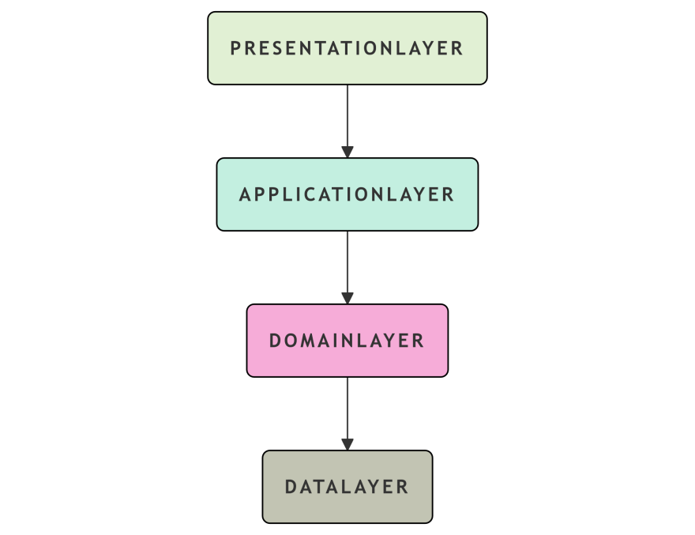
Figure 1: Modular Ticketing and Issue-Resolution Framework
- Triage & Intelligent Intake:
- Issues reported by Supplier/Category Managers (via emails, mobile apps, dashboard widgets).
- The input includes a description in Natural Language (NL) and may be accompanied by documents or attachments.
- Automated intake uses Natural Language Processing (NLP) techniques to associate the intent of the suppliers/categories with PROCUREMENTS Issue Templates. Automation translates two forms of the issue template (natural language description and attachment) into an appropriate procurement issue template.
- The context for an incoming issue is established through automatic linking to active objects, including open POs, verified suppliers and/or active contracts associated with the supplier/category.
- The support business rules and machine learning algorithms categorize the urgency of triaging issues and display the various SLAs for each priority level.
- P1 is the highest urgency (Critical) with a SLA of less than two hours. A P1 issue would be a PO Blocker and would take priority over all other issues.
- P2 has a SLA of 24 hours and would be related to contract Compliance.
- P3 has a SLA of 48 hours and relates to supplier Performance issues.
- Real-time Automated Workflow Orchestration:
- The Adaptive Assignment engine routes incoming tickets to the proper teams, i.e. Compliance, Category Manager, or Supplier Relations.
- The recipients are provided with real-time notifications that include a comprehensive history of all activity associated with that particular PO, contract, supplier, and the real-time key performance indicators.
- Smart Decision-Making (Hours vs. Days):
- The Resolver offers a single-click solution for problems, including changing or excluding suppliers through Blacklist.
- With Bi-Directional Syncing, any changes made to pertinent records are immediately reflected in real-time across all sites (amendment of POs, changes to how supplier performance is measured).
- Finalization and Continued Learning:
- Using the previously referenced AI Learning Cycle to validate the completion of a ticket automatically closes a ticket if all threshold criteria have been met. If the closure is not performed, a customer satisfaction survey will be generated for the resolver to collect information about the customer experience related to the resolution and ticket closure.
- AI Learning Cycle employs a continuous process of self-improvements via ML retraining which improves how accurately a resolver can determine how to triage an issue. The triage accuracy is currently measured at 93% and improving to 97%.
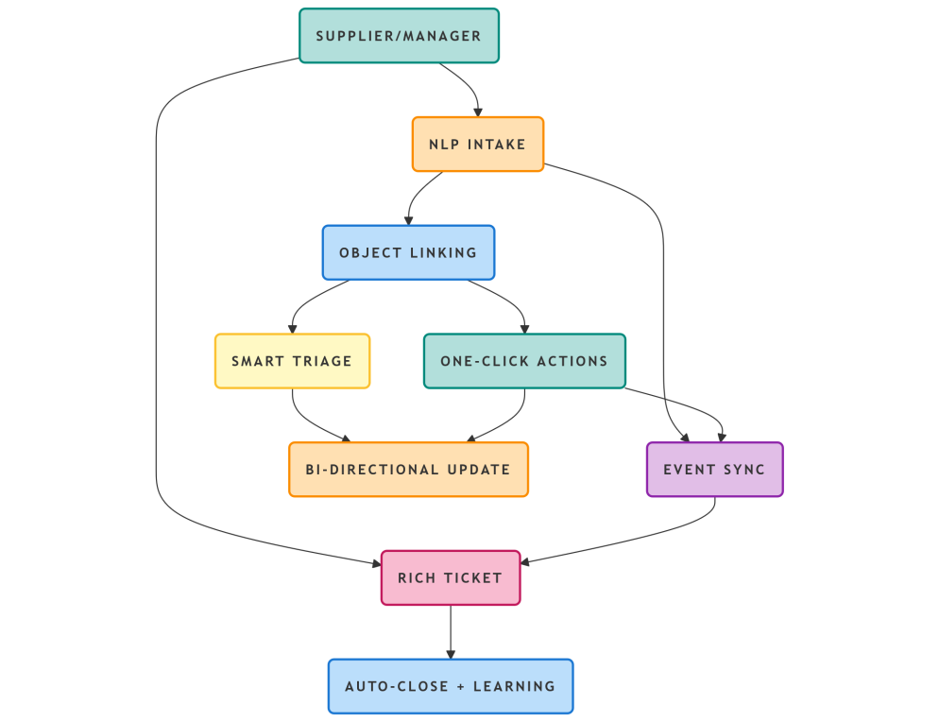
Figure 2: Modular Ticketing Framework
ServiceNow's Step Modular Framework Legacy significantly streamlines the intake and resolution of procurement support requests by providing both manual and automated intake options. The manual option typically requires between 5-15 minutes to complete; however, the automated option using NLP may allow users to complete intake in approximately 30 seconds. Time required for manual review and triage of procurement support requests varies between 1-4 hours. However, when using Machine Learning and rules for triage in 'real time' (i.e., as support requests are being processed), this process time is greatly reduced.
The resolution time varies by method as well. The manual recreation of the context typically takes 2-5 days; conversely, establishing the complete context through the automated process takes only 2-24 hours. Whereas closure of the request by the user may occur immediately when using the automated-validation option, manually closing the request may take between 1-2 days when multi-approvals are required. The overall processing time of a procurement support request through the use of ServiceNow's Step Modular Framework Legacy can take anywhere from 4-8 days when using the manual method or less than one day when utilizing the automated option, as shown in Table 1 below.
Step | Legacy (ServiceNow) | Modular Framework
Intake | 5-15 min (manual form) | 30 sec (NLP auto)
Triage | 1-4 hrs (manual review) | Instant (rules+ML)
Resolution | 2-5 days (context recreation) | 2-24 hrs (full context)
Closure | 1-2 days (multi-approval) | Instant (auto-validation)
Total | 4-8 days | <24 hours
Table 1: Ivalua Ticketing Role in Procurement platforms
The Procurement Intake Layer is the central point of contact for procurement requests. All incoming business requirements are treated as unstructured requests, and they are processed through Source-to-Pay workflows. The Procurement Intake Layer is built using standardized methods for collecting, validating, and intelligently routing all procurement requests to appropriate stakeholders. The Procurement Intake Layer includes the following seven (7) submission channels for procurement requests: Web Portal, Guided Purchasing (forms), Email Parsing, Voice Interface, Mobile App (for Users and Suppliers), and API Endpoints (for connection to ERP and HRM systems). All request information is collected through the automated Intelligent Form Engine. This engine automatically captures all necessary request information, such as requester contact information, business requirements, budget validation information, and supplier information. Additionally, the intelligent form engine validates that requests comply with organizational policies and that funding is available before sending requests to the appropriate stakeholders for approval.
Automated validation and compliance checks are completed automatically, and requests are routed and prioritized based on urgency, value, and business impact. Additionally, requests with the same value will use a pre-defined Route Matrix for routing and approval. Advanced degrees of intelligence are added to the Procurement Intake Layer via the use of Natural Language Processing (NLP) capabilities. The NLP engine allows users to search for specific keywords within procurement requests and classify them. The NLP engine also gives users context around procurement requests, suggesting preferred suppliers and existing contracts to consider as part of the purchasing process. The Procurement Intake Layer has integration touch points with downstream systems (e.g., ERP and CRM) to streamline communication during the procurement process.
The Procurement Intake Layer is designed with Dashboards to track key performance indicators (KPIs), including quick cycle times, high compliance rates, and a seamless user experience. Additionally, the Procurement Intake Layer has a modularized Ticketing System to classify and track all requests, along with the service level agreements (SLAs) associated with the respective requests. Through a proper Procurement Intake Process, organizations significantly reduce maverick spending, reduce the amount of time it takes to generate purchase orders, and improve the rate at which simple requests are auto-resolved. Thus, establishing a foundation for complete Procurement Orchestration.This comprehensive analysis of how to factor in the procurement support for the-principal transformation identifies 15 key performance indicators (KPIs) related to prospective suppliers with an emphasis on supplier performance, financial impact, operational efficiency and strategic value.
The operational efficiency KPIs provide two significant improvements compared to prior practices; both include a reduction in the average time to resolve issues (MTTR) for ticket resolution from four to four hours, with an operational target of less than 24 hours in the target time frames for ticket resolution and a 98% automation rate for resolution triage completion. The KPIs also include a high rate of first contact resolution of over 90% of total requests, with a reduction of at least 40% in ticket volume through predictive analytics. Regarding financial KPIs, the framework includes efforts to maintain a price per ticket time that is less than $50.00 per (resolved) ticket and a much better return on purchase order cycle time improvements from the time the requested order is created to the time it is paid (invoiced), with a purchase order compliance target of greater than 95%. There is also a target to reduce maverick spending by 25% or more.
Supplier performance KPIs include an average net promoter score (NPS) of greater than 50% and a resolution rate of at least 92% for all supplier-reported issues, with an emphasis on the timely and complete delivery of all orders made to the supplier. For provide a driving strategic value, the framework has established KPIs for a triage accuracy level of 97% and a 5.2 times ROI during the first-year of implementation with a health score of above 92 out of 100 (maximum achievable health score). The KPIs demonstrate savings of $2.4 million in spending (thus far) and improvements to both compliance and auto-close rates. In addition to savings and improved compliance and closure rates, the KPIs have identified numerous early warning indicators of potential procurement risk (e.g., an 89% predictive accuracy rating for purchase order delayed delivery dates) and successfully prevented a steady stream of budget impacts for the duration of the time frame during which the framework will be used.
Key to operational efficiency is the procurement cycle time KPI that specifically measures the period from a customer demand request to the time of fulfillment through the purchase order. The procurement cycle time KPI is calculated by determining the amount of time spent at any given time while completing the complete Procurement Lifecycle process, including any Procurement Cycle Processes for tracking and managing customer demand requests through to purchasing and receipt, as well as invoice processing and revenue collection. Common examples of Procurement Cycle Time sub-cycle time KPI measures will report average cycle times for various Procurement Cycle Time stages with comparable industry benchmarks indicating extreme variances in Procurement Cycle Time benchmarks from top performers to median performers to lower quartile performers in comparison to the Benchmark Procurement Cycle Time.
As a modular solution, the KPI framework is targeting a Procurement Cycle Time from requirement to purchase order of less than 24 hours, although targeted industry-specific benchmark times will vary greatly from organization to organization. The Procurement Cycle Time KPI calculation process requires the collection of the relevant dates from all procurement systems and the collection of the necessary Procurement Cycle Times to arrive at the total Procurement Cycle Time KPIs for the business organization and all its respective Benchmark Procurement Cycle Time peers over a period of time against each respective industry benchmark in order to benchmark efficiency and relative improvement level of each individual Procurement Cycle Time.
Improvements in Procurement Cycle Times can produce considerable operational benefits such as increases in cash flow and lower operating costs, along with providing a continuous monitoring program through each organizations effective use of KPI, as well as identifying procurement process bottlenecks and identifying opportunities for further automating of the Procurement Cycle Time Processes. Additionally, the KPI Performance Thresholds for each KPI provide a basis for determining what strategic actions would be appropriate upon reaching the respective performance threshold for each KPI. Overall, optimizing Procurement Cycle Time Processes will provide every organization with significant operational and financial advantages, as illustrated in Figure 3 below:
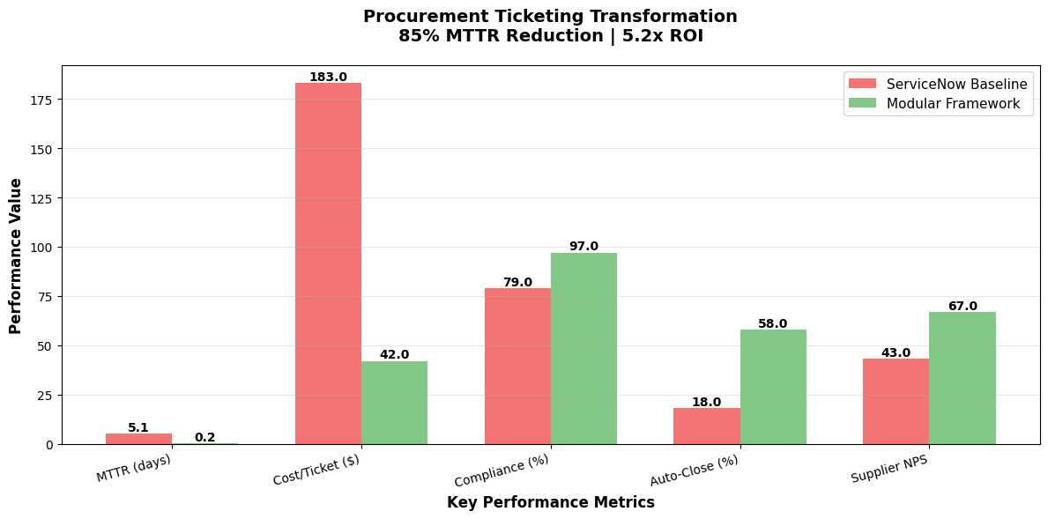
Figure 3: Procurement Ticketing Transformation

Conclusion
The combined Modular Ticketing and Issue-Resolution Infrastructure was developed to help modernize enterprise support roles by amalgamating all processes into one operation using the Ivalua Procurement Suite. This new combined Modular Ticketing and Issue Resolution Infrastructure allows enterprises to be more productive through intelligent automation and data synchronization, allowing enterprises to save time and respond to support tickets faster. The framework has many great capabilities, including: A common data model for all businesses; Cognitive triaging that removes the need for manual routing of support tickets; Real-Time Source-to-Pay Synchronization; Scalable to accept increased levels of procurement Volume.
As the framework evolves towards the rollout of Procurement 4.0, the initial phase of the rollout will use cognitive intelligence to replace approximately 40% of support tickets with predictive triage and GenAI Assistant. In addition, this framework will allow for improved orchestration of ecosystems providing for the self-Resolution of issues and enabling Enterprise Level Capabilities through Blockchain Minutes for auditability and Sustainability. The framework supports continuous organic growth and feedback through Closed Loop Learning and will provide the transition from Reactionary Support to Proactive Value Creation, establishing Procurement as an Intelligent Central Hub within enterprise operations.

References
- “The Turf War Between Procurement and Vendor Management (And How to Resolve It)”, February 25, 2022, https://www.gep.com/blog/strategy/turf-war-between-procurement-and-vendor-management.
- “Procurement Process: 7 Steps for Optimal Efficiency and Cost Savings”, 03/05/2019, https://www.zycus.com/blog/procurement-technology/you-didnt-know-these-7-steps-of-an-effective-procurement-process.
- “3 Stages of the Vendor Risk Lifecycle”, Hilary Jewhurst, December 6 2023, https://www.venminder.com/blog/3-stages-vendor-risk-lifecycle.
- “Our Ivalua Client Case Studies”, 2018, https://cdn-assets.inwink.com/da2f91c9-a4e5-4dc1-9611-3a777a7300f3/c081620f-92e7-45a3-8238-56a94ca9a4a3.
- “Research on Supplier Selection, Evaluation, and Relationship Management”, Xiaoyuan Shi, Weihua Zhang, May 2023, https://doi.org/10.4236/ojbm.2023.113067.
- “Services procurement: A systematic literature review of practices and challenges”, Stella Heinis, David Bamford, Marina Papalexi, Amin Vafadarnikjoo, 02 November 2021, https://doi.org/10.1111/ijmr.12281.
- “Global Data Harmonization”, Michael Stietz, 2021, https://info.ivalua.com/korber-case-study.
- “Dynamic capabilities for digital procurement transformation: a systematic literature review”, Silke Herold, Jonas Heller, Frank Rozemeijer, Dominik Mahr, November 10 2022, https://doi.org/10.1108/IJPDLM-12-2021-0535.
- “Digital Purchasing and Procurement – Whether and How Digital Tools and Platforms Enable Well-Positioned Supplier Negotiation”, Yujie Meng, 5 Dec 2022, https://papers.ssrn.com/sol3/papers.cfm?abstract_id=4256269.
- “The role of e-government in sustainable public procurement in developing countries: A systematic literature review”, Peter Adjei-Bamfo, Theophilus Maloreh-Nyamekye, Albert Ahenkan, March 2019, https://doi.org/10.1016/j.resconrec.2018.12.001.
- “Comparing Traditional And Sustainable Procurement Strategies: Analyzing The Connections Between These Strategies In Affecting Firm Profitability”, Ashok Upadhyay, Dr. Sheetal, Dr. Mohd. Imran Khan, Journal of Positive School Psychology http://journalppw.com, 2022, Vol. 6, No. 8, 17-28.
- “Quality appraisal for systematic literature reviews of health state utility values: a descriptive analysis”, Muchandifunga Trust Muchadeyi , Karla Hernandez-Villafuerte, Michael Schlander, 2022 Nov 25, https://doi.org/10.1186/s12874-022-01784-6.
- “Supporting Quality Assessment in Systematic Literature Reviews”, Yusra Shakeel, October 23, 2017, https://wwwiti.cs.uni-magdeburg.de/iti_db/publikationen/ps/auto/Shakeel2017.pdf.
- “Services procurement: A systematic literature review of practices and challenges”, Stella Heinis, David Bamford, Marina Papalexi, Amin Vafadarnikjoo, 02 November 2021, https://doi.org/10.1111/ijmr.12281.

