INVESTIGATION FOR STABILITY OF ROCK FOR FOUNDATION AND DEPTH TO AQUIFER DETERMINATION USING VERTICAL ELECTRICAL SOUNDING AT EKWEREONU CLOSE 33 NKWELLE EZUNAKA, SOUTHEASTERN NIGERIA

ABSTRACT
In today’s world, field investigation is a necessity to get a detailed overview of any area for civil engineering construction purpose. Precise determination of engineering geological properties is essential to plan for a proper design and successful construction for any civil engineering structure. The traditionally practiced conventional methods for the same are invasive, costly and time consuming. Electrical Resistivity Survey is an attractive tool for delineating subsurface geology without soil disturbance. The investigation involved the use of vertical electrical sounding of schlumberger array. The location is within Ogwashi Formation with latitudes 6°11.155’N to 6°11.171’N and longitudes 6° 48.868’E to 6° 48.883’E with elevation varying between 68m and 79m.The interpretation revealed resistivity range of 396 Ohmm to 746Ohmm from depth of 0.934m to 2.2m for the foundation of structures, while the resistivity and depth to aquifer of the location is 1569Ohmm at 9.44m and 1314Ohmm at 168m for the second zone.. In between these lithologies are mainly clay/shale units. This suggest that the underlying materials has to be treated or soil stabilized with one of the options of recommendation. This will enhance the bearing capacity of the foundation soil. Deep foundation is recommended for the main load bearing foundation to ensure that the load is mounted by the civil structure is transmitted to the hard shale. Failure to follow these procedures could lead to structural failure and economic loss or wastage.
INTRODUCTION
Maton and Templeton (1973) defined engineering geophysics as an intermediary discipline between engineering geology and soil mechanics. It involves the application of geophysical methods to civil engineering projects. It is frequently used in an initial site investigation to determine subsurface ground conditions prior to excavation and construction work. Engineering geophysics therefore gives detail information on the degree of competence of the subsoil in foundation engineering. This research examines the use of geophysical methods for post foundation studies at Ekwereonu close 33 NkwelleEzunaka. This is necessitated as a result of gradual failure of buildings. The rate of increase in fallen of building structures in Nigeria calls for serious attention. Hence the need to assess whether the part of the earth (topsoil) that carry these civil structures is fit to do so. Electrical method (VES) is one of the geophysical tools that has been prove effective in carrying out foundation studies. The use of Electrical Resistivity method becomes relevant with the aim of: (i) Mapping the subsurface conductive zones and geologic structures using (ii) Generating a geoelectric sequence and relevant resistivity maps of the study area using the Electrical resistivity method involving the Vertical electrical sounding, VES. (iii)determining the variation in lithology with depth. (iv) Delineating zones of weakness from (i) and (ii) above and thereby evaluate the cause of failure of buildings in the study. Also, this will help to establish presence of expansive soils within the study area that are deleterious and can lead to collapse civil structure. No civil structure is deeper than 15m hence characterization of soils from 0-15m.Expansive soils are soils that expand when water is added and shrink when they dry out. This continuous change in soil volume can cause homes built on it to move unevenly and crack. Often damage from expansive soils can be seen within first few months or years after a home is constructed. As water (from irrigation, flood, rainfall) migrates underneath the homes foundation the soil around the edge of the foundation expands, pushing up on the edges of the foundation this condition called edge lift can cause cracking in the drywall and in the foundation itself .Over a period of years as the moisture further migrates underneath the Centre of the slab, Centre lift can occur causing additional damage to the home. Additionally, trees [planted near the homes can cause long term damage to the foundation. As the trees age and their roots grow beneath the foundation the roots extract the moisture from the soil causing it to dry out and shrink. This shrinking can result in increased settlement of the structure many years after the original construction.
GEOLOGY OF THE AREA
Ekwereonu Street 33, Maryland Estate, Nkwelle Ezunaka is within the Ogwashi Formation, is a prominent Oligocene to Miocene lithostratigraphic unit characterized by cyclic alternations of continental and paralic sediments. (Reyment, 1965; Whiteman, 1982). Stratigraphically, the formation overlies the Eocene Ameki Formation and is conformably overlain by the Benin Formation (Chene et al., 1978). It exhibits a diverse lithology comprising predominantly coarse-grained, ferruginized cross-bedded sandstones, interbedded with carbonaceous shales, claystones, and notable lignite seams that can reach thicknesses of up to 6 meters. (Short & Stäuble, 1967, Ejeh et al., 2010; Bassey, 2015).These lignite deposits, representing Nigeria’s largest reserves in Africa, originated from extensive peat-forming swamps under oxygen rich, continental conditions, indicative of a fluvio-deltaic depositional environment transitioning from marine/paralic to fully continental (Madukwe & Bassey, 2018). Sedimentological evidence suggests a complex paleoenvironment encompassing fluvial channels, floodplains, marshes, lagoons, and tidal influences, reflecting basin infilling and regression during basin evolution (Akpoborie et al., 2015; Osokpor & Overare, 2017). Economically, the formation’s lignite deposits offer significant energy potential for power generation and industrial applications, despite challenges posed by high moisture content (Ogala, 2010). Additionally, the sandstone units serve as vital aquifers, supporting local water supply, while their petrographic properties inform their utilization as construction aggregates (Ejeh et al., 2012). The formation’s stratigraphy and sedimentology underscore its critical role in regional hydrogeology, resource exploitation, and basin evolution studies. figure 1 below is the map of the study area.
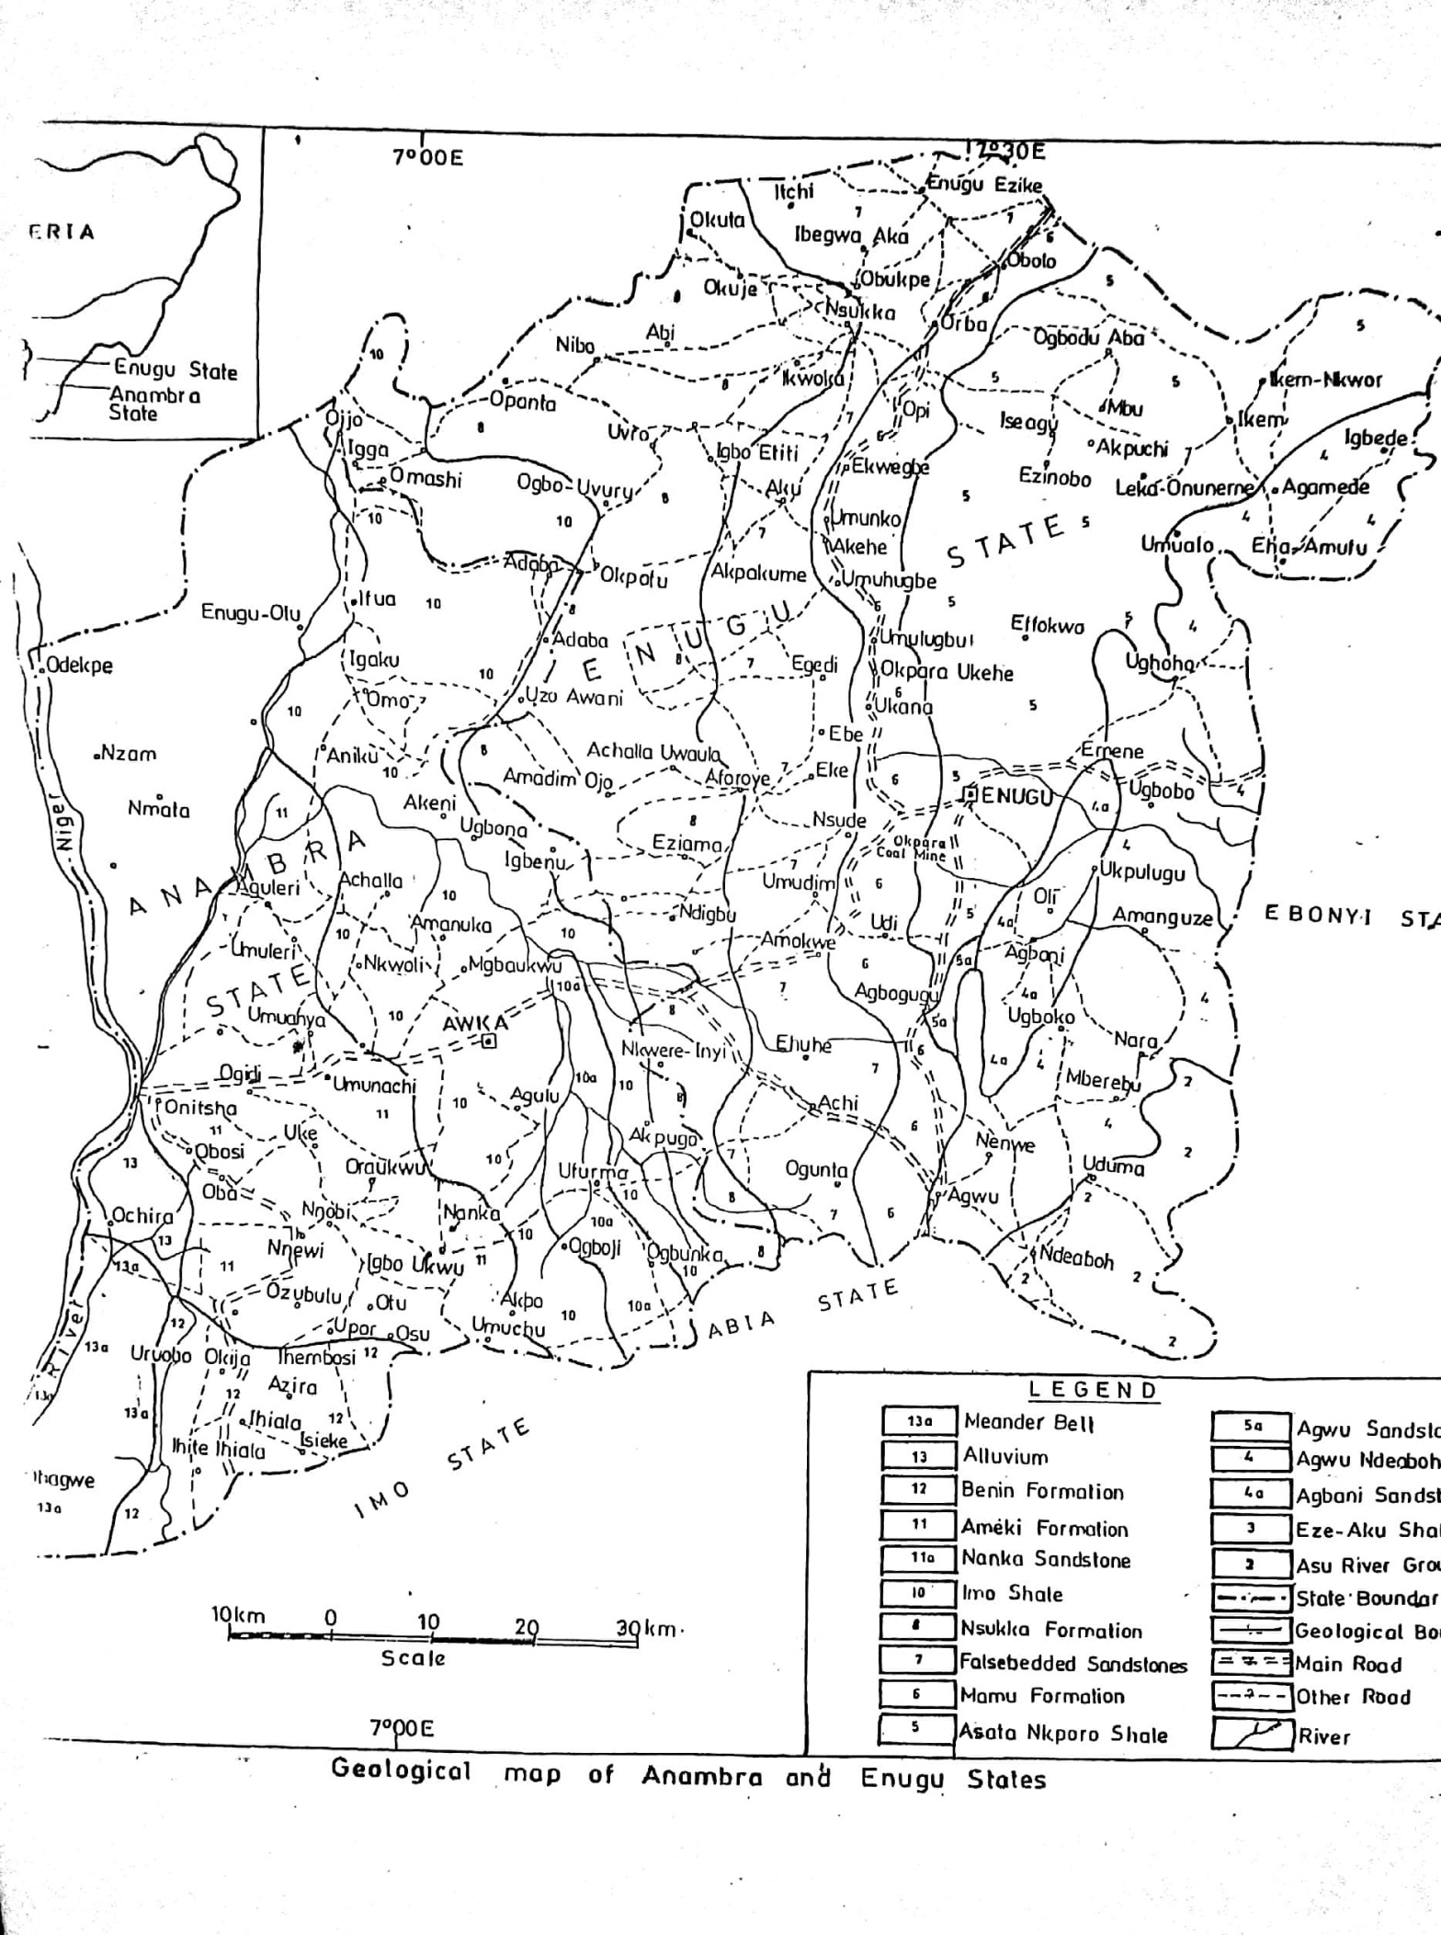
METHODOLOGY
This survey employed electrical resistivity methods to investigate subsurface conditions relevant to foundation studies. Field data acquisition was conducted using a resistivity meter, specifically the ABEM SAS 4000 Terrameter, along with accessories including self-rechargeable batteries, measuring tape, crocodile clips, hammer, cables, and four electrodes. The primary technique utilized was Vertical Electrical Sounding (VES) using the Schlumberger array configuration, which is effective for delineating subsurface stratigraphy and identifying suitable foundation levels (Telford et al., 1990; Afolabi & Olorunfemi, 2012).
The resistivity method involves passing a low-frequency or direct current into the ground via two current electrodes, while measuring the resulting potential difference with two potential electrodes. This process enables the calculation of apparent resistivity, which reflects the lithological and hydraulic properties of the subsurface (Keller & Frischknecht, 1966). Electrode spacing was set with a maximum current electrode separation (AB) of 400 meters, optimizing depth penetration for foundation investigations.
Two VES stations were established at strategic locations within the site, with electrode spacings (AB/2) determined using the Schlumberger equation. To ensure consistent and reliable data, crossover points were observed and electrode spacing was adjusted to minimize attenuation effects of the electrical signals. The apparent resistivity (ρa) was calculated using the formula:
ρ_{a=G∏∆V/2I}

where *ΔV* is the measured potential difference, *I* is the current injected, and the geometric factor accounts for electrode configuration and spacing (Telford et al., 1990). The geometric factor depends on the current and potential electrode spacings, which are determined based on the Schlumberger array configuration.
The resistivity data obtained is vital for identifying subsurface lithologies such as clay layers, sandy deposits, and bedrock, which influence foundation stability. Interpretation of resistivity profiles helps in determining appropriate foundation depths and locations, ensuring structural safety (Abolade & Olorunfemi, 2017).
This geophysical technique offers a non-invasive, cost-effective, and reliable approach for assessing subsurface conditions critical for foundation design and construction. Its application enhances the safety and stability of structures by providing essential subsurface information in a timely manner.
Figure 2: Typical Schlumberger Array. M and N; potential electrodes, A and B; current electrodes.
The acquired resistivity data were analyzed by plotting apparent resistivity against half electrode spacing. Inflection points on these graphs indicate the depth to subsurface interfaces, with an approximate relationship suggesting that the interface depth equals two-thirds (2/3) of the electrode spacing at the inflection point (Vingoe, 1972). This method is widely used in computer iterative modeling to refine subsurface layer parameters. Parameters such as apparent resistivity and layer thickness, derived from partial curve matching techniques—using multilayer master curves and auxiliary point diagrams—served as initial inputs for computer-assisted interpretation (Orellana & Mooney, 1966; Koefoed, 1977; Keller & Frischknecht, 1966). Quantitative analysis was performed using the IP 2win 1D computer program, which facilitated detailed interpretation of the resistivity data. The final results, including the sounding curves, were used to generate geoelectric sections with software such as Surfer 12 for visual representation of subsurface structures.
VES 1 |  |  |  |  | VES 2
Layer | Resistiviy (Ωm) | Depth  (m) | Depth  (ft) | Probable  Lithology | Layer | Resistiviy  (Ωm) | Depth  (m) | Depth  (ft) | Probable Lithology
1 | 396 | 0.476 | 1.6 | Topsoil | 1 | 746 | 0.273 | 0.9 | Topsoil
2 | 138 | 0.776 | 2.5 | Lateriticclay | 2 | 39409 | 0.934 | 3.1 | Lateriticsand
3 | 802 | 2.2 | 7.2 | Lateriticsand/  Clayeysand | 3 | 158 | 2.4 | 7.9 | Lateriticclay/Sandyclay
4 | 126 | 3.53 | 11.6 | Sandyclay/Clay | 4 | 213 | 2.89 | 9.5 | Sandyclay/  Clay
5 | 1569 | 9.44 | 31.0 | Clayeysand/  Siltysand | 5 | 29.7 | 4.8 | 15.7 | Clay/Shale
6 | 10.4 | 16.7 | 54.8 | Clay/Shale | 6 | 19 | >4.8 | >15.7 | Clay/Shale
7 | 97.7 | 44.2 | 145.0 | Sandyshale/  Shale
8 | 7 | 117.0 | 383.9 | Clay/Shale
9 | 111 | 168.0 | 551.2 | Sandyshale/  Shale
10 | 1319 | >168.0 | >551.2 | Shalysand/  Siltysand
RESULTS AND DISCUSSIONS
Two vertical electrical soundings were conducted within the area and the results are presented
Table 1: Resistivity and the Probable Lithology of the Geo-electric Layers

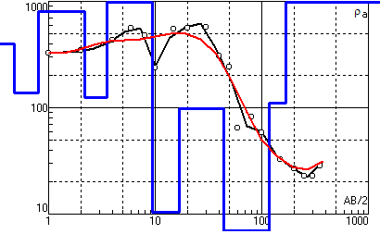
Figure 3a figure 3b
DISCUSSION
The Vertical Electrical Sounding (VES) results obtained from the two surveyed locations provide critical insights into the subsurface stratigraphy and geotechnical properties relevant for foundation design. The layered resistivity profiles reveal significant heterogeneity, which aligns with typical geological conditions observed in similar sedimentary environments within the region.
At VES 1, the topsoil layer exhibits a relatively low resistivity of 396 Ωm at a depth of approximately 0.476 m (1.6 ft), indicative of moist, clayey or sandy topsoil common in the area (Afolabi & Olorunfemi, 2012). The subsequent layer shows a marked increase in resistivity to 138 Ωm at 0.776 m depth, corresponding to lateritic clay, which is prevalent in tropical regions with lateritization processes (Olorunfemi, 2011). The third layer, with resistivity reaching 802 Ωm at 2.2 m (7.2 ft), suggests a sandy or clayey sand deposit, often associated with well-drained, coarse-grained sediments suitable for shallow foundations (Keller & Frischknecht, 1966).
Deeper layers reveal increasing resistivity values, notably the 1569 Ωm at 9.44 m (31 ft), indicative of clayey sand or silty sand, which are generally competent for supporting structures with appropriate foundation depths. The presence of shale-like formations at depths beyond 16.7 m (54.8 ft) suggests zones of low strength and potential instability, emphasizing the need for careful foundation design to avoid these strata.
Similarly, VES 2 displays a comparable stratigraphy, with topsoil resistivity at 746 Ωm and a thickness of approximately 0.273 m (0.9 ft). The subsequent layer, characterized by a very high resistivity (39409 Ωm) at 0.934 m depth, indicates a highly resistive material, likely a dense lateritic sand or gravel, which is advantageous for supporting heavy loads. The lower resistivity layers at greater depths, including 29.7 Ωm at 4.8 m (15.7 ft), correspond to clay or shale, where geotechnical considerations such as potential for swelling or slaking must be addressed (Das, 2010).
The resistivity profiles align well with regional geological knowledge, where alluvial and lateritic deposits dominate the subsurface sediments (Olorunfemi & Afolabi, 2010). These sediments are typically suitable for shallow foundations, provided that the bearing capacity and settlement criteria are met. The high resistivity layers at shallow depths are indicative of well-drained, competent materials, supporting the use of shallow footing designs in these locations.
The data also suggest that the upper 2 meters are generally suitable for foundation placement, with deeper, more resistive layers providing stability and load-bearing capacity. However, the presence of shale formations at greater depths necessitates geotechnical investigations such as Standard Penetration Tests (SPT) and laboratory analyses to validate the bearing capacity and settlement characteristics before final foundation design.
In terms of engineering practices, the resistivity results are consistent with regional standards where layers with resistivities above 100 Ωm are considered competent for shallow foundations (Keller & Frischknecht, 1966). The high resistivity values observed in the lower layers further affirm the presence of stable, coarse-grained deposits, aligning with recommendations for foundation depths in similar geological settings (Das, 2010).
Overall, the resistivity profiles derived from the VES data indicate that shallow foundations can be safely employed at these locations, provided that detailed geotechnical testing corroborates the geophysical interpretations. These results underscore the importance of integrating geophysical surveys with conventional geotechnical investigations to optimize foundation design and ensure structural stability.
The geo-technical implication of the presence of clay especially at VES, results in unstable foundation of structures. To correct this anomaly, it is advisable to make a deep foundation of about 1m and sand fill half the depth (1.0m) to prevent contraction and expansion of clay that causes cracks in the walls of buildings.

CONCLUSION
The vertical electrical sounding (VES) investigations at the study sites reveal a layered subsurface profile characterized by topsoil, clayey and sandy deposits, and deeper shale formations. The resistivity data indicate that the upper 2 meters generally comprise competent, well-drained materials suitable for shallow foundation construction. The presence of high-resistivity layers at shallow depths suggests favorable conditions for supporting structural loads, while deeper shale formations highlight zones of low strength that should be avoided for foundation placement. Overall, the geophysical results align with regional geological expectations and suggest that shallow foundation systems can be employed with appropriate geotechnical considerations. However, confirmation through detailed geotechnical testing is essential before final foundation design.
RECOMMENDATIONS
1. Site-Specific Geotechnical Testing: Conduct standard penetration tests (SPT), cone penetration tests (CPT), and laboratory soil analyses to validate the geophysical interpretations and assess parameters such as bearing capacity, settlement, and slope stability.
2. Foundation Design Considerations: Design shallow foundations to terminate within the competent, high-resistivity layers identified at shallow depths, avoiding shale zones that may compromise stability.
3. Monitoring and Quality Control: Implement geotechnical monitoring during construction to ensure that actual site conditions align with geophysical and laboratory findings.

4. Environmental and Hydrological Assessment: Evaluate groundwater conditions and potential seasonal variations that may influence foundation performance and soil resistivity.
5 The original design of a home can have a major impact on its short- or long-term success. Builders should be required by law to have a geologic engineer prepare a soil report to identify expansive soils and give the builders recommendation to build a home that will with stand these soils. These recommendations often include i) removal of the expansive soils, (ii) importation of non-expansive soils (iii) soil chemical treatments (iv) a post tensioned or structural floor foundation (v) caissons embedded in bedrock (vi) Gutters and downspouts (vii) limits on placement of irrigation systems, (viii) underground and surface drainage systems.
SUGGESTIONS FOR FURTHER STUDIES
Comprehensive Geotechnical Surveys: Integrate borehole drilling and laboratory testing to obtain detailed soil profiles, physical properties, and strength parameters.
Advanced Geophysical Methods: Employ seismic refraction, electrical resistivity tomography (ERT), or ground-penetrating radar (GPR) for higher-resolution subsurface imaging.
Long-Term Monitoring: Establish geotechnical instrumentation for long-term monitoring of settlement and stability, especially in zones with shale or clay-rich layers.
Hydrogeological Studies: Investigate groundwater flow and recharge characteristics to assess their impact on soil stability and foundation performance over time.
Implementing these recommendations and further studies will ensure the development of safe, cost-effective, and sustainable foundation systems tailored to the subsurface conditions of the area.
Care should be taken to prevent excessive moisture from entering the soil near the foundation. Landscape watering should be limited and consistent to prevent soaking or desiccation of the soil. Drainage patterns around the buildings should be maintained so that surface water flows away from, rather than towards the building. Gutters and downspouts should be kept clear of debris and should not discharge water close to foundation. Regular inspection after heavy rains is needed to determine areas of ponding and measures should be taken to correct the drainage. Underground drains should be regularly cleaned up to ensure flow of water is not obstructed. If the house has swimming pool the pool should be inspected to ensure that the over pressurized water lines do not leak. Separations between the buildings and concrete slabs(e.g. patios) should be caulked using a flexible caulked.

REFERENCES
Abolade, A. A., & Olorunfemi, M. O. (2017). Application of Electrical Resistivity Method in Foundation Investigation in Akure, Nigeria. Journal of Geosciences and Geomatics, 5(4), 112-119.
Afolabi, A. O., & Olorunfemi, M. O. (2012). Application of Vertical Electrical Sounding in the Investigation of Subsurface Lithology in Ibadan, Nigeria. Nigerian Journal of Physics, 23(1), 1-8.
Bassey, C. E. (2015). Petrographic and Geochemical Analysis of Sandstones in the Ogwashi-Asaba Formation, Nigeria. Journal of African Earth Sciences, 112, 88-98.
Chene, J. C., et al. (1978). Palynological Studies and Age Determination of the Ogwashi-Asaba Formation. Journal of Geology, 86(5), 439-448.
Das, B. M. (2010). Principles of Foundation Engineering (8th ed.). Cengage Learning.
Ejeh, O. I., et al. (2010). Depositional Setting and Provenance of the Ogwashi-Asaba Formation, Nigeria. Journal of Sedimentary Research, 80(4), 317-331.
Ejeh, O. I., et al. (2012). Petrographic and Engineering Properties of Sandstones from the Ogwashi-Asaba Formation. Engineering Geology, 137-138, 1-10.
Keller, G. V., & Frischknecht, F. C. (1966). Electrical methods in geophysical prospecting. Pergamon Press.
Koefoed, O. (1977). Geoelectric methods. Elsevier Scientific Publishing.
Koefoed, O. (1979). Geoelectric sounding. International Institute of Land Reclamation and Improvement.
Maton, P.I. and Templeton, M.C. 1973. “Some Technical Aspects of Present and Future Trends in
Madukwe, H. Y., & Bassey, C. E. (2018). Geochemistry and Provenance of Sandstones in the Ogwashi-Asaba Formation, Nigeria. International Journal of Earth Sciences, 107(3), 931-945.
Ogala, J. O. (2010). Lignite Resources and Utilization in Nigeria. Nigerian Journal of Mining and Geology, 47(1), 123-134.
Olorunfemi, M. O. (2011). Geotechnical and Geophysical Investigations for Foundation Design in Tropical Environments. Journal of Earth Sciences, 45(2), 123-134.
Olorunfemi, M. O., & Afolabi, A. O. (2010). Geophysical Investigations for Foundation Stability in Southwestern Nigeria. Nigerian Journal of Geophysics, 16(1), 45-56.
Orellana, A., & Mooney, H. (1966). Interpretation of geoelectric soundings by the method of auxiliary points. Geophysics, 31(3), 546–564.
Reyment, R. A. (1965). Aspects of the Geology of Nigeria. Ibadan University Press.
Short, K. C., & Stäuble, A. J. (1967). Stratigraphy of the Niger Delta. Geological Society of America Bulletin, 78(7), 841-862.
Telford, W. M., Geldart, L. P., Sheriff, R. E., & Keys, D. A. (1990). Applied Geophysics. Cambridge University Press.
Vingoe, T. (1972). The interpretation of resistivity soundings in geology. Geophysical Prospecting, 20(4), 713–736.
Whiteman, A. M. J. (1982). Nigeria: Its Petroleum Geology, Resources, and Potential. University of Ibadan Press.
Zohdy, A. A. R. (1976). A computer program for interpreting electrical resistivity data. US Geological Survey Open-File Report.
About the Authors
- NWUGHA, V.N. - holds a Doctor of Phyilosophy (PH.D) in Applied Geophysics from the Federal University of Technology, Owerri, Nigeria and he is a senior lecturer in the department of Physics at Alvan Ikoku Federal University of Education Owerri, Imo State, Nigeria. He is practically oriented and strives to explore his immediate environment to harness the benefits subsurface can give mankind.
- CHINAKA. A.I - Dr. Chinaka is a Senior Lecturer in the Department of Mathematics, Alvan Ikoku Federal University of Education, Owerri, Nigeria. She is also an avid researcher and her work has been published in both national and international journals with her research focus on Quasigroup and Loop Theory. Augustina, is committed to learning and self-development, able to work in a team work environment and good in conceptual and analytical skills.
- MBAGWU, E.C. - holds a Bachelor’s and Master’s degree in Geophysics . She is currently a graduate student in Geophysics at the University of Calgary, Canada, where her current research focuses on carbon capture and storage (CCS), geophysical monitoring, and reservoir characterization. She currently serves as a Teaching Assistant in Global and Planetary Geophysics and Introductory geophysics. Her research interests include CO₂ sequestration monitoring, geophysical data integration, unconventional reservoir characterization, and the application of geophysics to climate and energy transition challenges.
- EZEBUNANWA, A.C - is an ardent researcher he holds a Bachelor of Technology (B.Tech.) in Applied Geophysics from the Federal University of Technology, Owerri, Nigeria and masters in management. . His research interest is in the use of VES in solving day to day societal problems. He has a lot of publications to his name cutting across geophysics, groundwater, mineral investigation, geotechnical, environmental assessment and digital technology.
- ONWUGBUCHULAM, O.C - Chukwudi Obioma Onwuegbuchulam is a researcher and data scientist with a background in geophysics and a Master’s degree in Data Science. He has published research in both geophysics and data science, with work spanning digital technology, public health, and environmental systems. His research focuses on applying machine learning and robust data integrity frameworks to address complex challenges in healthcare delivery and environmental resource mapping

