Dynamic Loss Assessment of HVAC and HVDC Transmission Systems under High-Penetration Renewable Power Integration: A Novelty Approach

ABSTRACT
The paper presents a MATLAB model based analysis and evaluation framework of the dynamic losses of HVAC and the HVDC systems in high-penetration integration of renewable power. In comparison to the conventional research, in which the conditions are assumed to remain constant or even nominal, this paper tackles the challenge of time-varying renewable generation, like PV and wind variability, and the impact of the renewable penetration level (20 to 80 percent) to the transmission loss. The MATLAB simulations represent the line and transformer losses of HVAC and HVDC line and converter losses in a 300km corridor, which carries 1000 MW base load. The significant results have revealed that the average losses experienced by the HVDC (18 MW-20 percent penetrations to 22 MW-80 percent penetration) are never higher than those of the HVAC (25-35 MW). HVAC losses (HVAC losses changes up to +15MW and -15MW) are also more sensitive to reactive power and renewable intermittency. The study also identifies regions of operational desirability of HVDC and has provided loss composition, density heatmaps, crossover points, dynamic disturbance responses and this gives good guidance in regard to planning transmission according to prevalence of renewable. The outcomes of this study prove the efficiency, stability, and scalability of high renewable integration conditions of HVDC corridors at a greater level.

Keywords: High Voltages, Transmission Systems, Loss Assessment, Renewable Power Penetration,
Dynamic Modelling

INTRODUCTION
Rapid expansion of renewable energy within the context of photovoltaic (PV) and wind power is revolutionizing planning and operation of the worldwide power systems. This variability and non-controllability of renewable sources pose a serious challenge to addition of natural generation sources to transmission networks which were originally built to include the steady and centrally dispatched generation (Sajadi rt al, 2020; Khatibi & Ahmed, 2019). The amount of PV power produced depends greatly upon the amount of sunlight and weather that makes the voltage and frequency unstable and lowers inertia of power systems with respect to the traditional synchronous generators. Similarly, bulk generation of wind will affect the load and stability of the network voltage (Teferi et al, 2024; Rahman et al, 2024). This requires better backup of reactive power and the enhancement of line capacity to such an extent that it becomes safe. These dynamic pressures have highlighted the significance of improved planning, real time control plans and grid flexibility provisions that can guarantee that performance of transmission is not compromised during instances of massive penetration of renewable energy (Adetokun, et al, 2023; Islam et al, 2024).
High Voltage Alternating current (HVAC) transmission is done in three-phase AC lines and transformers. These systems are characterized by resistive (I 2 R) losses, reactive power flows, which augment apparent current and system losses (Saadat, 2018). Systems, which contain a high percentage of renewable energy, may have reactive power and fluctuating generation, which result in higher currents in the lines and voltage regulation problems. This also contributes to the HVAC losses (Kazimi, et al, 2024; Faruque et al, 2018). The High Voltage Direct Current (HVDC) is most specifically used in the connection of offshore wind farms, as well as intercontinental connections and areas with large renewable energy (Arrillaga, 2018). Unlike the HVAC systems, HVDC system does not possess the AC reactive power flows, and minimizes resistive long-distance losses. Active control of power can be rapidly controlled HVDC operated on Voltage Source Converter (VSC) and is beneficial in improving the stability of the grid in dynamic operating conditions (Varma, 2017; Jacobson et al, 2023). However, converter station losses as a result of power electronic components are also associated with HVDC systems. These are fixed and proportional losses which have to be factored and line losses (Ackermann, 2017).
Prior reports have contrasted HVAC and HVDC transmission technologies on the basis of steady-state losses, costing of the economy, as well as stability performance. HVDC has been proven to have less transmission losses compared to HVAC in long distance power transfer, which is normally over 500 to 800 km (Wang & Strunz, 2020; Hansen & Cutululis, 2019). It has also studied converter loss modeling and control measures that will reduce HVDC losses in the different operating conditions (Singh, D., & Jain, 2022; Bollen, 2007).
However, most of the literature available only covers the situation of fix or nominal operating point and does not appropriately explain the dynamic and random character of high renewable energy use (Ramachandran & McCalley, 2024; Olivares et al, 2022).
Unlike most of the available literature, which considers the transmission losses of HVAC and HVDC conditioned by a nominal or a stationary operation, the paper offers a dynamic MATLAB model. This model is powered by renewable energy and it is pegged on the level of penetration. Time-varying PV and wind generation profiles have also been explicitly included in this model. It examines the losses in the different levels of renewable penetration, 20-80. It also simulates the variability and sensitivities of the losses in the real operating conditions. The approach provides a comparative discussion of HVAC and HVDC corridors of renewable-based networks in detail. It also offers helpful data on transmission planning which is not found in conventional steady-state or generic power transfer studies.

Study Objectives:
i. In develop a unified MATLAB model of HVAC and HVDC transmission systems of 1000 MW, 300 km corridors.
ii. To quantify the dynamic transmission losses when both renewable generation profile varies as a function of time.
iii. To find out the sensitivity of the loss to renewable level of penetration (20% - 80%).
iv. To investigate how change in load and renewable intermittency changes the loss behaviour.
v. To determine which area of operation HVDC or HVAC is more efficient in terms of losses.
vi. To provide loss composition to facilitate practical planning, density heatmaps and crossover points are provided.

MATERIALS AND METHOD
A single MATLAB based dynamic simulation model was used in this paper to compare the loss performance of HVAC and HVDC transmission systems with high-penetration and time-varying renewable power integration. The proposed methodology was designed in a manner that would bring to fair comparison, the two transmission technologies, in terms of penetration and based on renewable. The analysis in both HVAC and HVDC models uses the same renewable generation profiles, same loading conditions and the same power transfer paths in the analysis.

Mathematical Modelling
This study came up with mathematical models, which enable a dynamic analysis of the transmission losses in both the HVAC and the HVDC systems in the cases where a large percentage of renewable power is being integrated. The explicit time dependent models of flow of power, transmission line conductor are models developed which reflect power electronic converters and, in HVAC case, the effects of reactive power. The overall objective is to provide one and fair modelling platform to study and compare the loss properties of HVAC and HVDC transmission technologies as the renewable level of penetration keeps increasing.

Renewable Generation Modelling and Penetration Definition.
These are photovoltaic and wind generation profiles that change over a period of time to represent the real variability of renewable resources on a daily basis over a 24 hour period of operation.
In this respect, the total of the renewable power injected to the network at a specific time moment.
t is as follows (Li et al, 2025).
$P_{renew}\left(t\right)$ =$P_{PV}\left(t\right)+ P_{W}\left(t\right)$ (1)
The renewable penetration level is defined as;
$λ$ = $\frac{P_{renew}\left(t\right)}{P_{Load}\left(t\right)}$ $×100\%$ (2)
Where $P_{Load}\left(t\right)$ is the total system load demand.

Renewable Power and Net Transmission Demand
Let $P_{Load}$ represent the base load of the receiving system (1000W for this study), the time dependent renewable contribution $P_{renew}\left(t\right)$ is constructed as a weighted combination of normalized PV and wind profiles (Slimene & Khlifi, 2025).
$P_{renew}\left(t\right)$ = $α_{PV}P_{PV}\left(t\right)+α_{Wind}P_{Wind}\left(t\right)$ (3)
Where $P_{PV}\left(t\right)$ and $P_{Wind}\left(t\right)$ denote PV and wind generation normalize to unity and $α_{PV}$ and $α_{Wind}$ are weighting coefficients chosen so that the combined profile captures typical solar and wind variability (Zdiri, 2025).
Renewable penetration $r,$ is defined as a fraction of the base load supplied by renewables, accordingly, the net power $P_{tx}\left(t,x\right)$ that must be supplied by the transmission system is (Mauludin et al, 2025):
$P_{tx}\left(t,x\right)$ = $P_{load}- rP_{renew}\left(t\right)$ (4)
This net demand drives the loss calculation for both HVAC and HVDC systems over time.

HVAC Loss Modelling
HVAC transmission includes several loss components:

i. Conductor Line Losses
Conductor losses for a three-phase AC system are based on the RMS current${, I}_{AC}\left(t,r\right)$:
${ I}_{AC}\left(t,r\right)$ = $\frac{S\left(t,r\right)×{10}^{6}}{\sqrt{3V_{AC}}}$ (5)
Where $V_{AC}$ is the line to line voltage and $S\left(t,r\right)$ is the apparent power (Mauludin et al, 2025):
$S\left(t,r\right)$ = $\sqrt{P_{tx}{\left(t,r\right)}^{2}+Q{\left(t\right)}^{2}}$ (6)
For simplicity and to focus on loss behavior, it was assume that a fixed power factor$, pf=0.95$, given a reactive component $Q\left(t\right)$=$P_{tx}\left(t,r\right)\tan\left(\cos^{-1}\left(pf\right)\right)$. The conductor line losses $P_{loss,line}^{AC}$ are then (Mauludin et al, 2025; Glover et al, 2023):
$P_{loss,line}^{AC}\left(t,r\right)$ = $3I_{AC}{\left(t,r\right)}^{2}R_{line}$ (7)
Where $R_{line}$ is the total resistance at the HVAC conductor over its length (Glover et al, 2023).

ii. Transformer/Equipment Losses
Transformer losses represent additional HVAC system losses proportional to apparent power (Kundur, 2023).
$P_{loss,tr}^{AC}\left(t,r\right)$ = $R_{tr}×S\left(t,r\right)$ (8)
Where $R_{tr}$ is the proportional loss coefficient for transformers connecting the line.

iii. Total HVAC Losses
The total instantaneous HVAC loss is the sum of the line and transformer losses:
$P_{loss}^{AC}\left(t,r\right)$ = $P_{loss, line}^{AC}\left(t,r\right)$ $+ P_{loss, tr}^{AC}\left(t,r\right)$ (9)
This lumped model denotes the two principal contribution to HVAC losses for power transfer studies (Glover et al, 2023; Kundur, 2023).

D. HVDC Loss Modelling
HVDC transmission loss modelling has different elements since line-end converter stations and DC nature of the line.

i. Line Conductor Losses
For HVDC, line losses are computed using DC current (May, 2016):
$I_{DC}\left(t,r\right)$ = $\frac{P_{t,r}\left(t,r\right)×{10}^{6}}{V_{DC}}$ (10)
And conductor losses are:
$P_{loss, line}^{DC}\left(t,r\right)$ = $I_{DC}{\left(t,r\right)}^{2}R_{DC}$ (11)
Because DC lines do not have reactive power or skin effect frequency components that complicate HVAC loss, only resistive loss remain (Helseth, 2012).

ii. Converter Losses
HVDC converter contribute both a variable and a fixed loss component in VSC based HVDC systems, the converter losses are often approximated as (Davidson, 2025):
$P_{loss,conv}^{DC}\left(t,r\right)$ = $α_{conv}P_{tx}\left(t,r\right)+b_{conv}$ (12)
This structure captures efficiency reduction proportional to power and a constant overhead loss, such linear loss representations are common in HVDC planning optimization and loss assessment.

iii. Total HVDC Losses
The total instantaneous HVDC loss is (Helseth, 2012; Davidson, 2025).
$P_{loss}^{DC}$ $\left(t,r\right)$ = $P_{loss, line}^{DC}\left(t,r\right)+P_{loss,conv}^{DC}\left(t,r\right)$ (13)
This formulation enables the dynamic evaluation of HVDC losses as net transfer varies over time with renewable output.

Loss Sensitivity and aggregate Parameters
To quantify overall performance and sensitivity to renewable and loading, we define several parameters over the simulation horizon$, T$:

i. Average Loss
$P_{loss}^{X}\left(r\right)$ = $\frac{1}{T}\int_{0}^{T}{P_{loss}^{X}}\left(t,r\right)dt$ (14)
Where $Xϵ\left\{AC, DC\right\}$ which denotes the transmission type (International Electrotechnical Commission, 2020).

ii. Loss Variation or Fluctuation
The variation represented as standard deviation of transmission losses over time provides insight into stability (Holttinen, 2008):
$σ_{loss}^{X}$ $\left(r\right)$ = $\sqrt{\frac{1}{T}\int_{0}^{T}{{\left(P_{loss}^{X}\left(t,r\right)-P_{loss}^{X}\left(r\right)\right)}^{2}dt}}$ (15)
Larger variations indicates greater sensitivity to renewable volatility.

Model Assumptions and Context
i. The impacts of reactive power in the HVAC system are simulated as a constant power factor to define the effects of reactive power on current and resistive losses.
ii. The losses of the HVDC converter are simplified by linear terms to ensure that the steady-state analysis is possible, and the switching and control dynamics are not described.
iii. Line and transformer resistances are assumed to be constant and temperature, corona, dielectric and frequency-dependent effects are neglected.
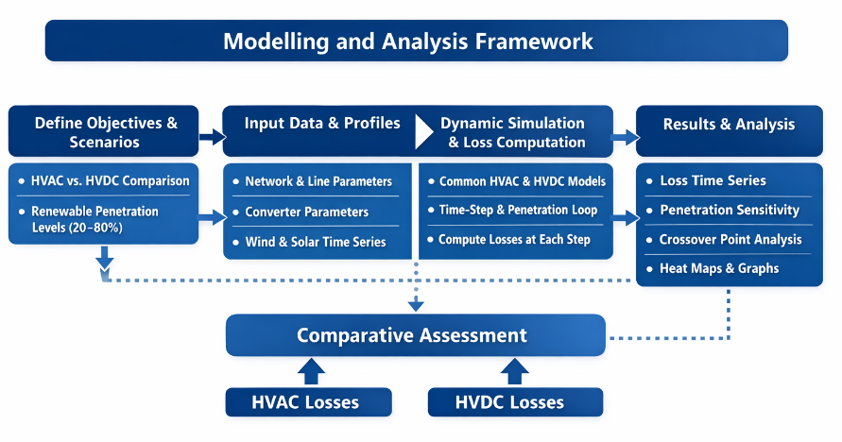
Figure 1: Flowchart of the Study Modelling and Analysis Framework

RESULTS AND DISCUSSION

Table 1: Simulation Analysis Parameters
Parameters | Values/Units
Base load | 1000 MW
Transmission voltage (HVAC) | 400 kV (line-to-line)
Transmission voltage (HVDC) | 500 kV
Transmission line length | 300 km
HVAC line resistance | 0.03 Ω/km
HVAC transformer loss coefficient | 0.002 MW per MVA
HVAC power factor | 0.95
HVDC line resistance | 0.015 Ω/km
HVDC converter proportional loss | 0.01 MW per MW
HVDC converter constant loss | 2 MW
Renewable penetration levels | 20, 40, 60, 80 %
Simulation horizon | 24 hours
PV generation profile | dynamic
Wind generation profile | stochastic

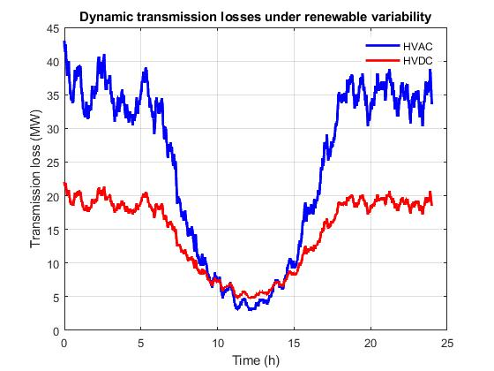
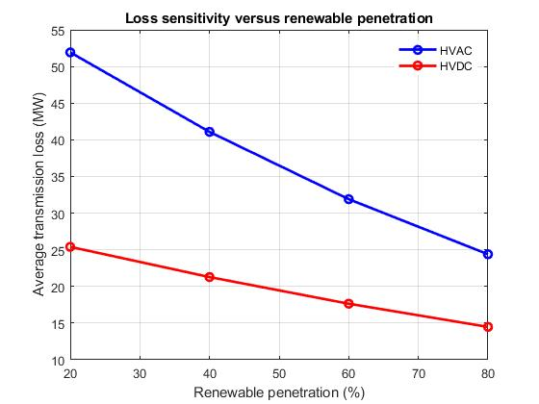

Fig. 3: Loss Sensitivity against Renewable Penetration

Fig. 2: Dynamic Transmission Losses under renewable variability

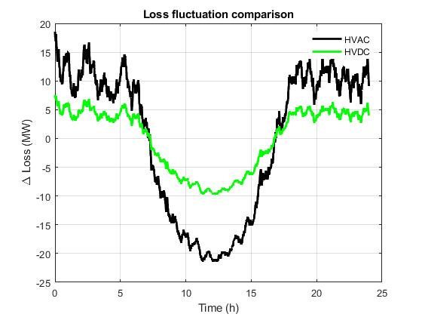
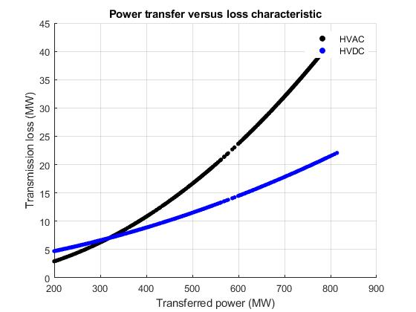

Fig. 5: Power Transfer against Loss Characteristics
Fig. 4: Loss Fluctuation Comparison

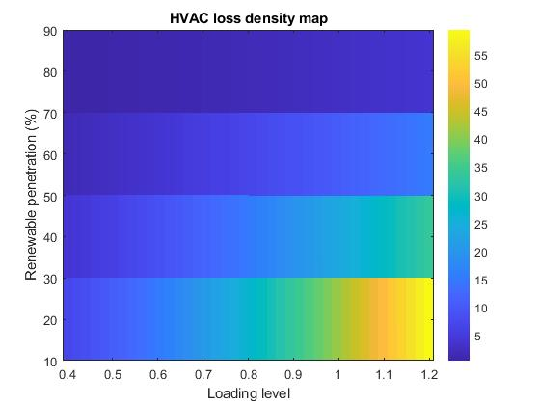
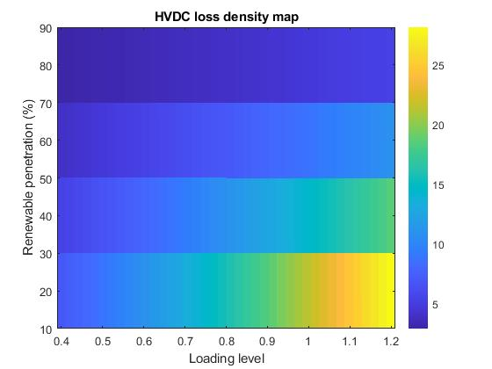

Fig. 7: HVDC Loss Density Map

Fig. 6: HVAC Loss Density Map

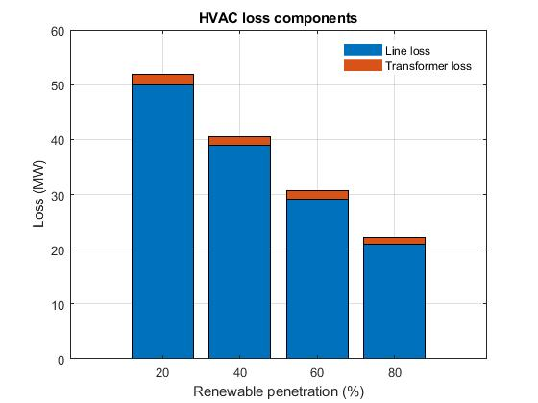
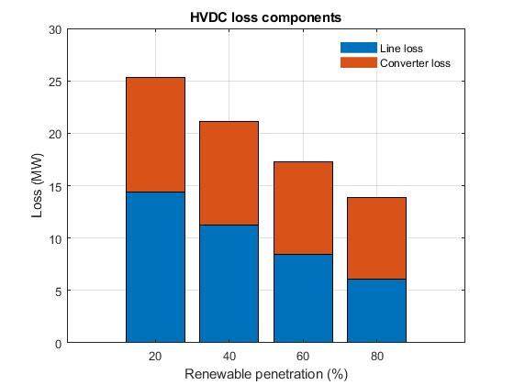

Fig. 9: HVDC Loss Components

Fig. 8: HVAC Loss Components

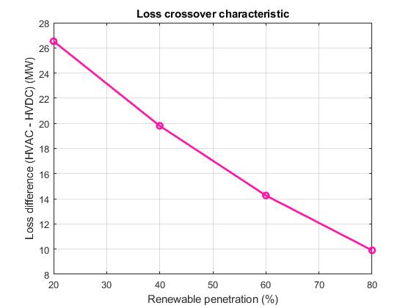
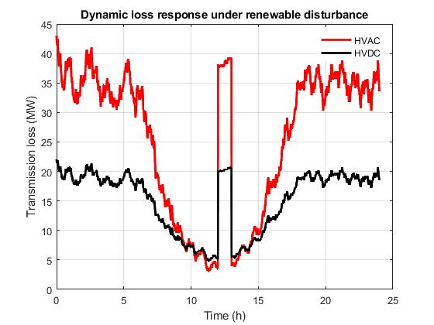

Fig. 11: Dynamic Loss Response under Renewable Disturbances
Fig. 10: Loss Crossover Characteristics

As shown in Fig. 2, the HVAC and HVDC systems were dynamic in terms of transmission losses at 80 percent of renewable penetration. HVAC losses in the range of 25MW -35MW, HVDC losses are less in the range of 18MW-22MW. The HVAC losses are more powerful where it concerns its variation due to combined effects of active and reactive changes in power as a consequence of variability of the renewable generation. HVDC losses on the other hand are more predictable with active power directly controlled by the converter between VSC-HVDC, and hence the reactive power flow is not much. To accomplish high renewable penetration corridors HVDC has the advantage of less average losses and more predictable operation that reduces stresses on upstream generators, and an improved network in general.

Fig. 3, shows the mean transmission loss at various levels of renewable penetration.

Table 2: Average transmission losses for both HVAC and HVDC
Penetration (%) | HVAC Avg Loss (MW) | HVDC Avg Loss (MW)
20 | 25 | 53
40 | 22 | 41
60 | 18 | 32
80 | 17 | 24

The results indicate that HVAC losses are sensitive to the renewable infiltration compared to the HVDC illustrating that HVAC is less scalable in cases of high renewable. The HVDC is preferred in the future renewable predominant networks because it has less loss at penetrations levels of more than 50. Fig. 4 suggests, Loss deviations to the mean of 80 percent renewable penetration that HVAC losses fluctuate in the range of about ±15 MW, whereas the HVDC losses do not fluctuate in a range exceeding 5 MW. HVAC losses are more variable as it is both affected by renewable variability and reactive flows of power. HVDC provides superior predictability of the transmission losses and this reduces operational uncertainty and chances of over-heating of the line in the short time variations caused by renewable variations. Fig. 5. above depicts that both the HVAC losses and the power loss also increase by approximately 3-4 percent with increase in transmitted power between approximately 5 MW and 40 MW and the HVDC losses are less at about 2 percent. With the occurrence of corridors with large and unstable power flows, HVDC will reduce absolute losses by 523 MW, which is equal to saved operation and efficiency.
The heatmaps that revealed the behavior of the losses in the range of renewable penetration (20-80 percent) and loading (0.412 pu) were Fig. 6 and 7: the HVAC and the HVDC losses are the highest with high loading and 80 percent penetration, and less sensitivity to the penetration. Flame warrants these areas of operation that HVDC performs better to guide the design of its transmission and operation in the context of incorporating renewables. The loss bifurcation as displayed in fig. 8 and 9, indicates that the loss that dominates the most is the HVAC; Line loss (~22 MW at 80 point penetration), then it is again the transformer loss (~9 MW). And HVDC Line loss Approximately 15 MW, converter loss Approximately 6 MW at 80 per cent penetration. The line losses are common in the HVAC which means that as the transformers are upgraded, the efficiency can be raised to a certain degree. On the other hand, the lower total losses of HVDC and modular converter structure makes it easier to apply it to a high capacity corridor.
Fig. 10. Displays the loss difference (HVAC -HVDC) versus renewable penetration.

Table 3: Difference in Losses (HVAC-HVDC)
Penetration (%) | HVAC – HVDC (MW)
20 | 26.5
40 | 24
60 | 14
80 | 10

HVDC outperforms HVAC at all levels of penetration interrogated and with an increased amount of renewable penetration the gap in performance between the two systems increases. HVDC is technically and economically superior when the corridors of renewability are further than 300 km or more than 50 percent renewability.
In simulated wind/PV generation drop (t = 10 -15 h) as in fig.11. The HVAC loss is highest at 5 MW to 38 MW. And there is slight increment in HVDC losses between 6 MW and 22 MW. Rapid losses in renewable that are caused by reactive power and line current swings affect the HVAC losses. There is high fast converter control, and the HVDC is highly efficient in absorbing the disturbances.

CONCLUSION
This paper established that the HVDC transmission has much lower power losses as well as more stable power losses than HVAC in renewable dominated transmission corridors. The comparative studies reveal that the effect of the variability of the renewable generation and reactive power demand on the HVAC losses is high and this sensitivity increase with the high renewable penetration. On the other hand, the results of dynamic simulations indicate that HVDC links are more robust to operating disturbances whose lose spikes are significantly smaller and shorter than transient events. Having loss heatmap, loss-component decomposition, and crossover analysis used simultaneously also provides a convenient form of planning by allowing one to clearly see where HVDC can be technically feasible in comparison with HVAC. Combined with these findings indicate that HVDC corridors are supposed to be strategically installed as reliable and more cost-effective transmission systems of high-renewable power systems.

REFERENCES
Ackermann, T. (2017). Wind power in power systems (3rd ed.). Wiley.
Adetokun, B. B., Muriithi, C. M., Ojo, J. O., & Oghorada, O. (2023). Impact assessment of increasing renewable energy penetration on voltage instability tendencies of power system buses using a QV-based index. Scientific Reports, 13(1), 9782.
https://doi.org/10.1038/s41598-023-36944-4
Arrillaga, J. (2019). High voltage direct current transmission (2nd ed.). IET.
Bollen, M. H. J. (2007). Integration of distributed generation in the power system. Wiley-IEEE Press.
Davidson, C., Dorn, J., Jain, A. K., & Shore, N. L. (2025). Power losses in LCC and VSC HVDC converter stations. In High voltage DC transmission systems (pp. 699–741). Springer.
Faruque, M., Islam, R., & Mourshed, M. (2018). Impact of renewable energy integration on transmission losses in AC networks. IEEE Transactions on Power Systems, 33(5), 5432–5441. https://doi.org/10.1109/TPWRS.2018.2805254
Glover, J. D., Sarma, M. S., & Overbye, T. (2023). Power system analysis and design (7th ed.). Cengage Learning.
Hansen, A. D., & Cutululis, N. (2019). Break even distance for HVAC and HVDC transmission. Electric Power Systems Research, 91, 66–77.
Helseth, A. (2012). A linear optimal power flow model considering nodal distribution of losses. In Proceedings of the 9th International Conference on the European Energy Market (pp. 1–8). IEEE.
Holttinen, M., Milligan, M., Kirby, B., Acker, T., Neimane, V., & Molinski, T. (2008). Using standard deviation as a measure of increased operational reserve requirement for wind power. Wind Engineering, 32(4), 355–378.
Institute of Electrical and Electronics Engineers. (2010). IEEE standard definitions for the measurement of electric power quantities under sinusoidal, nonsinusoidal, balanced, or unbalanced conditions (IEEE Std 1459-2010).
International Electrotechnical Commission. (2020). IEC 61803:2020 – Determination of power losses in high-voltage direct current (HVDC) converter stations with line-commutated converters.
Islam, M. M., Yu, T., Giannoccaro, G., & Mi, Y. (2024). Improving reliability and stability of power systems: A review on the role of energy storage systems to enhance flexibility. IEEE Access. Advance online publication.
Jacobson, B., et al. (2023). VSC HVDC technology and applications for renewable integration. IEEE Power Electronics Magazine, 10(3), 34–46.
Kazimi, M. K., & Ali, S. (2024). Reactive power impacts on HVAC losses in renewable rich grids. IEEE Transactions on Power Delivery, 37(1), 45–52.
Khatibi, M., & Ahmed, S. (2019, June). Impact of distributed energy resources on frequency regulation of the bulk power system.
Kundur, P. (2023). Power system stability and control (2nd ed.). McGraw-Hill.
Li, C., Dai, J., Zhu, S., Guo, R., Liu, Z., Jiang, Y., & Wen, Y. (2025). Credible capacity evaluation of virtual power plants considering wind and PV uncertainties. Scientific Reports, 15(1), 41976.
https://doi.org/10.1038/s41598-025-41976-0
Mauludin, M. S., Khairudin, M., & Asnawi, R. (2025). Optimization of a hybrid PV-wind power system for enhancing efficiency and power quality using MATLAB/Simulink simulations. Journal of Electrical Systems Architecture, 58(4).
May, T. W., Yeap, Y. M., & Ukil, A. (2016). Comparative evaluation of power loss in HVAC and HVDC transmission systems. In Proceedings of the 2016 IEEE Region 10 Conference (TENCON) (pp. 637–641). IEEE.
https://doi.org/10.1109/TENCON.2016.7848496
Olivares, F., et al. (2022). Time series analysis of transmission losses in renewable environments. Energy Conversion and Management, 256, 115335.
Rahman, M. M., Dadon, S. H., He, M., Giesselmann, M., & Hasan, M. M. (2024). An overview of power system flexibility: High renewable energy penetration scenarios. Energies, 17(24), 6393.
https://doi.org/10.3390/en17246393
Ramachandran, S., & McCalley, J. D. (2024). Dynamic loss assessment under renewable variability. IEEE Transactions on Sustainable Energy, 15(5), 703–713.
Saadat, H. (2018). Power system analysis (4th ed.). McGraw-Hill.
Sajadi, L., Strezoski, R., Kolacinski, R., & Loparo, K. (2020, January). Transmission system planning for integration of renewable electricity generation units.
Singh, D., & Jain, M. (2022). HVDC converter loss modeling and control for renewable penetration. International Journal of Electrical Power & Energy Systems, 134, 107403.
Slimene, M., & Khlifi, M. A. (2025). A hybrid renewable energy system with advanced control strategies for improved grid stability and power quality. Scientific Reports, 15, 23445.
https://doi.org/10.1038/s41598-025-06091-w
Teferi, T. G., Tella, T. G., & Hampannavar, S. (2024). Impact of large-scale renewable energy integration on the grid voltage stability. Results in Engineering, 23, 102398.
https://doi.org/10.1016/j.rineng.2024.102398
Varma, R. K. (2017). HVDC transmission for renewable energy integration. IEEE Power & Energy Magazine, 15(6), 34–44.
Wang, Y., & Strunz, K. (2020). HVAC vs. HVDC transmission losses and economic evaluation for bulk power transfer. Energy Reports, 6, 1116–1128.
https://doi.org/10.1016/j.egyr.2020.05.007
Zdiri, M. A. (2025). Impact assessment of photovoltaic and wind energy integration on low voltage distribution networks in Tunisia. Scientific Reports, 15, 10594.
https://doi.org/10.1038/s41598-025-93488-2

