AI-Enabled Predictive Systems for Women Safety in Smart Cities

Abstract—Recent progress in Artificial Intelligence (AI) has made it possible to create smart systems that make smart cities safer for women. This paper offers an extensive evalua- tion of current AI-driven predictive frameworks, emphasizing their functionalities, constraints, and prospective advancements in proactive threat identification and mitigation. The review looks at a number of different methods, such as surveillance systems based on deep learning, gesture and voice recognition techniques, predictive crime mapping, mobile safety apps, and WiFi-based models for recognizing human activity. Research that combines technologies like YOLO, ResNet, OpenPose, BiLSTM, and CNN-GRU shows that it is possible to find distress signals, suspicious behavior, and environmental risks in real time. The paper additionally discusses about how smart infrastructure solutions like intelligent street lighting, geospatial safety analytics platforms, and crowdsourced safety scoring systems can make cities safer for women. There are also talks about privacy- preserving machine learning and explainable AI frameworks to deal with ethical and transparency issues that come up with large-scale surveillance systems. The paper identifies important research gaps based on the literature that was reviewed. These gaps include the need for unified multimodal systems, zero- device safety mechanisms, and better integration with smart city infrastructure. The study concludes that AI-driven predictive systems, when integrated with ethical safeguards and urban planning strategies, can substantially improve women’s security, emergency responsiveness, and inclusivity in forthcoming smart cities.
Index Terms—Women’s Safety, Deep Learning, Predictive Policing, Explainable AI, Smart Cities, Gesture Recognition, Zero-Device Safety.
or wearable device. These advanced systems use Computer Vision, the Internet of Things (IoT), and multimodal analytics to look at complicated behavioral and environmental signals.
- Automated Threat Recognition: Using deep learning models like YOLOv8 and ResNet-50, systems can now find weapons, spot lone women in dangerous areas, and analyze crowd density to detect possible mob situations [18].
- Gesture and Audio Analytics: AI is trained to recognize SOS hand signals, defensive body language (such as crossing arms or freezing), and sounds of panic, including screams or sudden changes in voice tone [19].
- Predictive Policing: AI examines past crime data and environmental factors like lighting and isolation to gen- erate “threat scores” and dynamic heatmaps. This enables police to allocate resources to high-risk areas proactively [20].
These technologies are getting better to deal with ethical issues as they become part of larger smart city systems, like smart street lighting and Integrated Command and Control Centers (ICCCs). There are new unified frameworks being made to bring together Explainable AI (XAI) and Privacy- Preserving Machine Learning (PPML). This is to make sure that the push for more safety doesn’t put people’s privacy or data security at risk. [21]

  - Introduction
Keeping women safe in both public and private spaces is still a major global problem that has a big effect on their ability to move around, work, and get opportunities. Passive CCTV surveillance and manual panic buttons are examples of traditional security measures that have mostly been reac- tive. They only respond after an incident has happened or require the victim to actively trigger an alert, which is often impossible in high-stress situations. To fix these problems, new technologies have made it possible to create proactive safety systems that use Artificial Intelligence (AI) and Deep Learning to find threats in real time and stop them before they get worse. This move toward AI-driven safety focuses on ”zero-device” solutions, which means that the environment itself watches for distress without the victim having to use a smartphone
  - Related work
The paper highlighting the potential for creating a secure and self-sustaining infrastructure. The paper concludes by highlighting the need for strong regulatory frameworks, ethical oversight, and public participation to ensure that the power of AI is used responsibly and that smart cities are safe, inclusive, and consistent with the values of the communities they serve. [1]
The paper introduces a unified framework that integrates Ex- plainable Artificial Intelligence (XAI) with Privacy-Preserving Machine Learning (PPML) to address the dual challenges of transparency and data privacy in real-time decision-making systems. The study demonstrates that by employing federated learning, homomorphic encryption, and interpretable models like SHAP, the framework achieves significant improvements

in interpretability and privacy adherence without compromis- ing the computational efficiency required for sectors such as healthcare and energy optimization. [2]
The paper presents a proactive, AI-driven threat detection framework designed to enhance women’s safety in urban environments by utilising deep learning models like YOLOv8 and ResNet-50 to analyse live surveillance feeds for distress signals. The system features ”zero-device” safety through multimodal analytics, capable of recognising specific SOS gestures and auditory signs of panic, while leveraging edge computing to ensure real-time alerts even in low-connectivity areas. [3]
The article details a comprehensive AI-powered analytics system that shifts women’s safety measures from reactive responses to proactive threat detection by monitoring real-time interactions and identifying suspicious behavioural patterns. It highlights the integration of gesture and voice-activated distress signals, alongside predictive crime mapping tools that
mobility, services, and response to violence. By pilot-testing this framework in six smart cities, the study highlights the importance of integrating gender-disaggregated data and the ”care economy” into urban planning to build cities that are responsive, inclusive, safe, and equitable for women. [7]
The briefing note provides a comprehensive framework for addressing Violence Against Women and Girls (VAWG) through infrastructure and urban programming, identifying key entry points such as transport, energy, and water services to mitigate risks. It emphasizes the economic cost of violence and outlines strategies for creating safe spaces, arguing that infrastructure projects must go beyond basic compliance to empower women and transform social norms. [8]

TABLE I
AI-Enabled Predictive Systems and Their Applications

System / Frame- Key Technologies Uses and Applications
work

analyse historical data to generate dynamic heatmaps, thereby enabling law enforcement to deploy resources strategically to high-risk zones. [4]
The paper proposes a multi-layered safety system that combines a mobile application with AI-driven computer vision to detect weapons and record evidence in real-time, aiming to address the limitations of existing reactive safety tools. The system integrates GPS tracking, emergency alerts, and cloud-
Unified XAI &
PPML Framework

AI-Driven Real-
Time Threat Detection
Federated Learning,
Homomorphic Encryption, SHAP

YOLOv8, ResNet- 50, LSTM
Healthcare: Predicting
cardiovascular disease risk using anonymized data [1,2]. Energy: Forecasting household demand patterns.
Threat Detection:
Identifying high-risk scenarios and SOS gestures [3]. Alerts: Environmental-based

based evidence storage to ensure quick police intervention
predictive warnings [4].

and prevent evidence tampering, offering a holistic preventive mechanism for women’s security. [5]
The study evaluates deep learning architectures, specifically
Women Safety Ana- lytics System
Deep Learning, OpenPose
Crime Mapping: High- lighting risk-prone areas [5]. Behavior Analysis: Detecting suspicious ac-

BiLSTM and CNN+GRU models, for Human Activity Recog-
tivity [6].

nition (HAR) using WiFi Channel State Information (CSI) to enable non-intrusive monitoring without wearable sensors. The findings indicate that while CNN+GRU models excel
WiFi-Based HAR BiLSTM, CNN+GRU, WiFi CSI
Healthcare: Fall detection and anomaly monitoring [7]. Smart Homes: Predictive

in extracting spatial features for accuracy, BiLSTM models
Safetipin Geospatial Analysis,
automation.
Route

are superior for capturing temporal dependencies in high- resolution data, highlighting their potential applications in healthcare and smart home automation. [6]
The article explores the critical role of smart street lighting in fostering safer and more inclusive urban spaces for women,
citing studies that link improved illumination to a significant

AI-Powered Mobile Safety System
Safety Scoring:
Crowdsourcing risk assessment [8]. In-
frastructure: Identifying dark spots [9,10].
Machine Learning, Crime Prevention: Real- Weapon Detection time weapon detection
[11,12]. Risk Analysis:
Monitoring odd-hour ac-

reduction in violent crimes and harassment. It argues that beyond utility, intelligent lighting serves as a tool for em- powerment, enabling women to navigate public spaces with confidence and participate more fully in the workforce and community life. [7]
The entry describes Safetipin as a social organisation that leverages technology and mobile applications to collect data on urban safety parameters, such as lighting and visibility, to generate safety scores for neighbourhoods and routes. It details how this crowdsourced data informs users’ mobility decisions and guides government interventions to fix infras- tructure gaps, thereby making public spaces more inclusive for women. The report introduces the ”She RISES” assessment framework, developed to evaluate the gender responsiveness of Indian cities across five pillars, including policy, infrastructure,
tivities.

  - Research findings
The diagram 1 highlights core AI innovations that can be applied to women’s safety systems. Each component con- tributes to building an intelligent, proactive, and responsive safety ecosystem.
- Autonomous Threat Detection
AI systems can automatically identify potential danger without human intervention. For women’s safety, this includes:
  - Detecting suspicious behavior through CCTV or wearable devices
  - Recognizing distress signals such as screams, abnormal movement, or panic gestures

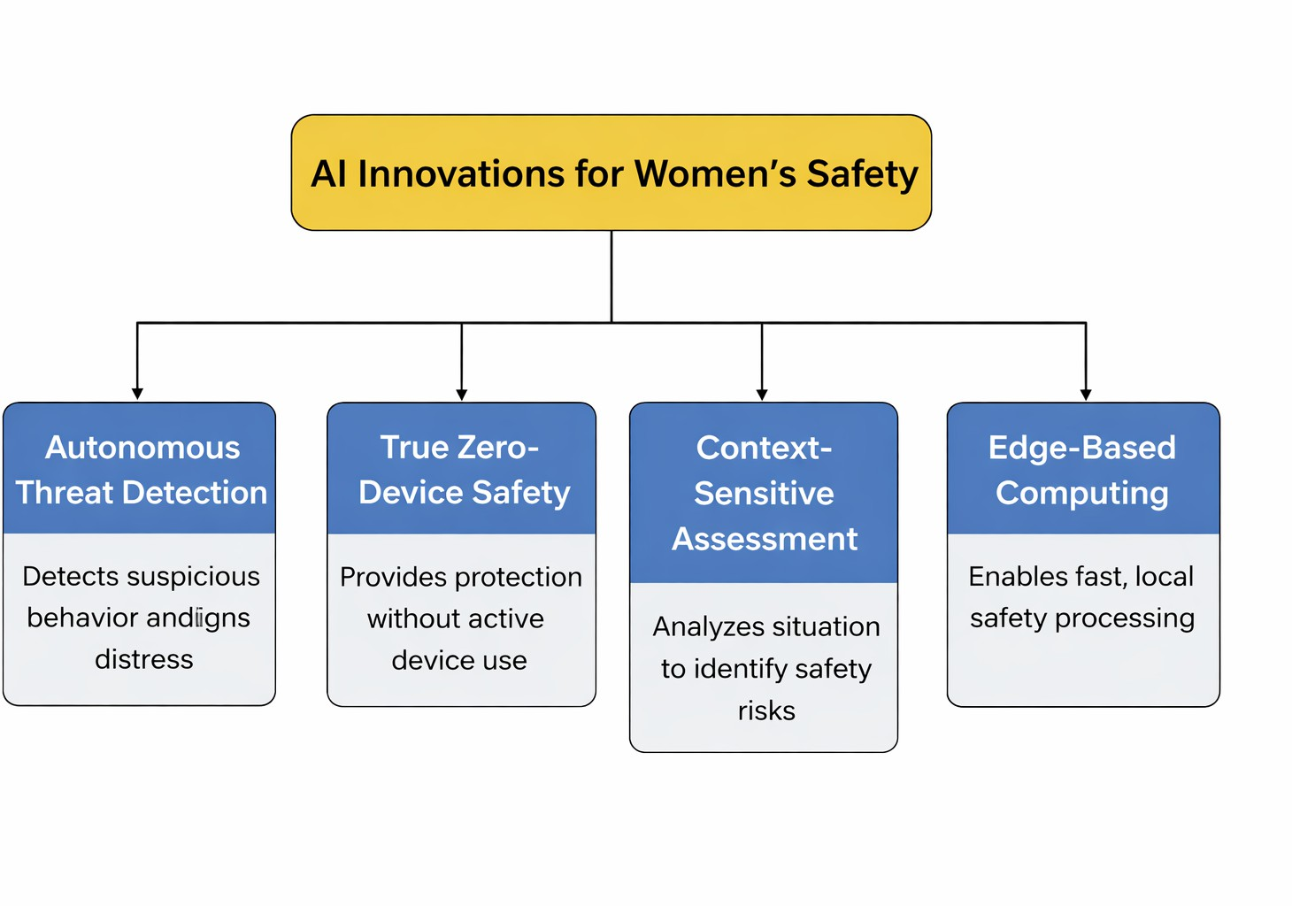
Fig. 1. AI Innovations for Women’s Safety Block Diagram

  - Sending real-time alerts to authorities or trusted contacts [9]
Example: A smart mobile application that detects sudden running, shaking, or shouting and triggers an emergency alert.
- True Zero-Device Safety
This concept ensures safety even when the individual does not actively use a device. Applications include:
  - Smart city surveillance systems recognizing unsafe situ- ations in public areas
  - AI-enabled street cameras detecting harassment or stalk- ing behavior
  - Public transport monitoring systems ensuring passenger safety [10]
Goal: Protection should not depend solely on the victim pressing an emergency button.
- Context-Sensitive Assessment
AI systems analyze the surrounding situation and environ- ment rather than relying only on raw data. This enables:
  - Distinguishing between normal interaction and aggressive behavior
  - Identifying high-risk locations such as isolated streets or late-night travel routes
  - Providing personalized safety recommendations based on time, location, and user habits [11]
Example: AI warning a user — “This area has low lighting and low activity. Consider a safer route.”
- Edge-Based Computing
In this approach, processing occurs directly on the device (mobile phone, wearable, or smart camera) instead of cloud servers. Benefits include:
  - Faster emergency response due to reduced latency [12]
  - Improved privacy protection since data remains local
  - Functionality in low or no network connectivity environ- ments [13]
Example: A smartwatch detecting distress and sending an SOS alert instantly without requiring internet connectivity.
  - Future Developments in AI-Based Women’s
Safety Systems
The figure illustrates the potential future advancements in AI-driven women’s safety solutions, highlighting emerging technologies that can significantly enhance protection, mon- itoring, and emergency response mechanisms.
Smart City Infrastructure Integration focuses on con- necting AI safety systems with urban infrastructure such as

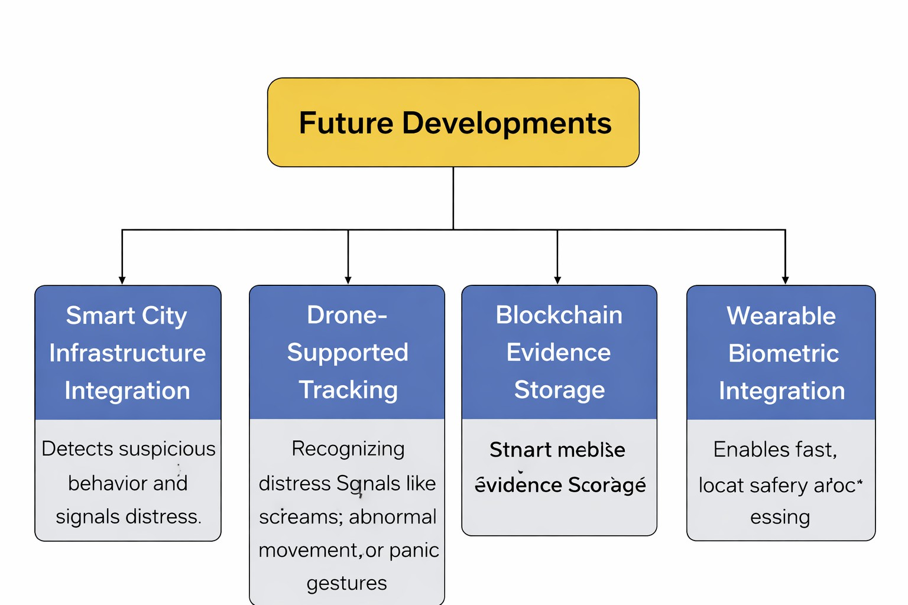
Fig. 2. Future Developments in AI-Based Women’s Safety Systems

surveillance cameras, street lighting, transportation systems, and emergency response networks. This integration enables real-time monitoring of public spaces and rapid identification of unsafe situations, thereby improving overall public safety. [13]
Drone-Supported Tracking represents the use of au- tonomous aerial systems to assist in locating individuals in distress situations. Drones equipped with AI-powered vision and tracking algorithms can quickly reach remote or crowded areas, provide situational awareness to authorities, and support rescue operations more efficiently. [14]
Blockchain Evidence Storage introduces secure and tamper-proof storage of safety-related data such as incident reports, video recordings, and emergency alerts. Blockchain technology ensures data integrity, transparency, and legal re- liability, which can be crucial for investigations and judicial processes. [15]
Wearable Biometric Integration emphasizes the use of smart wearable devices capable of monitoring physiological parameters such as heart rate, stress levels, and movement patterns. AI algorithms can analyze these biometric signals to detect distress conditions and automatically trigger alerts without requiring manual intervention. [16]
Overall, these future developments aim to create a com- prehensive, intelligent, and proactive safety ecosystem that combines advanced technologies with real-world infrastructure to enhance women’s security, emergency responsiveness, and trust in safety systems.

References

- S. Russell and P. Norvig, Artificial Intelligence: A Modern Approach, 4th ed., Pearson, 2021.
- M. Mohammadi, A. Al-Fuqaha, S. Sorour, and M. Guizani, “Deep Learning for IoT Big Data and Streaming Analytics: A Survey,” IEEE Communications Surveys & Tutorials, vol. 20, no. 4, pp. 2923–2960, 2018.
- A. Zanella, N. Bui, A. Castellani, L. Vangelista, and M. Zorzi, “Internet of Things for Smart Cities,” IEEE Internet of Things Journal, vol. 1, no. 1, pp. 22–32, 2014.
- Y. Liu, X. Ma, L. Shu, G. P. Hancke, and A. M. Abu-Mahfouz, “From Industry 4.0 to Agriculture 4.0: Current Status, Enabling Technologies, and Research Challenges,” IEEE Transactions on Industrial Informatics, vol. 17, no. 6, pp. 4322–4334, 2021.
- J. Chen and X. Ran, “Deep Learning With Edge Computing: A Review,”
Proceedings of the IEEE, vol. 107, no. 8, pp. 1655–1674, 2019.
- K. Rose, S. Eldridge, and L. Chapin, “The Internet of Things: An Overview,” The Internet Society (ISOC), 2015.
- S. Nakamoto, “Bitcoin: A Peer-to-Peer Electronic Cash System,” 2008.
- M. Crosby, P. Pattanayak, S. Verma, and V. Kalyanaraman, “Blockchain Technology: Beyond Bitcoin,” Applied Innovation Review, no. 2, pp. 6–19, 2016.

- A. Dorri, S. S. Kanhere, and R. Jurdak, “Blockchain in Internet of Things: Challenges and Solutions,” arXiv preprint arXiv:1608.05187, 2016.
- F. Restas, “Drone Applications for Supporting Disaster Management,” World Journal of Engineering and Technology, vol. 3, pp. 316–321, 2015.
- P. Voigt and A. Von dem Bussche, The EU General Data Protection Regulation (GDPR): A Practical Guide, Springer, 2017.
- J. Yang, J. Stankovic, S. Stankovic, and K. Qian, “A Survey of Wearable Sensors and Systems with Application in Rehabilitation,” Journal of NeuroEngineering and Rehabilitation, vol. 11, no. 1, 2014.
- M. Patel and J. Wang, “Applications, Challenges, and Prospective in Emerging Body Area Networking Technologies,” IEEE Wireless Communications, vol. 17, no. 1, pp. 80–88, 2010.
- N. Ma, X. Zhang, H. Zheng, and J. Sun, “Privacy-Preserving AI in Smart Healthcare: Challenges and Opportunities,” IEEE Access, vol. 8,
pp. 122076–122094, 2020.
- A. Albahri et al., “IoT-Based Smart Healthcare Monitoring Systems: A Systematic Review,” Journal of Ambient Intelligence and Humanized Computing, vol. 12, pp. 105–138, 2021.
- J. Redmon, S. Divvala, R. Girshick, and A. Farhadi, “You Only Look Once: Unified, Real-Time Object Detection,” in Proc. IEEE Confer- ence on Computer Vision and Pattern Recognition (CVPR), 2016, pp. 779–788.
- K. He, X. Zhang, S. Ren, and J. Sun, “Deep Residual Learning for Image Recognition,” in Proc. IEEE Conference on Computer Vision and Pattern Recognition (CVPR), 2016, pp. 770–778.
- T. Nishimura, K. Nishida, and S. Suzuki, “Human Behavior Recognition for Surveillance Systems Using Deep Learning,” IEEE Access, vol. 7,
pp. 135678–135688, 2019.
- A. Krizhevsky, I. Sutskever, and G. E. Hinton, “ImageNet Classification with Deep Convolutional Neural Networks,” Communications of the ACM, vol. 60, no. 6, pp. 84–90, 2017.
- B. Scho¨lkopf, R. C. Williamson, A. Smola, J. Shawe-Taylor, and J. Platt, “Support Vector Method for Novelty Detection,” in Advances in Neural Information Processing Systems (NeurIPS), 2000.
- H. Haddadi, R. Mortier, S. Hand, I. Brown, E. Yoneki, and J. Crowcroft, “Privacy Analytics,” ACM SIGCOMM Computer Communication Re- view, vol. 42, no. 2, pp. 94–98, 2012.
- Q. Yang, Y. Liu, T. Chen, and Y. Tong, “Federated Machine Learning: Concept and Applications,” ACM Transactions on Intelligent Systems and Technology, vol. 10, no. 2, 2019.
- W. Shi and S. Dustdar, “The Promise of Edge Computing,” Computer, vol. 49, no. 5, pp. 78–81, 2016.
- S. S. Intille, “A New Research Challenge: Persuasive Technology to Motivate Healthy Aging,” IEEE Transactions on Information Technology in Biomedicine, vol. 8, no. 3, pp. 235–237, 2004.
- M. A. Goodrich, B. S. Morse, D. R. Gerhardt, J. L. Cooper, M. Quigley,
J. A. Adams, and C. Humphrey, “Supporting Wilderness Search and Rescue Using a Camera-Equipped Mini UAV,” Journal of Field Robotics, vol. 25, no. 1–2, pp. 89–110, 2008.

