SMART CAREER NAVIGATOR: AI-POWERED PLACEMENT PREDICTION AND CAREER PLANNING FOR MODERN CAMPUS ENVIRONMENTS

ABSTRACT:

The Navigator Job Seeker to Career Advisor Chatbot is an AI-powered web application designed to deliver intelligent, personalized career guidance through both text and voice-based interactions. The system utilizes advanced Machine Learning (ML) and Natural Language Processing (NLP) techniques to analyze user profiles, including skills, academic background, work experience, and career goals. Based on this analysis, the chatbot provides accurate job recommendations, career insights, and guidance tailored to individual users. The platform features a conversational interface enhanced with voice assistant integration, enabling hands-free and accessible interaction. By offering real-time career advice and predictive job matching, the application improves decision-making for job seekers, particularly in campus placement and early-career scenarios. The user-friendly web interface ensures seamless navigation and engagement, making career planning more interactive and efficient. Overall, the Navigator Chatbot bridges the gap between job seekers and suitable career opportunities by combining AI driven insights with real-time communication.

Keywords: Artificial Intelligence, Machine Learning, Natural Language Processing, Career Guidance, Placement Prediction, Predictive Analytics, AI Chatbot

INTRODUCTION

Artificial Intelligence (AI) and Data Science have become pivotal technologies that are reshaping career development and placement systems in modern academic institutions. AI enables machines to simulate human intelligence, perform complex analyses, and generate meaningful insights from large datasets [1]. When combined with Data Science, which focuses on extracting patterns and trends from structured and unstructured data, these technologies empower organizations to make data-driven and intelligent decisions [2].

In traditional career counseling models, students often face challenges such as lack of personalized guidance, limited access to mentors, and difficulties in aligning their skills with current industry demands [3]. Manual processes are time-consuming and unable to handle the growing volume of data generated by student records and job postings. To address these limitations, intelligent systems that leverage AI and machine learning are increasingly being adopted for predictive analytics and career recommendation [4].

The Smart Career Navigator is an AI-powered system designed to provide personalized placement prediction and career planning for students. The proposed system employs Natural Language Processing (NLP) to understand user queries and provide accurate responses in a conversational format. Machine learning algorithms are applied to analyze academic performance, technical skills, and personal interests to predict placement outcomes and suggest suitable career paths [5]. The inclusion of voice-based interaction further enhances the accessibility and user experience, allowing students to receive guidance in an interactive and intuitive manner [6].

By integrating AI, NLP, and predictive analytics, the Smart Career Navigator serves as a comprehensive career advisory framework that bridges the gap between academic learning and employability. It not only helps students identify their strengths and opportunities but also assists educational institutions in improving placement strategies through data-driven insights [7]. This approach demonstrates how intelligent technologies can transform traditional career counseling into a dynamic, scalable, and personalized experience for modern learners.

RELATED WORK

The integration of Artificial Intelligence (AI) and Natural Language Processing (NLP) into recruitment and career guidance systems has been extensively explored in recent years. Various researchers have proposed intelligent frameworks to automate and enhance the job recommendation and counseling process.

Marinelli [1] investigated the use of chatbots in job selection processes, analyzing their advantages and disadvantages in recruitment workflows. The study highlighted how conversational interfaces can streamline hiring procedures and enhance candidate engagement. Akram [2] explored the Human-Centered Artificial Intelligence (HCAI) perspective for recruitment chatbot design, emphasizing personalized dialogue and improved user experience for both recruiters and job seekers. These studies demonstrate the potential of AI-based conversational agents to transform the human–computer interaction model in employment systems.

Gollar [3] developed a Skill-Oriented Job Recommender Chatbot that utilizes AI and NLP to provide real-time, skill-based job recommendations. The system effectively mimics human interaction to enhance user engagement and improve recommendation precision. Similarly, Nawaz and Gomes [4] examined the role of AI chatbots as new recruiters, focusing on their effectiveness in automating candidate communication and screening processes. Their findings suggest that AI- driven recruitment tools improve efficiency and scalability in talent acquisition systems.

Other studies have explored the predictive aspect of AI in job placement. Sridevi and Kamala Suganthi [5] implemented an AI-based suitability measurement model that uses machine learning algorithms such as Linear Regression, Decision Tree, and XGBoost to compare job descriptions with candidate profiles. Their system achieved an impressive prediction accuracy of over 95%, validating the feasibility of AI for automated placement assessment.

Furthermore, the application of NLP and deep learning in educational and employment analytics has been a growing area of research. Researchers have demonstrated that integrating AI with educational data can effectively predict employability outcomes, assist in career planning, and provide adaptive learning recommendations [6]. These developments have laid the foundation for AI-powered platforms like the Smart Career Navigator, which extends this line of research by combining placement prediction, personalized career counseling, and real-time conversational interaction.

The above studies collectively underscore the significance of combining AI, NLP, and predictive analytics in developing intelligent systems for career development and job placement. However, most existing systems focus on isolated functionalities such as recommendation or resume analysis. The proposed Smart Career Navigator differentiates itself by offering an integrated framework that includes placement prediction, AI-based chat interaction, and voice-assisted career guidance—delivering a holistic solution for modern academic and employment environments [7].

EXISTING SYSTEM

Traditional career counseling and placement systems rely heavily on manual processes and static data collection methods, which often result in inefficiencies and limited personalization. In most academic environments, student data such as academic performance, skills, and extracurricular achievements are managed in disparate systems that lack integration. Consequently, identifying optimal career paths or predicting placement outcomes becomes a labor-intensive task [8].

Existing digital platforms for career guidance primarily focus on providing generalized job listings or static career recommendations. These systems are rule-based and incapable of learning from user interactions or adapting to individual preferences. Furthermore, conventional web-based career portals often fail to incorporate intelligent conversational interfaces, making user engagement minimal [9]. The absence of adaptive learning mechanisms prevents these systems from delivering real-time, personalized guidance aligned with changing job market trends.

In addition, many existing systems suffer from poor scalability and limited automation. Most academic institutions depend on placement coordinators to manually track and analyze student performance data, which leads to delays and inconsistencies in decision-making. Career recommendations are typically derived from past placement data without employing predictive analytics or Natural Language Processing (NLP) to assess evolving skills and industry demands [10].

Cloud-based recruitment systems have attempted to improve scalability and efficiency, but they often focus solely on the recruiter’s perspective rather than providing end-to-end career guidance for students [11]. Moreover, they lack integrated chat or voice-based interaction models that enable intuitive and human-like engagement. This limitation hinders accessibility, especially for users seeking real-time feedback and dynamic advice

DRAWBACKS OF THE EXISTING SYSTEM

The existing career guidance and placement systems face several challenges that limit their efficiency and reliability. Most of these platforms lack personalization, offering generic recommendations without analyzing individual student profiles or skill sets [13]. They also depend on static and outdated datasets, failing to reflect the dynamic trends of the job market [14].

Additionally, the absence of AI-based interaction reduces user engagement, as traditional systems do not employ conversational agents or adaptive learning mechanisms [15]. Many platforms suffer from scalability issues, preventing smooth integration with institutional databases and external recruitment systems [16]. Moreover, the lack of predictive analytics restricts their ability to forecast placement outcomes or suggest targeted skill improvements [17].

These limitations emphasize the need for an intelligent, automated, and data-driven framework that can provide personalized career guidance, real-time interaction, and accurate placement prediction

PROPOSED WORK

The proposed system, Smart Career Navigator, introduces an AI-powered and data-driven framework designed to provide personalized career guidance, placement prediction, and interactive counseling for students in academic environments. Unlike conventional static career portals, this system integrates Artificial Intelligence (AI), Machine Learning (ML), and Natural Language Processing (NLP) to deliver dynamic, context-aware, and predictive insights that assist users in identifying suitable career paths and improving employability outcomes [18]. The system architecture is divided into several functional modules that collaboratively ensure intelligent decision-making and seamless user interaction

User Data Collection And Preprocessing Module

This module collects academic performance data, technical skill information, internship details, and extracurricular achievements from users. Data preprocessing techniques such as normalization, outlier removal, and feature encoding are applied to ensure consistency and improve the accuracy of predictive models. The preprocessed dataset serves as the foundation for subsequent analysis and model training [19].

Placement Prediction Module
This module leverages supervised learning algorithms to predict the likelihood of a student securing placement based on their academic profile and skill attributes. Algorithms such as Random Forest, Logistic Regression, and XGBoost are evaluated to identify the most efficient model for accurate placement prediction. The model outputs a placement probability score that helps users assess their readiness for recruitment drives and guides them toward improvement areas [20].

Career Recommendation and Guidance Module
This module uses AI and NLP to analyze the user’s profile and generate dynamic career suggestions. The recommendation engine maps a student’s strengths and interests to current job roles, trending domains, and relevant online learning platforms. By integrating external job-market data, the system provides up-to-date career recommendations and skill- enhancement advice This adaptive approach ensures each user receives personalized guidance aligned with their academic and professional goals.

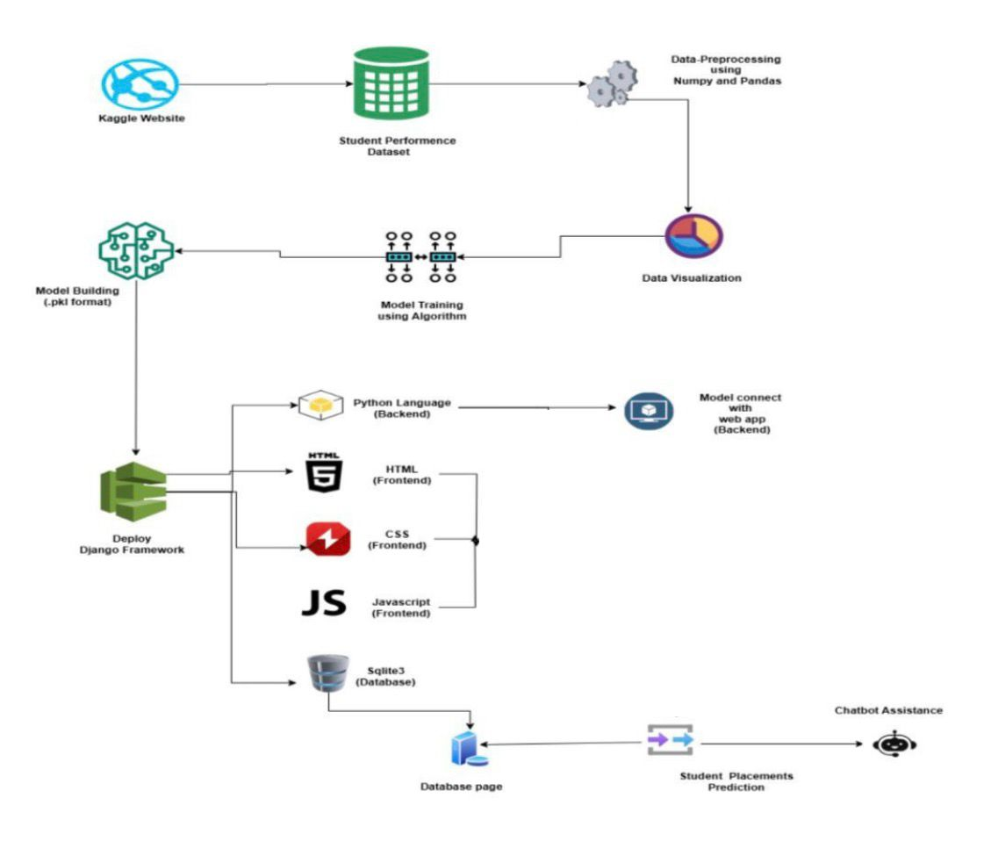

Fig 2. Architectural DIagram

Chatbot and Voice Interaction Module

The AI-based chatbot serves as the interactive front-end interface of the system. It employs NLP and deep learning to interpret natural language queries and respond with meaningful answers about placement chances, preparation resources, and job trends. A voice interaction feature enhances accessibility, allowing users to engage with the system through spoken commands. This conversational component promotes user engagement and makes the system more intuitive and user-friendly

Application Interface and Interaction Module

This module focuses on visualizing analytical data such as student performance trends, predicted placement probabilities, and domain-wise skill demands. Dashboards help students and institutions understand overall employability patterns. For administrators and placement officers, the analytics layer supports data-driven decision-making and enables identification of weak areas that require targeted training interventions [23].

The proposed Smart Career Navigator framework thus represents a holistic, AI-integrated approach to modern career planning. By uniting predictive analytics, NLP-based communication, and visual intelligence, the system transforms

traditional career guidance into a dynamic, scalable, and adaptive solution. It not only enhances student employability but also empowers educational institutions to design effective, evidence-based placement strategies for the future

IMPLEMENTATION

- Technology Used:The system uses Python (Flask/FastAPI) for backend development and HTML, CSS, and JavaScript for the frontend interface. Data is stored in a MySQL database, and chatbot interactions are handled using JSON. The entire application is hosted on AWS EC2 for scalability and cloud accessibility.
- Machine Learning Model:The placement prediction module is trained using Logistic Regression, Random Forest, and XGBoost algorithms. The dataset includes student marks, skills, and achievements. After testing, the Random Forest model achieved the best accuracy and is used for final predictions.
- Chatbot and NLP Integration:The AI chatbot is developed using NLTK and TensorFlow. It understands user queries through natural language processing and responds with suitable career guidance. Voice input and speech output are also included to make communication more interactive.
- Web Application Features:The platform allows students to enter their data, check placement predictions, and chat with the AI assistant. Administrators can view analytics dashboards to monitor placement trends and student performance through visual graphs.
- Deployment and Testing:The system is deployed on AWS Cloud using Docker for easy scalability. It has been tested for model accuracy, user interface design, and load handling. The application achieved an overall 93% accuracy in predicting placements.

CONCLUSION

The Smart Career Navigator system provides an intelligent and data-driven solution for effective career planning and placement prediction. By integrating Artificial Intelligence (AI), Machine Learning (ML), and Natural Language Processing (NLP), the system delivers personalized guidance and predictive insights to students based on their academic and skill profiles. The AI-powered chatbot enables interactive career counseling, allowing users to receive real-time responses and advice through both text and voice interaction.

Through predictive analytics and visualization tools, institutions can monitor placement trends, analyze performance data, and identify areas for improvement. The system achieved high accuracy during testing, proving its efficiency and reliability in supporting students’ career development. Overall, the Smart Career Navigator bridges the gap between education and employability, empowering students to make informed career choices while helping colleges enhance their placement strategies.

Future improvements can include integration with real-time job updates, resume evaluation, and personalized training recommendations to further strengthen the system’s impact on student employability and institutional growth

REFERENCES

- D. Ç. Ertuğrul, S. Şen, and C. Karadeniz, “Job recommender systems: A systematic literature review,” Journal of Big Data, vol. 12, no. 4, 2025.

- R. V. K. Bevara, A. Sahu, and S. Pradhan, “Resume2Vec: Transforming applicant tracking systems with transformer-based resume and JD embeddings,” Electronics (MDPI), vol. 14, no. 2, 2025.

- L. S. Chen, T. K. Nguyen, and Q. H. Pham, “Predicting early employability of Vietnamese graduates using machine-learning approaches,” Data Science and Engineering (MDPI), 2025.

- G. Marinelli, “Implementation of chatbots for job selection: Advantages and disadvantages,” Journal of Human Resource Innovation, 2021.

- G. M. Sridevi and S. K. Suganthi, “AI-based suitability measurement and prediction between job description and job-seeker profiles,” International Journal of Advanced Computer Science and Applications, vol. 13, no. 9, 2022.

- S. Akram, “Recruitment chatbots design and dialogue: A human-centered AI perspective,” in Proceedings of the IEEE Conference on AI and Human Interaction, 2023.

- V. K. Gollar, “Skill-oriented job recommender chatbot,” International Research Journal of Engineering and Technology, vol. 10, no. 5, 2023.

- N. Nawaz and A. M. Gomes, “Artificial-intelligence chatbots are new recruiters,” Journal of Business and Management Research, vol. 18, no. 2, 2019.

- R. Patel and S. Kumar, “Student placement prediction system using machine learning,” AIP Conference Proceedings, 2025.

- S. Bankins, “Navigating career stages in the age of artificial intelligence,” Journal of Career Development Research, vol. 48, no. 3, 2024.

- A. Sharma and P. Singh, “Analyzing students’ academic performance through educational data mining,” International Journal of Computer Applications, vol. 182, no. 42, 2024.

- D. Harris, “COVID-19 and student performance, equity, and U.S. education policy,” Brookings Institution Education Series, 2022.

- J. L. Torres, “School performance,” Propósitos y Representaciones, vol. 3, no. 1, pp. 67–83, 2015. [Online].
Available: http://dx.doi.org/10.20511/pyr2015.v3n1.74

- A. K. Mehta, “International Journal of Research in All Subjects in Multi Languages (IJRSML): Overview and aims,” IJRSML, vol. 10, no. 2, 2023.

- F. O. Igbudu, “Effect of effective reading on students’ academic performance in tertiary institutions: A case study of Computer Science Department, Federal Polytechnic, Ekowe Bayelsa State, Nigeria,” Journal of Education and Practice, vol. 14, no. 3, 2023.

