Prevalence and Molecular Characterization of Antibiotic-Resistant Escherichia coli O157:H7 Isolated from Human and Poultry Faeces in the Federal Capital Territory, Nigeria

ABSTRACT
This study accessed the prevalence and molecular characteristics of antibiotic-resistant Escherichia coli O157:H7 in humans and poultry within the Federal Capital Territory (FCT), Nigeria. A total prevalence of 9% was observed in humans, with 7.5% in Internally Displaced Persons (IDP) camps and 10.5% in hospitals, while poultry showed a prevalence of 0.8%. The isolates exhibited multiple antibiotic resistance, with 100% resistance to oxytetracycline in both human and poultry samples. Extended-Spectrum Beta-Lactamase (ESBL) enzymes were detected, and virulent genes including rfbE, eaeA, stx1, and stx2 were identified. Phylogenetic analysis revealed close genetic relationships between human and poultry isolates, suggesting possible cross-transmission and zoonotic potential. These findings highlight the urgent need for judicious antibiotic use, regular surveillance, and molecular monitoring to guide antimicrobial therapy and prevent outbreaks. The study underscores the importance of adopting a One Health approach to address antimicrobial resistance and safeguard public health.

Keywords:
Escherichia coli O157:H7, Antibiotic resistance, Oxytetracycline, Zoonosis and Extended-Spectrum Beta-Lactamase (ESBL)

INTRODUCTION

Escherichia coli (E. coli) is a Gram-negative enteric bacterium and a significant zoonotic foodborne pathogen worldwide (Hassan et al., 2021; Abebe, et al., 2020). It is grouped based on virulence factors and infection types: intestinal pathotypes [Entereopathogenic E. coli (EPEC), Entereotoxigenic E. coli (ETEC), Entereohaemorrhagic E. coli (EHEC) like O157:H7, Entereoadhesive E. coli (EAEC), Entereoinvasive E. coli (EIEC), Diffuseadherent E. coli DAEC] and extra intestinal pathotypes [Uropathogenic E. coli (UPEC), Meningitis-associated E. coli MNEC, Avian Pathogenic E. coli APEC] (Riley, 2020). Shiga-toxin producing E. coli (STEC) O157:H7 is responsible for intestinal and extra-intestinal disease syndromes in humans and animals, causing numerous outbreaks globally (Naidoo and Zishir, 2025).
- coli O157:H7 and non-O157 STEC can cause hemorrhagic colitis HC, hemolytic uremic syndrome HUS, thrombotic thrombocytopenic purpura TTP, and death. Isolation has been reported worldwide, but transmission pathways remain unclear (Meng et al., 2012). Globally, STEC causes about 2.8 million acute illnesses annually, with thousands of HUS cases and deaths (Joseph et al., 2020). In the US, E. coli O157:H7 was first recognized in 1982, with 390 outbreaks between 2003–2012 leading to thousands of illnesses and deaths. Similar outbreaks have been reported worldwide, including Germany and Africa, where O157:H7 contributes significantly to disease burden (Ison, 2016). The first African case was reported in 1990 in South Africa, with notable prevalence in Nigeria (Azubuike et al., 2018). Shiga toxins (Stx1 and Stx2), especially Stx2, are implicated in severe disease and HUS (Joseph et al., 2020. Symptoms include abdominal pain, watery diarrhea, and progression to bloody diarrhea. These toxins bind to eukaryotic cell receptors, causing tissue damage (Cohen, 2022).
Antimicrobial resistance (AMR) is a major global threat, responsible for millions of deaths annually and projected to rise annually (Tang et al., 2023). Multiple antibiotic resistance (MAR) in pathogens like Salmonella, Proteus, and E. coli O157:H7 has emerged due to widespread antimicrobial use in food animals (Grudlewska-Buda et al., 2023; Gambushe et al., 2022). Transmission from beef and poultry to humans is well-documented, with recent reports in Nigeria (Sanni, 2024). Commonly used antibiotics in poultry include tylosin, doxycycline, streptomycin, chloramphenicol, oxytetracycline, ciprofloxacin, neomycin, nitrofurantoin, gentamicin, and colistin, facilitating resistant strain spread (Fadipe and Hölzle, 2025).

MATERIALS AND METHODS
Study Area
The research was conducted in the Federal Capital Territory (FCT), Nigeria, which covers about 8,000 km² and consists of six Area Councils of Abaji, Kwali, Gwagwalada, Kuje, Abuja Municipal Area Council AMAC and Bwari (Madu, 2023; Ibilewa 2018). The FCT is mainly inhabited by the Gbagyi people, alongside other ethnic groups such as Hausa, Fulani, Yoruba, and Igbo, each engaged in farming, trade, politics, or civil service (Bawa, 2025). Agriculture is the backbone of the economy, with crops like maize, millet, yams, and beans widely grown (Ayuba et al., 2025). Poultry farming is significant, with 117 commercial farms reported in 2025, many establishing digital presence (Aminullah et al., 2025). There are five Internally Displaced Persons (IDP) camps in the FCT, located in poor sanitary conditions, lacking amenities, and prone to water-borne and infectious diseases (Ekoh et al., 2023).
Study Design
A cross-sectional epidemiological study design was adopted to investigate the prevalence and molecular characteristics of antibiotic-resistant Escherichia coli O157:H7 in human stool and poultry fecal samples within the Federal Capital Territory (FCT), Nigeria. A multi-stage sampling technique was employed. Three area councils (AMAC, Kwali, Gwagwalada) were selected by simple random sampling, and one major hospital from each council was purposively chosen: National Hospital (AMAC), University of Abuja Teaching Hospital (Gwagwalada), and General Hospital Kwali (Kwali). Stool samples of diarrhea patients were purposively collected. Two IDP camps (Kuchingoro and Karamajiji) were purposively selected, mainly occupied by children under 10 years, and stool samples from children and few adults were collected.
Commercial Production Poultry (CPP) farms with 2,500–10,000 birds in the three councils (totaling 58 farms) were listed, and three farms from each council were selected by simple random sampling. Faecal samples of birds in battery cages were purposively collected.

Sample Size Estimation
Sample size determined as described by Thrusfield (2018): Prevalence by Robert et al.2002: N= Z² pq/d²

Where: N = sample size,
Z = Standard normal deviation (1.96),
p = Prevalence in Chicken, E. coli 47.6% by Robert et al. (2002)
= Prevalence in Human, E. coli 53% by Robert et al. (2002)
d = Desired precision (0.05).
q = 1 – p
Therefore;
N _{chicken}= (1.96)² x 0.476 x (1-0.476) = 383.3;
(0.05)²
N _{Human} = (1.96)² x 0.53 x (1-0.53) = 382.8
(0.05)²

The calculated sample sizes of 383 for poultry and human were each increased by 5% and rounded to 400, resulting in 400 human stool samples and 400 poultry fecal samples. In total, 800 samples were analyzed.
Faecal Sample Collections from Poultry Farms
Faecal samples were collected from three commercial production poultry farms in AMAC, Gwagwalada, and Kwali (total 400 samples) over four weeks, following Siwela et al. (2007), and transported in ice packs to Namiroch Research Laboratory, Kwali.
Stool Sample Collections from Hospitals and IDP Camps
A total of 400 stool samples were purposively collected from three hospitals (AMAC (70), Gwagwalada (70), Kwali (60)) and two IDP camps (100 each from Kuchingoro and Karamajiji), with assistance from laboratory scientists and health workers, following Adeleke and Omafuvbe (2011). Samples were transported daily in ice packs at -4 to -8°C to Namiroch Research Laboratory for storage and analysis.
Laboratory Analysis
Sample Preparation
All samples were refrigerated before analysis, serially diluted, and plated on agar media as described by Diana et al. (2017). Media Preparation and Sterilization Media were prepared according to manufacturers’ instructions and sterilized by autoclaving or hot air oven.
The Nutrient Broth (Fluka, USA) was prepared and sterilized at 121°C for 15 minutes, refrigerated. Escherichia coli (EC) Broth (Oxoid, UK) was prepared as per APHA guidelines, sterilized at 121°C for 15 minutes. Nutrient Agar (Fluka, USA) was also prepared, autoclaved, cooled in slants, and refrigerated. Eosin Methylene Blue Agar (DIFCO, USA) was prepared, sterilized, cooled, dispensed into Petri dishes, incubated at 37°C for sterility check. And Cefixime–Tellurite Sorbitol MacConkey Agar (HIMEDIA, UK) was prepared with supplement, sterilized, cooled, dispensed into Petri dishes, incubated at 37°C for sterility check.

Bacterial Culture and Identification
Bacterial Isolation
Samples were inoculated into EC broth, streaked onto EMB agar, and incubated. E. coli colonies were identified by metallic sheen and confirmed through biochemical tests (Indole, Methyl red, Voges-Proskauer, Citrate, Catalase, Oxidase, Motility, Gelatin liquefaction, Triple sugar iron, Urease, H₂S production, Sugar fermentation). Presumptive isolates were further confirmed on CT-SMAC agar for E. coli O157:H7 (Alu et al., 2021)
Biochemical characterization of the isolated colonies was performed using the following tests: Indole Test confirmed indole production from tryptophan with a dark pink layer. Methyl Red Test confirmed acid production with a cherry-red color. Voges-Proskauer Test indicated positive results with pink to burgundy color. Citrate Utilization Test confirmed citrate use with a color change to blue. Catalase Test confirmed catalase enzyme production with bubble formation. Oxidase Test confirmed oxidase activity with a dark blue, maroon, or black color change. Motility Test confirmed motility with diffuse growth radiating from the inoculation line. Gelatin Liquefaction Test confirmed gelatinase production with liquefaction of gelatin. Triple Sugar Iron (TSI) Test confirmed glucose fermentation with CO₂ gas production, lactose and sucrose fermentation with a yellow slant, and absence of H₂S production with no blackening. Gram Staining Technique classified bacteria as Gram-positive (blue/purple) or Gram-negative (pink/red).
Identification and Characterization of E. coli O157:H7
Presumptive E. coli isolates were confirmed on Sorbitol MacConkey Agar with cefixime-tellurite supplement (CT-SMAC), where O157 appeared as colorless colonies while non-O157 strains fermented sorbitol and appeared pink. Antimicrobial susceptibility was tested using Kirby-Bauer disk diffusion with ten commonly used antibiotics from different classes, and results interpreted by CLSI guidelines to classify isolates as sensitive, intermediate, or resistant. Multiple Antibiotic Resistance (MAR) strains were identified, and ESBL production confirmed by double-disc diffusion test (DDDT) with ceftazidime and ceftazidime plus amoxicillin-clavulanic acid discs. Molecular confirmation was performed using Multiplex PCR assay targeting rfbE, eaeA, stx1, stx2, blaTEM, blaSHV, and blaCTXM genes, with DNA extracted by Phenol-Chloroform Method and analyzed by Agarose Gel Electrophoresis (AGE).
PCR Amplification Reactions
The amplification reaction mixture consisted of 2µl of extracted template DNA mixed with primers for blaTEM, blaSHV, blaCTX-M1, CTX-M2, CTX-M9, rfbE, eaeA, stx1, stx2, probes, and nuclease-free water. The PCR cycling conditions included pre-denaturation at 94°C for 5 minutes, denaturation at 94°C for 30 seconds, 30 cycles of denaturation at 94°C for 45 seconds, annealing at 55°C for 45 seconds, extension at 72°C for 60 seconds, and a final extension at 72°C for 5 minutes.
Gel Electrophoresis and Visualization under UV Lights through Transilluminator
PCR products were analyzed in 1.5% agarose gel with ethidium bromide, run at 100 volts for 60 minutes, and visualized under a UV transilluminator. Bands corresponding to expected sizes confirmed the presence of rfbE, eaeA, stx1, stx2, blaCTX-M1,2,9, blaSHV, and blaTEM genes in E. coli O157:H7 isolates.
Sequencing and Phylogeny of E. coli O157:H7-ESBL Positive Isolates from Human and Poultry in FCT
Amplified PCR fragments were purified using Nucleospin Gel Extraction Kit and sequenced with Inqaba Biotech tools. Results were analyzed using BLAST, and phylogenetic trees were constructed to show relatedness of human and poultry isolates.
Data Analysis
Data analysis were performed using Excel Spreadsheet 2016. Chi-square tests, relative risks (RR), and odd ratios (OR) were calculated, and results presented in tables and charts.
RESULTS
The prevalence of E. coli across the five selected sites was 179 (44.8%), while E. coli O157:H7 was 36 (9%). In IDP camps, Kuchingoro recorded 20 (20%) for E. coli and 5 (5%) for E. coli O157:H7, while Karamajiji had 37 (37%) and 10 (10%) respectively. In hospitals, Gwagwalada showed 51 (72.9%) and 11 (15.7%), Kwali 24 (36.9%) and 4 (6.2%), and AMAC 47 (72.3%) and 6 (9.2%) for E. coli and E. coli O157:H7 respectively.
TABLE 1: Prevalence of E. coli and E. coli O157:H7 in Humans in FCT
Location | No. of Samples | E. coli | E. coli O157:H7
Kuchingoro IDP  Karamajiji IDP  IDP Prevalence  National Hospital  UATH Gwagwalada  Kwali Gen. Hospital | 100  100  200  65  70  65 | 20 (20%)  37 (37%)  57 (28.5%)  47 (72.3%)  51 (72.9%)  24 (36.9%) | 5 (5%)  10 (10%)  15 (7.5%)  6 (9.2%)  11 (5.7%)  4 (6.2%)
Hospital Prevalence | 200 | 122 (61 %) | 21 (10.5%)
Overall Prevalence | 400 | 179 (44.8%) | 36 (9%)
χ² = 27.6, p= 0.0014, P< 0.05, OR =13, RR= 12.4

Overall, across the three area councils, the prevalence of E. coli in poultry in the FCT was 20 (5%), while E. coli O157:H7 had a prevalence of 3 (0.8%). The prevalence in AMAC was 4 (3%) for E. coli and 0 for E. coli O157:H7; in Gwagwalada 8 (5.9%) for E. coli and 2 (1.5%) for E. coli O157: H7; in Kwali 8 (6.2%) for E. coli and 1 (0.8%) for E. coli O157:H7 respectively (Table 2).
Table 2: Prevalence of E. coli and E. coli O157:H7 in Poultry in FCT
Location | No of Samples | E. coli | E. coli O157:H7
AMAC | 135 | 4 (3%) | 0 (0.0 %)
Gwagwalada | 135 | 8 (5.9%) | 2 (1.5%)
Kwali | 130 | 8 (6.2%) | 1 (0.8%)
Total | 400 | 20 (5%) | 3 (0.8%)

Escherichia coli O157:H7 in humans showed 100% resistance to Oxytetracycline, 71.8% to Amoxicillin-clavulanate, 28.2% to Erythromycin, Nitrofurantoin, and Sulphamethoxazole-Trimethoprim, and 25.6% to Ciprofloxacin. The lowest resistance was observed for Gentamicin (0.3%), Ceftazidime (2.6%), Meropenem (2.6%), and Colistin (2.6%). The multiple antibiotic resistance index (MARI) was calculated at 0.6 (Figure 1).

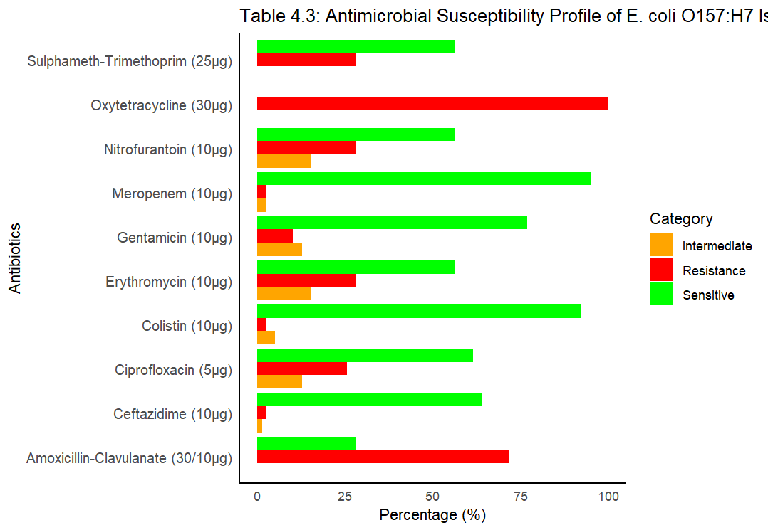
Figure 1: Antimicrobial Susceptibility Profile of E. coli 0157:H7 Isolates in Human (FCT)

E. coli O157:H7 isolates from poultry showed complete (100%) resistance to oxytetracycline, sulphamethoxazole-trimethoprim, nitrofurantoin, erythromycin, gentamicin, and colistin. Ciprofloxacin resistance was 90%, while amoxicillin-clavulanate, ceftazidime, and meropenem recorded 60%, 30%, and 10% resistance respectively. The multiple antibiotic resistance index (MARI) was notably high at 0.9 (Figure 2).
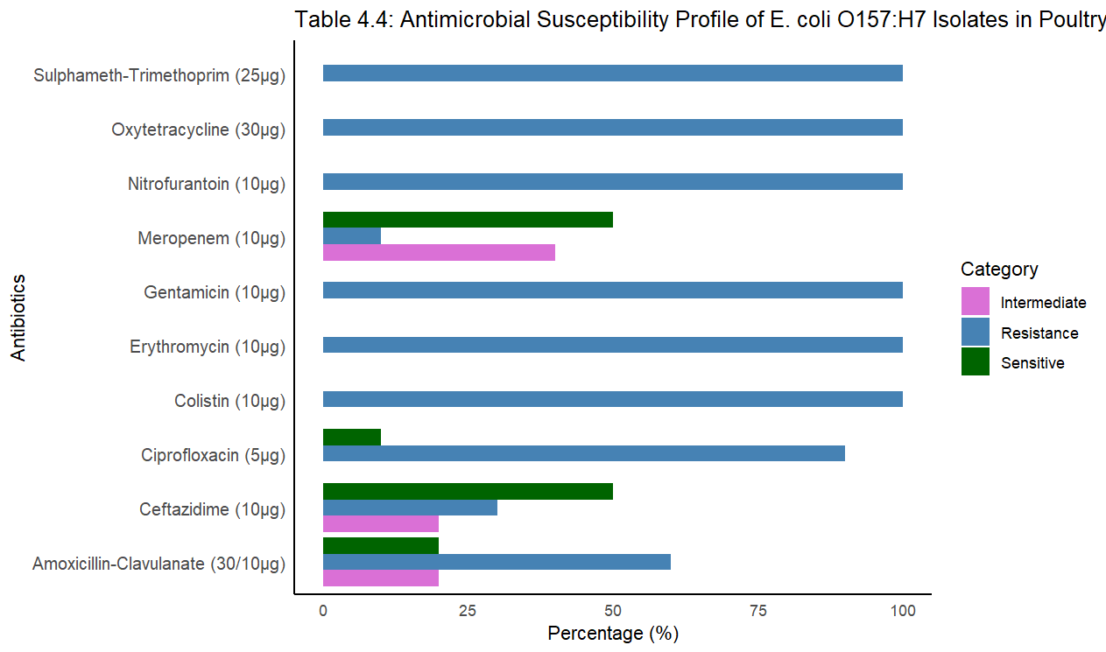
Figure 2: Antimicrobial Susceptibility Profile of E. coli 0157:H7 Isolates in Poultry
The ESBL positive isolates from Kunchingoro IDP (AMAC) were 2 (40.0%); Karamajiji IDP (AMAC), 2 (20%); National Hospital (AMAC), 0; UATH (Gwagwalada) 1 (16.7%); and General Hospital (Kwali), 1 (25%) (Figure 3).
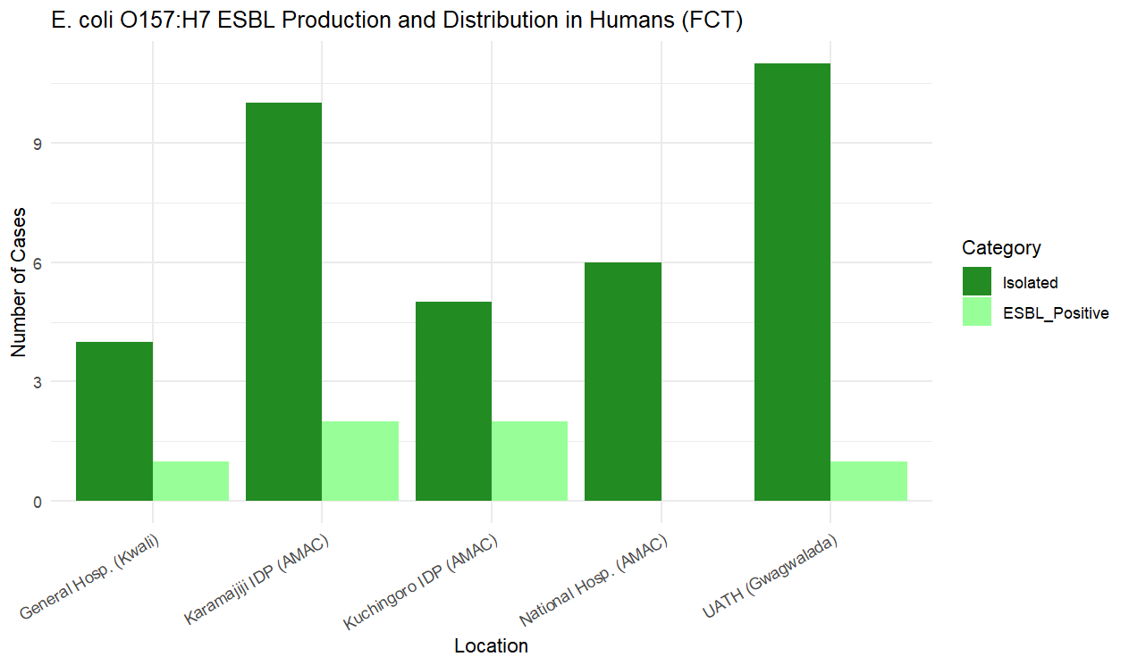
Figure 3: E. coli O157:H7 ESBL Production and Distribution in Humans in FCT
There was no ESBL positive E. coli O157:H7 isolated from AMAC farms, 0; Gwagwalada was 1 (100%); and Kwali farms 1 (50%) (Figure 4).
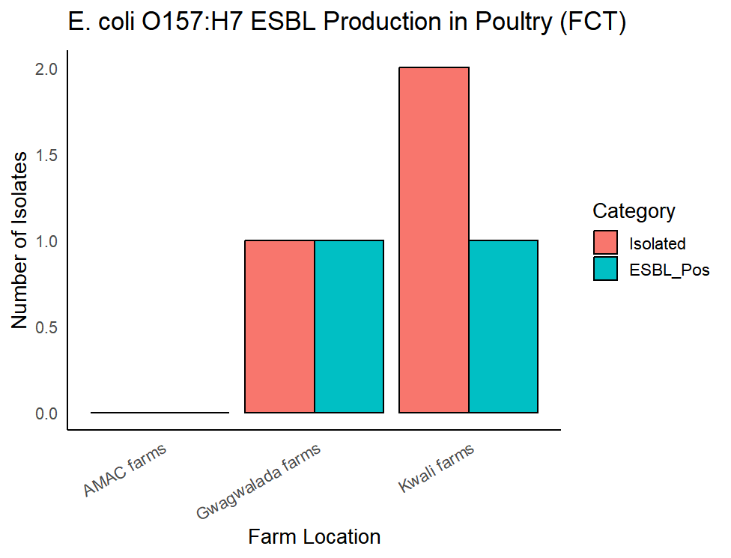
Figure 4: E. coli 0157:H7 ESBL Production in Poultry (FCT)
The agarose gel electrophoresis (1.5%) confirms the successful amplification of virulence and antibiotic resistance genes in Escherichia coli O157:H7 isolates from human and poultry sources. Human isolates H1, H2, and H3 consistently show the presence of rfbE and eaeA, with additional resistance genes such as CTX-M1, CTX-M2, CTX-M9, and TEM variably detected, indicating pathogenic and multidrug-resistant profiles. Poultry isolates P4 and P5 also exhibit rfbE and stx2, with P4 showing a broader resistance pattern including CTX-M variants and SH, suggesting a highly virulent strain. The gel image validates the multiplex PCR assay and highlights the genetic diversity and resistance potential of E. coli O157:H7 strains circulating in both human and poultry populations.
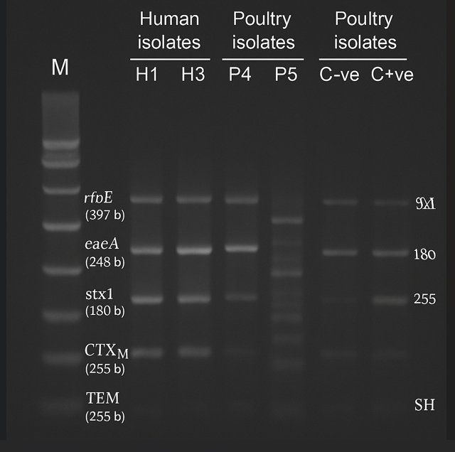
Plate 1: Agarose Gel Electrophoresis (1.5%) of Multiplex PCR Products
The phylogenetic tree analysis of E. coli O157:H7 ESBL-positive isolates in the FCT showed that the evolutionary relationships were rooted using 16S rRNA genes and core genome SNPs, with E. coli O55:H7 serving as the reference strain. The numbered nodes represent points of shared ancestry, from which lineages diverged. Genetic distances between isolates, measured in SNPs, ranged from a few to several hundred, reflecting a largely homogeneous population with occasional gene acquisitions and chromosomal rearrangements driven by prophages and plasmids. The evolutionary history indicates a gradual transition from sorbitol-positive (SOR+) ancestors to the typical sorbitol-negative (SOR–), beta-glucuronidase-negative progenies, highlighting the stepwise emergence of pathogenic lineages.

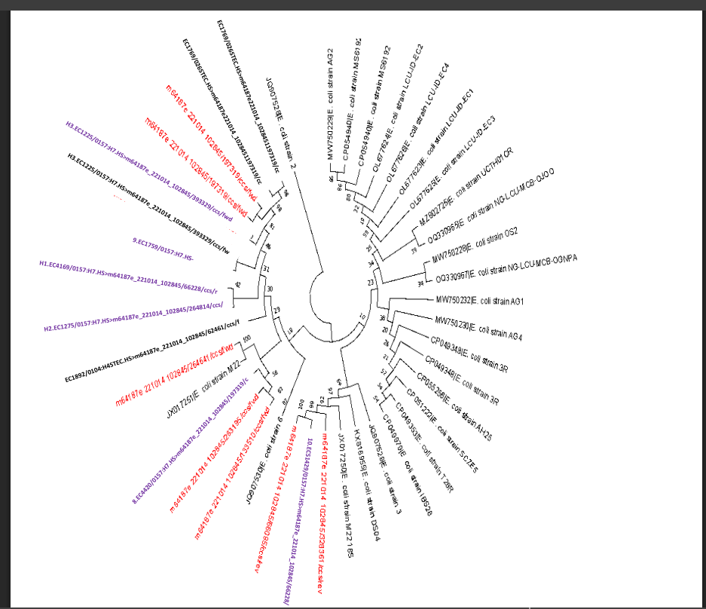
Figure 5: Human Phylogenetic Tree of E. coli O157:H7 identified from the Study (in purple) relative to the reference E. coli O157/other non-O157 Serotypes (in red) and E. coli strains (in black) from the GenBank

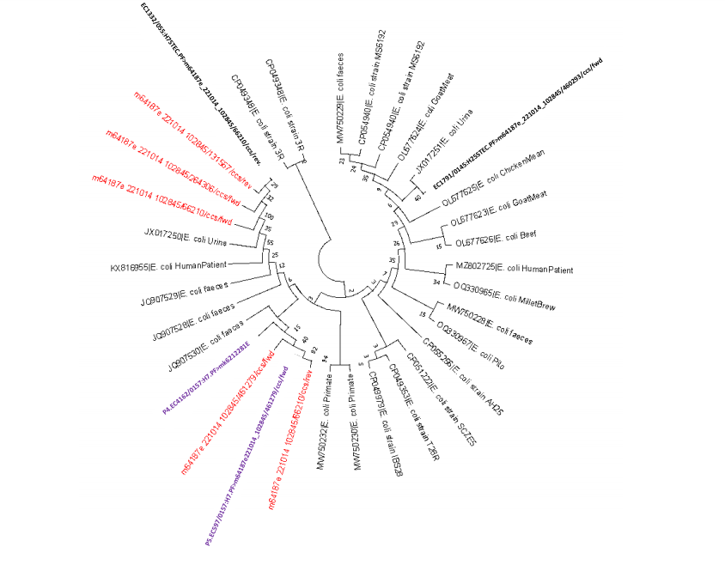

Figure 6: Poultry Phylogenetic Tree of E. coli O157 identified from the Study (in purple) relative to the reference E. coli O157/other non-O157 Serotypes (in red) and E. coli strains (in black) from the GenBank

DISCUSSION
This study investigated the prevalence of antibiotic-resistant Escherichia coli O157:H7 in humans and poultry in FCT, Nigeria. The study found a prevalence of 9% in humans (7.5% in IDP camps; 10.5% in hospitals) and 0.8% in poultry. The IDP camps had poor sanitary conditions, which may have contributed to the high prevalence. The study showed multiple antibiotic resistance (MAR) in E. coli O157:H7 from both humans and poultry. In humans, the highest resistance was to oxytetracycline (100%), amoxicillin-clavulanate (71.8%), and erythromycin (28.2%). In poultry, E. coli O157:H7 showed 100% resistance to oxytetracycline, sulphamethoxazole-trimethoprim, nitrofurantoin, erythromycin, gentamycin, and colistin. The study also detected Extended-Spectrum Beta-Lactamase (ESBL) enzymes in E. coli O157:H7, which confer resistance to different antibiotics. The Multiplex PCR assay amplified the target virulent and resistant genes, and Agarose Gel Electrophoresis (AGE) separated the genes based on molecular weights.
The study identified the virulent genes rfbE (100%), eaeA (100%), stx1 (33% human; 100% poultry), and stx2 genes (33% human; 50% poultry). The phylogenetic tree constructed from the identified E. coli O157:H7 showed a marked close phylogenetic relationship with other E. coli strains, especially the Shiga toxin-producing non-O157:H- E. coli (STEC) group. The study suggests possible cross-transmission and zoonosis of E. coli O157:H7 infections from poultry to human and vice versa. The findings highlight the need for regular surveillance and monitoring to guide antimicrobial therapy.
CONCLUSION
The study reported a prevalence of 7.5% in IDP camps, 10.5% in hospitals, and 0.8% in poultry in FCT, providing data that will guide policy makers in making decisions on the prevalence of E. coli O157:H7 during outbreaks and the choice of antibiotics. E. coli O157:H7 is pathogenic even at very low doses (10–100 CFU) and poses serious public health risks, especially in children under 5 years, as it can cause hemorrhagic colitis, hemolytic uremic syndrome (HUS), thrombotic thrombocytopenic purpura (TTP), and death. The study showed a MAR and 100% resistance to Oxytetracycline in both humans and poultry, emphasizing the need for clinicians and veterinary doctors to avoid Oxytetracycline and other tetracycline drugs due to 0% susceptibility, as their use may lead to treatment failures and further outbreaks. The specificity of AMC combo in the Kirby-Baur Double Disk Synergy Test (DDST) was equivocal, with a MAR Index of 0.6 and resistance rates of 72% in humans and 60% in poultry, suggesting AMC use may produce false negatives. The study detected and separated the eaeA virulent gene, which may serve as a candidate for developing new antibiotics, as conventional ones are increasingly compromised by microbial lactamase enzymes. Targeting eaeA could help solve MAR. The Multiplex PCR assay detected E. coli O157:H7, its Shiga toxin genes (stx1 and stx2), and non-O157 STEC strains, highlighting their public health importance. MPCR offered advantages such as confirming detection without reliance on costly rfbE primers, using Shiga toxin profiles as genetic markers, differentiating stx1 and stx2 to aid HUS management, and serving as a clue for STEC detection. Finally, the phylogenetic tree analysis of E. coli O157:H7 in humans and poultry, and its relatedness to GenBank reference serotypes, will help trace ancestral origins, guide antibiotic choices during outbreaks, and support new drug development by linking susceptibility patterns to evolutionary lineages.

RECOMMENDATION
- The FCT Health Management Board (HMB), through the FCT Ministry, should curb the prevalence of microorganisms of public health importance by utilizing the data provided in this study.
- Antibiotics in the tetracycline class should not be used in humans or animals to avoid treatment failures and unnecessary costs. Instead, carbapenems (e.g., meropenem) should be considered for effective therapy.
- The use of AMC in the Double Disk Synergy Test (DDST) for detecting ESBL should be discouraged, as it may yield false results. More sensitive antibiotics should be employed to improve diagnostic accuracy.
- Future pharmaceutical molecular research should focus on developing antibiotics that target the eaeA gene, thereby preventing bacterial attachment to host cells and reducing virulence.
- Phylogenetic tree construction and sequencing of detected serotypes and strains should be incorporated into outbreak screening to trace ancestral relationships and guide cost-effective, non-resistant antibiotic treatments in humans and animals.

ACKNOWLEDGEMENTS
The authors wish to acknowledge the management and staff of the Federal Capital Territory Health Management Board, hospitals, and poultry farms who provided access to samples and data used in this research. I also acknowledge the laboratory technologists and research assistants whose expertise and dedication ensured the smooth execution of the experimental procedures.

CONFLICTS OF INTEREST
The authors declare that there are no conflicts of interest regarding the publication of this research.

FUNDING
There was no source of funding for this research.

ETHICAL APPROVAL

The study protocol was approved by the Ethical Clearance Committee (ECC) of the FCT Health Department. Informed consent was obtained from poultry farm owners, hospital authorities, IDP camp managers, and participants, with the study’s purpose and scope clearly explained before consent.

DATA AVAILABILITY
The data supporting this research are available from the corresponding author(s) upon reasonable request.

AUTHOR’S CONTRIBUTIONS
The author conceived and designed the study, collected and processed the samples, and performed the laboratory experiments including culture, biochemical characterization, antibiotic susceptibility testing, multiplex PCR assays, and phylogenetic analysis. The author analyzed and interpreted the data, prepared the tables, figures, and charts, and wrote the manuscript. Guidance and supervision were provided by the project supervisors, while technical assistance was received from laboratory technologists. All contributions were made under the author’s direct coordination, and the final manuscript was reviewed and approved by the supervisors.

PROVENANCE AND PEER REVIEW
Not commissioned; externally peer reviewed.

DISCLAIMER
The views and opinions expressed in this research are solely those of the authors and do not necessarily reflect the official policy or position of the University of Abuja or any affiliated institution.

REFERENCES

- Abebe, E., Gugsa, G. and Ahmed, M. (2020). Review on Major Food‐borne Zoonotic Bacterial Pathogens. Journal of tropical medicine, 2020(1), 4674235.

- Aminullah, N., Azizi, M. N., Bawer, M. D., Mahaq, O. and Ahmadi, M. (2025). Poultry Production in Afghanistan: Trends, Challenges, and Future Prospects. Journal of World Poultry. Research, 15(4), 478-489.

- Ayuba Sr, D., Elizabeth, O. O., Olayinka, K. E., Fadele, K. P., Ogaya, J. B., Lucero-Prisno III, D. E. and Kouwenhoven, M. B. N. (2025). Food Security of the Staple Food in Africa: A focus on rice, maize (corn), millet, cassava, and yam. In Advances in Food Security and Sustainability (Vol. 10, pp. 113-153). Elsevier.

- Azubuike, S. O., Muirhead, C., Hayes, L. and McNally, R. (2018). Rising Global Burden of Breast Cancer: The Case of sub-Saharan Africa (with emphasis on Nigeria) and Implications for Regional Development: A Review. World Journal of Surgical Oncology, 16(1), 63.

- Bawa, K. N. (2025). Gbagyi Nation and Her Quest for National Identity and Recognition. Esut Journal of Social Sciences, 10(2).

- Cohen, M. B. (2022). Bacterial, Viral, and Toxic Causes of Diarrhea, Gastroenteritis, and Anorectal Infections. Yamada's Textbook of Gastroenterology, 2947-3005.

- Ekoh, P. C., Okoye, U. O., George, E. O., Chukwuemeka, E. and Agbawodikeizu, P. U. (2023). Resettlement of Internally Displaced Persons (IDPs) in Nigeria: The Housing Problems facing IDPs in Abuja Camps and the Risk of Homelessness and Secondary Displacement. Journal of Social Distress and Homelessness, 32(2), 263-271.

- Fadipe, E. O. and Hölzle, L. E. (2025). Phylogenetic Analysis and Public Health Implications of Salmonella Strains in Southwestern States of Nigeria Using InvA Gene Sequences. Animals, 15(23), 3399.

- Gambushe, S. M., Zishiri, O. T. and El Zowalaty, M. E. (2022). Review of Escherichia coli O157: H7 Prevalence, Pathogenicity, Heavy Metal and Antimicrobial Resistance, African Perspective. Infection and Drug Resistance, 4645-4673.

- Grudlewska-Buda, K., Bauza-Kaszewska, J., Wiktorczyk-Kapischke, N., Budzyńska, A., Gospodarek-Komkowska, E. and Skowron, K. (2023). Antibiotic Resistance in Selected Emerging Bacterial Foodborne Pathogens, An issue of Concern? Antibiotics, 12(5), 880.

- Hassan, A. O., Ojo, B. O. and Abdulrahman, A. O. (2021). Escherichia coli as a Global pathogen. Funksec here, 3(1), 239-260.

- Ibilewa, D. (2018). Vegetation and Wetland Resources Mapping in Kuje Area Council, Federal Capital Territory (FCT), Abuja, Nigeria. Ethiopian Journal of Environmental Studies & Management, 11(3).

- Ison, S. A. (2016). Antibiotic Resistant Escherichia coli and Salmonella enterica, and the Characterization of E. coli O26 recovered from Bovine Feces.
- Joseph, A., Cointe, A., Mariani Kurkdjian, P., Rafat, C. and Hertig, A. (2020). Shiga toxin-associated hemolytic Uremic Syndrome: A Narrative Review. Toxins, 12(2), 67.

- Joseph, A., Cointe, A., Mariani Kurkdjian, P., Rafat, C. and Hertig, A. (2020). Shiga toxin-associated Hemolytic Uremic Syndrome: A Narrative Review. Toxins, 12(2), 67.

- Madu, A. O. (2023). Impact of Urban Flooding on parts of Bwari Area Council, Federal Capital Territory (FCT), Abuja, Nigeria (Doctoral Dissertation).

- Meng, J., LeJeune, J. T., Zhao, T. and Doyle, M. P. (2012). Enterohemorrhagic Escherichia coli. Food microbiology: Fundamentals and Frontiers, 287-309.

- Naidoo, N. and Zishiri, O. T. (2025). Presence, Pathogenicity, Antibiotic Resistance, and Virulence Factors of Escherichia coli: a review. Bacteria, 4(1), 16.

- Riley, L. W. (2020). Distinguishing Pathovars from Nonpathovars: Escherichia coli. Microbiology spectrum, 8(4), 10-1128.

- Sanni, A. O. (2024). Eco-Epidemiology and Microbiological Evaluation of Poultry Salmonellosis in North Central Nigeria, and its Socio-Economics and Public Health Impacts (Doctoral Dissertation, University of Pretoria (South Africa).

- Tang, K. W. K., Millar, B. C. and Moore, J. E. (2023). Antimicrobial Resistance (AMR). British Journal of Biomedical Science, 80, 11387.

