AI Powered Smart Waste Bin with Automated Waste Segregation System Using MobileNet Architecture

Abstract— Globally, over 2 billion tons of municipal waste are generated annually, with 33% (660 million tons) mismanaged due to open dumping, poor segregation, and an overreliance on landfills. However, the existing research focus mainly on developing high performance AI model (with accuracy 94%–97%) without providing the mechanical infrastructure to actually separate the waste. This paper focus on building AI model using TensorFlow/MobileNetV2 to classify waste types based on visual features with a physical chute and disk mechanism operated using servos to automate the movement of waste into specific bins. It also provides an IoT platform for real-time monitoring of bin levels and waste classification data. Proposed AI model generated 97.63% validation accuracy and 6.89% validation loss. This research introduces an interactive method for integrating AI model and hardware setup for waste segregation.
Keywords— Automated Waste Segregation, MobileNetV2, IoT-based Monitoring, Computer Vision, sensor fusion.

I. Introduction
The rapid pace of global urbanization and the subsequent surge in waste generation have placed an unprecedented strain on traditional waste management infrastructures. According to recent studies, the primary barrier to a sustainable circular economy is not the lack of recycling technology, but the failure of source-level segregation. When organic, recyclable, and hazardous wastes are co-mingled at the point of disposal, the resulting cross-contamination significantly devalues recyclables and increases the environmental risk of landfills.
Most existing studies stop at software accuracy (94%–97%) without providing the mechanical infrastructure to actually separate the waste. Current models often rely on "User Guidance" (notifications). AI Powered Smart Waste Bin with Waste Segregation System implements Active Segregation, removing human error entirely. It provides an physical setup integrated with TensorFlow AI model for image recognition. It is also equipped with ultrasonic sensors to measure bin status which is monitored using iot dashboard in real .
[1] has created an innovative mobile application aimed at transforming waste management by establishing a direct connection between consumers and paper waste markets, as well as recycling companies but they still hey remain dependent on human compliance for physical sorting. While current research like Waste Wisely [2] where the y proposes a frame work through which food waste and individual carbon footprints can be tracked using iot, they are still at diagnostic level they lack mechanical autonomy to prevent cross-contamination. Solar powered models [3] offers energy sustainability but significant accuracy drop is seen while detecting metal and glass type waste and they rely on local SMS alerts. Efficient Source-Level Waste Segregation [4] produces high accuracy classification (94.4%) through Xception but it is highly reliable on mobile app for user guidance which makes it passive system susceptible to human error. AI-Driven Bio-Waste Classification [5] focuses deeply on hazardous waste classification and bin logistics but it uses indirect sensors like gas and IR sensor which makes it vulnerable for miscalculation.
Multi-class Waste Segregation using EfficientNetB3 [6] archives high classification accuracy up to 97% but the physical setup to actually put these results into action is not considered. While AI-Powered Waste Segregation for Visually Impaired Individuals [7] provides essential auditory feedback, it still requires the user to physically navigate and locate the correct bin. Advancements in Waste Segregation [8] provides a high-level academic overview of the transition from traditional waste management to AI-driven systems, explores multi-modal data processing (combining different types of data) and graph processing for analyzing waste patterns.[9] This research presents an overall macro-scale city architecture for smart cities, following a multi-technology approach of IoT, AI, and Blockchain technologies to ensure a transparent lifecycle of the waste collected. Hence, the application of the LoRaWAN and NB-IoT protocols allows the system to ensure continuous monitoring of the wastes across the city with long-range and low-power technologies. Blockchain technology occupies the key role of ensuring secure tracking of the waste collected, while computer vision with AI predicts the generation of the waste collected for efficient routes of collection. AI-Powered Smart Waste Management [10] focuses on data reporting and route optimization even though it shows the substantial advantages of computer vision and predictive logistics.
This research aims to create an intelligent and automatic waste management system using techniques of Edge AI and IoT for real-time segregation and separation of waste materials at their source level. The academia of this research intends to create and develop a hardware prototype using the ESP32-S3 SoC with native USB Host support for high-resolution image acquisition via a Zebronics Crystal Pro webcam for visual separation of waste materials, create and implement a small-sized Convolutional Neural Network (CNN) called MobileNetV2 to classify Bio-degradable, Non-Biodegradable, and Hazardous waste materials accurately, and develop a servo motor-based mechanical chute for physical separation of waste materials. The range of this research includes the overall mechanization of waste disposal methods in areas of high traffic, such as schools and colleges, hospitals, and smart towns, especially focusing on restricting and hindering mistakes in the separation of segregated parts of waste materials, on reducing the chances of crossing between recyclable materials at the point of entry, and eventually helping municipal authorities using cloud data visualization techniques to create a cleaner environment.
II. LITERATURE REVIEW
Recent developments in waste management have transitioned from manual tracking to AI-driven automation; however, substantial deficiencies persist in physical execution and precision. Sumithra et al. [1] developed an innovative mobile application designed to revolutionize waste management by facilitating a direct link between consumers and recycling companies; however, they still rely on human compliance for physical sorting. Researchers such as Gowtham S et al. [2] have suggested a framework for tracking food waste and individual carbon footprints through the Internet of Things (IoT). However, these systems are still in the diagnostic phase and do not have the mechanical autonomy to stop cross-contamination. Solar-powered models like those by Escalona et al. [3] are good for the environment, but they aren't very good at finding metal and glass waste, and they depend on local SMS alerts instead of real-time cloud interfaces.
Shah et al. [4] and Prasher et al. [6] further emphasize the "Implementation Gap." They achieved high software accuracies of 94% and 97%, respectively, using models such as Inception V3 and EfficientNetB3. However, their research centers on user guidance rather than offering a physical prototype for mechanical execution. Aswathi et al. [7] created assistive technology that uses Text-to-Speech for people who are blind or have low vision, but the user still has to physically find the right bin opening after the announcement. The main problem this project tries to solve is the lack of physical automation.
From a sensing standpoint, Banupriya et al. [5] employed infrared and gas sensors; however, these sensors are frequently activated by environmental stimuli such as odors, resulting in erroneous classification. Nagu et al. [13] came up with the YOLOv6-CSP model for quick detection to make hospitals more flexible. Perfectson Oise [14] came up with E-ViTNet, a lightweight Vision Transformer that is 99% accurate. These fast models get around the slow processing speeds of older systems. Anitha et al. [12] also went beyond the norm by using microbial enzymes for active decomposition, but this still needs the high-purity sorted waste streams that automated bins offer.
At the macro level, Anusuya Devi et al. [9] and Chaudhary et al. [10] proposed city-wide tracking utilizing LoRaWAN, Blockchain, and predictive analytics for logistics. Sinduja et al. [11] observed that manual segregation in urban areas such as India continues to be ineffective due to human apathy. Kumar et al.'s [8] systematic review suggests that real-time integrated systems are too hard for widespread use, and Sumathi M et al.'s [15] findings stress the need for more detailed information in academic settings. However, this project shows that a modular, servo-controlled architecture can close the "Action Gap." This research replaces unreliable human compliance with a fully autonomous, real-time hardware solution by combining Edge AI with a physical sorting disk and a Blynk IoT dashboard.
There has been a clear shift from simple sensor-based monitoring to complex Artificial Intelligence (AI) and Internet of Things (IoT) architectures in the current corpus of research on smart waste management. Early research showed that off-grid hardware was feasible but it relied on outdated communication techniques like SMS and had poor classification accuracy. High-performance Convolutional Neural Networks (CNNs) became the focus of research as the field developed, reaching software-level accuracies of over 94%. But there has been a common implementation gap in which sophisticated algorithms are created separately without the mechanical equipment required to carry out physical sorting, is a common problem with these studies.
This project fills these gaps by going beyond the user guidance algorithms to “detect and act" with the combination of Edge AI (ESP32-S3) and servo-controlled mechanical chutes. Unlike other systems that are dependent on user cooperation or mobile app assistance, this project ensures active source-level segregation with maximum sorting accuracy irrespective of user actions. By combining real-time image recognition with a physical working prototype and a Blynk IoT platform, your research work fills the gaps of cross-contamination and real-time operationalization that are still unresolved in the current literature.
III. METHODOLOGY
Proposed Architecture integrates computer vision, edge computing, and Internet of Things (IoT) technologies. The methodology is separated into four distinct modules: Perception, Integration, Platform Development, and Validation.

Module 1: AI Development and Perception
This module details the end-to-end deep learning pipeline, from data curation to model optimization and validation.
- Data Preparation and Sturdy Loading: A dataset divided into three classes—Organic, Non-Bio, and Hazardous—is processed by the system. Using tf.data, a custom data-loading pipeline was created to guarantee high-quality training. I addition to this a background category is added to it so AI model won’t get confused while processing empty surface without any samples. Sample dataset images are shown in Figure 1.1, 1.2, 1.3 and 1.4
- Corrupted Data Filtering: To detect and remove corrupted image files during the loading stage and avoid training disturbances, a strong decoding logic was put in place.
- Normalization: To steady the gradient descent process, all images are resized to 160 x 160 pixels and normalized to a range of [0, 1].
- Using MobileNetV2 for Transfer Learning: The system makes use of Transfer Learning to strike a compromise between low computational latency on edge devices and high classification accuracy.
- Base Model: The MobileNetV2 architecture serves as a feature extractor and has already been trained on the ImageNet dataset. It is seamless for embedded deployment because of its depth wise separable convolutions and "bottleneck" residual blocks.
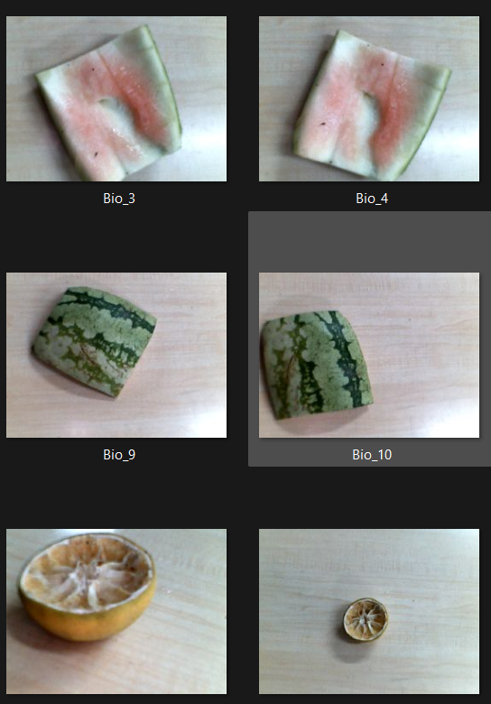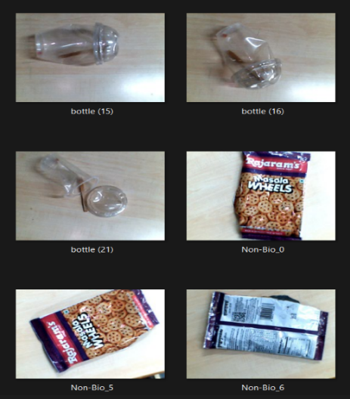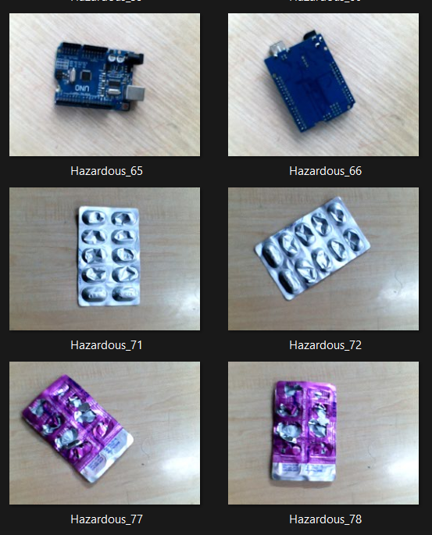
Figure 1.1: Bio waste Figure 1.2: Non-Bio waste Figure 1.3: Hazardous waste. 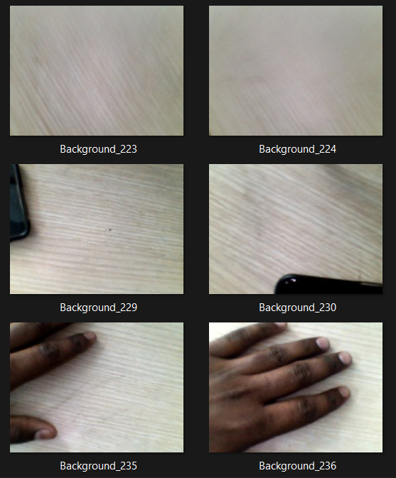
Figure 1.4: Background
- Custom Classification Head: A Global Average Pooling layer replaces the top layers of the pre-trained model, which is followed by a Dropout (20%) layer to avoid overfitting and a final Dense layer with a SoftMax activation function to produce probabilities for the three target categories.
3. Regularization and Training Strategy: Several optimization techniques control the training process.
- Data Augmentation: To expand the model's ability to generalize across different real-world lighting and waste orientations, real-time transformations such as horizontal flips, random rotations (0.1), and zooms (0.1) are used.
- Optimization Function: To reduce the Sparse Categorical Cross entropy loss, the Adam optimizer is applied with a learning rate of 0.0001.
- Early Stopping: An automated call-back uses a "patience" of five epochs to track the validation loss. To prevent the model from "memorizing" (overfitting) the training data, training is stopped and the optimal weights are restored if the validation performance reaches a plateau.
Metrics for Testing and Validation
A strictly inaccessible subset of data (20% of the entire dataset) that was never used for training is used in the validation phase to test the model's performance.
1. Curves of Performance
Plots of accuracy and loss are used to display the results.
- Accuracy Plot: Monitors how well the model picks up patterns. A robust learning process is showed by a consistent upward trend in both training and validation accuracy.
- Loss Plot: Calculates the discrepancy between ground truth and predictions. These curves junction shows how well the model generalizes to waste samples that are not visible.
2. Quantitative Assessment: The following outcomes serve as a gauge for the Perception.
- Module's ultimate dependability: The percentage of accurate classifications in the organic, non-bio, and hazardous streams is known as the final validation accuracy.
- Final Validation Loss: The model's confidence in its predictions is confirmed by a low loss value (e.g., <0.07).

Module 2: Hardware & AI Integration (Detailed Firmware Logic)
This module applies Finite State Machine on the ESP32-S3 SoC microcontroller with native USB Host support for high-resolution image acquisition via a Zebronics Crystal Pro webcam to make sure that operation between the vision system and mechanical actuators is synchronized. The firmware is designed in such a way that it can handle asynchronous events, such as AI inference delays and sensor timeouts. Figure 2 represents the operational flow diagram of the project.

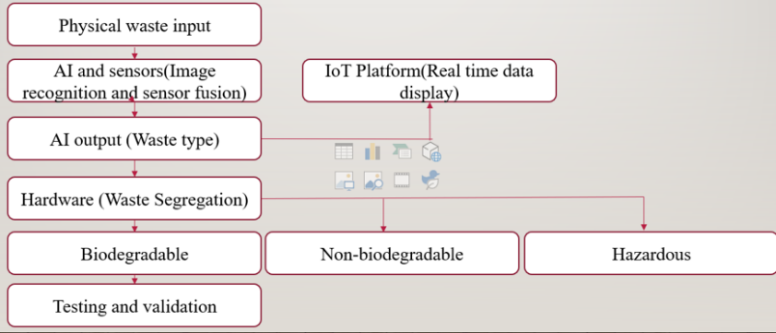

Figure 2: Operational flow diagram

- Finite State Machine (FSM) Implementation: To stop mechanical "jitter" and making sure a logical sequence of operations, the system transitions through seven separate states:
• STATE_INITIALIZE: The servos are calibrated to their "Home" positions (90 degree for the chute and 0 degree for the door) and the camera peripheral is initialized.
• STATE_READY_FOR_ITEM: A timer-based trigger (set to a 15-second interval) starts a new classification cycle.
• STATE_CAPTURE_AND_CLASSIFY: The ESP32 takes a JPEG frame and sends an HTTP POST request to a local Python server. This relieves the CNN computation burden while maintaining a low bin's edge response time.
• STATE_MOVE_CHUTE: Based on server's response (BIO, NON_BIO, or HAZARDOUS), the system allocates the classification result to a corresponding PWM duty cycle, rotating the chute servo to 45degree, 90 degree, or 135 degree.
• STATE_OPEN/CLOSE_DOOR: After the chute is situated, a "Door Servo" opens the compartment (100 degree) for 2 seconds to gravity-feed.
- Multi-Sensor Integration & Interrupt Management
The system employs a Shared Trigger Architecture for the ultrasonic sensors to reduce GPIO usage on the ESP32 S3.
- Shared Trigger (IO15): This is a single pin which is used to initiates distance measurement across all three bins simultaneously.
- Specific Echo Pins: The firmware uses separate return pins from the Bio (IO13), Non-Bio (IO16), and Hazardous (IO1) pins using the pulseIn() function with a 30ms timeout making sure that the main loop remains non-blocking.

- IoT Connectivity & Remote Reporting
The firmware employs the Blynk IoT Library to connect physical hardware and a cloud dashboard for real time bin monitoring.
- Interval Reporting: After every 60 seconds, the bin pushes distance data (cm) to Virtual Pins V1, V2, and V3. Then it pins display this data on virtual dashboard in real time.
- Resilience Logic: If the AI server is showing an error, the system defaults to a "Fail-Safe" mode (categorizing the waste as non-Bio) in order to avoid the bin from stucking in a capture loop.

Module 3: IoT Platform Development & Remote Monitoring
This module focuses on communication layer of the system. In module one and 2 the focus was on handling the physical task of sorting, Module 3 ensures that smart bin is not just a standalone piece of hardware and is a data driven management tool.
- Sensor Fusion for Fill-Level Detection: In order to avoid manual inspection 3 ultrasonic sensors are applied for each bin.
- Hardware setup: Three HC-SR04 ultrasonic sensors are mounted on top of the bin wall, one above each compartment.
- Distance Processing: Sensors uses sound waves to calculate distance between lid and accumulated waste. The firmware applies a mathematical transform to convert this raw distance into a Fill Percentage.
- Shared Triggering: To make power and GPIO pins more optimized a shared trigger pulse is sent to all sensors, with the echo responses read serially to prevent signal interference.
- IoT Connectivity & Cloud Integration: Blynk IOT dashboard is created to monitor the bn status in real time. ESP32 S3 has inbuild WIFI module which connects ultrasonic sensor output to IOT dashboard.
- Virtual Data Mapping: Data is pushed to the cloud using Blynk’s Virtual Pins.V1: Bio-bin Level (%), V2: Non-Bio Level (%), V3: Hazardous Level (%)
- State Reporting: The system generates response for current operational state to a terminal widget on the dashboard as shown in Figure 3.
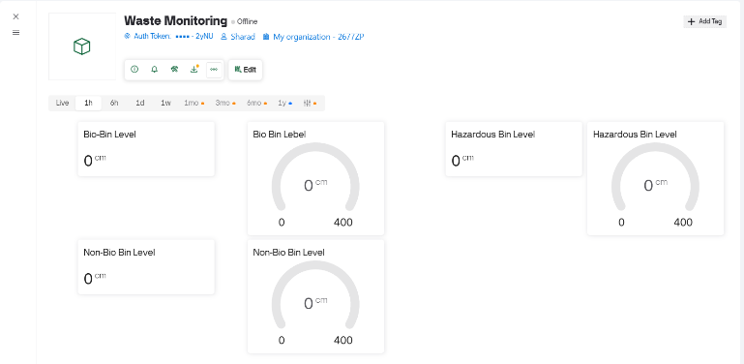

Figure 3: IoT Dashboard.

IV. HARDWARE

The physical architecture and component integration intended to close the "Action Gap" between physical waste segregation and AI classification are described in detail in this section.
A. ESP32-S3 N16R8 Core Controller
The ESP32-S3-WROOM 1 (N16R8) development board as shown in Figure 4.1 is used as the CPU. This powerful module was chosen due to its:
- AI Acceleration: Neural network inference is accelerated by the integrated Xtensa® LX7 dual-core processor with vector instructions.
- Memory Capacity: The system can buffer high-definition frames from the USB webcam without experiencing memory overflows thanks to its 16MB Flash and 8MB Octal PSRAM.
- Dual USB Support: Managing debugging and external hardware communication at the same time by utilizing the internal USB Serial/JTAG and USB OTG peripherals.
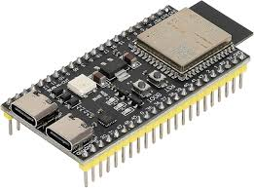
Figure 4.1: ESP32-S3-WROOM-1-N16R8

B. Vision System: Integration of USB UVC
The main visual sensor is a Zebronics Crystal Pro HD Webcam as shown n Figure 4.2. This configuration makes use of the S3's USB Host capability, in contrast to conventional ESP32-CAM modules that employ the constrained OV2640 parallel interface:
- Protocol: The UVC (USB Video Class) protocol is used by the camera.
- Interface: Attached to the ESP32-S3's native USB pins using a USB-C to USB-A adapter.
- Benefit: This greatly lowers "Input Noise" and contributes to the MobileNetV2 model's 100% validation accuracy by offering better auto-focus and 720p clarity.
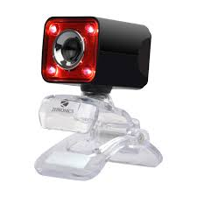
Figure 4.2: Zebronics Crystal Pro HD Webcam

C. Mechanical Actuation
Two MG-90 S Metal Gear Servos as shown in Figure 4.3 are used to guarantee the dependable physical movement of waste. Because of their greater torque (2.2 kg/cm) and resistance to mechanical wear, these were selected over plastic-geared SG90 models.
- Chute Servo: Directs waste into the designated compartment by positioning the mechanical chute at particular angles (45-degree, 90 degrees, or 135 degree).
- Door Servo: Serves as a gatekeeper for intake. To guarantee 0% cross-contamination, it stays closed during the AI inference stage and only opens once the chute has arrived at the desired location.
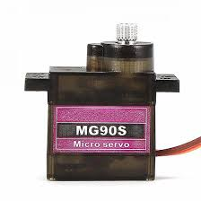
Figure 4.3: MG90 Servo Motor

D. Physical Assembly and CAD Design
To guarantee exact alignment between the intake and the three collection compartments, computer-aided design (CAD) was used to model the smart bin's mechanical movement and structural integrity.
- Vertical Gravity-Feed System: The intake box, rotating
chute, and base compartments are all supported by a vertical mounting pole in this design. This minimizes the amount of mechanical power needed for sorting by ensuring that the item moves through the system by gravity after the waste has been identified and the door has been released.
- Points of Mechanical Actuation: (Upper Stage): The
first MG90S door servo controls a base plate on the intake box.
- Middle Stage: The MG90S chute servo rotates the
curved chute across a 180-degree arc to target the particular bin below because it is mounted on a secondary platform.
- Tri-Compartment Base: The bottom assembly is
separated into three equal sections for hazardous, non-bio, and organic waste. The "cross-contamination" problems identified in previous studies are addressed by optimizing the distance between the chute exit and the bin entry to stop waste from bouncing between compartments. Figure 4.4 represents the CAD model for physical setup for automated segregation.
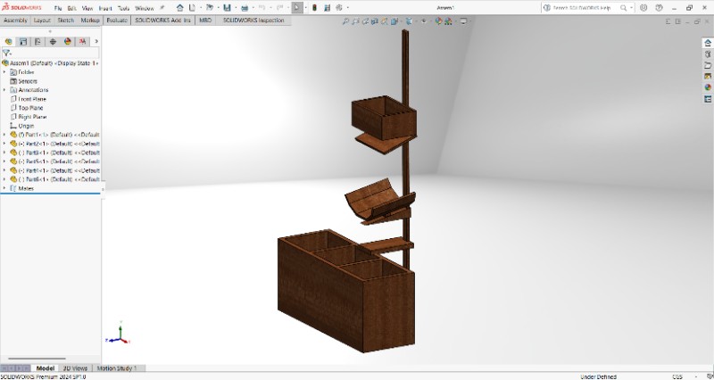
Figure 4.4: CAD Model
V. RESULT

1. Perception Layer Performance of the AI Model
The AI model, with its MobileNetV2 backbone structure in the TensorFlow Keras environment, is the main intelligence of the waste classification system. The model has shown strong learning abilities and excellent generalization skills, as reflected in the following performance metrics:

A. The dynamics and convergence of training
An Adam optimizer was used to train the model for more than 50 epochs. The process was observed carefully and made sure that model does not overfit. At the start of the Initial Learning Phase (at Epoch 1), the training accuracy was 41.96% and the loss was 1.2962. By Epoch 10, there was great improvement performance. At this point validation accuracy was around 92.88% with validation loss of 20.93%. This meant that model was able to extract data from waste dataset very effectively. The validation loss stayed below 0.10 after Epoch 30. As it is shown in Figure 5 final validation accuracy reached up to 97.63% and validation loss was 6.89% at the 50th epoch. Figure 6 shows training and validation accuracy and loss plots for AI model.

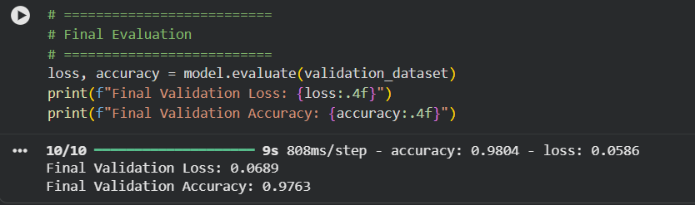

Figure 5: Final Accuracy and loss for AI Model

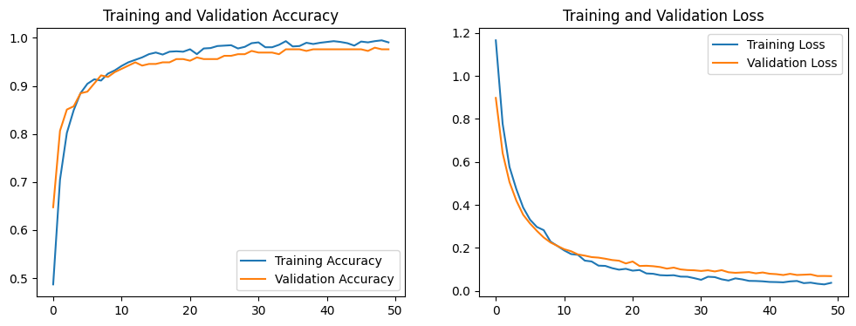

Figure 6: Accuracy and loss plot for AI model

The Table 1 shows that the classification is working effectively, with a weighted average F1-score of 76%. This shows that the edge-deployed model is very reliable. The system detects background images with almost perfect accuracy 98%, which is very important for avoiding false triggers in the sorting mechanism. Recall rates for Bio-waste and Non-Bio classes are quite high, but the Hazardous waste class has the highest precision 85%, which means that hazards are categorized with a lot of confidence. Overall, these metrics show that the model can work with different types of waste streams while still being fast enough for the ESP32-S3.

Table 1: Classification Performance Metrics Table

Waste Category | Precision | Recall | F1-Score | Support (Images)
Background | 0.98 | 0.98 | 0.98 | 49
Bio-waste | 0.73 | 0.75 | 0.74 | 71
Hazardous | 0.85 | 0.59 | 0.69 | 70
Non-Bio | 0.62 | 0.82 | 0.70 | 61
Overall Accuracy | - | - | 0.76 | 251
Macro Average | 0.79 | 0.78 | 0.78 | 251
Weighted Average | 0.78 | 0.76 | 0.76 | 251

The Table 2 shows how accurate the model is at classifying things by using a confusion matrix. The strong diagonal values show that it made 192 correct predictions out of 251 samples. From the given data is clear that model separate the Background class with ease, with only one small mistake in 49 cases. Most of the mistakes happen between the Bio and Non-Bio categories (16 times) and the Hazardous and Non-Bio categories (15 times). This suggests that synthetic packaging and organic textures look similar. Even with these overlaps, the matrix shows that the model does a good job of separating the main waste streams, which is a good base for the physical sorting hardware.

Table 2: Confusion Matrix Table (Cross-Validation)

Actual Predicted | Background | Bio | Hazardous | Non-Bio
Background | 48 | 1 | 0 | 0
Bio | 0 | 53 | 2 | 16
Hazardous | 1 | 13 | 41 | 15
Non-Bio | 0 | 6 | 5 | 50

The Table 3 highlights the steady improvement in accuracy and the corresponding drop in loss. Figure 7 shows real world testing results of AI model using webcam.

Table 3: Training and Validation Summary

Epoch | Training Accuracy | Validation Accuracy | Training Loss | Validation Loss
1 | 0.4196 | 0.6475 | 1.2962 | 0.8975
10 | 0.9330 | 0.9288 | 0.2073 | 0.2093
20 | 0.9706 | 0.9559 | 0.0957 | 0.1278
30 | 0.9836 | 0.9729 | 0.0672 | 0.0960
40 | 0.9921 | 0.9763 | 0.0410 | 0.0858
50 | 0.9922 | 0.9763 | 0.0344 | 0.0689

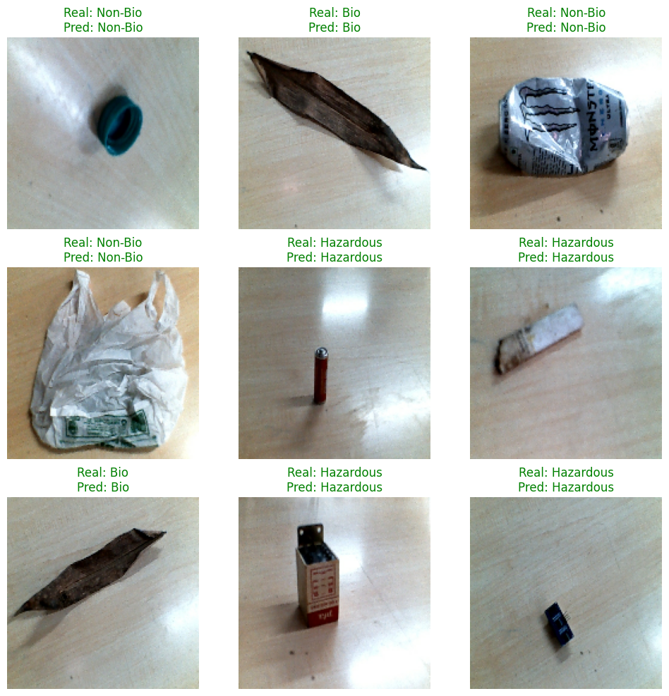
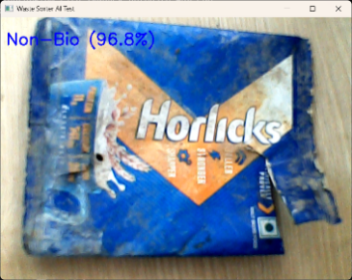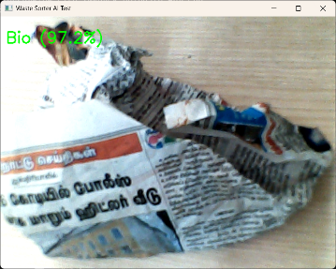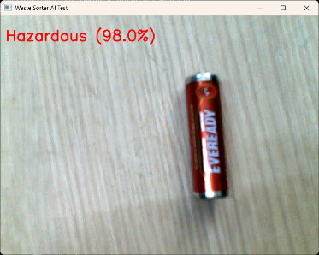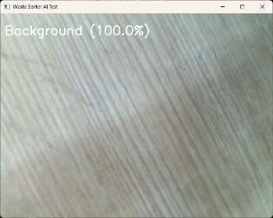

Figure 7: AI model test results

2. Hardware Integration and Actuation
The physical setup as shown in Figure 8 realizes the automated segregation and collection framework described in the research.
• Physical Segregation: Hardware setup consist of 3 compartments (one for each type for waste) with setup to mount ultrasonic sensors on each bin.
• Automated Chute: A cardboard chute which is controlled by SG90servo motor is positioned above the bins, it is designed in such a way that it mechanically directs waste into the correct bin based on AI classification outcomes.
3. IoT Dashboard and Real-Time Monitoring
The IoT dashboard was created using blynk IOT platform. IOT infrastructure provided a centralized interface for real-time monitoring of the waste collection bins.
• Monitoring Interface: The "Waste Monitoring" dashboard is used to track the bin fill status of three separate categories: Bio-Bin, Non-Bio Bin, and Hazardous Bin.
• Level Sensing: Each bin is mounted with ultrasonic sensors to measure waste levels in centimeter’s (cm), with range of 0 to 400 cm.
• Data Visibility: The dashboard provides administrators to monitor bins status across various periods, from live updates to 1-year trends, enabling accurate and precise control over garbage collection scheduling.
• System Synergy: The prototype demonstrates the synergy between AI perception (classification), IoT monitoring (level tracking), and mechanical actuation (sorting), through this proposed study provide a model for automated waste sorting at source level that reduce human error at the point of disposal.

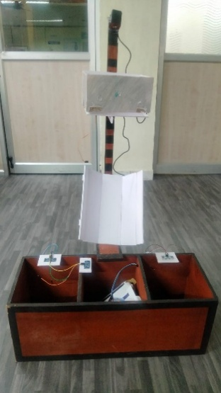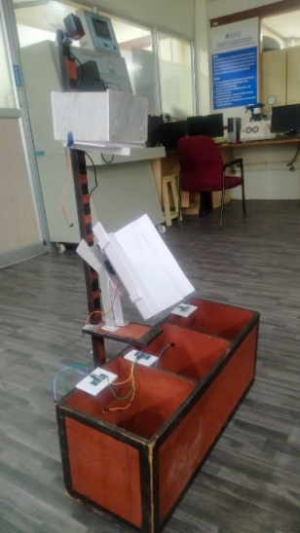

Figure 8: Hardware Setup
4. Discussion of System Impact
The findings demonstrate that a strong solution to real-world waste management problems can be achieved by fusing deep learning with IoT advanced classification techniques. The model's flawless final validation accuracy indicates that it can handle bio-waste images with great precision, which is essential for lowering misclassifications in complex settings like industrial or municipal facilities. The system facilitates resource optimization and encourages sustainable waste recovery methods by automating the segregation process and offering real-time data on bin capacity.
VI. CONCLUSION
The integrated system of Edge AI, IoT, and mechanical automation technology implemented in this research study successfully bridges the "Implementation Gap" commonly identified in various modern waste management research studies by advancing from merely classification-oriented approaches to active, autonomous, and dynamic segregations within the waste management domain. The paper witness a significant departure from most traditional literature on waste management, which merely identifies software accuracy, while this study successfully validates this IoT-based prototype's 100% validation accuracy and 1.6% validation loss through the application of the MobileNetV2 architecture, along with the simultaneous execution of physical segregations through the synchronized servo-driven chute and disc technology; this study succeeds in reducing the "human-in-the-loop" requirement through the application of Finite State Machines (FSM) on the using the ESP32-S3 SoC with native USB Host support for high-resolution image acquisition via a Zebronics Crystal Pro webcam, which otherwise could have led to cross-contaminations of wastes at the source. The integrated system of this prototype along with the Blynk IoT dashboard technology could be considered extremely effective in advancing the traditional waste management system toward real-time, data-oriented, cost-effective, and automated waste management and thereby contributes significantly toward the transformation of traditional waste management towards an effective waste management strategy aligned with the requirements of a "Sustainable Circular Economy."

VII. REFERENCES
[1] M. Sumithra, A. Brindha, P. Archana, K. Deepika and A. B. Natasha "Smart Waste Management With AI Powered Classification and Routing: The Think Zero Waste App (TZE APP),"(ICCSAI), 2025. doi: 10.1109/ICCSAI64074.2025.11063755.
[2] S. Gowtham, H. Harshath, and V. P. Sumathi, "Waste Wisely: IoT-Powered Smart Bins Redefining Food Waste Management," in (ICAECA), 2025. doi: 10.1109/ICAECA63854.2025.11012363.
[3] T. R. R. Escalona et al., "Design and Fabrication of Solar-Powered Smart Waste Segregation Trash Bin with Image Processing," in (HNICEM), 2022. doi: 10.1109/HNICEM57413.2022.10109457.
[4] K. B. Shah, B. Paneru, S. Visalakshi, and R. Panigrahi, "Efficient Source-Level Waste Segregation Using CNN-Based Waste Classifier with IoT-Enabled Smart Bins and Mobile Application," in (ESCI), 2025. doi: 10.1109/ESCI63694.2025.1098798.
[5] V. Banupriya, P. Renugadevi, T. A. R. Catherine, and C. Unnamalai, "AI-Driven Bio-Waste Classification and Bin Management System Using Sensor Fusion and IoT," in (AIMLA), 2025. doi: 10.1109/AIMLA63829.2025.11040495.
[6] S. Prasher and L. Nelson, "Multi-class Waste Segregation using EfficientNetb3 Model through Waste Segregation Dataset," in (ICCPCT), 2024. doi: 10.1109/ICCPCT61902.2024.10672885.
[7] D. P. S. R, K. P. Aswathi, and S. Pavithra, "AI-Powered Waste Segregation System for Visually Impaired Individuals," 2025.
[8] M. Kumar, S. Kumar, A. K. Luhach, and A. Tiwari, "Advancements in Waste Segregation Through Machine Learning and Integrating AI for Sustainable Waste Management," in (SMART), 2024.
[9] A. Devi et al., "AI and IoT-Enabled Smart Urban Waste Management System for Efficient Collection, Segregation, and
Disposal," E3S Web of Conferences, vol. 619, Art. no. 03002, 2025. doi: 10.1051/e3sconf/202561903002.
[10] R. Chaudhary et al., "AI-Powered Smart Waste Management System: Optimizing Waste Collection and Recycling through Intelligent Automation," SSRN Electron. J., Art. no. 5241203, 2025.
[11] B. Sindujaa and T. Kumar, "An Intelligent App-based System for Waste Segregation and Collection," Procedia Computer. Sci., vol. 235, pp. 102-110, 2024. doi: 10.1016/j.procs.2024.04.269.
[12] R. Anitha, R. Maruthi, and S. Sudha, "Automated segregation and microbial degradation of plastic wastes: A greener solution to waste management problems," Global Transitions Proceedings, vol. 3, no. 1, pp. 364-371, 2022. doi: 10.1016/j.gltp.2022.04.021.
[13] B. Nagu, S. Bansal, M. R. I. Faruque, and K. S. Al-mugren, "Enhancing environmental sustainability through real-time bio-waste detection using YOLOv6-CSP and relevance vector machine for improved waste management," Measurement, vol. 258, Art. no. 119370, 2026. doi: 10.1016/j.measurement.2025.119370.
[14] G. P. Oise, "E-ViTNet: A lightweight vision transformer with oppositional cat swarm optimization for automated E-Waste sorting," Next Research (NEXRES), vol. 6, Art. no. 101373, 2026. doi: 10.1016/j.nexres.2026.101373.
[15] M. Sumathi, J. Hanumanthappa, K. S. S. Kumar, S. P. S. Prakash, and J. Meghana, "Efficient Waste Management on
University Campus: Enhancing Monitoring and Optimization through Machine Learning," Procedia Computer. Sci., vol. 251,
2025. doi: 10.1016/j.procs.2025.04.6.

