Parking zone monitoring using IoT

ABSTRACT
However, because of the increased urbanization and the rapid rise in the number of vehicles in the cities, it has become very difficult to manage the traffic, parking and the monitoring of the area in an effective manner with human supervision and customary CCTV cameras to provide the real time automated solutions․ This paper describes an IoT based Parking Zone Monitoring System, which checks and monitors whether a car is present in a parking space․ It uses a camera with sensors and a processor to track car movement in `real time․ A video processing algorithm based on YOLO is used to detect the vehicle and check the availability of the parking slot and the number plate of the vehicle․ The information is uploaded to a cloud-based IoT database and displayed on a Blynk dashboard․ Thus, we can monitor the filled and unfilled slots, over-occupied slots, and instant notification of the violation in the system proposed․ It reduces human effort, improves monitoring accuracy, and can be applied to smart parking and traffic management․
Keywords: Internet of Things (IoT), Parking Zone Monitoring, Smart Parking, Deep learning, YOLO, Video Processing, Cloud Computing.

1.INTRODUCTION
As cities grow and more automobiles per resident take to the roads each day, it has become increasingly difficult to control traffic and parking․ More people on the road means more vehicles using busy roads and parking illegally, with no real-time intelligence to manage the congestion and efficient use of parking spaces․ These challenges highlight the need for more smart traffic and vehicle management․ Conventional vehicle monitoring is performed by human operators using CCTV cameras․ These methods are often time-consuming and prone to error because they require manual oversight as they do not automatically analyze data․
Thanks to the advent of Internet of Things (IoT) technology, real-time monitoring with clever data processing has become feasible and reliable, where sensors, cameras, processing units and the cloud can communicate together, leading to the development of smart traffic and smart parking technologies․ By combining IoT and video processing, vehicles can be detected, and zones can be monitored with high precision․
In this paper, an IoT-based Parking Zone Monitoring System is proposed to monitor vehicles in parking, school, highway, and restricted zones․ The proposed system uses a camera and sensor devices to gather information about the vehicle zone․ The YOLO-based video processing algorithm is applied to detect vehicles and parking availability in the vehicle zone․ The processed data is sent to a cloud database and displayed in a Blynk dashboard and provides real-time notifications, reduces human effort, increases precision and supports smart city traffic management․
The system would record and maintain logs of the vehicles that are moving through the various places of the city along with the time of the vehicle․ The number plate of the vehicle would be recorded through the CCTV cameras․ The system uses existing CCTV infrastructure and an IoT-based real-time number plate recognition system to track and park the vehicle․ Other than detecting number plates, the process includes segmenting and recognising characters with methods including Sobel edge detection, deep learning and contour analysis․ The character segmentation process includes connected component analysis and vertical projection․ The vehicle information is then stored in the database․

2.LITERATURE REVIEW
Clever Parking monitoring systems based on IoT, computer vision, and deep learning technologies for traffic monitoring and transportation management have also been studied․ The early research studies were focused on IoT-based vehicle monitoring systems proposed for remotely tracking and monitoring vehicles․
An IoT-based electric vehicle monitoring system was developed by Manjunathan et al․ [1] that allows real-time monitoring and tracking of a vehicle's condition through an interlinked network of sensors․ An IoT-based electric vehicle monitoring and control system was developed by S․ Prasad and R․ ‌Kumar [2] that allows remote monitoring of its parameters․ This further improves operational efficiency.
Likewise, Christy Mary Jacob et al․ [3] proposed a smart monitoring system which collects and sends vehicle details to the cloud server through an IoT-based system to continuously monitor and analyse these details with real-time data․ S․ Kumar Reddy Mallidi et al․ [4] presented an IoT-based vehicle monitoring system to check vehicle location and performance information ․
Additionally, Koppala Guravaiah and R․ G․ Thivyavignesh [5] designed a vehicle monitoring system, which employed IoT-based sensors and cloud for vehicle tracking, thus improving the process of ‌vehicle data management ․ With the advancement of technology, researchers started employing the use of computer vision for vehicle detection and tracking through external cameras․ Prem Kumar Bhaskar et al․[6] have proposed a moving vehicle detection and tracking system based on image processing techniques which is capable of detecting moving vehicles from video ․ P․ Rani et al․ [7] propose another vision-based traffic monitoring system that uses deep learning models for automatic vehicle detection and smart traffic monitoring․ This confirms that cameras are an effective option for traffic analysis without the need for IoT sensors․
More recently, researchers have concentrated on improving accuracy as well as real-time processing speeds for vehicle detection tasks using state-of-the-art deep learning models ․ Avaneesh Singh et al․ [8] proposed a deep learning-based method to detect moving vehicles from aerial images to enable smart traffic surveillance․ Likewise, the same authors proposed using YOLOv8 and transformer networks for a multi-vehicle detection and tracking system, which helps improve detection in complex traffic environments ․Ming-An Chung et al․ integrated SimAM [9] attention with a YOLOv7 model to improve vehicle detection performance with improved feature extraction and detection results․ Shan Luo and Jihong Liu [10] developed a high-speed license plate detection and recognition system using an improved YOLOv5 model and the LPRNet model ․
Furthermore, Tae-Moon Seo and Dong-Joong Kang [11] proposed a method of detecting a license plate based on CenterNet with an attention mechanism to improve the robustness and accuracy of the model under difficult situations․ Recently, Rahul Arora et al․ [12] proposed a vehicle license plate detection and recognition algorithm using YOLOv9 with EasyOCR under clever transportation systems for real-time applications ․
Overall, previous research shows a clear progression from basic IoT-based vehicle monitoring systems to more advanced deep learning-based vehicle detection and recognition methods. Despite these advancements, integrating IoT connectivity with real-time vision-based vehicle zone monitoring still presents opportunities for further research, particularly for improving smart traffic management and intelligent transportation systems.

IoT
DATABASE
3.BLOCK DIAGRAM
IoT
DATABASE
CLOUD
PROCESSOR
CAMERA

ACTUATOR
SENSOR

FIG.1 - BLOCK DIAGRAM OF SYSTEM

4.FLOW CHART
Start

Live video from CCTV camera
Video input
Collected data
Exit vehicle
End

Vehicle detection YOLO
Detect vehicle from live video

License plate recognition
text extraction using OCR

Check whether vehicle entry or exit
Exit
Entry

Exit gate open
If parking slot is available
No
Update slot count

Yes
Alert (slot is filled)
Entry gate open

Continue monitoring
If any vehicle is long stay
Update slot count
Yes
No

Collected data

Exit vehicle

FIG.2 – FLOWCHART OF SYSTEM
End

5. WORKING OF PARKING ZONE MONITORING USING IoT

The Parking zone monitoring system using IoT continuously monitors the movement of vehicles and saves the data in real time․ The components of the system include a CCTV camera, a sensor that detects the vehicle, a processing unit and an IoT cloud․
First, CCTV cameras take live images of the vehicles within the passing zone area․ Then, the images taken by the cameras are transferred to the processing unit, which implements image processing and deep learning techniques to analyze the vehicles and read their number plates․ Access to vehicles is controlled using their number plates, and other entries such as when the vehicle entered and exited the facility, and where, are recorded․
Next, the data goes to the cloud IoT platform, which regularly updates the database over the internet connection․ The IoT platform processes the data to analyze the movement pattern of the vehicle, zone violations and availability of parking space․ Alerts are generated in case of unauthorized entry or overcrowding․
The information regarding vehicles and their zones is displayed on the dashboard or mobile application, which can be checked remotely by the officials to monitor the vehicle's position and delivery in real time․ It can be deployed in parking areas, limited access zones, highways, toll plazas and smart cities to lessen human effort․
Parking area observation system uses video processing and internet of things (IoT) technology for observing and managing parking areas․ It allows monitoring and analyzing images by detecting vehicles in the fields of view, vehicle’s movement, occupied parking spaces and number plates․ The collected information is uploaded to an IoT dashboard at the cloud․ All users can remotely view the availability of the parking areas․ This eases the development of smart parking management solutions by combining deep learning models with cloud connectivity and analytics․

5.1. Video Acquisition and Input Module
The system uses a video feed taken either from a recorded security camera or a live camera, which is broken down into individual frames so that they can be processed individually․ The images are resized and formatted to ensure that the detection and the zone monitoring algorithms behave as expected․
5.2. Vehicle Detection Using YOLO
This vehicle detection uses YOLO (You Only Look Once) deep learning model, which is very fast and accurate․ This model detects different kinds of vehicles like cars, bikes, buses, and trucks in every frame of the video and gives the output as a bounding box․ YOLO also predicts the bounding box for each detected vehicle and assigns each bounding box a confidence score․

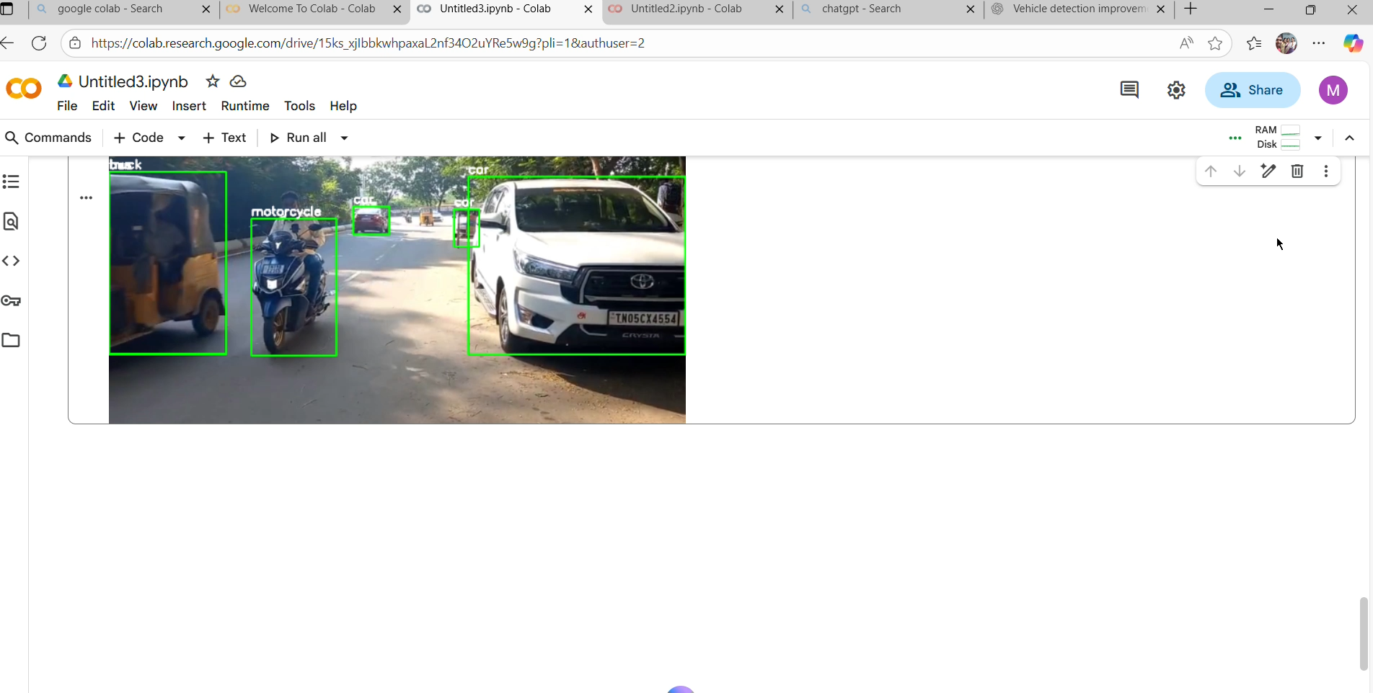
Fig 3: VEHICLE DETECTION
5.3. Vehicle Tracking and ID Association
This allows each vehicle to be localized in real time, even in high density parking scenarios․ To avoid false positives, an object tracking algorithm like Byte-Track or Rapid is utilized to ensure the same vehicle is not counted more than once․ Each detected vehicle is assigned a unique ID which remains the same as it moves through the frames․ This is useful for tracking vehicle entries and exits, and for parking occupancy․ We define a monitoring zone within the video frame․
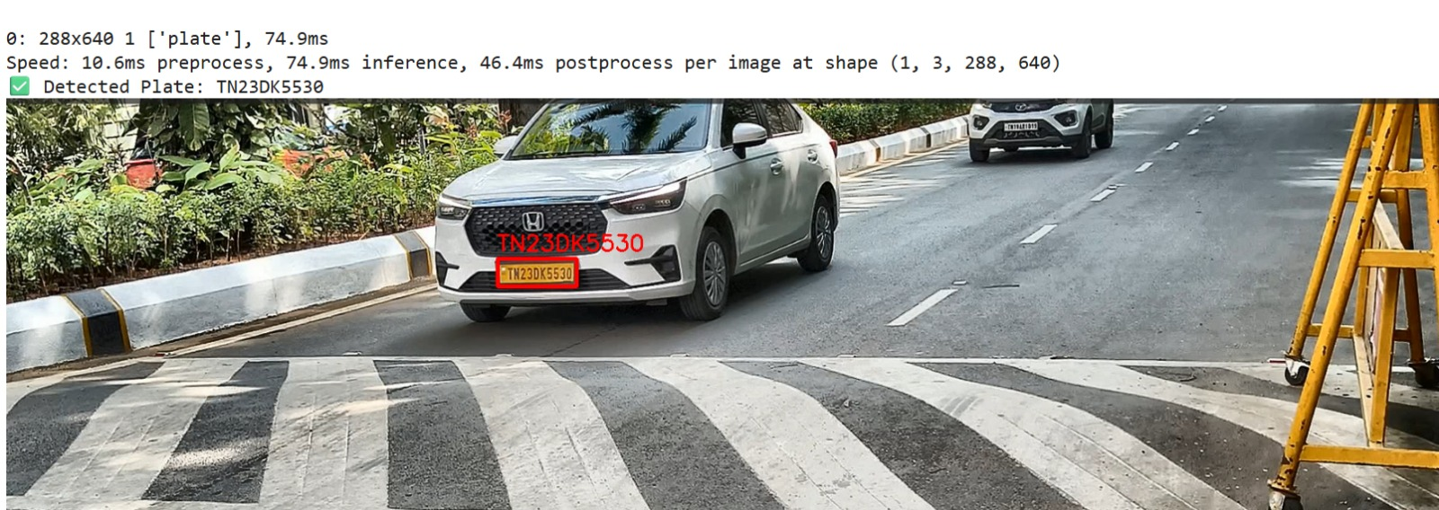

Fig 4: LICENSE EXTRACTION

5.4. Zone-Based Vehicle Monitoring
This monitoring zone is the parking region we are interested in․ Having defined the monitoring zone, we can determine if there is a vehicle within the parking region by calculating the centre of its bounding box․ Occupancy is determined by checking if the vehicle's centre point is inside the zone, allowing for flexible layouts and sizes of parking space detection․

5.5. Number Plate Detection and OCR Processing
When a vehicle is detected in a zone of interest, the system attempts to localize the plate using a separate detection model․ In the end, the information of the plate is captured through Optical Character Recognition (OCR) software, resulting in an alphanumeric string representing the vehicle registration number․
5.6. Parking Availability Estimation
The number of parking spaces is predefined and fixed, so the system can calculate the number of occupied and vacant parking spaces, given the number of vehicles in the specified area․ These values are updated constantly with current parking availability information for users․
5.7. Data Logging and Cloud Database Integration
The data regarding the date and time, number of vehicles and the availability status of the parking space, along with the number plate number, is stored in a file that is stored locally on the device and backed up to the cloud database using Internet of Things (IoT) services, for long-term monitoring and analysis․
5.8. IoT-Based Real-Time Monitoring Using Blynk
The Blynk IoT platform visualizes the parking information in real-time and sends the number of occupied and free parking slots to the cloud․ The data collected is displayed on a dashboard via gauges and indicators․ The current status of parking can also be checked via a mobile phone or web-based application, which can send notification alerts, for example, when a parking area is full․
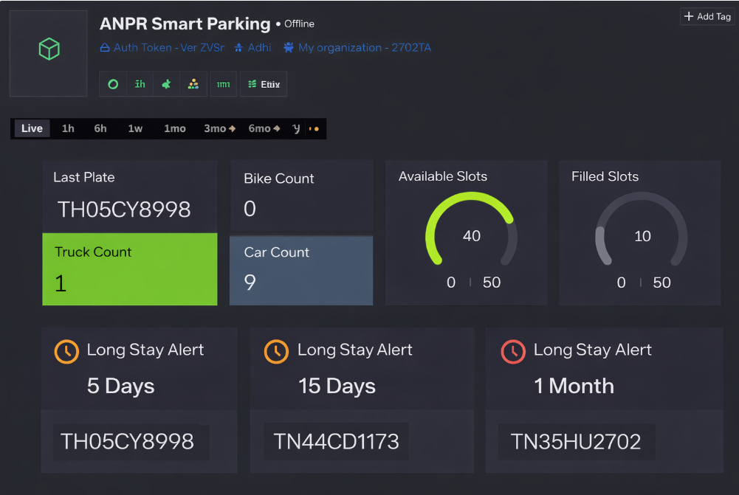

Fig 5: ANALYSIS OF LOT AVAILABILITY USING BLYNK IOT

5.9. System Output and Visualization
The final output of the system includes:
- Live video display with detected vehicles and number plate information
- Real-time parking availability shown on the IoT dashboard
- Logged records are stored in Excel and a cloud database

6.RESULTS:

The results of the tests show the ability of the IoT-based vehicle zone monitoring system to monitor the vehicle traffic of different user-defined zones in real-time․ The sensors and IoT modules were able to successfully detect the entry and exit of vehicles of interest in each zone and transmit the readings with minimal latency to the monitoring platform․ The system correctly detected vehicles intruding into the zones and could provide real-time alerts․ Therefore, it could be used for quick intervention and to monitor restricted or sensitive areas․ The system was proved to be reliable when traffic was normalized in a test and provided good information about the behaviour of vehicles in monitored zones․ There were minor delays during network fluctuations, but overall performance was favourable․ The results indicate that the system provides an efficient, low-cost, and practical solution for smart vehicle zone monitoring, which may improve traffic management and safety in smart city settings.

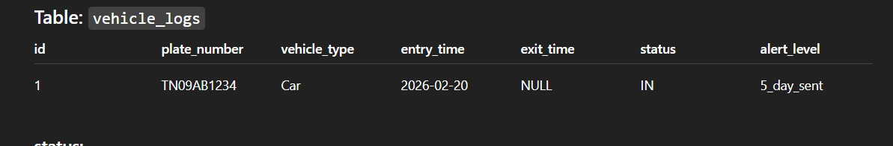
Fig 5: Data base

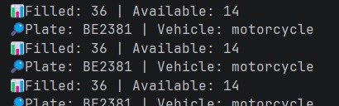
Fig 6: Output

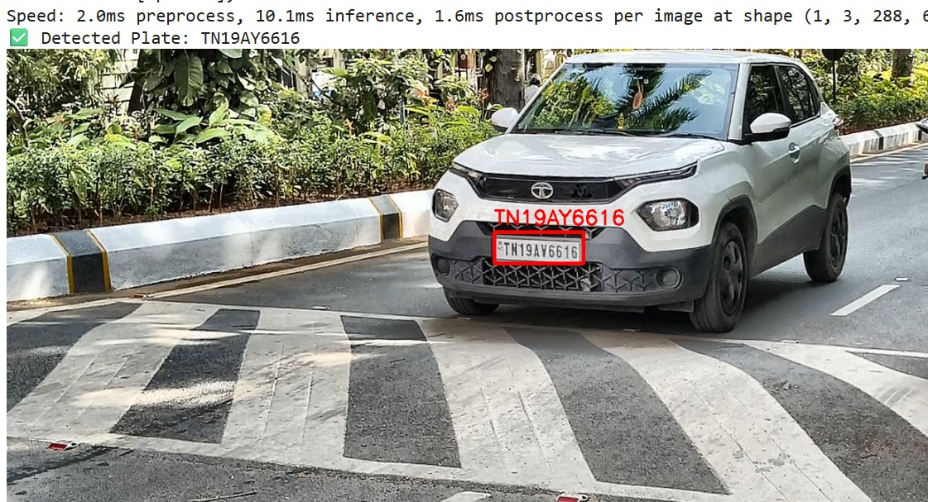
Fig 7: Output

7.DISCUSSION

Based on this study, IoT systems combined with video analytics applications can be leveraged to make parking surveillance systems more smart and effective․ The results acquired from the study show that the efficiency of the system depends on the YOLO model․ Light weight YOLO models are suitable for edge applications as they are faster and require lesser computing power․ Models are used to monitor entry/exit points, however low light conditions and overcrowded parking spaces may affect the precision of the model․ Larger models of YOLO generally provide more accuracy and better performance on complex data, but require more computational resources from either on-premises or cloud processing services․ The inclusion of OCR for license plates in YOLO implementations also improves system performance․ Thus it may be more useful for security systems and parking monitoring purposes, as vehicle tracking across frames avoids double counting and ensures tracking continuity․ In general, a clever and strong parking management system can be achieved based on YOLO detection, OCR and tracking techniques, along with an appropriate choice of model and stable IoT connectivity for smart parking management․

Table 1: RATE OF EFFICIENCY FOR DIFFERENT MODELS
S NO |  | MODELS | SUCCESS RATE | FAILURE RATE
1 |  | YOLO v8 | 90% | 10%
2 |  | YOLO v9 | 10% | 90%
3 |  | YOLO v10 | 30% | 70%
4 |  | YOLO v11 | 15% | 85%
5 |  | YOLO OCR | 40% | 60%

8.CONCLUSION
Using IoT technology and the YOLO model, the system makes it a clever solution to identify cars and detect whether the parking spaces are occupied or vacant through real-time camera footage․ These IoT devices, connected to the network, allow parking information to be monitored and shared in real time via mobile applications or dashboards with the aim of saving the manual effort and time, reducing traffic congestion, and making parking easier․ Overall, using IoT and YOLO for parking zone monitoring is an efficient and modern approach that supports smarter cities and better urban mobility.

9.REFERENCES
- Manjunathan et al. developed an IoT-based E-Vehicle Monitoring System, Prem Kumar Bhaskar et al. proposed a vehicle detection and tracking system based on image processing techniques.
- Rahul Arora et al, “Vehicle License Plate Detection and Recognition using YOLOv9 and Easy OCR”, 2025 International Conference on Data Science, Agents, and Artificial Intelligence (ICDSAAI), Chennai, India, March 2025, pp. 1–6.
- Avaneesh Singh et al, “Smart Traffic Monitoring Through Real-Time Moving Vehicle Detection Using Deep Learning via Aerial Images”, IEEE Transactions on Consumer Electronics, vol. 70, no. 4, November 2024, pp. 7302–7312.
- Shan Luo and Jihong Liu, “High-Speed License Plate Detection and Recognition Based on Improved YOLOv5 and LPRNet”, IEEE Access, vol. 10, 2022, pp. 45612–45624.
- Tae-Moon Seo and Dong-Joong Kang, “License Plate Detection Using Centre Net with Attention Mechanism”, IEEE Transactions on Intelligent Transportation Systems, vol. 23, no. 8, August 2022, pp. 11245–11255.
- Ming-An Chung et al, “Enhanced Vehicle Detection Using YOLOv7 With SimAM Attention Mechanism”, Sensors, vol. 24, no. 3, January 2024, pp. 1–15.
- Avaneesh Singh et al, “Real-Time Multi-Vehicle Detection and Tracking Using YOLOv8 and Transformer Networks”, International Journal of Intelligent Transportation Systems, vol. 18, no. 2, June 2024, pp. 210–223.
- S. Prasad and R. Kumar, “IoT-Based Electric Vehicle Monitoring and Control System”, International Journal of Engineering Research & Technology, vol. 11, no. 5, May 2022, pp. 345–349.
- P. Rani et al, “Vision-Based Traffic Surveillance System Using Deep Learning”, International Journal of Advanced Computer Science and Applications, vol. 14, no. 1, January 2023, pp. 98–104.

- S Kumar Reddy Mallidi et al, “IoT-based smart vehicle monitoring system”, International Journal of Advanced Research in Computer Science, 9, vol:(2), March-April 2018,738-741.
- Koppala Guravaiah, R G Thivyavignesh, “Vehicle monitoring using Internet of Things” 1st International Conference on Internet of Things and Machine learning. Article No : 24, Pages 1 - 7 ,17 October 2017.
- IEEE papers on vehicle detection & smart cities.
- Christy Mary Jacob; Nikhil George; Amul Lal; Roshan Jacob George; Merin Antony; Jineeth Joseph, “An IoT-based Smart Monitoring System for Vehicles”, 2020 4th International Conference on Trends in Electronics and Informatics (ICOEI) (48184), 15-17 June 2020

