Ayurvedic Managenent of Indralupta; A Case Study

ABSTRACT:
Alopecia areata is an autoimmune condition marked by the emergence of non-scarring bald patches that impact the hair-bearing regions of the body. The scalp is the most frequently affected area. This condition can be likened to Indralupta in Ayurveda. The pathophysiology of Indralupta involves the disturbed Tridoshas and Rakta, which affect the scalp, along with the obstruction of hair follicles due to the exacerbation of Rakta and Kapha, ultimately hindering hair regrowth. Acharya Vagbhata refers to it as Kapalgata Roga, while Acharya Sushruta and Madhava Nidana classify it as a Kshudra Roga. Management is by the intralesional and topical corticosteroids. Shodhana (Raktamokshana) and Shamana Chikitsa is advised for the Indralupta in ayurveda classics.
Keywords: Alopecia areata, Autoimmune, Ayurveda, Indralupta, Hair loss, Patchy baldness.
INTRODUCTION:
Alopecia areata is an autoimmune disease characterized by hair loss on body especially on scalp without any clinical inflammatory signs. Its prevalence in general population was estimated at 0.1-0.2% with a lifetime risk of 1.7%. Male was reported to be more affected with the disease in comparison to children and women, but it causes more emotional problems in woman and children due to cosmetic concern.
इन्द्राणां इन्द्रनीलवत केशानां लुप्तं नाशो यस्मात || (शब्द कल्प द्रुम 1/211)
Indra it means Utamanga/Shresta and Lupta means Morbid baldness of the head; loss of beard.
Ancient Ayurvedic scripts termed alopecia as ‘Khalitya’ if the hair is lost gradually. In case of the occurrence of sudden hair loss, it is termed as ‘Indralupta’. According to Ayurveda, the condition of the hair and scalp depends on the harmony of vital biological energies in the body: Vata, Pitta and Kapha. Any imbalances occurring in these tri-doshas would lead to a variety of scalp and hair problems. Sushruta has mentioned Indralupta as Raktapradhoshaja vikara.
CHIEF COMPLAINT:
Patchy Hair Loss from scalp (over vertex) × 1 Month
HISTORY OF PRESENT ILLNESS:
- A 26 years old Male patient presents with a localized patch of hair loss over the scalp, noticed approximately 1 month ago. The hair loss was sudden in onset and progressive initially, after which it has remained static. There is no history of pain, itching, scaling, discharge, or redness over the affected area. The patient denies excessive hair fall from other body sites.
- The patient gives no history of similar episodes in the past. There is no associated history of trauma, local infection, tight hairstyles, or use of new hair products.
- No history suggestive of systemic illness, autoimmune disorders, or recent emotional stress.
- Family history of similar complaints is absent.
Local Examination:
On examination, there is a single, well-defined, oval/round patch of non-scarring alopecia present over the vertex region of the scalp, measuring approximately 4 cm × 3 cm (anteroposterior × transverse). The skin over the patch appears smooth, normal in color, with absence of terminal hairs and presence of few short vellus hairs. There is no evidence of scaling, erythema, crusting, or atrophy.
GENERAL PHYSICAL EXAMINATION:

- General Conditions: stable
- Pulse: 76 beats per minute
- Blood Pressure: 116/80 mm of Hg
- Temperature: Afebrile Clinically
- Respiration Rate: 18 per minute
- Height: 5’11. (181 cm)
- Weight: 76kg
- Edema: Not Present.
- Clubbing: Not Present.
- Pallor: Not Present.
- Cyanosis: Not Present.
- Icterus: Not Present.

SYSTEMIC EXAMINATION:
- Abdomen: Soft and non-tender with no organomegaly; bowel sounds are present and normal.
- Respiratory system: Bilateral air entry is equal with normal vesicular breath sounds; no adventitious sounds are heard.
- Cardiovascular system: S1 and S2 are normal, with no added sounds or murmurs.
- Central nervous system: Higher mental functions are intact; cranial nerves, motor and sensory systems are normal; reflexes are physiological.

INVESTIGATIONS AND DIAGNOSIS:
- C.B.C. with E.S.R.
- Hair Pull Test: Positive (8 strands pulled out)
- Salt Score:
The alopecic patch over the vertex measures approximately 4 cm × 3 cm, giving an area of about 12 cm².
The average surface area of the vertex (crown) region of the scalp is approximately 100–120 cm².
Therefore, the estimated percentage hair loss over the vertex is:
$$\frac{12}{100\text{–}120}×100≈10\text{–}12\%$$
Estimated vertex hair loss: ~10%
Vertex (top of scalp) = 40% of total scalp surface area
Therefore, SALT Score contribution = 40×0.10 = 4
TREATMENT
Chikitsa Sutra:
इन्द्रलुप्ते सिरां मूर्ध्नि स्निग्धस्विन्नस्य मोक्षयेत् | कल्कैः समरिचैर्दिह्याच्छिलाकासीसतुत्थकैः ||_____
_____तैलमभ्यञ्जने शस्तमिन्द्रलुप्तापहं परम् ||
Line of Treatment:
Three crucial strategies are needed to manage hair loss in Indralupta;
- Harmonizing Doshas.
- Restoring Dhatu
- Reducing mental stress
- Doshas can be balanced by Pathya-Apathya Ahar and Vihar. External application of medicated oil and internal use of certain medicines like Arogyavardhini vati, Gandhak Rasayan, Saptamrit lauh etc. can be beneficial.
- Dhatus can be replenished by समानगुणाभ्यासो हि धातुनां वृद्धिकारणमिति । (च. सू. 12/6)
Ojas is the essence of all the seven Dhatus and Quality of Ojas depends upon quality of all Dhatus thus Quality of all Dhatus depends upon quality of Rasa Dhatu. Thus, consuming ahar that are Rasaposhak can be beneficial in managing Indralupta.
- Many stressful situations can trigger hair loss, so to counteract stress and protect your hair, one should learn and practice relaxation techniques. Rasayana treatment is thought to be helpful for hair loss because of its immune-modulators, antioxidant qualities, and renewing activity.

NON- PHARMACOLOGICAL TREATMENT
- Patient Education & Counselling
- Explain the benign, non-scarring and often reversible nature of alopecia areata
- Reassure regarding possibility of spontaneous regrowth
- Address myths, social stigma, and cosmetic anxiety
- Lifestyle Modification
- Adequate sleep and rest
- Avoid emotional stress, anxiety, and overwork
- Regular physical activity to improve circulation and mental well-being
- Hair & Scalp Care
- Gentle hair handling
- Avoid:
  - Tight hairstyles (traction)
  - Excessive brushing
  - Frequent heat styling
  - Harsh chemical treatments (coloring, straightening)
- Use mild shampoos
- Avoid frequent oil massage if it causes traction.
- Avoidance of Triggers
- Treat and control associated conditions (thyroid disorders, anemia)
- Avoid scalp trauma
- Prevent infections of scalp
PHARMACOLOGICAL TREATMENT
Rx
- Nimba churna - 3gm
Swarna Gairik - 250mg
Krimikuthar rasa -250mg
Arogyavardhini vati -250mg
Ras Manikya -125mg
1 × 2 after food with lukewarm water.
- Tankan Bhasma with Karanja Tail L/A.
- Saptamrita Lauh -500mg BD.
- Narsingh Rasayana - 1tsf. BD with Milk
- Indralupta massi with Maltyadi Tail L/A
Duration of Treatment- 3 months

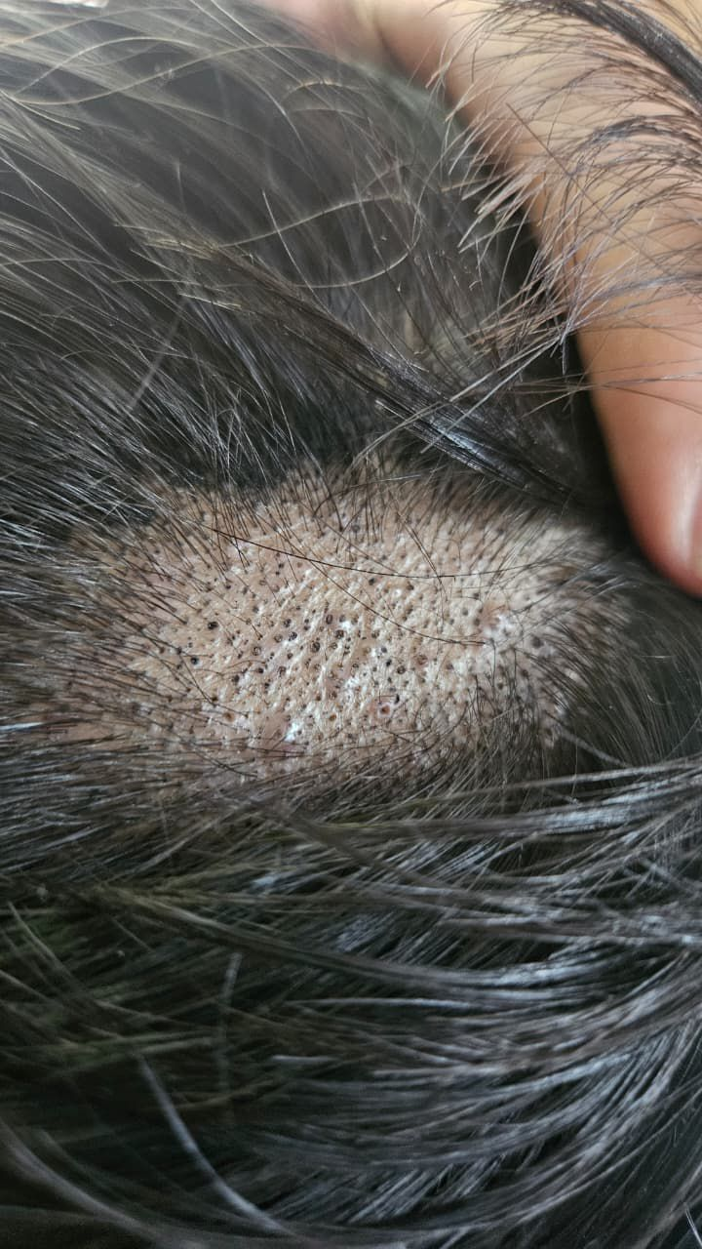
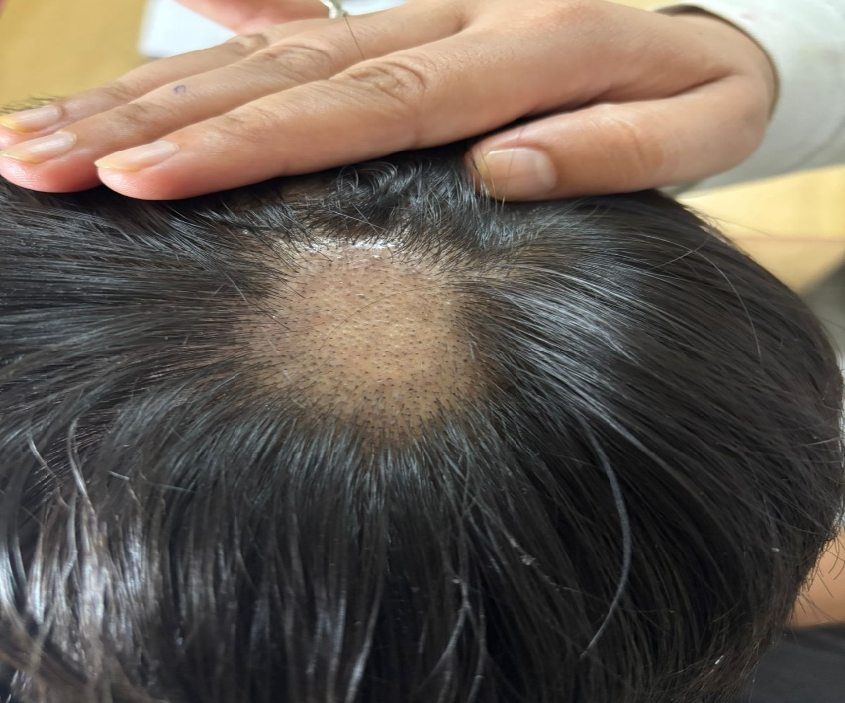
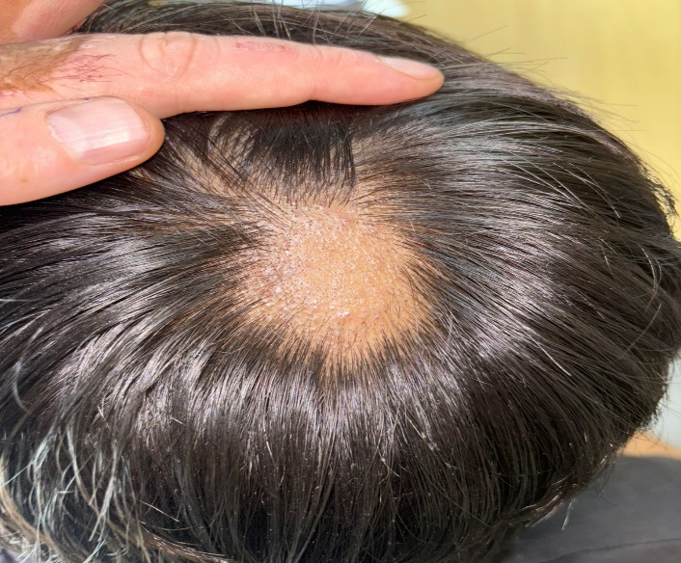
TREATMENT OUTCOME
VISIT-3
(After 2 Months)
The alopecic patch over the vertex shows further improvement with dense, uniformly distributed short terminal and pigmented hairs covering most of the previously bald area.
The size of the patch is markedly reduced, margins are ill-defined, and scalp skin appears completely normal with no erythema, scaling, or scarring. These findings indicate continued hair regrowth and near-complete clinical remission of alopecia areata.
VISIT-2
(After 1 Month)
Patch over the vertex shows significant improvement with appearance of multiple short, pigmented regrowing hairs uniformly distributed over the lesion.
The patch margins are less conspicuous, and the scalp skin appears healthy with normal color and texture, without erythema, scaling, or scarring.
VISIT-1
The patient presents with a single, well-defined round to oval patch of hair loss measuring approx. 4–5 cm over the vertex region of the scalp. The affected area shows smooth, normal-colored skin without erythema, scaling, scarring, or signs of inflammation. There is marked reduction of terminal hairs with few short vellus hairs seen within the patch, and the margins are clearly demarcated from the surrounding normal scalp hair.

AFTER TREATMENT
(After 3 Months)
BEFORE TREATMENT
(At first visit)
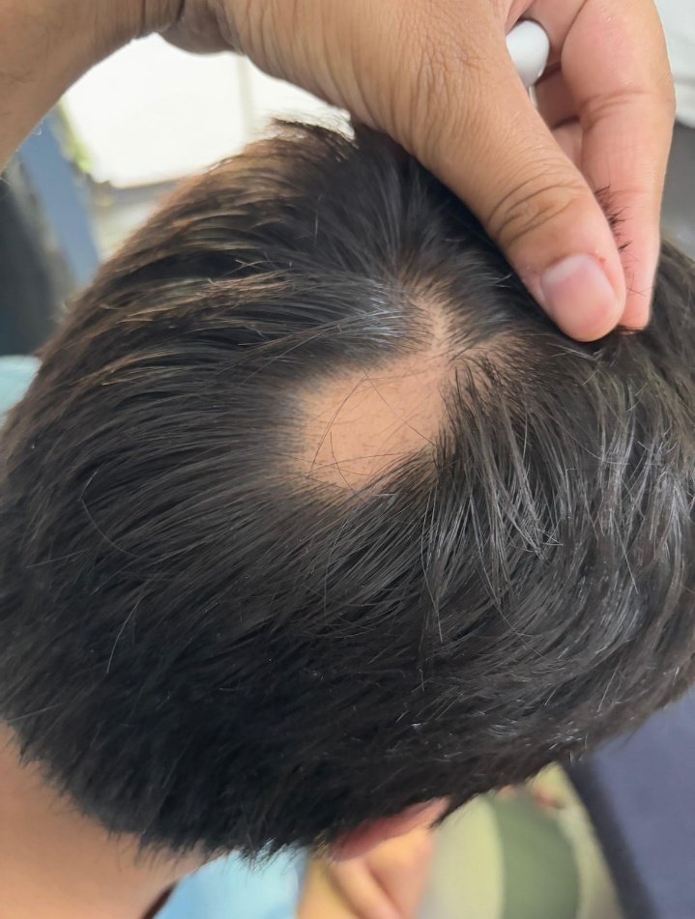
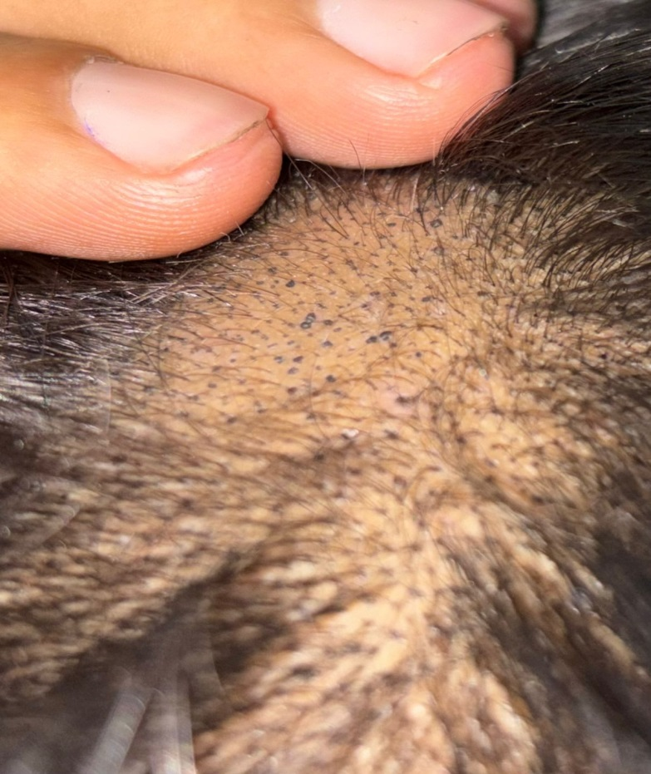
Before treatment: The patient presented with a well-defined, non-scarring alopecic patch over the vertex with complete loss of terminal hairs and smooth, normal-appearing scalp skin.
After treatment: Follow-up showed marked improvement with uniform regrowth of short, pigmented hairs, reduced patch size, indistinct margins, and healthy scalp skin, indicating a good therapeutic response in alopecia areata.

PROBABLE MODE OF ACTION OF DRUGS:
Nimba Churna: Tikta–Kashaya rasa, Laghu–Ruksha guna, Sheeta virya.
Acts as Rakta shodhaka and Pitta-Kapha shamaka. Corrects underlying Rakta dushti, thereby improving follicular nutrition.
Swarna Gairik: Madhura–Kashaya rasa, Sheeta virya.
Pitta shamaka, Rakta stambhaka. Thereby Maintains scalp homeostasis and supports follicular healing.
Krimikuthar Rasa: Krimighna, Kapha-vata shamaka.
Eliminates Krimi (microbial/fungal factors) (if any) contributing to hair loss. Improves scalp hygiene and reduces chronic follicular damage. Useful in dandruff or seborrheic scalp.
Arogyavardhini Vati: Deepana–Pachana, Yakrituttejaka.
Corrects Agni and Ama. Improves liver function and metabolic clearance. Acts as Rakta prasadaka. Addresses systemic metabolic causes of hair loss.

Ras Manikya: Ushna, Tikshna, Kapha-vata nashaka
Clears Srotorodha at Romakupa level and stimulates inactive hair follicles. Promotes regrowth by reactivating follicles.
Tankan Bhasma with Karanja Tail: Tikshna, Ushna, Krimighna.
Enhances local circulation. Removes follicular blockage and acts as antimicrobial and antifungal agent.
Saptamrita Lauha: Rasayana, Rakta vardhaka.
Improves Rasa–Rakta dhatu quality. Corrects nutritional Deficiencies. Thus, Enhances nourishment of hair roots.
Narsingh Rasayana: Balya, Rasayana.
Contains Bhallataka; which is considered as a “Shatru of kaphaja rogas” Therefore clears channel obstructions and Promotes Dhatu poshana.
Indralupta Mashi with Maltyadi Tail: Ushna, Tikshna, Romakupa shodhaka.
Stimulates dormant follicles.
OVERALL THERAPEUTIC EFFECT
Samprapti Vighatana by:
  - Pacifying Pitta–Kapha
  - Purifying Rakta dhatu
  - Removing Romakupa avarodha
  - Enhancing follicular nutrition and regeneration
Net Result: Reduction in hair fall, arrest of disease progression, and gradual hair regrowth with improved scalp health.

CONCLUSION:
Alopecia areata is a described as one of the Kshudra roga in samhita. Acharya Charaka mentions that Tejas by involving Vatadi Dosha when reaches the scalp, it results in Indralupta. The patient demonstrated a significant and satisfactory clinical response to treatment, evidenced by progressive hair regrowth, reduction in the size of the alopecic patch, and restoration of normal scalp appearance. The absence of scarring or active inflammation and the presence of pigmented regrowing hairs indicate remission of disease activity, suggesting effective management of alopecia areata and a favourable prognosis with continued therapy and follow-up.
SUMMARY:
According to Acharya Sushruta, Pitta along with Vata by involving the roots of hair (Romakoopa) causes fall of hair and thereafter Shleshma along with Shonita obstructs the channel of Romakoopa leading to the stoppage of the regeneration of hair and this condition is known as Indralupta. The patient with localized alopecia areata presented with a well-defined non-scarring alopecic patch over the vertex. Following treatment, there was progressive and uniform hair regrowth with reduction in patch size and normalization of scalp skin. Overall findings indicate an excellent therapeutic response and favourable clinical outcome.

Tan E, Tay YK, Goh CL, Chin Giam Y. The pattern of alopecia areata in Singapore - A study of 219 Asians. Int J Dermatol. 2002;41:748-53.
Al-Mutairi N, Eldin on. Clinical profile and impact on quality of life: Seven years experience with patients of alopecia areata. Indian J DermatolVenereolLeprol. 2011;77:489-93.
.VaidyaJadavji Trikamji Acharya, Sushruta Samhita (SS), Nibandhasamgraha Commentary, Reprint edition, 2009, Chaukhambha Surbharti Prakashana, Varanasi. Sutrasthana 24/10
Anonymous, The Ayurvedic Formulary of India, Ministry of Health and Family Welfare, Govt. of India, Part I (21:11), 2000;p. 755.
Banolta, S., Shukla, S. G., Bisht, D., & Raj, A. (2025). Review article on indralupta w.s.r. to alopecia areata. International Journal of Latest Technology in Engineering, Management & Applied Science, 14(8). https://doi.org/10.51583/IJLTEMAS.2025.140800132
Anonymous, The Ayurvedic Pharmacopoeia of India, Ministry of Health and Family Welfare, Govt. of India, part I, vol I (27);p. 70-2.
Anonymous, The Ayurvedic Pharmacopoeia of India, Ministry of Health and Family Welfare, Govt. of India, part I, vol I (3);p.9-11

